Visible Light Photoswitchable Covalent Tetra-ortho-fluoro-azobenzene Carbon Nanodot Hybrids for Optostimulation

Paul P. Debes,[a,b] Dominic Schatz,[a,c] Anthea Villano,[d,e] Yagmur Aydogan-Sun,[f] Juan Pablo Martínez,[g] Michal Langer,[h] Janis Hessling,[i] Monika Schönhoff,[i] Bernd M. Smarsly,[a,b] Silvio Osella,[g] Josef Wachtveitl,[f] Maria Rosa Antognazza,[e] Giuseppe M. Paternò,[d] Teresa Gatti,*[a,b,j] Hermann A. Wegner*[a,c]
[a] Paul P. Debes, Dominic Schatz, Bernd M. Smarsly, Teresa Gatti, Hermann A. Wegner
Center for Materials Research
Justus Liebig University
Heinrich-Buff-Ring 16, 35392, Giessen (Germany)
[b] Paul P. Debes, Bernd M. Smarsly, Teresa Gatti
Institute of Physical Chemistry
Justus Liebig University
Heinrich-Buff-Ring 17, 35392, Giessen (Germany)
[c] Dominic Schatz, Hermann A. Wegner
Institute of Organic Chemistry
Justus Liebig University
Heinrich-Buff-Ring 17, 35392, Giessen (Germany)
E-mail: Hermann.A.Wegner@org.chemie.uni-giessen.de
[d] Anthea Villano, Giuseppe M. Paternò
Department of Physics
Politecnico di Milano
Piazza L.da Vinci 32, 20133 Milano (Italy)
[e] Anthea Villano, Maria Rosa Antognazza
Center for Nano Science and Technology
Istituto Italiano di Tecnologia
Via Rubattino 81, 20134 Milano (Italy)
[f] Yagmur Aydogan-Sun, Josef Wachtveitl
Institute of Physical and Theoretical Chemistry
Goethe University
Max von Laue-Strasse 7, 60438, Frankfurt (Germany)
[g] Juan Pablo Martínez, Silvio Osella
Chemical and Biological Systems Simulation Lab, Centre of New Technologies
University of Warsaw
2c Banacha Street, 02-097, Warszawa (Poland)
[h] Michal Langer
IT4Innovations
VSB – Technical University of Ostrava
17.listopadu 2172/15, 70800, Ostrava-Poruba (Czech Republic)
[i] Janis Hessling, Monika Schönhoff
Institute of Physical Chemistry
University of Münster
Corrensstrasse 28/30, 48149, Münster (Germany)
[j] Teresa Gatti
Department of Applied Science and Technology
Politecnico di Torino
C.so Duca degli Abruzzi 24, 10129, Torino (Italy)
E-mail: teresa.gatti@polito.it

Abstract: Carbon nanodots (CNDs) have attracted growing interest due to their potential applications in sensing, imaging, and optically controlled bio-applications. In this study, we present the covalent functionalization of citric acid/ethylenediamine-based CNDs with a tetra-ortho-fluoro-azobenzene derivative (F-Azo). This approach aims to integrate the intrinsic photoluminescence of CNDs with the reversible photoisomerization properties of F-Azos triggered by visible light. The CND-F-Azo hybrids are synthesized via a terminal carboxylic acid group located on the F-Azo, which can be attached via amide coupling to surface-accessible amines on the CNDs. The structural and optical characterization of the resulting hybrid material is performed using a variety of analytical and spectroscopic techniques, as well as computational analyses supporting the covalent linking between the molecular and nanomaterial components and the interactions existing between them. In order to assess the impact of functionalization on physicochemical properties, the hybrid is further analyzed with respect to zeta potential, lipophilicity, and cell viability using HEK-293 cell assays. To assess cellular uptake and intracellular localization, confocal fluorescence imaging is employed. This work contributes to the development of light-responsive nanomaterials with tailored surface properties, highlighting the potential of Azo-functionalized CNDs as multifunctional platforms for future in-vitro and in-vivo optostimulation applications.
Introduction

The integration of molecular photoswitches into nanoscale systems holds immense promise for the advancement of light-controlled technologies in materials science, nanomedicine, and microbiology.[1,2] Azobenzenes (Azos) are among the most widely used photoresponsive compounds. A significant aspect contributing to the popularity of Azos is their ability to switch between two geometrical isomers, cis and trans, with large change in size.[3–5] Specifically, the area of optostimulation is getting more attention due to its ability to allow remote observation and control of cellular signals with high accuracy. In 2020, DiFrancesco et al. demonstrated that the amphiphilic azobenzene derivative Ziapin2 can non-covalently embed into neuronal membranes.[6] There, reversible photoisomerization disturbs membrane packing, increases capacitance, and initiates action potentials. More recently, in 2024, Florindi et al. applied this photophysical mechanism to cardiac tissue. Using light-induced membrane thinning and activation of mechanosensitive ion channels, they showed that Ziapin2 modulates excitation-contraction coupling in adult ventricular myocytes.[7] A significant challenge in biological applications is the limited suitability of conventional photochromic molecules, such as Azos, which typically require ultraviolet (UV) light for the trans-cis isomerization process. UV irradiation is associated with low tissue penetration and phototoxicity, thereby restricting the use of these systems in biological environments.[8–12]
Consequently, there has been a concerted effort to engineer Azo switches that are capable of being responsive to visible light.[13–22] Introduced by Hecht and Bléger, tetra-ortho-fluoroazobenzenes (F-Azos) have emerged as a class of rationally designed photoswitches that overcome these challenges through responsiveness to visible light, excellent photoconversion efficiencies, high bistability, and reversible switching. Due to separation of the n-π* band of both isomers, F-Azos can isomerize from the trans to the cis isomer under green light (530-560 nm) and revert back under blue light (400-500 nm), making them suitable for use as biocompatible and optically controlled materials.[13,22,23] Recent advances enable switching with orange light (595 nm)[24,25] and red light (623-660 nm)[26,27], the latter of which is particularly relevant for biomedical use since wavelengths above 630 nm can penetrate tissue without hemoglobin absorption. These advances underscore the increasing potential of F-Azos as biocompatible, deep-tissue optical switches.[26]

Carbon dots (CDs) represent a recent addition to the broader class of carbon nanomaterials.[28] These particles can be classified based on their structural and chemical characteristics into several subtypes, including amorphous carbon nanodots (CNDs) or carbonized polymer dots (CPDs), amorphous to partially crystalline carbon quantum dots (CQDs), and graphitic graphene quantum dots (GQDs).[29–31] The specific type of CD obtained is influenced by the synthetic approach and reaction parameters, including precursor composition, temperature, time, and atmosphere. A notable benefit of CDs is their tunable physicochemical properties, which can be modulated through variations in synthesis conditions. The versatility of these compounds is evident in their size, surface charge, photoluminescence (PL) properties, and functional group composition.[32–35]
CDs generally contain a high number of surface functional groups, including hydroxyl, carboxyl, carbonyl, and amine moieties.[36,37] These groups are derived from incomplete carbonization or targeted heteroatom doping during the synthesis process.[38,39] The density and distribution of these groups are largely dependent on the degree of carbonization and the precursor chemistry. Specifically, lower carbonization temperatures have been shown to favor the preservation of surface functionalities, rendering the resulting nanomaterials particularly suitable for post-synthetic modification.[40] A multitude of post-functionalization strategies have been employed in the literature. Among the most frequently used is the formation of amide bonds through carbodiimide-mediated coupling between surface-exposed amines on the CDs and carboxylic acids on molecular entities.[41,42] This reaction pathway facilitates the covalent conjugation of a diverse array of bioactive molecules, fluorophores, or responsive units, thereby expanding the functional utility of CDs.[43–45]
Furthermore, CDs have garnered considerable attention as multifunctional nanomaterials in the biomedical domain.[46] Their attractive features include small size (typically <10 nm), high water dispersibility, excellent photostability, and bright PL with broad excitation spectra and tunable emission across the visible range. The properties previously mentioned have enabled the application of these substances in various imaging modalities, including fluorescence imaging, magnetic resonance imaging, and photoacoustic imaging.[47,48] Furthermore, CDs have been explored for catalytic applications, targeted drug delivery, and in light-activated therapeutic strategies such as photothermal and photodynamic tumor therapies.[49–51] It has been demonstrated that nitrogen-doped CDs exhibit functionality as biocompatible actuators, thereby modulating key intracellular processes, including calcium ion signaling and the generation of reactive oxygen species, in a light-dependent and controllable manner.[52]

Consequently, covalently functionalizing CNDs with Azo photoswitches is a promising way to engineer nanomaterials that are biocompatible, membrane-active, and able to undergo structural changes upon visible-light irradiation. These nanohybrids could serve as novel tools for optostimulation and bioimaging, providing new approaches to studying cellular processes in biomedical research.[53]
In a previous study, we reported the successful covalent functionalization of amorphous nitrogen- and oxygen-rich CNDs with Azo derivatives. It was demonstrated that the connectivity (meta vs. para) and the incorporation of a sp3-hybridized glycine linker significantly influenced the photophysical properties of the hybrids. In the present study, we selected a F-Azo derivative with a para-connected carboxylic acid group. This derivative was chosen based on our earlier findings that the connectivity of the Azo unit had a negligible influence on the hybrid's optical properties. This was attributed to the absence of direct electronic conjugation between the CND core and the Azo moieties, as interactions occurred solely through space. In all cases, the Azo units exhibited reversible switching behavior, and the intrinsic PL of the CNDs remained detectable. However, the photoswitching process necessitated UV light (~340 nm), which is phototoxic and thus incompatible for biological applications. Previous fatigue resistance assessments showed that CND-m-Azo underwent 13 trans-cis-trans switching cycles before reaching 50% of its original absorbance. Conversely, CND-p-Azo retained 50% of its initial absorption over 18 cycles, indicating enhanced photostability. CND-m-Gly-Azo notably exhibited only an 18% decrease in absorbance after 15 cycles, demonstrating the highest durability among the synthesized hybrids.[54]

Based on these insights, the present study focuses on the development and in-depth characterization of CNDs covalently functionalized with F-Azo units. The hybrid CND-F-Azo nanomaterial demonstrates an absorption maximum in the UV light region at 338 nm. Despite this absorption in the UV region, the photoisomerization of the F-Azo units is triggered from trans to cis by visible light at 530 nm and back from cis to trans with 448 nm. Consequently, despite the presence of UV absorption in the material, UV irradiation is not a requirement for the initiation of photoswitching. This approach reduces the need for phototoxic stimulation wavelengths, enhancing the compatibility of the system with biological applications. The resulting CND-F-Azo nanohybrids are proposed to accumulate within the lipid bilayer of cellular membranes. There, the photoisomerization of the bound F-Azo units has the potential to cause reversible changes in membrane thickness. In this configuration, the CND serves as a novel carrier system that anchors the photoswitches within the lipid bilayer and provides intrinsic fluorescence for bioimaging. This dual functionality enables the development of nanohybrids that can modulate membrane properties with the control of light, while simultaneously allowing for their detection in cellular environments. The hybrid material was subjected to structural characterization using spectroscopic techniques. The degree of functionalization was determined through 19F-nuclear magnetic resonance (NMR) via integration of the fluorine signal in comparison to an internal standard.[55,56] A comprehensive investigation was conducted of the photochemical behavior of the material. These include the photoluminescence quantum yield (PLQY), as well as the absorption and emission properties, switching characteristics, and fatigue resistance. However, it is necessary to systematically evaluate the cytotoxic potential of newly synthesized CD formulations, given the fact that biocompatibility can vary depending on composition and surface chemistry. With this in mind, we employ a well-established in vitro, non-tumor cell line model, i.e., human embryonic kidney cells (HEK-293), to study the cell proliferation. In addition, a shake flask assay was conducted to determine the partition coefficients between media of differing polarity. Collectively, these investigations establish a foundation for the development of multifunctional nanomaterials for optically controlled biomedical applications.
Results and Discussion
CNDs were synthesized by microwave-assisted reaction of citric acid (CA) and ethylenediamine (EDA) (1:1) in aqueous media, followed by purification through filtration and size-exclusion chromatography.[57] Their structural and optical properties, including AFM morphology, UV-Vis absorption, PL emission, and NMR signals, have been reported in a previous work.[54] In addition, we confirmed the presence of surface-accessible primary amines on the CNDs in a preliminary study, allowing for post-synthetic amide coupling.[58] The carboxylic acid functionalized F-Azo derivative, synthesized via a Baeyer-Mills reaction, was covalently attached to the CNDs via EDC/NHS-mediated coupling (Figure 1).[23,41] The successful functionalization was confirmed by diffusion-ordered NMR spectroscopy (DOSY), analogous to the approach described by the group of Prato.[59]
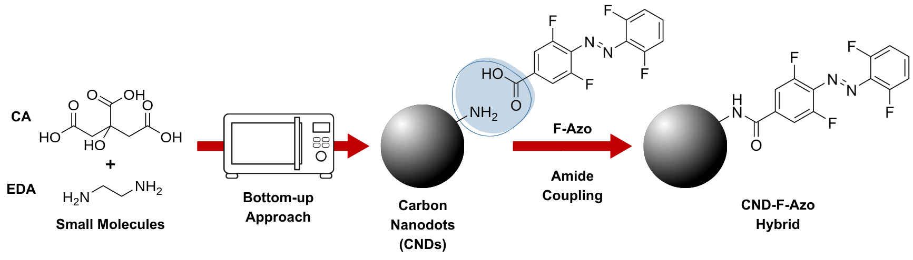
Figure 1. Schematic representation of the microwave-assisted synthesis of CNDs from CA and EDA (1:1) in water, followed by covalent functionalization via EDC/NHS-mediated amide coupling in DMF with F-Azo to yield the CND-F-Azo hybrid.

In order to ensure the comparability and contextual interpretation of the current results, we refer to previously published DOSY NMR data on m-Azo (bearing a meta-positioned carboxylic acid and no fluorine substitution), pristine CND, and a physical mixture of CND with m-Azo.[54] Due to its structural similarity to the fluorinated Azo compound (F-Azo) used in this study, the m-Azo in the physical mixture with CND serves as a suitable reference, reflecting the diffusion of a non-coupled Azo moiety. We show earlier 2D DOSY spectra (see Figures S1-S3) in comparison to a newly determined 2D DOSY spectrum of CND-F-Azo (see Figure S4). In addition, we compare diffusion decays (see Figure 2), thereby establishing a consistent framework for interpretation. In the earlier study, m-Azo, pristine CND, and the physical mixture of CND and m-Azo revealed distinct diffusion behaviors. In the DOSY spectra monomodal distributions were observed for m-Azo and CND, indicating monodisperse species. In contrast, the physical mixture exhibited two distinct diffusion domains, confirming the absence of covalent binding between the components. In contrast, analyzing the CND-F-Azo hybrid reveals a single monomodal distribution, indicating a successful covalent attachment of F-Azo to CND with no unbound F-Azo present. For a quantification, the diffusion coefficients were extracted from the diffusion echo decay curves (see Figure 2A) using the Stejskal-Tanner equation (eq. S1)[60] under the assumption of a log-normal distribution of diffusion coefficients (see ESI, eq. S2 and S3). Since no separated 1H resonance of F-Azo could be identified in the hybrid sample (see Figure S4, ESI), the integral over all 1H resonances in the chemical shift region from 8.5 to 7.3 ppm was evaluated like in the previous study.[54] The diffusion coefficient derived for the CND-F-Azo hybrid (D = 0.90 × 10−10 m2 s−1) is reduced by approximately 15% relative to pristine CND (1.05 × 10−10 m2 s−1), reflecting an increase in hydrodynamic radius consistent with surface functionalization. The absence of a fast-diffusing component for the CND-F-Azo hybrid in the 2D spectrum (see Figure S4, ESI) further supports complete functionalization of the F-Azo moieties and closely resembles the behavior observed of the previously reported, successfully synthesized CND-Azo hybrids. This is also evident in the diffusion coefficient distribution shown in Figure 2B, where the CND-F-Azo hybrid only exhibits a single peak, in contrast to the two distinct peaks observed for the physical mixture of CND with m-Azo. The hydrodynamic diameters were determined using the Stokes-Einstein equation (see SI, eq. S4), applied to the maxima of the diffusion coefficient distributions. This approach facilitated a direct comparison between the previously reported reference system and the newly synthesized CND-F-Azo hybrid.
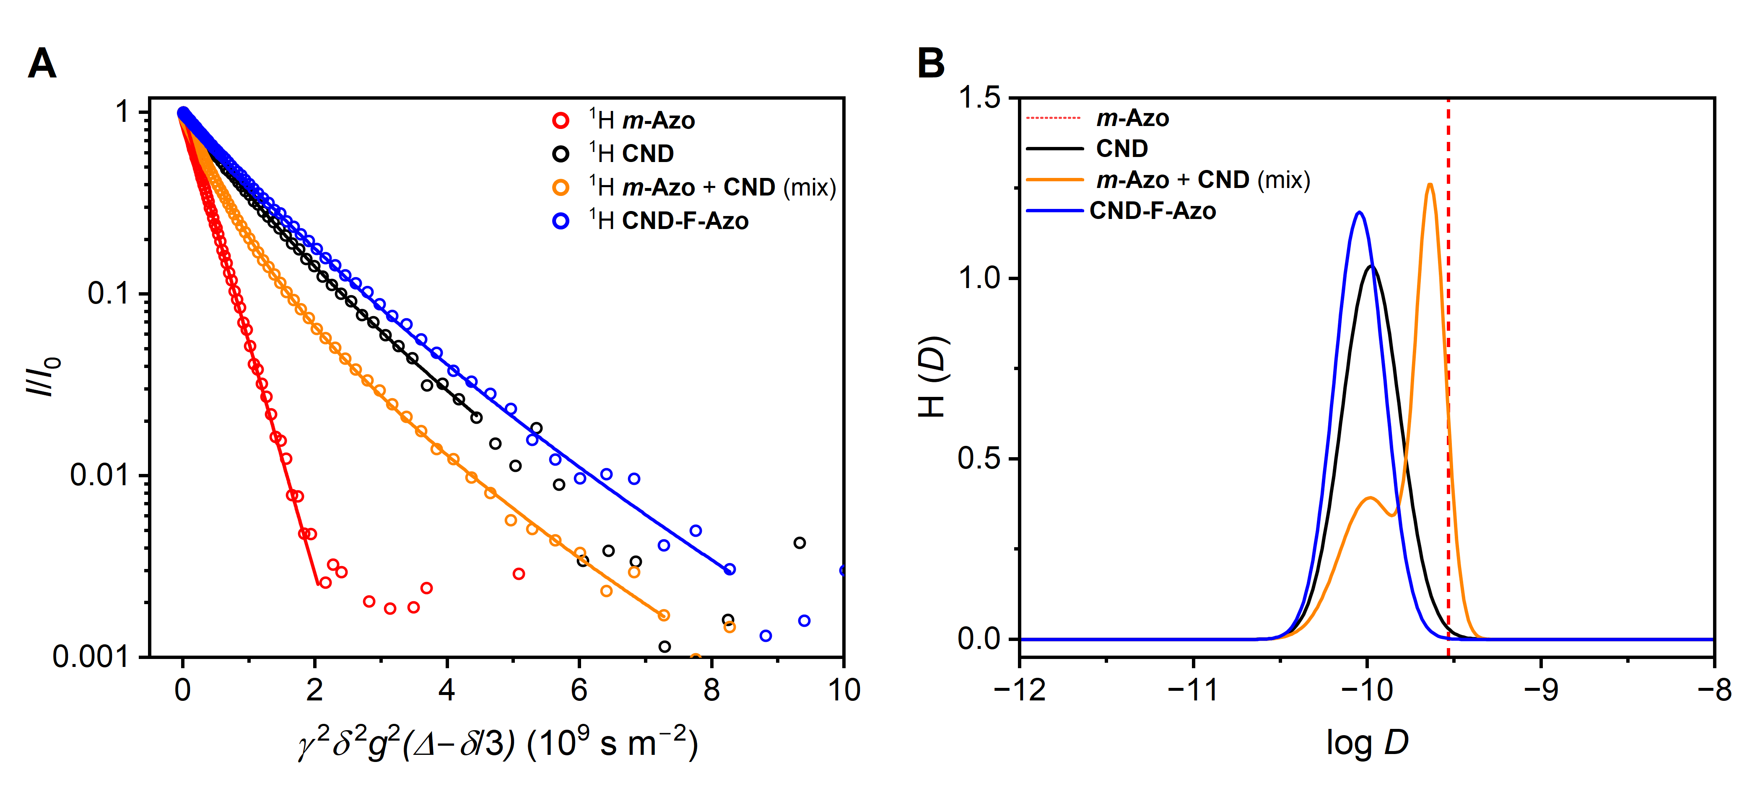
Figure 2. (A) Diffusion decay of the integrated 1H NMR signal (8.5-7.3 ppm) for m-Azo, pristine CND, and a physical mixture of m-Azo and CND (1:10, molar ratio), as reported in a previous study, shown here for comparison with the newly synthesized CND-F-Azo hybrid.[54] (B) Corresponding diffusion co distributions derived using a log-normal distribution.[61] (see SI for details). The diffusion coefficient of m-Azo is represented by a vertical dotted line, as it lacks a distribution due to its monodisperse molecular nature. The hybrid CND-F-Azo displays a monomodal diffusion profile as well as reduced diffusion, consistent with an increase in hydrodynamic radius following covalent functionalization.

For the pristine CND, the hydrodynamic diameter was reported to be 1.9 nm, which is in close agreement with the dimensions obtained from AFM. In the case of the CND-F-Azo hybrid, the diffusion-based diameter increased to 2.2 nm, likewise showing excellent agreement with the AFM-derived size of 2.2 nm (Figures S5-S6). The observed consistency in the values indicates a direct correlation between the reduction in diffusion coefficient and the subsequent, identifiable increase in particle size upon functionalization.
As shown in Figure 3A, the optical properties of the CND-F-Azo hybrid are compared with those of the corresponding non-emissive F-Azo molecule, as well as the previously reported pristine CND, for the purpose of comparative evaluation.[54] Notably, the spectra were recorded under ambient conditions, where the favored trans isomer is expected to predominate. Although direct experimental confirmation (e.g., by NMR or photoisomer ratio determination) was not performed in this context, the spectral features are consistent with a primarily trans population. The absorption and PL emission spectra of the hybrid material, along with the absorption spectrum of F-Azo, are presented to illustrate the spectral changes induced by functionalization. Table 1 summarizes the photophysical parameters, including the absorption maxima (λAbs), PL emission maxima (λEm), Stokes shifts, and PLQY (see Figures S7).

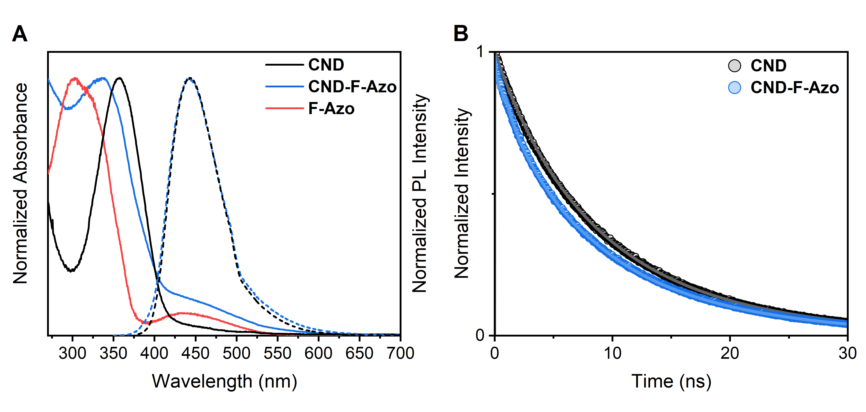
Figure 3. (A) Normalized UV-Vis absorbance spectra (solid lines) and corresponding PL emission spectra (dotted lines) of the previously reported pristine CNDs (black), the CND-F-Azo hybrid (blue), and the non-emissive F-Azo molecule. The comparison highlights the spectral shift in absorption upon functionalization of CNDs with F-Azo, as well as the absence of PL from the pristine F-Azo species. (B) Normalized fluorescence lifetime measurements (dots in dark colour) and their respective fits (solid lines in lighter colour) of the previously reported pristine CNDs (black) and the CND-F-Azo hybrid (blue). For each system, two lifetimes were obtained from the exponential tailfit.

A comparative analysis of the absorption spectra reveals that the CND-F-Azo hybrid exhibits a blue shift of 19 nm in its absorption maximum (338 nm) relative to the pristine CND (357 nm). F-Azo, in contrast, absorbs at 303 nm, corresponding to a 35 nm difference compared to the hybrid. Although para-functionalization of the Azo moiety allows for extended π-conjugation with the CND, indicative of potential intramolecular electronic interactions, this effect is not evident in the absorption spectra.[62] The spectral features of the CND-F-Azo hybrid remain largely additive, suggesting limited electronic communication between the two components. Moreover, the PL emission maximum of the CND-F-Azo hybrid is identical to that of the pristine CND, indicating that the emissive core remains electronically unaffected by the presence of the Azo functionality. This observation suggests that the F-Azo unit is electronically decoupled from the emissive domains of the CND, interacting primarily through space, which is consistent with the findings of our previous study.[54,63]
Additionally, the absorption coefficients suggest a moderate level of functionalization of the F-Azo on the CND surface (see Figure S8). Furthermore, neither the 3D fluorescence maps nor the excitation spectra (see Figures S9) reveal any substantial spectral shifts or new emissive states that would indicate a strong coupling between the F-Azo and the CND.

Table 1. UV-Vis absorption maxima (λAbs), photoluminescence (PL) emission maxima (𝜆Em), Stokes shift, and photoluminescence quantum yield (PLQY) of the CND-F-Azo hybrid in comparison to the pristine F-Azo and previously reported pristine CNDs.[54]
Sample λAbs / nm λEm / nm Stokes Shift / nm PLQY / %
F-Azo 303
CND[54]
357 443 86 37
CND-F-Azo 338 443 105 7

The excited-state lifetimes of pristine CND and the hybrid CND-F-Azo were measured using time-correlated single-photon counting (TCSPC), with excitation at 340 nm (see Figure 3B). Lifetime analysis was performed using a tail-fit approach, yielding two components rather than the three obtained previously using exponential deconvolution.[54] For pristine CND, lifetimes of 11.16 ns and 4.99 ns were determined, closely matching our earlier results (11.25 ns and 4.75 ns). In the case of the CND-F-Azo hybrid, slightly shorter lifetimes of 10.74 ns and 4.25 ns were obtained. A notable difference introduced by the Azo moiety is evident when comparing the relative contributions of the two lifetimes. In pristine CND, the longer lifetime accounts for 71% of the total decay (amplitude-weighted), whereas in the hybrid, its contribution decreases to 49%. As a result, the decay profile of the hybrid appears faster due to the increased dominance of the short-lived component. This shift leads to a reduction in the average lifetime from 9.40 ns for pristine CND to 7.45 ns for CND-F-Azo. This reduction is indicative of an additional non-radiative decay pathway, likely due to energy or charge transfer from the CND to the Azo moiety. However, fluorescence lifetime data alone cannot conclusively quantify the quenching efficiency, since the TCSPC technique is inherently biased toward detecting emissive states. Because the Azo moiety is non-emissive, its contribution remains undetected by this method. A more accurate measure of quenching efficiency is provided by the PLQY (see Table 1), which indicate a quenching efficiency of 81%. This value exceeds the 70% efficiency reported for the related CND-p-Azo system in our previous study. Despite the electronic decoupling between the CND and the Azo unit, the spatial proximity facilitates efficient energy and charge transfer, thereby reducing fluorescence efficiency. Such transfer does not require direct electronic conjugation and can occur through space, provided the donor and acceptor are sufficiently close. For instance, Förster resonance energy transfer (FRET) can operate over distances up to ~10 nm, while at shorter separations (<2 nm), coherent energy transfer or even electron transfer via orbital overlap may become possible. Since the exact structure and distances between the moieties are not precisely known in our system, we cannot unambiguously assign one mechanism, but the observed quenching efficiency indicates that such proximity-driven processes are highly effective. Full details of the TCSPC setup and the quenching efficiency calculation are provided in the SI.
Computational modelling was considered to understand the UV-Vis spectra presented in Figure 3A. As demonstrated in our recent work[54], we built an ad-hoc model of the CND, considering it in a polymeric form since the synthetic conditions do not permit full carbonization of the core, allowing for the formed IPCA fluorophores to dominate the CNDs optical properties. This model has been successfully validated for a CND-Azo hybrid, both in terms of accuracy of the computational description and accuracy (i.e. functional and basis set combination). In the present work, the same CND has been considered, and the fluorinated Azo molecule (F-Azo) added in a similar fashion as reported previously.
Both the CND-F-Azo cis and trans isomers were considered for the TDDFT optical analysis, reported in Figure 4 (the main transitions for the CND and F-Azo alone are reported in Figure S10). Starting from the CND-F-Azo trans isomer, the first broad, low intensity peak attributed to the S1, is a π-π* transition at 554 nm, localized on the Azo fragment, CND-F-Azo* (* indicates the excited moiety). The high intensity peak observed in the 300-350 nm range relates to two transitions, the S3 π-π* at 333 nm, with excitation localized over the CND fragment CND*-F-Azo, and a stronger transition from the S4 excited state which has a mix character, with partial CT from the CND to the Azo moiety, and a localized excitation on the Azo molecule which dominates the transition, CND-F-Azo*. Moreover, the calculated maximum of absorption intensity at 329 nm (f = 1.12) is in very good agreement with the experimental value of 338 nm. The π-π* transition S5 is a localized excitations on the nanodot fragment, CND*-F-Azo, at 315 nm. We also observed a CT state at 415 nm, from the nanodot to the Azo unit, CND+-F-Azo−, which can be reached after internal conversion from the S4 or S5 states, since the driving force is favourable, with values of 0.8 eV for S4 → S2 and 0.9 eV for S5 → S2 (see Figure 4), assuming neglecting entropic effects, which is valid under the Franck-Condon approximation.
A different scenario is present for the CND-F-Azo cis isomer, with the first peak associated to the S1 n-π* transition at 501 nm, localized on the Azo moiety. However, this peak is more pronounced, due to the change in geometry of the Azo molecule, for which the first transition is allowed. The most intense absorption peak in the same 300-350 nm range can be now attributed to three different transitions; the first, at 342 nm, relates to the S2 π-π* transition and is localized over the CND, CND*-F-Azo. The second, from the S3 excited state at 333 nm has a strong CT character, CND+-F-Azo−, while the strongest transition at 318 nm from S5 is once more a local excitation on the CND, CND*-F-Azo. Although the character of the CT excitation is stronger for the cis compared to the trans isomer, the driving force for the former is lower, of less than 0.2 eV, suggesting that CT for the cis isomer can be accessible, but with smaller values.
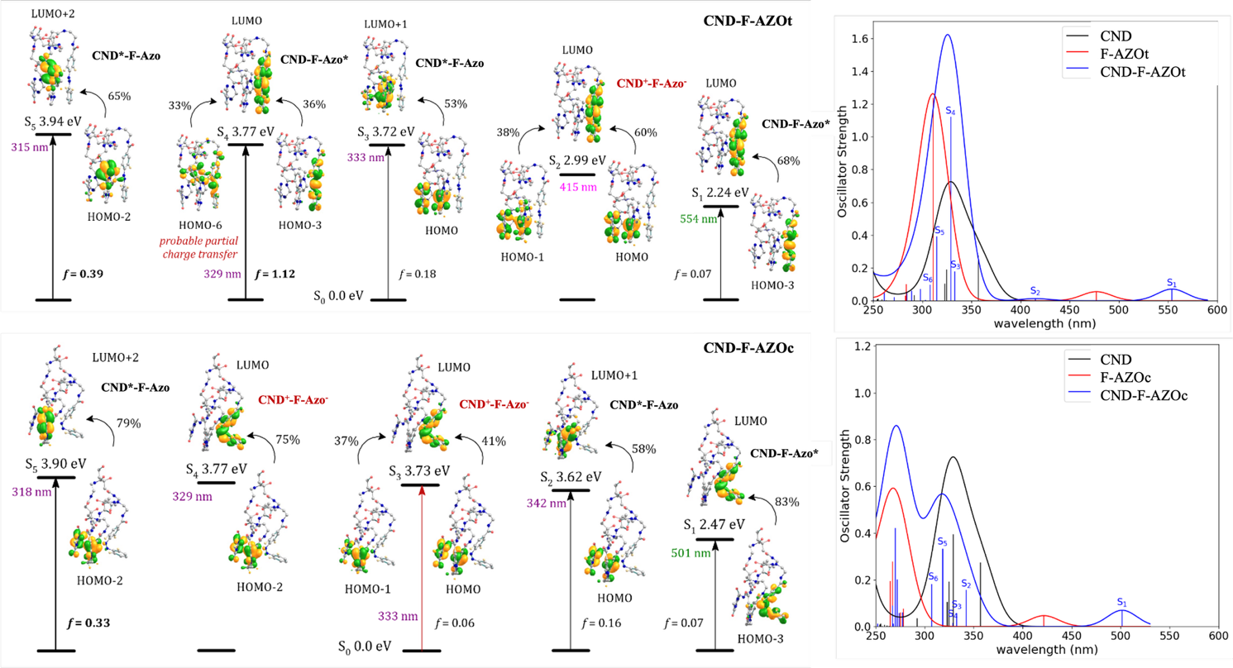
Figure 4. The lowest-energy electron transitions in the CND-F-Azo trans (top) and cis (bottom) isomers (f = oscillator strength, % of molecular-orbital contributions). The calculated spectra are also reported.

These results are comparable with the non-fluorinated counterpart, as reported in ref. [54]. In all fluorinated complexes, the wavelengths are 8-to-30 nm shifted towards the red part of the solar spectrum. This trend may be attributed to the electron-withdrawing effect of fluorine in the Azo moiety to induce the formation of the anionic counterpart of [CA-1]+-[F-Azo]−, although a change of <30 nm may be rather small. We emphasize that the Azo moiety is not directly conjugated to the fluorescent center of the CND and the interaction between them is mediated through space.
As earlier experiments have shown, there is a close correlation between spectral shifts of the absorption and the degree of surface functionalization. To quantify the degree of functionalization, a 19F-NMR-based method was employed, using 4,4’-difluorobenzophenone as an internal standard in DMSO-d6 (see Figure S11). This approach enables the selective quantification of F-Azo moieties covalently attached to primary and secondary amines on the CND surface via amide coupling. This methodology has been previously reported in a similar context for amide functionalized CNDs.[58,64]
The analysis yielded an F-Azo content of 280 µmol g−1, corresponding to 8.4% by mass in the CND-F-Azo hybrid. For comparison, the maximum density of primary amines available on the pristine CND surface was previously determined to be 1670 µmol g−1.[58] It is well established that full conversion of all accessible amines via amide coupling is rarely achieved due to steric and electronic constraints. Compared to our previous work, the present system displays a moderate to low degree of functionalization. The highest level of functionalization we obtained when using a glycine spacer between an Azo and the same kind of CND was 850 µmol g−1.[54]
To assess the sustained photoswitching capability in the visible range following covalent attachment of F-Azo to CNDs, the CND-F-Azo hybrid was subjected to alternating irradiation with 530 nm (green) and 448 nm (blue) LEDs for five minutes each, followed by UV-Vis absorbance measurements (Figure S12). The study investigated the feasibility of inducing photoswitching while concurrently enabling independent observation of the intrinsic fluorescence of the CND in the hybrid at distinct excitation wavelengths. The pristine F-Azo exhibited a pronounced decrease in absorbance upon 530 nm irradiation (Figure S12B), consistent with trans-to-cis photoisomerization. This conclusion is based on the observed shifts in the absorption spectra corresponding to the characteristic bands of the cis and trans isomers.[65] In contrast, the CND-F-Azo hybrid showed a smaller relative change in absorbance. This reduced optical response is attributed to the degree of Azo functionalization of 8.4%, with the CND contributing significantly to the total absorbance and thus covering the switch-induced spectral change. Nevertheless, the results confirm that reversible photoswitching is retained after immobilization, while at the same time the fluorescence of the CND scaffold remains accessible under irradiation with a different wavelength. These results indicate a predominant enrichment of one isomeric state under irradiation, although the exact photostationary composition cannot be determined quantitatively, as the changes of the Azo moieties are masked by the strong background of the CND scaffold. The fatigue resistance of the hybrid was further evaluated over 10 consecutive irradiation cycles (Figure 5A, Figure S13). CND-F-Azo showed a 0.5% decrease in absorbance, indicating a higher level of fatigue resistance compared to previously reported CND-Azo hybrids. Its performance surpasses that of CND-m-Azo (Z50 after 13 cycles), CND-p-Azo (Z50 after 18 cycles), and CND-m-Gly-Azo (an 18% decrease after 15 cycles). This highlights the improved photostability of the F-Azo-functionalized hybrid.[54] This increased stability is likely also due to the red-shifted switching wavelength, which changed from 340 nm to 530 nm. The corresponding PL spectra (Figure 5B) showed a slight decrease in emission intensity, likely due to a gradual decrease in CND-related PL rather than degradation of the Azo motif. Furthermore, the transition between the trans and cis configurations of the surface-bound F-Azo units does not significantly affect the emission properties, suggesting no significant change in the PLQY.
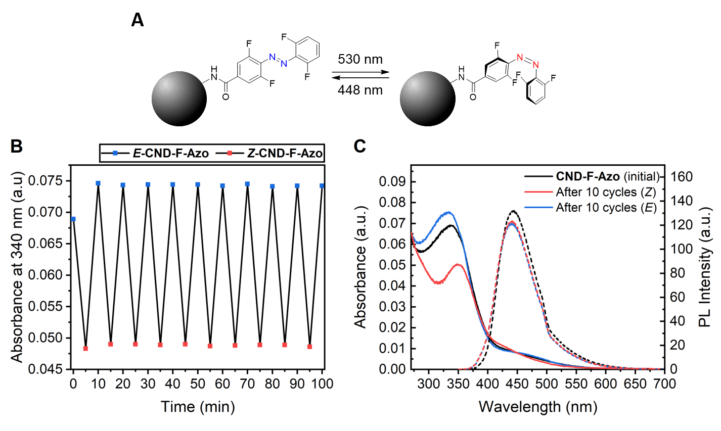
Figure 5. (A) A schematic illustration showing the photoinduced trans-to-cis conversion of the F-Azo-functionalized CNDs (black spheres) under 530 nm irradiation, followed by reversion to the trans-isomer via 448 nm exposure. (B) Fatigue resistance of the CND-F-Azo hybrid over ten photoisomerization cycles using 530 nm and 448 nm irradiation in an alternating order. The CND-F-Azo hybrid maintains 99.5% absorbance at 340 nm over ten cycles. (C) Absorbance and emission of the CND-F-Azo hybrid before and after ten cycles of light irradiation. Measurements were performed with an 8 mg L−1 dispersion in DMSO at 25 °C.

These results confirm that the F-Azo moieties retain robust switching behavior when covalently bound to the CND surface, which is consistent with literature reports of high fatigue resistance in ortho-fluorinated Azos that undergo minimal side reactions during repeated photoisomerization. Notably, compared to previous studies using high energy UV irradiation (e.g., 340 nm) to switch CND-Azo hybrids, the use of lower energy visible light (530 nm) reduces photodegradation and improves long-term optical stability, which presents significant advantages for use of these species in bio-applications.
Following confirmation of the preserved photoswitching properties, we proceeded to evaluate the bioapplicability of the CND-F-Azo hybrid. While CNDs are generally regarded as materials with low-toxicity, their biocompatibility is highly dependent on surface composition, functionalization, and dose. Therefore, each newly synthesized nanohybrid requires systematic cytotoxicity assessment prior to application in biological environments. To this aim, we use here a well-established in vitro non-tumour cell line model, namely human embryonic kidney cells (HEK-293). Figure 6A shows the proliferation of HEK-293 cells treated with the CND-F-Azo hybrid. The cell cultures were incubated in cell medium with CND-F-Azo dispersions at two different concentrations (5 μg ml−1 and 100 μg ml−1); after 12 hours the cell medium was replaced with fresh medium free of CND-F-Azo and cell proliferation was examined at three different time points [1, 3, and 6 days in vitro (DIV) after plating] until the cells reached approximately 90% confluence, using the consolidated Alamar-Blue assay. The latter provides a reliable indication of the metabolic activity of cultured cells and is a direct measure of cell proliferation capabilities. The higher dose of CND-F-Azo strongly affects the proliferation of HEK cells as already at DIV1 after treatment; conversely, cells treated with the lower dose of CND-F-Azo do not show a statistically significant difference in their proliferation rate compared to control, untreated samples, up to 6 DIV. Based on the data in Figure 6A, a non-toxic CND-F-Azo concentration can be determined that has no negative effects on in vitro cell proliferation. The presence of CND-F-Azo within the cell cytosol at 6 DIV after delivery was verified by confocal fluorescence in vivo imaging. A representative confocal image taken in a middle focal plane (i.e., corresponding to the inner part of the cells) is shown in Figure 6B. The cell membrane is visible in red, while CND-F-Azo aggregates are visible in blue due to their intrinsic fluorescence emission. The appearance of blue emission spots in the same plane of the cell cytosol and the nuclear membrane visible in red indicates that CDs have been efficiently internalized and not eliminated 6 DIV after plating.
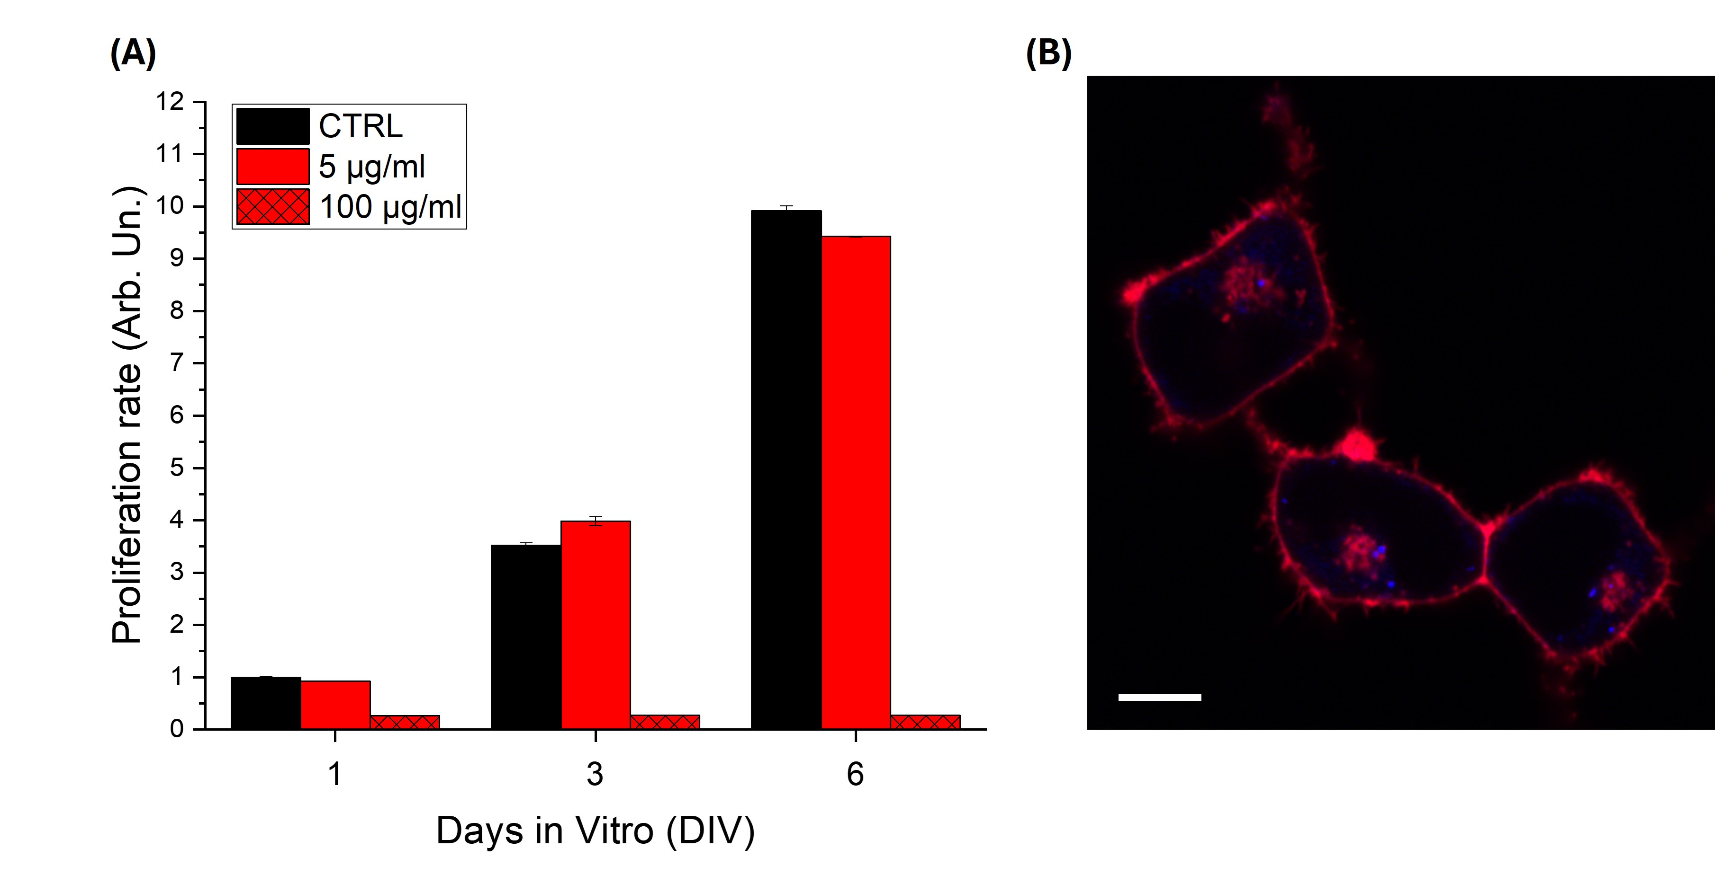
Figure 6. (A) Alamar Blue cell proliferation assay: two CND-F-Azo concentrations (5 and 100 μg mL−1) were considered and evaluated 1, 3, and 6 DIV after plating. Fluorescence values are normalized over untreated control samples (CTRL) at DIV1 and averaged over three replicates. All data represented as mean ± SEM (One-Way ANOVA and Tukey post-hoc test, p < 0.01). (B) Representative confocal image of HEK cells treated with CND-F-Azos (5 μg mL−1) acquired at intermediate focal plane, corresponding to internal part of cells. Cells are stained with Cell Mask (cell membrane, red); CND-F-Azo intrinsic fluorescence is visible in blue. Scale bar: 10 μm.
It is crucial to differentiate between temporary membrane association, integration into the lipid bilayer, and complete cytosolic internalization. As the present study primarily focuses on the internalization of nanomaterials into the lipid bilayer, particular attention must be directed toward evaluating the membrane-associating properties of the CND-F-Azo hybrid. The process of internalization is influenced by a multifactorial interplay of physicochemical characteristics, notably the size, morphology, and surface chemistry of the particles.[66] In order to gain insight into the membrane interaction potential of the CND-F-Azo system, two critical parameters were examined: surface charge (determined by zeta potential) and lipophilicity (quantified via the octanol-water partition coefficient).

Zeta potential measurements revealed negative surface charges for the CND-F-Azo hybrid, with values of −12 mV at pH 6.0 and −17 mV at pH 7.6 in DMSO (see Figure S14). Since cell membranes are predominantly negatively charged due to phospholipids and glycoproteins, positively charged nanomaterials are more likely to experience favorable electrostatic interactions leading to internalization.[67–69]
The negative zeta potential observed for the CND-F-Azo hybrid suggests limited electrostatic affinity toward the plasma membrane, which may result in limited membrane association. However, given the multifaceted nature of nanoparticle-cell interactions, zeta potential alone is inadequate for predicting uptake behaviors.
Furthermore, colloidal stability is often associated with the extent of surface charge. Dispersions exhibiting zeta potential values beyond ±30 mV are generally considered to be colloidally stable.[70] The values recorded for CND-F-Azo suggest moderate stability in suspension, indicating that further functionalization, particularly with positively charged groups, has the potential to enhance both membrane interactions and colloidal behavior.[71]
In addition to surface charge, lipophilicity is a substantial factor in determining the interaction of nanomaterials with the hydrophobic core of lipid bilayers. The octanol-water partition coefficient (log P) is a widely used parameter to quantify lipophilicity and predict membrane internalization, including key pharmacokinetic properties such as gastrointestinal absorption and blood-brain barrier penetration. The relationship between log P and membrane permeability is non-linear: molecules with low log P values have limited ability to diffuse into lipid bilayers, while those with excessively high log P values tend to localize within the membrane, reducing permeation across the bilayer. A log P value below 1 is generally associated with poor cellular permeation and even lower incorporation into lipid bilayers, underscoring the importance of tuning lipophilicity to enhance membrane interaction.[72]
To experimentally assess the lipophilicity of CND-F-Azo, the shake-flask method was employed, in which the material was equilibrated between an aqueous and an octanol phase (see Figure 7A). The experiment was performed using a non-irradiated sample, and equilibration was carried out in the dark to allow the sample to predominantly exist in its trans isomeric form. The concentrations in both phases were determined by UV-Vis absorption spectroscopy, and log P was calculated using Equation S5 (see SI, Figure S15-S17).[73] For the CND-F-Azo, the concentration in octanol was 7.3 mg L−1, while that in water was 14.5 mg L−1, resulting in a log P of −0.30. This value indicates low lipophilicity and, consequently, limited potential for membrane partitioning. The relative distribution of the different materials between the two phases was found to be as follows: 67% of the CND-F-Azo was found in the aqueous phase. In comparison, pristine CNDs remained exclusively within the aqueous phase (100%), confirming their strong hydrophilic character. Conversely, the pristine F-Azo exhibited 82% partitioning into the octanol phase, underscoring its elevated intrinsic lipophilicity (log P = 0.66) and favorable membrane affinity (see Figure 7A). This finding underscores the pivotal role of functionalization design in modulating the physicochemical properties of CNDs. Specifically, the enhanced partitioning of CND-F-Azo into the octanol phase indicates that the introduction of F-Azo groups improves the lipophilicity of the hybrid, but does not fully replicate the properties of the pristine F-Azo molecules. Consistent with observations from confocal microscopy and in agreement with zeta potential measurements, CND-F-Azo aggregates were observed during the shake-flask partitioning experiments (Figure S18). Allowing the biphasic systems to stand for an extended period following equilibration was intended to minimize the inclusion of aggregates in the subsequent concentration measurements. However, the partitioning values obtained for CND-F-Azo via the shake-flask method should be interpreted with caution.
Consequently, increasing the number of F-Azo groups could be a viable strategy to enhance the lipophilic character and thereby improve membrane association. This modification could also contribute to further optimization of the zeta potential and improved colloidal stability. Moreover, a corresponding increase in hydrophobicity upon functionalization with F-Azo was independently confirmed by water contact angle measurements. Specifically, glass substrates coated with CND-F-Azo exhibited significantly higher contact angles compared to those coated with unmodified CNDs, indicating a shift toward more hydrophobic surface characteristics (see Figure S19).
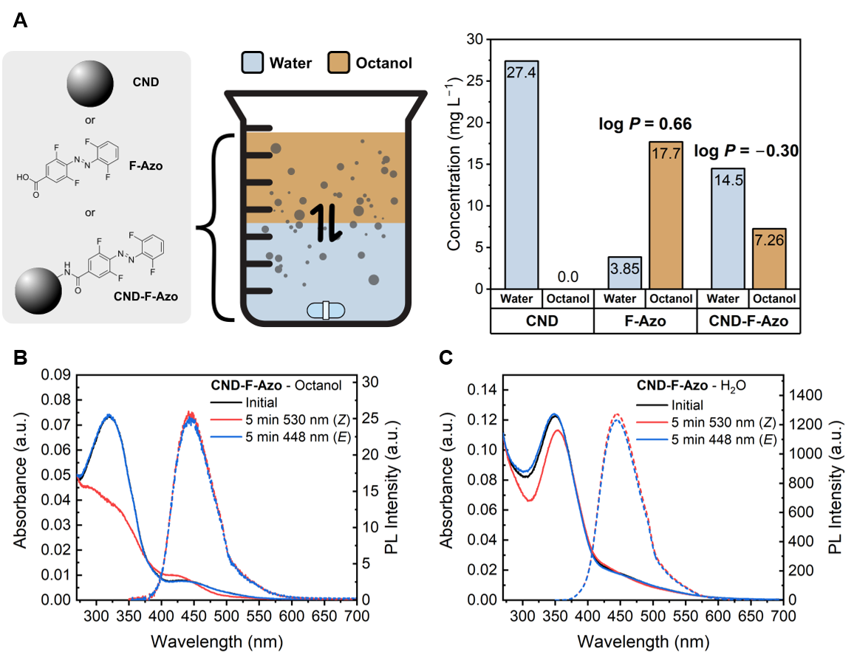
Figure 7. (A) Schematic representation of the biphasic shake-flask test to determine the distribution of CNDs, F-Azo, and the CND-F-Azo hybrid between the octanol (top, orange) and water (bottom, blue) phases, as well as the resulting concentration of CNDs, F-Azo, and CND-F-Azo hybrids in water and octanol after 24 hours of equilibration. Values were obtained by UV-vis absorption measurements along with a calibration row. The calculated partition coefficients (log P) are shown in the panels. Bottom panel: The UV-Vis absorption and PL spectra of the CND-F-Azo hybrid before and after light irradiation (B) in the octanol phase and; (C) in the aqueous phase. The samples were irradiated with 530 nm and 448 nm light for a duration of five minutes, inducing photoisomerization. The alterations in the absorption profile, along with the discrepancies in PL intensity, are indicative of the varying degrees of functionalization in the CND-F-Azo hybrid within each solvent phase.

This hypothesis was further evidenced by the UV-Vis absorption spectra, which exhibited significant spectral differences for the CND-F-Azo hybrid in the aqueous and octanol phase. The absorption maximum is observed at 322 nm in the octanol phase and at 350 nm in the aqueous phase (see Figure 7C-D). These variations are likely due to selective partitioning of more highly functionalized species into the lipophilic (octanol) phase, as the bulk UV-Vis spectrum represents a superposition of signals from particles with different degrees of functionalization. The results of the switching experiments of the respective phase, as well as the PL measurements, confirmed the presence of CND-F-Azo in both phases. However, a significantly greater response to the switching was observed, and a lower PL intensity was measured in the octanol phase (see Figure 7C-D). In addition, our previous study demonstrated that increasing functionalization results in greater PL quenching. The lower PL intensity in the octanol phase thus supports the assumption that more highly functionalized CND-F-Azo species preferentially partition into the lipophilic environment, further emphasizing the feasibility of tailored functionalization to optimize membrane interactions.[54]
A range of strategies can be considered to enhance the degree of functionalization of CNDs. One approach involves the use of nitrogen-rich precursors, such as arginine, or increasing the concentration of EDA during CND synthesis to raise the density of surface amine groups available for covalent coupling.[55] Alternatively, the incorporation of molecular spacers between the CND and the Azo unit may reduce steric hindrance and thereby enhance the coupling efficiency.[54] Additionally, earlier studies have demonstrated that the solubility of Azo derivatives varies depending on the predominance of the cis or trans isomer. Thus, this aspect must be considered in future studies of CND-Azo hybrids with stronger lipid bilayer partitioning, as the dominant isomeric state may affect the outcome of the shake-flask test and subsequent cellular membrane interactions.[74] Furthermore, if CND-Azo hybrids can be sufficiently enriched within lipid bilayers, future studies may use patch-clamp experiments to directly evaluate whether cyclic photoisomerization induces measurable changes in membrane potential and, consequently, bilayer thickness. This would be a powerful way to correlate switching events with membrane responses.[18]
However, a significant challenge remains: the CNDs employed in this study can only be excited at wavelengths from approximately 400 nm and lower, which is close to the boundary of the ultraviolet spectral region. In the context of bioimaging applications, it would be highly desirable to shift the absorption wavelength further into the visible range, thereby enabling more biocompatible excitation conditions.
In a prior study, it was observed that the utilization of arginine or the increment of EDA during CND synthesis resulted in a shift of the absorption towards shorter wavelengths.[58] Consequently, for subsequent efforts directed towards enhanced functionalization degrees and optimized optical properties, it would be beneficial to evaluate alternative synthetic methodologies, precursor systems, or solvent environments.[75] These approaches have the potential to yield CNDs with enhanced surface functionalization and a red-shifted absorption profile, which is more suitable for biological applications. At the same time, such optical properties must be carefully balanced to avoid undesired spectral competition with the Azo photoisomerization process.
Conclusion
In this study, we successfully synthesized a novel CND-Azo hybrid by covalently attaching a tetra-ortho-fluorinated Azo photoswitch to amine-containing CNDs via EDC/NHS-mediated amide coupling. The resulting nanomaterial exhibited the intrinsic photoluminescent properties of the CND while incorporating visible-light-addressable, reversible photoswitching functionality through the Azo moiety. Subsequent structural and spectroscopic analyses confirmed the successful post-synthetic functionalization and preservation of optical features. However, no direct conjugation effects on absorption or emission spectra were observed. The hybrid exhibited favorable switching performance under alternating green (530 nm) and blue (448 nm) light, maintaining isomerization efficiency over multiple cycles without significant fatigue. This result is consistent with the known robustness of ortho-fluorinated Azos and shows that this feature is maintained after covalent coupling to nanomaterials.
Subsequent physicochemical characterization further demonstrated the altered surface properties of the hybrid, including a moderate increase in lipophilicity and a shift in zeta potential, suggesting successful modification of the CND surface. The analysis of partitioning behavior into octanol/water phases and the use of confocal microscopy to examine treated HEK-293 cells revealed the occurrence of efficient cellular uptake and cytosolic internalization at non-toxic concentrations. These results underscore the biocompatibility and suitability of the hybrid for potential applications in light-responsive biointerfaces, although the degree of internalization into the lipid bilayer remained limited due to the relatively low lipophilicity and negative zeta potential. While the current system provides a proof-of-concept for visible-light-actuated, photostable CND hybrids, future work will focus on increasing the degree of surface functionalization to further modulate photophysical behavior and enhance responsiveness.
In summary, this study serves as a foundational contribution to the rational design of photoresponsive carbon nanomaterials, with the objective of achieving targeted emission and switching capabilities. The integration of biocompatibility, visible-light activation, and functional surface chemistry represents a significant advancement in the development of CND-based platforms for optically stimulated sensing, intracellular modulation, and responsive bio-nanomaterial systems.
Experimental
Materials and Methods
Citric acid (CA, ≥ 99.5%), 3-([(ethylimino)methylidene]amino)-N,N-dimethylpropan-1-amine hydrochloride (EDC, ≥ 99%), and ethylenediamine (EDA, ≥ 99.5%) were purchased from Carl-Roth. N-hydroxysuccinimide (NHS, ≥ 99%), Oxone® (100%) were purchased from Sigma-Aldrich. 4-Amino-3,5-difluorobenzoic acid (97%) were purchased from BLDpharm. 2,6-Difluoroaniline (98%) were purchased from Fluorochem. Trifluoroacetic acid (99%) were purchased from Acros Organics. Deuterated dimethyl sulfoxide (DMSO-d6, 99.8%) were purchased from Deutero. Anhydrous N,N-dimethylformamide (DMF, 99.8%, AcroSeal) were purchased from Thermo Scientific. Dimethylsulfoxide (DMSO, 99.5%) were purchased from Gruessing. Solvents for UV-Vis and PL spectroscopy were purchased from Merck (Uvasol® quality). Ultrapure water was obtained with the Milli-Q Direct Water Purification System. Unless otherwise stated, the reagents were used without further purification. The MW-assisted reactions were performed in a Silvia homeline set-up. The purification was performed with Sephadex® G-10 and LH-20 gel filtration media were used for size-exclusion chromatography. NMR-spectra were recorded with a Bruker Avance II 400 MHz, and Bruker Avance III 400 MHz HD. Diffusion measurements were performed using an AVANCE III HD 400 MHz NMR spectrometer equipped with a gradient probe head (Bruker „Diff50”) with a selective 1H insert, providing a magnetic field gradient strength of up to 28 T m−1. The samples were measured at 25 °C. To calibrate the temperature a PT 100 thermocouple inserted in an NMR tube, filled with oil, was used. DOSY spectra were acquired by a stimulated echo sequence, as detailed in SI. UV-Vis measurements were carried out with a SPECORD® 200 PLUS spectrophotometer equipped with two automatic eight-fold cell changers and a Peltier element thermostat system (0.1 °C accuracy) by Analytik Jena. The system was operated with the ASpect UV software by Analytik Jena. Fluorescence measurements were conducted with a Jasco FP-8300 Fluorescence Spectrometer. The sample solutions were measured in QS High Precision Cells made of Quartz Suprasil® with a light path of 10 mm by Hellma Analytics. Experiments were carried out in concentrations of 1-29 mg L−1. Stock solutions (1 mg mL−1) were prepared from freshly purified samples, and then diluted prior to every UV/Vis and PL experiment. The absorption spectra of the F-Azo were obtained using 5 μmol L−1 solutions in DMSO at 25 °C. Irradiation of UV/Vis samples was conducted in an in-house built box using LEDs by Lumitronix or Nichia purchased from leds.de, or by mounted LEDs from Thorlabs. AFM was performed with the AIST-NT SmartSPM 1000 under ambient conditions in AC mode. The zeta potential measurements were conducted with a Malvern Zetasizer Nano-ZS device (Malvern, U.K.) at 20 °C. The system was operated by the Zetasizer software from Malvern Panlytical (Malvern, U.K.). Water contact angle measurements were performed at room temperature using an OCA 20 contact angle system (DataPhysics Instruments, Germany). The instrument is based on a conventional goniometric setup, equipped with automated droplet dispensing, and digital image acquisition. Measurements were conducted using the sessile drop method and analyzed with the SCA 20 software.
CND Synthesis
For the sake of clarity, the details of the already reported and slightly modified method reported by Pham et al.[57] are given here. CA (1.44 g, 7.50 mmol, 1.00 eq) was dissolved in 5 mL Milli-Q water and was stirred until the substrate was completely dissolved. EDA (0.50 mL, 7.5 mmol, 1.0 eq) was added and the mixture was stirred for 20 min. The reaction mixture was heated in a domestic MW oven for 5 min at 400 W (50% power). The obtained brown resin was dispersed in 10 mL Milli-Q water and the brown dispersion was filtered over a 0.2 μm PTFE syringe filter. The filtered dispersion of the CNDs was filled up to a volume of 5 mL and size-exclusion chromatography with Sephadex® LH-20 with Milli-Q water as an eluent was performed. The fractions were combined and the resulting brown dispersion was lyophilized to obtain an orange/brown solid.
Yield: 0.577 g, 40 wt%
1H-NMR of the CND showed broad signals to ensure the presence of CNDs (Figure S20).[76]
4-[(1E)-2-(2,6-Difluorophenyl)diazenyl]-3,5-difluoro-benzoic acid (F-Azo) Synthesis
4-Amino-3,5-difluorobenzoic acid (0.993 g, 5.73 mmol, 1.00 eq) was dissolved in a mixture of 6 mL acetone and 30 mL dichloromethane. To this solution, an aqueous solution of Oxone® (7.00 g, 11.4 mmol, 1.99 eq) in 100 mL deionized water was added. After stirring the reaction mixture for 2 h at rt, the organic phase was extracted and washed three times with water. The solvent of the organic phase was removed under reduced pressure and the obtained orange/brown crude product was used as it in the next step.
The crude product was dissolved in a mixture of 15 mL dry toluene, 15 mL acetic acid, and 5 mL trifluoroacetic acid. To this solution 2,6-difluoroaniline (0.479 g, 3.70 mmol, 0.646 eq) was added and the reaction mixture was stirred for 5 d at rt under inert conditions. The resulting mixture was diluted with ethyl acetate and was washed three times with brine. The organic phase was dried over MgSO4 and the solvent was removed under reduced pressure. The crude product was purified by column chromatography (85 g SiO2, cyclohexane:ethyl acetate 3:1). Fractions containing the target compound were combined, and the solvent was removed under reduced pressure. The resulting solid was recrystallized from a minimal amount of ethyl acetate, affording the product as a red-brown solid.
Yield: 0.278 g, 16%
1H-NMR (400 MHz, CDCl3) δ = 7.80 (d, J = 8.4 Hz, 2H), 7.49 - 7.40 (m, 1H), 7.10 (t, J = 8.7 Hz, 2H) ppm. (Figure S21).
19F-NMR (377 MHz, CDCl3) δ = −119.95, −120.06 ppm. (Figure S22).
Analytical data corresponded to the literature.[23]
Amide Coupling of CNDs with F-Azo
F-Azo (0.124 g, 0.416 mmol, 1.00 eq) was dissolved in 32 mL anhydrous DMF. EDC∙HCl (0.154 g, 0.804 mmol, 1.94 eq) and NHS (0.0979 g, 0.851 mmol, 2.05 eq) were added, and the mixture was stirred for 15 min at rt under inert conditions. CNDs (0.0474 g) were added and the reaction mixture was stirred overnight at rt. The solvent was removed under reduced pressure. The obtained crude was packed on a Sephadex® G-10 gel column with DMSO as eluent. The obtained brown dispersion was lyophilized and an orange/brown solid was obtained.
Yield: 0.0235 g, 50 wt%
1H-NMR of the CND-F-Azo showed broad signals to ensure the presence of CNDs as well as new features, which can be assigned to the coupled F-Azo (Figure S23).
Computational details
The CND and hybrid models used in this study have been validated in our previous work.[54] Briefly, a CND model obtained from molecular dynamics simulations was obtained where polymeric CD were formed starting from citric acid and ethylenediamine, leading also to the formation of IPCA fluorophores. From the MD simulations, the CND was modified to incorporate the F-Azo moiety, and the obtained structure optimized at the GFN2-xTB level of theory (as implemented in the xtb ver. 6.4.1 software).[77,78] The analytical linearized Poisson-Boltzmann (ALPB) model was utilized to incorporate solvent effects due to DMSO. The optical properties were calculated with the ONIOM (Our own N-layered Integrated molecular Orbital and molecular Mechanics[79,80]) model, considering time-dependent density-functional-theory (TDDFT) under the linear response formalism. Here, the system is divided into different layers which are treated either at the TD-DFT level of theory (high layer) or with a semi empirical PM6 formalism[81] (medium layer). The low layer consists of polarizable continuum model (PCM)[82–84] to account for the effect of DMSO in the electronic transitions. In order to fully describe the optical transitions, 30 singlet-to-singlet transitions were considered for the TDDFT layer. The long-range hybrid functional ωB97X-D[85–88] together with the Pople’s 6-31G(d) basis set[89] were considered for the calculations, within the Gaussian16 software[90]. Their validity was assessed in our previous work.[54]
Cell cultures and viability assay
HEK-293 cells were grown in Dulbecco’s modified Eagles’ medium (D-MEM, Sigma Aldrich) with 10% fetal bovine serum (FBS, Sigma Aldrich), supplemented with 2 mM glutamine (Sigma Aldrich), 100 U ml−1 streptomycin (Sigma Aldrich). Cells were kept in T-75 culture flasks and maintained in incubator at 37 °C in a humidified atmosphere with 5% CO2. After reaching 80-90% of confluence, cells were detached by incubation with 0.5% trypsin-0.2% EDTA (Sigma Aldrich) for five min and then plated for experiments. To promote cell adhesion, a layer of 1 mg ml−1 fibronectin (from bovine plasma, Sigma Aldrich) in phosphate buffer saline (PBS, Sigma Aldrich) was deposited on the surface of the glass coverslips and incubated for 30 min. After rinsing fibronectin with PBS, cells were plated on round glass samples at a density of about 8x103 cells cm−2, cultured into well plates and eventually treated with CND-F-Azo. For viability assay, HEK cells were seeded on round glass samples in 12 well plates at 3x104 cells/well density. CND-F-Azo dispersed in MilliQ water were added to the cell culture medium at different concentrations (5 and 100 μg mL−1). Cell proliferation was evaluated at DIV1, 3 and 6 after plating, in 3 replicates. To this aim, AlamarBlue cell reagent was added to the cell culture medium at a volume concentration of 1:10. The samples were incubated for 3 h at 37 °C, 5% CO2 in the dark. Then, three aliquots of culture media were placed in black 96-well microplates and their fluorescence was acquired using a Tecan Spark microplate reader (excitation wavelength: 530 nm, emission acquired at 590 nm). After each time point, the growth medium was replaced with fresh medium. For confocal imaging, HEK cells were plated on glass slides in 12 well plates at 4x103 cells/well density and were incubated with CDs at 5 μg mL−1concentration. Cell membrane was stained by Cell Mask Red (Thermo Fisher). Z-stacks were acquired with an upright microscope (Olympus BW63), equipped with a 60X water immersion objective, a spinning disk confocal module (X-Light V2 spinning disk module from Crest Optics) and a sCMOS Camera (Prime BSI, Teledyne Photometrics; Tucson, Arizona, USA). The experiments were carried out at room temperature. Images were processed with ImageJ.
Supporting Information
The authors have cited additional references within the Supporting Information.[91–97]
Acknowledgements
We thank the financial support of the DFG and of the National Science Center, Poland through the joint project „Low-Dimensional Nano-Architectures for Light Emission and Light-to-Electricity Conversion” (LOW-LIGHT, grant no. UMO/2020/39/I/ST4/01446). J.P.M. acknowledges the funding of a post-doctoral contract by the LOW-LIGHT grant. T.G. acknowledges the European Research Council for the project JANUS BI (grant agreement no. [101041229]). This research was carried out with the support of the Interdisciplinary Center for Mathematical and Computational Modeling at the University of Warsaw (ICM UW) under grants no. G83-28 and GB80-24. M.L. acknowledges that this article has been produced with the financial support of the European Union under the REFRESH – Research Excellence For Region Sustainability and High-tech Industries project number CZ.10.03.01/00/22_003/0000048 via the Operational Programme Just Transition. This work was supported by the Ministry of Education, Youth and Sports of the Czech Republic through the e-INFRA CZ (ID:90254). J.W. gratefully acknowledges the European Union for funding the TCSPC laser system through the European Regional Development Fund as part of the Union's response to the COVID-19 pandemic - REACT-EU, IWB-EFRE-Programm Hessen, \#20008794. G.M.P. receives funding from the European Union (ERC, EOS, 101115925).
The authors thank Heike Hausmann (JLU, Giessen) for performing the NMR 1H and 19F spectra and Pascal Schweitzer (JLU, Giessen) for the support with the AFM measurements.
Keywords: Photoswitching • Isomerization • Bioimaging • Quenching • Fluorescence
References
[1] A. A. Beharry, G. A. Woolley, Azobenzene photoswitches for biomolecules Chem. Soc. Rev. 2011, 40, 4422–4437.
[2] R. S. Stoll, S. Hecht, Artificial Light-Gated Catalyst Systems Angew. Chem. Int. Ed. 2010, 49, 5054–5075.
[3] B. L. Feringa, B. R. Wesley, Molecular Switches, Wiley-VCH Verlag GmbH & Co. KGaA, Weinheim, 2011.
[4] T. Nägele, R. Hoche, W. Zinth, J. Wachtveitl, Femtosecond photoisomerization of cis-azobenzene Chem. Phys. Lett. 1997, 272, 489–495.
[5] K. Nakatani, J. Piard, P. Yu, R. Métivier in Photochromic Mater. Prep. Prop. Appl. (Eds.: H. Tian, J. Zhang), Wiley-VCH Verlag GmbH & Co. KGaA, Weinheim, Germany, 2016, pp. 1–45.
[6] M. L. DiFrancesco, F. Lodola, E. Colombo, L. Maragliano, M. Bramini, G. M. Paternò, P. Baldelli, M. D. Serra, L. Lunelli, M. Marchioretto, G. Grasselli, S. Cimò, L. Colella, D. Fazzi, F. Ortica, V. Vurro, C. G. Eleftheriou, D. Shmal, J. F. Maya-Vetencourt, C. Bertarelli, G. Lanzani, F. Benfenati, Neuronal firing modulation by a membrane-targeted photoswitch Nat. Nanotechnol. 2020, 15, 296–306.
[7] C. Florindi, V. Vurro, P. Moretti, C. Bertarelli, A. Zaza, G. Lanzani, F. Lodola, Role of stretch-activated channels in light-generated action potentials mediated by an intramembrane molecular photoswitch J. Transl. Med. 2024, 22, 1–12.
[8] R. A. Larson, M. R. Berenbaum, Environmental phototoxicity Environ. Sci. Technol. 1988, 22, 354–360.
[9] W. F. Cheong, S. A. Prahl, A. J. Welch, A review of the optical properties of biological tissues IEEE J. Quantum Electron. 1990, 26, 2166–2185.
[10] G. Banerjee, N. Gupta, A. Kapoor, G. Raman, UV induced bystander signaling leading to apoptosis Cancer Lett. 2005, 223, 275–284.
[11] P. Kamarajan, C. C.-K. Chao, UV-Induced Apoptosis in Resistant HeLa Cells Biosci. Rep. 2000, 20, 99–108.
[12] R. P. Sinha, D.-P. Häder, UV-induced DNA damage and repair: a review Photochem. Photobiol. Sci. 2002, 1, 225–236.
[13] A. A. Beharry, O. Sadovski, G. A. Woolley, Azobenzene Photoswitching without Ultraviolet Light J. Am. Chem. Soc. 2011, 133, 19684–19687.
[14] H. Mustroph, Studies on the UV-vis absorption spectra of azo dyes: Part 25. analysis of the fine structure of the π1 →π1* band of 4’-donor-substituted 4-N,N-diethylaminoazobenzenes Dyes Pigments 1991, 15, 129–137.
[15] H. Mustroph, Studies on UV/Vis absorption spectra of azo dyes.: Part 26. electronic absorption spectra of 4,4’-diaminoazobenzenes Dyes Pigments 1991, 16, 223–230.
[16] M. Gao, D. Kwaria, Y. Norikane, Y. Yue, Visible-light-switchable azobenzenes: Molecular design, supramolecular systems, and applications Nat. Sci. 2023, 3, e220020.
[17] R. Siewertsen, H. Neumann, B. Buchheim-Stehn, R. Herges, C. Näther, F. Renth, F. Temps, Highly Efficient Reversible Z−E Photoisomerization of a Bridged Azobenzene with Visible Light through Resolved S1 (nπ*) Absorption Bands J. Am. Chem. Soc. 2009, 131, 15594–15595.
[18] T. C. de Souza-Guerreiro, G. Bondelli, I. Grobas, S. Donini, V. Sesti, C. Bertarelli, G. Lanzani, M. Asally, G. M. Paternò, Membrane Targeted Azobenzene Drives Optical Modulation of Bacterial Membrane Potential Adv. Sci. 2023, 10, 2205007.
[19] V. Sesti, A. Magni, M. Moschetta, C. Florindi, M. E. Pfeffer, M. L. DiFrancesco, M. Guizzardi, G. Folpini, L. Sala, A. G. Ritacca, B. Campanelli, P. Moretti, G. M. Paternò, L. Maragliano, M. Tommasini, F. Lodola, E. Colombo, F. Benfenati, C. Bertarelli, G. Lanzani, Membrane-targeted push-pull azobenzenes for the optical modulation of membrane potential Light Sci. Appl. 2025, 14, 8.
[20] M. Dong, A. Babalhavaeji, S. Samanta, A. A. Beharry, G. A. Woolley, Red-Shifting Azobenzene Photoswitches for in Vivo Use Acc. Chem. Res. 2015, 48, 2662–2670.
[21] H. A. Wegner, Azobenzenes in a New Light—Switching In Vivo Angew. Chem. Int. Ed. 2012, 51, 4787–4788.
[22] D. Bléger, J. Schwarz, A. M. Brouwer, S. Hecht, o-Fluoroazobenzenes as Readily Synthesized Photoswitches Offering Nearly Quantitative Two-Way Isomerization with Visible Light J. Am. Chem. Soc. 2012, 134, 20597–20600.
[23] C. Knie, M. Utecht, F. Zhao, H. Kulla, S. Kovalenko, A. M. Brouwer, P. Saalfrank, S. Hecht, D. Bléger, ortho-Fluoroazobenzenes: Visible Light Switches with Very Long-Lived Z Isomers Chem. – Eur. J. 2014, 20, 16492–16501.
[24] K. Kuntze, J. Viljakka, E. Titov, Z. Ahmed, E. Kalenius, P. Saalfrank, A. Priimagi, Towards low-energy-light-driven bistable photoswitches: ortho-fluoroaminoazobenzenes Photochem. Photobiol. Sci. 2022, 21, 159–173.
[25] E. Cataldi, M. Raschig, M. Gutmann, P. T. Geppert, M. Ruopp, M. Schock, H. Gerwe, R. Bertermann, L. Meinel, M. Finze, A. Nowak-Król, M. Decker, T. Lühmann, Amber Light Control of Peptide Secondary Structure by a Perfluoroaromatic Azobenzene Photoswitch ChemBioChem 2023, 24, e202200570.
[26] A.-L. Leistner, S. Kirchner, J. Karcher, T. Bantle, M. L. Schulte, P. Gödtel, C. Fengler, Z. L. Pianowski, Fluorinated Azobenzenes Switchable with Red Light Chem. – Eur. J. 2021, 27, 8094–8099.
[27] M. M. Most, L. B. Boll, P. Gödtel, Z. L. Pianowski, B. Lewandowski, Glucose-derived receptors for photo-controlled binding of amino acid esters in water Commun. Chem. 2025, 8, 50.
[28] Y.-P. Sun, B. Zhou, Y. Lin, W. Wang, K. A. S. Fernando, P. Pathak, M. J. Meziani, B. A. Harruff, X. Wang, H. Wang, P. G. Luo, H. Yang, M. E. Kose, B. Chen, L. M. Veca, S.-Y. Xie, Quantum-Sized Carbon Dots for Bright and Colorful Photoluminescence J. Am. Chem. Soc. 2006, 128, 7756–7757.
[29] A. Cayuela, M. L. Soriano, C. Carrillo-Carrión, M. Valcárcel, Semiconductor and carbon-based fluorescent nanodots: the need for consistency Chem. Commun. 2016, 52, 1311–1326.
[30] C. Xia, S. Zhu, T. Feng, M. Yang, B. Yang, Evolution and Synthesis of Carbon Dots: From Carbon Dots to Carbonized Polymer Dots Adv. Sci. 2019, 6, 1901316.
[31] G. A. M. Hutton, B. C. M. Martindale, E. Reisner, Carbon dots as photosensitisers for solar-driven catalysis Chem. Soc. Rev. 2017, 46, 6111–6123.
[32] L. Wang, S.-J. Zhu, H.-Y. Wang, S.-N. Qu, Y.-L. Zhang, J.-H. Zhang, Q.-D. Chen, H.-L. Xu, W. Han, B. Yang, H.-B. Sun, Common Origin of Green Luminescence in Carbon Nanodots and Graphene Quantum Dots ACS Nano 2014, 8, 2541–2547.
[33] S. Zhu, Y. Song, J. Wang, H. Wan, Y. Zhang, Y. Ning, B. Yang, Photoluminescence mechanism in graphene quantum dots: Quantum confinement effect and surface/edge state Nano Today 2017, 13, 10–14.
[34] X. Huo, H. Shen, R. Liu, J. Shao, Solvent Effects on Fluorescence Properties of Carbon Dots: Implications for Multicolor Imaging ACS Omega 2021, 6, 26499–26508.
[35] M. M. F. Chang, I. R. Ginjom, M. Ngu-Schwemlein, S. M. Ng, Synthesis of yellow fluorescent carbon dots and their application to the determination of chromium(III) with selectivity improved by pH tuning Microchim. Acta 2016, 183, 1899–1907.
[36] B. Yao, H. Huang, Y. Liu, Z. Kang, Carbon Dots: A Small Conundrum Trends Chem. 2019, 1, 235–246.
[37] Y. Han, H. Huang, H. Zhang, Y. Liu, X. Han, R. Liu, H. Li, Z. Kang, Carbon Quantum Dots with Photoenhanced Hydrogen-Bond Catalytic Activity in Aldol Condensations ACS Catal. 2014, 4, 781–787.
[38] D. Yu. Osadchii, A. I. Olivos-Suarez, A. V. Bavykina, J. Gascon, Revisiting Nitrogen Species in Covalent Triazine Frameworks Langmuir 2017, 33, 14278–14285.
[39] S. Wu, R. Zhou, H. Chen, J. Zhang, P. Wu, Highly efficient oxygen photosensitization of carbon dots: the role of nitrogen doping Nanoscale 2020, 12, 5543–5553.
[40] M. Shamsipur, A. Barati, A. A. Taherpour, M. Jamshidi, Resolving the Multiple Emission Centers in Carbon Dots: From Fluorophore Molecular States to Aromatic Domain States and Carbon-Core States J. Phys. Chem. Lett. 2018, 9, 4189–4198.
[41] F. Arcudi, V. Strauss, L. Đorđević, A. Cadranel, D. M. Guldi, M. Prato, Porphyrin Antennas on Carbon Nanodots: Excited State Energy and Electron Transduction Angew. Chem. 2017, 129, 12265–12269.
[42] L. Ðorđević, F. Arcudi, M. Cacioppo, M. Prato, A multifunctional chemical toolbox to engineer carbon dots for biomedical and energy applications Nat. Nanotechnol. 2022, 17, 112–130.
[43] R. Liu, L. Zhang, J. Zhao, Z. Luo, Y. Huang, S. Zhao, Aptamer and IR820 Dual-Functionalized Carbon Dots for Targeted Cancer Therapy against Hypoxic Tumors Based on an 808 nm Laser-Triggered Three-Pathway Strategy Adv. Ther. 2018, 1, 1800041.
[44] Y. J. Chung, C. H. Lee, J. Lim, J. Jang, H. Kang, C. B. Park, Photomodulating Carbon Dots for Spatiotemporal Suppression of Alzheimer’s β-Amyloid Aggregation ACS Nano 2020, 14, 16973–16983.
[45] S. Sun, J. Chen, K. Jiang, Z. Tang, Y. Wang, Z. Li, C. Liu, A. Wu, H. Lin, Ce6-Modified Carbon Dots for Multimodal-Imaging-Guided and Single-NIR-Laser-Triggered Photothermal/Photodynamic Synergistic Cancer Therapy by Reduced Irradiation Power ACS Appl. Mater. Interfaces 2019, 11, 5791–5803.
[46] S. Anwar, H. Ding, M. Xu, X. Hu, Z. Li, J. Wang, L. Liu, L. Jiang, D. Wang, C. Dong, M. Yan, Q. Wang, H. Bi, Recent Advances in Synthesis, Optical Properties, and Biomedical Applications of Carbon Dots ACS Appl. Bio Mater. 2019, 2, 2317–2338.
[47] H. Cai, J. Ma, X. Xu, H. Chu, D. Zhang, J. Li, Sulfonated glycosaminoglycan bioinspired carbon dots for effective cellular labelling and promotion of the differentiation of mesenchymal stem cells J. Mater. Chem. B 2020, 8, 5655–5666.
[48] A. B. Bourlinos, A. Bakandritsos, A. Kouloumpis, D. Gournis, M. Krysmann, E. P. Giannelis, K. Polakova, K. Safarova, K. Hola, R. Zboril, Gd(III)-doped carbon dots as a dual fluorescent-MRI probe J. Mater. Chem. 2012, 22, 23327–23330.
[49] B. Zhi, Y. Cui, S. Wang, B. P. Frank, D. N. Williams, R. P. Brown, E. S. Melby, R. J. Hamers, Z. Rosenzweig, D. H. Fairbrother, G. Orr, C. L. Haynes, Malic Acid Carbon Dots: From Super-resolution Live-Cell Imaging to Highly Efficient Separation ACS Nano 2018, 12, 5741–5752.
[50] S.-T. Yang, L. Cao, P. G. Luo, F. Lu, X. Wang, H. Wang, M. J. Meziani, Y. Liu, G. Qi, Y.-P. Sun, Carbon Dots for Optical Imaging in Vivo J. Am. Chem. Soc. 2009, 131, 11308–11309.
[51] Y. Zhang, M. Wu, M. Wu, J. Zhu, X. Zhang, Multifunctional Carbon-Based Nanomaterials: Applications in Biomolecular Imaging and Therapy ACS Omega 2018, 3, 9126–9145.
[52] P. Lagonegro, C. Marzuoli, G. Tullii, F. Rossi, C. Bellacanzone, E. Mancinelli, F. Turco, B. M. Squeo, M. Pasini, M. R. Antognazza, Nitrogen doped carbon dots for in vitro intracellular redox modulation via optical stimulation J. Mater. Chem. B 2025, 13, 2029–2041.
[53] B. Liao, P. Long, B. He, S. Yi, B. Ou, S. Shen, J. Chen, Reversible fluorescence modulation of spiropyran-functionalized carbon nanoparticles J. Mater. Chem. C 2013, 1, 3716.
[54] P. P. Debes, D. Schatz, Y. Aydogan-Sun, J. P. Martínez, M. Langer, J. Hessling, J. Gallego, E. Menna, B. M. Smarsly, M. Schönhoff, S. Osella, J. Wachtveitl, H. A. Wegner, T. Gatti, Covalent carbon nanodot-azobenzene hybrid photoswitches: the impact of meta/para connectivity and sp3 spacer on photophysical properties J. Mater. Chem. C 2025, 13, 11879–11889.
[55] G. Filippini, F. Amato, C. Rosso, G. Ragazzon, A. Vega-Peñaloza, X. Companyó, L. Dell’Amico, M. Bonchio, M. Prato, Mapping the Surface Groups of Amine-Rich Carbon Dots Enables Covalent Catalysis in Aqueous Media Chem 2020, 6, 3022–3037.
[56] Y. Sun, F. Kunc, V. Balhara, B. Coleman, O. Kodra, M. Raza, M. Chen, A. Brinkmann, G. P. Lopinski, L. J. Johnston, Quantification of amine functional groups on silica nanoparticles: A multi-method approach Nanoscale Adv. 2019, 1, 1598–1607.
[57] S. N. Pham, J. E. Kuether, M. J. Gallagher, R. T. Hernandez, D. N. Williams, B. Zhi, A. C. Mensch, R. J. Hamers, Z. Rosenzweig, H. Fairbrother, M. O. P. Krause, Z. V. Feng, C. L. Haynes, Carbon Dots: A Modular Activity to Teach Fluorescence and Nanotechnology at Multiple Levels J. Chem. Educ. 2017, 94, 1143–1149.
[58] P. P. Debes, M. Langer, M. Pagel, E. Menna, B. Smarsly, S. Osella, J. Gallego, T. Gatti, Functional Groups Accessibility and the Origin of Photoluminescence in N/O-containing Bottom-up Carbon Nanodots ChemNanoMat 2024, 10, e202300471.
[59] I. J. Gomez, B. Arnaiz, M. Cacioppo, F. Arcudi, M. Prato, Nitrogen-doped carbon nanodots for bioimaging and delivery of paclitaxel J. Mater. Chem. B 2018, 6, 5540–5548.
[60] W. S. Price, NMR Studies of Translational Motion: Principles and Applications, Cambridge University Press, Cambridge, 2009.
[61] A. Lenoch, M. Schumacher, A. H. Gröschel, C. Cramer, M. Schönhoff, Diffusion NMR of Poly(acrylic acid) Solutions: Molar Mass Scaling and pH-Induced Conformational Variation Macromol. Chem. Phys. 2023, 224, 2300286.
[62] C. Slavov, C. Yang, L. Schweighauser, C. Boumrifak, A. Dreuw, H. A. Wegner, J. Wachtveitl, Connectivity matters – ultrafast isomerization dynamics of bisazobenzene photoswitches Phys. Chem. Chem. Phys. 2016, 18, 14795–14804.
[63] F. Rigodanza, M. Burian, F. Arcudi, L. Đorđević, H. Amenitsch, M. Prato, Snapshots into carbon dots formation through a combined spectroscopic approach Nat. Commun. 2021, 12, 2640.
[64] F. Kunc, V. Balhara, Y. Sun, M. Daroszewska, Z. J. Jakubek, M. Hill, A. Brinkmann, L. J. Johnston, Quantification of surface functional groups on silica nanoparticles: Comparison of thermogravimetric analysis and quantitative NMR Analyst 2019, 144, 5589–5599.
[65] G. S. Hartley, The Cis-form of Azobenzene Nature 1937, 140, 281–281.
[66] S. Mazumdar, D. Chitkara, A. Mittal, Exploration and insights into the cellular internalization and intracellular fate of amphiphilic polymeric nanocarriers Acta Pharm. Sin. B 2021, 11, 903–924.
[67] M. Pekker, M. N. Schneider, Interaction between Electrolyte Ions and the Surface of a Cell Lipid Membrane J. Phys. Chem. Biophys. 2015, 5, 1–7.
[68] E. Canepa, A. Relini, D. Bochicchio, E. Lavagna, A. Mescola, Amphiphilic Gold Nanoparticles: A Biomimetic Tool to Gain Mechanistic Insights into Peptide-Lipid Interactions Membranes 2022, 12, 673.
[69] C. He, Y. Hu, L. Yin, C. Tang, C. Yin, Effects of particle size and surface charge on cellular uptake and biodistribution of polymeric nanoparticles Biomaterials 2010, 31, 3657–3666.
[70] P. J. Kadu, Kushare ,Sachin S., Thacker ,Dhaval D., S. G. and Gattani, Enhancement of oral bioavailability of atorvastatin calcium by self-emulsifying drug delivery systems (SEDDS) Pharm. Dev. Technol. 2011, 16, 65–74.
[71] A. Radchanka, V. Hrybouskaya, A. Antanovich, M. Artemyev, Poly(maleic anhydride) Shell Modified with Negatively and Positively Charged Groups to Control Zeta Potential and Hydrodynamic Size of Encapsulated Quantum Dots at Variable pH ChemNanoMat 2022, 8, e202100538.
[72] J. E. A. Comer in Drug Bioavailab., John Wiley & Sons, Ltd, 2003, pp. 21–45.
[73] L. Bao, W. Luo, Q. Li, Y. Zhang, Z. Zhang, X. Li, L. Wang, J. Zhang, K. Huang, X. Yu, L. Xu, Chiral carbon dots based on ternary carbon sources: A multifunctional therapeutic agent for Cu2+-induced Alzheimer’s disease Carbon 2024, 228, 119333.
[74] M. Ishikawa, T. Ohzono, T. Yamaguchi, Y. Norikane, Photo-enhanced Aqueous Solubilization of an Azo-compound Sci. Rep. 2017, 7, 6909.
[75] H. Zhang, G. Wang, Z. Zhang, J. H. Lei, T.-M. Liu, G. Xing, C.-X. Deng, Z. Tang, S. Qu, One step synthesis of efficient red emissive carbon dots and their bovine serum albumin composites with enhanced multi-photon fluorescence for in vivo bioimaging Light Sci. Appl. 2022, 11, 113.
[76] B. Bartolomei, A. Bogo, F. Amato, G. Ragazzon, M. Prato, Nuclear Magnetic Resonance Reveals Molecular Species in Carbon Nanodot Samples Disclosing Flaws Angew. Chem. Int. Ed. 2022, 61, e202200038.
[77] C. Bannwarth, S. Ehlert, S. Grimme, GFN2-xTB—An Accurate and Broadly Parametrized Self-Consistent Tight-Binding Quantum Chemical Method with Multipole Electrostatics and Density-Dependent Dispersion Contributions J. Chem. Theory Comput. 2019, 15, 1652–1671.
[78] C. Bannwarth, E. Caldeweyher, S. Ehlert, A. Hansen, P. Pracht, J. Seibert, S. Spicher, S. Grimme, Extended tight-binding quantum chemistry methods WIREs Comput. Mol. Sci. 2021, 11, e1493.
[79] F. Maseras, K. Morokuma, IMOMM: A new integrated ab initio + molecular mechanics geometry optimization scheme of equilibrium structures and transition states J. Comput. Chem. 1995, 16, 1170–1179.
[80] S. Dapprich, I. Komáromi, K. S. Byun, K. Morokuma, M. J. Frisch, A new ONIOM implementation in Gaussian98. Part I. The calculation of energies, gradients, vibrational frequencies and electric field derivatives1 J. Mol. Struct. THEOCHEM 1999, 461–462, 1–21.
[81] J. J. P. Stewart, Optimization of parameters for semiempirical methods V: modification of NDDO approximations and application to 70 elements J. Mol. Model. 2007, 13, 1173–1213.
[82] M. Cossi, V. Barone, B. Mennucci, J. Tomasi, Ab initio study of ionic solutions by a polarizable continuum dielectric model Chem. Phys. Lett. 1998, 286, 253–260.
[83] J. Tomasi, M. Persico, Molecular Interactions in Solution: An Overview of Methods Based on Continuous Distributions of the Solvent Chem. Rev. 1994, 94, 2027–2094.
[84] J. Tomasi, B. Mennucci, R. Cammi, Quantum Mechanical Continuum Solvation Models Chem. Rev. 2005, 105, 2999–3094.
[85] Q. Wu, W. Yang, Empirical correction to density functional theory for van der Waals interactions J. Chem. Phys. 2002, 116, 515–524.
[86] A. D. Becke, Density-functional thermochemistry. V. Systematic optimization of exchange-correlation functionals J. Chem. Phys. 1997, 107, 8554–8560.
[87] S. Grimme, Semiempirical GGA-type density functional constructed with a long-range dispersion correction J. Comput. Chem. 2006, 27, 1787–1799.
[88] J. D. Chai, M. Head-Gordon, Long-range corrected hybrid density functionals with damped atom–atom dispersion corrections Phys. Chem. Chem. Phys. 2008, 10, 6615–6620.
[89] V. A. Rassolov, J. A. Pople, M. A. Ratner, T. L. Windus, 6-31G* basis set for atoms K through Zn J. Chem. Phys. 1998, 109, 1223–1229.
[90] M. J. Frisch, G. W. Trucks, H. B. Schlegel, G. E. Scuseria, M. A. Robb, J. R. Cheeseman, G. Scalmani, V. Barone, G. A. Petersson, H. Nakatsuji, X. Li, M. Caricato, A. V. Marenich, J. Bloino, B. G. Janesko, R. Gomperts, B. Mennucci, H. P. Hratchian, J. V. Ortiz, A. F. Izmaylov, J. L. Sonnenberg, D. Williams-Young, F. Ding, F. Lipparini, F. Egidi, J. Goings, B. Peng, A. Petrone, T. Henderson, D. Ranasinghe, V. G. Zakrzewski, J. Gao, N. Rega, G. Zheng, W. Liang, M. Hada, M. Ehara, K. Toyota, R. Fukuda, J. Hasegawa, M. Ishida, T. Nakajima, Y. Honda, O. Kitao, H. Nakai, T. Vreven, K. Throssell, J. A. Montgomery Jr., J. E. Peralta, F. Ogliaro, M. J. Bearpark, J. J. Heyd, E. N. Brothers, K. N. Kudin, V. N. Staroverov, T. A. Keith, R. Kobayashi, J. Normand, K. Raghavachari, A. P. Rendell, J. C. Burant, S. S. Iyengar, J. Tomasi, M. Cossi, J. M. Millam, M. Klene, C. Adamo, R. Cammi, J. W. Ochterski, R. L. Martin, K. Morokuma, O. Farkas, J. B. Foresman, D. J. Fox, Gaussian16, Revision C.01, Gaussian, Inc., Wallingford CT, 2019.
[91] A. Sacco, E. Matteoli, Isotopic substitution effects on the volumetric and viscosimetric properties of water-dimethylsulfoxide mixtures at 25°C J. Solut. Chem. 1997, 26, 527–535.
[92] D. Nečas, P. Klapetek, Gwyddion: an open-source software for SPM data analysis, Versita, Co-Published With Springer-Verlag GmbH, 2012.
[93] M. Levitus, Tutorial: measurement of fluorescence spectra and determination of relative fluorescence quantum yields of transparent samples Methods Appl. Fluoresc. 2020, 8, 033001.
[94] R. Luther, A. Nikolopulos, Über die Beziehungen zwischen den Absorptionsspektren und der Konstitution der komplexen Kobaltamminsalze Z. Für Phys. Chem. 1913, 82U, 361–384.
[95] M. Paloncýová, M. Šrejber, P. Čechová, P. Kührová, F. Zaoral, M. Otyepka, Atomistic Insights into Organization of RNA-Loaded Lipid Nanoparticles J. Phys. Chem. B 2023, 127, 1158–1166.
[96] P. Nagy, FRET, can be found under https://peternagyweb.hu/FRET.html(accessed 10 March 2025), 2025.
[97] E. Voutsas in Thermodyn. Solubility Environ. Issues (Ed.: T.M. Letcher), Elsevier, Amsterdam, 2007, pp. 205–227.

Entry for the Table of Contents

Tetra-ortho-fluoroazobenzene hybrids bound to carbon nanodots (CNDs) were prepared by covalent amide coupling. These show reversible switching between trans and cis using visible light (448 nm/530 nm), while retaining emission. The hybrids are non-toxic to cells and enable optical stimulation and offering potential for advanced light-controlled bioapplications.

