2025-04-XXXX

A zero-emissions braking system: experimental setup, system characterization and model validation
Author, co-author (Do NOT enter this information. It will be pulled from participant tab in MyTechZone)
Affiliation (Do NOT enter this information. It will be pulled from participant tab in MyTechZone)

Abstract
Following the current need of the automotive sector on reducing secondary emissions coming from non-exhaust sources, this paper presents an innovative zero-emissions magneto-rheological braking system, specifically designed to reach future brake emission targets while maintaining safety brake performance. In particular, the article focusses on the experimental setup design to evaluate a full-sized brake prototype under real load conditions and it presents the preliminary results obtained from the experimental campaign. The zero-emission braking prototype has been developed for reaching performance compatible with the automotive application, specifically a segment-A vehicle, being able to generate enough braking torque as to perform an emergency brake maneuver without any other traditional braking system. A central aspect to confirm the system’s performance is the development of a test bench engineered for assessing the magneto-rheological braking technology. Detailed insights into the comprehensive strategy underpinning the design of the test bench are provided, emphasizing its ability to faithfully replicate diverse driving scenarios and evaluate multiple braking performances. Following initial virtual validation, the first brake prototype, featuring an electric in-wheel motor with an integrated innovative braking system, was experimentally tested on a dedicated bench to verify peak torque performance and system reliability. The paper thus presents the results obtained by the first tests, considering the maximum braking capability of the system, its behavior under multiple rolling conditions and under different braking commands applied, to develop a braking solution able to maintain similar braking performance as traditional disk-brakes, but, at the same time, respecting the stringent environmental braking regulations, and promoting sustainable and efficient solutions aligned with environmental goals.
Introduction
The automotive industry is going through a real drastic change aimed at achieving the ambitious goal of developing zero-emission vehicles. In recent years, the market has veered somewhat precipitously toward electric or alternative-fuel powertrains. The development of these systems is certainly necessary for the automotive future; however, it does not enable the achievement of the above goal, as it does not solve the important issue related to so-called secondary emissions, i.e., emissions from the consumption of vehicle braking systems and tires [1][2][3]. The new Euro 7 Standard [4] is the first legislation to take this into consideration and imposes limits on these kinds of emissions that automakers will be forced to comply with. Consider this constrains an Innovative Zero-Emissions Braking System have been developed [5]. The solution proposed combines an MRF based braking system with an EM Regenerative Braking capability. Since the innovative braking system is coupled with an in-wheel electric motor, it is more appropriate to call the whole system an innovative Zero-Emissions Driving System (ZEDS). MR braking seems to be the more suitable in terms of torque capabilities and geometrical limits for a vehicle and for this reason an innovative prototype has been developed and, after a design phase, experimentally tested.
MR brakes use the innovative technology of the MR fluid. Some examples of this technology have been showed by Sohn [6] and how the torque needed to stop the vehicle could be reached adapting the internal geometry. Other studies adapted the geometry of classic disc brakes to take advantage of the physical properties of the fluid [7] or by devising new geometries deemed more efficient [8][9][10].
The objective of this paper is to briefly present the entire project phase that preceded the realization of the ZEDS prototype, a summary of the design of its testbed, describe the testing phase through which the experimental data subsequently processed with the purpose of characterizing the ZEDS system were derived.
The first Zero-Emissions Braking System
The proposed technological solution regards a zero-emission braking system, capable of developing brake torque without releasing harmful dust into the environment. The braking system under consideration has a physical structure such that it accommodates a MRF in a cavity developed between a rotating body, the rotor, integral to the wheel of the vehicle to be braked, and a fixed body, the stator. The MRF has the property of varying its viscosity as a function of the magnetic field passing through it. By developing a magnetic field in the cavity where the fluid is, it increases its viscosity and develops more friction with the walls of the rotor, generating braking torque.
The innovative braking system consists of an integration of the MRB with an in-wheel electric motor, shown in Figure 1. In particular the system is composed of coils locked into a stator, a rotor and sealings capable of keeping the MRF into the specific gap, and the numerated parts are:
- Electric Motor Rotor
- Electric Motor Stator
- MR Brake Stator
- EM Rotor protuberance
- Coils.
The MRF is set between the Rotor protuberance (4) and the MR stator (3) [11].
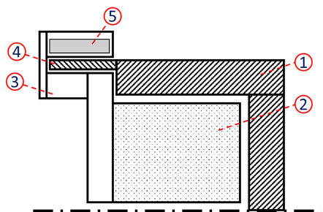
Figure 1. Schematic layout of ZEDS solution [11]
The system is structured by an in-wheel electric motor that also performs the vehicle traction. The ZEDS system works is as follows:
- during the drive phase, torque is provided by the electric motor, the coils are not only energized, but the MRF has the characteristics of an oil.
- during the braking phase, depending on the torque request made via the pedal by the driver, a signal develops that causes electrical power to be sent from the battery to the coils. These, when current flows through them, develop a magnetic field that passes through the MRF.
The fluid, due to its magnetorheological properties, transforms into a semi-solid state and generates a braking torque due to its contact with the rotor.
The new Zero-Emissions Braking System
The design of ZEDS went through several steps before reaching the production of an initial prototype. Because of the complexity of the behavior of the MR fluid, performing different simulations, combining multi-physical software capable of evaluating all the material’s characteristics, was necessary. Previous study [11] proposes a strategy capable of quickly verifying the feasibility of an innovative MR system, considering a sufficient accuracy of the approximation, able to easily verify the principal criticalities of the innovative applications concerning the MRF main electromagnetic and fluid-dynamic capabilities. The procedure follows the main steps:
- Design the solution (functionally related to the MR principles).
- Steady-state analyses (performed respectively with Altair Flux, Altair Acusolve and Matlab/Simulink) needed for defining the electromagnetic and the fluid-dynamic behavior of the fluid application.
- After the basic feasibility definition, material, and geometrical optimization are performed for maximizing the MR capabilities into the innovative system design.
- Production adaptation. Geometrical modifications for complying with a strong production method
The proposed strategy has been used to validate the feasibility analysis of the MRB for automotive applications, particularly for electric vehicles. Once the design phase defines a preliminary functional geometry for the application taken into consideration, it is needed to validate (through software analysis) the effectiveness of the innovative layout and its capabilities to reach the expected results, before developing a prototype that requires an important economical effort.
Design optimization
The innovative ZEDS solution, thanks to the presence of the electric motor, combines the advantage of regenerative braking with the braking component due to the magnetization of the MRF. However, there are several critical situations considered could be a safety braking maneuver in which the deceleration requested is around $0.9g$ or braking maneuvers when the battery has a high State of Charge (SoC), that strongly derates RB performances. Another important reason for having an auxiliary braking system is regulatory because the braking system is a pivotal component for the vehicle and a redundant system is needed for ensuring safety conditions also when the primary system is out of order [2]. Since it is crucial to ensure safety and homologation request, a minimum torque to be reached has been defined equal to $1025 Nm.$
The starting point for the design of ZEDS was its geometric definition, determined by the presence of several design constraints, as explained by first design of ZEDS solution [5]. In particular, the rotor should be designed with a protuberance that goes over the stator volume, to use the free space as the interference surface with the MR brake stator. The rotor protuberance width has been defined to satisfy structural performances, but at the same time, minimizing the packaging for maintaining it inside a 19” wheel-run. The MR brake stator has been developed with the goal of obtaining a sort of clamp able to surround the rotor. On the external part of the clamp the coil must be fixed. It has been considered as a double component of a bobbin where the coil is wrapped up and its dimensioning has been performed during the electro-magnetic validation, as one of the most effective parameters on the development of a sufficient magnetic field on the MR fluid. Another fundamental parameter is the gap between the stator and the rotor. For this application it has been optimized in order not to have an extremely high rolling resistance in zero magnetic field rotating condition, but to have satisfactory braking torque at the same time.
Depending on the constraints an optimized geometry, with respect to the schematic layout depicted in the Figure 1, was realized. The geometry of the optimized prototype is depicted in Figure 2.
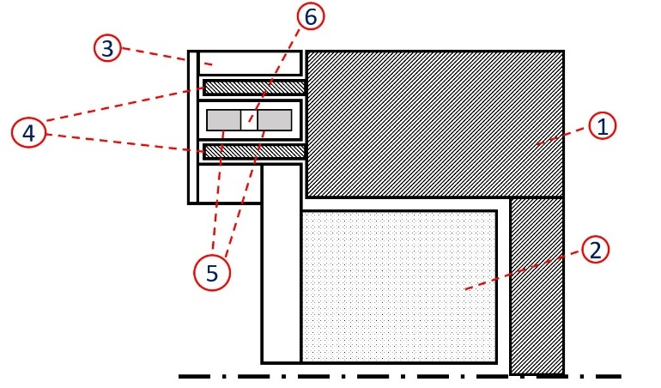
Figure 2. Optimized schematic layout of ZEDS solution
In the optimized geometry there are two circumferential protuberances (4 in the Figure 2) starting from the rotor of the electric motor. Consequently, the stator of the MRB also has two circumferential cavities to accommodate and envelop the two protuberances. This choice was made to increase the contact surface between the MRF and the rotor, so that more friction can be developed in the contact and, therefore, more braking torque. The choice of adding a protuberance rather than axially lengthening the only one already present has the following reasons:
- a single protuberance stretched along the axis did not guarantee sufficient torsional resistance during the braking phase in which the magnetized MRF develops friction along the walls of the protuberance.
- since the reference vehicle for ZEDS is an A-segment vehicle, an in-wheel motor with a smaller radius than the first one was adopted so that it could be mounted in the wheel rim; with a smaller radius, the resulting torque with a single bump is lower and it was decided to add a second protuberance to increase the contact area between the MRF and the rotor walls.
- extending the protuberance axially requires a less energetically convenient coil arrangement to ensure sufficient and uniform fluid magnetization and reduce the compatibility with a segment-A vehicle application.
For the electromagnetic aspect, a targeted optimization to achieve an energy-efficient solution was carried out.
Electromagnetic Optimization
Electromagnetic optimization had to consider several aspects. The main objective was to achieve the required average magnetization in the fluid gap and the most uniform magnetic distribution in the gap with the lowest possible energy consumption.
Sufficient magnetization of the MRF requires electrical power to the coils. In particular, the main design parameters are the number of coil windings and the current flowing through them. The intermediate volume of the brake stator available for the coils is limited, so the maximum number of windings depends on the cross-section of the copper cable chosen for the windings.
The structure of ZEDS features a coil arrangement like a solenoid. The magnetic field inside an ideal solenoid (with the term ‘ideal’ meaning an infinite axial length and much greater than the diameter of the solenoid itself) can be calculated using the formula (1):
$$B= μ∙\frac{NI}{l}$$
(1)
Where:
- $B$ is the magnetic field
- $μ$ is the magnetic permeability
- $N$is the number of the windings of the coil
- $I$ is the current on the coils
- $l$is the solenoid length.
The magnetic field generated by a solenoid depends on the number of coil windings $N$ and the current $I$ flowing through them.
The maximum current that can flow through a solenoid depends on the cross-section of the wire used for the windings. The larger the cross-section of the wire, the higher the fusion current of the wire itself. Based on the magnetic field required to magnetize the MRF, the type of wire to be used with the corresponding maximum possible current $I$ according to the AWG table limitations [12] and the number of windings $N$ needed have been defined. For safety reasons of the test bench, the maximum supply voltage of the coils is set at 60 V. This limit has necessitated dividing the initial coil with $N$ established windings into $n$ coils with $N/n$ windings placed in parallel to be powered with the predetermined current$I$.
Additionally, to achieve a better distribution of the magnetic field in the fluid gap, it was decided to separate the $n$ coils by inserting a metal ring (indicated with 6 in Figure 2) of sufficient width between them (5 in Figure 2) to close the magnetic circuit and magnetize the MRF more uniformly.
Steady-state analysis
The feasibility of the innovative ZEDS technology was first of all verified by means of simulations with various software, through which, after a careful modelling procedure of the technology under investigation, the different aspects of the physics of ZEDS could be analyzed.
The results from the electromagnetic optimization were obtained using Altair Flux software and for the sake of computational simplification, it was deemed appropriate to simulate only one quarter of ZEDS
Different configurations of coil winding numbers and current were simulated depending on the chosen volume available in the stator to house the coils. In Figure 3 and Figure 4 are reported the results obtained from the Flux simulation of the magnetic field generated in ZEDS and in the MRF gap.
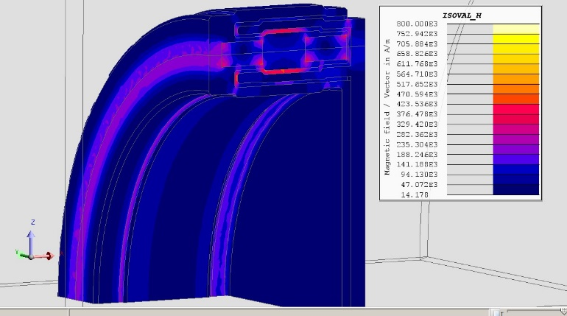
Figure 3. Magnetic Field generated in ZEDS
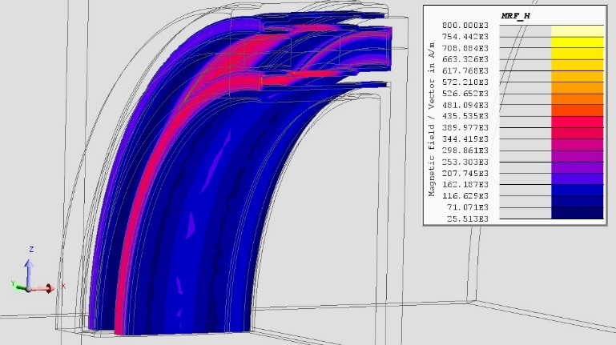
Figure 4. Magnetic Field generated in MRF
The simulated setup can be assumed to achieve the target mean magnetization in the fluid of $10000 A/m$. The average magnetization target was predetermined as a function of the “saturation” point of the MR fluid, beyond which an increase in the magnetic field passing through it does not result in changes in its viscosity.
An additional design phase of ZEDS was done using Particleworks software. Through this, an initial fluid-dynamic analysis was done to calculate the torque that can be developed by the MRF as a function of its viscosity, which varies with the magnetic field passing through it. In [13] a method with an Electro-Thermal equivalence for performing a mapping of the Magneto-Rheological Fluid put in a gap is proposed.
The performed procedure was an anisotropic analysis, following the steps:
- Definition of the simplified geometrical model of ZEDS adapted to the simulative needs of Particleworks software.
- Development of the Electro-Thermal equivalence, with the definition of an equivalent kinematic viscosity variable with the temperature, which represents the magnetic field generated in the MRF.
- Validation of the Electro-Thermal Equivalence with a defined CFD Model.
- Analysis of a non-uniformly magnetized fluid and understanding of the effects of a non-ideal magnetization.
The results obtained by [13] are comparable to the ones obtained using a CFD analysis (Figure 5).
Figure 5. Fluid Magnetization vs. Temperature through MPS [13]
In particular, this method allows to perform analysis on the effect of a not fully magnetized MRF, but there are important issues with the temperature scale to be controlled, the thermal conductivity of the wall and even with the need to determine a more precise mapping of the fluid for obtaining a temperature around the fluid as similar as possible to the one defined during the Electro-Magnetic Simulations.
Starting from the research made in [13] and [14] further design phase was conducted through a performance analysis obtained by simulations using a model created on Matlab Simulink [16], with the aim of verifying the ZEDS system's ability to develop braking torques high enough to guarantee safety standards and regulation requests. The braking torques in the Simulink model were calculated by exploiting equations obtained from [17]. The model is able to simulate the transient 1D motion of an electric vehicle equipped with four wheels, each having a ZEDS mounted. It has the ability to simulate a road test, supervise the behavior of the vehicle, monitoring parameters such as the State of Charge (SoC) of the battery, the current used by the vehicle's battery, speed, drive torque and the decoupling between the regenerative braking torque and the MRB torque.
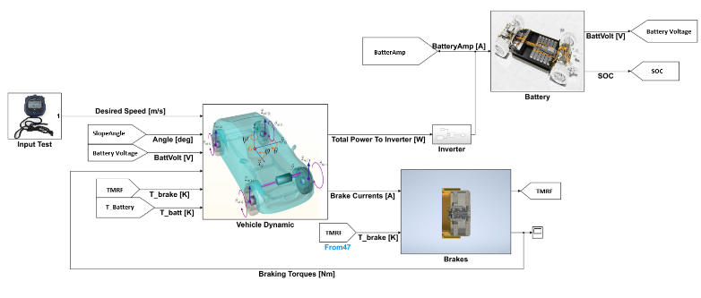
Figure 6. Simulink Model Layout [16]
In Figure 6 “Brakes” block is present, in which, as a function of the required current to the brakes, the braking torque generated by each brake and each relative operating temperature is calculated.
The results obtained from the simulation of a “0 km/h-130 km/h- 0 km/h” test, in which a vehicle is initially accelerated to 130 km/h and, at the second 30, is braked to a stop, are shown in Figure 7, according to the equations used to compute the braking torque, the ZEDS is able to develop a maximum torque of 1084 N·m, with a maximum rolling resistance torque of 34.7 N·m.

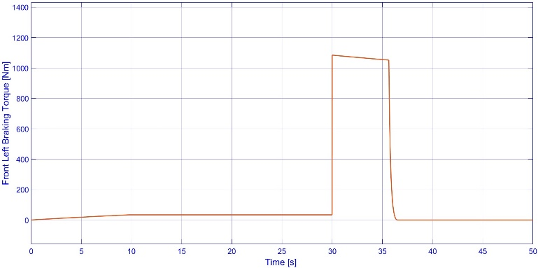
Figure 7. Torque generated by the left front MR brake with Test "0 km/h- 130 km/h- 0 km/h" [16]
The electro actuated nature of ZEDS made it possible to develop control logic within the model such that the energy consumption and working conditions of the main driveline components were optimized by dividing the braking torque demand between RB and MRB [18].
The very good results obtained from the various analyses demonstrated the feasibility of the innovative idea and led to the decision to proceed with the production of an initial prototype to be tested in a special test bed.
ZEDS Test Bench
The only way to validate the different simulation analyses done through the different software is to experimentally test ZEDS. This led to the design and the production of a test bench suitable for testing ZEDS under various desired working conditions.
In [19] details of the ZEDS test bench and the procedure adopted for its design are reported. In particular, within this paper the objective was not to address the issue regarding the sizing of the brake system, but rather the adaptation needed to couple the MR brake with an in-wheel motor model 268 from EMRAX [20]. The resulting solution is shown in Figure 8.
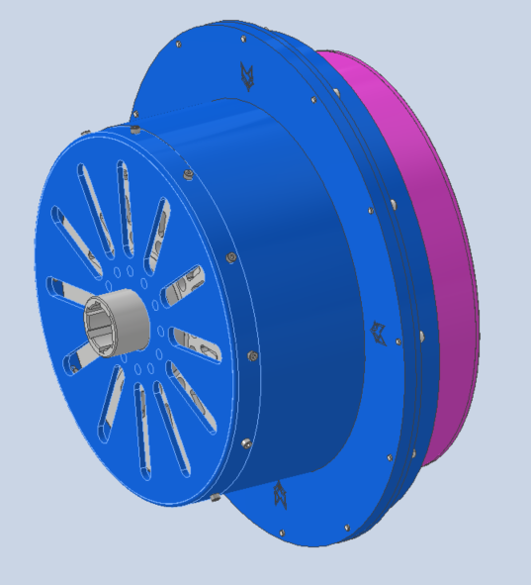
Figure 8. INNOVATIVE BRAKING SYSTEM LAYOUT [19]
The CAD of the test bench is shown in the Figure 9.
The test stand was designed to be mounted with a counter motor present in the Politecnico di Torino facility CARS laboratory, an infrastructure dedicated to testing vehicles, usually with hybrid and electric powertrain [21][22]. Starting from defining the main parameters and targets to be reached for evaluating the braking system functionality, the mechanical and electronics behavior of the bench is described analyzing the main evaluations to be performed. The main analyses to be conducted before starting with the actual testing procedure have been reported.
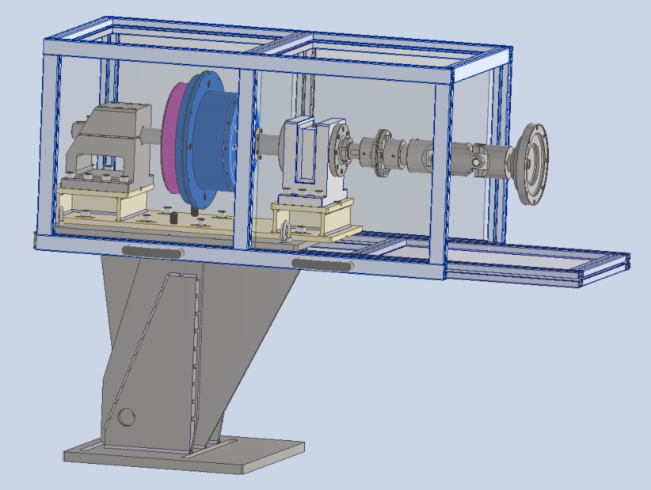
Figure 9. ZEDS Test Bench [19]
Testing
The experimental tests carried out were aimed at evaluating and analyzing various characteristics of the brake. In the first analysis, since the structure of ZEDS includes the use of the in-wheel electric motor, tests were carried out without MRF. In this way, it was possible to evaluate the characteristics of the electric motor and to derive the rolling resistance characteristic related exclusively to it. Only by deriving the rolling resistance characteristic of the EM was it then possible to identify the rolling resistance contribution linked to the presence of the MRF in the brake and so the total rolling resistance associated to ZEDS.
In Figure 10 is possible to see the Test-Bench Setup, where the counter motor is the blue component on the right-end side, In the center, there is the ZEDS system, while on the left-end side there is the thermoscanner, positioned for evaluating the temperature around the sealing area.
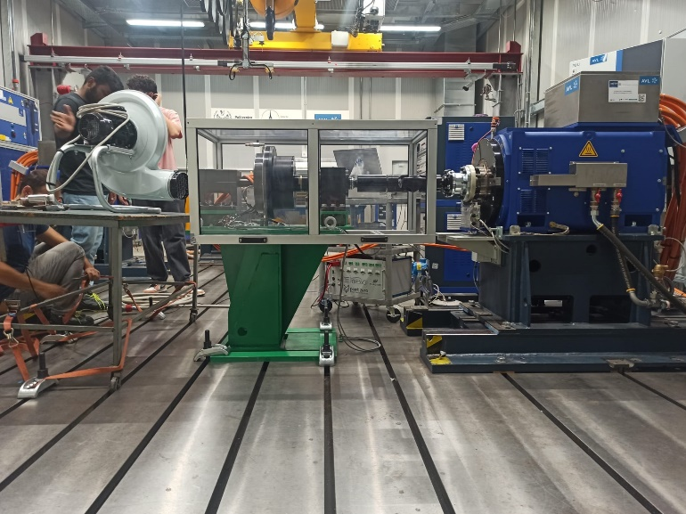
Figure 10 Test-Bench Setup
Subsequently, by activating the coils, it was possible to assess the braking power of ZEDS.
Testing Plan and Data Analysis
Test sequence
Before proceeding with the planned experimental tests, a check was made to see that the test bench worked properly. In detail, the correct power supply of the electric motor, the power supply of the individual coils and the correct exchange of data between the CARS control panel (through which input data are sent to perform the planned tests and output data are received) and ZEDS test bench.
The test plan was made, as already reported, to obtain the rolling resistance characteristics of the electric motor, the rolling resistance characteristics and the braking torque characteristics of ZEDS. The first tests were done without MR Fluid. These tests were done to characterize the in-wheel motor. Then, some tests were performed to analyze the behavior of ZEDS in its standard working condition, so with the MR Fluid and with the coils activated in the standard conditions, defined during the electromagnetic optimization.
Table 1. Testing Plan
Test | MRF inside | Motor Active | Brake Active | Scope
Rolling Resistance Characterization | No | No | No | Bench Resistance Evaluation
EM Characterization | No | Yes | No | Correlation between Current and EM Torque
ZEDS Rolling Resistance Characterization | Yes | No | No | Bench Resistance Evaluation with MRF
ZEDS Characterization | Yes | No | Yes | Correlation between Current and ZEDS Braking Torque

Data Analysis and Post-Processing
For the data analysis, the data measured by the test bench sensors have been filtered, eliminating all disturbances.
Data has been collected using a data acquisition board, receiving them on a CANBus line receiving all the sensors output.
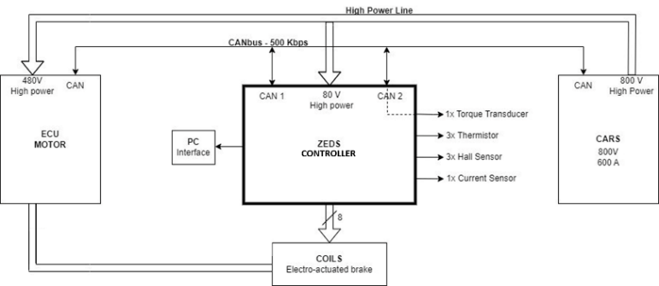
Figure 11. Electrical Setup of the ZEDS Test-bench [19]
The data acquisition process was made possible by an electronic setup (shown in Figure 11) and sensor arrangement adapted to the test bench and the quantities to be measured. There are several actuators on the test bench:
- ZEDS Actuator: to actuate the coils and read some of the critical sensors for the braking system
- ECU Motor (inverter): used to control and read the signals of the motor, ensuring its correct operation
- CARS: used for testing the braking system equipped with a battery emulator (PDU), counter-motor, torque transducer, and data acquisition system
- CANbus: is used as a serial communication bus to connect the various ECUs of the ZEDS system, allowing acquisition and control of all subsystems
- SENSORS:
  - Torque Transducer: Measures the torque between the braking system and the electric motor and counter-motor
  - Thermistors: Measure the temperature of the braking system coils at three different points on the stator
  - Hall Effect Sensors: Measure the magnetic field produced by the braking system coils at three different points
  - Current Sensor: Measures the current drawn by the FLAG ZEDS Actuator
- ACQUISITION SYSTEM: used to read all messages on the CAN line and display them on the screen using appropriate configuration files
Before proceeding with the data analysis in Matlab, it was necessary to convert the data collected from sensors in test bench into a format readable by Matlab (".mat").
The process followed to obtain all the required characteristics for ZEDS is:
- Conversion of data from the format used from sensors to the format readable from Matlab.
- Filtering and saving of the test data to obtain the electric motor characteristics (first tests).
- Filtering and saving of the test data to obtain the ZEDS characteristics (tests in which the MRF is present).
- Interpolation of saved electric motor data to obtain the rolling resistance characteristics.
- Interpolation of the data saved from the tests in which the MRF was present in ZEDS but it was not activated, to obtain the total rolling resistance of ZEDS.
- Interpolation of data saved from the tests in which ZEDS was activated to obtain its braking characteristics.
Filtering and saving of the test data to obtain the electric motor characteristics
To acquire and analyze the data measured during the first three tests, in which only the motor was activated, a Matlab code was designed. Specifically, by running the code, it is possible to manually upload one of the “.mat” files related to these tests, containing all the data measured by the sensors. The code extracts data from the uploaded file, including the motor's angular speed, the torque measured by the load cell, the current supplied to the motor, and the temperature measured on the external seal. All data are filtered to remove disturbances without compromising their validity, using the Matlab function “lowpass”.
After saving all the filtered data, the next step is to focus the analysis only on the steady-state data. To do this, only the data measured when the derivative of the motor’s angular speed is less than $0.5 rev/min$ and when the angular speed is greater than $10 rev/min$ are saved as “steady”. Since the goal of the tests is to obtain the rolling resistance characteristics of the electric motor, all the data measured when the current supplied to the motor is less than $1 A$ are saved in a file called “rolling”.
Filtering and saving of the test data to obtain the ZEDS characteristics
To acquire and analyze the data measured during the tests in which ZEDS was activated in its standard working condition a Matlab code was run in which the data related to these tests were uploaded. The code extracts data from the uploaded files, including the angular speed, the torque measured by the load cell, the current supplied to the coils of ZEDS, the temperature measured on the external seal and the magnetic field measured from the HALL sensors. All data are filtered using the Matlab function “lowpass”. After saving all the filtered data, the next step is to focus the analysis only on the steady-state data. To do this, only the data measured when the derivative of the motor’s angular speed is less than $0.5 rev/(min*s)$, the derivative of the current supplied to the coils is less the $0.1 A/s$ and when the angular speed is greater than $8 rev/min$ are saved as “steady”. Since the goal of the tests is even to obtain the rolling resistance characteristics of ZEDS, all the data measured when the current supplied to the coils is less than $0.1 A$ and the torque is greater than $0 N/m$ are saved in a file called “rolling”.
Interpolation of saved electric motor data to obtain the rolling resistance characteristics
Having obtained the electric motor data from the first tests, the next step has been to derive the rolling resistance characteristic of the motor itself.
Two different sealing solutions have been tested for evaluating the different resistance and sealing performances and evaluating the most suitable for the prototyping phase. Both the seals, called from now on Seal A and Seal B, have the same geometrical profile depicted in Figure 12. The difference between the two seals regards the polymeric mixture chosen, ensuring for Seal A a better thermal behavior but higher rolling resistance, while for Seal B optimizes the resistance reducing the sealing capabilities at higher speeds.

Figure 12. Geometry Section of the chosen Sealing Solution
The rolling resistance characteristic obtained as a function of angular velocity and seal temperature by interpolating experimentally measured data filtered using the ‘lasso’ function on Matlab is shown in Figure 13, considering Seal A.
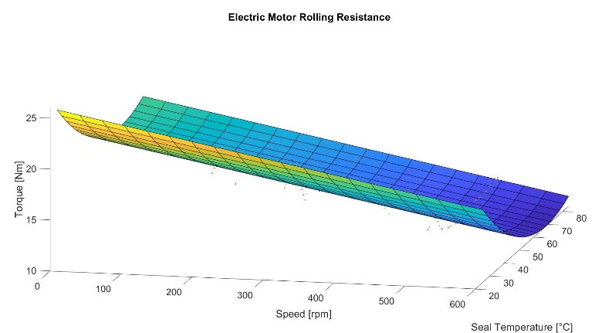
Figure 13. Electric Motor Rolling Resistance Characteristics with Seal A
Rolling resistance decreases with the increasing of the seal temperature. What is unexpected is the decrease in rolling resistance as angular speed increases: it is assumed that in the cases under consideration, the resistant effect of the seal used in these three tests is dominant with respect to all the other factors influencing the rolling resistance of the engine (such as inertia friction at the bearings, aerodynamics...). In fact, in this case, the increase in temperature, caused more by seal friction, is considerably more influential than the increase in angular speed. The increase in seal temperature causes a reduction in friction between the seal and the rotor; the lower friction reduces rolling resistance more than the increase in speed increases it.
The dominant effect of seal friction on the rolling resistance just obtained is confirmed by the results obtained using a different seal, which is more suitable for the ZEDS application due to the lower friction produced.
Figure 14 show the rolling resistance curve obtained after a test with the Seal B.
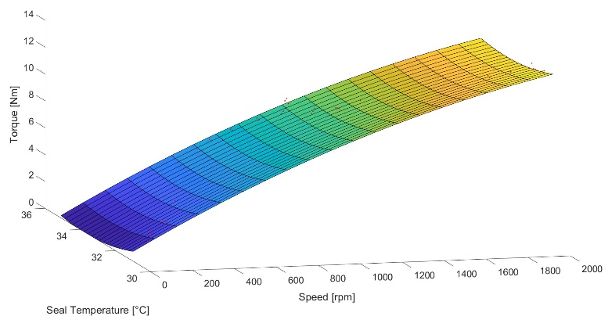
Figure 14. Electric Motor Rolling Resistance Characteristics with the latter seal
Table 2 and Table 3 show some values of rolling resistance torque in the case of the two seals used in the tests. The reported values show a clear discordance between the case with Seal A and the case with Seal B. From an empirical point of view, it is expected that rolling resistance increases with angular velocity, as is the case with the Seal B, which is certainly more efficient from the point of view of generated friction (note how the Seal A develops a static frictional braking torque of 25.2 N·m at 25°C compared to the 0.7 N·m developed by the Seal Bunder the same conditions.
Table 2. EM Rolling Resistance Values with the Seal A (Figure 13)
Speed [rpm] | Seal Temperature [°C]
 | 25 °C | 80 °C
0 | 25.2 N·m | 18.6 N·m
600 | 17.1 N·m | 10.6 N·m

Table 3. EM Rolling Resistance Values with the Seal B (Figure 14)
Speed [rpm] | Seal Temperature [°C]
 | 31 °C | 35 °C
0 | 0.7 N·m | 0.2 N·m
600 | 5.5 N·m | 5.1 N·m

However, this pair of rolling cannot be attributed solely to the presence of the seal. In fact, what certainly affects it to that extent is:
- the inertia of the in-wheel motor and its “intrinsic” rolling resistance due to its nature; in fact, it, being a motor mounted in the wheel of the vehicle, must ensure the isolation of the internal electrical system from the surrounding environment, which may present water (vehicle crossing a puddle for example) or earth. This necessity entails insulation at the motor's running points, which increases its rolling resistance.
- Inside the ZEDS test stand are two supports that support the rotating shaft that transmits torque between the ZEDS prototype and the counter-motor (Figure 9); these supports inevitably generate friction that results in an increase in resistant torque.
Given these important aspects, it was concluded that the derived rolling resistance values of the electric motor are currently unreliable and that further targeted testing is needed.
Despite the higher efficiency of Seal B, Seal A had to be used for the remaining performance tests because the Seal Bunder some more stressful operating conditions did not provide sufficient sealing.
Interpolation of data to obtain the total rolling resistance of ZEDS
Having derived the rolling resistance characteristic developed by the motor, to derive the overall rolling resistance and the contribution developed solely by the MRF an interpolation of the data saved from the tests with the MRF in ZEDS when this was not activated.
To obtain the rolling resistance contribution due to the presence of MRF the motor’s rolling contribution from the overall rolling resistance torque data measured by torque sensor has been subtracted.
Figure 15 highlights the difference between the overall rolling resistance of the entire ZEDS (indicated as ZEDS RR) system versus the rolling resistance component due solely to the presence of the MRF (indicated as Fluid RR). In detail, as a function of instantaneous speed and seal temperature, the EM rolling resistance value was derived by means of the previously derived characteristic (previous paragraph) and then subtracted from the total measured rolling resistance value of ZEDS.
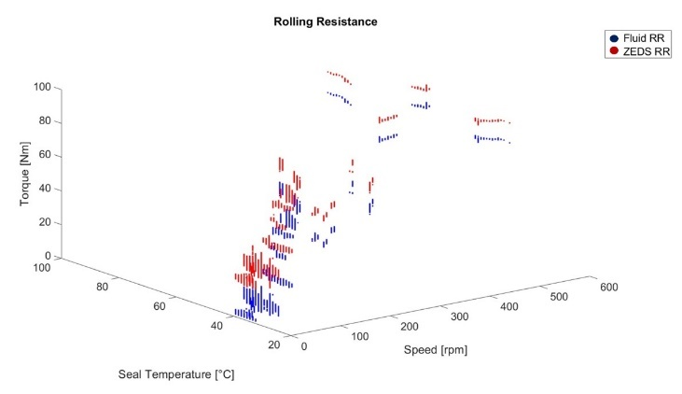
Figure 15. ZEDS Rolling Resistance data compared with MR Fluid Rolling Resistance data
In Figure 16 the rolling resistance characteristic of ZEDS as a function of angular speed and seal temperature and the rolling resistance characteristic due only to MRF are depicted.
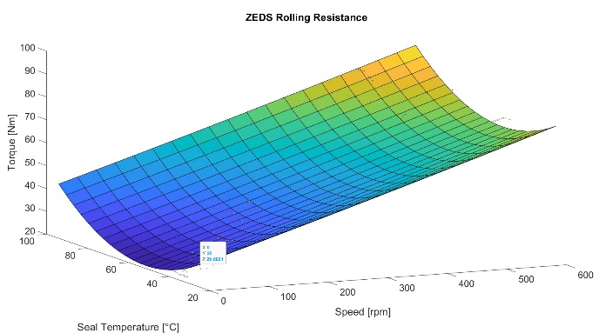
Figure 16. ZEDS Rolling Resistance Characteristics
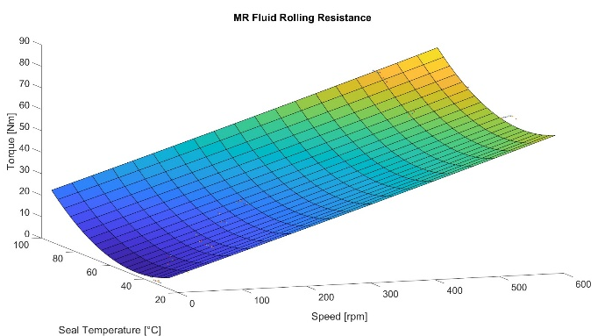
Figure 17. MRF Rolling Resistance Characteristics
Figure 17 shows the growth of rolling as a function of angular velocity, consistent with expectations. However, the relationship of rolling resistance as a function of temperature is uncertain. Usually, oil reduces its viscosity with increasing temperature, a phenomenon which is not clear from the results shown. The reason is the same as for the rolling resistance of the engine, namely the excessive friction developed by the seal. It must be remembered that the temperature taken into consideration is not that of the fluid, but the seal temperature measured with the thermal imaging camera.
Table 4. ZEDS Rolling Resistance Values (Figure 16)
Speed [rpm] | Seal Temperature [°C]
 | 25 °C | 95 °C
0 | 29.9 N·m | 43.8 N·m
600 | 79 N·m | 93 N·m

Table 5. MRF Rolling Resistance Values (Figure 17)
Speed [rpm] | Seal Temperature [°C]
 | 25 °C | 95 °C
0 | 5.4 N·m | 24.2 N·m
600 | 62 N·m | 81 N·m

Observing Figure 16 and Figure 17 and the data reported in Table 4 and Table 5, the rolling resistance values of ZEDS are considerable and for automotive application far too high. An important consideration must be made: the innovative solution stems from the need to cancel secondary emissions; however, if this solution requires significantly more energy than the solutions currently in use, the problem cannot be considered solved (it is well known that the energy that would be required to be produced would result in emissions). This leads to a first conclusion: the current prototype needs an initial optimization aimed at significantly reducing the total rolling resistance developed under operating conditions.
Interpolation of data in which ZEDS was activated to obtain braking characteristics
To derive the braking characteristics of ZEDS measured torque, angular velocity, seal temperature and current to the coils when the current to the coils is greater than 2A are derived from the steady state data.
During the post-processing phase, the total braking torque characteristic was first derived and then the braking component exclusively related to the magnetization of the MRF.
The dataset considered is shown in Figure 18. The total torque data were subtracted from the rolling resistance contribution obtained in the previous steps as a function of angular speed and seal temperature.
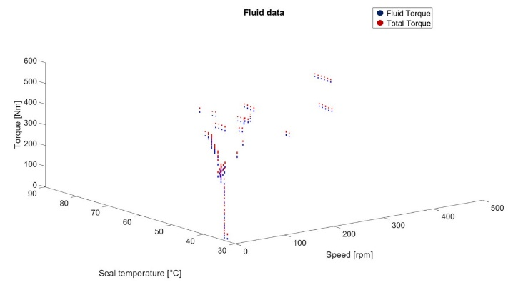
Figure 18. Total Torque and MRF Torque data
In Figure 19 and Figure 20 the 3D characteristics of the derived ZEDS braking characteristic and the braking characteristic due solely to fluid magnetization are reported. Since magnetization is generated by the supply to the coils, the above characteristics are reported as a function of angular speed and total current sent to the coils. It is possible to note a nonlinear dependence between the braking torque developed and the current sent to the coils.
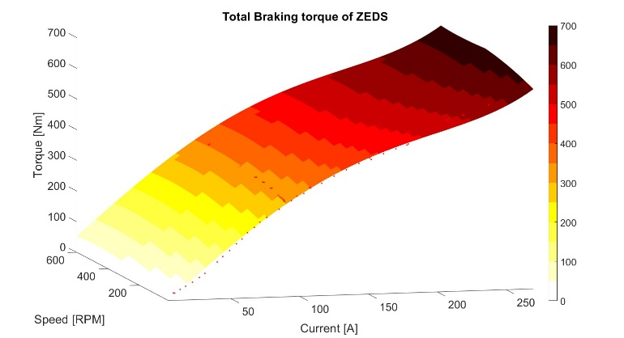
Figure 19. ZEDS Braking Characteristic
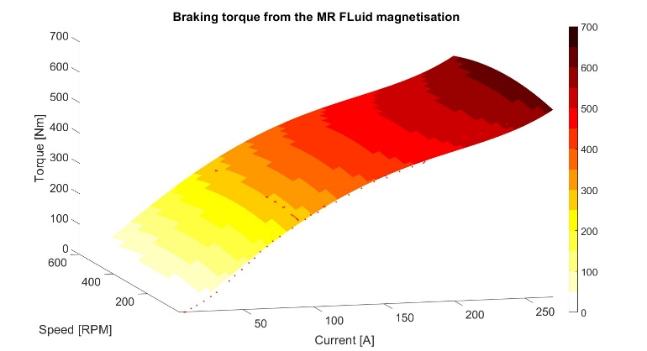
Figure 20. MRF Braking Characteristic
Table 6. ZEDS Braking Torque Values
Speed [rpm] | Current [A]
 | 270
10 | 650.2 Nm
600 | 691.3 Nm

Braking torque due to MRF magnetization is independent of angular velocity, consistent with expectations. There is a slight variation with angular velocity that is surely related to the unreliability of the obtained rolling resistance results.
The results shown in the Table 6 are lower than those simulated (Figure 7) using the Simulink model [16] with the equations obtained experimentally [17]. The reasons for this may be many and, for the most part, practical:
- the equations considered, because they are derived experimentally from cases similar to the one under consideration, may not be suitable and valid for the ZEDS system.
- the final coil setup is different magnetic field than the one simulated through the Flux Altair software because of changes in the production phase.
- the dependence of the viscosity on the magnetic field might be inconsistent with that derived from experimental rheometer tests or from the characteristic provided by the parent company of the MRF.
- ZEDS measure of rolling resistance extremely affected by the friction of the seal.
However, the increase in braking torque with current is certainly an excellent result obtained, which demonstrates the validity of the innovative idea, based on varying the viscosity of the MRF as a function of the magnetic field to develop more friction and, therefore, braking torque. It is also important to underline that the repeatability of the torque as a function of the speed is an important aspect for having a reliable braking solution.
Conclusions
The ZEDS project was born out of the need for zero-emission braking systems. In this paper, the entire procedure followed has been described, starting from the design of ZEDS through the use of multiple simulation platforms to the realization of an initial bench-tested prototype.
The most important results of the research are:
- the MRB takes advantage of the rheological capabilities of the MRF and is able to develop braking torque due to the magnetic field developed by the coils; the result, however, is lower than that simulated, with a peak torque of 691.3 N·m.
- the rolling resistance of ZEDS, which peaks at 93 N·m at 600 rpm, which is high compared to market demands.
The next step is to validate the simulation models, conducting an in-depth analysis on why the simulation models have errors compared to the experimental data. Once the simulation models have been validated, the next step is to optimize ZEDS in its efficiency: in particular, to reduce the rolling resistance to come closer to market demands, to develop higher braking torque with lower energy demand, and to ensure greater thermal stability through a cooling system that compensates for the thermal dissipation that develops in the fluid-wall contact and the thermal dissipation related to the electrical resistance of the coils.
Having reached the goal of a new optimized ZEDS prototype, it is intended to be tested first in the laboratory and, later, on a real vehicle in order to test it on the track.
rivedrei le conclusion spiegando meglio i risultati positivi e solo dopo i next steps
References
[1] G. Imberti, H. de Carvalho Pinheiro, e M. Carello, «Impact of the Braking System Generated Pollutants on the Global Vehicle Emissions: A Review», ICESE, 2023.
[2] G. Imberti, H. de Carvalho Pinheiro, e M. Carello, «Regenerative Braking Effects on Non-combustion Pollutant Release», IFToMM ITALY, vol. Advances in Italian Mechanism Science, ago. 2022, doi: 10.1007/978-3-031-10776-4_95.
[3] M. Rahimi, S. Candeo, M. Da Lio, F. Biral, J. Wahlström, e D. Bortoluzzi, «A novel approach for brake emission estimation based on traffic microsimulation, vehicle system dynamics, and machine learning modeling», Atmospheric Pollut. Res., vol. 14, fasc. 10, ott. 2023, doi: https://doi.org/10.1016/j.apr.2023.101872.
[4] European Commision, «Euro 7». 10 novembre 2022.
[5] G. Imberti, H. de Carvalho Pinheiro, e M. Carello, «Design of an Innovative Zero-Emissions Braking System for Vehicles», ICECCME, 2022.
[6] J. W. Sohn, J. Jeon, Q. H. Nguyen, e S.-B. Choi, «Optimal design of disc-type magneto-rheological brake for mid-sized motorcycle: experimental evaluation», Smart Mater. Struct., vol. 24, fasc. 8, lug. 2015, doi: 10.1088/0964-1726/24/8/085009.
[7] D. Quamar e C. Sarkar, «Optimal Design of Hydraulic Disc Brake for Magnetorheological (MR) Application», Def. Sci. J., vol. 72, fasc. 6, dic. 2022, doi: 10.14429/dsj.72.18369.
[8] C. Sarkar e R. K. Singh, «Two-wheeler magnetorheological drum brake operating under hybrid mode for enhancing braking torque: Development and validation», Mechatronics, vol. 92, giu. 2023, doi: https://doi.org/10.1016/j.mechatronics.2023.102971.
[9] Q. H. Nguyen, S.-B. Choi, Jagdeesha T, Hafsana A, A. Vijay, e M. P. Vinayan, «Reliability estimation of Magnetorheological Fluid Brakes for Electrical Vehicles», 2021 IEEE Bombay Sect. Signat. Conf. IBSSC, gen. 2022, doi: 10.1109/IBSSC53889.2021.9673400.
[10] A. Musolino, M. Raugi, R. Rizzo, L. Sani, e E. Diez-Jimenez, «A magneto-rheological brake excited by permanent magnets», Appl. Comput. Electromagn. Soc. J. ACES, vol. 34, fasc. 1, gen. 2019.
[11] G. Imberti, H. de Carvalho Pinheiro, e M. Carello, «Pre-Design and Feasibility Analysis of a Magneto-Rheological Braking System for Electric Vehicles», 2022.
[12] «Engineering Tables/American Wire Gauge, “https://en.wikibooks.org/wiki/Engineering_Tables/American_Wire_Gauge”, [Online]».
[13] G. Imberti, H. de Carvalho Pinheiro, e M. Carello, «MPS Analysis of Magneto-Rheological Fluid for a Braking System Application», 2023 IEEE Veh. Power Propuls. Conf. VPPC 2023, ott. 2023, doi: 10.1109/VPPC60535.2023.10403204.
[14] G. P. Tempone, M. De Carlo, e M. Carello, «1D control model of a hydrogen-powered vehicle for race strategy optimization», EEEIC 2023, giu. 2023, doi: 10.1109/EEEIC/ICPSEurope57605.2023.10194634.
[15] M. De Carlo, G. P. Tempone, P. Dragone, e M. Carello, «3DOF Vehicle Dynamics Model for Fuel Consumption Estimation», SAE WCX 2024 Pap. Accept., 2024.
[16] G. P. Tempone, G. Imberti, H. de Carvalho Pinheiro, e M. Carello, «Innovative Zero-Emissions Braking System: performance analysis through a Transient Braking Model», SAE WCX 2024 Pap. Accept., 2024.
[17] Terzo, «Sviluppo di un Differenziale Semiattivo a Fluido Magnetoreologico». 2007.
[18] G. P. Tempone, H. de Carvalho Pinheiro, G. Imberti, e M. Carello, «Control System for Regenerative Braking Efficiency in Electric Vehicles with Electro-Actuated Brakes», SAE Int. J. Veh. Dyn. Stab. NVH, vol. 8, fasc. 2, mag. 2024, doi: 10.4271/10-08-02-0015.
[19] M. Carello, G. Imberti, e H. de Carvalho Pinheiro, «Design and preliminary test on an innovative test bench for zero emission braking system», IMECE 2024, nov. 2024.
[20] «EMRAX d.o.o.»
[21] A. Ponso, A. Bonfitto, M. Silvagni, e S. Luciani, «OFF-BOARD TESTING DEVICE FOR BATTERY DIAGNOSTICS AND MARKET ANALYSIS FOR BATTERY REUSE», ASME 2023 Int. Des. Eng. Tech. Conf. Comput. Inf. Eng. Conf. IDETC-CIE 2023, vol. 1, ago. 2023, doi: 10.1115/DETC2023-116596.
[22] «POLITO, “https://www.cars.polito.it/facilities,” [Online].»

Contact Information
Contact details for the main author should be included here. Details may include mailing address, email address, and/or telephone number (whichever is deemed appropriate).
Acknowledgments
If the Acknowledgments section is not wanted, delete this heading and text.

Abbreviations
CAD  CFD  EM | Computer Aided Design  Computer Fluid Dynamics  Electric Motor
MR  MRB  MRF  RB  ZEDS | Magneto-Rheological  Magneto-Rheological Braking  Magneto-Rheological Fluid  Regenerative Braking  Zero-Emissions Driving System

Appendix
The Appendix is one-column. If you have an appendix in your document, you will need to insert a continuous page break and set the columns to one. If you do not have an appendix in your document, this paragraph can be ignored and the heading and section break deleted.

