Supporting information
Durable Bio-based Nanocomposite Coating on Urinary Catheters Prevents Early-Stage CAUTI-Associated Pathogenicity
Antonio Puertas-Segura¹, Kristina Ivanova¹, Leonardo Martín Pérez¹, Bzazou El Ouazzani Zine El Abidine², Aleksandra Ivanova¹, Barış Gökalsın³, Gianluca Ciardelli⁴, Tzanko Tzanov*¹

¹Grup de Biotecnologia Molecular i Industrial, Department of Chemical Engineering, Universitat Politècnica de Catalunya, Terrassa, Spain.
²Biotechnological Valorization of Microorganisms Laboratory, Department of Life Science, Abdelmalek Essaadi University, Tangier, Morocco.
³ Departament of Biology, Marmara University, Istanbul, Turkey
⁴Department of Mechanical and Aerospace Engineering, Politecnico di Torino,Torino , Italy.

*Corresponding author: tzanko.tzanov@upc.edu
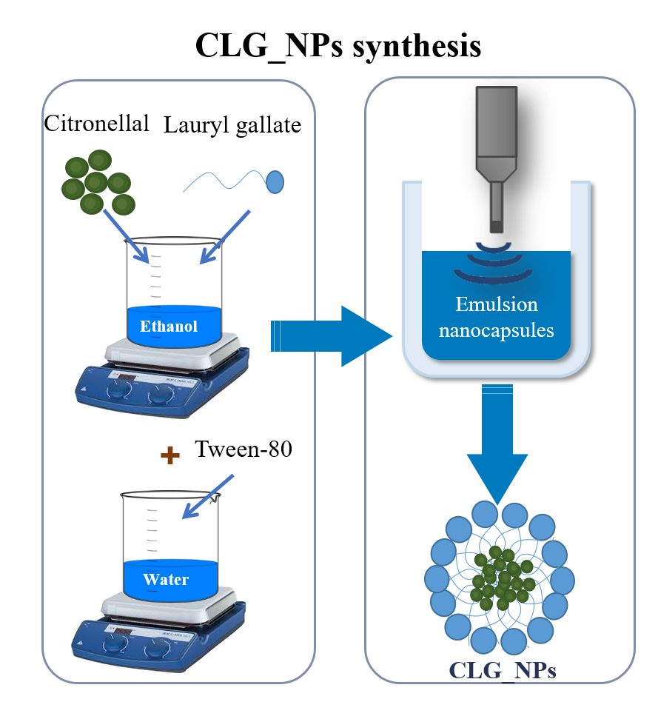
Figure S1. Scheme depicting the synthesis of CLG_NPs.
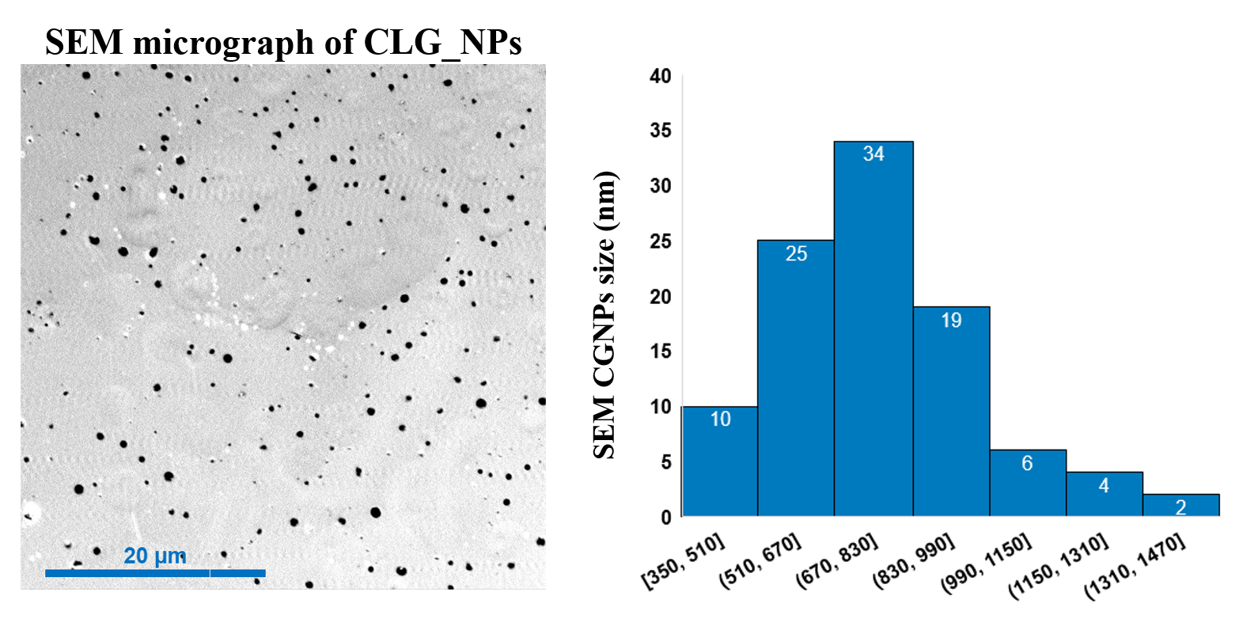
Figure S2. (A) SEM micrograph of CLG_NPs and (B) size histogram of CLG_NPs

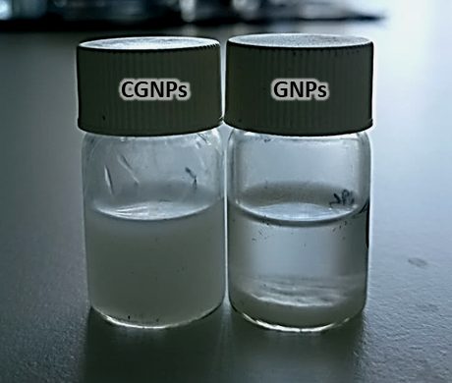
Figure S3. Representative photograph showing a suspension of lauryl gallate nanoparticles alone (LG_NPs) and loaded with citronellal (CLG_NPs). See LG_NPs aggregation and sedimentation (right) after 24-h synthesis indicative of lower NPs stability.
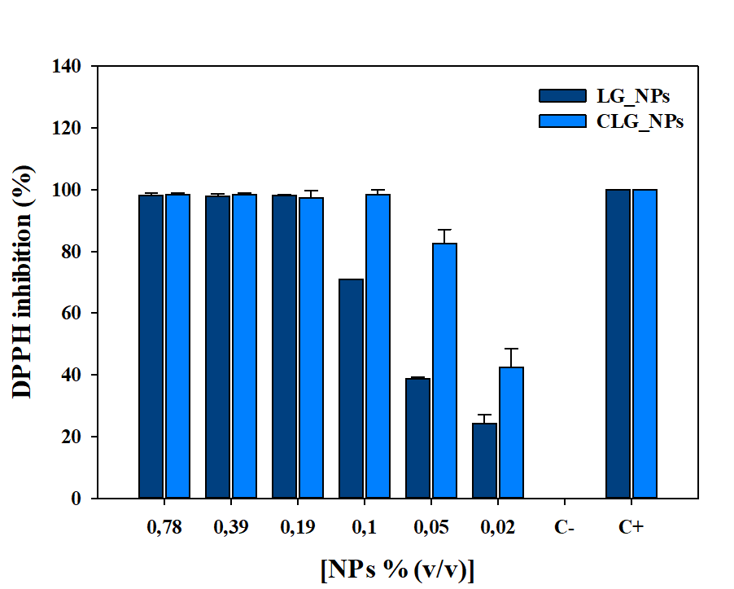
Figure S4. Antioxidant activity of LG_NPs and CLG_NPs. Negative (C-) and positive (C+) controls were performed by adding water or ascorbic acid (1.0 mg mL⁻¹) to the corresponding test tubes. Data are presented as the mean value ± S.D. (n = 3).

