2025-01-8054

Leveraging Traffic-in-the-Loop Simulations to Assess the Impact of Traffic on Vehicle Energy Consumption
Author, co-author (Do NOT enter this information. It will be pulled from participant tab in MyTechZone)
Affiliation (Do NOT enter this information. It will be pulled from participant tab in MyTechZone)

Abstract
The advancements in vehicle connectivity and the increased level of driving automation can be leveraged for the development of Advanced Driver Assistance Systems (ADAS) that improve driver safety and comfort while optimizing the energy consumption of the vehicle. In the development phase of energy-efficient ADAS, modeling and simulation are used to assess the potential benefits of these technologies on energy consumption. However, there is a lack of standardized simulation or test frameworks to quantify the benefits. Moreover, the driving scenario and the traffic conditions are often not explicitly modeled when simulating energy-efficient ADAS, even though they have a major impact on the attainable energy benefits.
This paper presents the development and implementation of a closed-loop traffic-in-the-loop simulator designed to evaluate the performance of vehicles under realistic traffic conditions. The primary objective is to qualitatively assess how varying traffic conditions influence vehicle energy consumption along a predefined route, highlighting the importance of considering traffic during the development of energy-efficient vehicle controllers. By integrating a dynamic micro-traffic model from the open-source software SUMO with a high-fidelity vehicle model in Simulink, the traffic-in-the-loop simulator provides a comprehensive platform for analyzing the impact of traffic on vehicle efficiency. The micro-traffic model is controlled online through a MATLAB script leveraging TraCI, a TCP based client/server architecture that allows to retrieve values of simulated objects in SUMO and to manipulate their behavior. The findings demonstrate the significant impact of traffic conditions on vehicle energy consumption, highlighting the necessity of simulating traffic environments to properly evaluate the potential benefits of advanced vehicle technologies.
Introduction
Most passenger and commercial vehicles sold today implement some Advanced Driving Assistance System (ADAS), such as Adaptive Cruise Control (ACC) and/or lane centering. These systems leverage sensors such as radars, cameras, and lidars, to provide additional safety and some level of driving automation. According to the SAE Levels of Driving Automation [1], ACC and lane centering are categorized as driver support features and fall under automation levels 1 and 2. Actual fully automated driving vehicles are capable of self-driving and are categorized under automation levels 3 – 5. In all cases, ADAS enable automatic control of the vehicle longitudinal dynamics, allowing to control the vehicle’s acceleration and braking. Since the vehicle’s speed, accelerations, and decelerations are directly related to the energy consumption, in recent years engineers and researchers have worked on the development of ADAS that not only improve the safety and comfort of the passengers, but also reduce the energy consumption [2] [3]. For example, eco-driving systems have been developed that leverage sensor and map data to optimize the vehicle speed and minimize energy consumption [4] [5] [6]. Similarly, Predictive Cruise Control (PCC) systems have been implemented in heavy-duty commercial vehicles, which adjust the vehicle speed based on the prediction of the upcoming road conditions (in particular the road slope) over a certain spatial horizon to reduce the energy consumption [7] [8]. Other systems may also leverage vehicle connectivity to the infrastructure and/or to other vehicles to further improve energy consumption, e.g., eco-approach systems that modulate the vehicle speed to efficiently approach intersections with traffic lights [8], or cloud-based systems that share traffic information to adjust the vehicle speed [9].
Motivation
Typically, the potential of ADAS and eco-driving technologies is first demonstrated through simulations. The vehicle under consideration is referred to as the ego vehicle, whereas the vehicle (or vehicles) ahead are referred to as lead vehicle or concurrent vehicles. In most of the literature, the Authors arbitrarily select a route of interest, artificial test scenarios, or standardized driving cycles to run their simulations and demonstrate the energy benefits of their technologies. However, traffic conditions are often neglected or simulated by only considering the speed of the lead vehicle. In most cases, traffic is considered in a macroscopic sense either by using macroscopic traffic models [10] [11] or just imposing the lead vehicle speed through a drive cycle [12] [13] [14], either way simply resulting in a reduction of the maximum velocity at which the ego vehicle can travel [8] [15] [16].
While macroscopic traffic models are very useful for gathering preview information for optimization purposes [17] [18], they cannot accurately reproduce the complex vehicle-to-vehicle interactions that characterize real-world driving. This can be done by micro-traffic simulations, which are today generally applied only to test lane changing [19] [20] [21], merging [22] [23] [24] [25] and intersection management algorithms [26] [27] [28] by constructing an artificial test environment for these specific maneuvers.
The construction of artificial test scenarios and/or simplified traffic conditions is beneficial to show how the presented technology works. Anyway, it can lead to overly favorable test conditions that are not encountered during real-world operation, complicating the comparison between different technologies. At the moment of writing, the lack of a standardized simulation framework to test different technologies on a level ground is a literature gap that still has to be filled.
Contribution
In this work, a traffic-in-the-loop simulation framework has been developed which allows to combine accurate vehicle modeling for energy consumption estimation, with micro-traffic simulations to simulate traffic conditions and ensure repeatability of the tests in a macroscopic statistical sense.
The main contributions of this work are as follows:
- Development of a traffic-in-the loop simulator to assess the energy consumption in a statistical and repeatable way, introducing the concept of standardized driving scenarios, rather than drive cycles.
- Demonstration of the large impact of traffic conditions on vehicle energy consumption, hence the importance of appropriately considering it when testing ADAS technologies for energy consumption improvements.
As detailed in the following, an additional contribution of this work is the modification of the Enhanced Driver Model (EDM) to indirectly consider the impact of road curvature (in particular in sharp turns) on the vehicle speed.
In the next section, the architecture of the traffic-in-the loop simulator is described. In essence, the simulator allows to co-simulate a powertrain model in MATLAB Simulink with a microscopic traffic simulation set up in Simulation of Urban MObility (SUMO) [29]. Next, a high-level description of the ego vehicle model is provided. More details are included on the driver models that are used to control the vehicles in the traffic-in-the loop simulation. The microscopic traffic model is compared to macroscopic traffic metrics to provide some level of validation and explain how the results of the microscopic traffic simulations can be interpreted and made repeatable. Finally, a test case is presented with simulation results.
Traffic-in-the-Loop Simulator Architecture
The traffic-in-the-loop simulator presented in this study is an evolution of the one presented in [30], whose main novelty with respect to his predecessor is the introduction of an additional layer in the software structure to allow the use of a custom longitudinal controller for the vehicles in the simulation.
The simulation environment is based on a three-layer structure where the traffic simulation environment interacts in a closed-loop with a Simulink-based powertrain model. The first layer is implemented in SUMO, a popular open-source micro-traffic simulator, and its role is to model the route and the vehicles moving along it, providing information like traffic lights phase and vehicles’ speed and position. The third layer is represented by the forward-facing ego vehicle powertrain model in Simulink, whose role is to simulate the ego vehicle dynamics as it moves along the route. The second layer, laying between the first and the third, is implemented in MATLAB and serves two distinct functions. One is to allow information to flow from SUMO (Layer 1) to the powertrain model in Simulink (Layer 3) and vice-versa by means of a Transmission Control Protocol (TCP) based client/server architecture called TraCI4MATLAB [31] [32], with the acronym TraCI standing for Traffic Control Interface. The second function is to control all vehicles in SUMO by implementing a longitudinal driver model that overrides SUMO’s embedded one, giving more control on traffic behavior.
A block diagram of the developed three-layer traffic-in-the-loop simulator is shown in Figure 1. At each iteration, information about all vehicles in the simulation is gathered from SUMO and passed to the driver model in MATLAB, thus generating a speed request for the subsequent SUMO timestep. Such speed request is directly fed back to SUMO as a command input in the case of concurrent vehicles, whereas in the case of the ego vehicle it is passed to the forward-facing Simulink powertrain model as a speed reference for the vehicle controller. The resulting speed from the powertrain plant model is then fed back to SUMO as a command input for the next time step, ensuring that the virtual vehicle in SUMO behaves as predicted by the Simulink powertrain model, thus establishing a closed-loop interaction between SUMO and Simulink that ensures causality.
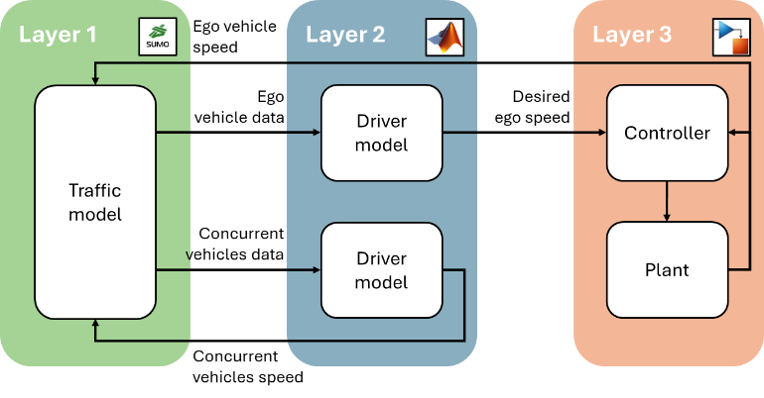
Figure 1. Block diagram of the traffic-in-the-loop simulator. The traffic model in SUMO (Layer 1) simulates and introduces all vehicles in the simulation (ego and concurrent vehicles). The driver models (Layer 2) determine the velocity of each vehicle in the co-simulation. The ego vehicle is further modeled to accurately estimate its speed and energy consumption (Layer 3).
Even though it could have been possible to implement the longitudinal vehicle controller directly into Layer 1 (SUMO), it was preferred to move it to Layer 2 due to the greater flexibility that this option allows. Indeed, this setup makes it possible to use different controllers in the same simulation without modifying SUMO’s source code, potentially customizing vehicles behavior based on driver aggressiveness and simulating vehicles featuring different ADAS in the same traffic flow. This great flexibility comes at the cost of larger computational burden as it increases the number of TraCI calls from Layer 2 to Layer 1.
Vehicle Model
The plant block shown in Figure 1 is the vehicle model, implemented in Simulink with an energy-based approach, using lookup tables for electric drive efficiency and a simple zero-order equivalent circuit model for the battery pack. The model represents a heavy-duty electric truck as a case study. Similar models have been developed in previous works and the reader can reference [33] [34] [35] [36] [37] for more details. In essence, the model takes as an input the desired ego speed, estimates the corresponding energy consumption, and outputs the actual ego vehicle speed. A block diagram of the ego vehicle model is provided in Figure 2.
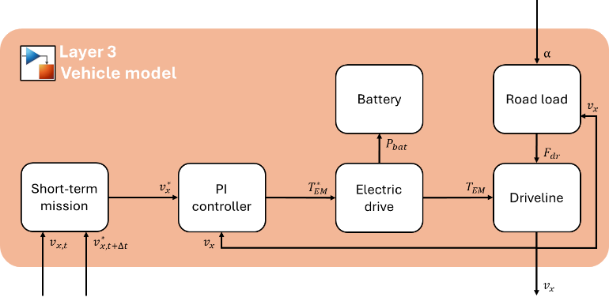
Figure 2. Block diagram of the vehicle model.
As shown in Figure 1, at each SUMO iteration, the desired speed value is calculated by the MATLAB-coded driver model in Layer 2 and fed to Simulink. Figure 2 shows that a linear interpolation between the current speed and the desired speed is performed to create a short-term driving mission (i.e., target speed profile) for the vehicle model. A simple PI controller (controller block in Layer 3 in Figure 1) is then used to actuate the powertrain, tracking the short-term speed profile. At the end of the short-term driving mission the simulation is paused and the vehicle velocity calculated by the Simulink model is passed back to SUMO, thus closing the co-simulation loop.
Simulations evidenced that the parameters of the PI controller had to be changed depending on the size of the timestep in the SUMO simulation. A satisfactory behavior has been obtained by applying Equation 1:
$$\left\{{k_{p} \atop k_{i}}\right\}=\frac{1}{Δt_{SUMO}} \left\{{k_{p,1} \atop k_{i,1}}\right\}$$ (1)
where $Δt_{SUMO}$ is the SUMO timestep size (shortened to $Δt$ in Figure 2), $k_{p,1}$ is the proportional gain when SUMO timestep is 1 s and $k_{i,1}$ is the integral gain when SUMO timestep is 1 s. In this study the proportional gain $k_{p,1}$ was set to 6 and the integral gain $k_{i,1}$ was set to 2.
Figure 2 shows that the motor torque from the electric drive, $T_{EM}$, provides the required traction to overcome the road load, which is calculated with Equation 2 and includes the contribution of aerodynamic drag, rolling resistance and road grade:
$$F_{dr}=\frac{1}{2} ρ_{air} S C_{x} V^{2}+m g\cos\left(α\right) \left(f_{0}+k v_{x}^{2}\right)+m g\sin\left(α\right)$$ (2)
where $ρ_{air}$ is the air density, $S$ is the vehicle frontal area, $C_{x}$ is the vehicle drag coefficient, $v_{x}$ is the vehicle longitudinal velocity, $m$ is the vehicle mass, $g$ is the gravitational acceleration constant, $α$ is the road inclination, and $f_{0}$ and $k$ are experimental rolling resistance coefficients. Vehicle characteristic parameters are not provided due to confidentiality constraints.
Cumulative energy consumption, $E_{bat}$, is calculated integrating battery power output as described by Equation 3, which is obtained from the motor power output by applying Equation 4.
$$E_{bat}\left(t\right)=\int_{t_{0}}^{t}{P_{bat} dτ}=\int_{t_{0}}^{t}{P_{EM} dτ}$$ (3)
$$P_{bat}=\left\{\begin{aligned}η_{ED}^{-1} T_{EM} ω_{EM} if T_{EM} ω_{EM}≥0 \\ η_{ED} T_{EM} ω_{EM} if T_{EM} ω_{EM}<0\end{aligned}\right.$$ (4)
Where $P_{bat}$ is the battery power output, $η_{ED}$ is the electric drive efficiency, $T_{EM}$ is the electric motor torque output and $ω_{EM}$ is the motor shaft speed.
Driver Model
The most popular driver models for the control of vehicles in microscopic traffic simulations are the Krauss Model [38] and the Intelligent Driver Model (IDM) [39], which are two deterministic car-following models built-in in SUMO. Several other descriptions of driver behavior have been developed starting from them, with the aim of more closely representing vehicle-to-vehicle and vehicle-to-infrastructure interactions. Relevant examples are the Extended Intelligent Driver Model (EIDM) [40], the Enhanced Driver Model (EDM) [41] and the Modified Enhanced Driver Model (mEDM) [42].
While the EIDM and the EDM are purely reactive models, the mEDM can anticipate the variations in speed limits. This feature offers the possibility to model in a simple way the behavior of drivers approaching a sharp turn, without the need to implement a dedicated lateral vehicle dynamics model. Approximating the vehicle to a point-mass system, its lateral acceleration while turning on a curve, $a_{y}$, can be calculated as shown in Equation 5.
$$a_{y}=\frac{1}{r} v_{x}^{2}$$ (5)
Where $r$ is the road curvature radius and $v_{x}$ is the vehicle longitudinal velocity.
Knowing the road curvature and imposing an upper bound to the lateral acceleration, $a_{y,lim}$, it is possible to obtain the corresponding maximum allowed longitudinal speed, $v_{x,LD}$, as described by Equation 6.
$$v_{x,LD}=\sqrt{r a_{y,lim}}$$ (6)
The value of $a_{y,lim}$ has been set to 0.15 g to account for passengers’ comfort [43] [44], and more refined analysis can be conducted in the future leveraging the work presented in [45] [46]. At each point along the route, the maximum allowed speed is defined as the minimum between the posted speed limit and the one imposed by the lateral dynamics, as shown in Figure 3.
This study uses a revised version of the mEDM to control all vehicles in the co-simulation, referred to as “EDM2”. The EDM2 operates under three different modes, similar to the EDM and the mEDM: Freeway Driving (FD), Car Following (CF) and Safe Deceleration (SD).
The EDM2 is described by the system of Equations 7 – 11.
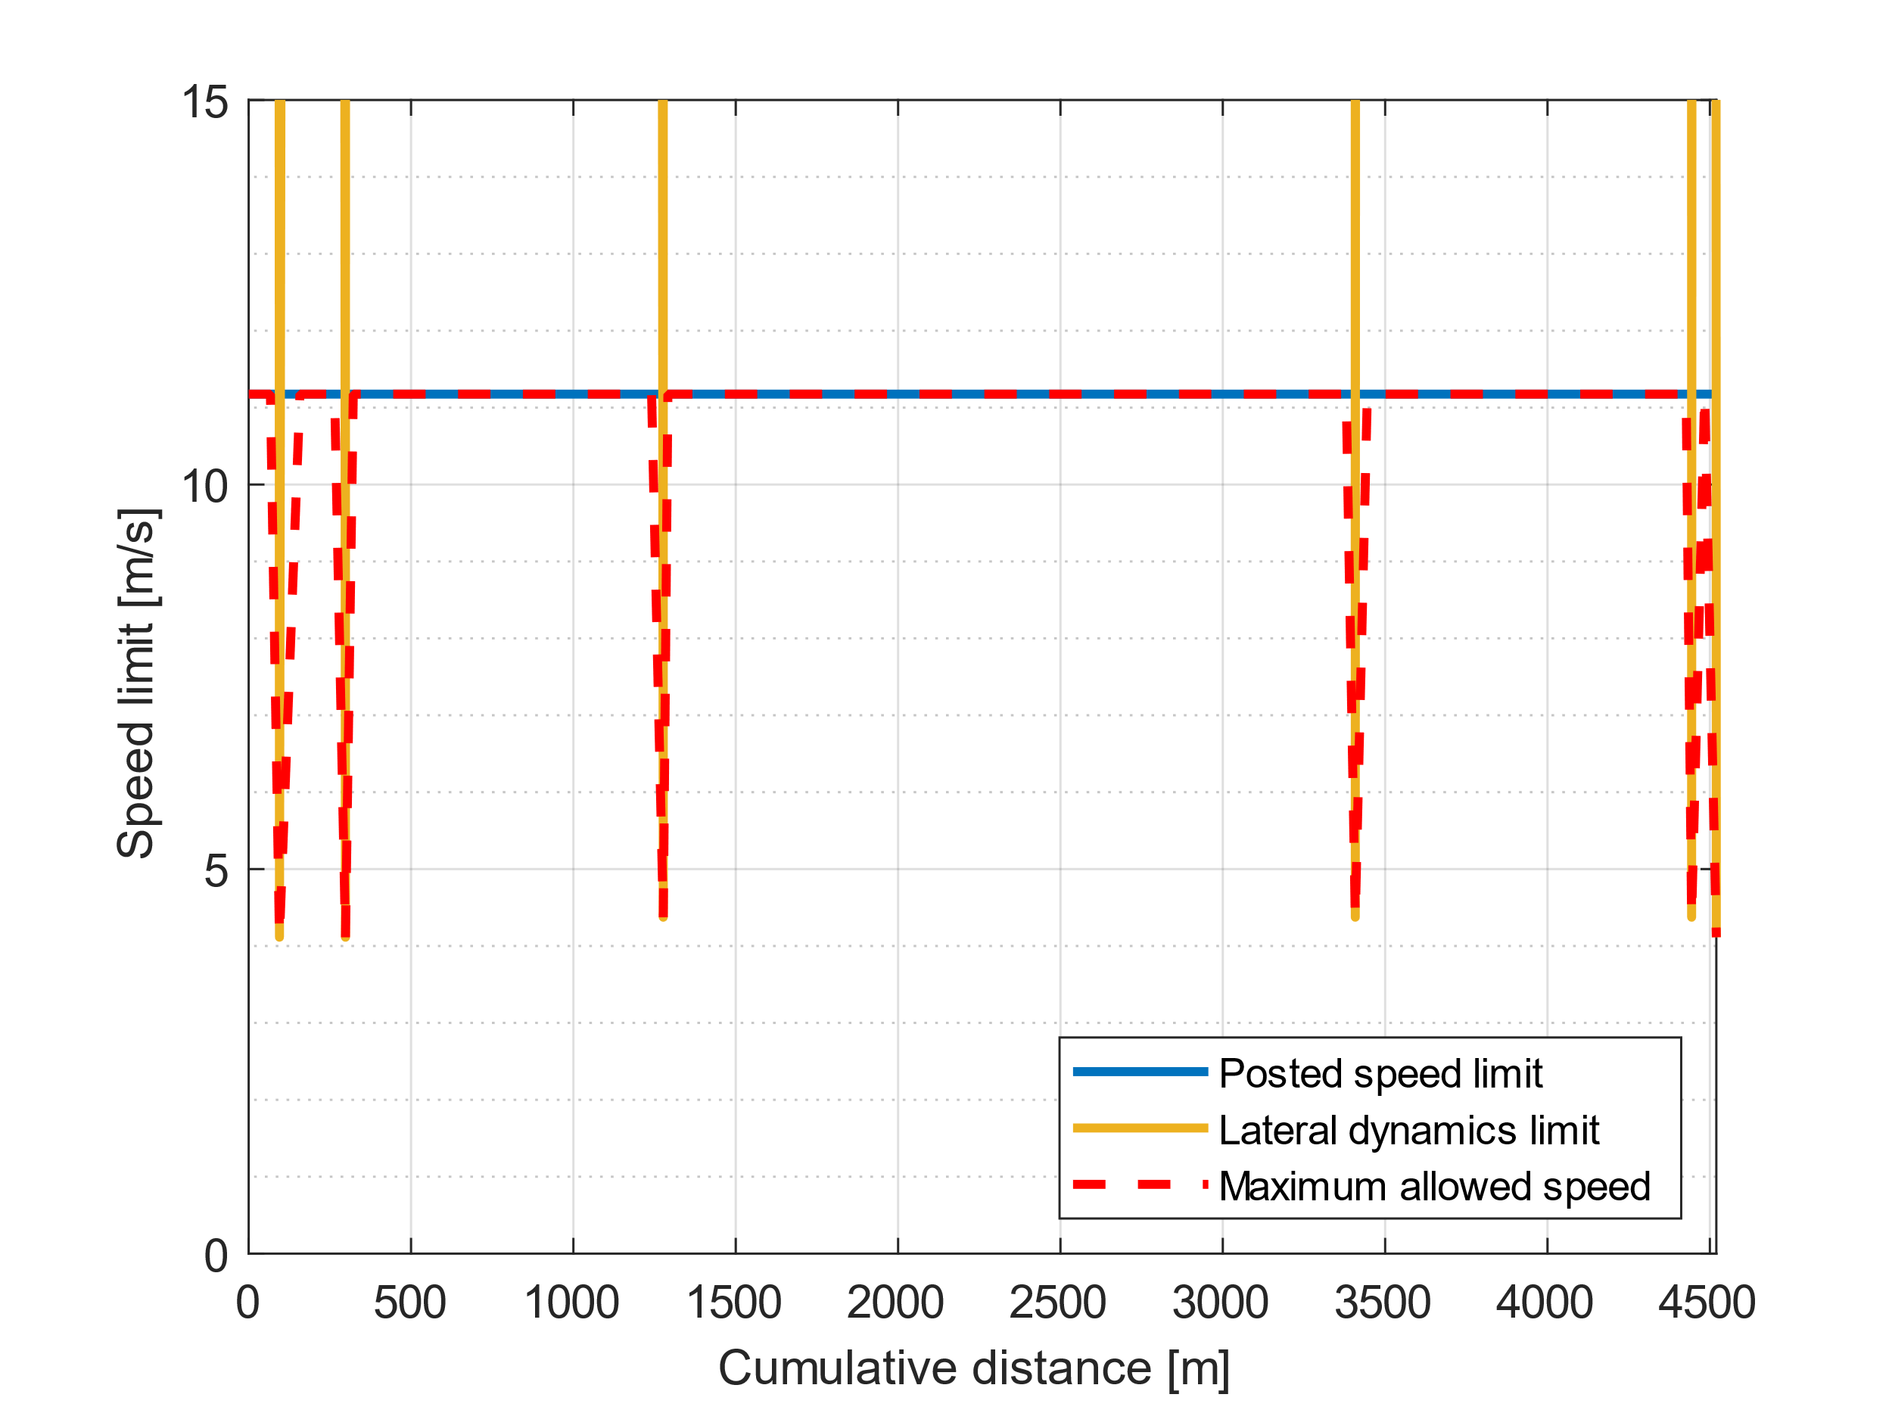
Figure 3. Maximum allowed speed along the test route. The posted speed limit (blue) is constant along the route (25 mph or 11.1 m/s), but the maximum allowed speed (red) is limited in correspondence of sharp turns.
$$\frac{dv\left(t\right)}{dt}=\left\{\begin{aligned}a \left[1-{\left(\frac{v\left(t\right)}{v_{SL}-θ_{0} }\right)}^{δ}\right] \left[FD\right], v\left(t\right)≤v_{SL}\left(t\right) \\ -b \left[1-{\left(\frac{v_{SL}-θ_{0}}{ v\left(t\right)}\right)}^{δ}\right] \left[FD\right], v\left(t\right)>v_{SL}\left(t\right) \\ \min\left\{\begin{matrix}a \left[1-{\left(\frac{v\left(t\right)}{v_{leader}\left(t\right)}\right)}^{δ}\right] \\ -\frac{1}{b} {\left(\frac{v^{2}\left(t\right)}{2 s\left(t\right)}\right)}^{2}\end{matrix}\right\} \left[CF\right], v\left(t\right)≤v_{leader}\left(t\right) \\ \min\left\{\begin{matrix}-b \left[1-{\left(\frac{v_{leader}\left(t\right)}{v\left(t\right)}\right)}^{δ}\right] \\ -\frac{1}{b} {\left(\frac{v^{2}\left(t\right)}{2 s\left(t\right)}\right)}^{2}\end{matrix}\right\} \left[CF\right], v\left(t\right)>v_{leader}\left(t\right) \\ -\frac{1}{b} {\left(\frac{v^{2}\left(t\right)-v_{next}^{2}}{2 s\left(t\right)}\right)}^{2} \left[SD\right], s\left(t\right)≤s_{brake}\left(t\right) \end{aligned}\right.$$ (7)
$$s\left(t\right)=x_{next}\left(t\right)-x\left(t\right)-s_{safe}$$ (8)
$$x_{next}\left(t\right)=\min\left(x_{SS}, x_{SLchange}, x_{leader}\left(t\right)\right)$$ (9)
$$s_{brake}\left(t\right)=\left(1+\frac{c_{1}}{δ}\right)\frac{v^{2}\left(t\right)}{2b}$$ (10)
$$s_{τ}\left(t\right)=τ v\left(t\right)$$ (11)
A brief description of the parameters in the Equations 7 – 11 is given in Table 1. The minimum safe gap, $s_{safe}$, was set to 2 m.

Table 1. EDM2 variables
Symbol | Units | Description
$x$ | m | Vehicle position
$x_{leader}$ | m | Leading vehicle position
$x_{SS}$ | m | Upcoming stop, yield or traffic light position
$x_{next}$ | m | Position of the closest change in driving scenario
$v$ | m/s | Vehicle speed
$v_{leader}$ | m/s | Leading vehicle speed
$s$ | m | Distance of the closest obstacle/driving scenario change
$s_{safe}$ | m | Safe gap
$s_{τ}$ | m | Distance corresponding to the constant time gap threshold

The EDM2 operating mode selection logic is represented by the flowchart in Figure 4.
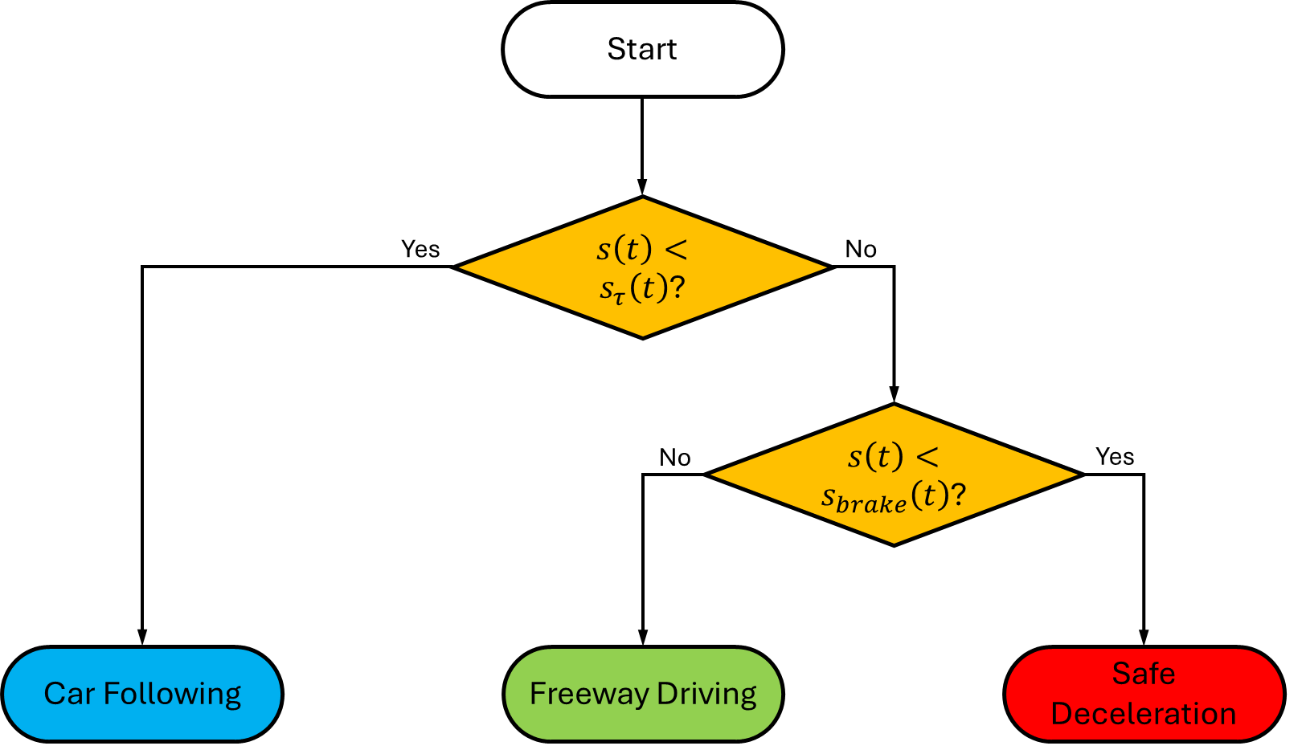
Figure 4. Flowchart showing the logic to select the operating modes of the EDM2.
The EDM2 has two main differences with respect to the mEDM. First, it introduces a time gap threshold, $τ$, to switch from CF to FD mode and vice-versa, preventing vehicles that are far away from their respective leaders to track their speed. Second, the CF mode equation for acceleration takes the minimum between the value predicted by mEDM’s CF mode and the EDM’s STOP mode, thus ensuring that a proper safety distance from the leading vehicle is maintained at all times. Furthermore, this last modification prevents the ego vehicle from tracking the leader speed in case the leading vehicle goes through a yellow or red traffic light or fails to respect a stop signal.
The EDM2 characterizes the behavior of the driver-vehicle system by means of the same parameters as those of the mEDM, plus the time gap threshold $τ$. The model parameters are: $a$ (>0) representing the maximum allowed acceleration, $b$ (>0) representing the maximum allowed deceleration, $δ$ representing driver aggressiveness, $θ_{0}$ representing the difference between driver’s perceived speed limit and the actual speed limit, and $c_{1}$, a calibration parameter for the critical braking distance. The values of the model parameters used in this work are shown in Table 2.

Table 2. EDM2 parameters
Parameter | Units | Calm car driver | Normal car driver | Aggressive car driver | Truck driver
$a$ | m/s² | 1.45 | 2.12 | 2.36 | 1.00
$b$ | m/s² | 0.52 | 1.04 | 1.28 | 1.00
$δ$ | / | 2.0 | 3.5 | 4.5 | 2.0
$θ_{0}$ | m/s | 0.57 | 0.18 | 0.08 | 0.57
$c_{1}$ | - | 2.75 | 1.46 | 0.96 | 2.75
$τ$ | s | 4.0 | 3.0 | 2.0 | 4.0

The EDM2 parameters in Table 2 for car drivers are taken from [41]. The $τ$ values were set based on simulation experience, as well as the $a$ and $b$ parameters for the truck. The minimum safe gap, $s_{safe}$, was set to 2 m. Further analyses should be conducted in the future about these parameters to ensure proper representation of driver behavior.
One important aspect to consider is that $b$ is a critical parameter in the EDM2. Indeed, $b$ is used to calculate the braking distance, $s_{brake}$, parameter that is used to discriminate between SD mode and FD mode as shown in Figure 4. If the powertrain model in Simulink is not able to deliver the deceleration expressed by the parameter $b$, the braking distance will be underestimated and so the vehicle will not be able to stop in time, failing to respect traffic signs and potentially causing collisions with other vehicles. As a consequence, the value of $b$ for the ego vehicle must be carefully evaluated through simulation. Future work will focus on the creation of a lookup table to adjust the value of $b$ based on the vehicle operating conditions. This will allow to tune the EDM2 on-the-fly, considering braking performance variations due to varying state of charge, load and road grade.
Macroscopic Traffic Benchmark
A micro-traffic model is used in this study to simulate a flow of vehicles moving along the test route. All the vehicles are controlled with the EDM2 described in the previous section. Micro-traffic models are the best choice to simulate detailed vehicle-to-vehicle interactions and are therefore ideal for traffic-in-the-loop simulations and benchmarking ADAS. Anyway, it is often a best practice to analyze the performance of the ego vehicle as a function of macroscopic traffic parameters, processing simulation results with a statistical approach. Therefore, a benchmark should be established to assess whether the micro-traffic simulation provides coherent results from a macroscopic perspective. An analysis is here proposed that allows to derive theoretical expectations on the evolution of traffic at macroscopic level, establishing such benchmark. A practical example of how simulation result distribute with respect to the theoretical benchmark is provided in the Simulation Results section.
Three different macro-traffic parameters are considered in this analysis: average traffic speed, $v_{avg}$, average traffic density, $ρ_{avg}$, and average traffic flow, $Q_{avg}$. Equation 12 correlates the average traffic density to the average traffic flow [10]:
$$Q_{avg}=ρ_{avg} v_{avg}$$ (12)
The average traffic speed is obtained directly from the micro-traffic simulation as the integral average over time of the instantaneous average traffic velocity, as detailed in Equation 13.
$$v_{avg}=\frac{1}{t_{f}-t_{0}} \int_{t_{0}}^{t_{f}}{\left(\frac{1}{n_{veh}\left(t\right)}\sum_{k=1}^{n_{veh}\left(t\right)}{v_{k}}\right) dt}$$ (13)
Where $t_{0}$ is the simulation start time, $t_{f}$ is the simulation end time and $n_{veh}\left(t\right)$ is the number of vehicles that are active in the simulation at time $t$.
Also the average traffic density is obtained directly from the simulation as the integral average over time of the instantaneous average traffic density, as shown in Equation 14.
$$ρ_{avg}=\frac{1}{t_{f}-t_{0}} \int_{t_{0}}^{t_{f}}{\frac{n_{veh}\left(t\right)}{s_{route}} dt}$$ (14)
Where $s_{route}$ is the length of the route.
The maximum theoretical free-flow traffic density, $ρ_{lim,FF}$, is the number of vehicles per unit length per lane that the road can accommodate when all the space along it is occupied. Since the braking distance varies with speed, the spacing between two consecutive vehicles is a function of the average traffic velocity, $v_{avg}$, and so does $ρ_{lim,FF}$. Applying this first-principle approach, the maximum theoretical free-flow traffic density along the test route can be calculated as described by Equation 15:
$$ρ_{lim,FF}\left(v_{avg}\right)=\frac{1}{s_{veh}\left(v_{avg}\right)}=\frac{1}{s_{lenght}+s_{brake}\left(v_{avg}\right)+s_{safe}}$$ (15)
Where $s_{length}$ is the length of the average vehicle in the traffic flow, which was set to 5 m since the scenario was composed of a single truck moving in a flow of cars.
The result of Equation 15 does not consider the fact that traffic lights interrupt the flow of vehicles, causing them to accumulate in proximity of intersections during red phases. It is possible to account for the effect of traffic lights by multiplying $ρ_{lim,ff}$ by the ratio of the green time over the total cycle time, as described by Equation 16. Since 17 traffic lights are present along the test route, each with its own phasing, the average green time, $t_{green,avg}$, and the average cycle time, $t_{cycle,avg}$, were considered.
$$ρ_{limTL}\left(v_{avg}\right)=ρ_{lim,FF}\left(v_{avg}\right)\frac{t_{green,avg}}{t_{cycle,avg}}$$ (16)
Equation 16 does not consider the dynamics of vehicles accelerating when the light turns green, but still provides valuable insights on the effect of traffic lights on the flow of vehicles. The effect of the approximation gets larger with increasing average traffic speed, because vehicles take longer to reach their steady-state velocity.
The free-flow theoretical maximum traffic flow, $Q_{lim,FF}$, can be obtained by substituting Equation 15 into Equation 12. Similarly, the traffic light-adjusted theoretical maximum traffic flow, $Q_{lim,TL}$, can be obtained by introducing Equation 16 into Equation 12.
Figure 5 shows how both free-flow and traffic light-adjusted theoretical limits for traffic density and traffic flow evolve as a function of traffic speed.
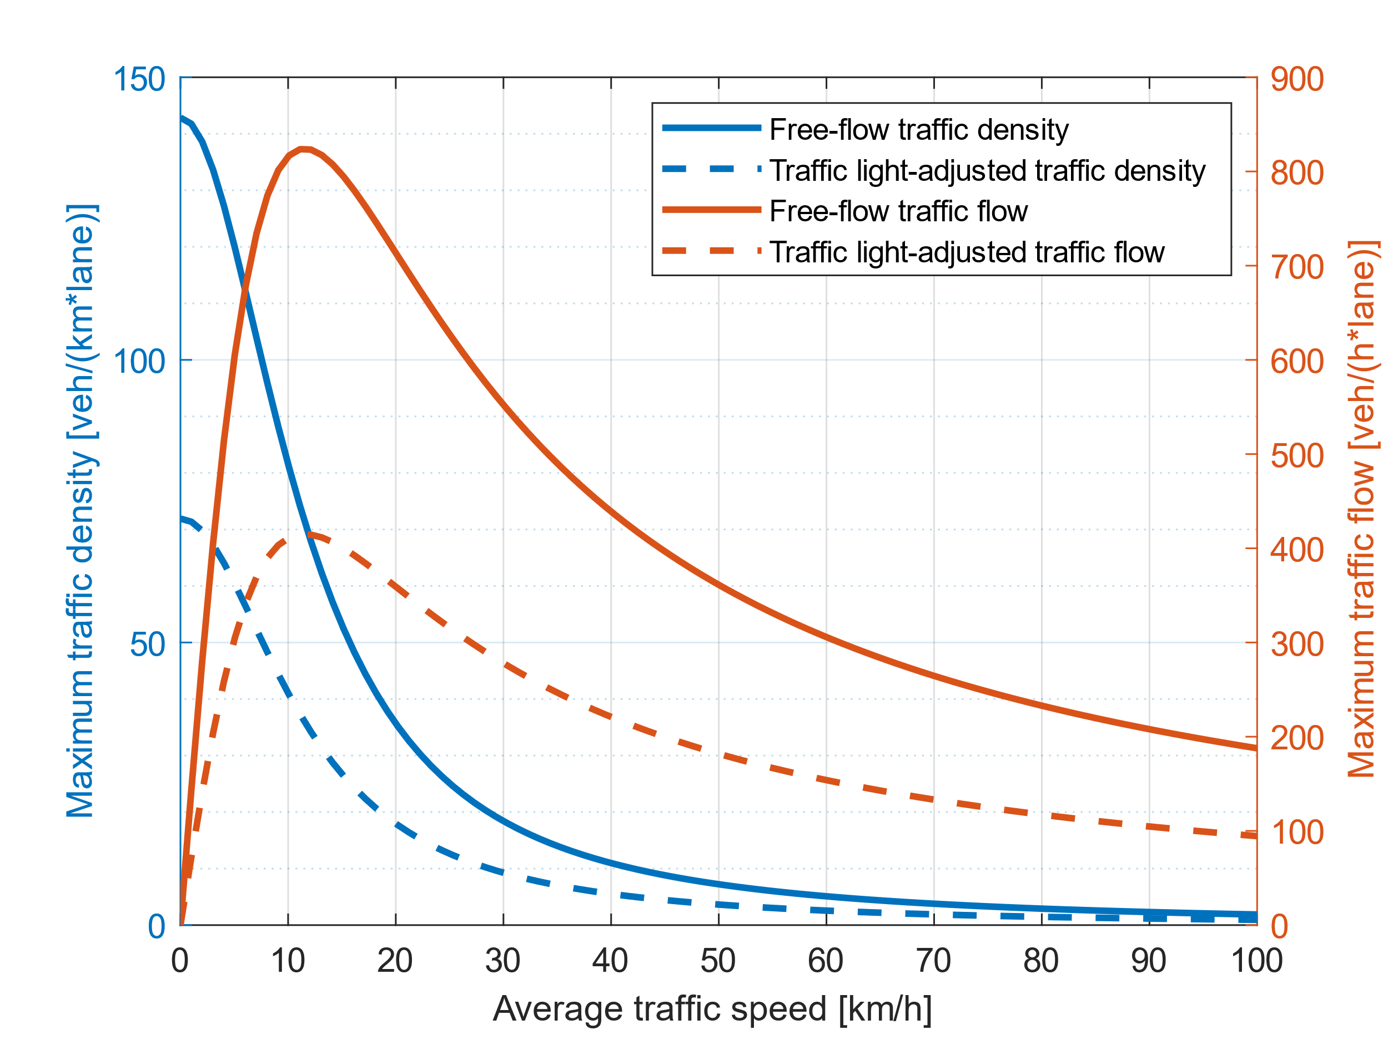
Figure 5. Theoretical free flow (solid lines) and traffic light-adjusted (dashed lines) limits for traffic density and traffic flow as a function of the average traffic speed.
The plot showing how traffic flow evolves with average traffic density, commonly referred to as fundamental diagram, is shown in Figure 6. From a qualitative perspective the fundamental diagram is in good agreement with literature references [10] [39] [47], with a parabolic shape that peaks before lowering to zero at high values of average traffic density, providing a sanity check for the micro-traffic simulations developed in this study. Anyway, it is hard to say whether the numeric values are truly representative of the test route because of lack of experimental data for validation. Indeed, the curves in Figure 5 and Figure 6 are heavily influenced by the EDM2 equations, in particular by the value of $s_{brake}$, which is likely overestimated in CF mode. A big role is played by traffic light timing too, which has the effect of scaling down the free flow curve.
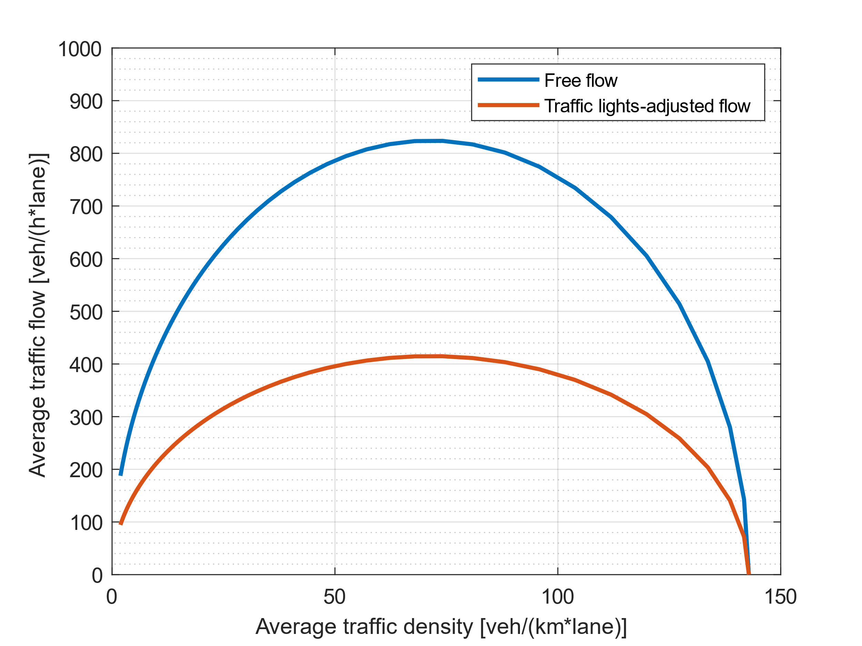
Figure 6. Macro-traffic fundamental diagram for the test route.
These considerations evidence the need for further development of the EDM2. Indeed, in CF mode the safety distance from the leader is calculated assuming its speed to be zero, as shown in Equation 7. This simplification was necessary to obtain a collision-free behavior of the micro-traffic model, giving vehicles enough space to react to leader’s deceleration at the cost of overestimating safety distance. This probably results in an underestimation of the free-flow theoretical maximum traffic density and traffic flow, especially at high values of average traffic speed.
Case Study
An urban route in Columbus, OH, has been considered in this study. As it is shown in Figure 7, the test route is characterized by 5 sharp right-hand turns and three main straight segments, with 17 traffic light intersections from origin to destination. The route is 4520 m long and the posted speed limit along it is 25 mph. The schedules of all traffic lights along the route, with their offset with respect to the first, have been recorded on site and they are available in Figure 8.
The main route characteristics are shown in Figure 9, displaying posted speed limits, road curvature and road grade as a function of cumulative distance.
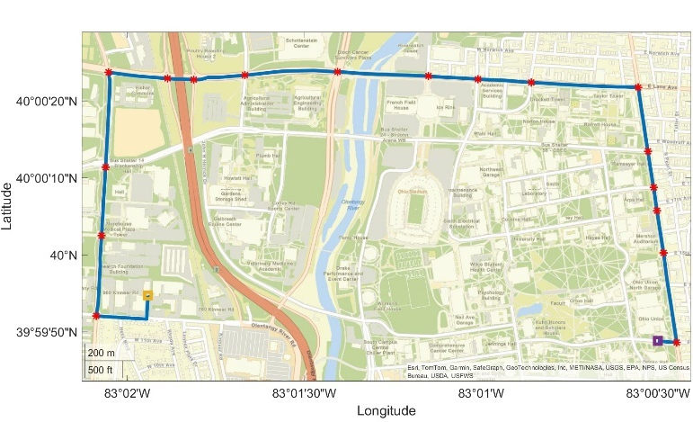
Figure 7. Test route from origin (in yellow) to destination (in purple). Red stars indicate traffic light locations.
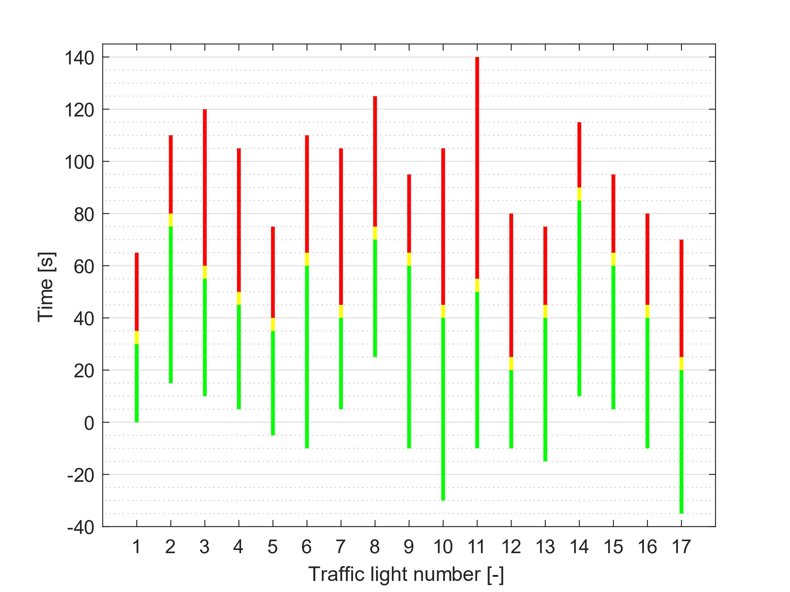
Figure 8. Traffic light schedules.
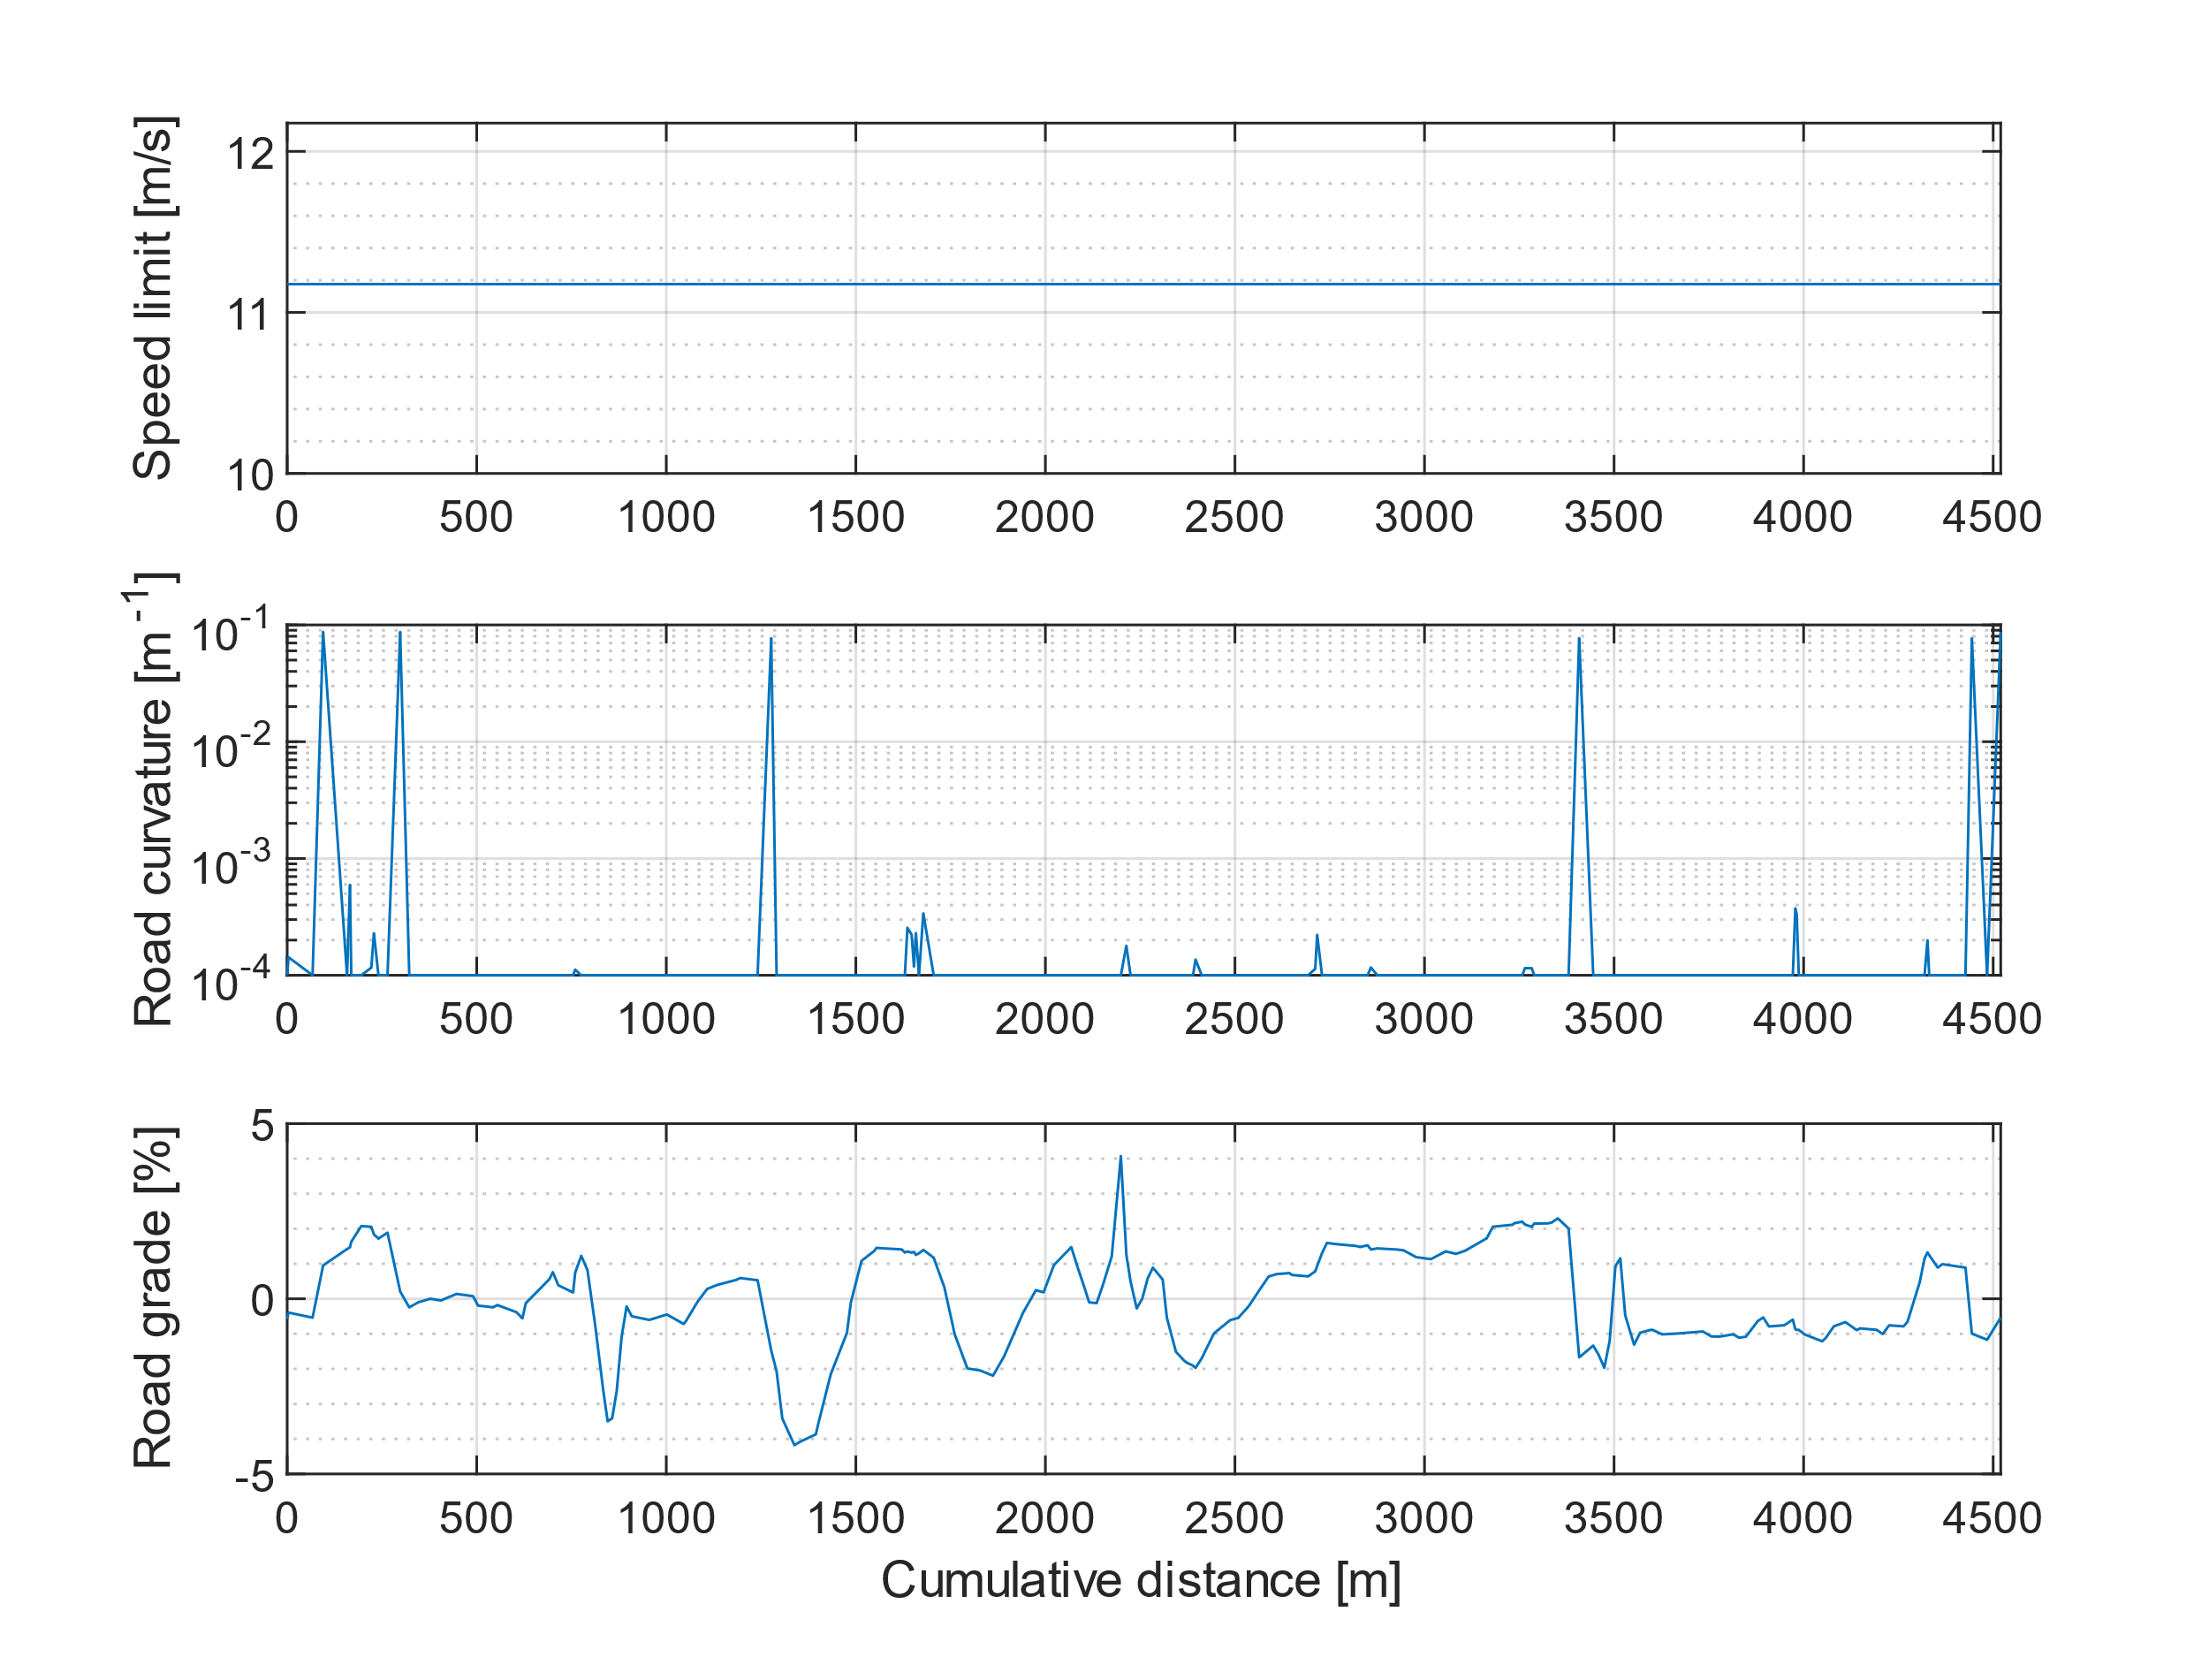
Figure 9. Main characteristics of the test route.
Simulation Results
This section presents simulation results for an electric heavy duty truck driving along the route plotted in Figure 7 in a traffic flow composed of passenger cars. All vehicles are controlled by means of the EDM2, with parameters changing based on vehicle type (passenger car or truck) as described in Table 2. Passenger cars are injected in the simulation with equal probability of having calm, normal or aggressive driving.
Seven different simulation batches were run, each composed of 100 individual cases, using a sample time of 1s in SUMO and of 0.1s in Simulink. Batches differ one another by the settings of the traffic management policy, whose scope is to introduce and remove vehicles to match a desired traffic density. Each simulation batch is shown with a different color in the following Figures 10 – 14, with each color representing a batch of 100 simulations run in similar macroscopic traffic conditions. Within each batch, simulations differ one another by ego vehicle injection time, sampled from a uniform distribution ranging from 0 to 100 s. The number of batches was limited by the available computational power, with simulations taking longer as traffic congestion increases due to the larger number of vehicles moving along the route at the same time.
Figure 10 shows how the average ego vehicle speed changes for different average traffic densities. In general, the average speed of the ego vehicle can greatly change even with small variations of traffic density within the same batch, probably because of stops at traffic lights, whose length and number change in every simulation.
The plot makes it evident that simulation results are in good agreement with the theoretical expectations derived in the Macroscopic Traffic Benchmark section, shown as red curves. The two limit curves are plotted under the assumption that the ego vehicle average speed is representative of the average traffic speed. The distribution of results only deviates from the traffic light-adjusted limit at high values of average speed, which can probably be attributed to the fact that the dynamics of vehicles accelerating after a traffic light is not considered in the traffic density limits, resulting in an overestimated limit. Indeed, the impact of the acceleration phases is likely to get larger with increasing average traffic speed because vehicles take longer to reach cruising velocity.
Figure 11 shows the ego vehicle specific energy consumption as a function of its average speed. Overall, energy consumption seems to be well correlated to average speed, indicating a significantly higher consumption under congested traffic scenarios.
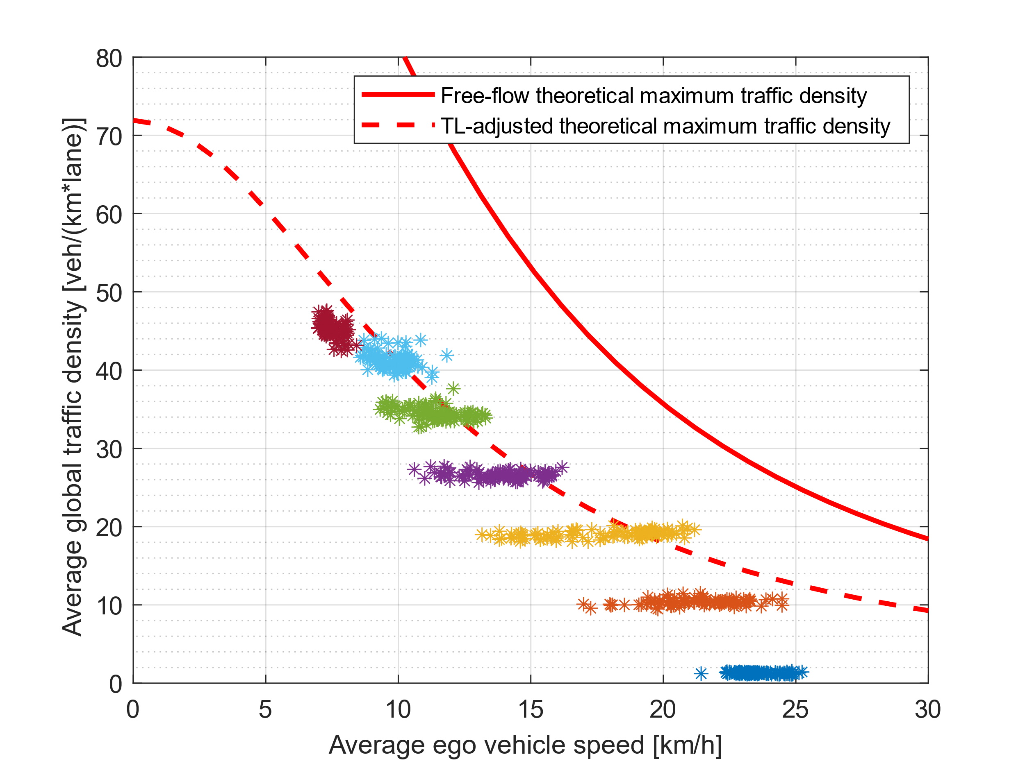
Figure 10. Comparison of simulation results and theoretical limitations to traffic density. Each color represents a batch of 100 simulations run in similar macroscopic traffic conditions. As traffic density decreases, the average ego vehicle speed increases, in agreement with the theoretical limitations.
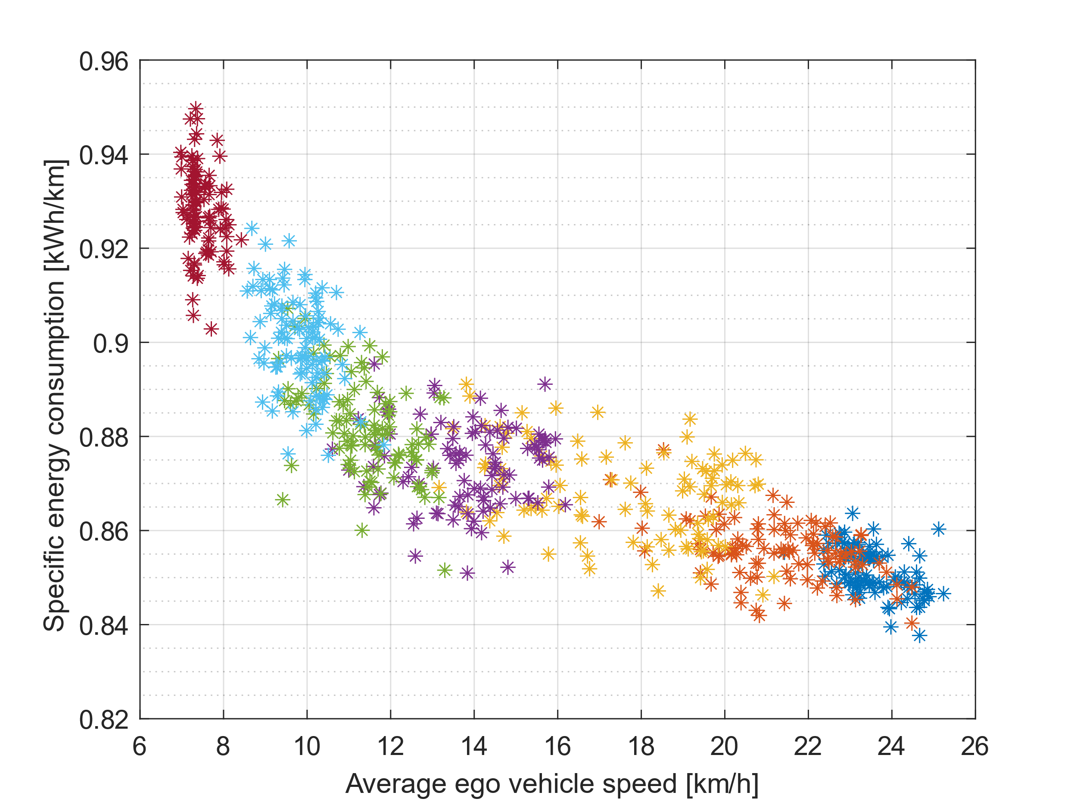
Figure 11. Specific energy consumption as a function of average speed
The reason why specific energy consumption gets larger with increasing traffic density is likely found in the larger number of accelerations and decelerations that the vehicle undergoes under such conditions, as shown in Figure 12. Indeed, speed oscillates much more when traffic is intense because of several different reasons, including the increased waiting time at traffic lights and the fact that drivers should adapt their speed to that of the surrounding vehicles to avoid collisions, generally leading to a more nervous drive. Assuming the more nervous driving dynamics in congested traffic scenarios to be the main cause of the energy consumption increase, the trend plotted in Figure 11 is likely magnified in the case of vehicles that are not capable of regenerative braking, further proving the importance of properly simulating traffic to assess real-world vehicle performance.
Another factor that may penalize conventional vehicles over electrified powertrains is the increase of idling time with reducing average speed, shown in Figure 13. Idling time does not only increase in absolute terms but also when the percentage of driving time spent idling is considered, as shown in Figure 14. Anyway, the distribution of results in this case is much more scattered than the one shown in Figure 14.
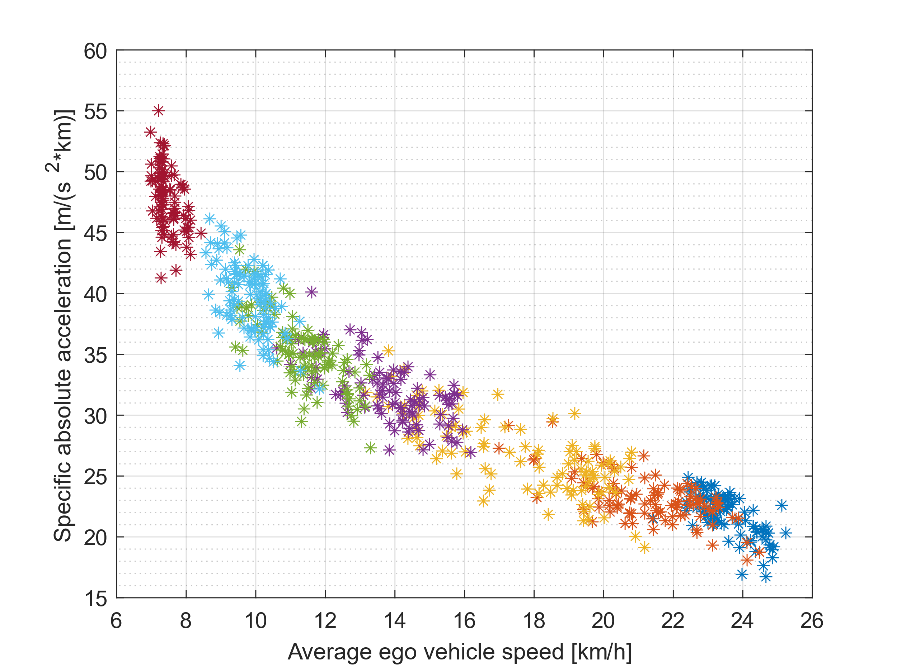
Figure 12. Cumulative absolute acceleration as a function of average speed
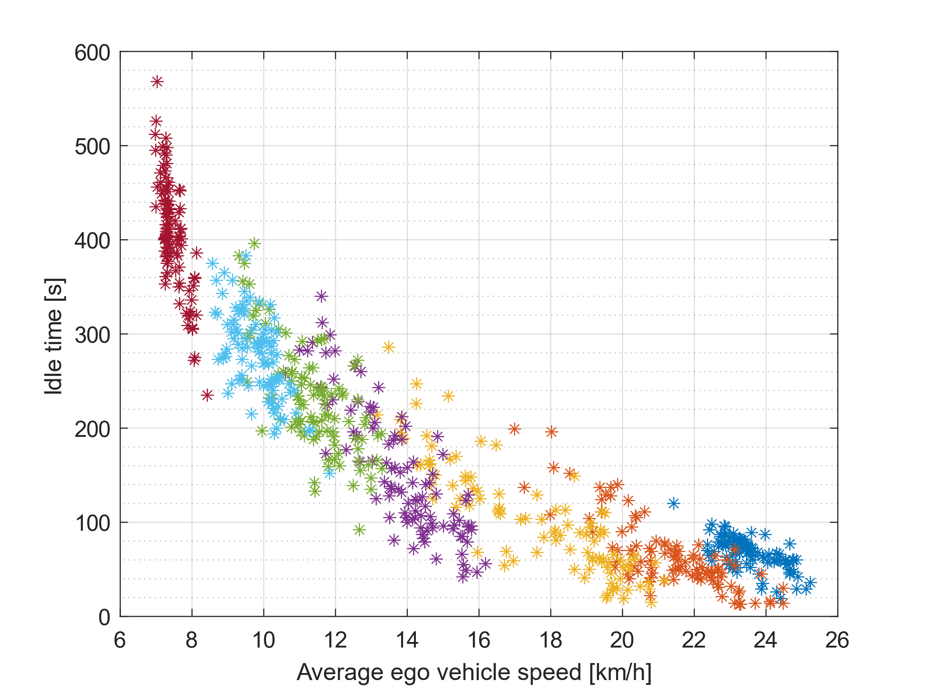
Figure 13. Cumulative idle time as a function of average speed
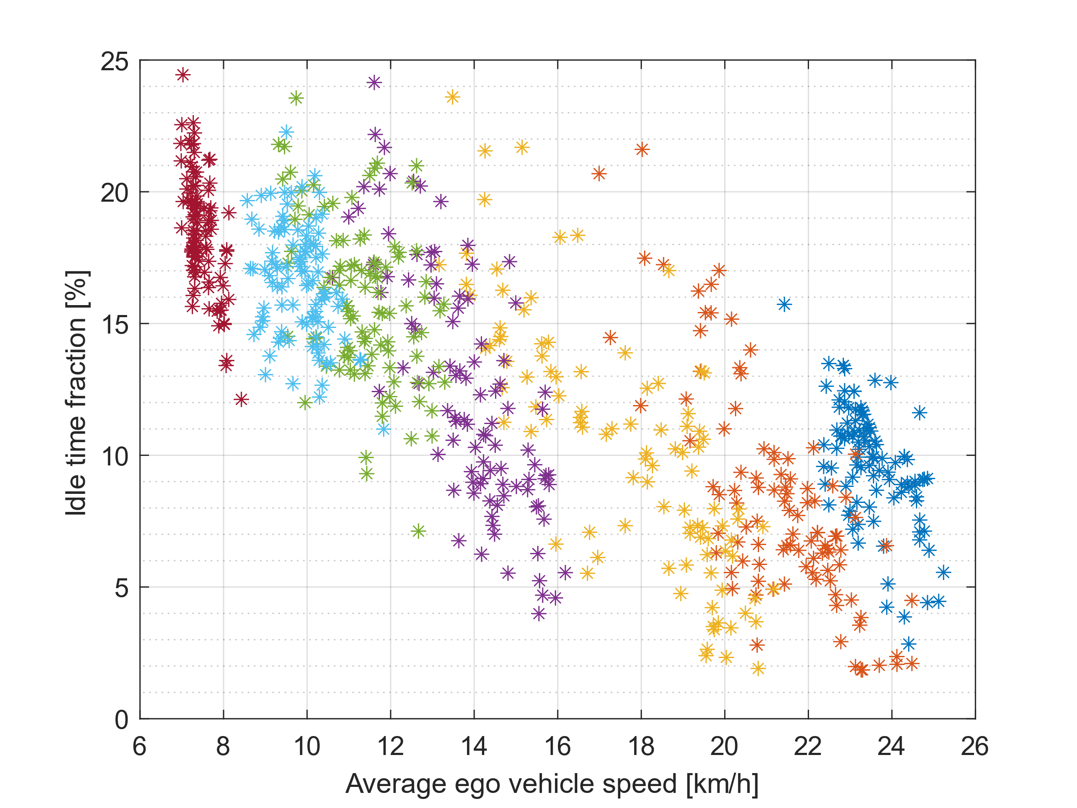
Figure 14. Cumulative idle time as a function of average speed
Conclusions
In an automotive industry that is evolving in the direction of increasingly sophisticated technologies to optimize safety, comfort and energy efficiency, vehicle simulation must keep the pace to truly assess the beneficial effects of such technologies. At the moment of writing, no standardized solution exists for the simulation of advanced ADAS, making it difficult to compare their benefits. Similar technologies lead to dramatically different results based on the simulation boundary conditions, complicating the comparison between the work of different authors. The development of a standardized test methodology that is capable to capture realistic driving conditions is therefore crucial to guarantee a fair comparison. The present study detailed a traffic-in-the-loop simulation framework aimed at satisfying such need, potentially shifting the focus of vehicle simulations from the concept of standard driving cycles to that of standard driving scenarios.
The study showed how is it possible to simulate a vehicle moving in a micro-traffic scenario, preserving the causality between powertrain dynamics and vehicle speed by means of a three-layers closed-loop co-simulation between SUMO, MATLAB and Simulink. The choice of overriding SUMO’s embedded controller for vehicles’ longitudinal speed with a custom controller in MATLAB gave great flexibility to the co-simulation framework allowing the creation of a heterogeneous traffic flow composed of drivers characterized by different levels of aggressiveness. This setup leaves the door open to further evolutions, like the use of different controllers within the same traffic flow to simulate vehicles characterized by different automation levels, potentially leading to a framework capable of modelling cooperative driving behaviors within a flow of heterogeneous vehicles.
Simulation results demonstrate how complicated vehicle-to-vehicle and vehicle-to-infrastructure interactions are, evidencing the need to move away from traditional deterministic simulation approaches in favor of stochastic ones to truly assess vehicle real-world performance. As shown in the Simulation Results section, the average ego vehicle speed is well correlated with energy consumption, showing that energy efficiency increases as the average velocity gets larger. At the same time, the amount of acceleration that the vehicle is subjected to decreases with increasing average speed, resulting in a less energy-intense drive. Future work should investigate whether this trend is confirmed over larger speed ranges, because at high speed aerodynamic drag increase may outweigh the benefit induced by low traffic conditions.
The increased speed variability under congested traffic conditions that emerged from simulation results demonstrate the great simplification introduced by the use of macroscopic traffic models. While these are very useful to gather preview information for optimization purposes, they cannot accurately reproduce the complex vehicle-to-vehicle interactions that characterize real-world driving and therefore cannot be used to reliably demonstrate the benefits of ADASs. Indeed, macro-traffic models impact the vehicle dynamics by imposing a speed limit that evolves with traffic conditions, without causing the oscillations in ego vehicle’s velocity that are typical of real-world driving.
Future research work must be dedicated to the further development of the presented simulation platform. Key areas of improvement are:
- Development of appropriate Key Performance Indicators (KPIs) for the assessment of vehicle performance within realistic traffic scenarios.
- Investigation of the influence of parameters like traffic light timing and number, stop and yield locations number, driving dynamics, and driving aggressiveness.
- Improvement of the driver model to reduce its dependence on the parameter $b$ and to obtain more realistic vehicle-to-vehicle distance.
- Development of a robust traffic management policy to better track the desired traffic density, giving more control over simulation conditions.
- Automatization of scenario creation in SUMO for quick simulation setup.
- Performance optimization to reduce computational burden.
Acknowledgement
The authors thank the United States Department of Energy for the support for this project. This material is based upon work supported by the Department of Energy, under Grant Number DE-EE0009861.
References
- SAE International Recommended Practice, “Taxonomy and Definitions for Terms Related to Driving Automation Systems for On-Road Motor Vehicles”, SAE Standard J3016_202104, Revised April 2021, Issued January 2014, doi: 10.4271/J3016_202104
- A. Vahidi, A. Sciarretta, “Energy saving potentials of connected and automated vehicles”, in Transportation Research Part C: Emerging Technologies, vol. 95, pp. 822-843, 2018, doi: 10.1016/j.trc.2018.09.001
- M. Noroozi, H. R. Moghaddam, A. Shah, H. Charkhgard, S. Sarkar, T. K. Das, “An AI-Assisted Systematic Literature Review of the Impact of Vehicle Automation on Energy Consumption”, in IEEE Transactions on Intelligent Vehicles, vol. 8 n. 2, pp. 3572-3592, 2023, doi: 10.1109/TIV.2023.3268300
- A. Sciarretta, G. De Nunzio, L. L. Ojeda, “Optimal Ecodriving Control: Energy-Efficient Driving of Road Vehicles as an Optimal Control Problem”, in IEEE Control Systems Magazine, vol. 35, n. 5, pp. 71-90, 2015, doi: 10.1109/MCS.2015.2449688
- S. R. Deshpande, S. Gupta, A. Gupta, M. Canova, “Real-Time Ecodriving Control in Electrified Connected and Autonomous Vehicles Using Approximate Dynamic Programing”, in Journal of Dynamic Systems, Measurements, and Control, vol. 144, n. 1, 2022, doi: 10.1115/1.4053292
- M. Spano, A. Shiledar, S. Gupta, M. Villani, D. Misul, M. Canova, G. Rizzoni, "Performance Evaluation of an Eco-Driving Controller for Fuel Cell Electric Trucks in Real-World Driving Conditions", SAE Technical Paper 2024-01-2183, 2024, doi: 10.4271/2024-01-2183
- F. Lattemann, K. Neiss, S. Terwen, T. Connolly, "The Predictive Cruise Control – A System to Reduce Fuel Consumption of Heavy Duty Trucks", SAE Technical Paper 2004-01-2616, 2004, doi: 10.4271/2004-01-2616
- S. Paul, V. Goyal, S. Joshi, M. Franke, D. Tomazic, J. Zeman, "Evaluation of Longitudinal ADAS Functions for Fuel Economy Improvement of Class 8 Long Haul Trucks", SAE Technical Paper 2023-01-0217, 2023, doi: 10.4271/2023-01-0217
- M. Villani, A. Shiledar, B. Block, M. Spano, G. Rizzoni, "Optimal Eco-Driving with Infrastructure-to-Vehicle Communication for Speed Adaptation Based on Real-Time Dynamic Macroscopic Traffic Conditions", SAE Technical Paper 2024-24-0025, 2024, doi: 10.4271/2024-24-0025
- M. Treiber, A. Kesting, “Traffic Flow Dynamics: Data, Models and Simulation”, Cham, Switzerland: Springer, 2012, doi: 10.1007/978-3-642-32460-4
- M. J. Lighthill, G. B. Whitham, “On kinematic waves II. A theory of traffic flow on long crowded roads”, in Proceedings of the Royal Society A: Mathematical, Physical and Engineering Sciences, 1955, doi: 10.1098/rspa.1955.0089.
- F. Ma, Y. Yang, J. Wang, Z. Liu, J. Li, J. Nie, Y. Shen e L. Wu, “Predictive energy-saving optimization based on nonlinear model predictive control for cooperative connected vehicles platoon with V2V communication”, in Energy, vol. 189, 2019, doi: 10.1016/j.energy.2019.116120
- C. Manzie, H. Watson and S. Halgamuge, “Fuel economy improvements for urban driving: Hybrid vs. intelligent vehicles”, in Transportation Research Part C: Emerging Technologies, vol. 15, no. 1, pp. 1-16, 2007, doi: 10.1016/j.trc.2006.11.003
- J. Han, A. Sciarretta, L. L. Ojeda, G. De Nunzio e L. Thibault, “Safe- and Eco-Driving Control for Connected and Automated Electric Vehicles Using Analytical State-Constrained Optimal Solution”, in IEEE Transactions on Intelligent Vehicles, vol. 3, n. 2, pp. 163-172, 2018, doi: 10.1109/TIV.2018.2804162
- S. B. Rengarajan, S. Hotz, C. Hirsch, P. Lobato, M. Gross, P. Sturgeon, J. Sarlashkar, "Test Methodology to Quantify and Analyze Energy Consumption of Connected and Automated Vehicles," SAE Technical Paper 2019-01-0116, 2019, doi: 10.4271/2019-01-0116
- D. Jia, H. Chen, Z. Zheng, D. Watling, R. Connors, J. Gao, Y. Li, “An Enhanced Predictive Cruise Control System Design With Data-Driven Traffic Prediction”, in IEEE Transactions on Intelligent Transportation Systems, vol. 23, n. 7, pp. 8170-8183, 2022, doi: 10.1109/TITS.2021.3076494
- M. I. Nasri, T. Bektaş e G. Laporte, “Route and speed optimization for autonomous trucks”, in Computers & Operations Research, vol. 100, pp. 89-101, 2018, doi: 10.1016/j.cor.2018.07.015
- C. Zheng, G. Xu, K. Xu, Z. Pan e Q. Liang, “An energy management approach of hybrid vehicles using traffic preview information for energy saving”, in Energy Conversion and Management, vol. 105, pp. 462-470, 2015, doi: 10.1016/j.enconman.2015.07.061
- M. A. S. Kamal, S. Taguchi and T. Yoshimura, “Efficient Driving on Multilane Roads Under a Connected Vehicle Environment”, in IEEE Transactions on Intelligent Transportation Systems, vol. 17, no. 9, pp. 2541-2551, 2016, doi: 10.1109/TITS.2016.2519526
- H. Yao e X. Li, ”Lane-change-aware connected automated vehicle trajectory optimization at a signalized intersection with multi-lane roads”, in Transportation Research Part C: Emerging Technologies, vol. 129, 2021, doi: 10.1016/j.trc.2021.103182
- C. Ma, C. Yu e X. Yang, “Trajectory planning for connected and automated vehicles at isolated signalized intersections under mixed traffic environment”, in Transportation Research Part C: Emerging Technologies, vol. 130, 2021, doi: 10.1016/j.trc.2021.103309
- J. Rios-Torres and A. A. Malikopoulos, “Automated and Cooperative Vehicle Merging at Highway On-Ramps”, in IEEE Transactions on Intelligent Transportation Systems, vol. 18, no. 4, pp. 780-789, 2017, doi: 10.1109/TITS.2016.2587582
- W. Xiao e C. G. Cassandras, “Decentralized optimal merging control for Connected and Automated Vehicles with safety constraint guarantees”, in Automatica, vol. 123, 2021, doi: 10.1016/j.automatica.2020.109333
- H. Min, Y. Fanf, X. Wu, G. Wu e X. Zhao, “On-ramp merging strategy for connected and automated vehicles based on complete information static game” in, Journal of Traffic and Transportation Engineering (English Edition), vol. 8, n. 4, pp. 582-595, 2021, doi: 10.1016/j.jtte.2021.07.003
- J. Liu, W. Zhao e C. Xu, “An Efficient On-Ramp Merging Strategy for Connected and Automated Vehicles in Multi-Lane Traffic”, in IEEE Transactions on Intelligent Transportation Systems, vol. 23, n. 6, pp. 5056-5067, 2021, doi: 10.1109/TITS.2020.3046643
- N. Wan, A. Vahidi and A. Luckow, “Optimal speed advisory for connected vehicles in arterial roads and the impact on mixed traffic”, in Transportation Research Part C: Emerging Technologies, vol. 69, pp. 548-563, 2016, doi: 10.1016/j.trc.2016.01.011
- M. Ferreira and P. M. D'Orey, “On the impact of virtual traffic lights on carbon emissions mitigation”, in IEEE Transactions on Intelligent Transportation Systems, vol. 13, no. 1, pp. 284-295, 2012, doi: 10.1109/TITS.2011.2169791
- S. Huang, A. W. Sadek and Y. Zhao, “Assessing the Mobility and Environmental Benefits of Reservation-Based Intelligent Intersections Using an Integrated Simulator”, in IEEE Transactions on Intelligent Transportation Systems, vol. 13, no. 3, pp. 1201-1214, 2012, doi: 10.1109/TITS.2012.2186442
- P. A. Lopez, M. Behrisch, L. Bieker-Walz, J. Erdmann, Y.-P. Flotterod, R. Hilbrich, L. Lucken, J. Rummel, P. Wagner, E. Wießner, “Microscopic Traffic Simulation using SUMO”, in 21st International Conference on Intelligent Transportation Systems (ITSC), Maui, 2018, doi: 10.1109/ITSC.2018.8569938
- A. V. Rajendran, B. Hegde, Q. Ahmed, G. Rizzoni, “Design and Development of Traffic-In-Loop Powertrain Simulation”, in 2017 IEEE Conference on Control Technology and Applications (CCTA), Maui, 2017, doi: 10.1109/CCTA.2017.8062473
- A. Wegener, M. Piorkowski, M. Raya, H. Hellbrück, S. Fischer, J.-P. Hubaux, “TraCI: An Interface for Coupling Road Traffic and Network Simulators”, in CNS '08: Proceedings of the 11th communications and networking simulation symposium, 2008, doi: 10.1145/1400713.1400740
- A. F. Acosta, J. E. Espinosa Oviedo, J. J. Espinosa Oviedo, “TraCI4Matlab: Enabling the Integration of the SUMO Road Traffic Simulator and Matlab® Through a Software Re-engineering Process”, in Modeling Mobility with Open Data. Lecture Notes in Mobility, 2015, doi: 10.1007/978-3-319-15024-6_9
- H. d. Carvalho Pinheiro, “PerfECT Design Tool: Electric Vehicle Modelling and Experimental Validation”, in World Electric Vehicle Journal, vol. 14, n. 12, 2023, doi: 10.3390/wevj14120337
- G. Imberti, H. d. Carvalho Pinheiro, M. Carello, “Modelling and Control of a Fuel Cell and Battery Electric Vehicle for Energy Optimization”, in Advances in Italian Mechanism Science, Cham, Switzerland, Springer Nature, 2024, pp. 163-170, doi: 10.1007/978-3-031-64569-3_20
- E. Bianco, L. Di Napoli, E. Grano, M. Carello, “E-scooter modelling: battery and fuel cell system integration”, in The Fourth International Conference of IFToMM Italy, Napoli, 2022, doi: 10.1007/978-3-031-10776-4_104
- E. Grano, T. Lazek, M. Carello, "A numerical Methodology for Induction Motor Control: Lookup Tables Generation and Steady-State Performance Analysis", SAE Technical Paper 2024-01-2152, 2024, doi: 10.4271/2024-01-2152.104
- E. Grano, E. Bianco, H. d. Carvalho Pinheiro, M. Carello, “MTPA and flux weakening control of electric motors: a numerical approach”, in 2023 IEEE International Conference on Environment and Electrical Engineering and 2023 IEEE Industrial and Commercial Power Systems Europe (EEEIC / I&CPS Europe), Madrid, 2023, doi: 10.1109/EEEIC/ICPSEurope57605.2023.10194684
- S. Krauss, P. Wagner, C. Gawron, “Metastable states in a microscopic model of traffic flow”, in Physical Review E, vol. 55, n. 5, pp. 5597-5602, 1997, doi: 10.1103/PhysRevE.55.5597
- M. Treiber, A. Hennecke, D. Helbing, “Congested traffic states in empirical observations and microscopic simulations”, Physical Review E, vol. 62, n. 2, pp. 1805-1824, 2000, doi: 10.1103/PhysRevE.62.1805
- D. Salles, S. Kaufmann, H.-C. Reuss, “Extending the Intelligent Driver Model in SUMO and Verifying the Drive Off Trajectories with Aerial Measurements”, in SUMO Conference Proceedings, 2020, doi: 10.52825/scp.v1i.95
- S. Gupta, S. R. Deshpande, P. Tulpule, M. Canova, G. Rizzoni, “An Enhanced Driver Model for Evaluating Fuel Economy on Real-World Routes”, in 9th IFAC Symposium on Advances in Automotive Control AAC, Orléans, France, 2019, doi: https://doi.org/10.1016/j.ifacol.2019.09.091
- A. Shiledar, M. Villani, G. Rizzoni, E. A. Adinolfi, P. Alfonso, A. Paolino, C. Pianese, "A Modified Enhanced Driver Model for Heavy-Duty Vehicles with Safe Deceleration", SAE Technical Paper 2023-24-0171, 2023, doi: 10.4271/2023-24-0171
- J.-W. Lee, B. Litkouhi, “A unified framework of the automated lane centering/changing control for motion smoothness adaptation”, in 15th International IEEE Conference on Intelligent Transportation Systems (ITSC), Anchorage, 2012, doi: 10.1109/ITSC.2012.6338738
- M. Carello, A. Ferraris, L. Bucciarelli, S. Data, G. Gabiati, "Customer Oriented Vehicle Dynamics Assessment for Autonomous Driving in Highway", SAE Technical Paper 2019-01-1020, 2019, doi: 10.4271/2019-01-1020.
- M. Carello, A. Ferraris, H. de Carvalho Pinheiro, D. Cruz Stanke, G. Gabiati, I. Camuffo, M. Grillo, "Human-Driving Highway Overtake and Its Perceived Comfort: Correlational Study Using Data Fusion", SAE Technical Paper 2020-01-1036, 2020, doi: 10.4271/2020-01-1036.
- H. de Carvalho Pinheiro, D. Cruz Stanke, A. Ferraris, M. Carello, G. Gabiati, I. Camuffo, M. Grillo, “Autonomous Driving Scenario Generation in Overtake Manoeuvres Through Data Fusion”, in Advances in Italian Mechanism Science (IFToMM ITALY 2020), 2020, doi: 10.1007/978-3-030-55807-9_87
- B. Block, S. Stockar, “A Physics-Inspired Distributed Energy Equation for Macroscopic Traffic Flow Models”, in IEEE Transactions on Intelligent Transportation Systems, vol. 25 n. 11, pp. 16666-16675, 2024, doi: 10.1109/TITS.2024.3416735
Contact Information
elia.grano@polito.it
massimiliana.carello@polito.it
Politecnico di Torino – Department of Mechanical and Aerospace Engineering
Corso Duca degli Abruzzi, 24
10129 Torino – Italy
villani.5@osu.edu
ahmed.358@osu.edu
The Ohio State University – Center for Automotive Research
930 Kinnear Road
43212 Columbus (OH) – USA
Definitions/Abbreviations
ACC | Adaptive Cruise Control
ADAS | Advanced Driver Assistance Systems
CF | Car Following
EDM | Enhanced Driver Model
EIDM | Extended Intelligent Driver Model
FD | Freeway Driving
KPI | Key Performance Indicator
IDM | Intelligent Driver Model
mEDM | Modified Enhanced Driver Model
PCC | Predictive Cruise Control
PI | Proportional Integral
SD | Safe Deceleration
SoC | State of Charge
SUMO | Simulation of Urban MObility
TCP | Transmission Control Protocol
TraCI | Traffic Control Interface

