A novel statistical approach for upper-limb movement segmentation using a single wrist-worn magneto-inertial measurement unit
Gregorio DOTTI¹, Marco GHISLIERI¹, and Marco KNAFLITZ¹
¹ Politecnico di Torino, Turin, 10129, Italy
Keywords: activities of daily living; MIMU; motor impairments; movement segmentation; telerehabilitation.

Introduction
Activities of Daily Life (ADLs) are fundamental tasks that need to be carried out for maintaining a good quality of life. For patients with motor impairments, task-oriented therapy is a reasonable approach for recovering the ability to perform basic ADLs [1]. Magneto-Inertial Measurement Units (MIMUs) are commonly used for kinematic assessments in various pathological conditions [2]. The time needed to complete a motor task is a metric often used by physical therapists to assess motor impairments. To facilitate this evaluation, accurate algorithms that can distinguish between movement and rest states are needed. This contribution aims at introducing a segmentation method for the identification of upper-limb movements based on statistical considerations.

Methods
Twenty-five healthy participants were instructed to grasp a bottle, take a sip of water, and then return the bottle while seated comfortably in front of a table. Subjects were instrumented with a MIMU fixed at the dominant wrist using double-sided adhesive tape. The proposed method segments upper-limb movements by applying a relative threshold to the norm of the angular velocities acquired through the MIMU. To compensate for segmentation errors, a post-processing step is applied based on statistical considerations of movement duration distribution [3]. The proposed approach was compared to the threshold-based segmentation methods proposed by Carpinella et al. [4] and Schwarz et al. [5]. The performance of the assessed approaches was tested against a gold standard, the stereophotogrammetric system (Vicon T20). Performance was tested through the Mean Absolute Error (MAE) of the movement onset/offset estimates. A 1-way ANOVA with Bonferroni correction for multiple comparisons was performed to test performance differences.

Results
Figure 1A and Figure 1B show the MAE distributions of the three tested segmentation approaches for movement onset and offset, respectively. The newly proposed approach significantly outperformed the other tested approaches in terms of both onset MAE (proposed method: 0.07±0.02 s (mean ± SD); Caprinella et al.: 0.10±0.04 s; Schwarz et al.: 0.22±0.05 s) and offset MAE (proposed method: 0.08±0.03 s; Caprinella et al.: 0.20±0.04 s; Schwarz et al.: 0.29±0.07 s).

Discussion
The newly proposed method revealed significantly better performance in movement segmentation from MIMU recordings compared to state-of-the-art approaches. This method has proven to be effective in segmenting upper-limb movements, indicating its usefulness in studies that require movement segmentation without the use of expensive stereophotogrammetric systems. Future studies will focus on validating the method on patients affected by neurological disorders and characterizing reach-to-grasp movements kinematically.

References
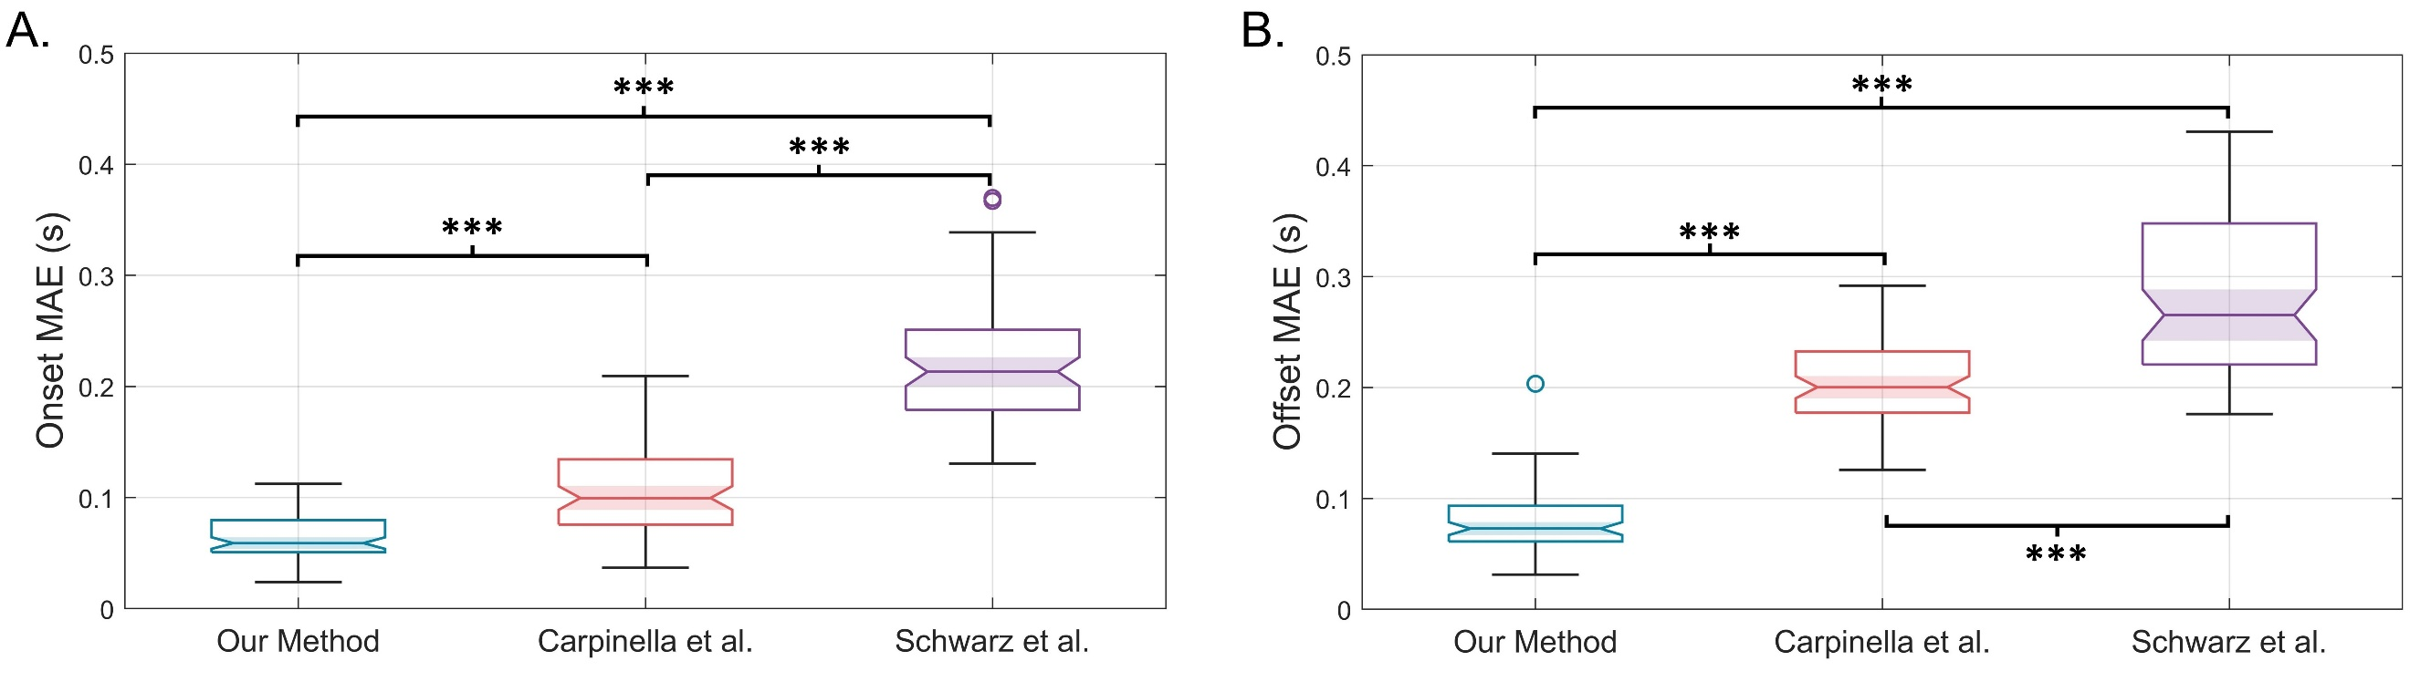
Figure 1. Boxplots of the onset and offset mean absolute errors between the tested segmentation methods and the gold standard.
Boxplot showing differences in onset and offset Mean Absolute Error (MAE) between the tested segmentation algorithms and the gold standard are represented in Figure 1A and Figure 1B, respectively. Statistically significant differences are represented by asterisks (*** p<0.001).
[1] V. M. Parker, D. T. Wade, and R. L. Hewer, “Loss of arm function after stroke: measurement, frequency, and recovery,” Int Rehabil Med, vol. 8, no. 2, pp. 69–73, 1986, doi: 10.3109/03790798609166178.
[2] I. Vanmechelen et al., “Assessment of movement disorders using wearable sensors during upper limb tasks: A scoping review”, Front Robot AI, vol. 9, Jan. 2023, doi: 10.3389/frobt.2022.1068413.
[3] V. Agostini, G. Balestra, and M. Knaflitz, “Segmentation and Classification of Gait Cycles”, IEEE Transactions on Neural Systems and Rehabilitation Engineering, vol. 22, no. 5, pp. 946-952, doi: 10.1109/TNSRE.2013.2291907.
[4] I. Carpinella, D. Cattaneo, and M. Ferrarin, “Quantitative assessment of upper limb motor function in Multiple Sclerosis using an instrumented Action Research Arm Test”, J Neuroeng Rehabil, vol. 11, no. 1, pp. 1–16, 2014, doi: 10.1186/1743-0003-11-67.
[5] A. Schwarz, M. M. C. Bhagubai, G. Wolterink, J. P. O. Held, A. R. Luft, and P. H. Veltink, “Assessment of upper limb movement impairments after stroke using wearable inertial sensing”, Sensors (Switzerland), vol. 20, no. 17, pp. 1–22, 2020, doi: 10.3390/s20174770.

