2024-01-2152

A numerical methodology for induction motor control: lookup tables generation and steady-state performance analysis
Grano E.¹, Lazek T.², Carello M¹.
¹Politecnico di Torino – Department of Mechanical and Aerospace Engineering
²Brno University of Technology - Department of Power Electrical and Electronic Engineering

Abstract
This paper presents a numerical methodology to generate lookup tables that provide $d$- and $q$-axis stator current references for electric motors’ control. The main novelty with respect to other literature references is the introduction of the iron power losses in the equivalent-circuit electric motor model implemented in the optimization routine. The lookup tables generation algorithm discretizes the motor operating map and, given proper constraints on maximum stator current and magnetic flux, solves a numerical optimization problem for each operating point to find the combination of $d$- and $q$- axis stator currents that minimizes the imposed objective function while generating the desired torque. This numerical interpretation of the motor control problem is declined in two different motor control strategies: Maximum Torque Per Ampere and Minimum Electromagnetic Power Loss. A practical example of calculation of the lookup tables for the control of an induction machine is presented. The results are then analyzed and compared to the corresponding analytical solution.
Introduction
To design the powertrain of hybrid and electric vehicles it is fundamental to properly simulate the electrical interactions among the different powertrain components [1, 2, 3]. Energetic powertrain models, widely adopted to estimate the vehicle torque and power needs [4], are not able to fully describe the interactions between the voltage source and the electric drive, as discussed in [5]. An example of this limitation is the fact that they cannot model the effect that the available DC voltage level has on motor operation. Additionally, the electrification of auxiliaries in road vehicles is bringing to the need to properly model these systems from an electrical point of view, enlarging the need to have a reliable electrical model of conventional vehicles too.
Creating a vehicle model that can describe the electrical interactions between the powertrain components can be challenging, especially in the early stages of the design process. The use of Look-Up Tables (LUTs) for the generation of stator current references is a viable methodology to keep the complexity of the model low. This type of approach is not new in the literature [6, 7, 8, 9]. However, most of the published works in this field propose experimental tests to generate the LUTs, meaning that it is not possible to create them unless both the motor and the test facilities are available. This is quite a hard constraint because the motor may not be available yet in the early stages of the vehicle design process. To solve this problem, [5] proposed a numerical methodology to calculate LUTs for electric motor control designed to facilitate the step up from energetic powertrain models to electrical ones. The fundamental idea behind that methodology is a numerical interpretation of the motor control problem which can be applied to both synchronous and asynchronous machines. The equivalent circuit electric motor models used by the authors are simple on purpose, in order to minimize the number of input parameters required to apply the methodology.
The scope of this paper is to apply the numerical interpretation of the electric motor control problem proposed in [5] to a detailed induction machine model, featuring iron losses and nonlinear magnetizing inductance. Additionally, to show the versatility of the proposed methodology, the control problem is declined in two different variants: Maximum Torque Per Ampere (MTPA) and Minimum Electromagnetic Power Loss (MEPL)
Induction machine model
A common induction machine (IM) model with a squirrel cage in an arbitrary rotating reference frame ($d$–q) has been used. By choosing the flux linkage constant, the control strategy can be varied to stator flux, rotor flux or air-gap flux orientation. For the purpose of this work, a stator flux-orientated model with iron loss resistance connected parallel to the magnetizing inductance was chosen. The dynamic IM model in the form of a Gamma (Γ)-network can be seen separately for the $d$-axis and $q$-axis in Figure 1 and Figure 2 respectively. A detailed description of the IM model is shown in [10].
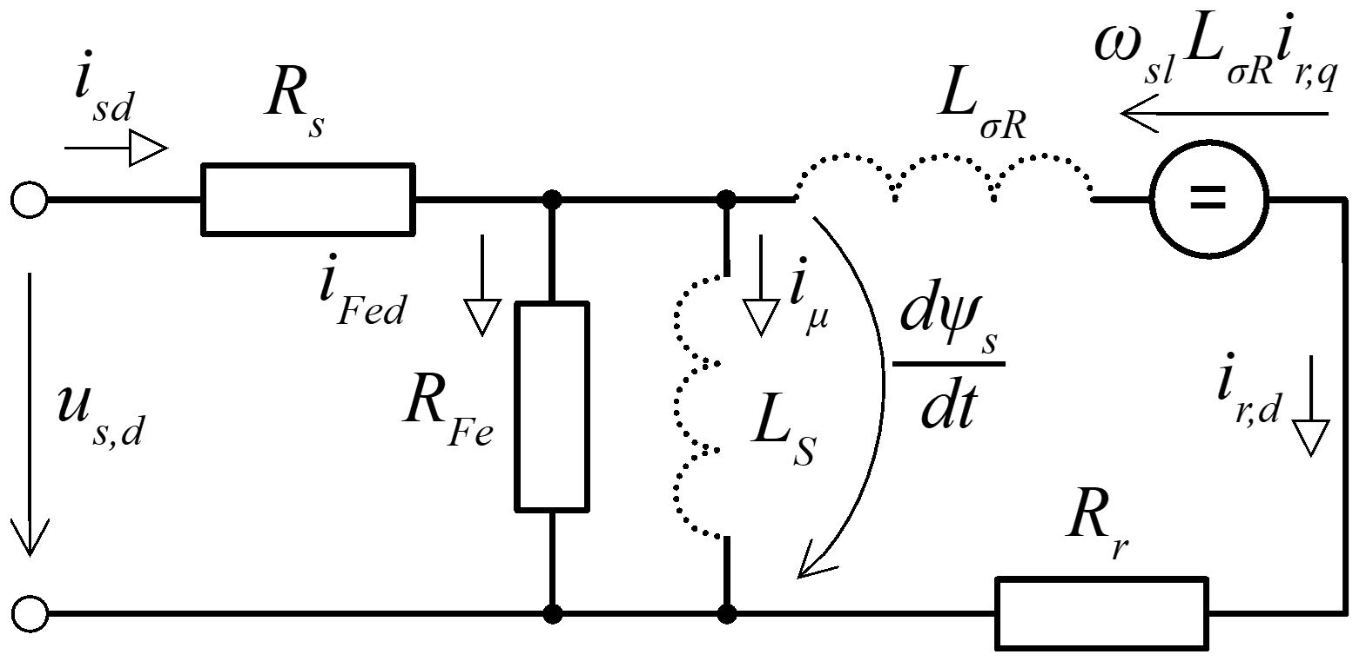
Figure 1. IM equivalent circuit in form of Γ-network in the d-axis
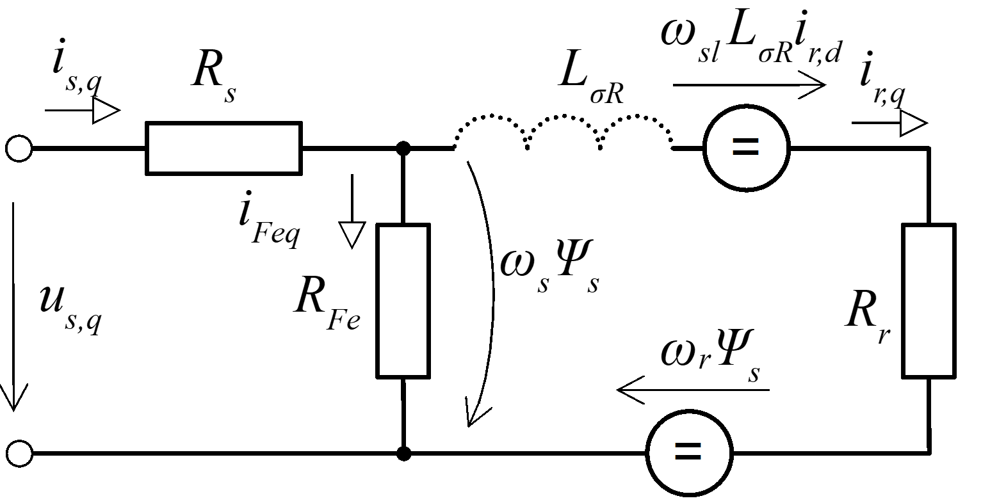
Figure 2. IM equivalent circuit in form of Γ-network in the q-axis
The expressions for the $d$- and $q$-axis stator voltages can be derived directly from the diagrams in Figure 1 and Figure 2 respectively:
$$u_{s,d}=R_{s} i_{s,d}+L_{σR}\frac{di_{r,d}}{dt}-ω_{sl} L_{σR} i_{r,q}+R_{r} i_{r,d}$$ (1)
$$u_{s,q}= R_{s} i_{s,q}+L_{σR}\frac{di_{r,q}}{dt}+ω_{sl} L_{σR} i_{r,d}+R_{r} i_{r,q}+ω_{r} Ψ_{s}$$ (2)
Where $i_{s,d}$ is the $d$-axis stator current, $i_{s,q}$ is the $q$-axis stator current, $i_{r,d}$ is the $d$-axis rotor current, $i_{r,q}$ is the $q$-axis rotor current, $R_{s}$ is the stator winding resistance, $L_{σR}$ is the rotor leakage inductance, $ω_{r}$ is the rotor speed, $R_{r}$ is the rotor winding resistance and $ω_{sl}$ is slip frequency.
$$ω_{r}=p ω_{m}$$ (3)
$$ω_{sl}=ω_{s}-ω_{r}$$ (4)
where p is the number of pole-pairs, $ω_{m}$ is the mechanical speed of the motor shaft and $ω_{s}$ is the stator synchronous frequency.
The two equations for $d$- and $q$-axis stator voltages can be directly implemented to simulate the IM. Their steady-state version is adopted for the calculation of the LUTs, therefore all coils can be considered as short-circuits. Since the d-axis is aligned to the stator flux, the magnetic model can be described as follows:
$$Ψ_{sd}=Ψ_{s}=L_{s}i_{μ}$$ (5)
$$Ψ_{sq}=0$$ (6)
where $L_{s}$ is the magnetization stator inductance and $i_{μ}$ is the magnetization current.
The expressions of the $d$- and $q$-axis stator voltages reduce to:
$$u_{s,d}=R_{s} i_{s,d}+\frac{dΨ_{s}}{dt}$$ (7)
$$u_{s,q}= R_{s} i_{s,q}+ω_{s} Ψ_{s}$$ (8)
Assuming that only the rotor current in the $q$-axis is torque generating, then for the electromagnetic torque is true:
$$T=\frac{3}{2} p Ψ_{s} i_{r,q}$$ (9)
A useful expression for the slip frequency, $ω_{sl}$, can be obtained by considering the right branch of the equivalent circuit diagram in Figure 2:
$$ω_{s} Ψ_{s}=ω_{sl} L_{σR} i_{r,d}+R_{r} i_{r,q}+ω_{r} Ψ_{s}$$ (10)
According to [11], the term $ω_{sl} L_{σR} i_{r,d}$ is negligible with respect to the others, therefore:
$$ω_{s} Ψ_{s}=R_{r} i_{r,q}+ω_{r} Ψ_{s}$$ (11)
Putting into evidence the slip frequency and considering Equation 4, we obtain:
$$ω_{sl}=\frac{R_{r} i_{r,q}}{ Ψ_{s}}$$ (12)
Lookup tables calculation procedure
The scope of the lookup tables is to provide $d$- and $q$-axis stator current references for induction machine control. They are built in such a way to allow the motor operation under different DC voltage levels and to weaken the stator flux, if necessary, thus giving the possibility to compare the performance of the machine under different voltages without the need to make modifications to the motor control strategy, like in the case of traditional approaches.
Definition of the optimization problem
The motor operating region, which is a three-dimensional space in the rotor frequency, electromagnetic torque and stator flux limit variables, is discretized into evenly spaced samples. Three vectors must be created to do so:
- Rotor frequency samples vector, $ω_{r}^{V}$.
Denoting the maximum rotor speed that the machine can produce as $ω_{r,max}$, the vector $ω_{r}^{V}$ can be created by subdividing the range $\left[0,ω_{r,max}\right]$ into evenly spaced samples. $ω_{r,max}$ can be easily found in the machine nameplate.

- Electromagnetic torque samples vector, $T^{V}$
Denoting the maximum torque that the machine can produce as $T_{max}$, the vector $T^{V}$ can be created by subdividing the range $\left[-T_{max},T_{max}\right]$ into evenly spaced samples. $T_{max}$ can be easily found in the machine nameplate.

- Stator flux limit samples vector, $Ψ_{s}^{V}$
Denoting the maximum stator flux that the machine can be operated at as $Ψ_{s,max}$, the vector $Ψ_{s}^{V}$ can be created by subdividing the range $\left[0,Ψ_{s,max}\right]$ into evenly spaced samples. $Ψ_{s,max}$ can be easily found in the machine nameplate. In [5] it is proposed a methodology to estimate $Ψ_{s,max}$ in case it is not available.
Using integers $a$, $b$ and $c$ to index into $ω_{r}^{V}$, $T^{V}$ and $Ψ_{s}^{V}$ respectively, numerical optimization problem is solved at each operating point sample $\left[ω_{r}^{V}\left(a\right);T^{V}\left(b\right);Ψ_{s}\left(c\right)\right]$.
Optimization variables and expressions
Two optimization variables are defined: $q$-axis stator current, $i_{s,q}^{ov}$, and stator flux amplitude, $Ψ_{s}^{ov}$. The acronym $ov$ stands for “optimization variable”. The optimization algorithm will provide the combination of these two variables that minimizes the objective function under the constraints that have been imposed.
To let the optimization algorithm run, all the quantities in the motor equivalent circuit model must be expressed as a function of the optimization variables. This type of expressions is denoted by the acronym $oe$, which stands for “optimization expression”. Considering the steady state version of the equivalent circuit model, the current across the magnetizing inductance can be directly expressed as a function of the stator flux:
$$i_{μ}^{oe}=\frac{Ψ_{s}^{ov}}{L_{s}}$$ (13)
An expression for the slip frequency as a function of the optimization variables can be easily obtained by reversing the torque equation to put into evidence the $q$-axis rotor current, $i_{r,q}$, and plugging it into Equation 12:
$$ω_{sl}^{oe}=\frac{2 R_{r} T}{3 p {Ψ_{s}^{ov}}^{2}}$$ (14)
The stator frequency can then be obtained as the sum of rotor frequency, which is an independent variable, and slip frequency:
$$ω_{s}^{oe}=ω_{r}+ω_{sl}^{oe}$$ (15)
Considering the equivalent circuit diagram represented in Figure 2 it is easy to notice that the voltage-drop across the resistor $R_{Fe}$ is equal to $ω_{s} Ψ_{s}^{ov}$. Therefore, the current flowing through the resistor used to model iron losses can be expressed as follows:
$$i_{Fe}^{oe}=\frac{ω_{s}^{oe} Ψ_{s}^{ov}}{R_{Fe}}$$ (16)
A useful expression for the $q$-axis rotor current can be easily obtained by applying the first Kirchhoff law:
$$i_{r,q}^{oe}=i_{s,q}^{ov}-i_{Fe}^{oe}$$ (17)
An expression for the $d$-axsi rotor current can be obtained by Considering the equivalent circuit diagram represented in Figure 2. Since in steady state conditions the magnetizing inductance behaves as a short circuit, the voltage drop across the rotor resistance must be equal to $ω_{sl} L_{σr} i_{r,q}$. Therefore:
$$i_{r,d}^{oe}=\frac{ω_{sl} L_{σr}^{oe} i_{r,q}^{oe}}{R_{r}}$$ (18)
It is finally possible to calculate the $d$-axis stator current by applying the first Kirchhoff law:
$$i_{s,d}^{oe}=i_{μ}^{oe}+i_{r,d}^{oe}$$ (19)
At this point the equivalent circuit model is completely expressed as a function of the optimization variables. In case the level of the detail of the model must be increased, it is possible to introduce new optimization expressions to implement equations describing the value of non-constant parameters of the model. An example of this is provided in the “Case study: a 2 Nm induction machine” section, in which proper optimization expressions have been used to model non-constant magnetizing inductance and frequency-dependent linear iron-loss resistance.
Objective function
The objective function is, as the name suggests, the objective of the optimization problem. More specifically, the objective of the optimization may be to either maximize or minimize it. Two different optimality criteria are applied in this paper: minimization of stator current amplitude and minimization of electromagnetic power losses. The motor control strategies corresponding to these two optimality criteria are called Maximum Torque Per Ampere (MTPA) and Minimum Electromagnetic Power Loss (MEPL) respectively.
The minimization of stator current amplitude to obtain MTPA control can be effectively implemented by means of the following objective function:
$$J_{MTPA}=\sqrt{{i_{s,d}^{oe}}^{2}+{i_{s,q}^{ov}}^{2}}$$ (20)
The optimality criterion adopted in the case of MEPL is the minimization of the electromagnetic power losses. Three power dissipation phenomena are considered at this purpose:
- Joule power loss at the stator
This source of dissipation is caused by the voltage drop across the resistance of stator windings. It can be described according to the equation below:
$$P_{Joule,s}=R_{s} \left(i_{s,d}^{2}+i_{s,q}^{2}\right)$$ (21)

- Joule power loss at the rotor
This source of dissipation is caused by the voltage drop across the resistance of the rotor. It can be described according to the equation below:
$$P_{Joule,r}=R_{r} \left(i_{r,d}^{2}+i_{r,q}^{2}\right)$$ (22)
- Iron power loss
This source of dissipation is modelled as the voltage drop across the iron resistance. It can be described according to the equation below:
$$P_{Fe}=R_{Fe} i_{Fe}^{2}$$ (23)
Combining the three equations above and expressing them as a function of the optimization variables, the following objective function is obtained for MEPL control:
$$J_{MEPL}=R_{s} \left({i_{s,d}^{oe}}^{2}+{i_{s,q}^{ov}}^{2}\right)+R_{r} \left({i_{r,d}^{oe}}^{2}+{i_{r,q}^{oe}}^{2}\right)+R_{Fe} {i_{Fe}^{oe}}^{2}$$ (24)
Optimization constraints
The optimization routine should determine the combination of $q$-axis stator current and stator flux that minimizes the selected objective function while producing the desired torque output. As discussed in [5], constraints on the maximum stator current amplitude and maximum stator flux must be imposed to avoid damaging the motor and to give the possibility to operate the machine under flux weakening conditions. Additionally, the rotor speed must be provided as input parameter of the Γ-network induction machine model, as it contains some frequency-dependent parameters and quantities. While the current constraint remains always the same, three vectors are used to impose proper constraints for torque, rotor speed and stator flux to impose the desired operating condition:
- Rotor speed vector, $ω_{r}^{V}$
Using an integer $a$ to index into the vector $ω_{r}^{V}$, a constraint on the rotor speed can be set by imposing the torque to be equal $ω_{r}^{V}\left(a\right)$:
$$ω_{r}=ω_{r}^{V}\left(a\right)$$ (25)

- Torque vector, $T^{V}$
Using an integer $b$ to index into the vector $T^{V}$, a constraint on the desired torque level can be set by imposing the torque to be equal $T^{V}\left(b\right)$:
$$\frac{3}{2} p Ψ_{s} i_{r,q}^{oe}=T^{V}\left(b\right)$$ (26)

- Stator flux vector, $Ψ^{V}$
Using an integer $c$ to index into the vector $Ψ^{V}$, a constraint on the maximum stator flux level can be set by imposing the torque to be equal $Ψ^{V}\left(c\right)$:
$$Ψ_{s}^{ov}≤Ψ_{s}^{V}\left(c\right)$$ (27)
The constraint on maximum stator current amplitude can be expressed as follows:
$$\sqrt{{i_{s,d}^{oe}}^{2}+{i_{s,q}^{ov}}^{2}}≤i_{s,max}$$ (28)
Solution of the optimization problem
The optimization algorithm outputs two scalar values, one for the $q$-axis stator current and the other for stator flux. The value of these two parameters represents the best combination to operate the motor under the imposed conditions (torque request, stator flux and rotor frequency). Running the optimization algorithm for each possible operating condition, a three-dimensional lookup table is obtained for each of the two parameters:
- $q$-axis stator current, LUT denoted as, $i_{q,s}^{LUT}$.
- Stator flux LUT, denoted as $Ψ_{s}^{LUT}$.
Post-processing
The optimization algorithm is not always capable of satisfying all the constraints that have been imposed. Because of this, it is fundamental to verify the compliance of the results to the imposed constraints, to reject unfeasible working conditions. This can be easily done by retrieving the values stored in the two LUTs and applying the steady-state versions of the equivalent circuit model equations to calculate electromagnetic torque and stator current. In most of the cases, it is the constraint on stator flux to be not respected. Whenever it is found that the optimization algorithm failed to converge to a feasible solution, the values stored in the corresponding cells of the LUTs must be replaced with “Not a Number” (NaN) values.
Since failures of the optimization algorithm occur in demanding working conditions only, it is assumed that it is possible to bring the motor to a feasible working point by reducing the demanded torque. Because of this, for each possible combination of stator flux limit and rotor frequency, the values of $q$-axis stator current and stator flux corresponding to the highest feasible torque are collected. These values are then used to replace the corresponding NaNs, if present, effectively saturating motor torque to the highest feasible value for each combination of stator flux limit and rotor frequency. The saturated LUTs are NaN-free at this point of the post-processing process, feature that is desirable to avoid numerical errors that may potentially arise during the practical use of the LUTs in dynamic simulations.
Since the scope of use of the LUTs is to provide stator current references for motor operation, it is convenient to apply the steady-state versions of the equivalent circuit model equations to calculate the $d$-axis stator current corresponding to each motor operating condition and to collect the results in a LUT; $i_{d,s}^{LUT}$. In this way, it is possible to directly provide the $d$-axis current reference without performing a conversion from stator flux to $d$-axis stator current.
Case study: a 2 Nm induction machine
An example of application of the proposed methodology is provided in this chapter. A 2 Nm, 600 W induction machine with nameplate parameters from [12], linear iron loss resistance model from [13], nonlinear magnetizing inductance model from [14] and mechanical loss model from [15, 16].
Table 1. Induction machine nameplate parameters
Parameter | Symbol | Value
Nominal power | $P_{n}$ | 600 W
Nominal torque | $T_{n}$ | 2 Nm
Nominal speed | $n_{n}$ | 2850 rpm
Nominal current | $I_{n}$ | 1.6 A
Number of pole pairs | $p$ | 1
Table 2. Induction machine additional parameters
Parameter | Symbol | Value
Stator resistance | $R_{s}$ | 11.74 Ω
Rotor resistance | $R_{r}$ | 8.70 Ω
Rotor leakage inductance | $L_{σ,R}$ | 0.1 H
Measured iron-loss resistance at nominal frequency $ω_{0}$ | $R_{Fe0}$ | 4300 Ω
Nominal frequency | $ω_{0}$ | 100π rad$∙$s⁻¹

Table 3. Nonlinear magnetizing inductance model parameters
Parameter | Symbol | Value
Zero order term | $c_{0}$ | 0.1728 H
First order term | $c_{1}$ | 6.526 H$∙$V⁻¹$∙$s⁻¹
Second order term | $c_{2}$ | -15.67 H$∙$V⁻²$∙$s⁻²
Third order term | $c_{3}$ | 17.71 H$∙$V⁻³$∙$s⁻³
Fourth order term | $c_{4}$ | -9.696 H$∙$V⁻⁴$∙$s⁻⁴
Fifth order term | $c_{5}$ | 1.841 H$∙$V⁻⁵$∙$s⁻⁵

Table 4. Mechanical loss model parameters
Parameter | Symbol | Value
Friction loss coefficient | $k_{f}$ | 5.750$∙$10⁻² W$∙$s$∙$rad⁻¹
Windage losses coefficient | $k_{w}$ | 1.742$∙$10⁻⁷ W$∙$s³$∙$rad⁻³

Optimization expressions for non-constant parameters of the equivalent circuit model
The plot in Figure 3 shows the trend of the magnetizing inductance as a function of the stator flux, which can be easily obtained by applying the following equation [12, 13, 14]:
$$L_{s}^{oe}=\sum_{j=0}^{5}{c_{j} {Ψ_{s}^{ov}}^{j}}$$ (29)
The values of the coefficients $c_{j}$ are reported in Table 3.
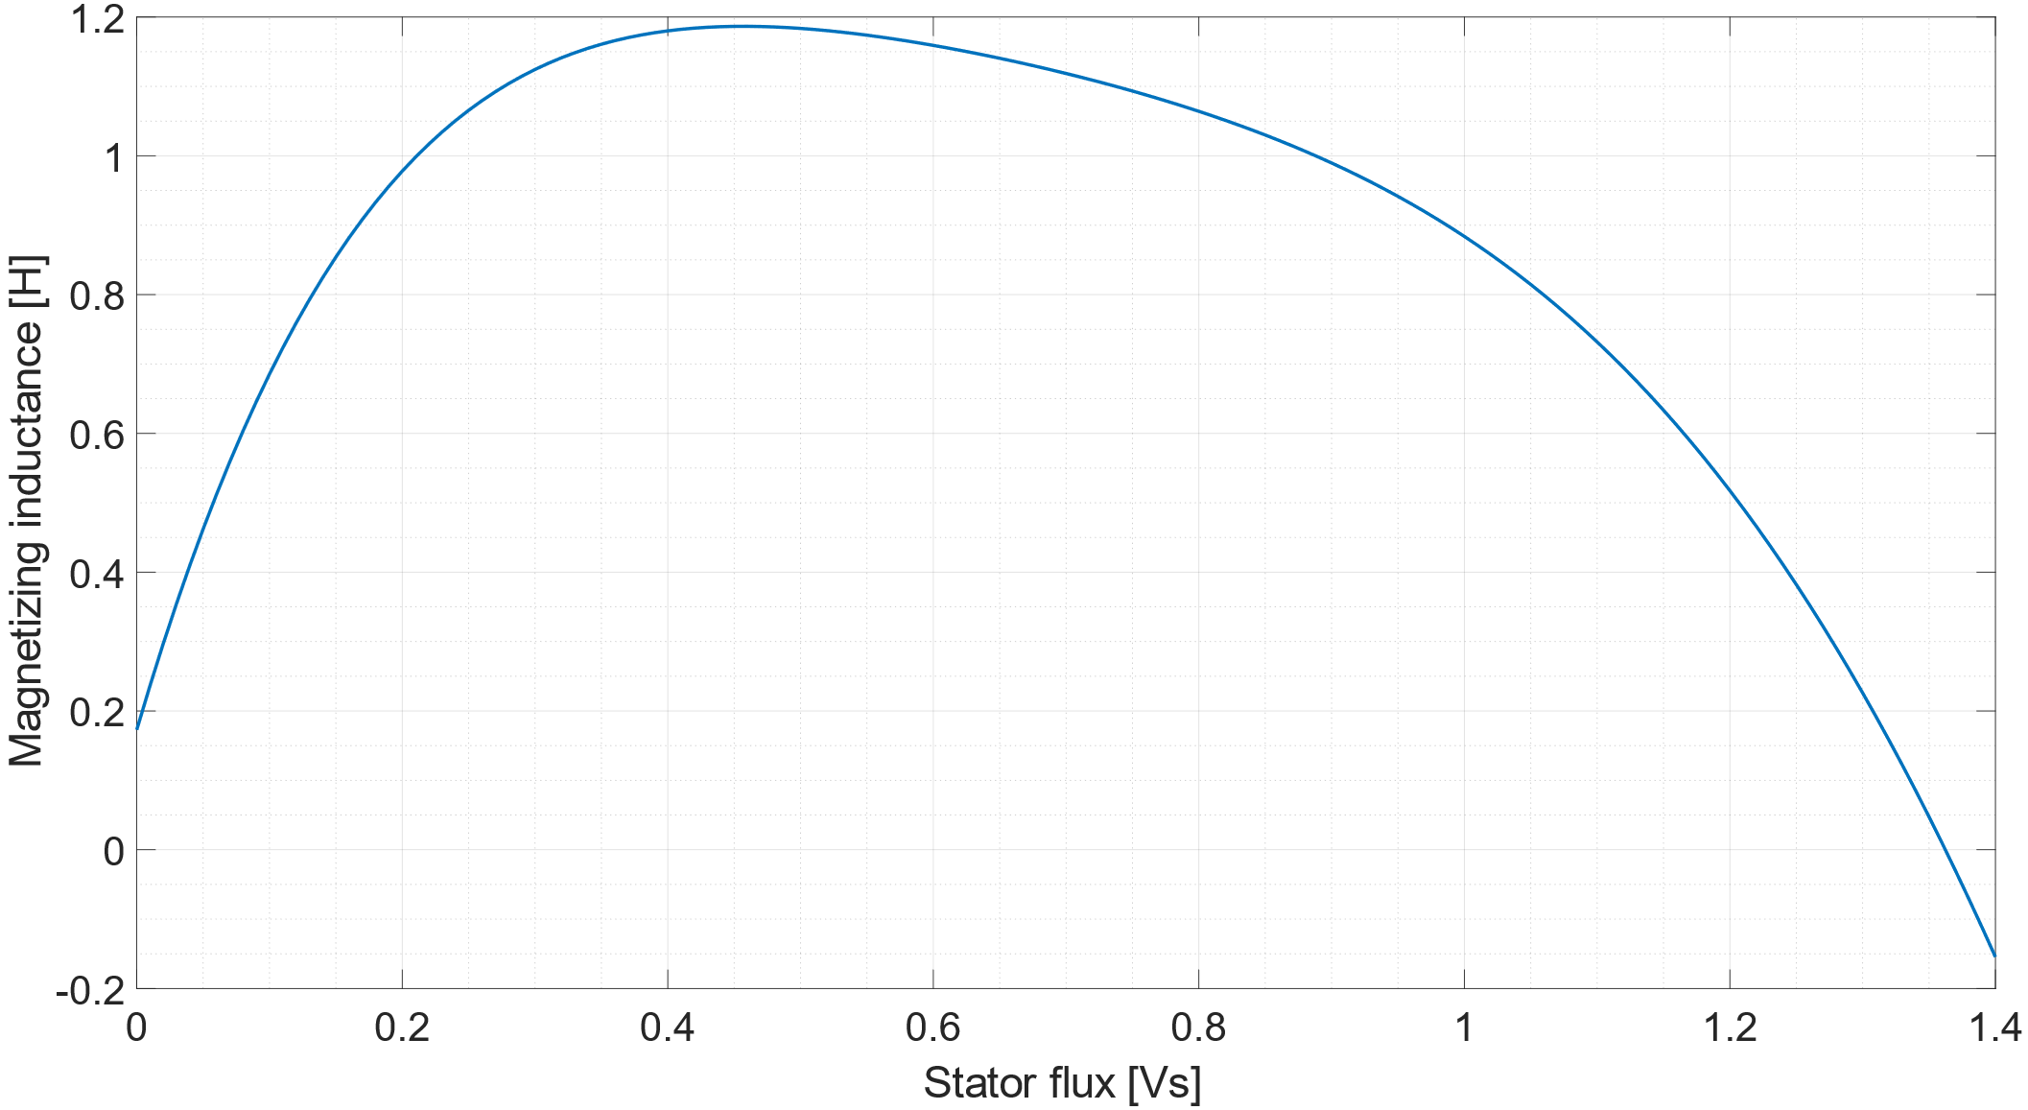
Figure 3. Magnetizing inductance as a function of the stator flux
The plot in Figure 4 shows the trend of the iron-loss resistance as a function of the stator frequency, which can be easily obtained by applying the following equation [10, 12, 13]:
$$R_{Fe}^{oe}=\frac{ω_{s}^{oe}}{ω_{s0}} R_{Fe0}$$ (30)
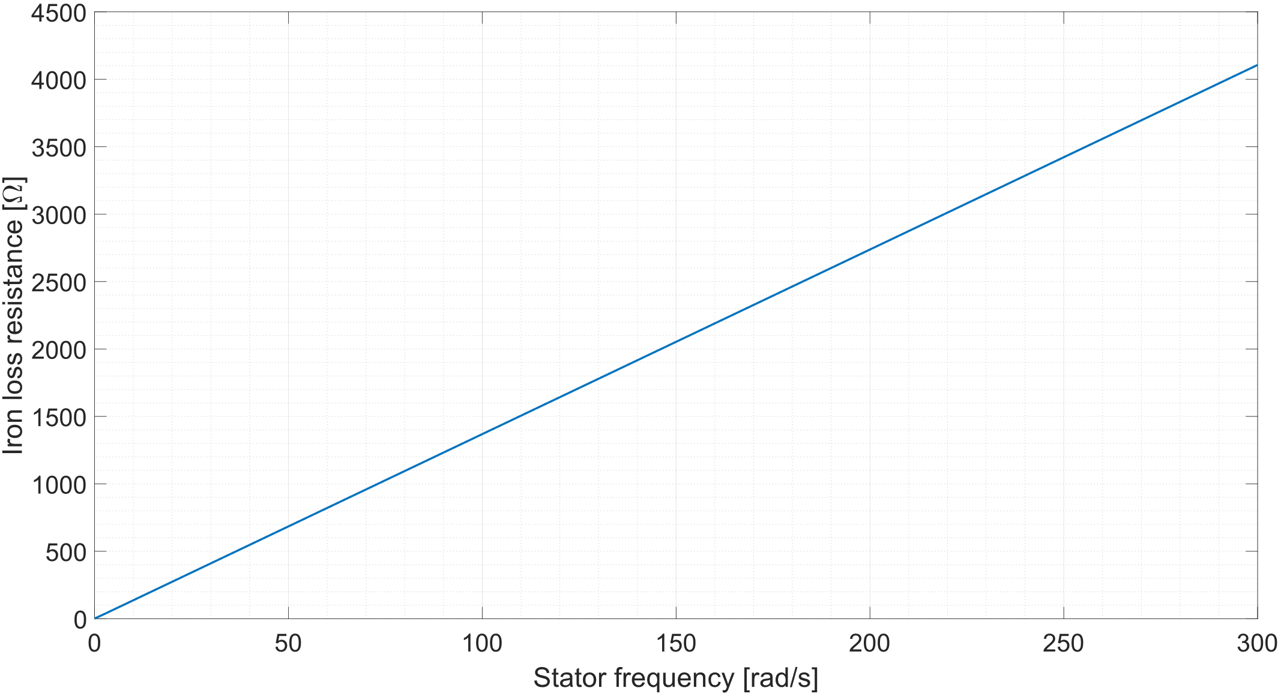
Figure 4. Iron-loss resistance as a function of stator frequency
To avoid numerical that may potentially arise due to divisions by zero, the iron loss resistance has been lower saturated to 1 Ω.
Lookup tables analysis
The lookup tables obtained for the MEPL are analyzed in this chapter to understand the effect that torque request, rotor frequency and stator flux have on motor operation. The analysis is not repeated for the MTPA LUTs for reasons of brevity, but the same conclusions obtained for MEPL control may be extended to the case of MTPA control too.
Figure 5, Figure 6 and Figure 7 are graphical representations of the $q$-axis stator current LUT, $i_{q,s}^{LUT}$, at $ω_{r}={ω_{n}}/3$, $ω_{r}={2 ω_{n}}/3$ and $ω_{r}=ω_{n}$ respectively. Each of them shows how the $q$-axis stator current changes depending on the torque request and the imposed stator flux limit at a given rotor frequency. Looking at the left side of the three diagrams it is possible to understand how the motor is operated when the stator flux is not weakened. Moving rightwards it is instead possible to observe how the $d$-axis stator current is changed to meet increasingly demanding limitations on stator flux.
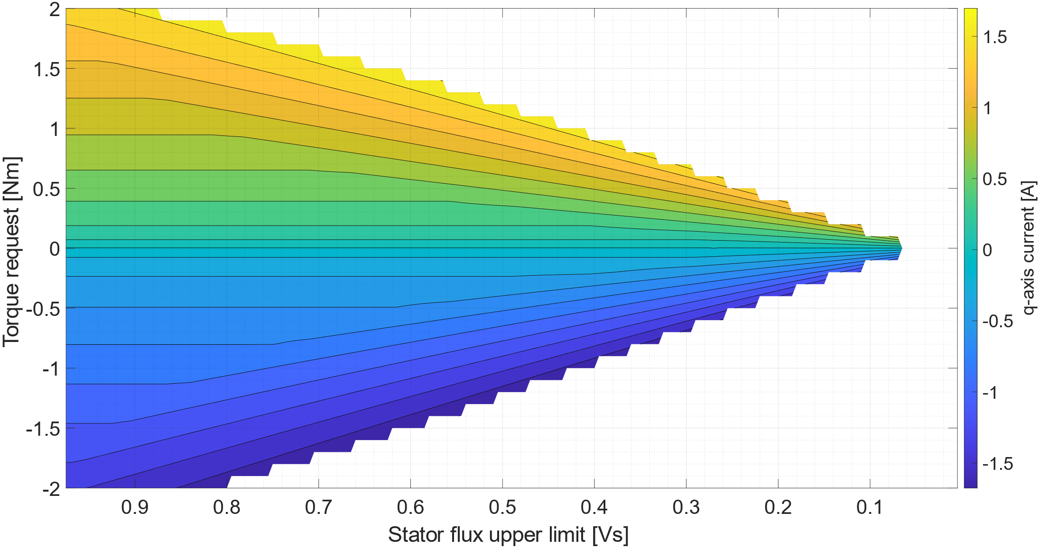
Figure 5. MEPL q-axis stator current LUT at $ω_{r}={ω_{n}}/3$
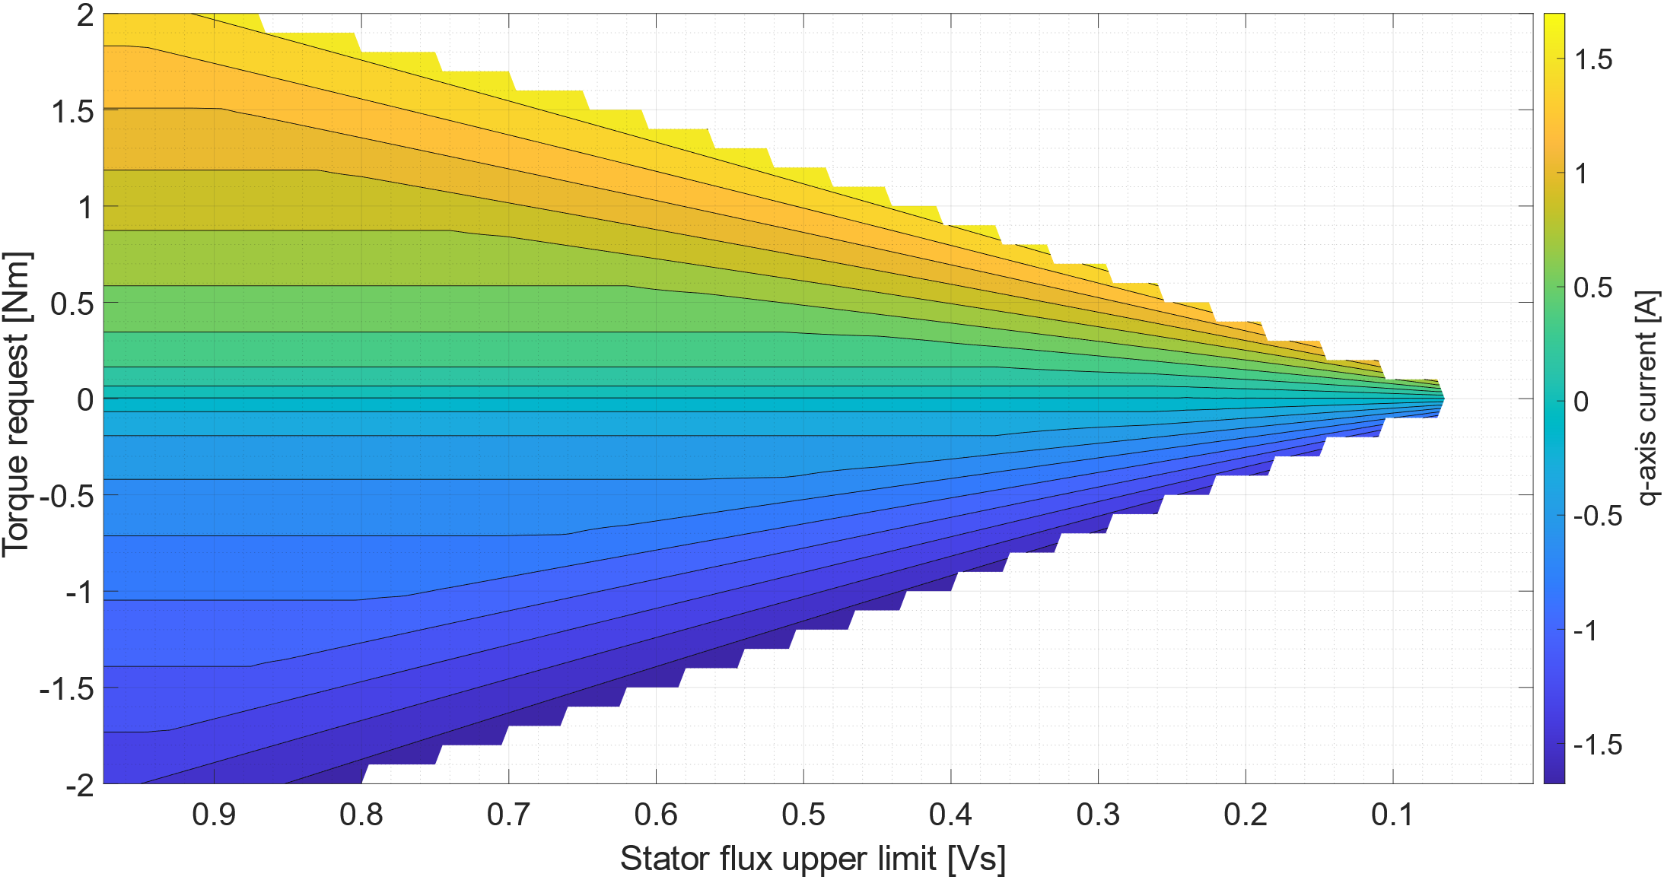
Figure 6. MEPL q-axis stator current LUT at $ω_{r}={2 ω_{n}}/3$
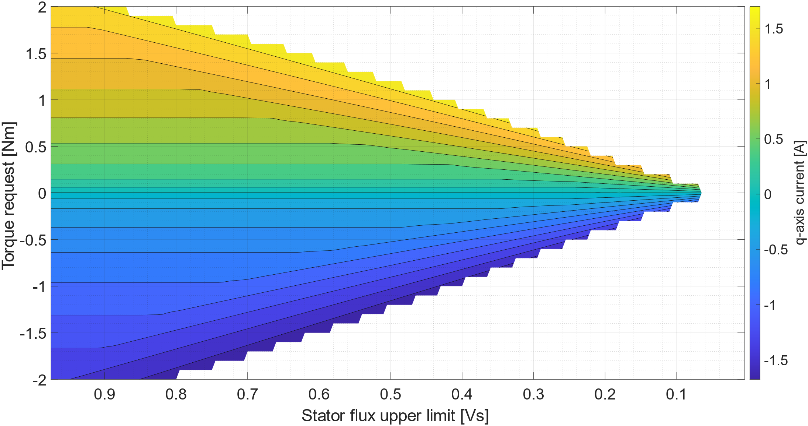
Figure 7. MEPL q-axis stator current LUT at $ω_{r}=ω_{n}$
As it is possible to see, the $q$-axis stator current is proportional to torque, coherently with the system of equation formed by Equation 9, Equation 16 and Equation 17. Following the iso-current lines it is can be observed that, after an initial segment in which they remain at a constant torque level, a knee is formed. After the knee the iso-current lines are still linear but directed toward the zero-torque line. As a consequence, the stator flux must be changed as described by Equation 9 to maintain a constant torque level. This is the reason why the iso-flux lines in Figure 8, Figure 9 and Figure 10 become suddenly vertical after an initial constant segment
While the rotor frequency seems not to have a noticeable influence on the $q$-axis stator current LUT, it does have an impact on the stator flux one. In particular, the higher the stator frequency, the lower the stator flux at which the motor is operated for the same combination of torque output and stator flux limit.
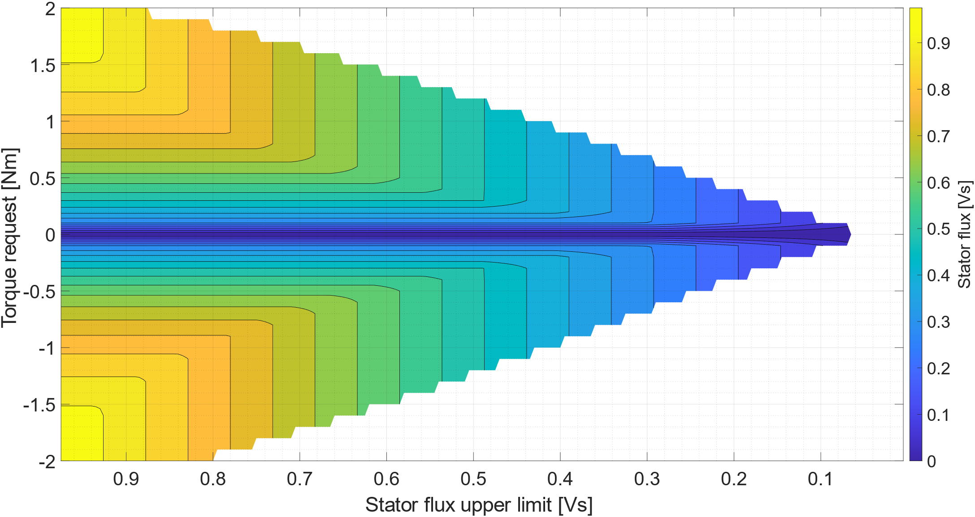
Figure 8. MEPL stator flux LUT at $ω_{r}={ω_{n}}/3$
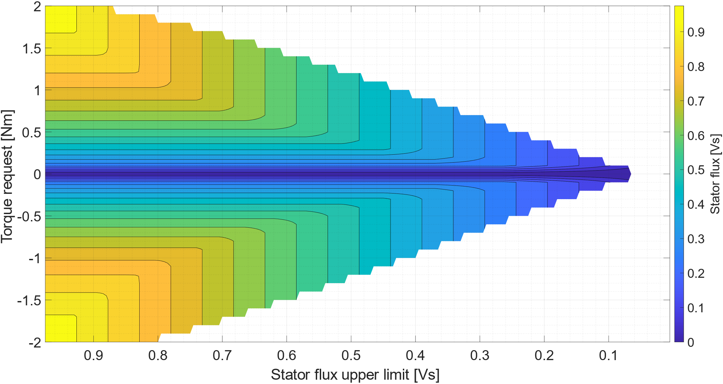
Figure 9. MEPL stator flux LUT at $ω_{r}={2 ω_{n}}/3$
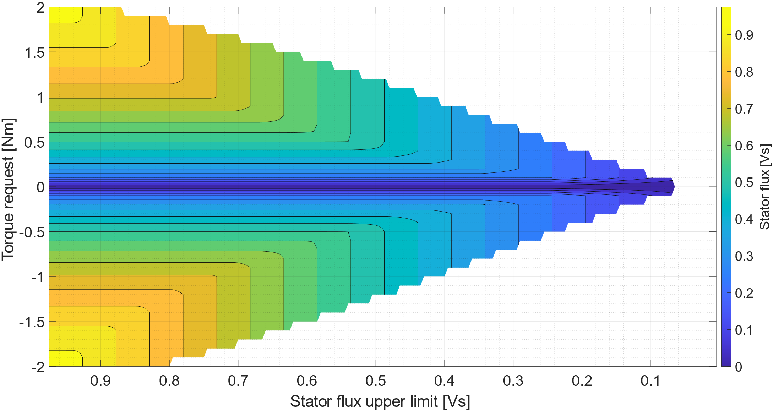
Figure 10. MEPL stator flux LUT at $ω_{r}=ω_{n}$
Differently from the stator flux, the stator current amplitude seems not to be much influenced by the rotor frequency, as it can be clearly seen in Figure 11, Figure 12 and Figure 13, which depict the trend of the stator current amplitude as a function of stator flux limit and torque request at different values of rotor frequency. Anyway, the stator current amplitude greatly increases as the stator flux limit is harshened. This is because imposing a lower stator flux limit means weakening the stator flux of the machine, leading to higher $q$-axis stator currents to produce the same torque.
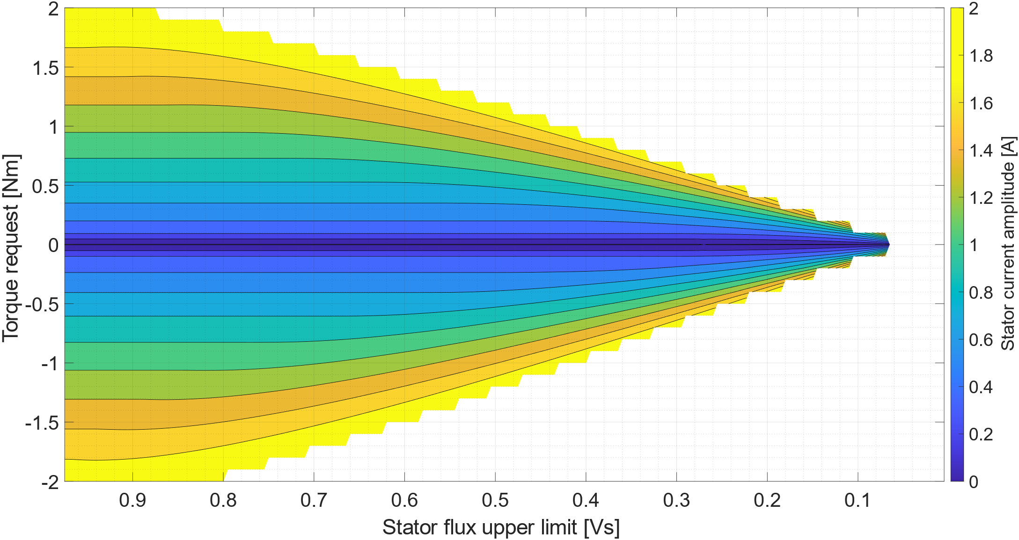
Figure 11. MEPL stator current amplitude at $ω_{r}={ω_{n}}/3$
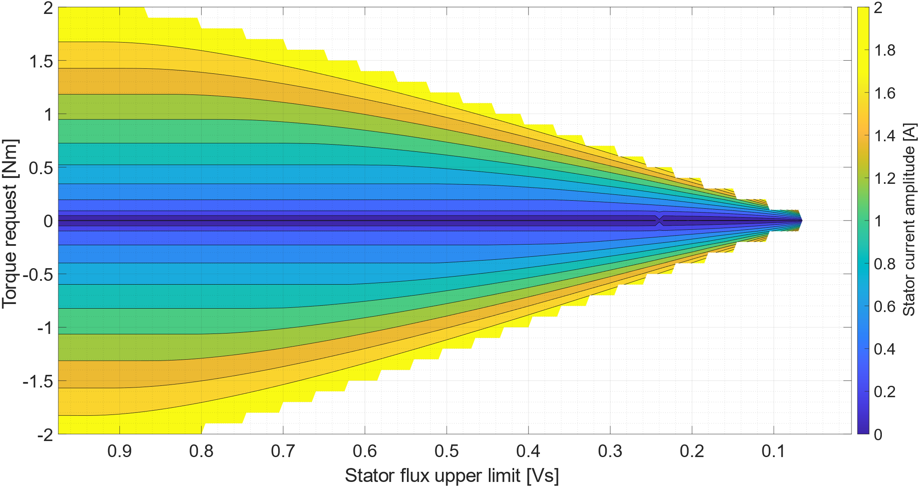
Figure 12. MEPL stator current amplitude at $ω_{r}={2 ω_{n}}/3$
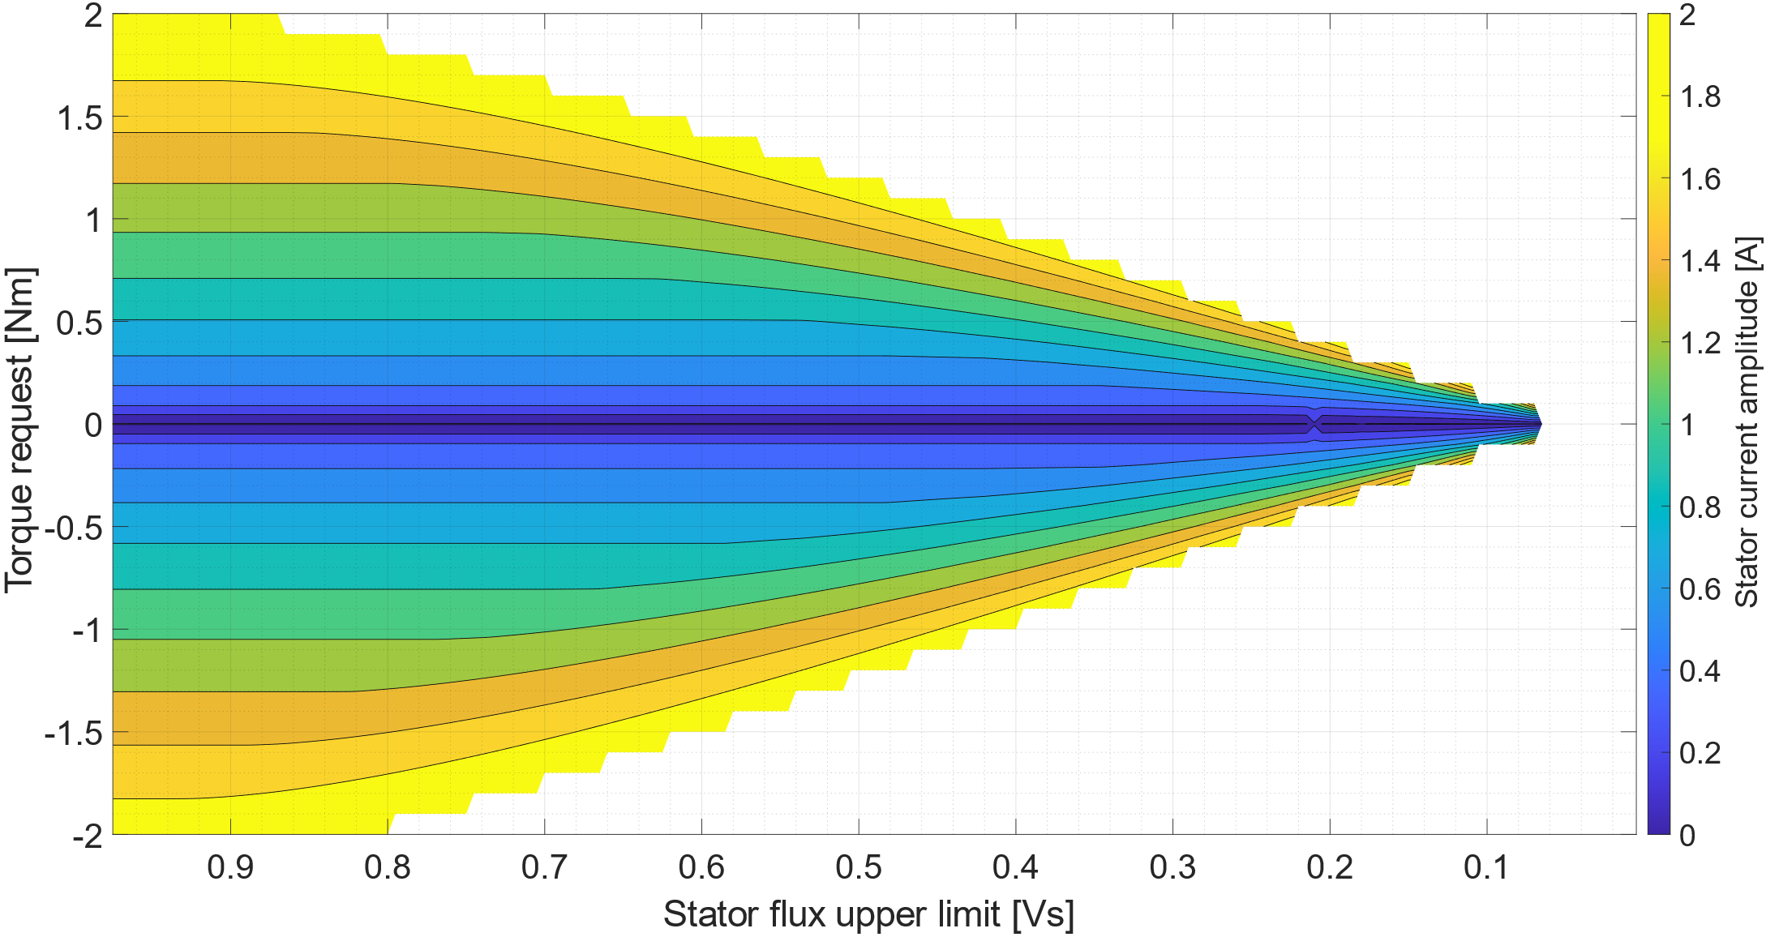
Figure 13. MEPL stator current amplitude at $ω_{r}=ω_{n}$
Figure 14, Figure 15 and Figure 16 show a graphical representation of the $d$-axis stator current LUT, $i_{d,s}^{LUT}$, at three different stator frequency levels, $ω_{r}={ω_{n}}/3$, $ω_{r}={2 ω_{n}}/3$ and $ω_{r}=ω_{n}$ respectively. As it is possible to see, the trend of the $d$-axis stator current with respect to torque request, imposed stator flux limit and rotor frequency qualitatively reflects that of the stator flux, coherently with Equation 19.
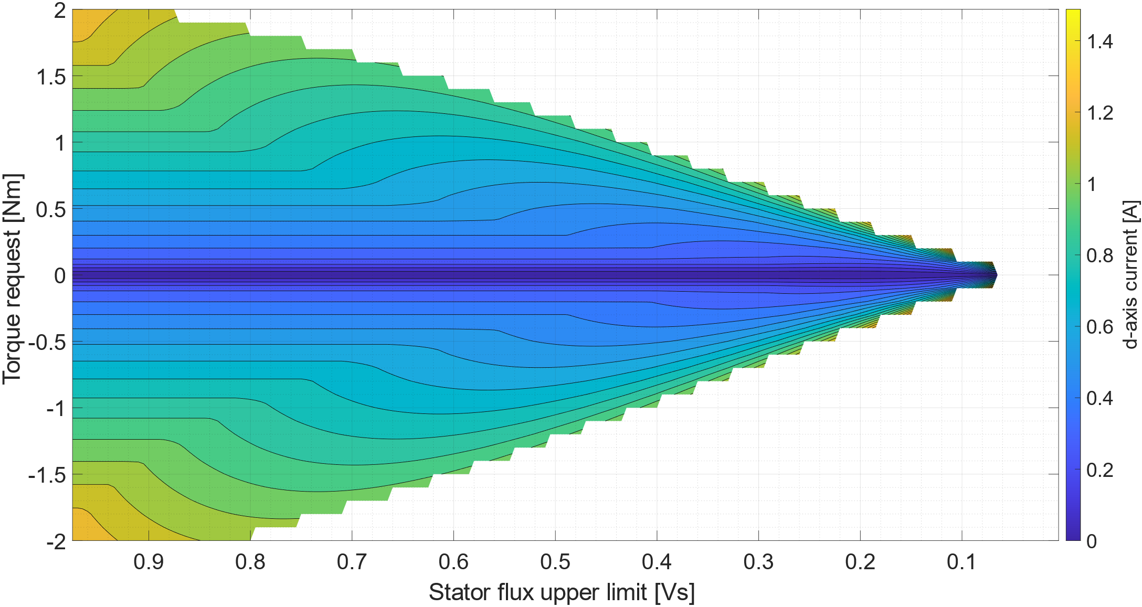
Figure 14. MEPL d-axis stator current LUT at $ω_{r}={ω_{n}}/3$
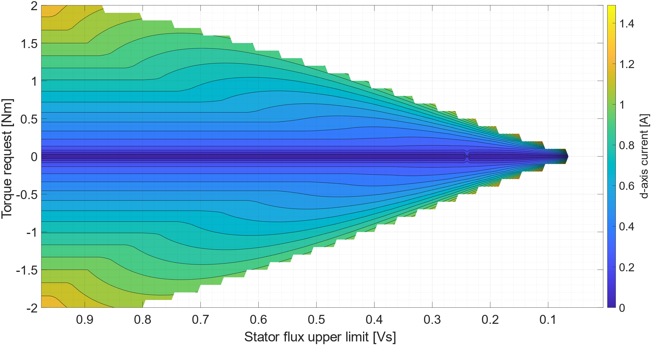
Figure 15. MEPL d-axis stator current LUT at $ω_{r}={2 ω_{n}}/3$
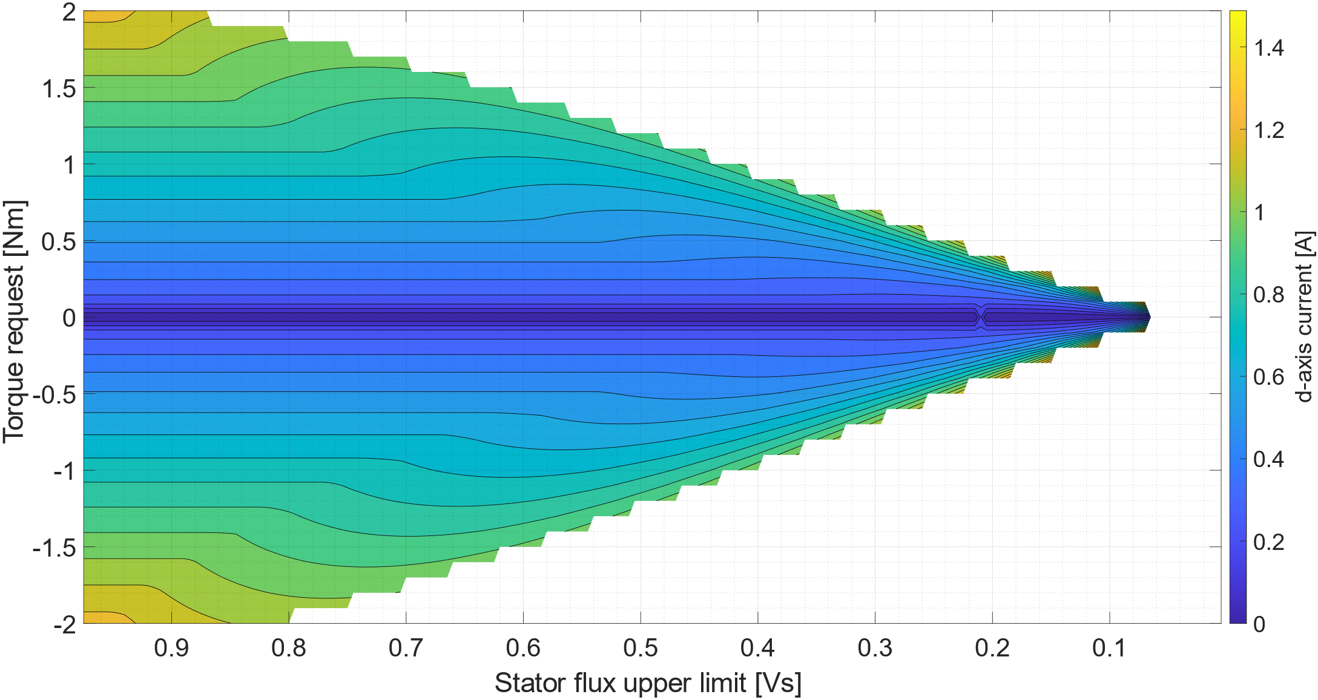
Figure 16. MEPL d-axis stator current LUT at $ω_{r}=ω_{n}$
Steady state performance analysis
Figure 18, Figure 19 and Figure 20 show the trend of motor efficiency as a function of the torque request at rotor frequency corresponding to $ω_{r}={ω_{n}}/3$, $ω_{r}={2 ω_{n}}/3$ and $ω_{r}=ω_{n}$ respectively. The efficiency is calculated considering all the sources of power dissipation discussed in the “Lookup tables calculation procedure” section, plus the effect of mechanical dissipations. Mechanical power losses can be calculated as show in Equation 31 [15, 16]:
$$P_{mech}=k_{f} ω_{m}+k_{w} ω_{m}$$ (31)
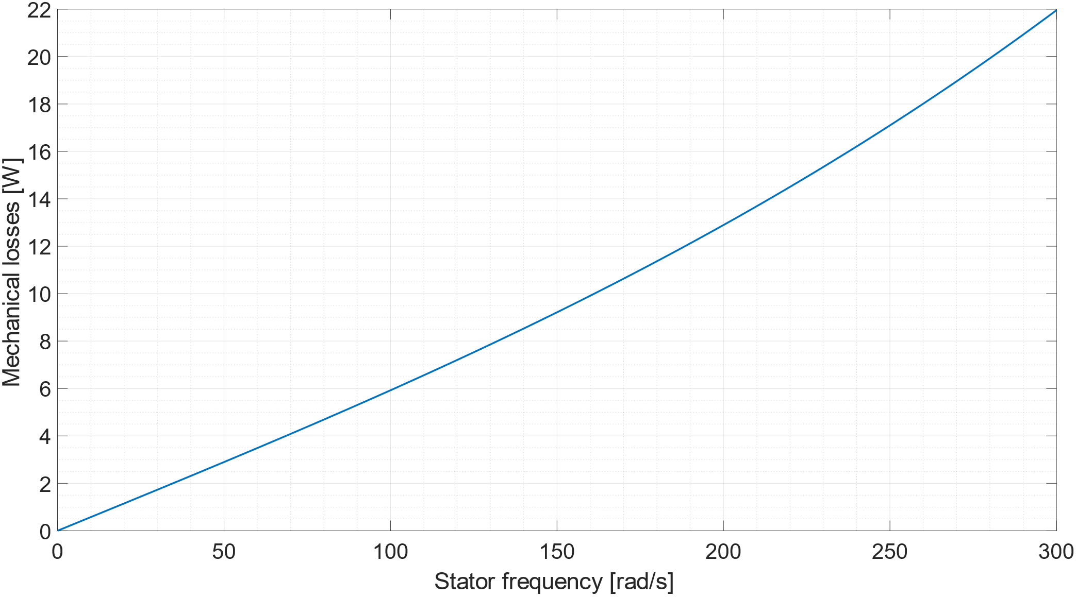
Figure 17. Mechanical losses as a function of stator frequency
Further details about the calculation of motor efficiency can be found in [12, 13].
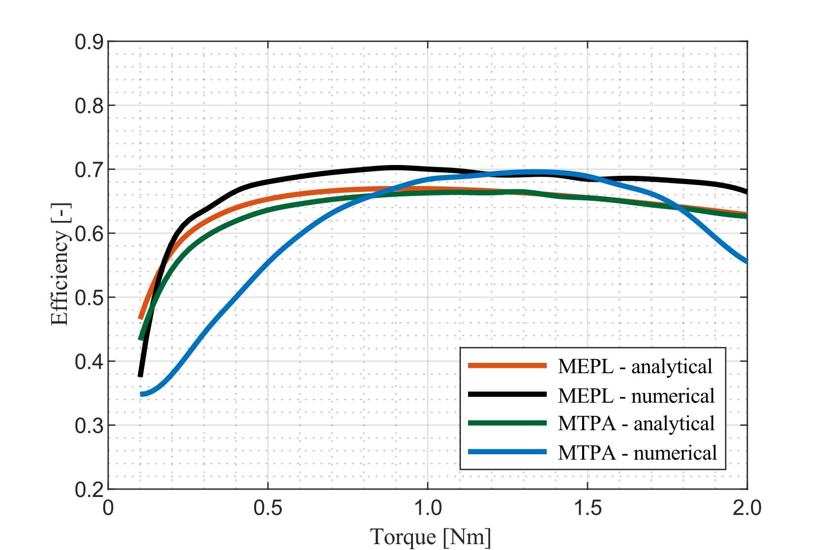
Figure 18. Motor efficiency at $ω_{r}={ω_{n}}/3$
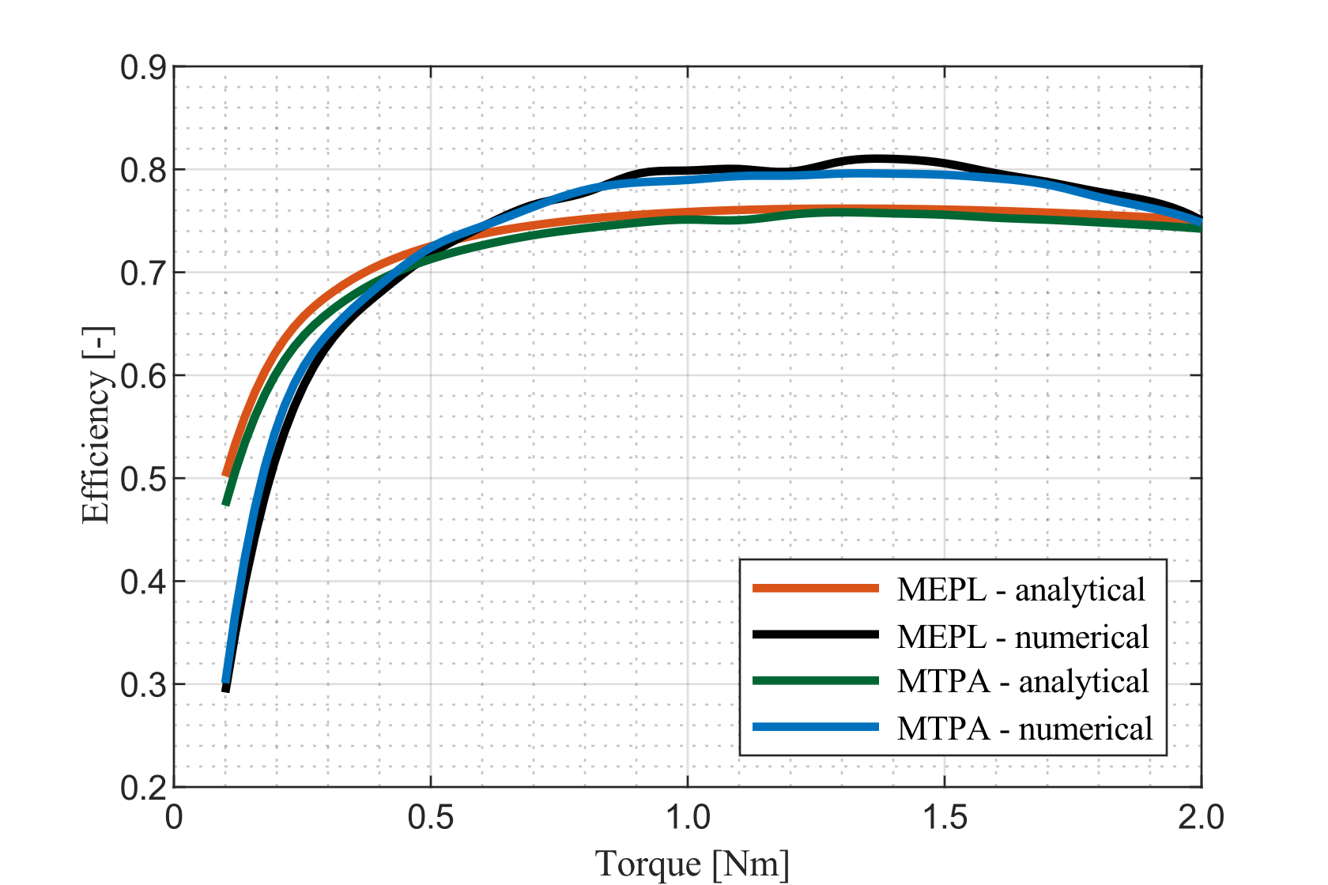
Figure 19. Motor efficiency at $ω_{r}={2 ω_{n}}/3$
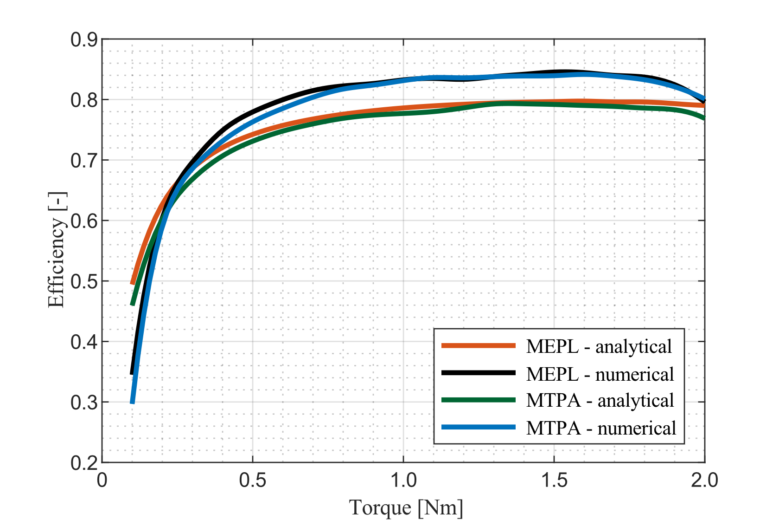
Figure 20. Motor efficiency at $ω_{r}=ω_{n}$
As it is possible to see, the results obtained by means of the LUT-based approaches are quite close to their analytical counterparts, except for the numerical MTPA control at $ω_{r}={ω_{n}}/3$. The efficiency curves obtained by means of the LUT have the same trend as the numerical ones from a qualitative perspective, but they are systematically higher than the numerical ones. The reasons for this behavior are unclear and the investigation of it may be the scope of future work.
Figure 24, Figure 25 and Figure 26 show the trend of motor efficiency as a function of the torque request at rotor frequency corresponding to $ω_{r}={ω_{n}}/3$, $ω_{r}={2 ω_{n}}/3$ and $ω_{r}=ω_{n}$ respectively.
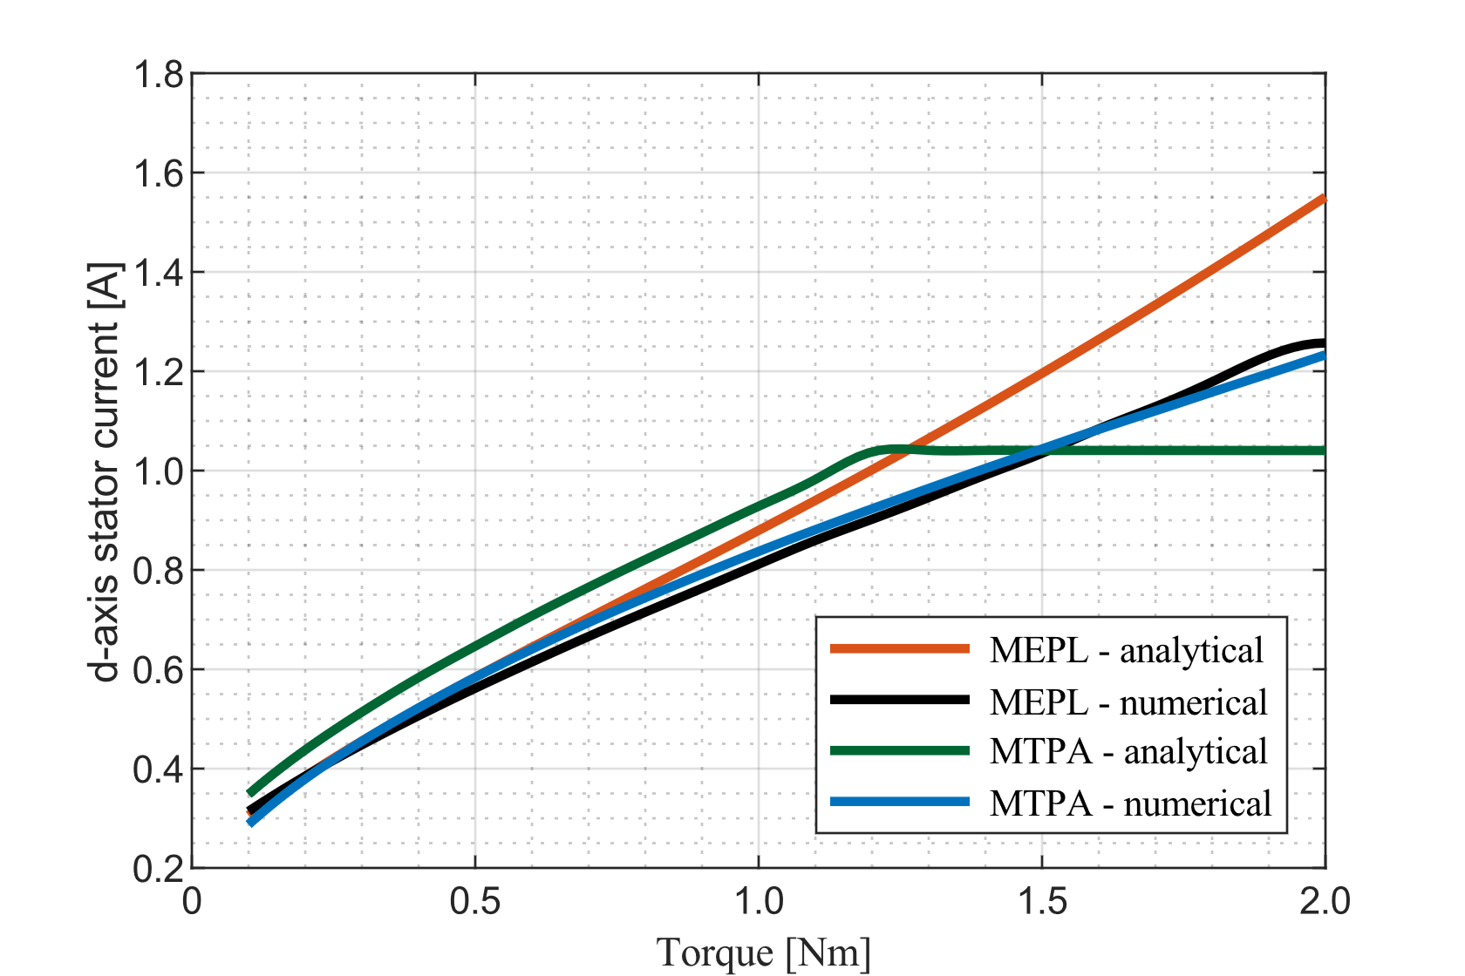
Figure 21. d-axis stator current at $ω_{r}={ω_{n}}/3$
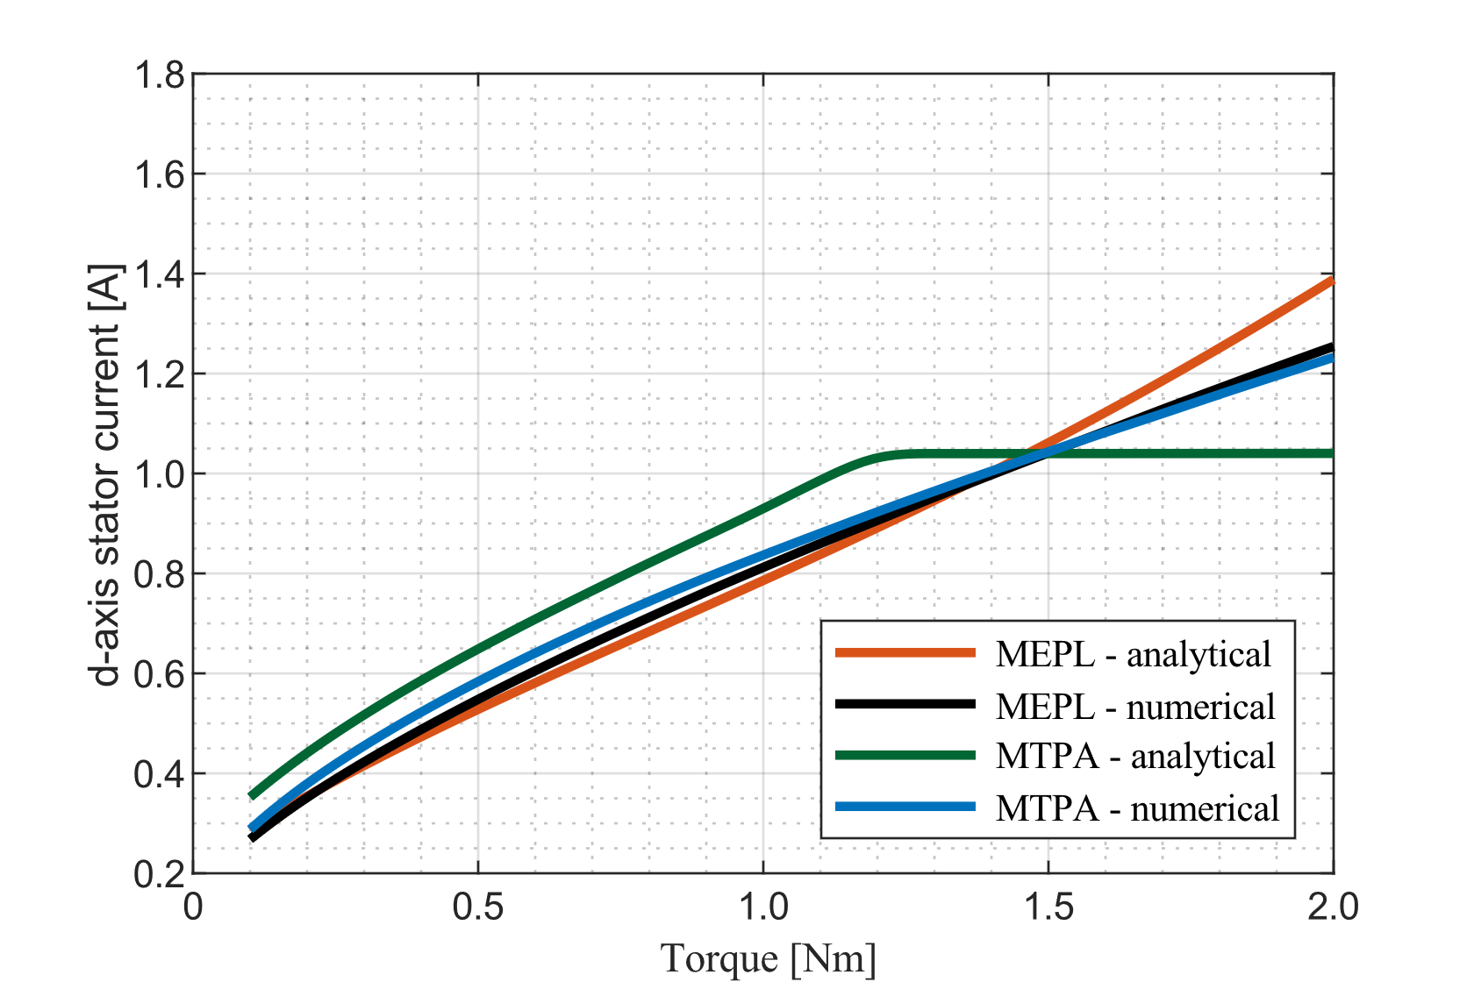
Figure 22. d-axis stator current at $ω_{r}={2 ω_{n}}/3$
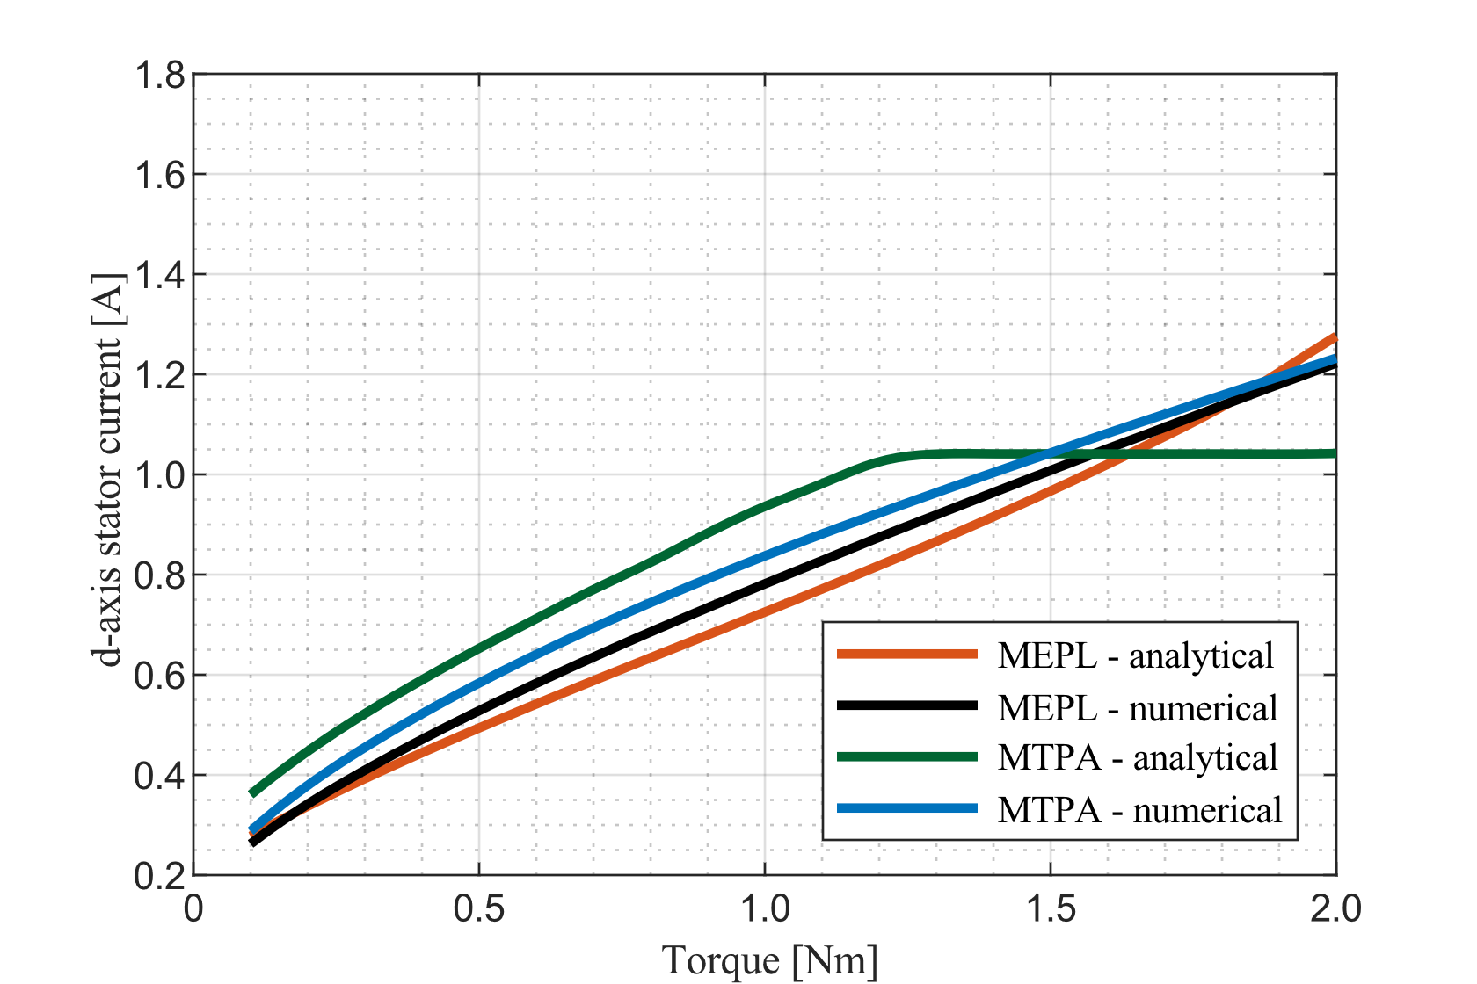
Figure 23. d-axis stator current at $ω_{r}=ω_{n}$
In general, the curves corresponding to the numerical control approaches well catch the trend of the analytical ones in the low-to-mid torque region. The two analytical curves follow a similar path in the high-torque region, but it departs more and more from both the two analytical solutions as speed reduces. As rotor frequency increases, the two numerical curves get closer to the analytical MEPL curve. The two numerical curves lay in-between the analytical ones throughout the entire torque range.
Figure 24, Figure 25 and Figure 26 show the trend of motor efficiency as a function of the torque request at rotor frequency corresponding to $ω_{r}={ω_{n}}/3$, $ω_{r}={2 ω_{n}}/3$ and $ω_{r}=ω_{n}$ respectively.
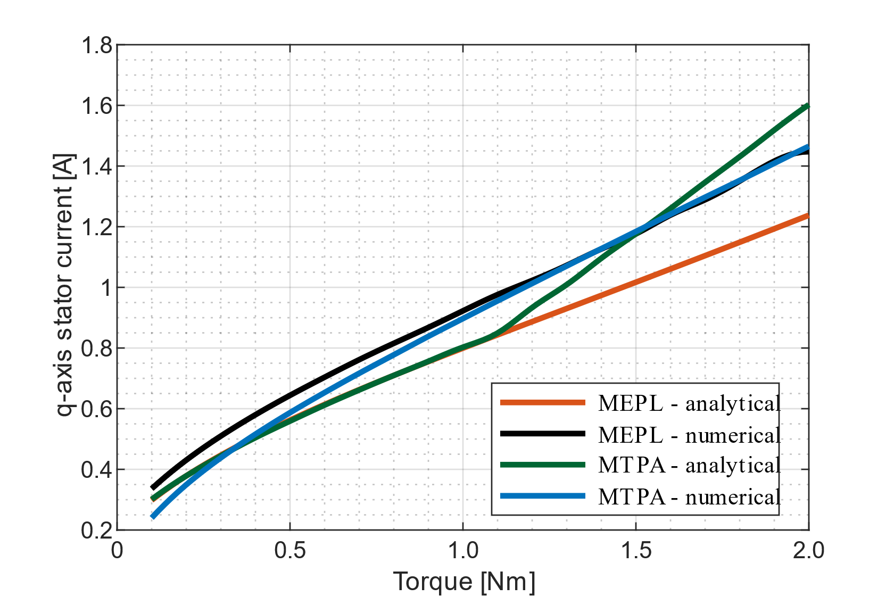
Figure 24. q-axis stator current at $ω_{r}={ω_{n}}/3$
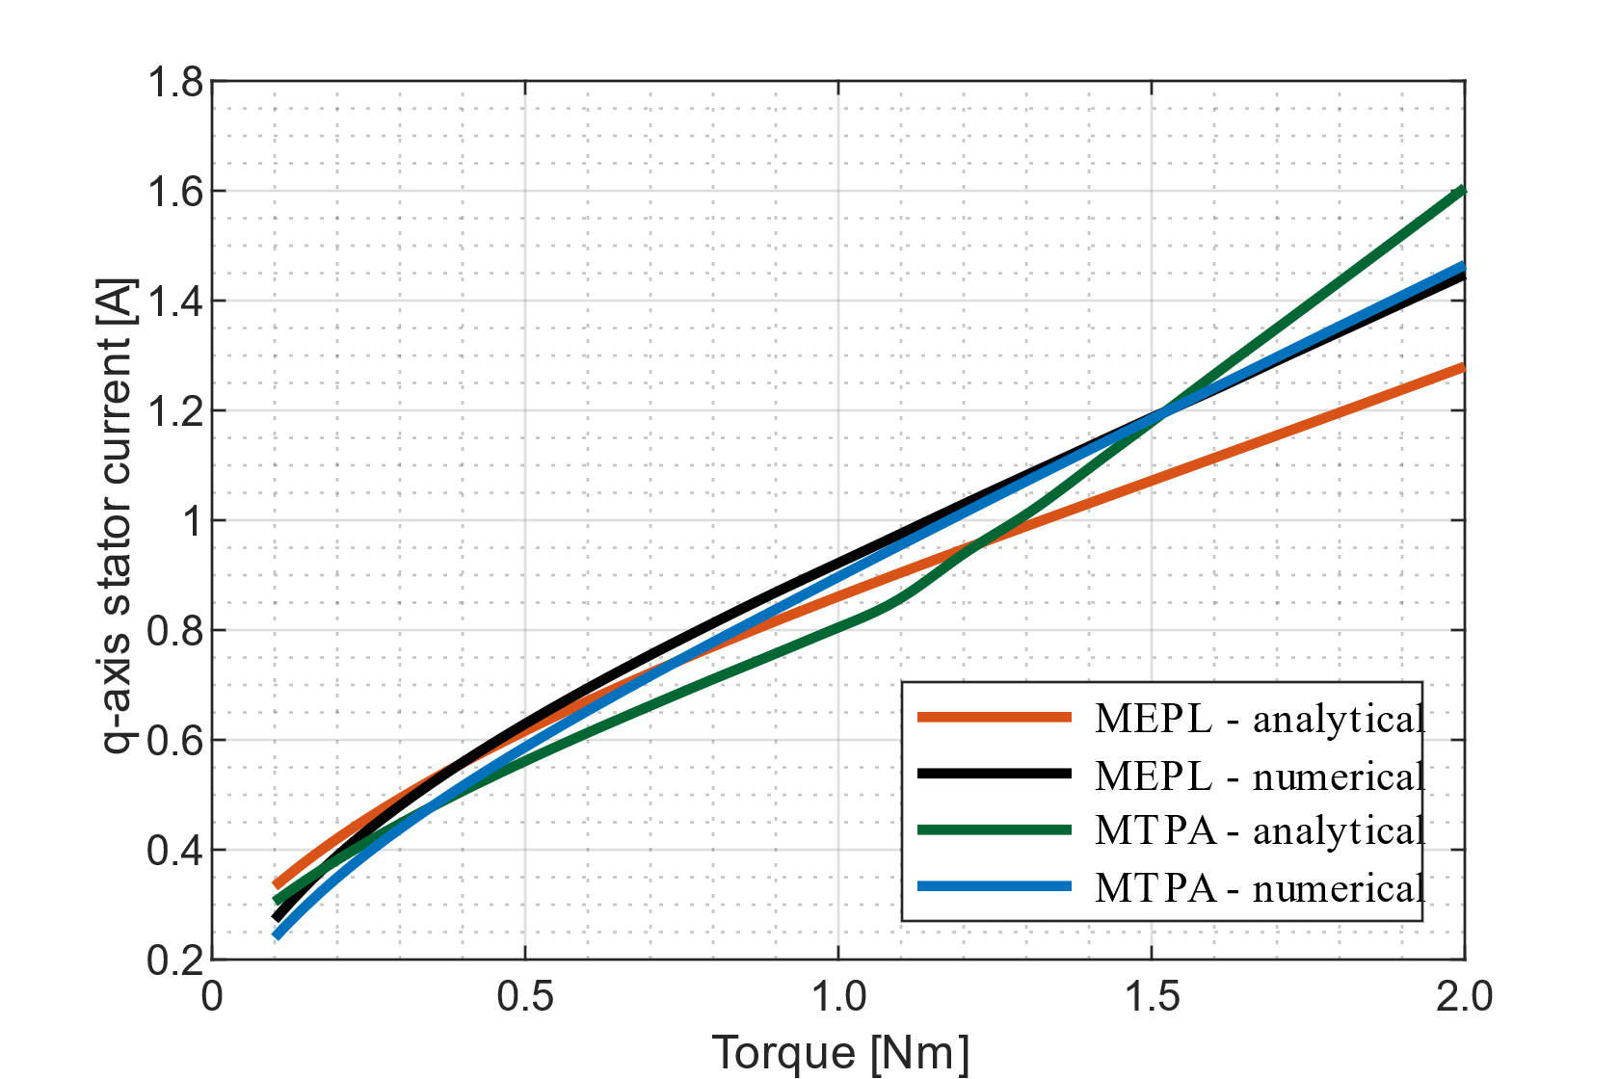
Figure 25. q-axis stator current at $ω_{r}={2 ω_{n}}/3$
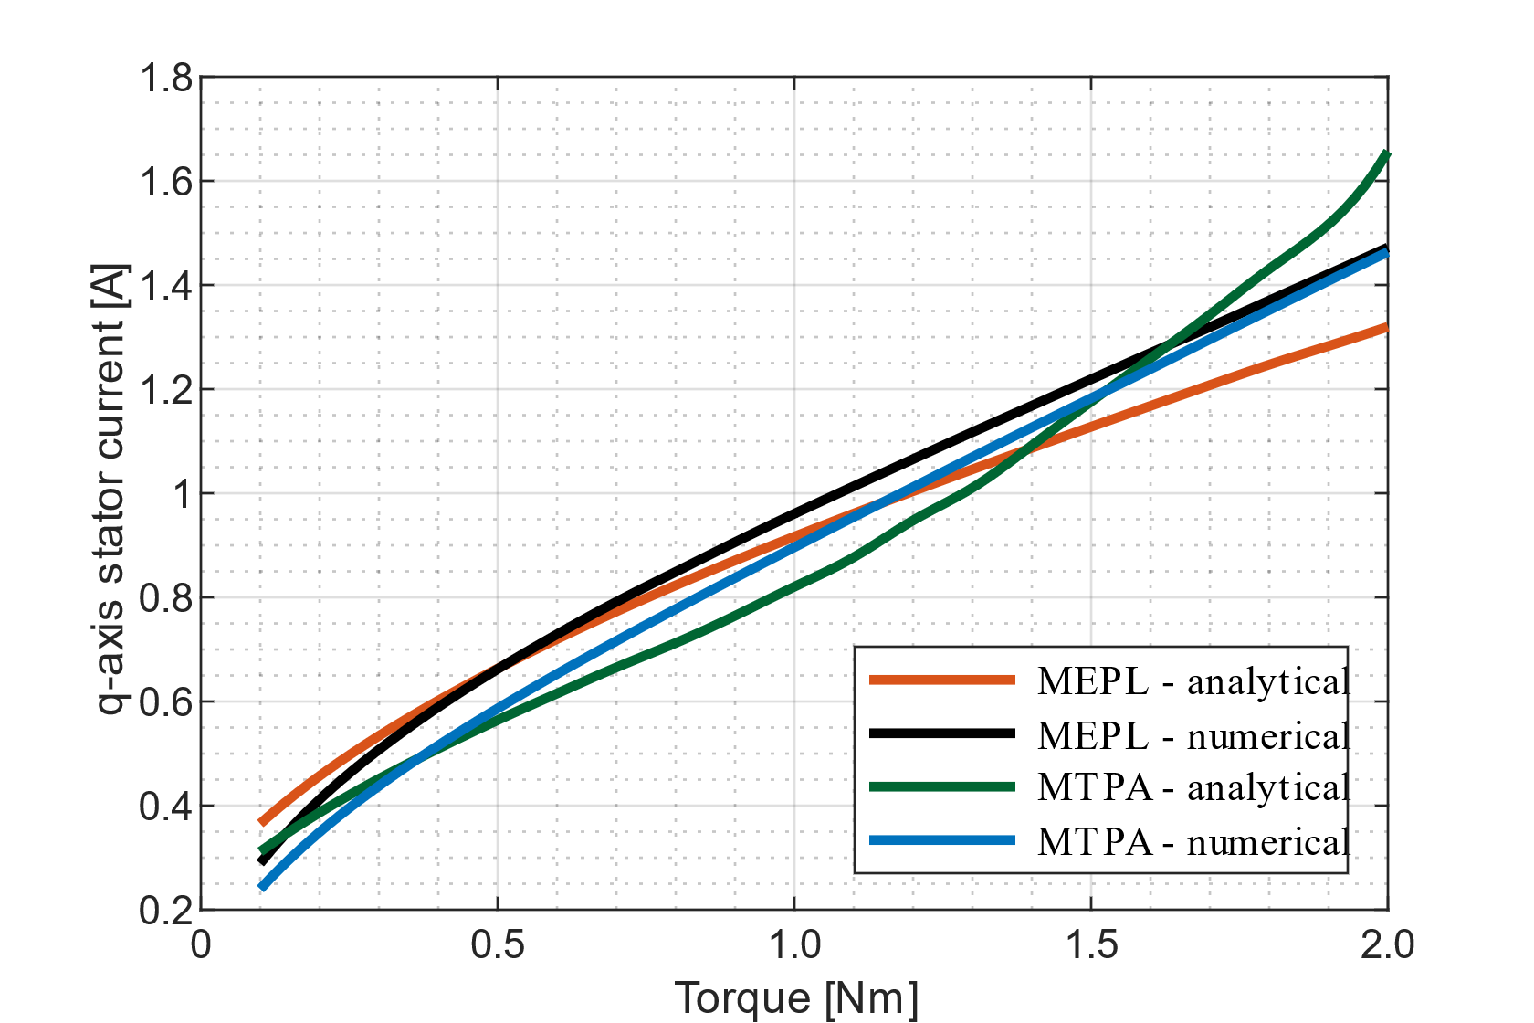
Figure 26. q-axis stator current at $ω_{r}=ω_{n}$
Similar considerations as for the $d$-axis stator current may be drawn for the $q$-axis stator current curves. In general, the numerical curves reproduce the trend of the analytical ones, with precision the increases at increasing values of rotor frequency.
Conclusions
A LUT-based approach to induction machine control has been presented in this paper. The numerical procedure to calculate the values in the LUT has been detailed, two different variants of it have been proposed and a steady-state analysis has been conducted by applying the methodology to a case study. The results showed that the methodology is in good agreement with the analytical expectations at medium to high values of motor speed, but effort should be dedicated to the improve the modelling accuracy in the low-speed high-torque motor operating region.
Overall, the methodology has proven valuable for application in system level simulations, especially at the early stages of the design process. Indeed, the use of a LUT-based approach can greatly reduce the complexity of the simulation model with respect to conventional approaches. Additionally, the numerical interpretation of the motor control problem that is used to generate the LUTs gives great flexibility to calculation algorithm itself. As it has been discussed in the “Case study: a 2 Nm induction machine” section, it is very simple to introduce optimization expressions to model non-constant behavior of the model parameters, thus giving the possibility to adjust the level of detail of the model based on the available input parameters dataset. Furthermore, the optimality criterion can be adjusted very easily, giving the possibility to tailor the motor control policy based on the needs of each specific application.
References
- H. d. Carvalho Pinheiro, A. Messana and M. Carello, “In-wheel and on-board motors in BEV: lateral and vertical performance comparison,” in 2022 IEEE International Conference on Environment and Electrical Engineering and 2022 IEEE Industrial and Commercial Power Systems Europe (EEEIC / I&CPS Europe), Prague, 2022.
- M. Carello, H. d. Carvalho Pinheiro, L. Longega e L. Di Napoli, «Design and Modelling of the Powertrain of a Hybrid Fuel Cell Electric Vehicle,» SAE International Journal of Advances and Current Practices in Mobility, vol. 3, n. 6, p. 2878–2892, 04 2021.
- E. Bianco, A. Rizzello, A. Ferraris e M. Carello, «Modeling and experimental validation of vehicle’s electric powertrain,» in 2022 IEEE International Conference on Environment and Electrical Engineering and 2022 IEEE Industrial and Commercial Power Systems Europe (EEEIC / I&CPS Europe), Prague, 2022.
- C. Cubito, L. Rolando, A. Ferraris, M. Carello e F. Millo, «Design of the control strategy for a range extended hybrid vehicle by means of dynamic programming optimization,» in 2017 IEEE Intelligent Vehicles Symposium (IV), Los Angeles, 2017.
- E. Grano, E. Bianco, H. d. Carvalho Pinheiro and M. Carello, “MTPA and flux weakening control of electric motors: a numerical approach,” in 2023 IEEE International Conference on Environment and Electrical Engineering and 2023 IEEE Industrial and Commercial Power Systems Europe (EEEIC / I&CPS Europe), Madrid, 2023. Guo, Q. and Liu, B., “Simulation and Physical Measurement of Seamless Passenger Airbag Door Deployment,” SAE Technical Paper 2012-01-0082, 2012, doi:10.4271/2012-01-0082.
- M. N. Yuniarto, I. Sidharta, Y. Yohanes e Y. U. Nugraha, «On the Development and Experimental Validation of a Novel and Intuitive Interior Permanent Magnet Synchronous Motor Controller for Electric Vehicle Application,» World Electric Vehicle Journal, vol. 13, n. 6, p. 107, 2022, DOI: 10.3390/WEVJ13060107.
- T. S. Kwon, G. Y. Choi, M. S. Kwak e S. S. Ki, «Novel Flux-Weakening Control of an IPMSM for Quasi-Six-Step Operation,» IEEE Transactions on Industry Applications, vol. 44, n. 6, pp. 1722-1731, 2008, DOI: 10.1109/TIA.2008.2006305.
- D.-Y. Kim e J.-H. Lee, «Low Cost Simple Look-Up Table-Based PMSM Drive Considering DC-Link Voltage Variation,» Energies, vol. 13, n. 15, 2020.
- I. M. Alsofyani and N. R. N. Idris, “Lookup-Table-Based DTC of Induction Machines With Improved Flux Regulation and Extended Kalman Filter State Estimator at Low-Speed Operation,” IEEE Transactions on Industrial Informatics, vol. 12, no. 4, pp. 1412-1425, 2016.
- N. P. Quang e J.-A. Dittrich, Vector Control of Three-Phase AC Machines: System Development in the Practice, Berlin: Springer-Verlang, 2008.
- T. Lažek, “Accuracy Analysis Of Rotor Frequency Calculation For Induction Motor Drive,” in Proceedings of the 27st Conference STUDENT EEICT 2021, Brno, 2021.
- T. Lažek, I. Pazdera e M. Toman, «Simulation and Comparison of a Loss Minimization Algorithm with Conventional Efficiency Improvement Methods for Field-Oriented Control of an Induction Machine,» in 023 IEEE International Conference on Environment and Electrical Engineering and 2023 IEEE Industrial and Commercial Power Systems Europe (EEEIC / I&CPS Europe), Madrid, 2023.
- T. Lažek, I. Pazdera e M. Toman, «Comparison and Simulation of Two Loss Minimization Algorithms for Field-oriented Control of Induction Motor,» in 2022 IEEE 20th International Power Electronics and Motion Control Conference (PEMC), Brasov, 2022.
- M. Toman, R. Cipin, P. Vorel e M. Mach, «Algorithm for IM Optimal Flux Determination Respecting Nonlinearities and Thermal Influences,» in 2018 IEEE International Conference on Environment and Electrical Engineering and 2018 IEEE Industrial and Commercial Power Systems Europe (EEEIC / I&CPS Europe), Palermo, 2018.
- M. Toman, R. Cipin, M. Mach and P. Vorel, “Application of acceleration method for evaluation of induction motor torque-speed characteristics,” in 2017 IEEE International Conference on Environment and Electrical Engineering and 2017 IEEE Industrial and Commercial Power Systems Europe (EEEIC / I&CPS Europe), Milan, 2017.
- J. Pyrhonen, T. Jokinen e V. Hrabovcova, Design of Rotating Electrical Machines, Wiley, 2009.
Contact Information
Contact details for the main author should be included here. Details may include mailing address, email address, and/or telephone number (whichever is deemed appropriate).
(Contact information is omitted to avoid problems of data disclosure in case of blind review. It will be included in the camera-ready version)
Definitions/Abbreviations
LUT | Lookup Table
MTPA | Maximum Torque Per Ampere
MEPL | Minimum Electromagnetic Power Loss
IM | Induction Machine (or Motor)
NaN | Not a Number

