Porpoising effect on racecars: preliminary vehicle dynamics virtual simulation
Matteo Caushi [0009-0005-6455-3071], Henrique de Carvalho Pinheiro ^{[0000-0001-8116-336X]}, Elia Grano [0000-0003-2322-0340] and Massimiliana Carello [0000-0003-2322-0340]
Politecnico di Torino, DIMEAS, Torino, Italy
matteo.caushi@studenti.polito.it
henrique.decarvalho@polito.it
elia.grano@polito.it
massimiliana.carello@polito.it
Abstract. The aim of this work is to provide a preliminary method for the analysis of the vehicle dynamics effect of the porpoising behaviour in a virtual environment. This phenomenon affects mainly wing-cars under specific running conditions, representing a dangerous condition for drivers’ health and vehicle stability, due to the magnitude of the vertical accelerations acting on the car and the oscillations induced on vertical tire forces. The article provides a description of the porpoising effect historical background and dynamical explanation of the phenomenon, followed by the first results of the full-vehicle simulations using an aero map strategy.
Keywords: wing-car, porpoising effect, aerodynamics, vehicle dynamics.
- Introduction
The study of aerodynamics is essential for the improvement of vehicle dynamics and performance, both for passenger vehicles and racecars [1, 2, 3, 4, 5].
In that context, the “wing-car” is a vehicle whose underbody is shaped like an inverted wing of big dimension. This concept was first introduced in Formula One by Lotus in 1977, with their revolutionary Lotus 78 [6, 7].
The shape of wing cars’ floor allows them to produce downforce not only from the front and rear wing, but also from vehicle’s body. The Lotus 78 was able to generate almost 2500 N of downforce from the underbody at 300 km/h, and following developments of the wing car concept led to a sixfold increase in just four years [6]. The increased vertical load enhanced cars’ performance under braking, acceleration, and cornering, resulting in improved lap times [8].
During the development of the Lotus 78, engineers noticed that the downforce generated by the underbody increases if the ride height is reduced. This effect, known as “ground effect”, wasn’t new to the field of aerodynamics. Indeed, it was known since the beginning of the 20th century but found application to Formula One vehicles only at the end of the ‘70s. The increase of negative lift coefficient that can be observed by reducing the ride height only occurs up to a threshold, which is characterized by the maximum negative lift coefficient. For lower ride heights, the downforce generated by the wing-car’s underbody reduces because the increased adverse pressure gradient in the diffuser area causes a major airflow separation. This ride height threshold, usually defined as “critical ride height”, is a key parameter for a wing-car performance [9].
- Porpoising effect mechanism
Porpoising is the name given by Mario Andretti, in the late 70’s, to address the aero-mechanical phenomenon which his wing-car was experiencing at high speeds [10]. It consists of vertical oscillations of the vehicle body that are triggered when the vehicle is running close to the critical ride height, which may be dangerous to the driver.
The porpoising effect was first observed in the late 70’s, with the first generation of Formula One wing-cars, and it was partially solved through the stiffening of the suspensions. Following the atrocious deaths of Gilles Villenueve and Riccardo Paletti occurred during the 1982 Formula One season, the wing cars were banned from the sport [11]. In 2022 the wing-car concept was reintroduced in Formula One and made mandatory for all the teams [12]. Unexpectedly, porpoising was still an issue even for the new generation of wing-cars.
To understand the physical mechanism that triggers the porpoising effect it is necessary to have a clear understanding of downforce. The relative motion between the air and the car itself results in an aerodynamic force. Downforce is one of the components of this interaction, conventionally aligned to the Z-axis and pointing downwards [13, 14]. Typically, air is deemed static. Consequently, downforce, $L$, depends only on vehicle’s velocity, $U$, and on the negative lift coefficient, $C_{Z}$, as described by Eq. 1 [8]:

$L=\frac{1}{2}∙ρ∙C_{Z}∙U^{2}$ (1)

An increase in negative lift, $L$, results in a car’s ride height reduction due to suspensions being more loaded. This leads to a car’s underbody capable of generating even more downforce due to the ground effect.
Reducing the ride height of the car, the airflow acceleration through the converging part of the underbody increases, resulting in a lower pressure at its outlet. The air pressure at the diffuser outlet is unaffected by ride height because it is determined by the boundary condition of being always equal to the atmospheric pressure. So, the pressure recovery coefficient of the diffuser and the pressure gradient gets larger as the ride height is reduced. Anyway, if the adverse pressure gradient gets too large, the nearest air particles to the diffuser surface start inverting their direction of motion, causing flow separation. When the diffuser stalls, the vehicle experiences a sudden downforce reduction. The ride height is therefore increased by the suspensions and, after a small transitory, the airflow reattaches to the diffuser. The vehicle is then capable of generating high levels of downforce once more, progressively reducing vehicle’s ground clearance, until the floor won’t reach the critical ride height once again [15]. This phenomenon is affecting mainly wing-cars because, to make them generate high levels of downforce, they need to run as close as possible to the ground. On the other hand, running very low also increases the probability of an aerodynamic stall.
- Porpoising effect simulation
Due to the restrictions imposed by Formula One technical regulations on testing, it’s almost impossible to detect the porpoising effect in the wind tunnel. Indeed, Formula One teams are only allowed to test 60% scale models and the air speed can’t exceed 50 m/s. Moreover, it’s also illegal to simulate it in the wind tunnel by forcing the car to vertical oscillations [12]. Consequently, the opportunity to replicate the effect in a virtual environment is of paramount importance for motorsport vehicle development.
This section offers insights on how to recreate the porpoising effect on VI-Grade CarRealTime [16]. The simulation process is based on the use of aero maps, which are tools that define the relationship between the vehicle setup parameters (front and rear ride heights in this case) and its aerodynamic properties (coefficients of lift and drag). Thus, an aero map is a key tool to create an aerodynamic model of a vehicle in a virtual environment. Aero maps of a 2022 Formula One wing-car inspired vehicle have been obtained from the raw data drawn from an Assetto Corsa mod called Formula Hybrid X 2022 [17]. The original aero maps have been suitably modified to trigger the phenomenon. The only differences between the two aero maps (original and modified one) are relative to the levels of negative downforce below the critical ride heights. Indeed, when the critical ride height is reached the car experiences a 50% reduction of the rear axle downforce, as it can be seen in Fig. 1. For even lower rear ride heights the rear axle downforce decreases linearly. It must be observed that those aero maps have no pretenses of quantitative accuracy because, due to the highly confidentiality level of the topic, it was not feasible for the authors to obtain a real aero map from a reliable source.

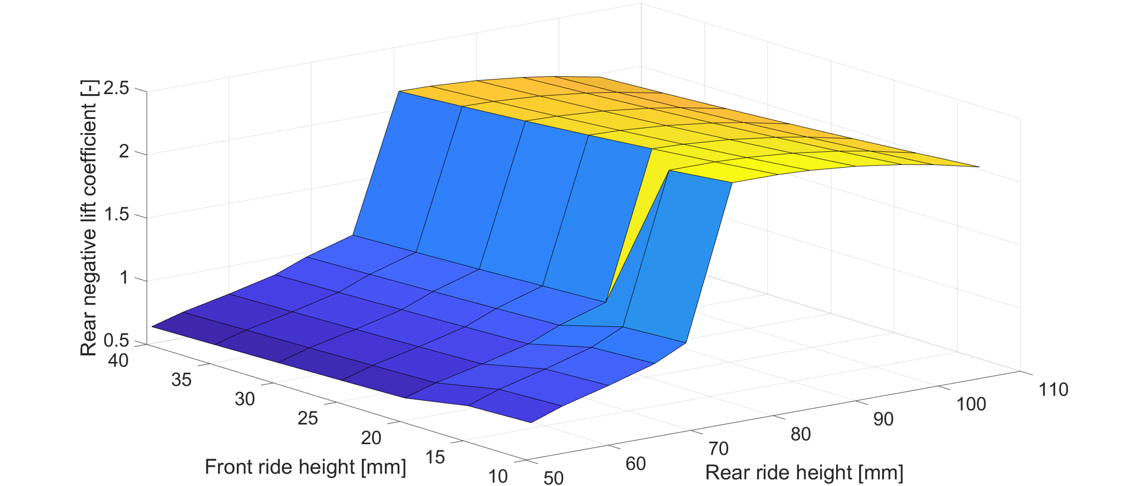
Fig. 1. Rear negative lift coefficient map
The model of the car was completed with the front and rear suspensions parameters. Two different setups were simulated, as shown in Table 1.
Table 1. Main vehicle parameters
Parameter | Value | Units
Total mass | 1052 | Kg
Wheelbase | 2712.9 | mm
CG Position (X, Y, Z) | (1230, 0, 381) | mm
Front axle suspension stiffness | 145 | N/mm
Rear axle suspension stiffness | 80 | N/mm
Static front ride height | 40 | mm
Static rear ride height (configuration 1) | 80 | mm
Static rear ride height (configuration 2) | 100 | mm

Apart from suspension and aerodynamics, the other vehicle parameters used were obtained through the baseline “racecar” model from Vi-Grade CarRealTime library.
The vehicle is simulated on a wide-open throttle (WOT) mission on a straight-line trajectory. Results are shown using the red color for configuration 1 and the blue color for configuration 2. The plots start showing the vehicle behavior after 10 s of simulation, since the relevant results are observed at high speeds. Fig. 2 and Fig. 3 show configuration 1 triggering porpoising, whereas configuration 2 doesn’t.

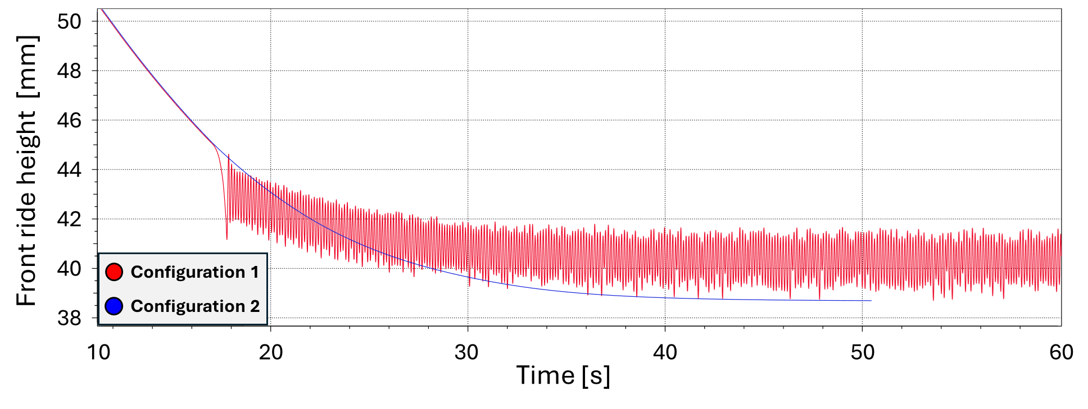
Fig. 2. Front ride height
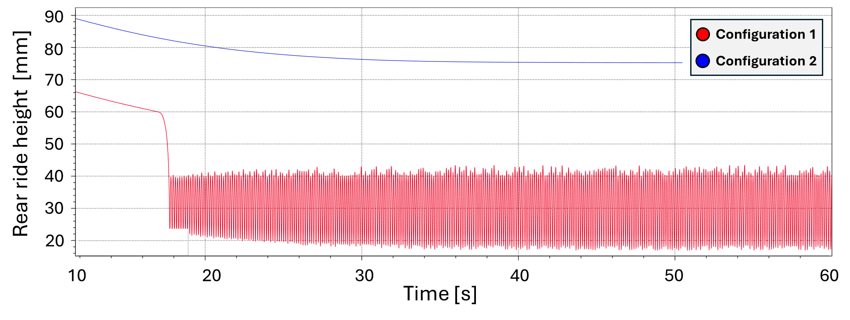
Fig. 3. Rear ride height
The amplitude of the oscillation of the rear axle is one order of magnitude greater than that of the front axle, thus generating a rotation of the vehicle body about the Y-axis [13, 14]. This is coherent with the high pitch angle diagram in Fig. 4

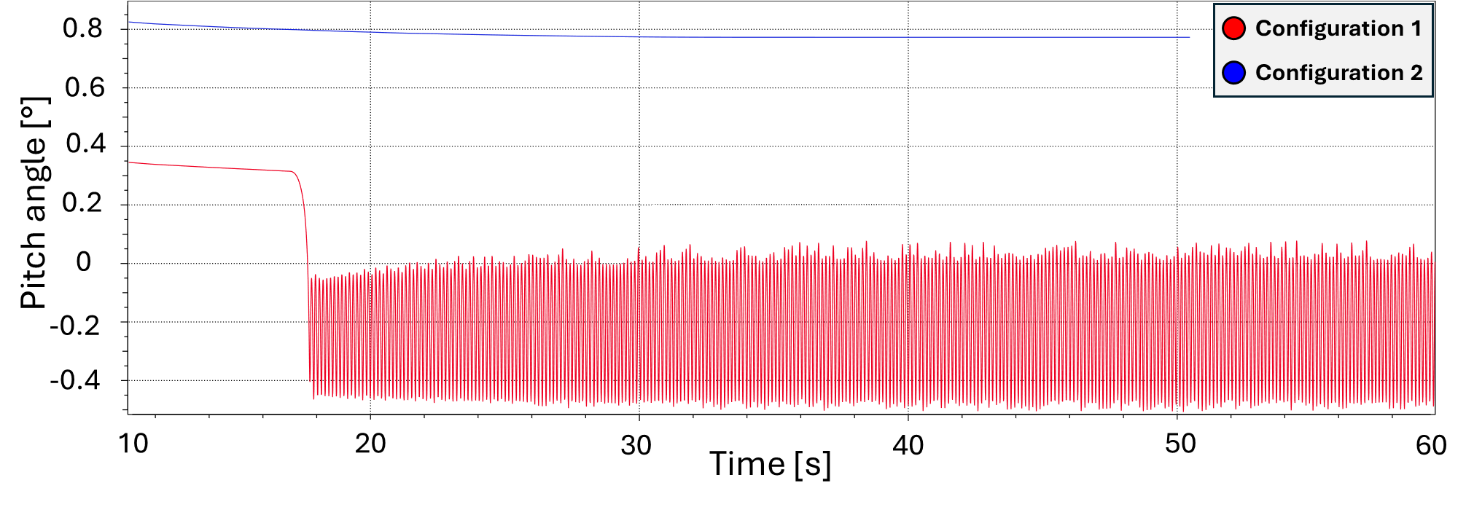
Fig. 4. Pitch angle
The amplitude of oscillations in Fig. 2, Fig. 3 and Fig. 4 initially rises before becoming steady. Considering Fig. 5, this behavior may be the consequence of the platooning of vehicle speed. This suggests that the amplitude of the porpoising-induced oscillations is positively correlated to vehicle speed.

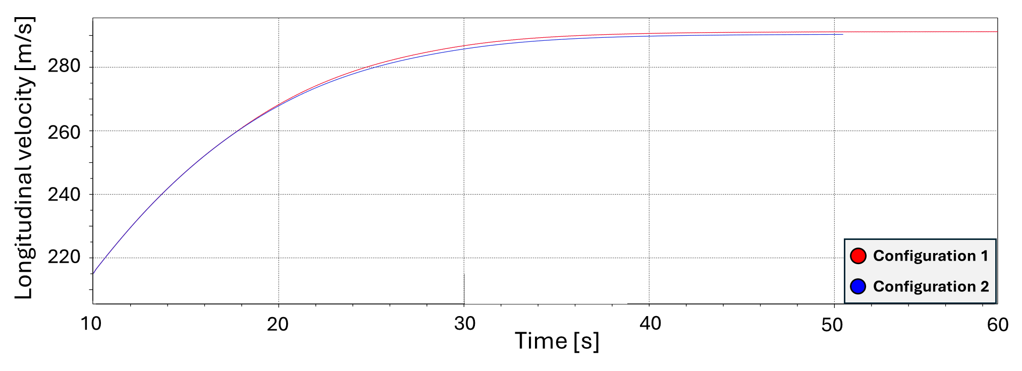
Fig. 5. Vehicle velocity
Fig. 6 and Fig. 7 show the trend of the downforce acting at the front and at the rear of the vehicle. As expected, oscillations are far more severe at the rear than at the front.
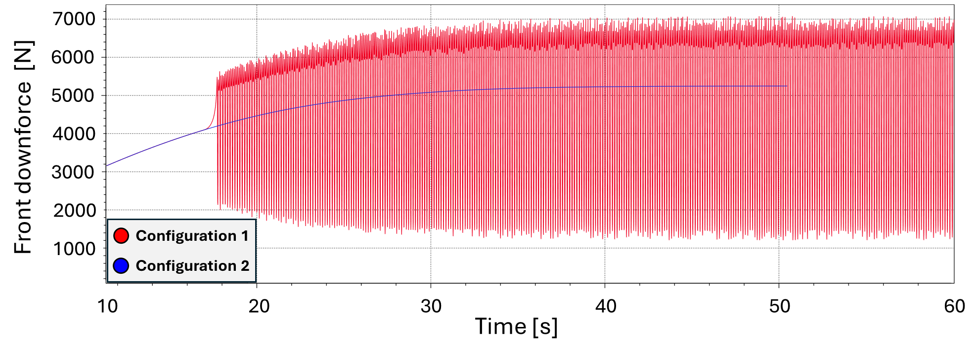
Fig. 6. Front axle downforce
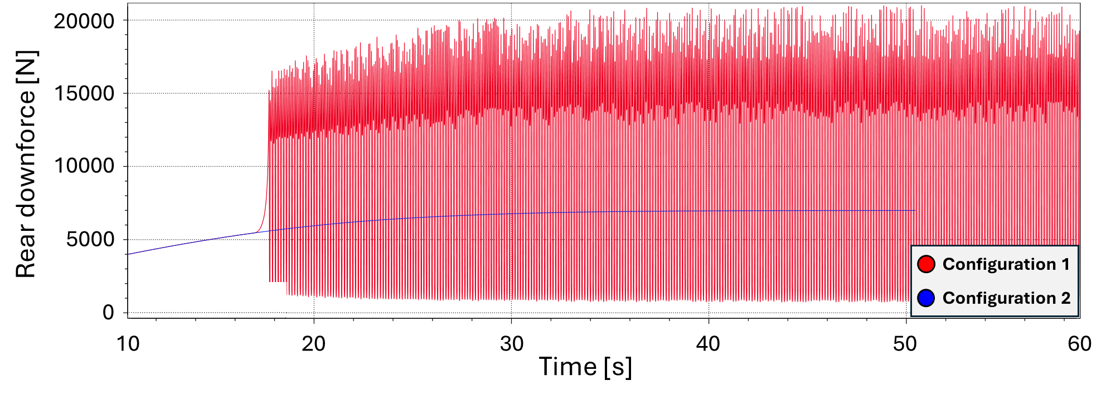
Fig. 7. Rear axle downforce
Fig. 8 shows a detail of the rear axle downforce diagram highlighting that the frequency of the oscillations is in the range 7$÷$8 Hz.

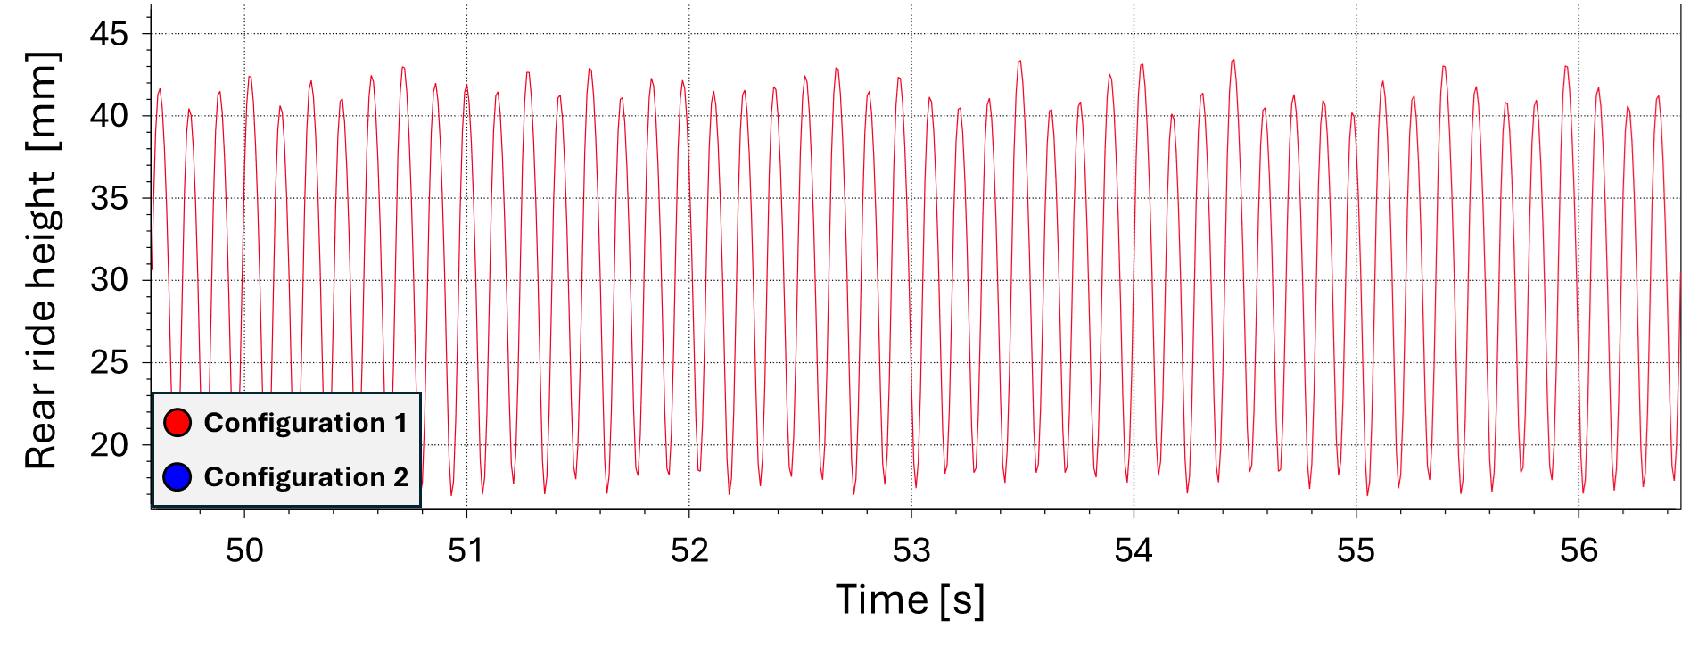
Fig. 8. Detail of rear axle displacements
As it is possible to see in Fig. 9, the vertical accelerations on the vehicle body have approximately the same magnitude in both upwards and downwards directions.

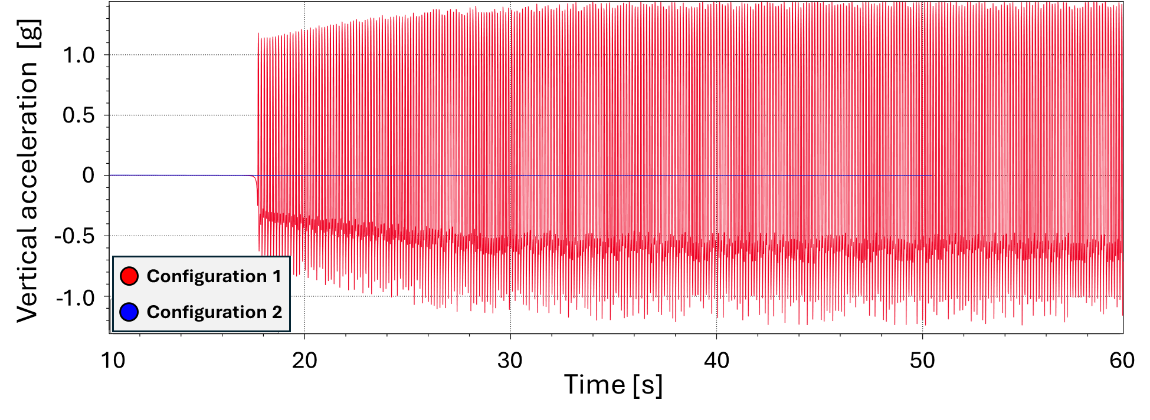
Fig. 9. Vertical acceleration acting on the sprung mass vs time comparison.
- Conclusions
As expected, when car’s ride height is reduced to the critical ride height the porpoising effect is triggered.
On the simulation run the phenomenon is generated when the car is moving at almost 260 km/h. Regularly this speed mainly depends on the underbody geometry, that is related to the aero maps, and on car’s suspensions setup. Consequently, by slightly increasing the static ride height of the car the phenomenon will be triggered at higher velocities since a greater aerodynamic vertical load will be required to reach the critical ride height. Obviously, a greater static ride height, as shown in the previous simulation’s results, will result in a car not able to trigger the phenomenon. On the other hand, an increase in the static ride height will also result in lower levels of downforce and, consequently, to a slower car through corners.
In terms of vertical accelerations, the simulations have partially confirmed what was experienced by the real Formula One cars. Indeed, the vertical accelerations acting on the car during the simulations were slightly greater than 1g, but according to Toto Wolff, CEO of the Mercedes-AMG PETRONAS F1 team, when their car was experiencing porpoising the vertical acceleration reached peaks of 6g [18]. This effect should be further analyzed by adjusting the sharpness of the aerodynamic map or creating an external force generation mechanism able to more closely describe the peak values.
Lastly, the porpoising effect triggered during the simulations is characterized by a frequency of 7$÷$8 Hz which is similar to the ones measured on the real cars (5$÷$6 Hz).
Future developments of the research can include the proposal of new modelling methods for describing the effect, the use of simulation tools to describe the aerodynamic behavior triggering the diffuser stall, as well as the experimental validation of the model through driving simulator DiL tests [19,20,21].
- References
- H. De Carvalho Pinheiro, F. Russo, L. Sisca, A. Messana, D. De Cupis, A. Ferraris, A. Airale e M. Carello, «Advanced Vehicle Dynamics through Active Aerodynamics and Active Body Control,» in Proceedings of the ASME IDETC/CIE 2020, Online, 2020.
- H. De Carvalho Pinheiro, F. Russo, L. Sisca, A. Messana, D. De Cupis, A. Ferraris, A. Airale e M. Carello, «Active Aerodynamics through Active Body Control: Modelling and Static Simulator Validation,» in Proceedings of the ASME IDETC/CIE 2020, Online, 2020.
- D. De Cupis, H. De Carvalho Pinheiro, A. Ferraris, A. Airale e M. Carello, «Active Aerodynamics Design Methodology for Vehicle Dynamics Enhancement,» in IFToMM, Advances in Italian Mechanism Science, Online, 2021.
- A. Ferraris, H. De Carvalho Pinheiro, A. Airale, M. Carello e D. Polato, «City Car Drag Reduction by means of Flow Control Devices,» in SAE Brasil 2020, SAE Technical Paper 2020-36-0080, Sao Paulo, Brasil, 2021.
- A. Ferraris, D. De Cupis, H. De Carvalho Pinheiro, A. Messana, L. Sisca, A. Airale e M. Carello, «Integrated Design and Control of Active Aerodynamic Features for High Performance Electric Vehicles,» in SAE Brasil 2020, SAE Technical Paper 2020-36-0079, Sao Paulo, Brasil, 2021.
- P. Pinto, «L’evoluzione aerodinamica delle vetture di Formula Uno,» in 1° Convegno Nazionale di Storia dell'Ingegneria, Napoli, 2006.
- Motor Sport Magazine, «Lotus 78: F1's first true ground effect car,» February 2020. [Online]. Available: https://www.motorsportmagazine.com/archive/article/february-2020/111/lotus-78-2/. [Accessed on 14 March 2024].
- L. Frömmig, Basic Course in Race Car Technology, 1 a cura di, Springer Vieweg Wiesbaden, 2023.
- J. Zerihan e X. Zhang, «Aerodynamics of a Single Element Wing in Ground Effect,» Journal of Aircraft, vol. 37, n. 6, pp. 1058-1064, January 2000.
- G. McCabe, «Hhistory of porpoising,» 05 May 2015. [Online]. Available: https://mccabism.blogspot.com/2015/05/a-history-of-porpoising.html. [Accessed on 2024 March 14].
- Wikipedia, «1982 Formula One World Championship,» [Online]. Available: https://en.wikipedia.org/wiki/1982_Formula_One_World_Championship. [Accessed on 14 March 2024].
- Federation Internationale de l'Automobile, «2022 Formula 1 Technical Regulations,» 19 February 2021. [Online]. Available: https://www.fia.com/sites/default/files/2022_formula_1_technical_regulations_-_iss_3_-_2021-02-19.pdf. [Accessed on 14 March 2024].
- SAE International, «Vehicle Dynamics Terminology,» 09 June 2022. [Online]. Available: https://www.sae.org/standards/content/j670_202206/. [Accessed on 13 March 2024].
- International Organization for Standardization, «ISO/TC 22/SC9,» [Online]. Available: https://www.iso.org/committee/46706.html. [Accessed on 13 March 2024].
- Z. Zhu, «Cause and Analysis of 2022 Formula 1 ‘Porpoising’,» in 6th International Conference on Mechatronics, Control and Electronic Engineering (MCEE 2023), 2023.
- VI-grade, «VI-CarRealTime,» [Online]. Available: https://www.vi-grade.com/en/products/vi-carrealtime/. [Accessed on 14 March 2024].
- Race Sim Studio, «https://racesimstudio.com/rss-formula-hybrid-x-2022,» [Online]. Available: https://racesimstudio.com/rss-formula-hybrid-x-2022. [Accessed on 14 March 2024].
- FormulaPassion.it, «Wolff: “Le ossa di Hamilton e Russell colpite da 6G”,» 17 June 2022. [Online]. Available: https://www.formulapassion.it/motorsport/formula-1/f1-piloti/wolff-ossa-hamilton-russell-colpite-6g-porpoising-direttiva-fia-mercedes. [Accessed on 15 March 2024].
- De Carvalho Pinheiro, H., Lubertino, S., and Carello, M., “Path planning development for human-like virtual driver,” Congresso SAE Brasil, Sao Paolo, Brazil: 2023-36–0068, 2024, doi:10.4271/2023-36-0068.
- De Carvalho Pinheiro, H. and Carello, M., “Design and Validation of a High-Level Controller for Automotive Active Systems,” SAE Int. J. Veh. Dyn., Stab., and NVH 7(1):10-07-01–0006, 2023, doi:10.4271/10-07-01-0006.
- Ferraris, A., De Carvalho Pinheiro, H., Galanzino, E., Airale, A.G., and Carello, M., “All-Wheel Drive Electric Vehicle Performance Optimization: From Modelling to Subjective Evaluation on a Static Simulator,” 2019 Electric Vehicles International Conference, EV 2019, 2019, doi:10.1109/EV.2019.8893027.

