2024-26-XXXX

Innovative Zero-Emissions Braking System: performance analysis through a Transient Braking Model

Author, co-author (Do NOT enter this information. It will be pulled from participant tab in MyTechZone)
Affiliation (Do NOT enter this information. It will be pulled from participant tab in MyTechZone)

Abstract
This paper presents the analysis of an innovative braking system as an alternative and environmentally friendly solution to traditional automotive friction brakes. The idea arose from the need to eliminate emissions from the braking system of an electric vehicle: traditional brakes, in fact, produce dust emissions due to the wear of the pads. The innovative solution, called Zero-Emissions Driving System (ZEDS), is a system composed of an electric motor (in-wheel motor) and an innovative brake. The latter has a geometry such that it houses MagnetoRheological Fluid (MRF) inside it, which can change its viscous properties according to the magnetic field passing through it. It is thus an electro-actuated brake, capable of generating a magnetic field passing through the fluid and developing braking torque.
A performance analysis obtained by a simulation model built on Matlab Simulink is proposed. The model is able to simulate the transient 1D motion of an electric vehicle equipped with four wheels, each having a ZEDS mounted. It has the ability to simulate a road test, supervise the behavior of the vehicle, monitoring parameters such as the State of charge (SoC) of the battery, the current used by the vehicle's battery, speed, drive torque and the decoupling between the regenerative braking torque and the Magneto-Rheological brakes torque.
The primary goal of the model is to verify the capability of the braking system to develop a sufficiently high torque to satisfy safety standards and regulation requests. The study creates also a starting point for thermal analysis of the system.
Introduction
The main goal of automotive research, focused primarily on electric propulsion, is to eliminate combustion emissions from vehicles. The new generation of electric vehicles completely eliminates combustion emissions and is able to use the energy obtained from the regenerative braking, thus reducing the work of friction brakes, which, in addition to dissipating energy, generate dust emissions due to pad wear [1] [2].
All the components acting on a frictional basis generate wear subproducts, which could have a dimension of micro or nanometres. Those are commonly called particles and are defined on a dimensional basis in categories as PM10 (aerodynamic diameter lower than 10μm), PM2.5 (aerodynamic diameter lower than 2.5μm), or PM1 (aerodynamic diameter lower than 1μm). Infact, brake wear is known as the primary source of traffic-related non-exhaust particle generation. Liu et al. [3] underline how, although in older studies the PM emitted by the braking system is around 20 to 30% of the global particulate emitted by the car using a WLTP or NEDC cycle, analysing a new WLTP-B cycle (specifically designed for analysing more realistic manoeuvres) it is possible to realise that the brakes are the largest contributor reaching 49% of the global PM emissions. For this reason, the new Euro-7 Standard, published in November 2022 and to be activated for July 2025, introduced for the first time the concept of non-exhaust pollutants: “non-exhaust emissions consist of particles emitted by tires and brakes of vehicles Emissions from tires is estimated to be the largest source of microplastics to the environment. As shown in the Impact Assessment, it is expected that by 2050 non-exhaust emissions will constitute up to 90% of all particles emitted by road transport”. [4] For the first time, limitations have been introduced for the non-exhaust emissions, alarming the main carmakers, whose scare is given by the complexity of evaluating the secondary pollutants and finding efficient solutions for reducing these emissions.
Rahimi [5] proposed a novel approach for brake emission estimation with a neural network brake emission modelling in order to provide fundamental information to the decision-makers to better insight into the rate of non-exhaust emissions generation.
However, as Wagner [6] explains, the regenerative braking system is not part of the service brake and, due to its heavy battery, the EV brakes are even larger than those of a conventional vehicle. In addition, the close dependence of regenerative efficiency with the SoC of the battery leads to the need to size the brakes so that they can independently provide the safety conditions required by regulations.
The paper exposes a suitable solution to replace traditional friction brakes to develop a real zero-emissions driveline. ZEDS is an idea which presents a system consisting of a MagnetoRheological (MR) brake placed in series with an in-wheel motor. The brake, thanks to its special geometry, is integrated with the rotor of the in-wheel motor, thus creating a cavity that can accommodate a film of MR fluid. Through a system of coils in the stator of the brake, a magnetic field is generated that passes through the fluid, changing its viscous properties, thus generating braking torque. An electro-actuated braking system is thus realized that does not exploit the friction between discs and pads and therefore does not generate pollutant emissions. Through a model built on MATLAB Simulink, the longitudinal dynamics of a vehicle equipped with four ZEDS, one for each wheel, was simulated. The model provided results that demonstrated the feasibility of the system, both from a performance and safety point of view.
Innovative Zero-Emissions Solution
MR brakes uses the innovative technology of the MR fluid. This smart fluid can change its rheological properties, changing its yield stress as a function of the magnetic field applied on it, because of the structure of a ferro-magnetic particulate inside the fluid itself, then, when excited, organizes itself in a way that makes it more rigid. Some examples of this technology have been showed by Sohn [7] and how the torque needed to stop the vehicle could be reached adapting the internal geometry. Other studies of magnetorheological brakes have been done over the years, often through an adaptation of the geometry of classic disc brakes to take advantage of the physical properties of the fluid [8] or by devising new geometries deemed more efficient [9] [10] [11]. The effectiveness of the system in term of reaction to the braking command from the driver is faster than traditional brakes [12]. In fact, considering a time response of around 0.3 s for a traditional disk-brake system whose fluid must be compressed and transfer the pressure to the brake-piston, the MR brake system has an instantaneous response, starting from a needed brake-by-wire system that sends the signal to the MR fluid that has an instantaneous response transforming its yield stress value [13] [14].
Two main drawbacks for this technology are considered: the resistive torque during zero-magnetic field at cruising speed and the temperature during every working condition. In fact, the fluid is generating an equivalent rolling resistance that must be as low as possible to not reduce the acceleration performance of the vehicle. Another pivotal issue is the temperature, because the MR fluid is operative under 140-150°C [15]. For this reason, temperature management must be studied to satisfy every working condition.
The proposed design
The geometry layout proposed by Imberti [16] [17] is represented in Figure 1. It is composed of combining an in-wheel motor with an external braking stator, while in between the MRF is inserted, for creating in that area the resistive forces needed to create the braking torque. The idea is to use the free spaces around the external part of the in-wheel motor to maximize the arm of the resistive forces generated by the changes in yield stress of the MRF, and, in this way, optimize the decelerating torque.
In particular, the rotor (1) is designed with a protuberance (4) that goes over the stator volume (2), to use the free space as the interference surface with the MR brake stator. The MR stator has been designed to obtain a sort of clamp (3) able to surround the part (4) and have part of the interference surface both on the inner and on the outer part of the rotor. It has also been thought of as a concave component to obtain an acceptable volume for the connection to the rest of the vehicle and the suspensions. On the external part of the clamp (5) the coil must be fixed. It has been considered as a double component of a bobbin where the coil is wrapped up and its dimensioning has been performed during the electro-magnetic validation, as one of the most effective parameters on the development of a sufficient magnetic field on the MRF.
The reason why the concept has been chosen is because it allows to consider different advantages.
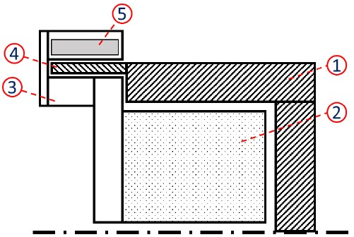
Figure 1. Schematic Layout of the Innovative Braking Solution.
A geometric description of the ZEDS is presented in Figure 2. In particular, all the parameters considered for the calculation of braking torque generated by the MR brake are shown:
- Ri_ext is the external radius of the rotor;
- Re_int is the internal radius of the rotor;
- L_ext is the depth of the outer annular section in contact with the MRF;
- R_out_ext is the external radius of the stator;
- R_out_int is the internal radius of the stator;
- L_int is the depth of the inner annular section in contact with the fluid;
- L_out is the outer width of the MR brake stator.
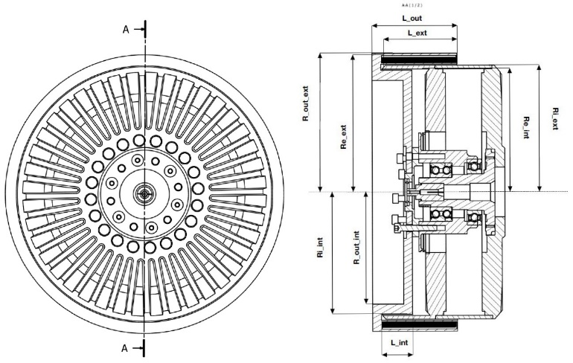
Figure 2. Innovative Solution Geometry
Onother study made by Terzo [18] presents a comparison of two geometric configurations (Figure 3).
In the first case (left), the traditional operation of the actual disk-brakes using the MR technology. In the second (right), a new geometric configuration in which the two rotating parts are composed of cylinders of different diameters arranged concentrically. The fluid is inserted into the annular crown.
In this second case (right), the meatus, in which the fluid is contained, is small compared with the diameter of the two cylinders, so the tangential tension of the fluid can be considered independent of the radius. It has been shown that as the geometric parameters that determine the footprint of the two devices vary the coaxial cylinder solution is always able to deliver higher torque. In particular, the comparison of the transmitted torque C_{c}(Re) from the solution with cylinders with that C_{d}(Re) transmitted by the disc solution, gives the result reported in Figure 4.

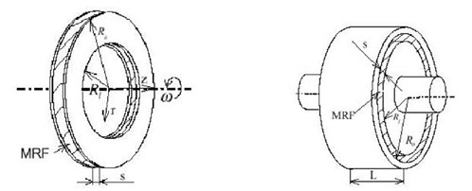
Figure 3. Schemes of operation proposed by Terzo [18]
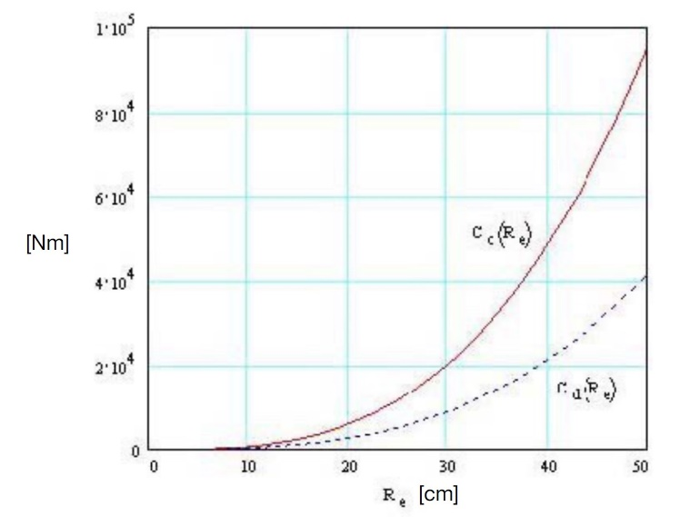
Figure 4. Comparison of transmitted torques in the two geometric configurations vs. Re [18]
Transient Braking Model
It is appropriate and advantageous to obtain feedback from simulation before moving on to the production of the prototype under consideration. Heydrich introduced a case study on the potential of new mechatronic chassis systems for
battery electric vehicles, in that case a brake-by-wire (BBW) system and in-wheel propulsion on the
rear axle combined with an integrated chassis control providing common safety features. [19]
So, a Simulink model has been created to implement data from a specific car, equipped with the ZEDS innovative braking. Specifically, the car is structured to have an integrated MR brake with an in-wheel motor (Table 1, EMRAX 268-MV [20]) for each wheel [21] [22]. It can simulate a road test, supervise the behaviour of the vehicle, monitoring parameters such as the SoC of the battery, the current used by the vehicle's battery, speed, acceleration, drive torque, regenerative braking torque and that generated by the MR brakes, and others. All with corresponding graphs, so that it would be possible to estimate which of them most influence the charging process through regenerative braking and which of them consume the most energy. All this is aimed at optimizing the regenerative braking logic to increase with the greatest efficiency the state of charge and thus the energy range of the car itself.
Whole system Layout
The main layout of the whole system(Figure 5) contains the basic blocks into which it is divided, thanks to which the driving cycle is defined, and then the test to be performed, the environmental conditions, and data are processed to monitor the behavior of the car, the braking system, the four in-wheel electric motors, and the battery.
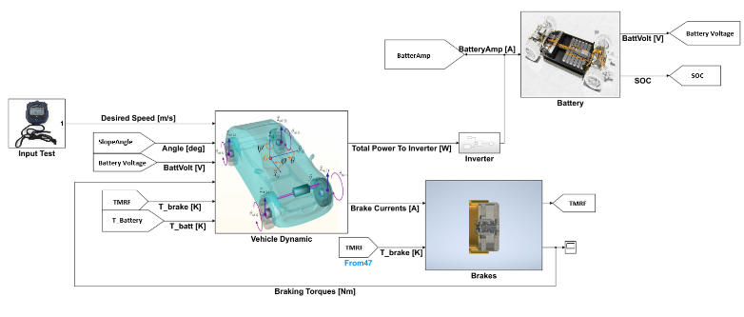
Figure 5. Whole System Layout
As shown in Figure 5, the model has several main blocks, in particular:
- "Input Test" block, in which the test to be performed is given as input; in particular, this gives as output the speed profile to be obtained from the vehicle and the slope of the road profile to be travelled by the vehicle in function of its instantaneous position;
- “Vehicle Dynamics” Block, in which is given as input the speed profile you want, the road slope, and the voltage at which the battery is, and calculates the torque required to the individual in-wheel motors, the torque required to the magnetorheological brakes, then the relative currents required to these, the total power consumed during the individual calculation step, and the resulting vehicle dynamics and the resultant motion of the vehicle; the torque needed is calculated by means of a proportional-integrative control ("PI Torque Controller"), which receives as input the speed error, calculated as the difference of the desired speed and the current speed of the vehicle, and derives the required torque. The calculated torque, however, is the total torque required. Since the model can handle and simulate the operation of each ZEDS per wheel, it is necessary to distribute the total required torque over the 4 systems. During braking, the load is not equal on each wheel, since there is a load transfer on the front axle and the rear axle will be more unloaded, tending to lock up. advantage presented by ZEDS is its independent implementation. Specifically, the ECU is able to electrically activate the system present on each individual wheel, thus ensuring optimal distribution for vehicle dynamics. In the SIMULINK model, the calculated torque is multiplied by four variable coefficients (KFL, KFR, KRL, KRR) that have been calculated according to the maximum torque that each wheel can deliver. Specifically, depending on the dimensions of the vehicle's characteristics (mass, centre of gravity height, wheelbase, front and rear half-pass) shown in Table 2, its instantaneous acceleration and the slope at which it moves, the load transfer between the front and rear axles and, subsequently, between the two wheels of the axle was calculated. Thus, having derived the maximum transmissible torques for each wheel, they have been divided by the total transmissible torque. At this point, according to what has just been explained, each ZEDS block is given the required torque as input.
- “Brakes” Block, in which, as a function of the required current to the brakes, the braking torque generated by each brake and each relative operating temperature is calculated;
- “Battery” Block, in which the battery performance is simulated as a function of the total current required through an inverter that can calculate it according to the total power required by the in-wheel motors and possibly the brakes, then the SoC is provided as output.

Table 1. Electric Motor Parameters
Peak Motor Power at max load RPM [kW] | 200
Continuous Motor Power [kW] | 91
Maximal Rotation Speed [RPM] | 4500
Maximal Motor Current [Arms] | 400
Continuous Motor Current [Arms] | 190
Maximal Motor Torque [Nm] | 500
Continuous Motor Torque [Nm] | 213
Torque / motor current [Nm/1Aph rms] | 1.30
Motor efficiency [%] | 92-98

Table 2. Vehicle Parameters
Vehicle Mass [kg] | 1040
Pilot Mass [kg] | 80
Wheel Radius [m] | 0.291
Distance of the CG from the front axle [m] | 0.861
Wheelbase [m] | 2.152
CG height [m] | 0.5376
Friction Coefficient [-] | 0.7
Rolling Resistance coefficient f0 [-] | 0.0136
Rolling Resistance coefficient K [m/s²] | 6.5·10⁻⁶
Vehicle Frontal Section [m²] | 2
Aerodynamic Drag Coefficient Cx | 0.33

A more detailed description of “Brakes” block is discussed in the next paragraph.
Brakes Block
The "Brakes" block, as already anticipated, simulates the behaviour of the four brakes mounted on the four wheels of the vehicle. Specifically, the main function of the it is to calculate the braking torque generated by each individual brake as a function of the current sent as input to each of them.
Having derived the torques for each brake, they are summed, and the total braking torque is used as input to the "Vehicle Dynamics" block to calculate the total torque acting on the vehicle.
The current sent to the individual brake is computed in the “Vehicle Dynamic” block as a function of the braking torque requested to the MR brakes. Starting from the current, it has been possible derive the magnetic field H [kAmp/m] generated in the MR fluid layer, known the trend of H a function of the coils’ current I. This trend has been at first obtained by Imberti [16] through simulations done with Altair Flux 2D. The application is magneto-static, as the magnet field has a constant value as a function of the current coil. It has a linear behaviour respect the magnetic flux generated, so, it is safe to say that higher the current, higher will be the magnetization of the MR fluid. Starting from the results obtained, it has been possible to move forward with new 3D simulations, through which more accurate developed magnetic field inherent data were obtained.
In the Figure 6 the curve that correlates the magnetic field generated in the meatus with the current is presented.
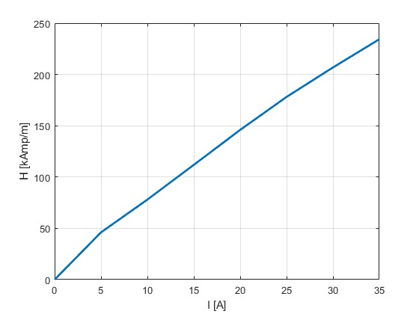
Figure 6. Magnetic Density vs. Current in MRF
Subsequently, the trend of the yield stress developed in function of the magnetic field has been obtained, depending on the characteristics of the MRF (in this case MRF-132-DG).
Knowing the yield stress in the MR fluid, it has been possible to compute the braking torque developed, respecting the following formulas proposed by Terzo [18]. Posed:
$$R_{m}=\frac{R_{e}+R_{i}}{2}$$
(1)
Where: $R_{e}$ is the external radius of the geometric configuration (right in Figure 3),$R_{i}$is the internal radius of the geometric configuration (right in Figure 3).
So, it follows that:
$$τ=\frac{η∙R_{m}∙(ω_{2}-ω_{1})}{R_{e}-R_{i}}+ τ\left(H\right)$$
(2)
Where:$τ\left(H\right)$ is the tangential stress as a function of the magnetic field H$ω_{2}$ and $ω_{1}$ are the angular speed of the two circular bodies shown on the right in the Figure 3, and$η$ is the MRF viscosity.
The expression of nominal torque as a function of geometric parameters becomes:
$$T_{N}=\int_{0}^{L}{τ\left(H\right)∙2∙π∙R_{m}^{2}∙dl}= \frac{π}{2}∙τ\left(H\right)∙L∙{\left(R_{e}+R_{i}\right)}^{2}$$
(3)
With: $L$ is the width of the surfaces in contact with the MRF (Figure 3).
In contrast, the zero-field torque considers only the viscous term: $τ≅τ_{η}=τ\left(r\right).$It is important to note that this term, depending on $r$, grows linearly as $r$ increases.
Therefore, the equation of the null-field pair is:
$$T_{0}=\int_{0}^{L}{\frac{η∙\left(ω_{2}-ω_{1}\right)∙R_{m}}{R_{e}-R_{i}}∙2∙π∙R_{m}^{2}∙dl}=4∙π∙η∙L∙\left(ω_{2}-ω_{1}\right)∙\frac{R_{m}^{4}}{\left(R_{e}^{2}-R_{i}^{2}\right)}$$
(4)
However, the ZEDS geometry under consideration turns out to be slightly different from that analysed by Terzo [18].
In Figure 7 a partial section of only the upper part of the ZEDS is shown. The rotor (1) is hollow and, due to the geometry of the stator (2), causes the generation of a fluid film consisting of two annular sections arranged outside and inside the rotor (respectively green and blue annular section) and a lateral annular section (the red one).
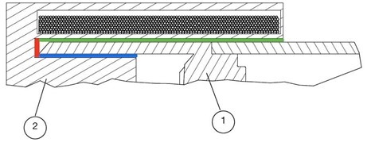
Figure 7. Partial Section of the Upper part of the ZEDS
So, the torque generated by each annular section was calculated by substituting the related parameters to the equation 1, equation 2, equation 3 and equation 4.
Consider the "Front_Left_Brake" block, which simulates the left front MR brake. What is described for torque calculation has been implemented in two sub-blocks called "Nominal Torque Calculation" and "Rolling Resistance Torque Calculation" (Figure 8).
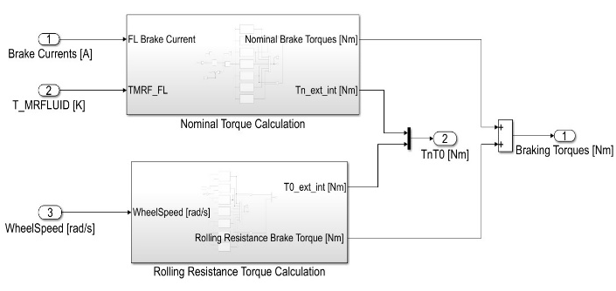
Figure 8. Front-Left Brake Block
In Figure 9, it is easy to see how the functions H=f(I) and τ=f(H) where implemented by two look-up tables. Equation 3 applied to the three annular sections were implemented in three MATLAB functions.
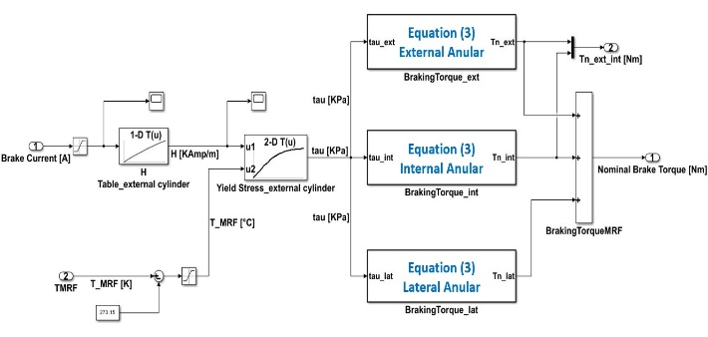
Figure 9. Nominal Torque Calculation Block
Also, for the calculation of rolling resistance torque, equation 4 applied to the three annular sections was implemented within three MATLAB functions. It is possible to observe from Figure 10 that η viscosity is calculated by look-up table as a function of strain rate. Terzo [18] shows that there is a relationship between the viscosity of the MR fluid and the strain rate. However, this relationship needs to be derived experimentally, so currently η is set at a constant value of 0.112 Pa·s, but it remains a goal for model improvement to derive this relationship.
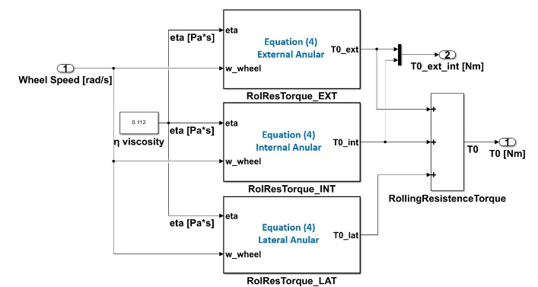
Figure 10. Rolling Resistance Torque Calculation Block
Analysis of the results
Imberti’s work [16] shows the results from fluid dynamic simulations with a resulting braking torque equal to 1110 Nm with the maximum magnetic field.
At this stage, the goal is to give further demonstration of the ability of MR brakes to generate high enough braking torque to ensure regulatory safety requirements. The required maximum torque target is 1025 Nm. Therefore, the "0 km/h-130 km/h- 0 km/h" test with only the use of MR brakes during braking is simulated. Specifically, at instant 0 s a reference speed of 130 km/h is imposed for a duration of 30 seconds, after which the reference speed is reset to 0 km/h. This test allows us to evaluate the performance of the in-wheel motors during the acceleration phase and the performance of the MR brakes during the final braking.
The longitudinal motion of an electric city car is simulated. The car is equipped of a lithium battery (parameterized through data typical of an electric city car [23]) and it has an integrated MR brake with an in-wheel motor for each wheel. The in-wheel motor chosen for the simulation is the. The simulation results obtained are shown in Figure 11, Figure 12 and Figure 13.
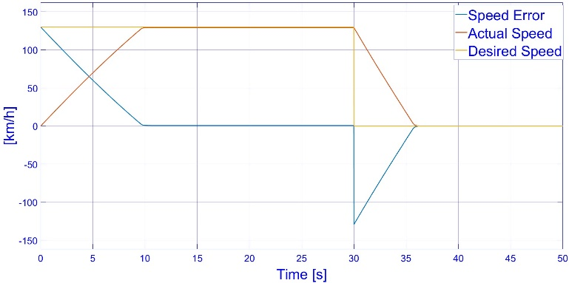
Figure 11. Vehicle speed compared to the desired speed of the Test "0 km/h- 130 km/h- 0 km/h"
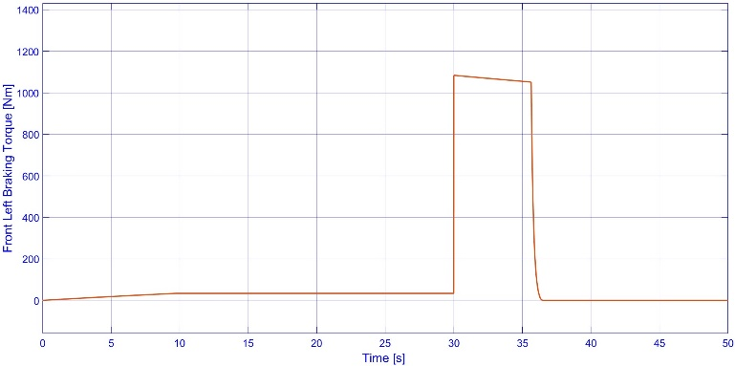
Figure 12. Torque generated by the left front MR brake with Test "0 km/h- 130 km/h- 0 km/h"
As shown in the Figure 11, the four MR brakes are capable of braking the vehicle to a stop in about 5.95 seconds. What is very interesting is definitely the maximum torque generated by each MR brake. As shown in the Figure 12, the maximum torque generated by the front left MR brake is 1084 Nm and the maximum rolling resistance torque is 34.7 Nm, reached at peak speed.
One of the future development goals is the geometric optimization such that the dynamic ratio [18] defined as the ratio of nominal torque to zero-field torque is maximized:
$$λ=\frac{T_{N}}{T_{0}}$$
(5)
Regarding the thermal behaviour of the brake, the "0 km/h-130 km/h- 0km/h" test is very stressful, as seen in Figure 13.
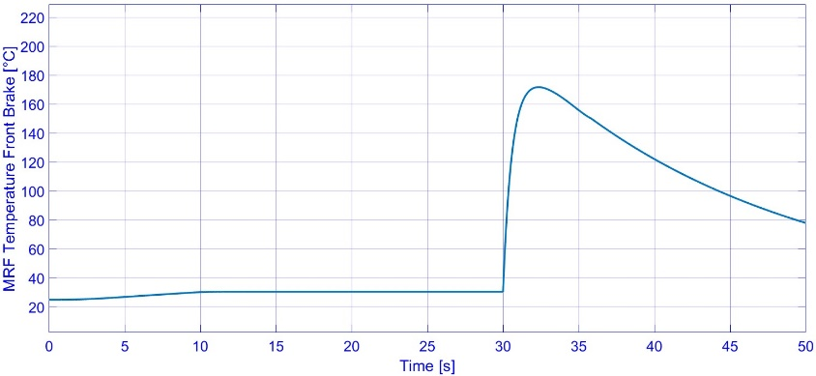
Figure 13. MRF temperature [°C] in the left front brake brake with Test "0 km/h- 130 km/h- 0 km/h"
During braking, a temperature of the MRF fluid is reached above the acceptable threshold (150 °C). It is worth mentioning that the case examined considers a braking of considerable intensity without any regenerative contribution, so this is a very extreme working condition with an uncommon manoeuvre for an electric utility car. Nevertheless, the result suggests the need for an efficient cooling system to be implemented in the MR brake.
Conclusions
The goal of achieving a real zero-emission car dictates the need to find an innovative solution for the braking system as well. ZEDS can be considered an innovative idea that can meet and guarantee the achievement of this goal.
Starting from the innovative idea of a MR Brake a Simulink model capable of simulating the longitudinal dynamics of an electric vehicle, equipped with four ZEDS, was developed.
The Test "0 km/h- 130 km/h- 0 km/h” was conducted in which the vehicle is accelerated to 130 km/h and then stopped solely by the use of MR brakes: the results obtained demonstrate the ability of a single brake to develop a maximum torque of 1084 Nm, causing the vehicle to stop in 5.95 s. The outcome obtained can be considered positive, but the heating that the fluid undergoes through dissipation should not be neglected: in fact, the brake thermal model calculates a peak fluid temperature during braking of 174 °C, which is higher than the allowable value of 150 °C. This highlights the need to design a brake cooling system that ensures the fluid works at temperatures below the maximum possible value.
The future goal is also the validation of the Simulink model, which is only possible after the design and implementation of a valid test-bench-prototype of the ZEDS. This will provide insight into the real behaviour of the brake, its instantaneous transformation of the fluid behaviour, also from its thermal point of view, and the instantaneous torque obtained. In this way, a validated model can be used to perform the global optimisation of the parts, so that a feasible and final layout could be considered ready.
Another pivotal operation is a structural validation, in order to ensure the reliability of each component so that the prototype definition will be satisfactory safe and the construction of it will be optimal and feasible.
Once the prototype is ready tests on the real torque obtained and on the temperature at magnetic field equal to zero will be performed to understand if the simulation results are valid enough to proceed with the implementation analysis and a real on-car prototype.

References

[1] | G. Imberti, H. de Carvalho Pinheiro and M. Carello, "Impact of the Braking System Generated Pollutants on the Global Vehicle Emissions: A Review," ICESE, 2023.
[2] | A. Ferraris, S. Xu, M. Carello, A. Messana and A. Airale, "The regenerative braking for a L7e Range Extender Hybrid Vehicle," 2018 IEEE International Conference on Environment and Electrical Engineering and 2018 IEEE Industrial and Commercial Power Systems Europe, no. doi: 10.1109/EEEIC.2018.8494000, 2018.
[3] | Y. Liu, "Brake wear induced PM10 emissions during the world harmonised light-duty vehicle test procedure-brake cycle," Cleaner Production, vol. 361, no. 10.1016/j.jclepro.2022.132278, 2022.
[4] | European Commission, "Euro 7," 10/11/2022.
[5] | M. Rahimi, S. Candeo, M. D. Lio, F. Biral, J. Wahlstrom and D. Bortoluzzi, "A novel approach for brake emission estimation based on traffic," Elsevier, no. https://doi.org/10.1016/j.apr.2023.101872, 2023.
[6] | Wagner, Steinstrater, Stohwasser, Hoffmann and Lienkamp, "Battery independent regenerative braking using model predictive control with auxiliary consumers," Forsch Ingenieurwes, 2019.
[7] | J. W. Sohn, J. Jeon and Q. H. Nguyen, "Optimal design of disc-type magnetorehological brake for mid-sized motorcycle: experimental evaluation," Smart Mater. Struct, 2015.
[8] | D. Quamar and C. Sarkat, "Optimal Design of Hydraulic Disc Brake for Magnetorheological (MR) Application," Defence Science Journal, no. DOI: 10.14429/dsj.72.18369, 2022.
[9] | C. S. Rakesh Kumar Singh, "Two-wheeler magnetorheological drum brake operating under hybrid mode for enhancing braking torque: Development and validation," Elsevier, no. DOI: 10.1016/j.mechatronics.2023.102971, 2023.
[10] | V. Manas, V. Athul, J. Hafsana, S. B. Choi and Q. Hung Nguyen, "Reliability estimation of Magnetorheological Fluid," IEEE BSSC, 2021.
[11] | A. Musolino, M. Raugi, R. Rizzo, L. Sani and E. Diez-Jimenez, "A Magneto-Rheological Brake Excited by Permanent Magnets," ACES Journal, 2019.
[12] | Mariotti, Marannano and D. Virzì, "Preliminary design of a magnetorheological brake for automotive use," 2011.
[13] | A. Zaifazlin, A. Zainordin, M. Abdullah and K. Hudha, "Experimental Evaluations on Braking Responses of Magnetorheological Brake," International Journal of Mining, Metallurgy & Mechanical Engineering (IJMME), 2012.
[14] | Q. H. Nguyen, Y. M. Han and S. B. Choi, "Geometry optimization of MR valves constrained in a specific volume using the finite element method," IOP PUBLISHING SMART MATERIALS AND STRUCTURES, no. DOI: 10.1088/0964-1726/16/6/027, 2007.
[15] | W. Song, SiyuanWang, S.-B. Choi, NaWang and S. Xiu, "Thermal and Tribological Characteristics of a Disc-Type Magnetorheological Brake Operated by the Shear Mode," Journal of Intelligent Material Systems and Structures, no. https://doi.org/10.1177/1045389X18770740, 2018.
[16] | G. Imberti, H. de Carvalho Pinheiro and M. Carello, "Pre-Design and Feasibility Analysis of a Magneto-Rheological Braking System for Electric Vehicles," no. DOI: https://doi.org/10.4271/2023-01-0888, 2022.
[17] | G. Imberti, H. de Carvalho Pinheiro and M. Carello, "Design of an Innovative Zero-Emissions Braking System for Vehicles," 2022 International Conference on Electrical, Computer, Communications and Mechatronics Engineering (ICECCME), no. doi:10.1109/ICECCME55909.2022.9988291, 2022.
[18] | Terzo, "Sviluppo di un Differenziale Semiattivo a Fluido Magnetoreologico," pp. 29-38, 2007.
[19] | M. Heydrich, V. Ricciardi, V. Ivanov, M. Mazzoni, A. Rossi, J. Buh and K. Augsburg, "Integrated Braking Control for Electric Vehicles with In-Wheel," MDPI, no. https://doi.org/10.3390/vehicles3020009, 2021.
[20] | E. INNOVATIVE, "Manual for EMRAX Motors," March 2020. [Online].
[21] | H. de Carvalho Pinheiro, P. Castro dos Santos, L. Sisca, S. Scavuzzo, A. Ferrari, A. Airale and M. Carello, "Dynamic Performance Comparison Between In-Wheel and On-Board Motor Battery Electric Vehicles," American Society of Mechanical Engineers Digital Collection, no. doi:10.1115/DETC2020-22306, 2020.
[22] | H. de Carvalho Pinheiro, E. Punta, M. Carello, A. Ferraris and A. G. Airale, "Torque Vectoring in Hybrid Vehicles with In-Wheel Electric Motors: Comparing SMC and PID control," 2021 IEEE International Conference on Environment and Electrical Engineering and 2021 IEEE Industrial and Commercial Power Systems Europe, no. doi:10.1109/EEEIC/ICPSEurope51590.2021.9584732, 2021.
[23] | E. Grano, H. de Carvalho Pinheiro, M. Carello and E. Bianco, "MTPA and flux weakening control of electric motors: A numerical approach," IEEE International Conference on Environment and Electrical, no. doi: 10.1109/EEEIC/ICPSEurope57605.2023.10194684, 2023.

Contact Information
Massimiliana Carello – massimiliana.carello@polito.it
Giuseppe Pio Tempone – giuseppe.tempone@polito.it
Henrique de Carvalho Pinheiro - henrique.decarvalho@polito.it
Giovanni Imberti – giovanni.imberti@polito.it

Politecnico di Torino – Mechanical and Aerospace Engineering
Department

Corso Duca degli Abruzzi, 24 10129 Torino – Italy
Acknowledgments
The research team wants to thank Tech4Planet cdp fund for his support for financing this project.

Definitions/Abbreviations
ZEDS | Zero-Emissions Driving System
MRF | MagnetoRheological Fluid
MR | MagnetoRheological

