Reinforcement learning based control for torque allocation in electric vehicles: a preliminary analysis

Henrique de Carvalho Pinheiro
Department of Mechanical and Aerospace Engineering -
Politecnico di Torino
Turin, Italy
henrique.decarvalho@polito.it
0000-0001-8116-336X
Massimiliana Carello
Department of Mechanical and Aerospace Engineering -
Politecnico di Torino
Turin, Italy
massimiliana.carello@polito.it
0000-0003-2322-0340

Abstract— This article conducts a preliminary exploration of an innovative Reinforcement Learning RL-based control system applied to the Torque Allocation problem in a fully electric All-Wheel-Drive vehicle. The investigation delves into the untapped degrees of freedom in four-motor Electric Vehicles beyond total torque request and Torque Vectoring bias. Utilizing a Deep Deterministic Policy Gradient (DDPG) agent, the RL architecture is implemented within MATLAB/Simulink, incorporating co-simulation with VI-CarRealTime for vehicle dynamics. Comparative analysis against reference Torque Allocation strategies (open differential, FWD, RWD) is performed, assessing key performance factors in the reward function. The most successful RL system, trained with Second Order Sliding Mode Suboptimal torque vectoring algorithm, surpasses the average performance of reference strategies. Nevertheless, challenges such as marginal advantages, repeatability issues, prolonged training durations, and a lack of interpretability are noted.
Keywords—Torque Allocation, Reinforcement Learning, Automotive Control, Electric vehicles, Vehicle dynamics.

Introduction
The new trend of Artificial Intelligence (AI) is ubiquitous. Every day it is possible to observe new technologies and applications of this disruptive method, and the automotive sector is no different. Most of the efforts on AI and Machine Learning (ML) are focused on Autonomous Driving, a huge trend in the field and a clear fit for advanced control strategies due to its intrinsic complexity [1].
Specifically, about Reinforcement Learning (RL) techniques it is possible to find studies on problems related to path planning and control. In [2] the paper proposes a TD3 algorithm associated with MPC controllers to perform emergency evasion maneuvers, with results outperforming human response.
It is also widespread the application of ML techniques in another part of the control task, namely the observers. The use of Supervised ML strategies in alternative to classis Kalman Filters, for instance, is well consolidated and studied [3].
Other authors [4] apply AI techniques to the pursuit of high-level control coordination. Following the requirements of the Integrated Chassis Control (ICC) paradigm, where is used Recurrent High–Order Neural Network (RHONN) to serve as system identifier, composing a torque vectoring TV optimal control system with a discrete observer using Extended Kalman Filter (EKF). Another example of RL based strategies being used as high-level coordination can be found in [5] where the authors proposed a mixed approach with a baseline LPV controller that is combined with a RL based algorithm, and with the action of a supervisor both control signals are fused, and the final control action decided.
Few other examples can be found in literature combining the use of RL techniques to perform Torque Vectoring tasks. One article falling into this description is [6], where the authors employ a DDPG RL algorithm to perform the tuning of the weights in the torque vectoring controller applied to a 6 dof vehicle model in a MATLAB/Simulink environment. In [7] the authors propose a Neural Q-fitted Iteration method for the stability control of a small RWD vehicle.
In the literature, however, few articles can be found regarding the application of novel RL based strategies dealing with Torque Allocation (TA) for what concerns goals different from Torque Vectoring (TV) and Direct Yaw Control (DYC) [8,9]. Most of the literature concentrates on classic control strategies such as MPC or Dynamic Programming (DP) when it comes to energy efficiency and thermal control [10].
This article proposes a preliminary analysis of an RL-based control system for TA. The case study regards a vehicle with full electric powertrain composed of four in-wheel independent electric motors. The modelling of the EMs follows the procedures presented in [11] while the vehicle dynamics and overall vehicle integration uses the PerfECT Design Tool presented in [12]. To the baseline vehicle model are added several classic control strategies for TV as in [13,14] and a novel DDPG RL algorithm is proposed and tested for the definition of the front/rear torque splits.
The goal of the proposed method is to take advantage of all the available degrees of freedom on an AWD to optimize variables as energy consumption, temperature increase on motors and battery, and overall lateral dynamics. Since the relation between the variables is intrinsically complex and interdependent, the RL-based method presents good perspectives.

Methodology

Reinforcement Learning framework
Reinforcement Learning is a kind of ML technique with “goal-directed” features, in which the machine learns how to perform/optimize a task by interacting with a representation of its environment. It differs from other ML strategies exactly because it does not require a priori knowledge about the “correct” answer.
In order to frame the problem of RL it is necessary to define its main building blocks, as in Fig. 1, referring to ML based control for vehicle dynamics:
- Agent: it is the part of the RL system responsible for the processing of the information and the selection of the best action. In the automotive case, it represents the vehicle central ECU.
- Environment: representation of the physical/virtual ambient where the agent must operate. It is both the “external world” and the “physical characteristics” of the system – for the automotive problem, it represents both the vehicle, its dynamic behavior, and the road.
- Action: way in which the agent interacts with the environment, changing the state of the ambient or its own state. For vehicle dynamics, it refers to the control actions sent to the motors and actuators.
- Observation: regards the set of information on the state of the environment that is acquired by the agent during the events. For the EV controller, it represents the information coming from all the sensors.
- Reward: signals coming from the environment that suggest to the agent if (and how much) the result of an action was good. For the EV control, it can be represented as a performance index during a maneuver, the energy cost of actuation, or a distance to a target behavior.
- Policy: represents the set of rules used by the agent to extrapolate the best action to be undertaken given the current state of the system received though the observation. For the ML based controller, the policy represents the core of the control law.
- RL algorithm: the key to characterize this action decision making process as a ML system is the RL algorithm, responsible for the “Policy update”. This element has access to the observations, actions and to the rewards, making it capable of evaluating how good a policy is and thus updating its parameters to improve its performance on time. For the control problem, it might be considered the automatic “tuning” of the system.
To put it simply, reinforcement learning means an agent finding out the most effective actions by engaging in multiple trial-and-error interactions with the environment, without the need for human intervention.
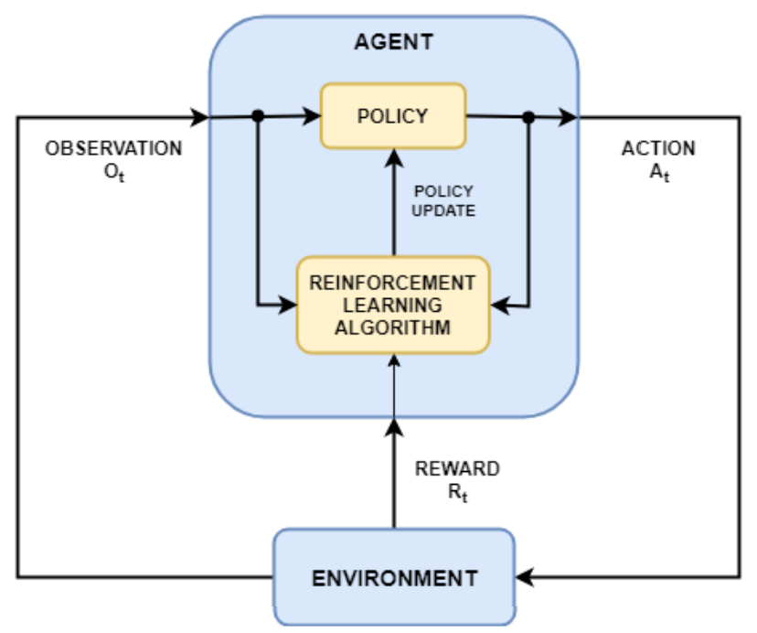
- - Reinforcement Learning main structure
To properly implement such strategy, in sequence, it is necessary to:
- Formulate Problem: Define the main task/event to be undertaken, how the agent interacts with the environment, and what are the goals and constraints of the system.
- Create Environment: Define the environment dynamics and main functioning mechanisms.
- Define Reward: Decide the best functions and methods to evaluate the goodness of the actions.
- Create Agent: Define the structure of the policy and how does the RL algorithm can alter it.
- Train Agent: Start the training process by letting the agent interact with the environment under the policy, constantly updated by the RL algorithm.
- Validate Agent: Once the training is over – because it reaches the desired performance or because the maximum number of episodes has passed –evaluates the agent’s final performance to verify if it is suitable to the problem.
- Deploy Policy: Finally implement the resultant policy to the real system in an operative environment.
It is important to highlight that not often the procedure is streamlined like this workflow, meaning that it is common not to achieve training convergence or sufficiently good results during validation. In this case it is necessary to go back to the previous steps and update the used strategy – changing the agent/environment dynamics, tuning hyperparameters, creating new reward functions, using new policy structure, or updating training strategies – in order to improve and optimize performance.

Torque allocation problem
In the proposed case-study, to best explore the presence of a distributed AWD powertrain, the Torque Allocation (TA) control problem is defined.
With four independent electric motors on the vehicle, there are four degrees of freedom (dof) that can be exploited. The E-PWT receives as a request two main values: total torque and the torque bias (as defined by another controller responsible for the Torque Vectoring strategy). Fig. 2 shows a schematic view of the concept.
Thus, a strategy is developed to explore the additional two degrees of freedom. The first decision in order to model the controller is to define the parameters that are adjusted. The most convenient way to do so is by choosing independent parameters. The preferred layout defines:
- Front/Rear split – Left Side: distribution of the total torque of the left side between FL and RL motors.
- Front/Rear split – Right Side: distribution of the total torque of the right side between FL and RL motors.

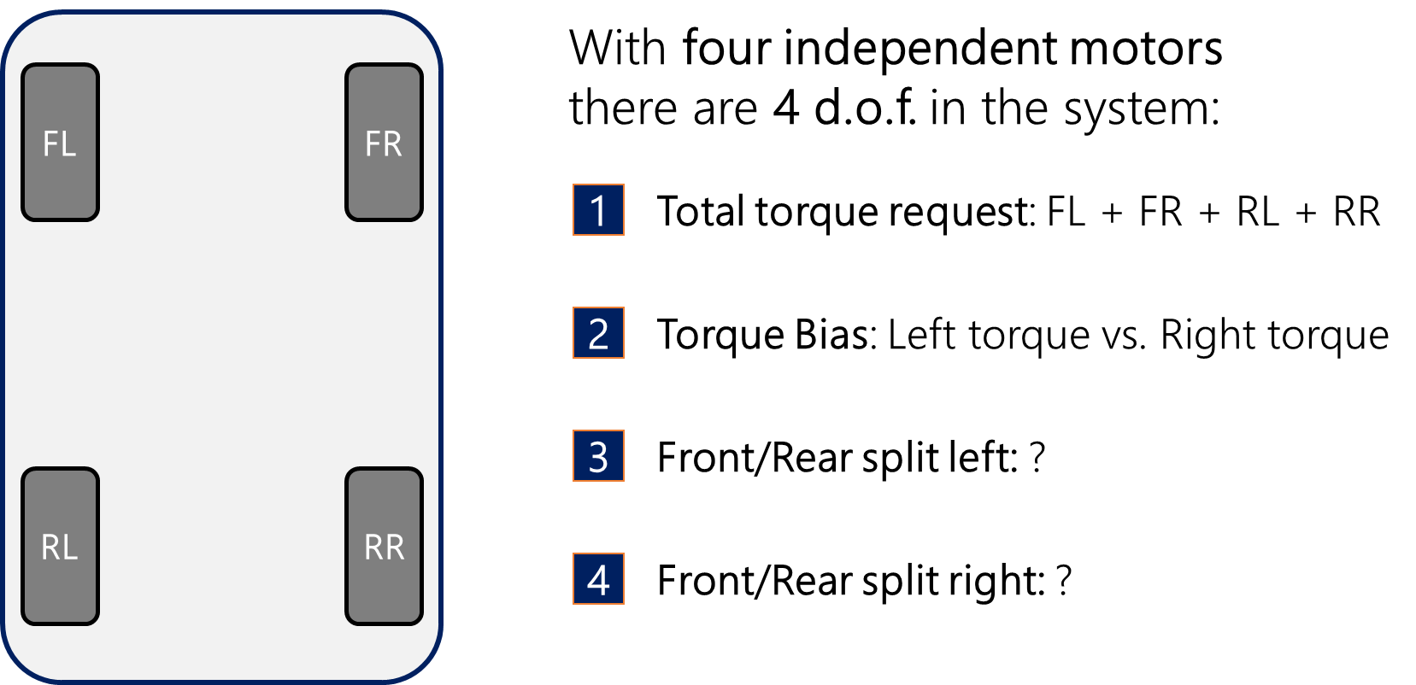
- - Four independent motors dof
The values of both biases are set between -1 and 1, being -1 the value correspondent to a “all-rear” configuration, a 0 value corresponding to a “open differential” (equal) distribution and the value 1 representing a “all-forward” configuration.
The first two inputs are coming directly from the TV algorithm. Notice that the information of maximum torque per motor is also relevant. It is necessary to saturate the single EMs request in order not to guarantee that (1) holds after the allocation.
 | $$\left\{ \begin{matrix}T_{FL}+T_{RL}=T_{Left} \\ T_{FR}+T_{RR}=T_{Right} \end{matrix}\right.$$ | (1)
It is imperative that the TA will not suggest a front/rear distribution that could reduce the total actual torque and jeopardize the TV outcomes. Letting T_{FL}, T_{RL}, T_{FR} and T_{RR} be T₁, T₂, T₃ and T₄ respectively, the MATLAB function used to perform the operation has been developed and used the following script:

function [T1, T2, T3, T4]= fcn(Total_L, Total_R, Bias_L, Bias_R, Max_torque_per_motor)

T1_ideal = Total_L * ((Bias_L+1)/2);
T2_ideal = Total_R * ((Bias_R+1)/2);

T3_ideal = Total_L *(1- ((Bias_L+1)/2) );
T4_ideal = Total_R *(1- ((Bias_R+1)/2) );

if T1_ideal > Max_torque_per_motor(1)
T1 = Max_torque_per_motor(1);
T3_ideal = T3_ideal + (T1_ideal - Max_torque_per_motor(1));
else
T1 = T1_ideal;
end

if T2_ideal > Max_torque_per_motor(2)
T2 = Max_torque_per_motor(2);
T4_ideal = T4_ideal + (T2_ideal - Max_torque_per_motor(2));
else
T2 = T2_ideal;
end

if T3_ideal > Max_torque_per_motor(3)
T3 = Max_torque_per_motor(3);
T1 = T1 + (T3_ideal - Max_torque_per_motor(3));
else
T3 = T3_ideal;
end

if T4_ideal > Max_torque_per_motor(4)
T4 = Max_torque_per_motor(4);
T2 = T2 + (T4_ideal - Max_torque_per_motor(4));
else
T4 = T4_ideal;
end
end

This script guarantees that the Left/Right bias is respected, with priority over the introduced splits. If, for instance, the TA algorithm is set to a FWD configuration (both biases equal to 1), but the EMs 1 and 2 are not able to supply the total torques demanded, the remaining request is sent to the rear motors, nonetheless.
Notice that, because the TV algorithms usually verifies the feasibility of the requested bias, it is not possible that at the same time the saturation conditions of either side are triggered. If the $T_{1,ideal}>T_{\max\left(1\right)}$ it follows that $T_{\max\left(3\right)}≥T_{3,ideal}+(T_{\max\left(1\right)}-T_{1,ideal})$, and equivalently for all the if clauses in the function.
Being the mechanics of the torque distribution specified, the problem becomes the definition of the desired splits. Some immediate ideas are:
- Open differential: both splits set to 0, making an equal distribution of torque whenever possible. This configuration has the advantage over a real open differential because it will automatically adapt to saturation.
- FWD: both splits set to 1, preferring the front axle to develop the requested loads.
- RWD: both splits set to -1, preferring the rear axle to develop the requested loads.
These strategies are straightforward to implement and will be used as reference to evaluate the ML based strategy.

RL based torque allocation system
To build a RL based strategy to solve the TA problem, it is necessary to define: the problem, the environment, the reward and the agent. Then a training phase can be deployed, and results analysed in comparison with a reference benchmarking.
The problem proposed in the article is the execution of a step steering manoeuvre. This open loop driving action allows for a better repeatability and prevents the virtual driver behaviour influence on the overall results.
The environment regards the vehicle and road definition, and as previously mentioned takes advantage of the PerfECT Design Tool in [12]. This model uses a Simulink model interfaced with the software VI-CarRealTime to handle the E-PWT and overall vehicle dynamics respectively. This model can be accessed from a MATLAB root algorithm in which the ML components are defined. For each step of the training, the environment is reset and called from the MATLAB script. During the training of the RL TA strategy, the baseline TV algorithm used in the model is the Second-Order Sliding Mode Suboptimal (S.O.) algorithm [14].
A specific kind of RL agent following the actor-critic strategy is the Deep Deterministic Policy Gradient (DDPG) agent. It is a model-free, online, off-policy reinforcement learning method based on the actor-critic framework that aims to solve the problems of Q-Learning/DQN for continuous action spaces [15].
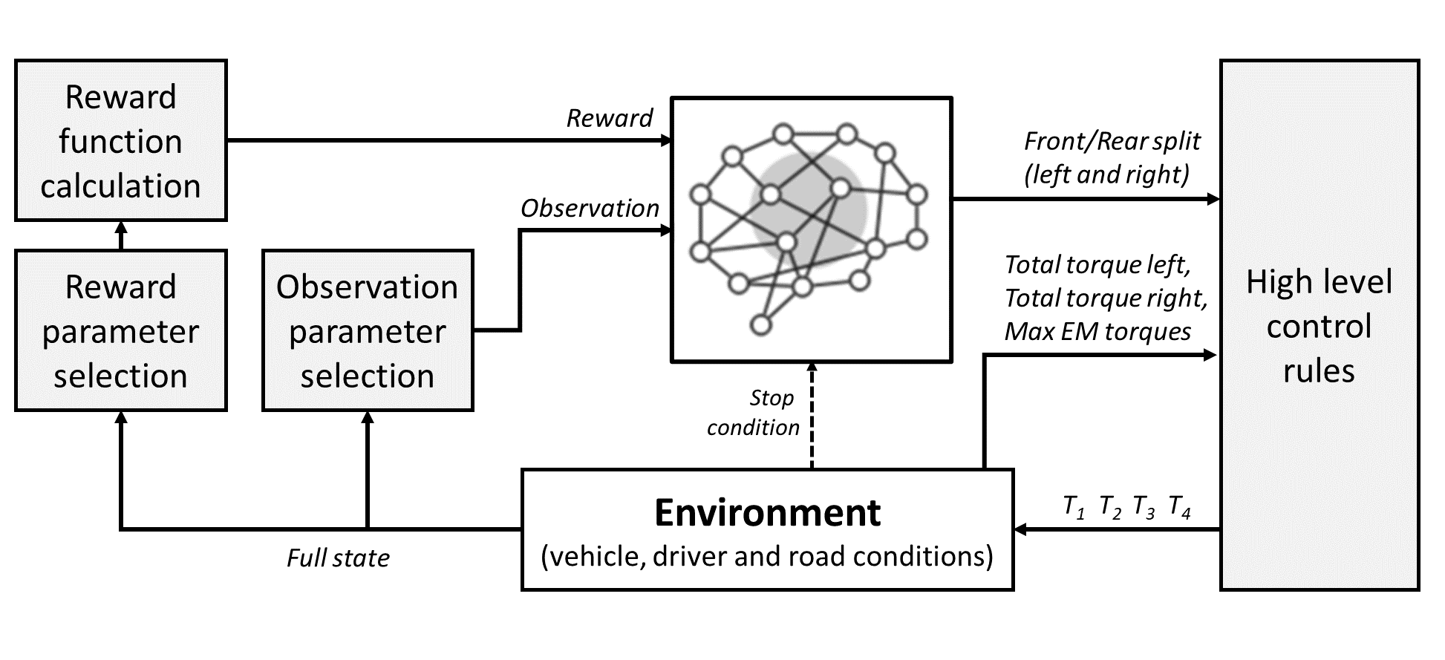
- - RL-based torque allocation implementation
In the Simulink environment a manual switch (not displayed) allows a quick change between RL and constant inputs for the biases. The RL agent’s actions are composed of [2x1] continuous signal from -1 to 1.
The key-factor to obtain successful training is the definition of the reward function. The main goal of the system is not related only to the lateral performance (as it would be in a classic TV problem) but the reward function is set to improve the following features:
- Energy efficiency: measuring if a particular TA strategy can bring the motors to more efficient working points and to reduce overall energy consumption.
- Thermal management: verifying if the torque allocation can help in limiting the overheating of critical E-PWT components, like EMs and battery.
- Lateral dynamics: guaranteeing that the longitudinal bias won’t negatively affect the handling performance and threaten the results of TV.
The reward function is then setup to measure the Cumulative sideslip angle (β) in rad, Yaw rate penalty factor (EP) as in [14], Battery State of Charge variation (ΔSOC), Battery temperature variation (Tbat), Rotor (Trot) and Stator (Tsta) temperature variation, all in °C.
All the specific values, chosen options and DNNs layouts were obtained after combining examples of literature, suggestions of user guides and tutorials from MATLAB and several trials performed by [4,16].
The best performing version is shown on the following description.
The construction of the agent is entirely performed in the MATLAB environment. The RL toolbox is used to support the setup of the necessary DNNs and training algorithms of the DDPG.
Since the TA problem has a broad range of variables to consider, the observed state shall reflect this increment on complexity. The observation vector is composed of:
Vehicle dynamics variables: Yaw rate γ, Sideslip angle β, lateral acceleration a_{y}, longitudinal acceleration a_{x}, vehicle speed V_{x}.
Driver demands: Steering angle, brake demand, throttle demand.
Battery state: battery current I_{bat}, battery voltage V_bat, SOC, battery temperature.
EMs states: stator temperature, rotor temperature and maximum torque for each EM.
The following parameters must be setup:
observationInfo: determine the number and type of information obtained through the observation state, in this case [24x1] continuous values. The state observations are not normalized with fixed reference values at the input phase, but a ‘layerNormalizationLayer’ is placed after the input layer of the actor and critic DNNs, for dynamic normalization.
actionInfo: determine the number and type of information output as actions, in this case [2x1] continuous values from 0-1 representing the two torque splits.
Environment: the function rlSimulinkEnv is used to connect with the suitable block in the Simulink model. Since the model runs in co-simulation with VI-CRT it is essential to set the ‘UseFastRestart’ parameter OFF.
Actor: the determination of the actor is composed of two main features, the neural network and its ‘actorOptions’. The Actor’s DNN feedforward ANN composed of an input layer, 4 fully connected hidden layers with 80 neurons each all of them using ReLU activation functions, an output layer with a tanh and a scaling layer to normalize and setup the correct scale outputs.
Table I shows the hyperparameters used in the best setup of the RL training.
- RL actor, critic and agent hyperparameters
Parameter | Value
Actor LearnRate | 1·10⁻⁴
Actor GradientThreshold | 1
Actor L2RegularizationFactor | 1·10⁻⁴
Critic LearnRate | 1·10⁻³
Critic GradientThreshold | 10
Critic L2RegularizationFactor | 1·10⁻⁴
TargetSmoothFactor | 1·10⁻³
ExperienceBufferLength | 1·10⁶
DiscountFactor | 1
MiniBatchSize | 64
NoiseOptions.Variance | 0,3
NoiseOptions.VarianceDecayRate | 1·10⁻⁵

Results
Fig. 4 displays an example of time evolution of the cumulative penalties in a “open differential” strategy.
Performing the training of the RL showed to be a long process. As expected for structures with many variables and wide neural network, there is a natural tendency to slow convergence or non-convergence. Many attempts – not displayed in the article – were performed in which the system got “blocked” into poorly performing solutions, usually consisting of quick variations on the biases from maximum to minimum values.
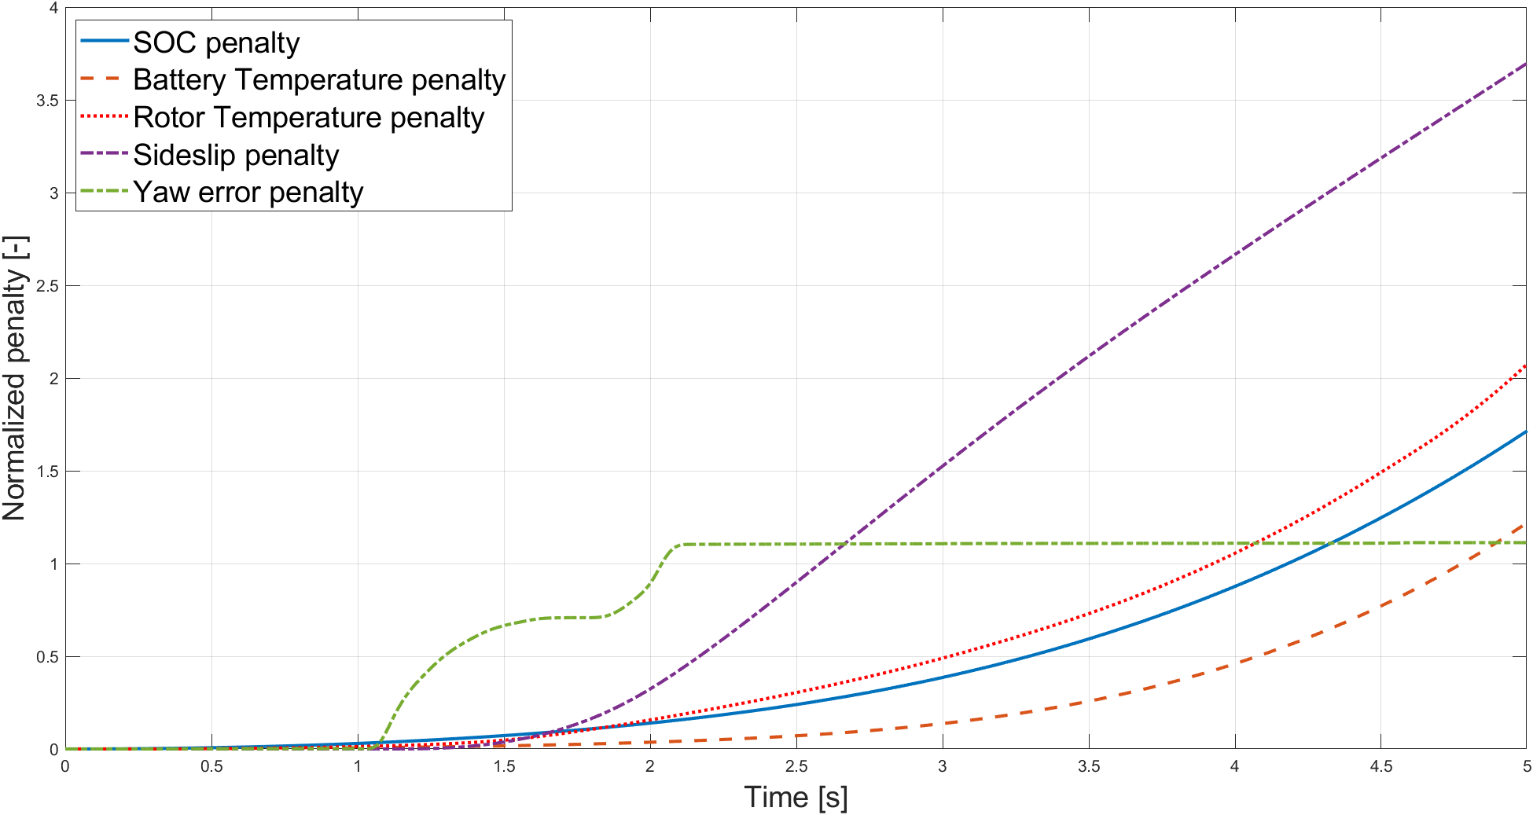
- – Open differential TA reward evolution
The best run on the TA agent training is depicted in Fig 5.
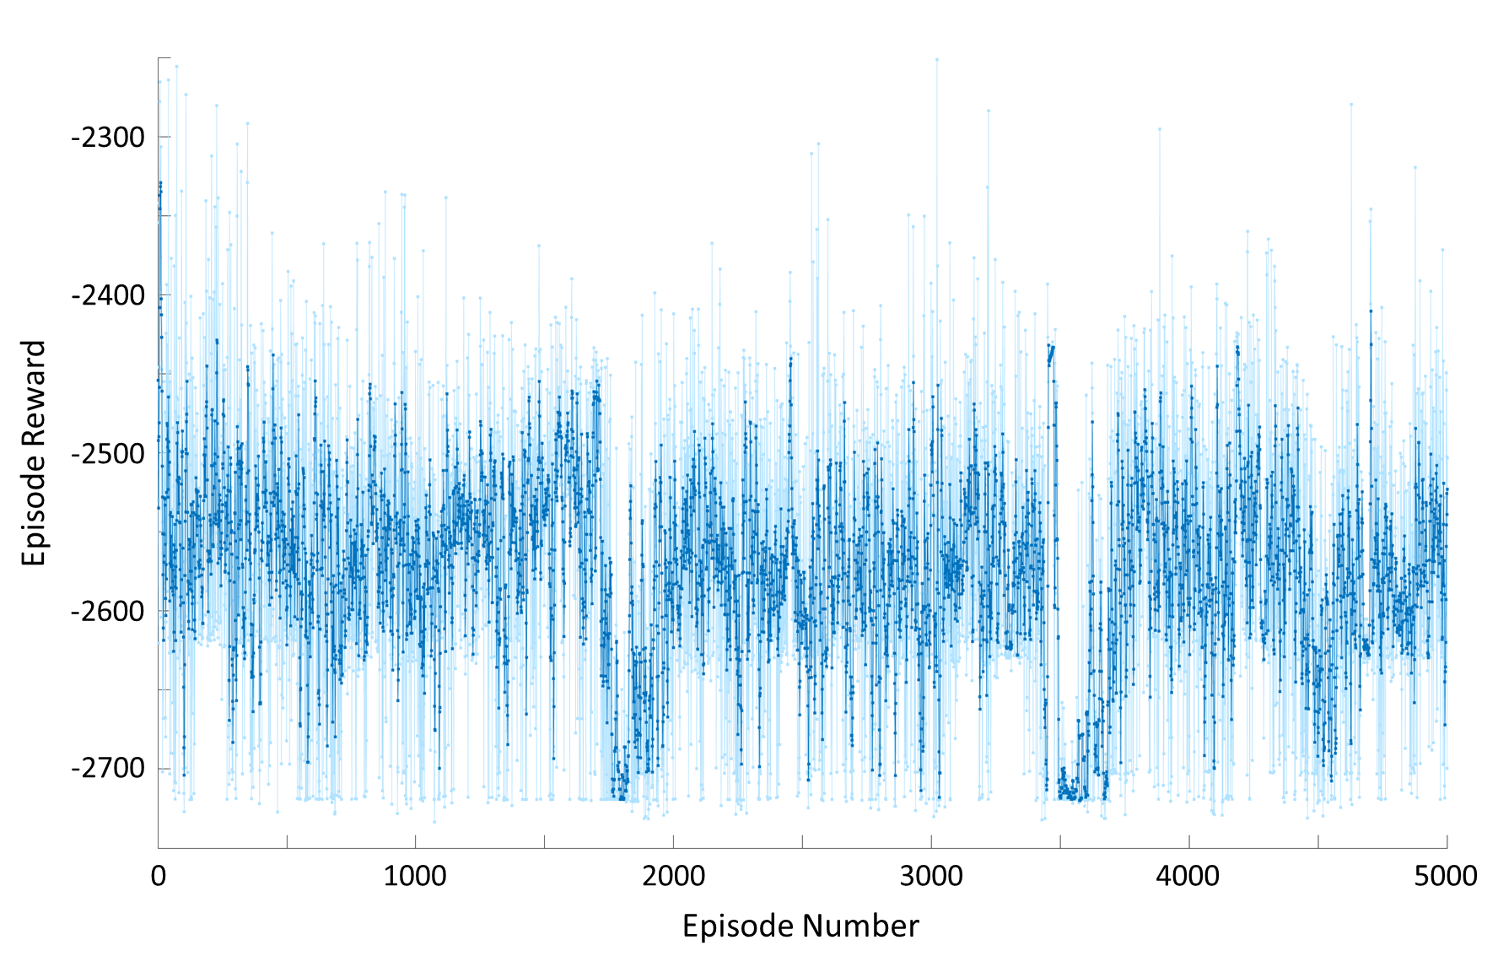
- - RL TA training progress
It is immediately noticeable that the training was very long, stopping at the maximum number of episodes criteria with a total of 5000. The simulation took 241 h to be completed, and yet the rewards seem not to find total convergence.
The simulations were performed by combining different TV strategies with each TA protocol, to guarantee that the lateral dynamics was not hindered and to verify generalization of the training. The SOSM suboptimal TV was used to the training.
Notice that in the benchmarking the FWD and RWD impact the two penalties related to vehicle dynamics, changing the under/oversteering response of the vehicle due to the longitudinal load requested for the acceleration phases. The “open” strategy does get the best outcomes when it comes to temperature management, since they distribute the load more equally and, therefore, reduce the impact of the maximum temperature increase. Regarding energy management, at this level of load request the EMs and overall E-PWT tend to display higher efficiency by decentralizing the torques, as well.
The reference strategies are summed up in Table II.

- Torque allocation reference performance
TA | TV | β | EP | ΔSOC | Tbat | Trot | Tsta | Total
Open | S.O. | 0.1811 | 0.094 | 0.0649% | 0.0067 | 0.1990 | 0.9362 | -2.19
FWD | S.O. | 0.1801 | 0.095 | 0.0655% | 0.0068 | 0.4278 | 0.9638 | -2.63
RWD | S.O. | 0.1825 | 0.094 | 0.0659% | 0.0069 | 0.4608 | 0.9692 | -2.70
Avg |  | 0.1812 | 0.094 | 0.0654% | 0.0068 | 0.3625 | 0.9564 | -2.51
Open | PID | 0.1737 | 0.617 | 0.0636% | 0.0064 | 0.1838 | 0.9340 | -2.74
FWD | PID | 0.1733 | 0.557 | 0.0641% | 0.0065 | 0.3709 | 0.9556 | -3.02
RWD | PID | 0.1744 | 0.685 | 0.0644% | 0.0066 | 0.3989 | 0.9607 | -3.23
Avg |  | 0.1738 | 0.620 | 0.0641% | 0.0065 | 0.3179 | 0.9501 | -3.00
Open | LQR | 0.1837 | 0.463 | 0.0648% | 0.0067 | 0.1950 | 0.9347 | -2.63
FWD | LQR | 0.1838 | 0.537 | 0.0654% | 0.0069 | 0.4158 | 0.9595 | -3.14
RWD | LQR | 0.1840 | 0.420 | 0.0657% | 0.0069 | 0.4425 | 0.9647 | -3.06
Avg |  | 0.1839 | 0.473 | 0.0653 | 0.0068 | 0.3511 | 0.9530 | -2.94

The comparison between RL performance and reference strategies are shown in Table III.
- RL-based control performance evaluation
TA | TV | β | EP | ΔSOC | Tbat | Trot | Tsta | Total
RL | S.O. | 0.1812 | 0.096 | 0.0649% | 0.0067 | 0.214 | 0.938 | -2.22
Δ vs avg |  | -0.04% | 1.23% | -0.77% | -1.70% | -41.1% | -1.87% | -11.3%
RL | PID | 0.1780 | 0.646 | 0.0647% | 0.0066 | 0.394 | 0.957 | -3.20
Δ vs avg |  | 2.43% | 4.33% | 0.96% | 2.52% | 24.0% | 0.78% | 6.59%
RL | LQR | 0.1883 | 0.485 | 0.0660% | 0.0070 | 0.436 | 0.961 | -3.14
Δ vs avg |  | 2.42% | 2.46% | 1.00% | 2.66% | 24.3% | 0.84% | 6.72%

When comparing the results of the best performing RL agent with the average performance of the benchmarking strategies, it stands out that the RL system can reduce penalties throughout the factors apart from EP. There is a slight reduction in yaw rate tracking of the TV due to the variations in torque allocation.
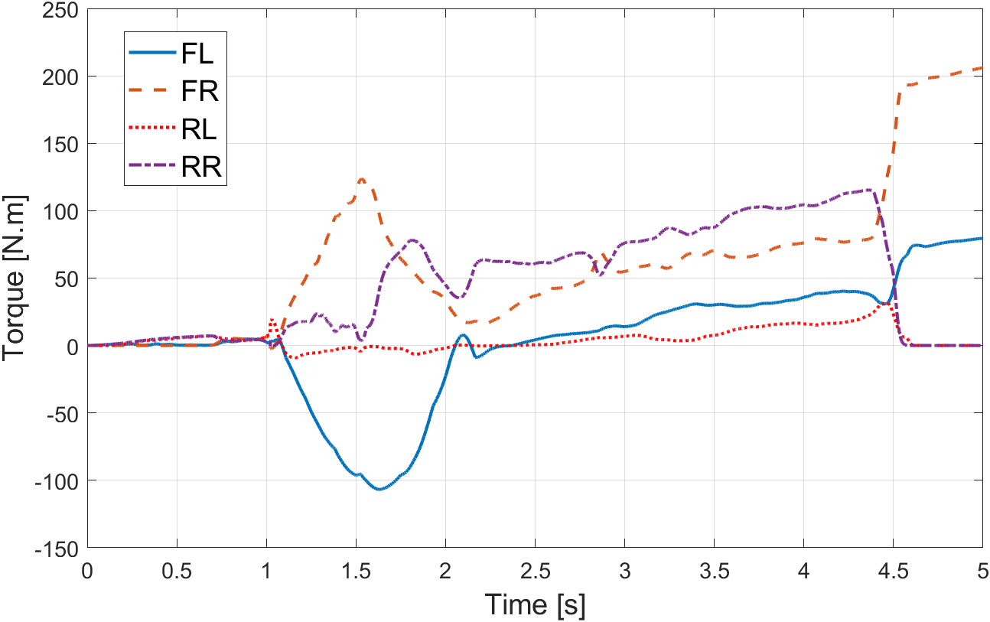
- – RL TA control vehicle response
The benefits, however, are small. When drawing a comparison between the RL system and the best performing benchmarking of each category, the trained agent does not consistently improve performance. Other than that, the advantages shown when applying the TA together with the TV algorithm it was trained with disappear when the TV method changes. Using the RL agent with PID or LQR generates a slightly worse response.
The RL agent is hard to interpret, thus making it tough to explain the mechanisms causing the observed outcomes or its lack of repeatability.

Conclusion
This article presents a preliminary analysis of an RL-based control system applied to the Torque Allocation problem for a full-electric AWD vehicle. The goal is to take advantage of the two remaining degrees of freedom of a 4-motor vehicle, once the first two DoF are used to guarantee the total torque request and the TV torque bias.
The case study is based on previously vehicle modelling and TV strategies, and the article focuses on the first implementation of the RL control. A MATLAB/Simulink environment is set up to build the RL architecture and the environment interaction. Vehicle simulation takes place with a co-simulation between Simulink and VI-CarRealTime.
The article presents the main features and layout of the agent, actor, critic, environment, and reward function, based on a DDPG framework through the MATLAB dedicated toolbox. The results of the training and simulation is then compared to reference TA strategies (open differential, FWD and RWD), by means of a set of performance factors, composing the reward function.
The best performing RL system outperforms the average of the reference strategies when using the SOSM Suboptimal TV algorithms, with which the training is performed.
However, some limitations were identified. Apart from the fact that the advantages are slim, these advantages are not reproduced for the other TV algorithms. Other than the lack of repeatability, the RL controller also presents drawbacks in terms of long training time and lack of explainability.
This article’s main contribution is a first step towards a comprehensive analysis of the potential of novel RL-based controllers applied to the Torque allocation problem in EVs.
The next steps of the research aim to tackle the issues identified in this preliminary analysis, namely: testing new architectures and RL algorithms to improve efficiency and robustness; compare and improve reward functions and observation/action states; expanding training conditions and maneuvers to cover a broader range of actual applications; and performing validation experiments, both with DiL/HiL and prototyping.

Acknowledgment
The content of this article has been developed on the context of the author’s Industrial PhD program, partnership between Politecnico di Torino, CNR and Beond. Special thanks to the VI-Grade team for the software license and technical support.

References
- Carello, M., Ferraris, A., de Carvalho Pinheiro, H., Cruz Stanke, D., Gabiati, G., Camuffo, I., and Grillo, M., “Human-Driving Highway Overtake and Its Perceived Comfort: Correlational Study Using Data Fusion,” WCX SAE World Congress Experience, SAE Technical Paper 2020-01-1036, 2020, doi:10.4271/2020-01-1036.
- Fehér, Á., Aradi, S., and Bécsi, T., “Hierarchical Evasive Path Planning Using Reinforcement Learning and Model Predictive Control,” IEEE Access 8:187470–187482, 2020, doi:10.1109/ACCESS.2020.3031037.
- Chindamo, D., Gadola, M., Bonera, E., and Magri, P., “Experimental Comparison of The Two Most Used Vehicle Sideslip Angle Estimation Methods for Model-Based Design Approach,” J. Phys.: Conf. Ser. 1888(1):012006, 2021, doi:10.1088/1742-6596/1888/1/012006.
- Cespi, R., Galluzzi, R., Ramirez-Mendoza, R.A., and Di Gennaro, S., “Artificial Intelligence for Stability Control of Actuated In–Wheel Electric Vehicles with CarSim® Validation,” Mathematics 9(23):3120, 2021, doi:10.3390/math9233120.
- Németh, B., “Coordination of Lateral Vehicle Control Systems Using Learning-Based Strategies,” Energies 14(5):1291, 2021, doi:10.3390/en14051291.
- Taherian, S., Kuutti, S., Visca, M., and Fallah, S., “Self-adaptive Torque Vectoring Controller Using Reinforcement Learning,” 2021 IEEE International Intelligent Transportation Systems Conference (ITSC), 172–179, 2021, doi:10.1109/ITSC48978.2021.9564494.
- Amaral, J.R., Göllinger, H., and Fiorentin, T.A., “Improvement of Vehicle Stability Using Reinforcement Learning,” Anais do Encontro Nacional de Inteligência Artificial e Computacional (ENIAC), SBC: 240–251, 2018, doi:10.5753/eniac.2018.4420.
- de Carvalho Pinheiro, H. and Carello, M., “Design and Validation of a High-Level Controller for Automotive Active Systems,” SAE Int. J. Veh. Dyn., Stab., and NVH 7(1):10-07-01–0006, 2023, doi:10.4271/10-07-01-0006.
- Cubito, C., Rolando, L., Ferraris, A., Carello, M., and Millo, F., “Design of the control strategy for a range extended hybrid vehicle by means of dynamic programming optimization,” 2017 IEEE Intelligent Vehicles Symposium (IV), IEEE, Redondo Beach, CA, USA, ISBN 978-1-5090-4804-5: 1234–1241, 2017, doi:10.1109/IVS.2017.7995881.
- Gang, L. and Zhi, Y., “Energy saving control based on motor efficiency map for electric vehicleswith four-wheel independently driven in-wheel motors,” Advances in Mechanical Engineering 10(8):168781401879306, 2018, doi:10.1177/1687814018793064.
- Grano, E., Bianco, E., de Carvalho Pinheiro, H., and Carello, M., “MTPA and flux weakening control of electric motors: a numerical approach,” 2023 IEEE International Conference on Environment and Electrical Engineering and 2023 IEEE Industrial and Commercial Power Systems Europe (EEEIC / I&CPS Europe), 1–7, 2023, doi:10.1109/EEEIC/ICPSEurope57605.2023.10194684.
- de Carvalho Pinheiro, H., “PerfECT Design Tool: Electric Vehicle Modelling and Experimental Validation,” World Electric Vehicle Journal 14(12):337, 2023, doi:10.3390/wevj14120337.
- de Carvalho Pinheiro, H., Punta, E., Carello, M., Ferraris, A., and Airale, A.G., “Torque Vectoring in Hybrid Vehicles with In-Wheel Electric Motors: Comparing SMC and PID control,” 2021 IEEE International Conference on Environment and Electrical Engineering and 2021 IEEE Industrial and Commercial Power Systems Europe (EEEIC / I CPS Europe), 1–6, 2021, doi:10.1109/EEEIC/ICPSEurope51590.2021.9584732.
- de Carvalho Pinheiro, H., Carello, M., and Punta, E., “Torque Vectoring Control Strategies Comparison for Hybrid Vehicles with Two Rear Electric Motors,” Applied Sciences 13(14):8109, 2023, doi:10.3390/app13148109.
- Lillicrap, T., Hunt, J.J., Pritzel, A., Heess, N., Erez, T., Tassa, Y., Silver, D., and Wierstra, D., “Continuous control with deep reinforcement learning,” CoRR, 2015.
- Reinforcement Learning Agents - MATLAB & Simulink - MathWorks Italia, https://it.mathworks.com/help/reinforcement-learning/ug/create-agents-for-reinforcement-learning.html, Mar. 2023.

