Investigation of ground movements induced by underground gas storages via unsupervised ML methodology applied to InSAR data.

Alberto Manuel Garcia Navarroª, Vera Roccaª, Alfonso Capozzoli^{b}; Roberto Chiosa^{b}, Francesca Vergaª
ª Department of Environment, Land and Infrastructure Engineering, Politecnico di Torino, Corso Duca degli Abruzzi 24, 10129 Torino, Italy
^{b} Department of Energy, Politecnico di Torino, Corso Duca degli Abruzzi 24, 10129 Torino, Italy

* Correspondence: vera.rocca@polito.it; Tel.: +39-0110907610

Declarations of interest: PhD Scholarship funded under the project “iENTRANCE@ENL - Infrastructure for Energy Transition and Circular Economy@EuroNanoLab” funded by the European Union - NextGenerationEU under the National Recovery and Resilience Plan (NRRP), Mission 04 Component 2 Investment 3.1 | Project Code: IR0000027 - CUP: B33C22000710006.

Keywords: InSAR, ground movement, unsupervised machine learning, cluster analysis, time series decomposition, underground natural gas storage, underground energy systems

Abstract
The research explores the definition, formalization, and validation of a sound and rigorous methodology for analyzing a vast amount of satellite-based measures to geo-localize and quantify the ground movements induced by the storage of natural gas in underground formations. Time series decomposition analysis and unsupervised machine learning algorithms (partitive and hierarchical clustering) are adopted for processing, categorizing, and interpreting ground vertical movements from InSAR acquisitions. At the surface level, storage operations induce characteristic seasonal and cyclical movements, showing uplift during the injection period and subsidence during the withdrawal one. Consequently, the analysis of the solely sinusoidal component of the vertical movements (obtained via the time-series decomposition) turns out to be the key aspect of the proposed approach for handling the superposition of different ground movement sources, and consequently for clearly and reliably identifying the effects of underground gas storage (UGS) only.
The proposed methodology was validated using two independent case studies in the Po Plain (northern Italy), a highly urbanized area affected by ground movements induced by several natural and anthropogenic causes, including underground gas storage facilities. For each case study, the methodology localizes one well-defined and confined area as the most affected by storage operations: this area corresponds to the cluster characterized by a high cohesion and by a seasonality phase coherent with the storage injection/withdrawal periods. The other clusters group areally wide-spread measurement points; the phase of their sinusoidal curves shows no time-coherency (or even phase opposition) with the seasonal storage operations. The results were verified via available independent information about the storage locations and were compared with the findings of previous research.

Introduction
Underground storage of natural gas is a common practice to guarantee a real-time response to energy market requests, as well as it provides “strategic” reserves to be accessed in case of shortages or disruption of gas supply (Verga, 2018; Benetatos et al., 2020). Underground gas storage (UGS) operations consist of the seasonal and cyclical withdrawal and injection of natural gas in deep porous and permeable geological formations. Over the last decades, underground storage systems and related technologies have been approached with increasing interest also for CO₂ geological sequestration and large-scale storage of chemical energy (Bocchini et al., 2017, Benetatos et al., 2021).
As a common practice and according to current regulations, the seasonal ground surface movements induced by storage operations are the focus of both monitoring surveys and dedicated analyses to guarantee the safety of existing structures and infrastructures as well as of the storage operations and facilities. The monitoring of the induced ground movements must be carefully addressed particularly in highly urbanized areas. Different techniques have been widely employed (Fibbi et al, 2022): seismic reflection and ambient seismic noise (Gassenmeier et al., 2014), the Global Positioning System (GPS) (Karegar et al., 2015) along with Global Navigation Satellite System (GNSS) and satellite-based indirect measurements (Czarnogorska et al., 2014). Other complementary monitoring techniques are often applied jointly, and their results are correlated with the geological/structural description of the formations used by storage activities and with operational data (such as the storage fluid pressure) (Teatiniti, 2011; Benetatos, 2017; Fibbi et al., 2023). In the last decades, remote sensing technologies such as the Interferometric Synthetic Aperture Radar (InSAR) have become the standard monitoring technology for gas storage operations worldwide (Burnol et al, 2019; Rapant et al., 2020; Fibbi et al., 2022). The SAR interferometry can detect and quantify slow terrain movements (in the order of mm/year) by analysing the phase variances of satellite-based measures; compared to GPS/GNSS, it covers wider investigation areas with higher measurement density, ensuring systematic acquisition in time. Remote sensing data has been also successfully applied to natural hazard investigations (such as landslides, volcanic activities, and earthquakes) (Ansari et al., 2021; Bernardi et al., 2021; Rygus et al., 2023; Festa et al., 2023) and to investigate the impact of a wide range of anthropogenic actives involving extensive investigation areas (e.g., ground deformations induced by fluid extraction) (Mirzaii et al., 2018) as well as critical infrastructure monitoring (i.e. dams, buildings, bridges) (Rygus et al., 2023 and references within; Schlögl et al., 2021).
Despite the great advantages offered by InSAR monitoring techniques, numerous challenges have to be faced for an even better exploitation of their potentialities. Further improvements are required in the signal-processing techniques, for example for mitigating atmospheric noise, but also in the post-processing interpreting approaches. The large amount of available data has been calling for an efficient analysis to exploit the data intrinsic value and disclose the underlying displacement patterns. Examples of data mining, supervised and unsupervised Machine Learning (ML) methods and Artificial Intelligence (AI) successfully applied to remote sensing data management and processing can be found in the technical literature. In the case of wide areas of investigation, the main focus is on automatic or semi-automatic identification and classification of ground motions due to various activities, such as landslides, volcanic-related processes, earthquake-induced deformation, mining activities, dump site activities, and geothermal activities. Time series displacements and/or velocities along the LOS (Line-of-Sight) of the satellite for all the measuring points (MPs) have been processed via cluster analysis (Festa et al., 2022) or data-mining algorithms to detect the anomalies of movements (i.e., measurement points with a changing deformation trend) (Confuorto et al., 2021), and compared with ancillary information as the inventory maps of geological hazards (Tomás et al., 2019). Data dimensionality reduction and feature extraction through Principal Component Analysis (Festa et al., 2023), via neural network architectures (Ansari et al., 2021) or non-linear, neighbour-based dimensionality reduction techniques (Rygus et al., 2023) have been applied before cluster analysis, especially in the case of high dimensional-datasets. If satellite-based data are adopted for infrastructure safe-monitoring, such as buildings, bridges, highways, railways and subways, a common approach consists in the time series analysis of a limited number of representative measuring points by assuming a priori models, such as linear, sinusoidal or their superposition, followed by statistical model selection (Ansari et al., 2021) or by decomposing the time series in their seasonal and trend components (Xiong at al., 2021) and clustering them (Schlögl et al., 2021). Concerning underground gas storage monitoring, it is a common practice to monitor velocities along the LOS to assess the overall stability of the investigated area together with the analysis of the time series of the vertical movements for a limited number of selected MPs (Burnol et al, 2019; Fibbi et al, 2022). This data is commonly adopted for the back-analysis of geomechanical models (Benetatos et al., 2020, Coti et al. 2018; Teatini et al., 2011) and also the analysis of the superposition with other ground movement phenomena, such as swelling of superficial clay layers (Burnol et al 2019). Examples of cluster analysis applied to the vertical component of time series movements for detecting potential fault activities near underground gas storage facilities are presented by Rapant et al. (2020).
To the best of our knowledge, the interpretation of InSAR data for UGS monitoring still suffers from a lack of a sound and rigorous methodology for geo-localizing and quantifying ground movements induced by storage effects. In fact, the investigation of the average velocity of ground deformations alone hides information about cyclical injection and withdrawal operations (Fibbi et. al, 2023), which conversely can be detected by the analysis of the time series of ground movements at selected MPs. However, the investigation of UGS effects is based solely on a limited, even if representative, number of MP ground movements that do not allow one to identify the area affected by storage activities. Therefore, on the one hand, the analysis of the whole data set would be necessary to fully unlock the information contained in it, on the other efficient management of extensive databases requires automatic or semi-automatic approaches via supervised and/or unsupervised ML, AI, or data mining techniques. Furthermore, ground movements are very often the result of the superposition of different anthropogenic as well as natural phenomena (Carminati and Di Donato, 1999), among which the storage effects could be mystified. The analysis of the net seasonal components, defined through the analysis of the decomposed time series, allows one to quantify the UGS effects more precisely than the analysis of the total measured ground movements both in terms of the magnitude of the induced seasonal oscillations and areal extension of the affected surface, as it will be shown in the papers.
Along this line, the present work is concerned with the definition, formalization, and validation of a sound and rigorous methodology for identifying the surface areas affected by gas storage activities and quantifying the ground movements. The time series decomposition analysis and unsupervised clustering algorithms are the core of the methodology for processing, categorizing, and interpreting InSAR data. GIS (Geographic Information Systems) visualization tools provide a georeferenced workspace to correlate the clustering results with the independent information available for the UGS systems under analysis.
The proposed methodology was tested in the Emilia-Romagna and Lombardy regions, in northern Italy. The domain of investigation is particularly challenging due to the high level of superposition of effects generating ground movements. Both regions are highly urbanized areas, with dense highway and railroad networks and significant water production for civil and industrial purposes from shallow aquifers (Eid et al., 2022). Furthermore, several underground gas storage systems, some of them active since the 1960s and others since the 1980s, are hosted in the underground of the Emilia-Romagna and Lombardia regions.

The underground storage of natural gas. An overview
The storage of natural gas in underground formations is an effective solution for strategic gas reserves, for the regulation of the gas supply, for meeting seasonal peak heating and electricity demand and for balancing the intermittent supply of renewable energy (Burnol et al., 2019). The global storage capacity has been increasing to 475 10⁹ m_{SC}³ in 2022, quadruplicating the volume available in the 1970s and demonstrating worldwide interest in UGS applications. In Europe, 160 UGS projects were active in 2021; 73% of the total European capacity is concentrated in Germany, Italy, France, Netherlands, and Austria (Fibbi et al., 2023).
Depleted gas and oil reservoirs, deep saline aquifers and salt caverns are the main candidates for the safe geological storage of natural gas. Seasonal storage operations consist of the injection of imported gas exceeding gas demand in summer and the withdrawal of gas, to meet increasing demand, during the winter period. The volume of injected/withdrawn gas, called working gas, is site-dependent and is influenced by the properties of the storage system (such as available storage volume, formation petrophysical characteristics, fluid-flow interaction properties, presence of active aquifers), by the storage facilities and strategies, as well as by market needs and regulations (Verga, 2018). When stored in clastic formations, such as depleted hydrocarbon reservoirs and saline aquifers, summer injection activities induce an increase in fluid pressure whereas a pressure decrease is induced by gas withdrawal in winter. Fig. 1 refers to different storage systems and exemplifies the characteristic relation between the seasonal oscillatory behavior of fluid pressure and the total induced ground movements measured by InSAR acquisitions on some selected measurement points above the reservoirs (Coti et al., 2018; Rocca et al., 2020). As a consequence of the fluid pressure change, the reservoir expands and contracts on a seasonal basis, also affecting the surrounding formations. At the surface, storage operations can induce earth-breathing phenomena, with uplift related to the injection period and subsidence to the withdrawal one. The maximum induced pressure variation and the consequent maximum ground movement effects are concentrated around the storage wells (where the higher-pressure variations occur) and they progressively attenuate towards the reservoir boundaries. The magnitude and the extension of the induced ground movements together with their time of occurrence are affected by different factors including the withdrawal/injection gas volume and the induced pressure variation, the depth, shape and properties of the reservoir, the presence and shape of surrounding aquifers if any and eventually the geomechanical properties of the reservoir and its surrounding formations (Benetatos et al., 2020).

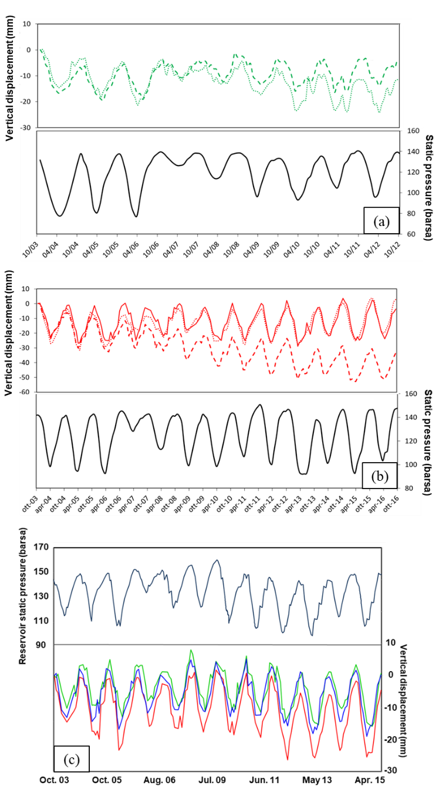
Fig. 1 - Average reservoir pressures and control points of vertical movements overlying the storage formations ((a) and (b) from Rocca et al., 2021; (c) from Coti et al., 2018).

Methodology
The methodology is developed considering two key features of the phenomenon under analysis: the periodic time-dependent behavior and the spatial recognizable correlation. The basic steps of the methodology are described in the following; the workflow is reported in Fig.2. Each acquisition point from satellite surveys (i.e., physical reflector targets commonly found in poorly vegetated and urbanized areas) is associated with its displacement in time. The seasonal component (or seasonality) of the vertical displacement of each acquisition point is obtained via the time series decomposition analysis. The unsupervised clustering method allows one to group the measured points according to their seasonal component. Different clustering methods were adopted to verify the soundness of the methodology, as discussed in the following section. Each cluster is then georeferenced and associated with the curves of the seasonal amplitude vs time of all class members. The higher the oscillation amplitude of the seasonal curves and their time coherence with the storage operations the stronger the UGS effects.
The spatial correlation between the UGS clusters and the independent information about the position of the underground storage (for the analysed cases the only available information is the location of the national Concessions of the UGs field) is adopted for the validation of the methodology. A comparison with the findings of previous research is also carried out. The following paragraphs briefly summarize the main concepts of the time series decomposition and the cluster analysis.

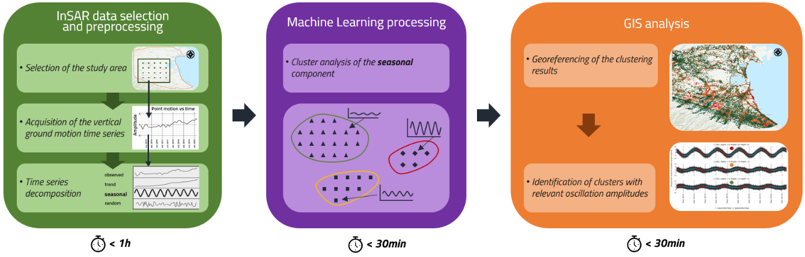
Fig. 2 - Workflow of the method.

Interferometric Synthetic Aperture Radar - InSAR
Interferometric Synthetic Aperture Radar (InSAR) serves as a remote sensing method to analyze radar images acquired by satellites equipped with Synthetic Aperture Radar (SAR) technology (Zisk, 1972; Gabriel, Goldstein and Zebker, 1989 and 1990; Solari et al., 2020). Within this system, the radar antenna continually transmits microwaves towards the Earth's surface, capturing waves reflected to the antenna's location along the Line-of-Sight (LoS) -the direction towards the satellite. Each pixel of the obtained images depicts the energy of the received signal and encompasses namely the amplitude and phase of the backscattered electromagnetic waves. The amplitude reflects details about the intensity of the signal, indicating the proportion of the wave that bounced back to the satellite. This factor depends on the absorption and reflection of the wave during its journey. The phase of the wave provides information about the relative position between the satellite and the reflected point (and also interferences like atmospheric disturbances or other noisy contributions that are dealt with), facilitating the measurement of positional changes over time. To exploit interferometric observations, the phase components captured at different times are compared and an interferogram is produced, this is known as Differential InSAR (DInSAR), later on, the Multi-temporal InSAR analysis makes use of several images, comparing them to a baseline observation, allowing to compute deformations that occur during the sensing periods.
The time series of displacements are derived from coherent and reflective ground features, such as buildings, roads, and rock outcrops. Typically, the algorithms for selecting and processing these relevant scatters can be categorized into permanent (or persistent) scatterers interferometry (PSI) (Ferretti et al., 2001) and distributed scatterers interferometry (DSI) (Berardino et al., 2002). The first category establishes a dominant (persisting) scattering point centered within the resolution cell, resulting from a combination of signals backscattered by elements inside. This reduces phase decorrelation effects due to different acquisition geometries, characterized by high reflectivity and stable phase values. In contrast, the second category comprises ground features that lack strong amplitude or stable phase if considered separately. However, their spatial and electromagnetic homogeneity can be averaged and enables specific algorithms to enhance their radar response (DS are more prevalent in natural environments) like SqueeSAR ®. The outcome of these multi-temporal Differential Interferometric Synthetic Aperture Radar (DInSAR) analyses is a deformation map consisting of multiple points. Each point is characterized by an annual velocity value and a displacement time series with a millimeter-range accuracy. For this paper, we will use data processed with the SqueeSAR ® (Ferretti et al., 2011) algorithm over different locations.

Time series Decomposition Analysis
As reported by Hyndman and Athanasopoulos (2021), the time series decomposition analysis consists of analyzing the behavior of a series of time-dependent data (Yt) via its decomposition into three components: seasonality (St), trend (Tt), and the remainder (Rt). Seasonality describes the periodic oscillation of the data over the entire considered period, the trend accounts for increasing or decreasing values (change of direction), and the remainder accounts for all the random variations.
The additive approach is used when the amplitude of the data oscillation is approximately constant over time and was adopted for the present work (Eq. 1); whereas the multiplicative deals with data that shows a constant increase or decrease in its oscillation.
 | $$Y_{t}=S_{t}+ T_{t}+ R_{t}$$ | Eq.1

Fig. 3 shows an example of an additive decomposed series.

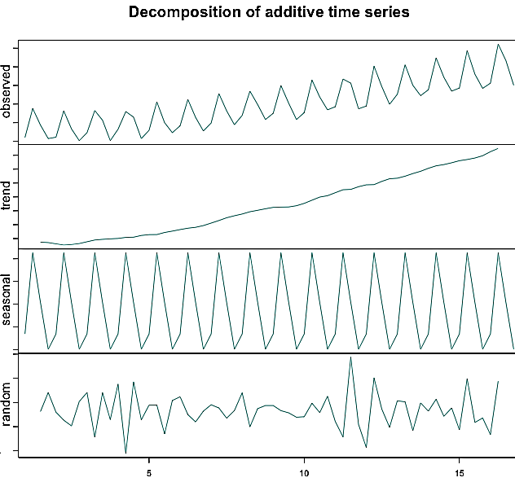
Fig. 3 - Decomposition of additive time series. Source: Anomaly.io.
For the formalization of the methodology, the “Seasonal-Trend decomposition based on Loess” developed by Cleveland et al. (1990) was adopted: it produces smoother decomposed series by diminishing the distortions caused by transient or aberrant behavior in data, and it uses Loess, a non-parametric weighted approach that fits multiple regressions in the local neighborhood.

Cluster Analysis
Cluster analysis is an unsupervised machine learning technique that allows organizing a collection of objects into groups (i.e., clusters) based on the similarity of some common property- or attributes (Tan, Steinbach, and Karpatne, 2018). Among the available clustering methods, the partitive and the hierarchical ones were selected: the first is an unnested method with non-overlapping classes, and the last is represented by a nested tree with overlapping classes (Tan, Steinbach and Karpatne, 2018).

One of the most used prototype-based partitional clustering techniques is K-means. This method attempts to find a user-defined number of clusters that are represented by their centroids (e.g., the mean value of a group of points). The basic K-means algorithm, according to Tan, Steinbach, and Karpatne (2018), starts by selecting $k$ points as centroids, randomly or user-defined, where $k$ is the desired number of clusters. Each data point is assigned to its closest centroids during a first iteration, and consequently the centroid’s clusters are re-calculated. The process is repeated until the optimization process of an objective function reaches the convergence, i.e. the centroids change between two successive iterations is lower than a threshold value.
The present work implements the Morissette et al., (2013) algorithm: the optimization of the squared error function (Eq.2) allows the selection of the optimal cluster configuration, based on the method developed by Hartigan & Wong (1979):

 | $$SSE2=\frac{N_{i}\sum_{J}{{\left\|x_{ij}-c_{i}\right\|}^{2}}}{N_{i}-1}< SSE1=\frac{N_{1}\sum_{j}{{\left\|x_{1j}-c_{1}\right\|}^{2}}}{N_{1}-1}$$ |  |  | Eq.2
where $SSE$ corresponds to the sum of squared errors, $N$ is the number of points assigned to the cluster $i$, $x_{ij}$ the $j$ point of cluster $i$; and $c_{i}$ the centroid of the cluster (its mean).
The hierarchical clustering technique could be categorized into agglomerative and divisive. Given a set of objects (or observations), the agglomerative approach starts from the single objects (singleton) and merges iteratively the closest objects and clusters based on their proximity. On the other hand, the divisive approach starts from all the observations and iteratively splits groups into smaller clusters until a single cluster of single objects remains. In this paper, the basic agglomerative hierarchical clustering is presented. According to Tan, Steinbach, and Karpatne (2018), this algorithm starts by defining a proximity measure and by calculating the relative distance matrix. Then, iteratively, the two closest clusters are merged and the distance matrix is updated considering the newly formed cluster. The process virtually ends when a single cluster remains. Among the available cluster proximity methods to define cluster measures, the proposed approach adopts Ward’s minimum variance method (Ward, 1963; Romesburg 2004). It is based on minimizing the sum of squared errors, starting with the hierarchical clustering algorithm. A further revisitation was made by Wishart (1969) to select the optimal cluster configuration, and further analyzed by Wishart (1969) based on the Lance–Williams (1967) dissimilarity update formula. Its formal description (Kaufman and Rousseeuw, 1990; Murtagh and Legendre, 2014) is presented in Eq. 3.

 | $$d^{2}\left(R,Q\right)=\frac{\left|A\right|+\left|Q\right|}{\left|R\right|+\left|Q\right|}d^{2}\left(A,Q\right)+ \frac{\left|B\right|+\left|Q\right|}{\left|R\right|+\left|Q\right|}d^{2}\left(B,Q\right)- \frac{\left|Q\right|}{\left|R\right|+\left|Q\right|}d^{2}\left(A,B\right)$$ | Eq.3
where $R$ represents a cluster configuration from joining clusters $A$ and $B$, let $Q$ be an independent cluster, $\left| i \right|$their cardinals, and $d^{2}\left(R,Q\right)$ corresponds to the dissimilarity between clusters based on the Euclidean distance between their centroids, multiplied by a factor.

Case studies
The two case studies are located in northern Italy (in the Emilia-Romagna and Lombardia regions). The investigation domain is the Po Plain (Fig. 4); it represents the foredeep-foreland domain of the Northern Apennines whose complex Oligocene-to-Neogene evolution resulted in a buried arcuate fold-and-thrust belt. Compressional tectonics led to the N-ward migration of folds and blind thrusts that progressively incorporated the Po Plain clastic infill and its substratum. The present-day subsurface architecture of the Po Plain is known through seismic reflection data collected since 1945 for hydrocarbon explorations (Pieri and Groppi, 1981). The investigated UGS are hosted in Pleistocene clastic gas-bearing formations at a depth in the range of 1200-1800 m ssl (sub-sea level) The Pliocene–early Pleistocene transgressive marine shale, named the Santerno Formation, provides the sealing caprock of the reservoirs throughout the area (Benetatos et al, 2023).
Case A approximately corresponds to an underground gas storage National Concession area (around 130 ${km}^{2}$) located in the Emilia-Romagna region. Case B includes a more extended area of investigation (about 330 ${km}^{2}$) and comprises one underground gas storage system located in the Lombardia region. Both investigated domains are hosted in highly anthropized areas where the surface movements are characterized by a strong superposition of anthropogenic effects. The data used for the clustering process consists of a monthly time series of the vertical ground displacement acquired via InSAR measurements -the time frame of acquisition ensures a reliable description of the phenomena. Table 1 summarizes the investigated datasets. For each investigation domain both partitive and hierarchical approaches are adopted, furthermore, the sensitivity on the numbers of clusters allows for assessing the soundness of the methodology. In the discussion that follows, the words “class” and “cluster” are used indistinctively for representing groups of measured points.

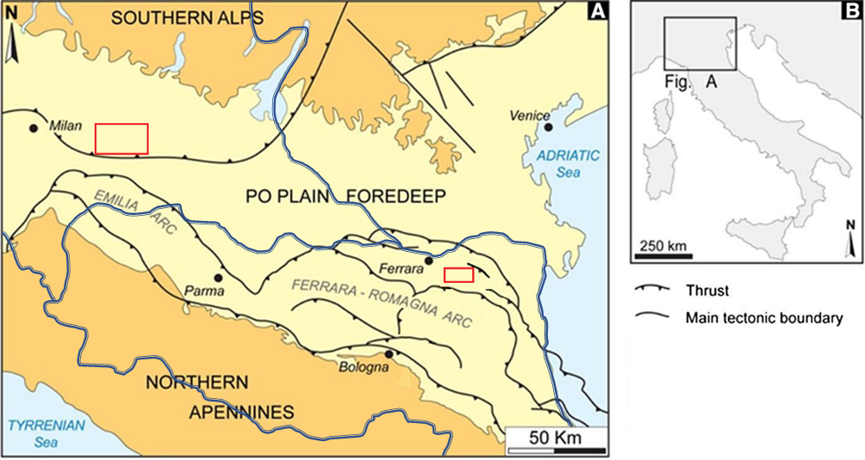
Fig. 4 - Simplified structural map of the eastern Po Plain - Studied areas polygons in red: case A at the SE, near Bologna; case B at the NW near Milan. Double blue lines delimiting Lombardia (NW) and Emilia-Romagna (S) regions. Modified from Codegone et al., 2016.

Table 1 – InSAR Datasets description.
Case | Spatial domain (${km}^{2}$) | Satellite / acquisition geometry | Number of images | Processing algorithm | Time domain | Spatial resolution (m) | Measure Points (MP)
A | 130 | RSAT1 – RSAT2 / ascen-desc | 75 | SqueeSAR© | 14/05/2011 – 23/05/2016 | 20x5 | 5847
A1  (subdomain of A) | 66 | RSAT1 – RSAT2 / ascen-desc | 75 | SqueeSAR© | 14/05/2011 – 23/05/2016 | 20x5 | 2575
B | 330 | RSAT1 – RSAT2 ascending | 178 | SqueeSAR© | 09/10/2003-24/10/2016 | 100x100 | 7776
B | 330 | RSAT1 – RSAT2 descending | 181 | SqueeSAR© | 13/10/2003-28/10/2016 | 100x100 | 7776

CASE A
Case A is a depleted gas reservoir converted into and operated as an underground gas storage system since the 80s of the last century. The reservoir formation corresponds to alternating sands and silty sands that contain two overlapped and hydraulically connected pools. The trap is a NW–SE trending, asymmetric anticline associated with a NW–SE striking regional thrust verging toward NE. The aquifer connected to the reservoir extends NW and SE and it is bound both to the NE and the SW directions by sealing faults (Codegone et al., 2016).
The domain of investigation approximates the UGS National Concessions. Both the partitive and hierarchical clustering methods were performed considering 2, 3 and 4 clusters. The two-cluster scenarios are not able to identify the UGS-induced phenomena because the amplitude discrepancy between UGS effects and the other phenomena is not enough relevant. In the case of three-cluster analysis, for both partitive and hierarchical approaches, a single, coherent class emerges as representative of the ground oscillations due to UGS. Fig. 5 shows the spatial localization of the clusters for the partitive approach and the position of the National Concession. Fig. 6 shows their seasonality plots: each plot consists of the seasonality curves of all the measuring points (MP) within the cluster. Appendix A Fig. A1 and Fig. A2 in Appendix A show the same results from the hierarchical approach.
The UGS-cluster (class 1 for both scenarios) is spatially well-defined and confined. Its oscillation phase is time-coherent with the storage operations (i.e., uplift during the summer injection period and subsidence during the winter withdrawal period) and the maximum amplitude is in the range of [-5 ÷ +5]. Furthermore, the dispersion of the seasonality curves of cluster 1 is very low, expressing a high cluster cohesion. The other two classes (2 and 3) areally identify wide-spread phenomena of lower magnitude, and they are characterized by a sinusoidal seasonal signal that precedes in time the UGS effects or even shows a phase-opposite behavior.
The results obtained from the hierarchical and the partitive approaches with the same number of clusters are extremely coherent, both in terms of cluster definition (number and geo-localization of the points belonging to each cluster) and, consequently, of seasonality curve grouping. Furthermore, increasing the number of clusters, the identification of the UGS class remains stable and consistent in terms of both the number of the MP and the range of the average seasonal amplitude, therefore it is not affected by either the number of the clusters or the clustering algorithm (Table 2).

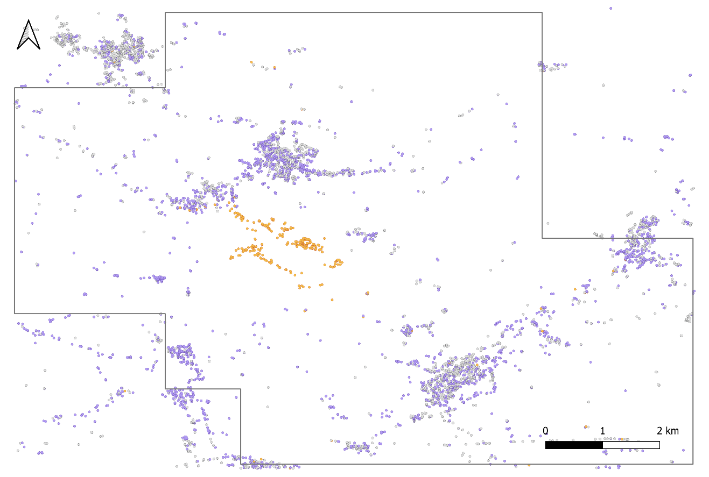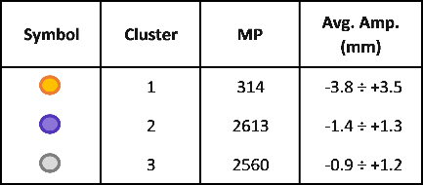
Fig. 5 - Case A – 3 cluster partitive case: localization of the clusters and of the National Concessions (dark grey polygon).

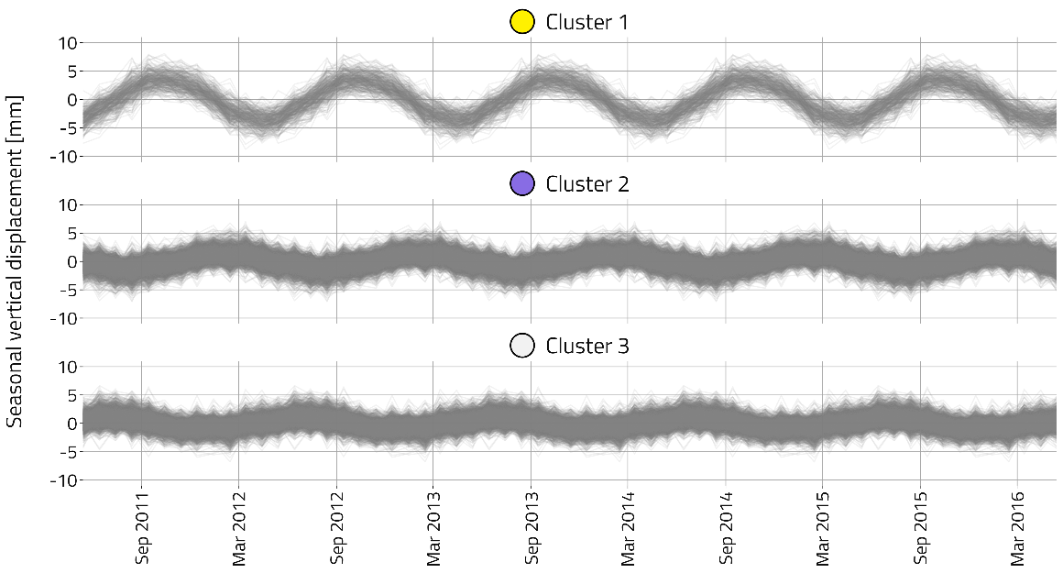
Fig. 6 - Case A –3 cluster partitive case: seasonal vertical displacement for each cluster.

Table 2 - Case A – summary of the results. In green the UGS cluster.
Number of clusters | Method | Cluster 1 |  | Cluster 2 |  | Cluster 3 |  | Cluster 4
Number of clusters | Method | N. of points | Average Amplitude (mm) | N. of points | Average Amplitude (mm) | N. of points | Average Amplitude (mm) | N. of points | Average Amplitude (mm)
2 | Hierarchical | 1762 | -1.4 ÷ +1.2 | 3725 | -1.0 ÷ +1.0
2 | Partitive | 2866 | -1.3 ÷ +1.3 | 2621 | -1.1 ÷ +0.9
3 | Hierarchical | 300 | -3.8 ÷ +3.6 | 1462 | -1.3 ÷ +1.4 | 3725 | -1.0 ÷ +1.0
3 | Partitive | 314 | -3.8 ÷ +3.5 | 2613 | -1.4 ÷ +1.3 | 2560 | -0.9 ÷ +1.2
4 | Hierarchical | 300 | -3.8 ÷ +3.6 | 1180 | -1.9 ÷ +1.8 | 1462 | -1.3 ÷ +1.4 | 2545 | -0.5 ÷ +0.7
4 | Partitive | 304 | -3.8 ÷ +3.5 | 1243 | -2.0 ÷ +1.8 | 1354 | -1.3 ÷ +1.7 | 2586 | -0.4 ÷ +0.6

CASE A1 and validation of the methodology
Aiming at the methodology validation, a sub-domain of investigation (Case A1) was analyzed and the results were compared with the findings of previous research developed by Codegone et al. (2016). They approached the study of surface movements related to gas storage via a 3D numerical approach: static, dynamic and mechanical models of the investigated area were defined and calibrated via production data and surface ground movement measurements. The numerical simulations calculated the surface movements induced by only UGS operations without any superposition with other anthropogenic or natural land movements.
Case A1 was investigated via both the partitive and hierarchical clustering methods considering 2, 3 and 4 clusters. Fig. 7 and Fig. 8 show the results of the two-cluster partitive approach: the cluster 1 identification with the UGS-class is straightforward, whereas class 2 aggregates all the other effects. Furthermore, Fig. 7 shows the comparison between the cluster 1 position and the iso-uplift (top) and the iso-subsidence (bottom) lines from Codegone et al. (2016). In particular, the iso-lines correspond to the average values obtained by numerical simulations in the period (2004-2012): in particular, the uplift lines are obtained by averaging all the injection period from March to November, whereas the subsidence lines are obtained by averaging all the production period from November to March. Both approaches coherently identify the same area mostly affected by UGS activities, i.e. the area elongated along the reservoir structure orientation which corresponds to the top of the reservoir, where the majority of the storage wells are located. In this area the largest pressure variations occur, inducing appreciable surface movements (Codegone et al., 2016). The main discrepancies between the results of the two approaches arise in the marginal areas, characterized by very small vertical movements, and they could be realistically attributed to the lack of MPs and the average values of the contour lines on a temporal interval which only partially coincided with the InSAR measurement time-frame.
Concerning Fig. 8, the seasonality curves of cluster 1 remain stable and cohesive as in case A; vice-versa, the high dispersion of the plot related to cluster 2 well describes the low cohesion and the high ‘heterogeneity’ of the cluster. In Appendix A, the same results of the two clusters in the case of the hierarchical approach are reported (Fig. A3 and Fig. A4). The consistency with the hierarchical results and with the results from Codegone et al. (2016) is evident.

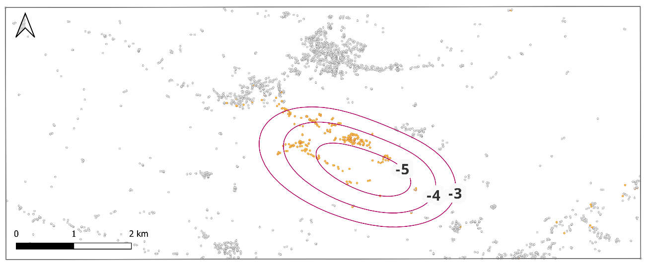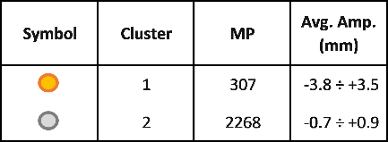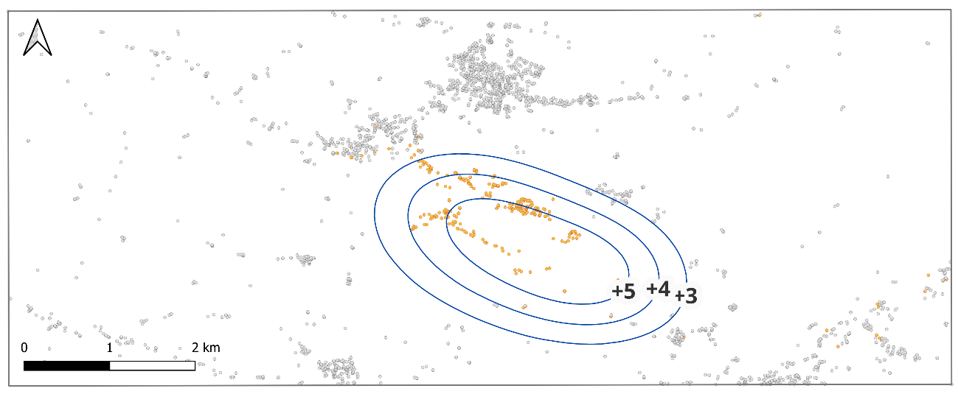
Fig. 7 - Case A1 – 2 cluster partitive case: clusters’ localization and comparison with the iso-displacement lines (top: blue line for uplift and bottom: pink line for subsidence) in [mm] modeled by Codegone et al. (2016).

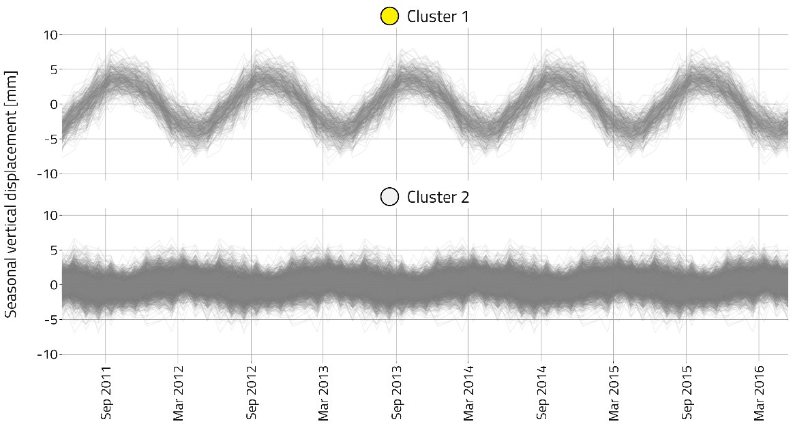
Fig. 8 - Case A1 – 2 cluster partitive case: seasonal vertical displacement for each cluster.

To further verify the soundness of the results, 3 and 4 cluster analyses were run. For both the hierarchical and partitive approaches, the same class emerges as representative of the ground oscillations due to UGS. This class remains stable in location, number of points, and sinusoidal signal shape. Marginal classes appear from a further split of the remaining points; the phases of their sinusoidal curves show no time coherency with the seasonal storage operations.
For the sake of brevity, maps and seasonal curves are reported only in the case of three-cluster analysis for the partitive (Fig. 9 and Fig. 10) scenarios, whereas the results of the hierarchical scenarios are in Appendix A (Fig. A5 and Fig. A6). Eventually, Table 3 summarizes the results of all the investigated scenarios: the identification of the UGS class is stable and consistent in terms of both number of the MP and the range of the average seasonal amplitude.
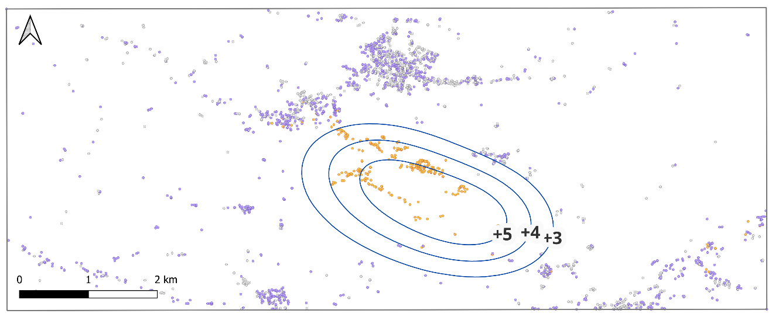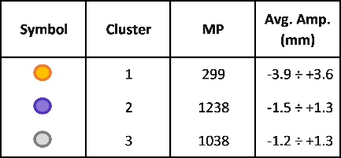
Fig. 9 - Case A1 – 3 cluster partitive case: clusters’ localization and comparison with the iso-uplift lines (blue) in [mm] modelled by Codegone et al. (2016).
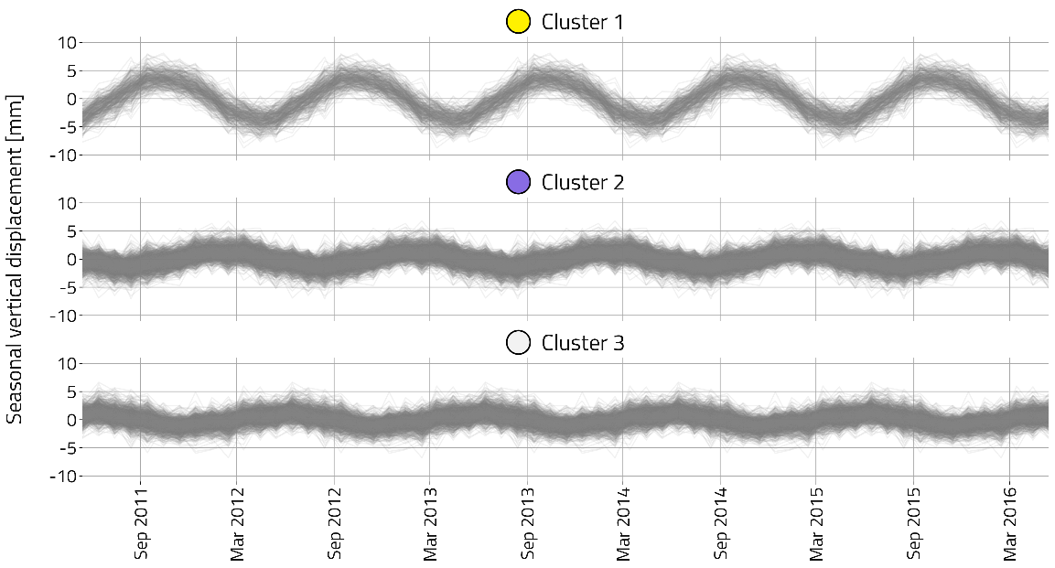
Fig. 10 - Case A1 – 3 cluster partitive case: seasonal vertical displacement for each cluster.

Table 3 - Case A1 – summary of the results. In green the UGS cluster.
Number of clusters | Method | Cluster 1 |  | Cluster 2 |  | Cluster 3 |  | Cluster 4
Number of clusters | Method | N. of points | Average Amplitude (mm) | N. of points | Average Amplitude (mm) | N. of points | Average Amplitude (mm) | N. of points | Average Amplitude (mm)
2 | Hierarchical | 250 | -4.2 ÷ +3.8 | 2325 | -0.7 ÷ +0.9
2 | Partitive | 307 | -3.8 ÷ +3.5 | 2268 | -0.7 ÷ +0.9
3 | Hierarchical | 250 | -4.2 ÷ +3.8 | 538 | -1.5 ÷ +1.9 | 1787 | -1.0 ÷ +1.0
3 | Partitive | 299 | -3.9 ÷ +3.6 | 1238 | -1.5 ÷ +1.3 | 1038 | -1.2 ÷ +1.3
4 | Hierarchical | 250 | -4.2 ÷ +3.8 | 538 | -1.5 ÷ +1.9 | 1368 | -1.3 ÷ +1.4 | 419 | -0.9 ÷ +0.8
4 | Partitive | 279 | -4.0 ÷ +3.7 | 729 | -1.5 ÷ +1.8 | 769 | -1.2 ÷ +1.5 | 798 | -1.3 ÷ +1.3

CASE A1 - Sensitivity analysis on cluster algorithms
Sensitivity analysis concerning different algorithms, distance matrixes and specific parameters affecting both the hierarchical and the partitive methods were accomplished to evaluate their performances in depicting the UGS cluster(s). The dataset of case A1 was analyzed.
Concerning the hierarchical approach, five different clustering algorithms were tested, namely: group average (Sokal & Michener, 1958), centroid (Sokal and Michener, 1958; Lance & Williams, 1966), complete link (Sokal & Sneat, 1963; Macnaughton-Smith, 1965), McQuitty (McQuitty, 1960) and Ward.D2 (Ward, 1963; Kaufman and Rousseeuw,1990; Murtagh and Legendre, 2014). Generally speaking, the methods calculate the distance between clusters’ centroids or points (proximity or remoteness) in order to group them; the Ward method looks to minimize the variance between and within clusters. Furthermore, for each algorithm, the calculation of the initial distance matrix is performed using 4 methods: Maximum, Minkowsky, Euclidean and Manhattan.
Table A1 in Appendix A shows the results for the hierarchical algorithms and the matrix distances. The more influential parameter was the clustering algorithm since no variation was observed varying the formula used for the distance matrix within the same hierarchical algorithm. The table highlights the clusters that identify the UGS site (“UGS classes”), being the Average and the Ward.D2 the most accurate one to delimit the phenomenon under investigation. All of the algorithms but the Centroid succeeded in recognizing the UGS area, being Average and Ward.D2 the most precise. Variations in the number of points associated with the classes recognizing the UGS site ranged from -25% to +400% with respect to both Average and Ward.D2, which performed similarly in this aspect (259 and 250 points respectively). The Average algorithm was more sensible to outliers, recognizing a singleton with the maximum variation inside the UGS site and a second class which groups all the points affected by UGS, more in agreement with the Ward.D2 results. The latter showed itself less sensible to outliers and it identified one UGS class and two noisy ones. For the purposes of this study, the Ward.D2 became more relevant since it better depicted the overall UGS phenomenon.
Concerning the partitive approach, the performance of four K-means algorithms was evaluated, namely: Hartigan-Wong (Hartigan & Wong,1979), Forgy (Forgy, 1965), Lloyd (Lloyd, 1982), and MacQueen (MacQueen, 1967). The first approach searches for the local optimal within-cluster sum of squares of errors, while the others minimize the distance between the centroid and the points belonging to a cluster given a specific metric. Furthermore, the impact of the initial seed selection (i.e., the first guess centroid definition) is considered to verify the convergence and stability of the results. For each of the above-mentioned algorithms, the seed was defined first as a fixed numerical seed to always generate the same sequence of random starting centroids, and then equal to the clusters’ centroids coming from each of the hierarchical clustering algorithms previously analyzed.
Table A2 shows the results of the sensitivity analysis run using the same numerical seed for setting the initial random centroids for the four considered partitive algorithms. The table highlights the UGS classes are well recognized by all of the algorithms, presenting global variation regarding the number of points associated with them lower than 1%. Table A3 shows the results obtained by adopting as seed the cluster’s centroid coming from each of the different combinations of hierarchical clustering algorithms and matrix distance calculations. For all the cases the UGS is well recognized and the results are quite stable and consistent, showing again variations lower than 1% for all of the cases. In this case, the partitive algorithms were not affected by the centroid selection.
As a final comment, we observed that at the macroscopic level both clustering approaches (hierarchical and partitive) succeeded in recognizing the UGS site with a max variation of 20% in the number of points belonging to the UGS classes. All the analyses presented in this paper were performed with the Ward.D2 using Euclidean distances (hierarchical) for its better depiction of the UGS site and the seasonal behavior of the MP’s and with Hartigan-Wong with the centroids resulting from the hierarchical clustering as seed (partitive).

CASE A1 – Cluster analysis of InSAR time series of the total ground deformations
The present section shows evidence of how the cluster analysis on the sinusoidal components turns out to be the key aspect of the proposed approach. Both partitive and hierarchical cluster analyses considering different numbers of clusters were performed on the total vertical displacement measurements available in the investigation domain of case A1. For the sake of brevity, maps, and curves are reported only in the case of two clusters for partitive scenarios (Fig. 11 and Fig. 12), please see Appendix A Fig. A7 and Fig. A8 for the partitive three-cluster analysis. The maps and curves for the hierarchical scenarios with two and three clusters are also reported in Appendix A (from Fig. A9 to Fig. A12). In total vertical displacement measurements, the effects of UGS are hidden by the superposition of different effects and in no configuration a class can disclose the UGS displacement patterns. The highlighted general subsidence trend was further analyzed also considering the wider investigation domain of case A and it turns out to be the general trend of the area ARPAE (2018).
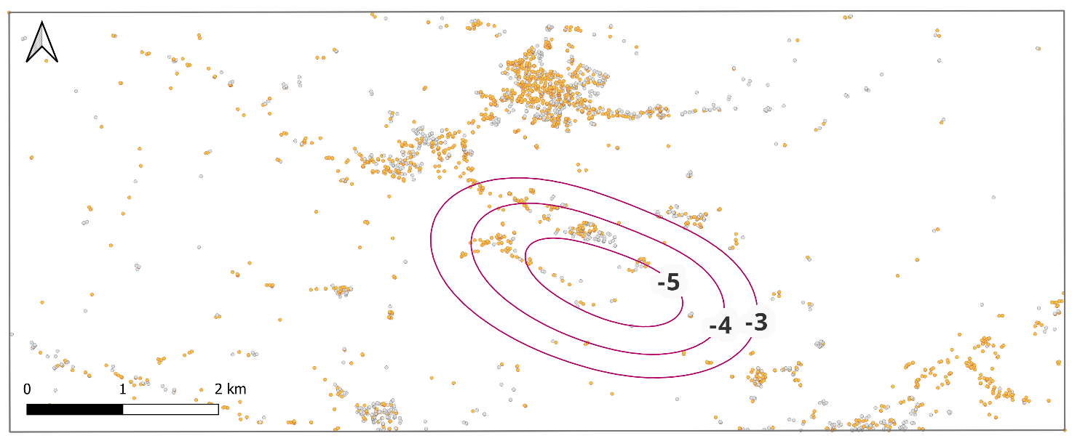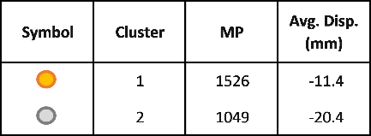
Fig. 11 - Total vertical displacement for Case A1 – 2 cluster partitive case: clusters’ localization and comparison with the iso-subsidence lines (pink) in [mm] modelled by Codegone et al. (2016).

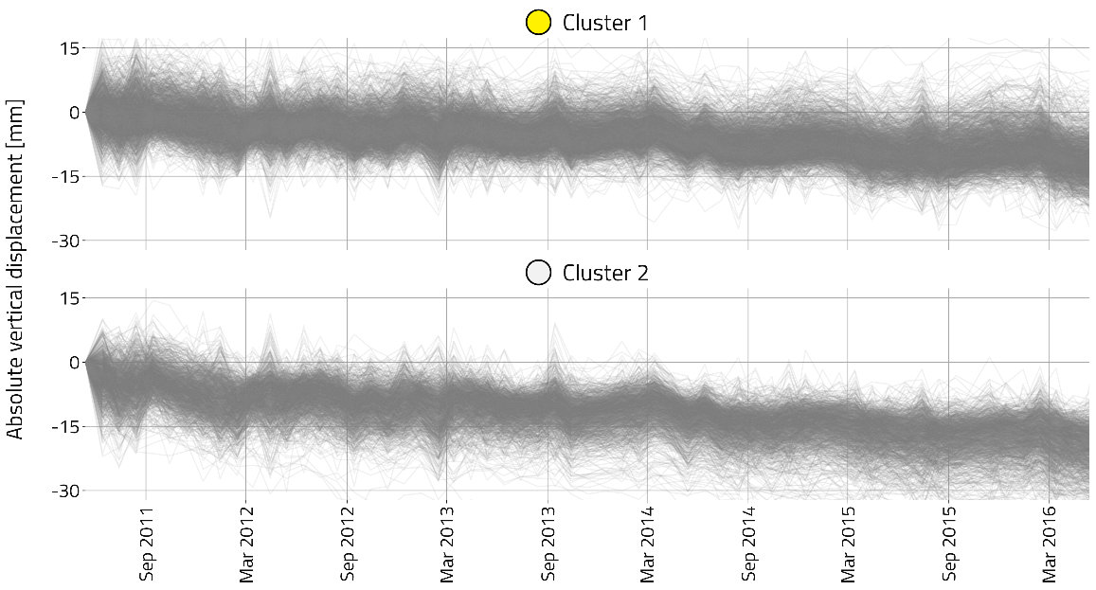
Fig. 12 - Total vertical displacement for Case A1 – 2 cluster partitive case: vertical displacement for each cluster.

CASE B
Case B encompasses the highly urbanized, industrial and agricultural area in the south of Milan, where one underground gas storage system is hosted. Case B is a depleted gas reservoir converted into and operated as an underground gas storage system since the 70s of the last century. The reservoir is hosted in an EW sandy anticline verging toward S; it is bounded to NS direction by an EW regional thrust and, elsewhere, connected with the aquifer. Similar to the previous case, both the hierarchical and partitive approaches, considering 2, 3 and 4 cluster configurations, were adopted. Information regarding the location of the storage National Concession supports the interpretation and validation of the results.
The two-cluster analysis can identify the effect of storage operation in terms of surface movements. The partitive configuration (Fig. 13) shows two macro areas, differentiated in time and spatial domains. Cluster 1 clearly identifies storage effects within the National Concessions; the seasonality curves of the MP within the cluster reflect the highest average amplitude, around [-5 ÷ +5] mm and a seasonal vertical oscillation coherent in time with the UGS operations (Fig. 14). Cluster 2 encompasses a heterogeneous group of points grouping different minor phenomena; it doesn’t show any time-coherent periodicity, and its average amplitude is in the range of |4| mm. The results related to the hierarchical scenarios are in line with the partitive configuration ones, and they are reported in Appendix A (Fig. A13 and Fig. A14).
Increasing the number of clusters, the UGS-class remains consistent and stable. Marginal classes appear from the further splitting of the other points; the phase of their sinusoidal signal remains uncorrelated with the seasonal UGS operations. Fig. 15 and Fig. 16 refer to the results in the case of partitive three-cluster scenarios, whereas the hierarchical three-cluster analysis results are reported in Appendix A (Fig. A15 and Fig. A16). Eventually, Table 4 summarizes the results of all the investigated scenarios: the identification of the UGS class is stable and consistent in terms of both number of the MP and the range of the average seasonal amplitude, therefore it is not affected by either the number of clusters or the clustering algorithm.

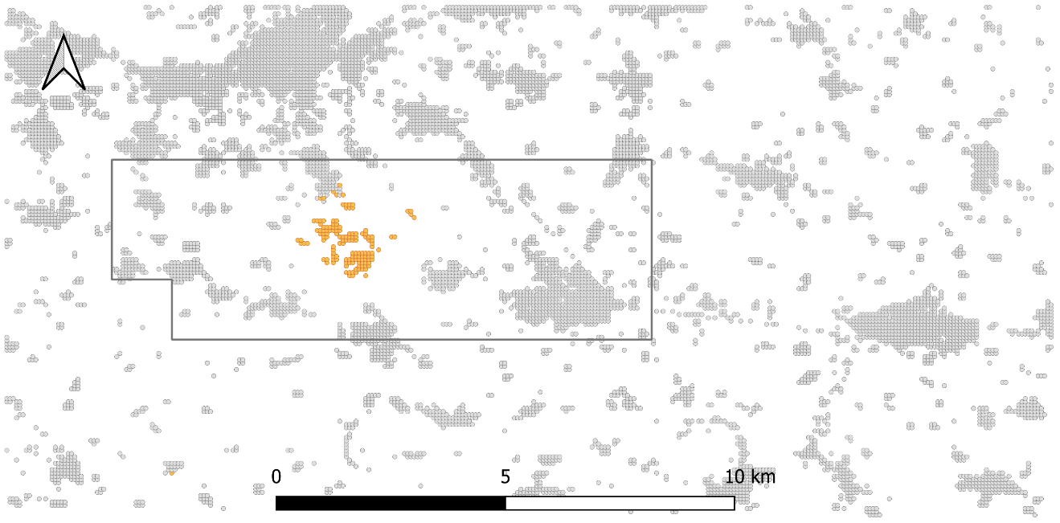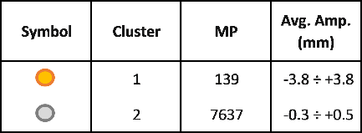
Fig. 13 - Case B – 2 cluster partitive case: localization of the clusters and the National Concessions (dark grey polygon).
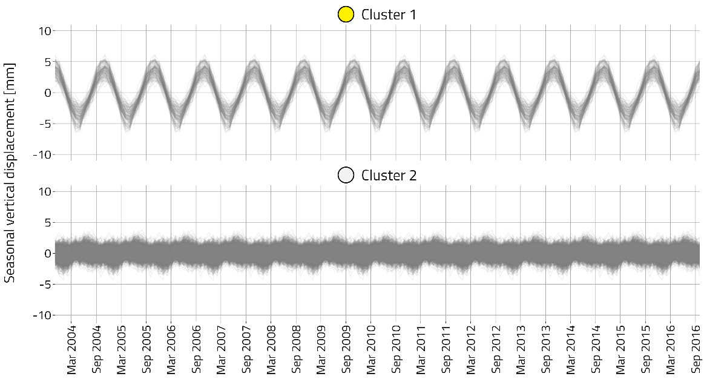
Fig. 14 - Case B – 2 cluster partitive case: seasonal vertical displacement for each cluster.

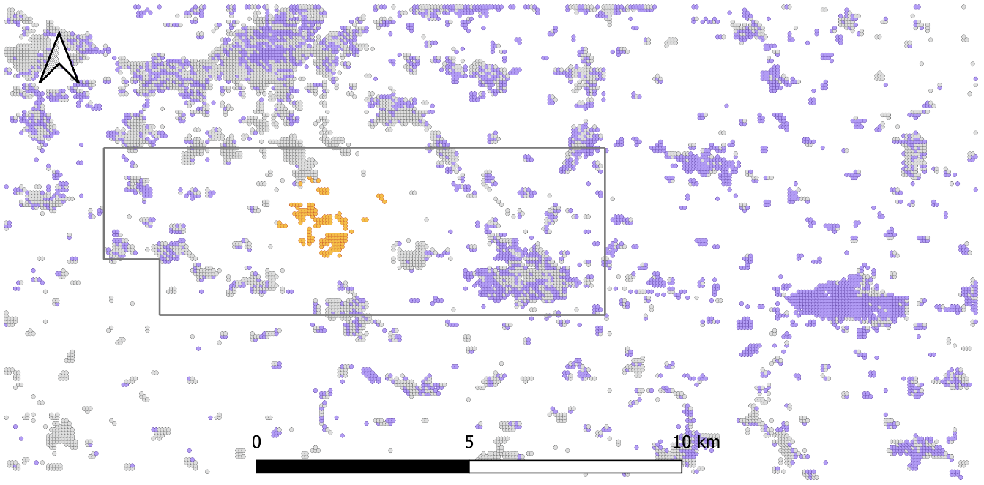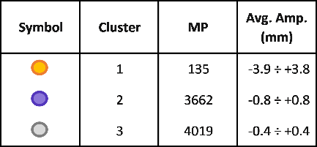
Fig. 15 - Case B – 3 cluster partitive case: localization of the clusters and the National Concessions (grey polygon).
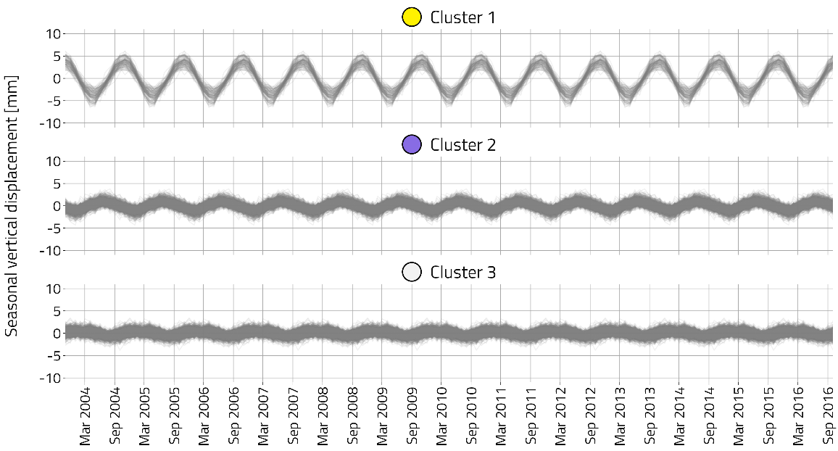
Fig. 16 - Case B – 3 cluster partitive case: seasonal vertical displacement for each cluster.

Table 4 - Case B – summary of the results. In green the UGS cluster.
Number of clusters | Method | Cluster 1 |  | Cluster 2 |  | Cluster 3 |  | Cluster 4
Number of clusters | Method | N. of points | Average Amplitude (mm) | N. of points | Average Amplitude (mm) | N. of points | Average Amplitude (mm) | N. of points | Average Amplitude (mm)
2 | Hierarchical | 133 | -3.9 ÷ +3.8 | 7643 | -0.3 ÷ +0.5
2 | Partitive | 139 | -3.8 ÷ +3.8 | 7637 | -0.3 ÷ +0.5
3 | Hierarchical | 133 | -3.9 ÷ +3.8 | 3335 | -0.8 ÷ +0.9 | 4308 | -0.3 ÷ +0.2
3 | Partitive | 135 | -3.9 ÷ +3.8 | 3662 | -0.8 ÷ +0.8 | 4019 | -0.4 ÷ +0.4
4 | Hierarchical | 133 | -3.9 ÷ +3.8 | 3335 | -0.8 ÷ +0.9 | 1750 | -0.6 ÷ +0.7 | 2558 | -0.3 ÷ +0.3
4 | Partitive | 132 | -3.9 ÷ +3.9 | 2152 | -1.0 ÷ +0.9 | 3543 | -0.5 ÷ +0.6 | 1949 | -0.5 ÷ +0.5

Final remarks
The proposed research, moving from well-established theoretical concepts and approaches, proposes an innovative application for an efficient and automatic InSAR data analysis to detect UGS effects. The methodology was tested and validated against two case studies. In each investigated scenario, an areally cohesive and well-defined UGS class is always clearly identified according to its seasonality in agreement with a standard withdrawal/injection schedule. The precision of the results, however, is somewhat affected by the magnitude of the induced UGS effects compared to the magnitude of other coexisting seasonal phenomena as well as by the spatial density of the MPs. The higher the amplitude of the induced ground oscillations and the density of data, the more accurate the geo-localization of the UGS cluster and the tighter the associated seasonality curves within the cluster. In the case of poor ground coverage of the reflective structures, such as in rural or farmed areas, additional artificial targets could be adopted.
Some plausible but very specific scenarios should be the focus of further investigations such as specific areas characterized by a strong superposition of seasonal phenomena of comparable amplitude and phases with the UGS ones. Another challenging aspect to be investigated is the specificity of the timeline of the ground movements induced by each investigated UGS system. Within the general pattern of uplift in the summer period and subsidence in the winter one, the timeline of the ground movements can be influenced by case-dependent injection/withdrawal schedule (not only affected by operational activities but also by market needs) and by the fluid-flow and stress-strain phenomena induced by storage activities. In all the above-mentioned scenarios, the interpretation of the InSAR data could be supported by additional information about, for example, storage operations, well locations and reservoir pressure variations in time and space, information not available for the two presented case studies. Moreover, further development of the research should be focused on the application of supervised approaches so as to condition the analysis via the above-mentioned ancillary information. Eventually, the effects of different InSAR processing algorithms should be evaluated in terms of the accuracy of the methodology.

Conclusions
The research proposes an automatic approach for geo-localizing and quantifying the ground movements induced by underground gas storage activities, implementing an unsupervised machine learning methodology on InSAR measurements. Time series decomposition analysis and unsupervised clustering algorithms (partitive and hierarchical approaches) are adopted for disclosing the displacement pattern induced by storage operations. The analysis of the solely sinusoidal component of the time series of vertical movements is the key aspect of the proposed approach for handling the superposition of ground movements generated by different sources and consequently for clearly and reliably identifying the UGS effects only.
The paper presents the definition and formalization of the methodology and its validation using two real case studies, located in the Po Plain (Italy). Despite the highly disturbed signals due to several anthropogenic activities, the methodology identified the position of each gas storage system in the investigated regions, in agreement with the available independent information about the storage location. The clusters associated with UGS effects are spatially isolated compared to the other ones. The seasonal curves of the UGS clusters are time-coherent with the cyclic injection/withdrawal operations.
Further developments of the research will focus on the application of the methodology to the detection of geo-hazards induced by different time-dependent ground movement phenomena that satisfy two main requirements: to be detectable by InSAR measurements and to show a characteristic sinusoidal or trend components - such as water production and landslides.

Alberto Manuel Garcia Navarro: Conceptualization, Formal analysis, Investigation, Methodology, Writing - original draft, Writing - review & editing. Vera Rocca: Conceptualization, Formal analysis, Investigation, Methodology, Writing - original draft, Writing - review & editing. Alfonso Capozzoli: Conceptualization, Writing - review & editing. Roberto Chiosa: Conceptualization, Writing - review & editing. Francesca Verga: Writing – review & editing.

Acknowledgements: PhD Scholarship funded under the project “iENTRANCE@ENL - Infrastructure for Energy Transition and Circular Economy@EuroNanoLab” funded by the European Union - NextGenerationEU under the National Recovery and Resilience Plan (NRRP), Mission 04 Component 2 Investment 3.1 | Project Code: IR0000027 - CUP: B33C22000710006.

References
Anomaly.io. (2015, December 1). Extracting Seasonality and Trend from Data: Decomposition Using R. Anomaly.io. https://anomaly.io/seasonal-trend-decomposition-in-r/index.html.
Ansari, H., Ruβwurm, M., Ali, M., Montazeri, S., Parizzi, A., & Zhu, X. X. (2021, July). InSAR displacement time series mining: A machine learning approach. In 2021 IEEE International Geoscience and Remote Sensing Symposium IGARSS (pp. 3301-3304). IEEE. https://doi.org/10.1109/IGARSS47720.2021.9553465.
Antoncecchi, I., Ciccone, F., Rossi, G., Agate, G., Colucci, F., Moia, F., ... & Petracchini, L. (2021). Soil deformation analysis through fluid-dynamic modelling and DInSAR measurements: a focus on groundwater withdrawal in the Ravenna area (Italy). BGTA-Bollettino di Geofisica Teorica ed Applicata. https://doi.org/10.4430/bgta0350.
ARPAE (Agenzia Prevenzione Ambiente Energia Emilia-Romagna). (2018). Rilievo della subsidenza nella pianura emiliano-romagnola – Seconda fase – Relazione finale [Subsidence measurement of the Emilia-Romagna plain 2017 – Second phase – Final report].
Benetatos C.; Codegone G.; Ferraro C.; Mantegazzi A.; Rocca V.; Tango G.; Trillo F. (2020). Multidisciplinary analysis of ground movements: an underground gas storage case study. Remote sensing. Volume: 12. issue: 21, pages: 3487-3505, MDPI. ISSN: 2072-4292. https://doi:10.3390/rs12213487
Benetatos, C., Codegone, G., Deangeli, C., Giani, G., Gotta, A., Marzano, F., Rocca, V., Verga, F. (2017). Guidelines for the study of subsidence triggered by hydrocarbon production, Geoingegneria Ambientale e Mineraria, 152(3), pp. 85-96, ISSN: 11219041.
Benetatos, C., Codegone, G., Ferraro, C., Mantegazzi, A., Rocca, V., Tango, G., & Trillo, F. (2020). Multidisciplinary analysis of ground movements: an underground gas storage case study. Remote Sensing, 12(21), 3487.
Benetatos, C.; Bocchini, S.; Carpignano, A.; Chiodoni, A.; Cocuzza, M.; Deangeli, C.; Eid, C.; Ferrero, D.; Gerboni, R.; Giglio, G.; Lamberti, A.; Marasso, S.; Massimiani, A.; Menin, B.; Moscatello, A.; Panini, F.; Peter, C.; Pirri, F.; Quaglio, M.; Rocca, V.; Rovere, A.; Borello, E. S.; Serazio, C.; Uggenti, A. C.; Vasile, N.; Verga, F.; Viberti, D. (2021). How underground systems can contribute to meet the challenges of energy transition. Geoingegneria Ambientale e Mineraria, 58 (2-30), pp. 65-80. https://doi.org/10.19199/2021.163-164.1121-9041.065.
Berardino, P., Fornaro, G., Lanari, R., & Sansosti, E. (2002). A new algorithm for surface deformation monitoring based on small baseline differential SAR interferograms. IEEE Transactions on geoscience and remote sensing, 40(11), 2375-2383.
Berardino, P., Fornaro, G., Lanari, R., & Sansosti, E. (2002). A new algorithm for surface deformation monitoring based on small baseline differential SAR interferograms. IEEE Transactions on geoscience and remote sensing, 40(11), 2375-2383.
Berti, M., Corsini, A., Franceschini, S., & Iannacone, J. P. (2013). Automated classification of Persistent Scatterers Interferometry time series. Natural Hazards and Earth System Sciences, 13(8), 1945-1958. https://doi.org/10.5194/nhess-13-1945-2013.
Bocchini, S., Castro, C., Cocuzza, M., Ferrero, S., Latini, G., Martis, A., Pirri, F., Scaltrito, L., Rocca, V., Verga, F., Viberti, D. (2017). "The Virtuous CO2 Circle or the Three Cs: Capture, Cache, and Convert". Journal of Nanomaterials, 2017, Article ID 6594151, 14 pages. https://doi.org/10.1155/2017/6594151.
Burnol, A., Aochi, H., Raucoules, D., Veloso, F. M., Koudogbo, F. N., Fumagalli, A., ... & Maisons, C. (2019). Wavelet-based analysis of ground deformation coupling satellite acquisitions (Sentinel-1, SMOS) and data from shallow and deep wells in Southwestern France. Scientific Reports, 9(1), 8812. https://doi.org/10.1038/s41598-019-45302-z
Carminati, E., & Di Donato, G. (1999). Separating natural and anthropogenic vertical movements in fast subsiding areas: the Po plain (N. Italy) case. Geophysical Research Letters, 26(15), 2291-2294.
Chang, L., & Hanssen, R. F. (2015). A probabilistic approach for InSAR time-series postprocessing. IEEE transactions on geoscience and remote sensing, 54(1), 421-430. https://doi.org/10.1109/TGRS.2015.2459037.
Cigna, F., Del Ventisette, C., Liguori, V., & Casagli, N. (2011). Advanced radar-interpretation of InSAR time series for mapping and characterization of geological processes. Natural Hazards and Earth System Sciences, 11(3), 865-881. https://doi.org/10.5194/nhess-11-865-2011.
Cleveland, R. B., Cleveland, W. S., McRae, J. E. & Terpenning, I. (1990). STL: A Seasonal-Trend Decomposition Procedure Based on Loess (with Discussion). Journal of Official Statistics, 6, 3-73.
Codegone, G., Rocca, V., Verga, F., & Coti, C. (2016). Subsidence Modelling Validation Through Back Analysis for an Italian Gas Storage Field. Geotechnical and Geological Engineering, 34, 1749-1763. https://doi.org/10.1007/s10706-016-9986-9.
Confuorto, P., Del Soldato, M., Solari, L., Festa, D., Bianchini, S., Raspini, F., & Casagli, N. (2021). Sentinel-1-based monitoring services at regional scale in Italy: State of the art and main findings. International Journal of Applied Earth Observation and Geoinformation, 102, 102448. https://doi.org/ 10.1016/j.jag.2021.102448.
Coti, C., Rocca, V., & Sacchi, Q. (2018). Pseudo-elastic response of gas bearing clastic formations: an Italian case study. Energies, 11(9), 2488. https://doi.org/10.3390/en11092488.
Czarnogorska, M., Samsonov, S., White, D., & Decker, V. (2014, July). Ground deformation at the Aquistore CO 2 storage site in Saskatchewan (Canada) measured by RADARSAT-2 DInSAR. In 2014 IEEE Geoscience and Remote Sensing Symposium (pp. 445-447). IEEE. http://dx.doi.org/10.1109/IGARSS.2014.6946454
Du, J., He, R. & Sugumaran, V. (2016). Clustering and ontology-based information integration framework for surface subsidence risk mitigation in underground tunnels. Cluster Computing, 19, 2001–2014. https://doi.org/10.1007/s10586-016-0631-4.
Eid, C., Benetatos, C., Rocca, V. (2022). Fluid production dataset for the assessment of the anthropogenic subsidence in the Po Plain area (Northern Italy). Resources, 11(6), 53. https://doi.org/10.3390/resources11060053
Ferretti, A., Fumagalli, A., Novali, F., Prati, C., Rocca, F., & Rucci, A. (2011). A new algorithm for processing interferometric data-stacks: SqueeSAR. IEEE transactions on geoscience and remote sensing, 49(9), 3460-3470.
Ferretti, A., Prati, C., & Rocca, F. (2001). Permanent scatterers in SAR interferometry. IEEE Transactions on geoscience and remote sensing, 39(1), 8-20.
Festa, D., Bonano, M., Casagli, N., Confuorto, P., De Luca, C., Del Soldato, M., ... & Casu, F. (2022). Nation-wide mapping and classification of ground deformation phenomena through the spatial clustering of P-SBAS InSAR measurements: Italy case study. ISPRS Journal of Photogrammetry and Remote Sensing, 189, 1-22. https://doi.org/10.1016/j.isprsjprs.2022.04.022.
Festa, D., Novellino, A., Hussain, E., Bateson, L., Casagli, N., Confuorto, P., ... & Raspini, F. (2023). Unsupervised detection of InSAR time series patterns based on PCA and K-means clustering. International Journal of Applied Earth Observation and Geoinformation, 118, 103276.
Fibbi, G., Beni, T., Fanti, R., & Del Soldato, M. (2023). Underground Gas Storage Monitoring Using Free and Open Source InSAR Data: A Case Study from Yela (Spain). Energies, 16(17), 6392.
Fibbi, G., Del Soldato, M., & Fanti, R. (2022). Review of the Monitoring Applications Involved in the Underground Storage of Natural Gas and CO2. Energies, 16(1), 12.
Forgy, E. (1965). Cluster analysis of multivariate data: efficiency vs. interpretability of classification. Biometrics, 21, 768.
Gabriel, A. K., Goldstein, R. M., & Zebker, H. A. (1989). Mapping small elevation changes over large areas: Differential radar interferometry. Journal of Geophysical Research: Solid Earth, 94(B7), 9183-9191.
Gabriel, A. K., Goldstein, R. M., & Zebker, H. A. (1990). U.S. Patent No. 4,975,704. Washington, DC: U.S. Patent and Trademark Office.
Gambolati, G., Teatini, P., & Ferronato, M. (2006). Anthropogenic land subsidence. Encyclopedia of hydrological sciences. John Wiley & Sons, Ltd. https://doi.org/10.1002/0470848944.hsa164b.
García, A. M. (2021). Application of the clusterization data approach to the satellite measures of altimetric variation in the Emilia-Romagna Region (Italy) [Master's thesis, Politecnico di Torino]. Polito Webthesis. http://webthesis.biblio.polito.it/id/eprint/19978.
Gassenmeier, M., Sens-Schönfelder, C., Delatre, M., & Korn, M. (2014). Monitoring of environmental influences on seismic velocity at the geological storage site for CO2 in Ketzin (Germany) with ambient seismic noise. Geophysical Journal International, 200(1), 524-533. https://doi.org/10.1093/gji/ggu413
Ghielmi M., Minervini M., Nini C., Rogledi S., Rossi M. & Vignolo A. (2010). Sedimentary and tectonic evolution in the eastern Po-Plain and northern Adriatic Sea area from Messinian to Middle Pleistocene (Italy). Rendiconti dell’Accademia dei Lincei, 21 (Suppl 1), S131–S166. https://doi.org/10.1007/s12210-010-0101-5.
Giani, G.P., Gotta, A., Marzano, F., Rocca, V. (2017). How to Address Subsidence Evaluation for a Fractured Carbonate Gas Reservoir Through a Multi-disciplinary Approach. Geotechnical and geological engineering, 35, p. 2977-2989, ISSN: 0960-3182. https://doi.org/10.1007/s10706-017-0296-7
Hartigan, J. A., & Wong, M. A. (1979). Algorithm AS 136: A K-Means Clustering Algorithm. Journal of the Royal Statistical Society. Series C (Applied Statistics), 28(1), 100–108. https://doi.org/10.2307/2346830.
Hyndman, R.J. & Athanasopoulos, G. (2021). Forecasting: principles and practice, 3rd edition. OTexts. https://www.OTexts.com/fpp3.
Jolliffe, I. T., & Cadima, J. (2016). Principal component analysis: a review and recent developments. Philosophical transactions of the royal society A: Mathematical, Physical and Engineering Sciences, 374(2065), 20150202. https://doi.org/10.1098/rsta.2015.0202.
Karegar, M. A., Dixon, T. H., Malservisi, R., Yang, Q., Hossaini, S. A., & Hovorka, S. D. (2015). GPS-based monitoring of surface deformation associated with CO2 injection at an enhanced oil recovery site. International Journal of Greenhouse Gas Control, 41, 116-126. https://doi.org/10.1016/j.ijggc.2015.07.006
Kaufman, L., & Rousseeuw, P. J. (1990). Finding groups in data: An introduction to cluster analysis. John Wiley & Sons, Inc.
Lance, G. N. & Williams, W. T. (1966). Computer Programs for Hierarchical Polythetic Classification ("Similarity Analyses"). The Computer Journal, 9, 60-64.
Lance, G. N. & Williams, W. T. (1967). A general theory of classificatory sorting strategies 1. Hierarchical systems. The Computer Journal, 9, 373-380.
Lloyd, S.P. (1982). Least squares quantization in PCM. IEEE Transactions on Information Theory, 28, 129-136. https://doi.org/10.1109/TIT.1982.1056489.
Lu, P., Casagli, N., Catani, F., & Tofani, V. (2012). Persistent Scatterers Interferometry Hotspot and Cluster Analysis (PSI-HCA) for detection of extremely slow-moving landslides. International journal of remote sensing, 33(2), 466-489. https://doi.org/10.1080/01431161.2010.536185.
MacNaughton-Smith, P. (1966). Some statistical and other numerical techniques for classifying individuals. Biometrics, 22, 638.
MacQueen, J. B. (1967). Some Methods for Classification and Analysis of MultiVariate Observations. In L. M. L. Cam & J. Neyman (eds.), Proc. of the fifth Berkeley Symposium on Mathematical Statistics and Probability (p./pp. 281-297), University of California Press.
Mancin, N., Di Giulio, A., & Cobianchi, M. (2009). Tectonic vs. climate forcing in the Cenozoic sedimentary evolution of a foreland basin (Eastern Southalpine system, Italy). Basin Research, 21, 799-823. https://doi.org/10.1111/j.1365-2117.2009.00402.x.
Massoli, D., Koyi, H.A., & Barchi, M.R. (2006). Structural evolution of a fold and thrust belt generated by multiple decollements: analogue models and natural examples from the Northern Apennines (Italy). Journal of Structural Geology, 28, 185-199. https://doi.org/10.1016/j.jsg.2005.11.002.
Mcquitty, L.L. (1960). Hierarchical Linkage Analysis for the Isolation of Types. Educational and Psychological Measurement, 20, 55 - 67. https://doi.org/10.1177/001316446002000106.
Mirzaii, Z., Hasanlou, M., & Hatami, J. (2018, July). Monitoring land subsidence in Azar Oilfield, Ilam, Iran through small-baseline SAR interferometry analysis. In IGARSS 2018-2018 IEEE International Geoscience and Remote Sensing Symposium (pp. 2235-2237). IEEE.
Morissette, L. & Chartier, S. (2013). The k-means clustering technique: General considerations and implementation in Mathematica. Tutorials in Quantitative Methods for Psychology, 9, 15-24. https://doi.org/10.20982/tqmp.09.1.p015.
Murtagh, F. & Legendre, P. (2014). Ward’s Hierarchical Agglomerative Clustering Method: Which Algorithms Implement Ward’s Criterion? Journal of Classification, 31. 274-295. https://doi.org/10.1007/s00357-014-9161-z.
Ori, G.G., & Friend, P.F. (1984). Sedimentary basins formed and carried piggyback on active thrust sheets. Geology, 12, 475-478. https://doi.org/10.1130/0091-7613(1984)12%3C475:SBFACP%3E2.0.CO;2.
Pieri M. & Groppi G. (1981). Subsurface geological structure of the Po Plain, Italy. CNR.
Rapant, P., Struhár, J., & Lazecký, M. (2020). Radar interferometry as a comprehensive tool for monitoring the fault activity in the vicinity of underground gas storage facilities. Remote Sensing, 12(2), 271.
Rocca V., Cannata, A, Gotta A. (2019). A critical assessment of the reliability of predicting subsidence phenomena induced by hydrocarbon production. Geomechanics for Energy and the Environment, 20, ISSN: 2352-3808. https://doi.org/10.1016/j.gete.2019.100129
Rocca, V., Benetatos, C., Codegone, G., & Mantegazzi, A. (2021, October). Subsidence Analysis in the Italian Po Plain Area: An Extended Case Study. In 82nd EAGE Annual Conference & Exhibition (Vol. 2021, No. 1, pp. 1-5). European Association of Geoscientists & Engineers. https://doi.org/10.3997/2214-4609.202011578
Rocca, V., Garcia, A., Capozzoli, A. & Romagnoli, R. (2020). A glance about the Big Data Analytics in the Oil&Gas industry. GEAM: GEOINGEGNERIA AMBIENTALE E MINERARIA, 2, pp. 36-43. ISSN 1121-9041.
Romesburg, C. (2004). Cluster analysis for researchers. Lulu. com.
Rygus, M., Novellino, A., Hussain, E., Syafiudin, F., Andreas, H., & Meisina, C. (2023). A clustering approach for the analysis of InSAR Time Series: application to the Bandung Basin (Indonesia). Remote Sensing, 15(15), 3776.
Schlögl, M., Widhalm, B., & Avian, M. (2021). Comprehensive time-series analysis of bridge deformation using differential satellite radar interferometry based on Sentinel-1. ISPRS Journal of Photogrammetry and Remote Sensing, 172, 132-146.
Sokal, R. & Sneath, P. (1963). Principles of numerical taxonomy. W. H. Freeman and Company.
Sokal, R. R. & Michener, C. D. (1958). A statistical method for evaluating systematic relationships. University of Kansas Science Bulletin, 38, 1409-1438.
Solari, L., Del Soldato, M., Raspini, F., Barra, A., Bianchini, S., Confuorto, P., ... & Crosetto, M. (2020). Review of satellite interferometry for landslide detection in Italy. Remote Sensing, 12(8), 1351.
Tan P., Steinbach M., Karpatne A. & Kumar V. (2018). Introduction to Data Mining, 2nd edition. Pearson.
Taravatrooy, N., Nikoo, M.R., Sadegh, M., & Parvinnia, M. (2018). A hybrid clustering-fusion methodology for land subsidence estimation. Natural Hazards, 94, 905–926. https://doi.org/10.1007/s11069-018-3431-8.
Teatini, P., Castelletto, N., Ferronato, M., Gambolati, G., Janna, C., Cairo, E., Marzorati, D., Colombo, D., Ferretti, A., Bagliani, A., & Bottazzi, F. (2011). Geomechanical response to seasonal gas storage in depleted reservoirs: A case study in the Po River basin, Italy. Journal of Geophysical Research, 116. https://doi.org/10.1029/2010JF001793.
Teatini, P., Castelletto, N., Ferronato, M., Gambolati, G., Janna, C., Cairo, E., ... & Bottazzi, F. (2011). Geomechanical response to seasonal gas storage in depleted reservoirs: A case study in the Po River basin, Italy. Journal of Geophysical Research: Earth Surface, 116(F2).
Teatini, P., Ferronato, M., Gambolati, G., & Gonella, M. (2006). Groundwater pumping and land subsidence in the Emilia‐Romagna coastland, Italy: Modelling the past occurrence and the future trend. Water Resources Research, 42. https://doi.org/10.1029/2005WR004242.
Tomás, R., Pagán, J. I., Navarro, J. A., Cano, M., Pastor, J. L., Riquelme, A., ... & Casagli, N. (2019). Semi-automatic identification and pre-screening of geological–geotechnical deformational processes using persistent scatterer interferometry datasets. Remote Sensing, 11(14), 1675. https://doi.org/10.3390/rs11141675.
Toscani, G., Burrato, P., Bucci, D.D., Seno, S., & Valensise, G. (2009). Plio-Quaternary tectonic evolution of the Northern Apennines thrust fronts (Bologna-Ferrara section, Italy): seismotectonic implications. Bollettino Della Societa Geologica Italiana, 128, 605-613. https://doi.org/10.3301/IJG.2009.128.2.605.
Verga, F. (2018). What’s conventional and what’s special in a reservoir study for underground gas storage. Energies, 11(5), 1245. http://dx.doi.org/10.3390/en11051245.
Ward, J. H. (1963). Hierarchical Grouping to Optimize an Objective Function. Journal of the American Statistical Association, 58(301), 236–244. https://doi.org/10.2307/2282967.
Wishart, D. (1969). An Algorithm for Hierarchical Classifications. Biometrics, 25, 165–170. https://doi.org/10.2307/2528688
Xiong, S., Wang, C., Qin, X., Zhang, B., & Li, Q. (2021). Time-series analysis on persistent scatter-interferometric synthetic aperture radar (PS-InSAR) derived displacements of the Hong Kong–Zhuhai–Macao Bridge (HZMB) from Sentinel-1A observations. Remote Sensing, 13(4), 546. https://doi.org/10.3390/rs13040546.
Zisk, S. H. (1972). Lunar topography: First radar-interferometer measurements of the Alphonsus-Ptolemaeus-Arzachel region. Science, 178(4064), 977-980.

APPENDIX
APPENDIX A
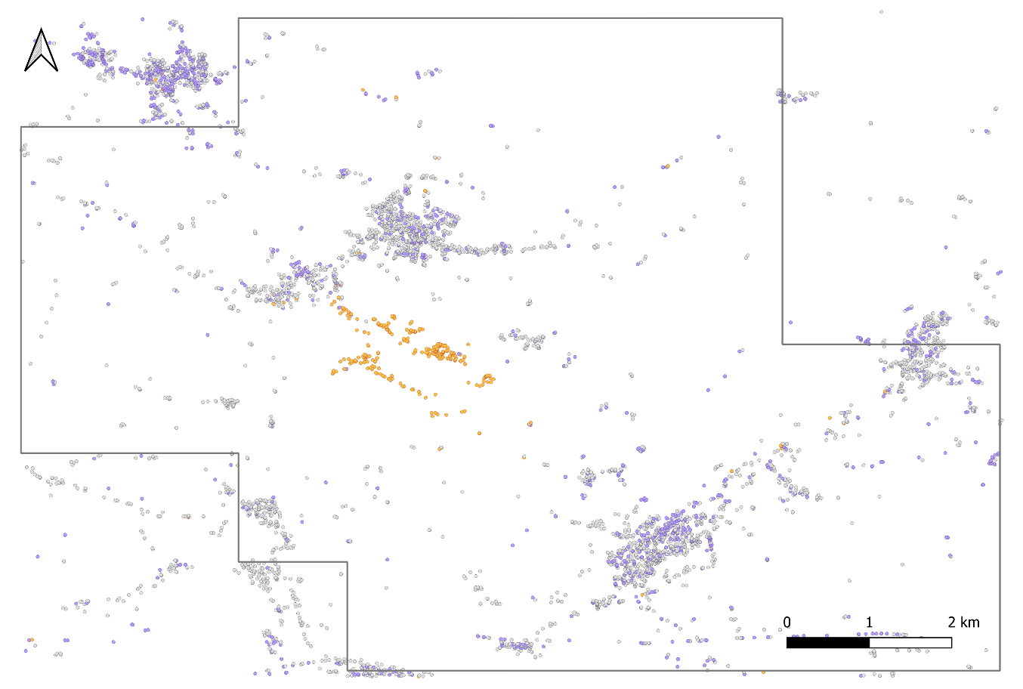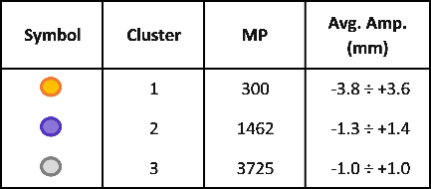
Fig. A1 - Case A – 3 cluster hierarchical case: localization of the clusters and of the National Concessions (dark grey polygon).

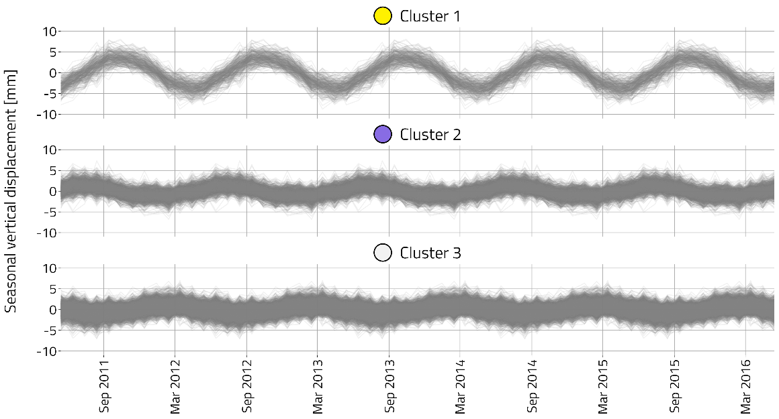
Fig. A2 - Case A – 3 cluster hierarchical case: seasonal vertical displacement for each cluster.
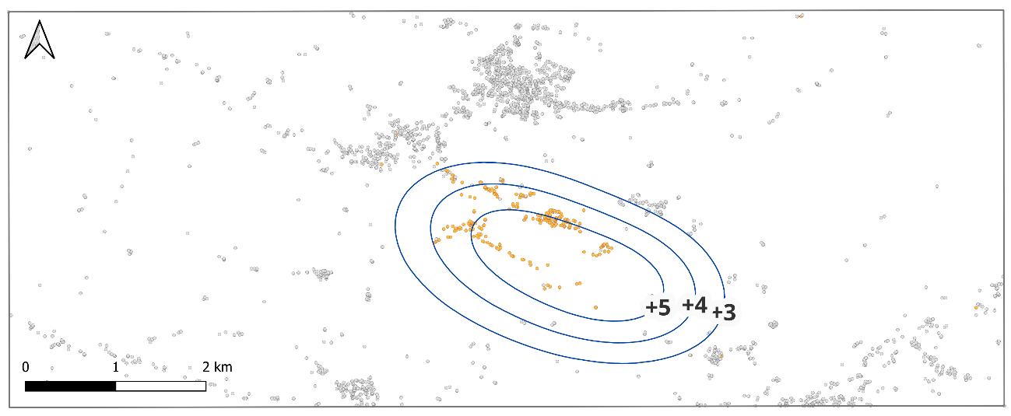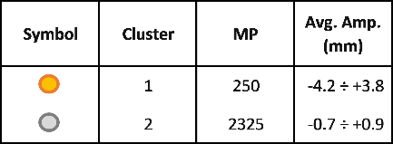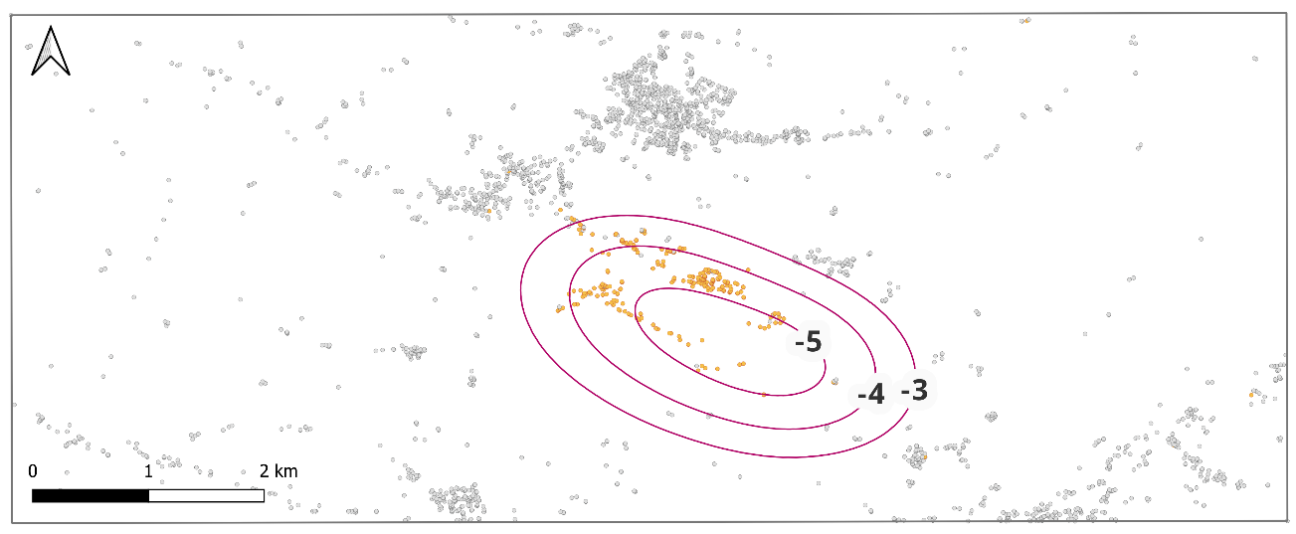
Fig. A3 - Case A1 – 2 cluster hierarchical case: clusters’ localization and comparison with the iso-displacement lines in [mm] (top: blue line for uplift; bottom: pink line for subsidence) modeled by Codegone et al. (2016).
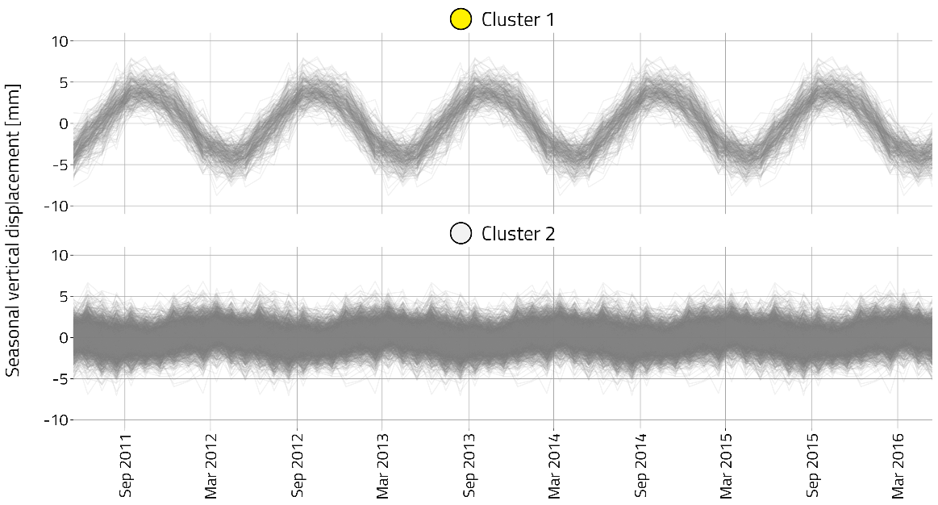
Fig. A4 - Case A1 – 2 cluster hierarchical case: seasonal vertical displacement for each cluster.
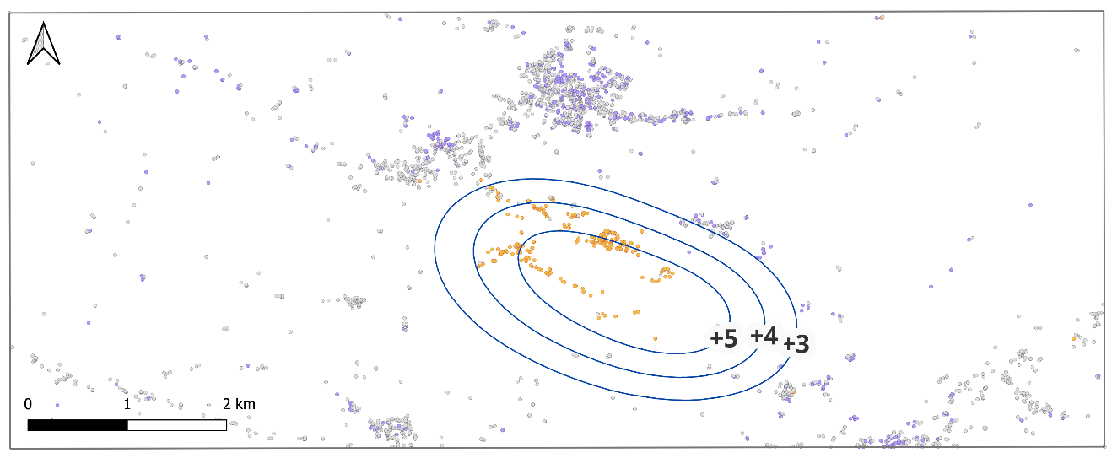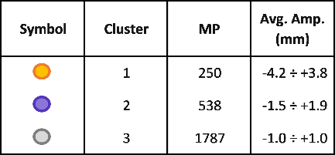
Fig. A5 - Case A1 – 3 cluster hierarchical case: clusters’ localization and comparison with the iso-uplift lines (blue) in [mm] modelled by Codegone et al. (2016).
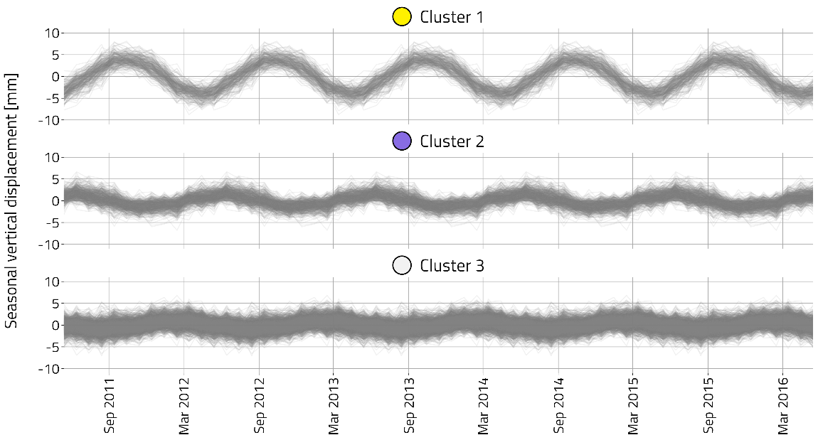
Fig. A6 - Case A1 – 3 cluster hierarchical case: seasonal vertical displacement for each cluster.
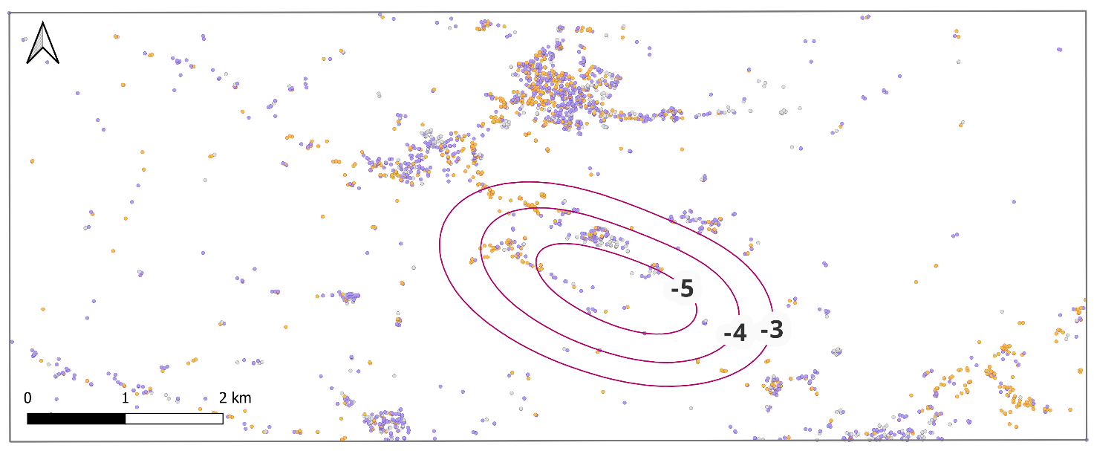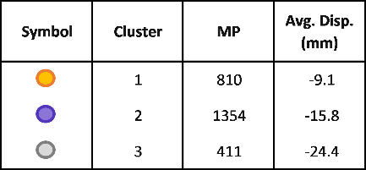
Fig. A7 - Total vertical displacement for Case A1 – 3 cluster partitive case: cluster localization and comparison with the iso-subsidence lines (pink) in [mm] modelled by Codegone et al. (2016).

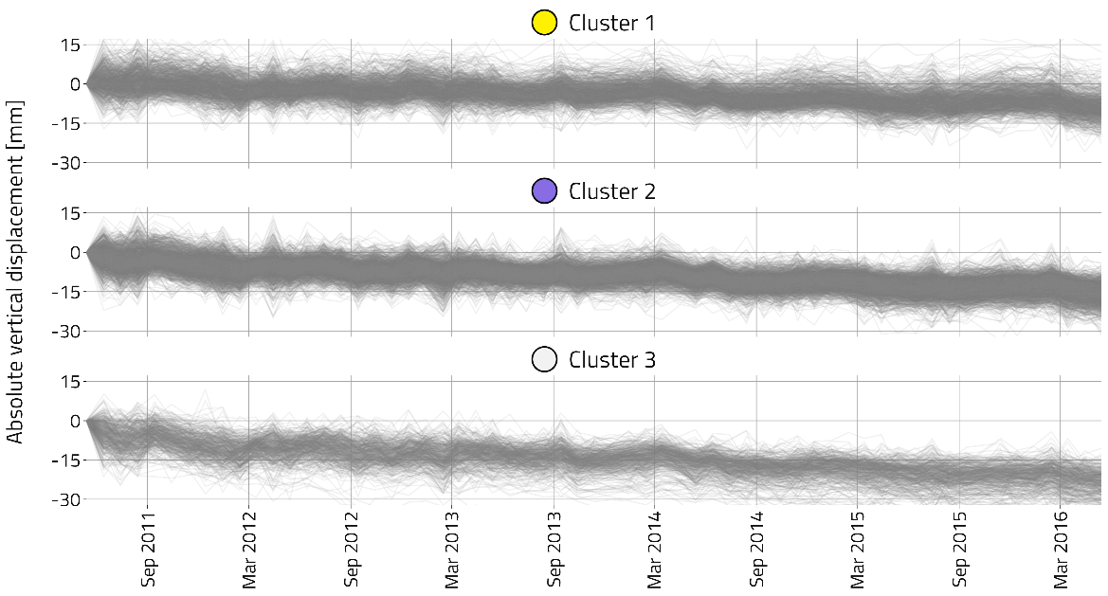
Fig. A8 - Total vertical displacement for Case A1 – 3 cluster partitive case: vertical displacement for each cluster.
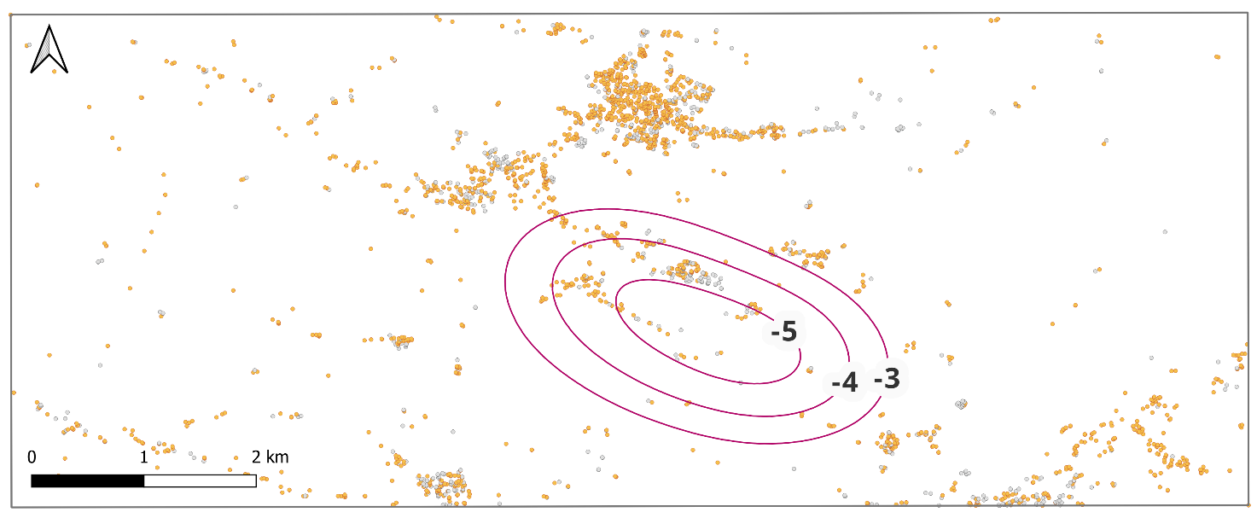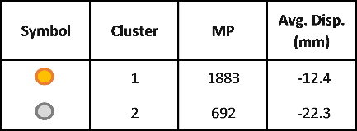
Fig. A9 - Total vertical displacement for Case A1 – 2 cluster hierarchical case: cluster localization and comparison with the iso-subsidence lines (pink) in [mm] modelled by Codegone et al. (2016).

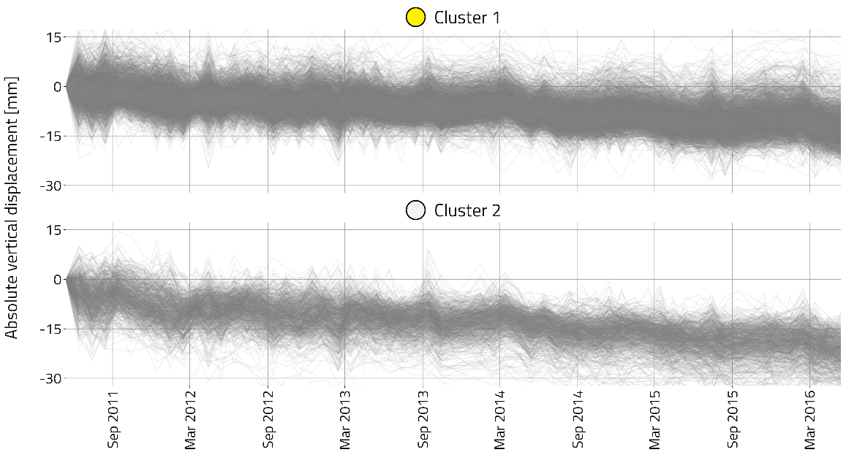
Fig. A10 - Total vertical displacement for Case A1 – 2 cluster hierarchical case: vertical displacement for each cluster.
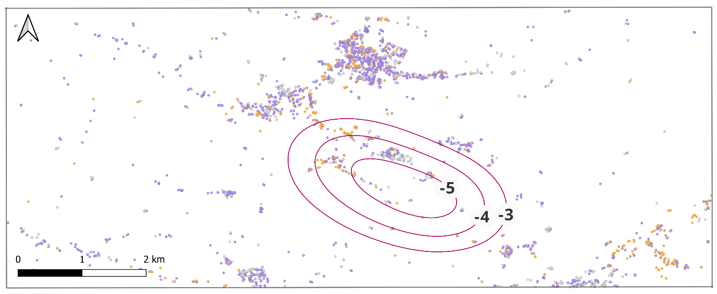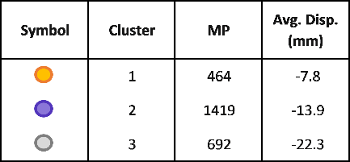
Fig. A11 - Total vertical displacement for Case A1 – 3 cluster hierarchical case: cluster localization and comparison with the iso-subsidence lines (pink) in [mm] modelled by Codegone et al. (2016).
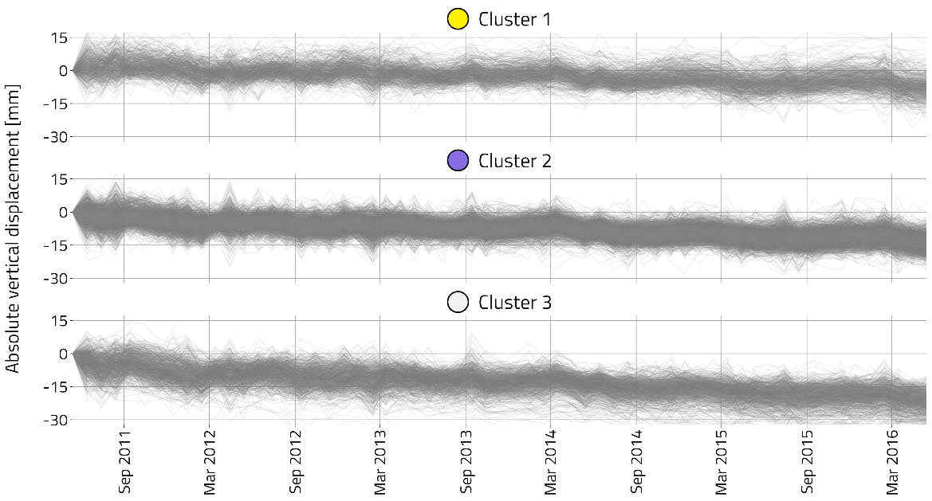
Fig. A12 - Total vertical displacement for Case A1 – 3 cluster hierarchical case: vertical displacement for each cluster.

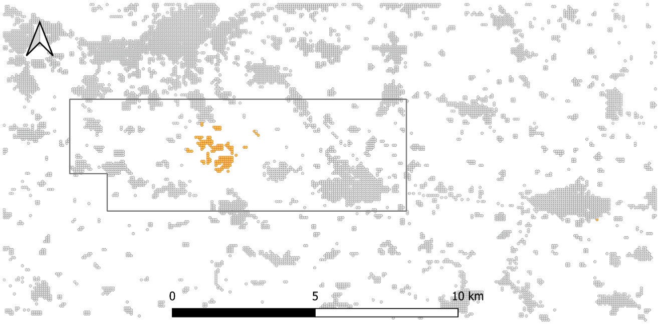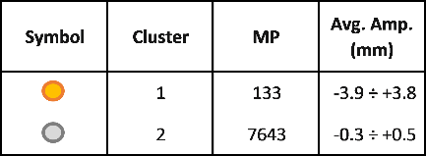
Fig. A13 - Case B – 2 cluster hierarchical case: localization of the clusters and of the National Concessions (grey polygon).

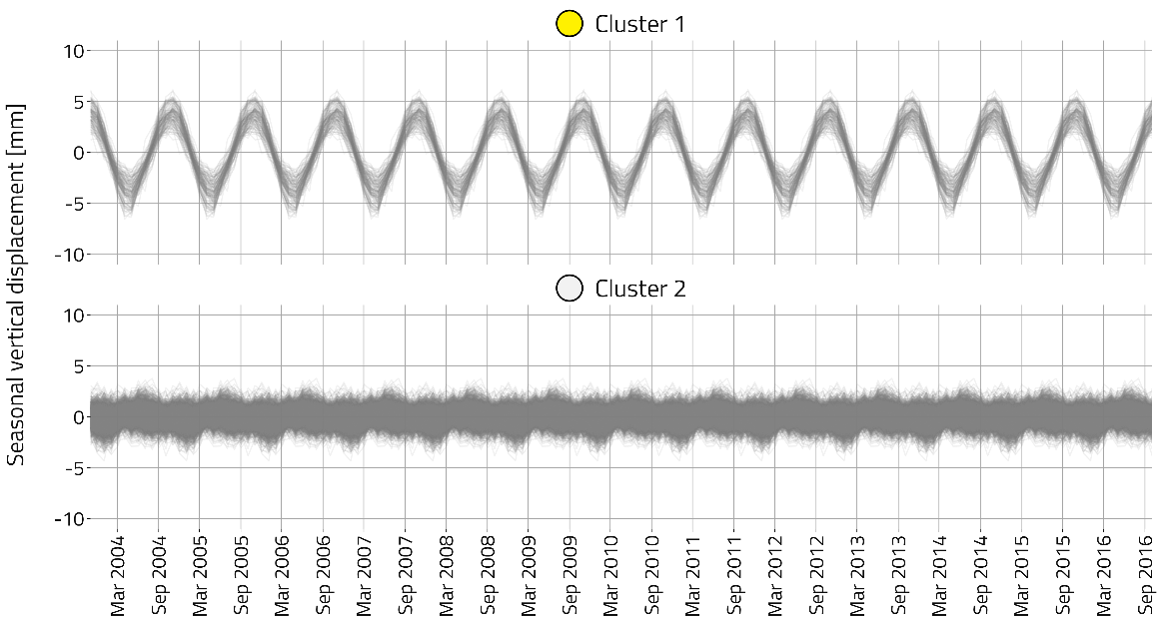
Fig. A14 - Case B – 2 cluster hierarchical case: seasonal vertical displacement for each cluster.
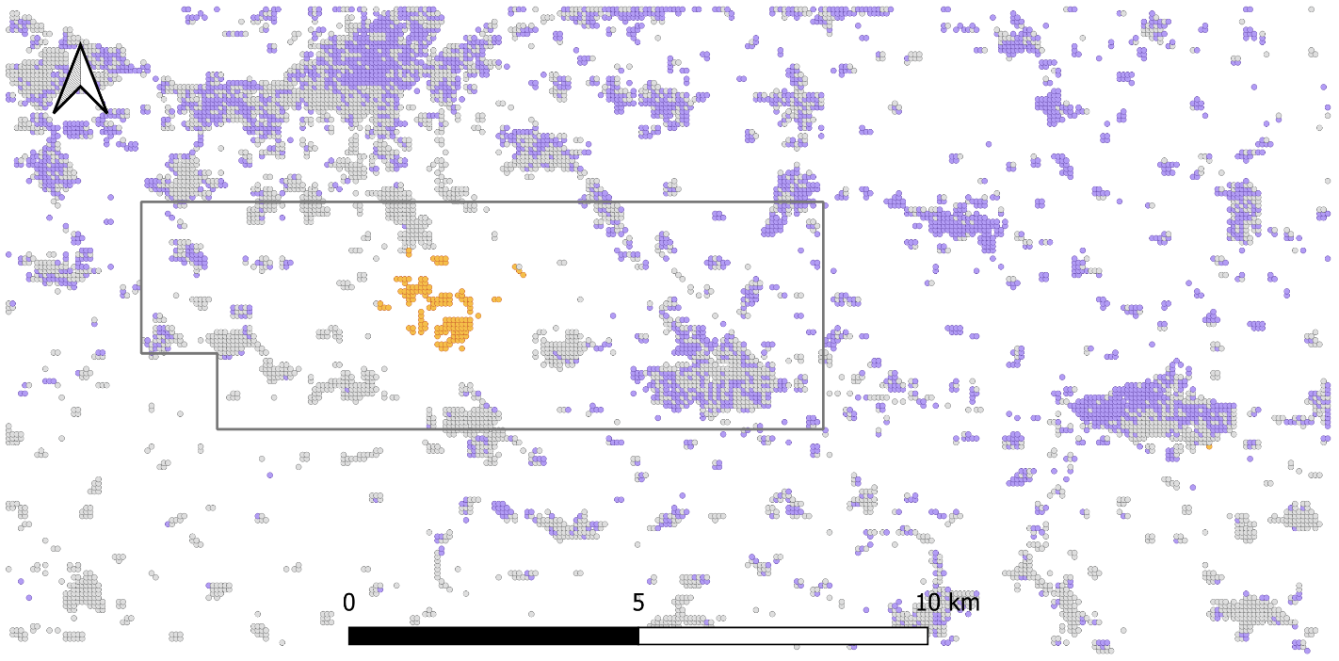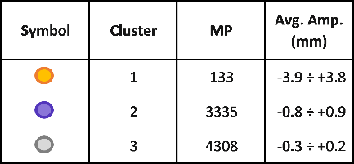
Fig. A15 - Case B – 3 cluster hierarchical case: localization of the clusters and of the National Concessions (grey polygon).

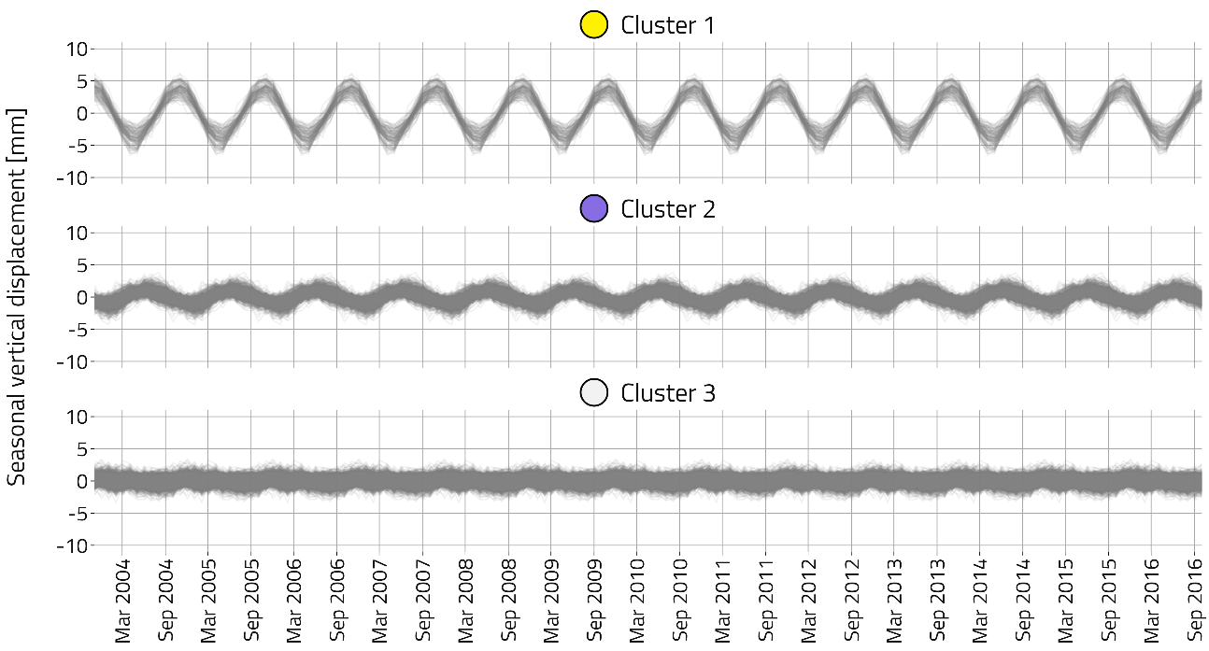
Fig. A16 - Case B – 3 cluster hierarchical case: seasonal vertical displacement for each cluster.

Tab. A1 - Numbers of points within each class obtained from the sensitivity analysis on different hierarchical clustering algorithms, and on different distance matrix methods. The highlighted rows correspond to the clusters that locate the UGS site.
 |  | Formulas for calculating the distance matrix
HIERARCHICAL  ALGORITHMS | CLUSTER | Euclidean | Manhattan | Maximum | Minkowski
Average | 1 | 1 | 1 | 1 | 1
Average | 2 | 259 | 259 | 259 | 259
Average | 3 | 2315 | 2315 | 2315 | 2315
Centroid | 1 | 1 | 1 | 1 | 1
Centroid | 2 | 2 | 2 | 2 | 2
Centroid | 3 | 2572 | 2572 | 2572 | 2572
Complete | 1 | 710 | 710 | 710 | 710
Complete | 2 | 651 | 651 | 651 | 651
Complete | 3 | 1214 | 1214 | 1214 | 1214
Mcquitty | 1 | 89 | 89 | 89 | 89
Mcquitty | 2 | 227 | 227 | 227 | 227
Mcquitty | 3 | 2259 | 2259 | 2259 | 2259
Ward.D2 | 1 | 250 | 250 | 250 | 250
Ward.D2 | 2 | 538 | 538 | 538 | 538
Ward.D2 | 3 | 1787 | 1787 | 1787 | 1787

Tab. A2 - Numbers of points within each class obtained from the sensitivity analysis on the partitive clustering algorithms, adopting the same fixed seed. The highlighted rows correspond to the clusters that locate the UGS site.
SEED: Fixed “123” | Partitive KMEANS ALGORITHM
CLUSTER | FORGY | HARTIGAN-WONG | LLOYD | MACQUEEN
1 | 298 | 299 | 298 | 298
2 | 1232 | 1238 | 1232 | 1232
3 | 1045 | 1038 | 1045 | 1045

Tab. A3 – Numbers of points within each class obtained from the sensitivity on seed for all partitive clustering algorithms considered. The seed is equal to the cluster’s centroids obtained from the 5 tested hierarchical algorithm. The highlighted rows correspond to the clusters that locate the UGS site.
SEED: cluster’s centroids coming from HIERARCHICAL clustering results |  | Partitive KMEANS ALGORITHM
HIERARCHICAL  ALGORITHMS | CLUSTER | FORGY | HARTIGAN-WONG | LLOYD | MACQUEEN
Average | 1 | 299 | 299 | 299 | 299
Average | 2 | 1238 | 1238 | 1238 | 1238
Average | 3 | 1038 | 1038 | 1038 | 1038
Centroid | 1 | 298 | 299 | 298 | 298
Centroid | 2 | 1232 | 1238 | 1232 | 1232
Centroid | 3 | 1045 | 1038 | 1045 | 1045
Complete | 1 | 299 | 299 | 299 | 299
Complete | 2 | 1238 | 1238 | 1238 | 1238
Complete | 3 | 1038 | 1038 | 1038 | 1038
Mcquitty | 1 | 298 | 299 | 298 | 298
Mcquitty | 2 | 1232 | 1238 | 1232 | 1232
Mcquitty | 3 | 1045 | 1038 | 1045 | 1045
Ward.D2 | 1 | 298 | 299 | 298 | 298
Ward.D2 | 2 | 1239 | 1238 | 1239 | 1239
Ward.D2 | 3 | 1038 | 1038 | 1038 | 1038

