ABSTRACT: In 2005, the exploitation activities in the Moncalvo underground gypsum quarry in the Monferrato area (Moncalvo, Piedmont Region, NW Italy), intercepted a karst cave filled with pressurized water (0.3 MPa). After this event, a hydrodynamic and hydrogeochemical methodology was developed and coupled to direct observations to monitor the water flows into the quarry. In particular, all the existing water flows and the new ones generated by the mining activities were mapped. Redox potential, electrical conductivity and water temperature were recurrently measured and integrated with chemical analyses. Piezometric levels were also measured in many piezometers located around the quarry site. The proposed methodology was successfully applied to the Calliano gypsum quarry, which is located in the same geological framework but it is representative of a different karst system. The paper highlights the key role of the hydrogeochemical monitoring as a potential technique for the sinkhole risk related to mining activities.
Bartolomeo Vigna
Department of Environmental, Land and Infrastructure Engineering, Polytechnic of Turin, Turin, Italy
Adriano Fiorucci
Department of Environmental, Land and Infrastructure Engineering, Polytechnic of Turin, Turin, Italy

Federico Vagnon
Department of Environmental, Land and Infrastructure Engineering, Polytechnic of Turin, Turin, Italy
Marco Barale
Department of Environmental, Land and Infrastructure Engineering, Polytechnic of Turin, Turin, Italy
Sinkholes and underground mining activities: the key role of monitoring for the hazard assessment and mitigation
15th ISRM Congress 2023 & 72nd Geomechanics Colloquium. Schubert & Kluckner (eds.) © ÖGG

Keywords: sinkholes, gypsum, hydrogeochemical monitoring, karst hydrogeology.
- INTRODUCTION
Karst rocks, such as evaporites and carbonates, cover the 10-15% of the continental surface of Earth and they can be considered one of the most problematic media from a rock mechanics point of view due to their marked anisotropy and heterogeneity (Stevanovic & Milanovic 2015). Moreover, these rock masses are characterized by an intense water circulation (mainly in the carbonates), which leads to dissolution phenomena that generate karst-related morphologies, such as caves and long conduits, often completely saturated by pressurized water. When there is an interaction with human activities (mainly underground mining), severe issues with serious consequences can occur both underground, with huge inrush in the artificial voids, and at the surface where sinkholes take place (Clay&Takacs 1997; Day 2004; Bonetto et al. 2008; Hou et al. 2016; Coli et al. 2020; Golian et al. 2021).
The 2005 Moncalvo sinkhole event (Piedmont region, NW Italy) is a clear example of the possible consequences of the interaction between mining activities and karst systems (Bonetto et al. 2008, Vigna et al. 2010a, Vigna et al. 2010b). During a drift excavation in the Moncalvo gypsum quarry, a karst cave was intercepted, triggering a 60000 m³ inrush of water and fine sediments. Fortunately, no injuries were recorded but a 20 m wide and 10 m deep cover-collapse sinkhole was generated close to the NE sector of the quarry.
That event highlighted the need of a forecasting methodology for preventing the possible interaction with karst morphologies during exploitation phases. In recent years, many methods have been developed to prevent inrush and sinkhole formation in karst systems: i) radar interferometry for the evaluation of subsidence rates (Galve et al. 2010), ii) geomorphological approaches and GIS-based large-scale mapping (Nam et al. 2020 and reference herein), iii) geophysical approaches (Youssef et al. 2020 and reference herein).
In this study, the developed hydrogeological approach (Vigna et al. 2010b) for preventing inrush and sinkhole generation is presented and discussed. The methodology is based on a multitemporal, multiscale and multiparametric analysis. At the quarry scale, it consists of hydrogeological monitoring of several piezometers surrounding the quarry for the definition of the water table and its variation through time. At the drift scale, it consists of mapping all the potential water inlets that were intercepted during drift excavation and measuring physical (temperature, electrical conductivity, redox potential and (when it is possible) discharge) and chemical (determination of major ion content) properties on site and on collected samples.
Due to the promising results obtained in the Moncalvo quarry, the same methodologies were used for the Calliano gypsum quarry (Piedmont region, NW Italy), located in the same area but with different hydrogeological and karst conditions. Interpretations and discussions of about 15 years of monitoring data coming from the developed methodology prove its reliability for the risk prevention of hidden karst voids, potentially intercepted during mining operations.
- CASE STUDIES
The Moncalvo and Calliano gypsum quarries (Fig. 1a) are both located in the Monferrato area (Central Piedmont, NW Italy). The latter is characterized by 5 km thick Upper Eocene-Pliocene sedimentary sequence, mainly composed of terrigenous sediments, known in literature as Tertiary Piedmont Basin (TPB).
The gypsum bodies in this area belong to the Formazione Gessoso Solfifera (or Complesso Caotico della Valle Versa) of Messinian age (Dela Pierre et al. 2003). The Messinian succession (Fig. 1b) in this sequence can be found at the surface along two W-E striking belts, and is deeply buried below Pliocene-Quaternary deposits and can be divided into three main horizons (from bottom to top):
- clayey deposits (pre-evaporitic phase) capped by a thin bed (less than 1 m thick) of evaporitic limestone;
- evaporites with intercalation of marl and gypsum beds deposited in a hypersaline lagoon environment (evaporitic and syn-evaporitic phase);
- the Messinian unconformity of tectonic nature followed by clays of Mio-Pliocene age (post-evaporitic phase).
In the area of Moncalvo and Calliano, the evaporites consist of three beds of macrocrystalline (selenitic) gypsum with thickness ranging between 10 and 12 m, interbedded by dark metric marly-clayey layers with fine lamination and fossil plants remains. The selenitic gypsum is capped by a microcrystalline gypsum bed, 10-25 m thick (Fig. 1b). These gypsum beds are inclined 10-20°, and are mostly buried underneath the Late Miocene-Pliocene sediments. Consequently, the mining activities follow the overall geometry of these evaporite bodies, and intersect different aquifer levels. In both the quarries, the gypsum is mechanically exploited by means of a rodheader in a room and diaphragm configuration.
Within this geological and structural framework, deeply rearranged after the uplifting occurred during the Intra-Messinian tectonic event and the exhumation during Quaternary erosion phases, the presence of karst morphologies fully saturated of water is frequent. In fact, even if those areas were expected to be dry zones, with only superficial circulation as a consequence of rainfall events, before and during mining activities, underground water circulations with not negligible discharges were detected.
The 2005 Moncalvo sinkhole is a clear example of this fact. The estimated 60000 m³ inrush, which flooded the lower level of the quarry, generated a sinkhole 23rd of February of that year: only at the end of July, the water level was dropped to an acceptable level, enabling to have a closer look at the place of inrush and discover 2 caves, located at different level with an average height of 30 m and a length of 370 m and 480 m respectively.
For what it concerns the Calliano quarry, at present, no hazardous events were recorded. Even if it is closely to Moncalvo site (5 km away) and the geological setting is the same, it shows a different karst system with many small conduits with diameter less than 20 cm and water-bearing fractures.
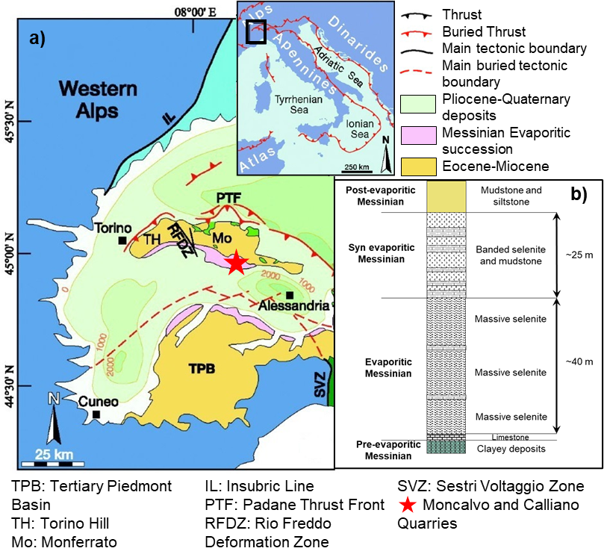
Figure 1. a) Geological sketch map if Tertiary Piedmont Basin and b) lithostratigraphy of the Messinian sedimentary sequence (modified from Banzato et al. 2017).
- METHODOLOGY
After the 2005 event, a monitoring program of flowing waters in gypsum discontinuities and karst system was set up. It was tested and validated in the Moncalvo quarry and then adopted since 2010 in the Calliano quarry. The monitoring program consist of:
- manual and automatic measurement of water levels in several boreholes surrounding the quarry with a depth up to 70 m (till the limestone layer) in order to reconstruct piezometric levels and control their fluctuation during exploitation phases;
- mapping of all the water inlets (from caves, fractures, borehoels) in the quarry drifts with (where it was possible) discharge measurements;
- physical characterization of each water inlets in terms of temperature (T), electrical conductivity (σ) and redox-potential (Eh) determination;
- geochemical analyses on collected samples coming from piezometers and inlets for the quantification of the main ion content.
The previous analyses were coupled with direct observations from horizontal boreholes drilled before the rodheader exploitation to prevent potential inrush.
- RESULTS
  - Moncalvo quarry
The analyses of groundwater levels in the monitoring wells (Fig. 2a) highlighted that piezometric surface couldn’t be properly drawn, suggesting that the water circulation is strongly influence by the discontinuity network. In particular, this discontinuity network can be distinguished in fragile structures related to overall geological setting and in karst morphologies related to the effect of water circulation inside gypsum bodies (Fig. 2b).
The results of hydrogeological analyses performed on the waters in the Moncalvo karst system highlighted dominant calcium-sulfate facies. However, on the basis of Eh and NO³⁻ content, three types of water can be distinguished (Fig. 2c):
- the water coming from the infiltration process through the shallow silty–clayey deposits, characterized by positive Eh, high concentrations in nitrates (often exceeding 20 mg/L) and low mineralization. This water is slightly undersaturated with respect to gypsum and consequently can create vertical shafts at the contact between gypsum and overlying deposits;
- the water from a deep circulation, characterized by negative Eh, negligible nitrate content and higher mineralization. These waters come from the fractured pre-evaporitic and limestone deposits and exhibit a Cl-alkaline subfacies;
- the water corresponding to a mixture of the two previously mentioned.
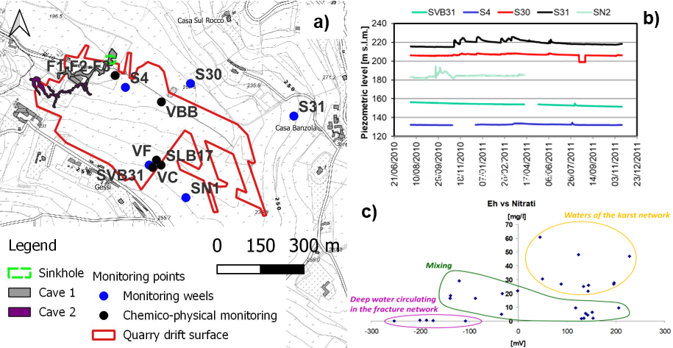
Figure 2. a) Location of the monitoring wells and monitoring inlet points in the quarry area. b) Trend of the piezometric levels over the monitoring time period and c) classification of the monitored waters as a function of redox-potential and nitrate content.
  - Calliano quarry
On the contrary, in the Callinao area the gypsum bodies have a hydrogeological and mechanical behaviour comparable to a porous medium and consequently, it has been possible to reconstruct the piezometric surface evolution from the starting of the mining activities (2010) till nowadays (Fig.s 3a to 3c).
The analysis of original piezometric level, compared to stratigraphy of the area, suggests that fractured gypsum bodies are sandwiched between low permeability sediments (aquitards). This hydrogeological setting was quite surprisingly since the presence of an active shallow aquifer cannot be hypothesized. From a chemo-physical point of view, the flowing waters in this gypsum aquifer are similar to those encountered in Moncalvo quarry but mainly coming from a deep circulation (Fig. 3d).
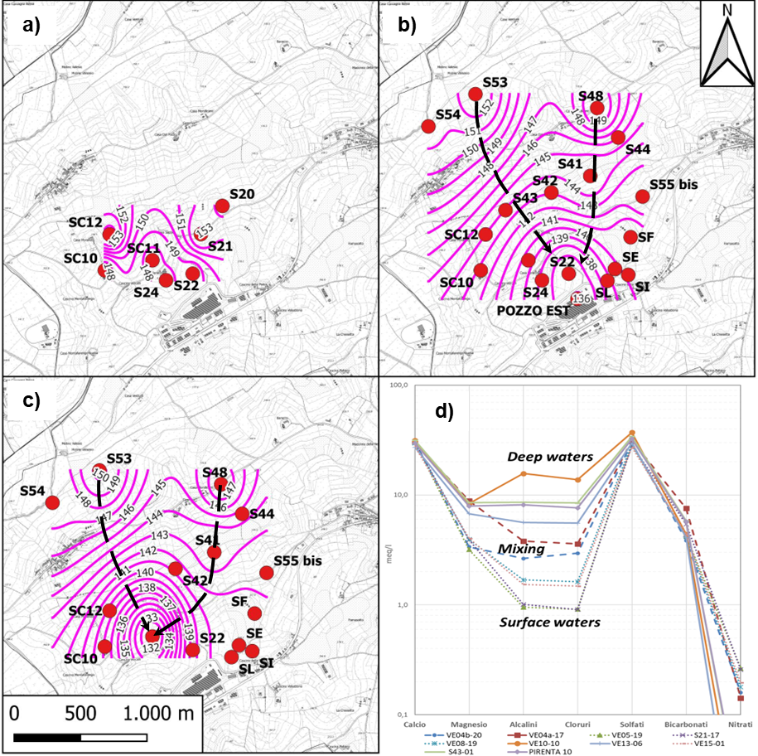
Figure 3. Location of the monitoring wells and reconstructed isopiezometric surfaces in a) 2010, b) 2016 and c) 2022 in the Calliano quarry. d) Chemistry of the different water types in the Calliano area.
- DISCUSSION AND CONCLUSIONS
The results of the developed hydrogeological monitoring highlighted that even if the quarries are located in the same geologic framework, they represent two completely different karst systems. Moncalvo quarry is characterized by two different karst systems operating with interconnected conduit drainage. In particular, the water coming from the surface, with positive redox potentials, high content of nitrates and slightly undersaturated in gypsum, has a moderate to high dissolving power and consequently the risk associated to karst voids with pressurized water and (consequent) sinkhole origin is extremely high. The deep water, undersaturated in sulfate, rises from the carbonate horizon and starts to dissolve the gypsum body, reaching the impermeable marl interlayer (see Fig. 1b). Once this marly horizon is reached, the water flows along the gypsum–marl contact continuing the dissolution of the underlying gypsum, explaining the two-level layout of the cave.
On the opposite, in the Calliano site, the mapped inflows have small to moderate discharges, low nitrates content and negative redox potentials, expression of a deeper water circulation. As a consequence of this dispersive circulation, the water reaches quickly gypsum saturation, losing the dissolving power and the capability to generate karst voids.
In conclusion, the chemo-physical monitoring of water flows provides a reliable tool to forecast and prevent karst related phenomena (inrush and sink hole) in underground mining. Redox potential, nitrate content and other physical parameters, such as temperature and electrical conductivity, allow the clear identification of water types in the karst system. In particular, if the water can be associated to a deep circulation (low nitrate, negative redox potential, high mineralization) the inrush risk is negligible. On the contrary, if the water comes from the superficial karst network, it is better to temporary change the quarry exploitation design in order to slowly dewater the associate saturated voids and consequently prevent the sinkhole formation.
References
Banzato, C., Vigna, B., Fiorucci, A., De Waele, J. 2017. Hypogene Gypsum Caves in Piedmont (N-Italy). Hypogene Karst Regions and Caves of the World, Cave and Karst Systems of the World, pp. 211-224. DOI 10.1007/978-3-319-53348-3_13
Bonetto, S., Fiorucci, A., Fornaro, M., Vigna, B. 2008. Subsidence hazards connected to quarrying activities in a karst area: the case of the Moncalvo sinkhole event (Piedmont, NW Italy). Estonian Journal of Earth Sciences 57 (3), pp. 125-134. DOI:10.3176/earth.2008.3.01
Clay, R.B., Takacs, A.P., 1997. Anticipating the unexpected – flood, fireoverbreak, inrush, collapse. In: Proceedings of one day seminar and international conference in Tunneling under difficult conditions and rock mass classification, Basel, Switzerland. October 27 – October 29, 1997, pp. 223-242.
Coli, M., Piccini, L., Muscedra, M.M. 2020. Tunneling and karst systems: A review. In: Proceedings of the 14th International Congress on Rock Mechanics and Rock Engineering, ISRM, September 13th -September 18th, 2020, Foz do Iguassu, Brazil, pp. 504–511.
Day, M.J. 2004. Karstic problems in the construction of Milwaukee’s Deep Tunnels. Environmental Geology 45, pp. 859–863. DOI: 10.1007/s00254-003-0945-4
Dela Pierre, F., Piana, F., Fioraso, G., Boano, P., Bicchi, E., Forno, M.G., Violanti, D., Balestro, G., Clari, P., D’Atri, A., De Luca, D., Morelli, M. & Ruffini, R. 2003. Note illustrative della Carta geologica d’Italia alla scala 1:50.000 - Foglio 157 Trino ARPA Regione Piemonte, Settore Studi e Ricerche Geologiche. – Sist. Inform. Prevenzione Rischi, Litografia Geda, Nichelino (in Italian).
Galve, J., Lucha, P., Bonachea, J., Castañeda, C. 2010. Integrating geomorphological mapping, InSAR, GPR and trenching for the identification and investigation of buried sinkholes in the mantled evaporite karst of the Ebro Valley (NE Spain). Geomorphology 134 (1), pp. 144-156. DOI: 10.1016/j.geomorph.2011.01.018
Golian, M., Teshnizi, E.S., Parise, M., Terzić, J., Milanović, S., Vakanjac, V.R., Mahdad, M., Abbasi, M., Taghikhani, H., Saadat, H. 2021. A new analytical method for determination of discharge duration in tunnels subjected to groundwater inrush. Bulletin of Engineering Geology and Environment 80, pp. 3293–3313. DOI: 10.1007/s10064-021-02140-6
Hou, T., Yang, X., Xing, H., Huang, K., Zhou, J. 2016. Forecasting and prevention of water inrush during the excavation process of a diversion tunnel at the Jinping II Hydropower Station, China. Springer Plus 5, 700. DOI: 10.1186/s40064-016-2336-9
Nam, B.H., Kim, Y.J., Youn, H. 2020. Identification and quantitative analysis of sinkhole contributing factors in Florida’s Karst. Engineering Geology 271, 105610. DOI: 10.1016/j.enggeo.2020.105610
Stevanovic, Z. & Milanovic, P. 2015. Engineering chanllenges in karst. Acta Carsologica 44 (3), pp. 381-399.
Vigna, B., Fioraso, G., Banzato, C., De Waele, J. 2010a. Evolution of karst in Messinian gypsum (Monferrato, Northern Italy). Geodinamica Acta 23(1-3), pp. 29-40. DOI:10.3166/ga.23.29-40.
Vigna, B., Fiorucci, A., Banzato, C., Forti, P., De Waele, J. 2010b. Hypogene gypsum karst and sinkhole formation at Moncalvo (Asti, Italy). Zeitschrift für Geomorphologie 54 (2), pp. 285–306.
Youssef, A.M., Zabramwi, Y.A., Gutiérrez, F., Bahamil, A.M., Otaibi, Z.A., Zahrani, A.J. 2020. Sinkholes induced by uncontrolled groundwater withdrawal for agriculture in arid Saudi Arabia. Integration of remote-sensing and geophysical (ERT) techniques. Journal of Arid Environments 177. DOI: 10.1016/j.jaridenv.2020.104132

