Assessment of normal and abnormal behaviour of people with dementia in living environment through non-invasive sensors and unsupervised AI

Arman Farsi
Department of Electronics and Telecommunications (DET)
Politecnico di Torino
Turin, Italy
arman.farsi@polito.it
Sara Casaccia
Department of Industrial Engineering and Mathematical Science
Università Politecnica delle Marche
Ancona, Italy
s.casaccia@univpm.it
Gian Marco Revel
Department of Industrial Engineering and Mathematical Science
Università Politecnica delle Marche
Ancona, Italy
gm.revel@univpm.it

Abstract — The objective of this work is to define a measurement protocol to compute and distinguish abnormal from normal behavior of older people with early to middle stage dementia living alone at home using training artificial intelligence (AI) algorithms (in specific K-means, Agglomerative and Spectral Clustering Algorithms). Unlabeled activities of daily living (ADLs) databases were acquired from an AI-based sensor network composed of three Passive Infrared (PIR) motion sensors and two door sensors which are installed in voluntary participants’ houses in Italy, Netherlands, Switzerland and Norway. Our blind approach proposes an unsupervised learning-based solution, representing real-world use case where it is not possible to provide accurate labeling and annotation of the sensor data. Results indicate two out of three algorithms, which applied for 32 participants during 75 days of recording, are valid to create clustering groups for participants with acceptable Silhouette coefficient of 0.77 and 0.65 for K-means and Agglomerative clustering, respectively, and 0.13 for Spectral clustering method that makes this algorithm less reliable respect to others.
Keywords—AI-based sensors network, ADL, remote monitoring

Introduction
In recent years the need for Artificial Intelligence (AI) technology to measure public well-being starting from heterogeneous datasets has been risen tremendously in the healthcare sector with a rapid growth in the aging population [1]. In order to gather knowledge about human health and well-being, the capacity to measure and track the activities of daily living (ADLs) of older people in their home environment, with sensors and AI has become an important factor [2]. ADLs are the activities that residents can provide inside the home environment, e.g. eating, sleeping, toileting. In literature [3], cameras, on-body sensors, domotic sensors are used to detect ADLs through the application of AI algorithms. Non-invasive sensors , e.g. sensors installed in the home and wearables, and AI are also used to measure activity level of older people also in multi-resident scenarios [4]. Indeed, tracking normal and abnormal behaviors from ADLs of older people, in particular, with cognitive diseases, e.g. dementia, Alzheimer’s, at their own residence, will serve to improve their quality of life by the promotion of their independence and to identify a potential decrease both in their cognitive and physical functioning, which could lead to ageing diseases arising [5], [6].
In this work, the ADLs, obtained from monitoring of older people with early to middle stage of dementia through AI-based life-style sensor network [1], have been analyzed and tested by means of unsupervised machine learning (ML) algorithms, to discover behavior-related features [7]. The research aims at testing different unsupervised ML algorithms to interpret ADLs dataset coming from sensors, i.e., PIR sensors and door sensors, which are installed in voluntary participants’ houses in Italy, the Netherlands, Switzerland and Norway. In this context, we are proposing a way to characterize the ADLs of residents based on unlabeled sensor data, analyzed using unsupervised cluster techniques. This technique has been used to recognize the similarities and discrepancies between residents’ behaviors. In this way, it is possible to help carers in understanding if support for older people is sufficient over time so that individual care plans can be refined.

Materials and methods

Data Description
The ADLs dataset has been obtained by monitoring the activities of 32 older people involved in the eWare project. eWare - “Early Warning (by lifestyle monitoring) Accompanies Robotics Excellence”, is a project co-financed under the AAL program, aiming to develop an ICT platform characterized by a social robot and AI-based life-style monitoring sensor network installed in the home environment to improve the life-quality and independency of older people with early to middle stage dementia living on their own and their caregivers. The life-style sensor network employed in this work included five wireless sensors: three PIR sensors which were installed in toilets/bathroom, hall and living room and two door contact sensors, which were set in the kitchen and on the main door [1]. PIR sensors have technical characteristics of 5V working voltage, 5m operative range, horizontal 140˚ field of view with 2s delay, working in -20˚C/+40˚C condition with continuous sensing of trigger mode. The accuracy of the PIR sensor has been evaluated in [8], in which the movements of the head of a lying person in bed are measured through this sensor. A movement accuracy detection of 85% is defined considering a total of 100 head movements performed at a distance of 1.10 m from the sensor. The life-style sensor network has been installed in voluntary residents’ houses in Italy, the Netherlands, Switzerland, and Norway and, for this work, the ADLs datasets of 32 older people through 75 days are selected for the analysis. The life-style sensor network to track the ADLs of people is based on a self-learning algorithm. During the first two weeks of use, the algorithm collects data and can learn a baseline lifestyle pattern (learned behavior period). Special filtering functions are used to make the system resistant to interfering inputs such as visitors, holidays, pets, false sensor messages, and etc [9]. In Table I is reported a sample of collected data and definitions of the attributes of dataset are explained below:

TABLE I. EXAMPLE OF DATASET
adl_type_id | adl_datetime | adl_resident_id
10 | 2019-02-01 00:35:20 | 97
1 | 2019-02-01 00:36:20 | 97
9 | 2019-02-01 00:46:41 | 97
1 | 2019-02-01 00:53:35 | 3
9 | 2019-02-01 01:11:20 | 3
10 | 2019-02-01 01:28:53 | 126
1 | 2019-02-01 01:30:02 | 126
9 | 2019-02-01 01:37:54 | 126
10 | 2019-02-01 01:57:05 | 49
1 | 2019-02-01 01:58:12 | 49
9 | 2019-02-01 02:06:18 | 49
10 | 2019-02-01 02:33:56 | 97
1 | 2019-02-01 02:34:56 | 97
9 | 2019-02-01 02:41:51 | 97
10 | 2019-02-01 03:11:42 | 102
1 | 2019-02-01 03:12:48 | 102
10 | 2019-02-01 03:16:22 | 126

• Adl_type_id: it describes the number ID of ADLs being carried by the resident at the period defined by the adl_datetime. The activities are categorized into unique IDs as explained in Table I.
• Adl_datetime: it describes the date and time of the ADL event.
• Adl_resident_id: it describes the unique identifier for each involved resident.
To better understand the ADLs analyzed in this work, a description of each ADL is provided in Table II.

Methodology
In this work, the issue of detecting abnormalities in the ADLs of residents that can identify a decline in cognitive health has been addressed by means of unsupervised approaches (in specific K-means, Agglomerative, and Spectral Clustering Algorithms) based on Principal Component Analysis (PCA) feature selection. The unsupervised approach is based on clustering that it is a technique of data exploration that groups them in different subsets (called clusters) without any prior information. These clusters are generated based on the similarity principle, which consists in grouping a set of points in such a way that those of the same group are more similar to each other than those of other groups. Most of the time the similarity coincides with the distance between points, so the formation of the classes takes place based on the distance between clusters, i.e. low distance for intra-cluster (the distance from one point to the same class) and highest distance for inter-cluster (the distance from one point to different clusters). This describes the broadest possible margins of separation [10]. By this definition, it is possible to conclude that a cluster is a collection of records "similar" to each other and most "dissimilar" from the records, belongs to other clusters, hence major cluster could be considered as normal and smaller one as the abnormal behavior of residences. For this work, algorithms have been implemented in Python and the work took place in the workplace of Jupyter Lab.
TABLE II. ADL Description
Unique ID | ADL | Description
1 | Toileting | Depends on the activation of the door sensor installed in the restroom
2 | Eating | Depends on the activation of the door sensor installed in the fridge and time of fridge opening and closing
7 | Inside | The resident comes inside the house using one of the external doors with a door sensor on it
8 | Outside | The resident goes outside using one of the external doors with a door sensor on it and the inactivity of all the sensors in the house for a certain period of time when nobody is at home
9 | Sleeping asleep | The resident goes to sleep and inactivation of sensor network during the regular night/evening hours when resident is at home
10 | Sleeping awake | The resident gets out of bed and activation of sensor network during the regular night/morning hours
13 | Entering_Leaving | Consecutive activation of several sensors, PIR and door sensors, in the house in short period of time

It should be noted that in preprocessing data phase first and last months of recording has been eliminated, first month due to the self-learning process of life-style monitoring sensor network and last month due to minimization of recording error. In order to describe the various algorithms carried out to cluster the normal/abnormal behavior of residents, the following procedure characterized by 6 steps has been used in the data analysis:
- Data segmentation: this process divides the dataset into different segments for precise analysis. The data segmentation is applied to split the dataset into 7 time segments which are early morning (6-9 a.m.), late morning (10-11 a.m.), early afternoon (12-13 p.m.), afternoon (14-16 p.m.), evening (17-19 p.m.), late evening (20-22 p.m.) and night time (23 p.m. – 5 a.m.).
- Extraction of time for each activity: the time taken for doing an activity in a record in the dataset can be computed by calculating the time difference of the timestamp for the record and the next record.
- Selection and Averaging: selection is the process of selecting the resident that has enough information to perform an accurate analysis and regarding to [8], 55 days of record is adequate to build a learning set. This work carried out by analyzing the residences that have up to 75 similar days of record and only 32 residences are chosen by removing IDs with dissimilar recorded dates in order to minimize the discrepancy. The averaging technique obtained a single record for each resident by computing the average of the time taken for each activity for the 75 days of record for a specific resident.
- Data visualization: data visualization is an essential component of any AI and ML applications. For this matter, visualization was used to represent activities of each resident. Figure 1 represents two examples of visualization step for eating and entering leaving of residents during early morning segment.
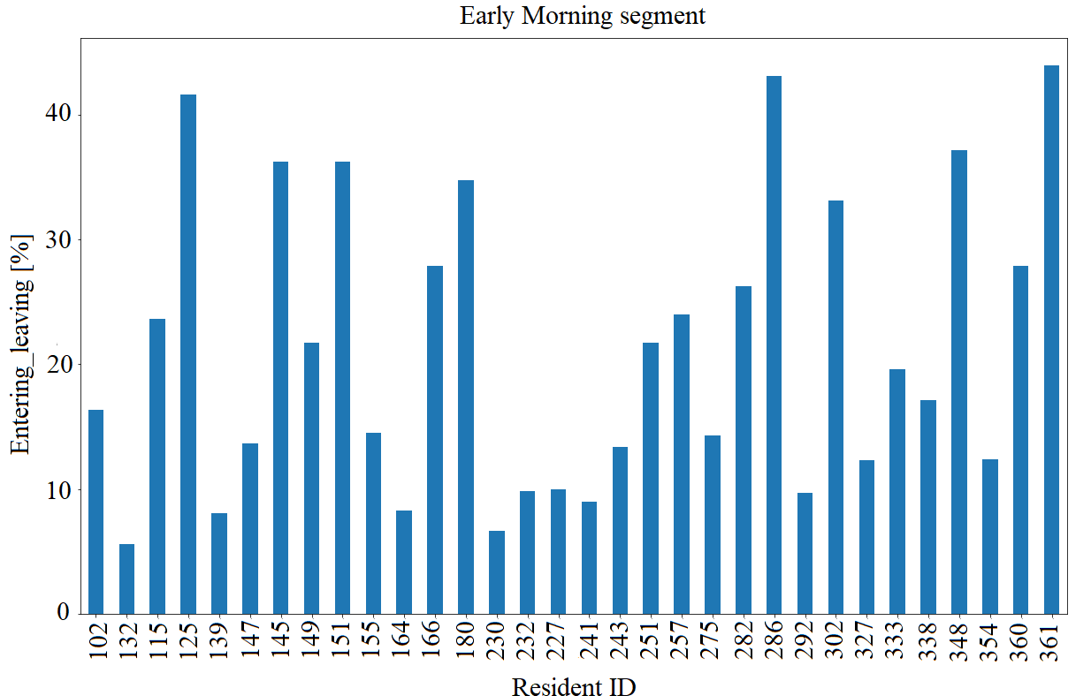
(b)

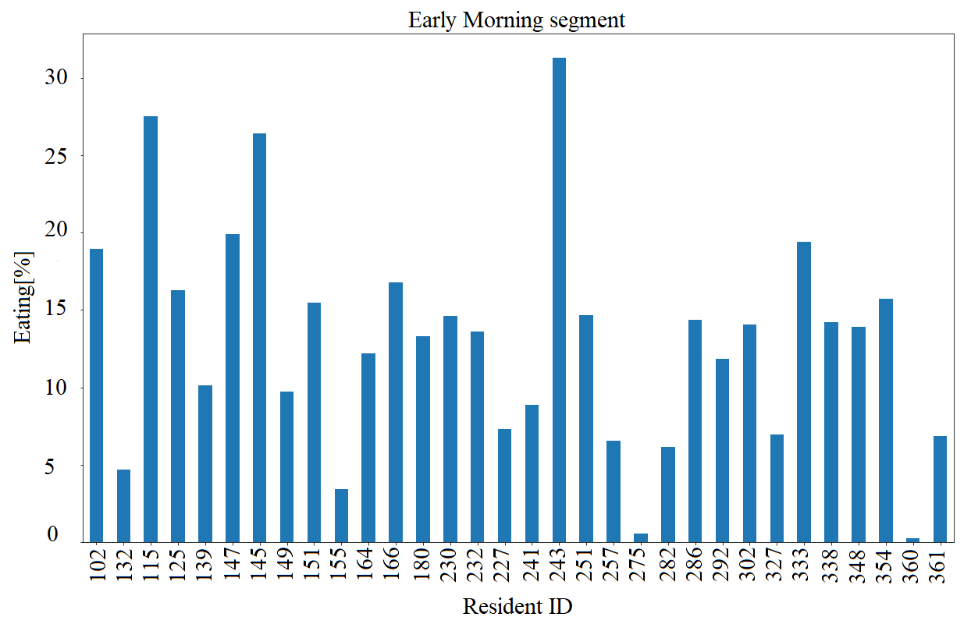
(a)

Fig. 1. Percentage of Eating (a) and Entering_Leaving (b) activities for early morning data for each residence ID
- Addition of Simulated Data: simulated datasets for normal ADLs behavior were generated using the normal distribution between the mean time duration for each activity and ± the standard deviation. While simulated data for each of the segmented data with abnormal behavior were generated by taking the time duration for each activity of resident that are located outside the mean ± the standard deviation and to which a random value between ±10 minutes has been added.
- Application of Unsupervised learning: unsupervised ML was introduced to analyze ADLs coming from 32 residents from 75 days of acquisition. To measure normality and abnormality in the ADLs of the residents, blind approaches are used (in specific K-means, Agglomerative and Spectral Clustering algorithms), after reducing dimensionality of datasets (feature extraction) by Principal Component Analysis (PCA). The algorithms were applied on each segment of datasets for simulated, real and both simulated and real datasets. As an example, two residences with normal and abnormal behaviors, averaged in 75 days during night time segment (23 pm – 5 am), are elaborated in Figure 2.

Fig. 2. Pie charts of 2 residents with normal and abnormal behaviors averaged in 75 days during night time interval

Statistical Analysis
In order to demonstrate the effectiveness of the unsupervised ML models, ML performance metrics have been used for model evaluation. According to [11], clustering validation statistics have been categorized into 3 different validations:

Internal validation: which evaluates the quality of a clustering structure without referring to external data by using the clustering process' internal knowledge.

External validation: which assesses how well cluster labels match externally given class labels. Since we know the "true" cluster number in beforehand, this method is mostly used to pick the best clustering technique for a given data set.

Relative validation: which tests the clustering structure by changing parameter values for the same method.

In this study, internal validation is used to evaluate the compactness, the connectedness and the separation of the clusters. Hence, Silhouette Coefficient which can be used to study the separation distance between the resulting clusters was applied. To do so, clusters are evaluated using certain measures such as distance between cluster points. The score is bounded between -1, for wide spread clustering, and +1 for highly dense clustering. Scores around zero indicate overlapping clusters. The score is higher when clusters are dense and well separated, which relates to a standard concept of the cluster [12].
Fig. 3. Early morning segment – cluster analysis and K-means centroids for real (a) and simulated (b) dataset with training datasets for 75 days. Smaller samples data is represented as the orange dots as anomaly datasets while the cluster with a larger number of samples is represented with blue color as normal datasets, the big dots represent centroids.

Fig. 3. Early morning segment – cluster analysis and K-means centroidsfor real (a) and simulated (b) dataset with training datasets in 75 days, smaller samples data is represented as the orange dots as anomaly datasets while the cluster with a larger number of samples is represented with blue color as normal datasets, the big dots represent centroids

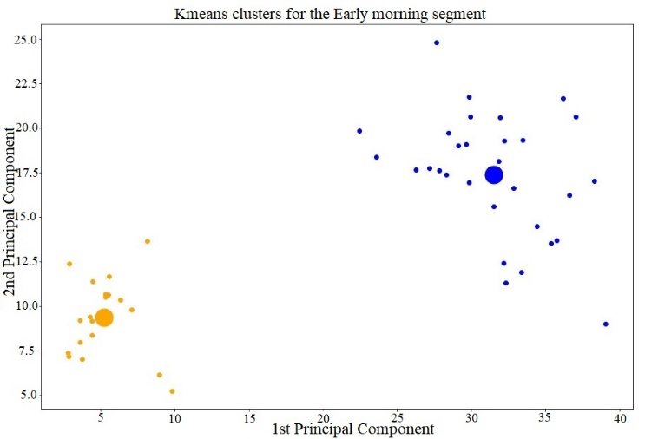
(b)
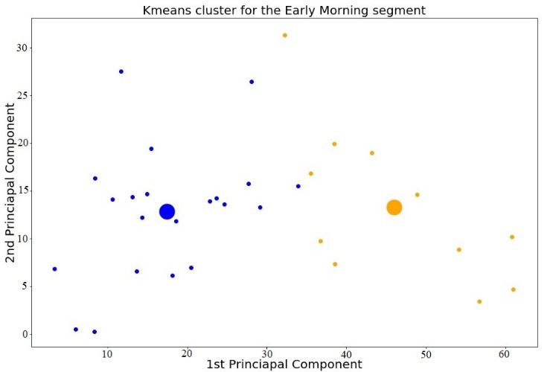
(a)

results
All experiment results are obtained by applying AI-based algorithms to find a solution for the detection of abnormal behavior from normal behavior on ADLs dataset of older residents with early to middle-stage dementia. The unsupervised ML algorithms described in previous section were applied to real, simulated and the combined dataset (simulated data and the original data) by specifying the cluster size of two. The algorithms were applied on each segment of datasets. Some examples of the results obtained are elaborated in the form of tables and plots, in which the cluster with smaller samples data is represented with the orange dots as anomaly datasets while the cluster with a larger number of samples is represented in blue as normal datasets. Fig. 3 indicates results obtained from K-means clustering algorithm for early morning for detecting normal and abnormal ADLs for both real dataset (Fig. 3a) and simulated dataset (Fig. 3b). As it is possible to see in Table III, average Silhouette Coefficient of Spectral algorithms for combined datasets with 0.13 is much lower than K-means and Agglomerative algorithms with 0.77 and 0.65, respectively. Plus, the result obtained from just real datasets for Spectral algorithm, Table IV, shows a lower Silhouette Coefficient, equal to 0.18, than other 2 algorithms which makes the algorithm less reliable. However, K-means and Agglomerative algorithms show acceptable Silhouette Coefficient for the real dataset with 0.35 and 0.50, respectively.
- Silhouette Coefficient metrics for combined dataset (range of Silhouette between -1 and 1)
 | K-means | Agglomerative | Spectral
Early Morning | 0.78 | 0.78 | 0.02
Late Morning | 0.79 | 0.79 | 0.03
Early  Afternoon | 0.80 | 0.80 | 0.28
Afternoon | 0.79 | 0.48 | 0.09
Evening | 0.78 | 0.46 | 0.00
Late Evening | 0.64 | 0.43 | 0.15
Night time | 0.80 | 0.80 | 0.31
Average | 0.77 | 0.65 | 0.13

Discussions and conclusions
This study aims at estimating older people’s well-being using non-intrusive sensors and a ML approach. In particular, the objective of this work is to define a measurement setup to compute and distinguish abnormal from normal behavior characterized by training ML algorithms (in specific K-means, Agglomerative and Spectral algorithms) and the unlabeled data obtained from PIR and door sensors which are installed in voluntary participants’ houses in Italy, Netherlands, Switzerland and Norway which successfully approached.
From the reported results, it can be ascertained that PIR and door sensors installed in individuals’ homes can provide beneficial information about the status of the resident. Our blind approach proposes an unsupervised learning-based solution that can be seen as representing real-world use case where it is not possible to provide accurate labelling and annotation of the sensor data which complies with the aim of this work. The evaluation of the clusters built using this dataset verified that the resulting models are robust, through the computation of Silhouette Coefficient. Indeed, acceptable Silhouette Coefficient are obtained, 0.77 and 0.65, respectively, for combined datasets from K-means and Agglomerative algorithms. However, Spectral clustering showed lower results with respect to K-means and Agglomerative with a Silhouette Coefficient equal to 0.13 for combined database.
- Silhouette Coefficient metrics for real dataset (range of Silhouette between -1 and 1)
 | K-means | Agglomerative | Spectral
Early Morning | 0.28 | 0.46 | - 0.03
Late Morning | 0.21 | 0.55 | 0.14
Early  Afternoon | 0.25 | 0.34 | 0.34
Afternoon | 0.36 | 0.55 | 0.15
Evening | 0.28 | 0.51 | 0.02
Late Evening | 0.40 | 0.36 | - 0.02
Night time | 0.68 | 0.76 | 0.62
Average | 0.35 | 0.50 | 0.18

This work seeks to check whether similarities and differences can be exposed using an easily generalizable approach which requires neither labelled data nor a thorough system configuration effort on the part of caregivers. In future works, the enhanced method could be applied for other studies in which people’s behaviours are acquired using sensor network installed in indoor living environments. In addition, results of this research could be compared with the feedback of the involved older people and caregivers and could be used in real scenario and in real time to have instant feedback of the people’s behaviour.

Acknowledgment
The authors gratefully acknowledge the partial support from the European Commission’s Active and Assisted Living program, co-financed by consortium national funding agencies. The authors thank the eWare (AAL-2016-071) partners for their support.

References

[1] S. Casaccia, G. M. Revel, and L. Scalise, “AI-based sensor network for ADLs monitoring on ageing people during COVID-19 epidemic,” in 2021 IEEE International Workshop on Metrology for Industry 4.0 IoT (MetroInd4.0 IoT), Jun. 2021, pp. 290–294. doi: 10.1109/MetroInd4.0IoT51437.2021.9488438.
[2] S. Shirmohammadi, K. Barbe, D. Grimaldi, S. Rapuano, and S. Grassini, “Instrumentation and measurement in medical, biomedical, and healthcare systems,” IEEE Instrum. Meas. Mag., vol. 19, no. 5, pp. 6–12, 2016.
[3] N. Gupta, S. K. Gupta, R. K. Pathak, V. Jain, P. Rashidi, and J. S. Suri, “Human activity recognition in artificial intelligence framework: a narrative review,” Artif. Intell. Rev., Jan. 2022, doi: 10.1007/s10462-021-10116-x.
[4] R. Naccarelli, S. Casaccia, and G. M. Revel, “The Problem of Monitoring Activities of Older People in Multi-Resident Scenarios: An Innovative and Non-Invasive Measurement System Based on Wearables and PIR Sensors,” Sensors, vol. 22, no. 9, Art. no. 9, Jan. 2022, doi: 10.3390/s22093472.
[5] B. Wallace et al., “Measurement of distinguishing features of stable cognitive and physical health older drivers,” IEEE Trans. Instrum. Meas., vol. 65, no. 9, pp. 1990–2001, 2016.
[6] M. Bassoli, V. Bianchi, I. De Munari, and P. Ciampolini, “An IoT approach for an AAL Wi-Fi-based monitoring system,” IEEE Trans. Instrum. Meas., vol. 66, no. 12, pp. 3200–3209, 2017.
[7] D. Yang, B. Xu, K. Rao, and W. Sheng, “Passive infrared (PIR)-based indoor position tracking for smart homes using accessibility maps and a-star algorithm,” Sensors, vol. 18, no. 2, p. 332, 2018.
[8] S. Casaccia, E. Braccili, L. Scalise, and G. M. Revel, “Experimental Assessment of Sleep-Related Parameters by Passive Infrared Sensors: Measurement Setup, Feature Extraction, and Uncertainty Analysis,” Sensors, vol. 19, no. 17, Art. no. 17, Jan. 2019, doi: 10.3390/s19173773.
[9] S. Casaccia et al., “Social Robot and Sensor Network in Support of Activity of Daily Living for People with Dementia,” in Dementia Lab 2019. Making Design Work: Engaging with Dementia in Context, Cham, 2019, pp. 128–135. doi: 10.1007/978-3-030-33540-3_12.
[10] S. Raschka and V. Mirjalili, Python machine learning. Packt Publishing Ltd, 2017.
[11] K. Koutroumbas and S. Theodoridis, Pattern Recognition. Academic Press, 2008.
[12] P. J. Rousseeuw, “Silhouettes: a graphical aid to the interpretation and validation of cluster analysis,” J. Comput. Appl. Math., vol. 20, pp. 53–65, 1987.

