2022-36-0059
Multibody parameter estimation: a comprehensive case-study for an innovative rear suspension
Henrique de Carvalho Pinheiro, Alessandro Messana and Massimiliana Carello
Department of Mechanical and Aerospace Engineering, Politecnico di Torino - Italy
Nicola Rosso
Beond Srl - Italy

Abstract
Numerical and virtual simulation of mechanical systems is a standard part of product development in the automotive sector, and multibody techniques are a consolidated tool to describe vehicle dynamics, elasto-kinematic behavior, handling, and comfort. To achieve high precision results as output of simulations, it is essential to provide the system with reliable data as input, and to accurately describe the vehicle and its subsystems. The task of gathering objective parameters to fully describe a vehicle can seem trivial to the stakeholders directly connected to a project, that can access detailed design data and a plethora of schemes and datasheets covering all subsystems of a vehicle. However, whenever this task regards benchmarking, prototyping, research projects or niche/low-volume products, data availability decreases drastically, and alternative forms of data acquisition become essential. This paper proposes a comprehensive overview of data gathering and experimental procedures used to reliably extract parameters of an existing vehicle using quick and accessible strategies. The analysis is based on a case-study project of an A-segment vehicle mounted with an innovative rear suspension scheme, whose behavior should be described by a dedicated elasto-kinematic multibody model as well as a full vehicle model for dynamic validation. The multibody model is based on Adams/Car with the inclusion of flexible elements, which is briefly described, while a closer focus is given to the experimental extraction of key features, such as: total mass, longitudinal and lateral position of the center of gravity, CoG height, wheel travel and wheel rate, shock-absorber damping coefficient, steering ratio, components inertia and flexible elements strain. The results obtained in the static and dynamic experimental validation suggest a good outcome from the methodology, that can be replicated on many kinds of vehicle modelling activities as an approachable and affordable experimental methodology for small projects.
Introduction
The automotive industry is known by its constant research and development efforts and its stringent requirements in terms of cost and time-to-market. The new trends of innovation, such as electrification [1], lightweight design, advanced control systems [2] and autonomous driving features [3,4] tend to further increase the pressure for faster and more precise engineering tools and methods.
The usage of virtual simulation tools has become a widespread technique to achieve good results with less time and resources employed. Undoubtedly, to achieve reliable models and guarantee the precision and soundness of simulations, it is mandatory to follow experimental validation procedures to gather physical parameters and assess the studied behavior.
The project that is illustrated in this article was born with the goal of developing of a multibody model of a common A-segment vehicle which had been previously modified by the research group. The unique characteristic of this vehicle was the innovative suspension system mounted on its rear axle, entirely designed and manufactured internally [5-7].
The importance of a validated and reliable full vehicle model is clear: It allows to simplify and accelerate the development of many studies required for the commercialization of the product, such as the evaluation of the handling and the comfort of the vehicle as well the extrapolation of the dynamic loads which act on the mechanical elements to compute their fatigue life.
However, many of the necessary parameters required to populate the full vehicle multibody model where not readily accessible to the authors, in such a way that the presented methodologies were implemented to estimate them without incurring in exorbitant costs or time-consuming methods.
Although this kind of experimental procedure is very common in several scenarios, such as research groups, motorsport teams, student competitions and small/startup companies, scientific literature regarding the best practices is scarce. Usually, the know-how related to approachable and affordable test methods remain in the tacit knowledge of experienced technicians, rarely being translated in comprehensive documents with validated outcomes. This paper main contribution, thus, is to present a real case study in which the proposed methodologies were implemented, discussing their main results, potentialities, and limitations.
The article briefly describes the innovative suspension system and its multibody modelling approach, then dedicates most of its content to the experimental procedures and results, namely: mass and inertia estimation, damping curve extraction, steering ratio calculation, center of gravity positioning and the parallel wheel travel test. A final chapter is dedicated to the dynamic results obtained in the test track, validating the overall model. The programming environments used during this activity were MSC Adams/CAR 2020 and MATLAB for modelling and data-processing, alongside other support software like NI MAX, and ETAS’ INCA mainly employed for the acquisition of data during both the static and dynamic tests.
The innovative suspension
The goal was that of replacing the rear suspension of a standard 2007 Fiat 500 with a custom-built innovative hybrid suspension system. Since the basic version of the Fiat 500 is a cheap A-segment car, its rear suspension is a simple twist beam suspension. The simplicity, lightness, and low cost of this type of suspension made it a standard for cheap and light city-cars.
However, since the transversal beam must both optimize handling and comfort, one of the major drawbacks of this layout is that comfort is quite harsh. This was such a relevant issue that Fiat, starting from 2009, has modified this layout on their 500s by adding an anti-roll bar to decouple the tuning of handling from that of comfort [8].
Additionally, since this suspension features a single control arm connecting the wheel to the body, the kinematic control of the tire and of its angles, as it moves vertically, cannot be performed as precisely as with other suspension set-ups. As a result, the camber recovery, and the control of the toe angle and of the rear track variation is quite poor, as widely known in the industry.
For these reasons, it was developed an innovative suspension design which has the potential to easily replace the standard twist-beam suspension on a car like the Fiat 500. The motivations behind the concept were:
By manufacturing one of the largest components of the subsystem with CFRP (carbon fiber reinforced polymers) and taking advantage of the functional integration, the overall mass of the assembly can be reduced by almost 25% [9,10].
The performance of the twist beam suspension is not as satisfying as one could expect from such a common archetype of suspension. The project aimed at improving both the comfort and the dynamic performance of the vehicle.
Although the cost of composite technology for low-segment passenger vehicle application still seems unfeasible, for lower volumes the overall cost can be equivalent, given that the investments of steel stamping are higher. Apart from that, this kind of solutions may become more appealing due to the rapid increase in the cost of steel.
A render of the layout is showed in Figure 1.
The main feature of this solution is its innovative transversal composite leaf spring (A), manufactured using CFRP. This element acts as a spring (which allows to remove the traditional coil springs from the assembly), control arm and anti-roll bar. The rear dampers (B) are maintained in a similar position as on the standard Fiat 500. On the other hand, the new suspension features two triangular upper control arms (C), to which the wheel hub (E) is hinged. The lower end of the hub (lower control arm D) is instead connected to the extremities of the leaf spring. Finally, the leaf spring and the upper control arm are both hinged to a subframe, which carries the whole suspension assembly and connects it to the chassis of the vehicle.
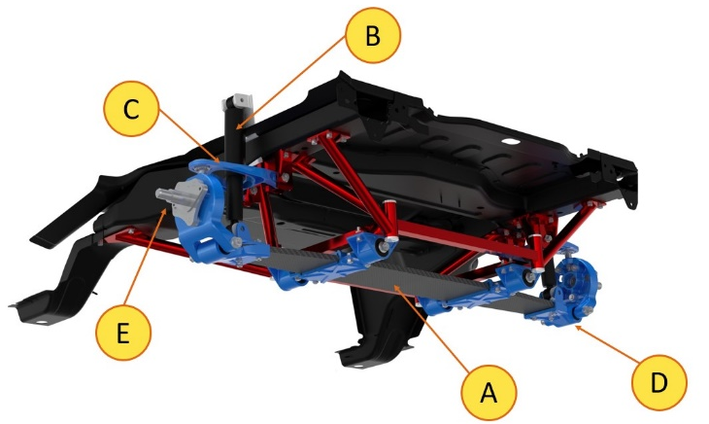
Figure 1. 3D render of the complete rear suspension and its subframe
Multibody modelling and vehicle parameters
To describe the behavior of the innovative transversal leaf spring suspension, two different approaches were followed:
The original modelling technique, used in the first rounds of design of the subsystem, consisting in a “Ideal Beam” approach. In this model the mechanical behavior of the leaf spring is simplified to a series of beam elements, being defined by their width, thickness, and linear elastic modulus. The leaf spring is divided in three sessions (the middle session between the clamps and the two extremities connected to the uprights) with different parameters, and each session is divided in six equidistant beam elements. The sessions were connected through rigid plates, representing the metallic clamps, with a fixed constraint relative to the borders of the beams.
The new model, in which the CFRP transversal leaf is represented by a flexible element imported from a FEM simulation [11]. Before entering the Adams/CAR multibody environment, a modal analysis modelling was performed, using the real geometry of the component and the mechanical characteristics of each carbon fiber layer used in its manufacturing. The stiffness of the leaf spring was then validated through a quasi-static dynamometer test, assuring that the overall mechanical behavior of the component is accurate. The free-free modal analysis is then imported into the multibody model through a MNF file, containing the geometry, interface nodes, modal forms and frequencies up to 100 Hz. The final suspension model (Figure 2) contains the other suspension elements and connects with the flexible leaf spring through bushings both in the upright interfaces and in the clamp side. The bushing leading to the body connection aims to describe the compliant and slipping clamp system.

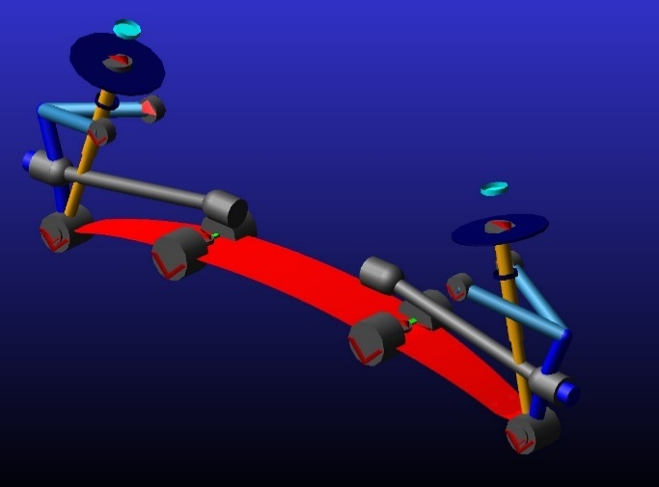
Figure 2. New multibody model of the rear suspension using flexible elements
Once the suspension subsystem was modelled, the remaining subsystems used straightforward modelling procedures, taking advantage of the shared databases in Adams/CAR upon which the vehicle data was inserted [12].
Apart from a more precise mechanical behavior, the presence of the flexible elements permit the continuous verification of stress and strain present in the component, to be compared with experimental data [13-15].
Different loading conditions were considered, characterized by a total mass which differs from the mass of the empty vehicle due to the presence of a different number of passengers (modelled as punctual bodies with a mass of 80 kg placed on the seats) and/or ballast (a maximum of 250 kg placed in the trunk). The main conditions used for the modelling and testing of the vehicle are reported in Table 1.
Table 1. Fiat 500's loading condition cases
Load Condition  L | Passengers | Ballast [kg] | Total Load [N]
Lifted | 0 | 0 | 0
Empty | 0 | 0 | 9908
Std A | 1 | 10 | 10791
Full Load | 1 | 250 | 13145

The Lifted condition has no load associated to it, since it corresponds to the vehicle being lifted from the ground so that no vertical load is acting on the wheels. The Empty condition corresponds to the nominal mass of the car with no passengers, while the Full Loaded condition was designed to maximize the stress acting on the rear suspension to push it closer to the design’s limit condition.
Static tests
Sprung and unsprung mass
The masses of the vehicle and of its relative subsystems are yet unchanged. Moreover, the inertias of each of the main components of each subsystem should be estimated as precisely as possible to obtain the highest possible model accuracy. To reach this goal, three parallel strategies were adopted:
1. The masses and inertias of the components of the front and rear suspension and steering system needed no further modification.
2. The mass and inertia of the real Fiat engine was included in those of the body of the vehicle, and the two were considered as a single rigid body. The mass and inertias of the braking system were included in the wheels of the vehicle.
3. Due to the extensive modification required by the remaining subsystems (tires, rims, front brake disks and calipers, rear brake drums and clamping mechanisms and wheel hubs) some additional data were collected from external sources.
The data listed in Table 2 were mainly obtained by searching for the mass of each of them on specialized spare part seller websites. Then, once these data were collected, a 3D CAD model of each of these subsystems was found and, if each component had homogenous density and symmetric geometry, their inertias was estimated by exploiting the “Mass Properties” tool of the DS software SolidWorks.
Table 2. Final mass and inertia values for the redefined subsystems
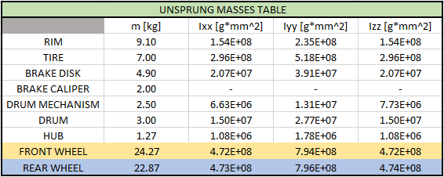
This relatively simple procedure, unluckily, could not be applied to all the components. No reliable mass data were found about the tire and the steel rim of the wheels, while it was possible to modify some available 3D CAD models of a tire and a rim to match their dimensions to those of the Fiat 500.
To solve these issues the mass of the tire, rim and nuts was measured by directly by dismounting one of the wheels of the Fiat 500 and weighting it all the components with the Intercomp EZ Weight Scale (Figure 3). Then the three inertia values of the body of the vehicle were estimated by proportionally increasing the inertia values of a 1999 Fiat Punto, taken from the literature [16]. Interestingly, this set of data also featured some real measurements of the inertia of the wheels of the Punto (which is reasonably similar to those of the Fiat 500): they were reported to have an axial inertia Ixx = 0.4 kg‧m2. This value is only 2% higher than the value obtained with the presented method (equal to 0.391 kg‧m2 as reported in Table 2). These were assumed to be satisfactory results, which also confirms the effectiveness of the whole procedure.
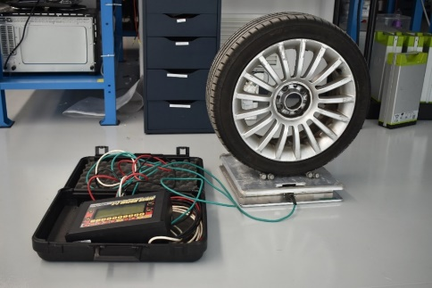
Figure 3. Measuring of the mass the Fiat 500’s 185/55 R15 tires and rim
Damper operating curves
A series of test on the actual components equipping the vehicle were performed with the goal of defining the real operating curve of the Fiat 500. The procedure consisted in the application of load pulses at different rates with a mechanical dynamometer. The displacement-controlled movements imposed by the equipment are performed around the middle length of the damper.
The results are shown in Figure 4 where four datasets are reported: the red functions represent the compression and rebound force-speed operating curve of the rear dampers, obtained by exciting the components with ±10 mm pulses; the operation was repeated increasing the damper extension up to ±30 mm as in the blue curve.
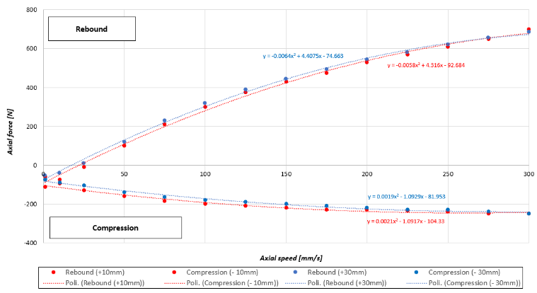
Figure 4. Experimental damper force vs. speed curves
The average of these tests outputs was computed by means of a 2nd order polynomial interpolating curve (green line in Figure 5) which also allowed to define a higher number of intermediate points. The plot reported in purple in Figure 5 is the final curve that was assigned to the Adams/Car rear suspension damper component.
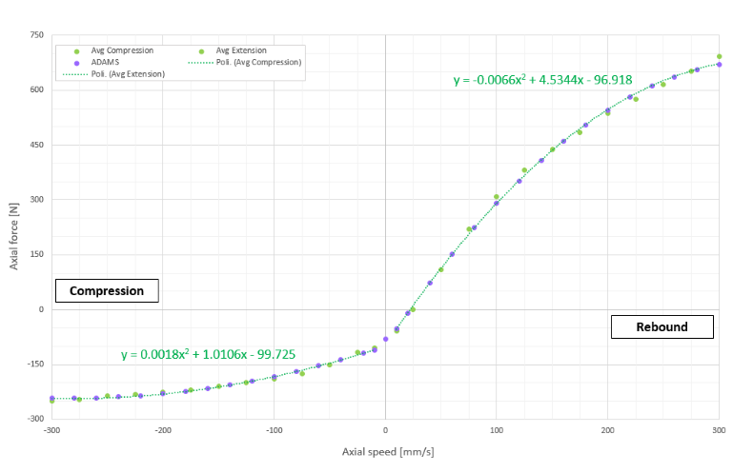
Figure 5. Continuous rear damper curve, ready for the final importation in the Adams/CAR model
Steering ratio
The steering ratio of the vehicle was estimated by computing the ratio between the input angle, provided by the driver through the steering wheel, and the output angle, corresponding to the angle between the mid-plane of the front wheels and the x-axis of the vehicle. In compliance with the on-board CAN protocol used to measure the input steering angle, a clockwise steering input corresponds to a negative angle.
As clearly showed by Figure 6 the results are strongly linear (R2 > 0.998) as expected by this kind of steering mechanism (rack-and-pinion). Also, the resulting steer ratio (Figure 7) is quite constant, even though it is interesting to notice how an anti-clockwise (positive) steering input produces a higher output angle on the inner wheel (in this case the front left wheel) hence resulting in a lower steering ratio, and vice versa. This is to be expected, as steering mechanism are usually tuned to produce this effect on purpose in order to slightly resemble the Ackerman steering design.
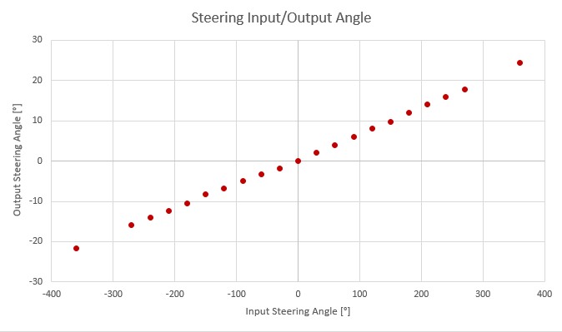
Figure 6. Output vs. Input steering angle
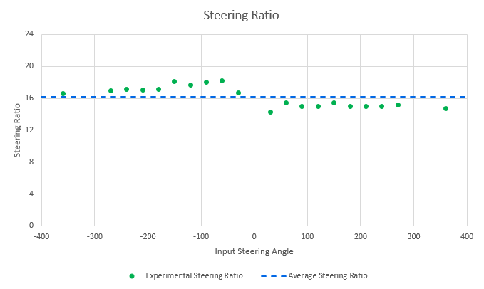
Figure 7. Steering Ratio vs. Input steering angle
Since the Adams/CAR models only needs a single steering ratio value, it was decided to import the average of the experimental results. This value (SR = 16.1747) is very close to the technical specifications of the Fiat 500 which reports SR = 16.3 [17] and is represented with a dashed blue line.
Center of Gravity height
Another fundamental vehicle parameter still missing in the model was the height of the center of gravity (referred to as hCG from now on). Few data were found in literature about the actual hCG of the Fiat 500 so that no straight-forward and reliable estimation could be made without some custom measurements on our vehicle. Therefore, the decision was made to calculate the value of the CG height by directly measuring it on the test vehicle.
In the automotive industry, several different methods have been developed in order to determine the CG position of a vehicle [18]. The selected test procedure is commonly known as “Lifting Test” or “Modified Reaction Method (MRM)” [18] and it is one of the most widespread techniques employed by manufacturers and racing teams to quickly estimate the value of hCG without the need for expensive dedicated equipment, while achieving an acceptable precision. In this test, one end of the vehicle is raised from its initial flat position so that its x-axis forms an angle θ with the ground. Depending on the distance between the CG and the x-axis of the vehicle, the reacting force acting on the other axle increases according to Eq. 1.
$h_{CG}=\frac{\left(m^{*}-m_{F}\right)*L}{m_{0}*tan⁡(θ)}+R$ (1)
Where m0 is the mass of the vehicle, mF is the force acting on the front axle of the levelled vehicle divided by the acceleration of gravity, m* is the force acting on the front axle of the tilted vehicle divided by the acceleration of gravity, L is the wheelbase of the vehicle and R is the wheel effective radius.
This means that the accuracy of the test is directly influenced by the achievable tilting angle θ, as clearly demonstrated by S. Shapiro in its paper [18]. Other studies [19-22] recommend a minimum tilting angle included between 15° and 20°, while [23] suggests that measurements with an angle lower than 7° should be considered practically meaningless as the resulting error is excessively high. However, this means that the rear axle of the Fiat, which has a wheelbase of 2308 mm ± 2 mm, had to be lifted by at least 600 mm from the ground (height h’ in Figure 8)
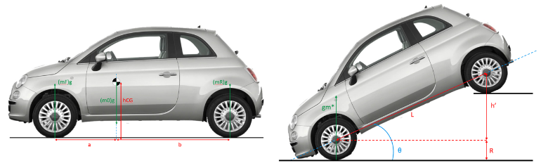
Figure 8. Schematic representation of the quantities involved in the MRM test
From the error propagation theory [24,25]., the error affecting the measured value of hCG can be estimated as in Eq. 2 for each measurement.
$$σ_{h_{CG_{i}}}=σ_{R}+…$$
$$\sqrt{{\left(\frac{∂h_{CG}}{∂m^{*}}\right)}^{2}σ_{m^{*}}^{2}+{\left(\frac{∂h_{CG}}{∂m_{F}}\right)}^{2}σ_{m_{F}}^{2}+{\left(\frac{∂h_{CG}}{∂L}\right)}^{2}σ_{L}^{2}+{\left(\frac{∂h_{CG}}{∂m_{0}}\right)}^{2}σ_{m_{0}}^{2}+{\left(\frac{∂h_{CG}}{∂θ}\right)}^{2}σ_{θ}^{2}}$$
(2)
Such uncertainty can be then reduced by averaging the results within the set of N measurements and among the M number of datasets (Eq. 3 and 4)
$\overline{{h_{CG}}_{k}}=\frac{1}{N}\sum_{i=1}^{N}{h_{CG_{i}}}; {σ_{h_{CG}}}_{k}=\sqrt{\frac{\sum_{i=1}^{N}{σ_{{h_{CG}}_{i}}^{2}}}{N^{2}}}$ (3)
$h_{CG}=\frac{\sum_{k=1}^{M}{\overline{\frac{{h_{CG}}_{k}}{σ_{{hCG}_{k}}^{2}}}}}{\sum_{k=1}^{M}{\frac{1}{σ_{{hCG}_{k}}^{2}}}}; σ_{h_{CG}}=\sqrt{\frac{1}{\left(\frac{1}{\sum_{k=1}^{M}{σ_{k}^{2}}}\right)}}$ (4)
Therefore, the error affecting the experimental value of hCG can be estimated prior to the test as a function of the tilting angle, as is showed in Figure 9. The red dots represent the total measurement error when the uncertainty on the angle is ±0.1° (equaling that of the available digital inclinometer), while the green line was obtained with a hypothetical error of ±0.05°. As it is clearly visible, both scenarios led to unacceptable errors on the final value even with extremely high tilting angles.
Due to the structure of Eq. 1, the error affecting the measurement of the tilting angle is by far the most relevant source of error (it was estimated to be responsible for over the 99% of the error on the final CG height value).
Therefore, as suggested in the literature [22, 26-29]., and since the direct measurement of the tilting angle is both impractical (the instrument had to fixed to the body hence it could not be operated easily) and unreliable, it was decided to indirectly estimating the angle θ ±${ σ}_{θ}$ as in Eq. 5.
$θ=\arcsin\left(\frac{h^{'}}{L}\right); σ_{θ}\left(θ\right)= \sqrt{{\left(\frac{∂θ}{∂h^{'}}\right)}^{2}*σ_{h^{'}}^{2}+ {\left(\frac{∂θ}{∂L}\right)}^{2}*σ_{L}^{2}}$ (5)
Where h’ can be measured directly during the test as it represents the vertical distance of the contact patch of the rear lifted tires from the ground.
The effect on the error on hCG is represented by the blue line inFigure 9. As a result, for angles higher than 9° the error for each measurement hCGi drops below 20 mm
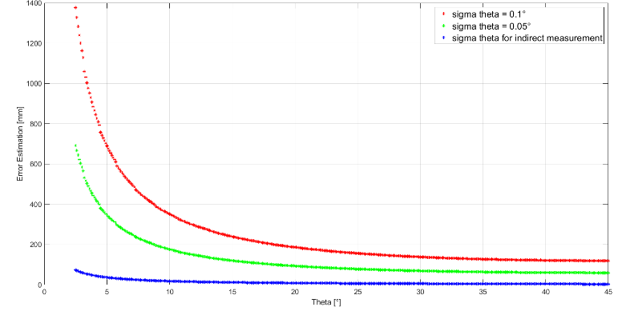
Figure 9. hCG total error estimation vs. different θ angle uncertainties
The final error was further reduced by averaging the results on a total of N = 17 measurements, all with different tilting angles, divided in M = 3 sets.
It is worth noting that, as many papers in the literature and the MRM ISO procedure [30] itself indicate, a few adjustments had to be made to the design of the test to improve accuracy:
To avoid a systematic variation in the estimated value, the suspensions and dampers of the vehicle should have been replaced with rigid bars. However, this was an unfeasible operation, so it was accepted to maintain this source of error in the test.
The tires of the vehicle were inflated up to the maximum pressure recommended by the constructor (3.5 bar).
The fluids contained in the various tanks of the vehicle (fuel, oil, water and so on) should have been filled or emptied prior to the test. All the fluids were in running order, while the quantity of fuel contained in the fuel tank was low enough to be considered a negligible source of uncertainty.
No object inside the cabin had the possibility to move.
The parking brakes of the vehicle were fully released, the gearbox was put in neutral, and the rear wheels were blocked with respect to the lifting board by means of four wedges. This is a key factor for the success of the test.
The results of the test are reported Figure 10. The estimated hCG value was 598 ± 5 mm.
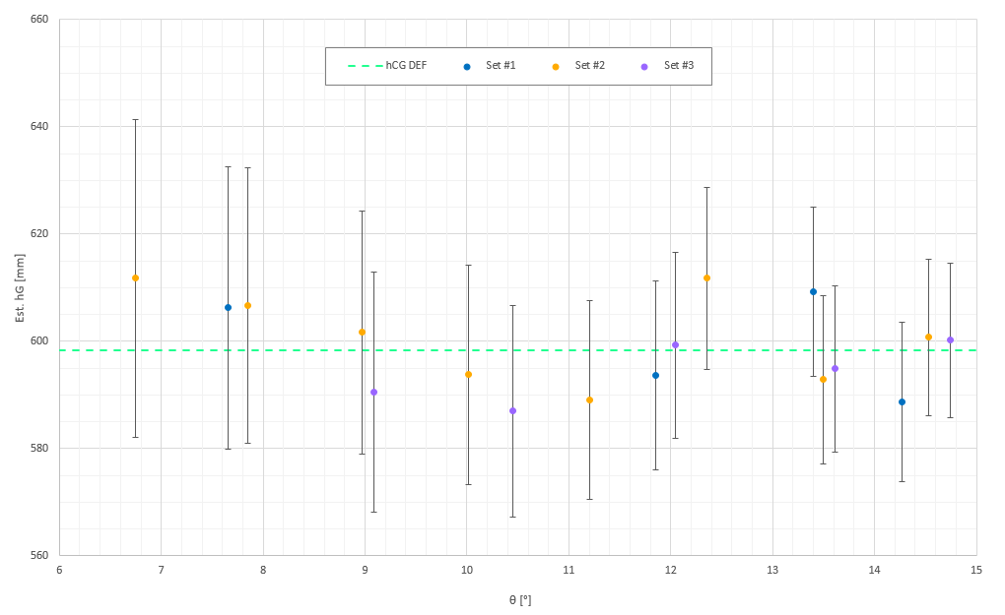
Figure 10. Modified Reaction Method hCG test results
Parallel wheel travel
The PWT test aimed at validating the behavior of rear suspension model. In particular, the main goals were:
To validate the curves produced in the Adams/CAR environment relating the wheel travel of the suspension to the load acting on the wheels.
To produce a map relating the abovementioned quantities to an intermediate variable able to be logged during dynamic tests, so that the same parameters could be indirectly estimated.
It was decided to mount four Linear Variable Displacement Transducers (LVDT) on the vehicle, one per wheel of the vehicle. These sensors can produce an analogue voltage signal, proportional to the distance between two known points. In this way, by recording the signal produced by the LVDT during a dynamic maneuver it is possible to estimate the vertical wheel travel in real time.
The four LVDTs between the chassis of the vehicle and a component of each suspension such as the Upper Control Arm, in case of the rear end (Figure 11), and the drop-link of the Antiroll Bar for what concerns the front end (Figure 12).
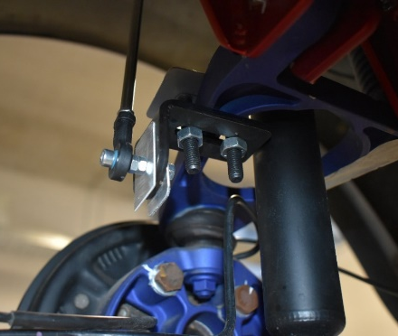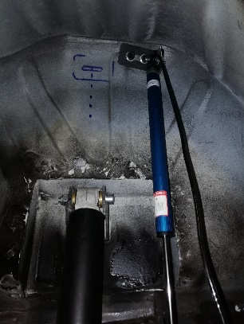
Figure 11. LVDT lower linkage to the rear suspension (left) and LVDT upper linkage to the chassis of the vehicle (right)
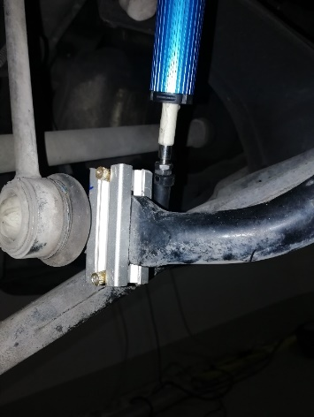
Figure 12. Lower end of LVDT number 2 connected to the front antiroll bar
Additionally, the deformation of the leaf spring suspension caused by the vertical load acting on the wheels has also been measured and recorded during the dynamic maneuvers by means of eight strain gauges mounted on its surface. This led to the design of a dedicated load-deformation map. The upper and lower surfaces of the composite leaf spring were equipped with eight strain gauges, placed in the configuration shown in Figure 13. These sensors were glued to the polymer’s surface and connected to an acquisition ECU located in the trunk of the vehicle by means of a series of cables, welded to the sensor itself (Figure 14). No calibration was needed since this task is automatically performed by the ECU at the beginning of the test.
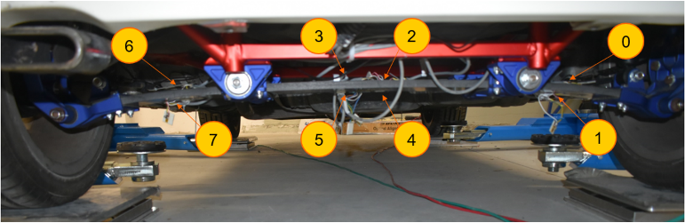
Figure 13. Position of the eight sensors placed on the surface of the composite leaf spring
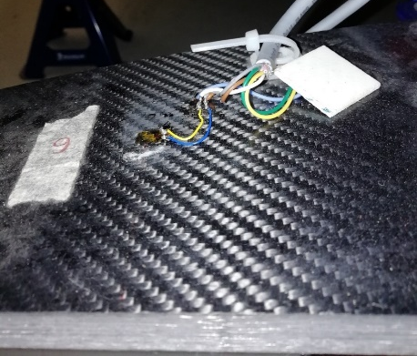
Figure 14. Detailed view of gauge number 6 glued to the leaf spring and connected to its cables
After installing the required sensors, split the test in two main parts:
In the first part the car was lifted from the ground by means of a car lifter (Figure 15) in order to reproduce the negative wheel travel, i.e. that condition in which the axle is unloaded and the wheels move away from the chassis.
Then, the car trunk was loaded with several sandbags, with a mass of 25 kg each (Figure 15).
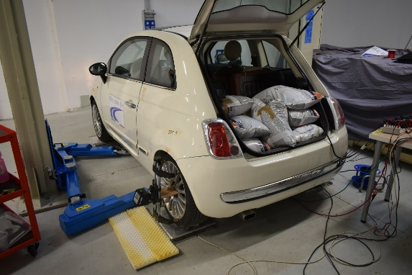
Figure 15. Full Load condition, achieved during the Static PWT test
During the test, the load on each of the four wheels was constantly monitored by using a set of Intercomp EZ Weight Scales, commonly used in racing applications. Additionally, the analogue signals coming from the four LVDTs and the eight strain gauges were recorded continuously throughout the test. Each test consisted of a lowering (i.e. loading of the vehicle) and a lifting phase (i.e. unloading of the vehicle) in order to improve the reliability of the results.
To assess the results, the signals coming from the rear LVDTs (number 1 and number 4) were converted to a length measurement. As showed in Figure 16, the results were plotted against the wheel travel measured at each of the steps as the distance between the center of the wheel and point of the wheel arch located directly above it. Even if the LVDTs were mounted with their axis being not aligned with the z-axis of the vehicle, and despite the asymmetry of the rear end of the Fiat 500, which forced to place the sensors in different positions from one another, the results were accurate. The interpolating curves are well fitted as two first order polynomials.
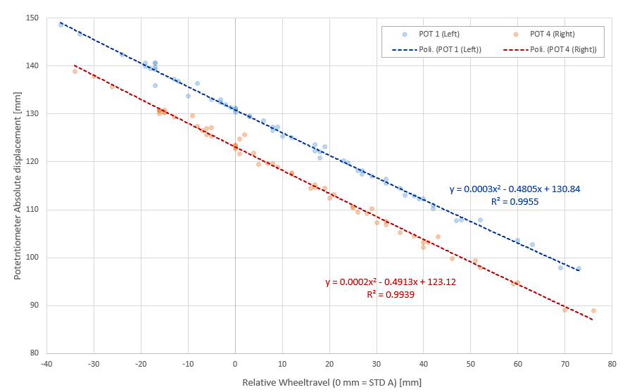
Figure 16. Conversion map between the displacement vs. wheel travel of the rear wheel’s LVDTs
In Figure 17 the values measured during the test are superimposed on the vertical load vs. wheel travel curves produced in the Adams/CAR environment with both the Beam and the Flexible Models.
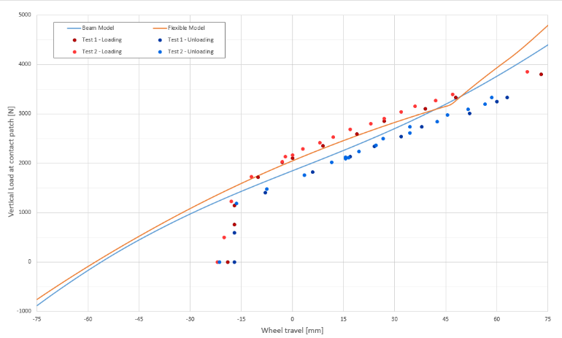
Figure 17. Vertical load vs. vertical wheel travel at the rear left contact patch
The most positive result was that the PWT Test confirmed the validity of the Adams/CAR simulations, since in the region included between a wheel travel of -10 mm up to a value of +45 mm all the results are almost coincident. It is also interesting to notice that a clear hysteresis is highlighted by the results, something that the model failed to predict.
By focusing the attention on the top end of the wheel travel scale, it is possible to notice how the test results maintain their trajectory as the load on the suspension is increased. No abrupt change of slope, i.e. no snap-trough phenomenon, is observed differently from what the initial flexible model suggested. On the other end of the spectrum, as the car was lifted from the STD A condition to the lifted condition, a wheel travel of only -20 mm was recorded, instead of the expected -60 mm. In particular, below -15 mm, a sudden drop in the vertical load is observed, with its value going to 0 N, i.e. with the wheels dethatching from the scales, within 5-10 mm of wheel travel.
As a result, the measured leaf spring stiffness in this section is over 4.5 times higher than both the designed one and that of the rest of the characteristic. As a by-product, this means that the suspension offers nearly no response to a load variation when the load acting on the wheel is included between 0 N and roughly 1200 N, an interval easily reachable during both hard braking and cornering. It is also interesting to notice how the hysteresis completely disappears in this section of the curves, almost as if the composite leaf simply stopped working with loads lower than 1200 N. This led to believe that an unprecise assembly of the suspension created a preload of a similar magnitude.
Dynamic test
The final step of the study was the validation of the full vehicle model by means of a dynamic test performed on a racetrack by a professional test driver. The maneuver presented in this article, as one of the most representatives of the dynamic behavior, is the ISO 3888-2 Double Lane Change (DLC) performed at 50 km/h.
According to the ISO definition such test is a “severe lane-change maneuver test for subjectively determining the obstacle avoidance performance of a vehicle, one specific part of vehicle dynamics and road-holding ability” [31]. The specifications of the DLC test designed for the Fiat 500 are reported inFigure 18.
The vehicle width is w = 1627 mm, hence obtaining A = 2040 mm and B = 2627 mm, with the centers of the lanes separated by $\frac{A+B}{2}+1000 mm=3333 mm$.
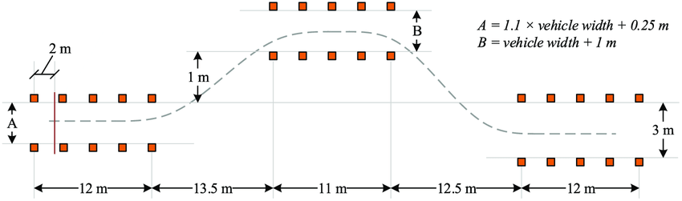
Figure 18. ISO 3888-2 Double Lane Change dimensions
The data needed for the maneuver analysis were collected from following equipment:
The CAN of the vehicle, on which signals like the throttle pedal position or the steering angle are transmitted from the on-board sensors to the vehicle’s ECU;
The strain gauges glued to the leaf spring and The LVDTs connected to the suspensions of the vehicle, as presented.
The Kistler Correvit S-Motion, a device able to measure longitudinal and lateral speed of the vehicle, the body’s roll and pitch angle, the yaw rate and the accelerations of the body along its main axis.
To collect the stream of data, two ETAS modules were employed (the ETAS 592 and the ETAS Daisy Chain). Additionally, the data coming from the strain gauges was collected by another device, a NI Compact RIO, whose data logging procedure was controlled by a purposely designed LabVIEW script.
Even with such a demanding maneuver, the Adams/CAR model managed to behave coherently. The speed and lateral acceleration profile are showed in Figure 19. The driver entered the first lane at 52 km/h, slightly higher than planned, and maintained such speed up to the end of the second lane. Then he accelerated exceeding the entering speed, whereas the simulation maintained the target speed of 52 km/h.
Interestingly, the controller of the simulation tried and succeeded in maintaining the vehicle straight while driving through the second lane. This is the reason behind the peak in the lateral acceleration visible at t=15s, in the right plot, which reached a maximum value of less than -1 m/s2. To achieve this goal, the controller had to sharpen both the entry and exiting steering maneuver, hence explaining the higher lateral acceleration peak values recorded during the test. On the other hand, the real driver decided to follow a shallower trajectory, more like a racing line, which forced him to maintain the steering wheel turned towards the right while driving through the second lane: this explains why the average acceleration between t = 14.5 s and t = 15.5 s remains well below 0 m/s2. Despite these minor imprecisions, the two test can be considered to have almost overlapping speed and acceleration profiles.
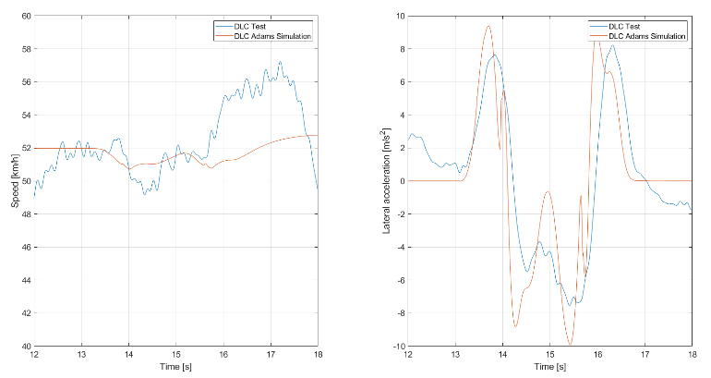
Figure 19. DLC speed (left) and lateral acceleration (right) profile
A positive result was achieved with the simulation of the roll angle of the vehicle, as reported in Figure 20. Despite a small initial overshoot, the curve produced by the simulations matches the experimental results. One noteworthy difference between the two is that the one produced by Adams/CAR slightly lags the experimental one, since the speed maintained by the test driver was higher than that imposed by the controller. The central peak of the orange curve doesn’t represent a relevant issue, since it is again a consequence of the distinct trajectory followed by the vehicle in the simulation, therefore related to a difference in the driver behavior not in the mechanical model itself.
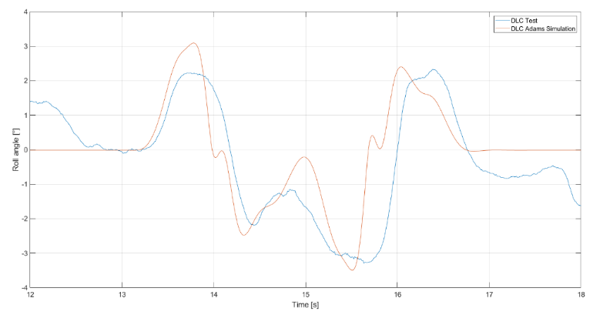
Figure 20. Roll angle comparison during DLC
Finally, the analysis of data coming from the strain gauges (SG) placed on the leaf spring. The raw data collected during the DLC test are reported in Figure 21. The curves are split among those belonging to the gauges placed on the upper surface of the leaf spring (in the upper plot) and those placed below it (gathered in the bottom plot).
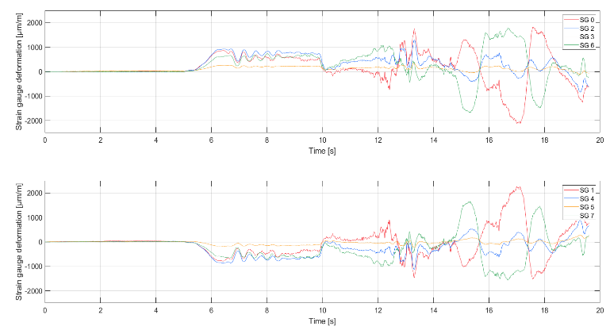
Figure 21. DLC maneuver - Strain gauges raw data
A positive deformation is translated in a compressive state of the material, while a tension acting on its surface causes the strain gauges to read a negative value.
From t=0 s to t=5 s the vehicle is stationary.
From t=5 s to t=12 s the vehicle accelerates, with a gear shift from 1st to 2nd gear at around t=10 s. The data in this window of time are very easily readable: the upper sensors recorded a parallel compression of the leaf while the lower one symmetrically recorded a tensile stress, as expected by the parallel loading of the suspension caused by the take-off of the car.
From t=12 s to t=14 s a transitory phase is visible, during which the driver had to align the car with the entry of the first lane by gently steering towards his right;
From t=14 s to t=19 s the actual DLC takes place.
During the DLC the red and green lines are the most interesting results. By focusing on the first lane change (from t=14 s to t=16 s) SG number 0 and number 7 recorded a local compression of the leaf as expected, since in this moment the right wheel is pushed towards the body while the left wheel is unloaded and therefore moves away from it. Coherently, the SGs placed on the opposite side (number 1 and 6) detected a tension in the surface of the material. The roles are inverted as the car aligns with the second lane by turning right. At the same time, SG number 2 and number 4 revealed that also the central section of the leaf is being deformed, although the magnitude of the deformations is far lower. However, these sensors were not placed exactly in the middle of the leaf spring, as originally planned, and therefore picked up a deformation slightly biased towards the left side of the spring.It is worth noticing that Adams/CAR, while perfectly able to replicate the macroscopic behavior of the entire vehicle even during a demanding maneuver such as the ISO 3888-2 DLC, was not capable of considering the precise local behavior of the materials constituting the flexible body, due to the FE modelling choices of the flexible body.
Conclusions
The multibody modelling of the composite transversal leaf rear suspension has been completed successfully by taking full advantage of the flexible body modelling solutions offered by Adams/CAR. The integration of a completely new flexible body in a pre-existing suspension model has been achieved.
The static and dynamic load cases and maneuvers simulated in the Adams/CAR environment have been successfully replicated in a workshop and on a racetrack, confirming the good outcomes of the experimental procedures. The final full vehicle model can predict quite accurately the macroscopic behavior of the body of the vehicle and of its subsystems even during very demanding maneuvers. Lateral acceleration, the roll of the body and the wheel travel of the wheels have been correctly simulated by the model.
The test methodology has been proved successful, especially considering the variety of tests which have been engineered. The described techniques are simple and effective for parameter extraction to populate the various subsystems of the multibody model. Among the most challenging features extracted it is possible to highlight the center of gravity height, that demanded several approaches before reaching an acceptable error level.
Future developments of the project can include: a different FEM modelling to extract the modal response using 3D elements, that would allow the correlation of the measured strains; further investigations on the tire response to improve the correlation on the steering wheel; evaluate possible design updates and active systems to the vehicle, improving its braking, lateral and vertical performance [32-34]; and a deeper study on the hysteresis and pre-load behavior observed in the PWT testing.
References
Carello, M., Carvalho Pinheiro, H. de, Longega, L., and Di Napoli, L., “Design and Modelling of the Powertrain of a Hybrid Fuel Cell Electric Vehicle,” SAE Int. J. Adv. & Curr. Prac. in Mobility 3(6):2878–2892, 2021, doi:10.4271/2021-01-0734.
Carvalho Pinheiro, H. de, Russo, F., Sisca, L., Messana, A., De Cupis, D., Ferraris, A., Airale, A.G., and Carello, M., “Active Aerodynamics Through Active Body Control: Modelling and Static Simulator Validation,” American Society of Mechanical Engineers Digital Collection, 2020, doi:10.1115/DETC2020-22298.
Carvalho Pinheiro, H. de, Cruz Stanke, D., Ferraris, A., Carello, M., Gabiati, G., Camuffo, I., and Grillo, M., “Autonomous Driving Scenario Generation in Overtake Manoeuvres Through Data Fusion,” Advances in Italian Mechanism Science, Springer, ISBN 978-3-030-55807-9: 786–794, 2021, doi:10.1007/978-3-030-55807-9_87.
Carello, M., Ferraris, A., Carvalho Pinheiro, H. de, Cruz Stanke, D., Gabiati, G., Camuffo, I., and Grillo, M., “Human-Driving Highway Overtake and Its Perceived Comfort: Correlational Study Using Data Fusion,” WCX SAE World Congress Experience, SAE Technical Paper 2020-01-1036, 2020, doi:10.4271/2020-01-1036.
Sisca, L., Airale, A., Massai, P., Xu, S., and Ferraris, A., “Function integration concept design applied on CFRP cross leaf spring suspension,” International Journal of Automotive Composites 3:276, 2017 doi:10.1504/IJAUTOC.2017.10012546.
Carello, M., Airale, A.G., Ferraris, A., Messana, A., and Sisca, L., “Static Design and Finite Element Analysis of Innovative CFRP Transverse Leaf Spring,” Applied Composite Materials 24(6), 2017, doi:10.1007/s10443-017-9596-6.
Fasana, A., et al. “NVH Analysis of Automotive Components: A Carbon Fiber Suspension System Case,” Advances in Italian Mechanism Science, Springer International Publishing, Cham, ISBN 978-3-319-48375-7: 345–354, 2017, doi:10.1007/978-3-319-48375-7_37.
Fiat 500 USA, “Examining the Fiat 500's Suspension”, Online, 29 September 2010. [Accessed in June 2022] http://www.fiat500usa.com/2010/09/examining-fiat-500-suspension.html.
Carello, M., Carvalho Pinheiro, H. de, Messana, A., Freedman, A., Ferraris, A., and Airale, A.G., “Composite Control Arm Design: A Comprehensive Workflow,” SAE Int. J. Adv. & Curr. Prac. in Mobility 3(5):2355–2369, 2021, doi:10.4271/2021-01-0364.
Messana, A. et al., “From Design to Manufacture of a Carbon Fiber Monocoque for a Three-Wheeler Vehicle Prototype,” Materials 12(3):332, 2019, doi:10.3390/ma12030332.
Carvalho Pinheiro, H. de, Messana, A., Sisca, L., Ferraris, A., Airale, A.G., and Carello, M., “Computational Analysis of Body Stiffness Influence on the Dynamics of Light Commercial Vehicles,”, Advances in Mechanism and Machine Science, Springer International Publishing, ISBN 978-3-030-20131-9: 3117–3126, 2019, doi:10.1007/978-3-030-20131-9_307.
Carvalho Pinheiro, H. de, Castro dos Santos, P.G., Sisca, L., Scavuzzo, S., Ferraris, A., Airale, A.G., and Carello, M., “Dynamic Performance Comparison Between In-Wheel and On-Board Motor Battery Electric Vehicles,” American Society of Mechanical Engineers Digital Collection, 2020, doi:10.1115/DETC2020-22306.
Carello, M., Ferraris, A., Airale, A.G., Messana, A., Sisca, L., Carvalho Pinheiro, H. de, and Reitano, S., “Experimental Characterization of Piezoelectric Transducers for Automotive Composite Structural Health Monitoring,” SAE Int. J. Adv. & Curr. Prac. in Mobility 2(5):2553–2567, 2020, doi:10.4271/2020-01-0609.
Messana, A. et al., “Feasibility Study on Piezoelectric Actuated Automotive Morphing Wing,” American Society of Mechanical Engineers Digital Collection, 2021, doi:10.1115/SMASIS2021-67601.
De Carvalho Pinheiro, H., Sisca, L., Carello, M., Ferraris, A., Airale, A.G., Falossi, M., and Carlevaris, A., “Methodology and Application on Load Monitoring Using Strain-Gauged Bolts in Brake Calipers,” SAE Technical Paper 2022-01-0922, SAE International, 2022, doi:10.4271/2022-01-0922.
G. Genta, “Motor Vehicle Dynamics: Modelling And Simulation”, World Scientific, 1997. ISBN: 9814497991.
Test Drive Now, “2016 FIAT 500c Abarth cabrio overview” Online, 30 July 2016. Available: https://testdrivenow.com/2016-fiat-500c-abarth-cabrio/. [Accessed in June 2022].
Shapiro, S., Dickerson, C., Arndt, S., Arndt, M. et al., "Error Analysis of Center-of-Gravity Measurement Techniques," SAE Technical Paper 950027, 1995, https://doi.org/10.4271/950027.
Mango, N., "Measurement & Calculation of Vehicle Center of Gravity Using Portable Wheel Scales," SAE Technical Paper 2004-01-1076, 2004. doi:10.4271/2004-01-1076
Zhao, X., Kang, J., Lei, T., Wang, Y., and Cao, Z., “Vehicle Centroid Measurement System Based On Forward Tilt Method Error Analysis,” IOP Conf. Ser.: Mater. Sci. Eng. 452, 2018, doi:10.1088/1757-899X/452/4/042189.
Suspension Secrets, “How to calculate centre of gravity position,” Online, May 2018. At: suspensionsecrets.co.uk/how-to-calculate-centre-of-gravity-position/.
UNECE, “Determination of Vehicle's CG Position,” 79th GRSG, Regulation 66, 16-20 October 2000. Available at: http://www.unece.org.
Wang, B., Nie, Y., Yang, Z., Zong, C., and Geng, L., “Study On The Barycenter Position Of Measurement And Data Processing For Dura-Axle Vehicle,” Atlantis Press, ISBN 978-94-6252-188-9, 2016, doi:10.2991/ameii-16.2016.265.
Università degli Studi di Udine, “Trattamento dei Dati Sperimentali e Teoria degli Errori”, Corsi di Laurea in Ingegneria, Laboratorio di Fisica.
V. Franco e M. L. Brutto, “Nozioni sulla teoria degli errori di osservazione” Università degli Studi di Palermo, 2004.
W. Milliken and D. Milliken, “Race Car Vehicle Dynamics,” Warrendale, PA, Society of Automotive Engineers, 1995, pp. 666-671.
F. Frera, “Simulation of the dynamic behavior of a self-driven electric vehicle,” Politecnico di Milano, Milano, 2017.
Winkler, Campbell and Mink, “Center of Gravity Height: A Round-Robin Measurement Program,” Transportation Research Institute, Ann Arbor, 1991.
W. J. Bagaria, “Vehicle Center of Gravity Height Measurement Errors,” Society of Automotive Engineers, Detroit, 1998.
International Standard, “ISO 10392: Road vehicles - Determination of centre of gravity,” March 2011. Available at: https://www.iso.org/standard/52978.html [Accessed in June/22].
International Standard, “ISO 3888-2:2011 - Passenger cars - Test track for a severe lane-change manoeuvre - Part 2: Obstacle avoidance,” 2011. Available at: https://www.iso.org/standard/57253.html [Accessed in June/22].
De Carvalho Pinheiro et al. “Torque Vectoring in Hybrid Vehicles with In-Wheel Electric Motors: Comparing SMC and PID control,” IEEE International Conference on Environment and Electrical Engineering, 2021, doi:10.1109/EEEIC/ICPSEurope51590.2021.9584732.
De Carvalho Pinheiro et al. “In-wheel and on-board motors in BEV: lateral and vertical performance comparison,” EEEIC 2022, doi:10.1109/EEEIC/ICPSEurope54979.2022.9854774
Imberti, G. et al. “Regenerative Braking Effects on Non-combustion Pollutant Release,” in: Advances in Italian Mechanism Science, ISBN 978-3-031-10776-4: 831–839, 2022, doi:10.1007/978-3-031-10776-4_95.
Definitions/Abbreviations
CAD | Computer aided design
CFRP | Carbon fiber reinforced polymers
CG | Center of gravity
DLC | Double Lane Change
ECU | Electronic control unit
FE | Finite Elements
hCG | Center of gravity height
LVDT | Linear Variable Displacement Transducers
MRM | Modified Reaction Method
PWT | Parallel wheel travel
SG | Strain gauge
SR | Steering Ratio

Contact Information
Politecnico di Torino – Department of Mechanical and Aerospace Engineering
C.so Duca degli Abruzzi, 24 -10129 Torino – Italy
Phone: +39.011.0906946
Henrique de Carvalho Pinheiro
henrique.decarvalho@polito.it

