Design of an Innovative Zero-Emissions Braking System for Vehicles

Giovanni Imberti
DIMEAS
Politecnico di Torino
Torino, Italy
giovanni.imberti@polito.it

Henrique De Carvalho Pinheiro
DIMEAS
Politecnico di Torino
Torino, Italy
henrique.decarvalho@polito.it

Massimiliana Carello
DIMEAS
Politecnico di Torino
Torino, Italy
massimiliana.carello@polito.it

Abstract—The automotive industry is going through one of the most challenging and revolutionary times of its history: the seek for a carbon neutral vehicle, allowing the spread of Electric Vehicles (EV) for breaking down direct emissions. It is equally important, however, to reduce or cut out the secondary emissions coming from the tires and the braking system. Starting from the on-market available technological zero-emission braking solution, the aim of this paper is developing an innovative system that would fit into a vehicle and at the same time satisfy the strict performance requests that a pivotal component, as the vehicle brake, should execute. The proposed solution reaches the technical targets of stopping a vehicle with a deceleration typical of an emergency braking maneuver and improves significantly the emissions emitted by secondary components of the vehicle.
Keywords—Braking System, Electric Vehicles, Zero-Emissions, Magneto-Rheological, Pollutants.

Introduction
The automotive industry focus is on breaking down CO₂, NO_{x}, and particulate emissions, for developing a new concept of vehicle, able to eliminate the emissions coming from the engine [1]. However, not all the pollutants are coming from the engine, there are a great number of emissions coming from non-combustion components, like the brakes for example, as it has been reported by Kukutschová et al. [2] [3], Hagino et al. [4] or Perricone [5].
A significant improvement of the Automotive Braking Technology is related to the innovative capability of the EVs of performing Regenerative Braking (RB).
RB is an already implemented feature on EVs, able to recover energy during decelerations and extending the maximum range of the vehicle, accumulating energy into the battery, that should be modelled and designed to optimize not only to reach the peak performance, but also to maintain its long lasting capability [6] [7] .
Another interesting feature of the technology is the capability of performing a vast number of braking manoeuvres reaching potential peaks of 0.5g/0.6g of decelerations, according with the different type of Electric Motor (EM) and the driveline layout. This allows to get rid of all the pollutant emitted by the EV’s braking system during a traditional WLTP cycle [8].
In this way it is possible to affirm that RB solves the problem of pollutants emitted by the braking system in the normal driving conditions, but there are several conditions in which RB is not enough to stop the vehicle and a parallel braking system is needed. For example, the most critical situations considered could be a safety braking maneuver in which the deceleration requested is around 0.9g or braking manoeuvres when the battery has a high State of Charge (SoC), that strongly derates RB performances. Another important reason for having an auxiliary braking system is regulatory because the braking system is a pivotal component for the vehicle and a redundant system is needed for ensuring safety conditions also when the primary system is out of order [8].
Defined the importance of a parallel braking system it is fundamental to understand the designing target of the innovative zero-emission braking system. Starting from the data coming from Nguyen et al. [9] it is possible to define an acceptable maximum torque to be reached by other systems to be compared to the performance of a standard disk-brake. In fact, it is crucial to at least ensure the same performance in order not only to satisfy safety and homologation requests [10], but also to improve and make the braking system more efficient.
A minimum torque to be reached has been defined using the energy conservation of equation (1):
$\frac{M_{C}V_{C}^{2}}{2}=\frac{T_{tb}V_{C}^{2}}{R_{w}2a_{c}}$ (1)
Where: $M_{C}$vehicle mass, $V_{C}^{2}$ vehicle speed, $T_{tb}$ torque to be computed, $R_{w}$ wheel radius and $a_{c}$deceleration to be performed.
Considering representative values for standard cars, with mass around 1600 kg, deceleration of an average limit braking 0.8 g and wheel radius equal to 0.326 m, considering the simplification of eq. (1) it is possible to obtain:
$T_{tb}=M_{c}R_{w}a_{c}=1025 Nm$ (2)
The number computed is critical in the further analysis for considering a technology feasible more than another, as it will be considered the minimum threshold to be obtained.
Other important data to be analyzed are the standby time between the signal and the activation of the braking system, the temperature, and the maintenance of the performance through the whole maneuver, considering that lots of braking magnetic system are strongly affected by the rotating speed. The different solutions analyzed are:
• Hysteresis Brakes,
• Magnetic Particle Brakes,
• Eddy Current Brakes,
• Magneto-Rheological Brakes.

State-of-the-art on Zero-Emissions Braking Systems

Hysteresis Brakes
This technology, already implemented in building clutches [11] uses permanent magnet to produce magnetic torque. No friction components are needed, only a magnetization of an air gap. It is composed by a reticulated pole structure and a rotor connected with the use of lip-seals and bearings. A coil is energized allowing the field magnet to start creating magnetizing force to the pole structure, which transform the air gap in a flux field. The rotor, controlled magnetically, starts decreasing its speed because of the magnetic torque developed in the air gap. The system can be easily controlled by the voltage and current applying in it. The operation is smooth fast and silent, and no maintenance needed [11].
The main application is for big dimensions working machine shafts, but for vehicles, the size does not fit the available packaging space and the braking torque available is extremely limited.

Magnetic Particle Brakes
Magnetic particles brakes are a technology that works decelerating and stopping a flywheel, connected to the rotating shaft, put to a fixed cage. The gap between the stator and the rotor is filled with a fluid with metallic particulate. A coil fixed to the cage creates a static magnetic field that energizes the particulate, ordering it in a reticulate from a disordered shape. The reticulate can reduce and stop the rotating shaft [12].
The crucial issues are related to the dimensions of the braking system able to reach near values to the vehicle expected torque and the inverse proportionality between the maximum torque and the maximum speed the tool can manage: if the braking system is built for reaching bigger torques, it has a lower maximum operating rotating speed.
Machine tools already implement this type of braking technology, but for a vehicle application a different layout is needed for maximising the peak braking torque and for fitting into a vehicle, too.

Eddy Current Brakes
Eddy current brakes work using a simple layout, geometrically like the traditional disk-brake, composed of a disk and a caliper where a coil is inserted. The physics of the system is developed as following: when magnetic flux linked to a metallic conductor change, a closed loop of induced currents is developed (so called eddy currents), generating an opposite magnetic field that, interacting to the first magnetic field varied, causes a force that resists to the change of the magnetic flux. A nearby conductive surface will exert a drag force on a moving magnet that opposes its motion, due to eddy currents induced in the surface by the moving magnetic field [13].
The torque, however, is theoretically not good enough for ensuring a complete braking system. No on-market solutions have been analyzed, but different papers proposed experimental data for this application, for example Mufti et al. [14] computed a maximum torque of 250 N·m, that would not be enough to satisfy the minimum torque for automotive application defined before as 1025 N·m.
Although the electric energy needed would be higher, Rao has shown [15] how it is possible to implement more than one caliper without a negative interaction between the components. For these reasons it would be possible to reach a value of torque nearer to the minimum one needed.
The greater issue presented by Mufti et al [14] is the limited performance of the eddy-current solution at lower speed. In fact, at higher rotating speed the technology is highly performant and better than the traditional disk-brake, but decreasing the speed, the braking torque is decreasing, too. The final statement about this phenomenon is that at a speed near to zero the brake is not anymore able to stop the car. This problem is physically related to the fact that the speed is one of the parameters that governs the maximum magnetic field [15] [16].
This issue is insurmountable because the redundant braking system to be coupled to the RB system is not enough secure to ensure the safety of the driver, for example the car is not able to be stopped when the SoC is higher than 98% and a braking higher than 0.4g must be performed.

Magneto-Rheological Brakes
Magneto-Rheological (MR) brakes uses the innovative technology of the magneto-rheological fluid that can change its rheological behaviour, altering its yield stress as a function of the magnetic field applied on it. Because of the structure of a magnetic particulate inside the fluid, when excited it organizes itself in a way that makes it more rigid. The structure of the brake, not already present in the automotive market, is composed by a stator with a coil and an internal rotor, while the gap between the two is filled by the MR fluid. The stator has a fixed coil hinged that can create a magnetic field acting through a magneto-static effect on the MR fluid, exciting it and allowing the variation in yield stress value. The basic behaviour is like the one of magnetic particle brakes, with the difference in using a MR fluid that is more effective and has higher response in sense of torque generated.
The effectiveness of the torque is not only function of the rotating speed, allowing the brake to rescale its behaviour during the deceleration in a smoother way, being effective for safety and regulatory reasons also at lower speeds. The effectiveness of the system in term of reaction to the braking command from the driver is faster than traditional brakes [17]. In fact, considering a time response of around 0.4s for a traditional disk-brake system whose fluid must be compressed and transfer the pressure to the brake-piston, the MR brake system has an almost instantaneous response, starting from a needed brake-by-wire system that sends the signal to the MR fluid that has an instantaneous response transforming its yield stress value [18]. The braking time should be reduced in this way, considering the same braking torque.
There are two main drawbacks for this technology to be considered: the resistive torque during zero-magnetic field at cruising speed and the temperature during every working condition.
In conclusion it is possible to say that this technology seems to be the most suitable for this type of braking application, because it is the only one whose braking torque values could reach levels comparable to the ones of the traditional disk-brakes. An innovative geometry should be defined for optimizing the braking torque and at the same time managing the temperature behaviour so that braking performance would not be affected by the decreasing performance of the fluid.

Innovative Zero-Emissions Solution Proposed

Physical Focus on Magneto-Rheological Fluid
Considering the MR Braking System as the most suitable for the vehicle application, it is important to evaluate the most critical parameters of the MR technology, for obtaining an optimal design able to satisfy the target requests and at the same time being feasible for the automotive application.
MR fluid has a characteristic behaviour of viscosity as a non-Newtonian fluid, characterized by the variation of the yield stress in function of the variation of the magnetic field applied to the fluid [19]. It is important to define the way in which this fluid can be described with equation, using the Bingham Model described by equation (3):
$τ = τ\left(H\right)+ η * γ$ (3)
Where: 𝜏 is the total tangential stress, equal to (𝐻), that is the tangential stress as a function of the magnetic field 𝐻, (𝜂) is the viscosity of the fluid (𝜂) and (𝛾) the tangent velocity gradient. The velocity gradient for small gaps is described by equation (4):
$γ = ωr ξ$ (4)
Where: r is the radius, ω is the angular speed and ξ is the small gap where the MR fluid is located. It has been also possible to choose the Herschell-Buckley model, chosen by Nguyen et al [9] for the simulation of the fluid because considered a little more precise, while the Bingham seems to be slightly over dimensioning. It has also been showed that there is no significant difference between the two and for this reason they are both appliable [9]. Eq. (3) allows to understand better the main advantage of the MR solution respect other braking applications as eddy current. In fact, the yield stress is a function of the magnetic field does not depend on the angular speed and allows to maintain an acceptable braking torque through the deceleration. The second part of the Eq. (3) depends on the angular speed, but it is less impactful. The derating of the braking torque as a function of the rotational speed, for this reason, is limited.
From an electro-magnetic point of view, it is fundamental to generate a magnetic field able to modify enough the viscous behaviour of the MR fluid to obtain the maximum tangential stress possible according to Eq. (3), but at the same time to have the minimum viscous resistance possible once the vehicle is running, resetting the tangential stresses coming from the magnetic field itself. No permanent magnetic field is needed for this reason, but a variable one must be generated. For these reasons it is fundamental to develop an electro-magnetic circuit that must maintain a certain level of magnetic field for a given time, then bringing it to zero. The best solution is to use the magneto-static behaviour of a coil, able to generate a magnetic field around when it is crossed by current. The magnetic field generated is:
$N ∙ I = Bfξ µf$ (5)
Where: N is the number of windings of the coil, 𝐼 is the current on the coils, 𝐵𝑓 is the ferromagnetic area around magnetic field and µ𝑓 is the magnetic permeability of the ferromagnetic material around. The product between 𝑁 ∙ 𝐼 is defined as magnetomotive force of the magnetic circuit. It is important to remember from the basic physics correlated to the magnetic fields generated by a coil the following statements:
- As it is possible to note in equation (5), the magnetic characteristic of the components around the fluid must be very performant from a magnetic conductivity point of view, to transfer the maximum magnetic field on the MR fluid.
- The magnetic field generated by the coil is not symmetric on the internal and external area around the coil, having a better performance on the internal surface.
- Reluctance parameter of the coil is a fundamental parameter to create an optimal electro-magnetic field. Maranno et al. [17] reported that: “Minimization of the total reluctance of the circuit is important to minimize the number of Amp-turns”. A reduction in number of the windings of the coils also means a mass reduction of the potential braking system.
The final goal is still the saturation of the yield stress-magnetic field curve, the objective must be reached managing and optimizing the current and the coils parameters. Another key evaluation to be considered is the limit of the MR fluid respect to the temperature. In fact, the main MR fluid present on the market have limitation in working over temperature higher than 140-150°C. Any possible braking system must maintain its operating temperature under those values to ensure the safety behaviour of the vehicle. Starting from the data of Nguyen et al [9] it is possible to compute the thermal function starting by convective parameter on the fluid as described in equation (6):
$\dot{Q}\left(t\right)=hA_{b}\dot{{(T}_{MR}\left(t\right)-T_{env})}$ (6)
Where: $T_{env}$ is the environmental temperature, set at 30°C, ℎ is the heat transfer coefficient which, when the car is cruising at 100 km/h, is around 60W/m²K. 𝐴𝑏 is the area of the outer surfaces of the MR brake structure and 𝑄̇(𝑡) is the rate of heat loss of the brake structure. The results obtained in theoretical computation have been synthetized by the equation (7):
$T_{MR}=T_{env}+\frac{T_{b0}V_{c}}{hA_{B}R_{w}}<T_{max}-∆T_{b}=115°C$ (7)
Where: the MR fluid temperature at zero-field braking torque (𝑇_{𝑀𝑅}) can be evaluated at a maximum temperature equal to 115°C that is under the operative limit value of the MR fluid. 𝑇𝑚𝑎𝑥 has been set as 130°C to maintain a safety limit to the limit temperature of the fluid, while ∆𝑇𝑏 has been computed starting from the maximum braking torque needed and represents the temperature increase due to a braking:
$∆T_{b}=\frac{∆Q}{m_{b}c}=\frac{M_{c}V_{c}^{2}}{8m_{b}c}=15°C$ (8)
It is possible to ensure that each braking is not able singularly to overcome the threshold given by the fluid (equal to 140°C) for the layout chosen by Nguyen et al [9], confirmed also by the test-bench performed, but it is not able to make more than one consecutive braking because of the high temperature reached. A cooling system able to bring the temperature lower than 90°C is needed to ensure the performance through the time and reduce the cooling time after a braking. This is one of the main reasons why an integration with an in-wheel motor is needed so that it could be possible to manage the EM cooling system to satisfy the MR brakes cooling, as both the systems work around the same operating temperatures.

Innovative Braking-System: Geometry Definition
To optimize the MR Brake application for vehicles, it is important to obtain the maximum capable torque from the technology, developing the surface in which the MR fluid is positioned as far as possible respect the rotational axis and, at the same time, finding ways to easily supply the braking system with electric current and a coolant, for maintaining the temperature under the critical threshold of the fluid.
For doing so, a combination between the MR fluid and the In-Wheel Motor allows to consider different advantages, not applicable before, for the innovative braking system. In fact, all the geometry presented in scientific papers, like Nguyen et al. [20] try to replace the actual disk-brakes using the MR technology, maintaining as a physical constraint the volume previously occupied by the traditional technology. This solution does not totally exploit the potentiality of the MR fluid, limiting the parallel area to the coil where the magnetic field is disposed, and, consequently, the maximum torque available. In this way the torque risks to be smaller than the minimum value considered of 1025 N·m.
The implementation of the MR brake inside the in-wheel motor allows to optimize the geometry, maintaining the same interaction surface between the rotor and the stator, presented by the other examples. But it puts on a different position that allows to have a more effective magnetic field, at the same time it is possible to combine the motor cooling system with the MR brakes to obtain a cooling of both the components. In fact, in-wheel motor should work under defined operational temperatures, that corresponds to be under 140°C, the critical temperature for the MR fluid [21] [22] [23].
Another advantage is related to the connections needed between the driving module and the vehicle: suspension interface, coolant in/out, current three phase cables.
Although the In-Wheel Motor already has a stator and a rotor respectively on the inner and the outer part, it is not possible to maintain this layout for the braking system, because the magnetic effect of the coil is more influent on the inside of the windings than outside, so to create the more efficient structure from an electro-magnetic point of view, another external stator is needed.
For this reason, the main components needed are:
- EM Rotor.
- EM Stator with capacitor and power electronics.
- MR Brake Stator.
- Bearing connecting stators and rotor.
The In-Wheel EM should be adapted to maintain a thinner and concentrated structure on the external part of the rim. In particular, the rotor should be designed with a protuberance that goes over the stator volume, to use the free space as the interference surface with the MR brake stator. The interference surface should be long enough to ensure the target Braking torque of 1025 Nm and for this reason it has been put both upper and lower the rotor protuberance. The rotor protuberance width has been defined to satisfy structural performances, but at the same time, minimizing the packaging for maintaining it inside a 19” wheel-rim.

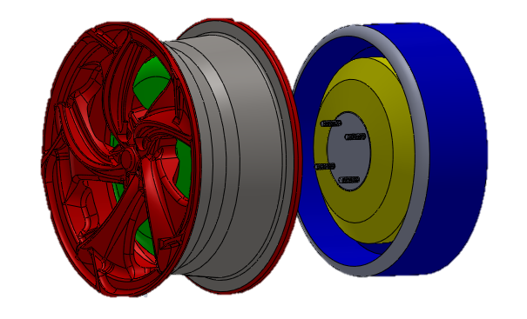
Fig. 1 Innovative Braking System Layout
The MR stator has been developed with the goal of obtaining a sort of clamp able to surround the rotor protuberance and have part of the interference surface both on the inner and the outer part of the rotor. It has been also thought as a concave component to obtain an acceptable volume for the connection to the rest of the vehicle and to the suspensions. On the external part of the clamp the coil must be fixed. It has been considered as a double component of a bobbin where the coil is wrapped up and its dimensioning has been performed during the electro-magnetic validation, as one of the most effective parameters on the development of a sufficient magnetic field on the MR fluid.

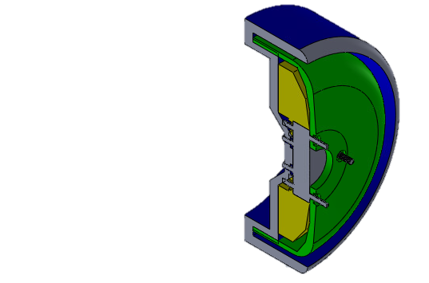
Fig. 2 Innovative Braking System Layout - Detail
Another fundamental parameter is the gap between the stator and the rotor. For this application it has been optimized in order not to have an extremely high rolling resistance in zero magnetic field rotating condition, but to have a satisfactory braking torque at the same time. In fact, rolling resistance depends on the gap as the fluid boundary layer creates a laminar flow resisting to the rotation to the rotor itself. At a higher speed, higher the resistance will be. In the development of the feasibility of the concept, the speed taken into consideration is 130 km/h. For what concern the effects on the maximum braking torque, Nguyen et al. [24] demonstrate how over a gap of 2 mm the effects on MR fluid are lowered because the magnetized structure of the fluid is not enough resistant to reduce and stop the rotating motion, using the geometry they chose.
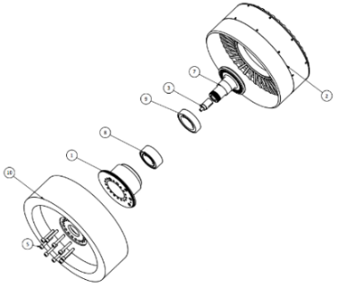
Fig. 3 Innovative Braking System Layout - Exploded
Tab. 1 Bill of Material of the Innovative Braking System
Parts List
Item | Qty | Part Name
1 | 1 | EM Stator
2 | 1 | EM Rotor
3 | 1 | Shaft
4 | 1 | Bracket Resolver
5 | 9 | Bolt
6 | 1 | Ring Sealing Assembly
7 | 1 | Shaft
8 | 1 | Bearing i/o
9 | 1 | Bearing o/i
10 | 1 | MR Brake Stator
The final layout presented and validated is shown in Fig. 1 Fig. 2 and Fig. 3, according to the geometrical constraints defined before. After the design both an electromagnetic and fluid-dynamic validations have been performed and results allow to affirm that the minimum braking torque considered for validating the technology (1025 N·m) has been overcome.
It is important to underline that the MR braking system is in parallel with an EM capable of performing RB [25] [26]. This allows to limit the use of the braking system to the minimum possible use and obtain a complete vectoring of the torque applied to the wheel [27] [28]. For doing so, a control management system has been developed and shown in Fig. 4.
The control system is expected to make the RB and the MR braking system work in series: since the deceleration request by the driver is lower respect the RB deceleration limit, the RB itself works autonomously. When the limit is overcome by the request of braking of the driver, the MR Braking system starts operating, satisfying the command. The same happens taking into consideration the SoC of the battery, as the main parameter limiting the maximum effectiveness of the RB; in that case the MR braking acts for satisfying the further braking torque requested by the driver.

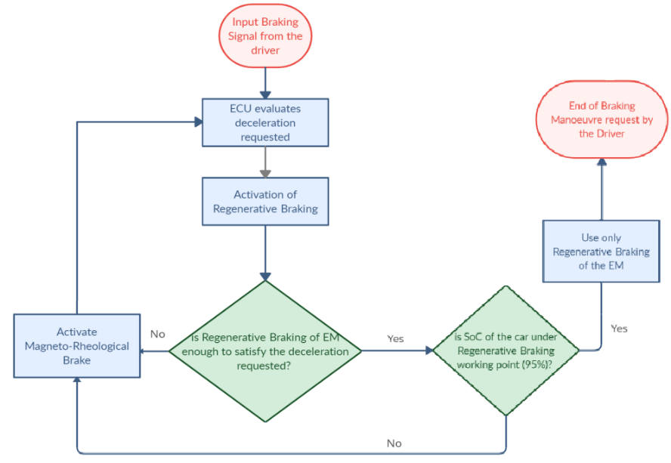
Fig. 4 MR Braking System Control Strategy

Conclusions
In conclusion, it is important to underline the advantages of the innovative solution respect to a traditional disk brake and respect to the already presented MR Brakes:
- The innovative solution is zero-emissions. This allows to develop a neutral emission drive that strongly affects the carbon footprint of the global automotive fleet.
- The innovative Braking solution has a faster response than a traditional disk brake, gaining around 0,3s, essential in terms of safety for the vehicle occupants. It depends on the fact that the MR Brakes are no pressure dependants but current dependants, which responds to the controller request immediately.
- The MR Brakes, presented with the innovative layout, are designed for maximising the effects of the MR fluid and, therefore, the braking torque available. The coupling with the In-wheel motor allows to create a modular solution, easier to be mounted and applied and prepared for the braking thermal management.
- The innovative driving module is capable of completely manage the requested torque by the driver in any condition, using a current signal. This allows to improve the torque vectoring operations on the vehicle and easily implement safety controls as ABS or ESP, governing and knowing each wheel rotating behaviour instantaneously.
After the adequate pre-design phase of the innovative technology proposed, concluded with the pre-feasibility computations that gave encouraging results, the next expected steps will be related to optimize the technology depicted for maximizing the braking torque available and then build up a Proof of Concept of the tool, to validate the computations and underline the criticalities of the innovative Magneto-Rheological Brake.
Finally, the paper underline which are the most suitable zero-emissions braking tools for an automotive application and describe how an innovative solution could be implemented combining a MR brake with an In-Wheel Electric Motor.
References

[1] | M. Carello and al., "Design and Modelling of the Powertrain of a Hybrid Fuel Cell Electric Vehicle," SAE Int. J. Adv. & Curr. Prac. in Mobility, vol. 3(6), no. doi: 10.4271/2021-01-0734, p. pp. 2878–2892, 2021.
[2] | J. Kukutschová and al., "On airborne nano/micro-sized wear particles released from low-metallic automotive brakes," Environmental Pollution, vol. 159, no. doi.org/10.1016/j.envpol.2010.11.036, pp. 998-1006, 2011.
[3] | J. Kukutschová and al., "Wear mechanism in automotive brake materials, wear debris and its potential environmental impact," Materials Science - Wear, no. doi:10.1016/J.WEAR.2009.01.034, 2009.
[4] | H. Hagino and al., "Laboratory testing of airborne brake wear particle emissions using a dynamometer system under urban city driving cycles," Atmospheric Environment, vol. 131, no. doi.org/10.1016/j.atmosenv.2016.02.014, pp. 269-278, 2016.
[5] | G. Perricone, “Laboratory measurements of airborne emissions from car brakes for clean air, Stockholm: ISBN: 978-91-7873-530-3, 2020.
[6] | Rizzello and al, "Electrothermal Battery Pack Model for Automotive Application: Design and Validation," AEIT International Conference, Turin – Italy, no. DOI: 10.23919/AEITAUTOMOTIVE50086.2020.9307377, 2019.
[7] | Rizzello and al, "Dynamic Electro-Thermal Li-ion Battery Model for Control Algorithms," AEIT International Annual Conference (AEIT), no. DOI: 10.23919/AEIT50178.2020.9241107, 2020.
[8] | G. Imberti and al, "Regenerative Braking Effects on Non-Combustion Pollutant Release," IFTOMM Conference Italy - Napoli, 2022.
[9] | Q. H. Nguyen and al, "Optimal design of disc-type magnetorheological brake for mid-sized motorcycle: experimental evaluation," Smart Mater. Struct, no. DOI: 10.1088/0964-1726/24/8/085009, 2015.
[10] | Road vehicles. Braking of automotive vehicles and their trailers, BS ISO 611:2003, 2003.
[11] | Placid Industries, "Hysteresis Brake," [Online]. Available: https://placidindustries.com/products/brakes/hysteresis-brakes/hysteresis-brake-h250/.
[12] | D. Shin, X. Yeh and O. Khatib, "A new hybrid actuation scheme with artificial pneumatic muscles and a magnetic particle brake for safe human–robot collaboration," International Journal of Robotics Research, vol. 33, no. DOI: 10.1177/0278364913509858, 2014.
[13] | D.-M. Ma, "The design of eddy-current magnet brakes," Transaction Canadian Society for Mechanical Engineering, no. DOI: 10.1139/tcsme-2011-0002, 2012.
[14] | R. Mufti and al, "Design of eddy current brake for electric motorcycle braking system," International Journal of Power Electronics and Drive Systems, no. DOI: 10.11591/ijpeds.v12.i1., pp. 41-55, 2021.
[15] | S. Rao, "Design and analysis of eddy current multi caliper disc brake," IAEME Publication, vol. 8, no. ISSN Print: 0976-6340 , pp. 267-274, 2017.
[16] | M. Gulec, E. Yolacan and M. Aydin, "Design, analysis and real time dynamic torque control of single-rotor–single-stator axial flux eddy current brake," IET, 2018.
[17] | S. Marannano and al, "Preliminary design of a magnetorheological brake for automotive use," in Science and motor vehicles, Belgrade, 2011.
[18] | A. Zaifazlin and al, "Experimental Evaluations on Braking Responses of Magnetorheological Brake," International Journal of Mining, Metallurgy & Mechanical Engineering (IJMMME), vol. 1, no. ISSN 2320-4052, 2013.
[19] | Lord Ltd, MRF-132DG Magneto-Rheological Fluid, 111 Lord Drive, Cary, NC, USA, 2019.
[20] | Nguyen and Choi, "Optimal design of an automotive magnetorheological brake considering geometric dimensions and zero-field friction heat," IOP PUBLISHING, no. doi:10.1088/0964-1726/19/11/115024, 2010.
[21] | D. Lim and al, "Performance Evaluation of an In-Wheel Motor Cooling System in an Electric Vehicle/Hybrid Electric Vehicle," MDPI Energies, vol. 7, no. doi.org/10.3390/en7020961, pp. 961-971, 2014.
[22] | H. d. C. Pinheiro and al, "All-Wheel Drive Electric Vehicle Performance Optimization: From Modelling to Subjective Evaluation on a Static Simulator," Electric Vehicles International Conference (EV), no. doi: 10.1109/EV.2019.8893027, pp. 1-6, 2019.
[23] | H. d. C. Pinheiro and al, "Dynamic performance comparision between in-wheel and on-board motor battery electric vehicles," ASME 2020 International Design Engineering Technical Conferences, vol. 4, no. DOI: 10.1115/DETC2020-22306, 2020.
[24] | Q.-H. Nguyen, Y.-M. Han and S.-B. Choi, "Geometry optimization of MR valves constrained in a specific volume using the finite element method," IOP PUBLISHING SMART MATERIALS AND STRUCTURES, 2007.
[25] | Rizzello and al, "Temperature-Dependent Thevenin Model of a Li-Ion Battery for Automotive Management and Control," IEEE International Conference on Environment and Electrical Engineering, Madrid, vol. DOI: 10.1109/EEIC/ICPSEurope49358.9160544, 2020.
[26] | A. Messana and al, "The Regenerative Braking for a L7E Range Extender Hybrid Vehicle," IEE International Conference, no. DOI: 10.1109/EEEIC.2018.8494000, p. Palermo, 2018.
[27] | H. d. C. Pinheiro and al, "Torque Vectoring in Hybrid Vehicles with In-Wheel Electric Motors: Comparing SMC and PID control," in 21st IEEE International Conference on Environment and Electrical Engineering, Bari, DOI: 10.1109/EEEIC/ICPSEurope51590.2021.9584732, 2021.
[28] | A. Messana and al, "Feasibility Study of an Innovative Urban Electric-Hybrid Microcar," International Journal of Automotive Technology, vol. 20, no. 2, DOI:10.1007/s12239-019-0023-x, pp. 237-246, 2019.

