To be submitted to Computer Methods and Programs in Biomedicine Version 2.3 (04.07.2022)
DermoCC-GAN: a new approach for standardizing dermatological images using generative adversarial networks

Massimo Salvi ª, Francesco Branciforti ª, Federica Veronese ^{b}, Elisa Zavattaro ^{c}, Vanessa Tarantino ^{d}, Paola Savoia ^{d}, and Kristen M. Meiburger ^{a,*}

ª Department of Electronics and Telecommunications, Polito^{BIO}Med Lab, Politecnico di Torino, Biolab, Corso Duca degli Abruzzi 24, 10129 Turin, Italy
^{b} AOU Maggiore della Carità, C.so Mazzini 18, 28100 Novara, Italy
^{c} Department of Translational Medicine, University of Eastern Piedmont, Via Solaroli 17, 28100 Novara, Italy
^{d} Department of Health Science, University of Eastern Piedmont, Via Solaroli 17, 28100 Novara, Italy

CORRESPONDENCE TO:
Prof. Kristen M. Meiburger
Biolab, Department of Electronics and Telecommunications, Politecnico di Torino, Torino, Italy
Corso Duca degli Abruzzi, 24 – 10129 Torino, ITALY
Phone: +39 011 090 4207
Fax: +39 011 090 4217
E-mail: kristen.meiburger@polito.it

Abstract

Background and objective: Dermatological images are typically diagnosed based on visual analysis of the skin lesion acquired using a dermoscope. However, the final quality of the acquired image is highly dependent on the illumination conditions during the acquisition phase. This variability in the light source can affect the dermatologist's diagnosis and decrease the accuracy of computer-aided diagnosis systems. Color constancy algorithms have proven to be a powerful tool to address this issue by allowing the standardization of the image illumination source, but the most commonly used algorithms still present some inherent limitations due to assumptions made on the original image. In this work, we propose a novel Dermatological Color Constancy Generative Adversarial Network (DermoCC-GAN) algorithm to overcome the current limitations by formulating the color constancy task as an image-to-image translation problem.
Methods: A generative adversarial network was trained with a custom heuristic algorithm that performs well on the training set. The model hence learns the domain transfer task (from original to color standardized image) and is then able to accurately apply the color constancy on test images characterized by different illumination conditions.
Results: The proposed algorithm outperforms state-of-the-art color constancy algorithms for dermatological images in terms of normalized median intensity and when using the color-normalized images in a deep learning framework for lesion classification (accuracy of the seven-class classifier: 79.2%) and segmentation (dice score: 90.9%). In addition, we validated the proposed approach on two different external datasets with highly satisfactory results.
Conclusions: The novel strategy presented here shows how it is possible to generalize a heuristic method for color constancy for dermatological image analysis by training a GAN. The overall approach presented here can be easily extended to numerous other applications.

Keywords: generative adversarial networks, color constancy, digital dermatology, deep learning, skin cancer, dermoscopy

Abbreviations:
DermoCC-GAN: Dermatological Color Constancy Generative Adversarial Network
GAN: generative adversarial network
NMI: normalized median intensity
GW: Gray World
SoG: Shades of Gray
MRGB: max-RGB
CNN: convolutional neural network
AKIEC: Actinic keratoses
BCC: Basal cell carcinoma
BKL: Benign keratosis-like lesions
DF: Dermatofibroma
MEL: Melanoma
NV: Melanocytic nevi
VASC: Vascular lesions
OHF: Optimized Homomorphic Filtering
RGB: red, green, blue color space
HSV: hue, saturation, value color space
HFEF: High frequency emphasis filter
AF: attenuation factor
YCbCr: luma, blue-difference and red-difference color space
CAD: computer-aided diagnosis
SD: standard deviation
CV: coefficient of variation

1. Introduction
Skin cancer is common worldwide, with an increase in incidence over the last decade [1] and can be divided into two types: melanoma and non-melanoma. Early diagnosis through the periodic screening of skin lesions is crucial for the prognosis of affected patients [1] and reduces the complexity of the interventions required for treatment and the resulting morbidity.
The ABCD rules, which are mainly based on the color and shape of pigmented lesions, allow the identification of many high-risk lesions [2]. However, diagnostic sensitivity can be significantly improved through the dermatoscope that allows the viewing and subsequent acquisition of an image of the skin lesion in a high-resolution and epiluminescent manner. Studies have in fact shown that more accurate diagnostic results can be obtained when made on dermoscopic images with computer-assisted methods [3]–[5]. Recently, and even more in the current pandemic context, teledermoscopy has also increased patient access to expert dermatologic care, thanks to the electronic transmission of dermoscopic images. Moreover, as technology continues to evolve, the use of smartphone cameras for skin lesion image acquisition has been investigated in numerous studies as a potential tool for general practitioners who can then consult expert dermatologists in dubious cases [6]–[8].
The accuracy of the clinical diagnosis of skin disease by a board-certified dermatologist is highly experience-related [9], and there are many factors that can influence the final quality of the image that is used for diagnosis. One of the main factors that influences the image quality is illumination (Figure 1), ranging from uneven illumination within the same dermoscopic image, to different illumination situations based on the device and the operator using the dermatoscope or device (e.g., how much pressure is applied to the lesion). Moreover, studies have shown how color features are more important than texture features for an accurate dermoscopic image analysis when using methods based on artificial intelligence [10]. The color within a dermoscopic image depends strongly on the image illumination, but also simply on the fact that different skin tones of patients make the final dermoscopic images appear very different from each other (i.e., the same lesion type may have high contrast on one patient but low contrast on another due to different phototypes). It is clear therefore how the variability that is observed in dermatological images can negatively influence the outcome of automatic algorithms that are developed for the segmentation and/or classification of skin lesions. In fact, if a strategy to address the multisource problem is not correctly dealt with, the color feature values which are computed by artificial intelligence methods on a dataset coming from one dermatological center will most likely not be robust if tested on images coming from another clinic, as the color feature values are altered.

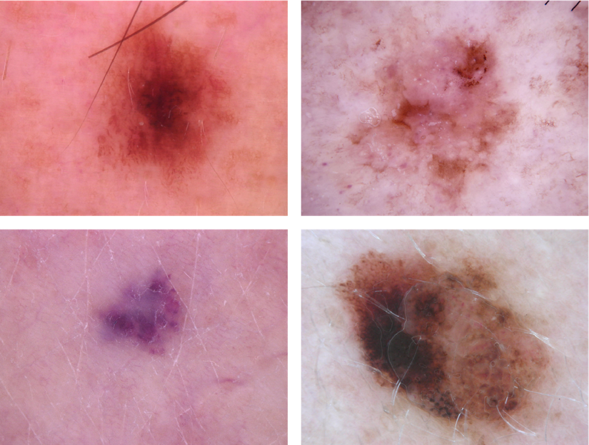

Fig. 1 Example of dermatological images acquired under different light conditions.

Color constancy algorithms provide a valuable approach to reducing the intrinsic variability in dermatological images. Given an image with an unknown acquisition preset, they are able to transform the colors of the image by exploiting image statistics. The result of color constancy is an image that appears as if it had been acquired under a canonical light source, which is usually assumed to be perfect white light [10]. Color constancy has been shown to have a great influence on deep learning frameworks in dermatology [11]. Almost all of the published deep learning methods for skin lesion segmentation or classification integrate a color constancy process, based on the algorithms described below [12], [13]. An increase in deep network performance has been consistently observed when using color constancy, regardless of the task.
The most widely used color constancy algorithms in dermatology are: Gray World (GW) [14], Shades of Gray (SoG) [15] and max-RGB (MRGB) [16]. These algorithms adopt a two-step strategy: i) estimation of the light source in the RGB color space, and ii) color transformation using the von Kries diagonal model [17]. While the second step remains unchanged among the three algorithms, the first step of light estimation depends on the upstream assumption. In fact, traditional color constancy algorithms impose priors to estimate the color of the light source [18]. The Gray World algorithm, the oldest and simplest, assumes that the average of all colors is a neutral gray while the Shades of Grey method states that the average of pixels raised to the power of p is gray, where p is the degree of the Minkowski norm. Finally, the max-RGB technique, based on perfect reflectance theory, assumes that the maximum values of each R, G, B channel of the image represent the color of the light source. Starting from different assumptions, the results of the three color constancy algorithms appear different, as shown by Barata et al. [10]: Gray World tends to give the image a grayish color, Shades of Gray shows an attenuated version of GW and max-RGB corrects the image in a less invasive but sometimes ineffective way (Figure 2).

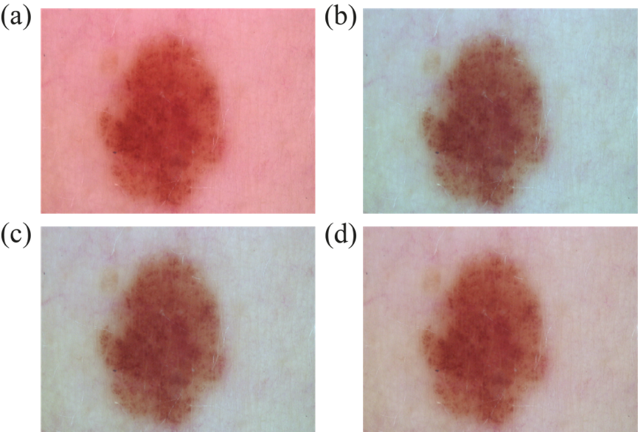

Fig. 2 Color constancy algorithms currently used in dermatology. (a) Original image, (b) Gray World [14], (c) Shades of Gray [15], (d) max-RGB [16].

Although they succeed in improving some images, the previously described classical color constancy algorithms have some inherent limitations in processing more complex images that do not meet the starting assumptions. Hence, there is a great need to create a more refined and adaptive normalization framework, capable of transforming images into a more natural result, without repeating artifacts due to the starting assumptions, such as a grayish color on the final image. On the other hand, the success of convolutional neural networks (CNNs) in other computer vision tasks has motivated researchers to develop deep CNN models to help this issue. For example, Brainard et al. [19] and Hu et al. [20] were the first to employ CNNs for illuminant estimation and achieved state-of-the-art results. Previous studies based on machine learning and deep learning models have been proposed in literature for confronting the general color constancy issue [21]–[23]. However, these studies focus on the general color constancy problem and do not focus on the specific application to dermatological images.
In parallel, image-to-image translation tasks gained attention by the introduction of generative adversarial networks (GANs) [24]. The objective is to map one representation of a scene to another (e.g., converting daytime images to nighttime or transferring images into different styles). Recently, GANs were extensively used in the field of dermatology to generate highly realistic images [25], [26] for skin lesion classification [27], [28] and segmentation [29]. Although previous studies have shown the potential of GANs to perform color constancy [18], [30], no work has yet been presented for the normalization of dermatological images using GANs.
In this paper, we propose a novel view on this classical problem via a generative end-to-end algorithm based on an image-conditioned Generative Adversarial Network (GAN). Our goal is to model the image normalization task as an image-to-image translation problem where the input is the dermatological image taken under an unknown light source and the output is the corrected image obtained by a custom color constancy algorithm. The main contributions of this paper can be summarized as follows:
- We present a custom heuristic algorithm for color constancy for dermatological images. This algorithm is able to reduce the variability introduced by different illumination sources, while increasing the local contrast of the image.
- We propose a novel hybrid framework that combines our custom heuristic algorithm and a generative adversarial network for color constancy of dermatological images. In particular, the GAN, named DermoCC-GAN (Dermatological Color Constancy Generative Adversarial Network), is trained only on image pairs in which our heuristic algorithm provides optimal results. This innovative approach makes it possible to obtain a GAN that simulates the heuristic algorithm without inheriting its limitations.
- We show how a color constancy algorithm not only represents a powerful preprocessing strategy for deep learning-based methods, but also allows for improved visual diagnosis by dermatologists, especially for cancerous lesions.
- We publicly release the dataset used to develop and test the proposed method. For each image of the dataset, we also provide the output of the DermoCC-GAN.
An extended validation is performed by comparing the proposed approach with the most recent state-of-the-art techniques. The segmentation and classification results obtained when using our algorithm are highly satisfactory and outperform all the compared methods [14]–[16].
The rest of this paper is organized as follows: Section 2 provides a thorough description of the proposed approach; Sections 3 reports the experimental validation results; Section 4 and 5 discuss the obtained results and conclusions.

2. Materials and methods
In this section, we first describe the dataset used in this work. Then, we introduce the methodology for standardizing dermatological images using generative adversarial networks. Finally, we describe the performance metrics used to validate the proposed method.

2.1 HAM10000 dataset
The image dataset used in this work is the HAM10000 [31], [32] which contains 10015 dermatological images of seven different skin lesions: Actinic keratoses - AKIEC (327 images); Basal cell carcinoma - BCC (514 images); Benign keratosis-like lesions - BKL (1099 images); Dermatofibroma – DF (115 images); Melanoma – MEL (1113 images); Melanocytic nevi – NV (6705 images); Vascular lesions – VASC (142 images). For a better understanding, some illustrations and background knowledge of these skin lesions are provided in the Supplementary Material.
The HAM10000 dataset was divided into two subsets: train (1300 images) and test (8715 images). This division between the training set and test set was based on various factors: first of all, the training set must include only pairs of images where the proposed heuristic algorithm (described in detail in Section 2.2) performs well; secondly, we aimed to keep a balanced dataset for the training set. Hence, considering the various classes of skin lesions included in the dataset (i.e., 7) and the number of images available for each class, this resulted in a reduction of the training set and an amplification of the test set. Further details are provided in Section 2.3. We applied the stratified method to split HAM10000 into training (13% or, 1300) and test (87% or, 8715) sets so that we could maintain the same ratio between each class, considering that this is a class-imbalanced dataset. Table 1 shows the details of the dataset used in this work. In order to train the DermoCC-GAN, an optimized color constancy algorithm for dermoscopic images was developed and applied on the training set (see next Section).

Table 1
Dataset composition for training and testing the DermoCC-GAN. AKIEC: Actinic keratoses, BCC: basal cell carcinoma, BKL: benign keratosis-like lesions, DF: dermatofibroma, MEL: melanoma, NV: melanocytic nevi, VASC: vascular lesions.

Lesion | Train | Test
AKIEC | 180 | 147
BCC | 180 | 334
BKL | 180 | 919
DF | 80 | 35
MEL | 180 | 933
NV | 420 | 6285
VASC | 80 | 62
Total images | 1300 | 8715

2.2 Proposed color constancy heuristic algorithm for dermatological images
The objective of the proposed heuristic algorithm is to i) reduce the variability introduced by different sources of illumination, ii) decrease the range of light intensity, and iii) increase the local contrast of the image. The algorithm was developed specifically for dermatological images. Let’s consider the dermatological image as a combination of the intensity of light hitting the skin surface and the amount of light reflected from the skin itself:
$I(x,y) = I_{L}(x,y)*I_{R}(x,y)$ | (1)
where $I_{L}$ is the illuminant component and $I_{R}$ is the reflected one. According to the illumination-reflectance model [33] $I_{L}$ tends to change slowly while $I_{R}$ tends to change abruptly. Consequently, the contribution in the frequency domain of $I_{L}$is concentrated in the low frequencies, while that of $I_{R}$ is concentrated in the high frequencies [33]. The proposed color constancy algorithm consists of two macro steps:
- Optimized Homomorphic Filtering (OHF) to reduce the variability introduced by different illuminant sources, attenuating the illuminant component ($I_{L}$) while preserving the reflected one ($I_{R}$), which contains the most relevant information;
- Light/shadows correction to balance the underexposed and overexposed areas and to optimize the image brightness.

2.2.1 Optimized Homomorphic Filtering
The first macro step of the algorithm is based on homomorphic filtering (Figure 3), a widely used approach for image enhancement [34], [35]. In particular, we designed an OHF that is capable of adapting to each source image. The purpose of OHF is to sufficiently attenuate the low-frequency components of the image (so as to reduce the illuminant's contribution), while preserving the spatial distribution of reflectance, which contains the most important information in the image.
First, the source image is converted from the RGB to HSV (Hue Saturation Value) color space. To preserve the information contained in the H and S channels, only the V channel, that controls the brightness of the color, is processed by our algorithm (Figure 3b). After a min-max normalization, the normalized V channel is transformed into the logarithmic domain to create a Homomorphism, moving from a multiplicative to an additive model:
$$ln(V\left(x,y\right)+ϵ) = ln(V_{L}(x,y)*V_{R}(x,y)) = ln(V_{L}(x,y)+ln(V_{R}(x,y))$$ | (2)
where $V_{L}$ and $V_{R}$ are the illuminant and reflectance components in the V channel, respectively. Using this additive model, it is possible to attenuate low-frequency ($V_{L}$) components while preserving high-frequency ($V_{R}$) components so that significant information is not lost. To reduce the $V_{L}$ component, we need to switch to the frequency domain by applying the Fast Fourier Transform (FFT), and then filter the V channel with the following transfer function (Figure 3c):
$$H(x,y) = α+β*HFEF(x,y)=\frac{1}{AF} + (1-\frac{1}{AF} )*HFEF(x,y)$$ | (3)
where $α$ is the offset parameter, $β$ is the scaling factor, HFEF represents a High Frequency Emphasis Filter [33] and AF (Attenuation Factor) is the parameter that defines how much the high-frequency components should be emphasized over the low-frequency components. To amplify high frequencies, AF must be greater than 1 and thus $α$ < 1, $β$ > 1 (Eq. 3). In this work, the AF is set to 1.5. The effect of this parameter on the final image is shown in Figure S2 (Supplementary Materials). A Butterworth high-pass filter is chosen as the HFEF, defined by the following transfer function:
$$HFEF = \frac{1}{1+ {\left(\frac{f_{cutoff}}{radius}\right)}^{2*N}}$$ | (4)
where $f_{cutoff}$ is the cutoff frequency of the filter ($f_{cutoff}=0.25$), $radius$is a threshold parameter that defines the frequencies to be attenuated ($radius$ = 2) and $N$ is the order of the HFEF ($N$ = 2). Then, the filtered V channel is subjected to the $FFT^{-1}$and exponential function to return to the image domain. Finally, a new HSV image is created using this new V channel and subsequently converted to the RGB color space (Figure 3d).
The last step in OHF is RGB normalization which is achieved by dividing each channel by an image-specific value (P). The value of P is adapted for each image, through an analysis based on the luminance variation of the individual image. A four-step procedure is applied to find the optimal value of P (Figure 3e):
- Estimation of the luminance of the original image (L_{ORIGINAL}), defined as the mean intensity of all pixels within the image;
- Normalization of the three layers of the original image, using a set M of different percentiles related to the pixel intensities of each layer. In particular, the original image is normalized with five different percentiles (i.e., M = {95th, 96th, 97th, 98th, 99th}), resulting in five different normalized images. Then, the luminance $L_{NORM}$ of each normalized image is estimated;
- Computation of the percentage of luminance variation for each normalized image obtained in the previous step. $L_{\%}=\frac{L_{NORM}-L_{ORIGINAL}}{L_{ORIGINAL}} *100$ ($L_{ORIGINAL}$: luminance of the original image, $L_{NORM}$: luminance of the image normalized with the generic percentile);
- Looking at the curve generated by the different values of percentage of luminance variation $L_{\%}$, starting from the 95th up to 99th percentile, a decreasing trend can be observed. This downward curve is characterized by a drop point after which the slope of the curve increases dramatically. An automated method, based on the findabruptchange function implemented in Matlab, finds the exact point before the drop and returns the corresponding P value defined as $P_{optimal}$. Further details on the choice of $P_{optimal}$ can be found in the Supplementary Material (Figure S3).
Finally, each RGB channel is normalized with the $P_{optimal}$ found in the previous step. The resulting image, i.e. the corrected OHF image, appears as if it had been acquired under a canonical light source (perfect white light). The final result is shown in Figure 3f.

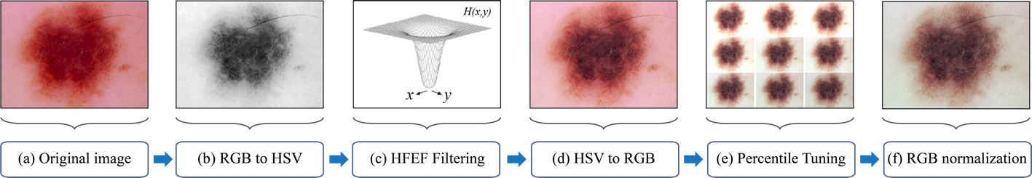

Fig. 3 Steps of the Optimized Homomorphic Filtering employed to normalize the illuminant source. The output image appears as if it had been acquired under a perfect white light.

2.2.2 Light/shadows correction
Starting from the OHF image obtained in the previous section (Figure 4a), our color constancy algorithm performs an additional step to highlight color patterns within the skin lesion by balancing the underexposed and overexposed areas of the image. Specifically, this step performs a four-step light and shadow correction:
- The corrected OHF image is firstly converted from RGB to YCbCr color space. Y is the luminance component (Figure 4b), while Cb and Cr represent the chrominance components;
- A “light map” and a “shadow map” are obtained from the content of the Y channel following an open-source code [36]. The “light map” identifies pixels in the luminance component of the image greater than a given threshold $L_{TH}$, setting all pixels smaller than $L_{TH}$ (i.e., all pixels considered as shadow) to 0. Instead, the “shadow map” identifies pixels in the complementary version of Y greater than a given threshold $S_{TH}$, setting all points smaller than $S_{TH}$ (i.e., all pixels considered as light in the original image) to 0. This results in two grayscale images showing how the intensity of light and shadows is distributed within the original image (Figure 4c). For our purpose $L_{TH}$ and $S_{TH}$ have been set to 127.5 (i.e., half the range of image pixel intensities);
- The light and shadow maps are then filtered with a 30x30 averaging kernel (Figure 4d). This step is intended to soften the transition within the light and shadow maps;
- Luma correction: once the light and shadow distributions have been obtained, the over- and under-exposed areas of the image can be corrected by interpolating the light map and shadow map with the Y channel of image, as indicated by the open-source code [36]. This interpolation proportionally lightens all pixels identified by the “shadow map” and proportionally darkens the pixels identified by the “light map” (Figure 4e).

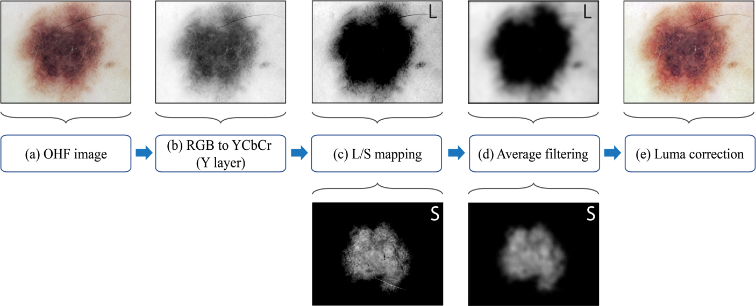

Fig. 4 Steps performed for light/shadow correction to optimize the image brightness. ‘L’ and ‘S’ stand for light and shadow, respectively.

After balancing the Y channel, the image is recomposed in YCbCr space and then converted to the RGB color space. The result of the proposed color constancy algorithm is an image i) deprived of the variability introduced by the illumination and ii) improved from the point of view of contrast and details within the skin lesion.

2.3 DermoCC-GAN
In the last few years, Generative Adversarial Networks (GANs) have been extensively used to perform image normalization in medical imaging [37]–[39]. GANs are unsupervised generative networks that take advantage of adversarial training [40]. Adversarial training consists of a generative and a discriminative model trained through an objective function using a two-player min-max game. The GAN model includes a generator G and a discriminator D, that are trained simultaneously. The generator network generates sample $G\left(x\right)$using a noise variable x. The task of the generator is to resemble a target domain $y ∈Y$as accurately as possible, generating $G\left(x\right)= \hat{y}$, where $\hat{y}≈y$. The discriminator has the binary task to distinguish between the fake data $→D\left(\hat{y}\right)=0$ and the original distribution $→D\left(y\right)=1$. Conversely, the generator tries to fool the discriminator, training for $D\left(\hat{y}\right)=1$. This adversarial game is generally expressed by the following loss function:

$$L_{GAN}\left(G,D,x,y\right)=\log{D\left(y\right)}+1-log⁡D\left(G\left(x\right)\right)$$ | (5)

For this application, we use the concept of image-to-image translation to normalize each dermatological image. A Pix2Pix GAN architecture is chosen for the color constancy problem. Our DermoCC-GAN employs a ResNet architecture [41] with 9 residual blocks as the generator network. This allows the architecture to learn an image transformation, conditioned on the input image. The discriminator is a three-layer fully convolutional PatchGAN [42], which evaluates the generated samples. Additionally, an extra L₁ loss is used to encourage the generator to produce a sample close to the target y:

$$L_{1}\left(G\right)= {\left\|y-G(x)\right\|}_{1}$$ | (6)

Thus, the L1 normalization term (Eq. 6) is added to Eq. 5 to create the final combined loss:

$$L_{Pix2Pix}=L_{GAN}\left(G,D,x,y\right)+λ⋅L_{1}(G)$$ | (7)

where $λ$ is the hyper-parameter that controls the weights of the L₁ loss. As suggested by a previous work [43], we set $λ$ to 100.
The Pix2Pix method requires pairs of images in the training phase that consist of an original image and the corresponding transformed image, which in this case is obtained by the color constancy algorithm described in Section 2.2. Figure 5 shows the overall architecture of the proposed DermoCC-GAN. As previously described, 1300 pairs of images (i.e., original image and image standardized with the proposed heuristic approach) were carefully selected by an expert dermatologist for the training of the network. The operator viewed all original images alongside the images that were standardized by the proposed heuristic algorithm (Section 2.2) and selected those that provided the best visual results. During the selection, the operator was advised to also keep the final training set balanced between the various skin lesion classes (Table 1). This step is crucial in the entire pipeline of our proposed method. In fact, the heuristic algorithm is limited and sensitive to parameter selection, making it perform only subpar on a large amount of images included in the HAM10000 dataset. By training the GAN only on pairs of images in which our algorithm for color constancy performs well, the model is able to learn the domain transfer problem of the heuristic algorithm without inheriting its sensitivity to parameter selection. Before being processed, each image undergoes an aspect ratio check: if the image is rectangular, zero padding is applied so that the aspect ratio is equal to one. Then each image was downscaled to 512x512 pixels to fit the input size of the generator and discriminator of the GAN model. Both generator and discriminator models are trained with the Adam optimizer with an initial learning rate of 0.0001 and a $β_{1}$ (momentum term of Adam) equal to 0.5. The DermoCC-GAN is trained for 200 epochs, and the entire model is updated every 64 images (batch size). The training is performed on a NVIDIA RTX 3090 24 GB using Pytorch framework. After training, we select one of the best-stored models of the generator according to loss values.
Training the DermoCC-GAN only on image pairs in which our heuristic algorithm performs well allows to build a reliable framework for color constancy on dermatological images. The source codes of the DermoCC-GAN and the dataset of images generated by our model are freely available to be downloaded at https://data.mendeley.com/datasets/6nr7symnjj/draft?a=057077cd-ae97-41d4-a360-e515fbca6059.

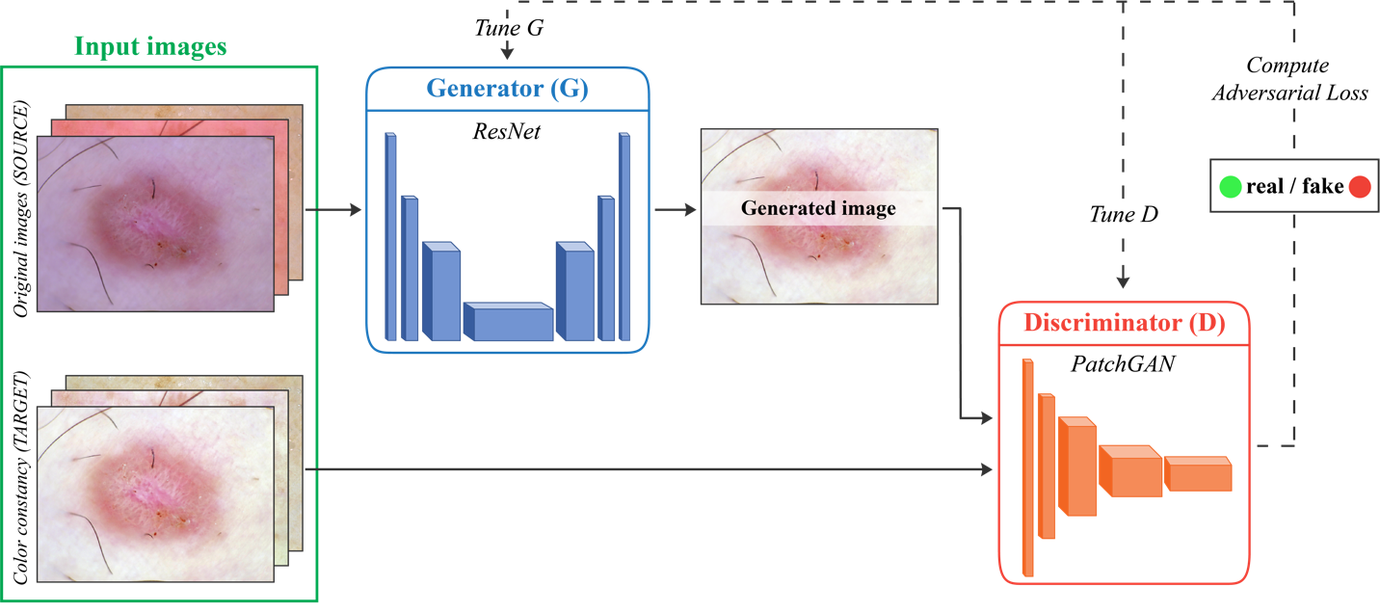

Fig. 5 Overview of our novel GAN-based color constancy algorithm. The input image is provided as a condition to the Generator (G), whose output, along with a true sample is passed to the Discriminator (D). The original dermatological image is used as the source domain while the result of our heuristic color constancy algorithm is employed as the target domain.

2.4 Classification and segmentation networks
The majority of recent machine learning methods have a pre-processing stage (e.g., color constancy for dermatological images) which is integrated with a deep neural network [12], [13], [44]. Previous studies have shown that color constancy can increase the accuracy of a computer-aided diagnosis (CAD) system for skin lesions segmentation [45] and classification [10], [12]. To demonstrate the quality of the output generated by our DermoCC-GAN, we implemented two different deep networks for (i) skin lesion classification and (ii) skin lesion segmentation.
Specifically, the DenseNet121 architecture [46] is employed for the classification task. The DenseNet (Dense Convolutional Network) is characterized by a special connectivity pattern that connects any layer to all subsequent layers, providing a better information flow. The architecture has been implemented for classification of skin lesions and its superior performance has been presented recently [47], [48]. Our deep network is pretrained on ILSVRC 2012 ImageNet [49] and the transfer learning strategy is applied during the network’s training to reduce the training time [50]. Moreover, on-the-fly data augmentation is implemented by applying random transformations (i.e., rotation, shifting, flipping) to the input images. This strategy prevents network overfitting and makes the model more robust by increasing the amount of data available during training [51]. The deep network is trained using an input size of 512x512x3 pixels, a mini-batch size of 64 and an initial learning rate of 10⁻⁴. The Adam optimizer and categorical cross-entropy are employed as the optimization and loss function, respectively. To improve the performance of CNN based architectures, hybrid loss functions have been proposed in several works [52], [53]. We used categorical cross-entropy because of its low computational cost and efficiency with our data sets. Finally, the total number of epochs is set to 300, with a validation patience of 10 for early stopping of the training process.
For the segmentation task, we implemented a convolutional neural network (CNN). In particular, the UNET architecture adopted in our previous works [54] is employed to perform semantic segmentation. The overall network architecture is shown in Figure S4. This deep network is composed of an encoder and a decoder structure. The goal is to project all the discriminative features (lower resolution) learned by the encoder onto the pixel space (higher resolution) to achieve a dense classification. The entire network is trained giving the 512x512 RGB images as input and the corresponding labeled masks as the target. To give the reader the opportunity to observe the entire procedure, we added a detailed description of the network training strategy for the segmentation task in the Supplementary Material.

2.5 Performance metrics
The normalized median intensity (NMI) is used to quantify the intensity variation of an image population after normalization and it is commonly used to demonstrate color consistency. Its mathematical definition, reported in the works of Basavanhally et al. [55]is:

$$NMI=\underset{i∈I}{Med}\left(u_{i}\right)/\underset{i∈I}{P_{95}}\left(u_{i}\right)$$ | (8)

where $I$ is the image after the normalization process and $u_{i}$ denotes the mean value of the RGB triplet related to the $i$-th pixel. The numerator presents the median value and the denominator the 95th percentile. Typically, this value is not significant as is, hence the standard deviation (NMI SD) and the standard deviation divided by the mean, i.e., the coefficient of variation (NMI CV), of the NMI values are computed. A population of images are considered more consistent when the NMI, SD and NMI CV computed over the population decrease. Hence, the lower the NMI SD and NMI CV, the more consistent the normalization process.
In addition, to validate the deep learning networks that employ the DermoCC-GAN images as pre-processing for skin lesions segmentation and classification, different approaches were employed depending on the task (i.e., classification or segmentation). The accuracy is used to evaluate the overall success of the model during the classification task. We calculated both the average and weighted accuracy. The average accuracy is computed as the mean accuracy of each class individually, while the weighted accuracy takes into account the number of images for each class [56]. For the segmentation task, the average dice and the weighted dice are calculated to assess the performance. The dice score [57] measures the spatial overlap between two binary shapes. These validation metrics were computed using all color constancy algorithms: our proposed DermoCC-GAN along with the three previously described color constancy methods that are commonly employed for dermatological images: GW, SoG, MRGB. Finally, three experienced dermatologists evaluated the quality and impact of the normalized image within the diagnostic process. More details are provided in the next section.

3. Results

3.1 DermoCC-GAN image normalization
The NMI measure is used to quantitatively assess the consistency of the normalization process [55]. The computed NMI SD and NMI CV are shown in Table 2, where they are also compared with the unnormalized set (i.e., original images). The best values are shown in bold. The results provided by the DermoCC-GAN in terms of SD MNI and CV NMI are also compared with previously published works [14]–[16].
The goal of these metrics is to quantify how much the color varies between images after color normalization. Hence, as described previously, lower values of these parameters indicate that the method is more able to transform an entire image dataset into a common color space.

Table 2
Quantitative metrics used to compare the DermoCC-GAN normalization with current state-of-the-art methods for dermatological image color constancy methods. GW: Gray World, SoG: Shades of Gray, MRGB: Max-RGB. NMI SD and NMI CV indicates the standard deviation and the coefficient of variation of the normalized median intensity (NMI) (lower values are better).

Subset | Method | Comp. Time (s) | NMI SD | NMI CV
Train | Original images | - | 0.0517 | 0.0584
Train | GW [14] | 0.09 | 0.0531 | 0.0604
Train | SoG [15] | 0.04 | 0.0522 | 0.0596
Train | MRGB [16] | 0.02 | 0.0516 | 0.0584
Train | DermoCC-GAN | 0.08 | 0.0461 | 0.0527
Test | Original images | - | 0.0530 | 0.0602
Test | GW [14] | 0.09 | 0.0554 | 0.0632
Test | SoG [15] | 0.04 | 0.0547 | 0.0623
Test | MRGB [16] | 0.02 | 0.0535 | 0.0609
Test | DermoCC-GAN | 0.08 | 0.0479 | 0.0546

All compared methods are fast, ranging from about 20 ms (MRGB) to 90 ms (GW). As can be seen from Table 2, the proposed method is characterized by the lowest SD and CV of the NMI metric. This result shows that the intensity variation of the image dataset after the DermoCC-GAN normalization is the lowest among all the compared methods. The visual performance of the compared methods is shown in Figure 6. As can be seen from the same figure, DermoCC-GAN reported less intensity variations than the existing approaches due to the inherent robustness of the generative network. Interestingly, with respect to the other compared methods, the DermoCC-GAN normalization preserves image contrast by highlighting patterns within the skin lesion. The DermoCC-GAN, unlike the heuristic algorithm, does not produce artifacts (black pixels) within the lesion that could be confused with structures/patterns of diagnostic relevance.

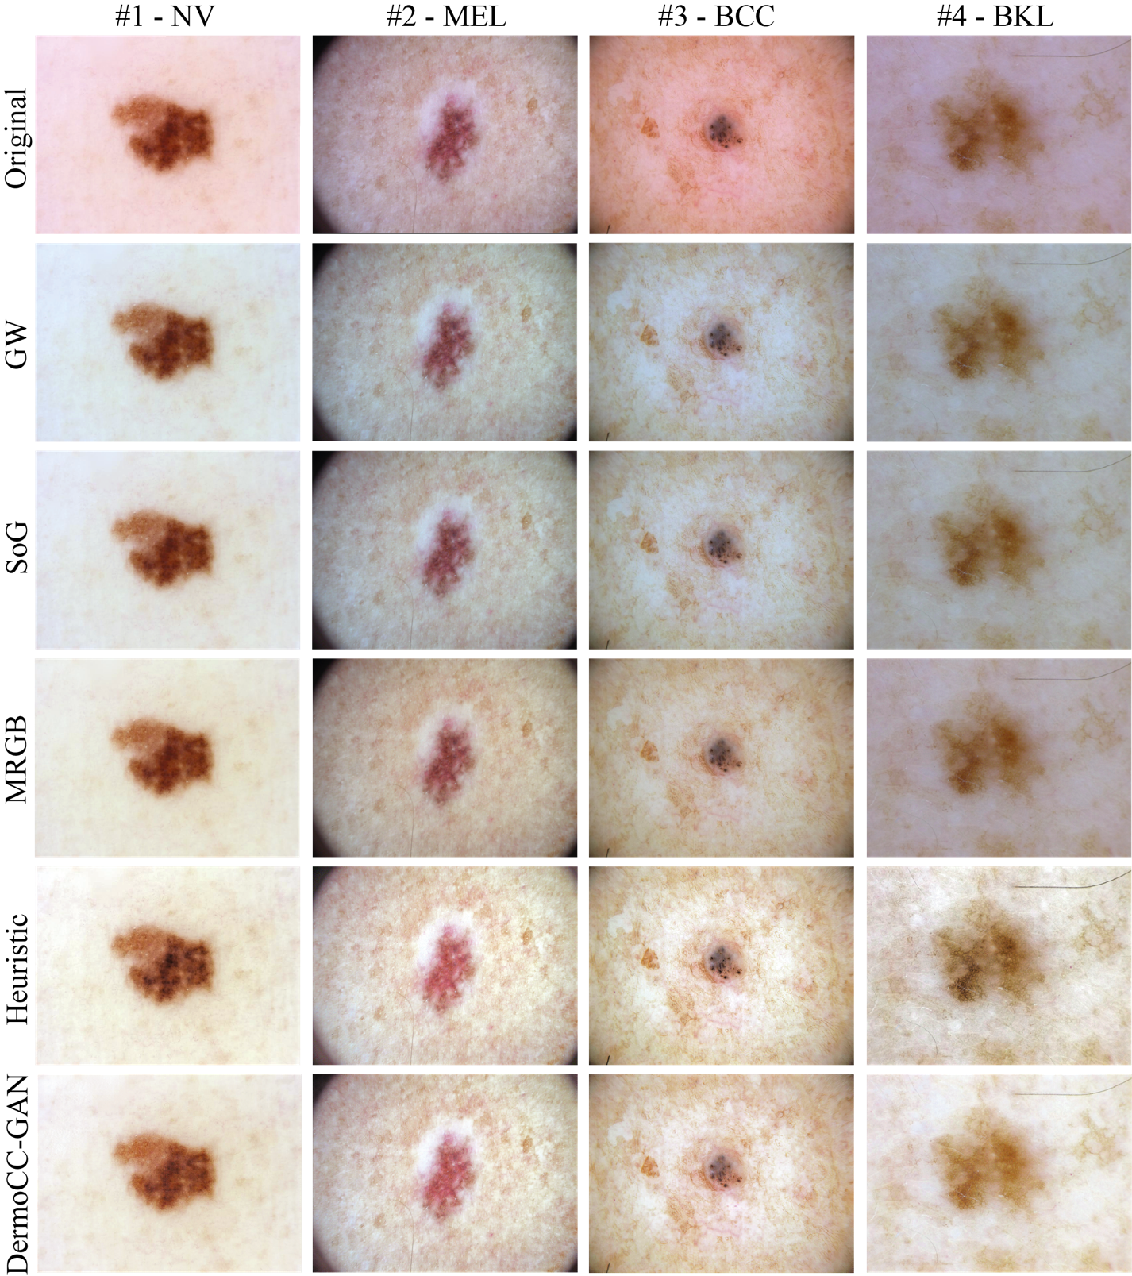

Fig. 6 Visual performance between the published papers for color normalization and the proposed method. Four dermatological images of the test set are used as an example. The original images are shown in the first row while compared methods are presented from the second row. GW: Gray World, SoG: Shades of Gray, MRGB: Max-RGB, Heuristic: custom color constancy algorithm (Section 2.2) used to train the DermoCC-GAN.

To test the constancy of the DermoCC-GAN under different illuminant conditions, we applied a random Hue-Saturation-Value (HSV) shift to the original image. This HSV shifting simulates different light sources applied to the same dermatological image (Figure 7). As can be seen, the color standardization provided by the DermoCC-GAN produces similar normalized images regardless of the starting illumination preset. This result suggests that the DermoCC-GAN is able to separate the illumination component of the image, which needs to be normalized, from the informative content of the skin lesion, which needs to be preserved. The full comparison with the state-of-the-art is reported in the Supplementary Material (Figure S5).

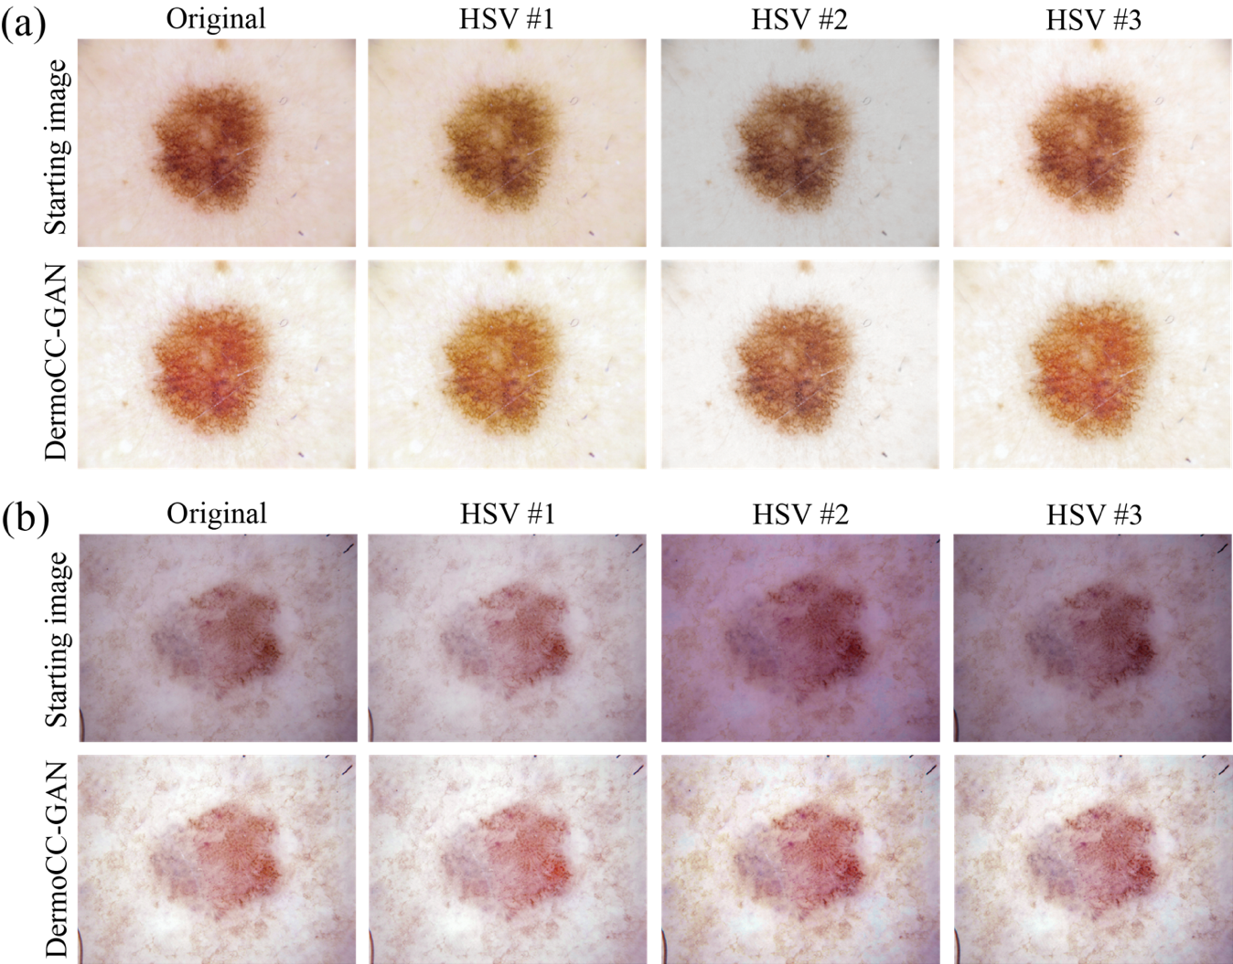

Fig. 7 DermoCC-GAN results under different illuminant conditions. Two images of the test set are used as an illustrative example. HSV shifts (HSV #1, #2 and #3) are applied to the original image to simulate different sources of illumination. The results of our methods in shown in the second row of panel (a) and (b).

3.2 Impact of DermoCC-GAN on CNN-based lesion classification and segmentation
Recent studies have demonstrated that color normalization is a useful pre-processing step to improve the performance of CAD systems for skin lesion classification and segmentation [12], [13], [44]. To assess the impact of the color constancy provided by DermoCC-GAN within a deep learning framework, we divided the HAM1000 dataset into train, validation and test sets for both classification and segmentation tasks (Table 3). Specifically, a DenseNet121 architecture is employed for classification while a UNET architecture is implemented for the segmentation task, as previously described in Section 2.4.

Table 3
Data partitioning for training and testing the deep learning networks for skin lesion classification and segmentation. AKIEC: Actinic keratoses, BCC: basal cell carcinoma, BKL: benign keratosis-like lesions, DF: dermatofibroma, MEL: melanoma, NV: melanocytic nevi, VASC: vascular lesions.

Lesion | Training | Validation | Testing
AKIEC | 229 | 33 | 65
BCC | 360 | 51 | 103
BKL | 769 | 110 | 220
DF | 81 | 11 | 23
MEL | 779 | 111 | 223
NV | 4694 | 670 | 1341
VASC | 100 | 14 | 28
Total images | 7012 | 1000 | 2003

For each color constancy algorithm (i.e., Gray World [14], Shades of Gray [15], Max-RGB [16] and DermoCC-GAN) and also for the original images, we trained and tested one classification network. Hence, five total networks were trained and tested, using the same parameters and changing only the input image which varied based on the color constancy algorithm. The performance of the DenseNet121 in the test set according to the normalization method employed as pre-processing is summarized in Table 4. The overall accuracy of the DenseNet121 in the training and validation sets is reported in the Supplementary Material. The network trained on DermoCC-GAN normalized images obtained the highest average accuracy (79.2%) and weighted accuracy (79.5%) in the test set. When considering the individual classes, it is important to point out how the same network obtained the best accuracy for the malignant classes (BCC: basal cell carcinoma and MEL: melanoma).

Table 4
Classification performance of the DenseNet121 in classifying skin lesion as a function of the applied pre-processing (TEST set). GW: Gray World, SoG: Shades of Gray, MRGB: Max-RGB. AKIEC: Actinic keratoses, BCC: basal cell carcinoma, BKL: benign keratosis-like lesions, DF: dermatofibroma, MEL: melanoma, NV: melanocytic nevi, VASC: vascular lesions.

Normalization method | AKIEC | BCC | BKL | DF | MEL | NV | VASC | Average accuracy | Weighted accuracy
Original images | 0.662 | 0.602 | 0.950 | 0.826 | 0.735 | 0.729 | 0.857 | 0.766 | 0.748
GW [14] | 0.600 | 0.777 | 0.941 | 0.783 | 0.722 | 0.769 | 0.893 | 0.783 | 0.779
SoG [15] | 0.569 | 0.621 | 0.864 | 0.870 | 0.771 | 0.784 | 0.964 | 0.562 | 0.777
MRGB [16] | 0.508 | 0.631 | 0.905 | 0.826 | 0.794 | 0.753 | 0.893 | 0.758 | 0.763
DermoCC-GAN | 0.585 | 0.835 | 0.809 | 0.826 | 0.803 | 0.796 | 0.893 | 0.792 | 0.795

Similarly, five UNET networks (one for each normalization method) were trained to quantify the impact of color constancy in the skin lesion segmentation task. The performance obtained for the test set are reported in Table 5. The network trained on DermoCC-GAN images exhibits excellent performance in segmenting skin lesions with an average dice of 90.9% and a weighted dice of 93.5%. Our method also achieves the highest dice score for 6 out of 7 skin lesions compared to previously published methods, and for the last skin lesion (i.e., basal cell carcinoma, BCC) the method shows the second-highest dice score. Similar results are obtained for the training and validation sets (see Supplementary Material).
A visual comparison of the segmentation performance is reported in Figure 8. As can be seen from the same figure, the increase in contrast of the image normalized with the DermoCC-GAN allows the segmentation network to better delineate the contour of the skin lesion.

Table 5
Segmentation performance of the UNET during lesion segmentation as a function of the applied pre-processing (TEST set). GW: Gray World, SoG: Shades of Gray, MRGB: Max-RGB. AKIEC: Actinic keratoses, BCC: basal cell carcinoma, BKL: benign keratosis-like lesions, DF: dermatofibroma, MEL: melanoma, NV: melanocytic nevi, VASC: vascular lesions.

Normalization method | AKIEC | BCC | BKL | DF | MEL | NV | VASC | Average dice | Weighted dice
Original images | 0.821 | 0.746 | 0.813 | 0.866 | 0.826 | 0.844 | 0.762 | 0.811 | 0.831
GW [14] | 0.861 | 0.795 | 0.911 | 0.895 | 0.919 | 0.940 | 0.832 | 0.879 | 0.922
SoG [15] | 0.866 | 0.837 | 0.907 | 0.922 | 0.924 | 0.945 | 0.855 | 0.893 | 0.928
MRGB [16] | 0.878 | 0.803 | 0.916 | 0.929 | 0.932 | 0.944 | 0.893 | 0.899 | 0.929
DermoCC-GAN | 0.888 | 0.827 | 0.929 | 0.934 | 0.935 | 0.948 | 0.903 | 0.909 | 0.935

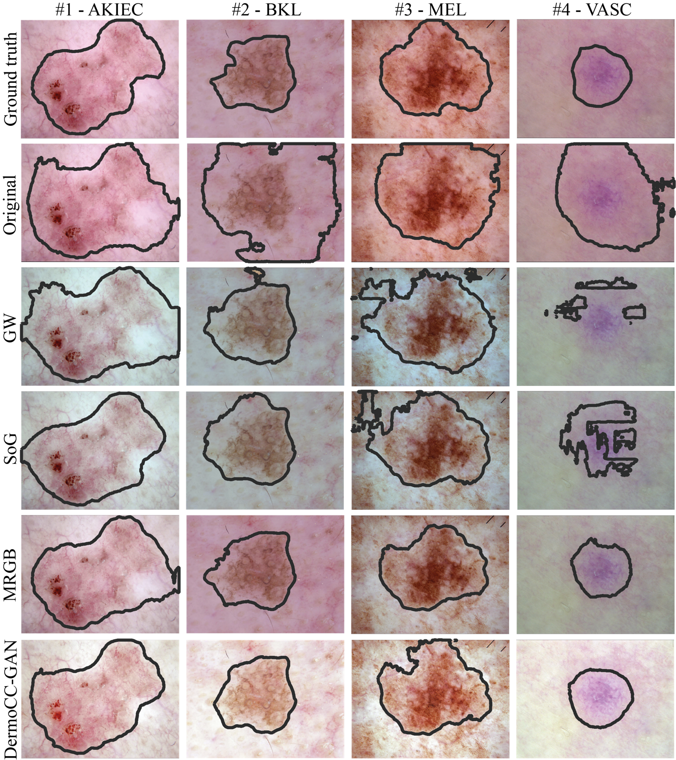

Fig. 8 Visual performance of the segmentation network trained with different color normalization algorithms. The first row illustrates the manual annotation for four different lesions. The compared methods are shown from the second row onwards. GW: Gray World, SoG: Shades of Gray, MRGB: Max-RGB. AKIEC: Actinic keratoses, BKL: benign keratosis-like lesions, MEL: melanoma, VASC: vascular lesions.

Finally, we compared the performance of our segmentation network with the ISIC 2018 Leaderboard (Task 1: Lesion Boundary Segmentation) [31]. For each image, a pixel-wise comparison of each predicted segmentation with the corresponding ground truth segmentation is made using the Jaccard index. The final score for each image is computed as a threshold of the Jaccard according to the following: score = 0, if the Jaccard index is less than 0.65; score = the Jaccard index value, otherwise. The mean of all per-image scores is taken as the final metric value for the entire dataset (Table 6).

Table 6
ISIC 2018 Leaderboards for lesion boundary segmentation.

Rank | Team | Approach Name | Primary Metric Value (Jaccard)
#1 | DermoCC-GAN (proposed) | Color constancy with GAN + segmentation with weighted loss function | 0.867
#2 | MT | MaskRcnn2+segmentation | 0.802
#3 | Holidayburned | ensemble_with_CRF_v3 | 0.799
#4 | Imsight | Automatic Skin Lesion Segmentation by DCNN | 0.799
#5 | Tencent Youtu Lab | Skin Lesion Segmentation with Adversarial Learning | 0.798

3.3 Dermatologist evaluation
Three experienced dermatologists (F.V., E.Z., V.T.) were involved in this study and rated the quality of the DermoCC-GAN normalized images. In particular, the three dermatologists provided a qualitative assessment ('negative', 'null', or 'relevant') on the impact of the normalized image on the total lesion diagnosis. The score 'Negative' was assigned to all images in which the normalization provided by DermoCC-GAN decreased the dermatologist’s confidence during diagnosis. The score 'Null' was given to all images where our normalization did not bring any additional information compared to the original image. Finally, the score 'Relevant' was assigned to all images in which the normalization process increased the confidence of the diagnosis. Fifty images from each class were randomly selected to perform this analysis. The result of the dermatologists' evaluation is shown in Figure 9. On average our normalization helped the dermatologists in 43% of cases, was irrelevant for about 54% and only in 3% of cases did it decrease the confidence of the diagnosis. It is worth noting that for all classes, especially for some benign lesions (BKL, DF, NV) and for all the malignant classes (BCC, MEL), the normalized image helps and supports the dermatologist in establishing the final diagnosis. To the best of our knowledge, this work is the first to demonstrate how a normalized image can also support a dermatologist's visual diagnosis.

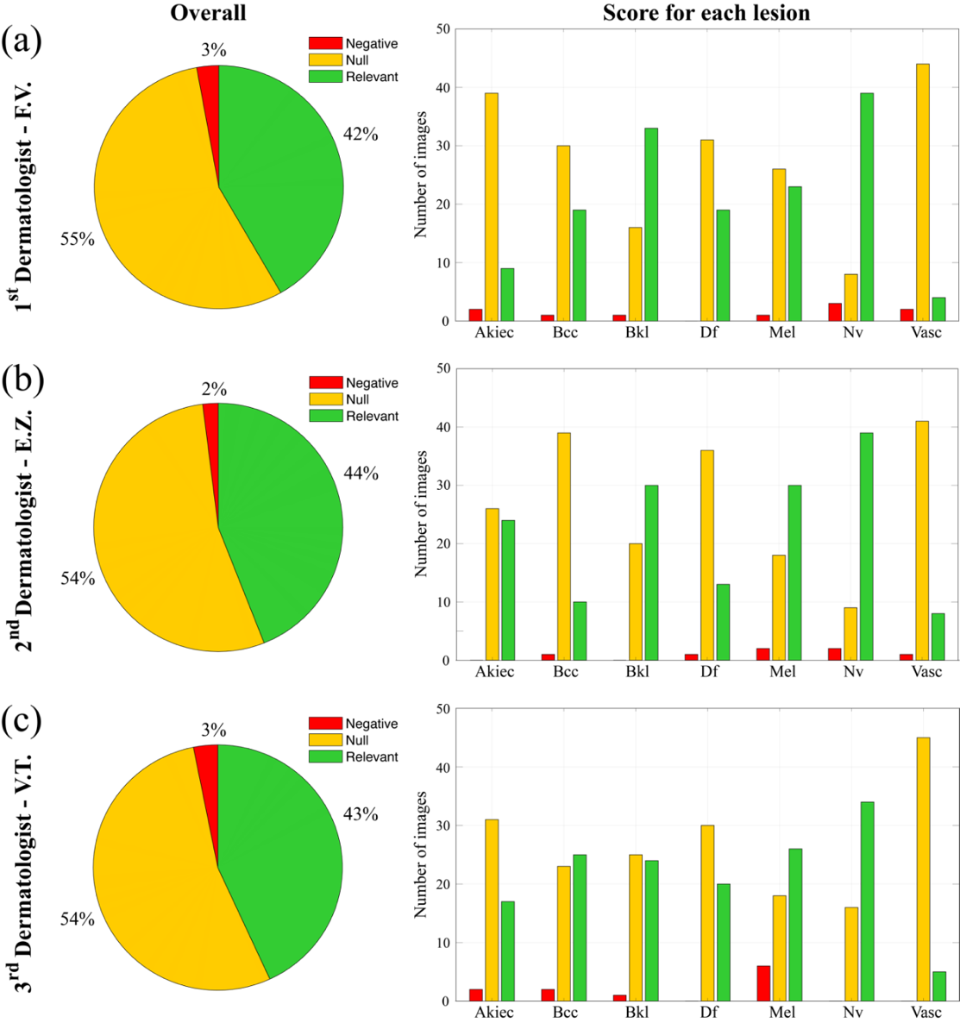

Fig. 9 Dermatologists’ evaluation of color normalization carried out by DermoCC-GAN. Three dermatologists provided a qualitative assessment ('negative', 'null', or 'relevant') on the impact of the normalized image on the final lesion diagnosis. AKIEC: Actinic keratoses, BCC: basal cell carcinoma, BKL: benign keratosis-like lesions, DF: dermatofibroma, MEL: melanoma, NV: melanocytic nevi, VASC: vascular lesions.

3.4 Extension to other datasets
Although the HAM10000 dataset collects dermatological images from different populations and acquired by different modalities [32], we decided to qualitatively test the reliability of our DermoCC-GAN on two other external datasets. In particular, we used a public database of skin lesion images [58] and a set of proprietary dermatological images used in our previous work [7]. Before testing the DermoCC-GAN, we resized each image to 512x512 pixels according to the input size of our GAN. Again, the GAN was very fast at processing dermatology images, with an average processing time of approximately 80 ms/image. As can be appreciated from Figure 10, which shows the normalization results on sample images coming from external datasets, the DermoCC-GAN method was able to effectively normalize the images coming from these datasets, which presented very different initial illumination preset. This result demonstrates a good generalization capability of DermoCC-GAN since, compared to other learning-based algorithms [59], [60], it was trained exclusively to process dermatological images. In fact, the heuristic algorithm employed to train DermoCC-GAN performs color constancy using assumptions based on dermatological images (Section 2.2)

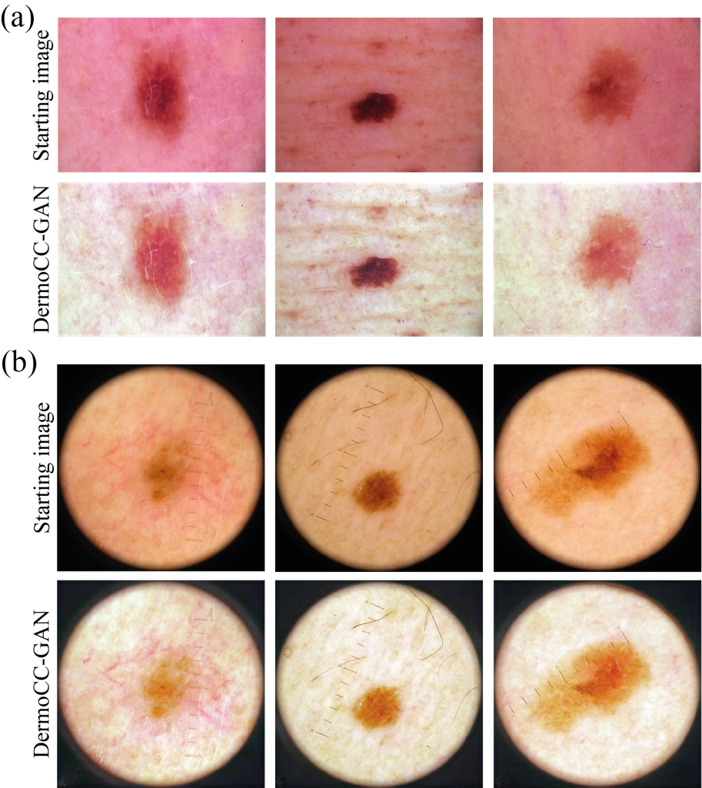

Fig. 10 Results of the DermoCC-GAN on (a) three public dermatological images [58] and on (b) three images acquired at the University of Eastern Piedmont (Novara, Italy).

4. Discussion
In this paper, we formulate the color constancy task in dermatological images as an image-to-image translation problem using GANs. A novel GAN-based approach is employed for generalized color constancy of dermatological images. The proposed strategy consists of two steps:
- develop a custom heuristic algorithm (Section 2.2) able to reduce the variability introduced by different sources of illumination in dermatological images acquired with a clinical dermatoscope and increase the local contrast of the image.
- train a specific GAN, called DermoCC-GAN, only on the images in which the heuristic algorithm provides optimal results, in order to create a reliable framework for color constancy.
The color constancy task is critical as the accuracy of the clinical diagnosis of skin lesions strongly depends on the quality of the dermatological images, which often comes down to the image contrast and illumination. The inherent illumination variability among images due to different types of acquisition devices and illuminant conditions can make diagnosis a challenge for both experienced dermatologists [61] and CAD systems [12], [13], [44].
The innovative approach presented here overcomes many previously described color constancy algorithms by making it possible to obtain a GAN that simulates a custom-made heuristic algorithm for dermatological image standardization without inheriting its limitations. In fact, all heuristic color constancy algorithms rely on the definition of some parameters or are based on some sort of starting assumption that is often not met, which compromises the final results especially when considering a large and varied database. The main advantage of our GAN-based color constancy algorithm is its being independent from the parameters of the heuristic algorithm on which it was trained (Sections 2.2.1 and 2.2.2). In fact, the DermoCC-GAN learns the domain transfer task (from original image to normalized image) without knowing the parameters on which the heuristic algorithm was optimized. DermoCC-GAN does not replicate the artifacts that the heuristic algorithm produces in some test images, but only emulates the strengths of the approach. Figure 11 show how the heuristic algorithm improperly transforms the dark pixels of the lesion to black pixels, creating wrong contrasts and patterns; instead, our the DermoCC-GAN performs a normalization that preserves the characteristics of the lesion (color and texture). Moreover, DermoCC-GAN is much faster than the custom-made heuristic algorithm (0.08 s vs. 4.8 s, respectively) since it relies only on simple convolutions. To the best of our knowledge, this is the first work that applies GANs for color constancy in dermatology, and more generally that uses the results of a heuristic algorithm to train a GAN in this research field.

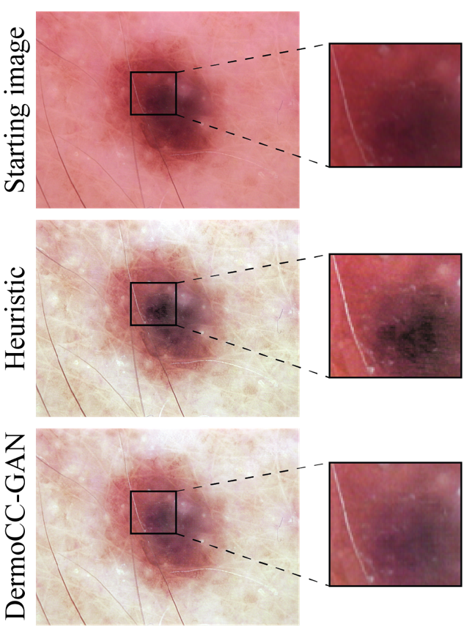
Fig. 11 Comparison between the heuristic algorithm and DermoCC-GAN for a test image. The heuristic algorithm creates erroneous contrasts within the lesion while DermoCC-GAN manages to preserve the color and texture of the lesion.

The DermoCC-GAN is developed and tested on a large and open-source dataset (HAM10000) and the results are compared with previously published color constancy algorithms (i.e., gray world, shades of gray, max-RGB) [14]–[16]. Our method shows the lowest NMI SD and NMI CV compared to state-of-the-art techniques for dermatological image color constancy algorithms in both the train and test datasets. As can be seen from Figure 6, DermoCC-GAN provides more stable and repeatable results when compared to existing approaches. Moreover, the DermoCC-GAN normalization process is also more consistent than the heuristic algorithm on which the GAN was trained because it is not constrained by its intrinsic parameters. To further verify the effectiveness of the proposed method, we qualitatively compared the results obtained by DermoCC-GAN with traditional histogram equalization techniques. The results are discussed in the Supplementary Materials and are shown in Figure S6.
While it is important for a color constancy algorithm for dermatological images to provide reliable results in terms of normalization consistency, it is even more fundamental to ensure that the obtained images enhance and improve the diagnosis process and do not hinder it. We analyzed this in-depth considering deep learning frameworks for segmentation and classification and also expert dermatologists’ opinion on if the obtained images helped their visual diagnosis or not. It is interesting to note how the network that employed the DermoCC-GAN normalization as preprocessing achieved the highest performance in both the segmentation and classification tasks (Table 4 and 5). The increased contrast on the DermoCC-GAN images helps the segmentation network, which achieves the best performance (average dice score above 90%). More importantly, the network that employed the DermoCC-GAN images as input achieved the best classification accuracy for malignant lesions (i.e., BCC, MEL). This suggests that the GAN normalization does not cause information loss within the skin lesion, but rather helps the network in identifying malignant cases. These results confirm the recent trend in deep learning challenges, where focus is put not so much on the network model that is employed but rather on data preparation and optimizing the input image [62]. Regarding the assessments made by expert dermatologists (Figure 9), all three expert dermatologists agreed that the normalized images improved the diagnosis for melanocytic nevi, which can often be confused for melanoma, and two out of the three experts agreed that the normalized images improved the diagnosis for melanoma. Although the ability to make the true diagnosis is proportional to the healthcare worker’s training and experience in dermoscopy, a possible variability linked to a subjective evaluation can also be typically observed. In our study, every evaluation was made in blind by each dermatologist (unaware of the judgement of the other two) and an overall complete agreement can be observed. This represents a further proof of the DermoCC-GAN benefit in helping the correct dermoscopy-based diagnosis of skin lesions.
This high performance is mainly due to the novel view of the color constancy problem via a generative end-to-end algorithm based on GANs. As the DermoCC-GAN is trained on a set of images where our heuristic algorithm works optimally, the results provided are more robust and stable when compared to existing approaches and also to even the heuristic algorithm on which the GAN was trained (Figure 6). In addition, the DermoCC-GAN results could also be exploited in data augmentation problems. Since GANs are widely used to perform data augmentation of small datasets or poorly represented lesions [29], having all images with the same illumination preset can make the generative task much easier and more consistent.
Despite the very promising results, DermoCC-GAN is not free of limitations. First of all, it is limited by the image dimensions, as the training and test images need to be the same size; secondly, it does still depend on the initial heuristic algorithm on which is trained, which must therefore be able to provide optimal results for a high number of images (around 1000) so that the GAN can generalize the entire approach.
Finally, our research group is planning to extend our dataset with images acquired from multiple centers and different types of dermoscope to further increase the robustness of the DermoCC-GAN. Moreover, the proposed methodology can be easily extended in the future to other medical imaging tasks such as color normalization or artifact correction, since it is based on the combination of a custom heuristic algorithm and a generative adversarial network.

5. Conclusion
This study demonstrates the feasibility and optimal results obtained when using a heuristic algorithm to train a GAN for color constancy in dermatological images. The proposed DermoCC-GAN generalizes the heuristic algorithm by learning higher-level features and demonstrates good results also on images where the heuristic algorithm fails. The results shown here underline the importance of data preparation and again demonstrate how a standardized and well-prepared input dataset can optimize both segmentation and classification results when considering a deep learning framework.
The color normalization and standardization that the DermoCC-GAN is able to provide does not depend on the starting illumination preset. Hence, the DermoCC-GAN is able to distinguish between the two most important features of the input image: the illumination component that needs to be normalized, and the informative content of the skin lesion which needs to be preserved.

Declaration of Competing Interest
The authors declare that they have no known competing financial interests or personal relationships that could have appeared to influence the work reported in this paper.

References
[1] G. P. Guy et al., “Vital signs: melanoma incidence and mortality trends and projections - United States, 1982-2030.,” MMWR. Morb. Mortal. Wkly. Rep., vol. 64, no. 21, pp. 591–6, 2015.
[2] B. Hazen, A. Bhatia, T. Zaim, and R. Brodell, “The clinical diagnosis of early malignant melanoma: expansion of the ABCD criteria to improve diagnostic sensitivity.,” Dermatol. Online J., vol. 5(2), no. 3, 1999.
[3] A. Rezvantalab, H. Safigholi, and S. Karimijeshni, “Dermatologist Level Dermoscopy Skin Cancer Classification Using Different Deep Learning Convolutional Neural Networks Algorithms,” arXiv Prepr. arXiv, Oct. 2018, doi: 10.48550/arxiv.1810.10348.
[4] S. K. Datta, M. A. Shaikh, S. N. Srihari, and M. Gao, “Soft Attention Improves Skin Cancer Classification Performance,” Lect. Notes Comput. Sci. (including Subser. Lect. Notes Artif. Intell. Lect. Notes Bioinformatics), vol. 12929 LNCS, pp. 13–23, 2021, doi: 10.1007/978-3-030-87444-5_2/FIGURES/2.
[5] E. Goceri, “Automated Skin Cancer Detection: Where We Are and the Way to the Future,” 2021 44th Int. Conf. Telecommun. Signal Process. TSP 2021, pp. 48–51, 2021, doi: 10.1109/TSP52935.2021.9522605.
[6] S. J. Coates, J. Kvedar, and R. D. Granstein, “Teledermatology: From historical perspective to emerging techniques of the modern era: Part I: History, rationale, and current practice,” J. Am. Acad. Dermatol., vol. 72, no. 4, pp. 563–574, 2015, doi: 10.1016/j.jaad.2014.07.061.
[7] F. Veronese et al., “The Role in Teledermoscopy of an Inexpensive and Easy-to-Use Smartphone Device for the Classification of Three Types of Skin Lesions Using Convolutional Neural Networks,” Diagnostics, vol. 11, no. 3, p. 451, 2021, doi: 10.3390/diagnostics11030451.
[8] P. Pala, B. S. Bergler-Czop, and J. M. Gwiżdż, “Teledermatology: idea, benefits and risks of modern age – a systematic review based on melanoma,” Postep. Dermatologii i Alergol., vol. 37, no. 2, pp. 159–167, 2020, doi: 10.5114/ada.2020.94834.
[9] S. Patel, J. V. Wang, K. Motaparthi, and J. B. Lee, “Artificial intelligence in dermatology for the clinician,” Clin. Dermatol., vol. 1, no. xxxx, 2021, doi: 10.1016/j.clindermatol.2021.03.012.
[10] C. Barata, J. S. Marques, and M. E. Celebi, “Improving dermoscopy image analysis using color constancy,” 2014 IEEE Int. Conf. Image Process. ICIP 2014, vol. 19, no. 3, pp. 3527–3531, 2014, doi: 10.1109/ICIP.2014.7025716.
[11] C. Barata, M. Ruela, M. Francisco, T. Mendonca, and J. S. Marques, “Two systems for the detection of melanomas in dermoscopy images using texture and color features,” IEEE Syst. J., vol. 8, no. 3, pp. 965–979, 2014, doi: 10.1109/JSYST.2013.2271540.
[12] W. F. Chabala and I. Jouny, “Comparison of Convolutional Neural Network Architectures on Dermastopic Imagery,” 2020 11th IEEE Annu. Ubiquitous Comput. Electron. Mob. Commun. Conf. UEMCON 2020, pp. 0928–0931, 2020, doi: 10.1109/UEMCON51285.2020.9298059.
[13] A. Mahbod, G. Schaefer, C. Wang, G. Dorffner, R. Ecker, and I. Ellinger, “Transfer learning using a multi-scale and multi-network ensemble for skin lesion classification,” Comput. Methods Programs Biomed., vol. 193, p. 105475, 2020.
[14] G. Buchsbaum, “A spatial processor model for object colour perception,” J. Franklin Inst., vol. 310, no. 1, pp. 1–26, 1980.
[15] G. D. Finlayson and E. Trezzi, “Shades of gray and colour constancy,” in Color and Imaging Conference, 2004, vol. 2004, no. 1, pp. 37–41.
[16] E. H. Land, “The Retinex Theory of Color Vision,” 1977.
[17] J. Von Kries, “Chromatic adaptation,” Sources Color Vis., pp. 145–148, 1970.
[18] O. Sidorov, “Conditional gans for multi-illuminant color constancy: Revolution or yet another approach?,” in Proceedings of the IEEE/CVF Conference on Computer Vision and Pattern Recognition Workshops, 2019, p. 0.
[19] D. H. Brainard and B. A. Wandell, “Analysis of the retinex theory of color vision,” JOSA A, vol. 3, no. 10, pp. 1651–1661, 1986.
[20] X. Hu, C.-W. Fu, L. Zhu, J. Qin, and P.-A. Heng, “Direction-aware spatial context features for shadow detection and removal,” IEEE Trans. Pattern Anal. Mach. Intell., vol. 42, no. 11, pp. 2795–2808, 2019.
[21] H. H. Choi and B. J. Yun, “Deep learning-based computational color constancy with convoluted mixture of deep experts (CMODe) fusion technique,” IEEE Access, vol. 8, pp. 188309–188320, 2020, doi: 10.1109/ACCESS.2020.3030912.
[22] V. Agarwal, A. V. Gribok, and M. A. Abidi, “Machine learning approach to color constancy,” Neural Networks, vol. 20, no. 5, pp. 559–563, Jul. 2007, doi: 10.1016/J.NEUNET.2007.02.004.
[23] A. Flachot, A. Akbarinia, H. H. Schütt, R. W. Fleming, F. A. Wichmann, and K. R. Gegenfurtner, “Deep neural models for color classification and color constancy,” J. Vis., vol. 22, no. 4, pp. 17–17, Mar. 2022, doi: 10.1167/JOV.22.4.17.
[24] M. Mirza and S. Osindero, “Conditional generative adversarial nets,” arXiv Prepr. arXiv1411.1784, 2014.
[25] C. Baur, S. Albarqouni, and N. Navab, “Generating highly realistic images of skin lesions with GANs,” Lect. Notes Comput. Sci. (including Subser. Lect. Notes Artif. Intell. Lect. Notes Bioinformatics), vol. 11041 LNCS, pp. 260–267, 2018, doi: 10.1007/978-3-030-01201-4_28.
[26] A. Ghorbani, V. Natarajan, D. Coz, and Y. Liu, “DermGAN: Synthetic generation of clinical skin images with pathology,” arXiv, pp. 155–170, 2019.
[27] P. Sedigh, R. Sadeghian, and M. T. Masouleh, “Generating Synthetic Medical Images by Using GAN to Improve CNN Performance in Skin Cancer Classification,” ICRoM 2019 - 7th Int. Conf. Robot. Mechatronics, no. ICRoM, pp. 497–502, 2019, doi: 10.1109/ICRoM48714.2019.9071823.
[28] Z. Qin, Z. Liu, P. Zhu, and Y. Xue, “A GAN-based image synthesis method for skin lesion classification,” Comput. Methods Programs Biomed., vol. 195, p. 105568, 2020, doi: 10.1016/j.cmpb.2020.105568.
[29] F. Pollastri, F. Bolelli, R. Paredes, and C. Grana, “Augmenting data with GANs to segment melanoma skin lesions,” Multimed. Tools Appl., vol. 79, no. 21–22, pp. 15575–15592, 2020, doi: 10.1007/s11042-019-7717-y.
[30] P. Das, A. S. Baslamisli, Y. Liu, S. Karaoglu, and T. Gevers, “Color constancy by GANs: An experimental survey,” arXiv, 2018.
[31] N. C. F. Codella et al., “Skin lesion analysis toward melanoma detection: A challenge at the 2017 International symposium on biomedical imaging (ISBI), hosted by the international skin imaging collaboration (ISIC),” Proc. - Int. Symp. Biomed. Imaging, vol. 2018-April, pp. 168–172, 2018, doi: 10.1109/ISBI.2018.8363547.
[32] P. Tschandl, C. Rosendahl, and H. Kittler, “Data descriptor: The HAM10000 dataset, a large collection of multi-source dermatoscopic images of common pigmented skin lesions,” Sci. Data, vol. 5, pp. 1–9, 2018, doi: 10.1038/sdata.2018.161.
[33] I. Liviu, H. R. Myler, and A. R. Weeks, “Practical considerations on color image enhancement using homomorphic filtering,” 1997.
[34] H. G. Adelmann, “Butterworth equations for homomorphic filtering of images,” Comput. Biol. Med., vol. 28, no. 2, pp. 169–181, 1998.
[35] C. N. Fan and F. Y. Zhang, “Homomorphic filtering based illumination normalization method for face recognition,” Pattern Recognit. Lett., vol. 32, no. 10, pp. 1468–1479, Jul. 2011, doi: 10.1016/j.patrec.2011.03.023.
[36] HViktorTsoi, “Shadow Highlight Correction.” https://gist.github.com/HViktorTsoi/8e8b0468a9fb07842669aa368382a7df#file-shadowhighlightcorrection-py
[37] X. Dai et al., “Intensity non-uniformity correction in MR imaging using residual cycle generative adversarial network,” Phys. Med. Biol., vol. 65, no. 21, p. 215025, 2020.
[38] M. Salvi, U. R. Acharya, F. Molinari, and K. M. Meiburger, “The impact of pre-and post-image processing techniques on deep learning frameworks: A comprehensive review for digital pathology image analysis,” Comput. Biol. Med., p. 104129, 2020.
[39] L. Wei, Y. Lin, and W. Hsu, “Using a generative adversarial network for ct normalization and its impact on radiomic features,” in 2020 IEEE 17th International Symposium on Biomedical Imaging (ISBI), 2020, pp. 844–848.
[40] I. Goodfellow et al., “Generative adversarial nets,” Adv. Neural Inf. Process. Syst., vol. 27, 2014.
[41] K. He, X. Zhang, S. Ren, and J. Sun, “Deep residual learning for image recognition,” in Proceedings of the IEEE conference on computer vision and pattern recognition, 2016, pp. 770–778.
[42] C. Li and M. Wand, “Precomputed real-time texture synthesis with markovian generative adversarial networks,” in European conference on computer vision, 2016, pp. 702–716.
[43] P. Salehi and A. Chalechale, “Pix2pix-based stain-to-stain translation: A solution for robust stain normalization in histopathology images analysis,” in 2020 International Conference on Machine Vision and Image Processing (MVIP), 2020, pp. 1–7.
[44] B. Hewitt, M. H. Yap, J. Ng, and M. Goyal, “The effect of color constancy algorithms on semantic segmentation of skin lesions,” Mar. 2019, p. 25. doi: 10.1117/12.2512702.
[45] M. Goyal, A. Oakley, P. Bansal, D. Dancey, and M. H. Yap, “Skin Lesion Segmentation in Dermoscopic Images with Ensemble Deep Learning Methods,” IEEE Access, vol. 8, pp. 4171–4181, 2020, doi: 10.1109/ACCESS.2019.2960504.
[46] G. Huang, S. Liu, L. Van der Maaten, and K. Q. Weinberger, “Condensenet: An efficient densenet using learned group convolutions,” in Proceedings of the IEEE conference on computer vision and pattern recognition, 2018, pp. 2752–2761.
[47] A. A. Adegun and S. Viriri, “FCN-Based DenseNet Framework for Automated Detection and Classification of Skin Lesions in Dermoscopy Images,” IEEE Access, vol. 8, pp. 150377–150396, 2020, doi: 10.1109/ACCESS.2020.3016651.
[48] P. Carcagnì et al., “Classification of skin lesions by combining multilevel learnings in a DenseNet architecture,” Lect. Notes Comput. Sci. (including Subser. Lect. Notes Artif. Intell. Lect. Notes Bioinformatics), vol. 11751 LNCS, pp. 335–344, 2019, doi: 10.1007/978-3-030-30642-7_30/FIGURES/3.
[49] A. Krizhevsky, I. Sutskever, and G. E. Hinton, “Imagenet classification with deep convolutional neural networks,” in Advances in neural information processing systems, 2012, pp. 1097–1105.
[50] D. Sarkar, R. Bali, and T. Ghosh, Hands-On Transfer Learning with Python: Implement advanced deep learning and neural network models using TensorFlow and Keras. Packt Publishing Ltd, 2018.
[51] E. Goceri, “Image Augmentation for Deep Learning Based Lesion Classification from Skin Images,” 4th Int. Conf. Image Process. Appl. Syst. IPAS 2020, pp. 144–148, Dec. 2020, doi: 10.1109/IPAS50080.2020.9334937.
[52] D. N. T. Le, H. X. Le, L. T. Ngo, and H. T. Ngo, “Transfer learning with class-weighted and focal loss function for automatic skin cancer classification,” arXiv Prepr. arXiv, pp. 1–7, 2020.
[53] W. Chen, W. Shen, L. Gao, and X. Li, “Hybrid Loss-Constrained Lightweight Convolutional Neural Networks for Cervical Cell Classification,” Sensors, vol. 22, no. 9, 2022, doi: 10.3390/s22093272.
[54] M. Salvi et al., “Fully automated quantitative assessment of hepatic steatosis in liver transplants,” Comput. Biol. Med., vol. 123, no. March, p. 103836, 2020, doi: 10.1016/j.compbiomed.2020.103836.
[55] A. Basavanhally and A. Madabhushi, “EM-based segmentation-driven color standardization of digitized histopathology,” in Medical Imaging 2013: Digital Pathology, 2013, vol. 8676, p. 86760G.
[56] M. Grandini, E. Bagli, and G. Visani, “Metrics for multi-class classification: an overview,” arXiv Prepr. arXiv2008.05756, 2020.
[57] K. H. Zou et al., “Statistical Validation of Image Segmentation Quality Based on a Spatial Overlap Index,” Acad. Radiol., vol. 11, no. 2, pp. 178–189, 2004, doi: 10.1016/S1076-6332(03)00671-8.
[58] V. Rotemberg et al., “A patient-centric dataset of images and metadata for identifying melanomas using clinical context,” Sci. data, vol. 8, no. 1, pp. 1–8, 2021.
[59] C.-Y. Li, M. Zhang, S.-B. Gao, and Y.-J. Li, “Improving color constancy by discounting the variation of camera spectral sensitivity,” JOSA A, Vol. 34, Issue 8, pp. 1448-1462, vol. 34, no. 8, pp. 1448–1462, Aug. 2017, doi: 10.1364/JOSAA.34.001448.
[60] Ç. Aytekin, J. Nikkanen, and M. Gabbouj, “A Data Set for Camera-Independent Color Constancy,” IEEE Trans. Image Process., vol. 27, no. 2, pp. 530–544, Feb. 2018, doi: 10.1109/TIP.2017.2764264.
[61] A. Finnane, K. Dallest, M. Janda, and P. Soyer, “Teledermatology for the Diagnosis and Management of Skin Cancer A Systematic Review,” JAMA Dermatology, vol. 153, no. 3, pp. 319–327, 2017, doi: 10.1001/jamadermatol.2016.4361.
[62] S. E. Whang and J.-G. Lee, “Data collection and quality challenges for deep learning,” Proc. VLDB Endow., vol. 13, no. 12, pp. 3429–3432, 2020.

