Dimensional transitions in creeping materials due to nonlinearity and microstructural disorder
Gianni NICCOLINI¹, Alessio RUBINO¹, Alberto CARPINTERI¹
¹Department of Structural, Geotechnical and Building Engineering,
Politecnico di Torino, Corso Duca degli Abruzzi 24, 10129 Torino, Italy
Email: gianni.niccolini@polito.it, alessio.rubino@polito.it, alberto.carpinteri@polito.it
Abstract
The transition from extremely brittle to very ductile behaviours of creeping materials is discussed, where analogies with power-law hardening materials are pointed out. Considering Norton’s Law as a viscous constitutive law, it is possible to define a generalized stress-intensity factor $K^{c}$ ―characterizing the intermediate asymptotic behaviour under steady-state creep conditions― with physical dimensions depending upon the Norton stress exponent $n$. In the two limit cases of creep resistant materials ($n≅1$) and creep sensitive materials ($n≫1$), $K^{c}$ assumes respectively the dimensions of an elastic stress-intensity factor ($FL^{{-3}/2}$) and of a stress ($FL^{-2}$). Such a dimensional transition, with consequent stress-singularity attenuation, is completely analogous to that occurring through the introduction of a fractal stress-intensity factor ${\left(K^{c}\right)}^{*}$, when the influence of microstructural disorder is considered.
Keywords: creep; creep crack growth; brittle fracture; plastic flow collapse; material nonlinearity; microstructural disorder; fractals; dimensional transition.

Introduction
Early efforts in fracture mechanics are represented by the so-called linear elastic fracture mechanics (LEFM), where only linear elastic materials under quasi-static conditions were considered. In this respect, it is worthwhile pointing out that a typical example of quasi-static loading is a conventional tensile test within the linear elastic range, where the specimen, although subjected to a time-dependent deformation process, experiences in reality a sequence of states of equilibrium.
Subsequent advances in fracture mechanics considered the behaviour of nonlinear time-independent materials, i.e. plastic deformation under quasi-static conditions, thus constituting the domain of elastic-plastic fracture mechanics (EPFM) [1-3].
Later, fracture mechanics included time as a variable (time dependent fracture mechanics, or TDFM [4-5]) so as to consider the behaviour of time-dependent materials, such as viscoelastic and viscoplastic materials, where the quasi-static hypothesis must be abandoned. As regards the time-dependent behaviour, the attention is here focused on creeping materials, which exhibit elastic, plastic, and viscous components of response, and display both temperature and time-dependent relationships between applied stress and resultant strain [6].
Elastic-plastic and time-dependent fracture mechanics are sometimes grouped in the more general heading of nonlinear fracture mechanics, bridging the gap between LEFM –which cannot predict another crisis different from the brittle fracture, or separation– and limit load analysis, where plastic flow collapse is the governing failure mechanism. Something analogous occurs in creeping materials, whereby a transition is observed from extremely brittle circumstances –in which an elastic stress distribution is preserved at the crack tip and failure may occur by creep crack growth– to very ductile situations, where failure is essentially due to net-section rupture of the uncracked ligament [7].
Therefore, a number of fracture mechanics parameters have been proposed to characterize crack-tip stress conditions and crack growth rates, such as the elastic stress-intensity factor $K$, restricted to very brittle circumstances, and the reference stress $σ_{ref}$ in case of extreme ductility. The brittle-to-ductile transition, represented by materials with intermediate values of hardening exponent $n_{0}$ and Norton stress exponent $n$, is traditionally described in terms of the energetic integrals $J$ and $C^{*}$. More recently, extensive work has been devoted beyond the limits of classical one-parameter fracture mechanics, and a two-parameter approach, either $J-Q$ or $C^{*}-Q$, has been proposed to describe the effect of crack-tip constraint on the stress field for finite cracked bodies [8]. The parameter $Q$ can be estimated as the deviation of the crack-tip stress distribution from that based upon possible reference fields, i.e the HRR field or the corresponding creep stress field. Specifically for creeping materials, numerical and experimental studies recently reported in the literature illustrate the dependence of $Q$ on the loading configuration [9-11], crack depth [12-14] (in-plain constraint effects), and specimen thickness (out-of-plain constraint effects) [15-16].
It is well-known that when a single parameter describes the crack-tip conditions, a critical value of this parameter, i.e. the fracture toughness, is independent of specimen size. When the single-parameter assumption breaks down, fracture toughness becomes size-dependent, and the structural behaviour cannot be predicted from small scale fracture toughness tests [17].
A unified characterization of the crack-tip stress field for power-law hardening materials was proposed by Carpinteri [18], who introduced a plastic stress-intensity factor, $K^{p}$, directly connected to the $J$-integral. The physical dimensions of $K^{p}$ are dependent upon the Ramberg–Osgood hardening exponent, $n_{0}$, so as to range between those of an elastic stress-intensity factor $\left(\left[F\right]{\left[L\right]}^{-3/2}\right)$ and those of a stress $\left(\left[F\right]{\left[L\right]}^{-2}\right)$. This clearly illustrates the transition from brittle separation to plastic collapse by increasing the constitutive non-linearity of the material.
Later, a relevant step towards a one-parameter approach, covering size-scale effects, was taken for linear elastic materials with disordered microstructure, wherein tortuous crack profiles were modeled by fractal sets [19]. In this case, fractal geometry and renormalization group theory were used to explain the scaling effect experimentally observed on the fracture toughness, increasing with specimen (crack) size [20-22]. In this regard, it was possible to define a generalized stress-intensity factor, $K^{*}$, with anomalous physical dimensions dependent upon the fractal dimension $2+d_{\text{G}}$ of the fracture surface [21]. The fractal stress-intensity factor $K^{*}$ turns out to be a size-independent parameter, namely a true material constant. In the limit case of extremely disordered materials, the stress-singularity at the crack tip was found to vanish, and $K^{*}$ to assume the physical dimensions of stress.
This led to establish that analogous dimensional transitions for generalized stress-intensity factors, $K^{p}$ and $K^{*}$, occur in power-law hardening materials with smooth cracks, and in linear elastic materials with fractal cracks. The scaling exponents governing the two phenomena are $n_{0}$ and $d_{\text{G}}$, respectively.
Purpose of the present paper is to analyze the transition from brittle fracture to ductile collapse of power-law hardening materials and creeping materials under a unifying perspective, by introducing a creep stress-intensity factor, $K^{c}$, in the same way as $K^{p}$. For both classes of materials, the combined effects of microstructural disorder and material non-linearity are discussed.

Crack-tip parameters in fracture mechanics
A review is made of various parameters for characterizing crack-tip stress and strain fields in a solid subjected to a remote tensile stress.
When LEFM is applicable, the well-known Irwin’s solution provides $r^{{-1}/2}$-type near-tip singular stress distributions:
$$σ_{ij}∝{K r}^{-\frac{1}{2}} , (1)$$
where $r$ is the distance from the crack tip and $K$ the elastic stress-intensity factor.
When the stress-strain response is nonlinear, the power-law hardening Ramberg-Osgood stress-strain law (Fig. 1) can be considered as a constitutive model:

$$ε=\frac{σ}{E}+αε_{y}{\left(\frac{σ}{σ_{y}}\right)}^{n_{0}}≃A_{0} σ^{n_{0}} , (2)$$
where $σ_{y}$ is the yield stress, $E$ the Young’s modulus, $ε_{y}={σ_{y}}/E$, $α$ and $n_{0}$ dimensionless material constants,$A_{0}≡{αε_{y}}/{{σ_{y}}^{n_{0}}}$.

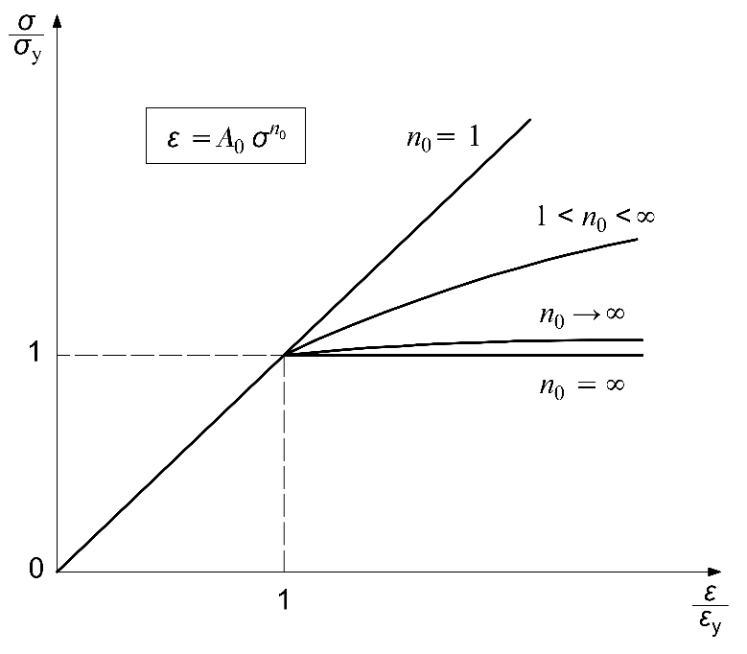
Fig. 1. Power-law hardening Ramberg-Osgood stress-strain law.
Under such conditions, the HRR solution [23-24] provides the near-tip singular stress distribution:
$$σ_{ij}∝{\left(\frac{J}{A_{0}I_{n_{0}}}\right)}^{\frac{1}{n_{0}+1}}r^{-\frac{1}{n_{0}+1}} , (3)$$
where $J$ is the Rice’s contour integral [1], and $I_{n_{0}}$ a well-known dimensionless function of $n_{0}$.
As Eq.(3) makes evident, for ductile materials the $J$-integral acquires significance as the dominating crack-tip parameter instead of $K$, and the stress-singularity proves to be a function of the hardening exponent $n_{0}$.
When the time-dependent mechanical behaviour of creeping materials must be considered, neither $K$ nor $J$ could adequately characterize the crack tip situation. This is true when near-tip stresses relax with time due to creep deformation, and the size of the creep zone increases before crack propagation (Fig. 2).

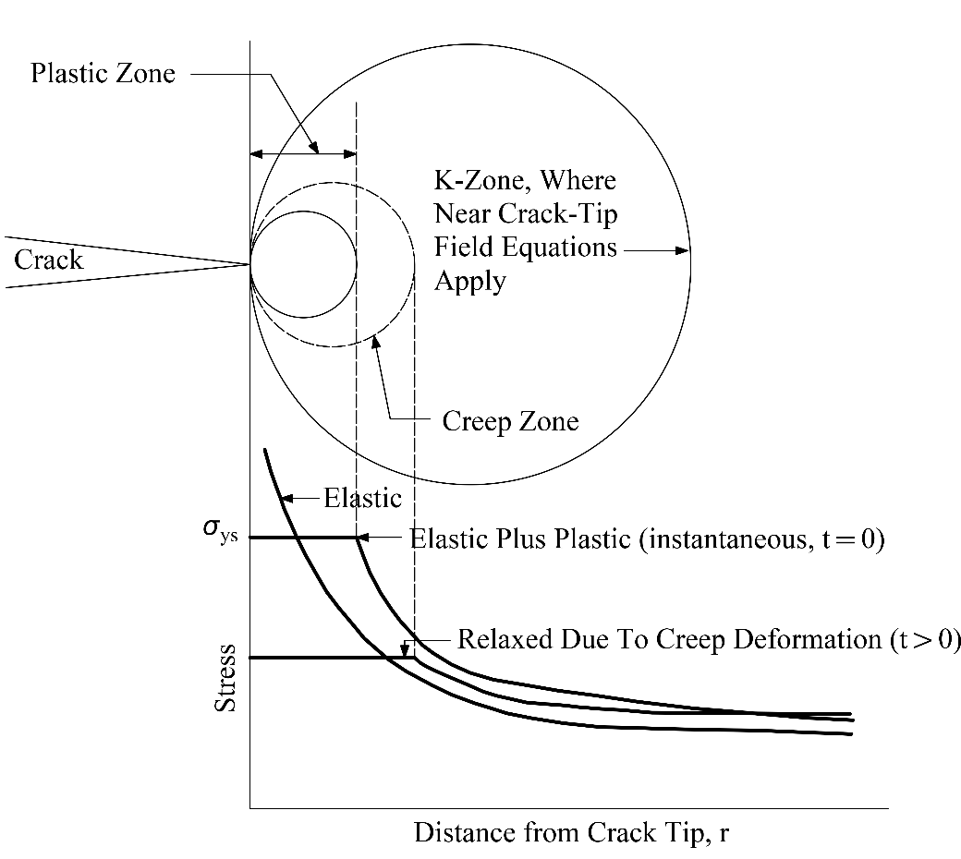

Fig. 2. Schematic representation of the deformation zones ahead of the crack tip and the associated crack-tip stress field.

Under such conditions, a field parameter, termed $C^{*}$ by Nikbin et al. [25] and by Landes and Begley [26], was introduced as the creep equivalent of the $J$-integral. Without further notice we will adopt the convention of denoting the creep fracture mechanics parameter $C^{*}$ with the symbol $\dot{J}$ (which clearly does not represent here ${dJ}/{dt}$) so as to avoid confusion with the fractal notation. Recognizing that the relationship between strain and stress in power-law hardening materials (Eq.(2)) is analogous to the Norton’s law [6,27], which relates stress and strain rates in creeping materials:
$\dot{ε}=A σ^{n}$, (4)
the crack-tip stress field in the presence of extensive creep was derived by analogy with the HRR solution:
$$σ_{ij}∝{\left(\frac{\dot{J}}{AI_{n}}\right)}^{\frac{1}{n+1}}r^{-\frac{1}{n+1}}. (5)$$
where the power of the singularity strictly depends on the stress sensitivity of creep $n$.
The Norton law (4) for materials undergoing secondary creep (steady-state creep conditions) is an example of power law, with the inherent property of self-similarity. Self-similarity solutions not only describe the behaviour of a phenomenon reproducing itself on different time and space scales, but also describe the ‘intermediate asymptotic’ behaviour of these solutions in the region where they have ceased to depend on the details of the initial (primary creep) and boundary conditions, and the influence of the instability (tertiary creep) has not yet intruded [28].
By comparing the LEFM description of the crack-tip stress field given by Eq.(1) with analogous formulations accounting for the role of plasticity and creep (Eqs.(3) and (5)), it is apparent that material nonlinearities involve an attenuation of the inverse square-root singularity, as the exponents $n_{0}$ and $n$ increase. The latter are found to range respectively between 1 and 10 and between 1 and 15 (Smith and Webster [7] reported that the stress sensitivity of creep, $n$, lies typically in the range 3-15 for metals, and it can be 1 for polymers).
It is possible to formulate a description of this intermediate asymptotic behaviour in terms of stress-intensity factor, also in the presence of extensive plastic or creep deformation in the uncracked ligament.
A plastic stress-intensity factor, $K^{p}$, can be put in connection with the $J$-integral [18, 29]:
$$K^{p}={{σ_{y}\left(\frac{EJ}{{{ασ}_{y}}^{2}I_{n_{0}}}\right)}^{\frac{1}{n_{0}+1}}≡{\left(\frac{J}{A_{0}I_{n_{0}}}\right)}^{\frac{1}{n_{0}+1}}}^{}. (6)$$

Likewise, it is possible to define a creep stress-intensity factor, $K^{c}$ in terms of $\dot{J}$:
$$K^{c}={\left(\frac{\dot{J}}{AI_{n}}\right)}^{\frac{1}{n+1}}. (7)$$
Both generalized stress-intensity factors, $K^{p}$ and $K^{c}$, present physical dimensions depending upon the related stress exponent:
$$\left[K^{p}\right]=\left[F\right]{\left[L\right]}^{-\frac{2n_{0}+1}{n_{0}+1}}, (8a)$$

$$\left[K^{c}\right]=\left[F\right]{\left[L\right]}^{-\frac{2n+1}{n+1}}. (8b)$$

In correspondence to the two limit cases ($n_{0}=1$ or $n=1$) and $(n_{0}≫1$ or $n≫1$), two extreme situations can be identified.
When materials are linear elastic $(n_{0}=1)$ or able to resist large creep deformations $(n=1)$, the generalized stress-intensity factors have the canonical dimensions $\left[F\right]{\left[L\right]}^{-3/2}$, and the elastic stress distribution is preserved at the crack tip with LEFM singularity. In the latter circumstance, crack growth rates are so high that the specimen always remains in small-scale creep condition. Such behaviour is also termed creep-brittle as failure is essentially by separation collapse (fracture) [30-31].
When materials are rigid-plastic ($n_{0}≫1$) or highly susceptible to creep deformations ($n≫1$), the stress-intensity factor tends to assume the physical dimensions of a stress, i.e. $\left[F\right]{\left[L\right]}^{-2}$, and the stress singularity disappears due to complete stress redistribution. In the latter creep-ductile circumstance, crack growth rates are so low that failure is essentially by net section failure of the uncracked ligament, which is completely engulfed by the creeping zone (ductile collapse) [32-33].
For intermediate values of $n_{0}$ and $n$, failure can occur by a combination of brittle fracture and net section collapse, where stress and strain, or strain rate, fields are characterized by $J$ (or $K^{p}$) and $\dot{J}$ (or $K^{c}$), respectively. As regards creeping materials, in the current scientific literature the creep $\dot{J}$-integral is widely used as a characterizing parameter for creep crack growth rate (CCGR) [5, 25-27, 34-36], and the related dependence of CCGR on loading configuration [9-11], crack-size [12-14], and specimen thickness [15-16] are interpreted in the framework of the so-called constraint effects. Fig. 3 shows a schematic of the creep deformation zone under which creep crack growth occurs, varying the creep sensitivity $n$.
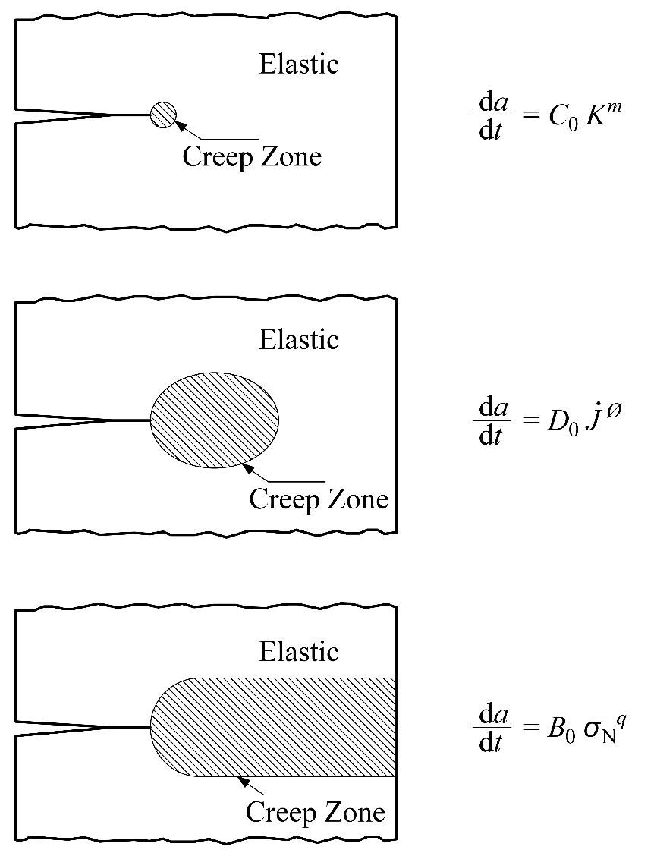

Fig. 3. Schematic representation of the levels of creep deformation and characterization of crack growth rate ${da}/{dt}$ by the related crack-tip parameter: $K$ for $n=1$, $\dot{J}$ for $n>1$, and $σ_{N}$ (net section stress) for $n≫1$.

Effect of microstructural disorder on fracture mechanics parameters
Considering the microstructure of nonlinear materials, a RG transformation can be applied on the energy dissipation domain, which is modeled by a fractal crack (Fig. 4).

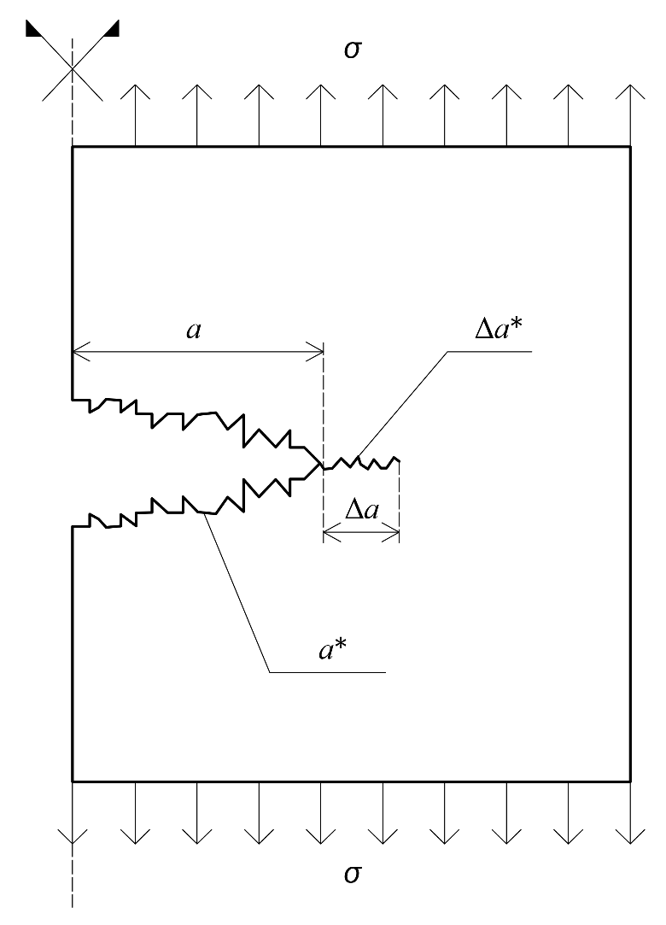

Fig. 4. Representation of a fractal crack.

When a cracked body of power-law hardening material is subjected to monotonic loading, the $J$-integral is also an energy parameter, representing the rate of decrease in potential energy per unit crack advancement. Since the potential energy $∆U$ released by crack growth, as a macro-parameter, is invariant with respect to the observation scale, the following equalities hold:

$$-∆U=J_{0 }{∆A}_{0}=J_{1 }{∆A}_{1}=…=J_{n }{∆A}_{n}=… =J_{∞ }{∆A}_{∞}. (9)$$

The first scale of observation is the macroscopic one, i.e. $J_{0 }{∆A}_{0}=J ∆A$, being $∆A$ the incremental crack area, and the asymptotic scale of observation is the microscopic one, i.e. $J_{∞ }{∆A}_{∞}= J^{*}{∆A}^{*}$, being ${∆A}^{*}$ the measure of the fractal set representing the irregular fracture surface and $J^{*}$ the renormalized $J$-integral.
In case of a through-thickness cracked body, equating the extreme members of Eq.(9) yields [37]:

$$J=J^{*}\frac{{∆A}^{*}}{∆A}=J^{*}\frac{{∆a}^{*}}{∆a}=J^{*}{\left(∆a\right)}^{d_{\text{G}}}, (10)$$

where $∆a$ denotes the projected length of the macroscopic crack increment and ${∆a}^{*}≡{\left(∆a\right)}^{1+d_{\text{G}}}$ the fractal measure of crack profile (see Fig. 4).
In case of creeping materials, an energy rate interpretation of $\dot{J}$ is possible by considering two identically loaded bodies with incrementally differing crack lengths $a$ and $a+∆a$. Taking the difference $∆\dot{U}$ of the stress-power input between the two bodies ―entirely dissipated by creep as cracks are assumed to be stationary― the scaling of $\dot{J}$ is obtained by a RG procedure:

$$-∆\dot{U}={\dot{J}}_{0 }{∆A}_{0}={\dot{J}}_{1 }{∆A}_{1}=…={\dot{J}}_{n }{∆A}_{n}=… ={\dot{J}}_{∞ }{∆A}_{∞}. (11)$$

In analogy with the above, we get:

$$\dot{J}={\dot{J}}^{*}{\left(∆a\right)}^{d_{\text{G}}}. (12)$$

As a consequence of the fractality, Eqs.(10) and (12) show that the energy parameters $J$ and $\dot{J}$ turn out to be increasing functions of the crack length, whereas the renormalized quantities, $J^{*}$ and ${\dot{J}}^{*}$, are material constants. These achievements, implying that crack resistance increases during propagation, represent a natural extension to nonlinear materials of the scaling properties deduced in LEFM for ${\text{G}}_{F}$.
The failure behaviour due to competing nonlinearities, coming from microstructural disorder and material constitutive laws, can be examined either combining Eqs.(6) and (10) or Eqs.(7) and (11):

$$K^{p}={\left(\frac{J^{*}}{A_{0}I_{n_{0}}}\right)}^{\frac{1}{n_{0}+1}}{\left(∆a\right)}^{ \frac{d_{\text{G}}}{n_{0}+1}}≡{\left(K^{p}\right)}^{*}{\left(∆a\right)}^{ \frac{d_{\text{G}}}{n_{0}+1}} , (13a)$$
$$K^{c}={\left(\frac{{\dot{J}}^{*}}{A{ I}_{n}}\right)}^{\frac{1}{n+1}}{\left(∆a\right)}^{ \frac{d_{\text{G}}}{n+1}}≡{\left(K^{c}\right)}^{*}{\left(∆a\right)}^{ \frac{d_{\text{G}}}{n+1}} . (13b)$$

The crack-size independent parts of these expressions, or fractal stress-intensity factors, ${\left(K^{p}\right)}^{*}$ and ${\left(K^{c}\right)}^{*}$, present the following physical dimensions:

$$\left[{\left(K^{p}\right)}^{*}\right]=\left[F\right]{\left[L\right]}^{-\frac{2n_{0}+1+d_{\text{G}}}{n_{0}+1}}, (14a)$$

$$\left[{\left(K^{c}\right)}^{*}\right]=\left[F\right]{\left[L\right]}^{-\frac{2n+1+d_{\text{G}}}{n+1}}. (14b)$$

Thus, generalizing Irwin’s solutions, the near-tip stress fields for power-law hardening and creeping materials can be written respectively as:

$$σ_{ij}∝{\left(K^{p}\right)}^{*} r^{-\frac{1-d_{\text{G}}}{n_{0}+1}}, (15a)$$
$$σ_{ij}∝{\left(K^{c}\right)}^{*} r^{-\frac{1-d_{\text{G}}}{n+1}}. (15b)$$

Then, increasing $n_{0}$ (or $n$) from 1 to $∞$ or $d_{\text{G}}$ from 0 to 1 provides an attenuation of the stress singularity, respectively due to extensive plastic (creep) deformation or diffused microcracking. That means an attenuation in the fracture severity and, consequently, a more ductile behaviour for nonlinear and disordered materials.
As regards the critical values of Eqs.(13), i.e. the generalized fracture thoughnesses, $K_{C}^{p}$ and $K_{C}^{c}$, crack-size dependencies are apparent. However, this size-scale effect vanishes as ductility increases ${(n}_{0}$ or $n≫1$) or fractality disappears ${(d}_{\text{G}}→0)$. In particular, for a cracked structure of a rigid-plastic material, the plastic fracture thoughness goes to coincide with the yield strength $σ_{y}$, as Eq.(6) makes evident.
For extremely creep-ductile materials, $K_{C}^{c}$ is likewise expected to coincide with a critical stress acting on the remaining ligament. Actually, the reference stress concept was experimentally found to be more appropriate when $n≫ 1$.
In general, a fracture criterion based on a renormalized, size-independent fracture toughness may be the only way to preserve the single-parameter assumption.

Discussion and conclusions
The previous discussion can be summarized by identifying the following limit cases:

a)
$$n_{0}=1 ⇒ \left[{\left(K^{p}\right)}^{*}\right]=\left[F\right]{\left[L\right]}^{-\frac{3+d_{\text{G}}}{2}} , σ_{ij} α r^{-\frac{1-d_{\text{G}}}{2}}, (16a)$$

$$n=1 ⇒ \left[{\left(K^{c}\right)}^{*}\right]=\left[F\right]{\left[L\right]}^{-\frac{3+d_{\text{G}}}{2}} , σ_{ij} α r^{-\frac{1-d_{\text{G}}}{2}}. (16b)$$

The presence of disorder (d_{G} > 0) introduces a certain ductility in the failure behaviour of linear elastic ($n_{0}=1$) and creep-brittle materials $(n=1$), since the energy dissipation on the developing fractal crack is intermediate between surface energy dissipation (according to LEFM) and volume energy dissipation (according to plastic limit analysis and damage mechanics).

b)
$$d_{\text{G}}=0 ⇒ \left[{\left(K^{p}\right)}^{*}\right]=\left[F\right]{\left[L\right]}^{-\frac{2n_{0}+1}{n_{0}+1}} , σ_{ij} α r^{-\frac{1}{n_{0}+1}} , (17a)$$

$$d_{\text{G}}=0 ⇒ \left[{\left(K^{c}\right)}^{*}\right]=\left[F\right]{\left[L\right]}^{-\frac{2n+1}{n+1}} , σ_{ij} α r^{-\frac{1}{n+1}} . (17b)$$

Considering smooth Griffith cracks (d_{G} = 0), the crack-tip stress field is uniquely governed by the nonlinearity in the constitutive law. The transition towards a larger ductility ―with extensive plastic, or creep, deformation and stress redistribution accompanying crack growth― occurs by increasing the stress sensitivity $n_{0}$, or $n$.

c)
$$n_{0}≫1 ⇒ \left[{\left(K^{p}\right)}^{*}\right]=\left[F\right]{\left[L\right]}^{-2} , σ_{ij} α r^{0}, (18a)$$
$$n≫1 ⇒ \left[{\left(K^{c}\right)}^{*}\right]=\left[F\right]{\left[L\right]}^{-2} , σ_{ij} α r^{0}. (18b)$$

For extremely high stress sensitivities ― $n_{0}≫1$ (rigid-perfectly plastic materials) or $n≫1$ (extremely creep-ductile materials) ― the singularity at the crack tip disappears due to complete stress relaxation and redistribution. For these circumstances, failure occurs by plastic flow or creep collapse of the uncracked ligament before the onset of crack propagation.

d)
$$d_{\text{G}}=1 ⇒ \left[{\left(K^{p}\right)}^{*}\right]=\left[F\right]{\left[L\right]}^{-2} , σ_{ij} α r^{0}, (19a)$$

$$d_{\text{G}}=1 ⇒ \left[{\left(K^{c}\right)}^{*}\right]=\left[F\right]{\left[L\right]}^{-2} , σ_{ij} α r^{0}. (19b)$$

In case of highly disordered materials, the accumulation of microdamage across the crack front extends over the volume, yielding diffused microcracking with no fracture localization (d_{G}$→1$). Also this situation would involve a complete stress redistribution with disappearance of the crack-tip singularity.
Since the influence of microstructural disorder, namely the fractality, increases progressively (d_{G}$→1$) at the smallest scales, a certain equivalence appears with sufficiently small structural sizes. For the latter circumstance, when the body is too small or the notch too deep so that a sufficiently wide zone dominated by the stress singularity cannot develop, failure by brittle fracture (separation) is preceded by ductile collapse.

References
[1] Rice J.R. (1968) A path independent integral and the approximate analysis of strain concentration by notches and cracks. Journal of Applied Mechanics, 35, 379-386.
[2] Begley J.A., Landes J.D. (1972) The J integral as a fracture criterion. ASTM Special Technical Publication 514, 1-23.
[3] Landes J.D., Begley J.A. (1972) The effect of specimen geometry on J_{IC}. ASTM Special Technical Publication 514, 24-39.
[4] Saxena A. (2003) Analysis of cracks under creep conditions. In: Comprehensive Structural Integrity (Edited by I. Milne, R.O. Ritchie and B. Karihaloo) Vol. 5: Creep and High-Temperature Failure (Edited by A. Saxena). Elsevier Ltd., Oxford, United Kingdom, 201-240.
[5] Webster G.A. (2003) Creep Crack Growth. In: Comprehensive Structural Integrity (Edited by I. Milne, R.O. Ritchie and B. Karihaloo) Vol. 5: Creep and High-Temperature Failure (Edited by A. Saxena). Elsevier Ltd., Oxford, United Kingdom, 241-271.
[6] Garofalo F. (1965) Fundamentals of Creep and Creep-Rupture in Metals. Macmillan Series in Materials Science.
[7] Smith D.J., Webster G.A. (1981) Characterizations of creep crack growth in 1 per cent Cr Mo V steel. Journal of Strain Analysis, 16(2), 137-143.
[8] Yu. G. Matvienko (2019) Comparison of the constraint parameters in elastic-plastic fracture mechanics. Frattura ed Integrità Strutturale, 49, 36-43.

[9] Wang G.Z., Li B.K., Xuan F.Z., Tu S.T. (2012) Numerical investigation on the creep crack-tip constraint induced by loading configuration of specimens. Engineering Fracture Mechanics, 79, 353-362.
[10] Zhang J.W., Wang G.Z., Xuan F.Z., Tu S.T. (2014) Prediction of creep crack growth behavior in Cr-Mo-V steel specimens with different constraints for a wide range of C*. Engineering Fracture Mechanics, 132, 70-84.
[11] Zhao L., Xu L., Han Y., Jing H. (2015) Quantifying the constraint effect induced by specimen geometry on creep crack growth behavior in P92 steel. International Journal of Mechanical Sciences, 94-95, 63-74.
[12] Sun P.J., Wang G.Z., Xuan F.Z., Tu S.T., Wang Z.D. (2011) Quantitative characterization of creep constraint induced by crack depths in compact tensions specimens. Engineering Fracture Mechanics, 78(4), 653-665.
[13] Wang G.Z., Liu X.L., Xuan F.Z., Tu S.T. (2010) Effect of constraint induced by crack depth on creep crack-tip stress field in CT specimens. International Journal of Solids and Structures, 47(1), 51-57.
[14] Zhao L., Jing H., Xu L., Han Y., Xiu J. (2012) Evaluation of constraint effects on creep crack growth by experimental investigation and numerical simulation. Engineering Fracture Mechanics, 96, 251-266.
[15] Sun P.J., Wang G.Z., Xuan F.Z., Tu S.T., Wang Z.D. (2012) Three-dimensional numerical analysis of out-of-plane creep crack-tip constraint in compact tension specimens. International Journal of Pressure Vessels and Piping, 96-97, 78-89.
[16] Tan J.P., Tu S.T., Wang G.Z., Xuan F.Z. (2013) Effect and mechanism of out-of-plane constraint on creep crack growth behaviour of a Cr-Mo-V steel. Engineering Fracture Mechanics, 99, 324-334.
[17] Anderson T.L. (1995) Fracture Mechanics: Fundamentals and Applications, CRC Press.
[18] Carpinteri A. (1983) Plastic flow collapse vs. separation collapse (fracture) in elastic-plastic strain-hardening structures. Matèriaux et Constructions, Vol. 16, No. 2, 85-96.
[19] Carpinteri A. (1994) Fractal nature of material microstructure and size effects on apparent mechanical properties. Mechanics of Materials, 18, 89-101.
[20] Carpinteri A. (1994) Scaling laws and renormalization groups for strength and toughness of disordered materials. International Journal of Solids and Structures, 31, 291-302.
[21] Carpinteri A., Chiaia B. (1996) Power scaling laws and dimensional transitions in solid mechanics. Chaos, Solitons & Fractals, 7(9), 1343-1364.
[22] Carpinteri A., Chiaia B. (1997) Multifractal scaling laws in the breaking behaviour of disordered materials. Chaos, Solitons & Fractals, 8(2), 135-150.
[23] Hutchinson J.W. (1968) Singular behaviour at the end of a tensile crack in a hardening material. Journal of the Mechanics and Physics of Solids, 16(1), 13-31.
[24] Rice J.R., Rosengren G.F. (1968) Plane strain deformation near a crack tip in a power-law hardening material. Journal of the Mechanics and Physics of Solids, 16(1), 1-12.
[25] Nikbin K.M., Webster G.A., Turner C.E. (1976) Relevance of nonlinear fracture mechanics to creep cracking. ASTM Special Technical Publication 601, 47-62.
[26] Landes J.D., Begley J.A. (1976) A fracture mechanics approach to creep crack growth. ASTM Special Technical Publication 590, 128-148.
[27] Webster G.A., Ainsworth R.A. (1994) High Temperature Components Life Assessment. London: Chapman and Hall.
[28] Barenblatt G.I. (1996) Scaling, Self-similarity and Intermediate Asymptotic. Cambridge University Press, Cambridge.
[29] Goldman N.L., Hutchinson J.W. (1975) Fully plastic crack problems: the center-cracked strip under plane strain. International Journal of Solids and Structures, 11, 575-591.
[30] Siverns M.J., Price A.T. (1970) Crack growth under creep conditions. Nature, 228, 760-761.
[31] Siverns M.J., Price A.T. (1973) Crack propagation under creep conditions in a quenched 2.25 chromium 1 molybdenum steel. International Journal of Fracture, 9(2), 199-207.
[32] Harrison C.B., Sandor G.N. (1971) High-temperature crack growth in low-cycle fatigue. Engineering Fracture Mechanics, 3, 403-420.
[33] Nicholson R.D., Formby C.L. (1975) The validity of various fracture mechanics methods at creep temperatures. International Journal of Fracture, 11(4), 595-604.
[34] Harper M.P., Ellison E.G. (1977) The use of C* parameter in predicting creep crack propagation rates. Journal of Strain Analysis, 12(3), 167-179.
[35] Saxena A. (1980) Evaluation of C* for the characterization of creep crack growth behaviour in 304 SS. ASTM Special Technical Publication 700, 131-151.
[36] Grover P.S., Saxena A. (1995) Creep crack growth in power plant materials. Sadhana, 20(1), 53-85.
[37] Williford R. (1990) Fractal fatigue. Scripta Metallurgica et Materialia, 24, 455-460.

