The Generation and Validation of CUF-based FEA Model with Laser-based Experiments
Xiangyang Xu, Riccardo Augello, Hao Yang
Abstract: Architectural structures today are increasingly complex and structural health monitoring plays an important role in guaranteeing the safety. Therefore, how to improve the reliability of deformation analysis is one of the key problems. This paper combines the Laser-based measurement technology and Carrera Unified Formulation (CUF) method to investigate the deformation of engineering structures. Within this paper, we simulate architectural structures using the CUF geometric model, which is consistent with the result of laser tracker (LT) experiment. We aimed at constructing an intelligent and efficient CUF model which can be extensively applied in the monitoring of various constructs, such as tunnels, bridges and so on. The innovation of this paper is that high-accuracy LT technology is integrated with effective CUF model to investigate the load-displacement relationship considering lateral displacement.
Keywords: Laser Tracker; CUF; Structures Health Monitoring; Deformation Monitoring
- Introduction
Laser-based measurement is widely used in various engineering applications due to that it collects high-accuracy spatial data with non-contact and non-destructive measurement technology which is based on laser distance measuring principle. The combination of laser-based technologies with CUF methods surpasses some traditional manners of measurement and testing. On one hand laser measurement is a promising technology for investigating deformations of structures; on other hand CUF method is an effective way to analyze structural problems and allows detailed visualization of the distribution of displacement and so on. In current paper, we simulated the displacement by CUF models, which has been validated with analytical results and experiment tests. The goal of this study is to generate and validate an efficient CUF-based FEA model for the deformation simulation and prediction of complex structures.
1.1. Laser measurement technology
Laser measurement technologies are nowadays widely used in engineering fields, especially laser scanning and laser tracking technologies. Laser scanning techniques to measure 3D (three dimensional) objects is well known in the area of airborne surface information acquisition for many years. The main principle is that the laser beam from the aircraft measures the distance and the angle of the objects. Today theories and methods of TLS have been widely studied to solve the assignments of object monitoring. TLS technique is a promising method to monitor the deformations of artificial and natural constructions. It is extensively applied in the area of high-precision monitoring, three-dimensional measurement and 3D digital design. The sensors provide angle and distance information without artificial reflectors on monitoring object [1]. In recent years, terrestrial laser scanning (TLS) has occupied its main position in traditional fields like geosciences, imaging sciences and geography physical. However, new applications of TLS in interdisciplinary fields, such as civil engineering, forestry, water resources and etc. are gaining increasing attention [2]. As a non-contact and surface-based measurement technology, TLS maintains high accuracy and fast scanning speed [3]. TLS uses 3D point clouds to depict the measured objects. In the case of a time of flight instrument, data acquisition consists of three phases, i.e. sending of a laser pulse along a direction instantaneously defined by means of rotating mirrors, reflection of laser pulse on object surface and reception of the reflected laser pulse. In this way, TLS gains the coordinate information of 3D points over the object surface. Besides x, y and z coordinates information, intensity value of reflected laser can be also obtained, which together compose 4D information of the object. TLS measurement is reliable and relatively precise, and has broad application perspectives [4]. Laser scanning technology is used to update finite-element models for structural health monitoring [5]. Yang et al. [6] adopted response surface methodology to obtain the optimal parameters of finite element model with the benefit of TLS measurement. Xu et al. [7] investigated TLS-based feature extraction and 3D modeling for arch structures. TLS measurement is combined with intelligent recognition methods for deformation analysis [8]. Xu et al. [9] innovatively apply network method for deformation analysis of three-dimensional point cloud with terrestrial laser scanning sensor. Yang et al. [10] study an automatic and intelligent optimal surface modeling method with TLS technology. The deformation analysis for arch and beam structures are compared based on the terrestrial Laser Scanning data [11]. Time-efficient filtering method for three-dimensional point clouds data based on TLS measurement was investigated [12]. TLS technology was applied for the deformation monitoring and surface modeling [13]. Laser tracker was adopted to validated the deformation analysis based on TLS measurement [14]. In the experimental investigation of this paper, both TLS and LT technologies were adopted to collect the spatial deformation of the structure.
1.2. CUF Description
Taking into account the research significance of finite element method in structural analysis, effective CUF method will be widely used in many engineering fields. Prof. Erasmo Carrera created and carried forward the CUF method which has gained rapid development due to the practical application of computer science. As a numerical analysis method for structures, CUF method could be widely used in civil engineering, aeronautics and astronautics, mechanical engineering, vehicle engineering, medicine, etc. Deformation is usually an important variable simulated by CUF model. Carrera E. et al investigated higher-order finite element models with displacement variables for the analysis of fiber-reinforced composite structures [15]. Mantari J.L. et al studied the static analysis of functionally graded plates using new non-polynomial displacement fields via CUF method [16]. Carrera E. et al also research the accurate static response of single- and multi-cell laminated box beams [17]. Carrera E. and Petrolo M. applied in the refined beam elements with displacement variables and plate capabilities [18]. Varello A. et al used to the static aeroelastic response of wing-structures accounting for cross-section deformation [19]. CUF method also serviced for the large-deflection and post-buckling analyses of laminated composite beams [20]. Carrera, E. and Giunta, G. surveied refined beam theories based on a unified formulation [21]. Carrera, E. and Demasi, L. utilized the classical and advanced multilayered plate elements with CUF method [22]. Carrera, E. and Petrolo, M. focused on the effectiveness of higher-order terms in refined beam theories [23]. Recently, Carrera, E. evaluate the Energy and Failure Parameters in Composite Structures via a Component-Wise Approach [24], and investigated the hierarchical theories of structures based on legendre polynomial expansions with finite element applications [25].
1.3. Motivation
LT integrated with FE research is superior in civil engineering and disaster assessment because LT offers high-accuracy data to FE analysis, and FE as a mechanism model conducts simulation and prediction for the monitoring system [26]. However, well-established integrative procedures are still lacking for LT measurement and FE simulation, and key challenges remain for their widespread industrial applications. These include proper methods for free-form parameterizations to reproduce complex geometry and deformations[27], fusion of the LT measurement and the CUF simulation, training and validation of models. Comparing with main commercial FE software, CUF is a 'white' box with visible mathematical models and data structures. Furthermore, displacement definition over the real physical surfaces activates a compatible modifications of surface parameters between FE and CAD models [28]. Integration of LT with CUF enables a compatible parameter transfer frame as well as a flexible FE training system based on TLS surface modeling. This paper focuses mainly on the surface-oriented measurement data to train the CUF parameters and validate the displacement results of CUF models. This paper considers the benefits of TLS in the generation and calibration of CUF models to construct an efficient monitor and analysis tool. This requires high-accuracy construction of geometric models and determination of the structure displacement from a monitoring aspect, coupling of the monitoring and FE model, and effective validation of the coupling system. Originality of the paper lies in: 1) expansion of a CUF model for more complex structure geometries; 2) integration of LT technology with CUF-based FE analysis; and 3) novel surface-based validation of CUF analysis.

- CUF Method
The proposed FE model of the analyzed arch structure is built in the framework of the Carrera Unified Formulation (CUF). According to CUF, the three-dimensional displacement field of a structure can be expressed as a general expansion of the primary unknowns. In this application, the arch structure is treated as a one-dimensional structure, which cross-section lays on the xz plane of a cartesian reference system, and the axis is placed along y. Consequently, the three-dimensional displacement field can be written as:
$$u\left(x, y, z\right)= F_{s}\left(x, z\right)u_{s}\left(y\right), s=1, 2, …, M$$
where $F_{s}$ are the expansion functions on the cross-section, $u_{s}$ is the vector of the displacement along the beam axis and M stands for the order of the expansion. The research work proposed in this paper makes use of nine-point Lagrange polynomials (L9) to approximate the cross-sectional deformation. Further information about L9 polynomials can be found in Pagani et al. [29].
To approximate the displacements along the 1D model axis, the Finite Element Method is used (FEM). In this way, the vector of the displacement along the beam axis $u_{s}$ reads as:
$$u_{s}= N_{j}\left(y\right)q_{sj} j=1, 2, …, p+1$$
where p is the order of the $N_{j}$ shape function. For the sake of brevity, the shape functions Nj are not reported here, but can be found in [30]. In this work, classical one-dimensional finite elements with four nodes (B4) are adopted, i.e. a cubic approximation along the y axis is assumed.
- Experiment
In order to investigate the deformation of arch structures transverse movement. The arch is supported with two piers, where the right pier is fixed on the ground and the left pier can be moved along the X direction. So there is no displacement at the right side of arch but the left side of arch there is the lateral displacement at the direction X. Considering the safety of the experiment, more loading does not continue. However, the ultimate load that the arch structures can withstand is much higher. The experiment setup is shown in Figure 1. The red arrow indicates the direction of the lateral displacement, where the coordinate system is marked in Figure 1.

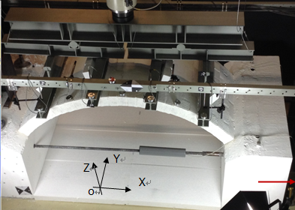
D
C
A
B
CCR3 CCR2 CCR1
Figure 1: Experiment setup and boundary condition
As described in Figure 1, the points A, B, C and D are the corners of the arch structures. The boundary condition could be points A and B without displacements at X, Y and Z directions, points C and D without the displacement at Y and Z direction but with the displacement at X direction. Considering the lateral displacement in the X direction, the maximum length increment is 2.19mm with the final load 521.1 kN. Four supports are equidistantly fixed on the arch structure where three CCRs are equidistantly disposed in the middle of the four supports (see Figure 1).
The Parameters of FEM is present in Table 1 where the length L, width W and thickness T are 200, 100 and 10mm. The Young's Modulus Y is 2.5e4 Pa, Poisson's ratio P is 0.15 and density ρ is 2.1E6 kg·mm⁻³.
Table 1: The geometric parameters of arch structures
Parameters | Values
L (Length) | 200 mm
W (Width) | 100 mm
T (Thickness)  H (Hight)  R (Radius) | 10 mm  58 mm  122 mm
The sketch of the arch structure is descript in Figure 2 where the dimensions are clearly marked and the values of the inner and outer radius are corresponding to 112.16 mm and 122.15 mm.
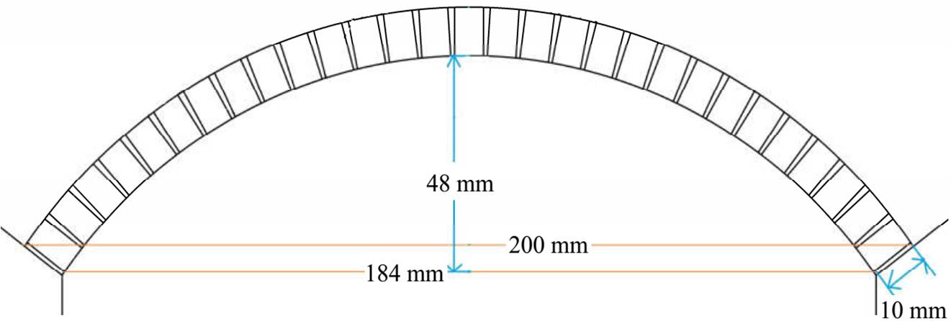
Figure 2: The sketch of the arch structure
In the Figure 2 the total height of the arch structure is 58 mm, and corresponding to inner radius, the inner height is 48 mm, and corresponding to outer radius, the outer height is 52 mm. The relation of loads and the displacements of CCRs are presented in Table 2 where the CCRs are described in Figure 1.
Table 2: The load and the displacement of CCRs
Load | F [kN] | D_CCR1 [mm] | D_CCR2 [mm] | D_CCR3 [mm]
1 | 40kN | 0.45 | 0.73 | 0.43
2 | 80kN | 0.85 | 1.43 | 0.78
3 | 120kN | 1.26 | 2.14 | 1.19
4 | 160kN | 1.67 | 2.87 | 1.54
5 | 200kN | 2.12 | 3.67 | 1.94
6 | 240kN | 2.51 | 4.48 | 2.34
7 | 280kN | 2.78 | 5.32 | 2.73
8 | 320kN | 3.19 | 6.14 | 3.14
9 | 360kN | 3.50 | 7.12 | 3.43
10 | 400kN | 3.76 | 7.99 | 3.71
11 | 440kN | 3.96 | 8.85 | 3.90
In Table 2 the F stands for the force loading of eleven date with the unit kN, and the D_CCR1, D_CCR2, D_CCR3 are corresponding to the displacements of three CCRs with the unit mm.
- Result
In this section, the results obtained by the experimental tests are evaluated through numerical simulation. The mathematical model was built in the framework of the Carrera Unified Formulation (CUF) [51]. The arch structure is shown in Fig. 1, along with the loading condition. The geometric properties come from the experimental setup, so that L1 = 200 mm, L2 = 184 mm, R1 = 112:15 mm, R2 = 122:15 mm, t = 10 mm, w = 100 mm, and l = 50 mm.
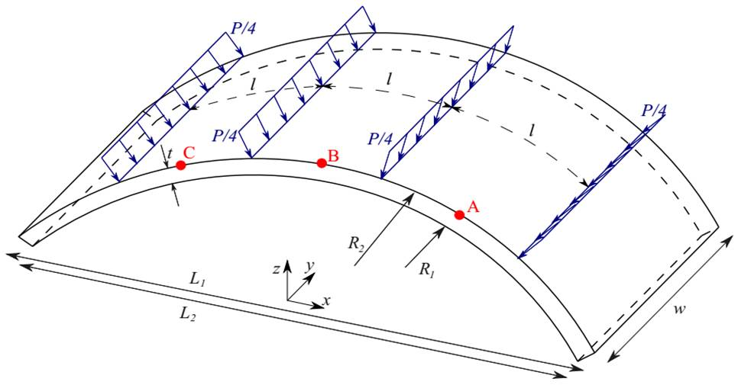
Figure 3: Geometric properties and loading condition of the arch structure
The load generated by the external machine was split in 4 equal parts, and each part was distributed along the width of the arch, as depicted in blue in Fig. 3. The loadings were set in a radial direction, to simulate the contact between the upper surface of the arch and the arms of the external machine. Figure 4 shows the kinematic description of the one-dimensional model. 72L9 Lagrange polynomials were used as the expansion function to approximate the displacement field over the cross-section (which lays on the plane xz), and 3B4 cubic elements were used along the 1D model axis (y direction).
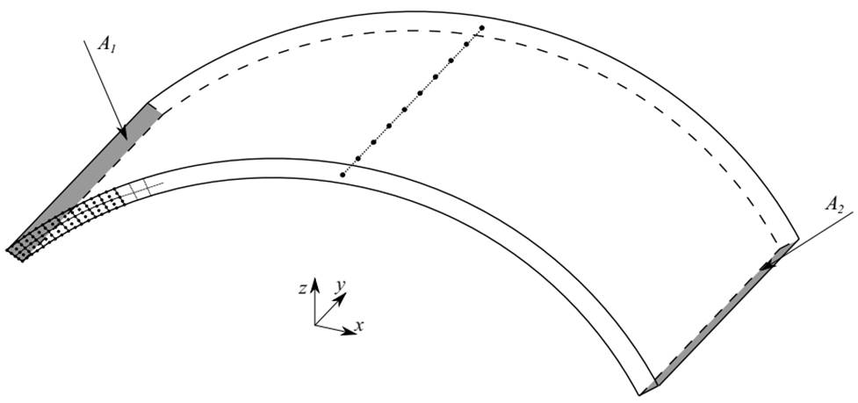
Figure 4: Cross-sectional and longitudinal approximation of the displacement field and boundary condition of the arch structure.
As far as the boundary condition as concerned, all the points which lay on the A1 area were fixed in each direction, where the point on the plane A2 are able to move in the x direction. The proposed model was at first validated with analytical results available in the literature, coming from Young and Budinas [52]. As a simple example, the external loading was set to P = 10 kN and the Young modulus E = 25000 MPa. The lateral displacement at the free end of the arch was monitored, and the results are shown in Table 3. The percentage error between the two solutions is less than 4%, which is a reasonable value justified because of the higher-order of the proposed model. Then, the experimental results were simulated adopting the proposed verified model. Starting from the experimental results shown in Table 2, the main goal was to estimate the material properties of the arch structure.
Model | Displacement [mm]
Analytical | 2.1834
Proposed model | 2.2738
Table 3: Comparison between the values of the lateral displacement of the free end of the arch between the analytical model from Young and Budinas [2] and the proposed model. The load is equal to 10 kN, the displacement is expressed in mm.
Since the analysis is a linear static analysis, only the first case with P = 40 kN was considered. From the numerical simulation, vertical displacement of points A, B, and C (see Fig. 1) were calculated, in correspondence of the three corner cube reflectors (CCRs) from the experimental setup. The Young Modulus and Poisson’s ratio are calculated by comparing the displacements obtained by the numerical simulation and those from the experimental test. The results are shown in Table 4:
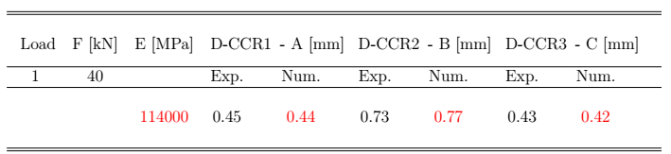
Table 4: Results of numerical simulations compared to the displacement evaluated through experimental tests. Poisson’s ratio ν is fixed as 0.15.
According to comparison in the Table 4, the deviation between numerical simulations and experimental tests are approximately 2.27%, 5.19%, 2.38% which are corresponding to CCRs marked in Figure 1.

  - Structural damage

An analysis of the damaged structure is considered hereafter. Basically, considering the Young Modulus calculated from the previous analysis, a small damage d is applied to the structure, to evaluate the structural response increasing the damage. The damage d is applied to the Young Modulus with the following relation:

$$E_{d}=\left(1-d\right) E$$

where $E_{d}$ is the Young Modulus of the damaged structure. Various values of d are considered, from 0 to 0.5 and the transverse displacement of points A, B, and C (see Fig. 1) is evaluated.
Figures 5 and 6 show the obtained results.
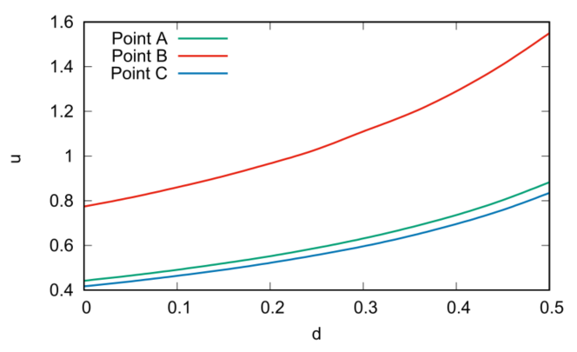
Figure 5: Transverse displacement of the points A, B, and C (see Fig. 1), varying the damage d.

Fig. 5 reports the values of the transverse displacement of the damaged structure varying the damage d. A slight nonlinear effect arises from $d=0$ (un-damaged structure) to $d=0.5$ ($E_{d}=0.5 E$). The same trend comes out looking at the non-dimensional values of the displacement, that are reported in Fig. 6.

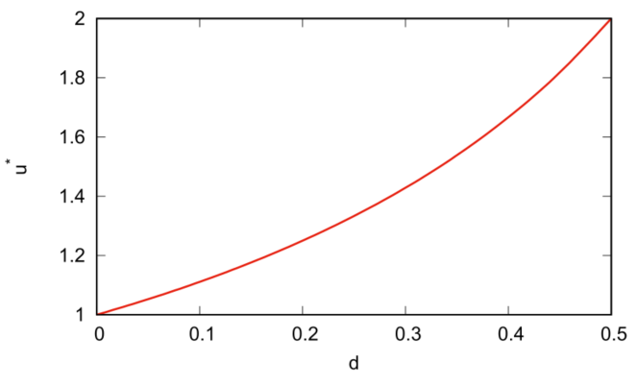
Figure 6: Transverse displacement of the points A, B, and C (see Fig. 1) of the damaged structure over the undamaged structure ones, varying the damage d.

  - Structural reinforcement

Finally, an analysis of a structural reinforcement below the arch structure is performed. The configuration considered for this analysis is shown in Fig. 7, where the red zone is the structural reinforcement with thickness $t_{r}$
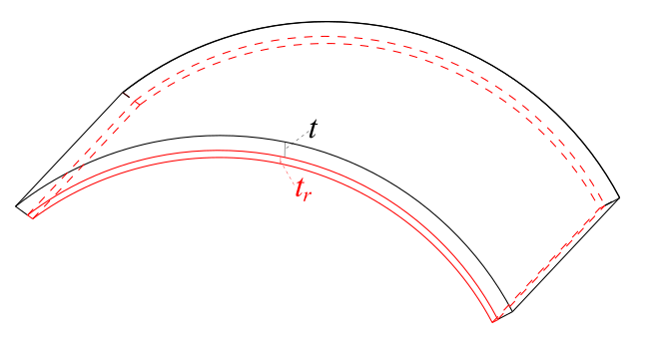
Figure 7: Structural reinforcement with thickness $t_{r}$
The structural reinforcement was made by an orthotropic fiber glass material with Young Moduli $E_{11}=37 GPa$, $E_{22}=9.5 GPa$ and $E_{33}=9.5 GPa$, Poisson ratios $ν_{12}=0.27$, $ν_{13}=0.34$ and $ν_{23}=0.27$ and shear moduli $G_{12}=3.1$, $G_{13}=3.5$ and $G_{23}=3.1$. The loading and boundary conditions are the same described in Section 4, where the external load is equal to 40kN and the boundary conditions involve a clamped side, while the other side can move in the X direction. Different static analyses were performed, considering various thickness ratios $t^{*}= \frac{t_{r}}{t}$, going from 0 (original structure) to 0.3. Then, the transverse displacements at the points A, B, and C (see Fig. 1) were calculated and their trend are reported in Fig. 8. Clearly, increasing the thickness of the structural reinforcement, a decrease of the displacement arises. Figure 9 shows the non-dimensional values of the displacement, and a greater decrease of the displacement of the point B is highlighted.
Finally, in Fig. 10 shows the trends of the evaluated displacements for six valued of the damage d (from 0 to 0.5) and for values of $t^{*}$ from 0 to 0.3. Barely, the more damaged is the structure, the more efficient is the structural reinforcement. For example, with $t^{*}$ = 0.3, for d = 0 the decrease of the displacement of the point B is less than than 20%, but for d = 0 it is almost 30%. Correspondent values of the Fig. 10 are shown in Table 4.

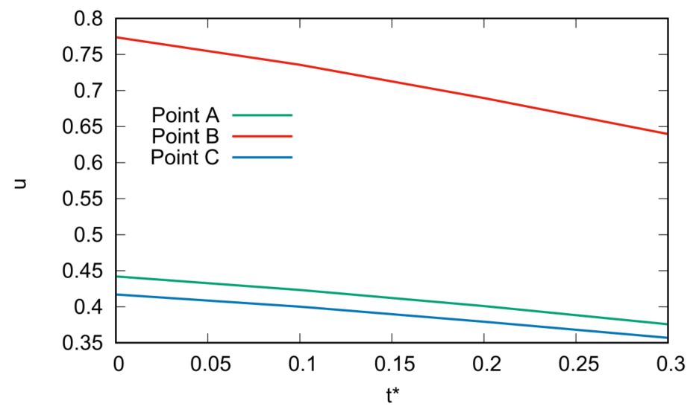
Figure 8: Transverse displacement of the points A, B, and C (see Fig. 1), varying the thickness of the structural reinforcement. $t^{*}= \frac{t_{r}}{t}$

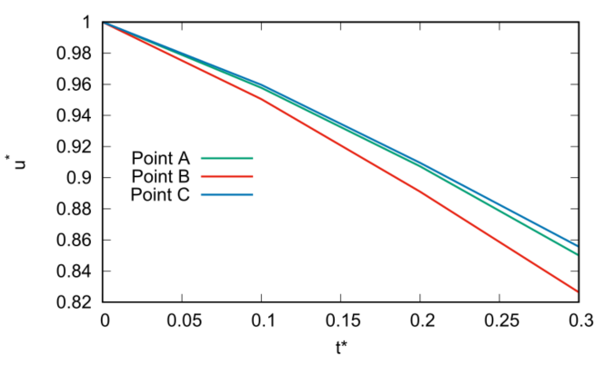
Figure 9: Transverse displacement of the points A, B, and C (see Fig. 1) of the reinforced structure over the original one, varying the thickness of the structural reinforcement. $t^{*}= \frac{t_{r}}{t}$
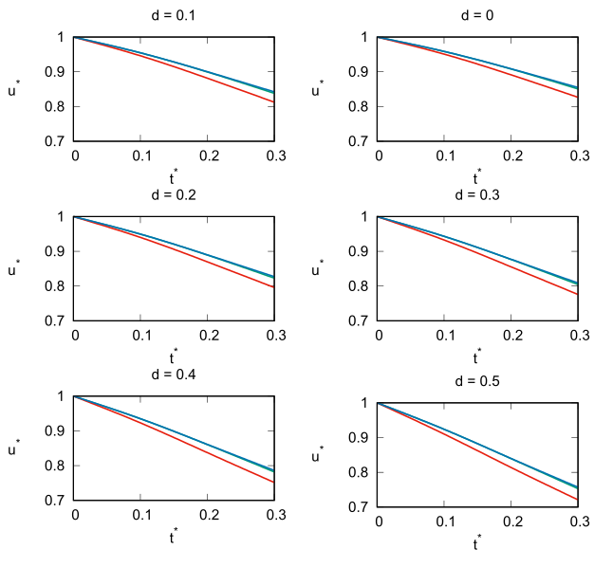
Figure 10: Transverse displacement of the points A (green line), B (red line), and C (blue line) of the reinforced structure over the original one for some values of the damage d. $t^{*}= \frac{t_{r}}{t}$

d | $$t^{*}$$ | D_CCR1 [mm] | D_CCR2 [mm] | D_CCR3 [mm]
0  0  0  0 | 0  0.1  0.2  0.3 | 0.77  0.74  0.69  0.64 | 0.44  0.42  0.40  0.38 | 0.42  0.40  0.38  0.36
0.1  0.1  0.1  0.1 | 0  0.1  0.2  0.3 | 0.86  0.81  0.76  0.70 | 0.49  0.47  0.44  0.41 | 0.46  0.44  0.42  0.39
0.2  0.2  0.2  0.2 | 0  0.1  0.2  0.3 | 0.97  0.91  0.84  0.77 | 0.55  0.52  0.49  0.45 | 0.52  0.50  0.46  0.43
0.3  0.3  0.3  0.3 | 0  0.1  0.2  0.3 | 1.11  1.03  0.95  0.86 | 0.63  0.60  0.55  0.51 | 0.60  0.56  0.52  0.48
0.4  0.4  0.4  0.4 | 0  0.1  0.2  0.3 | 1.29  1.19  1.08  0.97 | 0.74  0.69  0.63  0.58 | 0.70  0.65  0.60  0.55
0.5  0.5  0.5  0.5 | 0  0.1  0.2  0.3 | 1.55  1.41  1.26  1.12 | 0.88  0.82  0.74  0.67 | 0.83  0.77  0.70  0.63
Table 3: Transverse displacement of the points A, B, and C (see Fig. 1), varying the thickness of the structural reinforcement. $t^{*}= \frac{t_{r}}{t}$

- Conclusion
This paper considers the benefits of multi-sensors technology in the generation and calibration of CUF method to construct an efficient analysis model which requires high-accuracy construction of geometric models and determination of the structure displacement from a monitoring aspect. In this paper, the mechanical properties of arched structures are investigated by combining CUF model and SHM experiment. The load-displacement relationship obtained by multi-sensor experiments is employed to calibrate the physical parameters of complex structures.
i) This paper proposed to integration of laser-based technology with CUF method and adopted novel CCRs validation of CUF geometric model.
ii) A 3D CUF model of arch structure is generated which is an application of engineering structures and an expansion of the CUF model for more complex structure geometries.
iii) The material parameters, such as such as Young’s module and Poisson’s ratio, are calibrated by the laser tracker measurement which can obtain extremely high accuracy through the displacements of CCRs.
iv) Numerical simulations are compared to the displacement evaluated through experimental tests where the deviation of three CCRs are approximately 2.27%, 5.19%, 2.38%.
In future we will focus on the CUF intelligent modeling through full-field information with laser-based measurement and multi-parameter calibration in order to construct an AI-based health monitoring framework.

Reference
- Park, H.S., Lee, H.M., Adeli, H., Lee, I. A New Approach for Health Monitoring of Structures: Terrestrial Laser Scanning, Computer-Aided Civil and Infrastructure Engineering, Vol. 22, pp. 19–30, 2007.
- Xu, X.; Kargoll, B.; Bureick, J.; Yang, H.; Alkhatib, H.; Neumann, I. TLS-based profile model analysis of major composite structures with robust B-spline method. Composite Structures, 184, 814-820, 2018.
- Yang, H.; Xu, X.; Neumann, I. Deformation Behavior Analysis of Composite Structures under Monotonic Loads Based on Terrestrial Laser Scanning Technology, Composite Structures, 183, 594-599, 2018.
- Yang, H.; Xu, X.; Neumann, I. The benefit of 3D laser scanning technology in the generation and calibration of FEM models for health assessment of concrete structures. Sensors 2015, 14(11), 21889-21904.
- Yang, H.; Xu, X.; Neumann, I. Laser Scanning-Based Updating of a Finite-Element Model for Structural Health Monitoring, IEEE sensor, 16, 2100–2104, 2016.
- Yang, H.; Xu, X.; Neumann, I. Optimal finite element model with response surface methodology for concrete structures based on Terrestrial Laser Scanning technology. Composite Structures 2018, 183, 2-6.
- Xu, X.; Zhao, X.; Yang, H.; Neumann, I. TLS-Based Feature Extraction and 3D Modeling for Arch Structures, Journal of Sensors, 2017, Article ID 9124254, 2017.
- Xu, X., Yang, H., Zhang, Y., Neumann, I. Intelligent 3D data extraction method for deformation analysis of composite structures. Composite Structures, 203, 254-258, 2018.
- Xu, X.; Yang, H. Network method for deformation analysis of three-dimensional point cloud with terrestrial laser scanning sensor. International Journal of Distributed Sensor Networks, Vol. 14, 2018.
- Yang, H.; Xu, X.; Kargoll, B.; Neumann, I. An automatic and intelligent optimal surface modeling method for composite tunnel structures. Composite Structures, 208, 702-710, 2019.
- Yang, H.; Xu, X.; Xu, W.; Neumann, I. Terrestrial Laser Scanning-Based Deformation Analysis for Arch and Beam Structures, IEEE Sensors Journal, 17, 4605 – 4611, 2017.
- Xu, X.; Yang, H.; Neumann. I. Time-efficient filtering method for three-dimensional point clouds data of tunnel structures, Advances in Mechanical Engineering, 10, 1-6, 2018.
- Yang, H.; Omidalizarandi, M.; Xu, X.; Neumann, I. Terrestrial laser scanning technology for deformation monitoring and surface modeling of arch structures. Composite Structures 2017, 169, 173-179.
- Xu, X.; Bureick, J.; Yang, H.; Neumann, I. TLS-based composite structure deformation analysis validated with laser tracker. Composite Structures 2018, 202, 60-65.
15. Carrera E., Petrolo M., Maiarù M.. "1D Higher-Order Finite Element Models with only Displacement Variables for the Analysis of Fiber-Reinforced Composite Structures", ECCOMAS 3rd Thematic Conference on Mechanical Response of Composites, 21-23 September 2011. Hannover, Germany
16. Mantari J.L., Ramos I.A., Carrera E., Petrolo M.. "Static analysis of functionally graded plates using new non-polynomial displacement fields via Carrera Unified Formulation", Composites Part B (2016), 89, pp. 127-142
17. Carrera E., Filippi M., Mahato P.K., Pagani A.. "Accurate static response of single- and multi-cell laminated box beams", Composite Structures (2016), 136, pp. 372-383
18. Carrera E., Petrolo M.. "Refined beam elements with only displacement variables and plate/shell capabilities", Meccanica (2012), 47, pp. 537-556
19. Varello A., Lamberti A., Carrera E. "Static Aeroelastic Response of Wing-Structures Accounting for In-Plane Cross-Section Deformation", International Journal of Aeronautical & Space Sciences (2013), 14(4), pp. 310-323
20. Pagani, A., & Carrera, E. (2017). Large-deflection and post-buckling analyses of laminated composite beams by Carrera Unified Formulation. Composite Structures, 170, 40-52.
21. Carrera, E., & Giunta, G. (2010). Refined beam theories based on a unified formulation. International Journal of Applied Mechanics, 2(01), 117-143.
22. Carrera, E., & Demasi, L. (2002). Classical and advanced multilayered plate elements based upon PVD and MVT. Part 1: Derivation of finite element matrices. International Journal for Numerical Methods in Engineering, 55(2), 191-231.
23. Carrera, E., & Petrolo, M. (2011). On the effectiveness of higher-order terms in refined beam theories. Journal of Applied Mechanics, 78(2), 021013.
24. Carrera, E. (2019). Evaluation of Energy and Failure Parameters in Composite Structures via a Component-Wise Approach.
25. Carrera, E., de Miguel, A. G., & Pagani, A. (2017). Hierarchical theories of structures based on Legendre polynomial expansions with finite element applications. International Journal of Mechanical Sciences, 120, 286-300.
26. Schmitt C, Neuner H, Neumann I, Piehler J, Hansen M, Marx S. Erstellung von Ist-Geometrien für strukturmechanische Berechnungen. Ingenieurvermessung. 2014;14:37-48.
27. Reu PL, Rohe DP, Jacobs LD. Comparison of DIC and LDV for practical vibration and modal measurements. Mechanical Systems and Signal Processing. 2017 Mar 1;86:2-16.
28. Carrera E, Cinefra M, Petrolo M, Zappino E. Finite element analysis of structures through unified formulation. John Wiley & Sons; 2014 Jul 29.
29. Pagani, A., R. Augello, and E. Carrera. "Frequency and mode change in the large deflection and post-buckling of compact and thin-walled beams." Journal of Sound and Vibration 432 (2018): 88-104.
30. K.J. Bathe. Finite element procedure. Prentice hall, Upper Saddle River, New Jersey, USA, 1996.
51. E. Carrera, M. Cinefra, M. Petrolo, and E. Zappino. Finite Element Analysis of Structures through Unified Formulation. John Wiley & Sons, New York, USA, 2014.
52. Warren Clarence Young, Richard Gordon Budynas, Ali M Sadegh, et al. Roark’s formulas for stress and strain, volume 7. McGraw-Hill New York, 2002.

