New frontiers for MCDA: from several indicators to structured models and decision aid processes

Maria Franca Noreseª, Aqeel Mustafaª, Antonino Scarelli^{b}
a Politecnico di Torino, Department of Management and Production Engineering , Corso Duca degli Abruzzi, 24, 10129 Turin, Italy
b University of Tuscia, Department of Environmental and Biological Science, Viale Università, 01100 Viterbo, Italy

Introduction

A multicriteria decision aid (MCDA) process is developed by means of interaction with decision maker(s) and stakeholders, but it may also be oriented towards facilitating the Intelligence phase of a decision process when a decision system (with rules and formal relationships between decision makers and with other actors in the decision process) has not yet become active. This situation arises frequently when a decision problem is complex or not well structured. If there is time to develop a “simulating” approach to the real problem, a study that includes modelling and the application of methods can clarify the situation and its results can be proposed to facilitate new decision processes.
This simulating approach needs clear and complete attention to the specific incremental nature of this learning process, which includes and integrates the modelling and validation of each conceptual or formal result (Landry et al. 1983). A cyclic application of a method can facilitate and control the development of this process and the analysis, as well as the use of the temporary results in the various steps of the process. Each application implies a clear definition of all the inputs, and a careful and critical analysis of each result, in order to use this information to converge towards a final model or to formulate new treatment hypotheses for the problem situation. A “good” SW tool could facilitate this approach aiding the “visualization” of the limits of a result and of its positive or negative evolution in a way that is generated from recurring modelling cycles.
A simulating approach may also be motivated by a criticism of some policy making processes, and it could have the aim of improving the quality of indices, which are then used to obtain evidence in order to set specific goals and to measure the progress that has been made towards these goals. A multicriteria (MC) application may be developed in relation to an international composite index, to remedy some of the methodological problems when a weighted sum is computed using ordinal data (Mailly et al, 2014), or to outline how an indicator can be generated and why this indicator is essential in policymaking (Scarelli and Benanchi, 2014). In the aforementioned case, an MC model was developed, without decision makers or stakeholders, in relation to a pilot case, in order to underline the limits of the adopted resilience indices and to demonstrate, by means of a new resilience model and an MC application, that MCDA “exists” and can be very useful in decision processes that have the aim of increasing resilience.
Starting from the result of this simulating approach, some criticisms and improvement proposals were developed in relation to the original model, which had been influenced by the limited availability of adequate data and the not so consistent nature of the family of criteria that had been deduced from literature. A result analysis, as a tool that facilitates MC modelling, was described in (Norese, 2006), in relation to some complex cases and to always more structured laboratories that were proposed to a large number of degree and master course students (more than 3500 over the last sixteen years). In the last few years, the same logic of learning has been applied in laboratories for doctoral students and in some master theses, in relation to actual problems, in order to facilitate the modelling of not so clear decision situations and the understanding of how some MC methods can be used in unstructured problem situations. The students have now arrived at a good problem formulation and model structuring stage, and they have learned to criticize their models when they produce strange or unacceptable results as well as how to consistently improve their models and results. The only great remaining difficulty is in relation to the role that an SW tool could play (but currently does not play ) in this process.
The next sections propose the definition of the resilience problem and a sequence of some ELECTRE III applications to the original model and some variants, in order to underline how the analysis of each new result can orient the sequence of changes and to what extent the comparative visualization of the results can facilitate an identification of limits in the evaluations and in some model parameters. The potential role of a good SW tool is underlined by means of some figures that show some of the ELECTRE results and which should be visualized together during the modelling process, in order to understand which relationships connect a result to some model components. This procedure could be suggested to those people who are involved in IT innovation and SW development projects, in relation to the difficulties that the end users encounter in MCDA.

- Resilience and MCDA

The term resilience stems from the Latin verb resilire (rebound), and resiliens was originally used to refer to the pliant or elastic quality of a substance. Resilience in engineering is the capacity of a material to withstand impulsive forces, while in ecology it is defined as the capacity of an ecosystem to return to the point of equilibrium that existed before a disruption of either an anthropic nature (pollution) or natural nature (climate, earthquake, landslide and so on). In the last few decades, the concept of ‘resilience’ has gained much ground in a wide variety of academic disciplines, including research on not only engineering and ecological sciences (which include climate change and disaster management), but also on psychology (the capacity to react and to face the adversities of life), medicine (as the patients’ reaction to a treatment of therapy), or law (as a community’s capacity to react and integrate new rules or proceedings of local authorities). Each definition includes concepts, such as flexibility, adaptation or reaction.
Resilience seems to be the answer to a wide range of problems and threats, and has therefore garnered the attention of policymakers and researchers from different fields and disciplines. It could be useful to design a reflexive management process that guides policymakers or other actors through the steps of understanding which factors they can influence to strengthen the resilience property of the system (Duijnhovena and Neef, 2014).
ANDROID - Lifelong learning Programme to increase society’s resilience to disasters of human and natural origin (http://www.disaster-resilience.net) proposes the resilience definition that is used hereafter: resilience is something we can grow in ourselves, in our family and in our communities, as the result of an education activity addressed to the prevention and minimization of negative effects (of adversities, natural events, disasters, …). Therefore, resilience, in this context, can be seen as the capacity of the administrators to face the risk of a catastrophe, their level of interest, time, resources and efforts devoted to it (the social life sphere). The resilience concept should be considered as interactions among the several factors that can influence the various spheres of social life in different ways. These factors may be synthesized as environmental, socio-political and economics factors. A combined analysis of the four spheres led to an innovative study on the territory and its resilience, which was conducted in order to propose the results to the policy makers and stakeholders of territorial processes.
In this context, some questions may be posed: is it possible to evaluate the resilience of some territorial units, starting from specific indicators? Is it possible to say that one territory is more resilient than another and to offer some explanations? How can an accurate evaluation be made and finalized to further interventions? How can critical factors of resilience be pointed out and used to facilitate focused investments in order to assure more safety of the examined territorial assets? Could management and financing plans for vulnerable communities be generated or facilitated by this combined analysis, in relation to different administrative sectors, at a Regional, National or International level? Can the awareness of the real problems be improved by a transparent resilience evaluation in the involved communities, which include citizens and administrators?
In order to answer some of these questions, an MC model was developed to evaluate the resilience of some territorial units, that is, twenty-two municipalities belonging to the Ombrone river hydrographic basin in the Tuscany region in Italy, where several floods events have occurred in recent years (Scarelli and Benanchi, 2014). The logical structure of the model and the identification of available data, in relation to the large numbers of indicators that had been proposed in the literature, were the first steps of the work on this pilot case. The last steps involved a difficult definition of the preference parameters (that is weights, indifference and preference thresholds, the need to activate the discordance principle and the relative veto thresholds), without interaction with an activated decision system, and an ELECTRE III application to the pilot case.

- Result analysis in modelling processes

A preference elicitation process proceeds through an interaction between decision-makers and analysts in which decision-makers express information about their preferences within a specific aggregation procedure (Figueira et al, 2005). Decision-makers can directly provide information on the values of the preference parameters (direct elicitation), but the understanding of the precise meaning of each parameter may be difficult for decision-makers and therefore elicitation can be activated indirectly by posing questions, whose answers can be interpreted through an aggregation procedure.

Inference procedures have been developed to elicit parameter values from action ranking or assignment to categories examples. However, these preference elicitation or inferring procedures cannot be used when a decision system is not active. In these situations, which aim to facilitate future decision processes, analysing the results of the application of an MC method to a provisional model could be the correct way of improving and validating both the understanding of the whole problem situation and the model. An analysis that puts the results into question may lead to an important communication space and an occasion of learning.
In the analysed case, a careful analysis of the model and ELECTRE III application and results was considered essential to verify whether this resilience evaluation was accurate enough, could give suitable explanations to the different situations in the Ombrone basin and could be used to facilitate improvement actions.
The study started with an analysis of the results of the ELECTRE III application and of its possible limits, and continued with an examination of the model elements that could negatively influence the result.
Some change hypotheses were made and a sequence of ELECTRE III applications to the original model and the proposed variants was provisionally planned, because the analysis of each new result could orient the sequence of changes. The comparative visualization of the results facilitated the identification of possible limits in the model parameters, evaluations and/or structure.

2.1 The result and the model parameters

The result of an ELECTRE III application is a classification of compared actions, from “best to worst”, which is represented by a final partial graph, i.e. a pre-order that is developed as the intersection of the two complete pre-orders resulting from two distillation procedures, that is, the descendant procedure and the ascendant one (Figueira et al, 2005). The final partial graph can include different paths, the longest of which can be visualized as the vertical and considered the main path, while each lateral path indicates a situation of incomparability and underlines a distance (of one or more classes and sometimes even of several ones) between some action positions in the two distillations. The presence of different paths is more frequent when several actions are compared, and the lateral paths may be visualized above all in the intermediate part of the graph. The number of lateral paths grows if the comparability of some actions is not so high, but a high number of paths can sometimes be the sign of a difficult definition of some model parameters and above all of the veto thresholds.
When MC modelling is particularly difficult, the result, in terms of final partial graph, often presents several incomparable actions. This event has been observed in some particularly complex cases (Balestra et al., 2001; Cavallo and Norese, 2001) and tested and verified in several laboratories with students at their first experience in MC modelling, who could be considered just like inexpert practitioners (Norese, 2006). The frequent final partial graphs with several incomparable actions were considered to be the consequence of incomplete or unstructured models, or of non-consistent or wrong definitions of some parameters. When the reasons for these possible erroneous actions were analysed and eliminated step by step, the number of incomparable actions was always reduced.
In the resilience case, the model included not a few actions (22 municipalities) and could have presented some elements of uncertainty, because it was not created for a specific decision problem, but only to improve future decision processes, and because it synthesized logical inputs from literature and analytical inputs from the few available but not so reliable and consistent data.
The final partial graph that resulted from the ELECTRE III application to the model is presented in figure 1, with fifteen actions in the vertical path and seven actions in the lateral paths, which are only present in the intermediate part of the graph. It can be observed that the municipality that is incomparable with the maximum number (6) of other municipalities is Trequanda (TREQU in the figure 1) and there is a maximum number of only two actions in the same class. The only element that caught our attention was the presence of Siena in the last positions. Siena is the main city in the county, with more than 50,000 inhabitants, while the population of the other twenty-one municipalities is always less than 5,000, except for five municipalities which have populations of about 7,000 or 9,000 inhabitants. For this reason, Siena is not easily comparable with the other municipalities.
As a consequence, Siena was eliminated from the set of actions, and it was believed that this measure would have changed the result to a great extent. However, the result without Siena was not so different (see figure 2), with 15 actions always being present in the vertical path and six in the lateral ones. Some small changes occurred in the intermediate part, where three actions were included in the same class, the same actions which, with another two, were first in the vertical path and then resulted to be in a lateral one, while three of the lateral ones moved into the main path. Essentially, the ELECTRE III result seemed to be not so sensitive to the Siena elimination.
At this point, some small changes were introduced to improve certain thresholds of indifference and preference that were too large, and the result changed the situation considerably in relation to each small change (see the graph resulting from a combination of all the small changes in figure 3). When some veto thresholds were introduced, because the original model had not included any veto threshold, the result became disastrous (see figure 4). All the parameter changes that were introduced step by step to improve the model produced different results, and when all the changes were introduced together it was evident (as can be seen in figure 3 and above all in figure 4) how sensitive the result of the ELECTRE III application to this model and to some parameter variants was.
The first five positions of the classification in figure 3 include the same actions as figure 2. It can be observed that the last seven positions are not so different, and some small changes in the central part of the graph can be considered acceptable. However, the main path, which should be the longest, no longer exists, and there are two paths with almost the same number of actions, plus some lateral paths.
Several paths characterize the result of the ELECTRE III application to the model variant that includes all the changes (see figure 4). However, just one head action is not included in this graph and a similar strange situation is shown at the end of the ranking. This result is a clear sign that something is wrong in the model and small changes in its parameters only underline that the structure and contents of the model should be analysed.

2.2 The model and its structure

The model, which was first analysed in terms of parameters (thresholds and modelling of the discordance principle) and in terms of the nature of the action set, was then studied in terms of structure (main conceptual aspects and consistent family of criteria that analytically deal with these aspects) and evaluation process (choice of data-indicators to be used in the evaluations).
The structure of the model only apparently results to be consistent with the multidimensional definition of resilience. The model that was deduced from literature consists of 14 criteria, and the environmental aspects are included with almost the same importance as the socio-economic ones. However, while a lot of possible indicators of the resilience environmental aspects are available, indicators of social or economic resilience are not easily defined and not frequently included in institutional data bases. Therefore, several indicators that were suggested in the literature to deal with socio economic resilience are not easily available or are even inconsistent with the analysed socio-economic context. A careful reading of the meaning of all the criteria and the indicators that were used for the evaluations indicates that there are more environmental criteria than socio-economic ones and they show a net prevailing importance (78%). Moreover, some indicators that were used for the evaluations are not so consistent with the criteria to which they were associated.
A new model was created to include only 7 of the original 14 criteria, with the “clearest and most reliable” indicators. They deal with three main aspects: Reaction capability, risky or adverse to risk Behaviour of the actors and Environmental and social awareness.
Reaction capability is facilitated if the Reaction time, which is evaluated in terms of the ratio between the active population and the young plus old population, is high (the indicator for this criterion was taken from INSTAT, the National institute of Statistics), if the Territorial desirability (touristic attractiveness, as evaluated by the Touristic Office of the Siena Province) motivates citizens and administrators to preserve the territorial qualities and to prevent any kind of negative impact, and if a high average value of Spendable income of the citizens generates resources for the public administration to prevent disasters (source: Siena Province).
The Behaviour of the actors, in the analysed area, could indicate an insufficient awareness of the risks for the territory, as can be seen for the Urbanization criterion, where the % of urbanized area (elaborated by means of GIS) is a sign of limited rainfall absorption, and therefore of flood risk, and for the CO2 emissions criterion (source: Siena Province), where a high level of emissions does not imply only alteration of the atmosphere, but also limited sensitivity to the territory needs.
Environmental and social awareness can be expressed by means of two criteria: the first is Environmental awareness, in terms of percentage of differentiated waste (source: Siena Province), and the other is Progress in the social life, in terms of percentage of women in the waiting list for a job (source: Siena Province).
The new thresholds of indifference, preference and veto that were proposed in the analysis described in 2.1 can also be used for this model, while the importance coefficients are new but maintain the aim of balancing the main aspects, and the criteria in relation to each aspect. Together with this first base scenario, another three weight scenarios were proposed and used, each of which represented a different way or policy of improving resilience. The first scenario was mainly oriented towards educating people about resilience, the second was oriented towards training people on how to react to a disaster and the third towards basing resilience improvement on funds that could be assigned to the municipalities of the involved territory.
ELECTRE III was applied to the new model, in relation to the “balanced” scenario, and the result is shown in figure 5, with both the head actions and the others at the end of the ranking again appearing clear. Eleven actions are included in the longest path while the others appear in the lateral paths, above all in the intermediate part of the graph. The municipality that results to be incomparable with the maximum number (11) of other municipalities is San Quirico d’Orcia (SANQ). There are only a few evident changes in the ranking, above all as far as MONTI is concerned, which has moved from the first position to the last group of actions. RADI has also moved from the second to almost the last position, while MONTA was in the last or almost the last position in the original model and is now in the third position. Other municipalities have now become more resilient, they are PIENZ, SANQ and above all MONGG, which was preceded by 9 actions and is now in the first position, while MURLO is less resilient.
A high number of incomparable actions in the final partial graph is often the consequence of a veto threshold that has had a heavily impact on the result. In order to test this possibility, the model was partially changed and each time one of the veto thresholds was deactivated. In only one case did a single veto threshold deactivation evidently change the result, above all the position of SANQ, which was the most incomparable action and its position has now become clear (see figure 6): it is evidently not resilient. However, even in this case the result has not changed structurally and the first, the intermediate and the last action groups are the same.
The other three weight scenarios were tested and these results (see figure 7) also maintain the same distinction between first, intermediate and last action groups. There is only a partial change for MONTI, which tends to pass from the intermediate group to either the first or the last group.
At this point, the result analysis moved on to the analysis of the few “strange” actions, above all that pertaining to San Quirico d’Orcia (SANQ), Monticiano (MONTI), Radicofani (RADI) and Montalcino (MONTA), and of some of the best and the worst municipalities. Some remarks, which could be useful for the improvement of the model, have arisen from this analysis. Most of the analysed actions are municipalities with just a few people and a mixture of economic activities (agriculture, cattle breeding, handicraft, commerce and tourism). However, some of them, which may be small, intact and beautiful Middle-Age villages, or small cities that are very famous throughout the world for their wine or touristic attractiveness, are different and in fact these are the municipalities that show the strangest results. For this reason, the possibility of using ELECTRE Tri in relation to the new model is currently being examined. This would mean accepting this “natural” incomparability and assigning the municipalities to resilience categories.
- Final remarks and recommendations

An analysis of an MC model, which was developed without decision makers to underline the limits of the adopted resilience indices, and the application of ELECTRE III to this model, can be considered as a sort of sensitivity analysis, that is, a study on how the uncertainty of an output can be connected to different sources of uncertainty in the model structure and parameters, which are the inputs of the ELECTRE III application. Some alternative assumptions on the choice of the parameters (and then on the model structure), which could generate uncertainty or criticalities in the results, were tested to determine their impact on the results, and were then used to increase the understanding of the expected and unexpected relationships between the model and results of an ELECTRE application. The first outcome could facilitate the modelling process in this kind of technical learning process. An identification of the inputs that cause significant uncertainty in the output should orient attention towards improving a model that cannot be validated by means of a natural interaction between decision makers and analysts. A comparison of some strange elements of a result with a different type of information about these elements (the second outcome, which includes a detailed analysis of each strange element) can be used to orient a new cycle of modelling.
When a model is produced by a culture that associates information above all to a large amount of data, and several inexpensive data-indicators may be available, the logical consequence can be a model with a high number of indicators-criteria. The result of this sort of sensitivity analysis, which could identify inputs that have no effect on the output, or even redundant parts of the model structure, could be a simplification of the model.
In this case, a result analysis procedure was used to orient a sequence of parameter changes and a variant of the original model. A comparative visualization of the results facilitates the identification of the limits of some model parameters, evaluations and criteria. An SW tool could play an important role in this modelling process, by facilitating the visualization of the impact on the results that is generated by each parameter assumption or modelling scenario. An SW tool could include and visualize parameters that describe the main elements of a final partial graph and its evolution during the modelling process and could also propose other visualization tools, such as the Surmesure diagram that is described in (Rogers et al, 2000). Some difficulties that the end users encounter when they use ELECTRE III are linked to the not so easy interpretation of its results, above all when the problem is new and several actions are compared.
A model-based process has been used to facilitate this simulating approach (Norese, 2016). The different steps of this learning process are currently being used to enhance communication between modellers and decision makers, to explain logics, difficulties and methodologies of analysis to some stakeholders/decision makers who, in the Piedmont Region, have to face the problem of activating new participatory processes and of finding and allocating resources in answer to the needs of communities of users. A new MC application is currently underway, again adopting a simulating approach, but this time in relation to a river basin in Piedmont. The analysed application has been considered the starting point for a decision aid intervention throughout this territory.

References

Balestra G., Norese M.F., Knaflitz M., 2001, Model structuring to assess the progression of muscular dystrophy, in A. Colorni, M. Parruccini, B. Roy (eds.) A-MCD-A – Aide Multicritère à la Décision (Multiple Criteria Decision Aiding), European Commission Joint Research Centre, EUR Report, Luxembourg, 31- 46.
Cavallo A., Norese M.F., 2001, GIS and Multicriteria Analysis to evaluate and map erosion and landslide hazard, Informatica, 12, 1, 25-44.
Duijnhovena H., Neef M., 2014, Framing Resilience. From a model-based approach to a management process. Procedia Economics and Finance, 18, 425 – 430.
Landry M., Malouin J. L., Oral M., 1983, Model validation in operations research. European Journal of Operational Research, 14, 207–220.
Figueira J., Mousseau V., Roy B., 2005, ELECTRE methods, in S. Greco (ed) Multiple Criteria Decision Analysis: State of the Art Surveys, Springer, Heidelberg, 133-153.
Mailly D., Abi-Zeid I., Pepin S., 2014, A Multi-Criteria Classification Approach for Identifying Favourable Climates for Tourism. Journal of Multi-Criteria Decision Analysis, 21, 65–75
Norese M.F., 2006, Multicriteria modeling and result analysis, Newsletter of the European Working Group “Multiple Criteria Decision Aiding”, 3 (14), Fall 2006, 10-14.
Norese M.F., 2016, A model-based process to improve robustness in MultiCriteria Decision Aiding interventions, Accepted for publication in the Journal of Multi-Criteria Decision Analysis.
Rogers M., Bruen M., Maystre L., 2000, ELECTRE and decision support. Methods and applications in engineering and infrastructure investment, Kluwer Academic Publishers, Boston.
Scarelli A., Benanchi M., 2014, Measuring resilience on communalities involved in flooding Ombrone river. Procedia Economics and Finance, 18, 948 – 958.
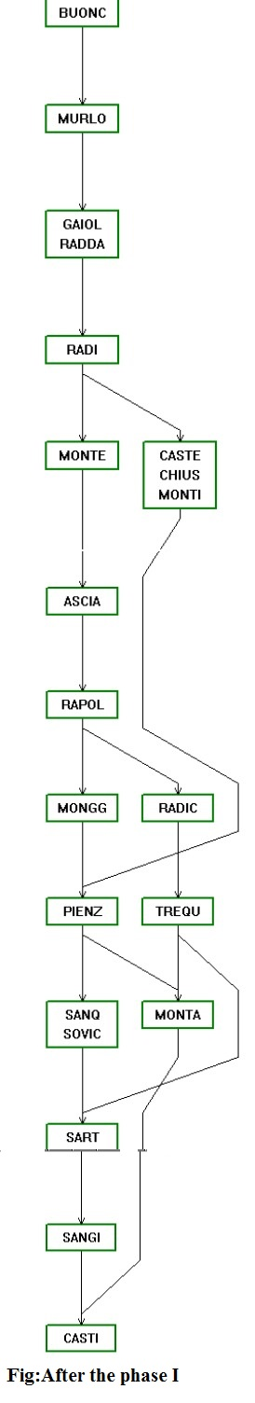
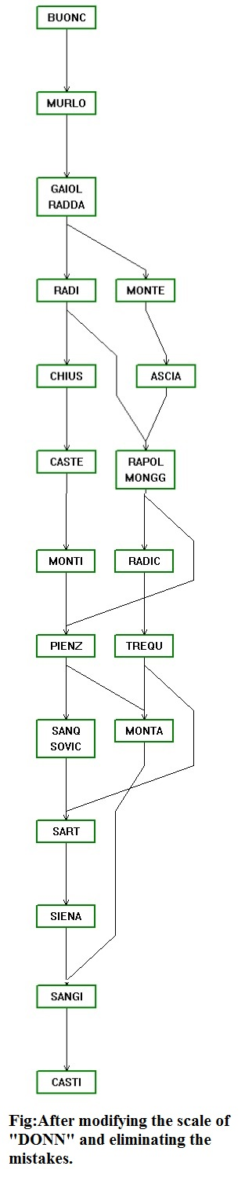
Figure 2 – Result without Siena
Figure 1 – Result of the original model

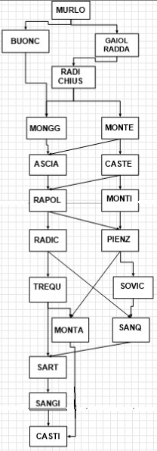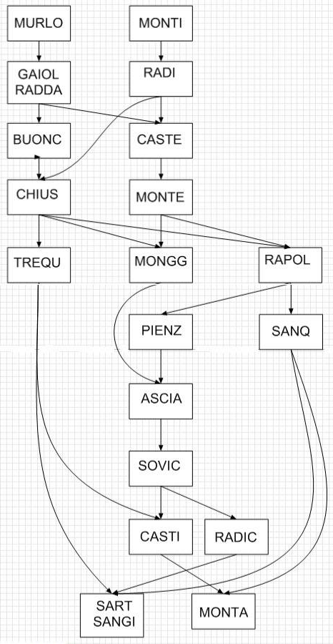
Figure 4 – Introduction of some veto thresholds
Figure 3 – Result of a combination of small changes

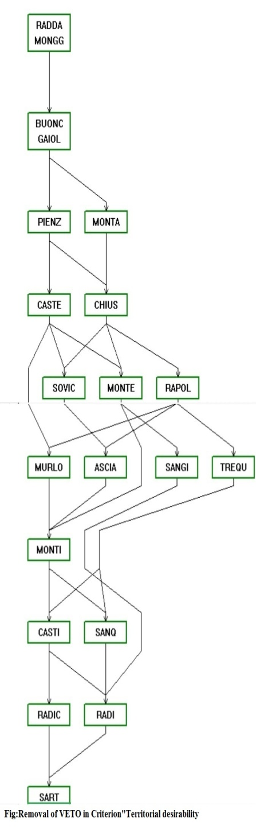
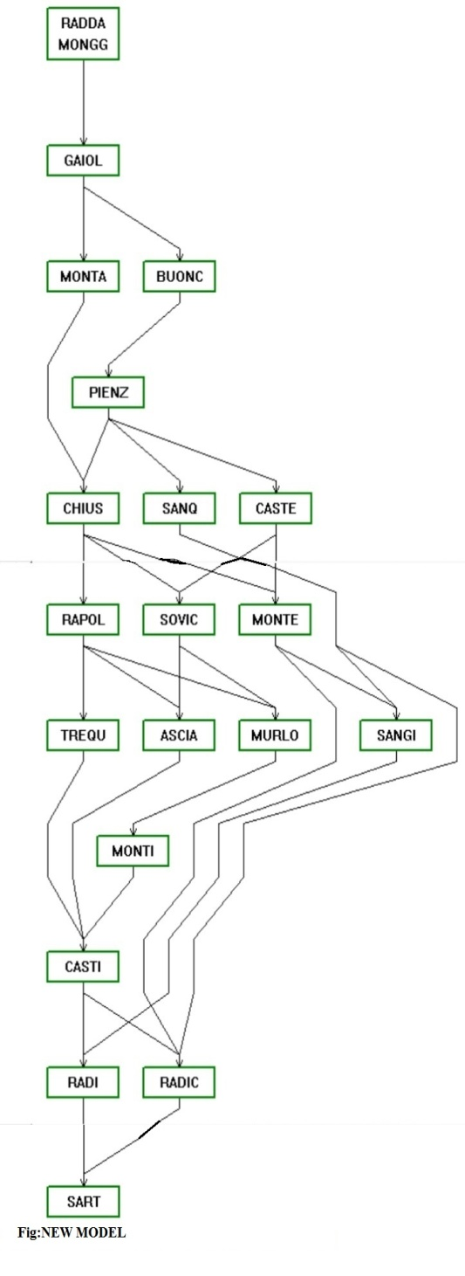

Figure 5 – ELECTRE application to the new model
Figure 6 – A new result for a single veto threshold deactivation

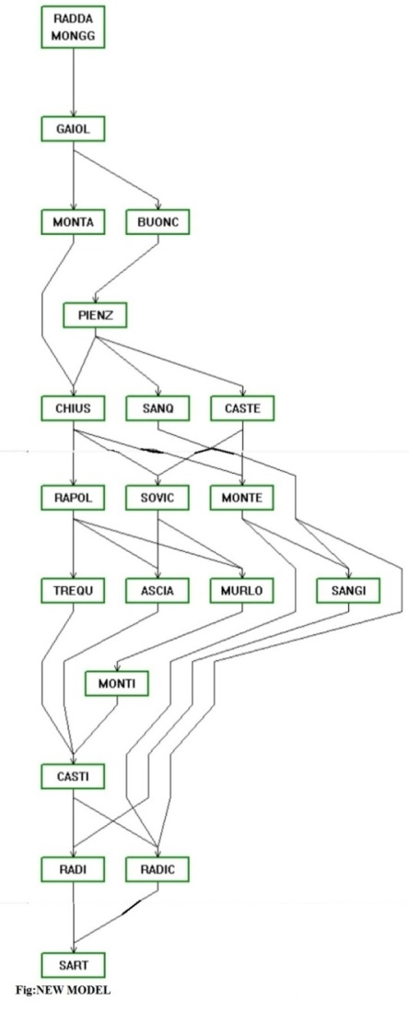
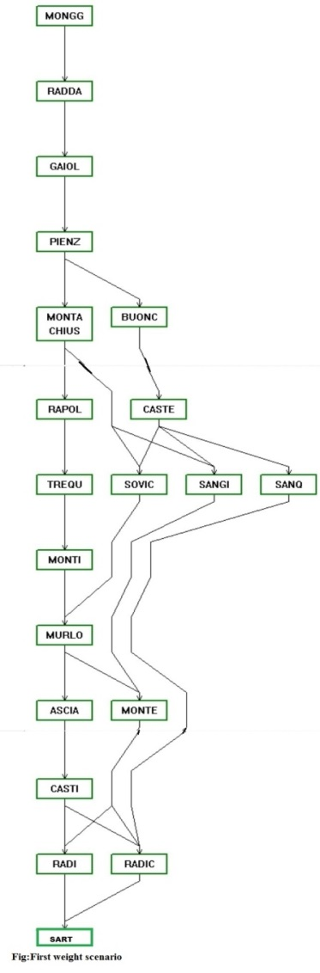
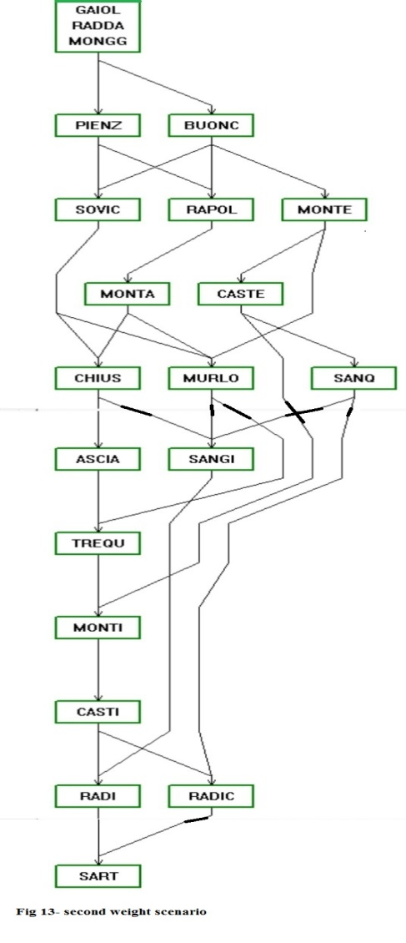
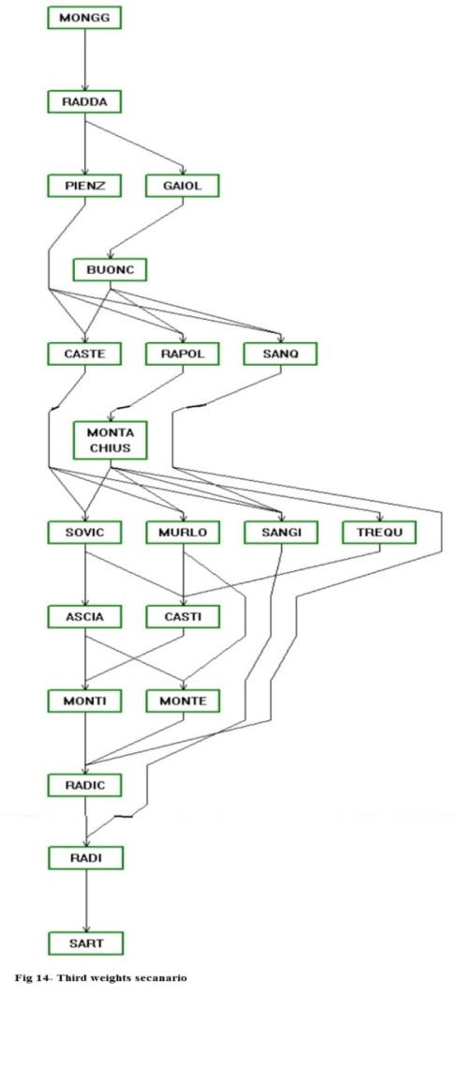

Figure7 – Results in relation to the balanced and the other weight scenarios

