Reverberation time measurements in non-diffuse acoustic field by the modal reverberation time.

Andrea Prato ^{a,*}, Federico Casassa ^{b}, Alessandro Schiavi ª.
ªNational Institute of Metrological Research – INRIM, 10135 Torino, Italy.
Tel. +39 011 3919627, Fax. +39 011 3919621, email a.prato@inrim.it.
^{b}Department of Electronics and Telecommunications, Politecnico di Torino, 10129 Torino, Italy.
ªNational Institute of Metrological Research - INRIM, 10135 Torino, Italy.

Keywords: modal reverberation time, non-diffuse field, low frequency.

Abstract
The increasing presence of low frequency sources and the lack of acoustic standard measurement procedures make the extension of reverberation time measurements to frequencies below 100 Hz necessary. In typical ordinary rooms with volumes between 30 m³ and 200 m³ the sound field is non-diffuse at such low frequencies, entailing inhomogeneities in space and frequency domains. Presence of standing waves is also the main cause of bad quality of listening in terms of clarity and rumble effects. Since standard measurements according to ISO 3382 fail to achieve accurate and precise values in third octave bands due to non-linear decays caused by room modes, a new approach based on reverberation time measurements of single resonant frequencies (the modal reverberation time) has been introduced. From background theory, due to the intrinsic relation between modal decays and half bandwidth of resonant frequencies, two measurement methods have been proposed together with proper measurement procedures: a direct method based on interrupted source signal method, and an indirect method based on half bandwidth measurements. With microphones placed at corners of rectangular rooms in order to detect all modes and maximize SNRs, different source signals were tested. Anti-resonant sine waves and sweep signal turned out to be the most suitable for direct and indirect measurement methods respectively. From spatial measurements in an empty rectangular test room, comparison between direct and indirect methods showed good and significant agreements. This is the first experimental validation of the relation between resonant half bandwidth and modal reverberation time. Furthermore, comparisons between means and standard deviations of modal reverberation times and standard reverberation times in third octave bands confirm the inadequacy of standard procedure to get accurate and precise values at low frequencies with respect to the modal approach. Modal reverberation time measurements applied to furnished ordinary rooms confirm previous results in the limit of modal sound field: for highly damped modes due to furniture or acoustic treatment, the indirect method is not applicable due to strong suppression of modes and the consequent deviation of the acoustic field from a non-diffuse condition to a damped modal condition, while standard reverberation times align with direct method values. In the future, further investigations will be necessary in different rooms to improve uncertainty evaluation.

1. Introduction

The growing interest of the international scientific community to extend the conventional architectural and building acoustics measurements to frequencies below 100 Hz [1-2] due to an increase of low frequency sound sources [3-4] requires detailed studies on sound pressure decay and reverberation time in small enclosures and typical ordinary rooms (30-200 m³). At such frequencies in small rooms, a condition of non-diffuse sound field is reached due to the presence of standing waves, whose wavelengths are comparable to boundary dimensions. The resulting sound field is inhomogeneous in space and frequency domains. Besides, standing waves entail problems on acoustic comfort and quality of listening, especially in recording studios, small concert halls or open-space offices. At resonant frequencies, amplitudes are wider and decays are much longer, causing uneven tonal quality, interference with clarity and rumble effects, and noise in other environments [5-11]. Furthermore, a new method to evaluate speech intelligibility based on reverberation time measurements has been proposed [12]. Therefore, the measurement of reverberation time at low frequency is preparatory and necessary for the acoustic treatment of listening and working rooms.
Reference measurement standard of reverberation time in ordinary dwellings is IS0 3382-2:2008 [13], which is applied from 100 Hz to 5000 Hz. Such standard reports the procedure for interrupted noise and integrated impulse response methods. For what concerns the interrupted noise method, standard states that the signal provided to the loudspeaker shall be derived from broadband random noise, the source shall be able to produce a sound level sufficient to ensure a decay curve starting at least 25 dB above the background noise in the corresponding frequency band and microphone positions should cover a portion of space sufficient to determine average behaviour of the acoustic diffuse field. No mention to frequencies below 100 Hz is reported, where the diffuse field approach is not suitable. In general there is no frequency distinction and the considered ones are calculated by simple average of decays within a certain bandwidth. At such frequencies sound decay with a broadband analysis (one-third octave bands as stated by ISO standard) is strongly non-linear due to the presence of more resonant frequencies in one band, each one with its own particular decay [14]. Such condition involves high measurement uncertainties (percentage relative standard deviations are in the order of 20% - 60%) and thus inaccurate values of reverberation time [15-17].
The aim of this work is to determine a new and more suitable measurement method to describe the reverberation time at low frequencies taking into account the involved physical phenomenon and the resulting effects on human perception. Due to the peculiarity of non-diffuse nature of sound field at low frequency in small ordinary rooms, it is convenient to move from a classical approach based on third octave bands measurements, which does not take into account modal peculiarities and entails inaccurate and imprecise values, to a modal approach, based on reverberation time measurements of single resonant frequencies: the modal reverberation time. From background theory (see next Section) modal reverberation time can be measured with two different methods: the direct method, based on standard guidelines for interrupted signal method, but with different source/receiving positions and source signals; the indirect method, based on half bandwidth measurement of resonant modes, which is related to the modal damping and, as a consequence, to the modal reverberation time. Both methods were firstly evaluated in an empty test room as described in depth from Section 3 to Section 7, in order to work in a condition of pure modal sound field. At a later stage, modal reverberation times were evaluated in two different ordinary rooms, with different furniture and acoustic treatment. Results are reported in Section 8.

2. Background theory

Reverberation time is defined as the time (in seconds) required for the sound energy density to decrease by 60 dB after the source emission has stopped. In diffuse field conditions (above the Schroeder frequency), the behaviour of sound field is statistical, and the frequency response of the room is linear. This is due to the fact that the room modes are not spaced, and the peaks corresponding to the resonant frequencies are so close to be indistinguishable. In this case measurement of the reverberation time simply consists in averaging the temporal decay of a certain frequency band (usually octave or third octave bands from 100 Hz on) to calculate T₆₀. In case of non-diffuse field, the decay curve may not be approximated by a straight line across the entire range of the 60 dB decay. This is due to the fact that, given a certain frequency band, the shape of the curve depends on room modes that fall in that octave or third octave band, and on the interaction between them. If within the considered frequency band there are two modes (with different decay times), the decay curve presents two different slopes, entailing a non-linear sound decay of that particular band [18]. Thus, in non-diffuse field conditions, evaluation of reverberation time of each single room mode (T_{n}), main cause of high uncertainty in one-third octave band and deterioration of sound quality and unwanted rumble effects, is more useful and more representative of the real physical situation. Considering a rectangular room with reactive surfaces and dissipative properties, it is supposed to supply energy to a resonant system through a sound source emitting a sinusoidal signal at a resonant frequency. In reality, although the sound radiation of just a single resonant frequency, energy is distributed by the system among its modal frequencies, and all modes are excited [19]. When the source emission is interrupted, at time t=0, wave continues its path: part of its energy is reflected by the walls, and another part is dissipated by the boundary walls and the air in the room.
Considering the decay of a single n^{th} mode, the squared sound pressure proportional to its energy becomes:

$p^{2}\left(t\right)=p^{2}\left(0\right) exp⁡ (-2δ_{n}t)$ (1)
where δ_{n} is the decay constant of the n^{th} mode, or the modal damping constant [20] and gives information about the half bandwidth of the resonant frequency Δf_{-3dB} according to the formula:

${Δf}_{-3dB}=\frac{δ_{n}}{π}$ (2)
In order to evaluate the reverberation time of a single mode after a decay of 60 dB, the following formulations are obtained:

$L\left(T_{n}\right)-L\left(0\right)=10 \log_{10}\left(\frac{p^{2}\left(T_{n}\right)}{p^{2}\left(0\right)}\right)=-60 dB;$
$\left(\frac{p^{2}\left(T_{n}\right)}{p^{2}\left(0\right)}\right)=\exp{(-2δ_{n}T_{n})}={10}^{-6}$;
(3)
$2δ_{n}T_{n}=6 \ln\left(10\right);$
${ Δf}_{-3dB}=\frac{δ_{n}}{π}=\frac{3 \ln\left(10\right)}{π{ T}_{n}}=\frac{2.2}{T_{n}}$

and so the modal reverberation time of a single mode can be expressed by

$T_{n}=\frac{2.2}{{Δf}_{-3dB}}$ (4)

In this way a relation between the resonance half bandwidth and the modal reverberation time is obtained. Such result allows to perform an indirect measurement of modal reverberation time through the evaluation of the resonant half bandwidth.

3. Measurement setup and procedures

The new approach is based on the decay of individual resonant frequencies (f_{n}) of rectangular rooms, or modal reverberation times, instead of one-third octave band analysis required by ISO 3382. Two measurement methods, derived from background theory, were experimentally evaluated: a direct method, based on the interrupted signal method, but with different measurement positions and acoustic source signals (statistical or sinusoidal) with respect to ISO Standard. Such method, which directly evaluates sound decays, is considered as the reference for accuracy. The integrated impulse response method was unfortunately neglected since it could not be possible to get high resolution frequency analysis. The second is an indirect method based on resonant half bandwidth measurements. This is the first experimental verification of Eq. (4). Different source signals were also evaluated. Measurement tests are reported in the corresponding Sections.
Measurements were performed in the receiving room of the impact sound insulation laboratory at INRIM which is completely empty and has a rectangular shape with dimensions L_{x}= 4.02 m, L_{y}=3.64 m, L_{z}=3.45 m. Walls are made of concrete and are completely bare as well as the inner volumetric space. A brief description of measurement devices used in the experimental tests is presented as follows: 1/2'' microphones, closed-box loudspeaker with a 15-inch cone in order to generate suitable low frequency sound pressure levels, microphone preamplifiers or impedance adapters, power amplifier, 24-bit A/D converter, spectrum analyzer.
In this first step, measurements have been limited to an empty test room such as an impact sound insulation laboratory that is characterized by a strong non-diffuse field due to the lack of furniture or bass traps. Furthermore it is geometrically representative of ordinary rooms and is acoustically insulated from outside. In this way, it was possible to evaluate the pure modal acoustic response of the room, considering only damping of boundary walls, and to obtain accurate and precise measurements for a reliable comparison between direct and indirect methods.
To have a first comparison and reference with standard procedure, reverberation time measurements at low frequencies with interrupted noise method according to ISO 3382 were performed in the empty test room (3 microphone positions, 2 source positions, 2 repetitions). Results are reported in Table 1. As mentioned above, the presence of different modes in a low frequency third octave band entail non-linear decays. An example for 50 Hz third octave band is shown in Fig. 1.

Table 1.
Low frequency reverberation times measured according to ISO 3382 in the empty test room. Means and standard deviations refer to the 12 spatial measurements.

f / Hz | / s | s(T) / s
50 | 7.49 | 1.89
63 | 4.32 | 0.59
80 | 3.83 | 0.39
100 | 2.63 | 0.29

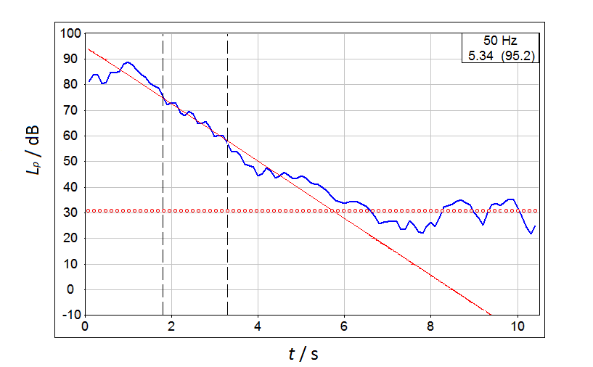
Fig.1. Example of non-linear decay of 50 Hz one-third octave band with standard measurement.

4. Modal characterization of the empty test room

Preliminary measurements were necessary in order to perform a modal characterization of the empty test room. For this reason, loudspeaker was placed at a room corner and microphones were placed at seven corners, as points of maximum modal excitation according to theory [20] and experimental measurements in similar rooms [21]. Corner position means a distance of about 5 cm from all three neighbouring walls. A sweep signal (frequency range of 30-200 Hz and linear increase in 10 s) for the whole considered frequency range (35-112 Hz) was used to generate the acoustic field. Compared to pink noise, sweep signal guarantees a well-defined and smooth spectrum. An example of room response at a single corner position is shown in Fig. 2 (resolution of 0.1 Hz). Measurements at different corner positions are consistent. Resonant frequencies (f_{n}) are reported in Table 2.

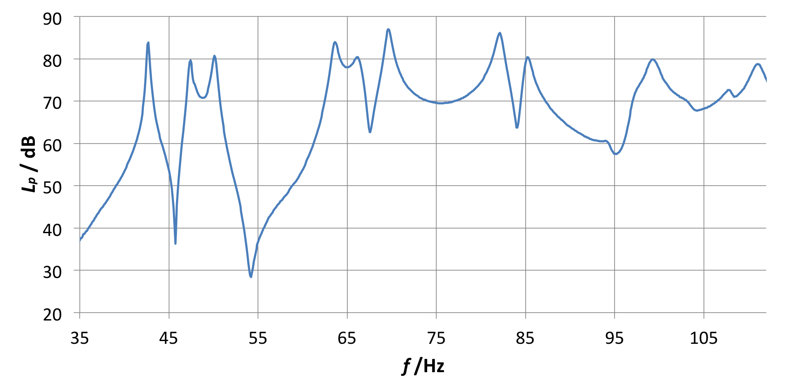
Fig.2. Sweep spectrum at a single room corner of the empty test room.

Table 2.
Measured resonant frequencies.

f_{n} / Hz | 42.6 | 47.4 | 50.1 | 63.7 | 66.2 | 69.6 | 82.0 | 85.4 | 99.2

5. Direct method

Direct measurement of modal reverberation times is based on the interrupted signal method. Measurements consisted of waterfall spectrum measurements with source and microphone placed at room corners. As first step, spatial measurements were neglected (see Section 7) as the aim was to focus just on the determination of the most suitable source signals for decay measurements. Different source signals were tested: a random noise (pink noise) and sinusoidal signals. For what concerns sinusoidal signals, more tones were tested on the basis of room response obtained in preliminary measurements: two resonant frequencies (47.5 Hz and 63.5 Hz) and two anti-resonances (56 Hz and 75 Hz). Modal decays were analysed and compared to determine the most suitable one. From waterfall data referred to the whole temporal evolution of the spectrum (resolution of 0.25 Hz), only modal sound pressure level decays were considered. For each one, a linear interpolation of decay curve considering the starting point at -5 dB from the peak until at least 5 dB above the level of background noise was performed. The interpolation returns the linear equation y=-ax+b. The reverberation time is computed as

$T_{x}=\frac{60}{a}$ (5)

where x indicates the range of sound pressure level considered for the linear interpolation and a is the slope of the interpolation straight line. It was not possible to directly determine the T₆₀, due to the impossibility to have a sufficient signal-to-noise ratio. In most of cases, T₃₀ and, in few cases, T₂₀ were evaluated. The attention was focused on the range between 40 Hz to 100 Hz, which are the bounds of the considered low frequency interval.

5.1 Pink noise source signal

A first test was performed with pink noise source signal. The spectrum decay is depicted in Fig. 3 and modal reverberation times together with an indicator of curve fitting accuracy, the standard deviation of residuals s_{res}, are reported in Table 3. The presence of prevalent peaks in the spectrum corresponding to resonant frequencies is evident. This confirms the validity of the used approach since modal frequencies have different and longer decays compared to other frequencies and heavily affect the reverberation time of the room. Due to the statistical nature of the source signal, the spectrum is quite disturbed. It is more evident analysing single decay curves of resonant frequencies (see an example in Fig. 4 for 50 Hz resonant frequency): residual standard deviations are high compared to sinusoidal source signals ones, reported in Table 4 in the next paragraph, and decay curves are not perfectly straight. In addition the fluctuating steady state does permit to determine the exact moment of source interruption.

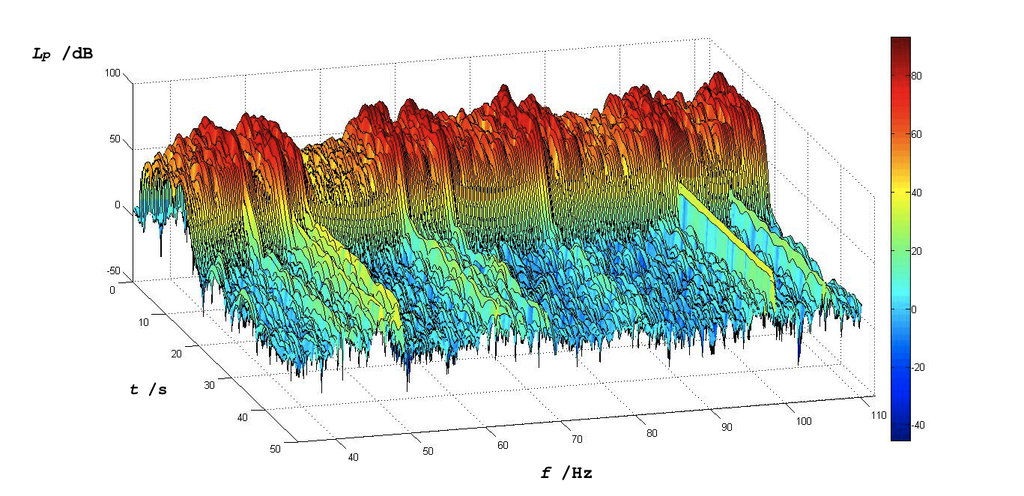

Fig.3. Waterfall spectrum with pink noise source signal.

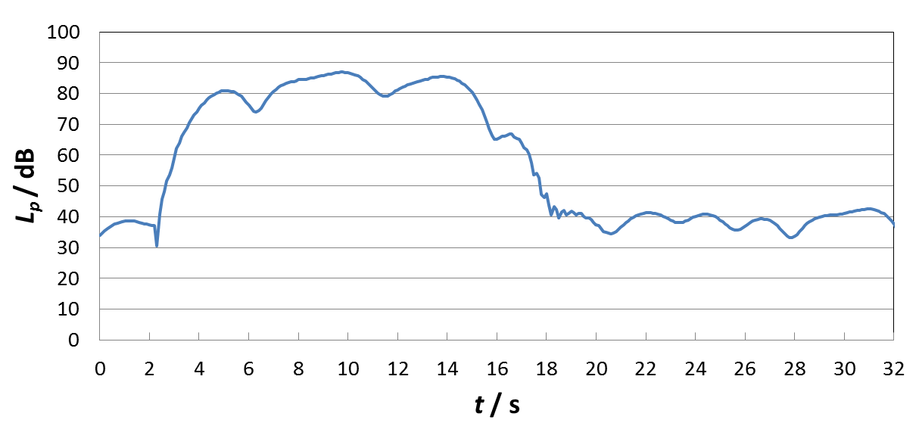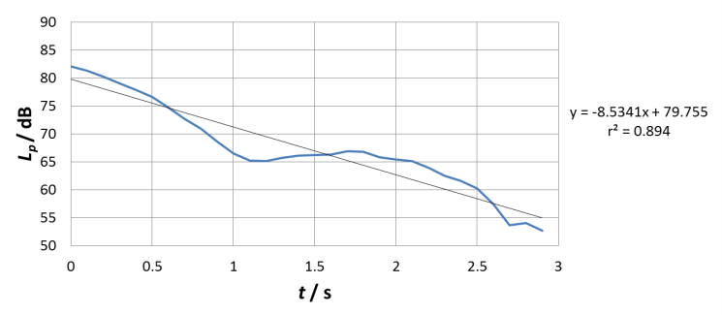

Fig.4. Decay curve of 50 Hz resonant frequency with pink noise source signal.

Table 3.
Modal reverberation times evaluated with pink noise and standard deviation of residuals from linear regressions.

f_{n} / Hz | T_{n} / s | s_{res} / dB
42.50 | 6.43 | 0.76
47.50 | 4.19 | 0.45
50.00 | 7.03 | 2.63
63.50 | 3.49 | 0.72
66.00 | 1.89 | 5.65
69.50 | 3.53 | 0.50
82.00 | 3.33 | 0.49
85.50 | 2.53 | 2.30
99.25 | 2.81 | 2.40

5.2 Anti-resonant sinusoidal source signals

Given the results obtained in preliminary measurements, sinusoidal signals were tested. Measurement method was the same used for pink noise: a signal is sent to the sound source in the room and the decay of the frequency spectrum is achieved at a room corner. The intention is to obtain cleaner and clearer modal decays. With a sine wave as source signal, the system is forced to resonate at a specific frequency: at the beginning, when energy supply is still low, the system vibrates according to its resonant frequencies. With increasing energy supply, the system becomes unable to redistribute energy according to its modes but is forced to resonate at the driving frequency. When the energy supply is interrupted, the system stops resonating at the driving frequency and dissipates energy vibrating again according to its modes, until the complete dissipation of energy. This phenomenon allows to get cleaner and clearer modal decays and lower values of s_{res}.
At the beginning, sinusoids at room’s modal frequencies were tested as source signals. Unfortunately an interference between the modal field of the room and the direct wave produced by the source occurs: the membrane of the loudspeaker is obstructed by the modal field generated at that frequency. This can induce to a distortion in the modal behaviour of the room.
To overcome this problem, two anti-resonant sine waves were tested as source signals: 56 Hz and 75 Hz which are quite far from near modes. From waterfall spectra (Fig. 5 and 6) it is evident that when energy input is high and constant in time, the system is unable to distribute energy throughout the whole spectrum, but it is entirely focused on the driving frequency. When energy supply is interrupted, energy is redistributed among room modes.
Since modal decays are very clean and clear (Fig. 7), anti-resonant sine waves are the most appropriate to study modal decays in small rooms, without the interference between the sound field and the loudspeaker (mentioned before for resonance source signals). Values obtained with two anti-resonant sine waves are reported in Table 4. Modal reverberation times are similar and this confirms the relevance of such direct method.

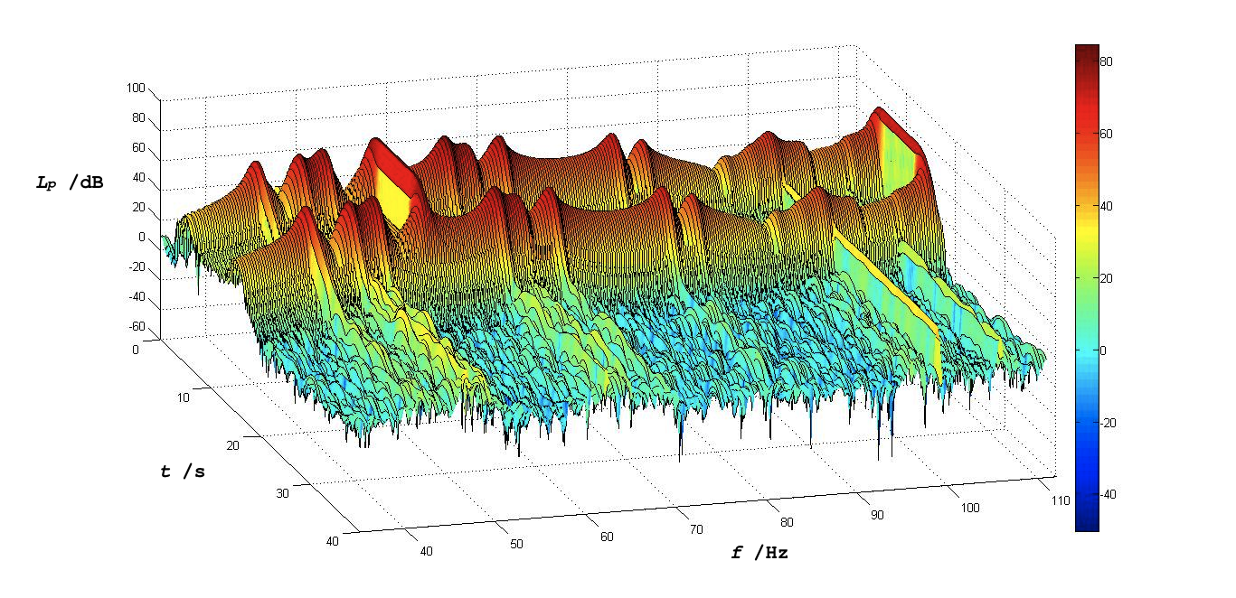
Fig.5. Waterfall with 56 Hz non-resonant sine wave as source signal.

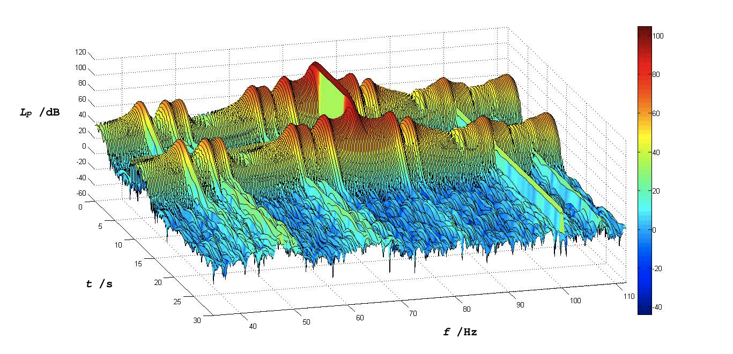
Fig.6. Waterfall with 75 Hz non-resonant sine wave as source signal.

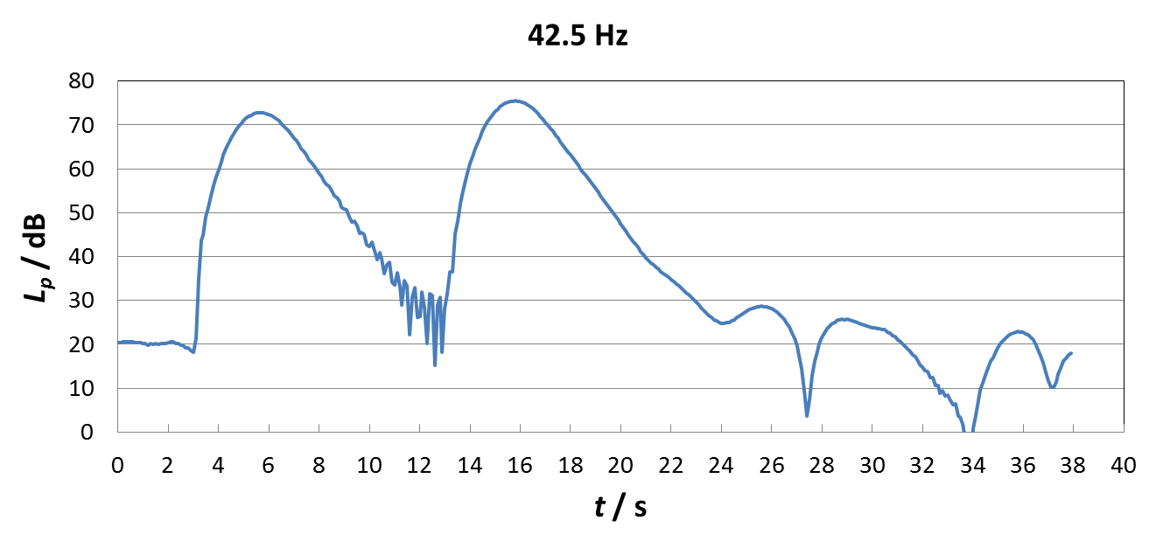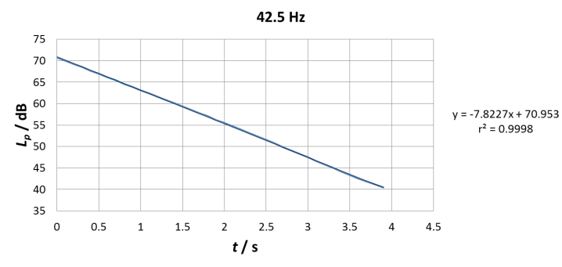

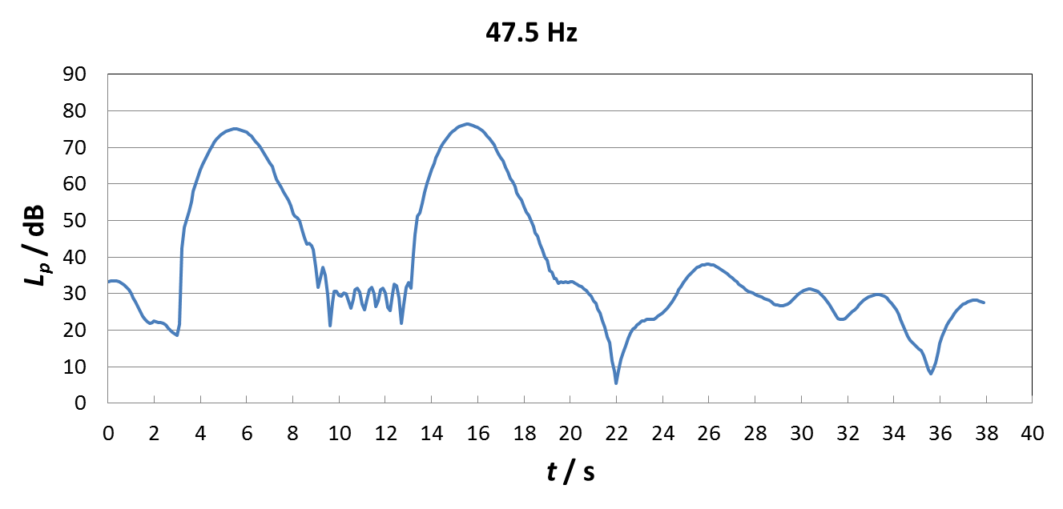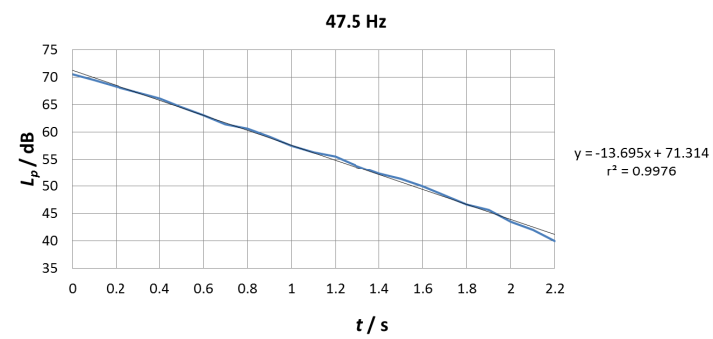

Fig.7. Examples of 42.5 Hz and 47.5 Hz modal decay curves measured
with 56 Hz non-resonant sine wave as source signal.

Table 4.
Modal reverberation times evaluated with 56 Hz and 75 Hz non-resonant sine waves as source signals and standard deviation of residuals from linear regressions.

 | 56 Hz driving frequency |  | 75 Hz driving frequency
f_{n} / Hz | T_{n} / s | s_{res} / dB | T_{n} / s | s_{res} / dB
42.5 | 7.67 | 0.13 | 7.51 | 0.32
47.5 | 4.38 | 0.46 | 4.27 | 0.76
50 | 3.66 | 0.42 | 4.08 | 0.59
63.5 | 3.17 | 0.51 | 2.89 | 0.68
66 | 2.25 | 2.76 | 2.46 | 1.86
69.5 | 3.58 | 0.26 | 3.39 | 0.07
82 | 3.24 | 0.45 | 3.21 | 0.21
85.5 | 2.91 | 1.14 | 2.74 | 1.11
99.25 | 2.73 | 3.27 | 2.03 | 1.86

5.3 Comparison between pink noise and anti-resonance source signals

The most suitable source signal for the direct measurement of modal reverberation time is the anti-resonance sine wave. In this way, modal sound pressure level decays are clearer compared to those obtained with pink noise source signal (statistical fluctuations) or a resonant sine wave (interaction between the modal field and the loudspeaker membrane). A quantitative comparison of modal reverberation times with the three different source signals are reported in Table 5 together with an analysis of residuals standard deviations derived from each curve fitting.

Table 5.
Comparison between modal reverberation times obtained with pink noise and anti-resonances (56 Hz and 75 Hz). Standard deviations refer to residual distribution function obtained from each curve fitting.

f_{n} / Hz | Source signal | T_{n} / s | s_{res} /dB | f_{n} / Hz | Source signal | T_{n} / s | s_{res} /dB | f_{n} / Hz | Source signal | T_{n} / s | s_{res} /dB
42.5 | 56 Hz | 7.67 | 0.13 | 63.5 | 56 Hz | 3.17 | 0.51 | 82 | 56 Hz | 3.24 | 0.45
 | 75 Hz | 7.51 | 0.32 |  | 75 Hz | 2.89 | 0.68 |  | 75 Hz | 3.21 | 0.21
 | Pink | 6.43 | 0.76 |  | Pink | 3.49 | 0.72 |  | Pink | 3.33 | 0.49
47.5 | 56 Hz | 4.38 | 0.46 | 66 | 56 Hz | 2.25 | 2.76 | 85.25 | 56 Hz | 2.91 | 1.14
 | 75 Hz | 4.27 | 0.76 |  | 75 Hz | 2.46 | 1.86 |  | 75 Hz | 2.74 | 1.11
 | Pink | 4.19 | 0.45 |  | Pink | 1.89 | 5.65 |  | Pink | 2.53 | 2.30
50 | 56 Hz | 3.66 | 0.42 | 69.5 | 56 Hz | 3.58 | 0.26 | 99.25 | 56 Hz | 2.73 | 3.27
 | 75 Hz | 4.08 | 0.59 |  | 75 Hz | 3.39 | 0.07 |  | 75 Hz | 2.03 | 1.86
 | Pink | 7.03 | 2.63 |  | Pink | 3.53 | 0.50 |  | Pink | 2.81 | 2.40

Reverberation times obtained with sine waves are slightly different compared to those achieved with pink noise and residual distribution standard deviations are lower. This is due to the fact that pink noise fails to adequately excite the acoustic field at low frequencies and decays present more fluctuations, as seen previously in Fig. 3.
Furthermore, for such laboratory room, since the 75 Hz sine wave is localized in the flat and central part of the low frequency spectrum and does not influence adjacent modes, it can be considered as the reference source signal for direct method used for comparisons described in Section 7.

6. Indirect measurement of modal reverberation times

In this Section the indirect method is discussed. Modal reverberation times were calculated by half bandwidth measurements of resonance peaks according to Eq. 4, and thus no decay measurements were performed. Half bandwidths were obtained by spectrum measurements (resolution of 0.1 Hz). Also in this case, loudspeaker and microphone were placed at two corners of the room to maximize the modal acoustic response and SNRs. Two different source signals were tested: a pink noise and a sweep signal (see Fig. 8).

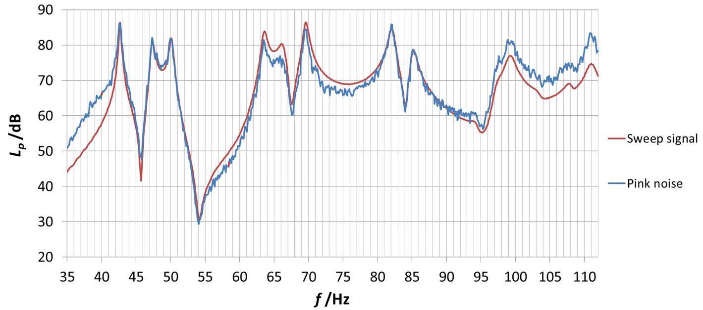

Fig.8. Modal spectra generated with a pink noise and a sweep signal.

Spectrum obtained with the sweep signal is smoother and resonance peaks are well defined compared to the one obtained with pink noise. Half bandwidths of resonance peaks were then calculated through the implementation of the best fit with a Lorentzian function that minimizes normalized residual sum of squares (RSS). Modal reverberation times evaluated with both signals are reported in Table 6. In Fig. 9 and 10 two examples of resonant peak half bandwidth, referred to sweep and pink noise signals respectively, are depicted. In this case, resonance peaks measured with sweep signal are well defined and the Lorentzian fit is more precise since residual standard deviations are lower. For this reason, sweep signal can be considered as the reference for indirect method.

Table 6.
Summary of modal reverberation times evaluated with pink noise and sweep signal and comparison of residual standard deviations of Lorentzian best fits.

 | Pink noise |  | Sweep
f_{n} / Hz | T_{n} / s | s_{res} / dB | T_{n} / s | s_{res} / dB
42.5 | 5.83 | 0.14 | 7.46 | 0.18
47.5 | 6.34 | 0.19 | 4.38 | 0.16
50.0 | 4.06 | 0.24 | 3.96 | 0.16
63.5 | 4.26 | 0.26 | 2.50 | 0.13
66.0 | 1.49 | 0.21 | 2.19 | 0.11
69.5 | 4.12 | 0.22 | 2.99 | 0.08
82.0 | 4.71 | 0.22 | 2.42 | 0.13
85.5 | 2.26 | 0.26 | 2.29 | 0.10
99.25 | 1.61 | 0.20 | 1.31 | 0.06

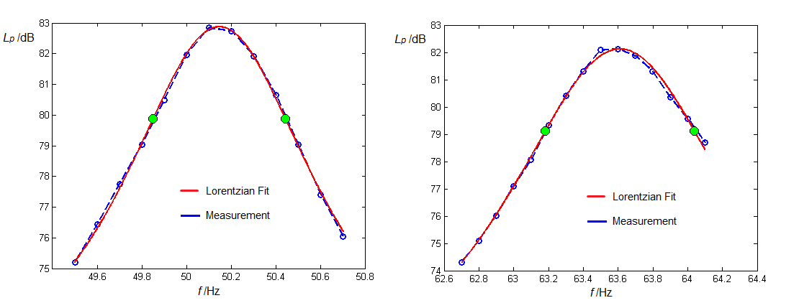

Fig.9. Examples of half bandwidth calculation for 50 Hz and 63.5 Hz modes using sweep signal.

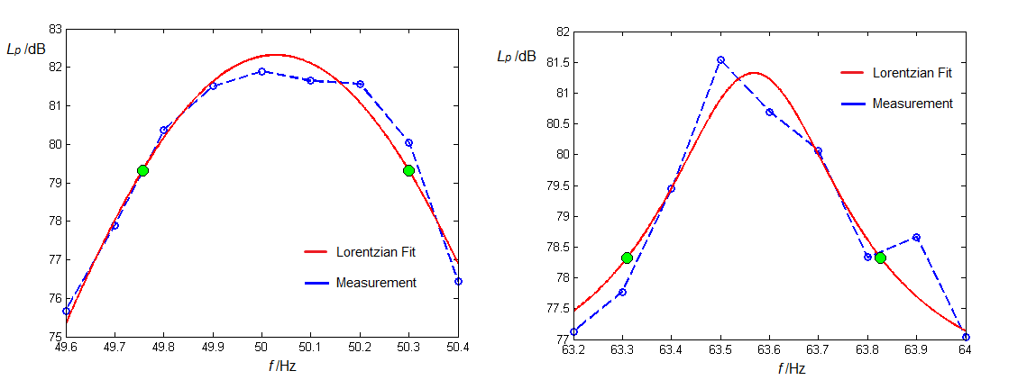

Fig.10. Examples of half bandwidth calculation for 50 Hz and 63.5 Hz modes using pink noise.

Repeatability standard deviations of modal reverberation times for the indirect method (sweep signal) evaluated with five consecutive measurements in one corner of the room are in the order of 0.34 s (min 0.10 s, max 0.81 s). It is important to underline that such values do not want to be definitive, but are useful to give an idea of the dispersion of results. In the following Section spatial measurements will provide a more detailed indication of uncertainty.

7. Comparison between direct and indirect methods

In previous Sections the most suitable methods for direct and indirect measurements have been described. In order to get a better assessment of modal reverberation time and a first uncertainty evaluation, spatial measurements (as indicated in ISO 3382) were performed. Microphones were placed at 7 room corners (one corner is occupied by the loudspeaker) and at 3 inner positions (2 random positions plus the center of the room, see Fig. 11), in order to have an indication of the acoustic field behaviour even in positions where room modes are not excited at the highest levels. In this part 99.25 Hz mode is not considered due to the presence of a background tone at 100 Hz that could not be excluded.
On the basis of the conclusions in previous Sections, direct measurements were performed with 75 Hz anti-resonant sine wave as source signal, while indirect measurements were performed with a sweep signal (30-200 Hz with a linear increase of 10 s).

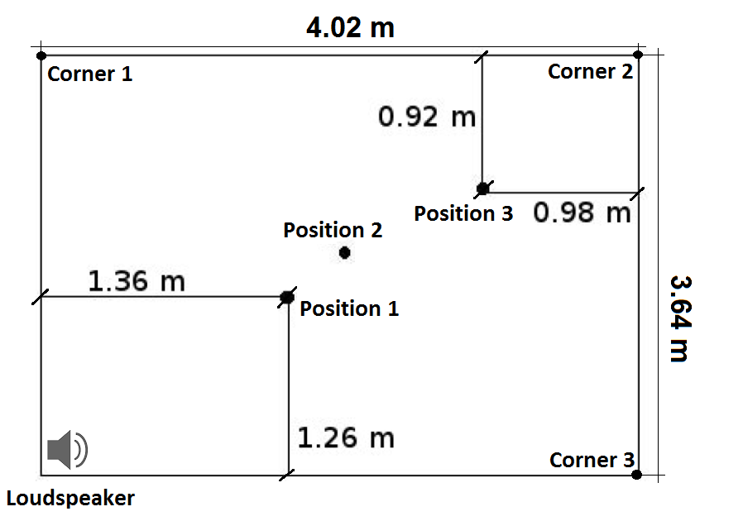

Fig.11. Empty test room plan with inner microphone positions for spatial measurements. Figure refers to xy plane. Vertical z values of inner positions are z₁=2 m, z₂=1.72 m and z₃=1 m.

7.1 Direct spatial measurements

Spatial measurements were firstly performed with direct method. Moving away from corners, intensity of resonance peaks decreases until mingling with background noise at the center of the room so it was not possible to get modal reverberation times at such position. Means and standard deviations of modal reverberation times were then calculated considering, firstly, all spatial positions and, secondly, just corner positions. Results are reported in Table 7. Modal reverberation times are consistent, and standard deviations of corner positions measurements are lower than those for all positions: another proof that room corners can be considered the reference positions for modal reverberation times measurement.

Table 7.
Spatial direct measurements: averages and standard deviations of modal reverberation times.

 | All positions |  | Corner positions
f / Hz | $\overline{Tn}$ / s | s(T_{n}) / s | $\overline{Tn}$ / s | s(T_{n}) / s
42.5 | 6.22 | 0.94 | 6.61 | 0.59
47.5 | 3.82 | 0.31 | 3.74 | 0.28
50 | 4.21 | 0.51 | 4.34 | 0.53
63.5 | 2.66 | 0.13 | 2.69 | 0.12
66 | 2.65 | 0.29 | 2.78 | 0.18
69.5 | 3.26 | 0.03 | 3.27 | 0.03
82 | 2.67 | 0.26 | 2.75 | 0.13
85.5 | 2.77 | 0.19 | 2.71 | 0.16

7.2 Indirect spatial measurement

Spatial measurements with indirect method were also performed. Corner measurements provide well defined resonant peaks, while at intermediate positions (1 and 3) resonant peaks present lower values and at the center (position 2) some modes are completely suppressed as seen for direct method (Fig. 12). This confirms the fact that corner positions are the best to evaluate room modes as their intensity is maximum and all modes are detectable. In Table 8, results are reported. Modal reverberation times in different spatial positions are consistent and corner standard deviations are basically lower.

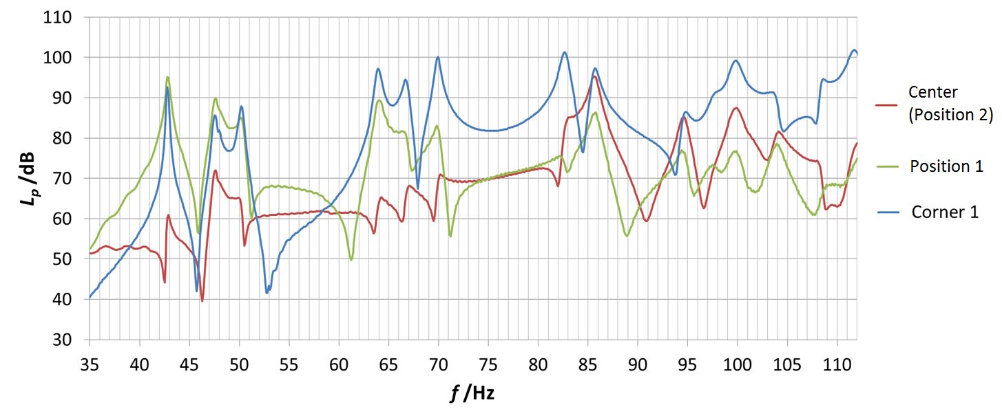
Fig.12. Examples of spectra obtained at a corner, at position 5 and at the center of the room.

Table 8.
Spatial indirect measurements: averages and spatial standard deviations of modal reverberation times.

 | All positions |  | Corner positions
f / Hz | $\overline{Tn}$ / s | s(T_{n}) / s | $\overline{Tn}$ / s | s(T_{n}) / s
42.5 | 6.26 | 0.54 | 6.29 | 0.62
47.5 | 4.36 | 0.33 | 4.46 | 0.28
50 | 4.10 | 0.29 | 4.11 | 0.31
63.5 | 3.07 | 0.20 | 3.06 | 0.18
66 | 2.95 | 0.40 | 3.01 | 0.26
69.5 | 3.18 | 0.17 | 3.19 | 0.17
82 | 2.34 | 0.26 | 2.43 | 0.12
85.5 | 2.90 | 0.23 | 2.89 | 0.22

7.3 Comparison between direct and indirect measurements and standard procedure

Previous results of spatial measurements considering only 7 corner positions are now compared in order to verify the accuracy of direct and indirect measurements (Fig. 13). In general, comparison shows a good agreement between the two methods since mean values are consistent (error bars correspond to experimental standard deviations). This means not only that the methodology contained in the ISO 3382 has been adapted for reverberation time measurements at low frequencies, but this is also the first experimental proof of the relation between the modal reverberation time and the half bandwidth of resonant peaks in Eq. 4. Besides, reverberation times decrease with frequency, as also confirmed by theory: first axial modes are more energetic and their decay time is longer [20].

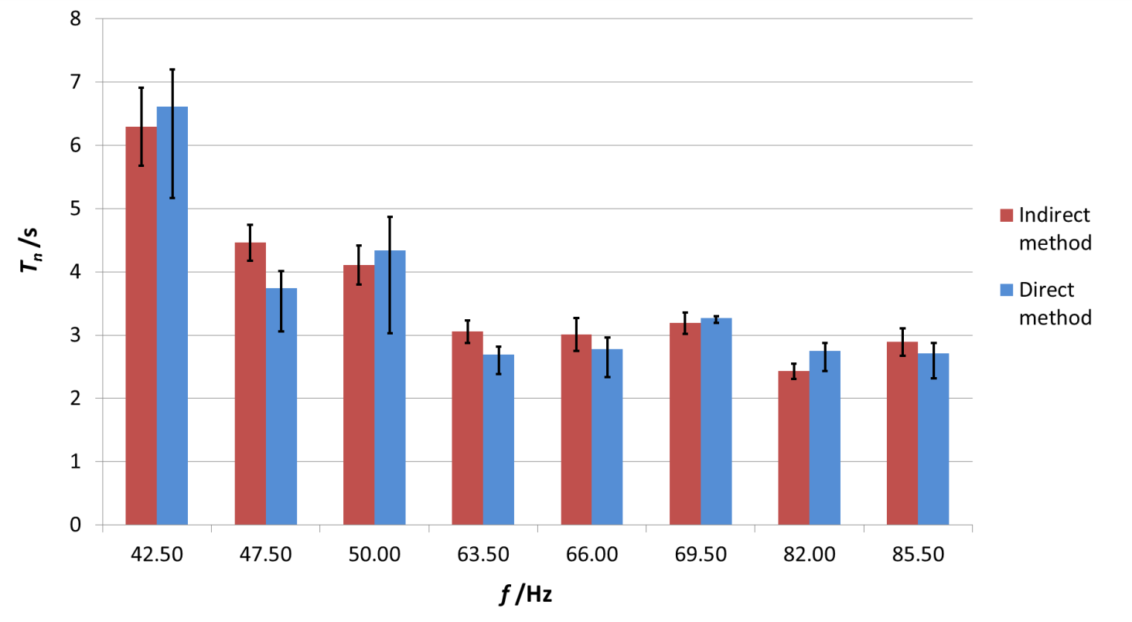
Fig.13. Comparison between direct and indirect spatial measurements of modal reverberation times. Error bars correspond to experimental standard deviations of corner measurements.

In the end, comparing reverberation times of modes that fall within the corresponding one-third octave band (e.g. 47.5 Hz and 50 Hz resonant frequencies are within the 50 Hz third octave band; 63.5 Hz, 66 Hz and 69.5 Hz are within the 63 Hz third octave band; 82 Hz and 85.5 Hz are within the 80 Hz third octave band) with ISO measurements reported in Table 1 and Fig. 14, it is evident that standard procedure fails to obtain accurate values (differences in the range between 1.1 s and 3.6 s) and precise measurements (compare standard deviation of modal reverberation times in Table 8 with third octave bands reverberation times in Table 1).

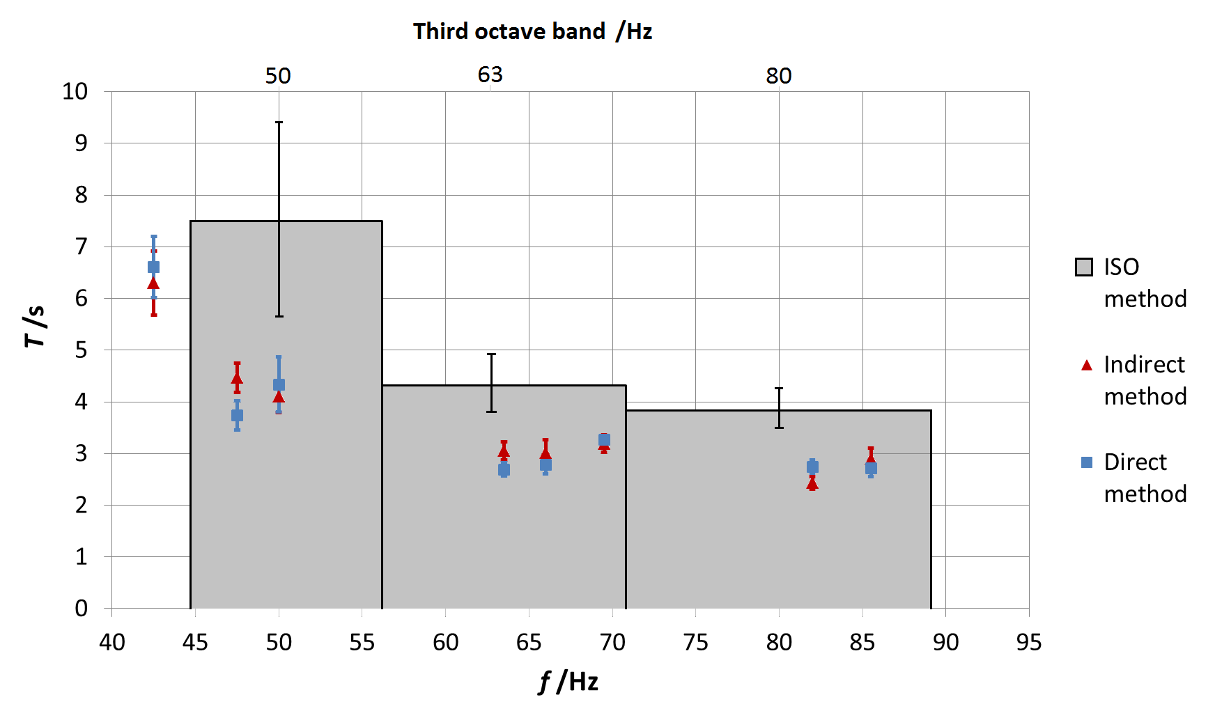

Fig.14. Direct and indirect modal reverberation times compared to ISO standard measurements in the empty test room. Error bars correspond to experimental standard deviations.

8. Modal reverberation time measurements in furnished ordinary rooms

In a second phase, once experimentally proved the relation between modal decays and resonant half bandwidths in an empty test room as seen in previous Sections, modal reverberation time measurements were performed in two rectangular furnished ordinary offices in order to evaluate the influence of increased damping due to the presence of furniture. The first room (4.60 m x 3.62 m x 3.00 m) contained a closet, two desks and few shelves. The second one (5.24 m x 3.43 m x 3.00 m) presented three closets, three desks and was acoustically treated with a suspended ceiling. Modal reverberation times were evaluated with direct (anti-resonance sinusoidal source signal) and indirect (sweep source signal) methods, according to the previous procedures, at four available room corners, and were compared to the standard reverberation times, according to ISO 3382-2:2008. All measurements were performed with two operators inside the rooms. Measurements in office n.1 are reported in Table 9 and Fig. 15. Direct and indirect measurements of modal reverberation times for the first resonant frequencies, at least up to 69.5 Hz, are consistent while for higher frequencies, values begin to diverge. This is mainly due to the fact that the non-diffuse field condition is compromised over 70 Hz due to the strong damping of furniture. Resonant peaks are unclear and half bandwidth measurements are not accurate enough. Furthermore when the sound field approximates a diffuse (overlapped modes) field or, in this case, a damped modal sound field, standard measurements are accurate due to a minor contribution of resonant frequencies to the whole third octave band decay. In such condition, standard reverberation times and modal reverberation times evaluated through the direct method are similar (e.g. 80 Hz third octave band). Nevertheless, modal reverberation times keep providing more precise values.

Table 9.
Means and spatial standard deviations of modal reverberation times and standard reverberation times in office n.1.

 | Modal reverberation times |  |  |  | Standard reverberation times
 | Indirect method |  | Direct method |  | ISO 3382
f_{n} /Hz | $\overline{Tn}$ /s | s(T_{n}) /s | $\overline{Tn}$ /s | s(T_{n}) /s | f /Hz | $\overline{T}$ /s | s(T) /s
36.00 | 6.01 | 0.34 | 6.34 | 0.84 | - | - | -
45.75 | 2.38 | 0.23 | 2.67 | 0.26 | 50 | 1.63 | 0.12
57.50 | 1.81 | 0.14 | 1.86 | 0.04 | 63 | 1.78 | 0.59
62.75 | 1.34 | 0.14 | 1.47 | 0.09
69.50 | 1.13 | 0.01 | 1.48 | 0.01
76.00 | 0.97 | 0.54 | 1.83 | 0.53 | 80 | 1.95 | 1.00
78.50 | 0.81 | 0.12 | 1.77 | 0.13
83.50 | 1.22 | 0.16 | 1.84 | 0.04

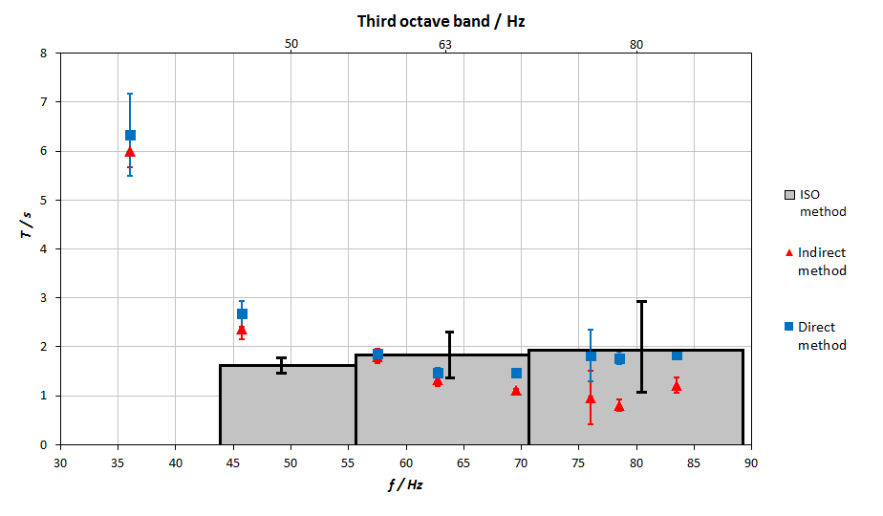
Fig.15. Direct and indirect modal reverberation times compared to ISO standard measurements in office n.1. Error bars correspond to experimental standard deviations.

Although Schroeder frequency is around 250 Hz, for lower frequency, at least down to 69.5 Hz, the modal sound field is strongly damped and non-diffuse field condition is not fully reached. This suggests to add a new parameter beside the classical Schroeder frequency to describe the correct sound field (non-diffuse, damped or diffuse) in enclosed spaces.
In office n.2, the strong damping due to suspended ceiling and massive furniture did not permit to evaluate modal reverberation times for frequencies above 60 Hz at four corners, as showed in Fig. 16. At such frequencies resonant half bandwidths are very large and room modes are suppressed due to high damping and modal overlap. For lower frequencies (e.g. 49.25 Hz abd 55.75 Hz modes) where the acoustic field presents a non-diffuse condition and a lower damping, indirect and direct methods provide consistent modal reverberation times (1.16 s and 1.12 s respectively) while standard reverberation time for the corresponding 50 Hz third octave band is fairly inaccurate (1.95 s). Thus, the same conclusions descripted above and in Section 7 are confirmed.

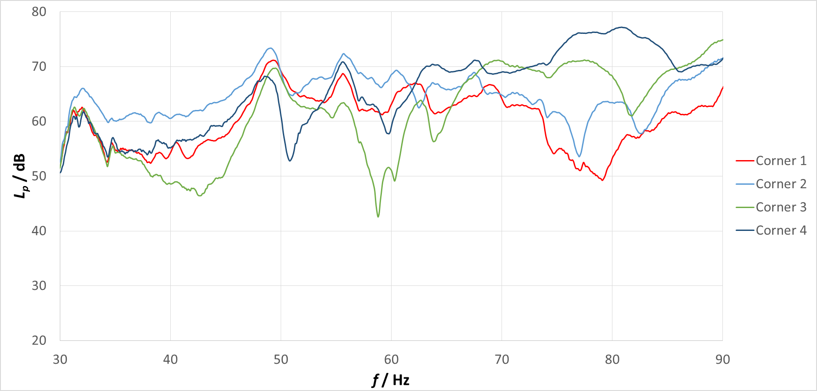

Fig.16. Sweep spectra at four room corners of office n.2.

9. Conclusions

In non-diffuse sound field, the non-linearity of sound pressure level decays in one-third octave bands suggest to focus just on resonant frequencies, as the most influential parameters of acoustic field and main cause of annoyance on humans in terms of quality of listening. Following this approach the modal reverberation time is introduced. In particular two measurement methods were investigated in an empty rectangular room: the direct method and the indirect method. For the first one, starting from the interrupted noise procedure stated in ISO 3382-2:2008, different source signals were compared: pink noise and anti-resonant sine waves. The last one shows cleaner and clearer decays. Indirect method, whereas, requires measurement of half bandwidths of modes, mathematically related to modal reverberation time. The source sweep signal is preferable with respect to pink noise as spectra are smoother and half bandwidth calculations are even more precise.
In the end, comparison between direct and indirect methods for modal reverberation time measurement shows a good agreement as results are consistent and comparable. This is the first experimental validation of the relation between half bandwidth of resonant frequencies and modal reverberation time. Furthermore, comparing means and standard deviations of modal reverberation times with standard reverberation times in third octave bands, large discrepancies and higher dispersion of standard values are shown. This is a confirmation of the inadequacy of standard procedure to get accurate and precise values in non-diffuse sound fields.
Application of modal approach to furnished ordinary rooms confirmed previous conclusions in the limit of non-diffuse sound field condition. For highly damped room modes due to furniture or acoustic treatment, indirect method does not provide accurate modal reverberation times. In a condition of damped modal field, direct method results agree with standard ones, as seen in office n.1. Nevertheless modal reverberation times are still more precise than standard ones. Room modes in high modal damping condition (office n.2 with acoustic treatment, above 60 Hz) are undistinguishable and modal reverberation times can not be evaluated neither with indirect nor with direct methods. Such evidence suggests to add a new parameter to describe the correct acoustic field (non-diffuse, damped or diffuse) in enclosed spaces beside the well-known Schroeder frequency.
In conclusion, in non-diffuse condition where room modes are detectable it useful to evaluate modal reverberation times, while in case of strong modal damping, standard measurements are still accurate.
In the future, further investigations will be necessary in different rooms to improve uncertainty assessment and to evaluate the limit between the non-diffuse field and the damped modal field.
In the end, results of such work open the possibility of assessing sound absorption in reverberant rooms at low frequencies. As consequence, such work can feed further researches in the development of particular solutions for low frequencies measurements in building acoustics, and for room acoustic treatment to guarantee good quality of listening in spaces like recording studios or small concert halls.

9. Bibliography

[1] Hopkins C, Turner P. Field measurement of airborne sound insulation between rooms with non-diffuse sound fields at low frequencies. Applied Acoustics 2005;66:1339–1382.
[2] Zhu X, Ma Q, Zhu Z. Cheng J. Validation of an optimization procedure to improve low frequency characteristics of rooms. Applied Acoustics 2006;67:529–540.
[3] Berglund B, Hassmen P, Soames F. Sources and effects of low-frequency noise. J Acoust Soc Am. 1996;99(5):2985–3002.
[4] Dibble K. Low-frequency noise propagation from modern music making. J Low Freq Noise Vib
1997;16(1):1–12.
[5] Bucklein R. The audibility of frequency response irregularities. Journal of Audio Engineering Society 1981;29(3):126-131.
[6] Toole FE, Olive SE. The modification of timbre by resonances: perception and measurement. Journal of Audio Engineering Society 1988;36(3):122-142.
[7] Karjalainen M, Antsalo P, Makivirta A, Valimaki V. Perception of temporal decay of low-frequency room modes. Proc. of the 116th AES Convention; Berlin; 2004.
[8] Bradley JS. Annoyance caused by constant-amplitude and amplitude-modulated sounds containing rumble. Noise Control Engineering Journal 1994;42(6):203-208.
[9] Landstrom U, Akerlund E, Kjellberg A, Tesarz M. Exposure levels, tonal components, and noise annoyance in working environments. Environment International 1994;21(3):265-275.
[10] Stephenson M. Assessing the quality of low frequency audio reproduction in critical listening spaces. Degree of Doctor of Philosoph; School of Computing; Science & Engineering; University of Salford; 2012.
[11] Duarte AC, Moorhouse A, Viveiros E. Indirect measurement of acoustic power into a small room at low frequencies. Applied Acoustics 2012;73:248–255.
[12] Nowoswiat A, Olechowska M. Fast estimation of speech transmission index using the reverberation time. Applied Acoustics 2016;102:55–61.
[13] ISO 3382. Acoustics – Measurement of room acoustic parameters - Part 2: Reverberation time in ordinary rooms. ISO, 2008.
[14] Howard and Angus. Acoustics and Psychoacoustics. 4th ed. Oxford – Boston: Focal Press; 2009.
[15] Wszołek T. Uncertainty of sound insulation measurement in laboratory. Archives of Acoustics 2007;32(4):271-277.
[16] Masovic D. Analysis of reverberation time field measurement results in building acoustics. Telfor Journal 2013;5(2):145-150.
[17] Scrosati C, Scamoni F, Zambon G. Uncertainty of façade sound insulation in buildings by a Round Robin Test. Applied Acoustics 2015;96:27-38.
[18] Hopkins C. Sound insulation. Oxford: Elsevier; 2007.
[19] Morse P. Vibration and sound. New York: McGraw Hill; 1948.
[20] Kuttruff H. Room acoustics. Abingdon: Taylor & Francis; 2000.
[21] Prato A, Schiavi A. Problems and possible solutions in the evaluation of laboratory airborne sound insulation at low frequencies. Proc. INTER-NOISE Conference; Innsbruck; 2013.

