Dynamic model with experimental validation of a biogas-fed SOFC plant
D’Andreaª G., Gandiglioª M., Lanziniª A., Santarelli^{a,b} M.
ª Energy Department, Politecnico di Torino, Torino (Italy)
^{b} Energiteknik, Royal Institute of Technology KTH (Sweden)

Abstract
The dynamic model of a poly-generation system based on a biogas-fed solid oxide fuel cell (SOFC) plant is presented in this paper. The poly-generation plant was developed in the framework of the FP7 EU-funded project SOFCOM (www.sofcom.eu), which consists of a fuel-cell based polygeneration plant with CO₂ capture and re-use. CO₂ is recovered from the anode exhaust of the SOFC (after oxy-combustion, cooling and water condensation) and the Carbon is fixed in the form of micro-algae in a tubular photobioreactor.
This work focuses on the dynamic operation of the SOFC module running on steam-reformed biogas. Both steady state and dynamic operation of the fuel cell stack and the related Balance-of-Plant (BoP) has been modeled in order to simulate the thermal behavior and performance of the system.
The model was validated against experimental data gathered during the operation of the SOFCOM proof-of-concept showing good agreement with the experimental data. The validated model has been used to investigate further on the harsh off-design operation of the proof-of-concept.
Simulation results provide guidelines for an improved design of the control system of the plant, highlighting the feasible operating region under safe conditions and means to maximize the overall system efficiency.

Nomenclature
Acronyms
ASR Area Specific Resistance
CHP Combined Heat and Power
DIR Direct Internal Reforming
FU Fuel Utilization
INSUL Insulation
INTER Interconnector
LPM Lumped Model
NG Natural Gas
PBR PhotoBioReactor
PID Proportional Integrative Derivative
MEA Membrane Electrode Assemblies SIM Simulation
SMR Steam Methane Reforming
S/C Steam to Carbon
SOFC Solid Oxide Fuel Cell
WGS Water Gas Shift
WWTP Waste Water Treatment Plant

Symbols
$c_{p}$ Specific heat capacity [kJ/kg K]
Vol (or V) Volume [m³]
$G_{i}$ Mass flow rate of i-stream [kg/s]
$h_{i}$ Enthalpy of i-stream [kJ/kg]
$\dot{Q}$ Thermal power [kW]
$\dot{P}$ Electrical power [kW]
T Temperature [°C]
t Time [s]
$y_{i}$ Mole fraction of i-stream [-]
f Constant percentage value [-]
$V_{OCV}$ Open Circuit Voltage [V]

$P_{el}$ Electrical Power [kW]
i Current density [A/cm²]
I Total current [A]
M Mass [kg]

$n_{cell}$ Number of cells

Greek symbols
$ρ$ Density [kg/m³]
$λ$ Thermal conductivity [W/m K]
η Thermal efficiency [-]

Introduction
Among CHP generators, fuel cells could be the option with a higher emphasis towards the maximization of the energy efficiency. Furthermore, the coupling with a renewable fuel such as biogas can determine an interesting synergetic effect, putting together a sustainable fuel and technology with characteristics of very high conversion efficiency. Moreover, it is possible to take advantages of other specific aspects of the SOFC-based systems, such as the opportunity of a simplified recovery of CO₂ from the cell exhausts, and thus their operation in the framework of more ambitious poly-generative systems.
In 2004, Van Herle et al. were already discussing the potential for the integration of sewage biogas with high temperature fuel cells [1][2]. Over the last years, new research activities aimed to the demonstration of the same concept; in fact, the use of fuel cells in biogas plants can lead to many advantages in terms of environmental and economic aspects [3][4].
In order to analyze the advantages of SOFC-based systems, mathematical models can be developed from micro to macro scale, depending on the scales investigated. The analysis of the SOFC at the stack level focuses on the mathematical description of electrochemical processes, chemical reactions, transport phenomena, and geometry influence. Investigation of the entire system includes, instead, studies on the system integration, heat and mass exchange, electrical circuits, and equipment. Intensified research efforts have been made in the development of SOFC mathematical models at the system level in recent years, and several dynamic models have been reported as well [5]–[11]. Various mathematical models based on mass, energy and momentum conservation laws and statistical data-driven models of the SOFC system have been proposed [12]–[15].
Most of these algorithms are suitable only for steady state performance analysis, whereas they are not suitable for the study of complex integrated power systems in which the monitoring of real-time plant performance (on load tracking) and its impact on power quality are required.
Mathematical models of the dynamic behavior of the SOFC have been proposed already in the literature [16]–[18]. Hall proposed a dynamic model of a single tubular cell [18]. Nehter et al. [16] extended the dynamic modeling approach toward a two-dimensional transient model of a multi-cell system consisting of micro-tubular cells arranged in a cascade configuration. However, large (of approx. 250 K) thermal gradients were calculated for this configuration. Huangfu et al. [19] provided a transient 1-dimensional model of a tubular SOFC that was able to predict the non-uniform distributions of current density, gas composition and temperature across the fuel cell. Padulles et al. [17] provided a mathematical description of the control system of an SOFC unit. However, the thermal response of fuel cell was not included in his work. Achenbach [5] formulated a three-dimensional time-dependent model of an SOFC stack. Different internal flow configurations and internal methane reforming were assessed in his model. The time constants of the stack were calculated showing how load changes entail a response time of 5 minutes. Achenbach [20] extended further the study of load changes on the transient behavior of the SOFC by simulating the impact of fast load changes. Results showed how a step load change produces a temperature overshoot followed by a relaxation time whose duration depends on the thermal properties, size and geometrical and flow configuration of the cell. However, no attempts at establishing the effects of a control loop on the cathode air flow rate to moderate the temperature overshoot and relaxation time were modeled in the works of Achenbach.
The design of accurate control strategies is a critical aspect for integrated SOFC systems, as described in Refs. [11][21]. Recently, Barelli et al. [22] developed a mathematical model of an SOFC stack system for which the cathode air flow rate is dynamically adjusted by a PID controller unit. Nearly a constant stack temperature behavior has been calculated even during fast load changes by rapidly varying the PID-controlled cathode airflow rate. The simulations were carried out for a 4-cell stack. The fast adapting transient behavior of the stack temperature might be ascribed to the low thermal mass of the modeled fuel cell stack. Looking to their dynamic model assumptions, the thermal capacity of the metallic interconnected has been not included thus yielding a low thermal inertia of the solid stack structure.
Recently, Barelli et al. have experimentally shown on an SOFC short stack how the fuel composition affects the amount of cathode air flow rate that is needed to maintain a constant operating temperature [23]. Wu and Go [24] developed an extensive control methodology for the SOFC that is based a non-linear predictive and that includes fault diagnostics. They proposed a fault-tolerant control strategy that makes use of artificial neural network algorithms. The internal stack flow configuration is also key to control and limit the in-plane thermal gradient of the SOFC. Fardadi et al. [25] proposed a modified cross-flow arrangement with non-uniform air flow feeding. The control unit adjusts both air flow rate and temperature resulting in calculated negligible temperature variations for the fuel cell, even when large load changes are applied.
This paper develops a modeling approach in order to reproduce the dynamic behavior of a proof-of-concept poly-generation system based on SOFC: an integrated system, in which the SOFC is the core element of a more complex structure with several processes running simultaneously.
As discussed in [26]–[29], to meet these purposes, 0D, 1/2/3D techniques can be used. However, in the overall perspective of a system integrating several components, already in operation, and especially considering the dynamic approach, 0D methods proved to be sufficient for a suitable simulation and analysis of the system. Thus, the considered model includes multi-physics phenomena, as better described below, such as thermal processes (i.e. heat exchanges and oxy-combustion of the anode exhausts), electrochemical reactions in the SOFC stack, and chemical reactions occurring in the fuel processor.
In particular, the model has been validated making use of the experimental results obtained from the first-of-a-kind proof-of-concept of this type of systems, developed by the Authors. This work has been developed in the framework of the SOFCOM European Project (2010-2015), where a poly-generation proof-of-concept, able to produce electricity from an SOFC, recover heat from exhaust streams and capture CO₂ for algae growth in a photobioreactor, has been designed, built and tested.
The validated model has been used to investigate the performance of the demonstration plant in specific operating condition. In particular, the following off-design conditions have been analysed: (i) the impact of a possible malfunction of the coolant air regulation system, (ii) the stack performance under different degrees of direct internal reforming (which could be also connected to loss of catalytic activity of the external steam reformer) and, finally, (iii) the influence of a sudden current load change.

Methodology

Mathematical modeling the integrated system
The SOFCOM [30] proof-of-concept is composed of a biogas clean-up unit (for the removal of H₂S and siloxanes), gas pre-heaters, an evaporator to feed the methane reformer, a catalytic reactor for steam reforming, an SOFC stack, an oxy-combustor of the anode off-gas stream, a water condenser, a dryer of the residual CO₂ stream, and finally a photo-bio-reactor (PBR) for the CO₂ recycling in microalgae (see Figure 1). The oxy-combustor is installed in order to recover pure CO₂ from the anode exhaust stream: in fact, it is able to convert all the residual fuel (mainly H₂ and CO) into H₂O and CO₂. The resulting oxy-combusted anode exhaust thus consists mainly of H₂O and CO₂. Then, a relatively simple condenser unit is sufficient to recover a high-purity CO₂ stream [31]–[33].
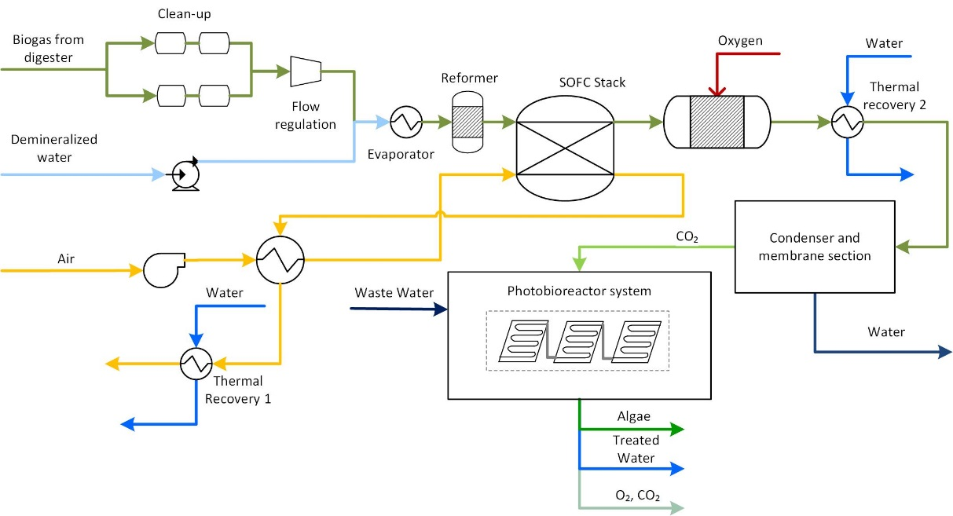
Figure 1. SOFCOM proof-of-concept layout.

The developed model takes into account the above-listed components at macroscopic lumped-volume scale, in order to analyze their transient behavior. In the description and analysis developed in this paper, the clean-up system, oxy-combustor, water condenser and the PBR have been neglected since the focus is the dynamic behavior of the SOFC island.
Figure 2 shows the strategy adopted. The core component of the SOFCOM proof-of-concept, the integrated SOFC stack biogas reformer, is modeled using a lumped-parameters MATLAB® code (SOFC LPM), which solves a set of equation that includes molar balances (based on the electrochemical reactions within the SOFC), steam reforming and water-gas shift chemical reactions based on the equilibrium constants of the two reactions, and the energy balance of the overall ‘hot box’. The LPM code is nested loop inside a second model, which is a SIMULINK® Dynamic Model. A detailed description of the two models is provided in the following paragraphs.
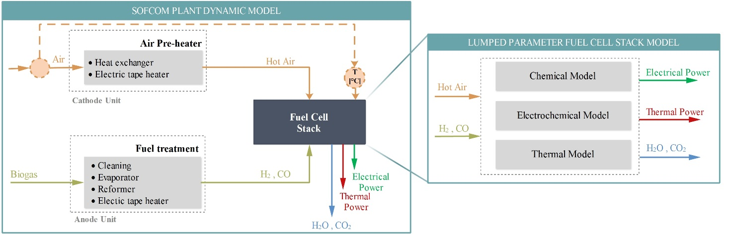
Figure 2. Model’s strategy adopted.

Lumped models for reformer and SOFC stack
A schematic block diagram for the lumped volume model of the SOFC stack + biogas reformer is shown in Figure 3 ([27][28][34]). The block diagram in Figure 4 summarizes the model implementation. All the used assumptions were reported in a previous publication [35].
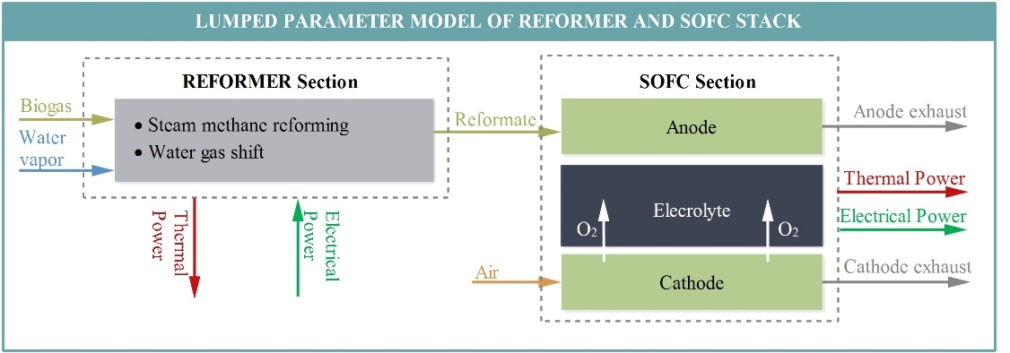
Figure 3. Lumped volumes for reformer and SOFC stack.
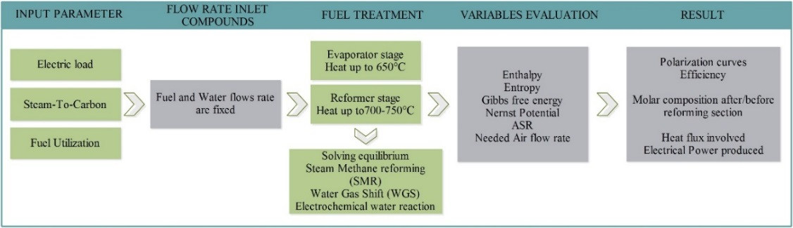
Figure 4. Flow diagram of reformer and SOFC stack according to the lumped volume modeling approach.
By applying an electrical load to the cell, the rate of fuel introduced into the system is determined. According to the fuel composition (methane content), the Steam-to-Carbon (S/C) ratio is imposed, and the vapor flow rate is calculated. The fuel, mixed with the high temperature water vapor, reaches the reforming section where the steam methane reforming and water gas shift reactions are considered by imposing chemical equilibrium of the mixture. The reformate gas is then flushed into the SOFC anode at a temperature of around 750 °C; here, the chemical and electrochemical model determine the fuel conversion rate and the power production.
The main assumptions of the stack model are:
- adiabatic control volume;
- the same temperature of cathode and anode outlet streams;
- anode inlet stream composed of a mixture of CH₄, CO, CO₂, H₂, H₂O;
- stack current density (A/cm²) and fuel utilization are given as input values.
Reforming and shifting reactions are taken at equilibrium condition and as a function of temperature, using the polynomial expression given below (coefficients of the polynomial were taken from Ref. [35]):
$$\log{K_{p}}=A∙T_{SOFC,4}+B∙T_{SOFC,3}+C∙T_{SOFC,2}+D∙T_{SOFC}+E$$ | (1)
where:
- $K_{p}$ is the equilibrium constant of the reaction;
- $T_{SOFC,i}$ is the temperature at which chemical reactions occurs, in K;
- $A, B, C, D, E$ are polynomial coefficients taken from [35];
It was assumed that only H₂ reactant moles are responsible for the electric flow. A further simplification is the use of an overall area specific resistance (ASR) parameter, provided by the manufacturer as a function of the SOFC working temperature, instead of the polarization terms (ohmic, diffusion and activation losses).

Dynamic model of the integrated system

Overall approach
The model reproduces the transient behavior of the integrated system: a schematic block diagram of the dynamic model is shown in Figure 5.
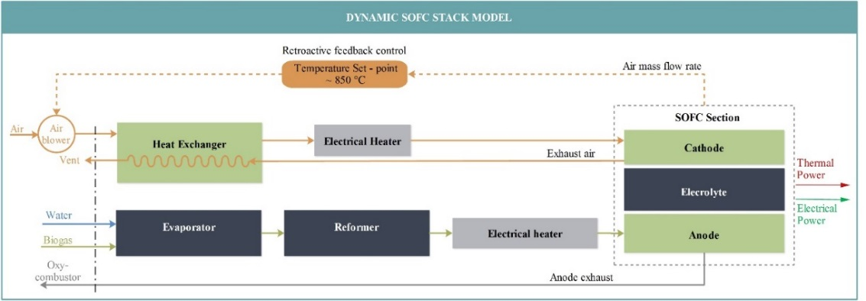
Figure 5. Conceptual map of the dynamic model.
The main material flows of the system are the anodic streams (green lines, biogas) and the cathodic streams (orange lines, air). The anode line deals with the pre-treatment of the fuel before feeding the SOFC; the three main components are, from left to right: evaporator, reformer, and electric heater. The flow rate of fuel is determined according to the electric load applied and the molar composition of the biogas. Biogas and liquid water are mixed in the evaporator component to reach the desired S/C ratio. In the evaporator, water is first vaporized before mixing the biogas. The mixed humid gas is finally preheated to reach a temperature of about 650°C.
The pre-heated fuel stream feeds the reformer where both SMR and WGS reactions occur. The methane is almost completely converted to produce a hydrogen and carbon monoxide rich reformate gas. The required thermal power for the endothermic reformer reactions (SMR) was supplied by electrical heaters, located around the reactor. In a real-size plant, the reformer would be either thermally integrated with the exothermic SOFC stack, or heated externally by the fuel cell exhaust [36]. Furthermore, an additional electrical heater was inserted between the reformer and the SOFC in order to provide the thermal power required to compensate for heat losses along the piping and thus maintain the required inlet temperature at the SOFC anode inlet.
The cathode line provides air (oxygen) to the stack that is required both as a reactant and for the internal stack cooling. An air blower is used to flow ambient air through the pre-heater section. The blower speed is controlled by an inverter, while the flow rate is measured by a rotameter. In the dynamic model, the air blower is assumed to follow the load quickly, so its dynamics has been neglected. Then a heat exchanger heats up the inlet air (450-600°C) recovering heat from the cathode exhaust, released out at a high temperature (850°C).
The nominal inlet temperature of the air is 650°C. In order to reach this set-point, an electrical heater is installed (again, a not optimized solution, useful only in case of a proof-of-concept), to provide the extra thermal power needed. The stack core temperature should never go above 860°C. The thermal control is carried out by regulating the amount of cathode air fed through the air blower: a retroactive feedback control calculates and imposes the mass flow rate needed to keep the core temperature below this critical level.
Tables 1 to 4 give the input parameters to the model for each component.
Table 1. SOFC stack input parameters.
SOFC STACK | Parameter | Value | Unit | Ref.
MEA properties | λ _{MEA} | 2 | W/m K | [37], [38]
MEA properties | c_{p MEA} | 600 | J/kg K | [37], [38]
MEA properties | ρ _{MEA} | 7500 | kg/m³ | [37], [38]
Interconnector Properties | λ _{INTER} | 25 | W/m K | [39]
Interconnector Properties | c_{p INTER} | 627 | J/kg K | [39]
Interconnector Properties | ρ _{INTER} | 7500 | kg/m³ | [39]
Insulation Properties | cp _{INSUL} | 1130 | J/kg K | [40]
Insulation Properties | ρ _{INSUL} | 125 | kg/m³ | [40]
Insulation Properties | Vol _{INSUL} | 0.104 | m³ | Sunfire
Technical data | Rated Power | 1.9 | kW | Sunfire
Technical data | Rated voltage output | 58.5 | V | Sunfire
Technical data | Number of cells | 90 ESC | - | Sunfire
Technical data | Weight | ~80 | kg | Sunfire
Technical data | Size | 709 x 436 x 426 | mm² | Sunfire
Technical data | Max Temperature | 860 | °C | Sunfire
Technical data | Fuel utilization | 75% | - | Sunfire
Technical data | Fuel composition | Reformed NG or Biogas | - | Sunfire

Table 2. Evaporator section input parameters.
EVAPORATOR | Parameter | Value | Unit | Ref.
Evaporator | Length | 0.260 | m | [36]
Evaporator | Volume | 0.00093 | m³ | [36]
Evaporator | Density | 8000 | kg/m³ | [36]
Evaporator | Mass | 7.48 | kg | [36]
Evaporator | Heat capacity | 0.502 | kJ/kg K | [36]
Heater Evaporator | Length | 0.390 | M | [36]
Heater Evaporator | Volume | 0.00452 | m³ | [36]
Heater Evaporator | Density | 8000 | kg/m³ | [36]
Heater Evaporator | Mass | 36.13 | kg | [36]
Heater Evaporator | Heat Capacity | 0.502 | kJ/kg K | [36]

Table 3. Air pre-heater section input parameters.
HEAT EXCHANGER | Parameter | Value | Unit | Ref.
Heat exchanger Air Preheater | Max. flow rate | 300 | Nl/min | Sunfire
Heat exchanger Air Preheater | Min. flow rate | 130 | Nl/min | Sunfire
Heat exchanger Air Preheater | Exchange heat flow | 4.4 | kW | Sunfire
Heat exchanger Air Preheater | Max inlet temp. | 830 | °C | Sunfire
Heat exchanger Air Preheater | Max outlet temp. | 650 | °C | Sunfire
Electrical Air Preheater | Power | 3.5 | kW | Sunfire
Electrical Air Preheater | Max inlet temp. | 650 | °C | Sunfire
Electrical Air Preheater | Max outlet temp. | 850 | °C | Sunfire

Table 4. Reformer section input parameters.
REFORMER | Parameter | Value | Unit | Ref.
Reformer | External height | 0.185 | m | [36]
Reformer | Internal height | 0.175 | m | [36]
Reformer | External Volume | 0.00118 | m³ | [36]
Reformer | Internal Volume | 0.00088 | m³ | [36]
Reformer | Density | 7940 | kg/m³ | [36]
Reformer | Mass | 2.360 | kg | [36]
Reformer | Heat capacity | 0.460 | kJ/kg K | [39], [36]
Heater Reformer | Height | 0.300 | m | [36]
Heater Reformer | Volume | 0,00726 | m³ | [36]
Heater Reformer | Density | 7940 | kg/m³ | [36]
Heater Reformer | Heat capacity | 0.460 | kJ/kg K | [39], [36]
Heater Reformer | Mass | 57.61 | Kg | [39], [36]
Catalyst | Mass catalyst | 0.700 | Kg | [36]
Catalyst | Density of bed catalyst | 970 | kg/m3 | [36]
Catalyst | Heat capacity - Pellet | 0.880 | kJ/kg K | [36]
Catalyst | Heat capacity - Gas | 3.174 | kJ/kg K | [36]
Catalyst | Heat capacity - fluid bed | 1.912 | kJ/kg K | [36]
Catalyst | Mass catalytic bed | 0.853 | kg | [36]

Equations and hypothesis
A “black box” modeling technique is used to model all the system components, including the auxiliaries of the overall Balance-of-Plant. Each plant section has been modeled starting from information available either from on experiments performed during the field activity or from the manufacturer of the component itself. For auxiliary components such as heaters and heat exchangers, some simplifying assumptions were taken.
Each component is modeled by applying the energy conservation equation for open systems (given in the differential form):
$$\left(Cp_{x}∙ρ_{x}∙V_{x}\right)∙\frac{dT_{x}^{out}}{dt}= \sum_{i=1}^{n}{\dot{G_{i}}}∙\left(h_{i}^{in}\left(T_{x}^{in}\right)-h_{i}^{out}\left(T_{x}^{out}\right)\right)+ \sum_{k=1}^{j}{Φ_{x,k}}$$ | (2)
where:
- $Cp_{x}$ is the heat capacity of x-th component, in [kJ/kgK];
- $ρ_{x}$ is the density of x-th component, in [kg/m³];
- $V_{x}$ is the volume of x-th component, in [m³];
- $T_{x}^{out}$ and $T_{x}^{in}$ are the outlet/inlet temperatures of x-th component, in [K];
- $h_{i}^{in}$ and $h_{i}^{out}$ are the inlet/outlet enthalpies of i-th compound, in [kJ/mol];
- $\dot{G_{i}}$ is mass flow rate of i-th compound, in [mol/s];
- $Φ_{x.k}$ is the incoming/leaving heat flux of x-th component, in [kW].
The integrated reformer SOFC stack model include a dedicated chemical and electrochemical model. In the reformer section, both SMR and WGS occur.
The calculation procedure for the reformer is the following:
- given the reformer core temperature, the equilibrium constants are evaluated according to [35];
- given current density and fuel utilization of the stack and biogas composition, the inlet biogas flow rate is calculated;
- given the biogas (and steam) inlet molar flow and the equilibrium constants for reforming reactions, the reactions products are calculated by the equation solver;
- the endothermic and exothermic heat of SMR and WGS reactions are evaluated in order to evaluate the thermal balance of the reformer component;
- the gross power required for the SMR is regulated by an external PID controller, introduced to keep the reformer at the constant temperature of 800°C.
The reformer dynamic thermal behavior is finally modeled by applying the energy conservation equation for open systems:
$$\left(C_{p_{ref}}∙M_{ref}+C_{p_cat}∙M_{cat}\right)∙\frac{dT_{ref}^{out}}{dt}=Φ_{in}^{ref}+Φ_{out}^{ref}-Φ_{WGS}\left(T_{ref}^{out}\right)-Φ_{SMR}(T_{ref}^{out})+Φ_{H2}$$ | (3)
where $C_{p_{ref}}, { M}_{ref},C_{p_cat}, M_{cat}$indicate the mass and heat capacity of the reformer and the catalyst contained therein;$Φ_{H2}$ is the power supplied by the electrical heater to the anode stream; $Φ_{WGS}\left(T_{ref}^{out}\right) and Φ_{SMR}(T_{ref}^{out})$ represent the energy fluxes produced/absorbed at reformer temperature; $Φ_{in}^{ref}and Φ_{out}^{ref}$ are the energy fluxes due to the mass flux inlet/outlet from the reformer;
$$Φ_{in}^{ref}={\dot{G}}_{in}^{ref}∙\sum_{i=1}^{5}{y_{i}^{ref,in}∙}h_{i}^{ref,ion}\left(T_{eva}^{out}\right) i=\left\{CH_{4},CO,CO_{2},H_{2}O,H_{2}\right\}$$ | (4)
$$Φ_{out}^{ref}={\dot{G}}_{out}^{ref}∙\sum_{i=1}^{5}{y_{i}^{ref,out}∙}h_{i}^{ref,out}\left(T_{ref}^{out}\right) i=\left\{CH_{4},CO,CO_{2},H_{2}O,H_{2}\right\}$$ | (5)
$$Φ_{H2}={Φ_{H2}}_{n}∙f∙ η$$ | (6)
where:
- ${ T}_{eva}^{out} and{ T}_{ref}^{out}$ are the reformer and evaporator leaving temperature, in [K];
- $f$ is a percentage parameter managed by SIMULINK® for the power modulation;
- $η$ is the electrical efficiency of heater;
- $Φ_{H2,n}$ is the inlet power controlled by PID feedback (varying $f$ parameter);
The development of the SOFC section follows these guidelines:
- The inlet anode composition is known;
- The air flow rate necessary for the stack thermal control is imposed by a PID controller;
Note that also an “internal reforming” of possible residual methane are taken into account by the simulator. These calculations are the same used for the reformer section, implemented in the LPM previously discussed.
Knowing the molar fraction of inlet/outlet compounds, the Nernst potential ${(V}_{0CV})$calculation is done, considering the final value as the average between two different Nernst potentials:
- The first one is evaluated considering the SOFC inlet molar fraction of oxygen, hydrogen, and water;
- The second one is evaluated with all the terms considered at SOFC outlet conditions.
Finally, knowing the average stack temperature it is possible to obtain the ASR value and calculate the output voltage of stack with the following equations:
$${V_{cell}=V}_{0CV}-ASR({\overline{T}}_{stack})∙i$$ | (7)
where:
- ASR, is the Area specific resistance, in [Ω cm²]
- i is the current density [A/cm²];
The electric power produced is calculated as follows
$${W_{el}=V}_{cell}∙i∙A_{cell}∙n_{cell}$$ | (8)
where $A_{cell}$ is the surface of a single cell (127.8 cm²).
The implemented thermal energy balance is reported below:
$$\left(C_{p},_{isol}∙M_{isol}+C_{p},_{MEA}∙M_{MEA}+C_{p},_{INTER}∙M_{INTER}\right)∙\frac{dT_{SOFC}^{out}}{dt}=Φ_{in}^{an}+Φ_{out}^{an}+Φ_{in}^{cat}+Φ_{out}^{cat}-W_{el}$$ | (9)
$$Φ_{in}^{an}={\dot{G}}_{in}^{an}∙\sum_{i=1}^{5}{y_{i}^{an,in}∙}h_{i}^{an}(T_{pipe}^{out}) i=\left\{CH_{4},CO,CO_{2},H_{2}O,H_{2}\right\}$$ | (10)
$$Φ_{out}^{an}={\dot{G}}_{out}^{an}∙\sum_{i=1}^{5}{y_{i}^{an,out}∙}h_{i}^{an}\left(T_{SOFC}^{out}\right) i=\left\{CH_{4},CO,CO_{2},H_{2}O,H_{2}\right\}$$ | (11)
$$Φ_{in}^{cat}={\dot{G}}_{in}^{cat}∙\sum_{i=1}^{5}{y_{i}^{cat,in}∙}h_{i}^{cat}\left(T_{air}^{out}\right) i=\left\{CH_{4},CO,CO_{2},H_{2}O,H_{2}\right\}$$ | (12)
$$Φ_{out}^{cat}={\dot{G}}_{out}^{cat}∙\sum_{i=1}^{5}{y_{i}^{cat,out}∙}h_{i}^{cat}\left(T_{SOFC}^{out}\right) i=\left\{CH_{4},CO,CO_{2},H_{2}O,H_{2}\right\}$$ | (13)

Model validation
The dynamic model is validated according to two different approaches:
- the first benchmark session is carried out against data provided by the SOFC manufacturer;
- the second benchmark session is carried out with results collected during the tests performed during the SOFCOM proof-of-concept operation.
Model validation is carried out by initially setting the model in the same initial condition as the experimental tests.

Model validation with manufacturer’s performance
The stack operating conditions at three different operating points are given in Table 5.
Table 5. Reference test data from manufacturer.
I [A] | I [A/cm²] | V [V] | H₂ [Nl/min] | N₂ [Nl/min] | Air [Nl/min] | T2001 [°C] | T1001 [°C] | T2111 [°C] | P_{el} [W]
24 | 0,18 | 62 | 20.1 | 30.1 | 210-235 | 650 | 750 | 855 | 1500
29 | 0,23 | 58 | 24.1 | 36.1 | 315-330 | 650 | 750 | 855 | 1680
34 | 0,27 | 55 | 28 | 42 | 400 | 650 | 750 | 862 | 1880

The stack temperature is detected by six type-N thermocouples disposed along the package of the cells. Other four thermocouples are installed to monitor the input/output anode and cathode temperatures. The main thermocouples used as reference indicate:
- T2001 measure the inlet cathode temperature;
- T1001 measure the inlet anode temperature;
- T2105, T2107, T2111, T2106, T2108, T2112 are the six thermocouples located inside the core of the cell package. Among the different temperatures, T2111 (shown in Table 5) is the reference thermocouple chosen by the manufacturer for the performances datasheet and used as ‘stack temperature’ for the validation.
The test was carried out imposing the air flow rates shown in Figure 6.
Then, results have been compared with values from manufacturer’s technical datasheet (Table 5).
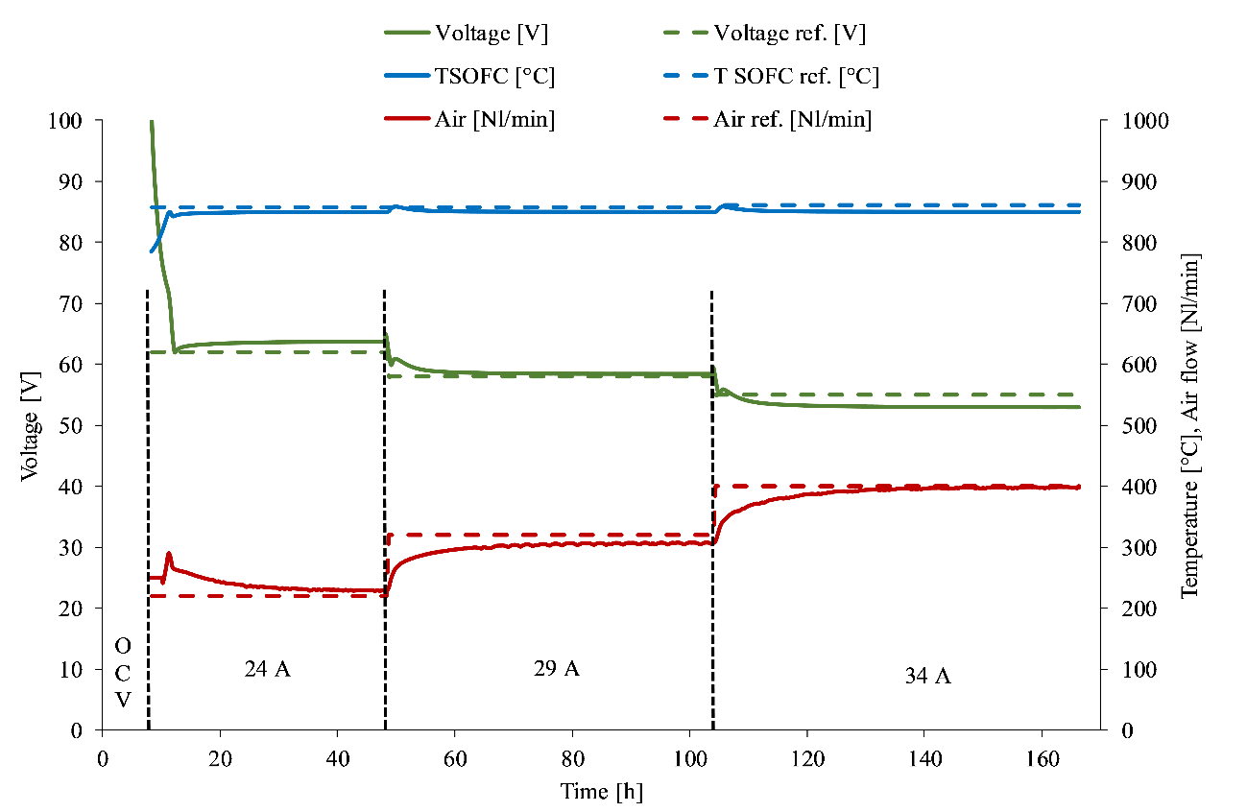
Figure 6. H₂/N₂ (40/60%) 24-29-34 A @ FU=75%. Model results are represented by continuous lines. Reference data from the manufacturer are represented with dashed lines.
In Figure 6 T_{sofc} is the SOFC stack temperature computed by the dynamic model and compared with T2111. The maximum allowable stack temperature was set to 10°C lower compared to the manufacturer specification, equal to 860°C. The vertical black dashed lines highlight three main regions where a constant load is imposed (24A, 29A, and 34A).
It is possible to observe a very good correlation between the obtained results and those provided by the manufacturer. In particular:
- The air flow rate which is necessary to keep the fixed temperature set-point is in the range of the manufacturer datasheet;
- The model tends to slightly underestimate (0.2-0.5V less) the voltage at 24 and 34A while showing an excellent correlation at medium load.
- The temperature set point is kept constant by the PID controller that regulated the amount of cathode air in the stack.

Model validation with experimental results from the proof-of-concept
The comparisons are made with the data obtained monitoring the SOFCOM prototype at the SMAT WWTP. In particular, three polarization tests are considered:
- Polarization Test session#1 & Test session#2: at first, polarization in H₂/N₂ mix up to 24A was implemented once completed the heat-up; then, once stabilized the working point, the shift from H₂/N₂ to the fuel reformate was gradually carried out, completing the polarization until reaching the OCV conditions.
- Polarization Test session#3: using a mixture of H2/N2 up to 24A again.
Each polarization test was carried out by varying the stack current step-wise from 0 to 24 A using current steps of 0.25 A/min. Throughout the polarization test, the anode fuel composition and flow rate was kept constant. The inlet fuel temperature was set to 750 °C. The cathode flow rate was gradually adjusted (increased) as the current load increases to maintain a stack temperature below 860 °C.
Test session #1
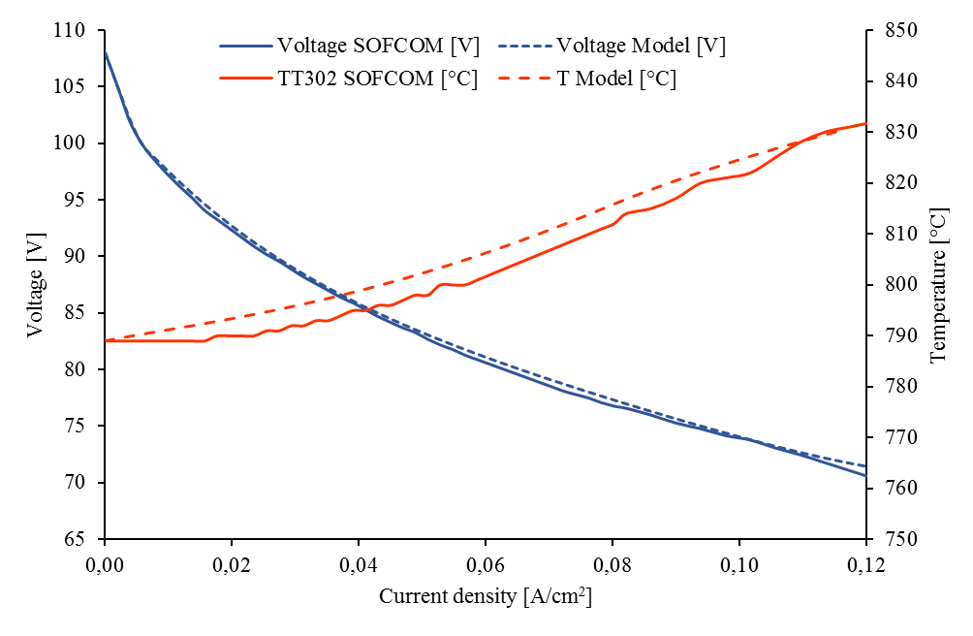
Figure 7. Test session #1.

Test session #2
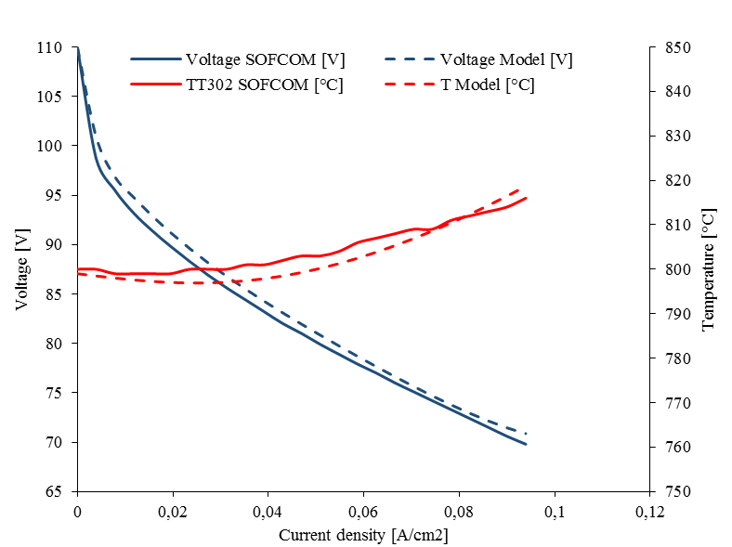
Figure 8. Test session #2.
Test session #3
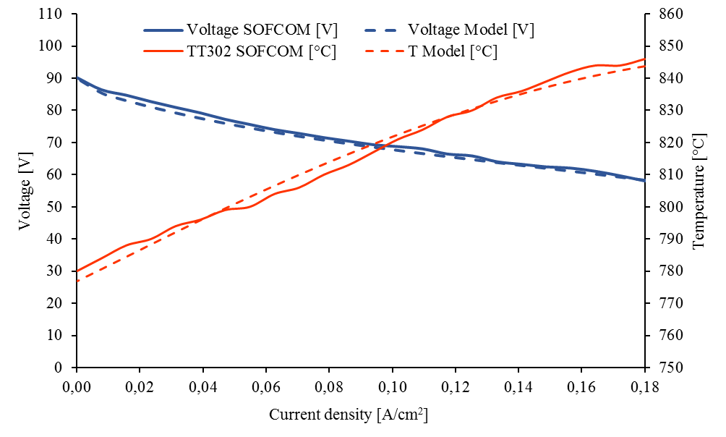
Figure 9. Test session #3.
The results of the presented analysis show good agreement between experimental and simulated data.
Considering all the temperature charts, the results obtained from the model fitting well TT302 values. Note that the temperature obtained by the model represents both the core and the outlet stack temperature (outlet gasses are assumed to be at the same temperatures stack core).
A good data correlation concerning the polarization curves has also been obtained. While the curve overlap is nearly perfect for the test session #1, small deviations from the experimental data are detected in both test session #2 and test session #3. These differences stand out only in the first section of the curve (at currents of the order of 0.01 – 0.03 A/cm², so very low currents, that are of low interest in the real operation of the plant), with the average relative errors below 1.21% anyway. The maximum relative error was about 2.47% (voltage curve comparison), registered during the test session #3 at 0.04 A/cm².

Simulations of harsh off-design conditions
The validated model is useful for predictive purposes: as an example, we analyze the behavior of the proof-of-concept under unconventional situations possibly related to an unexpected malfunctioning of a given plant component. Hence, the following sections cover specific cases of practical interest and/or abnormal working conditions caused by an unforeseen (partial) failure of a crucial BoP component. The analyzed off-dosing conditions are:
- DIR - Direct Internal Reforming operation. This condition can be caused by a reduction in the catalytic activity of the reformer catalyst: in this scenario, the reformer is not able to convert 100% of methane, which is fed directly to the fuel cell. The same condition can also be a design choice in order to reduce the size and the heat requirement of the external reformer;
- Unexpected variations of the electrical load. This condition is expected especially during load flowing operation; the related risk is to generate stack overheating and thermal stresses on the cells.
- Instability or incorrect operation of the air blower.

DIR- Direct Internal Reforming
The purpose of this simulation is to understand the behavior of the stack resulting from the DIR - Direct Internal Reforming operation. DIR operation is obtained by feeding part of the biogas directly to the stack anode without any reformation: in the model, this is obtained through the introduction of a by-pass line to let some biogas entering the stack directly without passing into the reformer (see Figure 10). It is worth noting that a reformer with a partially deactivated catalyst would result in a similar operating condition, i.e., with a higher fraction of unconverted CH₄ (biogas) fed directly to the SOFC.
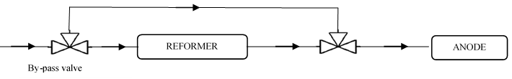
Figure 10. Direct internal reforming: by-pass layout.
By directly feeding methane to the fuel cell, a thermal sink is brought inside the stack due to the internal reforming reactions now taking place on the Ni-based anode electrodes.
At the stack temperature of around 830-850°C, the reforming of methane is fast directly on the anode electrode; due to the highly endothermic DIR reaction, part of the heat generated by the electrochemical oxidation of hydrogen (and polarization losses) is internally recycled to sustain reforming reactions, thus reducing the need for external cooling air (and thus reducing the air blower consumption). This has an effect on the regulation of the cathode air flow in order to assure the correct thermal balance inside the SOFC modules.
Three by-pass ratios of the reforming section (and thus DIR%) have been evaluated, starting from the zero by-pass condition (0%) up to 60% of DIR (above this percentage, the DIR is not practical under the present conditions, due to a sub-cooling of the anode stream at the stack inlet). In stationary working conditions, the operating temperature is stabilized at around 850°C, varying the cathode air flow rate, while the FU is kept constant at 75%.
Figure 11 shows the obtained simulation results, confirming the trend discussed above. The air blower PID controller, thanks to the progressive cooling of the stack due to an increasing DIR, progressively reduces the flow rate to maintain the working temperature. It is evident that the transition from a 0% by-pass to a by-pass of 60% will cause about 25 Nl/min less air.
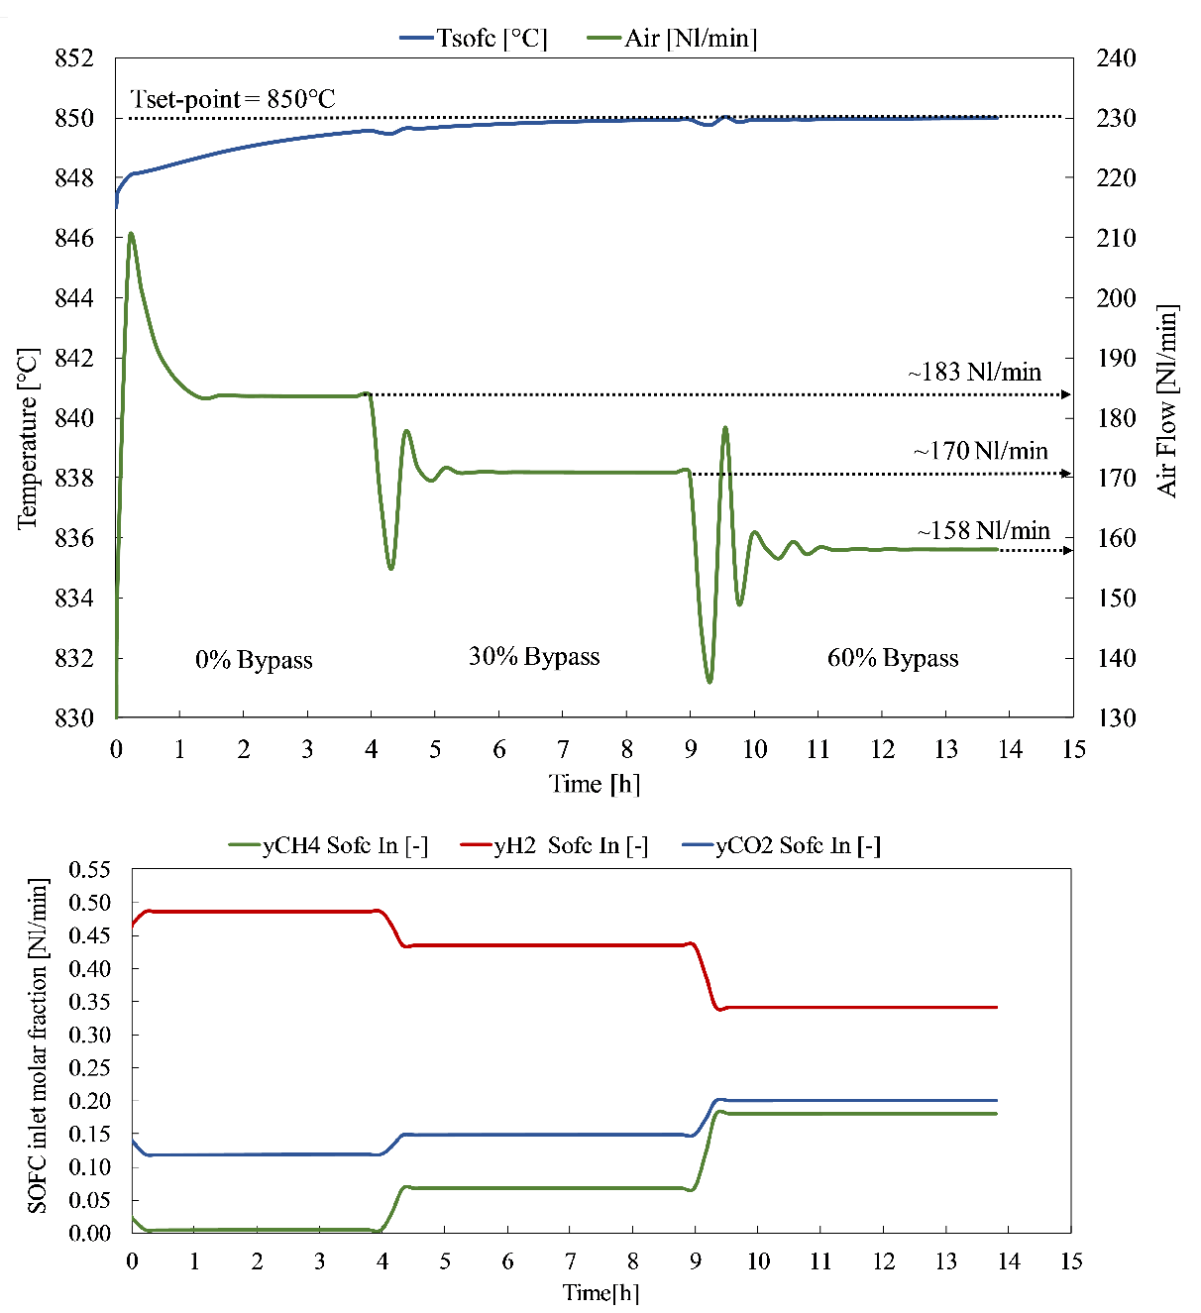

Figure 11. DIR simulation with CH4/CO2 (60/40%) - I=24 A @FU=75%
The cathodic airflow reduction for cooling is important in industrial applications: in SOFC plants, the electric power required for the air cooling (proportional to the airflow rate) is one of the most energy intensive auxiliaries. It means that a proper management of this facility implies an economic saving.

Load following: ramp rates and related thermal effects
The goal of this trial is to simulate the load following capability of the plant, and especially to identify the maximum allowable change in the load that can be accepted in order to avoid any possible SOFC over-heating.
Several load conditions, simulated varying the fuel flow rate (H₂/N₂ mix – 40/60%) while guaranteeing an FU equal to 75%, are performed. A selection of some meaningful simulations is reported in Table 6 with the related starting conditions.
Table 6. Load following simulations.
 | T sofc [°C] | T anode inlet [°C] | T air inlet [°C] | Air [Nl/min]
Set-Point | 825 | 750 | 650 | PID regulated
 | Current target [A] |  | Time interval [min] | Current ramp [A/min]
Simulation A | 14 34 |  | 125 | 0.16
Simulation B | 14 34 |  | 62.5 | 0.32
Simulation C | 14 34 |  | 0 | Instantaneous

All simulations start with a constant load equal to 24A. Follows a progressive linear load reduction to 14A in order to show the PID regulation of the air flow (remember that its function is to keep the stack temperature below 850°C). After, Sim A, Sim B, and Sim C differ in the ramp rate (A/min) to reach the final target of 34A (a current increase of 20A is then simulated). Results are shown in Figure 12.
Both in the first (constant load) and in the second (descending ramp) part, the air PID controller manages to maintain the previously established set point (850°C).
On the contrary, different dynamics is involved in the subsequent load variation (14 to 34A):
- Sim A – no over-heating problems occur and the current ramp applied is well handled by the PID controller;
- Sim B – the required speed load application leads to a slight overheating of the SOFC, reaching the maximum acceptable stack temperature (860°C);
- Sim C – the most extreme case (sudden current jumping from 14A to 34A) should be strictly avoided as it leads an overrun of 15°C above the maximum design stack temperature.
Some horizontal lines for Sim B and C are noticeable in the air graph: they represent the upper saturation limit for the PID controller, which corresponds to the maximum airflow rate managed by the air blower.
Please note that about three and a half hours are necessary to bring the stack to its optimum working condition in the Sim C. This is, however, unacceptable as a hot spot for this time length can lead to a thermo-mechanical degradation of the stack components (especially cells and sealing layers).
Finally, according to the previous calculation, the maximum applicable load ramp results to be equal to 0.30 A/min, which corresponds approximately to 13W/min in terms of electric power.
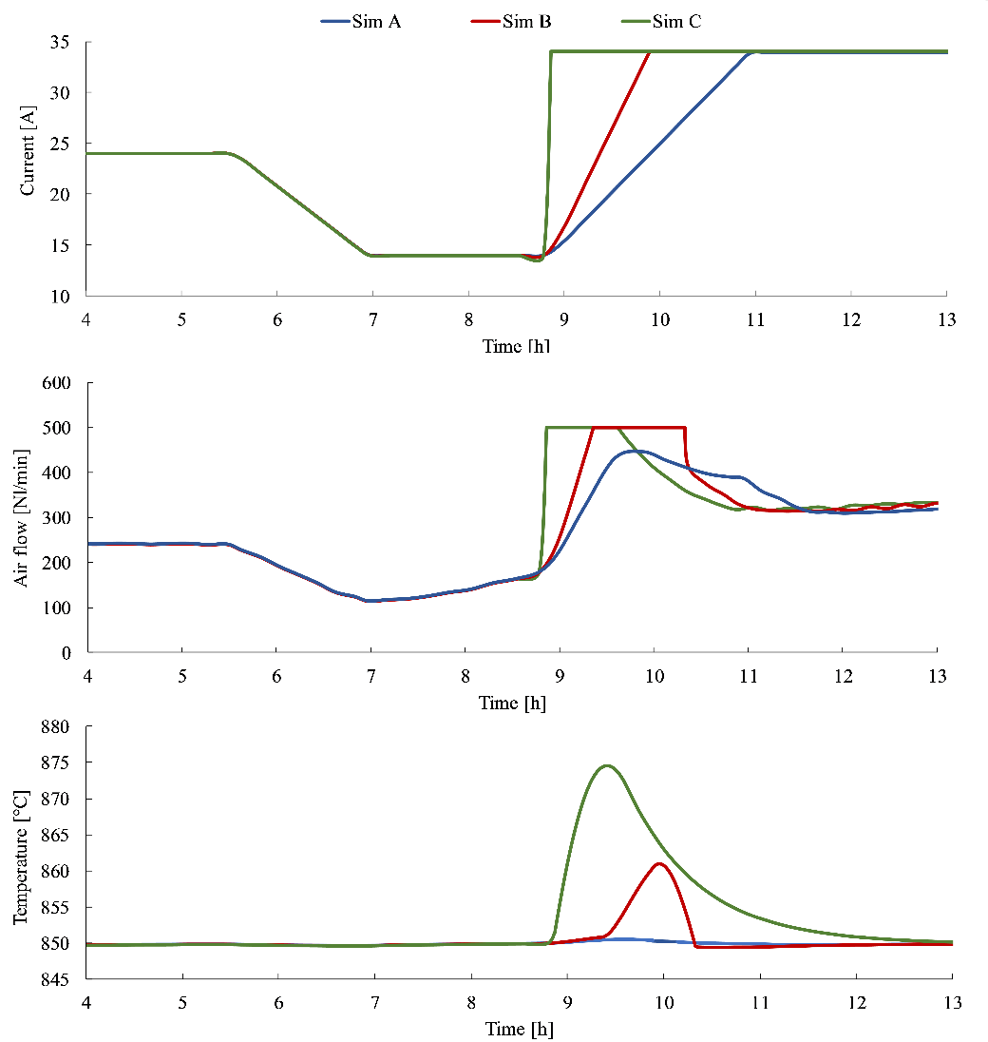
Figure 12. Load following simulations – Temperature vs. Airflow vs. Current.

Malfunction of cathode air blower: reduced air flow at constant load
The purpose of this simulation is to verify how a malfunctioning of the air blower during the plant operation would affect the stack behavior.
The simulations are down in two different load conditions: medium load (12A) and nominal load (24A). In both cases, the fuel feed is H₂/N₂ 40/60 vol. % and FU is equal to 75%. For both conditions, the airflow rate was progressively reduced, from 250 Nl/min to 175 Nl/min. The simulations results are shown in Figure 13.
We observe that:
- At medium-load operation (12A), any further reduction of the air flow rate does not lead to any harmful condition for the fuel cell – the stack temperature rises by 10-15°C maximum. As the temperature increases, internal losses will decrease, leading to a slightly increased power output (about 100 W).
- At high current load (24A), a critical stack operating condition might be reached depending on the available stack air flow rate. A 50 Nl/min reduction of the air flow rate results in a stack temperature that exceeds the maximum temperature allowed by the manufacturer (860 °C). A further reduction of the air flow rate to 175 Nml/min results to a stack temperature of 950°, well above the limiting value provided by the manufacturer.
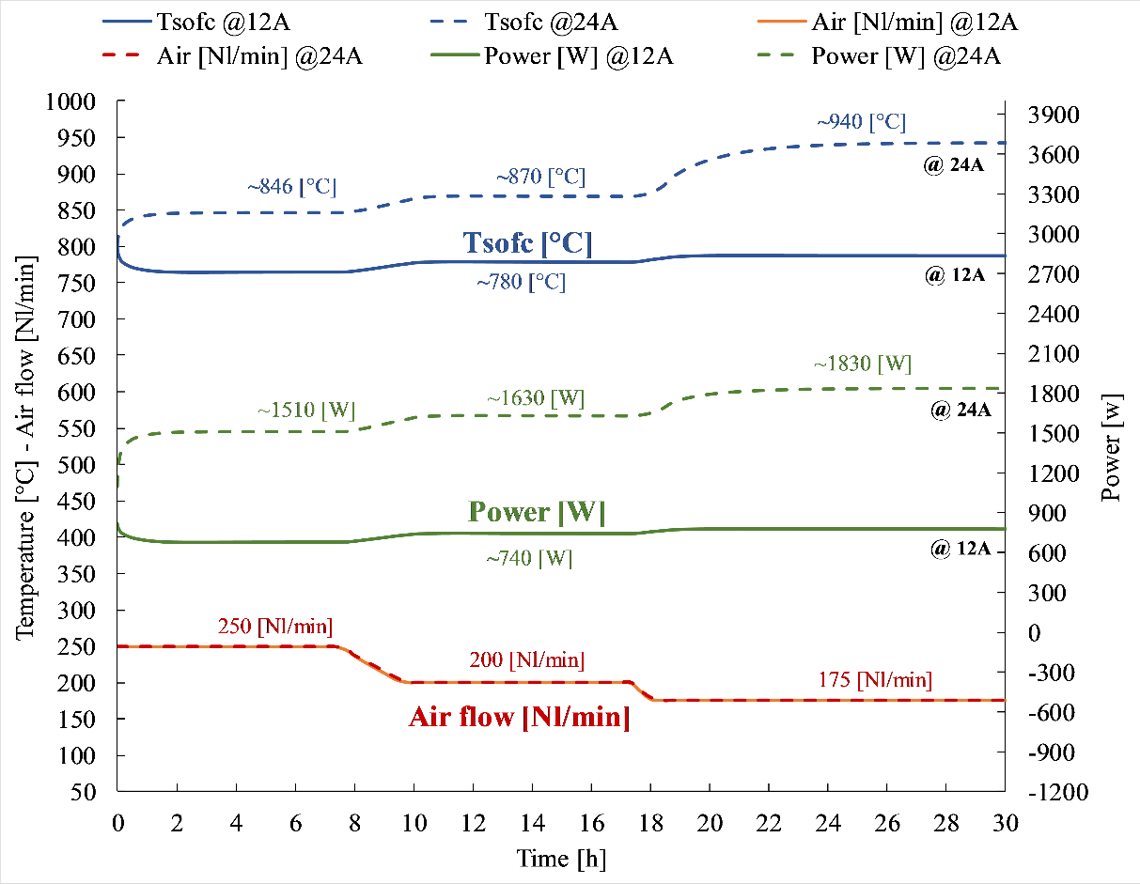
Figure 13. Malfunctioning of the cathode air blower (i.e., the available air flow rate reduces at constant load)

Conclusion
This work presents findings from the SOFCOM project, an EU-funded applied research project devoted to demonstrating the technical feasibility, efficiency and environmental advantages of CHP plants based on the SOFC technology and fed by different types of locally produced biogenous primary fuels. This work focuses especially on the performance of a biogas-fed SOFC stack.
The aim of the paper was to develop a dynamic model of the fuel cell stack in order to predict its behavior under unconventional (or fault) operating conditions which might occur during the power plant lifetime. The research focus has been directed on the design and simulation of a robust control system of the fuel cell stack, which is able to avoid the damaging of the stack (e.g., overheating).
Since the load-response of an SOFC system is strongly influenced by the auxiliaries included in the Balance of Plant – as it was also confirmed by the real operation of the proof-of-concept – a simulation model has been implemented to predict the thermal performances of the fuel cell stack that also includes the reformer unit and the heat-exchangers. Realistic thermal data (e.g., thermal capacity) for the stack components have been used for the dynamic simulations by relying on information provided by the SOFC stack manufacturer.
The dynamic model has been validated using both the manufacturer’s available performance data as well as experimental data gathered directly for the operation of the proof-of-concept in a real wastewater treatment plant.
The validated model has been used to study the plant behavior under harsh operating conditions of the SOFC stack due to the possible malfunctioning of selected components (e.g., a deactivated reformer, an ill-regulated air blower, etc.). The main results show that:
- The Direct Internal Reforming (DIR) of biogas fuel in the fuel cell stack has been simulated up to 60% of direct CH₄ conversion into the fuel cell anode. DIR operation can be seen as an additional means to control the stack thermal behavior: by feeding more biogas directly to the fuel cell, endothermic reforming reactions are promoted which can sink the internal heat generation of the stack thus limiting the risk of stack overheating. Also, by increasing the DIR ratio, a reduced air flow rate to the stack is required. We calculated how, going from 0% to 60% of DIR, the air flow rate is reduced by 14% (Fig. 11). A reduced cathode air flow rate would also entail a lower parasitic loss from the air blower: by assuming an overall pressure drop of 200 mbar in the overall SOFC system and an isentropic efficiency of 50%, operation at DIR = 60% would also save about 14% of the electric power supplied to the air blower.
- The cathode air flow rate is efficiently controlled by the PID regulation; the PID controller can well manage the stack temperature set point within the safety limits provided by the manufacturer. However, careful attention should be paid to the applied current load. Especially, it is important to control (limit) the current ramp rate in the case of load-following operation. A dangerous stack overheating might occur when a sudden increase of the electric load occurs. Results show that a current ramp-up rate above 0.30 A/min could be the maximum allowed one to avoid a stack damage; ramping up the current above this threshold will lead to a too high thermal gradient across the fuel cell. One of the expected consequences of a too high thermal gradient is the cracking of the glass-ceramic sealing, which joins the fuel cell to the interconnect thus providing gas tightness among anode and cathode volumes. A shown by simulations provided in Fig. 12, an instantaneous load-following of the fuel cell of the electric load has been shown as being not feasible since a temperature overshoot of the solid stack structure would occur.
- A malfunctioning of the cathode air blower has also been simulated. When working at high current loads, dangerous situations might occur in the case of a sudden and unexpected reduction in the cathode air flow rate. At partial-load operation (12 A), a sudden air reduction by 20% would not result in any stack damage since the stack temperature remains quite constant as well as the power output. At high-load operation (24 A), a sharp increase of the stack temperature would occur instead upon a sudden reduction in air flow rate. Simulations (Fig. 13) show a large overshoot of the stack temperature well above the safety limit specified by the manufacturer.
Our findings, which have been calibrated and validated on a commercial stack module, show how critical is the stack thermal management for the stable and durable operation of a fuel cell plant. We have verified again that fast load following is problematic for the real-life operation of an SOFC stack. In addition, the availability of the cathode air flow rate is essential to avoid a stack overheating. The immediate open-circuit condition should be forced to the system in the case of a sudden reduction of the air flow rate due to a malfunctioning of the cathode air blower. Finally, direct internal reforming of biogas into the SOFC stack represents an effective means to reduce the parasitic loss of the air blower.
Simulation results provide guidelines for an improved design of the control system of the plant, highlighting the feasible operating region under safe conditions and the means to maximize the overall system efficiency.

Acknowledgments
The research leading to these results has received funding from the European Union’s Seventh Framework Program (FP7/2007-2013) for the Fuel Cells and Hydrogen Joint Technology Initiative under grant agreement number 278798 ‘SOFCOM’.

Bibliography
[1] J. Van Herle, Y. Membrez, and O. Bucheli, “Biogas as a fuel source for SOFC co-generators,” vol. 127, no. 2004, pp. 300–312, 2010.
[2] J. Van herle, F. Maréchal, S. Leuenberger, Y. Membrez, O. Bucheli, and D. Favrat, “Process flow model of solid oxide fuel cell system supplied with sewage biogas,” J. Power Sources, vol. 131, no. 1–2, pp. 127–141, 2004.
[3] G. Venkatesh and R. Abdi, “Economic e environmental analysis of handling biogas from sewage sludge digesters in WWTPs ( wastewater treatment plants ) for energy recovery : Case study of Bekkelaget WWTP in Oslo ( Norway ),” Energy, vol. 58, pp. 220–235, 2013.
[4] N. De Arespacochaga, C. Valderrama, C. Peregrina, A. Hornero, L. Bouchy, and J. L. Cortina, “On-site cogeneration with sewage biogas via high-temperature fuel cells : Benchmarking against other options based on industrial-scale data,” Fuel Process. Technol., vol. 138, pp. 654–662, 2015.
[5] E. Achenbach, “Three-dimensional and time-dependent simulation of a planar solid oxide fuel cell stack,” J. Power Sources, vol. 49, no. 1–3, pp. 333–348, Apr. 1994.
[6] R. G. Hall, D.J. and Colclaser, “Transient modeling and simulation of a tubular solid oxide fuel cell,” IEEE Trans. ENERGY Convers., vol. 14(3), pp. 749–753, 1999.
[7] T. Ota, M. Koyama, C. Wen, K. Yamada, and H. Takahashi, “Object-based modeling f SOFC system: dynamic behavior of micro tubolar SOFC,” J. Power Sources, vol. 118, pp. 430–439, 2013.
[8] L. Petruzzi, S. Cocchi, and F. Fineschi, “A global thermo-electrochemical model for SOFC system design and engineering,” J. Power Sources, vol. 118, pp. 96–107, 2003.
[9] M. Pfafferodt, P. Heiderbrecht, M. Stelter, and K. Sundmacher, “Model-based prediction of suitable operating range of a SOFC for an Auxiliary,” J. Power Sources, vol. 149, pp. 53–62, 2005.
[10] P. Aguiar, C. Adjiman, and N. Brandon, “Anode-supported intermediate temperature direct internal reforming solid oxide fuel cell,” J. Power Sources, vol. 138, pp. 120–136, 2004.
[11] H. Xi and J. Sun, “Proceedings of ASME International Mechanical Engineering Congress and Exposition,” 2005.
[12] R. Bove, P. Lunghi, and N. M. Sammes, “SOFC mathematic model for systems simulations–Part 2: Definition of an analytical model,” J. Hydrog. Energy, vol. 30, pp. 189–200, 2005.
[13] K. P. Recknagle, R. E. Williford, L. A. Chick, and D. R. Rector, “Three-dimensional thermo-fluid electrochemical modeling of planar SOFC stacks,” J. Power Sources, vol. 113 (1), pp. 109–114, 2003.
[14] J. Arriagada, P. Olausson, and A. Selimovic, “Artificial neural network simulator for SOFC performance prediction,” J. Power Sources, vol. 112, pp. 54–60, 2002.
[15] X.-J. Wu, X.-J. Zhu, G.-Y. Cao, and H.-Y. Tu, “Modeling a SOFC stack based on GA-RBF neural networks identification,” J. Power Sources, vol. 167 (1), pp. 145–150, 2007.
[16] P. Nehter, “Two-dimensional transient model of a cascaded micro-tubular solid oxide fuel cell fed with methane,” J. Power Sources, vol. 157, no. 1, pp. 325–334, 2006.
[17] J. Padulles, G. W. Ault, and J. R. McDonald, “An integrated SOFC plant dynamic model for power systems simulation,” J. Power Sources, vol. 86 (1-2), pp. 495–500, 2000.
[18] D. J. Hall and R. G. Colclaser, “Transient modeling and simulation of a tubular solid oxide fuel cell,” IEEE Trans. ENERGY Convers., vol. 14 (3), pp. 749–753, 1999.
[19] Y. Huangfu, F. Gao, A. Abbas-Turki, D. Bouquain, and A. Miraoui, “Transient dynamic and modeling parameter sensitivity analysis of 1D solid oxide fuel cell model,” Energy Convers. Manag., vol. 71, pp. 172–185, 2013.
[20] E. Achenbach, “Response of a solid oxide fuel cell to load change,” J. Power Sources, vol. 57, pp. 105–109, 1995.
[21] C. Aguiar, N. Adjiman, and J. Brandon, “Anode-supported intermediate temperature direct internal reforming solid oxide fuel cell,” J. Power Sources, vol. 147, pp. 136–147, 2005.
[22] L. Barelli, G. Bidini, and A. Ottaviano, “Solid oxide fuel cell modelling : Electrochemical performance and thermal management during load-following operation,” Energy, vol. 115, pp. 107–119, 2016.
[23] L. Barelli, G. Bidini, G. Cinti, and A. Ottaviano, “SOFC regulation at constant temperature: Experimental test and data regression study,” Energy Convers. Manag., vol. 117, pp. 289–296, 2016.
[24] X. Wu and D. Gao, “Fault tolerance control of SOFC systems based on nonlinear model predictive control,” Int. J. Hydrogen Energy, pp. 1–21, 2016.
[25] M. Fardadi, D. F. McLarty, and F. Jabbari, “Investigation of thermal control for different {SOFC} flow geometries,” Appl. Energy, vol. 178, pp. 43–55, 2016.
[26] S. C. Singhal and K. Kendall, High-temperature solid oxide fuel cells: fundamentals, design, and applicatons. 2003.
[27] K. N. Grew and W. K. S. Chiu, “A review of modeling and simulation techniques across the length scales for the solid oxide fuel cell,” Journal of Power Sources, vol. 199. pp. 1–13, 2012.
[28] J. M. J. Kupecki, J, Jewulski, “Multi-Level Mathematical Modeling of Solid Oxide Fuel Cells,” Clean Energy, 2012.
[29] T. Tanaka, Y. Inui, A. Urata, and T. Kanno, “Three dimensional analysis of planar solid oxide fuel cell stack considering radiation,” Energy Convers. Manag., vol. 48, pp. 1491–1498, 2007.
[30] Http://www.sofcom.eu., “SOFCOM Project, SOFC CCHP with Poly-fuel Operation and Maintenance.” .
[31] a. Lanzini, T. G. Kreutz, E. Martelli, and M. Santarelli, “Energy and economic performance of novel integrated gasifier fuel cell (IGFC) cycles with carbon capture,” Int. J. Greenh. Gas Control, vol. 26, pp. 169–184, Jul. 2014.
[32] F. Curletti, M. Gandiglio, A. Lanzini, M. Santarelli, and F. Maréchal, “Large size biogas-fed Solid Oxide Fuel Cell power plants with carbon dioxide management: Technical and economic optimization,” J. Power Sources, vol. 294, pp. 669–690, Oct. 2015.
[33] M. Gandiglio, A. Lanzini, M. Santarelli, and P. Leone, “ASME DC | Journal of Fuel Cell Science and Technology | Design and Balance-of-Plant of a Demonstration Plant With a Solid Oxide Fuel Cell Fed by Biogas From Waste-Water and Exhaust Carbon Recycling for Algae Growth,” J. Fuel Cell Sci. Technol., vol. 11, no. June, p. 31003, 2014.
[34] J. Larminie and A. Dicks, Fuel Cell Systems Explained, vol. 93. 2001.
[35] F. L. A.F. Massardo, “Internal Reforming Solid Oxide Fuel Cell- Gas Turbine Combined Cycles (IRSOFC-GT): PartA—Cell Model and Cycle Thermodynamic Analysis,” J. Eng. Gas Turbines Power, vol. 122/2, 2000.
[36] M. Gianotti Pret, D. Ferrero, A. Lanzini, and M. Santarelli, “Thermal design, modeling and validation of a steam-reforming reactor for fuel cell applications,” Chem. Eng. Res. Des., vol. 104, pp. 503–512, Dec. 2015.
[37] A. Salogni and P. Colonna, “Modeling of solid oxide fuel cells for dynamic simulations of integrated systems,” Appl. Therm. Eng., vol. 30, pp. 464–477, 2010.
[38] H. Cao, X. Li, Z. Deng, J. Li, and Y. Qin, “Thermal management oriented steady state analysis and optimization of a kW scale solid oxide fuel cell stand-alone system for maximum system efficiency,” Int. J. Hydrogen Energy, vol. 38, no. 28, pp. 12404–12417, 2013.
[39] T. Vdm, “Crofer22H Material Data Sheet No. 4050,” no. 4050, 2008.
[40] Microtherm, “FREEFLOW-Free pouring granules of high temperature insulation 1000°C.”

