# Carbon recovery and re-utilization (CRR) from the exhaust of a solid oxide fuel cell (SOFC): analysis through a proof-of-concept

M. Santarellia[[1]](#footnote-1), L. Briesemeisterb, M. Gandiglioa, S. Herrmannb, P. Kuczynskic, J. Kupeckic, A. Lanzinia, F. Llovelld, D. Papurelloa, H. Spliethoffb, B. Swiatkowskic, J. Torres-Sanglase, L. F. Vegaf

## Abstract

In the context of the paradigm of Carbon Recovery and Re-utilization (or CRR), this work investigates the role of electrochemical generators (such as high-temperature fuel cells) to perform CRR as a practical secondary effect.

In fact, the solid oxide fuel cell (SOFC) operating principle is inherently beneficial toward CO2 separation from the exhaust gas since the fuel is electrochemically oxidized resulting in no N2 mixing at the anode (fuel) electrode. An oxy-combustor downstream the fuel cell will complete the residual fuel (mostly H2 and CO) oxidation to yield a stream that contains only H2O and CO2. After water condensation and further drying, the captured CO2 is fed to a photobioreactor that can fix carbon into microalgae.

In this work, results of the first SOFC-based poly-generation system with complete CO2 recovery in the form of fast-growing biomass (micro-algae) are presented, as developed in the EU-funded project SOFCOM (GA 278798, www.sofcom.eu).

The overall plant layout is described, and results on the performance of the proof-of-concept plant units are provided.

## Nomenclature

CFD Computational Fluid Dynamic

CRR Carbon Recovery and Re-utilization+

DPM Discrete Phase Model

GT Gas Turbine

ICE Internal Combustion Engine

LHV Lower Heating Value

NG Natural Gas

PBR PhotoBioReactor

ppm parts per million

S/C Steam to Carbon

SOFC Solid Oxide Fuel Cell

STD Standard

STL Standard Liters

WWTP Waste Water Treatment Plant

## Introduction

Innovation in energy technology is connected to solutions for the climate mitigation, one of the most challenging efforts of human society in the 21st century. One of the principal targets of climate mitigation is the control and management of CO2 in the Earth’s biosphere.

The global average temperature is already at 1°C above pre-industrial levels, and the carbon budget (the amount of atmospheric carbon we can emit before reaching 1.5°C) is half what is allowable under a limit of 2°C. In a very short time, we will be out of carbon budget to stay below 1.5°C, so regardless of how fast we limit fossil fuels, we will need to invest in third-way technologies to capture CO2 from the atmosphere, which is energy-intensive due to its low concentration in absolute values [1].

However, another paradigm based on the capture of the CO2 before its emission into the atmosphere, and on the re-fixation of the carbon content of the CO2 molecule, can be of high interest and effectivity. This concept is the central one of the Carbon Recovery and Re-utilization (or CRR) paradigm.

In fact, the carbon atom could be recovered and re-used rather than being stored in unground sites. CCR could be applied not only to the energy sector (i.e., to produce synthetic carbon fuels) but also for other market applications such as the production of green chemicals. The carbon atom contained in the CO2 can be used to produce synthetic fuels, green chemicals, materials and also new biomass. This recovery is not free regarding energy, of course: to recover carbon from the CO2 molecule, chemical, biological, or electrochemical processes have to be driven, with an expenditure of energy, as the Gibbs free energy has to increase again.

Carbon recovery from CO2 is certainly not an easy task to accomplish. The average CO2 concentration in the exhaust gas of an NG-fired combined cycle power plant and a pulverized coal power plant are about 4% and 15% vol., respectively; these values are high compared to the atmospheric concentration (around 400 ppm at the beginning of the XXI century). Still, the concentration is quite low to allow an easy and economic recovery of CO2.

Nevertheless, it is possible to perform oxy-combustion even without a preliminary O2 – N2 separation. This reaction is allowed by materials that use membranes with a selective conductivity of ions, such as the case of solid oxide fuel cells (SOFC). In SOFC systems oxygen ions are selectively extracted from cathode air because the electrolyte layer allows only the conduction of O2- ions toward the anode (fuel) electrode. In the anode electrode, the primary fuel undergoes “electrochemical oxidation” in the absence of N2. The main constituents of a conventional anodic fuel are thus oxidized into H2O and CO2, which constitute the main part of the SOFC anode exhaust stream. Some residual H2 and CO is still available in the anode exhaust, as the fuel cell cannot reach 100% reactants’ utilization due to concentration losses. Hence, the residual fuel can be oxy-combusted in a subsequent burner to achieve an H2O – O2 stream only. The exhaust CO2 is eventually cooled and water is separated by condensation. CO2 recovery from the SOFC anode exhaust is thus relatively straightforward. Once a stream of very concentrated CO2 is available, it is ready to be used again.

The conclusion is that CRR is an easier and cheaper task from the SOFC anode exhaust. This opportunity is not common to other technologies generating power, such as the thermal cycles (such as ICE and GT).

This generates an interest in the application of fuel cells, far beyond their high efficiency in the conversion of chemical energy (of the primary fuels sent to the anode) into electric power. The interest is now connected to the paradigm of CRR, and so to the paradigm of climate change mitigation. This opportunity is available; however, it needs to be designed and demonstrated at the level of proof-of-concept, to study the feasibility of the process, potential for improvements, and finally measures to define and reduce problematic steps.

The first demonstration, at international level, of the concept above described has been carried out through a research and demonstration project funded by the European Commission in 2011, named SOFCOM (European Union’s Seventh Framework Program (FP7/2007-2013) for the Fuel Cells and Hydrogen Joint Technology Initiative under grant agreement number 278798 ‘SOFCOM’).

The core component of the SOFCOM proof-of-concept is an SOFC generator fed by biogas (i.e., a renewable fuel already rich in CO2 – about 35-40 % vol. –, and containing the remainder of Carbon as CH4 – 60-65% vol.). Biogas is converted to electricity through high-efficiency electrochemical reactions (the overall fuel cell electrical efficiency is >50% when running on biogas) and with the characteristic that the only exhausts of the plant are pure CO2 and water. The as-received biogas is first cleaned to remove harmful contaminants (mostly H2S and siloxanes), partially steam-reformed in an external fuel processor and then fed to a 2 kWe SOFC stack (Sunfire, Germany). The anode exhaust is oxy-combusted to yield a stream that contains only H2O and CO2 (with only traces of H2 and CO; N2 is also found depending on the initial concentration of this compound in biogas). A water condensation/drying process is finally carried out to produce pipeline quality CO2.

In the SOFCOM plant, CO2 is thus fully recovered and converted into a “fast growing” biomass as micro-algae. Therefore, the Carbon content of the CO2 is embedded in a secondary biomass through a photosynthetic process, which occurs in a closed tubular photobioreactor that fixes CO2 into algae biomass through solar radiation and nutrients (nitrates and phosphates), found in locally available wastewater. The algae production leads to a high nutrients removal from inlet water generating two products: a potential fuel (biomass from algae) and a purified water stream.

This work summarizes the results of the proof-of-concept of a fuel cell based poly-generation plant that is able to co-produce electricity, heat, cleaned water and finally a fast growing biomass (microalge) via the recovery of the CO2 from the fuel cell exhaust, and its re-use in a photobioreactor. From the perspective of climate change mitigation, the proposed plant offers to the opportunity to recover CO2 from an energy process in an easy way compared to conventional (i.e., combustion–based) power, thus making the recovered carbon available again for other uses.

## Concept and layout of the proof-of-concept

The SOFCOM demo unit was located inside the wastewater treatment plant (WWTP) of Torino (IT), where mixed urban and industrial wastewater is treated. The collected sludge is digested in thermophilic anaerobic digesters. Normally, the as-produced biogas is burnt in internal combustion engines that provide a fraction of the overall electricity consumed on-site by the WWTP. In the framework of the SOFCOM project, a portion of the produced biogas is used to feed the SOFC demonstration plant. A biogas blower is required to feed the fuel mixture (found slightly above the atmospheric pressure in the reservoir tanks) across the various plant sections. The biogas is cleaned to remove harmful contaminants for the SOFC: according to historical data, cyclic siloxanes (D4 and D5), and sulfur compounds have to be removed carefully to avoid poisoning of the reformer unit and the SOFC. The clean biogas is converted via an external steam reformer to a bio-syngas rich in H2 and CO that is feed to the SOFC stack. The anode-off gas is burnt with pure oxygen to yield an almost pure CO2-H2O stream. The latter is condensed in a dedicated unit to produce a relatively pure CO2 stream also complying with purity requirements for sequestration. The pure CO2 stream is finally used (recycled) for the carbon bio-fixation in microalgae reactors with additional waste-water treatment via biological nutrients removal [2].

The demonstration plant layout is shown in Figure 1 and Figure 2. Figure 1 shows the first part of the demo plant, from biogas inlet feed to pure CO2 exhaust. The main components in this section of the demo plant are:

* Clean-up vessels for biogas contaminants removal.
* The processing unit (reformer) for methane conversion into an H2-CO mixture using demineralize water.
* SOFC for electricity production.
* Air line for feeding oxygen to the SOFC cathode (blower and air pre-heater).
* Oxy-combustor for oxygen combustion of unreacted fuels from SOFC.
* Two heat recovery sections.
* Condenser for water removal.

Figure 2 shows the photobioreactor unit. Wastewater is filtered and then flowed through the recirculation loop. CO2 is injected into this loop to promote algae growing. In the degasification tank, suspended microalgae are gradually precipitated and removed from the bottom of the reactor. From the degasification tank, the water purification loop also starts. In fact, the water / micro-algae mixture is fed to an ultra-filtration membrane to extract purified water that is eventually collected in the permeate tank.

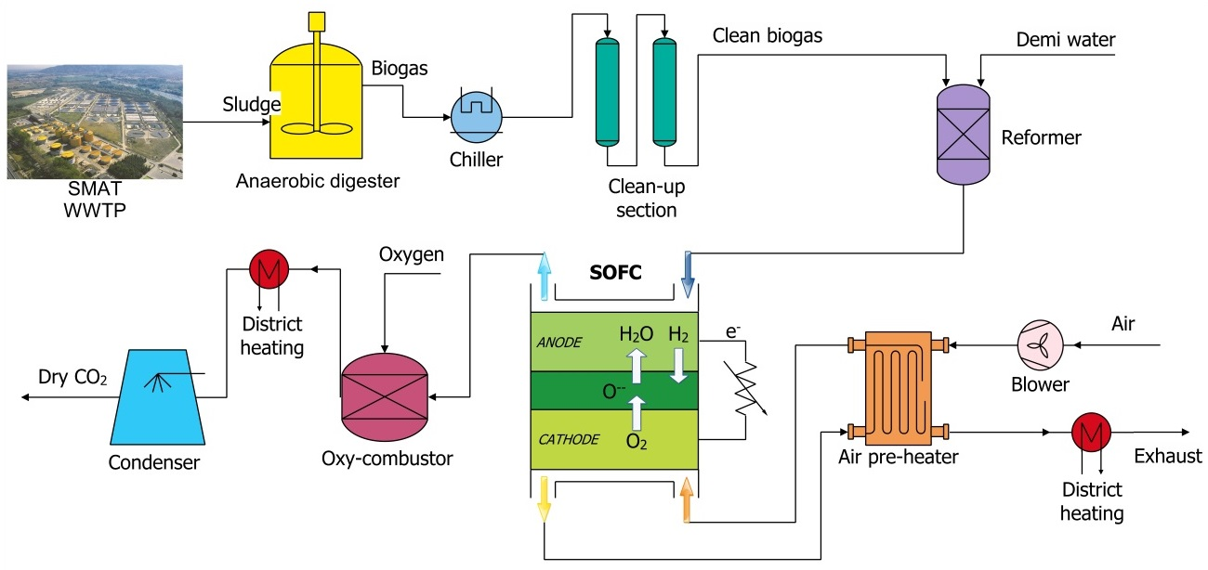

Figure 1. Demonstration plant layout: from biogas to electricity, heat and CO2.

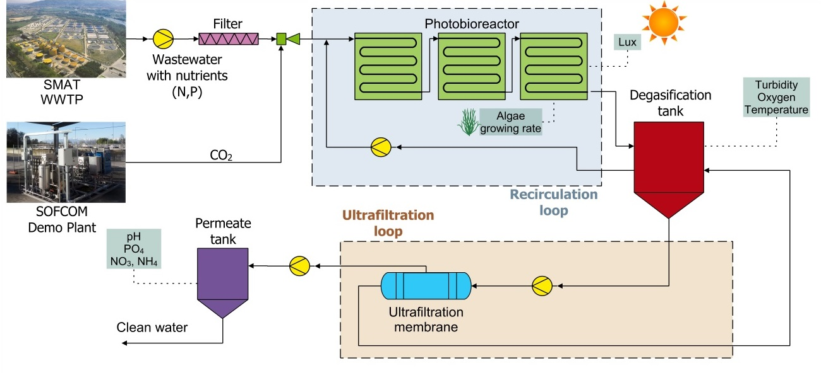

Figure 2. Photobioreactor layout: from CO2 to algae and clean water.

The nominal operating conditions are listed in Table 1.

Table 1. Nominal operating conditions of the SOFCOM proof-of-concept.

|  |  |  |  |
| --- | --- | --- | --- |
| Parameter | | Value | Unit |
| Biogas flow rate | 8.36 | | NLPM |
| Demineralized water flow rate | 604 | | g/h |
| Air flow rate | 150-250 | | NLPM |
| Biogas inlet pressure | 220 | | mbar |
| Evaporator temperature | 400-450 | | °C |
| Reformer temperature | 650-850 | | °C |
| S/C (steam-to-carbon) | 2.5 | | - |
| Anode inlet temperature | 750 | | °C |
| Cathode inlet temperature | 650 | | °C |
| SOFC working temperature | 820-850 | | °C |
| Current | 24 | | A |
| Oxy-combustor temperature | < 1200 | | °C |
| O2 % in oxy-combustor exhaust | 1.1 | | % vol. |
| Condenser set point | 0 | | bar |
| Compressor outlet pressure | 8 | | bar |
| Compressor outlet temperature | 200 | | °C |
| Water % at the membrane outlet | < 500 | | ppm(v) |

## Oxy-combustion of residual fuel in SOFC anode exhaust

The oxy-combustor is designed to complete the oxidation of the anode exhaust fuel into CO2 and H2O. Table 2 shows the ranges of species comprising the off-anode gas accepted for the design., the off-anode gas has a low LHV value in the range of 1.87 – 3.32 MJ/m3 and can be classified as a lean fuel, owing to its composition.

The component was developed by a first modeling phase, shown in the supporting material (section 1 of Appendix), followed by laboratory characterization of the constructed combustor (paragraph 3.1). Results show a comparison of the operation of the oxy-combustor with numerical modeling.

Table 2. Composition range of the off-anode gas leaving SOFC stack.

|  |  |
| --- | --- |
| Species | Range, % vol. |
| CO2 | 29.0 – 38.7 |
| CO | 8.9 – 14.5 |
| H2 | 6.8 – 13.8 |
| H2O | 40.7 – 48.4 |

### Lab characterization

The main parameters of the fuel, oxygen and cooling air streams used in the test are summarized in Table 3. During the experiment, the temperatures T1, T2, T3 were measured by thermocouples installed in three ports. Moreover, the exhaust gas composition, oxygen flow rate, and cooling system load were registered.

Table 3. Main parameters of the test – nominal case.

|  |  |  |
| --- | --- | --- |
| Parameter | Unit | Value |
| *Fuel (off-anode gas)* |  |  |
| Composition (vol.) |  |  |
| CO2 | % | 34.6 |
| CO | % | 8.9 |
| H2 | % | 8.1 |
| H2O | % | 48.4 |
| Mass flow rate | kg/s | 7.58e-4 |
| Temperature | °C | 640 |
| *Oxygen* |  |  |
| Vol. flow rate | STL/h | 201 |
| Temperature | °C | 20 |
| Primary oxygen | % | 34.0 |
| Secondary oxygen | % | 66.0 |
| *Cooling air* |  |  |
| Vol. flow rate | mSTD3/h | 3.5 |

The results of the experiment are shown in Figure 3. The comparison between experimental and numerical data is summarized in Table 4.

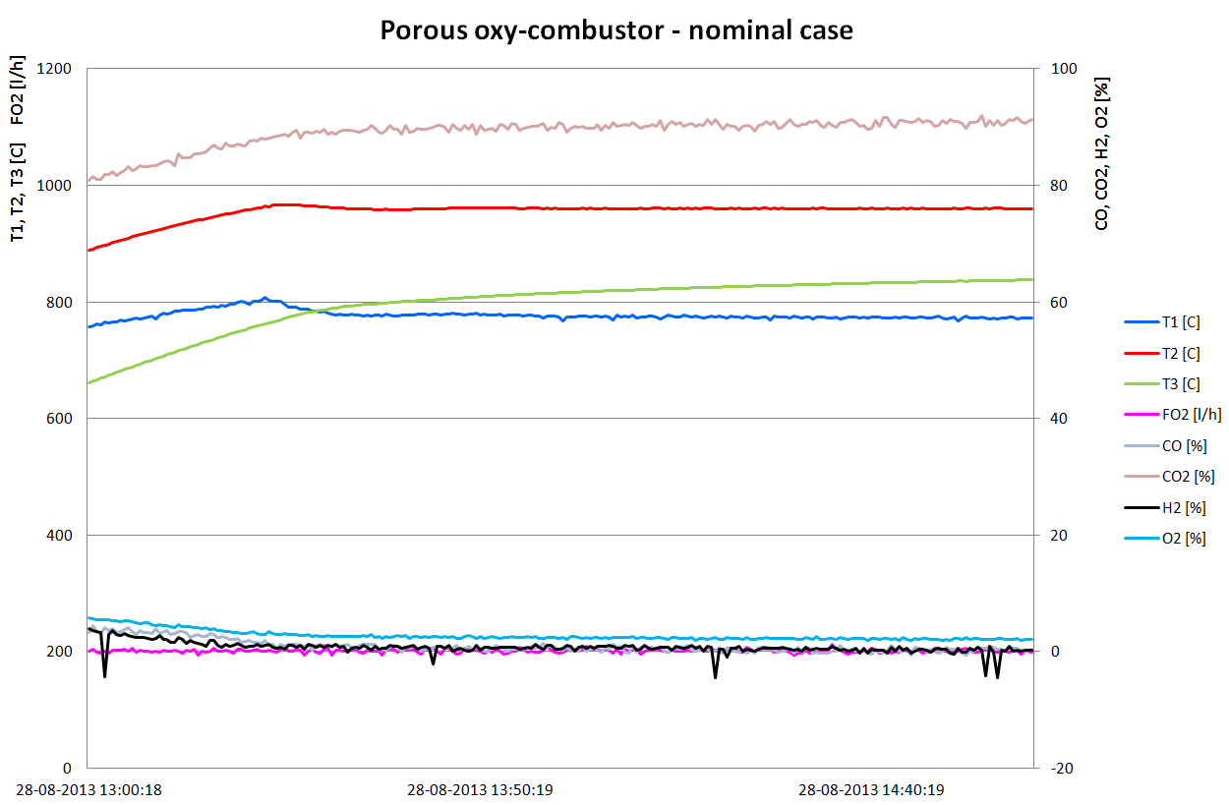

Figure 3. Parameters of the porous oxy-combustor during the test.

Table 4. Comparison of the working conditions of oxy-combustor – nominal case.

|  |  |  |  |
| --- | --- | --- | --- |
| Parameter | Unit | Experiment | Model |
| $$T_{1}$$ | °C | 775 | 810 |
| $$T_{2}$$ | °C | 960 | 910 |
| $$T_{3}$$ | °C | 830 | 890 |
| $$CO$$ | % | 0.29 | mean 0.16  max 0.53 |
| $$H_{2}$$ | % | 0.52 | mean 0.10  max 0.34 |
| $$F_{O2}$$ | l/h | 201 | 199 |

The temperature predictions obtained by the numerical model differ no more than 8% on the values measured by thermocouples T1, T2, T3. The biggest difference between the model and the experiment is reported at the outlet (T3). It can be explained by the fact that the domain of the numerical model does not extend much into the outlet duct, but ends at a short distance downstream the burner. Thus, the temperature assumed at the outlet of the model can differ from reality. Secondly, the measured temperature at the outlet (T3) was not constant during the experiment, and it tended to be higher with time. This fact can indicate that the heating-up process of the experimental stand was not fully completed.

The emissions of H2 and CO predicted by the model are shown in Table 4 in the form of area mean value and maximum value in the cross-section area of the outlet. Although the mean emission values differ significantly from the experimental data, this is not the case for the maximum values, which are close to the measurements. The measurements of H2 and CO concentrations are done probing the gases in the symmetry axis of the duct. In the case of the numerical model, the highest values of H2 and CO are reported in the axis of symmetry of the duct. Therefore, the numerical model predictions are accepted at this stage. It should be emphasized that the experiment show that H2 emission was greater than CO, whereas the numerical model showed the opposite. This can be explained by the fact that slightly inaccurate kinetics parameters of the combustion reactions for H2 and CO species were chosen.

## Separation of H2O and CO2

The following section describes the development and lab testing of the unit used to constantly dry the CO2 stream resulting from oxy-combustion of the SOFC anode exhaust to a value below 500 ppm, which has been defined as the upper limit of H2O tolerable for pipeline transport in the EU project DYNAMIS [3].

In Table 5, the nominal gas composition after the oxy-combustor is given. The gas inlet temperature was assumed to be up to 400 °C at approximately atmospheric pressure.

The description of the condenser unit model is shown in section 2 of the Appendix, while experimental results and performance are available in paragraph 4.1.

Table 5. Nominal gas composition after oxy-combustor. [4]

|  |  |  |  |  |  |
| --- | --- | --- | --- | --- | --- |
| Gas | $$CO_{2}$$ | $$CO$$ | $$H_{2}$$ | $$H_{2}O$$ | $$O_{2}$$ |
| Vol. % | 43.2 | 1.71 | 0.42 | 53.5 | 1.2 |

### Lab characterization

A compact test rig has been built consisting of the condenser followed by a downstream membrane stage. The system is built for autonomous operation. An implemented self-regulating control system has been designed allowing compensation of variations in the gas composition from the oxy-combustor. For this purpose, the pressure inside the condenser is measured and used as a control variable for the compressor speed control. The system is supplied with a gas-steam mixture described in Table 5. As inert gas, either compressed air or CO2 can be used. Condensate is automatically drained from the condenser and the fog separator. The membrane pressure can be adjusted as well as the purge gas stream. After the membrane stage, the humidity is measured using a capacitive dew point transmitter. Figure 4 shows a scheme of the water separation unit and the test rig in the lab.

K:\Herrmann\CO2-Entwässerung Paper\Abbildungen_Paper\P&ID_Test_Rig_reduced.emf

Figure 4. Scheme of the test setup: 1. Steam generator 2. Condenser 3. Condensate drain 4. Compressor unit 5. Gas cooler 6. Fog/Water separator 7. Membrane 8. Purge gas split control 9. Membrane pressure regulation.

The system has been tested concerning its performance at different operating parameters. To investigate the influences separately, standard conditions are defined. At standard conditions air is used as an inert gas with *Π*=0.25 and a membrane pressure of 6.5 bars. In Figure 5 the influence of the membrane pressure on the humidity is shown. A higher membrane pressure leads to a lower water content, since the partial pressure difference over the membrane increases. Residual H2O fractions of below 500 ppm can be reached for pressures above 6.5 bar. Depending on the utilization of the CO2 the membrane pressure can be optimized either for minimizing the H2O content or the power consumption of the compressor, which increases with higher membrane pressure and/or rising recirculation rates.

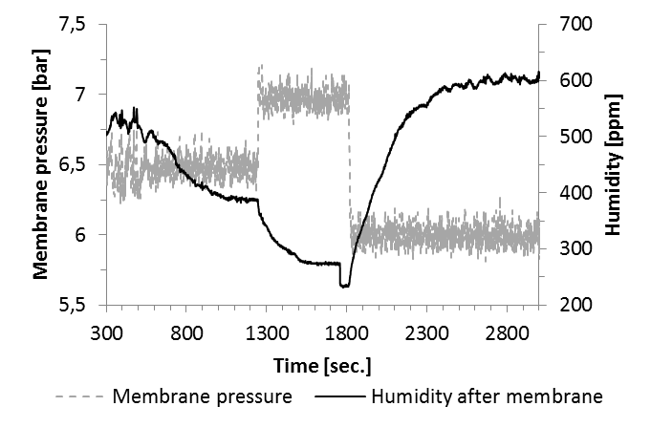

Figure 5. Influence of the membrane pressure on the system. Abrupt signal steps of the humidity signal are due to a self-calibration of the sensor.

In Figure 6 the dynamic behavior and stability of the control system is investigated. At constant operation the process gas flow is reduced by 30%, resulting in a pressure drop inside the condenser. The system responds by decreasing the compressor speed, and thus flow rate, and stable operation is reached again within seconds. A following increase of the process gas flow causes an inverse reaction and the system stabilizes likewise.

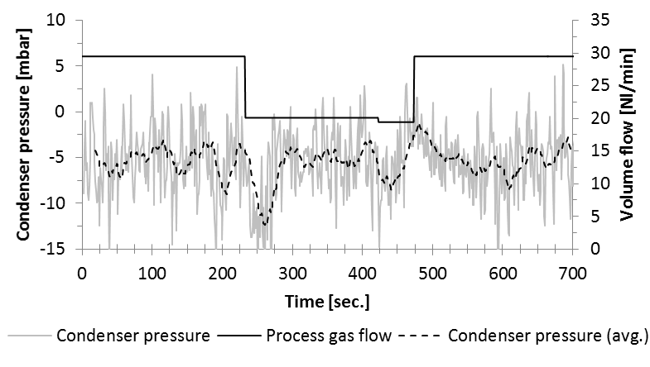

Figure 6. Dynamic behavior of the condenser pressure control system on a variation of the process gas flow.

Since the unit has been designed for long-term operation, a stable operating scheme is also investigated over a period of several hours at constant operating parameters. Although an observable influence of the applied inert gas (air/CO2) is not expected in Figure 7 results for a CO2/H2O gas mix are shown. Again the humidity stays clearly below the 500 ppm value.

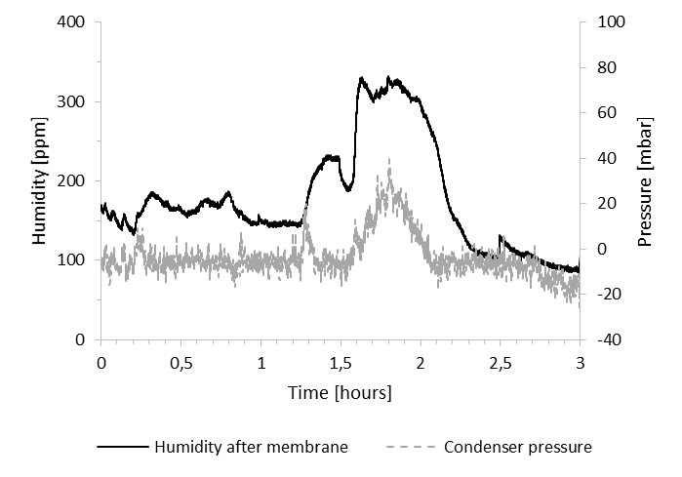

Figure 7. Long term test with CO2/H2O gas mix.

The observable increase of the condenser pressure and humidity after 1.5 hours is due to instabilities of the CO2 supply in the laboratory resulting in an increased flow rate at the specific time. Therefore, and for safety reasons, it was decided to proceed with longer-term lab testing with air as an inert gas. As is observable in Figure 8 in the long term test for a period of 50 hours the system is operated stable without showing any negative long-term effects; the desired humidity of below 500ppm can be obtained with a large safety margin of at least 200 ppm, whilst no significant over- or under-pressure is measured in the condenser.

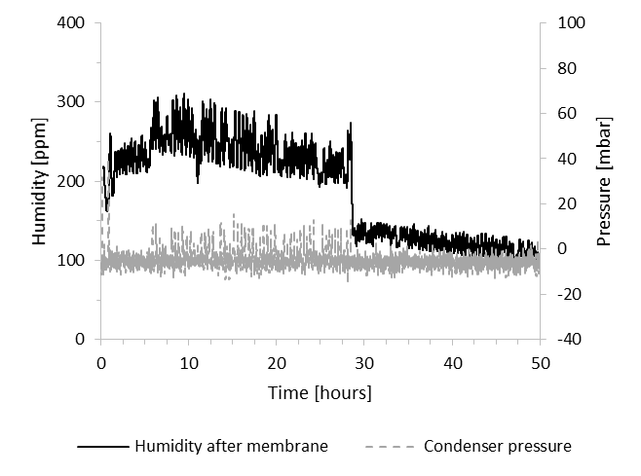

Figure 8. Long-term test with air/H2O gas mix at reference conditions.

## CO2 sequestration in the form of algae: photobioreactor

Recent developments have demonstrated that microalgae are a promising sustainable route for CO2 bio-fixation [5,6]; also, they are also an excellent source for wastewater treatment applications, due to their ability to remove nitrogen and phosphorus contained in agricultural effluents and industrial discharges. Hence, as mentioned in the introduction, there is an excellent opportunity to recover CO2 and convert it into a so-called “fast growing biomass” (micro-algae) through a photosynthetic process while also performing water treatment. As a result, it is expected to generate a potential fuel (biomass algae) and a purified water stream.

Considering that there is a wide variety of algae species (between 2·105 and 8·105 algae types), having a wide range of sensitivity, it is expected that the growing conditions will strongly depend on the selected family. In the SOFCOM project, a study of a local strain from the Barcelona area from the Nostoc family was carried out to check its efficiency for wastewater treatment, with a particular focus on the nitrates and phosphates removal, as well as on the carbon bio-fixation. For this purpose, a systematic experimental study was done at a laboratory scale to determine the best-growing conditions and affecting parameters. In parallel, Computational Fluid Dynamic simulations (CFD) were also performed to optimize the microalgae growth conditions and the carbon bio-fixation rates. The CFD model is presented in section 3 of the Appendix.

### Lab characterization

The conversion of CO2 into organic carbon for its bio-fixation requires organisms able to perform photosynthesis. Several classes of organisms achieve such conversions like plants, algae, and microalgae. Among them, microalgae are gaining a huge interest for the production of biofuels and sequestration of CO2 for their high growing capacity. Microalgae are extensive, and a wide nature provides a variety of groups. It is estimated that there are between 200 to 800 thousand different species of microalgae. Two main groups can be differentiated based on morphology: cyanobacteria, also called blue-green algae, and eukaryote microalgae, which includes green, red and gold-brown algae.

The development of any technology based on microalgae requires defining which type of algae to use and the best strategy to preserve them against external factors. Several criteria can be used to select the optimal microalgae: growing productivity, CO2 absorption capacity, and oil or sugar yield production, production of specific products for pharma and cosmetics, removal of pollutants like metals or organic compounds, among others. The selection of a specific species of algae requires protecting the strain against competitors or depredators and avoiding any impact on the surrounding ecosystem; failure of these safeguards could result in the catastrophic loss of the crop or the downstream biological invasion if selected microalgae run away from the photobioreactor.

Main current limitations of the production of biofuels from algae are related to the high cost of growing algae and converting them into biofuels. Of the different solutions proposed to reduce such cost, wastewater treatment plants (WWTP) are among the most promising ones. Wastewater from secondary treatment is clean enough to transmit light and still contains a significant concentration of nutrients (nitrogen and phosphorous), avoiding the need to fertilize the growing media. Also, sludge digesters are already available in most of WWTP, allowing the conversion of microalgae into biogas. However, WWTPs are open systems with continuous inlet and outlet of water, which cannot be sterilized; hence, the selected algae must be strong enough to compete against the microorganism contained in the wastewater but not strong enough to invade the downstream ecosystems. The easiest and cheapest solution is to grow the same microalgae contained and growing in the same geographic area, in the Mediterranean rivers and water in the SOFCOM, scarifying the CO2 fixation capacity if required.

The microalgae used in this project were collected from a demonstration pond dedicated to the unmanned tertiary treatment of wastewater located in the Barcelona area (Can Cabanyes in Granollers) and from the Po river in Torino (Italy). The initial algae contained in these waters were diverse in specimens and having a similar quantitative composition (being Chlorella sp, Micractinium pusillum, Nostoc cf caeruleum and Leptolynbya sp the more abundant specimen). After six months of continuous growing in the lab, such diversity disappeared and only *Nostoc genus*, probably *Nostoc Caeruleum,* were populating the laboratory crops. *Nostoc* is a cyanobacterium characterized by being unicellular algae (round shape sizing 2-4 µm) and tending to aggregate into filamentous forms, either simple or branched. The toxicological analysis of these microalgae showed that there is no more risk to the health or environment than found in nature.

The microalgae’s lab scale growth was performed in two different systems: 1L Erlenmeyer’s flasks and 15 L tubular reactor. Crops were prepared using synthetic wastewater and inoculated by adding 1-10% of concentrated microalgae solution (average 0.8-0.9 dry g/L), obtained from previous crops. Synthetic wastewater was defined to contain 20 ppm of N-NO3-, 2 ppm of P-PO4-2 and 500 ppm of HCO3- to simulate the exit of a secondary treatment, and was prepared by dissolving nitrates and phosphates into tap water or treated wastewater from Sabadell WWTP. Micronutrients were not controlled and assumed to be contained in the used water. The concentration of nutrients (nitrates, ammonium, phosphates, and carbonates) was controlled by weekly chemical analysis and the later addition of the required amount to keep concentration at the target values. The nutrients were added using concentrated solutions of NH4Cl, NaNO3, KH2PO4 and NaHCO3.

The 15 L tubular photobioreactor had an illuminated area of 0.5 m2 and was composed by 6 transparent tubes of a length of 1.1 m and diameter DN50 made from transparent PVC (Figure 9). The illumination system was composed by 12 fluorescents Biovital 958 and managed by a Profilux Plus II controller computer. To avoid the growing of the algae outside the photobioreactor, piping, and the degasification unit were made from opaque PVC (DN40 and DN100). The flow through the reactor was upwards to enhance the CO2 dissolution in water, which was injected at the inlet of the photobioreactor using a standard gas diffuser. Temperature and pH were measured at the outlet of the photobioreactor. The degasification unit was used to remove and release the oxygen produced by the algae, as well as a filling point of the reactor during the start-up and nutrients addition. The temperature was controlled by an SS316 tubular heat exchanger and an external cooling bath. Water was recirculated by a centrifugal pump at a flow ranging from 2 to 5.5 m3/h. The CO2 was sourced from a compressed bottle supplied by Carburos Metálicos S.A., Air Products Group.

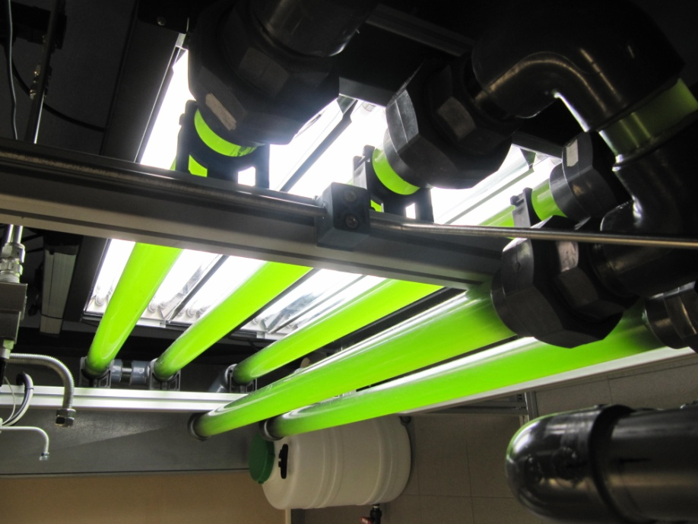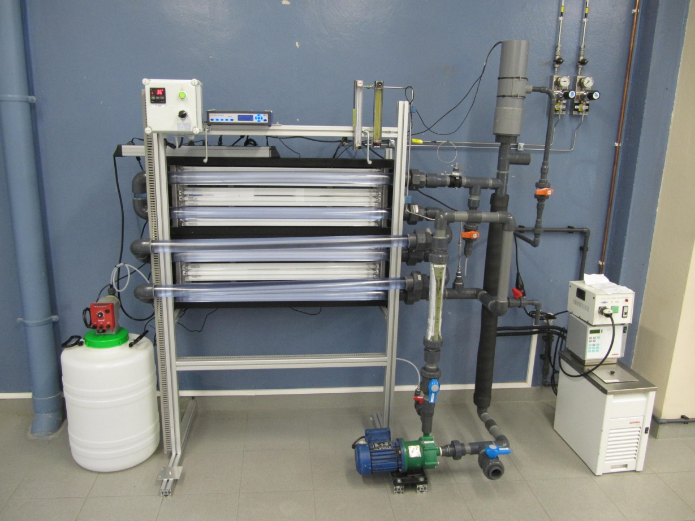

Figure 9. Set up of the laboratory photobioreactor located at MATGAS.

The laboratory experiments were designed to support the demonstration trials by evaluating the influence of the main operating parameters on the microalgae growing, and defining guidelines for the design of the demonstration photobioreactor. Usually, light emittance is reported to be the main limiting parameter in the growth of microalgae. Most of the studies reviewed in the literature reported low ranges of light emittance (3.2-17 kLux) which correspond to daylight but not direct light intensities which could peak up to 120 kLux on summer in the Mediterranean area.

Several experiments were carried out at different light emittance between 15 and 30 kLux and adjusting CO2 injection to 32.4 ppm of CO2/day; temperatures fluctuated between 33-37°C. No microalgae attachment to the walls of the photobioreactor was observed at a light irradiance of 15 kLux, obtaining a constant growth of microalgae at a relatively low rate (µ= 0.003±0.001 h-1). Increasing light irradiance up to 30 kLux, a slightly higher growing rate (µ=0.004±0.001 h-1) was obtained but the attachment of the microalgae was observed after one week (Figure 10). Good compromise was found at 20 kLux, no attachment on the walls of the photobioreactor was observed and the growth was similar to 30 kLux. Shadowing meshes to reduce natural sunlight below 20 kLux are recommended to avoid algae attachment in the demonstration unit.

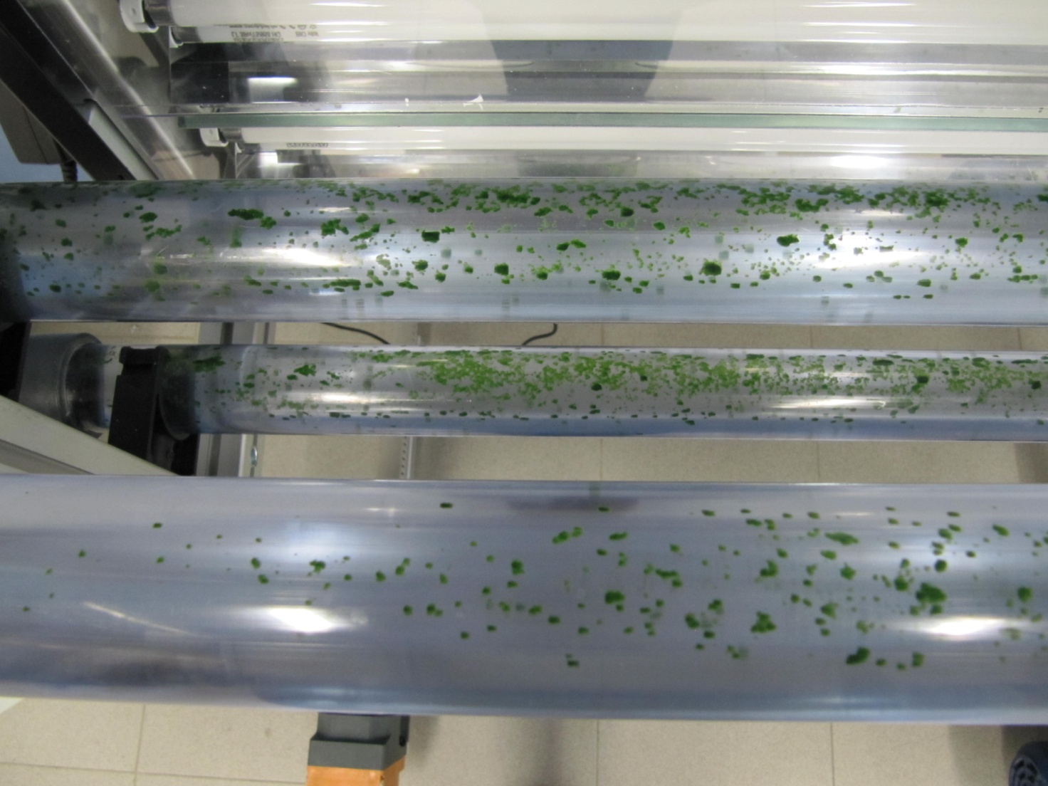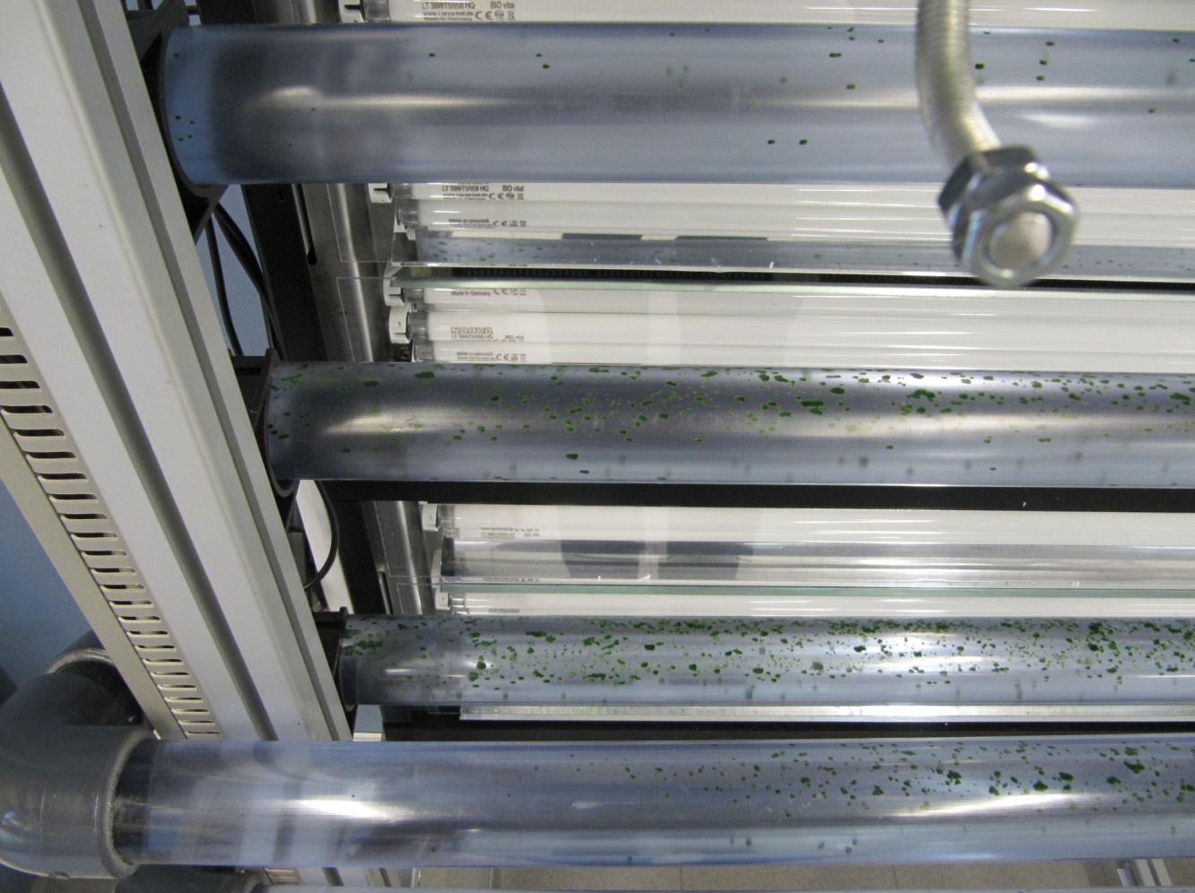

Figure 10. Microalgae attachments in the bench scale photobioreactor when 30kLux light emittance was applied.

The capacity of the carbon bio-fixation of the selected microalgae was checked by running the photobioreactor without injecting CO2 during 1 week (0.1 g algae/L - 16 kLux - 33-37°C). No microalgal growth was observed and even death of the microalgae was detected by the decrease of the turbidity to one-half of the initial; also, no consumption of nutrients was observed. Immediately after the injection of pure CO2 (377 ppm CO2/day), the growth of the microalgae was detected by the increase of the turbidity and confirmed by the reduction of the nutrients concentration. The growth continued during the trial, demonstrating that the selected microalgae were able to biologically fix CO2 by injection of pure CO2 like the CO2 captured and purified in the SOFCOM project.

Since not all the injected CO2 was absorbed by the microalgae and the photobioreactor was run in batch mode, the CO2 concentration in the water was constantly increased. When 550 ppm CO2 were reached, growth inhibition was observed. The injection of CO2 was stopped when its concentration in water reached 700 ppm. Afterwards the CO2 concentration was reduced by desorption and release to the atmosphere. The growth of the microalgae was recovered when the CO2 concentration was below 200 ppm, as shown in Figure 11. The growth increased when the CO2 injection was restarted and dose adjusted to 32.4 ppm CO2/day (2 NL/h during 0.75 h/day) to keep a constant CO2 concentration close to 100 ppm. Therefore, it can be concluded that there is a threshold of maximum dissolved CO2 in water before microorganisms present growth inhibition.

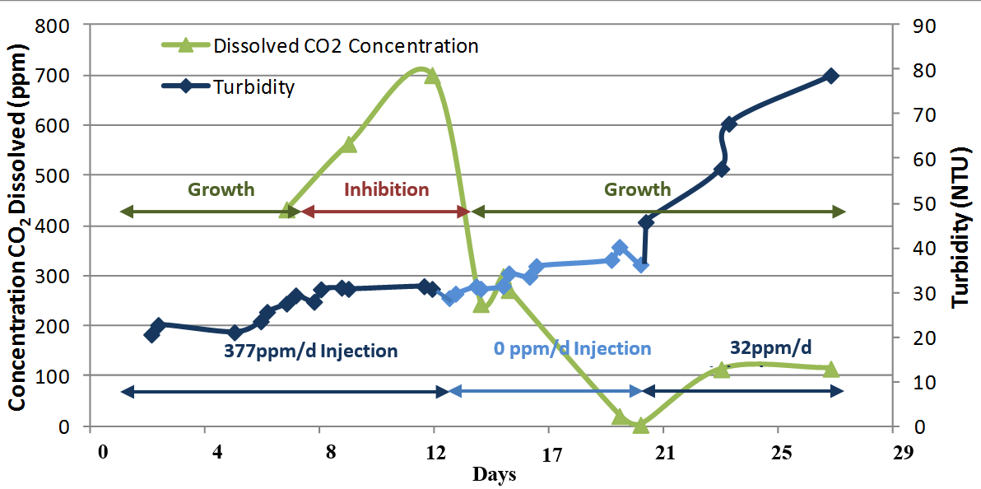

Figure 11. Growth of microalgae versus concentration of CO2 dissolved in water

The influence of the purity and CO2 concentration of the feed gas is widely discussed in the literature, where pure gas CO2 andlarge concentrations of CO2 in water are described by most of the authors to inhibit or reduce the growth of the algae. Our study measured 550 ppm CO2 in water for Nostoc algae as the threshold for the inhibition of growing, while recommending doses around 100 ppm CO2 in agreement with Kumar et al. [7] and Silva et al. [8] (92 and 104 ppm of CO2, respectively) and below the results offered by Chiu et al., who proved continuous growth at levels of 575-705 ppm of dissolved CO2 [9]. In this range, no relationship between pH and CO2 concentration was observed, and pH could not be used as an indirect measure of the CO2 concentration.

The temperature of the photobioreactor was not controlled in the previous experiments and oscillated between 33 and 37°C. In this range, successful growth of the microalgae was obtained for weeks. Higher temperatures (above 39°C) turned the color of the microalgae from green to yellow, and they became smelly, indicating the death of the microalgae population. Additional indicators were: the increase of dissolved phosphorous in the water and the decrease of dissolved oxygen in the water. To confirm the influence of temperature on the growth of Nostoc microalgae, a healthy crop from the lab scale PBR was exposed to 40°C. After few hours, the initially green microalgae became yellow as in the bench scale PBR, the population could not be recovered after cooling the crop to 25°C. After one week, no growing of the algae was observed, leading to the conclusion that Nostoc microalgae grow at temperatures lower than 38°C, but they quickly die at higher temperature values. These results are in agreement with the literature, where the optimum growth range is claimed to be 25-35°C [10,11].

A tubular heat exchanger was proposed as a solution to remove the excess heat in the bench scale PBR. As dissolved copper, nickel and chromium are described in the literature to be algaecides above a specific concentration, the influence of several metals over the microalgae growth was evaluated. Metallic copper and stainless steel (304 and 316 types) pieces were introduced to three different crops. An inhibition of the growth and the death of the microalgae were quickly observed in the reactor in contact with metallic copper at pH 7 (17% reduction of the turbidity), meanwhile, at pH 6 the culture changed colour to yellowish, indicating microalgae death. The piece of copper introduced in the system had different texture/color after the trial, signifying chemical attack of the metal. The corrosion of the copper and the dissolution of Cu2+ were confirmed by chemical analysis, showing a copper concentration as high as 6 ppm, 80 times above the upper limit recommended for drinkable water (75 ppb). Contrarily, the two crops in contact with stainless steel (304 and 316) were successfully grown without any inhibition during a week at pH 6. Moreover, the metal pieces in contact with the culture did not show any sign of corrosion. In conclusion, PVC, SS316, and SS304 are recommended materials and can be safely used in PBR in the operating conditions required for the microalgae growth. Copper is strongly discouraged and should not be used in microalgae cultivation since corrosion releases Cu2+ till biocide levels.

## Field tests of the proof-of-concept: results

### Oxy-combustion of the SOFC anode exhausts

The oxy-combustor was designed with two inlet pipes for oxygen (Figure 12). This choice was because the geometry of the reactor should be able to spread the combustion across the entire length.

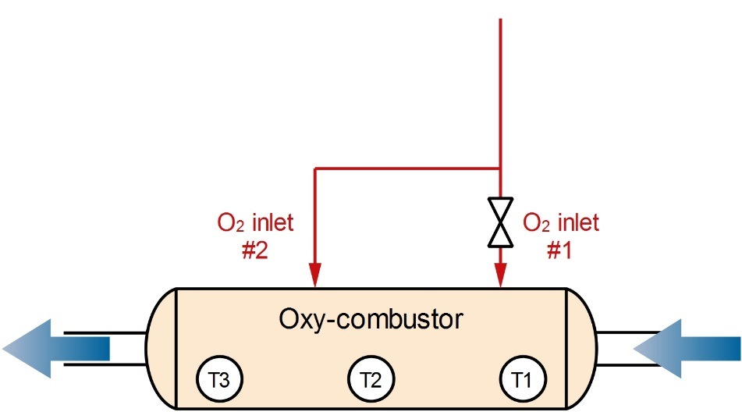

Figure 12. Oxy-combustor oxygen inlets layout.

Results from the first test with oxygen sent only to inlet #1 (nominal system configuration) are shown in the figure below (Figure 13). The maximum temperature achievable in the reactor should be 1200°C to avoid problems for materials. With this configuration, anyway, in a standard nominal condition, temperature T1 was higher than the maximum allowable value. Furthermore, the temperature change across the reactor was high: from T1 @ 1300°C to T3 @ 700°C: the combustion reaction was thus taking place only in the first combustor section.

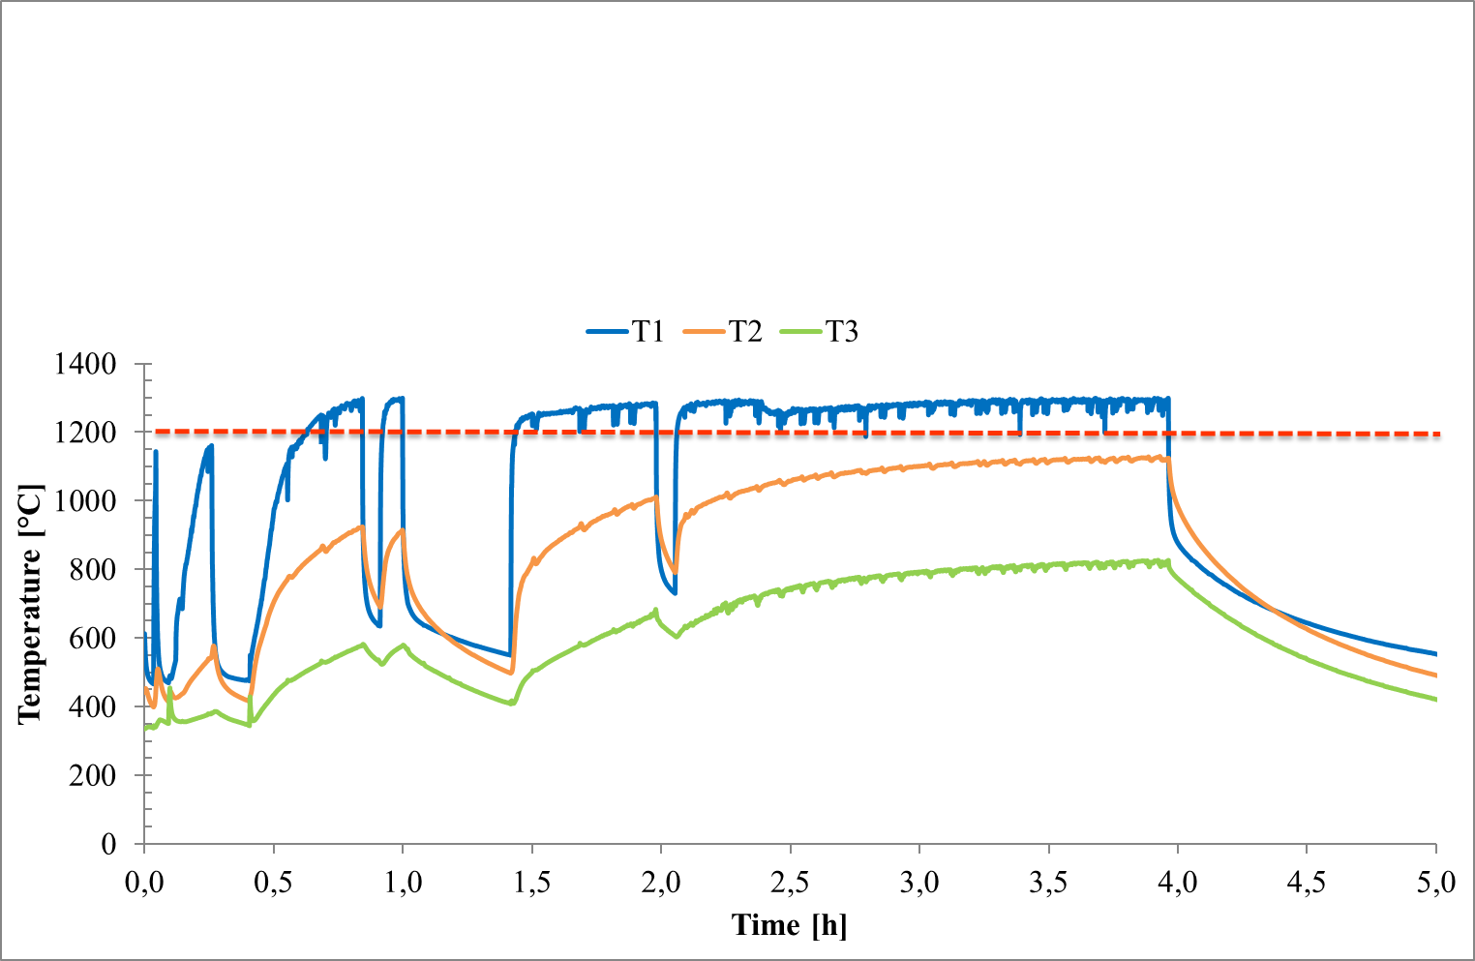

Figure 13. Oxygen feed #1. Vertical axis: temperature in °C. Horizontal axis: time in hours.

The final layout chosen for the tests was to use both inlet #1 and #2 since the reactor design seemed not able to spread the combustion across the overall length. The inlets were already placed and connected in the system, so the flow would not be split in equal part since the inlet #2 pipe was longer and thus with higher pressure drops. For this reason, a manual needle valve was inserted before inlet #1, to create the same pressure drop as for inlet #2 and have a similar flow rate going into the two pipes.

Results for this final layout are shown in Figure 14. All the temperature are lower than the acceptable max. value (1200°C) and the temperature difference across the combustor was reduced from 500 to less than 300°C. A staged combustion seems to be achieved with this new layout, with a diffusion of the flame along all the combustion chamber.

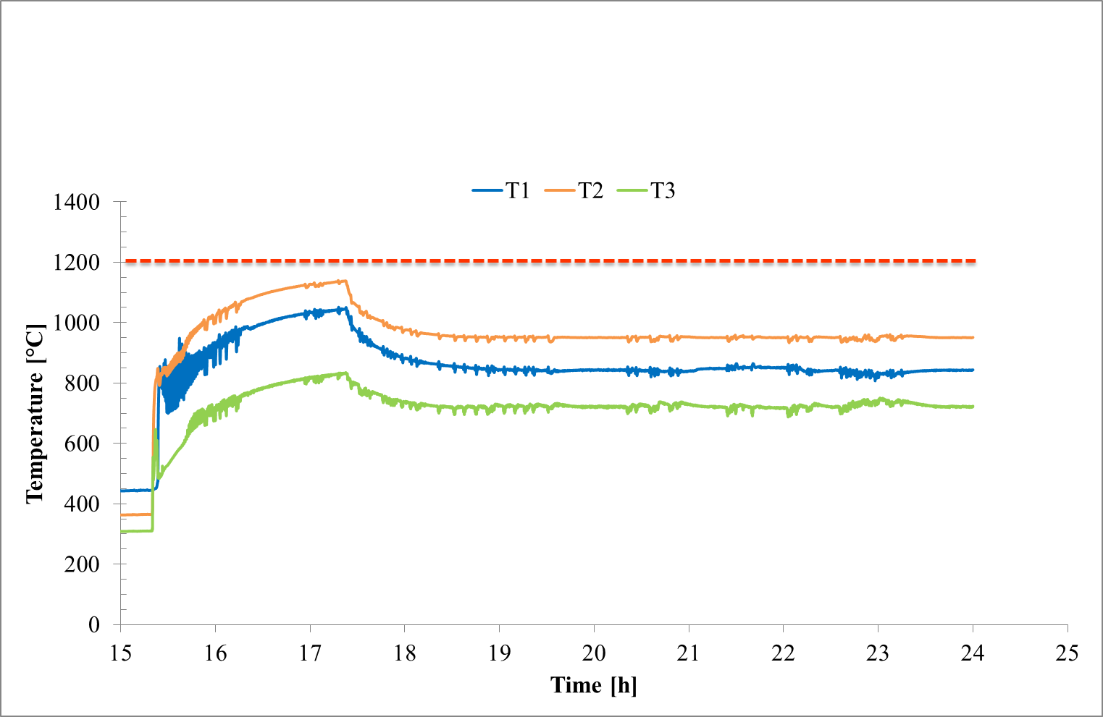

Figure 14. Oxygen feed #1 + #2. Vertical axis: temperature in °C. Horizontal axis: time in hours.

### Separation of H2O and CO2

The condenser system has been tested for several times during the demo working period. No specific test has been performed in this unit since its working mode was suitable for the system and no change was needed. The only modification, respect to the nominal working conditions set in its user manual, is related to the compressor outlet pressure.

The flow rate reaching the condenser was lower than the one for which the system was designed since the major part of the water was already condensed in the anode CHP cooler. Furthermore, a long run @ 50% of nominal power has been performed. In these low-flow conditions, the compressor showed some difficulties in reaching a stable operation since a too low rotation speed was required and the system was going in continuous on/off operation. One of the solutions adopted for reducing this problem was to increase the compressor outlet pressure from 5 to 7 barg.

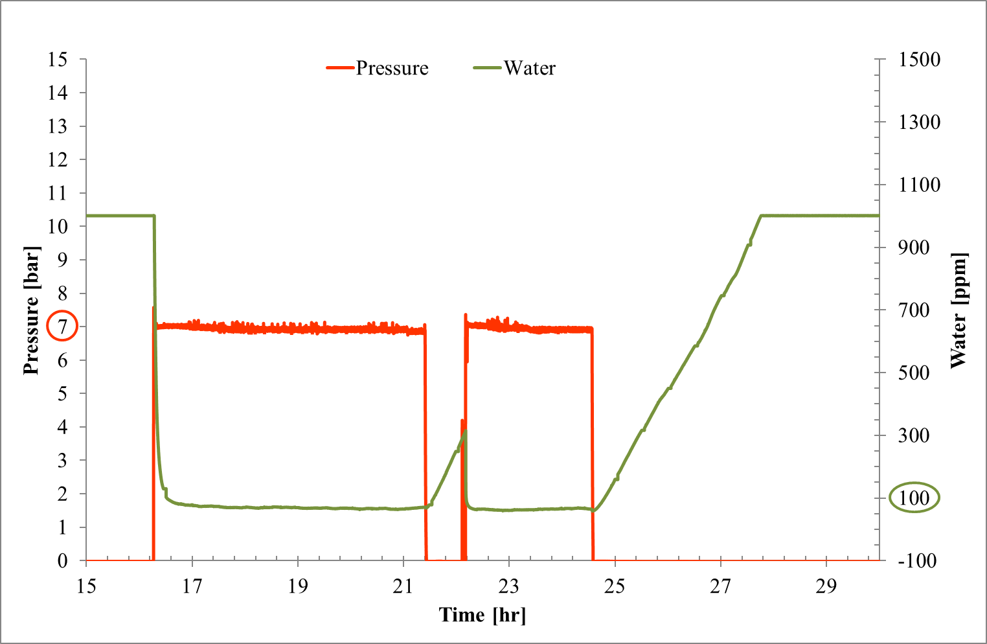

Figure 15. Condenser test results.

The global CCS institute stated that existing long-distance US CO2 pipelines typically operate with a maximum specified water content around 25–30 lb/MMscf (which corresponds to approximately 200-245 ppm w/w) [12] Buit el al. [13] have also analyzed different references for the limiting water concentrations in CO2 pipelines, which ranges from 40 to over 500 ppm [14,15]. As a conclusion, the authors confirm that under normal operating conditions, dense phase CO2 can be transported when containing 500 ppm water without any risk of free water formation, because the water solubility is at least 1,500 ppm under these circumstances (see Figure 1). For this reason, the lower extremes of 40 and 50 ppm are probably rather conservative values.

The water content inside the outlet CO2 stream was extremely low in the proposed SOFCOM system: the water content in the outlet stream reaches a value around and lower than 100 ppm (v) (Figure 15). Hence, the water content that was achieved is safe in term of water condensation and related corrosion issues.

### Photo-bio-reactor

Photobioreactor specific tests have been performed related to the direct feeding of biogas and non-combusted exhaust to the system, to check if the feeding with purified CO2 was indeed a more effective solution.

Results from the biogas feeding test are shown in Figure 16. As can be seen, the injection of biogas in the autochthone algae species Chlorella Vulgaris for Turin cause growth inhibition. The oxygen curve (oxygen production means that algae are growing), which is normally following the temperature/irradiation trend during the day, presents a decrease when biogas is fed. This standard Chlorella is thus not suitable, in its current operating conditions, for biogas feed.

When biogas feeding was stopped, the PBR was able to recover the inhibition phase, and the trend was again proportional to the irradiation one. When the system growing phase was started again (O2 proportional to temperature), the non-combusted stream was fed to the PBR.

The choice of analyzing the effect of non-combusted fuel feeding to the PBR was due to the following reasons:

* In different literature works, it is shown how the CO2 feed to PBR does not need to be 100% pure. A more diluted CO2 is also suitable for algae growth. The anode exhaust is a diluted CO2 stream, even if carbon dioxide is diluted with fuels such as hydrogen and carbon monoxide.
* To avoid the oxy-combustion stage would be interesting from and economic point of view, since pure oxygen is required with a consequent energy and economic cost.
* Despite these advantages in feeding the non-combusted stream to the PBR, results in (Figure 16) show again an inhibition of the algae growth. The behavior of the system is the same presented before when biogas was injected.

Furthermore, if the derivative trend is analyzed, the non-combusted stream seems to have a higher slope than the biogas one. The CO2 content in the anode exhaust, on a dry basis, is 58% on nominal conditions, thus higher than 40% content in pure biogas.

Despite a higher CO2 stream concentration, the presence of H2 and CO seems to have a more negative effect on the PBR performance.

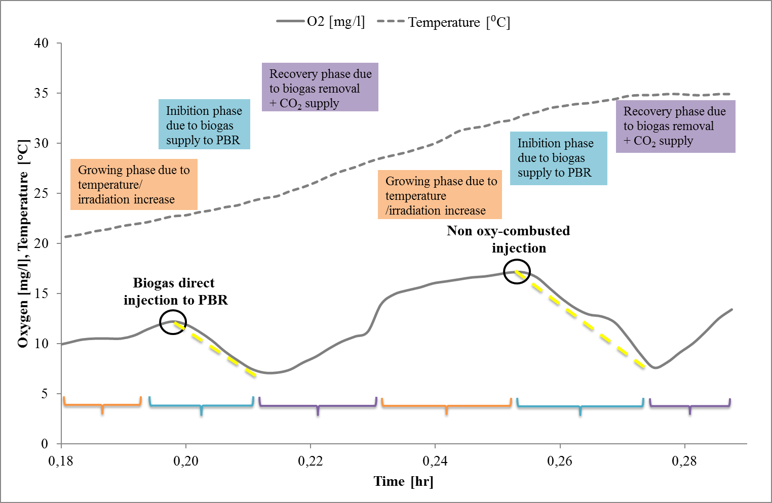

Figure 16. PBR specific tests results.

### Analysis of actual CO2 capture in micro-algae

The main result achieved during the PBR operation, in the long run, is the growing rate of algae. The growing rate was calculated with algae sampling and elementary analysis done by SMAT laboratories.

The growing rate is calculated by dividing the measured dry algae quantity per the time required for the growth and the total PBR surface (area of the system exposed to sun radiation, equal to 9 m2).

The working operation of the system can be divided into different operation intervals:

* **Test A (January-February 2015)**: almost no algae growth was observed. This was mainly due to the cold weather with few sunny days and a consequent unstable operation of the system due to maintenance and freezing problems.
* **Test B (March 2015)**: during March 2015 the algae started to grow, and pipes started to become green. A high irradiation was reached in mid-March leading to the maximum growing rate. After the 6 g/m2/day maximum value, the system had a decrease of the performance. This was due to a high attachment of the algae to the pipes, probably because of a too high irradiation (no protective system for reducing sunlight irradiation was used). The system was completely dark and full of algae, and no sunlight was able to penetrate the surface and reach the inlet water. A degradation was thus observed.
* **Test C (April 2015)**: the system degradation was increasing, and algae changed their color from green to brown, probably because of starvation, as previously observed in the lab experiments. The PBR was thus cleaned and re-started until the end of April. A new but reduced (because of the time length), growth was observed. Sunlight protective systems were also included in this second phase.

Moving from January to April, the average maximum temperature in Turin usually increases from 6 to 17°C. The temperature increase has played a fundamental role in the PBR operation and algae growth.

The cumulative growing rate (Table 6) for the longest performed test (test B, from 25/02/2015 to 15/04/2015) is shown. The first growing period was strongly influenced by the temperature and thus by the sun irradiation. From March on, despite higher temperatures, problems related to the algae attachments were the reason for the decrease in the growing rate. A maximum cumulative growing rate of 6 g/m2/day was reached on the second sampling point.

Table 6. Cumulative growing rate.

|  |  |  |  |  |
| --- | --- | --- | --- | --- |
| **Star time** | | **End time** | | **Growing rate [g/m2/day]** |
| **t0** | **25/02/2015** | **t1** | **13/03/2015** | **1,34** |
| **t0** | **25/02/2015** | **t2** | **19/03/2015** | **6,13** |
| **t0** | **25/02/2015** | **t3** | **02/04/2015** | **3,14** |
| **t0** | **25/02/2015** | **t4** | **07/04/2015** | **1,54** |
| **t0** | **25/02/2015** | **t5** | **13/04/2015** | **1,66** |

When algae sampling was performed by cleaning a pipe of the PBR, not only the growing rate was measured but also the elemental analysis was performed in the WWTP laboratories at SMAT.

As can be seen in Figure 17, the total carbon content was always close to 40%. Other elements were nitrogen, hydrogen, and sulfur.

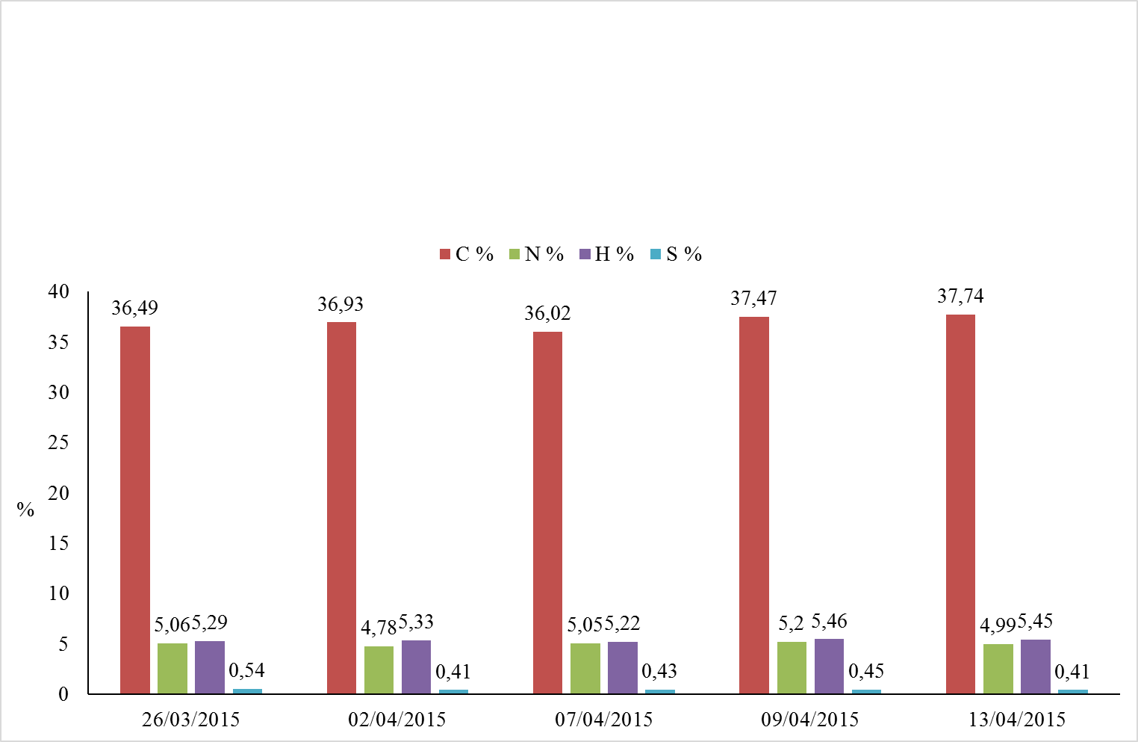

Figure 17. Single element analysis for the algae.

Furthermore, the quota of carbon related to organic C has been calculated and can be seen in Figure 18. The ration Corg/Ctot is almost kept constant during the tests and the Corg percentage is around 34-35%.

The fact that algae prefer to grow attached to the pipes, confirmed by the PBR producer, the lab experiments explained in the previous section, and by literature, has also been confirmed during two sampling points in which the percentage of algae attached to the pipe and suspended in the contained water were measured separately. Results can be seen in Figure 19 and show that 90% of the algae are found to be attached to the pipe.

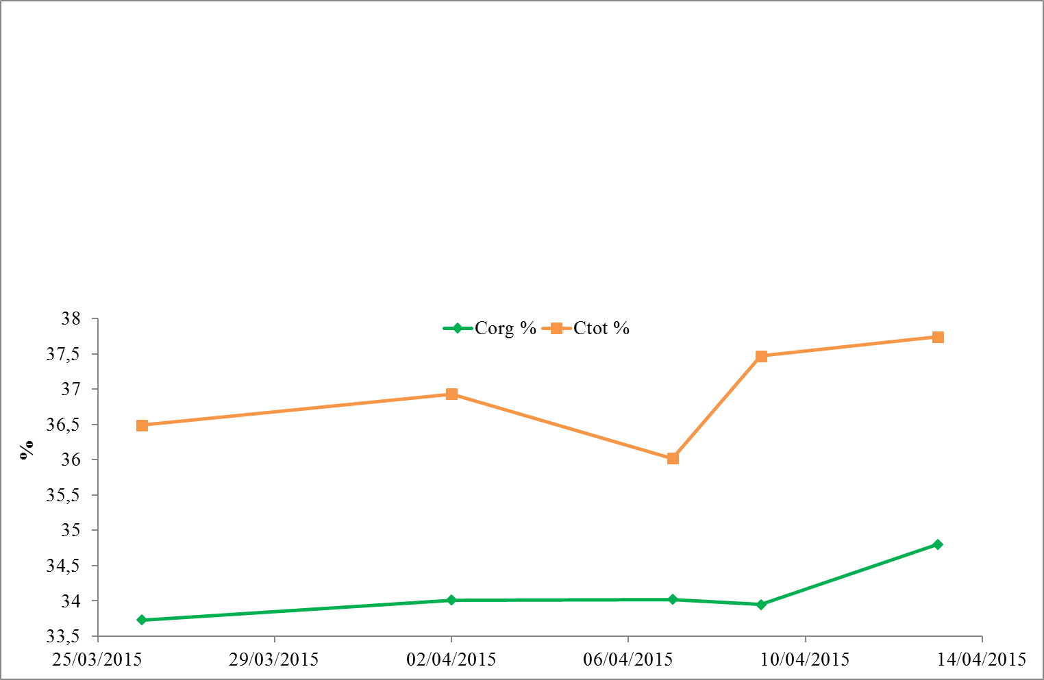

Figure 18. Total and organic carbon ratio.

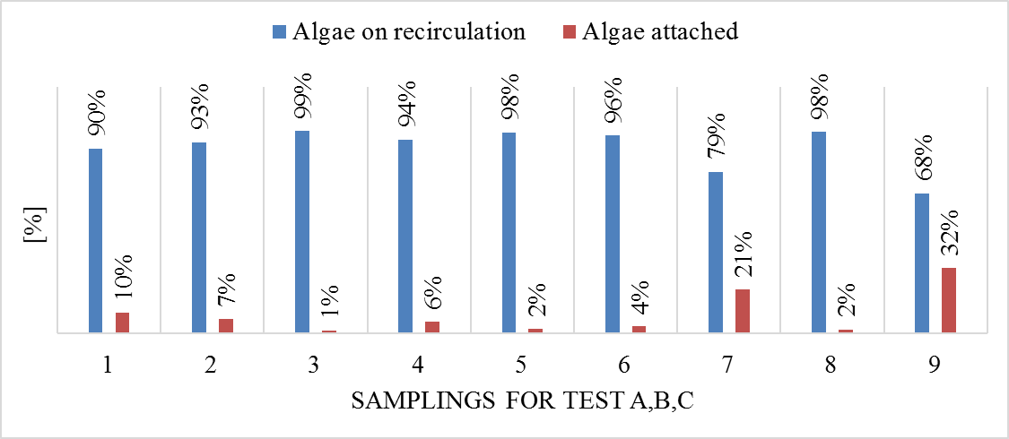

Figure 19. Distribution of detected algae in the PBR.

## Discussion

By considering all the obtained results, it is possible to derive some main conclusions.

The first one is that the oxy-combustion step is not problematic from the technical point of view. The process is very effective in converting the residual H2, and CO contained in the SOFC anode exhausts into H2O and CO2 respectively. Some considerations follow below:

* A way to reduce the amount of residual H2 and CO in the anode exhaust, could be to operate the SOFC at a higher Fuel Utilization; this can generate a slight reduction of the efficiency of the electrochemical reaction, but this could represent a negligible reduction to accept if the emphasis is given to the effectiveness of carbon recovery from the plant
* the needed reactant is O2; of course, O2 would represent a high cost (in terms of energy and economy) if it has to be separated from air (or, even worst, if extracted from cylinder as in our proof-of-concept); a plausible solution could be to use the O2 recovered from the downstream PBR, coming from the algae photosynthetic reaction; then, the O2 would be recovered directly from the reduction of the CO2 into the PBR; in terms of mass balance, the amount of moles of CO2 inlet into the PBR is by far higher than the amount of moles of H2 and CO inlet into the oxy-combustor to be oxidized, then the O2 from PBR is highly in excess compared to the needs of the oxy-combustor; this O2 would be then available free of charges, and representing another example of strict mass and energy integration inside this poly-generative plant.

The second conclusion, based on the results, is that the H2O separation step is not problematic from the technical point of view. The process is very effective in separating the H2O from the CO2 in the exhaust stream from the oxy-combustion. Some considerations regarding this point are:

* In order to reduce the energy cost related to the compression of the mixture before the membrane separator, a possible solution could be to operate the whole process in pressure; this would generate some higher mechanical requests (and costs) to the structures, but could generate positive effects: (a) the SOFC operating under pressure has a higher conversion efficiency [16,17]; (b) the oxy-combustion reaction would be more effective; (c) the separation of the H2O by condensation would be more effective, as a lore amount of H2O is maintained in equilibrium with the gas when the pressure increases; (d) the separation of the residual H2O from the CO2 would not need the necessity of a compressor. Nevertheless, this configuration would have also some drawbacks (due to the more complicated mechanical behavior): (a) the biogas in origin is usually available at ambient pressure in a gas holder; and so, in absence of a gas already in pressure (standard case), the biogas entering in the plant would have to be compressed (and this would be really a significant energy expenditure); (b) the O2 sent to the oxy-combustor would have to be compressed as well. Then, as a conclusion, it has to be evaluated if the positive effects (e.g. higher efficiency of the SOFC generator) can compensate the negative effects (e.g. the necessity to compress the biogas).

The third set of conclusions comes from the PBR, which has revealed as the most problematic component of the chain: the main considerations are:

* the productivity of the PBR in terms of micro-algae is not optimized; the amount of specific productivity is in the order of 6 g/m2/day in terms of maximum cumulated value and 18.8 g/m2/day in terms of weekly-average value. From literature, ranges from 20 to 40 g/m2/day are found for similar PBR [18], even if peaks up to two orders of magnitude more (more than 3 g/L/day against 0.03 g/L/day in the presented work) have also been reached with PBR in specific operating conditions [19]. The present test was conducted in an outdoor real environment, with variable nutrients concentrations depending on the inlet waste water, variable irradiation and no initial inoculum for defining a specific algae specie.
* the energy consumptions of the PBR are not negligible: the solutions based on loop recirculation of the water, in order to avoid algae attachment to the pipes and to maximize the effectiveness of the photosynthetic reaction is significant in terms of energy consumption; the amount of energy consumed for gram of micro-algae is around 9 W/m2, in the current PBR layout, high if compared to the energy contained in the algae. The use of a high flow rate recirculation, operating 24 hours per day, is a key issue to be optimized in future plants [18,20–22], where a less energy intensive way to avoid algae attachments to pipes should be found. Furthermore, an increase in the productivity value (W/m2) is the second way to reduce the unbalance between energy production and consumption.
* one of the reasons of the low productivity is due to the fact that the micro-algae tend to adhere to the surface of the tubes, forming a screen to the transmission of the solar irradiance and so reducing the specific productivity of the PBR; this adhesion can be reduced in different ways: (a) higher turbulent flow inside the tubes, which means a further increase of the energy consumption for the water recirculation; (b) deposition of coating materials in the inner surface of the tubes to reduce the adhesion; (c) adoption of a screen outside the PBR, but in that way reducing also the specific productivity of the micro-algae. This aspect has to be further analyzed and optimized.
* as it is well know from literature, and from the results obtained in this project, the concentration of CO2 in the water needs to be controlled in order to avoid a too high reduction of the local pH, because an acidic water is detrimental for the grow up of most of the typologies of algae; in this sense: (a) the research has to be improved in the selection of algae cultures able to grow up fast also in acid water; (b) from the engineering point of view, the solution (also applied in our proof-of-concept) could be to control the mass flow of CO2 injected inside the water flow, in order to control the pH; so, there is the necessity of accumulating the CO2 mass flow coming from the upstream SOFC plant in a buffer volume, in order to control its injection in the PBR
* during the dark hours of the day, the micro-algae are not produced; instead they release CO2; thus, it comes evident the necessity to accumulate the CO2 coming from the SOFC plant during the dark periods in a storage buffer; this is due to the fact that, of course, the upstream energy plant based on SOFC operates in a continuous way 24/7. This is again related to the need to control the flow of CO2 before injecting it into the PBR, and so the need to adopt a buffer volume (with related costs of installation and management); also, this depends on the location of these typologies of plant, having on effect on the distribution of light and dark hours during the day and during the year.

Coming to the final target of our discussion, which is related to the evaluation of this innovative opportunity to completely recover CO2 from an energy process, in a paradigm of complete CCR, the main results and discussions that come from our experience in the SOFCOM proof-of-concept are the following.

**Effectiveness of the micro-algae solution**

The main results in terms of effectiveness of carbon removal in PBR in our pilot experience is expressed by the quantification of the fact that micro-algae are really a fast growing biomass. In fact, standard biomasses (wood, maize, energy crops, corn) show always growing rates lower than 1 W/m2; only sugarcanes and tropical plantations are able to reach values close to 2 W/m2 [23]; micro-algae produced during the experimental SOFCOM activities show a cumulative growing rate of 1.36 W/m2 with a weekly peak of 4.18 W/m2. These results can be further optimized with the solutions already highlighted here.

**Carbon impact of the tested solution**

* considering the pathway biogas-SOFC (without CO2 recovery in PBR), the CO2 emissions from the SOFC biogas fed system (with optimized sludge pre-thickening) are 0.198 kgCO2,eq/kWhel against 0.429 kgCO2,eq/kWhel in case of NG feeding;
* taking into account the energy (and environmentally) intensive and not optimized PBR system, the CO2 emissions from the SOFCOM system are 0 kgCO2/kWhel, but only if considering the intermediate buffer able to store the CO2 during the period of null irradiance
* the environmental performance of the PBR has been studied only in reference to the operation mode (the manufacturing and assembly phase has been considered negligible with respect to the operation). At PBR level it is calculated that 60% of the total emissions of CO2 from SOFC are fixed in biomass (because of a limited seasonal buffer). The rest is released into atmosphere.

For the production of 1 kg of biomass this translates in a consumption of 1.84 kg of biogenic CO2 and emissions for 1.23 kg biogenic CO2. To these emissions, using Climate Change impact category for PBR operation, it must be added another 35.9 kg of CO2eq. Overall GHG emissions are thus 20 times higher than the CO2 consumption (presented results have been determined from the Life Cycle Assessment (LCA) analysis of the SOFCOM plant, presented in the related project Deliverable 4.5 [24]).

Hence, the chosen PBR technology, according to the available information and on the choices made for its operating mode, does not provide neither an energetic nor CO2 sequestration-effective improvement compared to the original energy path (biogas-fed SOFC). However, the conclusions just presented does not imply a negative judgment of the concept of achieving positive effects (energy production, carbon sequestration) in contexts similar to the one presented; more research is required to identify and understand all the parameters involved in the operation of such complex system, and new designs would propose more interesting performances (e.g., hybrid photobioreactors) [25].

Moreover, in the presented results from SOFCOM plant LCA analysis, the benefit of water purification (nitrates and phosphates removal) is not considered when analyzing the Climate Change impact category. Data on nitrogen and phosphorus balances (available through other LCA impact categories) would underline this positive effect of the PBR system.

**Considerations about the interest and effectiveness of the process in relation to the expectations of COP21**

Biogas production in Europe has been steadily increasing. Looking at historical data of the past 25 years (Figure 20), the share of biogas toward the overall gross energy consumption in Europe has been increasing with an exponential trend. In 2014, the overall biogas production was 625,213 TJ (a value more than 20 times greater than biogas production in 1990).

Regardless biogas is burnt in conventional thermal engines, or in more sophisticated fuel cell power modules without carbon capture, all the carbon contained in it is eventually transformed to CO2.

Figure 20. Share of biogas to the overall energy consumption in EU-28 zone (red line: actual data; black dashed line: exponential fit). Source of data: EUROSTAT database (http://ec.europa.eu/eurostat/web/energy/data/database).

Assuming an average biogas composition of 60% vol. CH4 and 40% vol. CO2, the overall energy biogas production translates into 35.4 Mton of gas. This amount yields an overall CO2 emission of about 57 Mton assuming complete fuel burning (or oxidation) in engines (or fuel cell), or in conventional gas boilers. Carbon capture in integrated SOFC-CCS plants would thus entail a large potential of CO2 emissions cut. In fact, 57 Mton of CO2 represents 1.6% of the overall EU-28 GHG emissions in 2013. As the biogas is CO2-neutral, these quantities can be considered as “negative” CO2, recovered in compensation to other CO2 sources from fossils. The amount is thus not negligible at the EU scale.

## Conclusions

In the context of the paradigm of Carbon Recovery and Re-utilization (or CRR), this work focused on the role of electrochemical generators (such as SOFC) to perform CRR as an efficient secondary effect. In particular, results of the first SOFC-based poly-generation system with complete CO2 recovery in form of fast-growing biomass (micro-algae) are presented, as developed in the EU-funded project SOFCOM.

From the technological point of view, the main lessons learned from the experience of the SOFCOM proof-of-concept are:

* the oxy-combustion step does not present technical limitations, but it can be enhanced with some improved management of the plant: (a) in order to reduce the amount of residual H2 and CO in the anode exhaust, operate the SOFC at a higher Fuel Utilization; (b) in order to fully oxidize the residual H2 and CO molecules, make use of the O2 recovered from the downstream photo-bio-reactor, coming from the algae photosynthetic reaction
* the H2O separation step is not problematic from the technical point of view. A possible solution to reduce the energy cost related to the compression of the mixture before the membrane separator could be to operate the whole process in pressure
* the PBR, has revealed as the most problematic component of the chain: (a) the productivity of the PBR in terms of micro-algae has proven to be satisfactory (maximum cumulated value 18.8 g/m2/day), even though it might be further improved; (b) the energy consumption of the PBR (around 9 W/m2) is too high and should be reduced; (c) the micro-algae tend to stick to the surface of the tubes, and this adhesion has to be reduced as it precludes further microalgae growth; (d) there is the necessity to control the injection of CO2 in the water in order to avoid a too high reduction of the local pH, because an acidic water is detrimental for the grow up of most of the typologies of algae; (e) the need to accumulate the CO2 coming from the SOFC plant during the dark periods in a storage buffer.

From the general perspective of CRR, the main outcomes are:

* Effectiveness of the micro-algae solution: micro-algae are really a fast growing biomass (weekly peak of 4.18 W/m2 in terms of growing rate)
* Carbon impact of the tested solution: the CO2 emissions from the SOFCOM system are 0 kgCO2/kWhel, but only if considering the intermediate buffer able to store the CO2 during the period of null irradiance
* Considerations about the interest and effectiveness of the process in relation to the expectations of COP21: carbon capture from biogas power plants can contribute to an overall emissions cut of 1.6% of the current CO2-equivalent emissions in EU-28 zone.

## Acknowledgements

This work has been developed in the framework of the European Union's Seventh Framework Program (FP7/2007-2013) for the Fuel Cells and Hydrogen Joint Technology Initiative under grant agreement number 278798 ‘SOFCOM’ (www.sofcom.eu).

### List of symbols

|  |  |
| --- | --- |
| **Latin** |  |
| $$a$$ | Gas adsorption coefficient |
| $$a_{sf}$$ | Area of the solid-fluid interface per unit volume of porous material |
| $$ΔA$$ | Total tube surface |
| $$c_{p}$$ | Heat capacity at constant pressure |
| $$C_{2}$$ | Inertial resistance factor |
| $$d$$ | Pore diameter |
| $$D_{k,m}$$ | Molecular diffusivity of chemical species *k* in the mixture |
| $$D_{T}$$ | Thermal (Soret) diffusion coefficient |
| $$G$$ | Algae growing rate |
| $$G_{max}$$ | Species dependent maximum growth rate |
| $$h_{k}$$ | Specific enthalpy of chemical species *k* |
| $$I$$ | Radiative intensity |
| $$\vec{J_{k}}$$ | Mass diffusion of *k-th* species |
| $$k$$ | Thermal conductivity |
| $$k_{s}$$ | Species dependent half saturation coefficient |
| $$M$$ | Molecular weight |
| $$n$$ | Refractive index |
| $$\dot{n}$$ | Mole flow rate |
| $$N_{sp}$$ | Number of chemical species |
| $$p$$ | Pressure |
| $$Pe$$ | Peclet number based on pore diameter |
| $$q_{r}$$ | Radiative heat flux |
| $$Re$$ | Reynolds number |
| $$R_{k}$$ | Net rate of production of *k-th* species |
| $$s$$ | Direction vector |
| $$\hat{s}$$ | Scattering direction vector |
| $$S_{m}$$ | Momentum source term |
| $$S_{r}$$ | Radiative heat source term |
| $$Sc$$ | Schmidt number |
| $$Sh$$ | Sherwood number |
| $$t$$ | Time |
| $$T$$ | Temperature |
| $$v$$ | Velocity vector |
| $$\dot{V}$$ | Volume flow rate |
| $$y$$ | Mass fraction of the *k-th* species in a mixture |
| **Greek** |  |
| $$α$$ | Permeability |
| $$ε$$ | Porosity |
| $$μ$$ | Dynamic viscosity |
| $$μ_{t}$$ | Turbulent dynamic viscosity |
| $$υ$$ | Kinematic viscosity |
| $$Φ$$ | Scattering phase function |
| $ϕ_{T}$ | Dimensionless factor |
| $$ρ$$ | Density |
| $$σ$$ | Stefan-Boltzmann constant |
| $$σ_{s}$$ | Scattering coefficient |
| $$Ω$$ | Solid angle |
| $$Π$$ | Recirculation rate |
| **Subscripts** |  |
| $$f$$ | Fluid |
| $$k$$ | Index |
| $$liq$$ | Liquid |
| $$max$$ | Maximum |
| $$p$$ | Pore |
| $$r$$ | Radiation |
| $$s$$ | Solid |
| $$sp$$ | Species |
| $$t$$ | Turbulent |

## Appendix – System modeling

### Section 1: Oxy-combustor

**The proposed geometry**

The oxy-combustor is composed of four concentric pipes. The oxygen is divided into two streams: primary and secondary. As shown in Figure A1, primary oxygen has an inlet (2) and flows through the distribution pipe to its outlet being the three rows of nozzles. Analogously, the secondary oxygen inflows through an inlet (5) and enters the combustion zone by outlet nozzles. The primary oxygen pipe is placed inside the cylinder made of porous material (SiC). The porous material cylinder is connected to the inlet of off-anode gases (1) leaving the SOFC stack by a pipe. The primary oxygen outlet nozzles (total of three) are fabricated by circumferentially boring holes in the pipe at a certain angle on the main axis of the combustor. The second part of the oxy-combustor is also filled-up with a porous material that forms a cylinder. The ignition and outlet zone is located near the outlet of the exhaust gases, just after the cylinder made of porous material (11). The zone (12) is equipped with igniter ports and oxygen probe ports (18). There are also thermocouple ports (16) installed in crucial areas of the oxy-combustor. The casing of the whole device is cooled by the flow of cooling air. The cooling air is flowing from its inlet (13), through spiral path enforced by a helix-shaped baffle (15), to the outlet (14).

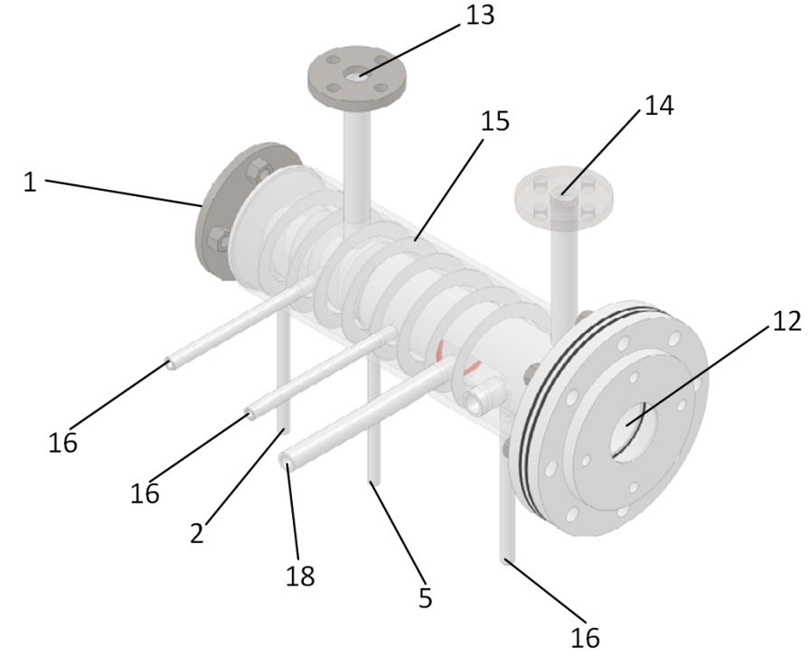

Figure A1. Isometric view of the oxy-combustor.

**The numerical model**

On the proposed geometry, a numerical model was developed and implemented in Computational Fluid Dynamic (CFD) code. The mathematical model of the oxy-combustor is described by a set of equations, which are solved by ANSYS-Fluent solvers.

Continuity equation:

|  |  |
| --- | --- |
| $$\frac{∂(ερ_{f})}{∂t}+∇∙\left(ερ_{f}v\right)=0$$ | (1) |

Momentum equation:

|  |  |
| --- | --- |
| $$ερ_{f}\frac{∂v}{∂t}+ερ_{f}v∙∇v=-εμ_{f}∇∙\left(∇v\right)-{(∇p)}_{p}+S_{m}$$ | (2) |

Energy balance for gaseous phase:

|  |  |
| --- | --- |
| $$ερ_{f}c_{p,f}\frac{∂T_{f}}{∂t}+ερ_{f}c_{p,f}v∙∇T_{f}=ε∇∙\left(k_{f}∙∇T_{f}\right)+h_{f}\left(T_{s}-T_{f}\right)-ε\sum_{k=1}^{N_{sp}}{{\dot{ω}}_{k}M_{k}h_{k}}+S_{r}$$ | (3) |

Energy balance for solid phase:

|  |  |
| --- | --- |
| $$\left(1-ε\right)ρ_{s}c_{p,s}\frac{∂T_{s}}{∂t}=\left(1-ε\right)∇∙\left(k_{s}∙∇T_{s}\right)+h_{v}\left(T_{s}-T_{f}\right)$$ | (4) |

Transport of chemical species:

|  |  |
| --- | --- |
| $$\frac{∂}{∂t}\left(ερ_{f}y_{k}\right)+∇∙\left(ερ_{f}vy_{k}\right)=-∇∙\vec{J_{k}}+R_{k} k=1, …{, N}_{sp}-1$$ | (5) |

Radiative transfer equation (RTE):

|  |  |
| --- | --- |
| $$\frac{dI}{ds}+\left(a+σ_{s}\right)I=an^{2}\frac{σT^{4}}{π}+\frac{σ_{s}}{4π}\int_{0}^{4π}{I\left(\hat{s}\right)Φ\left(s,\hat{s}\right)dΩ}$$ | (6) |

Mass diffusion:

|  |  |
| --- | --- |
| $$\vec{J_{k}}=-\left(ρD_{k,m}+\frac{μ_{t}}{{Sc}_{t}}\right)∇y_{k}-D_{T,k}\frac{∇T }{T}$$ | (7) |

The SOFC is fed by a mixture of gases, comprising mostly of CH4. Conversely, the off-anode gas leaving the stack is mostly composed of CO2 and H2O but has significant shares of CO and H2. The main goal for the oxy-combustor is to provide stable combustion conditions for lean off-anode gas leaving the SOFC stack, allowing the recovery of the fuel chemical energy that otherwise would be wasted. Therefore it is a key issue to properly model the combustion process.

For the simulation, the multi-step finite-rate eddy-dissipation combustion model was selected. Contrary to the single-step reaction model, the choice of this approach can be justified by a few reasons. It was proven [26,27], that the single-step reaction models yield better predictions of the burning speed compared to more detailed ones, especially for fuel-lean conditions. However, the results were obtained by over-prediction of the energy release in some areas of a combustion zone, due to lack of pathways for incomplete combustion. In the case of oxy-combustor, proper estimation of the temperature field is crucial, because peaks in the temperature influence the type of material that should be used, as well as the overall design concept and eventually the cost of the device.

The detailed optimized combustion mechanism for mixtures of H2/CO was proposed by Davis *et al.*, [28] and was proven to give good predictions for a wide range of inlet conditions. The un-optimized version of the mechanism involves 14 species and 30 reactions, therefore, even after its optimization, it would give prohibitively long computing times when applied to our model. In their work [29], the authors selected and used global two-step reaction mechanism. Their approach was utilized in the current model. It comprises of two global reactions:

|  |  |
| --- | --- |
| $$H_{2}+ \frac{1}{2}O_{2}→H_{2}O$$ | (8) |
| $$CO+ \frac{1}{2}O_{2}→CO_{2}$$ | (9) |

with the respective reaction rate given in the Arrhenius form of:

|  |  |
| --- | --- |
| $$R_{1}=A_{1}e^{{-E_{1}}/{RT}}\left[H_{2}\right]{[O_{2}]}^{a}$$ | (10) |
| $$R_{2}=A_{2}e^{{-E_{2}}/{RT}}[CO]{\left[H_{2}O\right]}^{b}{[O_{2}]}^{c}$$ | (11) |

and coefficients from Table A1.

*Table A1. Arrhenius reaction rate coefficients for the two-step mechanism.*

|  |  |  |  |
| --- | --- | --- | --- |
| T inlet | K | 300 | 500 |
|  |  | 1.8 x 1013 | 3.0 x 1014 |
|  | K | 17 614,0 | 18 335.0 |
|  | - | 0.50 | 0.53 |
|  |  | 1.2 x 1011 | 4.8 x 1012 |
|  | K | 8053.0 | 12 100.0 |
| $$b$$ | - | 0.30 | 0.29 |
| $$c$$ | - | 0.50 | 0.52 |

In general, heat transfer inside the porous material is described by the equations (3), (4) and (6). The porous foam volume is partially occupied with solid material that creates a complicated structure with pores, which in turn are filled up by gas. The heat exchange occurring in those two phases (solid and gaseous phases) have to be taken into account separately and then coupled. Inside the gaseous phase, the heat is being transferred by three modes, namely convection, conduction, and radiation, to the contrary to the solid phase, in which only conduction is present. The before mentioned approach is seen as two energy equations, written separately for gaseous (3) and solid (4) phases. The coupling between the two phases is done using a volumetric heat transfer coefficient *hv*, which expresses the rate of heat transfer per degree of temperature per unit volume of the porous material. This coefficient is equal to the product of a superficial heat transfer coefficient *h* and the area of the solid-fluid interface per unit volume of porous material:

|  |  |
| --- | --- |
| $$h_{v}=ha_{sf}$$ | (12) |

Radiation heat transfer mode is present only in gaseous phase and is accounted for in the energy equation (3) by term *Sr*. However, the presence of the non-transparent to radiation medium (solid) is not taken into account in the radiation equation (6) and that is the reason for modifying the existing radiation model. The porous matrix is assumed to be a grey absorber and emitter which scatters radiation isotropically. The radiative transfer equation is solved using Discrete Ordinates Method. The modification of the existing model includes the adjustment of the absorption and scattering coefficients in the volumes where the porous material is present. Radiative properties of the 10 PPI porous foam made of silicon carbide were taken from [30] and are summarized in Table A2.

*Table A2. Radiative properties of the silicon carbide porous material.*

|  |  |  |  |
| --- | --- | --- | --- |
| Material | ε, % | σs, 1/m | 𝜅, 1/m |
| SiC | 87,0 | 66 | 28 |

In summary, enhanced heat transfer in porous foam was accounted for in simulations by setting appropriate heat conduction coefficients for solid and gaseous phase and by modifying radiation mode of heat transfer.

Due to the presence of porous material in the flow stream, the dispersion of scalar quantities, such as heat and mass, enhances. The mass transfer is increased because of the hydrodynamic mixing of the interstitial fluid at the pore scale in addition to molecular diffusion. In the case of heat transfer, the presence of well conducting solid part of the porous foam, higher interstitial gas flow velocities, and intensive hydrodynamic mixing is responsible for the increased heat dispersion [30].

The model of enhanced mass dispersion was developed based on the results of an experiment found in the literature [31]. In the experiment by Pereira and co-authors, a tracer was installed inside the stabilized air flow within a tube. After passing through the 10 PPI porous foam sample element, the smoke from the tracer was dispersed, and its image was taken. Analyzing the digital image, it was possible to find the smoke intensity and, therefore, deduce its dispersion. In general, the scalar dispersion can be broken down into two components - transverse *DT*, and longitudinal *DL*. According to Pereira et al., for pore Reynolds number in the range of 10 < *Red* < 100, and high *Pe* numbers *Pe* >> 1 the components of the dispersion tensor are expressed by Koch and Brady [32] formulas, using pore diameter as a characteristic length for *Pe* and *Re* numbers:

|  |  |
| --- | --- |
| $$\frac{D_{L}}{D_{m}}=1+\frac{3}{4}Pe+\frac{1}{6}π^{2}(1-ε)Pe\ln{(Pe)}$$ | (13) |
| $$\frac{D_{T}}{D_{m}}=1+\frac{63}{320}\sqrt{2(1-ε)}Pe$$ | (14) |

where Peclet number is in the form of:

|  |  |
| --- | --- |
| $$Pe=\frac{ud}{D_{m}}$$ | (15) |

and the mean diameter of the pore is estimated from [33] for 10 PPI porous foam:

|  |  |
| --- | --- |
| $$d[m]=\frac{2×0.0254}{PPI}$$ | (16) |

Scalar diffusion was implemented in Fluent via User Defined Function mechanism. It modifies the turbulent Schmidt number present in the species diffusion equation (7). Turbulent Schmidt number is given by:

|  |  |
| --- | --- |
| $${Sc}_{t}=\frac{ν}{D_{t}}$$ | (17) |

moreover, the turbulent diffusion coefficient *Dt* is replaced by the sum of longitudinal and transverse dispersion coefficients, calculated from equations (13) and (14):

|  |  |
| --- | --- |
| $$D_{t}=D_{T}+D_{L}$$ | (18) |

According to the authors [31], the value of the longitudinal dispersion coefficient *DL* can vary with the ration of foam length to the pore diameter *(L/d)* and it can influence the values of *DT*. The higher the *L/d* ratio, the better prediction of dispersion coefficients by Koch and Brady formulas (13), (14). In the case of oxy-combustor geometry, the *L/d* ratio is high enough, to rely on the before-mentioned formulas.

Porous media are modeled by the addition of a momentum source term to the standard fluid flow equation (2). In the case of homogeneous porous medium, momentum source in each direction *i* = *(x, y, z)* can be written as:

|  |  |
| --- | --- |
|  | (19) |

where: *α* – permeability and *C2* – inertial resistance factor. The first term on the right-hand side of the equation (19) is called a viscous loss term (Darcy) and the second term – an inertial loss term.

To properly estimate the coefficients *α* and *C2* the modified Ergun equation is used (20). It is semi-empirical correlation applicable over a wide range of Reynolds numbers and for many types of packing beds and can be used for porous foams as well. According to Ergun equation, the pressure loss in a given *i-th* direction is given by:

|  |  |
| --- | --- |
| $$\frac{dp}{dx_{i}}=-\frac{180{(1-ε)}^{2}}{ε^{3}}\frac{μ_{f}}{d}v_{i}-\frac{c(1-ε)}{ε^{3}}\frac{ρ_{f}}{d}{v_{i}}^{2}$$ | (20) |

After some manipulations of Eqs. (19) and (20), the following expressions for *α* and *C2* are found to be:

|  |  |
| --- | --- |
| $$α=\frac{d^{2}}{180}\frac{ε^{3}}{{(1-ε)}^{2}}$$ | (21) |
| $$C_{2}=\frac{3.6}{d}\frac{(1-ε)}{ε^{3}}$$ | (22) |

The literature covers the problem of pressure drop in porous foams of similar PPI and porosity [34–37], but none of them addresses the problem of pressure drop at high temperatures. Nevertheless, the pressure drop on the fuel side of the burner was not limiting due to relatively low fuel velocities within the ceramic foam.

As a result of the modeling, the temperature and molar concentration of species were obtained and are presented in Figure A3-A5.

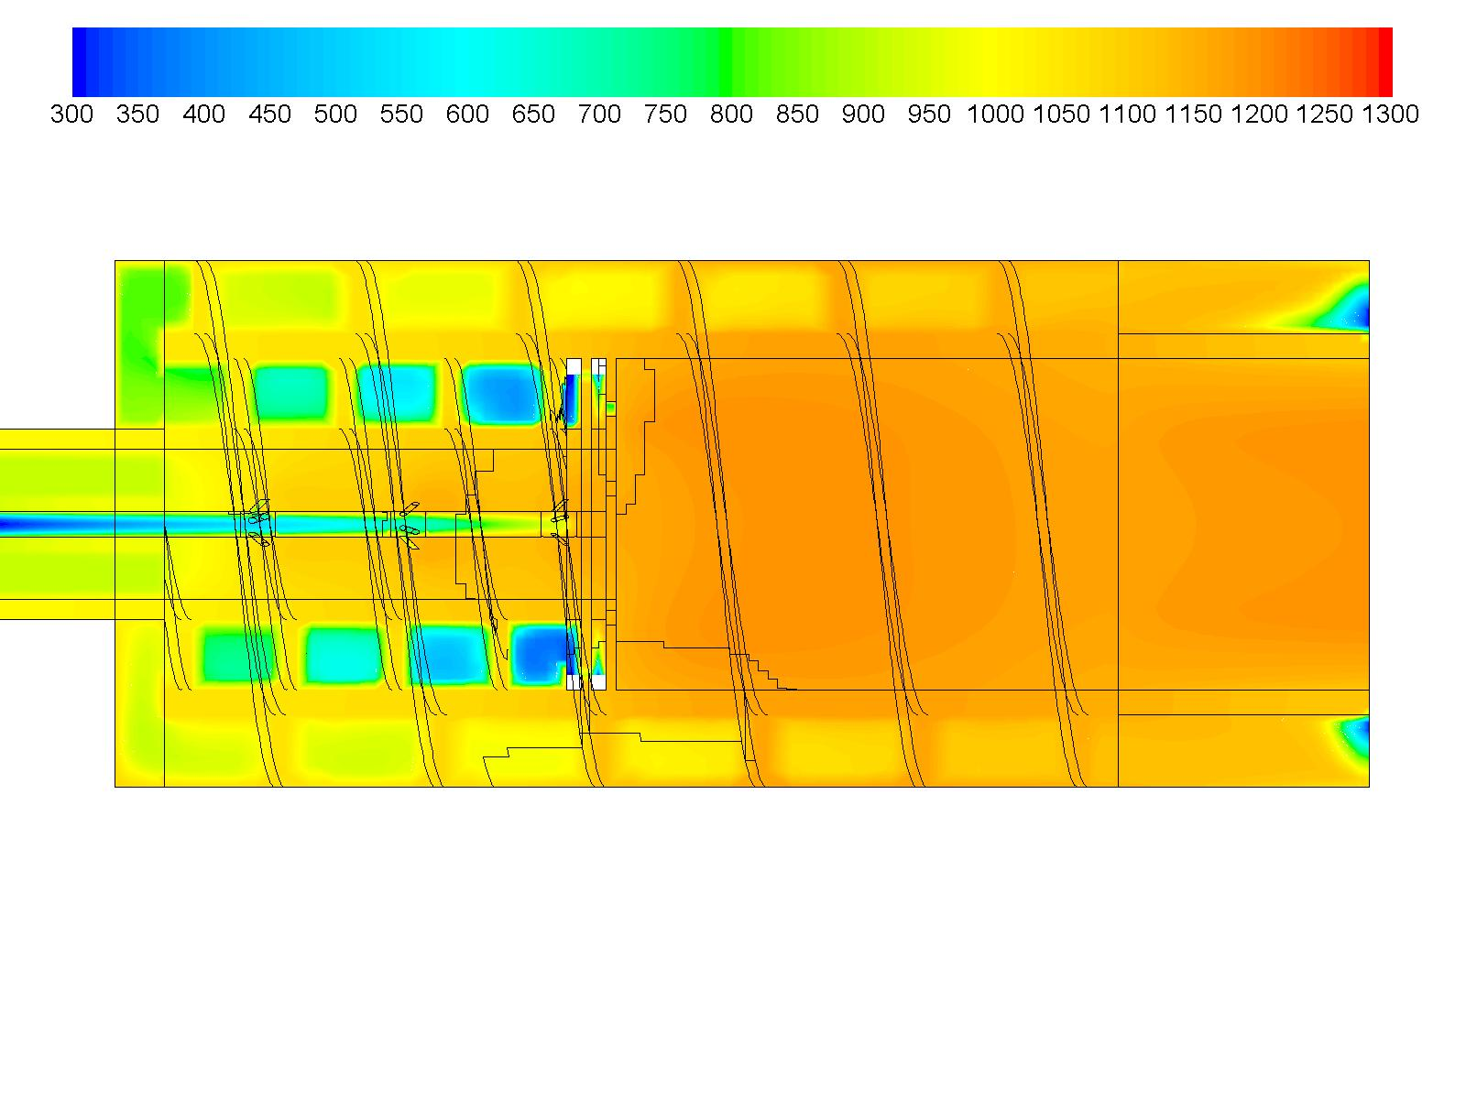

*Figure A3. Temperature (K) profile in the symmetry plane of the oxy-combustor.*

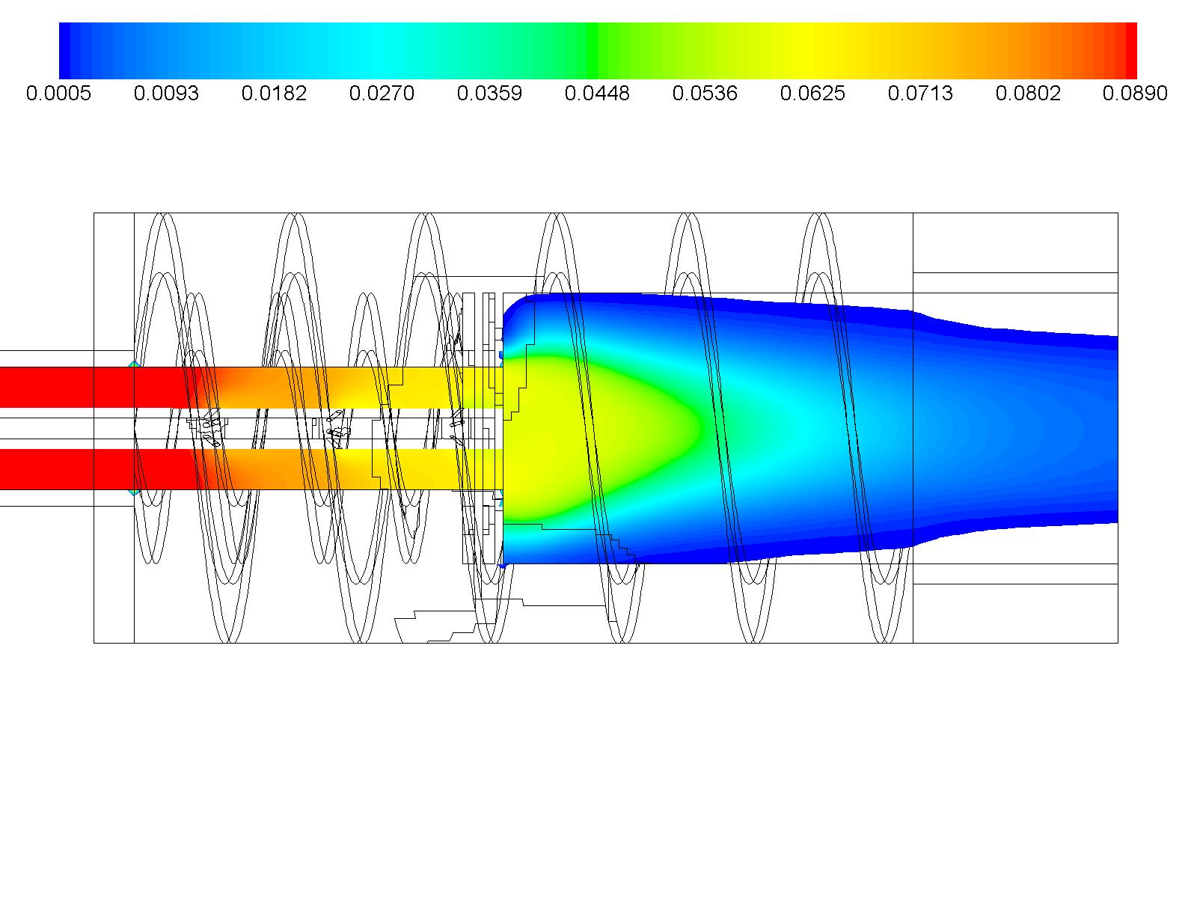

*Figure A4. Molar concentration (-) of CO in the symmetry plane of the oxy-combustor.*

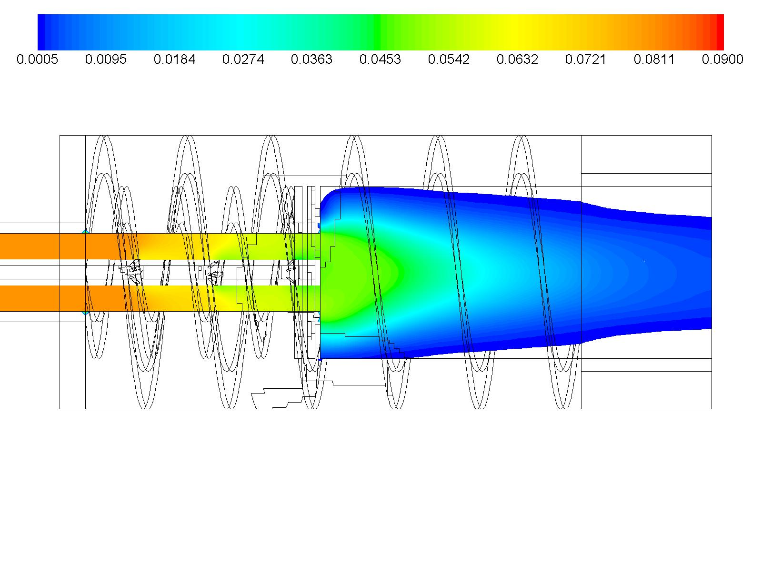

*Figure A5. Molar concentration (-) of H2 in the symmetry plane of the oxy-combustor.*

### Section 2: CO2 separation

The basic concept of the developed separation unit is shown in Figure A6. The gas mixture coming from the oxy-combustor is entering the system. Water is separated in two steps: in the condenser unit, the gas mixture is cooled down with a tubular heat exchanger and condensate is drained. After the condenser, the gas stream is compressed and cooled down again using an air-cooled heat exchanger. Condensed water and fog droplets are separated. The final water content below 500 ppm is reached in the membrane section. For this purpose, a part of the pressurized gas is expanded and used as a purge gas to dehydrate the outlet gas, which can be applied for further treatment at membrane pressure. To minimize the release of CO2 to the environment, the purged gas is mixed with the inlet stream coming from the oxy-combustor and fed back to the condenser unit.

K:\Herrmann\CO2-Entwässerung Paper\Abbildungen_Paper\Concept_Streams.emf

Figure A6. Basic flow sheet of the main components and the fluid streams

A simplified model for the heat and transfer and condensation in the condenser unit is used for its dimensioning. In a first step, the inlet gas composition and temperature is calculated. From Figure A6 the condition in Eq. (23) can be derived meaning that the CO2 stream is preserved in the system.

|  |  |
| --- | --- |
| $${\dot{n}}_{CO_{2,in }}={\dot{n}}_{CO_{2,out }}$$ | (23) |

For determining the total condenser inlet gas stream the recirculation rate $Π$ is used.

|  |  |
| --- | --- |
| $$Π=\frac{{\dot{n}}_{CO_{2},rec.}}{{\dot{n}}_{CO_{2},out}}$$ | (24) |

Using the recirculation rate, the molar streams of CO2 and H2O at the condenser inlet can be calculated using Eq. (25) and Eq. (26), where $y_{H_{2}O,rec.}$ and $y_{{CO}_{2},rec.}$ are the molar fractions of H2O and CO2 in the purge gas stream.

|  |  |
| --- | --- |
| $${\dot{n}}_{CO_{2},in,cond}={\dot{n}}_{CO_{2},in}∙(1+Π)$$ | (25) |
| $${\dot{n}}_{H_{2}O,in,cond}={\dot{n}}_{H_{2}O,in}+{\dot{n}}_{CO_{2},in}∙Π∙\frac{y_{H_{2}O,rec.}}{y_{{CO}_{2},rec.}}$$ | (26) |

In Table A3, the gas composition and amount at the condenser inlet are summarized. The effect of an increasing volume stream and a lower H2O partial pressure has to be considered for the condenser design.

Table A3. Effect of the recirculation rate on the gas composition and amount on the condenser inlet streams

|  |  |  |  |
| --- | --- | --- | --- |
| $$Π$$ | 0 | 0.11 | 0.25 |
| $y_{H_{2}O, in,cond.}$ | 0.566 | 0.541 | 0.513 |
| $y_{CO_{2}, in,cond.}$ | 0.434 | 0.459 | 0.487 |
| ${ \overset{.}{V}}_{Rec}$*[ln/min]* | 0 | 2.49 | 5.61 |
| ${ \overset{.}{V}}_{in, cond.}$*[ln/min]* | 49.8 | 52.3 | 55.41 |

The design of the condenser unit is based on the heat and mass transfer calculations described in [38] considering the partial condensation of water in the presence of an inert gas. A bundle of heat exchanger tubes is defined with given dimensions. Cooling water is fed to the inside of the tubes, while the CO2/H2O mixture is directed along the outside of the tubes. For each row, the gas temperature and the locally condensing water is calculated. Results from the previous row are used as inlet conditions for the next one. A schematic representation of the model is shown in Figure A7.

K:\Herrmann\CO2-Entwässerung Paper\Abbildungen_Paper\Condensator_Modeling.emf

Figure A7. Scheamtic on the numerical model used of the cooler-condenser unit.

The temperature of the gas-steam mixture $T_{G,i+1}$ after each row is calculated with Eq. 27 using the whole tube surface $ΔA$.

|  |  |
| --- | --- |
| $$T_{G,i+1}=T_{G,i}-\frac{{{\dot{n}}_{i}}/{{\dot{N}}_{G,i}}}{\exp\left(ϕ_{T}\right)-1}∙\left(T_{G,i}-T_{F,i}\right)∙ΔA$$ | (27) |

Here $T_{F,i}$ is the local film temperature and ${\dot{N}}_{G,i}$ is the incoming total molar stream. ${\dot{n}}_{i}$ represents the locally condensing molar stream and $ϕ_{T}$ is a dimensionless factor. The molar stream of H2O is calculated with Eq. (28) while the molar stream of CO2 stays constant.

|  |  |
| --- | --- |
| $${\dot{N}}_{H_{2}O,i+1}={\dot{N}}_{H_{2}O,i}-{\dot{n}}_{H_{2}O,cond.}∙ΔA$$ | (28) |

Eq. (27) is valid for cooling of superheated gas mixtures. If $T_{G,i+1}$ falls below the saturation temperature further on a saturated gas mixtures is assumed.

Simulation results are represented in Figure A8. At the inlet, a hot gas temperature of 400°C is assumed as a worst case scenario. The influence of the change in gas composition resulting from the recirculation can be seen. Entering hot gas is cooled down quickly and reaches saturation at the 3rd tube row. As expected, higher CO2 fractions, resulting from the recirculation, inhibit the condensation. With the chosen design an outlet water fraction ranging from 6 vol. % (*Π* = 0; $T_{G,10}$ = 32°C) up to 10 vol. % (*Π* = 0.25; $T_{G,10}$ = 45°C) can be reached.

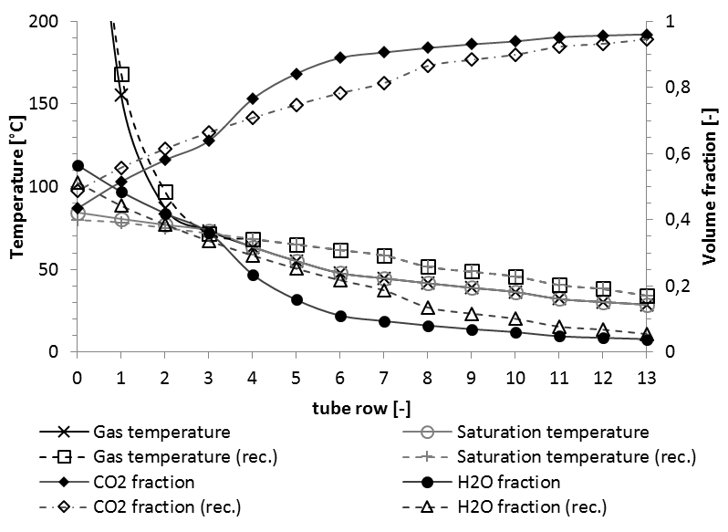

Figure A8: Results from the cooler-condenser simulation model considering nominal gas inlet ($Π$ =0, solid lines), as well as the gas composition with recirculation ($Π$ =0.25, dashed lines). Every row consists of 8 tubes with a length of 0.4 m and an outer diameter of 0.018 m.

### Section 3: Photobioreactor

CFD simulations of the CO2 injection into a tubular photo-bioreactor (PBR) were carried out to optimize the geometry of the system and evaluate the efficiency of the dissolution of CO2 in water. The commercial program ANSYS Fluent v.14.5 was used for the simulations. Several transient 3D simulations were done using the pressure-based solver and gravitational acceleration set to -9.81 m/s2. The "Discrete Phase Model" (DPM) was used to describe the gas and algae distribution along the pipe. The primary phase was set to liquid water, although dissolved carbon dioxide was also defined as a pseudo-material to allow mass transfer between phases. The discrete phase was set to pure carbon dioxide. The Nostoc algae were defined in the Fluent Database as a new compound. They were considered to be solid particles. The water mass flow was set to 0.45 kg/s, ensuring that, in both cases, the turbulent regime was achieved. The injection of the CO2 in water was numerically calculated by the simulation of CO2 through a Venturi injector in a 0.6 m length pipe.

One of the variables studied using CFD was the influence of the diameter of the tubular photobioreactor on the CO2 distribution in water. In this calculation, no interaction between the CO2 and the algae was considered to speed up the calculations. A 30 seconds simulation was carried out for two cases (50 mm and 100 mm). Results for the 50mm diameter are shown in Figure A9.

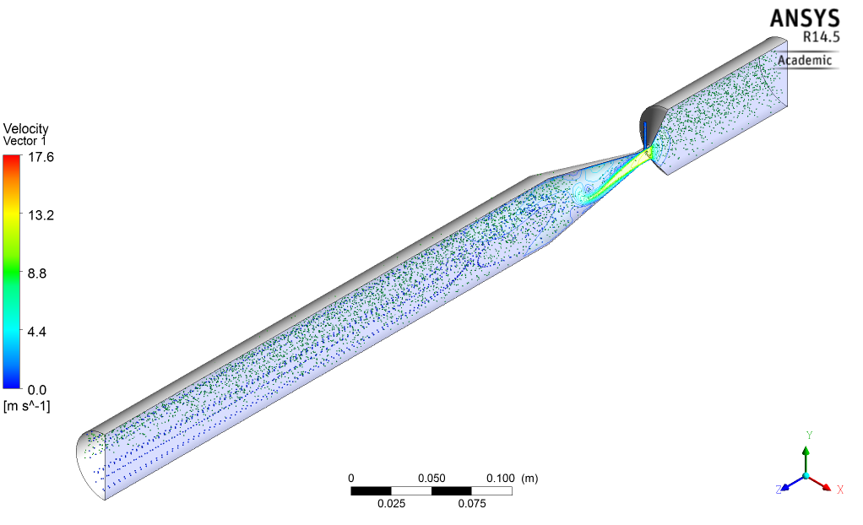

*Figure A9. CFD simulation of a CO2 injection into a water pipe with a diameter of 50 mm. Blue particles represent the CO2 bubbles; green particles are the algae.*

The analysis of the results obtained revealed that the 50 mm pipe diameter allows a better distribution of the CO2 and the algae, maximizing the contact along the pipeline. The larger diameter had a poorer distribution due to a lower turbulence and required increasing the flow velocity, which might cause algae destruction.

The determination of the mass transfer coefficient of CO2 into the water was evaluated next, as this step is essential for the biofixation process. To simplify the simulations, only CO2 was considered in the calculations (neglecting the effect of nitrates and phosphates), and not evaluating the formation of carbonic acid (H2CO3), whose equilibrium constant at the current conditions is around 0.002 [39]. The mass transfer coefficient, kL, was evaluated using a correlation relating the Reynolds, Schmidt, and Sherwood numbers, which had been successfully tested for an immobilized elongated bubble [40]:

|  |  |
| --- | --- |
| $$Sh=1.76∙{10}^{-5}{Re}^{1.506}{Sc}^{0.5}$$ | (29) |

Simulations carried out with CFD also showed a superior mass transfer rate (kL=2.36·10-5 m/s) when using a 50mm pipe, which results in a higher amount of CO2 dissolved in water. Additionally, the gradient concentration of CO2 in water was checked by running a 10 seconds simulation for the best-tested geometry (50mm pipe). The mass transfer coefficient was included to determine the amount of CO2 dissolved in water. Also, the interfacial mass transfer between both phases was accounted for by including the experimental interfacial tension of CO2 and water at the operating temperature (0.072 N/m). Results of the simulation (Figure A10) indicate that the higher mass transfer rates of CO2 dissolution are achieved at the center and upper part of the pipe, (approximately 10-4 kg/m3·s).

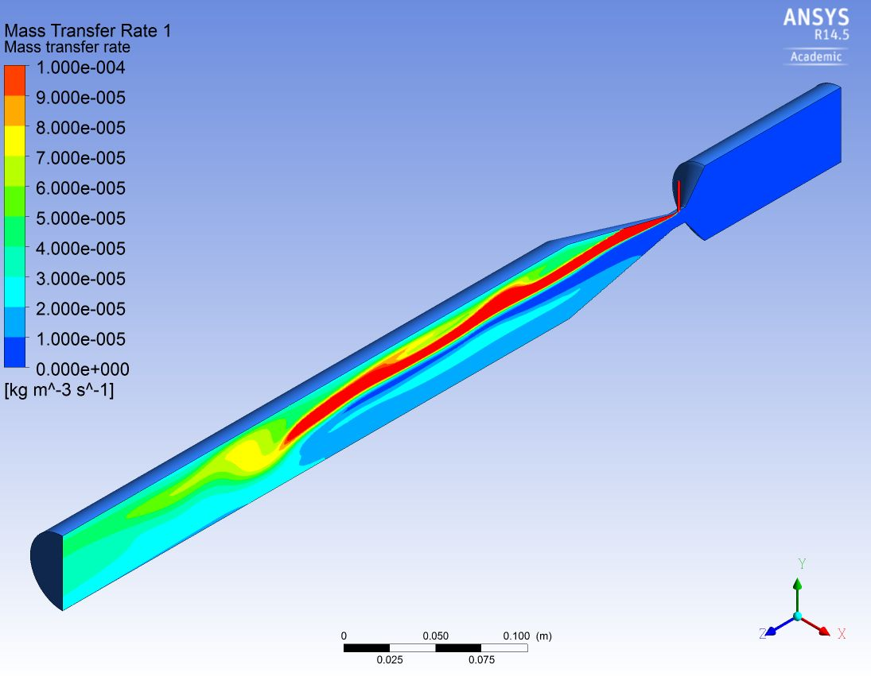

*Figure A10. CFD 10 seconds simulation of the injection of CO2 into a 50 mm pipe containing water and microalgae. Mass transfer rate distribution at the end of the simulation.*

Conversely, the lower side of the pipe seems to have a lower mass transfer rate, despite the re-circulating effect of the CO2 particles observed in Figure A9. However, it is believed that an overall good mass transfer rate will be achieved at steady conditions using this geometry, except the lower part of the pipe closer to the injection point.

Finally, the influence of the CO2 concentration in water, including the effect of light, in the algae growth was also investigated. Ideal growth is possible in an area of the reactor where light is plentiful, but not excessive since too much solar radiation might result in photoinhibition, as described in the Ref. [41] and confirmed in the lab scale experiments (see next section).

Algae growth in the bioreactor was modeled following a Monod equation-type:

|  |  |
| --- | --- |
| $$G=G_{max}\left(\frac{{\left[{CO}_{2}\right]}_{liq}}{{\left[{CO}_{2}\right]}_{liq}+k_{s}}\right)$$ | (30) |

This equation has been used to model the growth of single-celled microorganisms, including algae [35]. In Eq. (30), G is the algae growth rate, Gmax is a species dependent maximum growth rate, [CO2] is the substrate concentration, and ks is a species dependent half saturation coefficient. In this study, the values for Gmax (0.07 h−1) and ks (2.3 × 10−6 mol/L) were chosen for Nostoc species at 27°C and 600 foot-candles of light (6.50 kLux) [35]. Here, it is important to note that this simple model does not consider the light variation as a function of the radius of the pipe. The choice of this equation was done based on the possibility of providing qualitative knowledge in a relatively simple manner without the need of performing long-time simulations.

From Figure A10, the average molar concentration of CO2 in water can be calculated and using Eq. (30), the algae growth rate can then be obtained. This value will change as a function of the amount of CO2 dissolved in water, as it is observed in Figure A11.

*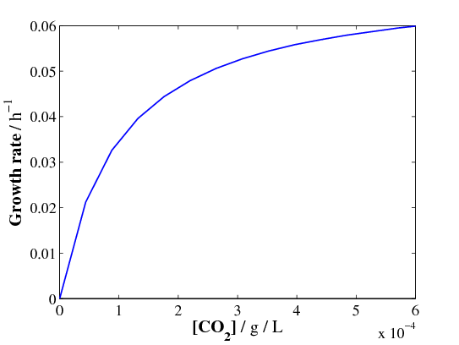*

*Figure A11. Algae growth as a function of the CO2 concentration for a 50 mm diameter pipe.*

According to the mass transfer calculations and the determination of the *ks* parameter, it is expected that the average algae growth rate in most of the pipe will be between 0.03 and 0.04 h-1. The highest rates (0.07 h1) achieved are located at the top of the reactor and close to the injection point. However, as mentioned, the growth rate can be affected by photo-inhibition due to the attachment of algae in the walls of the reactor, a feature not considered in the current calculations but seen in the lab characterization.

## Reference

[1] FCCC United Nations, Adoption of the Paris Agreement under the United Nations Framework Convention on Climate Change, FCCC/CP/2015/L.9/Rev.1, 2015.

[2] M. Gandiglio, A. Lanzini, M. Santarelli, P. Leone, Design and balance of plant of a demonsration plant with a Solid Oxide Fuel Cell fed by biogas from Waste-water and exhaust carbon recycling for algae growth, J. Fuel Cell Sci. Technol. 11 (2013) 14. doi:10.1115/FuelCell2013-18082.

[3] E. de Visser, C. Hendriks, G. de Koeijer, M. Barrio, S. Liljemark, A. Austegard, A. Brown, DYNAMIS CO2 quality recommendations - D 3.1.3 of Project &quot;Towards Hydrogen and Electricity Production with Carbon Dioxide Capture and Storage&quot;, 2007.

[4] A. Lanzini, M. Santarelli, P. Leone, Nominal operating condition for the AlphaSFC-5 Siemens SOFC unit with WWTU biogas fuel for Demonstration in Torino - Deliverable of Project SOFCOM, 2012.

[5] J.R. Benemann, CO2 MITIGATION WITH MICROALGAE SYSTEMS, Energy Convers. Mgmt. 38 (1997) 475–479.

[6] B. Wang, Y. Li, N. Wu, C.Q. Lan, CO2 bio-mitigation using microalgae, Appl Microbiol Biotechnol. 79 (2008) 707–718. doi:10.1007/s00253-008-1518-y.

[7] K. Kumar, C.N. Dasgupta, B. Nayak, P. Lindblad, D. Das, Development of suitable photobioreactors for CO2 sequestration addressing global warming using green algae and cyanobacteria, Bioresour. Technol. 102 (2011) 4945–4953. doi:10.1016/j.biortech.2011.01.054.

[8] H.J. Silva, J.S. Pirt, Carbon Dioxide Inhibition of Photosynthetic Growth of Chlorella, J. Gen. Microbiol. 130 (1984) 2833–2838.

[9] S.-Y. Chiu, C.-Y. Kao, C.-H. Chen, T.-C. Kuan, S.-C. Ong, C.-S. Lin, Reduction of CO2 by a high-density culture of Chlorella sp. in a semicontinuous photobioreactor, Bioresour. Technol. 99 (2008) 3389–3396. doi:10.1016/j.biortech.2007.08.013.

[10] J.B.K. Park, R.J. Craggs, A.N. Shilton, Wastewater treatment high rate algal ponds for biofuel production, Bioresour. Technol. 102 (2011) 35–42. doi:10.1016/j.biortech.2010.06.158.

[11] Y. Li, C. Wan, Algae for Biofuels - The Ohio State University, AEX-651 Agric. Nat. Resour. (2011). http://ohioline.osu.edu/factsheet/AEX-651-11 (accessed December 29, 2016).

[12] International Energy Agency- Greenhouse Gas R&D Programme (IEAGHG), Corrosion and materials selection in CCS systems, 2010.

[13] L. Buit, M. Ahmad, W. Mallon, F. Hage, CO2 EuroPipe study of the occurrence of free water in dense phase CO2 transport, Energy Procedia. 4 (2011) 3056–3062. doi:10.1016/j.egypro.2011.02.217.

[14] D.C. Thomas, S. Benson, Carbon dioxide capture for storage in deep geologic formations: results from the CO₂ capture project, Elsevier, 2005.

[15] Det Norske Veritas, RECOMMENDED PRACTICE DNV-RP-J202: DESIGN AND OPERATION OF CO2 PIPELINES, 2010.

[16] S.C. Singhal, K. Kendall, High-temperature solid oxide fuel cells: fundamentals, design, and applicatons, 2003.

[17] F. Curletti, M. Gandiglio, A. Lanzini, M. Santarelli, F. Maréchal, Large size biogas-fed Solid Oxide Fuel Cell power plants with carbon dioxide management : Technical and economic optimization, J. Power Sources. 294 (2015) 669–690. doi:10.1016/j.jpowsour.2015.06.091.

[18] R. Slade, A. Bauen, Micro-algae cultivation for biofuels : Cost , energy balance , environmental impacts and future prospects, Biomass and Bioenergy. 53 (2013) 29–38. doi:10.1016/j.biombioe.2012.12.019.

[19] C.-Y. Chen, K.-L. Yeh, R. Aisyah, D.-J. Lee, J.-S. Chang, Cultivation, photobioreactor design and harvesting of microalgae for biodiesel production: A critical review, Bioresour. Technol. 102 (2011) 71–81. doi:10.1016/j.biortech.2010.06.159.

[20] M.R. Tredici, N. Bassi, M. Prussi, N. Biondi, L. Rodolfi, G.C. Zittelli, G. Sampietro, Energy balance of algal biomass production in a 1-ha Green Wall Panel plant: How to produce algal biomass in a closed reactor achieving a high Net Energy Ratio, Appl. Energy. 154 (2015) 1103–1111. doi:10.1016/j.apenergy.2015.01.086.

[21] N.-H. Norsker, M.J. Barbosa, M.H. Vermuë, R.H. Wijffels, On Energy Balance and Production Costs in Tubular and Flat Panel Photobioreactors, SCHWERPUNKT. 1 (2012).

[22] E. Sevigné Itoiz, C. Fuentes-Grü Newald, C.M. Gasol, E. Garcés, E. Alacid, S. Rossi, J. Rieradevall, Energy balance and environmental impact analysis of marine microalgal biomass production for biodiesel generation in a photobioreactor pilot plant, Biomass and Bioenergy. 39 (2012) 324–335. doi:10.1016/j.biombioe.2012.01.026.

[23] D.J. MacKay, Sustainable Energy - without the hot air (Version 3.5.2. November 3), 2009.

[24] M. Santarelli, A. Lanzini, M. Gandiglio, Technical report on the potential impact of biogas exploitation with the SOFC technology in waste-water treatment plants - Deliverable 4.5 of SOFCOM Project n° 278798 “SOFC CHP WITH POLY-FUEL: OPERATION AND MAINTENANCE,” 2014.

[25] R.N. Singh, S. Sharma, Development of suitable photobioreactor for algae production – A review, Renew. Sustain. Energy Rev. 16 (2012) 2347–2353. doi:10.1016/j.rser.2012.01.026.

[26] P.-F. HSU, W.D. EVANS, J.R. HOWELL, Experimental and Numerical Study of Premixed Combustion Within Nonhomogeneous Porous Ceramics, Combust. Sci. Technol. 90 (1993) 149–172. doi:10.1080/00102209308907608.

[27] X.Y. Zhou, J.C.F. Pereira, Comparison of four combustion models for simulating the premixed combustion in inert porous media, Fire Mater. 22 (1998) 187–197. doi:10.1002/(SICI)1099-1018(199809/10)22:5<187::AID-FAM652>3.0.CO;2-T.

[28] S.G. Davis, A. V Joshi, H. Wang, F. Egolfopoulos, An optimized kinetic model of H2/CO combustion, Proc. Combust. Inst. 30 (2005) 1283–1292. doi:10.1016/j.proci.2004.08.252.

[29] M. MENDES, J. PEREIRA, J. PEREIRA, On the stability of ultra-lean H2/CO combustion in inert porous burners☆, Int. J. Hydrogen Energy. 33 (2008) 3416–3425. doi:10.1016/j.ijhydene.2008.04.019.

[30] T.C. Hayashi, Multidimensional modeling and calculation of combustion In porous media, 2005.

[31] J.C.F. Pereira, I. Malico, T.C. Hayashi, J. Raposo, Experimental and numerical characterization of the transverse dispersion at the exit of a short ceramic foam inside a pipe, Int. J. Heat Mass Transf. 48 (2005) 1–14. doi:10.1016/j.ijheatmasstransfer.2004.08.001.

[32] D.L. Koch, J.F. Brady, Dispersion in fixed beds, J. Fluid Mech. 154 (1985) 399. doi:10.1017/S0022112085001598.

[33] J.R. Howell, M.J. Hall, J.L. Ellzey, Combustion of hydrocarbon fuels within porous inert media, Prog. Energy Combust. Sci. 22 (1996) 121–145. doi:10.1016/0360-1285(96)00001-9.

[34] W. Azzi, W.L. Roberts, A. Rabiei, A study on pressure drop and heat transfer in open cell metal foams for jet engine applications, Mater. Des. 28 (2007) 569–574. doi:10.1016/j.matdes.2005.08.002.

[35] N. Dukhan, P. Patel, Equivalent particle diameter and length scale for pressure drop in porous metals, Exp. Therm. Fluid Sci. 32 (2008) 1059–1067. doi:10.1016/j.expthermflusci.2007.12.001.

[36] N. Dukhan, M. Ali, Strong wall and transverse size effects on pressure drop of flow through open-cell metal foam, Int. J. Therm. Sci. 57 (2012) 85–91. doi:10.1016/j.ijthermalsci.2012.02.017.

[37] S. Mancin, C. Zilio, A. Cavallini, L. Rossetto, Pressure drop during air flow in aluminum foams, Int. J. Heat Mass Transf. 53 (2010) 3121–3130. doi:10.1016/j.ijheatmasstransfer.2010.03.015.

[38] VDI, LV Software for Pressure Vessel Design and Heat Exchanger Design - 10th Edition - System Version 8.3, (2006).

[39] J.D. Smith, A.A. Neto, S. Cremaschi, D.W. Crunkleton, CFD-Based Optimization of a Flooded Bed Algae Bioreactor, Ind. Eng. Chem. Res. 52 (2013) 7181–7188. doi:10.1021/ie302478d.

[40] P. Valiorgue, M. El Hajem, A. Vassilev, V. Botton, H. Ben Hadid, Elongated gas bubble dissolution under a turbulent liquid flow, Chem. Eng. Process. 50 (2011) 854–858. doi:10.1016/j.cep.2011.05.005.

[41] E.K. Nauha, V. Alopaeus, MODELING ALGAL CULTIVATION IN A BUBBLE COLUMN PHOTOBIOREACTOR, in: 14th Eur. Conf. Mix. Warszawa, 10-13 Sept. 2012, 2012: p. 6.

1. 1. Energy Department, Politecnico di Torino - Corso Duca degli Abruzzi 24, 10129 Torino, Italy.
   2. Energy Systems, TU Munich, Boltzmannstr. 15, 85748 Garching, Germany.
   3. Institute of Power Engineering, Thermal Processes Department, Warsaw, Poland.
   4. IQS School of Engineering, Universitat Ramon Llull, Via Augusta, 390, 08017 Barcelona, Spain.
   5. Carburos Metalicos, Grupo Air Products, Avinguda de la Fama,1, 08940 Cornellà, Barcelona, Spain.
   6. Gas Research Center and Chemical Engineering Department. The Petroleum Institute. P.O. Box 2533. Abu Dhabi. United Arabs Emirates.

   [↑](#footnote-ref-1)