SYNTHESIS, PREPARATION AND CHARACTERIZATION OF UV-CURED
METHACRYLATED POLYSULFONE-BASED MEMBRANES
M. Sangermano^{1*}, M. Mian Farrukh¹, A. Tiraferri², C. Dizman^{3, 4}, Y. Yagci³

¹Politecnico di Torino, Dipartimento di Scienza Applicata e Tecnologia, C.so Duca degli Abruzzi 24, 10129 Torino, Italy
²Politecnico di Torino, Dipartimento di Ingegneria dell’ambiente, del territorio e delle infrastrutture, C.so Duca degli Abruzzi 24, 10129 Torino, Italy
³Istanbul Technical University, Department of Chemistry, Maslak, 34469, Istanbul, Turkey
⁴Chemistry Institute, TUBITAK Marmara Research Center, Gebze,
Kocaeli 41470, Turkey

ABSTRACT: A new two-step method involving non-solvent induced phase separation (NIPS) and a UV curing process for the preparation of networked-polysulfone membranes is described. In this approach, first, methacrylated polysulfone macromonomers (PSU-DM)s were prepared by polycondensation followed by end-group esterification. PSU-DMs thin films containing phenylbis(2,4,6-trimethylbenzoyl)phosphine oxide (BAPO) photoinitiator cast on glass plates were successively subjected to NIPS and UV curing processes to produce the ultrafiltration membranes. The reverse sequence, i.e. first UV-curing followed by NIPS was also applied. Although different double bond conversions were attained, both procedures essentially yielded structurally analogous membranes which were insoluble in DMF, DMSO, and boiling water. UV-curing behavior, structure, thermo-mechanical and morphological properties of the membranes were investigated. Regardless of the preparation sequences, membranes exhibited pure water permeability in the range of tight ultrafiltration membranes.

Keywords: polysulfone membranes, methacrylated polysulfone, UV-curing, non-solvent induced phase separation

* Corresponding authors: marco.sangermano@polito.it

1. Introduction
Polymeric membranes have gained an important place in chemical technology and, in particular, porous membranes are commonly used in micro and ultra-filtration [1]. While polymeric membranes represent the state-of-the-art in water and wastewater treatment, current membrane design and chemistries suffer from inherent shortcomings that hinder further widespread development of the related separation technologies [2]. Many of these weaknesses, related to fouling, separation performance, and chemical and mechanical resistance, can be overcome by progresses in materials science and technology.
There are several ways to prepare porous polymeric membranes, but the majority of membranes are prepared by controlled phase separation of a polymer solution into two phases: one with high and one with a low polymer concentration. The concentrated phase solidifies shortly after phase separation, thus forming the membrane. The separation performance of membranes prepared by this process depends on the morphology formed during phase separation and subsequent solidification. The most common method to induce phase separation is via phase inversion using the non-solvent induced phase separation technique (NIPS) [3]. In this process, the polymer solution is cast as a thin film and is subsequently immersed in a non-solvent bath. Precipitation occurs because the good solvent in the polymer solution is exchanged for the non-solvent.
Polymers such as polyvinilydene fluoride (PVDF) and polysulfone (PSU) have been widely used to prepare microfiltration and ultrafiltration membranes because of their mechanical strength and their behavior under a relatively broad range of chemical and pH conditions [4]. However, PSU is not resistant to many aprotic solvents and therefore it is not suitable for nanofiltration processes where these solvents are used [5, 6].
To improve the solvent resistance as well as the mechanical performance of PSU-based membranes, a post-crosslinking process is often required. Electron-beam irradiation was proposed [7] which, however, requires expensive equipment and induces damage of the membrane structure during irradiation. Alternatively, UV-irradiation was adopted and mixtures of PSU and acrylic cross-linker were thus investigated [8, 9]. In these works, acrylic cross-linkers and photoinitiators are added to the PSU casting solution. Both additives are chosen in such a way that they do not leach out from the polymer matrix to the non-solvent bath during the NIPS process. The formed membranes are then UV-irradiated after phase inversion. A different but more elegant approach could involve the incorporation of cross-linkable functionalities on the PSU-backbone. In general, the chemical incorporation of functional groups into PSUs can be achieved through two approaches, namely (i) by using functional co-monomers during polycondensation,[10–14] and (ii) by post-synthesis modification [15–24].
In this study, we propose a facile post-synthesis approach to incorporate methacrylic functionalities at the chain ends of PSU molecules. The attachment of such cross-linking sites essentially provides rapid curing while preserving the PSU properties. We report scalable fabrication of novel porous PSU network membranes by photoinduced cross-linking of the macromonomer. We investigate both phase inversion/UV-curing or UV-curing/phase inversion sequences. The cross-linked membranes are fully characterized and their viscoelastic properties, solvent stability, morphology, and flux performance are evaluated.

2. Experimental
2.1. Materials
The solvents, N, N, dimethyl formamide (DMF, anhydrous, 98.8%) and acetone (99.9 %) were purchased from Aldrich. The photo initiator, phenylbis(2,4,6-trimethylbenzoyl)phosphine oxide (BAPO, PI) Irgacure 819, was kindly provided by BASF. Bisphenol A and bis(p-chlorophenyl) sulfone (Hallochem Pharma Co. Ltd, China), methanol (Merck), dimethylacetamide (DMAc, 99%, Merck) and triethylamine (TEA, Aldrich, HPLC grade) were used without any purification. Dichloromethane (99%, Aldrich), methacryloyl chloride (+97%, Merck) were used as received.

2.2. Synthesis of dimethacrylate functionalized PSU (PSU-DM)
Synthesis of methacrylate functionalized polysulfones was achieved by condensation and subsequent esterification. Firstly, hydroxyl functionalized PSU-2000, PSU-4000, and PSU-15000 were prepared by condensation polymerization according to the modified procedure described in the literature [25]. Hydroxyl terminated polysulfone oligomers with desired molecular weights were obtained by adjusting the monomer concentrations. Thereafter, methacrylate functionalized polysulfones were synthesized by esterification of the oligomers with methacryloyl chloride in the presence of triethylamine as the base. The overall procedure is presented in Scheme 1.

2.2.1. Synthesis of hydroxyl functional polysulfones (PSUs)
To synthesize PSU-2000, bisphenol A (20.00 g, 87.61 mmol), bis(p-chlorophenyl) sulfone (12.58 g, 43.81 mmol), and dried potassium carbonate (25.43 g, 183.98 mmol) were added to 400 mL DMAc and 50 mL toluene in a 2000 mL, two necked round bottom flask, fitted with a condenser, nitrogen inlet, a Dean and Stark trap, and an overhead mechanical stirrer. The reaction mixture was heated under reflux at 150 °C for 4 h with water removal. The reaction was stopped after about 2 h and cooled to room temperature. The solution was filtered to remove most of the salts and poured into a mixture of methanol and water (4:1). The precipitated polymer was filtered, and washed several times with water in order to remove the remaining salts and impurities. Finally, the polymer was washed with methanol and dried in a vacuum oven at 60 °C for about 12 h to give PSU-2000 oligomer (15.62 g). An analogous procedure using appropriate ratios of the monomers was followed for the synthesis of PSU-4000 and PSU-15000.
IR (ATR, cm⁻¹ ): 3435 (-OH), 3200–3000 (Ar), 2975 (-CH₃ sym-), 2945 (-CH₃ asym-), 1322 and 1293 (O=S=O asym-), 1240 (C-O-C), 1175 and 1151 (O=S=O sym-) and 1014 (Ar).
¹H NMR (CDCl₃, ppm): δ = 7.85 (16H), 7.26 (16H), 7.07 (4H), 7.00 (16H), 6.94 (16H), 6.75 (4H), 1.69 CMe₂ (30H).
2.2.2. Synthesis of dimethacrylate functionalized polysulfones (PSU-DMs)
To synsthesize PSU-DM-2000, 1.52 g (1.25 mmol) PSU-2000 were added to 20 mL CH₂Cl₂ contained in a 50-mL, two necked round bottomed flask stirring in an ice bath, fitted with a condenser and nitrogen inlet, and mixed for about 5 minutes. Then, 0.87 mL (excess amount) triethylamine was added. 0.62 mL (6.24 mmol) (excess amount) methacryloyl chloride dissolved in 5 mL CH₂Cl₂ was added slowly to the reaction flask in a time period of 10 minutes. The reaction mixture was stirred for 24 h. Subsequently, the reaction mixture was filtered to remove salts and it was poured into methanol in order to precipitate the methacrylate oligomer. The precipitated oligomer was filtered and washed several times with water in order to remove salts and impurities. Subsequently, the polymer was washed with methanol and dried in a vacuum oven at room temperature for about 12 h. 1.29 g PSU-DM-2000 was thus obtained. An analogous procedure using appropriate ratios of the monomers was used for the synthesis of PSU-DM-4000 and PSU-DM-15000.
IR (ATR, cm^{–1}): 3200–3000(Ar), 2968(-CH₃ sym-), 2872(-CH₃ asym-), 1735(-C=O), 1324 and 1295 (O=S=O asym-), 1244(C-O-C), 1170 and 1151(O=S=O sym-) and 1014(Ar).
¹H-NMR (CDCl₃, ppm): δ=7.88 (16H), 7.28 (16H), 6.98 (16H), 6.95 (16H), 6.36 (2H) and 5.77 (2H), 2.08 (C=-Me) (6H), 1.63 CMe₂ (30H).

2.3. Preparation of UV cured functionalized PSU membranes
2.3.1. Preparation of functionalized PSU Membranes
A 25 wt% functionalized PSU was dissolved in DMF via sonication for 15 minutes. The photoinitiator was added at 3 wt% with respect to the amount of PSU. After obtaining homogenous solutions, a film of 100 µm thickness was cast onto a glass plate. Membrane formation was initially induced by exposing the wet film to air for 60 sec, thus forming a thin selective layer at the film surface. Subsequently, the film was subjected to either of two sequences, i.e., NIPS followed by UV curing (NIPS – UV) or UV curing followed by NIPS (UV – NIPS). NIPS was carried out in a coagulation bath, containing distilled water, for 24 h. During the casting and phase separation, the temperature of air was 25 ± 3 ºC and its relative humidity was 40 ± 10 %. The cross linking of modified PSU membranes was performed through UV curing, either after (NIPS – UV) or before (UV – NIPS) phase inversion. The UV curable membranes were irradiated in a static UV lamp for one minute under nitrogen atmosphere. The main UV irradiation light was UVA (320 – 390 nm). The energy dose utilized to cure the membranes was 10.05 J / cm². The compositions of the casting solutions and the preparation sequences are summarized in Table 1 and followed schematized in Scheme 3.

Table 1: Composition of the membrane casting solutions and adopted sequence
Membrane Code | PSU  wt. % | DMF  wt. % | PI  wt. % of PSU | Sequence I NIPS–UV | Sequence II UV–NIPS
M1 | 25 | 75.0 | 3 |  | -
M2 | 25 | 75.0 | 3 | -

2.4. Characterization of functionalized PSU Membranes
2.4.1 Fourier transform infrared analysis (FTIR)
Spectrophotometer by Thermo Electron Corporation equipped with attenuated total reflectance (ATR) accessory containing a diamond crystal internal reflection element was used for both FTIR and ATR – FTIR analysis. In the case of UV – NIPS sequence, wet (not yet precipitated) polymer films were analyzed by FTIR during UV curing after being applied onto a silicon crystal. Instead, already formed membranes with the UV – NIPS procedure were directly analyzed via ATR – FTIR at the end of all the fabrication steps. The degree of cross-linking was measured with a resolution of 4 cm⁻¹ and samples were scanned 32 times in the wave number range between 650 and 4000 cm⁻¹. A background was run before each sample. The conversion of acrylate double bonds was calculated by following the decrease of the peak area of C=C group at 810 cm⁻¹ and normalized with the peak area of C=O group at 1730 cm⁻¹.

2.4.2 Dynamic mechanical thermal analysis (DMTA)
Dynamic mechanical thermal analysis (DMTA) was performed using a Triton DMTA apparatus equipped with tension – film clamp assembly and operating in multi-frequency strain mode. The size of all samples was measured using an electronic caliper and the dimension of the samples was approximately 6 × 10⁻³ m by 10 × 10⁻³ m. In this technique, the membrane was held in tension mode at a designated preload force equal to 0.001 N while sinusoidal stress was applied. Both the storage and the loss modulus were obtained over the range of temperature. The ending temperature was set at 200 ºC. The rate of increase of temperature was set as 3 ºC per minute. Each sample was tested in replicates and selected results are presented here.

2.4.3 Field emission scanning electron microscopy (FESEM)
The morphology of membrane cross –sections was analyzed through FESEM. The instrument was a MERLIN model FESEM by ZEISS equipped with a state of the art GEMINILIS column ensuring good control of both spot and current. Samples were removed from substrate and mounted onto SEM stubs with their cross–section facing upward. The samples were snapped after immersion in liquid nitrogen in order to obtain a sharp edge. After being snapped, the samples were mounted in the brass clamp. Thereafter, samples were sputter coated with chromium (8.0 nm) so as to counteract charging effects.

2.4.4. Permeability test
Membrane hydraulic permeability experiments were conducted in a stirred cell (Amicon 8010, Millipore Co.). To drive the flow, the cell was pressurized with N₂(g) to reach a pressure drop of about 250 kPa (35 psi), monitored using a pressure gauge. Deionized water was used for these experiments and obtained from a Milli-Q ultrapure water purification system. The flow rate was determined by measuring the permeate mass in time after reaching steady-state.

3. Results and Discussion
While PSU membranes are widely used because of their strength and resistance towards a relatively broad range of chemical and pH conditions, they are inherently soluble in aprotic solvents and therefore a crosslinking process is required to enhance their solvent resistance as well as mechanical performance. Our strategy is based on the use of methacrylated PSU macromonomer in a photoinduced cross-linking process.

3.1 Synthesis of dimethacrylated polysulfones
First, PSU dimethacrylate (PSU-DM) macromonomer was synthesized by condensation polymerization and subsequent esterification according to the described procedure [25] (Scheme 1). Synthesis parameters given in Table 2 were adjusted so as to obtain PSU with sufficient molecular weight and desired functionality, in order to have efficient cross-linking and impart the properties of PSU to the final membrane.

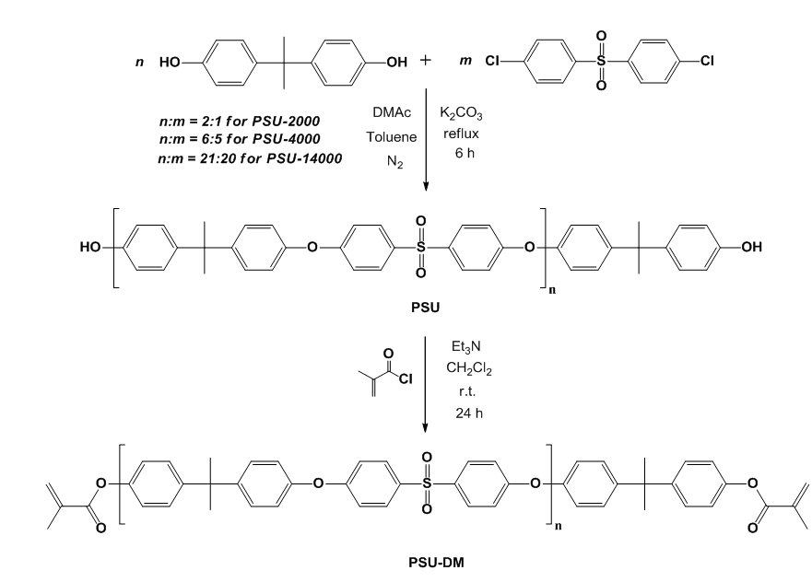
Scheme 1 Synthesis of PSU and PSU-DM oligomers.

Table 2. Synthesisª and molecular weight characteristics of phenol and methacrylate functional polysulfones.
Polymer | BisphenolA/  Chlorosulfone (mol/mol) | Yield^{b} | M_{n}^{c}  (g/mol) | M_{w}^{c}  (g/mol) | PDI
PSU-2000 | 2/1 | 47.9 | 2080 | 2615 | 1.26
PSU-4000 | 6/5 | 80.4 | 4173 | 6475 | 1.55
PSU-14000 | 21/20 | 60.7 | 14125 | 21503 | 1.52
PSU-DM-2000 | - | 84.1 | 2451 | 2986 | 1.22
PSU-DM-4000 | - | 90.0 | 4494 | 6641 | 1.48
PSU-DM-14000 | - | 84.7 | 15039 | 23045 | 1.53
ªReaction temperature: 170 °C, time: 6 h.
^{b}Determined gravimetrically.
^{c} Determined from GPC measurements based on polystyrene standards.
The general photoinduced cross-linking reactions are presented in Scheme 2. This is a classical UV-induced crosslinking reaction where a radical initiator is photogenerated and the polymerization reaction proceed via a classical chain-growth addition reaciton of the radicals on methacrylic double bond.

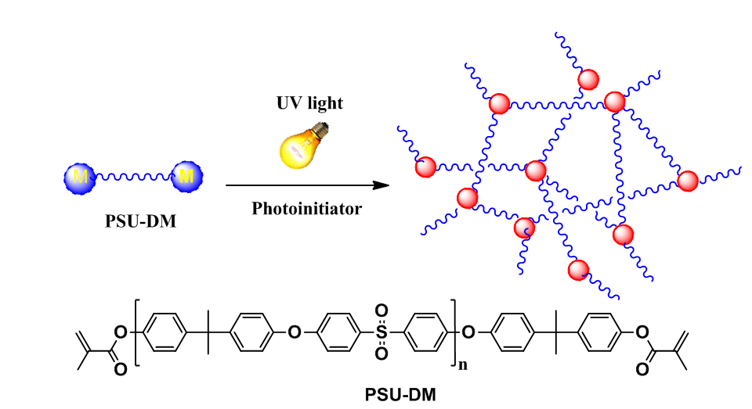
Scheme 2. Photoinduced cross-linking of PSU-DM.

3.2 Membrane preparation
The synthesized macromonomer was dissolved in DMF and the membranes were prepared either by phase separation followed by UV-curing process, or vice versa. A representation of the two sequences procedures is reported in Scheme 3.

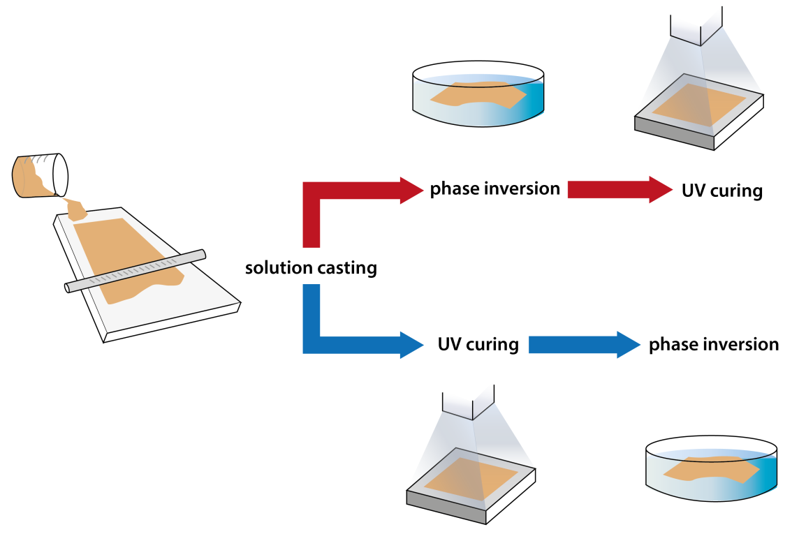
Scheme 3: representation of the two sequences procedure

The radical photoinitiator was selected with absorption in a different spectral window from PSU absorption, and with a very limited solubility in water in order to avoid leaching out in the coagulation bath during the NIPS process. For membrane preparation, the oligomer PSU-DMA-14000 was chosen because of its high molecular weight. All the results related to membrane structure and properties refer to this particular macromonomer samples.
The degree of cross linking was measured via FT-IR. The C=C (810 cm⁻¹) peak was analyzed to measure the degree of crosslinking, while C=O (1730 cm⁻¹) peak was taken as reference.
When NIPS-UV sequence was followed, the casting solution was immersed in water for 24 h, in accordance with the usual preparation conditions reported in literature for PSU membranes [26, 27]. The obtained membrane was irradiated and the acrylic double bond conversion was measured with ATR-FTIR collected before and after UV irradiation. A conversion of about 41% of acrylic double bonds was achieved after one minute of irradiation under nitrogen (Table 3). The limited acrylic double bond conversion could be attributed to a limited mobility in the PSU membrane (the Tg is around 178 °C, in accordance with the data reported in literature for pristine PSU).
In order to increase the acrylic double bond conversion, the reverse sequence was applied, involving first the crosslinking reaction and subsequently the phase inversion of the crosslinked matrix. For this purpose, a film of the polymer solution in DMF was cast on a SiC wafer and the curing reaction was monitored via FT-IR analysis, collecting spectra before and after one minute of UV-irradiation. A final conversion of about 62% was reached during this sequence (Table 3).
The resulting UV-crosslinked membranes were insoluble in DMF, DMSO and boiling water, showing always a gel content value of 100%. These results highlight the high solvent resistance of cross-linked membranes.

3.2 Viscoelastic behaviors of the membranes
The viscoelastic properties of the PSU membranes were characterized by DMTA analysis, which allows the evaluation of both the elastic and viscous component of the modulus of the material in a large temperature interval. The tanδ curves (tanδ = E’’/E’: ratio loss modulus/storage modulus) are reported in Figure 1, respectively, for the membrane obtained via NIPS-UV (M1) and UV-NIPS (M2) sequence; in the T_{g} region, the tanδ curve shows a maximum, which is assumed as the T_{g} of the cured films.
When phase inversion is performed before UV-curing, a Tg value of about 185 °C was measured (See Figure 1 and Table 3). The Tg is slightly shifted to higher temperature (around 195 °C) when the UV-curing process is performed as a first step before the phase inversion process.
This difference is in accordance with the higher crosslinking density achieved when the membranes were prepared through the UV–NIPS sequence. Furthermore, a narrower tanδ peak was obtained for these membranes.

INSERT FIGURE 1

3.3 Membrane morphology
Morphological investigations were performed by FESEM analysis on cross-sections of the obtained membranes. The micrographs are reported in Figure 2 and 3, respectively, for the membrane obtained via NIPS–UV and UV–NIPS sequence. It is evident that the UV–NIPS sequence (Figure 4) produces a more uniform porous distribution with pore dimension ranging from 800 nm to 1.8 µm. On the other hand, when NIPS–UV sequence was adopted (Figure 3), the membranes showed some larger pores, even larger than 2 µm, as well as a less uniform distribution.

INSERT FIGURE 2

INSERT FIGURE 3

3.4 Permeability test
Preliminary tests showed that the pure water permeability of membranes prepared was 2.5±0.1 and 9.5±0.1 L m⁻²h⁻¹bar⁻¹, respectively, for NIPS–UV and UV–NIPS sequences (see Table 3). These permeability values lie in the range of tight ultrafiltration membranes. These results confirm that our fabrication procedure is a viable route, yielding comparable performance to traditional polysulfone membranes. Both in commercial and laboratory application, higher permeability is easily achievable through further optimization of polymer synthesis, UV curing time, and membrane structure. This work is currently in progress.

Table 3: Composition of the membrane casting solutions and adopted sequence
Membrane Code | Conversion  %¹ | Tg  °C² | Pore dimension  µm
M1 | 41 | 185 | 2
M2 | 62 | 195 | 0.8-1.8
1: measured via FT-IR analysis
2: determined as the maximux of tanδ curve of DMTA analysis
3: determined by FESEM morphological analysis

4. Conclusions
Crosslinked polysulfone membranes were prepared using a scalable phase inversion (NIPS) and UV curing processes. Methacrylate functionalized polysulfone precursors were synthesized by condensation and subsequent esterification and the macromonomer was fully characterized. Porous membranes were obtained either by dissolving the macromonomer in DMF and successive phase separation and UV-curing (NIPS-UV), or viceversa, therefore via UV-NIPS sequence. The resulting UV-crosslinked membranes, obtained with either sequences were insoluble in DMF, DMSO and boiling water, showing always a gel content value of 100%. The viscoelastic properties of the membranes were characterized by DMTA analysis. When phase inversion was performed before the UV-curing, a T_{g} value of about 185 °C was measured. The T_{g} is shifted to a higher temperature (around 195 °C) in the reverse mode. These data are in accordance with FT-IR analysis. Morphological investigations showed that the UV–NIPS sequence produced a more uniform porous distribution with pore dimension ranging from 800 nm to 1.8 µm. On the other hand, when NIPS–UV sequence was adopted, the membranes showed some larger pores, even larger than 2 µm, as well as a less uniform distribution. The pure water permeability of membranes obtained with both procedures was in the range of tight ultrafiltration membranes. Further studies are under progress in order to selectively control porous dimensions and performance of crosslinked membranes, but important enhancement of mechanical behavior and solvent stability of PSU-based membranes were already achieved in this study.

Acknowledgements: This research is partially supported by a Marie Skłodowska-Curie Research and Innovation Staff Exchange (RISE) Fellowship (Mat4Treat, proposal n. 645551) within the H2020-MSCA-RISE-2014 European Community Call.

REFERENCES
- R.W. Baker, "Membrane Technology and Applications", Wiley 2004.
- M.A. Shannon, P. W. Bohn, M. Elimelech, J. G. Georgiadis, B. J. Mariñas, A. M. Maye, Nature 452 (2007) 301-310.
- A.K. Holda, I.F.J. Vankelecom, J. Appl. Polym. Sci. 132 (2015) 42130/1-42130/7.
- P. Vandezande, L.E.M. Gevers, I.F.J. Vankelecom, Chem. Soc. Rev. 37 (2008) 365-372.
- K. Vanherck, G. Koecklberghs, I.F.J. Vankelecom, Prog. Polym. Sci. 38 (2013) 874-885.
- K. Vanherck, A. Cano-Odena, G. Koecklberghs, T. Dedroag, I.J.F. Vankelecom, J. Membr. Sci. 353 (2010) 135-143.
- Li, A. Oshima, T. Miura, M. Washio, Polym. Degr. Stab. 91 (2006) 2867-2675.
- Struzynska-Piron, J. Loccufier, L. Vanmale, I-F.J. Vankelecom, Macromol. Chem. Phys. 215 (2014) 614-623.
- Struzynska-Piron, M.R. Biland, J. Loccufier, L. Vankelecom, J. Memb. Sci. 462, (2014) 17-22.
- Jouanneau, R. Mercier, L. Gonon, G. Gebel, Macromolecules 40 (2007) 983-990.
- H. R. Kricheldorf, L. Vakhtangishvili, D. Fritsch, J. Polym. Sci. Polym. Chem. 40 (2002) 2967-2975.
- T. Koch, H. Ritter, Macromol. Chem. Phys. 195(1994) 1709-1719.
- C. G. Herbert, H. Ghassemi, A. S. Hay, J. Polym. Sci. Pol. Chem. 35 (1997) 1095-1100.
- M. D. Guiver, G. P. Robertson, S. Foley, Macromolecules 28 (1995) 7612-7623.
- H. Toiserkani, G. Yilmaz, Y. Yagci, L. Torun, Macromol. Chem. Phys. 211 (2010) 2389-2395.
- C. Dizman, D. O. Demirkol, S. Ates, L. Torun, S. Sakarya, S. Timur, Y. Yagci, Colloids Surf. B 88 (2011) 265-273.
- M. Karadag, G. Yilmaz, H. Toiserkani, D. O. Demirkol, S. Sakarya, L. Torun, S. Timur, Y. Yagci, Macromol. Biosci. 11 (2011) 1235-1243.
- G. Yilmaz, H. Toiserkani, D. O. Demirkol, S. Sakarya, S. Timur, L. Torun, Y. Yagci, Mater. Sci. Eng. 31 C (2011) 1091-1099.
- S. Ates, C. Dizman, B. Aydogan, B. Kiskan, L. Torun, Y. Yagci, Polymer 52 (2011) 1504-1523.
- G. Yilmaz, H. Toiserkani, D. O. Demirkol, S. Sakarya, S. Timur, Y. Yagci, L. Torun, J. Polym. Sci. Pol. Chem. 49 (2011) 110-115.
- B. Van der Bruggen, J. Appl. Polym. Sci. 114 (2009) 630-637.
- Breitbach, E. Hinke, E. Staude, Angew. Makromol. Chem. 184 (1991) 183-191.
- C. Dizman, S. Ates, T. Uyar, M. A. Tasdelen, L. Torun, Y. Yagci, Macromol. Mater. Eng. 296 (2011) 1101-1123.
- Sangermano, I. Roppolo, V. H. A. Camara, C. Dizman, S. Ates, L. Torun, Y. Yagci, Macromol. Mater. Eng. 296 (2011) 820-827.
- Dizman C, Ates S, Torun L, Yagci Y. Beilstein J. Organ. Chem. 56 (2010).
- Viswanathan, R.; Johnson, B. C.; McGrath, J. E. Polymer 25 (1984) 1827-1833.
- V. S.T. Sim, Q. She, T. H. Chong, C. Y. Tang, A. G. Fane, W. B. Krantz, Membranes, 98 (2013) 125-133.

SYNTHESIS, PREPARATION AND CHARACTERIZATION OF UV-CURED
METHACRYLATED POLYSULFONE-BASED MEMBRANES
M. Sangermano^{1*}, M. Mian Farrukh¹, A. Tiraferri², C. Dizman^{3, 4}, Y. Yagci³

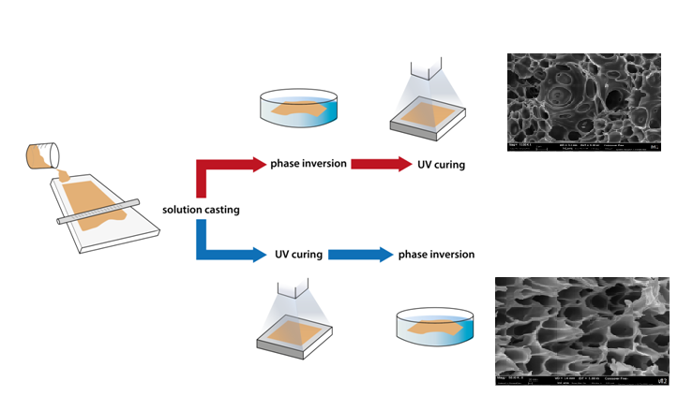

Captions for Figures:

Figure 1: DMTA curve of M1(sequence NIPS–UV) and M2 (sequence UV-NIPS) crosslinked membranes.
Figure 2: FESEM picture of the cross section of the membrane M1 obtained via sequence I NIPS-UV.
Figure 3: FESEM picture of the cross section of the membrane M2 obtained via sequence II UV-NIPS.

Figure 1:

Figure 2:
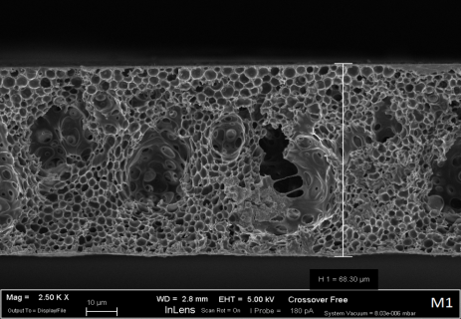 | 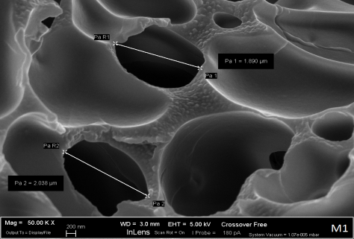 | 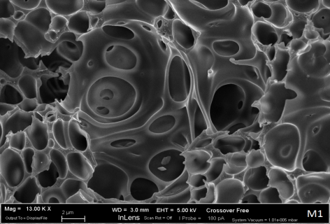

Figure 3:
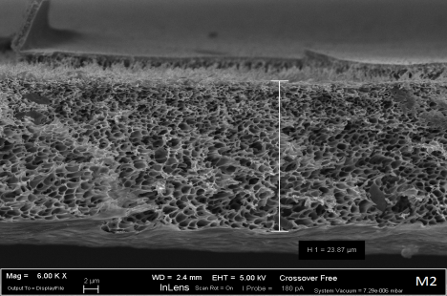 | 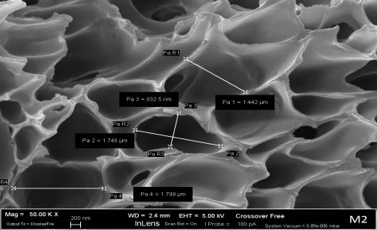 | 