HEFAT2012
9th International Conference on Heat Transfer, Fluid Mechanics and Thermodynamics
16 – 18 July 2012
Malta

ELECTRICAL CAPACITANCE PROBE CHARACTERIZATION FOR VERTICAL ANNULAR AIR-WATER FLOW INVESTIGATION

M. De Salve*, G. Monni*, B. Panella*, C. Randaccio**

*Politecnico di Torino - Dipartimento ENERGIA - Torino
** SIET S.p.A. – Piacenza
Email: grazia.monni@polito.it bruno.panella@polito.it

ABSTRACT
The experimental analysis and the qualification of an Electrical Capacitance Probe (ECP), for the void fraction measurement, is presented. The ECP, developed at the SIET Company, is used to investigate a vertical air/water flow, characterized by high void fraction. Mass flow rates have been analyzed between 0.094 and 0.15 kg/s for air and between 0.002 and 0.021 kg/s for water, corresponding to void fraction up to 90% and to annular and wavy-annular flow patterns. The ECP signals are used to obtain the geometrical shape functions (signals as a function of electrode distances) in single and two phase flows. The dependence of the signal from the void fraction is derived and other flow characteristics as the liquid film thickness and the phase velocities are evaluated by means of rather simple models. The experimental analysis allows to characterize the ECP, showing the advantages and the drawbacks of this technique for the two-phase flow characterization at high void fraction, and it provides a reliable tool for the selection of the instrumentation for the SIET Company SPES3 facility.

INTRODUCTION
The design of new nuclear reactors requires to carry out integral and separate effect tests on simulation facilities, as well as to perform safety systems verification and safety code validation. Within the framework of an Italian R&D program on Nuclear Fission, managed by ENEA and supported by the Ministry of Economic Development, the SPES3 experimental facility [1], able to simulate the innovative small and medium size PWR nuclear reactors, is being built and will be operated at SIET Company laboratories. In such facility some design and beyond design basis accidents, like Loss Of Coolant Accidents (LOCAs), with and without the emergency heat removal systems, will be simulated [2], according to an experimental matrix of a series of primary and secondary loops breaks which data will be fundamental for the certification process of those reactors. New accidental transients, following the Fukushima accident learning lesson, will be also studied.
The LOCA tests and the secondary side breaks foresee two-phase flow conditions in the pipes simulating the break flow paths, in critical flow during the early phases of the transients and driven by differential pressure in the later phases. An accurate accident analysis requires the measurement of the mixture mass flow rate occurring in a LOCA, when a piping break occurs at high temperature and pressure. For this reason, instruments and methodologies to evaluate mass flow rates, at the break and at other locations of the plant, need to be developed, considering the severe thermal-hydraulic conditions during the blow-down phase (the velocity reaches a hundred m/s, the average void fraction is more than 95% and the flow pattern is annular or annular-mist).
Typically a set of instruments (Spool Piece) must be installed in order to evaluate the mass flow rate of the phases [3][5]. One of such instruments has to be able to measure the void fraction and to identify the flow pattern. In fact the response of a meter in two-phase flow tends to be highly sensitive to the flow pattern, to the upstream configuration and flow history. Moreover the flow pattern is likely to be time dependent in transient tests. As a first step to achieve this purpose, the present study deals with the characterization of a capacitive meter device for annular flow. The behavior of the sensor is tested and advantages and drawbacks are highlighted.
The void fraction in the region of interest is one of the key parameters in gas–liquid two-phase flow systems, as it is used for determining several other important parameters (density and viscosity, velocity of each phase etc.) and for predicting heat transfer and pressure drops. It can be measured using a number of techniques, including radiation attenuation (X or γ-ray or neutron beams) for line or cross-sectional averaged values, optical or ultrasound techniques for local and chordal void fraction measurement, impedance techniques using capacitance or conductance sensors and direct volume measurement using quick-closing valves. The use of the different techniques depends on the applications, and whether a volume averaged or a local void fraction measurement is desired. All the different techniques are based on the use of a sensor that is sensitive to the variation of the physical properties of the phase mixture and then able to detect the presence of one of the phases.
The impedance method is based on the fact that the liquid and gas phases have different electrical conductivity and relative permittivity, and the electrical impedance of a mixture is usually different by the impedance of each component. The gases are generally poor conductors with a low dielectric constant, while the liquids although not good conductors, assume higher value of the dielectric constant due to a greater concentration of dipoles. In the electrical impedance void meters the resistive and/or the capacitive response of the two phase flow field to electrical activation by injecting current or applying voltage is measured and the resultant resistance and/or capacitance reading is used to estimate the void fraction. Impedance sensors have been used successfully to measure time and volume averaged void fraction, and its instantaneous output signal has been used to identify the flow pattern [6]. The fast response of the impedance meter allows to obtain information about virtually instantaneous void fractions and their distributions across a pipe section. This type of meter can work at high pressure and temperature also with high velocity fluid flow. Moreover, it is more attractive than other techniques from an economic point of view. The measurements of the void fraction with impedance sensors are quasi-local: the sensor determines the percentage of both phases not strictly in a selected cross section of the pipe but in a certain volume, based on the electrodes geometry. The exact boundary of this volume cannot be precisely drawn due to fringe effects. The measurements of the impedance takes place in a volume defined by the lines of an electric field associated with the electrodes system. Concerning the impedance probes, one of the most important drawbacks is the strong sensitivity to the flow pattern. To address this problem, in the last years tomography sensors using the impedance probes have been developed and several researches have been carried out (Huang et al. [11], Wu et al. [12] and Warsito and Fan [13]). The impedance measurements are taken from a multi-electrode sensor surrounding a process vessel or pipeline. The working principle consists of injecting a sinusoidal signal inside an electrode and measuring the output signal in the remaining electrode. This procedure is repeated for all the other electrodes pairs until a full rotation is completed to get a set of measurements.
Each dataset is interpreted by algorithms to compute a cross-sectional electrical capacitance distribution. The concentration of each phase can be computed based on the knowledge of the electrical permittivity of each phase. The advantage is its excellent time resolution arising from the very fast measurement of electrical resistances. The drawback is the relatively low spatial resolution, since the phases distribution reconstruction is based on measurements at the periphery of the sensor. This problem is stressed in presence of an annular flow as the liquid film at the wall creates a preferential path for the electric field lines that shields the core region and makes the sensor poorly sensitive to the void fraction. In order to solve this problem a sensor consisting of 9 external electrodes and an internal one has been developed. In this paper the sensor design and the experimental chraracterization at very high void fraction and in presence of annular air/demineralised-water flow is described. The possibility to obtain information about other thermal-hydraulic parameters is also discussed.
NOMENCLATURE
A [m²] area
D [m] pipe internal diameter
E∞ [-] equilibrium Entrainment
ECP [-] Electrical Capacitance Probe
f_{ac} [Hz] signal acquisition frequency
f_{ec} [Hz] signal excitation frequency
g [m/s²] gravity acceleration
J [m/s] superficial velocity
Re [-] Reynolds number
U [m/s] phase velocity
V* [-] normalized RMS signal
We [-] Weber number
x [-] flow quality
w [-] signal weight

Special characters
α [-] void fraction
δ [mm] annular film thickness
θ [°] angle between measuring electrodes
µ [Ns/m²] dynamic viscosity
ρ [kg/m³] density
σ [N/m] surface tension

Subscripts
ac acquisition
c core region (annular flow)
d droplet
ex excitation
f film region (annular flow)
g gas
i i-th electrode
j j-th electrode
l liquid
max maximum
TP Two-Phase

ELECTRICAL CAPACITANCE PROBE (ECP)
The sensor (ECP), developed by the SIET Company, consists of 10 measurement electrodes: 9 external and one internal (Fig. 1). The internal and the external diameters of the Plexiglas pipe, where the probe is mounted, are 80 mm and 90 mm respectively. The external electrodes (steel stripes of 400 mm length and 5 mm width) are spaced with 22.5° angle only on a half-circumference of the pipe, due to the vertical flow symmetry. The angle corresponds to an external chord of 17.56 mm and an internal chord of 15.6 mm. The external electrodes are pasted on the Plexiglas pipe and are welded with the conductor that allows the link with the electronic part; while the internal electrode is connected through a metallic support at the outside of the pipe.


Fig. 1 Schematic of the ECP

The electrodes are connected in an electronic circuit (Fig. 2) by several reed relays and two insulation transformers that prevent common mode disturbances. Each external electrode is connected, at the upper and lower extremity, to two reed relays to activate, in a predefined sequence, the excited electrode and the measuring one; the internal one is connected only in the upper extremity and it is always used as measuring electrode, when the corresponding reed relay is activated. The device is managed by NI USB-6259 DAQ, within the LabView® environment.

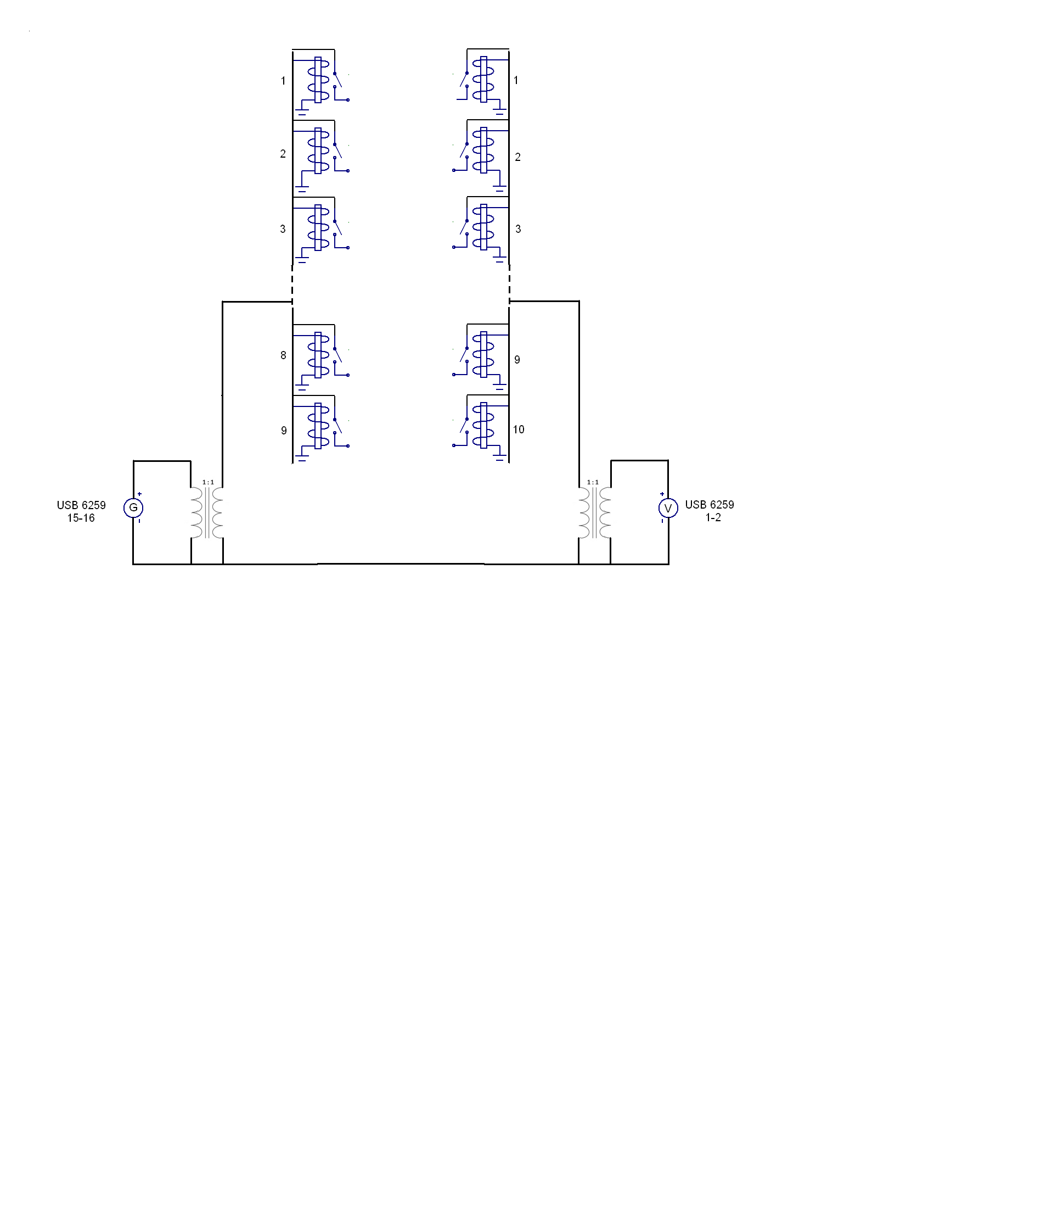
Fig. 2 Schematic of the ECP electronics

EXPERIMENTAL FACILITY AND TEST SECTION
The experimental facility consists of the feed water and the feed air loops with instruments used to measure the single phase flow parameters (flow meter, temperature and pressure). The water mass flow rate is measured by means of a rotameter with 2% full scale accuracy, while the air flow rate is measured by a calibrated orifice flow meter. The facility, shown in Fig. 3, is composed by a Plexiglas vertical pipe having a nominal diameter of 80 mm and total length of about 4000 mm. The mixing zone is located at 400 mm from the test section inlet. Air enters axially in the test section and water flow is also injected axially by means of a porous bronze (Fig. 3). The test section, having a total length of 2500 mm, is equipped with two pneumatic quick closing valves used to measure the volumetric void fraction. The test section, in Plexiglas allows to visualize the flow.
Downstream of the upper valve, a tank, that allows to separate the phases, is installed. The flow is discharged at atmospheric pressure. Experiments are made at a constant water temperature of 20°C, and measuring the absolute pressure, by a transducer Rosemount 3051/1, at the inlet of the test section.

EXPERIMENTAL METHODOLOGY AND SIGNAL ACQUISITION
The signals from the sensor are acquired using the NI USB-6259 DAQ, and managed using a LabView® program. The predefined measurement sequence is read and the corresponding reed relay is activated by using a 5 V DC signal. The excitation signal is sent to the electrodes (sinusoidal signal with f_{ec} = 25 kHz and 5 V amplitude) and the output signal is sampled using a frequency of 250 kHz; the RMS value corresponding to 2000 samples is acquired.
The measurement sequence is defined as follows. The external electrodes are excited in sequence and for each one the output signal of the other external electrodes is read.
After the scan of the external electrodes, the output signal relative to the central electrode is acquired for each excited external electrode. For each measurement cycle all the 81 possible combinations are then registered and for each experimental run 50 cycles are acquired, in order to evaluate the mean signal and its time variation.

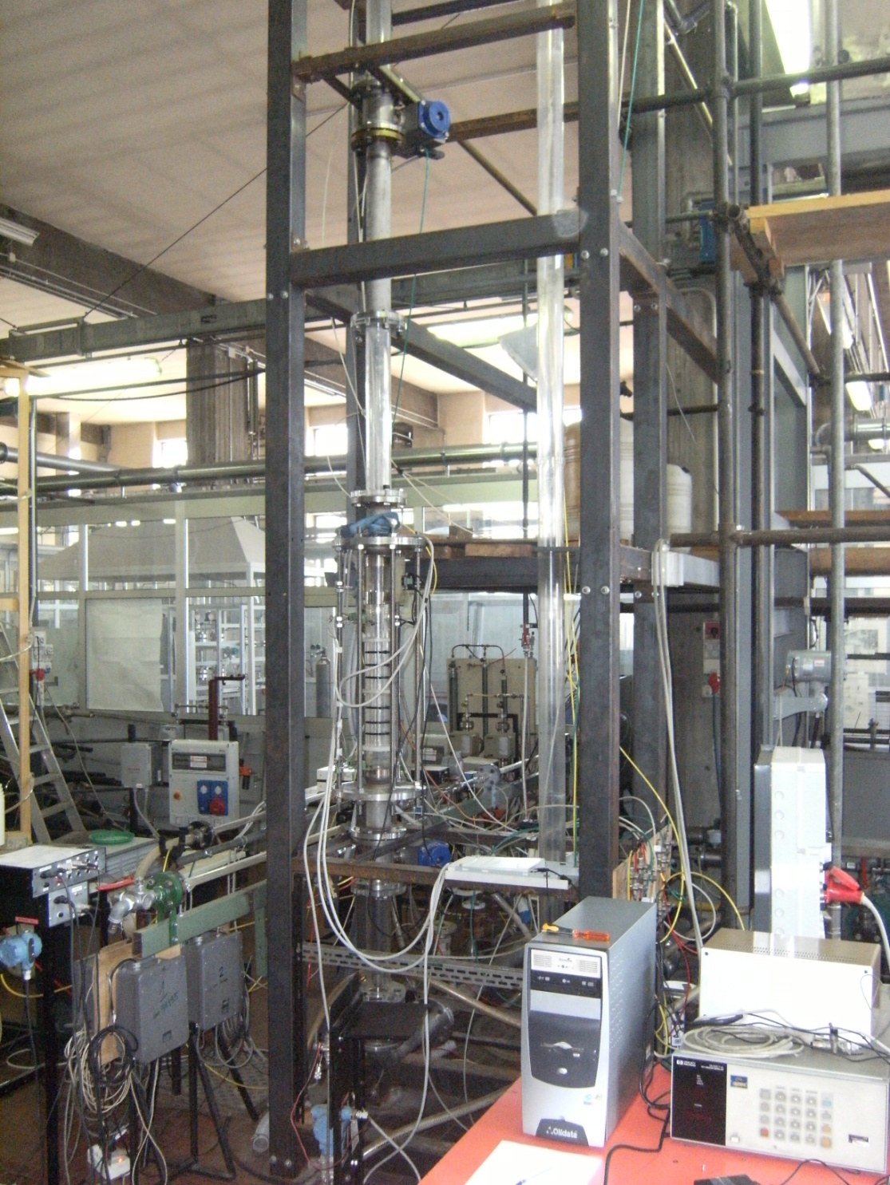
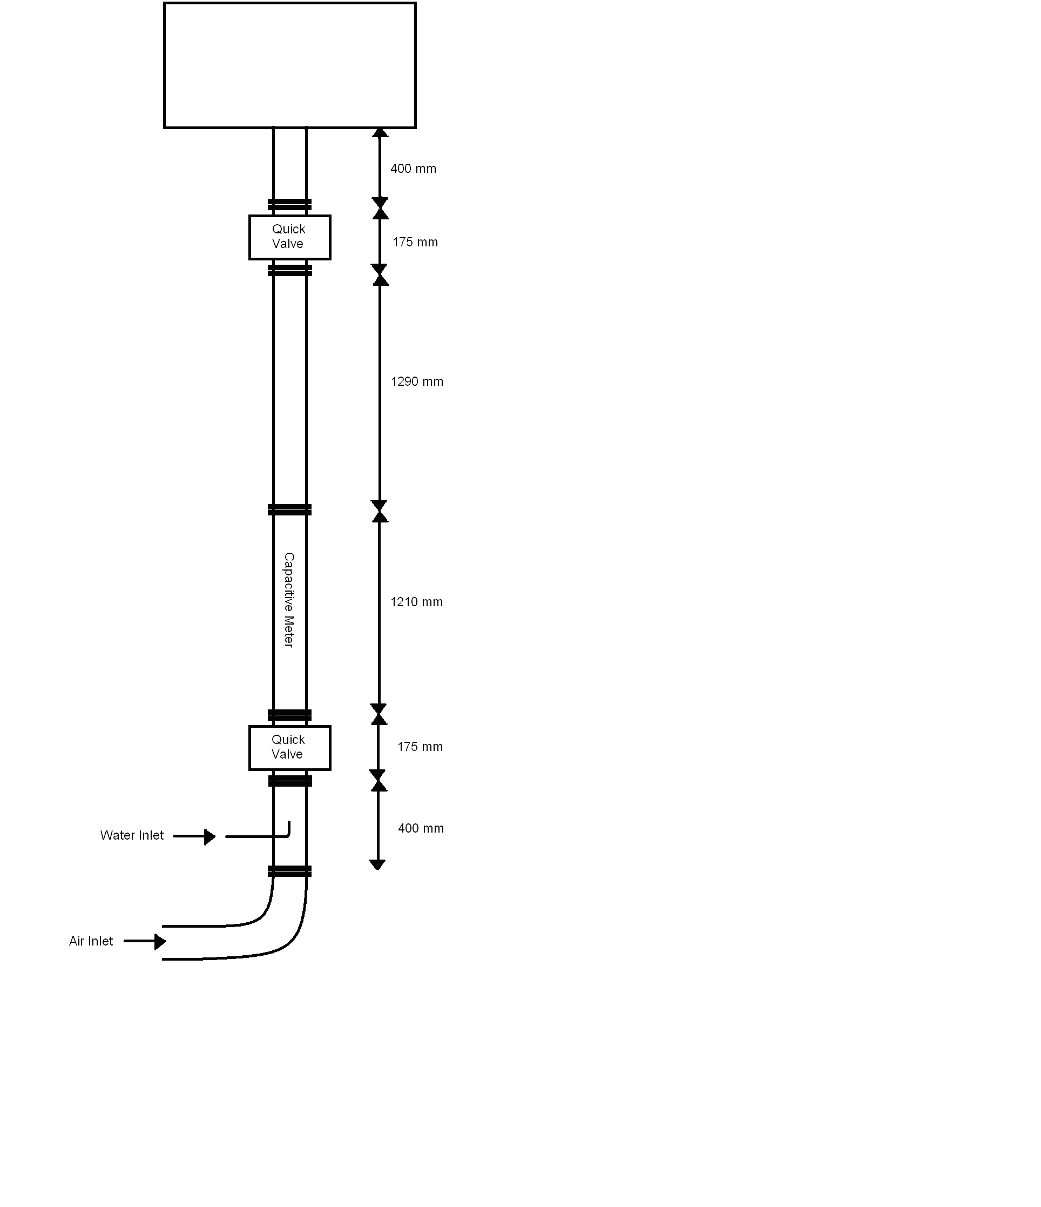
(a) (b)
Fig. 3 Experimental facility. Schematic (a) and picture (b)

Before each set of experimental runs the static values of the signals for air and water are measured. Then, for each run, the mass flow rates of water and air are fixed and when the flow is stabilized in the test section, the pressure value and the signal from the sensor are acquired. At the end of the measurement procedure, the volume averaged void fraction is measured using the quick closing valves. The uncertainty associated to the void fraction measurement has been estimated as ∆α = ± 0.0012.
EXPERIMENTAL MATRIX
In order to evaluate the response of the sensor at high void fraction, corresponding to annular and dispersed flow, a mixture of air and demineralized water is introduced in the test section. Mass flow rates have been analyzed between 0.094 and 0.15 kg/s for air and 0.002 and 0.021 kg/s for water, corresponding to void fraction up to 95%. The tests have been performed at atmospheric pressure. In Fig. 4, 5 the experimental void fraction is plotted as a function of the air superficial velocity (Fig. 4) and of the flow quality (Fig. 5) at different liquid superficial velocities.
In the tested range the observed flow pattern is annular smooth and annular wavy. The annular flow regime in vertical configuration, for the symmetry, can be analyzed, in a simplified scheme, as a liquid film region and a core region (Fig. 6). The liquid film is characterized in terms of film thickness, and frequency and amplitudes of waves at the interface. The core region, instead, is characterized in term of mean void fraction value. By increasing the water flow rate, the amplitude of the waves increases and the flow tends to become annular-churn while increasing the air flow rate, the film becomes smooth and thin (smooth annular flow). By further increasing the air flow rate, the liquid entrainment, from the film to the gas-core flow, occurs and increases.
Fig. 4 Experimental void fraction as a function of water and air superficial velocities
Fig. 5 Experimental void fraction as a function of the flow quality

Then the void fraction can be written as:

(1)

where
(2)
(3)

A_{c} is the core region area and α_{d} is the cross-sectional fraction occupied by the droplets in the core. Then the value of the α_{c} is an indirect index of the liquid film thickness.
In order to characterize the interface evolution in annular flow, Ishii [14] derived the criteria for the onset of entrainment based on the balance of the forces acting on the waves. The fraction of the liquid flux flowing as droplet is derived [14][15] as:

(4)

where

(5)

and

(6)

In the tested range the liquid Reynolds number Re_{l} ranges from 44 to 332 and the Weber number ranges from 2200 to 7000.
In pure annular flow, the liquid flows entirely in the film region, then the maximum value of thickness is evaluated from the measured void fraction as:

(7)

Under the hypothesis of pure annular flow the liquid film velocity and the core gas velocity are evaluated as:

(8)

(9)

In Fig. 7, the film thickness is plotted as a function of the superficial velocities.

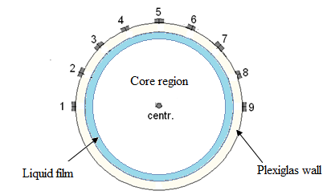
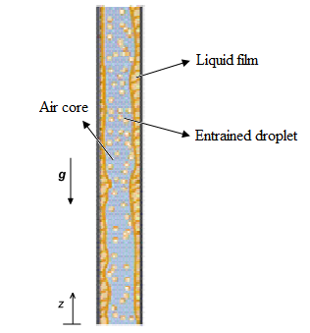
Fig. 6 Schematic of annular vertical air-water flow
Actually this model is valid for the pure annular flow regime. In the tested range, for liquid superficial velocity higher than 0.00152 m/s, the flow tends to become annular-churn. Above this value the model is no more applicable.

Fig. 7 Maximum film thickness as a function of the phases’ superficial velocity

Fig. 8 Equilibrium entrainment predicted by the Ishii’s model [14] as a function of the tested void fraction

By introducing the correction due to the entrainment, the core gas fraction is evaluated. The velocities of the phases are corrected considering the same liquid droplets velocity as of the gas in the core region:

(10)

(11)

(12)

The phases’ velocities are plotted in Fig. 9, 10. In Fig. 11, the derived slip ratio (S= U_{g} /U_{l} ) is plotted as a function of the flow quality, at different liquid superficial velocities. The liquid film thickness is corrected, as shown in Fig. 12, taking into account the amount of liquid that is entrained into the core region:
(13)

Fig. 9 Water velocity as a function of the flow quality

Fig. 10 Air velocity as a function of the flow quality

Fig. 11 Slip ratio S= U_{g} /U_{l} as a function of the flow quality
Fig. 12 Corrected mean film thickness as a function of the phases’ superficial velocities

ECP EXPERIMENTAL RESULTS
The first qualification step consists of the characterization of the sensor for single phase conditions. Measurements with air and demineralized water have been carried out before each test, in order to evaluate the stability of the system, and to normalize the signals for the two phase flow. The single phase measurements are used to build the characteristic shape function of the sensor. In Fig. 13 the RMS signals of all the possible combinations of the external electrodes are reported, as a function of the value of the angle θ between the excited and the measuring electrode (defined in Fig. 1). The little difference between the signals at the same angle value is due to the electronic circuit characteristic. The measured RMS value is proportional to the electrical capacitance between the measuring electrodes. It also depends on the excitation frequency and on the resistance, that is different between air, water and two-phase mixture, also with demineralized water. As it is shown in Fig. 13, the signal variation range is very limited due to the presence of the quite large Plexiglas thickness (5 mm) and the absence of any signal amplification.

Fig. 13 Single phase ECP signals as a function of the angle θ
The theoretical ratio between the water electrical permittivity and the air electrical permittivity, that is equal to 80, is reduced, in the practical case, at a value from 1.05 to 1.1 depending on the electrodes distance. The ratio is lower at θ=22.5° due to the strong influence of the wall. The angle dependency is stronger for the signal measured in air single phase flow, while it seems to reach a constant value at angles higher than 90° in presence of only water.
For each electrodes combination the ratio RMS_{g}/RMS_{l} shows a very high repeatability. The ratio of the RMSs, obtained measuring between external electrodes produces the shape shown in Fig. 14.
The analysis of the signals of the central electrode shows a higher sensitivity due to the direct contact of the probe with the mixture. In this case the mean RMS_{g}/RMS_{l} ratio is equal to 0.582 ±0.002.
In order to take into account the single phase signal variations, the two-phase flow measured values are normalized as follows:

(14)

where the subscript ij identifies the measuring electrodes combination.
Because of the physical differences between internal and external electrode response, the signal of external and internal electrodes has been analyzed separately.

Fig. 14 Single phase ECP signals ratio as a function of the angle θ, for the electrode 1 excited

External Electrodes Signals
In order to evaluate the behavior of the sensors as a function of the mean void fraction, only the i-j combination signals are considered (deriving the mean value and the standard deviations), while in order to evaluate the interface phenomena in the liquid film and in the core region the time dependent signals (an example is reported in Fig. 15 for the electrodes combination 1-2 and void fraction equal to 0.995) and the relative differences between the value of the i-j and the j-i combinations have to be analyzed.
Each combination is analyzed in terms of dependency from the fluid-dynamic quantities (experimental void fraction, superficial velocities of air and water) and geometrical quantities (θ).
Fig. 15 RMS value in time for 1-2 electrodes combination at J_{l} = 0.00055 m/s and J_{g} = 23.8 m/s

A typical series of curves is reported in Fig. 16: also with this low sensitivity, it is possible to extract important information concerning the void fraction in the annular flow configuration. The sensor is sensitive at very little variation of the void fraction, and this variation is detected from all the measuring electrodes combinations.
The relationship between the capacitance and the void fraction is dependent on the dielectric values of the two phases, but also on the cross-section of the sensors, on the separation distance between the two electrodes and on the voltage distribution inside the measurement volume, that in turn depends on the phases distribution. Considering the flow pattern, it is possible to develop a qualitative model for the signal variation: in the annular flow the measurements taken from the external electrodes are rather insensitive to the core region, because the preferential path of the electrical field lines is located in the continuous liquid film. The analysis of the signal shows that the measurement, taken between close electrodes (θ=22.5°), is affected by the presence of the liquid film because the measured volume is that relative to the liquid film zone, while electrodes having higher distances are partially affected by the core region. In the hypothesis of axial symmetric flow, and in order to evaluate the sensor sensitivity to the mean void fraction variation, all the signals measured between electrodes, placed at the same angular distance, are used to evaluate the average normalized signal at the angle θ. The average signals measured between electrodes at 22.5°, 45°, 90° and 180° are plotted in Fig. 17 as a function of the measured void fraction. V* increases with θ at constant void fraction, and approaches the air value at higher angular distance.
No significant difference has been found between the signals of electrodes at 90° and 132.5° and at157.5° and 180°.

Central Electrode Signals
The signal of the central electrode, that is in direct contact with the fluid, is sensitive to the mean cross section void fraction and could be directly related to the measured void fraction and to the amount of liquid droplets in the core region. In Fig. 18, the mean signal, measured in the central electrode, is represented as a function of the experimental void fraction, measured by means of the quick closing valves: the signal is linearly dependent on the void fraction at value higher than 0.98 and it is characterized by a higher standard deviation at lower values.
(a)

(b)

Fig. 16 V*=f(θ,α)

Fig. 17 Mean signal measured in the external electrodes as a function of the experimental void fraction

In the tested range, the observed flow pattern is annular, with rather low turbulence at the film interface, at liquid superficial velocities lower than 0.00152 m/s. While at a higher water mass flow rate, and void fraction values lower than 0.98, the flow pattern tends to become more turbulent with a higher mass of liquid entrained in the core region (churn-annular flow). This flow pattern change is clearly detected from the sensor, as it is shown in Fig. 18.

Fig. 18 Mean signal measured in the central electrode as a function of the measured void fraction

Liquid film thickness and core droplets fraction dependency
In order to analyze the dependency of the sensor signal from the measured volumetric void fraction, the data of the different electrodes combination are related with the liquid film thickness δ by means of the core void fraction α_{c}, and with the liquid fraction in the core region by means of the droplets fraction α_{d}. A model correlating the probe signals to the two phase flow parameters, as α_{c}, α_{d} , j_{l}, j_{g}, pressure p, geometrical and fluid parameters is needed. For an axial symmetrical two phase flow at constant pressure and temperature a simple model with two parameters and two signals (an external and the central electrodes) can estimate the film thickness, the liquid core droplet fraction and the void fraction. In Fig. 19 the signals measured in the central electrode are shown as a function of the core fraction. The flow pattern change from annular to churn-annular is clearly detected. In Fig. 20, the same signal is evaluated as a function of the droplets fraction; the internal probe is more sensitive than the external ones to the effect of the liquid and gas velocity change.
In the future the measurement of the liquid film thickness and of the frequency of the film waves will be performed. The influence of these parameters will be considered in the signal analysis.

CONCLUSIONS
The design of new nuclear reactors requires to carry out integral and separate effect tests on simulation facilities, as well as to perform safety systems assessment and safety code validation. The SPES3 experimental facility, able to simulate the innovative small and medium size PWRs, is being built and will be operated at SIET Company laboratory. In such facility some design and beyond design basis accidents, like LOCAs, with and without the emergency heat removal systems, will be simulated.
An accurate accident analysis requires the measurement of the mass flow rate of the mixture during the LOCA.
Fig. 19 Normalized-mean signal of central electrode, as a function of the core void fraction.

Fig. 20 Normalized-mean signals of the central electrode, as a function of the core droplets fraction at different liquid superficial velocity

The measurement device used for the flow parameters measurement must be able to work at high temperature and pressure, and at fluid velocity higher than one hundred m/s. This requires to develop a non-intrusive probe with no moving parts, but also sensitive at very little variation of the flow parameters, and with a very high frequency response, in order to evaluate the parameter variations during the transient. Concerning the measurement of the void fraction, the impedance meter fulfills these requirements, but in presence of annular flow the sensitivity is reduced due to the presence of the liquid film on the wall.
The sensor (ECP), that is presented in this paper, has been developed by the SIET Company, and consists of 10 measurement electrodes, 9 external and one internal. The presence of the internal electrode, introduces very little flow disturbances, but allows to obtain important information on the phase distribution, into the core region of the annular flow.
The response of the sensor has been qualified in terms of single phase flow sensitivity and signal variation dependency. Geometry and fluid-dynamic influences on the signal have been evaluated. The first analysis performed in single phase flow shows a poor sensitivity of the ECP system, so a signal amplification is required in order to increase the measurement accuracy. Although the sensitivity in single phase flow is low, variations lower than 1% in void fraction are detected. The presence of the central electrode allows to evaluate the mean cross-sectional void fraction also in annular flow, where the liquid film is the principal cause of the sensor low sensitivity. The signal measured in the central electrode is linear with the void fraction in the range 98-100% and is quite sensitive to flow pattern variation. The variation of the signal measured in the external electrodes has been related to the mean liquid film thickness, that is evaluated, with simple model and geometrical considerations. In the future, the film thickness and the wave frequencies will be evaluated in order to develop a model of the sensor suitable to evaluate the chordal void fractions and other fluid dynamic parameters. In this context, the time analysis of the signal of these electrodes can be used to identify important fluid-dynamic parameters as the frequency of the waves in the film, the mean film thickness and the film interface oscillations. The tests have shown the potentiality of this technology for the measurement of two phase flow parameters at very high void fraction conditions (higher than 95%); in the future on the ground of the present experimental results the modifications concerning electronics and sensor design aspects will improve the electrical capacitance probe performance and will extend the measurement parameters range.

ACKNOWLEDGEMENT
The present research has been supported by ENEA and by the Ministry of Economic Development.
The authors wish to thank Rocco Costantino and Giuseppe Vannelli for their technical support.
REFERENCES
- M. Carelli, L. Conway, M. Dzodzo, et al., The SPES3 experimental facility design for the IRIS Reactor simulation, Science and Technology of Nuclear Installations, vol. 2009 (2009)
- R. Ferri, A. Achilli, C. Congiu, et al., SPES3 facility and IRIS reactor numerical simulations for the SPES3 final design, in Proceedings of the European Nuclear Conference (ENC '10), Barcelona, Spain, May June 2010.
- M. Greco, R. Ferri et al., Two-Phase Flow Measurement Studies for the SPES3 Integral Test Facility for IRIS Reactor Simulation, in 18th International Conference on Nuclear Engineering (ICONE18) May 17–21, 2010 , Xi'an, China

M. De Salve, G. Monni, B. Panella, State of art and Selection of techniques in Multiphase Flow Measurement, Report RdS/2010/67, ENEA
- C. Bertani, M. De Salve, M. Malandrone, G. Monni, B. Panella, A. Mosetto, SPES-3 Facility Analysis, reference data for postulated Accident Simulation, Criteria for general and special instrumentation selection. Report RdS/2010/68 ENEA
- M. S. Rocha1, E. L. L. Cabral and J. R. Simões-Moreira, Capacitance Sensor for Void Fraction Measurement in a Natural Circulation Refrigeration Circuit. International Nuclear Atlantic Conference - INAC 2009
- S.X. Yang, W. Qiang, A portable stray-immune capacitance meter, Review of Scientific Instruments 4 (2002) 1958 – 1961
- G. Costigan, P. B. Whalley, Slug flow regime identification from dynamic void fraction measurement in vertical air-water flows , Int. J. Multiphase Flow Vol. 23, No. 2 (1997), pp. 263-282.
- K.J. Elkow, K. Rezkallah, Void fraction measurements in gas–liquid flows using capacitance sensors, Measurement Science and Technology 7(1996) 1153
- D.L. George, J.R. Torczynski, K.A. Shollenberger, T.J. O’Hern, S.L. Ceccio, Validation of electrical-impedance tomography for measurements of material distribution in two-phase flow, International Journal of Multiphase Flow 26 (2000) 549-581
- Z. Huang, B. Wang, and H. Li, Application of Electrical Capacitance Tomography to the Void Fraction Measurement of Two-Phase Flow. IEEE Transaction on Instrumentation and Measurement, Vol. 52, No. 1, 2003
- Y. Wu, H. Li, M. Wang, and R.A. Williams, Chraracterization of air-water two-phase vertical flow using electrical resistance imaging. The Canadian Journal of Chemical Engineering, Vol. 83, February 2005
- W. Warsito, L.S. Fan, Measurement of real-time flow structures in gas–liquid and gas–liquid–solid flow systems using electrical capacitance tomography (ECT), Chemical Engineering Science 56 (2001) 6455–6462
- M. Ishii, K. Mishima, Two-fluid model and Hydrodynamic constitutive relations. Nuclear Engineering and Design 82 (1984) 107-126
- T. Hazuku, T. Takasama, T. Hibiki, M. Ishii, Interfacial area concentration in annular two-phase flow. International J. of Heat and Mass Transfer 50 (2007) 2986-2995

