20XX-01-XXXX

3DOF Vehicle Dynamics Model for Fuel Consumption Estimation
Author, co-author (Do NOT enter this information. It will be pulled from participant tab in MyTechZone)
Affiliation (Do NOT enter this information. It will be pulled from participant tab in MyTechZone)
Abstract
The dynamic model is built in Siemens Simcenter Amesim platform and simulates the performances on track of JUNO, a low energy demanding Urban Concept vehicle to take part in the Shell Eco-Marathon competition, in which the goal is to achieve the lowest fuel consumption in covering some laps of a racetrack, with limitations on the maximum race time.
The model starts with the longitudinal dynamics, analysing all the factors that characterize the vehicle’s forward resistance, like aerodynamic forces, altimetry changes and rolling resistance.
To improve the correlation between simulation and track performances, the model has been updated with the implementation of a Single-Track Model, including vehicle rotation around its roll axis, and a 3D representation of the racetrack, with an automatic trajectory following control implemented. This is crucial to characterise the vehicle’s lateral dynamics, which cannot be neglected in simulating its performances on track.
Analysis of suspension geometry, vehicle mass distribution and tire characteristics are made to properly define the parameters of the model, which is used for the optimal race strategy model.
The model has been validated by analysis of performance data obtained by the properly made telemetry system during the 2023 competition, and it predicts with good accuracy the fuel consumption obtained.
Introduction
The aim of this paper is to present the methods used to produce and validate an accurate vehicle dynamics mathematical model of an ICE-propelled vehicle.
The final purpose of the simulation model is to predict the vehicle fuel consumption after simulating different types of tasks. For the model to be considered complete, all the conditions of a vehicle can be modelled according to different environmental conditions including wind, rain, slopes, and type of road surface. The model itself can be customized according to the vehicle properties such as mass, engine size, axis stiffness etc.
The model has been validated on a low consumption vehicle but can be used on any vehicle thanks to its versatile approach [1]. The vehicle used for validation is the Urban Concept JUNO designed and built at the Politecnico di Torino. JUNO participates in the Shell Eco-Marathon Europe and Africa competition, taken yearly in different racetracks around the continent, in which the main goal is reaching maximum efficiency in terms of fuel consumption.
JUNO is designed to be as efficient as possible, and so the mathematical model describing its vehicle dynamics, in which the main effort is put into accurately estimating the fuel consumption of the Urban Concept. To do so, it is needed to correctly define the forward resistance and the losses due to cornering by considering the lateral vehicle dynamics.
The model features also an automatic trajectory control, which makes the simulation and the comparison between different paths on track easier, making the choice of the most efficient one possible.
All the simulation system is used to predict the behavior of JUNO on track during testing and race runs, making it possible to detect, prior to these events, the correct race strategy needed to obtain the best possible result in terms of fuel consumption.
The model is developed in Siemens Simcenter Amesim environment by using a mix of prebuilt and custom subcomponents. Longitudinal and lateral dynamics, track representation, trajectory control, parameters definition and model validation are discussed in the following sections of this paper.
Longitudinal Dynamics Model
The longitudinal dynamic behavior of the vehicle has been simulated using Siemens Simcenter Amesim thanks to a specifically built model. The model was first built to simulate the longitudinal behavior of the vehicle, without considering lateral dynamics, hence no characterization of a considerable amount of energy losses given by cornering manoeuvres is considered. It must be specified that Amesim works thanks to prebuilt component blocks.
For the sake of clarity, a brief description of the main subcomponents constituting the model will be given.
Engine and transmission components
The internal combustion engine (Honda 50 cc type supplied by bioethanol) of the vehicle is simulated via multiple blocks representing the engine itself and the external operative conditions such as air temperature, pressure, and humidity. The engine simulation block, represented in Figure 1, has been customized accordingly for the correct number of cylinders, size of cylinders, and number of strokes. In its configuration, the engine simulation block simulates output torque and fuel consumption based on the given throttle pedal input.
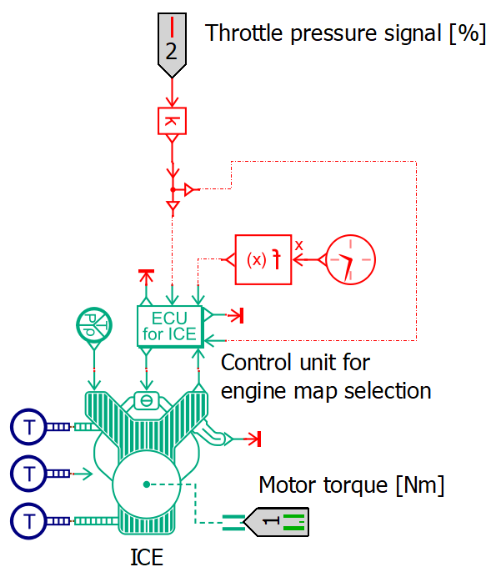
Figure 1. Internal Combustion Engine simulation block
The output torque is then linked to the transmission simulation component, shown in Figure 2, which allows for the simulation of both the clutch and the transmission assemblies.
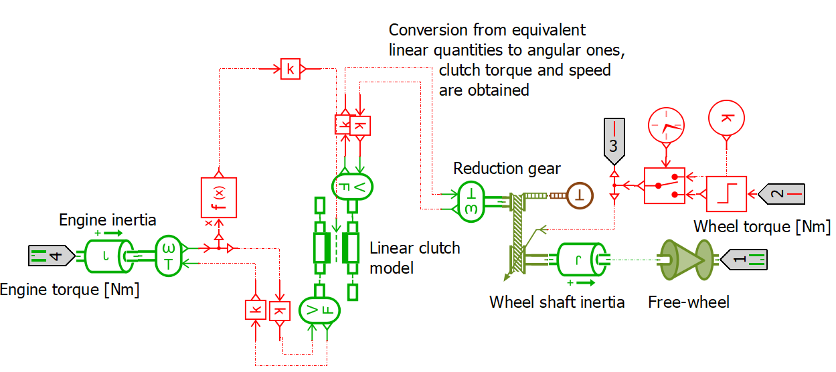
Figure 2. Transmission simulation block with centrifugal clutch and freewheel
The clutch assembly is created to simulate the transient behavior of the clutch and allow for smoother torque transmission from the engine to the driving wheel. The transmission assembly is modulable to the number of gears available and customizable for each gear ratio. An additional component in the transmission assembly is the freewheel which allows for the disconnection of the wheels from the powertrain hence making it possible to roll free of resistances given by the engine and transmission assembly. The freewheel can be activated or deactivated depending on whether it is equipped on the vehicle that is simulated.
The final torque and axle speed is used in the vehicle simulation block, which only simulates the longitudinal behavior of the vehicle. The vehicle mass, wheels inertia and the external environment forces are considered. All the main resistances experienced by the vehicle are considered. Slope resistance is calculated thanks to an altimetry file of the track/road in equation 1:
$F_{cl}=Mg\sin\left(\operatorname{atan}\left(\frac{α_{slope}}{100}\right)\right)$ (1)
The aerodynamic drag and rolling resistance are calculated with equations 2 and 3:
$F_{aero}=\frac{1}{2}ρ_{air}SC_{x}{\left(v+v_{wind}\right)}^{2}$ (2)
$F_{roll}=Mg\left(f_{0}+f_{1}∙v+f_{2}∙v^{2}\right)∙\cos\left(\operatorname{atan}\left(\frac{α_{slope}}{100}\right)\right)$ (3)
All these three resistances, explained by [2] are summed to evaluate the total resistance experienced by the vehicle. Additional resistance force can be modelled thanks to an additional port present in the longitudinal block. Such external resistance had been previously used to simulate the additional resistance given by cornering.
The data had been calculated through coast-down tests, where the reference vehicle had to reach a given speed then disengage the clutch and turn off the engine hence initiating a coast-down. Moreover, the vehicle had to follow both a straight-line path and a constant radius turns with decreasing turning radius. Unfortunately, such tests proved inefficient and time-consuming, providing disturbed data that could not be clearly correlated to the additional resistance given by cornering. Hence the simulation of the lateral dynamics was needed to better comprehend the magnitude of the losses due to cornering, which, according to [3], accounts for up to 10% of total rolling resistance.
Lateral dynamics implementation
3DOF Single-Track Model
Longitudinal dynamics are not enough to correctly represent the performance of a vehicle, also for JUNO on track due to big estimation errors during cornering. It is needed also to model the lateral vehicle dynamics and, after exploiting the empirical approach of adding an additional resistive force based on the cornering radius encountered across the trajectory and detecting its problems, a more theoretical approach. As suggested by [4] has been implemented a Single-Track Model in the Amesim simulating system through the usage of a predefined component, shown in Figure 3, which works simultaneously with the original longitudinal dynamics model. This model has been chosen for its relative simplicity and because it correctly evaluates lateral vehicle dynamics in the case of low velocities and low lateral accelerations (0.5 g), which is appropriate for vehicles designed for fuel efficiency competitions.
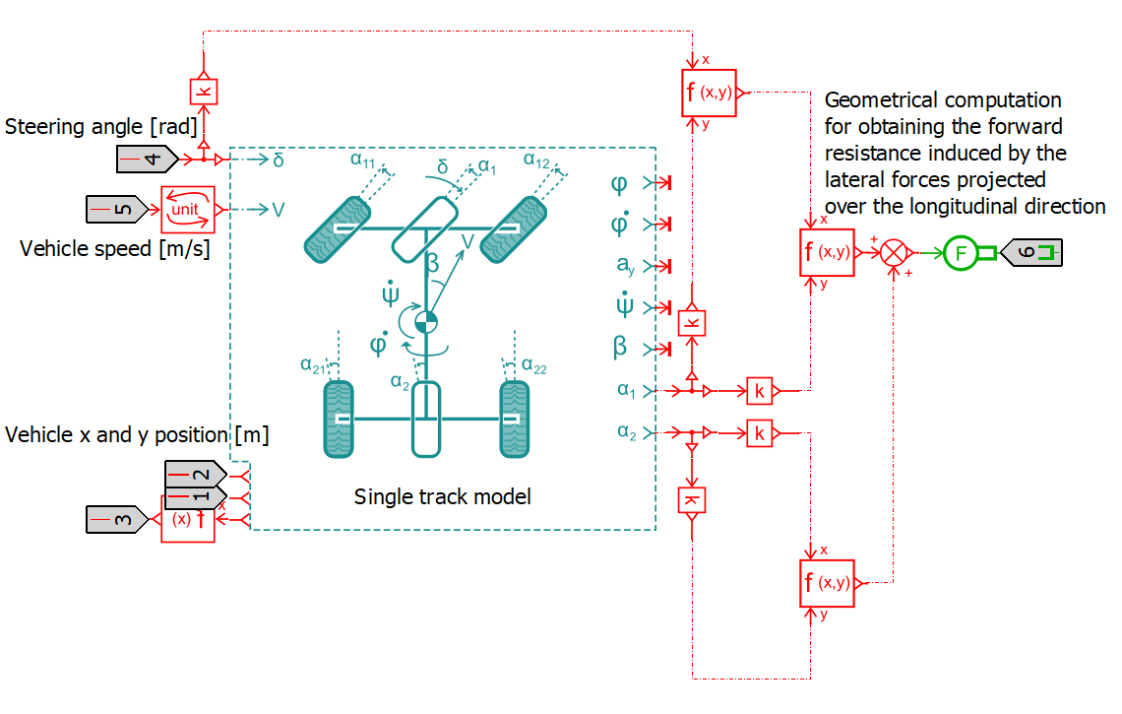
Figure 3. 3DOF Single-Track Model
This component models the lateral dynamics of a four-wheel chassis with a medium-wheel approach for the front and rear axles. It exploits 3 degrees of freedom (3DOF), which are: the vehicle’s yaw velocity $\dot{ψ}$, the vehicle’s sideslip angle $β$, and its roll angle $φ$, by receiving as input the steering angle, computed in the trajectory definition and control section of the model (presented in the next section), and the vehicle speed, given by the longitudinal dynamics modelling.
This 3DOF Single-Track Model considers several effects with a linear approach:
- Tire sideslip considering both cornering and camber stiffness.
- Axle elastokinematics.
- Axle kinematics with camber and toe induced by roll.
- Anti-roll stiffness with front/rear repartition.

The component, to derive its current 3DOF internal state, uses the equation system 4-5-6, from [5]:
$$\begin{aligned}\begin{aligned}MV\dot{β}+\left(2D_{1}+2D_{2}\right)β+\left(MV+\frac{2D_{1}a_{1}-2D_{2}a_{2}}{V}\right)\dot{ψ}-Mh\ddot{φ}+… \\ +a_{r}φ-2D_{1}δ=0 (4) \\ I_{zz}\ddot{ψ}+\frac{2D_{1}a_{1}^{2}+2D_{2}a_{2}^{2}}{V}\dot{ψ}+b_{r}φ+\left(2D_{1}a_{1}-2D_{2}a_{2}\right)β+… \\ -2D_{1}a_{1}δ=0 (5)\end{aligned} \\ \left(I_{xx}+Mh^{2}\right)\ddot{φ}-MhV\left(\dot{β}+\dot{ψ}\right)+b_{φ}\dot{φ}+… \\ +\left(K_{φ}-Mgh\right)φ=0 (6)\end{aligned}$$
Where: coefficients a_{r} and b_{r} relating to the roll angle effect on the system excluding roll acceleration are defined by equations 7 and 8:
$$a_{r}=2C_{1}λ_{1}-2D_{1}ε_{1}+2C_{2}λ_{2}-2D_{2}ε_{2} (7)$$
$$b_{r}=2a_{1}C_{1}λ_{1}-2a_{1}D_{1}ε_{1}+2a_{2}C_{2}λ_{2}-2a_{2}D_{2}ε_{2 }(8)$$
The relative position of the roll center with respect to the car center of gravity h [m] is given by equation 9:
$$h=h_{g}-\left(\frac{a_{2}}{a_{1}+a_{2}}h_{r1}+\frac{a_{1}}{a_{1}+a_{2}}h_{r2}\right) (9)$$
Tire forces estimation
Once all the parameters are set and the input steering angle and velocity are given, the front and rear tire sideslip angles α_{1/2} are computed as component outputs. Considering the Pacejka Tyre Magic Formula [6], since the goal of this model is to simulate vehicles going at low speeds and lateral accelerations, it is possible to assume that the lateral force F_{y} exerted by tire on track is linearly dependent to its sideslip angle, with $D_{1/2}$, the cornering stiffness, as a proportionality constant, as shown in equation 10.
$F_{y, 1/2}=D_{1/2}α_{1/2}$ (10)
It must be specified that, since the medium tire approach is considered for both axes, in which a single tire represents the axis’ pair, the cornering stiffness is related to the whole axle, and its value is the double of the actual value of the single tire.
Such forces, according to Figure 4 and [3], are projected on the car longitudinal axis, computed, as like the tire’s lateral force, externally from the Single-Track Model component, using custom function blocks, visible on the right side of Figure 3.
The longitudinal component of the lateral force at the front tire is, given equation 11:
$$F_{yproj,1}=F_{y,1}\sin\left(δ+α_{1}\right) (11)$$
Equation 12 is for the rear tire:
$$F_{yproj,2}=F_{y,2}sin\left(α\right) (12)$$
Finally, these longitudinal force components (obtained from equation 11 and 12) are summed and used for the longitudinal dynamics component, as input of the external force F_{ext} port, representing an additional resistive force component due to cornering operations.
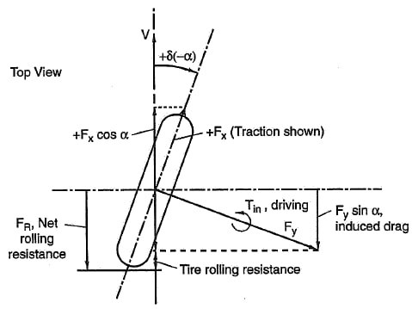
Figure 4. Projection of tire lateral forces on the vehicle's longitudinal axis, resulting into an additional resistive force caused by cornering.
Racetrack representation and trajectory control
With the implementation of lateral vehicle dynamics in the model, it is necessary to represent the complete path of the vehicle in a 3D space, going beyond the previous distance/altimetry relationship characterization used for the former longitudinal dynamics model. The correct execution of the simulation is guaranteed by an automatic control able to follow the reference path given by the user. Figure 5 shows the racetrack modelling system in the Amesim environment.
Trajectory definition and comparison
The reference path for the vehicle is defined in a dedicated .data file, for which an example is shown in Figure 6. Each row of this file represents the x and y coordinates (first two columns), in meters, of the ending point of a portion of the trajectory. The third column represents the curvature radius (in meters, too) of this portion, with negative values representing left turns, positive values representing right turns, and null values representing, as a convention, straight sections.
This information about trajectory coordinates and curvature radii is acquired by manually analyzing the track on AutoCAD software, by evaluating, through drawing, the optimal path over a satellite image of the circuit (Figure 7). Then the coordinates of the trajectory are measured taking the start-finish line as the reference point.
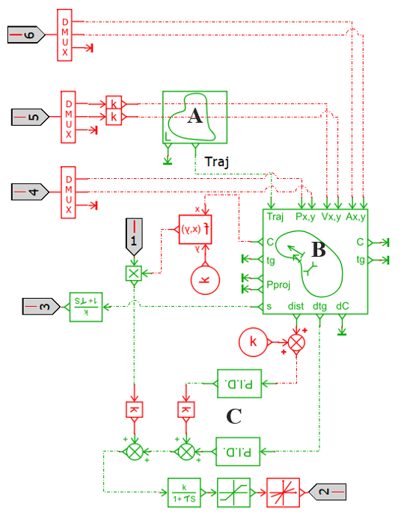
Figure 5. Racetrack representation and trajectory control system
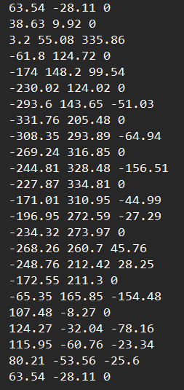
Figure 6. Example of track coordinates file obtained through AutoCAD
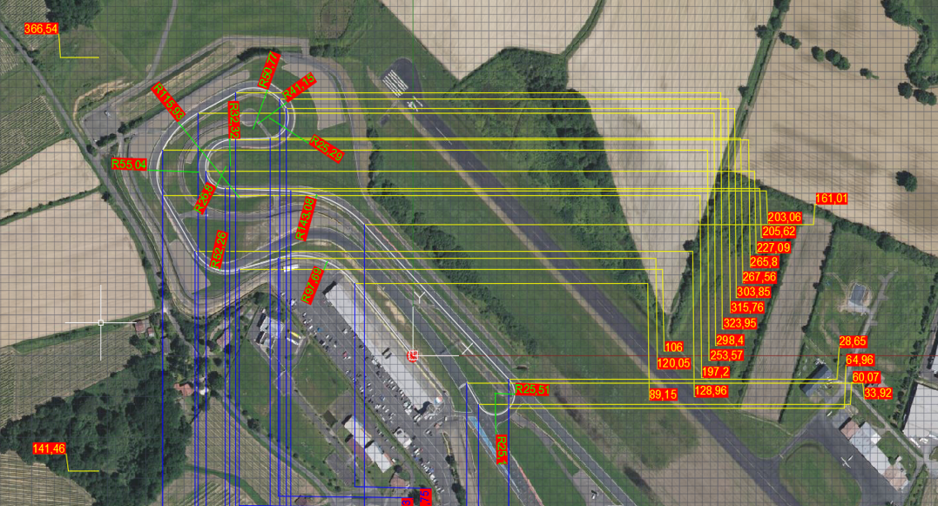
Figure 7. Track coordinates drawing over the satellite map on AutoCAD.
For instance, looking at Figure 6, the second row represents a straight section starting at (63.54, -28.11) m and ending at (38.63, 9.92) m.
This file represents the “A” component of Figure 5, which gives the reference trajectory to the “B” component, used for a comparison between the actual and the desired path during simulation runtime. Other than the reference trajectory, the component receives as inputs the x,y positions, velocities and acceleration of the simulated vehicle, obtained from the Single-Track model through differentiation.
The ”B” component computes the distance (dist, [m]) and the orientation difference (dtg, [rad]) of the simulated vehicle path from the desired trajectory. In addition to these, a curvilinear coordinate (s, [m]) is given by this comparison component. This coordinate, related to the nearest reference point to the actual vehicle position, gives the distance from the starting point of the reference path, considering travelling the reference trajectory. This distance can be related to the altimetry of every point of the trajectory which, combined with the planar representation shown before, completes a 3D characterization of the reference path to be followed by the vehicle during simulation. The curvilinear coordinate is used in place of the actual distance travelled by the vehicle to have a unique representation of each point of the reference trajectory, especially for the altimetry definition. If the actual distance travelled is used instead, each point would not be any more uniquely represented, since the actual vehicle trajectory can differ from the desired one during simulation.
Trajectory control
The signals dist and dtg, taken from the ”B” component of Figure 5 as errors with respect to the reference path, are used for enabling two P.I.D. controllers (“C” components of Figure 5) useful to evaluate the steering activity needed to correctly follow the desired trajectory. Control with only proportional gain is used in most of the cases; sometimes the integral gain is also used, with a lower magnitude than the proportional one, to control slower divergences from the ideal trajectory.
The signal outputs from both P.I.D. controllers are then summed to obtain the steering angle signal (in degrees) needed to follow the correct trajectory. This value, before being transferred as a signal input of the Single-Track Model, is passed through a saturator, which represents the physical steering angle limits of the vehicle, and then through a rate limiter, imposing a limit in the speed of change of the steering angle, to obtain a more realistic behaviour.
Vehicle parameters identification
The presented model can be adapted to different types of vehicles, just by correctly setting up the needed parameters. In this section, it is presented the validation case study, in particular the JUNO Urban Concept vehicle shown on track during SEM 2023 in Figure 8.
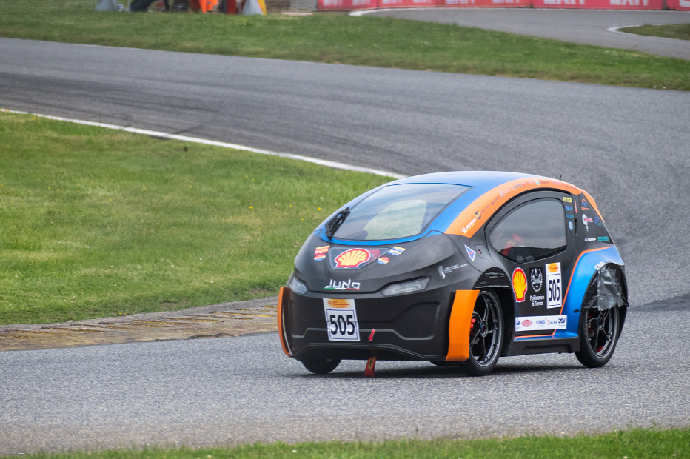
Figure 8. JUNO on track during the Shell Eco-Marathon 2023
Parameters for longitudinal vehicle dynamics
The most important parameters for running the longitudinal vehicle dynamics model are shown in Table 1.
Table 1. Longitudinal vehicle dynamics parameters
M - Unladen mass | 130 kg
M_{dr} - Driver mass | 70 kg
f₀ - Coulomb friction coefficient | 0.001336
f₁ - Viscous friction coefficient | 2.0828·10⁻⁴ s/m
f₂ - Windage coefficient | 3.889·10⁻⁶ s²/m²
C_{x} - Drag coefficient | 0.33
S - Vehicle front section area | 1.13 m²
J_{w} - Wheel inertia | 0.23 kg·m²
W_{T} - Tire width | 0.090 m
H_{T} - Relative tire height | 80 %
D_{rim} - Rim diameter | 0.4064 m
I_{tr} - Transmission ratio | 15.7:1
Maximum engine torque | 3.2 Nm @ 5000 rpm

The coefficients f₀, f₁, and f₂ define the tire rolling resistance. These parameters are obtained from information provided by the tire manufacturer [7] and analysis of straight-line coast-down tests performed by the Team in the past.
Parameters for lateral vehicle dynamics
Data used for the Single-Track lateral vehicle dynamics Model implementation are reported in Table 2.
Table 2. Lateral vehicle dynamics parameters
I_{xx} - Roll inertia | 40.63 kg·m²
I_{zz} - Yaw inertia | 359.72 kg·m²
h_{COG} - Center of gravity height | 0.194 m
h_{r1} - Front roll center | 0.156 m
h_{r2} - Rear roll center | 0.208 m
a₁ - Front wheelbase | 0.865 m
a₂ - Rear wheelbase | 0.735 m
b_{1,2} - Front and rear half-track | 0.610 m
K_{r1} - Front anti-roll stiffness | 36857 Nm/rad
K_{r2} - Rear anti-roll stiffness | 36674 Nm/rad
D₁ - Front axle cornering stiffness | 8167 N/rad
D₂ - Rear axle cornering stiffness | 9611 N/rad

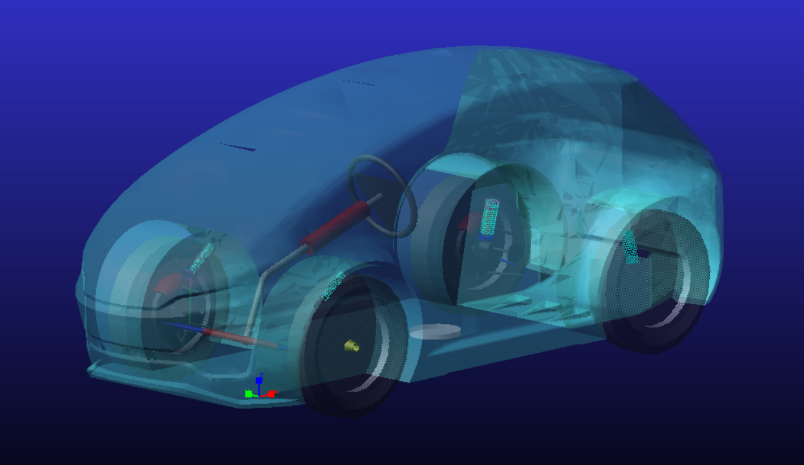
Figure 9. JUNO multi-body model in Adams Car
Many of the parameters shown in Table 2 have been obtained using an Adams Car multi-body model properly developed (Figure 9). This multi-body model of JUNO is made of several subsystems that describe the different components of the vehicle. Each component has been modelled with its dimension, mass, and inertia parameters. Once the design phase is completed, it is possible to obtain specific properties of the vehicle, like the yaw and roll inertia values, through mathematical simulation.
Adams Car model makes possible also to simulate the kinematic behaviour of the vehicle suspension systems. This provides some parameters needed by the newly integrated Single-Track Model, like the height of the roll centres at front and rear axles, their anti-roll stiffness and the gain factors for camber and toe angles induced by roll.
This is possible thanks to the virtual suspension test-bench available in Adams Car, on which an opposite wheel-travel testing simulation, has been performed (Figure 10). Once the bump and rebound dimensions are set, the simulation starts and acquires data that can be later inspected.
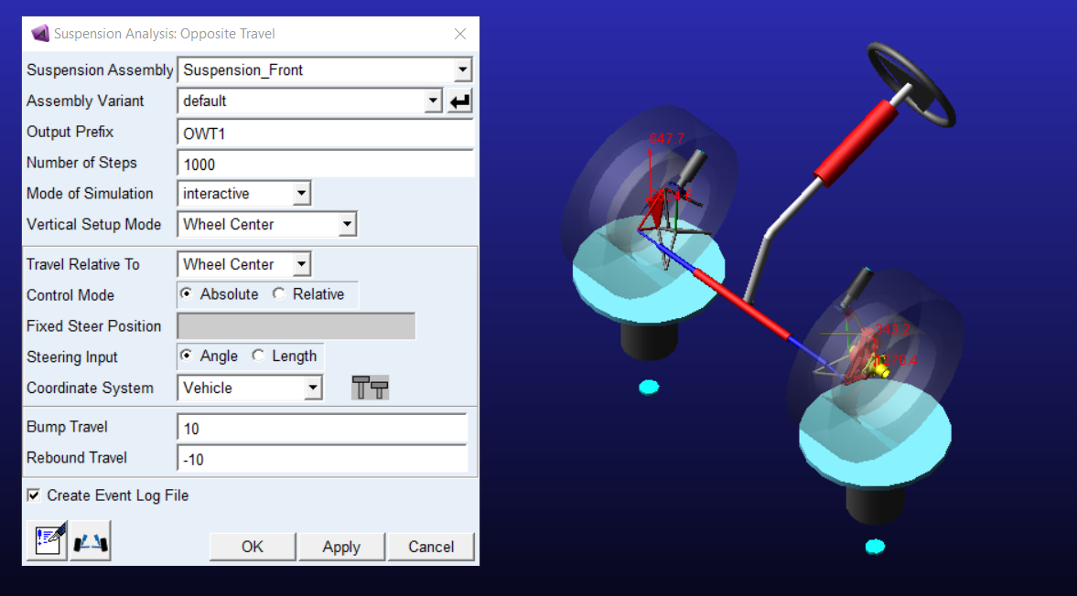
Figure 10. Front suspension assembly on Adams Car
The results of the opposite wheel-travel test show a front roll centre height at null relative wheel vertical displacement of 0.156 m (Figure 11), while at the rear vertical displacement is of 0.208 m (Figure 12). The anti-roll stiffness at the front axle is 36857 Nm/rad while at the rear its value is 36674 Nm/rad.
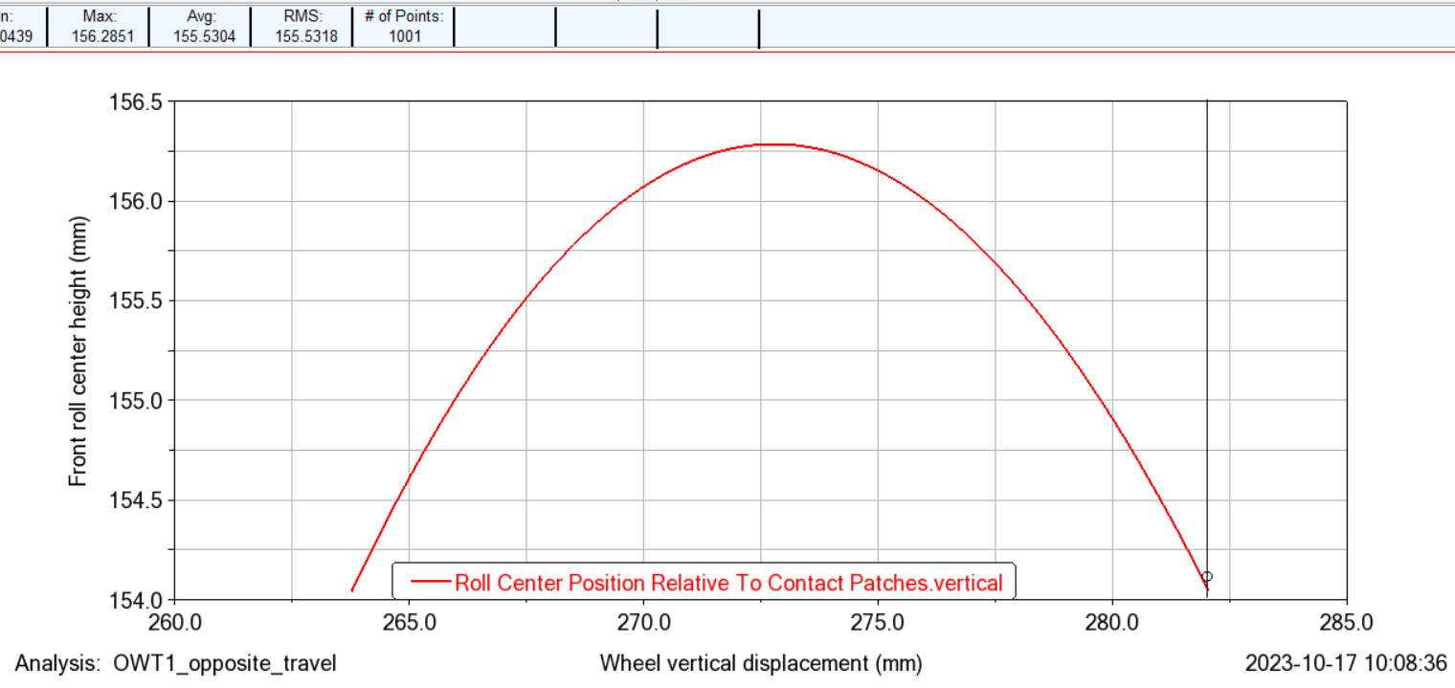
Figure 11. Front roll centre height over wheel vertical displacement
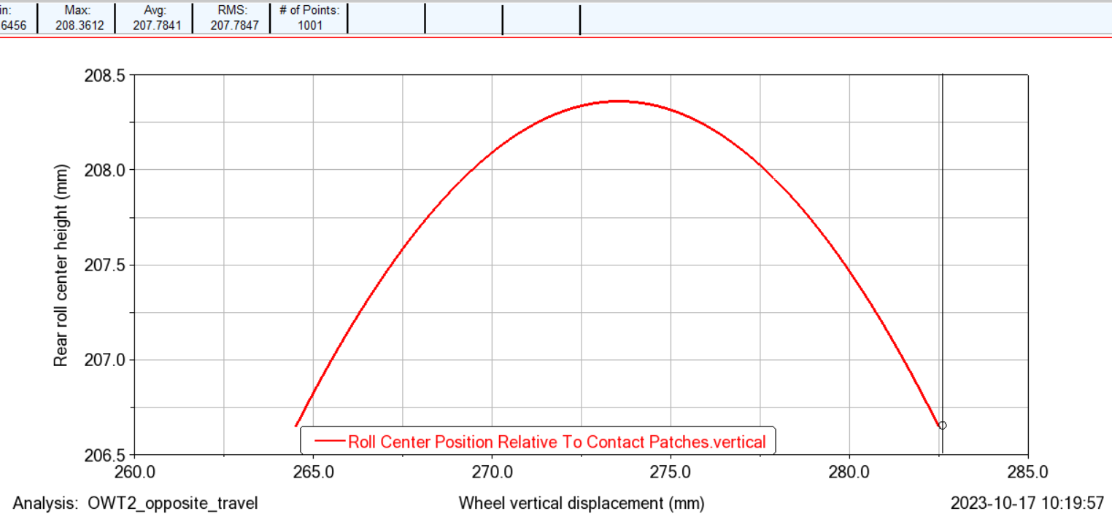
Figure 12. Rear roll centre height over wheel vertical displacement
Vehicle’s front and rear wheelbases are measured by weighing it over four balances, one for each wheel. In this way it’s possible to get the lateral (which is negligible) and the longitudinal mass distribution, which results for a 45.94% at the front axle and a 54.06% at the rear axle over the total mass. Planar positioning of the centre of gravity is thus defined, with front wheelbase of 0.735 m and rear of 0.865 m. Centre of gravity height is of 0.194 m (obtained through the Adams Car model).
Tire cornering stiffness is actually the most difficult parameter to find inside the model. It has been chosen to take reference from the axle cornering stiffness value reported by [8]. By considering that JUNO and driver’s total mass is 23.46% higher and considering the non-uniform longitudinal weight distribution just shown, an 8167 N/rad front axle cornering stiffness and a 9611 N/rad rear axle cornering stiffness are used for 3DOF JUNO model.
Model validation
The development of the model is due to the need to identify, along with the analysis of the ideal trajectory, the optimal collocation and length of accelerations to perform on track during a race run of the Shell Eco-Marathon. This means finding the most fuel-efficient strategy to apply during the competition.
To do so, it is needed a high level of accuracy from the model in predicting the instantaneous speed on the racetrack and in estimating the final consumption result, decisive for the ranking, and main yardstick in comparing different race strategies.
Prior to the main competition, JUNO is tested on track to evaluate its performances and to validate the 3DOF mathematical model in order to improve its accuracy in detecting the right race strategy. Real-life data of vehicle performance and model simulation data are compared in both live and a-posteriori fashion. Live comparison means the usage of real-time data to adapt the prior strategy to a modified one, effectively more fuel-efficient, based on the differences found between simulation and reality when the vehicle is running on track.
A-posteriori comparison is more useful for correcting the model’s structure, by analyzing the biggest divergences and finding their main causes. This can lead to re-tuning the model’s parameters to improve its estimation performance. Let’s stick first to how an a-posteriori comparison is performed.
Usage of GPS-based data for performance comparison
To improve accuracy and validate the mathematical model prior to the main competition, the use of an external GPS acquisition system proved essential. Racelogic PerformanceBox has been used to do so, as it provides information as the vehicle’s absolute position and distance covered, its speed, heading, and acceleration. All data are saved onto a SD card and can be preliminarily analyzed on the VBOX TestSuite, of which an interface example is shown in Figure 13.
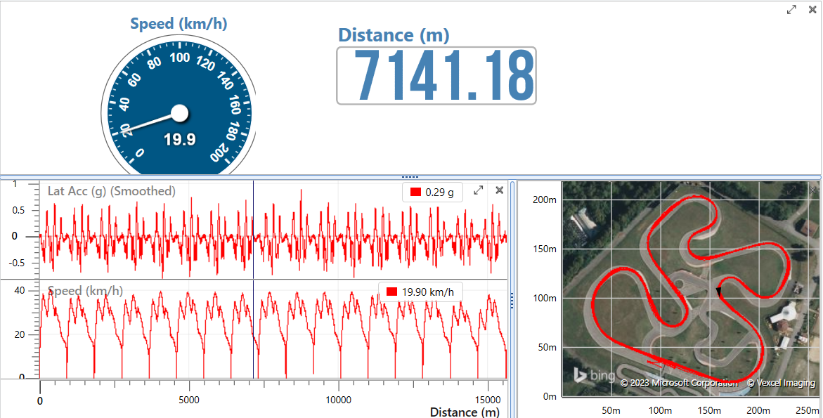
Figure 13. Example of VBOX interface
Once it is established that the data has been correctly acquired, it is exported into a .csv file, which can be read into MATLAB, where it is possible to split the telemetry data and inspect the single laps, to inspect each of them separately. Comparison between simulation and on-track data is made on vehicle:
- linear velocity,
- lateral acceleration,
- longitudinal acceleration.
Data provided by the Racelogic PerformanceBox presents a non-negligible component of noise, especially for accelerations, so it is needed to perform some data filtering on MATLAB to perform better analysis. First, power spectral density analysis of the data is carried out, by using the function pwelch, given the inputs of the data file, number of data points, and the sample frequency, which is 10 Hz for the Racelogic PerformanceBox. The results are shown in Figure 14.
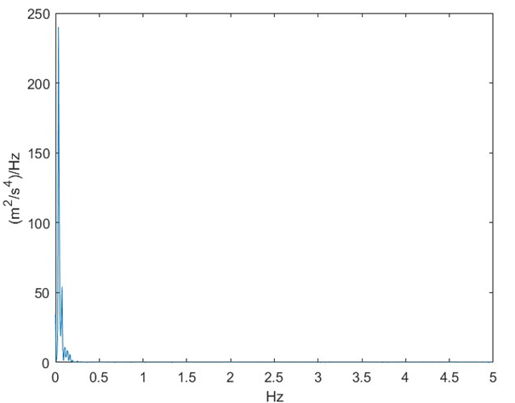
Figure 14. Power spectral density analysis of acceleration data
By analyzing the power spectral density, a cut frequency of 0.25 Hz is chosen to design a low-pass filter to be applied to the data. The result of this filtering is shown in Figure 15.
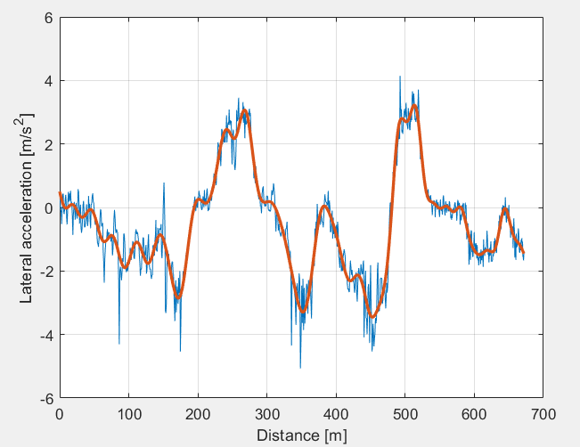
Figure 15. Comparison between filtered (red) and unfiltered (cyan) lateral acceleration
The filtered data is then saved onto a .data file, compatible with Amesim. Such file is used to trace the kinematics data (velocity, longitudinal and lateral acceleration) acting on JUNO.
Once data is obtained and cleared from noise, the simulation is run on the Amesim model, trying to replicate as closely as possible what JUNO performed during on-track testing. By trying to match the acceleration points used in real life testing, it is possible to assess the losses given by cornering maneuvers. Also, a comparison between the vehicle actual lateral acceleration and the simulated one is necessary to understand if the simulation model replicates accurately the real-life performance of JUNO.
The linear velocity in the simulation is overlapped with the linear velocity obtained by on-track testing. By trying to replicate the driver inputs in the simulation model, the result obtained is a very close replica of what the vehicle does, as can be seen in Figure 16.
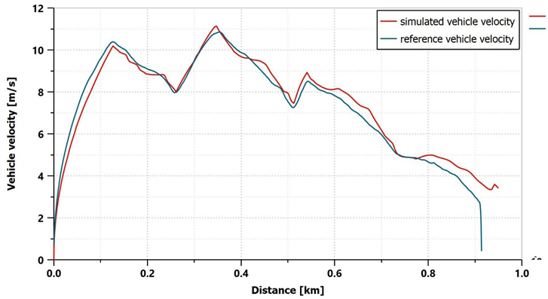
Figure 16. Comparison between real (cyan) and simulated (red) vehicle speed
The points in which the vehicle speed diverges the most are where there are rapid changes of direction. The lateral forces may be sometimes higher than the real counterpart. Moreover, the trajectory followed by the driver during on-track testing may differ from the one used in the simulation, hence modifying the overall altimetry and slopes of the track. The general trend, though, is accurate enough to balance out those disturbances.
The lateral forces are shown in Figure 17, where it is possible to note a disturbance given by the P.I.D. controller used for trajectory control and steering actuation. The trend is anyway satisfactorily accurate.
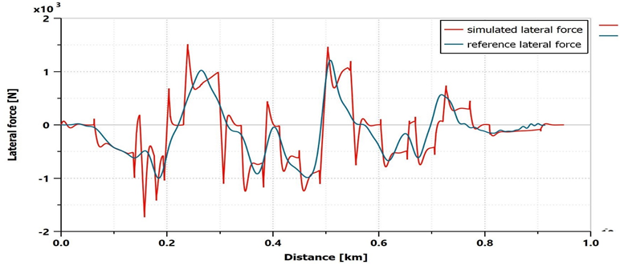
Figure 17. Comparison between real (cyan) and simulated (red) lateral force
Figure 18 shows a comparison between the longitudinal model and the full model with lateral dynamics, to assure the difference of results when the lateral forces are not implemented. Significant changes in the strategy outcome appear. During a single lap the effect of the lack of increased resistances due to cornering showcases a snow-ball effect on vehicle speed which is incorrectly simulated and over-estimated.
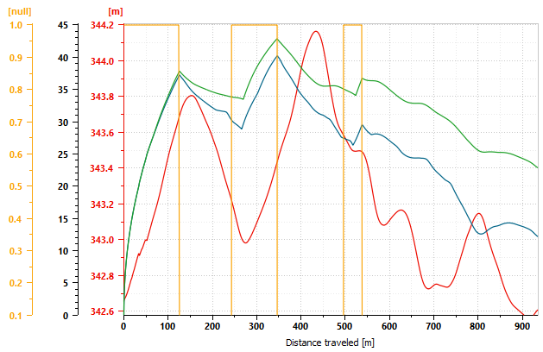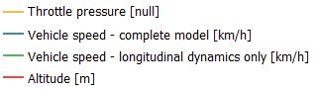
Figure 18. Comparison of vehicle speed between the longitudinal model (green) and the complete one (blue)
Live data analysis for strategy adaptation
Information about JUNO’s performance can be obtained also in real-time fashion thanks to a properly developed telemetry system [9]. The system is made of an electronic board that converts data from the vehicle’s CAN bus to the USB protocol. This board is then connected to a smartphone, which acquires and shows the data on the screen to the driver and on a web application available for the strategists.
The board receives data from a GPS sensor, like the Racelogic PerformaceBox’s, from a barometer, able to detect track altimetry, and from an accelerometer. Data gathered from this system can be used in real time to adapt the strategy towards a most efficient one, by looking at a dashboard (Figure 19).
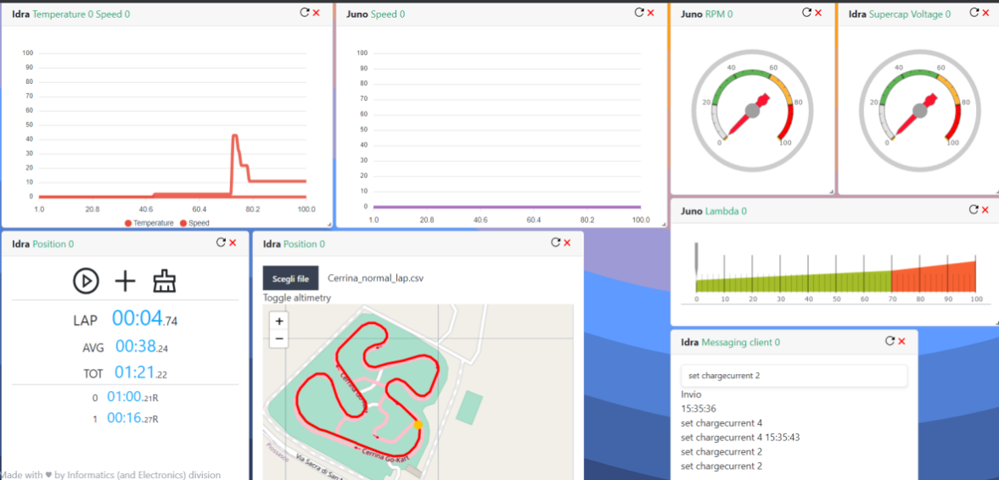
Figure 19. Telemetry system interface
Data from telemetry are used not only in real time, but also in post-processing phase.
Accelerometers sensors, instead, can provide a better estimation of lateral forces than those provided by GPS sensors, improving lateral dynamics analysis.
Model application at Shell Eco-Marathon 2023
The whole 3DOF model has been completed before the start of the 2023 Shell Eco-Marathon (SEM) and has been applied for studying the most efficient race strategy.
The track at which SEM 2023 was held is the Circuit Paul Armagnac, located in Nogaro, France.
For the competition, three different gear ratios were available: 12.96:1, 15.7:1 and 18:1. Through simulation, the choice for the optimal gear ratio was determined, going towards the 15.7:1, with the 18:1 not far off in terms of fuel efficiency.
After the gear ratio choice, all the effort went into fine-tuning the optimal acceleration points and lengths, exploiting Nogaro’s circuit’s favorable features while respecting the maximum-time limit.
Figure 20 shows the motor-on track portions provided by the middle-laps strategy.
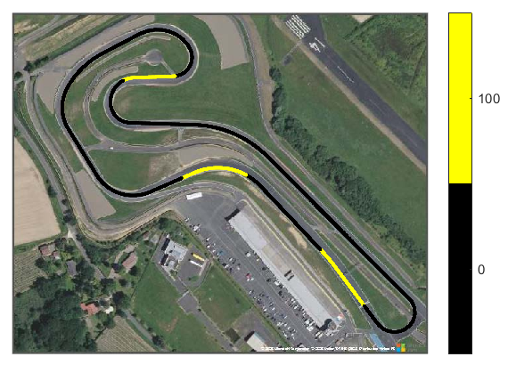
Figure 20. Motor on sectors (in yellow) of middle laps strategy
The simulated consumption for the most optimal race strategy, prior to the start of the competition, was calculated at 258.3 km/L (in terms of equivalent SP95 consumption).
Four different runs have been attempted by JUNO during the 2023 Shell Eco-Marathon, with the following results [10]:
- I_{tr}=15.7:1, 243.03 km/L
- I_{tr}=15.7:1, 252.50 km/L
- I_{tr}=18:1, 251.67 km/L
- I_{tr}=15.7:1, 254.93 km/L
This, after a constant improvement through the four runs, gave JUNO the 3rd place at SEM 2023, obtaining its best result in its history in terms of ranking and of fuel consumption. This gave also an evidence of the effectiveness of the 3DOF dynamic model in simulating JUNO’s performances and in estimating its fuel consumption, with just a 1.32% error with respect to the best result, and also in making easier setup choices: the third run, attempted by mounting the 18:1 gear ratio instead of the 15.7:1 one, made evident that the latter was the most optimal, since that was the only run without any improvement, although with little margin.
Conclusions
The model proves both simple and effective due to its reliability. The choice to include the lateral dynamics of the vehicle has been revealed as fundamental in increasing the model accuracy in predicting the vehicle behaviour and final outcome of a given strategy. The correctness of the model in simulating longitudinal and lateral dynamics of the vehicle is further proven by the correctness of the prediction of fuel consumption. The fuel consumption estimation which is the final objective for this model reveals itself as accurate.
This vehicle model, which is developed with the goal to specifically represent the performance of JUNO, can be easily used, thanks to its simple structure, to simulate also other types of vehicles, just by changing the parameters presented in the “Vehicle parameters identification” section. This simulating system can be a good basis for exploiting vehicle dynamics and optimizing fuel efficiency in many different contexts.
Further improvements can be made in order to characterize the vehicle's behaviour with increased precision. An important improvement would be represented by the tire model. The lack of data about tires cannot allow for a more precise representation of their behaviour. In future iterations of the model, tire data will be implemented to better understand and predict the overall performance of such an important component.
Furthermore, the P.I.D. controller for steering control can be made smoother in order to simulate the driver controls with greater accuracy. Driver input is indeed smoother compared to what the P.I.D. controller is capable of recreating. The P.I.D. controller though has the advantage of a low computational time which makes the simulation time low as a consequence. Quick simulations are useful during fast-paced situations in which making a decision in a few minutes is fundamental. Hence, low simulation times, reliability, and automation are requirements for a good steering controller.
A different type of controller can be studied to accommodate all the given requirements. A proposed solution is the possibility of creating a predictive control. Such control would work on two separate phases the first of which is made specifically to find the most optimal trajectory to follow on a given path. Such phase is ended when the correct prediction is made, and the most optimal path is chosen. Once the path is complete, it is saved together with the inputs needed to cover such track and used in the simulation. The vehicle would be able to automatically recreate the correct inputs without relying on an external controller based on the error between actual and simulated path.
References
- G. Tempone, M. De Carlo and M.Carello, “1D control model of a hydrogen-powered vehicle for race strategy optimization”, 2023 IEEE International Conference on Environment and Electrical Engineering and 2023 IEEE Industrial and Commercial Power Systems Europe, 6-9 June 2023, Madrid, doi: 10.1109/EEEIC/ICPSEurope57605.2023.10194634.
- G. Genta e L. Morello, “The Automotive Chassis”, Torino, Springer, 2009, doi:10.1007/978-1-4020-8675-5.
- L. Ydrefors, M. Hjort, S. Khazzari, J. Jerrelind and A. Stensson Trigel, “Rolling resistance and its relation to operating conditions: A literature review”, Journal of Automobile Engineering, Vol. 235 (12), pp. 2931-2948, 2021, doi: 10.1177/09544070211011089.
- U. Kiencke and L. Nielsen, “Automotive Control Systems”, Heidelberg: Springer Berlin, 2005, doi: 10.1007/3-540-26484-1_8.
- J. P. Brossard, “Dynamique du Véhicule, Modélisation des systémes complexes”, Chapter 4, PPUR (Presses Polytechniques et Universitaires Romandes), 2006.
- H. B. Pacejka, Tyre and vehicle dynamics, Butterworth-Heinemann, 2006; ISBN 9780750669184.
- “The tire digest” 2023, Available: https://thetiredigest.michelin.com/michelin-ultimate-energy-tire.
- F. Ballo, P. Stabile, M. Gobbi and G. Mastinu, “ Lightweight Ultra-Efficient Electric Vehicle Multi-Physics Modeling and Driving Strategy Optimization”, IEEE Transactions on vehicular technology, vol. 71, n. 8, pp. 8089-8103, 2022, ISSN: 0018-9545.
- M.De Carlo, E. Simeone, L. Radano and M.Carello, “A telemetry-driven architecture for the development of data-intensive race strategies”, Proc. of International Conference on Artificial Intelligence, Computer, Data Sciences and Applications (ACDSA 2024), 1-2 February 2024, Victoria-Seychelles (accepted after revision).
- Shell Eco Marathon Rules 2023, Available: https://www.shellecomarathon.com/2023-programme-on-track/regional-europe.html.
Contact Informations
Massimiliana Carello - massimiliana.carello@polito.it
Giuseppe Pio Tempone - giuseppe.tempone@polito.it
Matteo De Carlo - decarlomatteo.mdc@gmail.com
Paolo Dragone - paolodragone.h2o@gmail.com
Politecnico di Torino – Mechanical and Aerospace Engineering Department
Corso Duca degli Abruzzi, 24 10129 Torino – Italy
Acknowledgments
Thanks to the remaining part of the team H₂politO that made possible the realization of this project and in particular to the Strategy group for the help and simulation activity year by year.
Thanks to Siemens for providing software and tools.
The vehicle JUNO is financially supported by the “Committee on Contributions and funds for students’ projects” of the Politecnico of Turin and other sponsors and technical partners (see also www.polito.it/h2polito).
Definitions
$$a_{1/2}$$ | Wheelbase (1 – front, 2 – rear) [m]
$$α_{1/2}$$ | Tire side slip angle (1 – front, 2 – rear) [rad]
$$α_{slope}$$ | Track slope [%]
$$b_{1/2}$$ | Half-track (1 – front, 2 – rear) [m]
$$b_{φ}$$ | Total roll damper rating [Nm×s/rad]
$$β,\dot{β}$$ | Car body side slip angle and velocity [rad, rad/s]
$$C_{x}$$ | Drag coefficient [null]
$$D_{1/2}$$ | Tire cornering stiffness (1 – front, 2 – rear) [N/rad]
$$δ$$ | Steering angle [rad]
$$ε_{1/2}$$ | Coefficient for roll-induced toe angle (1 – front, 2 – rear)
$$f_{0}, f_{1}, f_{2}$$ | Rolling resistance coefficients [null, s/m, s²/m²]
$$g$$ | Gravitational acceleration on Earth [m/s²]
$$h$$ | Relative position of roll center with respect to vehicle center of gravity [m]
$$h_{g}$$ | Vehicle center of gravity height [m]
$$h_{r1/2}$$ | Absolute height of roll center (1 – front, 2 – rear) [m]
$$I_{xx}$$ | Vehicle roll inertia [kg×m²]
$$I_{zz}$$ | Vehicle yaw inertia [kg×m²]
$$K_{φ}$$ | Total anti-roll stiffness [Nm/rad]
$$λ_{1/2}$$ | Coefficient for roll-induced camber angle (1 – front, 2 – rear) [null]
$$M$$ | Vehicle mass [kg]
$$φ, \dot{φ}, \ddot{φ}$$ | Roll angle, velocity, and acceleration [rad, rad/s, rad/s²]
$$ψ, \dot{ψ}, \ddot{ψ}$$ | Yaw angle, velocity, and acceleration [rad, rad/s, rad/s²]
$$ρ_{air}$$ | Density of air [kg/m³]
$$S$$ | Vehicle frontal section area [m²]
$$v$$ | Vehicle speed [m/s²]
$$v_{wind}$$ | Wind speed [m/s²]

