Supporting Information of:
Simple Approach Using g-C₃N₄ to Enable SnO₂ Anode High Rate
Performance for Li Ion Battery
Daniele Versaci, Julia Amici, Carlotta Francia, Silvia Bodoardo
Fig. S1 N₂ adsorption desorption measurements at 77 K of samples SnO₂, C₃N₄, SnO₂@C₃N₄.

Element | Area 1 |  | Area 2 |  | Area 3
 | Weight % | Atomic % | Weight % | Atomic % | Weight % | Atomic %
Sn | 59.19 | 15.77 | 60.92 | 16.78 | 57.40 | 14.72
O | 24.79 | 48.99 | 23.89 | 48.80 | 25.75 | 48.98
C | 8.21 | 21.61 | 7.51 | 20.45 | 9.12 | 23.10
N | 4.55 | 10.27 | 4.55 | 10.61 | 4.71 | 10.23
Cl | 2.30 | 2.05 | 2.17 | 2.00 | 2.22 | 1.91
Na | 0.95 | 1.31 | 0.95 | 1.36 | 0.80 | 1.06
Total: | 100.00

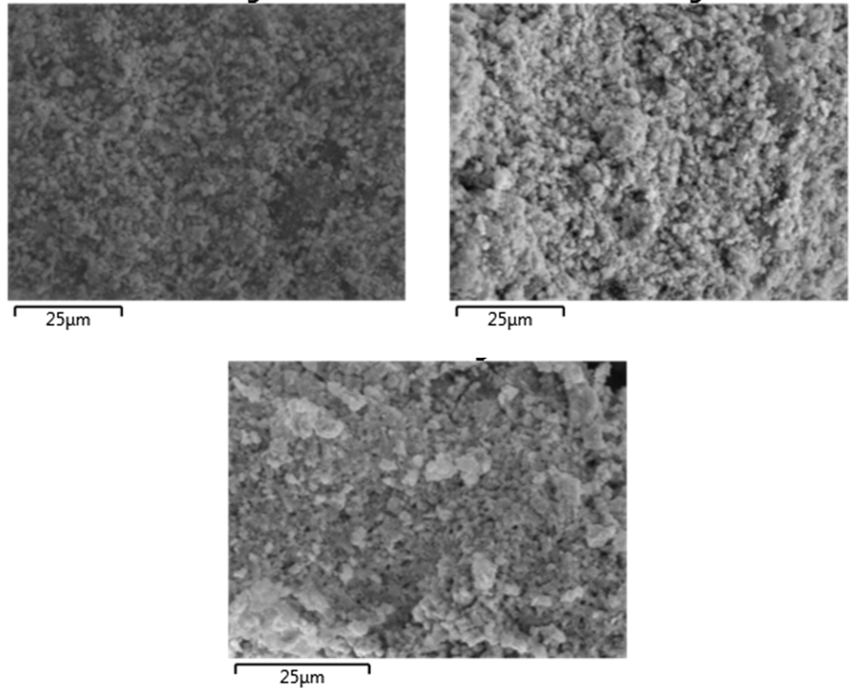
Area 3
Area 2
Area 1

Fig. S2 EDS of the SnO₂@C₃N₄ sample.

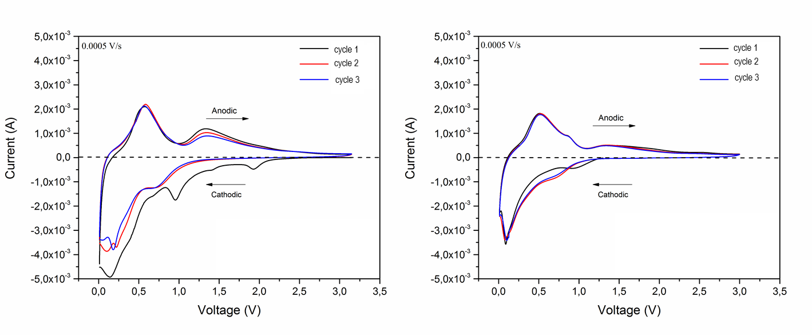
Fig. S3 Cyclic voltammetry of sample SnO₂ in the voltage range of 0.01-3.25 V vs Li⁺/Li at 0.5 mV/s (left), three CV cycles collected after 10 galvanostatic discharge/charge cycles at 0.78 A/g.

