A telemetry-driven architecture for the development of data-intensive race strategies

Matteo De Carlo
Mechanical and Aerospace Engineering Department
Politecnico di Torino
Turin, Italy
decarlomatteo.mdc@gmail.com
Emanuele Simeone
Mechanical and Aerospace Engineering Department
Politecnico di Torino
Turin, Italy
emanuelesimeone0@gmail.com
Luigi Radano
Mechanical and Aerospace Engineering Department
Politecnico di Torino
Turin, Italy
luigi.radano03@gmail.com
Massimiliana Carello
Mechanical and Aerospace Engineering Department
Politecnico di Torino
Turin, Italy
massimiliana.carello@polito.it 0000-0003-2322-0340

Abstract—The paper presents the design, development, and implementation of a telemetry system able to acquire the vehicle parameters and process them in real time, thanks to a specific mathematical model. The live data provided to the driver helps establishing the best driving strategy, also thank to a continuous connection with the pitwall. The architecture of the telemetry system consists of an electronic board, capable of managing information towards the driver, received from a smartphone, and forwarded to the cloud for external monitoring, which allows for real-time changes to the control strategy. In particular, the developed system has been used during the Shell Eco-marathon competition to obtain the lowest possible consumption.
Keywords—telemetry, vehicle dynamics, race strategy, transmission data, data acquisition, performance.

Introduction
Telemetry is a key factor in modern motor racing, like Formula 1 or Formula E. In fact, it enables the collection of data (for example about speed, acceleration, and track position) from remote points to support monitoring, analysis and visualization. Engineers are able to interpret a vast amount of data collected during a test or race and use them to fine-tune the vehicle set up for optimal performance.
The data collected from sensors installed on car components are transmitted to the pitwall to be used as input of real-time car performance simulations, to obtain the best lap time [1, 2] or to the best consumption.
As a function of the competition, the vehicle is equipped with many sensors, for example: acceleration, temperature, wheel and vehicle speed, vehicle position on track and time, aerodynamic and mechanical load, suspension displacement, etc.
To enhance vehicle performance it is important to have a handy, precise, and accurate storage of the history of technical parameters collected, for example during tests campaign or tests before the race obtained in the same track to establish the best race strategy before the competition.
Furthermore, there are some competition cars where the telemetry is bidirectional, in fact it is important gives engineers the ability to update the calibrations on the car in real time, to modify the most important parameter to improve the performance, usually the vehicle speed and lap time but, in the recent years, also the consumption.
In this paper, a telemetry system for Shell Eco marathon [3] competition vehicle is presented. Thanks to its versatile nature has been used for two different categories of vehicles designed and built at the Politecnico di Torino by the Team the H₂politO: a prototype IDRAzephyrus, a three wheels prototype powered through a Fuel Cell, Supercapacitors and Electric Motor coupled (Figure 1) and an Urban Concept JUNO, an Internal Combustion car supplied by bioethanol (Figure 2).
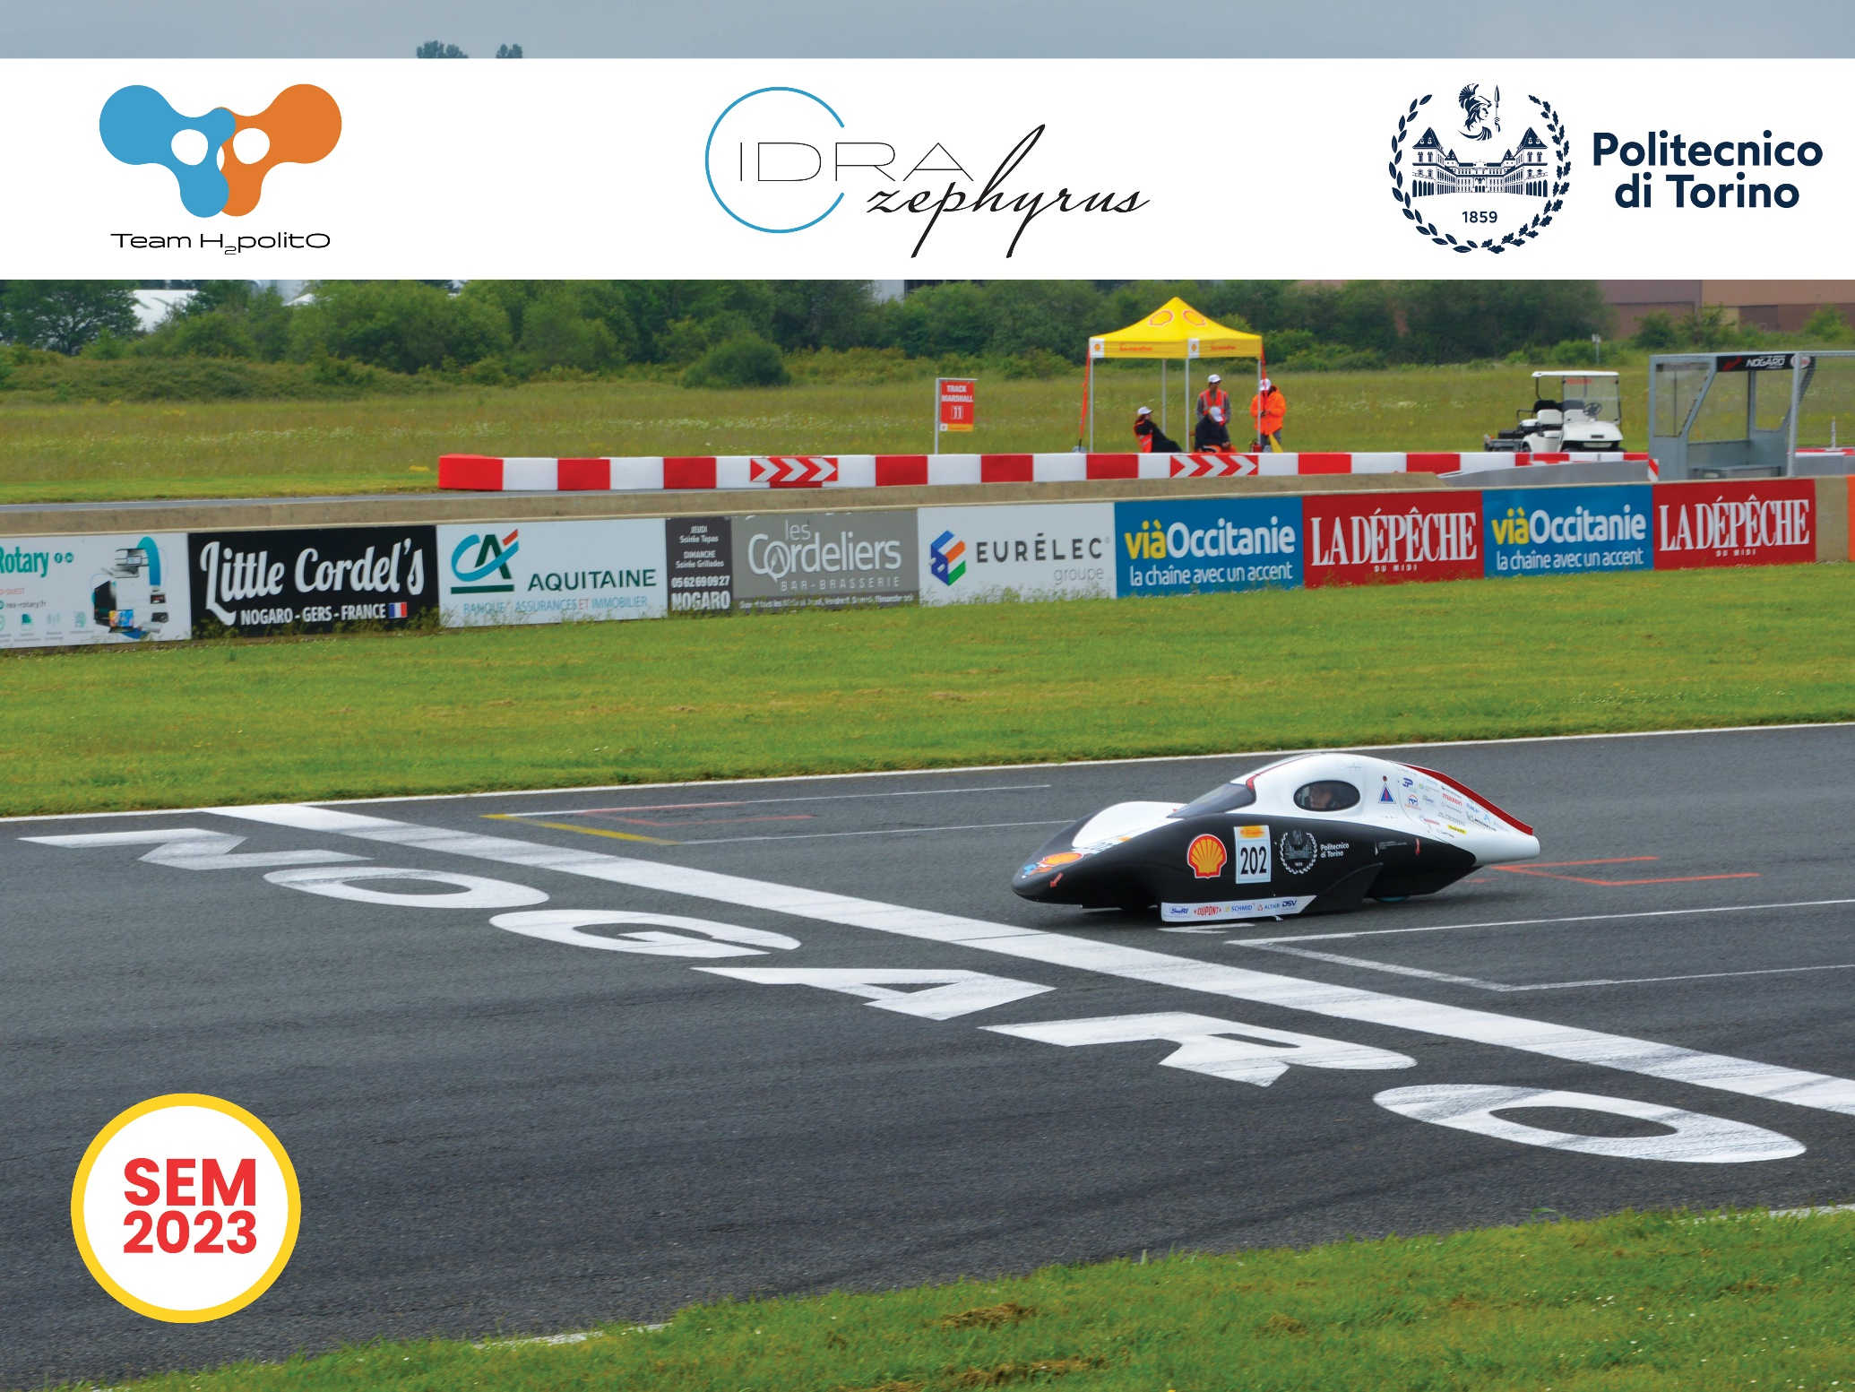
Fig. 1. The Prototype IDRAzephyrus
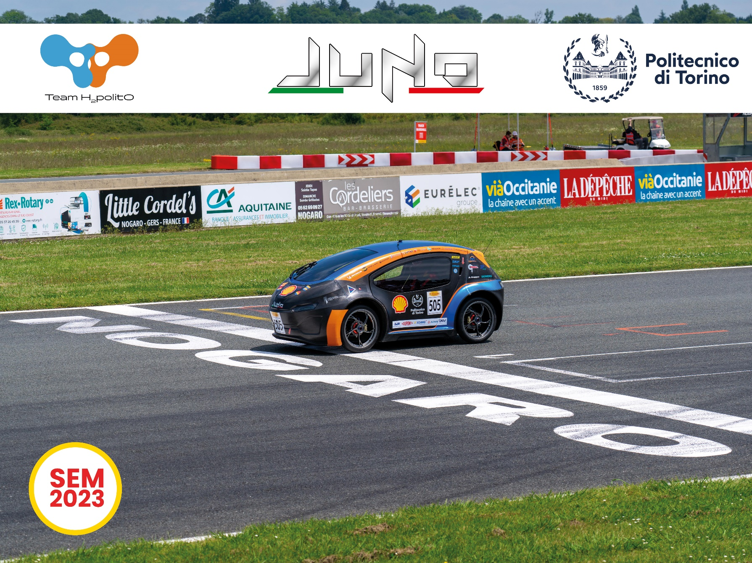
Fig. 2. The Urban Concept JUNO
The Shell Eco-Marathon happens yearly in different racetracks - Europe, America and Asia - but with the same goal: reaching maximum efficiency in terms of fuel consumption. The vehicles to be classified have to cover a pre-established number of laps of the track in a maximum time, corresponding to an average speed of 25 km/h. At the end of the race the winner is the vehicle that, in his category (combustion engine, fuel cell or battery electric), obtain the lowest consumption, measured in km travelled with the equivalent of 1 L of gasoline.
The data, obtained from the developed telemetry system, have been used for the Strategy and Vehicle dynamics model to optimize, through the action of the driver, the trajectory (as a function of the traffic in the track) or the vehicle speed.

Architecture Introduction
The developed telemetry system is composed of 3 main nodes:
- a custom-built sensory board that allows to gather data over the vehicle,
- a smartphone in the driver's cockpit to visualize information on the screen and to communicate with the paddock,
- a full stack web application that allows the pit-wall to visualize, interact and gather information of the vehicle, both in real-time and for post-processing.
The three parts are depicted respectively with the red, green, and blue dashed boxes in Figure 3.
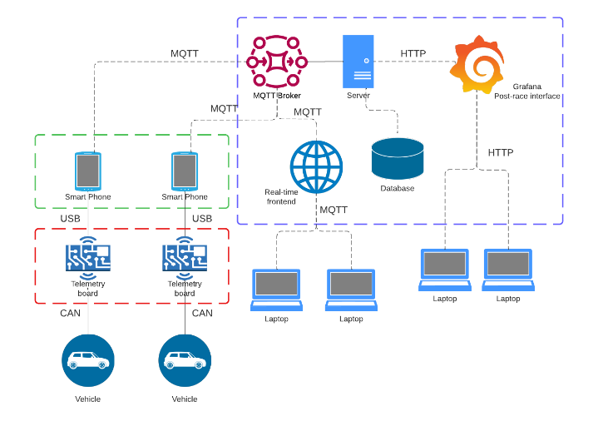
Fig. 3. Architecture of the telemetry system
The main communication protocol involved for remote and real-time communication between the car and the remote server is MQTT, a lightweight publisher-subscriber network protocol that allows to send and to receive data and information in remote locations, such as practice and competition circuits [4].
To access data from the database for post-processing analysis, HTTP API requests has been done to transfer heavier files like data from a specific run.

Hardware
The specially crafted PCB board, shown in Figure 4, serves as the interface gateway for the smartphone, facilitating the extraction of data from the CAN bus, where various electronic boards communicate with one another. Subsequently, the data is transmitted to the mobile device via the USB protocol.
Additionally, the board incorporates extra sensors that enhance the understanding of the circuit and the vehicle's dynamics. The current hardware setup includes:
- GNSS positioning for precise location tracking, approximate lap-time calculations, and strategic point setting.
- A barometric sensor to capture altimetry data [5], providing valuable insights into track altimetry to refine run strategies.
- Accelerometers for acquiring quantitative data on the vehicle's dynamics during turns.
- Steering wheel positioning to record information about the steering angle, aimed at minimizing tire slippage, optimizing fuel consumption, and gathering information for modelling the vehicle’s lateral dynamics.
The data from the vehicle and these supplementary sensors are acquired and transmitted synchronously to the smartphone.

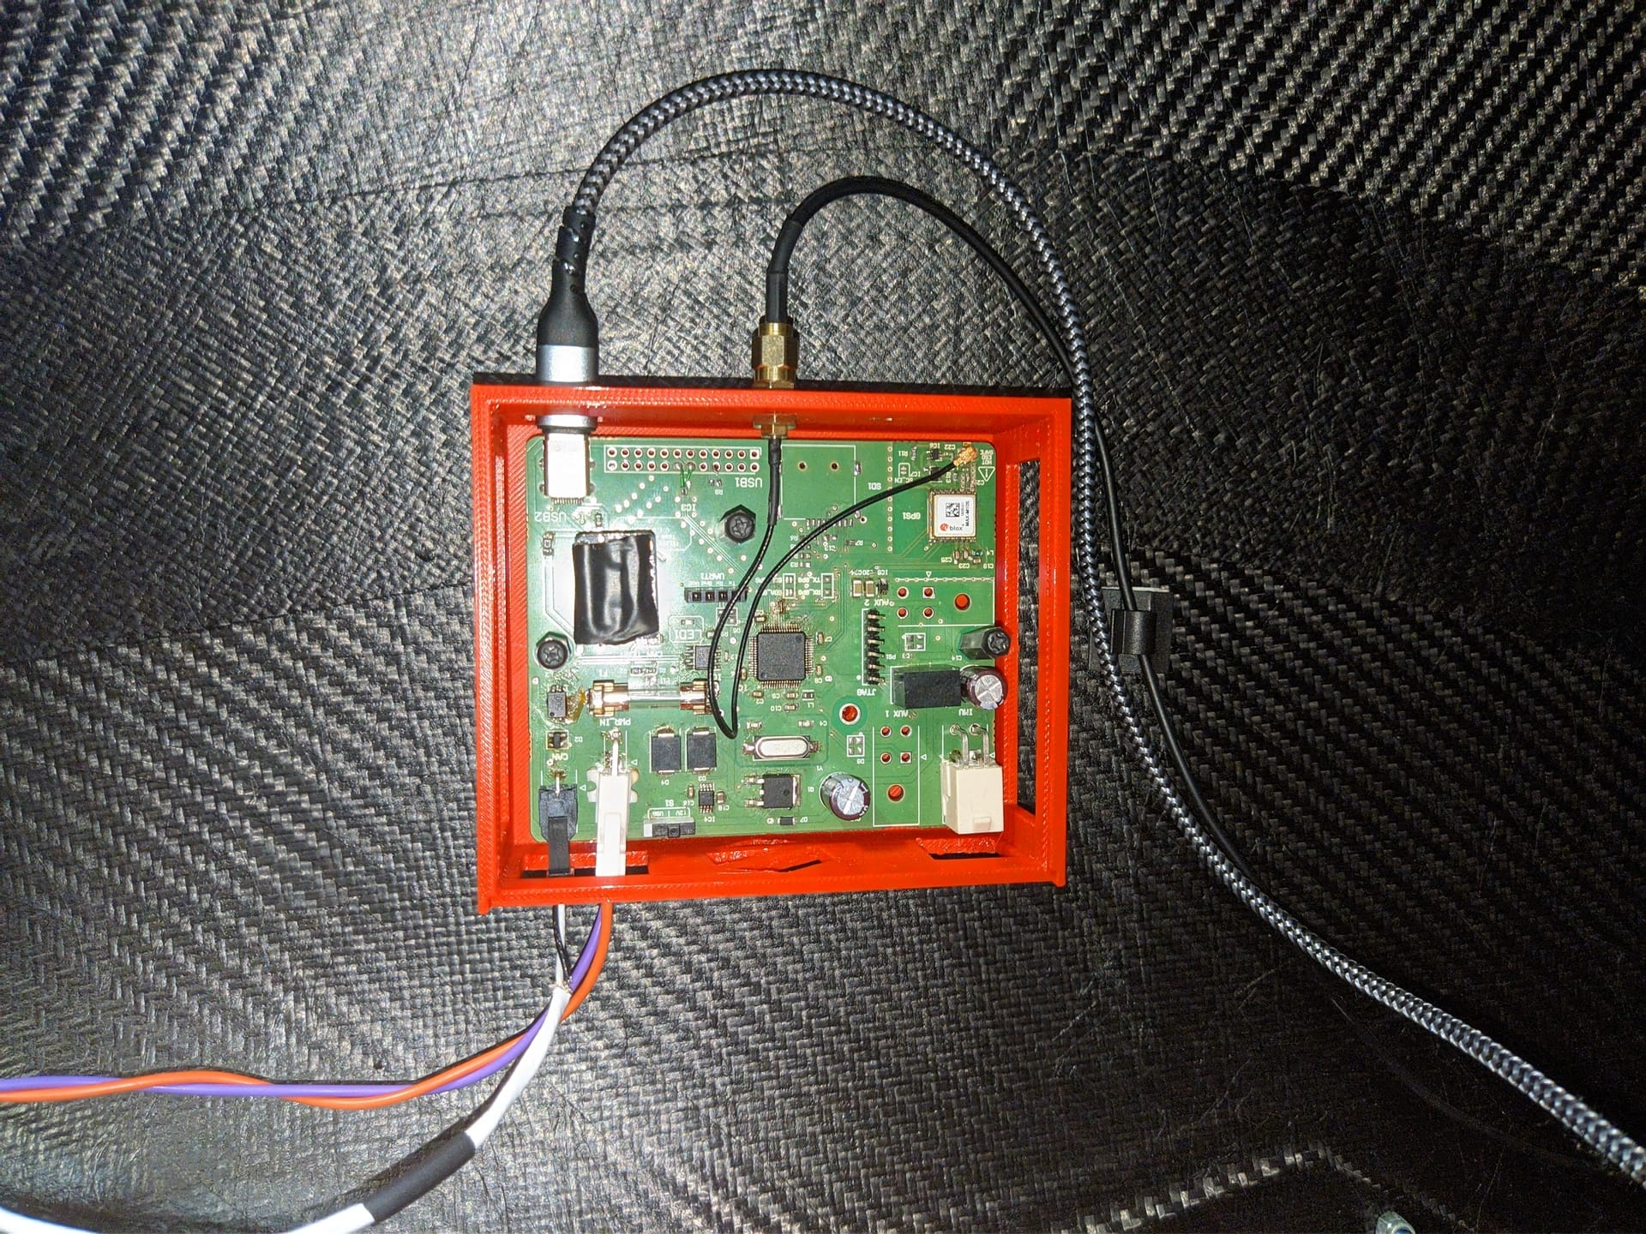
Fig. 4. Telemetry board installed in the vehicle

Mobile Application
The Android application acts as a screen for the driver to show the parameters of the vehicle to allow to the driver to respect the set strategy defined by the Race Strategy Division. The phone is placed on the top part of the steering wheel, as shown in Figure 5. Depending on the vehicle and the fuel type (Hydrogen or Combustion Engine powered), various types of data regarding the prototypes and their powertrain are necessary to be sorted of and shown on the screen.
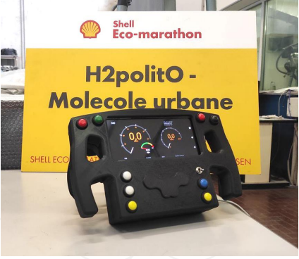
Fig. 5. Integration of the smartphone and app in JUNO’s steering wheel
If the strategy involves a FC hydrogen prototype (e.g. IDRAzephyrus of Figure 1) it might require the driver to observe the supercapacitors stack and fuel cell voltages and act on them through rapid manoeuvres on the steering wheel to achieve maximum energy efficiency. Instead, for an ICE urban concept (e.g. JUNO of Figure 2), the driver is required to accelerate and change gears at precise speed and accelerate to maintain the engine in its optimal operating range.
The mobile application has also additional features: vehicle data are saved in an internal file storage and uploaded automatically over the cloud, other than the possibility to stay in contact with the driver to communicate updates of the track status, the strategies, and eventual emergencies (i.e. accident on track).

Web Application
The primary purpose of the Web application is to receive real-time data and present it through customizable graphs by the user. A dynamic user interface to accommodate the different vehicle parameters has been chosen. This approach allows each Strategy engineer to monitor specific information, enabling effective communication with the Strategy Leader to convey the current state and performance of the vehicle.
The web application comprises three key sections:
- a front end application, employing a React single-page interface for on-the-go and post-processing data access,
- a back end application hosting our MQTT server,
- a required code for API requests, and a well-organized database structuring data by files for later data retrieval.
At the front end, besides accessing user information, there is the possibility to upload custom strategy maps. These maps serve as a guide to the driver to illustrate the correct inputs required on the steering wheel for successive laps. This feature enhances comprehension of set strategies, assisting the driver in adhering to predefined acceleration and deceleration points picked by the dynamics division.
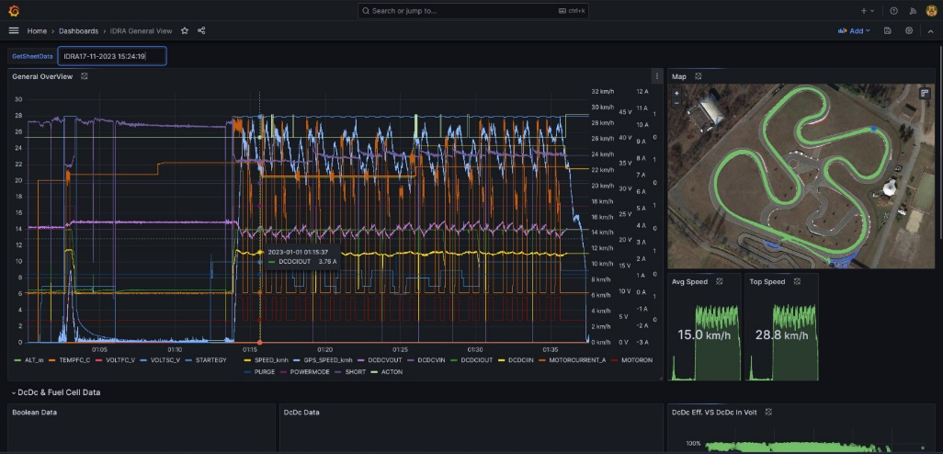
Fig. 6 Customizable Grafana post-race interface
A supplementary website section introduces a Grafana dashboard, as shown in Figure 6, for post-processing the acquired vehicle information. This allows for convenient access, visualization, and online processing of telemetry data related to the track trial after each run. Importantly, this streamlines the analysis process, eliminating the need for additional tools and accelerating the understanding of the vehicle's performance.
The last additional feature implemented is the possibility of controlling remotely various settings of the vehicle, allowing the Race Team to perform operations and parameters adjustments (like changes of the charging of supercaps currents for the fuel cell vehicle) remotely even during the race to strive for the maximum energy efficiency.

Data Acquisition and Visualization
All data collected by the telemetry board during testing or racing is saved into a .csv file. This file contains:
- Vehicle’s longitude and latitude coordinates, acquired by the GNSS device.
- Raw altimetry, given by the installed barometer.
- Vehicle’s speed, given by a wheel speed sensor.
- GNSS Vehicle’s speed.
• For Fuel Cell vehicles, as IDRAzephyrus:
o FC temperature.
o FC and supercaps voltages and currents.
o Strategy (that is the reference motor current to reach when a motor-on is commanded).
o Motor current (comparable with the strategy).
o Steering wheel’s control signals, in particular:
- Purge (indicates when it is done in the FC).
- Short (indicating commanded short circuits in the FC).
- Powermode (controls the connection of the supercaps to the vehicle’s electrical system).
- Actuation (providing the time instants in which the motor control board is powered or not).
• For Internal Combustion Engine vehicles, as JUNO:
o ICE temperature.
o ICE rotational speed.
o ICE fuel injection lambda.
All this data, flowing through the vehicle’s CAN communication bus, is correlate with a time vector, making possible synchronization between different sensors.
The average data sample frequency can be approximated to 10 Hz.
All this information can be viewed both online, during test on track, through the usage of the telemetry website, and offline, via a properly made MATLAB script, which allows visualization and deep analysis of vehicle data acquired by the telemetry system.
The first part of the script shows the vehicle’s trajectory detected by the GNSS device mounted on-board, and a comparison between vehicle velocity information provided by the GNS and the wheel speed sensors, as can be seen in Figures 7 and 8 respectively.
Figure 8, shows, in particular, the vehicle speed acquired by GNSS and by the wheel sensor. The difference between the two speeds allow to estimate the wheel longitudinal slip, especially during JUNO’s standing start procedures, and this data it is very important for the vehicle dynamic model and to establish the correct race strategy.
Then, electrical data is displayed through plots. SC and FC voltages and currents are presented, other than the motor current compared to its control reference. This information is also synchronized with the steering wheel’s control signals and the emergency signals, which makes it possible to correlate performances and anomalies detected through the race run.
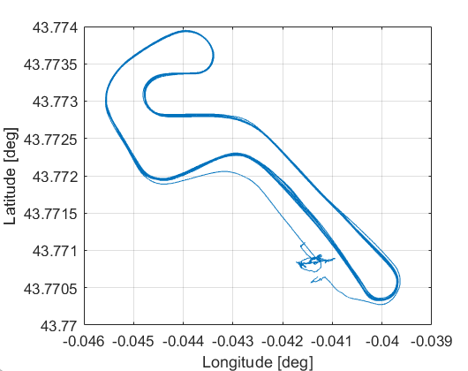
Fig.7. Vehicle's track position displayed by the script
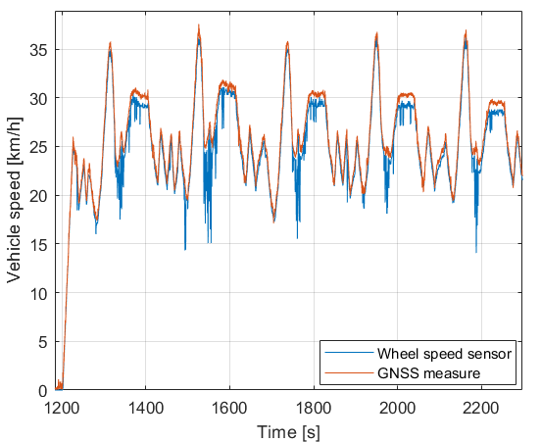
Fig.8. Vehicle's speed: comparison between GNSS and sensor wheel speed
The strategy is done by referring to geographical references, so it can be useful to correlate data to the vehicle’s position on track [6], as it is done lap by lap through the creation of color maps, presented in Figure 9. These maps make it possible to detect the track positions in which maximum and minimum speeds are obtained, the positions in which critical supercaps voltages are reached, the track portions in which the motor is running, and at which reference current. This can be useful to understand the accuracy of strategy execution in terms of positioning of the motor-on and motor-off track points.
As will be presented in the next section, it is important also to export this data to Siemens Simcenter Amesim, in which the vehicles’ dynamic models have been developed [7, 8]. In particular, it is necessary to export the telemetry data to a .data file format, which is the one readable by Amesim, and this has been done with a properly developed MATLAB script. The user can choose which data to export in a command window. The measurement about speed, voltages and strategy currents can be exported, related to time or distance travelled on track.
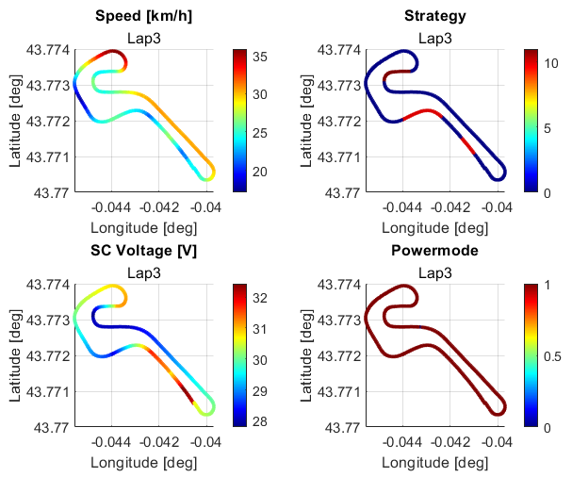
Fig. 9. Coloured maps generated by the script, displaying performance data

Data Analysis
Data provided by telemetry can be used for vehicle dynamics performance evaluation, consumption estimation, strategy optimization, simulation model correction and validation.
A first example can be the data analysis of the centrifugal clutch mounted on JUNO’s powertrain, in which its spring rate and preload variables optimization is important for obtaining the total engagement of the engine with the gearbox in the desired speed range in terms of efficiency. Many on-track tests have been done with different clutch configurations; by comparison of data related to the clutch slip during starting procedures, for which an example is reported in Figure 10.
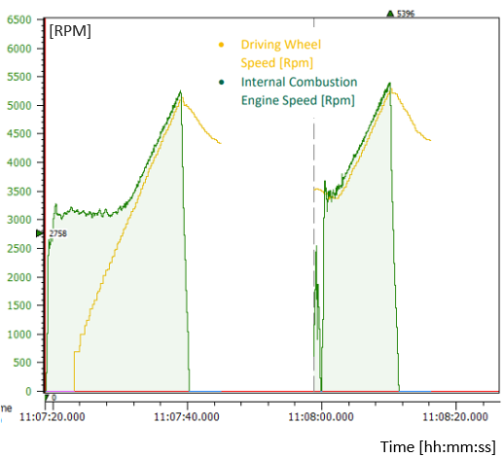
Fig. 10. Speed for evaluation of slip behaviour of the centrifugal clutch
Data provided by telemetry is used also for modelling the FC behavior. Information regarding FC voltage and current are reported, with the short circuits and purge commands through the run.
During test on track and by experimental tests on the FC, it has been seen a progressive decrease of the cell voltage through time at constant currents, until a short circuit or a purge is commanded, which puts the voltage back at the original value, meaning an efficiency recovery.
This behavior has been modelled through telemetry data employing a LASSO algorithm [9] that examines current and voltage data and correlates them with the time that occurred between purge or short circuit commands for the fuel cell. The results are shown in a 3D map, depicted in Figure 11, which has been used in the Amesim models for better estimation of FC performance during race run simulation.
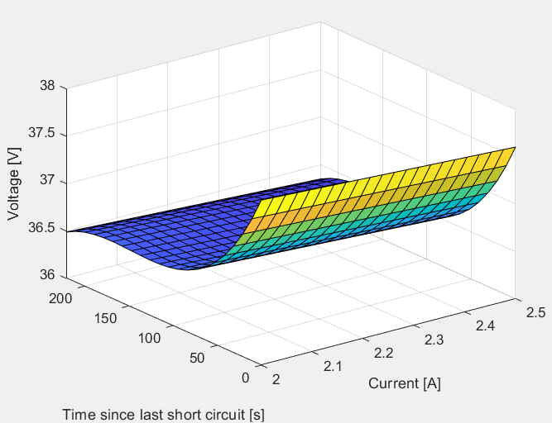
Fig. 11. 3D FC polarization curve, based on time since the last short circuit
Telemetry data are of great importance for reviewing Amesim models’ performance and correcting its weaknesses. This is useful to validate these models, which are crucial to estimate the optimal strategy to employ on track during tests or competition runs.
The MATLAB script exports telemetry data in a compatible format for Amesim, becoming visualizable on in-software plots. This is a very powerful methodology for model validation since this data can be visually compared with data given by the simulation (Figure 12). The vehicle’s speed, SC and FC electric quantities, and electric motor currents can be analyzed together with simulation results, making it possible to actuate a correction and estimation of the system’s parameters, which can be related to the vehicle rolling resistance, its tires’ cornering stiffness, the motor efficiency, or the supercaps capacitance.
The usage of data acquired by the telemetry system is very important to improve model performance in terms of the capability to represent faithfully the real vehicle behavior on track. A well-validated model, through correlation with real data, makes it possible to accurately predict which can be the most efficient a-priori race strategy to apply during the competition, with a good certainty of obtaining a track performance similar to the one predicted by the simulation. Having a good predicting model is important also, for performing reliable off-track analysis of vehicle setup, as happened with JUNO’s centrifugal clutch tuning presented previously.
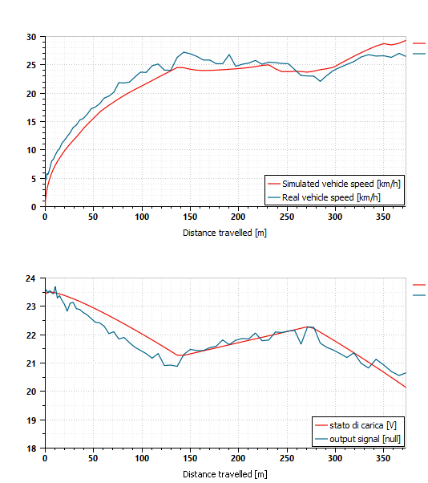
Fig. 12. Vehicle speed real and simulated (upper part) and supercaps voltage (lower part)
Live visualization of data, through the telemetry website, is important to understand whether the vehicle is performing as expected or not and allows the strategist to intervene by modifying the strategy or suggesting to the driver which commands to use on the steering wheel for solving eventual technical problems that may be encountered during a race run. There is also the possibility, by future developments, to improve this live visualization of data by automatically suggesting, which are the operations necessary for improving the vehicle’s efficiency and reliability.
IDRAzephyrus and JUNO performed well in the Shell Eco-Marathon 2023 and obtained both 3rd place in the competition [10]. JUNO obtained a result of 254.93 km/L, with just a 1.32% error with respect to the model-predicted result [8], showing the effectiveness of data analysis and correlation procedures performed to validate the model.
IDRAzephyrus, at its first participation, completed three runs over four attempts, but they would have been less without the possibility, provided by the telemetry system, to gather live data from the vehicle and detect the causes of technical problems that, without intervention, would have made impossible to complete the race attempt.
Efficiency performance improved too thanks to telemetry, given the possibility to remotely modify the supercaps recharge current to a more efficient amount during the competition run, through commands sent in the message box implemented in the telemetry website.

Conclusion and Future Developments
In conclusion, the telemetry system developed and applied at Shell Eco Marathon vehicles represents a significant leap forward in the pursuit оf enhanced energy efficiency and racing performance.
The integration оf custom hardware, a dedicated smartphone app, and a web-based visualization platform not only provides real-time insights into the intricate dynamics of our prototype vehicles, but also exemplifies an innovative approach to data-driven decision-making іn the realm of competitive racing. Our architecture could allow racing teams in different competitions and the respective strategists to easily configure the parameters to monitor and to interact with them bidirectionally. Data can be sent and received wirelessly, allowing changes to the vehicle setup, like ICE mappings, kinetic energy recovery and electric energy delivery systems for an F1-like competition.
All this can be easily achieved with this lightweight, compact and scalable ecosystem, that includes a CAN interface for the already present bus implemented in most of the vehicles, a visual interface for the driver, and a remote management and data visualization console for the team.
Furthermore, the applicability оf the telemetry system extends beyond the racetrack. The same principles and components can be seamlessly adapted for city mobility, addressing the growing need for efficient fleet management in the urban context of electric bike or scooter rental services. By implementing the developed telemetry system and architecture, rental companies can gain unprecedented visibility into the performance of their electric fleets, enabling optimized maintenance schedules, route planning, and resource allocation.
This scalability underscores the versatility and practicality of the proposed approach, positioning the telemetry system not only as a competitive advantage for racing applications, such as the Shell Eco-marathon, but also as a potential solution for advancing sustainable urban mobility.

Abbreviations
- API: Application Programmable Interface
- CAN: Controller Area Network
- EM: Electric Motor
- FC: Fuel Cell
- GNSS: Global Navigation Satellite System
- HTTP: Hyper Text Transfer Protocol
- ICE: Internal Combustion Engine
- MQTT: Message Queueing Telemetry Transport
- PCB: Printed Circuit Board
- SC: SuperCapacitor
- USB: Universal Serial Bus

Acknowledgment
Thanks to the remaining part of the team H₂politO that made possible the realization of this project and in particular to the Electronic and Informatic group for the help.
The vehicles IDRAzephyrus and JUNO are financially supported by the “Committee on Contributions and funds for students’ projects” of the Politecnico of Turin and other sponsors and technical partners (see also www.polito.it/h2polito).

References
- A Banerjee, A V Jindal, A Shankar, V Sachdeva and M Kanthi, “Motorsport Data Acquisition System and Live Telemetry using FPGA based CAN controller”, Journal of Physics: Series, 2022, doi:10.1088/1742-6596/2161/1/012041.
- D. Assies, “Developing a Smart Telemetry Feedback System for Sim Racing”, 35th Twente Student Conference on IT, 2022.
- https://www.shellecomarathon.com/about/global-rules.html
- U. Hunkeler, H. L. Truong e A. Stanford-Clark, “MQTT-S — A publish/subscribe protocol for Wireless Sensor Networks”, 3rd International Conference on Communication Systems Software and Middleware and Workshops COMSWARE, 2008.
- W. G. Brombacher, “Altitude by measurement of air pressure and temperature”, Journal of the Washington Academy of Sciences, vol. 34, n. 9, pp. 277-299, 1944.
- M. Carello, A. Ferraris, H. de Carvalho Pinheiro, D. Cruz Stanke, G. Gabiati, I. Camuffo, and M. Grillo, “Human-Driving Highway Overtake and Its Perceived Comfort: Correlational Study Using Data Fusion,” WCX SAE World Congress Experience, SAE Technical Paper 2020-01-1036, 2020, doi:10.4271/2020-01-1036.
- M. Carello, M. De Carlo and G. P. Tempone, “1D control model of a hydrogen-powered vehicle for race strategy optimization” 2023 IEEE International Conference on Environment and Electrical Engineering and 2023 IEEE Industrial and Commercial Power Systems Europe (EEEIC / I&CPS Europe), Madrid, 6-9 june, 2023, doi: 10.1109/EEEIC/ICPSEurope57605.2023.10194634.
- M. Carello, M. De Carlo and P. Dragone, “3DOF Vehicle Dynamics Model for Fuel Consumption Estimation”, WCX SAE World Congress, Detroit, 16-18 April 2024 [accepted, in press].
- R. Tibshirani, “Regression Shrinkage and Selection via the Lasso” Journal of the Royal Statistical Society. Series B (Methodological), vol. 58, n. 1, pp. 267-288, 1996.
- S.E.M. 2023. https://www.shellecomarathon.com/2023-programme-on-track/regional-europe.html.

