2025-36-0050

Multi-physics Numerical Modelling of a Magnetorheological Braking System
Henrique de Carvalho Pinheiro¹, Lucas Billiant², Giovanni Imberti¹ and Massimiliana Carello¹
¹Politecnico di Torino, Italy and ²INSA Centre Val de Loire, France

Abstract
The global effort to reconsider transport in compliance with ecological challenges leads to a significant increase in the market share of Electric Vehicles (EVs), enlightening secondary sources of pollution. One of the most important is the particles emitted by the abrasion of braking pads. The innovative system addressed in this paper is among the most promising non-polluting solutions to ensure safety and comfort. It uses the capability of the Magneto-Rheological Fluid (MRF) to change its properties when subjected to a magnetic field, generating a braking torque between a stator and a rotor. This study focuses on characterizing the system's performance and endurance during an emergency braking situation by developing a numerical model that involves fluid and structural considerations. This model takes the form of a Finite-Element Model (FEM) that interpolates local forces determined from Computational Fluid Dynamics (CFD) and takes them as input. It enables analysis of the stresses induced by the variation of fluid behavior described by a Bingham theoretical model developed following experimental rheological results.
Introduction
The current ecological context is leading to a general reevaluation of propulsion systems. In Europe, particularly since the first European emission standards for internal combustion engine vehicles in 1992, the legislation becomes stricter approximately every five years. Consequently, manufacturers increasingly turn to emission-free alternatives such as electric vehicles [1], which gain significant market share. The reduction of exhaust emissions highlights other sources of pollution, including the braking system. Indeed, most of today's vehicles are equipped with friction brakes, primarily for their high performance, even at high temperatures. However, the friction causes pads to disperse, up to 3.5 mg of dust into the surrounding air for each braking action [2].
This dust, composed by 74% to 94% of fine metallic particles [3], creates significant environmental and health hazards. For this reason, innovative zero-emission braking solutions are arising, notably Regenerative Braking (RB) implemented on most EVs, while being the most efficient in less complex configurations like in-wheel motors that are still in development. Indeed, RB technology is based on the capability of electric motors to work as generators, allowing vehicles to gather and store a part of the kinetic energy. This condition, though, makes it unusable with fully charged batteries.
Even if RB constitutes an excellent alternative as it can reach up to 0.6 g deceleration peaks, possibly reducing the use of traditional brakes in most urban driving scenarios, in situations like emergency braking - requiring levels of deceleration in the range of 1 g - a parallel braking system is necessary to ensure safety conditions, leading to the ambition of replacing the disc brakes commonly installed inside in-wheel motors.
Primarily, it is fundamental to define the objectives to reach. Naturally, the alternative must be non-polluting through its utilization and manufacturing process, but before that, it must generate sufficient force to stop the vehicle.
The energy conservation equation enables the definition of a minimum braking torque T_{r} requirement [4], as in Eq. 1.

$$\frac{mV^{2}}{2}=\frac{T_{r}V^{2}}{2r_{w}a_{x}}$$ | (1)
Where m is the vehicle mass, V is its speed, $r_{w}$ is the wheel radius, and $a_{x}$ is the deceleration.
Considering values for a standard vehicle of m=1600 kg, an average deceleration of 0.8 g necessary for critical braking, and a wheel radius r_{w}=0.326 m, the torque requirement T_{r} would be given by Eq. 2.
$$T_{r}=m∙a_{x}∙r_{w}=1025 Nm$$ | (2)
In that respect, multiple alternatives could potentially fulfil the announced criteria. For example, non-contact systems like eddy-current brakes or hysteresis brakes are interesting for specific purposes but are unable to reach the objective in acceptable dimensions to fit in a personal vehicle. One exception is the MRF braking system, which shows outstanding potential.
Thus, a solution is developed as presented in previous research [5, 6]. It uses the MRF capability to change its rheological properties under the influence of a magnetic field to generate a resistive effort between a rotor and a stator. Most importantly, this whole system can fit in existing in-wheel motors while reaching the maximum torque requested for an emergency braking.
In this paper, focused on the numerical modelling of the system, the primary focus is to become capable of assessing the transitory and vibratory behavior of the system when it is subject to a nearly instantaneous and repeated braking effort. The available numerical data obtained through previous research [5, 6] consists mainly of separated structural, fluid, and electro-magnetic models. It is necessary to develop an analytic model of the influence of the magnetic field on the fluid forces and of the fluid forces on the structural stresses. This article aims to describe the characterization methodology of the fluid behavior and its influence on the stator's structural response by inputting the CFD simulation into a FEM, considering the following step:
- FEM creation, modelling and validation of a stator component.
- Formulation of a fluid behavior model describing its evolution under the influence of a magnetic field.
- Execution of a CFD simulation of fluid behavior at multiple magnetization stages.
- Computation of stress applied by the fluid on the stator's walls into local forces.
- FEM analysis, including the local forces determined through CFD.
- Mass reduction optimization of the component, based on displacements and stress analysis.

Finite Element Model
Braking system geometry and material
Figure 1 presents a schematic cross-sectional view to show the system's operating principle. The rotor of the braking system (5) connects to the wheel motion through the rotor of the in-wheel motor (6). The stator (2) holds the coils (1) that generate a magnetic field proportionally to their input current. When subjected to this field, the MRF (3) enclosed between the stator, rotor, and seals (4) is magnetized and behaves almost like a solid, which results in a braking force slowing the rotor movement.
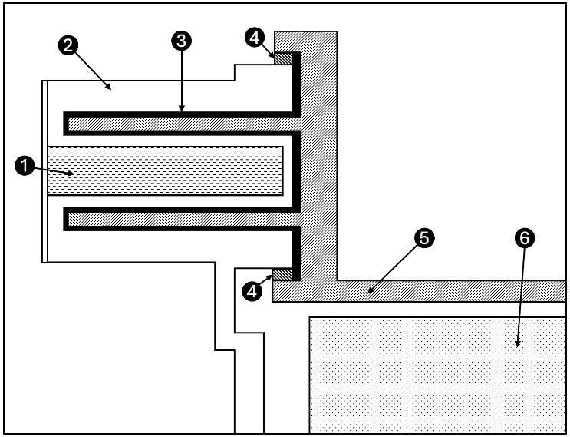
Figure 1. Schematic cross-sectional view of the braking system
The FEM contains exclusively the stator, which undergoes the most significant stresses since it links the moving and static parts of the system. Modelling the stator's structural response allows the characterization of, on the one hand, torque performance relative to the announced criteria and, on the other hand, endurance by assessment of computed stresses. The material chosen to build the stator needs to be highly magnetic, which helps to magnetize the fluid and guide the field to prevent its dispersion in the local environment that most certainly contains sensitive devices. For this study, the material is standard steel, with the properties detailed in Table 1.
Table 1. Stator material properties
Property | Symbol | Value | Unit
Elastic modulus | E | 200 | GPa
Poisson's ratio | ν | 0.3 | -
Density | ρ | 7850 | $$\text{kg/}{\text{m}}^{\text{3}}$$

Mesh, Loads and Constrains
One of the most consequential parameters in the finite-element method is the size or number of elements. Indeed, the smaller and more numerous the elements, the more accurate the solution will be, at the cost of higher computation time. While the software evaluates the mesh quality based on predefined criteria, it is necessary to assess the mesh dimensions. Thus, the same simulation is repeated with both finer and coarser meshes. The finest mesh considered is 2 $mm^{3}$ due to computational power restrictions.
Figure 2 shows the evolution of computation time and error in maximum stress relative to the finest mesh as a function of element size. 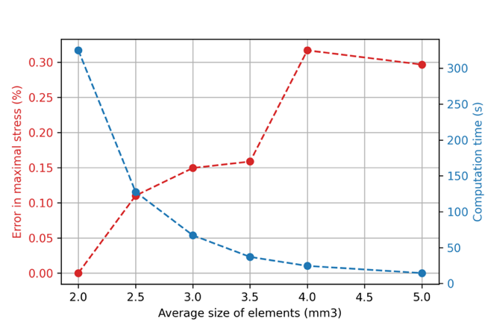
Figure 2. Evolution of error and computation time vs. elements size
The 3 $mm^{3}$mesh resulting in approximately 660,000 elements is an acceptable compromise. The mesh was made with first-order solid tetrahedral elements of the CTETRA type.
To perform the simulations, a standard constraining approach was adopted, where the components were constrained using SPC interfaces positioned at the wheel center, blocking all degrees of freedom, both translational and rotational. This SPC is then connected to a rigid component that connects with the relevant nodes in the fixing area at the center of the stator.
The applied loads are distributed on the interface area between the stator and the MRF, based on the simulated fluid behavior, which is integrated through the CFD results into the FEM environment.
It is necessary to acknowledge that the CFD software needs definite inlet and outlet surfaces, which makes it impossible to simulate closed cylindrical circuit conditions. Consequently, working with a portion of the whole stator obtained by symmetry is more suitable, besides reducing computational time and enabling finer meshes.
As shown in Fig. 3, the stator admits an XZ plane of symmetry. As it is essential to replicate similar boundary conditions, the elements on the symmetry plane are locked in all degrees of freedom except for translation along the Y-axis and rotation around the X-axis. These non-constrained degrees correspond to the direction of motion and allow for the most accurate result relative to the original simulation. The results obtained from the simulation with the half-stator are very close to the whole part, with a relative gap of approximately 3% in the results.
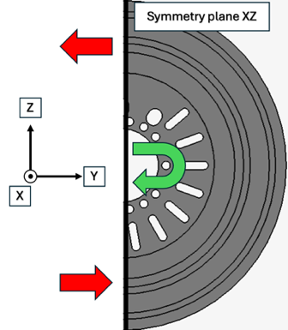
Figure 3. Schematic view of the symmetry reduction
Magneto-Rheological Fluid
MRF brakes use a fluid composed of a carrier oil and ferromagnetic particles ranging in size from 0.1 to 10 micrometers. When a magnetic field is applied, the particles align in the direction of the field, increasing the fluid's viscosity. Figure 4 shows a schematic representation of this behavior.
In a braking system, this increase in viscosity allows the application of force on the walls of a stator and a rotor driven by the wheels. The magnetic field can be generated with coils, allowing control of the braking force based on the input current.
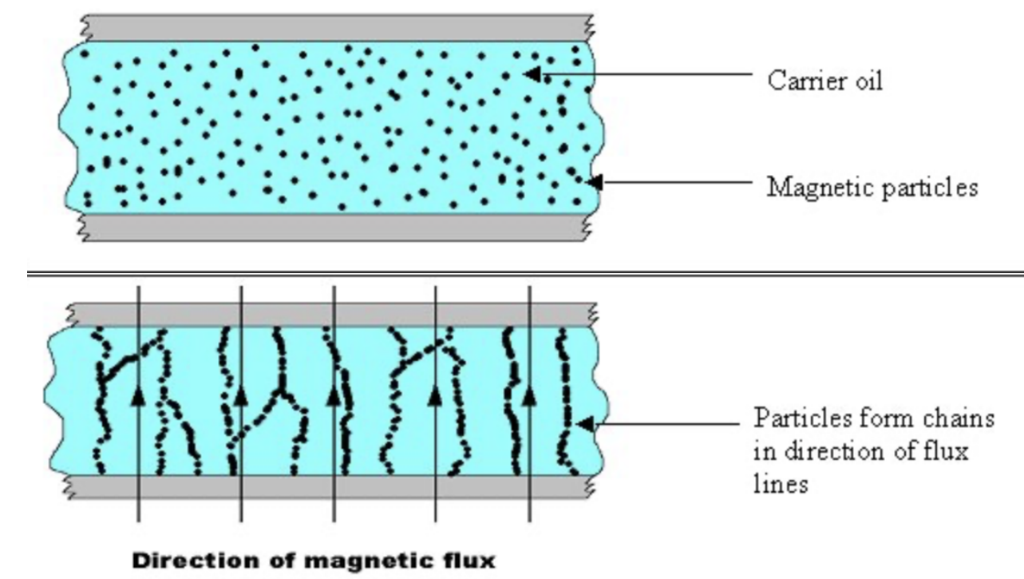
Figure 4. MRF behavior schematization
There are no commercial examples of this type of brake yet, but several scientific studies have investigated its application in the automotive field. Among other things, Sohn et al. [4] showed that acceptable dimensions are sufficient to achieve the required torque. The main parameters of interest in increasing the braking torque are the thickness of the gap occupied by the fluid and the surface area of the stator/rotor interface. Although technology can meet performance needs without emitting fine particles, it is critical to consider the production cycle of the magnetorheological fluid to ensure it is not heavily polluting. Jinga et al. [6] showed that the fluid production process is not more polluting than that of brake discs and pads.
Multiple models can describe the actual behavior of the fluid, among which the Bingham model seems very promising. This theoretical model defines perfect solid behavior under a threshold yield stress, beyond which the fluid acts as a classic viscous liquid.
Therefore, the magnetorheological fluid's ability to change its yield stress as a function of the magnetic field allows for viscous behavior in the absence of magnetization, thus not generating significant resistance when braking is not required, and a quasi-solid behavior when a sufficient field is applied. The model can be described with Eq. 3.
$$τ=τ_{cr}\left(H\right)+η\dot{γ}$$ | (3)
Where $τ_{cr}$ is the yield stress, $η$ is the viscosity, and $\dot{γ}$ is the shear rate. The MRF behavior under the Bingham model is illustrated in Figure 5.
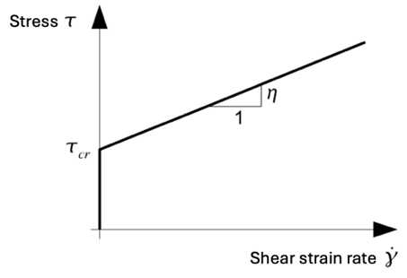
Figure 5. Bingham model stress vs. shear strain rate
In this study case, the shear rate of the fluid depends on the small spacing it occupies, as expressed in Eq. 4.
$$\dot{γ}=\frac{rω}{ξ}$$ | (4)
Where $r$ is the radius, $ω$ is the angular speed, and $ξ$ is the spacing between the stator and the rotor.
Magnetic field influence on yield stress
The electromagnetic field generated must allow for the highest yield stress during braking, while maintaining a sufficiently low minimal yield stress to avoid impacting the vehicle during driving use. For these reasons, the magneto-static behavior of coils, capable of generating a field proportionally to the current flowing through them, has been chosen, as in Eq. 5.
$$NI=\frac{B_{f}}{μ_{f}}$$ | (5)
Where $N$ is the number of windings, $I$ is the coil entry current, $B_{f}$is the ferromagnetic surface around the coil, and $μ_{f}$ is the magnetic permeability of the ferromagnetic material.
Technical data of the chosen commercial fluid (Lord MRF132DG [7]) gives a relation between the applied magnetic field and the yield stress, and most importantly, the minimal yield stress of 0.8 kPa and the maximal yield stress of 50 kPa.
The CFD software computes the fluid Bingham model using parameters defined in keeping with the previously mentioned considerations. First, acknowledging that the software cannot simulate the yield stress evolution, it is necessary to separate two study cases: the non-braking situation and the critical braking corresponding to the 1025 Nm criteria. Even if the fluid’s behavior is more complex, its viscosity is set constant to simplify the model, like in Figure 5, by setting equal the reference and the infinity viscosities. Thus, Table 2 details all the imposed characteristics.
Table 2. Fluid Parameters in the CFD model
Property | Inactive braking | Critical braking
Density ($kg/{mm}^{3})$ | 3 | 3
Specific heat ($J/kg$) | 800 | 800
Reference viscosity ($Pa·s$) | 0.112 | 0.112
Yield stress ($kPa)$ | 0.8 | 50
Infinite viscosity ($Pa·s)$ | 0.112 | 0.112

The rheometer tests provided experimental data valuable to assess the validity of the fluid behavior model [8], the results in Figure 6 shows the stress curves as a function of the current applied to the coils generating the magnetic field.
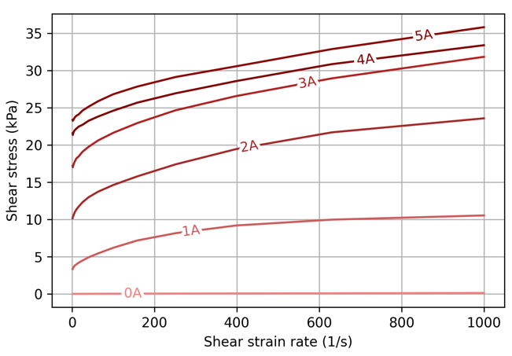
Figure 6. Shear stress vs. shear strain rate for different currents applied to the coils
The yield stress evolution observed during the tests confirms the validity of the Bingham model. Note that the viscosity is not constant as in the simplified model previously established. Technical reasons forced test production under low rotational speed ranges compared to the needs of the simulation, which takes place in a critical scenario. Therefore, it is impossible to directly integrate these experimental results into the simulation, as the software would extrapolate the results, which is naturally incorrect.
Overall, the chosen model seems to overestimate reality since the absolute magnetization of the fluid does not seem to occur even at the maximum current. Figure 7 illustrates the difference between the chosen Bingham model and the behavior expected, based on the tests conducted.
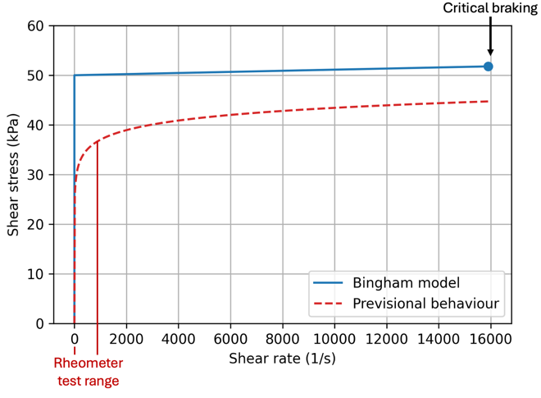
Figure 7. Shear stress vs. shear strain rate for Bingham and previsional model comparison
Computational Fluid Dynamics model
In this study, the tangential velocity is approximately 24 m/s, corresponding to the wheel’s rotational speed of a standard vehicle travelling at 130 km/h, the maximum allowed speed in typical roads. Figure 8 depicts the fluid model and its boundary conditions for each family of surfaces constituting the fluid boundaries. These boundary conditions are critical for the simulation, as they define how the fluid interacts with its environment and the braking system components.
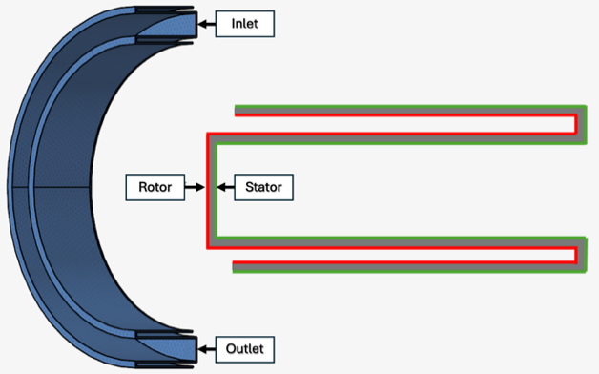
Figure 8. Illustration of the CFD model and its boundary conditions
The different surfaces are:
- The inlet surface is defined as an average velocity of 12 m/s, the average velocity between the rotor and stator.
- The stator contact surfaces are defined as stationary walls, reflecting the immobile nature of the stator in the system.
- The rotor contact surfaces are defined as moving walls with a tangential velocity of 24 m/s, matching the speed of the rotor.
- The outlet surface is defined as zero pressure relative to the ambient pressure, allowing the fluid to exit the system under realistic conditions.
Note the approximation of equality between fluid velocity at the boundaries and respective wall velocity, significantly reducing computational time.
Acknowledging that CFD problems are particularly nonlinear, one shall solve the governing Navier-Stokes equations only under restrictive conditions. Therefore, the calculations perform iteratively. The software identifies the iteration stopping time by waiting for relevant values to reach predefined criteria, a process known as convergence. For each calculated quantity of interest, in our case pressure, velocity and eddy viscosity, we observe:
- The convergence of residual ratios that directly quantifies the error in the solution of a system of equations. More precisely, it corresponds to the local imbalance of a conserved variable in each control volume.
- The convergence of solution ratios, which, in the context of solving conservation equations, correspond to the error in conservation of these quantities.
Figure 9 shows the evolution of these values over the iterations in both study cases. It confirms the coherence of the calculation.
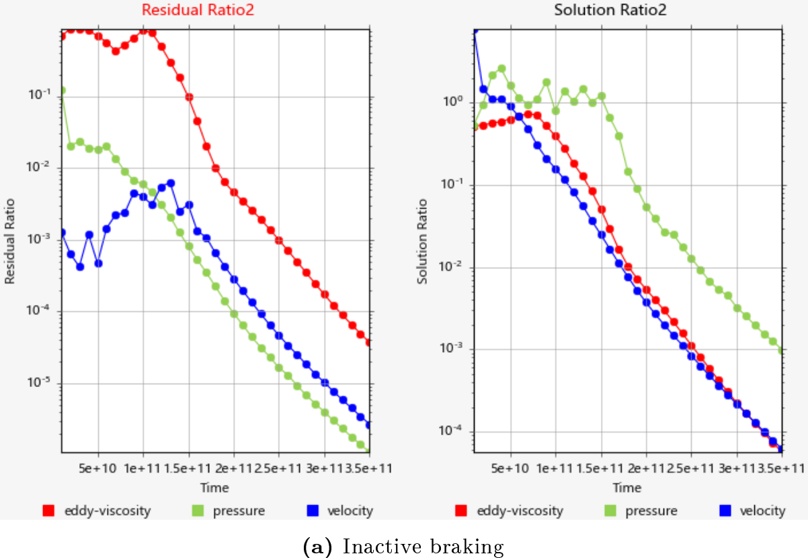
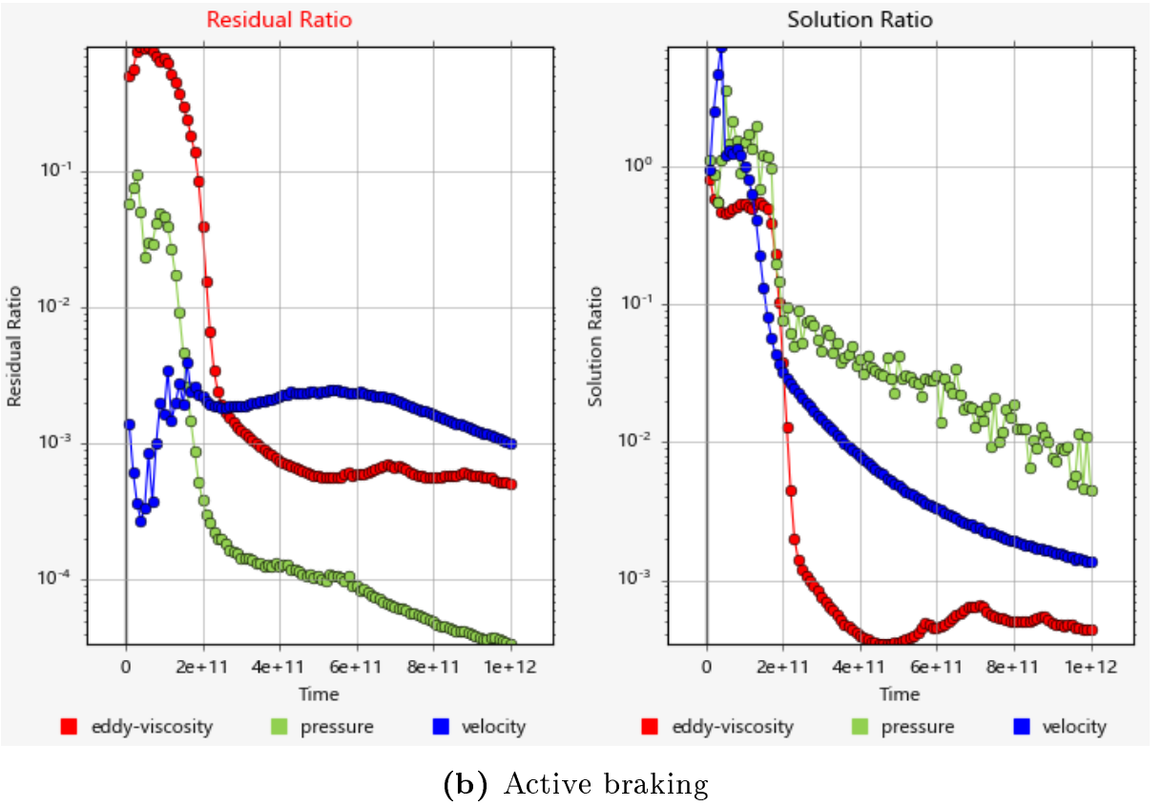
Figure 9. Convergence for residual and solution ratios for (a) Inactive and (b) Active braking case
The software enables visualization of fluid velocity along a section of the model, as shown in Figure 10. It is possible to note the difference between the two cases, particularly in the corners, demonstrating the evolution of fluid behavior.
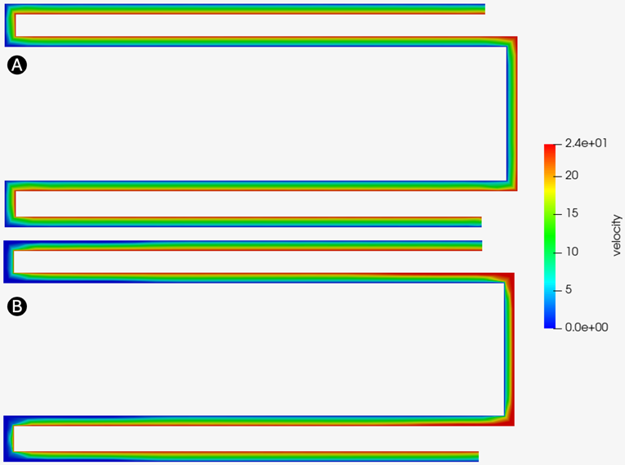
Figure 10.Cross section view of the fluid velocity in inactive braking (A) and critical braking (B) case
The values to look at are the forces applied by the fluid on its contact surfaces with the stator. The software gives, for each node, the shear stress exerted from which it is possible to establish total exerted force as in Eq. 6.
$$F_{nod}=τ_{nod}∙S_{nod}$$ | (6)
Where $F_{nod}$ is the force in each node of the boundary surface, computed from the shear stress $τ_{nod}$ and the area covered by each node $S_{nod}$. The area depends on mesh size and should be as small as possible. Thus, it is possible to determine the resulting torque in the stator centre by summing all the nodal forces, as shown in the Eq. 7.
$$T_{r}=2\sum_{k=0}^{k=N}{{(F}_{nod}∙r_{nod})}$$ | (7)
Where $T_{r}$ is the resulting torque, $N$ is the number of elements in the contact surface, and $r_{nod}$ is the distance between each node and the centre. Note the factor granting an estimation of the total value.
The torque results for both cases are:
- Inactive Braking: 160 N·m
- Critical Braking: 1774 N·m
As anticipated, they are highly overestimated compared to the objectives and experimental observations. However, given that a critical case is studied, it is not considered a problem. This error likely comes from the Bingham model itself but may also come from parameters such as inlet velocity or the nature of contact between the fluid and the walls. One might adjust these parameters in the need for a more precise result at the cost of higher computation times.
Fluid-Structure Interaction: CFD and FEM coupling method
Several approaches exist to integrate fluid behavior into the structural analysis. Primarily, it is possible to develop a direct coupling of both simulations by exchange of effort and displacement values at each iteration. However, experience showed that, besides excessive computation durations, this method is most suitable for situations with significant structure movements. Finally, the withheld strategy consists of extracting the resulting fluid forces node described in Eq. 6 and inserting it as an input for the finite-element analysis. Note that the meshing is not consistent between the two models, which means that every CFD nodal force extracted will not be located on a FEM node. However, the FEA software can interpolate the efforts to obtain coherent values. By combining the two sets of efforts obtained, corresponding to the inactive braking and the critical braking, the load curve shown in Figure 11 is obtained. This curve helps develop a transient, i.e. time-based, analysis.
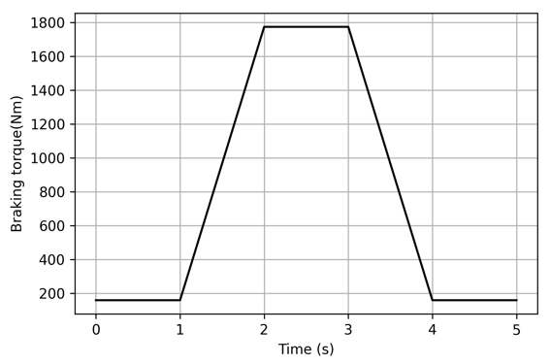
Figure 11. Braking torque applied for the transient analysis
Baseline simulation results
Figure 12 shows the Von-Mises equivalent stress resulting from the transient analysis, at maximal braking. It is possible to note that the main point of stress concentration is the wall between two holes. It is an expected result since it is the thinnest section of the entire model. The maximum stress is 248 MPa, above the material's yield strength. However, the Bingham model gave forces more than 73% superior to the expected ones.
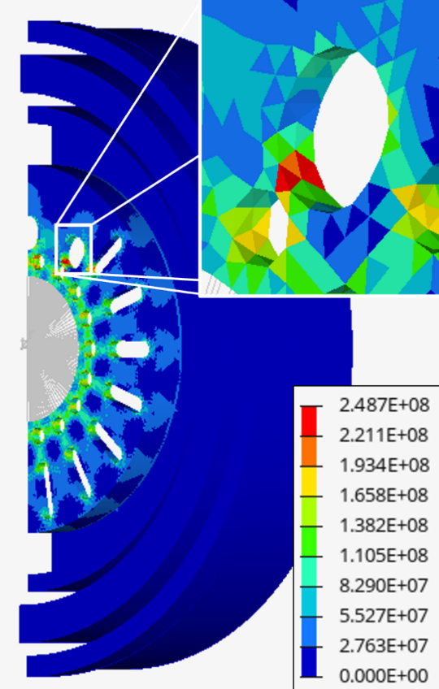
Figure 12. Von-Mises stress [Pa] in maximal braking condition
To verify the method, it is preferable to contrast the results presented with those of a standard finite-element analysis. A simulation was previously done with constant effort on the contact surfaces, corresponding to the required torque of 1025 N·m, with a security coefficient of 1.5 that increased it to 1538 N·m. Acknowledging that the values should still be higher with the CFD results, Figure 13 shows that the repartition of stresses is equivalent. It demonstrates that the interpolating method chosen to implement CFD wall stress results into FEA local forces is correct.
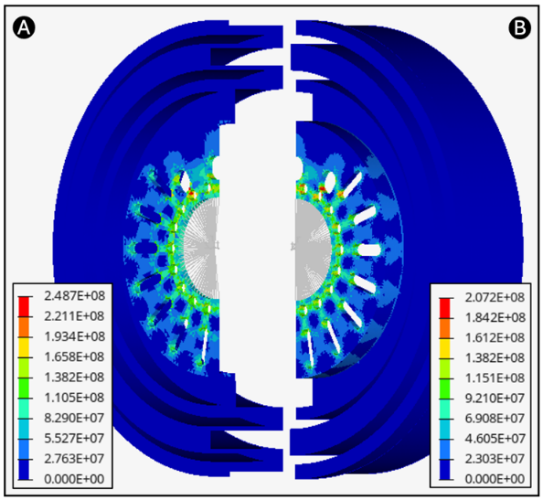
Figure 13. Comparison of Von-Mises stress [Pa] repartition between the coupled (A) and the standalone (B) FEM models
System mass optimization
The main goal of this last session is to reduce the stator mass without significantly changing its structural response to the efforts. Its starting mass is around 12 kg, which is not compatible with industry standards – acknowledging that it is part of the unsprung mass, leading to substantial issues in vehicle handling, reliability and comfort. The two main criteria to study are maximal stress, which defines the local plasticization risk, and maximal displacement, which represents system compliance. Both need minimization to ensure good behavior. Furthermore, optimization should consider external constraints such as thermal exchanges or part feasibility. First, this study addresses the identification of the parts that do not present a defined structural use and the deliberation upon reducing them. Next, the study focuses on redesigning the fluid-structure interface and the front-face, which are the main components of the stator.
Figure 14 shows a cross-sectional view of the external part of the piece. In Figure 14(a), it is possible to note the two highlighted areas that do not seem to have significant structural interest:
- The areas hatched in blue help position seals selected from a catalogue with limited dimensions. These seals should be custom-made in the future, leading to the removal of these areas.
- The areas hatched in green are an extra thickness of steel used to guide the magnetic field to close the circuit at the coils and avoid the dispersion of the field into the environment, which is composed of elements that may be sensitive to it. This issue is neglected in favor of the weight excess, knowing that other solutions to fulfil this function are under design.
Figure 14(b) shows the cross-sectional view obtained after removing the abovementioned areas. This initial reduction allows for a mass saving of approximately 4 kg without significantly altering the structural response to the applied load.
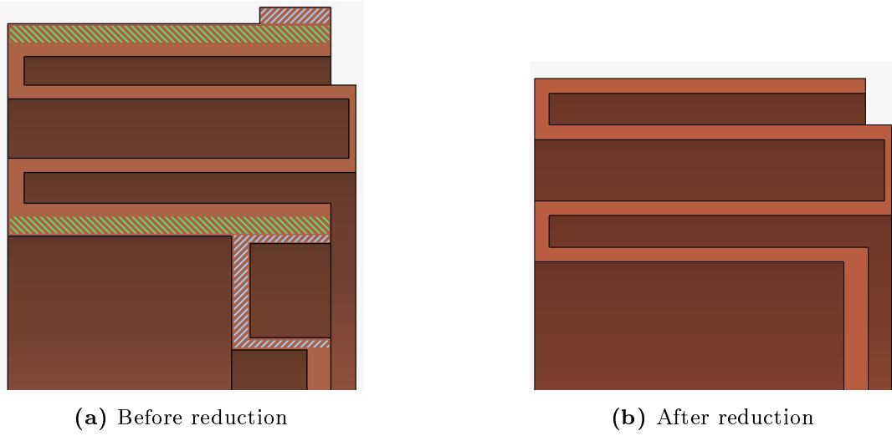
Figure 14. Cross-sectional views of the stator
As a second step, the fluid-structure interface thickness is addressed. In Figure 14(b), it is equal to 3 mm. On the magnetic front, reducing the thickness of the separation wall with the coils would allow for increased fluid magnetization. Conversely, the outer walls shall be thicker.
Figure 15 illustrates the impact of reducing this thickness on stress and maximum displacement when the structure is subjected to loads. The maximum stress does not seem to undergo significant change and remains close to 220 MPa, while the part compliance increases significantly with the thickness reduction of the interface. The selected dimensions compromise is 2 mm for the outer walls and 1 mm for the separation walls with the coils. This choice allows a mass reduction of approximately 3 kg.

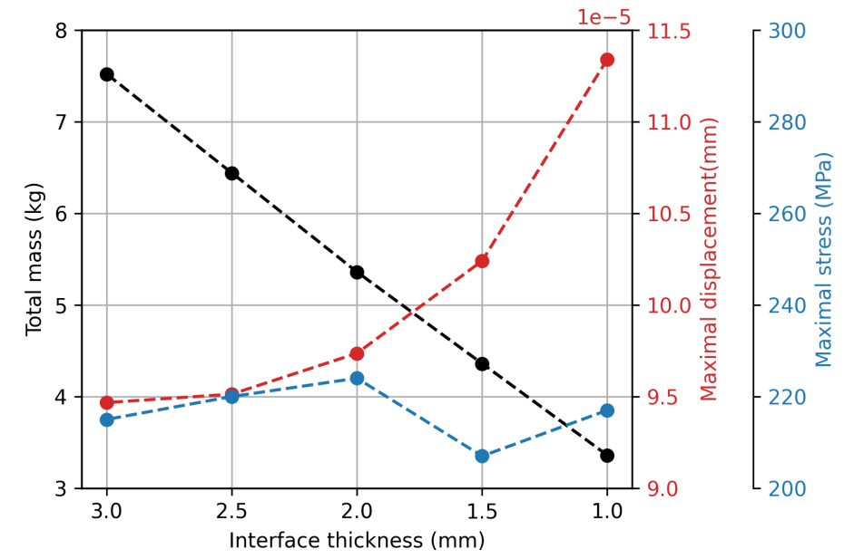
Figure 15. Stator mass, maximal stress vs. interface thickness
The front-face plays a substantial role by connecting the shaft to the housing, transferring the fluid's loads. One could consider two solutions to lower its weight: reducing its thickness or increasing the size of the holes passing through it. Given the importance of these holes for cable passage and system cooling, the second option seems better. A topological optimization calculation provides a design that minimizes the part's mass while minimizing its compliance. Figure 16 shows the results of this calculation, with the scale corresponding to density, which represents the structural significance of each element.
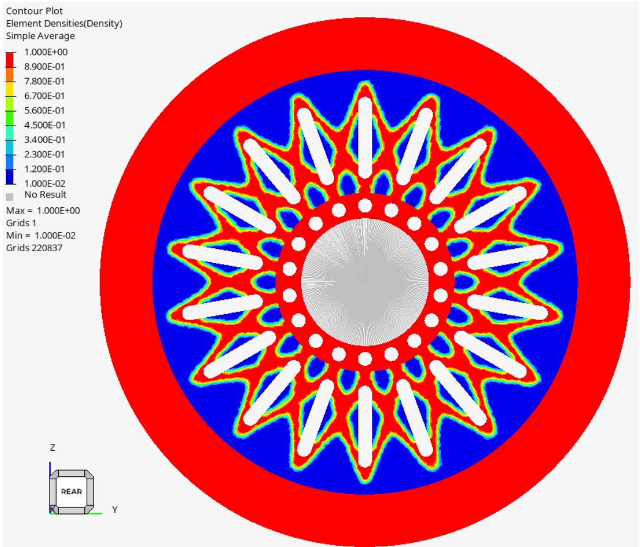
Figure 16. Topology optimization simulation results
A simulation is done on the new model by applying the same loads and conditions to the optimized model as the original. Figure 17 and Figure 18 illustrate respectively the displacement and stress results.
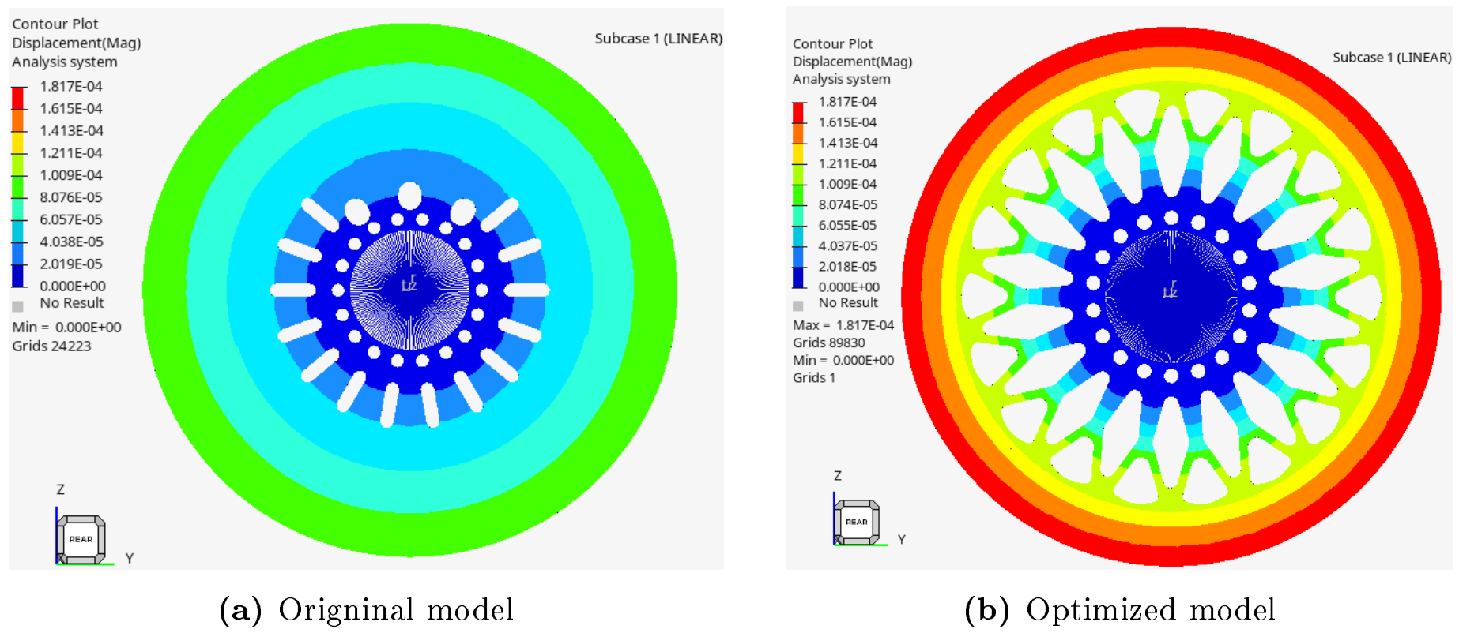
Figure 17. Displacement results of the original (a) and optimized (b) models
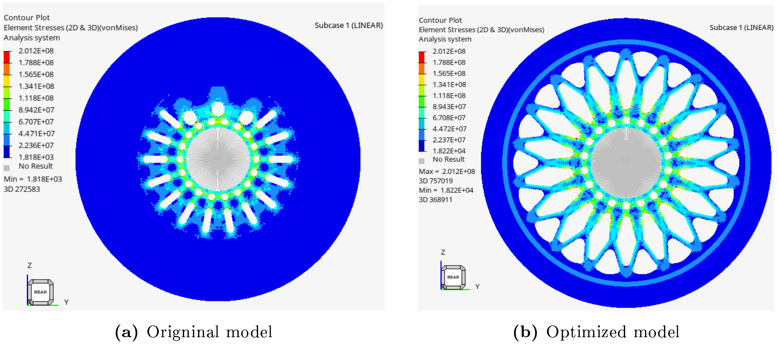
Figure 18. Von Mises stress results of the original (a) and optimized (b) models
It is possible to note that the stress distributions are relatively similar, with maxima of the same amplitude, also located in the holes. The displacement is significantly higher in the optimized model due to the compliance introduced by the front-face optimization, however the values still lower than 0.2 mm, which is considered acceptable for the application.
The results obtained from each successive optimization step, detailed in Table 3, indicate that most of the mass savings were achieved during the first two steps, inducing limited behavioral changes. The third step provides a lesser weight reduction and demonstrates a much higher level of structural criticality
Table 3. Mass optimization results
Step | Optimization | Mass  [kg] | Displacement [mm] | Max Stress [MPa]
0 | Baseline | 11.46 | 0.100 | 210
1 | 0 + Section  removal | 7.27 (-37%) | 0.095 (-5%) | 228 (+9%)
2 | 1 + Thickness reduction | 4.20 (-42%) | 0.106 (+12%) | 206 (-10%)
3 | 2 + Topological optimization | 3.74 (-11%) | 0.182 (+72%) | 201 (-2%)

Conclusion
The method presented enables the study of fluid influence on small-displacement structural response. Besides previous work, its results show that the innovative MR braking system can reproduce the performance of traditional disc brakes without emitting any particles. Beyond having similar performance, this system has numerous advantages compared to its predecessor, notably the almost null time between the braking command and execution and its low need for maintenance.
The model developed proved to be a good compromise between accuracy and complexity, allowing for a unified analysis of fluid dynamics and structural assessments. The optimization process lead to a significant mass reduction from the original prototype geometry, eliminating excess material present in the first non-optimized geometry, without jeopardizing structural performance. The methodology will be also valuable in future studies, notably for transitory behavior when the system undergoes these instantaneous changes.
Further studies can include experimentally characterizing the stresses applied to the stator, essential to assess the system's feasibility, as it not only indicates its performance but is also revelatory of its endurance to fatigue. Additionally, it can lead to further optimization of the part design to reduce its mass, which is necessary as the system's total mass is unsprung in the vehicle, leading to drivability and comfort issues on top of the vibrations degrading the parts.

References

[1] | M. Carello and al., "Design and Modelling of the Powertrain of a Hybrid Fuel Cell Electric Vehicle," SAE Int. J. Adv. & Curr. Prac. in Mobility,, vol. 3, no. 6, pp. 2878–2892, doi: 10.4271/2021-01- 0734, 2021.
[2] | A. Iijima, K. Sato, K. Yano, M. Kato, K. Kozawa and N. Furuta, "Emission Factor for Antimony in Brake Abrasion Dusts as One of the Major Atmospheric Antimony Sources," Environmental Science & Technology, vol. 42, no. 8, pp. 2937-2942. DOI: 10.1021/es702137g, 2008.
[3] | G. Imberti, H. de Carvalho Pinheiro and M. Carello, "Impact of the Braking System Generated Pollutants on the Global Vehicle Emissions: A Review," in International Conference on Environment Science and Engineering, Leuven, Belgium, 2023. DOI: 10.1007/978-981-97-5685-8_2.
[4] | J. W. Sohn, J. Jeon, Q. H. Nguyen and S.-B. Choi, "Optimal design of disc-type magneto-rheological brake for mid-sized motorcycle: experimental evaluation," Smart Materials and Structures, vol. 24, no. 8, 2015.
[5] | G. Imberti, H. de Carvalho Pinheiro and M. Carello, "Design of an Innovative Zero-Emissions Braking System for Vehicles," in International Conference on Electrical, Computer, Communications and Mechatronics Engineering, ICECCME, Maldives, 2022. DOI: 10.1109/ICECCME55909.2022.9988291.
[6] | H. De Carvalho Pinheiro, G. Imberti and M. Carello, "Pre-Design and Feasibility Analysis of a Magneto-Rheological Braking System for Electric Vehicles," in WCX SAE World Congress Experience, Detroit, Michigan, United States, 2023. DOI: 10.4271/2023-01-0888.
[7] | R. Jinaga, T. Jagadeesha, S. Kolekar and S.-B. Choi, "The Synthesis of Organic Oils Blended Magnetorheological Fluids with the Field-Dependent Material Characterization," International Journal of Molecular Sciences, vol. 20, no. 22, p. 5766, 2019.
[8] | Parker Lord, "MRF-132DG Magneto-Rheological Fluid - LORD technical data," [Online]. Available: https://www.shoplordmr.com/mr-products/mrf-132dg-magneto-rheological-fluid-1-liter. [Accessed May 2025].
[9] | G. Peruzzi, G. Imberti, H. de Carvalho Pinheiro, L. Tsantilis, R. Sethi and E. Santagata, "Rheological Characterization of Magnetorheological Fluids for Brake Applications: An Experimental Procedure," Fluids, vol. 10, no. 2, p. 50. DOI: 10.3390/fluids10020050, 2025.

Contact Information
Politecnico di Torino – Department of Mechanical and Aerospace Engineering (DIMEAS)
C.so Duca degli Abruzzi, 24 -10129 Torino – Italy
Phone: +39 011 0905692
henrique.decarvalho@polito.it
massimiliana.carello@polito.it
Definitions/Abbreviations
CFD | Computational Fluid Dynamics
EVs | Electric Vehicles
FEA | Finite-Element Analysis
FEM | Finite-Element Model / Finite-Element Modelling
HEVs | Hybrid Electric Vehicles
MRF | Magnetorheological Fluid
PM | Particulate Matter
RB | Regenerative Braking

