Health and condition monitoring tool for real-time and on-board diagnosis of PEM fuel cell in heavy duty vehicles

Abstract
The deployment of PEM fuel cell systems is becoming an increasingly pivotal aspect of the electrification of the transport sector, particularly in the context of heavy-duty vehicles. One of the principal constraints to market penetration is durability of the fuel cell which hardly meets the expected targets set by the vehicle manufacturers and regulatory bodies. Over the years, researchers and companies have faced the challenge of developing reliable diagnostic and condition monitoring tools to prevent early degradation and efficiency losses of fuel cell stack. The diagnostic tools for fuel cell rely usually on model-based, data driven and hybrid approaches. Most of these are mainly developed for stationary and offline applications, with a lack of suitable methods for real-time and vehicle applications. The work presented is divided into two parts: the first part explores the main degradation conditions for a PEMFC and characteristics, advantages, and application limits of the main methodologies for fuel cell diagnostic, while in the second part the features and the development process of an innovative, real-time, and on-board health and condition monitoring system, based on electrochemical impedance spectroscopy (EIS), are presented. The new innovative tool allows to detect, identify and isolate degradation, faults and non-optimal conditions. The computational performance and reliability of the diagnostic tool are tested and validated through experimental tests carried out in the laboratory on single cell and short fuel cell stack over a wide range of operating conditions and under specific sub-optimal/fault states such as drying, flooding and reactants starvation. The condition and health of PEMFC are estimated using specific health indicators for the most common root causes of faults such as drying, flooding, catalyst poisoning and anode/cathode starvation.

Introduction
The transport sector is a significant contributor to global greenhouse gas emissions, this sector emits about 25% of total CO₂ emissions. Specifically, the road vehicles account for about 74.5% of transport emissions, passengers vehicles (including motorcycles, cars, taxis and buses) contribute for 45.1% of road vehicles emissions while heavy-duty trucks and lorries 29.4% (all the data are referenced at a global level) [1].
The proton exchange membrane fuel cell electric vehicles (PEMFCEVs) have been demonstrated to be a practical, environmentally friendly and highly efficient alternative to internal combustion engine vehicles (ICEVs), particularly when the hydrogen is sourced from renewable energy [2], [3]. Even when hydrogen is not renewable, PEMFCEVs produce no local emissions, combining the benefits of battery electric vehicles (BEVs) and internal combustion engines by featuring a rechargeable tank for extended range and quick refueling.
The focus of hydrogen technologies (i.e. fuel cell) for vehicle applications has recently shifted from light-duty to heavy duty vehicles applications for the following characteristics:
- Hydrogen high gravimetric energy density.
- Hydrogen fuel cell system is easily scalable (Power and energy).
- PEMFCEVs are lighter than BEVs alternatives for same driving range and have shorter refueling time.
- Commercial deployment of heavy duty vehicles (HDVs) requires less infrastructure investment as fewer hydrogen refueling stations (HRSs) are required compared to light duty vehicles (LDVs) [4].
HDVs are subject to different drive cycles, operating conditions and, in particular, higher durability/lifetime and efficiency targets than LDVs, which are primarily concerned with performance and cost [4].
The main U.S. Department of Energy (DoE) targets for fuel cell HDVs and LDVs are shown and represented in Figure 1.
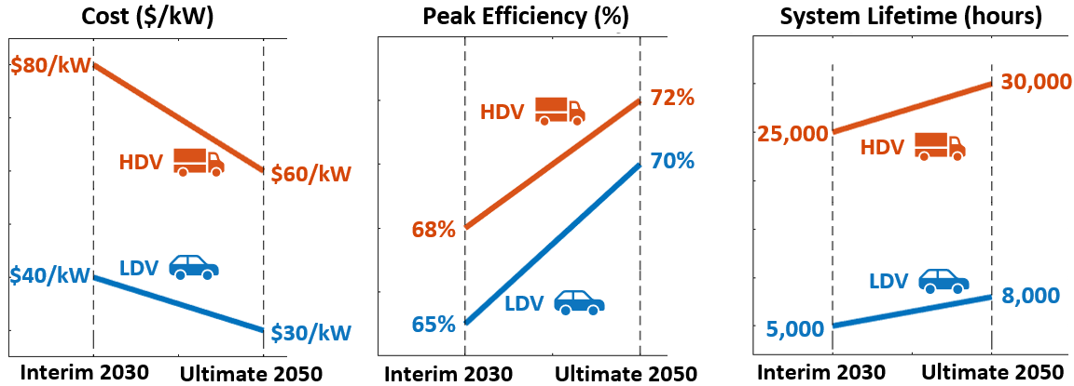
Figure 1: DOE targets 2030 and 2050 [5].
As of today, it is challenging to accurately determine the cost, efficiency, and durability of a PEMFC system for HDVs, as these metrics are highly dependent on the manufactured volume and specific design considerations. According to a 2023 study by the DoE [6] , the projected cost of a 275-kWnet PEM fuel cell system for a Class 8 long-haul heavy-duty truck, based on next-generation laboratory technology (based on an analysis of state-of-the-art components, developed and demonstrated at the laboratory scale) and operating on direct hydrogen, would be $179/kWnet for a production volume of 50,000 units per year and $170/kWnet at 100,000 units per year. These projections include features designed for enhanced durability, aimed at achieving one million miles (25,000 hours) of operation, a critical requirement for long-haul trucks. The assumptions underlying these estimates involve technical specifications such as:
- Stack oversizing to compensate for electrochemical surface area (ECSA) loss over time.
- High platinum loading (0.45 mg Pt/cm² total) for catalyst durability.
- A monometallic Pt cathode catalyst.
- A 20-micron thick membrane to ensure operational robustness.
- Balance of plant (BoP) replacement costs factored into long-term performance projections.
It is important to underline that the specific performance and durability requirements defined for heavy-duty fuel cell systems must be met while simultaneously achieving the associated cost targets, ensuring the technology's economic viability and widespread adoption.
To achieve medium-term and long-term targets, R&D is focusing mostly on:
- Materials and Components: Identification and developing of optimized materials and components that can improve durability, power density, efficiency reducing the fuel cell cost (i.e., catalysts, membranes, MEA, bipolar plate, GDL).
- Innovative stack/system design: Optimized for durability, power density and efficiency, focusing on air, fuel, water and thermal management.
- Improvements in BoP: Improvement of performance and durability of air loop components (i.e., compressor, expander, humidification system), H2 loop and power electronics.
- Diagnostic tool and mitigation strategies: development of new innovative tool to optimize the operating strategies of the FC system, identify in a preventive way faults/sub-optimal conditions and mitigate the degradation effects [5].
In this paper the focus will be on Diagnostic and Health Management for PEMFC as this represents a feasible, low-cost solution to increase the performance and durability of FC system without a significant increase of the cost.
There are three main approaches used and explored to perform diagnosis of fuel cell and extract information about faulty conditions:
- Model-based approaches are typically founded upon analytical or black box PEMFC models. By examining the discrepancies between the real-time PEMFC-specific state or diagnostic object and a healthy fuel cell model, it is possible to ascertain the extent of degradation or failure. As the accuracy of the diagnosis depends on the accuracy of the model these types of approaches are most suited for simplified PEMFC system and in general it is very difficult to perform real-time degradation diagnosis of PEMFC based only on the method of building degradation/failure models [7].
- Data-driven approaches, referred to as model-free techniques, are predicated on the collection of a substantial volume of real-time data, derived from the operation of the PEMFC system. The implementation of machine learning, signal processing, or other algorithms allows for the extraction of degradation or failure states. These types of approaches don’t require specific research on degradation conditions and physics behavior of the system under development as it doesn’t need to build an accurate model and for this reason it is suitable for complex PEMFC system. However, these approaches are based entirely on the analysis of collected data, which is a time-consuming process. This reduces the generality of the approach and consequently increases the cost of time. Furthermore, as the analysis is based only on the database without any physical evidence, errors and false alarms can easily occur, reducing the reliability of the approach [7].
- Hybrid approaches are a combination of model-based and data driven approaches to combine the advantages and disadvantages of the two methodologies, increasing the reliability and robustness of diagnostic and prognostic approaches. The use of hybrid methods can address the limitation of only one diagnosis method.
The dynamic duty cycle of a PEMFC in an electric vehicle (i.e. heavy duty, medium duty, light duty) leads to degradation mainly due to fluctuating operating conditions such as current/voltage, temperature, internal humidity, flow rate and reactant pressure; these variations can directly and indirectly lead to degradation of the FC stack and thus affect the remaining useful life (RUL) and state of health (SOH) [7], [8].
In this work the main degradation causes and failure mechanisms are classified and analyzed in order to extract the most important health indicators for a PEMFC intended for use in mobile applications (that the approach can be generalized to all the PEMFC).
For mobile applications the heath indicators extracted need to be monitored online (under normal operation of the system), in real-time and on-board so that preventive and mitigating actions can be implemented on the basis of the diagnosis made to ensure the correct, safe and durable operation of the FC stack and system.
Most of the diagnostic approaches presented in literature are meant for offline diagnosis and are not suitable for real-time and embedded application. The development of a diagnostic tool for in-vehicle applications is subject to a multitude of constraints and diverse challenges.
In this paper, the main causes of degradation for different layers of a PEMFC (Degradation and failure mechanisms of PEMFC) and main faults root causes in vehicle application (PEMFC faults causes in vehicle application) will be identified and analyzed and then the different approaches used for fuel cell diagnostics will be presented in detail (Diagnostics methods).
In addition, the characteristics of the in-house developed diagnostic tool based on the use of a fast Electrochemical Impedance Spectroscopy (EIS) approach for real-time extraction of PEMFC health and faults indicators will be presented. The tool is validated through an extensive validation campaign by means of laboratory tests on single cells and short fuel cell stacks (30 cells).
Finally, the section SW and HW development presents the initial concept of the embedded tool on BeagleBone Black, together with an analysis of the diagnostic system's performance in MiL, SiL and PiL, with particular attention to computational time and performance.

Degradation and failure mechanisms of PEMFC
In this section will be presented all the main degradation and faults mechanisms for a PEMFC and then will be analyzed the specific causes of the faults in vehicle applications as fuel cell system differ in vehicle applications compared to other applications.
The PEMFC is composed of different components, so each of the main components as different degradation/faults mechanisms that can affect the overall lifetime and performance of the PEMFC stack. It is important to mention that another important area to investigate is the auxiliaries faults (i.e., air supply system, H2 system, cooling system) but is not part of this work.

Proton exchange membrane
The proton exchange membrane is one of the most critical components in a PEMFC stack and can affects strongly the lifetime of the entire stack.
The PEM needs to have some specific properties to guarantee correct functioning of the stack:
- High proton conductivity.
- Electrochemical stability.
- Good stability under wet and dry cycles that is strictly related to the water retaining capacity of the ionomers [9].
- Fuel separation property (keep separate O2 and H2).
- Mechanical strength.
- Low water electro-permeability coefficient.
Thus, the most critical degradation phenomena are:
- Mechanical degradation, caused by stress cycling or manufacturing defects, involves the formation of cracks and pinholes in the membrane;
- Thermal degradation causes loss of mechanical integrity and increased gas permeability;
- Chemical and electrochemical degradation can cause the breakdown of the membrane due to chemical reactions with reactants and product of PEMFC [10].

Catalyst layer
The catalyst is the essential materials for catalyzing the oxygen reduction reaction (ORR) and hydrogen oxidation reaction (HOR) that occur respectively at cathode and anode of a PEMFC. The research and development focuses more on cathode ORR catalyst as the reaction is six or more orders of magnitude slower than anode HOR and thus limit the performance [11]. Most MEA catalysts used today are based on Pt in the form of nanoparticles dispersed on carbon black support. The principal characteristics that the catalyst should possess are as follows:
- High activity in the reaction environment.
- High stability even in extreme transient events (i.e., operating conditions such as load, relative humidity, pressure, impurities.
However, some degradation phenomena can occur in PEMFC under long-term variable loading, thus is fundamental identify and control to avoid serious damage of the fuel cell stack.
The main degradation phenomena that can happen under variable load are analyzed in detail in literature. In particular Sharma et al. [12] analyzes the quantitative contributions on ECSA of dissolution/detachment of Pt, electronic connectivity loss and particle growth during an Accelerated Stress Test (AST) at different cycles, in particular the ECSA loss due to dissolution/detachment varies linearly with N while high rates of losses have been observed initially (N < 200 cycles) for the particle growth and the electrons connectivity loss mechanisms.
Qu et al. [13] confirmed the different reasons for the degradation/failure of Pt/C catalysts at the cathode and anode after PEMFC load-changing cycles (this is also strictly related to humidity cycles) (80,000 rapid current-variation cycles). The degradation/failure on the anode side was mainly due to the migration and aggregation of Pt particles, while the degradation/failure on the cathode side was mainly caused by corrosion of the carbon support. Thus, the dynamic operating conditions of PEMFC could lead to the interfacial shedding of Pt/C agglomerates due to the expansion and contraction of the film as the relative humidity is varied.
Chen et al. [14] conducted a study on hydrogen starvation of PEMFC and found that the Pt particles on the anode CL carbon support were exfoliated and agglomerated due to the reaction with water.
The start-stop operating conditions heavily affects the durability and lifetime of a fuel cell stack, the main reason for performance degradation under this condition is the formation of the hydrogen-air interface inside the anode, the presence of H2-Air interface leads to oxidation reaction in the anode, forming a high potential on the cathode surface and leading to the oxidation of carbon carrier in the cathode catalyst layer (reverse current phenomena) . This behavior implies that Pt particles fall off the catalyst surface, thus decreasing the ECSA and performance of the fuel cell [15].
Thus, the main degradation phenomena that can affect the catalysts and decrease the ECSA and fuel cell performances are:
- Corrosion of carbon carries and specifically of carbon support.
- Dissolution/detachment of Pt in redeposition and agglomeration.
- Degradation of ionomer.
While the main causes are:
- Load changing cycle involving as consequence humidity cycles.
- Hydrogen and cathode starvation.
- Start and stop operating conditions.

Gas Diffusion layer
The Gas Diffusion layer (GDL) provide mechanical support for the catalyst layer and membrane under clamping pressure during assembly and governs the mass, heat and electron transport that directly affect the cell performance [16]. The GDL is typically constituted of two layers: a macroporous substrate (MPS) and a microporous layer (MPL).
As seen for the catalyst, degradation of the GDL is usually due to and accelerated mainly by non-optimal or harsher operating conditions. For vehicle applications, these are :
- Idling at Open-circuit Voltage (OCV) – this condition promotes the hydrogen peroxide formation involving GDL oxidation.
- Start-up/shutdown (SUSD) – as for the catalyst this condition promotes the formation of H2-Air interface at the anode involving reverse currents and carbon corrosion in the cathode (GDL corrosion).
- Load-changing cycle.
The effects of the degradation phenomena analyzed can be summarized in two main categories:
- Structural changes due to heterogenous compression, fiber breakage and mechanical/chemical carbon corrosion affects all the transport properties of the GDL.
- Surface wettability changes due to surface oxidation and PTFE on MPS loss that causes a degradation in water management.

Bipolar plate
The Bipolar plates (BPPs) should provide some important characteristics to the PEMFC:
- Mechanical support for the MEA.
- Gas reactants flow distribution to the GDL.
- Current conduction.
- Hydrothermal transport.
The performance of a BPP strictly affects the operation of a PEMFC stack. The main degradation phenomena that can affect BPP are:
- Chemical corrosion of the BPP surface, specifically Okonowo et al. [17] noticed that when the BPP is exposed to strongly acidic environment it produces an oxide layer that poses a significant threat to the BPP's overall health and performance [18]. As the oxide layer thickened, it led to a notable decline in the BPP's electrical conductivity, ultimately resulting in a noticeable deterioration in its operational capabilities. Orsi et al. found a relationship between the interface contact resistance (BPP/GDL interface) with the applied potential and the environmental pH.
In addition, corrosion of the BPP can lead to the detachment of particles that can be deposited in the membrane, creating a reduction in proton transport and potential mechanical damage.

Sealing element
The sealing element plays a critical role in the PEMFC providing mechanical stability to the cell and it is essential for the long life of the PEMFC keeping the hydrogen, oxygen and coolant in their respective regions [19]. The mechanical and chemical stability of the sealing element can be affected by operating temperature, humidity and acid concentrations which may cause the mixing or leakage of reactive gases, resulting in stack degradation/failure and safety risk due to the formation of explosive atmospheres.
Qiu et al. [19] noted how the mechanical properties of the sealing material is limited by compression rate and that the elastic modulus of the sealing material is inversely proportional to temperature, this leads to degradation under thermal cycling. Zhang et al. [20] analyzed as the Temperature has a great influence on the von-Mises stress of sealing system and the deformation of MEA frame in the sealing system. Liang et al. [21] noticed as the sealing structure failure, resulting in the loss of the gas reactants, can occur during the assembly process and start-up operation of the PEMFC.

PEMFC faults causes in vehicle application
The preceding chapter provided a comprehensive examination of the primary degradation mechanisms for the different layer of a PEMFC, along with the underlying causes and operational conditions that contribute to the observed phenomena.
Some of the causes of degradation are linked to the failure of BoP components and are contingent upon other faults [22]. In particular, the overall primary fault conditions for PEMFC for automotive applications that emerged from the aforementioned analysis are analyzed.

Flooding
It is the accumulation of liquid water particles that limits the permeation of gas reactants towards active reaction site. This fault condition results in the following consequences:
- Starvation (i.e., cathodic and anodic) and this will result in a loss of performance and lifetime due to increased concentration overvoltage, and as shown in previous paragraph (Catalyst layer) there is a degradation of carbon support ,dissolution of Pt particles and a decrease in ECSA.

Drying
This is the lack of water in the different layers and and results in the following direct consequences:
- Increase of the conductive resistance of the membrane due to the limitation of the permeation process of H+ through the membrane [23].
- Increase of the diffusion resistance of H+ in the cathode and anode catalyst layer.
- Thermal membrane degradation.
- Chemical fuel cel membrane degradation [22].

Cathodic starvation
This is the lack of oxygen on the active sites of cathode and results in the following direct consequences:
- Degradation of catalyst carbon support.
- Dissolution/detachment of Pt.
- Thermal membrane degradation.
- Reversal polarization phenomenon.

Anodic starvation
This is the lack of hydrogen on the active sites of anode and results in the following direct consequences:
- Degradation of catalyst carbon support.
- Dissolution/detachment of Pt.
- Reversal polarization phenomenon [22].

Catalyst Poisoning
This is the adsorption by platinum of poison species (i.e., CO, H₂S) and results in the following direct consequences:
- Degradation of catalyst and loss of ECSA.
The catalyst poisoning can affects both anode and cathode but it tends to be more significant for the cathode, this is due to the sluggish nature of the oxygen reduction reaction (ORR) at the cathode [24], which is much slower than the hydrogen oxidation reaction (HOR) at the anode. In addition, the cathode requires more catalyst and is therefore more prone to poisoning by impurities such as CO, H₂S and other compounds [25].

Diagnostics methods
In this section the main diagnostic approaches presented in literature are presented, analyzing the main advantages and limits.
Model based
In literature are proposed different approaches belonging to this category to investigate specific degradation or sub-optimal conditions, such as “Mechanistic model in fuel cell membranes” where growth factors of membrane pinholes during cyclic loads were investigated [26], “Lattice Boltzmann method” to evaluate effect of GDL compression on water transport [27], “Electrical equivalent circuit” to evaluate water management issues such as flooding using relationship between resistances and failures [28], “Cell impedance model for resistive constant-phase element circuits and resistive capacitors” to identify different degradation states and failure types [29] and an “Autoregressive moving average model” where the failure and degradation states are identified comparing the critical parameters variations [7].
The accuracy of model-based approaches is significantly influenced by the model employed. While the PEMFC stack can be characterized in great detail, including a comprehensive analysis of the primary mass transport phenomena of the various compounds involved, as well as charge transport and energy exchange with the external environment, certain degradation phenomena have yet to be studied in sufficient depth. These phenomena often depend on stochastic events that are challenging to predicate, making them difficult to accurately assess. For these reasons, it is challenging to rely solely on model-based approaches for PEMFC online and real-time diagnostics.
Data driven
As discussed for the previous category, there are different approaches investigated in literature such as, “Spherical-shaped multiple class support vector machine” where the SoH is identified and predicted [30], “Deep Neural Network” where RUL under dynamic conditions was predicted [31], “Double fuzzy diagnosis method” where the flooding and dry degradation/failure states in the PEMFC system were diagnosed online [32], “Wavelet transform method” where the flooding and membrane dry degradation/failure features in the output signal were located and identified [33], five degradation states are identified based on the fusion of “t-Distributed Stochastic Neighbor Embedding (t-SNE)” with an “eXtreme Gradient Boosting (XGBoost)”, where the t-SNE is adopted to extract the diagnostic features from the individual cell output voltages and the XGBoost is adopted to identify the fault type based on the extracted diagnostic features. A facile method based on the “Gray Relational Analysis (GRA)” is also proposed to quantify the fault degree, which can contribute to the condition-based maintenance of the system [34] .
The data driven approaches are computationally demanding and require an extensive quantity of high quality and specific historical and empirical data. Moreover, when employing data-driven methodologies, it is essential to identify parameters/features that can be utilized to identify and isolate degradation and faults conditions. In addition, these methodologies cannot be extended and generalized to different case studies in a direct manner as they are highly data dependent.
Hybrid methods
The hybrid methods combine the model-based and data-driven approaches to address the limitations of only one diagnostic approach and can support the penetration in the market of PEMFC.
The hybrid methods can be divided in three main categories [35]:
- The first category exploits the advantages of different approaches and in particular, the model-based methods are employed for the specific purpose of identifying and characterizing the degradation characteristics of the PEMFC system, while the degradation and faults analysis is done using data-based method.
- The second category uses the data-based method to fit the degradation data collected and the model-based method then are used to diagnose and predict the health condition of the PEMFC.
- The third category exploits multiple data driven and model-based approaches for the identification of degradation/faults, the results obtained are the weighted average of the results derived from the application of the multiple methods.

Health Monitoring Unit
The approach developed to perform the diagnostic of PEMFC is based on a hybrid approach, using a fast Electrochemical Impedance Spectroscopy (EIS) method to collect real-time data about the internal condition/state of fuel cell and then the data are processed using a new algorithm (physics based) developed in-house. The outputs of the entire procedure are the resistance and capacitance, classified for the different layer and phenomena, of the fuel cell, these electrical parameters of the fuel cell (Effective resistance and capacitance) are then used to build health/faults indicators to diagnose and control the efficiency and lifetime of the device under analysis.
The hybrid approach refers to the combination of a data acquisition approach based on high quality data obtained by EIS coupled with a frequency response analysis and subsequent Impedance analysis, which employ advanced mathematical techniques based on the physical equations of the system, viewed in this case as series and parallel arrangements of circuit elements such as inductances, resistances, capacitances, or constant phase elements (CPE), or other types of resistances like the Warburg resistance. Furthermore, the classification and separation of the different electrochemical contribution is based on physical knowledge about the system.
The developed procedure allows for real-time (or near-real time application) of the EIS procedure using fast approaches, significantly reducing the measurement time (from 5-10 min to 5-10 s) and high accuracy in the results due to the developed analysis procedure based on Equivalent Circuit Modelling (ECM).

EIS – Overview
Electrochemical Impedance Spectroscopy offers kinetic and mechanistic data of various electrochemical systems and is widely used for noninvasive diagnostics. The EIS is based on the perturbation of an electrochemical system in steady state via the application of AC signal (voltage or current) over a range of frequencies and monitoring of the AC response (current or voltage) of the system toward the applied perturbation. The EIS can be considered as a “transfer function” that models the output signal to the input signal over a wide range of frequencies [36] (as shown in ).
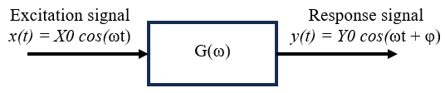
Figure 2: Schematic representation of a system with input sinusoidal signal x(t) and output sinusoidal signal at the same frequency, the two signal are related to a transfer function G(ω).

Excitation signals methods

The AC excitation signals method are classified primarily on the basis of their measurement time, accuracy repeatability and practical HW integration complexity within the analysis device [37]. These can be classified into two principal categories: single frequency signals and broadband signals [38] (Figure 3). Each category possesses distinctive advantages and disadvantages.
The single frequency signals have all the energy concentrated at one fundamental frequency while the broadband signals have the energy at multiple harmonics frequencies. This means that single frequencies have a much higher Signal to Noise Ratio (SNR) and greater accuracy per frequency analyzed because all the signal energy is concentrated at the fundamental frequency and , while broadband signals have a lower SNR and may involve greater complexity in terms of HW integration but require less measurement time because more harmonics are injected into the system simultaneously.
The main excitation signal used for EIS are represented in Figure 3 and specifically:
- The sine sweep method is the most used approach, this process entails the injection of a series of discrete sine waves at a precise frequency range, spanning from fmax to fmin., and it guarantees reliable results due to its high accuracy but is not practical for real-time measurements due to its long measurement time mostly for low frequencies (<1 Hz) [39];
- The square sweep method uses a square wave signal which alternates between two voltage or current level and the frequency of the square wave is varied systematically from maximum to minimum frequency. This approach is faster compared to the sine sweep but can introduce harmonics and noise due to abrupt changes in voltage and current.
- The multi-sine method is a technique that combines multiple sine waves at varying frequencies, which are applied to the device under observation simultaneously [40]. This approach significantly reduces the time required for measurements (i.e., around 70% [41]) while providing similar level of response and accuracy.
- The PRBS involves applying a pseudo-random binary sequence that appears random but it is generated in a deterministic way. This approach is really attractive for online and real-time applications as it allows for faster measurement and since the number of signal required level are two the complexity of signal implementation can be reduced as well. A disadvantage of this approach is that it can only be used for linear systems and can be susceptible to noise [38].
- The chirp signal, in which the frequency increases or decreases with time, allows to scan a wide range of frequencies in a very short time. This methodological approach does not necessitate the stabilization of data at steady state; only transient data are required, which further reduces the measurement time. However, it is only applicable to linear or weakly non-linear systems, and this approach leads to a reduction in accuracy and increased complexity in signal analysis [42].
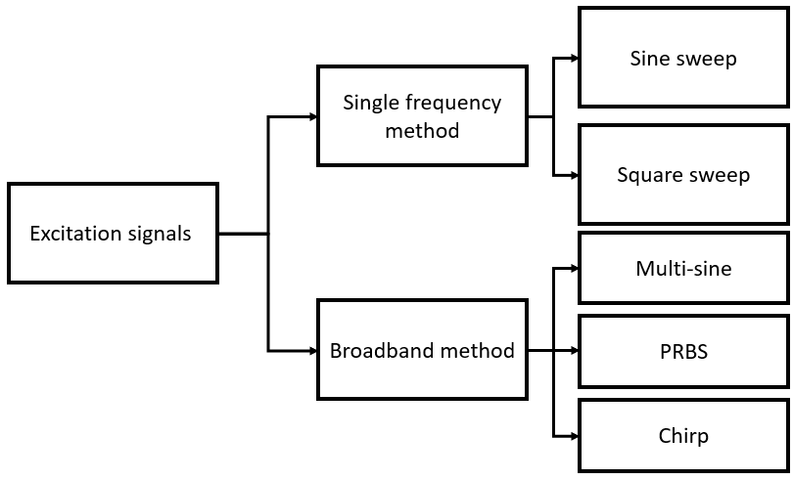
Figure 3: Excitation signals methodologies
The mentioned excitation signals were analyzed and tested in order to define the more suitable approach for real-time application. As pointed out, each has advantages and disadvantages and depending on the application, one approach may be preferred over the other. Considering the measurement time and the accuracy of the measurement the more suitable approach for real-time (or near-real time) vehicle application is a combination of sine sweep (for high and mid frequencies) and multi-sine (for low frequencies) in the frequency range between 5 kHz to 0.3 Hz. The frequency range selected still allows to detect the most meaningful information about the fuel cell but through a restricted range of frequencies and a reduced number of points per decade (6 to 8) is possible to optimize the measurement time in a time range between 5 and 10 seconds. The complete analysis about the optimized excitation signal and the comparison of the experimental tests performed with the different excitation approach will not be part of this work. For the analysis of the developed diagnostics software (described in the following paragraphs), experimental tests using the sine sweep method (which is still the standard) will be used, considering a variable number of points per decade, in order to assess the impact of a more or less rapid approach, involving the analysis of a smaller number of points, on the performance of the software.

Frequency response analyzer tool
The Frequency Response Analyzer (FRA) tool is equipped with the functionality to calculate an estimated frequency response of the fuel cell, based on the analysis of the AC voltage and current components collected by the fuel cell voltage monitoring and current sensing probe. This enables the computation of impedance values in the frequency domain.

The FRA tool employs a variety of methodologies in accordance with the type of excitation signal employed for the EIS analysis. For the analysis of sine sweep and multi-sine is used a recursive squares (RLS) algorithm. If the input excitation signal ($u\left(t\right)$) and the fuel cell response ($y\left(t\right)$) to the system is:

$$u\left(t\right)=A_{1}sin\left(ω_{1}t\right)+A_{2}sin\left(ω_{2}t\right)+… Eq.1$$
$$y\left(t\right)=A_{1}γ_{1}sin\left(ω_{1}t+θ_{1}\right)+A_{2}γ_{2}sin\left(ω_{2}t+θ_{2}\right)+… Eq.2$$
And using trigonometric identity transformation and angle addition formula to $y\left(t\right)$ is possible to estimate the unknown $γ_{i}cos(θ_{i})$ and $γ_{i}sin(θ_{i})$ using $A_{i}sin\left(ω_{i}t\right)$ and $A_{i}cos\left(ω_{i}t\right)$ as regressors for the RLS algorithm. Through this algorithm is possible to estimate the amplitude ($γ_{i})$ and phase shift ($θ_{i})$ at a specific frequency of the response signal (i.e., voltage) and thus in order to evaluate the real and imaginary parts of the impedance at different frequencies, the Eq.3,4,5 should be employed:
$$Z\left(ω\right)= Re\left(Z\left(ω\right)\right)+j∙Im\left(Z\left(ω\right)\right) Eq.3$$
$$Re\left(Z(ω)\right)= \frac{Re(V(ω))}{Re(I(ω))} Eq.4$$
$$Im\left(Z(ω)\right)= \frac{Im(V(ω))}{Im(I(ω))} Eq.5$$
Where the $V(ω)$ (response signal $y\left(t\right)$ in frequency domain) and $I(ω)$ (input excitation signal $u\left(t\right)$ in frequency domain) are the voltage and current in the frequency domain associated to the specific frequency ($ω$). And $Re\left(Z\left(ω\right)\right)$ and $Im\left(Z\left(ω\right)\right)$ are the real and imaginary part of the impedance $Z$.
The accuracy and computational efficiency of the Frequency response analyzer tool is validated comparing the performance with the commercial instrument used during the experimental tests (Metrohm Autolab PGSTAT302N).

Impedance analysis tool (IAT)
In order to minimize measurement time, the fast EIS approaches analyzed and developed (such as multi-sine) shown in the Excitation signals methods” section should be used in combination with fast analysis approaches such as Equivalent Circuit Modelling (ECM) [43], [44], [45].
The approach and algorithm developed in-house (Impedance analysis tool IAT) will be explored in more detail in another paper (not part of this work), but it is based on an ECM in which the electrochemical impedance spectrum obtained from the FRA tool can be represented and modelled by means of an equivalent circuit. The main losses of a fuel cell [2], [23] (i.e., activation caused by the slowness of the reaction taking place on the electrodes, ohmic caused by electronic resistance of the cell and membrane ionic ($H^{+}$) resistance and concentration associated to the reduction in the reactants partial pressure at the active sites of the catalyst layer) can be translated in a resistance while the transient behavior of a PEMFC can be described using a capacitive element. In an electrochemical cell an electric double layer (EDL) is formed spontaneously. The EDL is strictly related to the rate of reaction that leads to the formation of the charges, so on electric point of view it can be modeled as a resistance (R) and capacitance (C) in parallel. Also the GDL has a capacitive rule, it scatters and store reactants in order to obtain an uniform reaction over the electrode area and immediately have enough reagents in case of a load increase, however it is a different concept of capacitance than that of the EDL but thanks to this similarity, if modeled as a parallel R-C branch, it is also possible to give meaning to the capacitive part. Considering the real capacitive phenomena present in the cell, these do not turn out to be ideal and therefore it is appropriate to introduce constant phase element (CPE) which is an empirical approach to describe non ideal distributed capacitance [46]. On the basis of all the assumptions made, the equivalent circuit used as a reference for fitting the impedance spectra is as follows (Figure 4) and the fitting representation of a case study spectrum is showed in Figure 5,
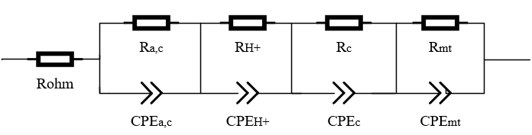
Figure 4: Equivalent circuit for a PEMFC
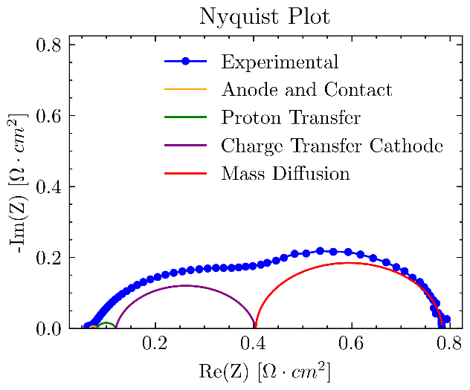
Figure 5: Clusters contribution to the impedance spectrum fitting using ECM approach
where we note the following clusters [47], which are then used to build the Health Indicators (HI):
- Ohmic membrane resistance ($R_{ohm })$.
- Charge transfer kinetics related to HOR and electrode and membrane contact resistance ($R_{a,c }and C_{a,c })$.
- Proton transfer process inside ionomer of CCL ($R_{H+ }and C_{H+ })$.
- Charge transfer kinetics related to ORR ($R_{c }and C_{c })$.
- Mass diffusion transfer (i.e., oxygen) inside the cathode ($R_{mt }and C_{mt })$.
Specifically, the method is capable to separate and classify the different contribution of the losses using appropriate guess values (as input for ECM approach) based on the expected (from literature and experimental data) time constant and resistance of the specific electrochemical phenomena [48], [49].
The Resistance and CPE are converted to effective resistance (Reff) and effective capacitance (Ceff) using the approach developed by Chang [46].

Health Indicators

As previously discussed in detail, the degradation and fault conditions of PEMFC stacks can be monitored by observing abnormal changes in certain characteristic indicators. In the literature, some characteristic parameters of the fuel cell are typically employed for the purposes of diagnosis and prognosis, with voltage [7], current, power [50] ECSA [51] and OCV being the most commonly utilized. While these indicators offer insights into the fuel cell's actual state, they often fail to isolate the potential causes of degradation or faults. This results in only partial information being provided, which does not allow for the effective prevention of faults or the implementation of targeted mitigation strategies. To overcome all these limitations in the accuracy/efficacy of health and faults indicators, the approach proposed here is based on using the output of the process (through the Impedance analysis tool) of real-time analysis of fast EIS data as input to build indicators which can isolate the conditions of faults and degradation within the fuel cell. In particular, the analysis carried out in the section “Degradation and failure mechanisms of PEMFC” shows that there are “common root causes” of faults which can be identified through the information of effective resistance (Reff) and effective capacity (Ceff) outputted from the EIS analysis.
As previously discussed in “PEMFC faults causes in vehicle application” the main causes are drying, flooding, anode starvation, cathode starvation and catalyst poisoning, thus for each of these a health/faults indicator is built.
Respectively, the drying indicator (${HI}_{dry}$) is defined as a function of ohmic resistance and protons ($H^{+})$ diffusion at CCL [47] since the main effect of this condition being the decrease in relative humidity inside the membrane and catalyst layer:
$${HI}_{dry}\left(T_{i}\right)=\frac{{w_{i}∙R}_{ohm,ref}\left(T_{i}\right)+\left(1-w_{i}\right)∙R_{H+,ref}\left(T_{i}\right)}{{w_{i}∙R}_{ohm }\left(T_{i}\right)+\left(1-w_{i}\right)∙R_{H+}\left(T_{i}\right)} Eq.6$$
Where $R_{ohm,ref }$is the reference (i.e., optimal condition) ohmic resistance at the operating temperature of the system, $R_{H+,ref}$ is the reference resistance of proton diffusion at the CCL, $w_{i}$ is a weight factor to take into account the influence of both parameters (usually is 0.8) and $T_{i}$ is the operating temperature of the PEMFC. It is important to note that these reference parameters are updated during the life of the device in order to take into account the degradation of the system. As with all the other indicators that will be introduced, the drying indicator ranges from 0 to 1. A value less than 0.9 indicates a more or less severe drying condition, which represents a deviation from the optimum condition.
The flooding and cathode starvation can be detected mainly by analyzing mass diffusion transfer and cathode charge transfer. The two phenomena, as analyzed in the previous chapters, are strongly correlated, but they can be isolated by reducing the capacity associated with the mass transfer cluster within the indicator, since the latter is influenced by the presence of water in the CL and GDL, specifically an excess of water leads to very high values of $C_{mt }$. Thus, the flooding and cathode starvation indicator is defined as:
$${HI}_{flo/c_starv}\left(T_{i},i_{i}\right)=\frac{{w_{i}∙R}_{c,ref}\left(T_{i},i_{i}\right)+\left(1-w_{i}\right)∙R_{mt,ref}\left(T_{i},i_{i}\right)}{{w_{i}∙R}_{c}\left(T_{i},i_{i}\right)+\left(1-w_{i}\right)∙R_{mt}\left(T_{i},i_{i}\right)} Eq.7$$
The indicators take into account of the influence of PEMFC operating current density ($i_{i}$) and temperature ($T_{i}$).
In a similar way, anode starvation is a function of anode charge transfer (both resistance and capacitance are considered).
$${HI}_{a_starv}\left(T_{i},i_{i}\right) =mean\left[\begin{aligned}w_{i}∙\frac{R_{a,c,ref}\left(T_{i},i_{i}\right)}{R_{a,c}\left(T_{i},i_{i}\right)} ; \\ \left(1-w_{i}\right)∙\frac{C_{a,c, ref}\left(T_{i},i_{i}\right)}{C_{a,c}\left(T_{i},i_{i}\right)}\end{aligned}\right] Eq.8$$
The catalyst poisoning being predominant at the cathode (see Catalyst Poisoning) is expressed as a function of cathode charge transfer resistance $R_{c,}\left(T_{i},i_{i}\right)$ at the operating temperature and current:
$${HI}_{c,poi}\left(T_{i},i_{i}\right)=\frac{R_{c,ref}\left(T_{i},i_{i}\right)}{R_{c}\left(T_{i},i_{i}\right)} Eq.9$$
Note that in order to have a complete view of degradation phenomena, it is necessary to analyze and combine all indicators. In addition, these indicators can be further correlated using information from on-board sensors (i.e., temperature, pressure and flow rate of reactants).

Experimental tests
The validation of approach developed, and the analysis of SW performance and computational time are done through an extensive campaign of experimental tests. The campaign involves the use of single cells and a 300 W commercial stack (from Baltic [52]) that can be modulated up to 30 cells in series. The single cells were created and assembled in the laboratory, The bipolar plate used were in graphite with a serpentine flow field for both cathode and anode. Non-woven carbon paper is used as gas diffusion layers with a Microporous Layer (MPL) that has been PTFE treated to 5 wt% and an overall thickness of 215 μm (Sigracet 22BB [53]. The catalyst layer is composed of platinum mixed with carbon powder as support with an I:C ratio of 0.4 (Platinum on carbon XC-72 [54] the mixture were deposited on the membrane via ultrasound assisted deposition procedure. The proton exchange membrane is commercial Nafion NRE 212 [55]. The experimental setup used for the tests allows for the control of pressure, temperature, relative humidity, and the mass flow rate of the reactants, enabling the analysis of various operating conditions, as shown in Figure 6. Electrochemical Impedance Spectroscopy was performed using a Metrohm Autolab PGSTAT302N potentiostat in either potentiostatic or galvanostatic mode, with an excitation amplitude of 5%.
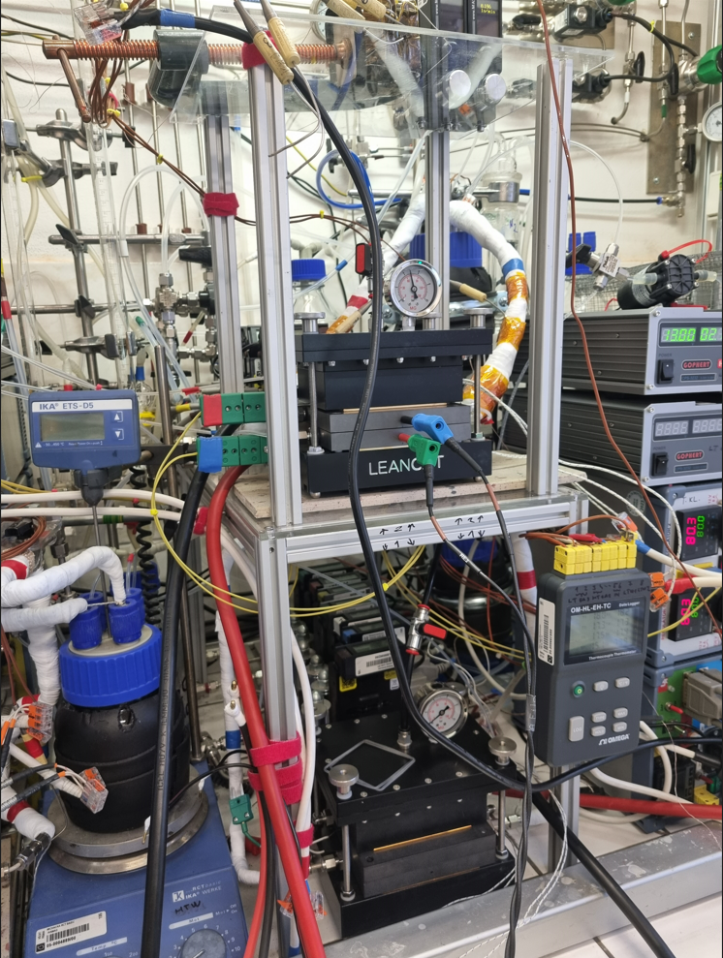
Figure 6: Experimental test setup for single cell PEMFC

SW and HW development
The software was developed in MATLAB due to its robust environment, which is supported by a wide range of packages and applications. These tools facilitate the seamless conversion of code into C and enable performance analysis across different configurations, such as stand-alone applications running on a personal computer and on the target hardware prototype. The software development process can be outlined as follows:
- Development of the initial code within the MATLAB environment.
- Conversion of the code into C via MATLAB Executable (MEX), that is a function directly callable from MATLAB enabling faster computations and preliminary considerations on the performances.
- Analysis of the C code in Software-in-the-Loop (SiL), i.e., a stand-alone application running on a personal computer that sends outputs to the MATLAB environment (Processor 12th Gen Intel(R) Core(TM) i7-12650H, 2300 MHz, 10 core, 16 logic processor).
- Analysis of the C code in Processor-in-the-Loop (PiL), i.e., a stand-alone application running on the target hardware that sends outputs to the MATLAB environment (BeagleBone Black, 1GHz ARM® Cortex-A8, Figure 7).
Each step was tested and validated on the entire experimental dataset previously introduced to assess accuracy and performance. The MATLAB code was used as a reference to evaluate the reproducibility of the results across the other configurations. The primary outcome of the analysis is the reproducibility of the results in comparison to the reference (MATLAB) and the experimental data, as well as the computational time. The latter is a critical parameter, as the ultimate goal of the analysis is to be performed online, in real-time, on the vehicle.
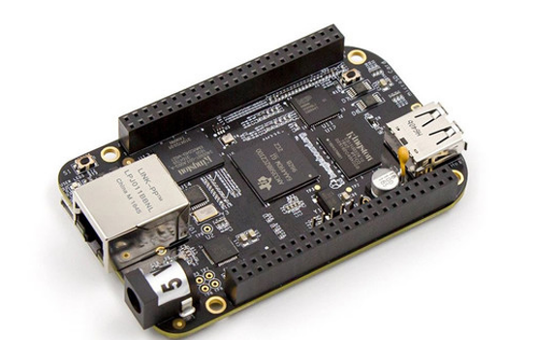
Figure 7: BeagleBone Black Board

Frequency Response Analysis tool
In Figure 8 (a), the results of the impedance calculated using the Frequency Response Analyzer (FRA) in MATLAB are presented alongside the experimental data obtained from the reference potentiostat (Autolab). Figure 8 (a and b) shows the errors in the real and imaginary components of the impedance, respectively, comparing the MATLAB FRA results with the experimental data, as well as the FRA results from the C code across various cases against the reference. The FRA takes the input values of current and voltage from the cell at different frequencies and calculates the associated AC impedance.
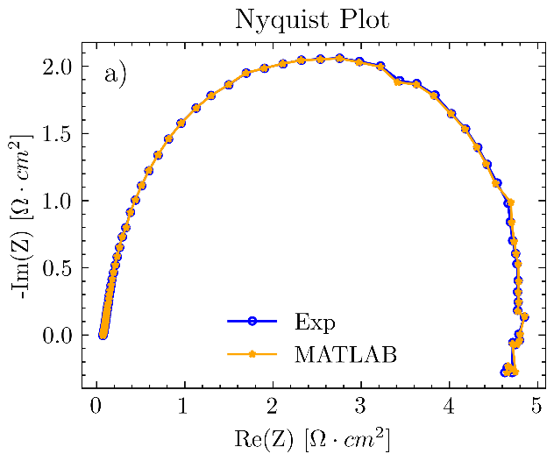
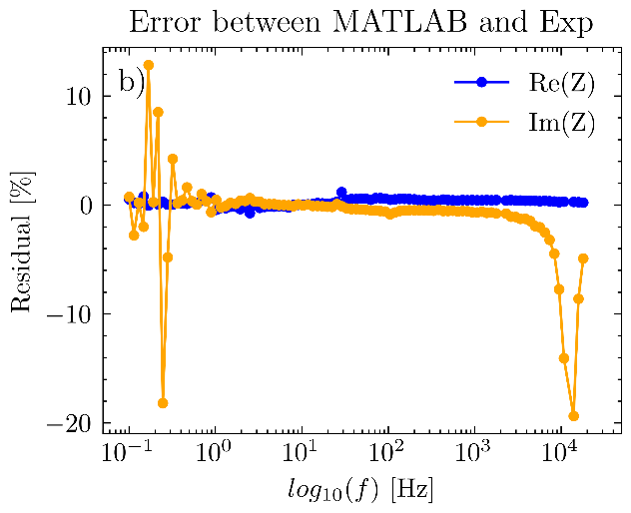
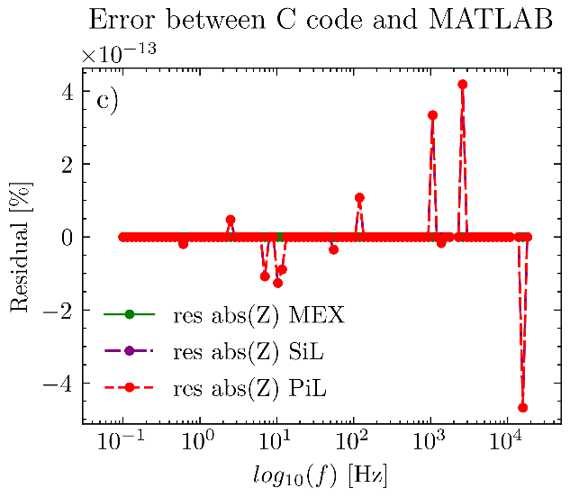
Figure 8: a) Impedance data comparison using Nyquist plot between FRA tool and Metrohm AutoLab b) Percentage error between FRA tool and Metrohm AutoLab c) Percentage error of module of impedance between FRA tool in MATLAB code and C code (MEX,SiL,PiL)
The Nyquist plot in Figure 8 (a) clearly demonstrates a perfect correspondence between the experimental impedance data and those calculated with MATLAB. Indeed, the error shown in Figure 8 (b) is approximately zero for the real component, while the imaginary component exhibits spikes of ±20% at both high and low frequencies. This is primarily since the imaginary part of the impedance is nearly zero under these conditions, leading to significant errors unless the precision of the calculation is increased. Regarding the C code, both the MEX and the SiL and PiL implementations yield identical results to those obtained in the MATLAB environment, with a percentage error on the order of 10⁻¹³. Thus, the C code has the same performance as the source MATLAB code.

Impedance Analysis Tool
Figure 9 (a) shows the Nyquist plot of both the experimental impedance data and the output from the IAT in MATLAB, while Figure 9 (b and c) shows the extracted resistances and capacitances for each identified cluster. The fitting of the experimental data is highly accurate, with an average error of 0.12% for the real part and 2.27% for the imaginary part. The latter is slightly higher due to minor scattering of the experimental data at high and low frequencies. Regarding the resistances extracted from the experimental spectrum, there is a good agreement between the MATLAB code and the C code for all clusters, except for the one associated with proton diffusion in the PiL case. It is important to note that this discrepancy is negligible, because the resistance associated is on the order of 10⁻⁴ Ohm cm² and thus the lower precision of the board prevents accurate capture, resulting in an overestimation. The same phenomenon occurs for the capacitances of the same cluster, leading to results that differ from the reference. However, this is not problematic, as it is mainly due to computational precision limitations rather than an error in the methodology.
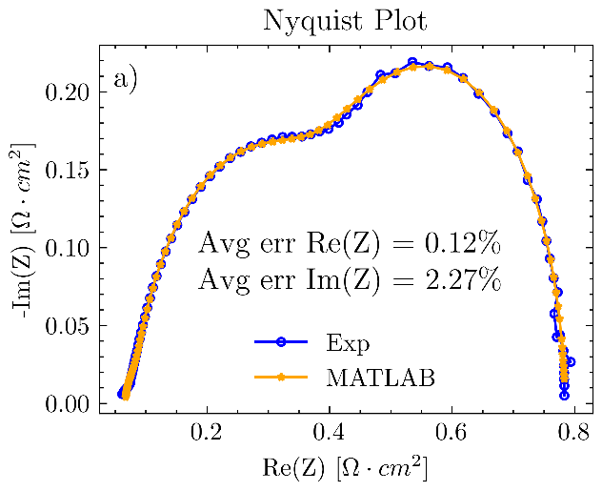
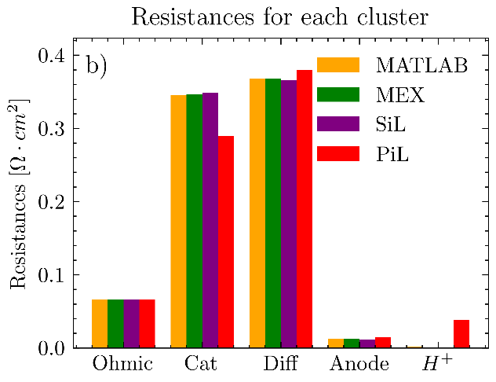
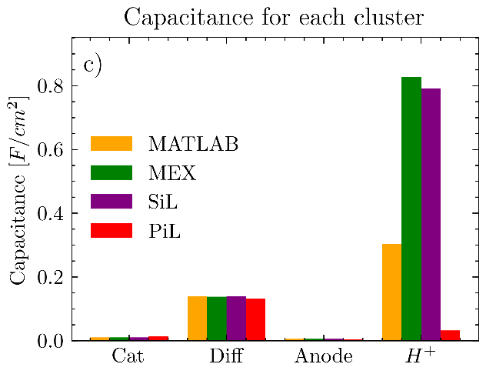
Figure 9: a) Nyquist plot of experimental impedance data and fitted impedance by IAT with corresponding average error for real and imaginary component b) Resistance for each cluster for the case study in the different SW environment c) Capacitance for each cluster for the case study in the different SW environment

Computational Time
To evaluate the computational time of the entire analysis, impedance spectra were collected using sine-sweep approach under the conditions of RH = 100%, p = 0.5 barg, T = 60°C, with points per decade (ppd) ranging from 18 to 6, in steps of 2. The experimental data were used to assess the timing of the analysis through the MATLAB profiler, a tool that allows for the monitoring of the computational time of functions. The results are shown in Figure 10, where the timings of the FRA (part a), the IAT (part b), and the complete analysis (part c) for the various case studies can be compared. For the FRA, the computational time increases linearly with the number of ppd, and there is a drastic reduction in computation time by an order of magnitude when performed in C using SiL and MEX. In the PiL case, although the performance is improved compared to the MATLAB environment (halving the computation time), it is still significantly limited by the processing power of the board. As for the IAT, a parabolic trend is observed for both MATLAB and MEX, although the latter is only slightly pronounced. PiL and SiL exhibit a linear trend, with SiL being the fastest at higher ppd values. For the complete analysis, SiL once again proves to be the fastest, taking approximately 1 second to complete the analysis with 18 ppd, compared to the 5 seconds required for PiL. In any case, this analysis does not account for the time required to acquire experimental data but only represents the post-processing phase. Additionally, it is important to note that under online-real-time conditions, the analysis will operate between 6 and 8 ppd, with a total computational time of approximately 4s with the prototyping hardware.

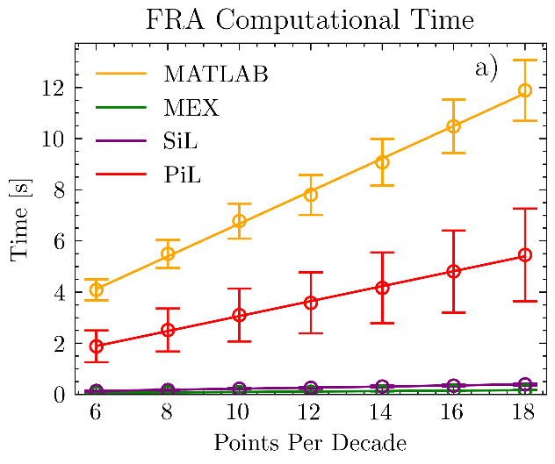

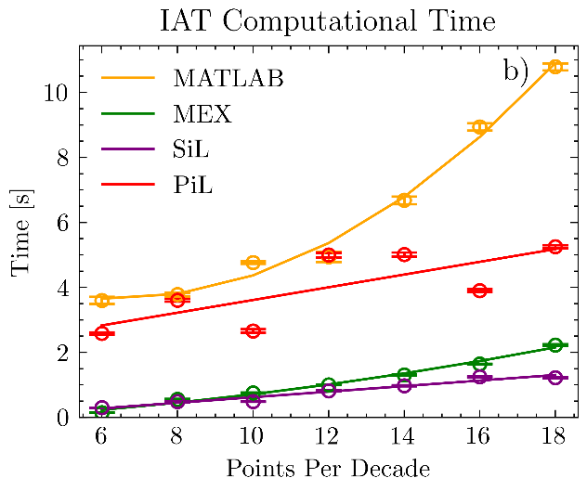
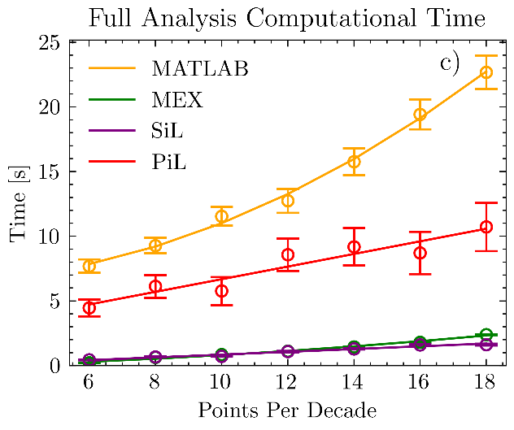
Figure 10: a) Computational time per different points per decade for FRA analysis b) Computational time per different points per decade for IAT analysis c) Computational time per different points per decade for full (FRA + IAT) analysis

Conclusions
This work presented the durability targets for PEMFC systems for automotive applications, along with the research and development scenarios aimed at achieving them. Among these, diagnostic systems play a crucial role in reaching the target of 25,000 hours of operation under real-world conditions for heavy-duty systems. In this context, an innovative in-house health monitoring EIS-based software was introduced, which enables a rapid assessment of the PEMFC system's performance and health status through the calculation of specific indicators. The code was fully developed in MATLAB, and its validation was demonstrated using experimental datasets. Furthermore, the reliability of the results was assessed by converting the code to C and testing it in various environments: MATLAB, Software-in-the-Loop (SiL) on a PC, and Processor-in-the-Loop (PiL) on prototype hardware. The main outcomes are as follows:
- Reconstruction of the impedance spectrum from current and voltage data at different frequencies has negligible error for intermediate frequencies of the spectrum while the latter increases at low and high frequencies only for the imaginary part approaching zero.
- The C code has the same performance as that in the MATLAB environment for reconstructing the experimental impedance spectrum.
- The performance of the impedance analysis tool is very similar between MATLAB and C code.
- The computational time of the analysis has a quadratic trend for the MATLAB environment and a linear trend for the C code over the range of points per decade analyzed. The total analysis for 18 points per decade takes about:
  - MATLAB: 22.7 s
  - MEX: 2.4 s.
  - SiL: 1.6 s.
  - PiL: 8.7 s.
- While the total analysis for 6 points per decade takes about:
  - MATLAB: 7.7 s
  - MEX: 0.21 s.
  - SiL: 0.44 s.
  - PiL: 4.47 s.
Thus, by using a fast signal excitation, it is also possible to reduce the computational analysis time.

Future Directions and Perspectives
Subsequent research will undertake a detailed examination of the entire analysis procedure developed in-house, as well as a comprehensive analysis of the advantages and disadvantages of the various Fast EIS approaches.
Furthermore, a novel and innovative tool will be developed for on-board integration of the signal generator, with the objective of injecting the Fast EIS signal into the FC.

Acknowledgments


This publication is supported by EATON which significantly contributed to the advancement of this work.
This publication is part of the project PNRR-NGEU which has received funding from the MUR – DM 352/2022.

Bibliography

[1] P. Halder et al., “Performance, emissions and economic analyses of hydrogen fuel cell vehicles,” Renew. Sustain. Energy Rev., vol. 199, p. 114543, Jul. 2024, doi: 10.1016/j.rser.2024.114543.
[2] M. Carello, H. De Carvalho Pinheiro, L. Longega, and L. Di Napoli, “Design and Modelling of the Powertrain of a Hybrid Fuel Cell Electric Vehicle,” SAE Int. J. Adv. Curr. Pract. Mobil., vol. 3, no. 6, pp. 2878–2892, Apr. 2021, doi: 10.4271/2021-01-0734.
[3] E. Bianco, L. Di Napoli, E. Grano, and M. Carello, “E-scooter Modelling: Battery and Fuel Cell System Integration,” in Advances in Italian Mechanism Science, vol. 122, V. Niola, A. Gasparetto, G. Quaglia, and G. Carbone, Eds., in Mechanisms and Machine Science, vol. 122. , Cham: Springer International Publishing, 2022, pp. 909–916. doi: 10.1007/978-3-031-10776-4_104.
[4] D. A. Cullen et al., “New roads and challenges for fuel cells in heavy-duty transportation,” Nat. Energy, vol. 6, no. 5, pp. 462–474, Mar. 2021, doi: 10.1038/s41560-021-00775-z.
[5] “Hydrogen and Fuel Cell Technologies Office Multi-Year Program Plan,” 2024.
[6] “DOE Hydrogen Program record-23002:HD Fuel cell Cost.” Accessed: Dec. 13, 2024. [Online]. Available: https://www.hydrogen.energy.gov/docs/hydrogenprogramlibraries/pdfs/23002-hd-fuel-cell-system-cost-2022.pdf#:~:text=The%20cost%20of%20a%20275-kWnet%20proton%20exchange%20membrane,a%20volume%20of%2050%2C000%20units%2Fyear%20%28%24170%2FkWnet%20when%20
[7] C. Zhang, Y. Zhang, L. Wang, X. Deng, Y. Liu, and J. Zhang, “A health management review of proton exchange membrane fuel cell for electric vehicles: Failure mechanisms, diagnosis techniques and mitigation measures,” Renew. Sustain. Energy Rev., vol. 182, p. 113369, Aug. 2023, doi: 10.1016/j.rser.2023.113369.
[8] J. Liu, Q. Li, W. Chen, Y. Yan, and X. Wang, “A Fast Fault Diagnosis Method of the PEMFC System Based on Extreme Learning Machine and Dempster–Shafer Evidence Theory,” IEEE Trans. Transp. Electrification, vol. 5, no. 1, pp. 271–284, Mar. 2019, doi: 10.1109/TTE.2018.2886153.
[9] E. O. Balogun, N. Hussain, J. Chamier, and P. Barendse, “Performance and durability studies of perfluorosulfonic acid ionomers as binders in PEMFC catalyst layers using Electrochemical Impedance Spectroscopy,” Int. J. Hydrog. Energy, vol. 44, no. 60, pp. 32219–32230, Dec. 2019, doi: 10.1016/j.ijhydene.2019.10.079.
[10] L. Fan, J. Gao, Y. Lu, W. Shen, and S. Zhou, “Analysis of the Influence of Component Degradation on Different Degradation Indexes of PEMFC,” Energies, vol. 16, no. 23, p. 7806, Nov. 2023, doi: 10.3390/en16237806.
[11] M. K. Debe, “Electrocatalyst approaches and challenges for automotive fuel cells,” Nature, vol. 486, no. 7401, pp. 43–51, Jun. 2012, doi: 10.1038/nature11115.
[12] R. Sharma, S. Gyergyek, Q. Li, and S. M. Andersen, “Evolution of the degradation mechanisms with the number of stress cycles during an accelerated stress test of carbon supported platinum nanoparticles,” J. Electroanal. Chem., vol. 838, pp. 82–88, Apr. 2019, doi: 10.1016/j.jelechem.2019.02.052.
[13] L. Qu et al., “Effect of electrode Pt-loading and cathode flow-field plate type on the degradation of PEMFC,” J. Energy Chem., vol. 35, pp. 95–103, Aug. 2019, doi: 10.1016/j.jechem.2018.09.004.
[14] W. Chen, B. Chen, K. Meng, H. Zhou, and Z. Tu, “Experimental study on dynamic response characteristics and performance degradation mechanism of hydrogen-oxygen PEMFC during loading,” Int. J. Hydrog. Energy, vol. 48, no. 12, pp. 4800–4811, Feb. 2023, doi: 10.1016/j.ijhydene.2022.11.036.
[15] T. Zhang, P. Wang, H. Chen, and P. Pei, “A review of automotive proton exchange membrane fuel cell degradation under start-stop operating condition,” Appl. Energy, vol. 223, pp. 249–262, Aug. 2018, doi: 10.1016/j.apenergy.2018.04.049.
[16] Y. Pan, H. Wang, and N. P. Brandon, “Gas diffusion layer degradation in proton exchange membrane fuel cells: Mechanisms, characterization techniques and modelling approaches,” J. Power Sources, vol. 513, p. 230560, Nov. 2021, doi: 10.1016/j.jpowsour.2021.230560.
[17] P. C. Okonkwo et al., “A review of bipolar plates materials and graphene coating degradation mechanism in proton exchange membrane fuel cell,” Int. J. Energy Res., vol. 46, no. 4, pp. 3766–3781, Mar. 2022, doi: 10.1002/er.7428.
[18] M.-C. Hsiao et al., “Preparation and properties of a graphene reinforced nanocomposite conducting plate,” J. Mater. Chem., vol. 20, no. 39, p. 8496, 2010, doi: 10.1039/c0jm01679a.
[19] D. Qiu, P. Liang, L. Peng, P. Yi, X. Lai, and J. Ni, “Material behavior of rubber sealing for proton exchange membrane fuel cells,” Int. J. Hydrog. Energy, vol. 45, no. 8, pp. 5465–5473, Feb. 2020, doi: 10.1016/j.ijhydene.2019.07.232.
[20] J. Zhang and Y. Hu, “Sealing performance and mechanical behavior of PEMFCs sealing system based on thermodynamic coupling,” Int. J. Hydrog. Energy, vol. 45, no. 43, pp. 23480–23489, Sep. 2020, doi: 10.1016/j.ijhydene.2020.06.167.
[21] P. Liang, D. Qiu, L. Peng, P. Yi, X. Lai, and J. Ni, “Structure failure of the sealing in the assembly process for proton exchange membrane fuel cells,” Int. J. Hydrog. Energy, vol. 42, no. 15, pp. 10217–10227, Apr. 2017, doi: 10.1016/j.ijhydene.2017.01.026.
[22] J. Aubry, N. Y. Steiner, S. Morando, N. Zerhouni, and D. Hissel, “Fuel cell diagnosis methods for embedded automotive applications,” Energy Rep., vol. 8, pp. 6687–6706, Nov. 2022, doi: 10.1016/j.egyr.2022.05.036.
[23] F. Mazzeo, L. Di Napoli, and M. Carello, “Assessing Open Circuit Voltage Losses in PEMFCs: A New Methodological Approach,” Energies, vol. 17, no. 11, p. 2785, Jun. 2024, doi: 10.3390/en17112785.
[24] H. Wang, R. Wang, S. Sui, T. Sun, Y. Yan, and S. Du, “Cathode Design for Proton Exchange Membrane Fuel Cells in Automotive Applications,” Automot. Innov., vol. 4, no. 2, pp. 144–164, May 2021, doi: 10.1007/s42154-021-00148-y.
[25] “Li, H., Song, C., Zhang, J., Zhang, J. (2008). Catalyst Contamination in PEM Fuel Cells. In: Zhang, J. (eds) PEM Fuel Cell Electrocatalysts and Catalyst Layers. Springer, London. https://doi.org/10.1007/978-1-84800-936-3_6”.
[26] A. Kusoglu and A. Z. Weber, “A Mechanistic Model for Pinhole Growth in Fuel-Cell Membranes during Cyclic Loads,” J. Electrochem. Soc., vol. 161, no. 8, pp. E3311–E3322, 2014, doi: 10.1149/2.036408jes.
[27] D. H. Jeon and H. Kim, “Effect of compression on water transport in gas diffusion layer of polymer electrolyte membrane fuel cell using lattice Boltzmann method,” J. Power Sources, vol. 294, pp. 393–405, Oct. 2015, doi: 10.1016/j.jpowsour.2015.06.080.
[28] A. Hernandez, D. Hissel, and R. Outbib, “Modeling and Fault Diagnosis of a Polymer Electrolyte Fuel Cell Using Electrical Equivalent Analysis,” IEEE Trans. Energy Convers., vol. 25, no. 1, pp. 148–160, Mar. 2010, doi: 10.1109/TEC.2009.2016121.
[29] A. Gebregergis, P. Pillay, and R. Rengaswemy, “PEMFC Fault Diagnosis, Modeling, and Mitigation”.
[30] Z. Li, R. Outbib, S. Giurgea, and D. Hissel, “Diagnosis for PEMFC Systems: A Data-Driven Approach With the Capabilities of Online Adaptation and Novel Fault Detection,” IEEE Trans. Ind. Electron., vol. 62, no. 8, pp. 5164–5174, Aug. 2015, doi: 10.1109/TIE.2015.2418324.
[31] J. Liu et al., “PEMFC Residual Life Prediction Using Sparse Autoencoder-Based Deep Neural Network,” IEEE Trans. Transp. Electrification, vol. 5, no. 4, pp. 1279–1293, Dec. 2019, doi: 10.1109/TTE.2019.2946065.
[32] Z. Zheng, M.-C. Péra, D. Hissel, M. Becherif, K.-S. Agbli, and Y. Li, “A double-fuzzy diagnostic methodology dedicated to online fault diagnosis of proton exchange membrane fuel cell stacks,” J. Power Sources, vol. 271, pp. 570–581, Dec. 2014, doi: 10.1016/j.jpowsour.2014.07.157.
[33] M. Ibrahim et al., “Signal-Based Diagnostics by Wavelet Transform for Proton Exchange Membrane Fuel Cell,” Energy Procedia, vol. 74, pp. 1508–1516, Aug. 2015, doi: 10.1016/j.egypro.2015.07.708.
[34] R. Ma, H. Dang, R. Xie, L. Xu, and D. Zhao, “Online Fault Diagnosis for Open-Cathode PEMFC Systems Based on Output Voltage Measurements and Data-Driven Method,” IEEE Trans. Transp. Electrification, vol. 8, no. 2, pp. 2050–2061, Jun. 2022, doi: 10.1109/TTE.2021.3114194.
[35] H. Liu, J. Chen, D. Hissel, J. Lu, M. Hou, and Z. Shao, “Prognostics methods and degradation indexes of proton exchange membrane fuel cells: A review,” Renew. Sustain. Energy Rev., vol. 123, p. 109721, May 2020, doi: 10.1016/j.rser.2020.109721.
[36] A. Ch. Lazanas and M. I. Prodromidis, “Electrochemical Impedance Spectroscopy─A Tutorial,” ACS Meas. Sci. Au, vol. 3, no. 3, pp. 162–193, Jun. 2023, doi: 10.1021/acsmeasuresciau.2c00070.
[37] X. Wei, X. Wang, and H. Dai, “Practical On-Board Measurement of Lithium Ion Battery Impedance Based on Distributed Voltage and Current Sampling,” Energies, vol. 11, no. 1, p. 64, Jan. 2018, doi: 10.3390/en11010064.
[38] J. Sihvo, D.-I. Stroe, T. Messo, and T. Roinila, “Fast Approach for Battery Impedance Identification Using Pseudo-Random Sequence Signals,” IEEE Trans. Power Electron., vol. 35, no. 3, pp. 2548–2557, Mar. 2020, doi: 10.1109/TPEL.2019.2924286.
[39] E. Karden, S. Buller, and R. W. D. Doncker, “A method for measurement and interpretation of impedance spectra for industrial batteries”.
[40] P. Fortin, M. R. Gerhardt, Ø. Ulleberg, F. Zenith, and T. Holm, “Multi-Sine EIS for Early Detection of PEMFC Failure Modes,” Front. Energy Res., vol. 10, p. 855985, May 2022, doi: 10.3389/fenrg.2022.855985.
[41] C. Brunetto, A. Moschetto, and G. Tina, “PEM fuel cell testing by electrochemical impedance spectroscopy,” Electr. Power Syst. Res., vol. 79, no. 1, pp. 17–26, Jan. 2009, doi: 10.1016/j.epsr.2008.05.012.
[42] B. Bullecks, R. Suresh, and R. Rengaswamy, “Rapid impedance measurement using chirp signals for electrochemical system analysis,” Comput. Chem. Eng., vol. 106, pp. 421–436, Nov. 2017, doi: 10.1016/j.compchemeng.2017.05.018.
[43] L. Zhao, H. Dai, F. Pei, P. Ming, X. Wei, and J. Zhou, “A Comparative Study of Equivalent Circuit Models for Electro-Chemical Impedance Spectroscopy Analysis of Proton Exchange Membrane Fuel Cells,” Energies, vol. 15, no. 1, p. 386, Jan. 2022, doi: 10.3390/en15010386.
[44] A. M. Dhirde, N. V. Dale, H. Salehfar, M. D. Mann, and T.-H. Han, “Equivalent Electric Circuit Modeling and Performance Analysis of a PEM Fuel Cell Stack Using Impedance Spectroscopy,” IEEE Trans. Energy Convers., vol. 25, no. 3, pp. 778–786, Sep. 2010, doi: 10.1109/TEC.2010.2049267.
[45] J. Choi, J. Sim, H. Oh, and K. Min, “Resistance Separation of Polymer Electrolyte Membrane Fuel Cell by Polarization Curve and Electrochemical Impedance Spectroscopy,” Energies, vol. 14, no. 5, p. 1491, Mar. 2021, doi: 10.3390/en14051491.
[46] B.-Y. Chang, “Conversion of a Constant Phase Element to an Equivalent Capacitor,” J. Electrochem. Sci. Technol., vol. 11, no. 3, pp. 318–321, Aug. 2020, doi: 10.33961/jecst.2020.00815.
[47] H. Yuan, H. Dai, P. Ming, X. Wang, and X. Wei, “Quantitative analysis of internal polarization dynamics for polymer electrolyte membrane fuel cell by distribution of relaxation times of impedance,” Appl. Energy, vol. 303, p. 117640, Dec. 2021, doi: 10.1016/j.apenergy.2021.117640.
[48] A. Iranzo, S. J. Navas, F. Rosa, and M. R. Berber, “Determination of time constants of diffusion and electrochemical processes in Polymer Electrolyte Membrane Fuel Cells,” Energy, vol. 221, p. 119833, Apr. 2021, doi: 10.1016/j.energy.2021.119833.
[49] L. Han, Y. Shang, Q. Liang, Y. Liu, and Z. Guo, “Distribution of relaxation times used for analyzing the electrochemical impedance spectroscopy of polymer electrolyte membrane fuel cell,” Renew. Energy, vol. 227, p. 120485, Jun. 2024, doi: 10.1016/j.renene.2024.120485.
[50] Z. Hua, Z. Zheng, E. Pahon, M.-C. Péra, and F. Gao, “Remaining useful life prediction of PEMFC systems under dynamic operating conditions,” Energy Convers. Manag., vol. 231, p. 113825, Mar. 2021, doi: 10.1016/j.enconman.2021.113825.
[51] X. Zhang and P. Pisu, “An Unscented Kalman Filter Based Approach for the Health- Monitoring and Prognostics of a Polymer Electrolyte Membrane Fuel Cell,” 2012.
[52] “Baltic - https://www.balticfuelcells.de/htmdocs/en/dienstleistungen.shtml.”
[53] “Sigracet 22 bb, https://www.fuelcellstore.com/sigracet-22-bb.”
[54] “Platinum on carbon XC-72 - https://www.fuelcellstore.com/fuel-cell-components/catalyst/platinum-catalysts/40-platinum-carbon.”
[55] “Nafion NRE 212 - https://www.h2planet.eu/it/detail/NafionNRE212.”

Contact information
Luca Di Napoli – Senior Engineer Fuel Cell System
Eaton – European Innovation Center
LucaDiNapoli@eaton.com

Francesco Mazzeo – Ph.D. student
Politecnico di Torino - DIMEAS
francesco.mazzeo@polito.it

