20XX-01-XXXX

Predictive steering angle generation algorithm for high efficiency vehicle’s path optimization
Author, co-author (Do NOT enter this information. It will be pulled from participant tab in MyTechZone)
Affiliation (Do NOT enter this information. It will be pulled from participant tab in MyTechZone

Abstract
In this article predictive performance simulation of a high-efficiency lightweight vehicle is performed through development of a multi-physics MATLAB Simulink model including advanced vehicle dynamics. The vehicle is put into a three-dimensional representation of the racetrack, including its limits, slope, banking, and adhesion coefficient along the model space, elaborated from the track GPS data points. The vehicle’s reference trajectory is not priorly provided to the model at the simulation start as, during run-time, a predictive Steering Angle Generation (SAG) algorithm based on Nonlinear Model Predictive Control (NMPC) computes the optimal steering angle input needed to drive the vehicle on the track within its limits. Computation is based on fast predictive simulations of a simplified version of vehicle’s dynamics modelling of the prototype. Each single simulation exploits a different possible steering angle to be applied by the virtual driver, starting from the initial conditions given by the actual simulated state of the system. The results of the various-steering angle simulations are collected and used by a cost function minimization algorithm. The performance target of the path optimization is described by the tunable parameters inserted in the algorithm’s cost function, allowing to prioritize speed or fuel consumption. The model is being tested and validated, with good accuracy, on the prototype track data obtained during 2023 and 2024 racing events and can be used as a basis for developing an automated race strategy algorithm for vehicle’s performance enhancement.
Introduction
This paper describes a predictive Steering Angle Generation algorithm, which is fundamental for an accurate modelling of a vehicle’s on-track behavior, to optimize its performance: the lightweight prototype IDRAzephyrus is designed to race in the Shell Eco-Marathon (Hydrogen Prototype category) by the team H₂politO and since the race rewards the most energy efficient competitor, finding the best strategy for the vehicle inputs is crucial to obtain the best possible output.
In previous works, an original longitudinal model was improved by adding lateral dynamics, the chosen approach for the steering input was to draw an ideal trajectory from GPS data [1] and use it as a reference for a control system simulating the driver: Stanley [2], PI and PID controller [3] with cross-track and heading error were tested with a low pass filter downstream, and eventually the last one was selected. Unfortunately, this approach had some issues: the controller, even if fine-tuned, showed a delay at corner entry and was often oscillating at corner exit (usually, parameter tuning privileged one or another, without a silver bullet solution capable of solving both problems), and this led to a longer covered distance, even 100 m more after 10 km of travelled distance, unacceptably; additionally, it was very sensitive to speed, imposing once again a compromise. Furthermore, the original trajectory was decided by the race strategists, thanks to experience but without specific data to validate it, only common sense without clear evidence.
To solve this issue a completely new approach based on Nonlinear Model Predictive Control (NMPC) was developed on MATLAB Simulink. NMPC is a very flexible approach to system control, as it can deal with nonlinear systems, constraints of any type and it is able to privilege “cost” or performance: each time-step, it predicts the state of the system after a certain amount of time (called horizon) and performs a command in order to force the state to be as close as possible to the desired one, limiting the command activity as well; the time-step is shorter than the horizon, so the control algorithm works with a “receding horizon strategy”[4].
In the system described in this paper, each fixed time step, a simple nonlinear single-track model simulates the vehicle behavior with different steering angle inputs, starting from the conditions of the vehicle in that instant; the results of these microsimulations are then entered in a cost function, where different quantities are weighted to evaluate the most efficient steering angle for the following step. The cost function includes also a term considering track limits, which are retrieved from GPS data. To stabilize the control, some outputs are sent as input at the following time step, and a filter is present to account for steering inertias and human actuation. The ideal trajectory of the previous system is still used but only to give information to the controller before it runs: for example, it gives a reference for covered distance, and deactivates some cost function terms if they have to be ignored in that part of the track.
NMPC-based controllers for steering have been investigated already [5], the innovation of this work consists in the introduction of other goals in the path planning asides of obstacle avoidance: this system is able to evaluate the least energy consuming trajectory (which is not obvious at tracks with change of elevation, banking and different turn radii) for different acceleration inputs, allowing to find the best strategy considering more variables. The goal of the work is not to create an algorithm for autonomous driving, then some information about the circuit will be provided a priori to the control algorithm.
In the following sections, the vehicle and its model will be introduced, with some information on track modelling too, followed by a more accurate description of the control algorithm and the blocks connected to it. Finally, results will be shown and commented on before the final thoughts and future developments.
Vehicle and environment modelling
The Prototype IDRAzephyrus, shown in Figure 1, debuted in 2023 in the Shell Eco-Marathon for Team H₂politO.
The competition awards the team which can complete a 16 km run on a circuit in less than 38 minutes consuming the least energy possible; therefore, energy efficiency is the main goal for which the car was designed. IDRAzephyrus is a closed-cockpit 3-wheeler, with rigid suspensions and full carbon monocoque which keeps the curb weight below 33 kg. The powertrain is composed by a 500 W PEM fuel cell, an energy buffer and a 150 W DC motor, which powers the rear wheel through a planetary gear and a free-wheel, while the front wheels are steering. In both the races it has participated to it has reached the podium of its category, improving the 3rd place of 2023 with a 2nd place in 2024, both at Circuit Paul Armagnac in Nogaro (France), with an official record of 794 km/m³ under the current regulations [6].
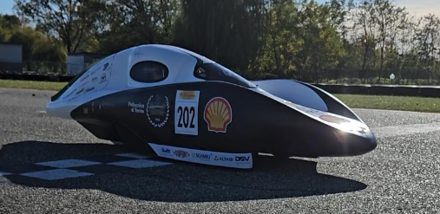
Figure 1. IDRAzephyrus
As already mentioned, the prototype has rigid suspensions, so a 3 degrees of freedom model has been employed: the monocoque deforms in turns, but a lumped parameters modelling would not be effective. At the same time, the goal of this work was to consider changes in elevation and banking: at this scope, a 3D scan of the track supplied by the competition organizers, represented by the 3D plot of Figure 2, was converted in local metric units from geographical coordinate and interpolated to compute the gradient.
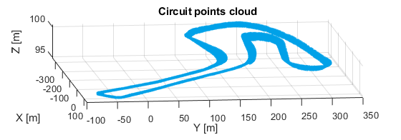
Figure 2. Circuit map with altitude 10x magnificated
In this way, knowing the position of the vehicle in the inertial frame XY, the altitude can be univocally determined, and the yaw angle allows to establish the slope and the banking of the road in each instant, with a scalar product. With this input angles, load transfers and resistive forces are computed, both longitudinal and lateral.
Powertrain
The powertrain power source is, as already written, a fuel cell, whose experimental polarization curve V_{FC}=f(I_{FC}) of Figure 3 is modelled with a polynomial expression reported in Equation 1. The current I_{FC} is drained by the circuit downstream and by the fans used to supply Oxygen, as required by the rulebook:
$$\begin{aligned}V_{FC}=V_{OCV}-k_{I1}∙I_{FC}-k_{I2}∙I_{FC}^{2}-k_{I3}∙I_{FC}^{3} \#\left(1\right)\end{aligned}$$

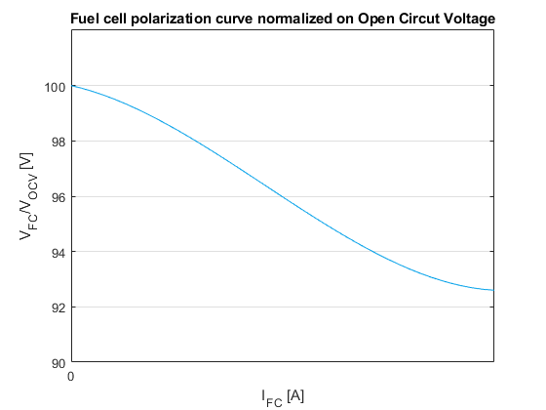
Figure 3. Fuel cell experimental polarization curve in its working range
The energy buffer consists in a stack of super-capacitors in series, modelled with their characteristic equation and a parasitic resistance. The power in input is set during the run, and it is controlled by a DC/DC buck converter [7] in-between the fuel cell and the energy storage, allowing a constant power control regardless of the super-capacitors voltage; this is not completely true as it also limits the current in function of voltage to avoid overcharging: the maximum current decreases linearly with voltage; this translates into a constant power input when SOC is below circa 98%, because current limit below this threshold is not reached, while in the last 2% the current is progressively reduced to 0. The power in output is drained by the DC motor actuation, which regulates the voltage in input of the motor through a duty cycle with a bang-bang control [8] in order to achieve the target current, selected by the driver following the strategy prepared before the race or corrected during the run. The actuation consumes a further amount of current for its operation. The motor is then modelled electrically with Equation 2:
$$\begin{aligned}V_{act,out}=R_{a}∙I_{act,out}+k_{mot}∙ω_{mot}+L_{a}\frac{dI_{act,out}}{dt} \#(2)\end{aligned}$$
With I_{act,out} never negative as a diode is present in the circuit. The mechanical torque is computed through Equation 3, derived by bench tests:
$$T_{mot}=\left(η_{0}+{ k}_{ηω}∙ω_{e}-{ k}_{ηT}∙\left({ k}_{mot}∙I_{act,out}-T_{fr}\right)\right)∙⋯$$
$$∙\left({ k}_{mot}∙I_{act,out}-T_{fr}\right) \left(3\right)$$
Where the efficiency is the sum of a fixed value and two terms linearly dependent on the rotational speed and armature current, and T_{fr} is the constant friction torque that stops the motor when the free-wheel is disengaged. The free-wheel is modelled such that the output torque depends on the speed difference between the transmission output and the wheel: when the wheel is faster, no torque is transmitted, when the opposite happens, the torque increases non-linearly, reaching saturation, as shown in Figure 4. T_{max} is dimensioned such that the operating point is always in the almost-linear region during the race.
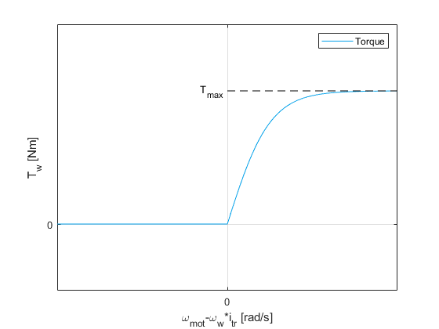
Figure 4. Free-wheel mechanical characteristic
Consumption
The Hydrogen mass flow rate is computed from the current produced by the fuel cell, as per Equation 4:
$$\begin{aligned}{\dot{m}}_{H_{2}}=\frac{N_{cells}∙{Mm}_{H_{2}}}{2∙N_{A}∙e^{-}} \#\left(4\right)\end{aligned}$$
Where N_{A} times e⁻ (Avogadro number times elementary charge) is the Faraday constant. To this quantity, as stated by the rulebook, an equivalent Hydrogen consumption is added to account for the auxiliaries battery electrical consumption, as in Equation 5:
$$\begin{aligned}{\dot{m}}_{H_{2},eq}=\frac{P_{aux}}{{LHV}_{H_{2}}} \#\left(5\right)\end{aligned}$$
The sum is then, following Equation 6, integrated on time, divided by the covered distance and the Hydrogen density, to show the result as it is after the race:
$$\begin{aligned}RESULT=\frac{m_{H_{2}}+m_{H_{2},eq}}{ρ_{H_{2}}∙d} \left({km}/{m^{3}}\right)\#\left(6\right)\end{aligned}$$
Inputs
The powertrain has 2 inputs that can be set while the vehicle is running:
- Target input power to the energy storage.
- Target current to the motor.
The first one is set from remote by the team in pit-lane, the second one by the driver, but coached by the Team’s Strategy division; when the target current is null, the motor is directly switched off. The two inputs are strongly inter-dependent, since the super-capacitors voltage level limits the speed (as it limits the motor supply voltage): this is why a charge-sustaining strategy is desirable; furthermore, the rulebook states that the voltage level of the energy buffer must be equal or higher at the end of the attempt with respect to the beginning.
In the model the action of the driver and the team is simulated by look-up tables, which take as input the track’s curvilinear coordinate and the lap number and vary the commands accordingly, with a flat interpolation. It is significant to point out that the positions in which the motor is activated or disactivated are fixed on the track (they may coincide with the end of a kerb, for example), and do not depend on the covered distance, but on the curvilinear coordinate: this is relevant and must not be forgot when tuning the trajectory parameters.
Vehicle dynamics
The free-wheel output torque is used in Equation 7 describing the rear wheel’s acceleration, together with a component taking into account an unwanted touch, as experienced on track, between the brake disc and the brake pads when lateral force is high. This effect, as shown in Figure 5, is modelled as null for lower lateral accelerations, then proportional to the lateral force after a certain threshold, with a non-discontinuous increase below this threshold:
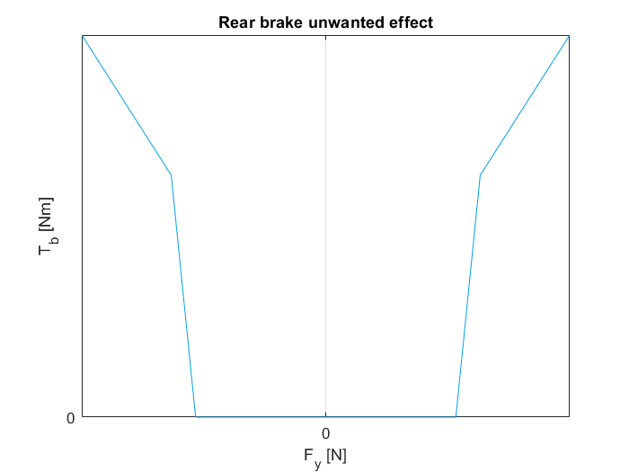
Figure 5. The qualitative effect of rear brake unwanted activation
$$\begin{aligned}{\dot{ω}}_{w}=\frac{T_{fw}-F_{x}∙\frac{D_{w}}{2}-T_{b}}{J_{w}} \#\left(7\right)\end{aligned}$$
The integration of wheel rotational acceleration allows to compute its longitudinal slip, which together with the tire’s side-slip angle makes possible to calculate tire’s friction coefficients, with Equation 8:
$$\begin{aligned}μ_{i}=k_{1}∙\tanh\left(k_{2}∙u\right)-\frac{u}{k_{3}} \#\left(8\right)\end{aligned}$$
Where u is the longitudinal slip or the tire side-slip angle. Equation 8 is derived from a fitting of Pacejka’s Magic Formula: it is employed as it can give similar outputs with less computational cost. The tire forces are computed multiplying the tire friction coefficient per the varying vertical loads, as in Equations 9,10, and 11:
$$\begin{aligned}F_{z,traction}=\frac{m}{wb}∙\left(h_{G}∙\dot{v}+h_{G}∙g∙\sin{ϑ_{x}+}l_{f}∙g∙\cos{ϑ_{x}}\right) \#\left(9\right)\end{aligned}$$
$$F_{z,fr}=m∙a_{y}∙\left(\frac{h_{G}}{track}∙\cos{ϑ_{y}}+\frac{1}{2}∙\sin{ϑ_{y}}\right)+⋯$$
$$\begin{aligned}+\left(m∙g-F_{z,traction}\right)∙\left(\frac{1}{2}∙\cos{ϑ_{y}}-\frac{h_{G}}{track}∙\sin{ϑ_{y}}\right) \#\left(10\right)\end{aligned}$$
$$\begin{aligned}F_{z,fl}=m∙g-F_{z,traction}-F_{z,fr} \#\left(11\right)\end{aligned}$$
The forces for each wheel are then transformed to the wheel coordinate system and eventually to the vehicle frame [9]. Forces just computed are then used to compute the yaw acceleration, from which, after integration, the side slip angles can be obtained as in Equation 12: $\begin{aligned}α_{i}= δ_{i}-\tan^{-1}\left(\frac{v∙β+ x_{i}∙\dot{ψ}}{v-y_{i}∙\dot{ψ}}\right) \#\left(12\right)\end{aligned}$
And it is possible to transform the forces to the inertial reference frame after summing them with resistive forces (aerodynamic forces, rolling resistance, slope climbing resistance and banking effect); to conclude, dividing F_{X} and F_{Y} by the mass and integrating results in velocity, from which the vehicle’s side slip angle can be computed (Equation 13), and vehicle position.
$$\begin{aligned}β=\tan^{-1}\left(\frac{v_{y}}{v_{x}}\right) \#\left(13\right)\end{aligned}$$
Simulink settings
The chosen solver for the model is the ode23tb, implementation of TR-BDF2 [10], with variable step: the maximum step size coincides with the steering algorithm time-step, the minimum is set as automatic. The variable step solver is necessary to correctly model the rear wheel motion without losing running speed: in a standing start, the slip computation in order to retrieve the tire friction force needs a very short time-step to be effective, in the order of 10⁻¹⁴ s; however, after the first acceleration, those speeds are never reached again, so a time-step of about 0.1 s is sufficient and helps to shorten the simulation running time. The solver choice has proven effective in terms of speed and robustness.
Steering algorithm
The steering algorithm is designed with the goal of finding the best trajectory, with a deep focus on the stability too: the control should be able to keep the vehicle on track even if the coefficients are not perfectly tuned. One of the first ways to avoid divergency and oscillations is to enable the control only when the speed of the vehicle has overcome 2 m/s: below that the steering input is fixed at 0.
Inputs
The algorithm is implemented in Simulink as a Matlab Function called SAG (Steering Angle Generation) Fcn, receiving as input 14 Simulink signals and other parametric data from the Matlab workspace: 9 scalars and 3 matrices.
The Simulink signals are:
- Three signals to individuate the position to be reached: coordinates X* and Y* and the target yaw $ψ$*.
- Vehicle state: coordinates X and Y, speed $v$, yaw angle $ψ$, yaw rate $\dot{ψ}$ and vehicle side slip angle β.
- Curvilinear coordinate cc.
- Vehicle traction force, computed in Equation 14 as:
- $\begin{aligned}F_{x}={{ k}_{mot}∙\frac{i_{tr}}{R_{w}}∙I}_{act,out} \#\left(14\right)\end{aligned}$
- Previous steering input δ_{prev}.
- Two flag signals, one indicating when the vehicle is on the finish line straight, the second when a local minimum or maximum in altitude is being crossed..
The 9 scalars comprehend:
- Two values defining the vector of steering input values to be tested.
- Two values that are involved in setting the micro-simulations time span.
- 5 coefficients used in the cost function.
The matrices are providing information regarding the track. There are:
- A table including a set of points on the previously used ideal trajectory: each one is individuated by the X and Y coordinates and the distance covered in the trajectory during the lap, which is what has been called as the curvilinear coordinate; these points are circa 1 m distant from each other
- Two track limits tables, one for each side, containing a series of coordinates individuating the track limits; the points are close enough between each other to avoid the vehicle can pass through it: a circle of radius equal to the vehicle’s track width around a point contains two other points; every point is associated with a curvilinear coordinate value.
- A table with a X, Y and Z coordinates of the circuit; the points are circa 1 m distant between each other, but this value can be varied to have more accuracy or execution speed.
Initialization
Before the evaluation of each steering angle some code lines are employed to set some values, which do not vary between the different micro-simulations.
Two griddedInterpolant objects are generated, one for the altimetry from the 3D map given in input and one to consider the brake unwanted touch. Flag signals are multiplied to some coefficients to annul them in certain parts of the track, further explanation will be given when describing the cost function. The vector with the steering angles is created starting from the previous steering angle, then it is completed with this pattern: δ_{prev} – δ_{range} , … , δ_{prev} – 2·δ_{step} , δ_{prev} – δ_{step} , δ_{prev} , δ_{prev} + δ_{step} , δ_{prev} + 2·δ_{step} , … , δ_{prev} + δ_{range}.
The time span for the micro-simulations is calculated through Equation 15, where $v_{0}$ is the speed in the vehicle state input and the two coefficients are given in input:
$$\begin{aligned}t_{μsim}= \frac{k_{1}}{v_{0}}+k_{2}\#\left(15\right)\end{aligned}$$
With an expression like this the distance covered during the simulation increase linearly with speed if we suppose that acceleration is null: this is not true, but being the simulation short enough (usually, around 5 s are simulated) the speed difference is not large. The time span is crucial since a too short simulation would affect stability, since track limits crossings may be detected too late, and a long simulation would affect running time and exclude some valuable steering angles because of a track limits crossing at corner exit.
The track limits table cannot be considered wholly for every micro-simulation, or it will slow down considerably the execution; this is the reason why each track limit point is associated to a curvilinear coordinate: with the current value obtained as external input, the algorithm is able to eliminate the points behind the vehicle and those too far away; the limit for the furthest points is defined differently from the simulation span: as in Equation 16, the points not considered are those whose distance from the vehicle (in terms of curvilinear coordinate) is larger than:
$\begin{aligned}d= t_{hor}∙v_{0} \#\left(16\right)\end{aligned}$
This quantity depends on the type of turns the racetrack has: it may be different for each track, even if fine tuning is not necessary.
To conclude, vectors to collect the results of the micro-simulations are initialized to 0.
Micro-simulations
The simulations are run with ode23 solver and have as input the steering angle considered, the traction force and the griddedInterpolant object simulating the brakes unwanted action. The variables are 6 and coincide with the vehicle state ones, so the initial conditions are derived from that external input. The time step is limited to avoid that track limits crossing goes undetected, while the time span was already discussed.
The function is non-linear, while the tire behavior is simplified as linear, as given by Equation 17 and 18:
$$\begin{aligned}F_{sf}={2∙c}_{f}∙\left(-β-l_{f}∙\frac{\dot{ψ}}{v}+δ_{f}\right) \#\left(17\right)\end{aligned}$$
$$\begin{aligned}F_{sr}=c_{r}∙\left(-β+l_{r}∙\frac{\dot{ψ}}{v}\right) \#\left(18\right)\end{aligned}$$
The front side force is then split in longitudinal and lateral forces using δ_{f} angle, and the derivatives are computed in Equation 19:
$$\begin{aligned}\frac{d}{dt}\left\{\begin{matrix}X \\ Y \\ \begin{matrix}v \\ ψ \\ \begin{matrix}\dot{ψ} \\ β\end{matrix}\end{matrix}\end{matrix}\right\}=\left\{\begin{aligned}v∙\cos\left(β+ψ\right) \\ v∙\sin\left(β+ψ\right) \\ \begin{matrix}\frac{\cos\left(β\right)∙\left(F_{xf}+F_{xr}-F_{aero}-F_{b}\right)+\sin\left(β\right)∙\left(F_{yf}+F_{yr}\right)}{m} \\ \begin{matrix}\dot{ψ} \\ \frac{{l_{f}∙F}_{yf}-{l_{r}∙F}_{yr}}{J_{z}} \\ \frac{\cos\left(β\right)∙\left(F_{yf}+F_{yr}\right)-\sin\left(β\right)∙\left(F_{xf}+F_{xr}-F_{aero}-F_{b}\right)}{m∙v}-\dot{ψ} \end{matrix}\end{matrix}\end{aligned}\right. \\ \# \\ \left(19\right)\end{aligned}$$
Cost function evaluation
The cost function is a sum of 6 terms, named:
- Distance
- Direction
- Track limits
- Altitude variation
- Progression
- Average speed
The first two ensure that the selected checkpoint is reached: each micro-simulation is evaluated by how close the vehicle gets to the checkpoint and how different the yaw is in the closest point from the target. The coefficients for these two values are respectively k_{dist} [1/m] and k_{dir} [-] and are null outside of the finish line straight.
The track limit indicator TL is set as a relatively large number when the path of the vehicle is not distant enough to the track limits points: the threshold is a bit less than twice the semi-track width, to have a safety margin and avoid that part of the track closer to its limit, whose tarmac is often imperfect.
The altitude variation term contains the difference between the minimum and the maximum altitude in the path of the micro-simulation. It is only active in proximity of local minimum or maximum in the altimetry, and its goal is to avoid peaks and grooves to keep the speed as constant as possible: it is useful to manage optimally the variation of banking too. Its coefficient is k_{z} [1/m].
The progression term measures how much the path is longer or shorter with respect to the curvilinear coordinate variation; it is important in its interaction with the just mentioned altitude variation term, to prevent the control from forcing the vehicle to cross the track transversally. The coefficient is k_{progr} [1/m].
The average speed term is the one in which the result, average speed, is divided to the coefficient, because the average speed is desired to be as high as possible: this term is crucial to avoid higher steering angles which slow down the vehicle and to consider the brakes unwanted effect, making possible in the most challenging turns to take a longer path to reduce lateral acceleration. The coefficient is called k_{v} [m/s].
$$cost=k_{dist}∙dist+k_{dir}∙dir+k_{progr}∙progr+k_{z}∙∆z+⋯$$
$$\begin{aligned}+{k_{\overline{v}}}/{\overline{v}}+TL \#\left(20\right)\end{aligned}$$
Computing Equation 20 each steering angle considered is associated to a cost, and then the angle with the minimum cost is chosen. If the track limits indicator is activated for every steering angle, the controller is able to recognize if the track edge is on the right or the left side and consequently choose the minimum or maximum steering angle available, depending on the side.
Other blocks
The algorithm output is composed by the chosen steering angle and an integer number which is the difference between the track limits point considered from the right side and the left one, which is called C_{RL}.
The steering angle is filtered with the continuous time first-order filter of Equation 21:
$$\begin{aligned}G\left(s\right)=\frac{1}{1+τ∙s} \#\left(21\right)\end{aligned}$$
With $τ$ larger than the algorithm time step: the goal is to smoothen the discrete output and reduce oscillations, in order to get a realistic output taking into consideration the inertia of the steering system and the behavior of the human driver. This filter actually alters the output of the control, so the cut-off frequency cannot decrease too much or else the stability will be affected.
C_{RL} allows the algorithm to understand if the vehicle is going through a left turn (C_{RL} positive), a right turn (negative) or a straight (null). However, this signal, of which an example is provided by Figure 6, is very unstable, so it must be processed to work correctly.
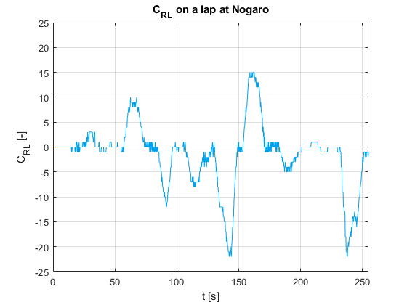
Figure 6. C_{RL} variation during a lap
First of all, it may happen that even if the track is straight, C_{RL} is not null: to avoid this, a threshold is included, so that the turn flag C_{TF}, with an example given in Figure 7, is computed as in Equation 22:
$$\begin{aligned}C_{TF}=\left\{\begin{aligned}1 if C_{RL}≥3 \\ -1 if C_{RL}≥-3 \\ 0 else\end{aligned}\right. \#\left(22\right)\end{aligned}$$
Where 1 means left turn, -1 right turn and 0 straight.
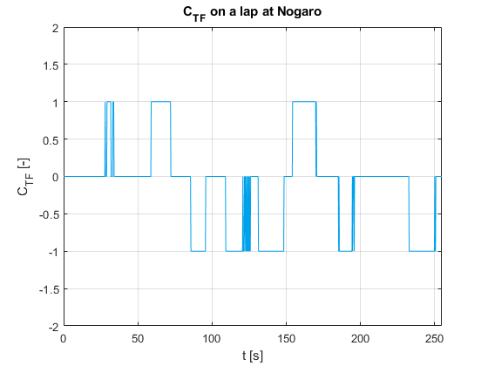
Figure 7. C_{TF} variation during a lap
Then this flag is furtherly stabilized:
- C_{TF} starts as null at instant zero.
- When the C_{TF} is null, the output C_{TF,stab} is kept null; when C_{TF} becomes non-null, another procedure is activated for the following step.
- When the alternative procedure is activated, the average of C_{TF} in the last 10 steps (including the current) is computed, and since it will be different from 0, C_{TF,stab} will be equalled to C_{TF}, so 1 or -1.
- The average will be checked for each following step, until it becomes null; in that iteration that C_{TF,stab} is put to zero and the alternative procedure is deactivated; at this point the turn is completed and the vehicle is once again in a straight portion of the track, so the procedure can start once again.
The result of this stabilization is shown in Figure 8.
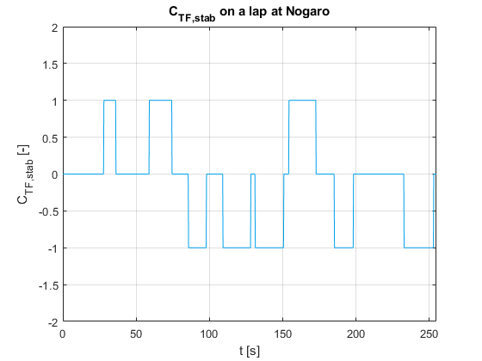
Figure 8. C_{TF,stab} variation during a lap
Then C_{TF,stab} is used as input for a counter and when it varies, the counter adds 1, until it is reset to 1 when the lap is completed.
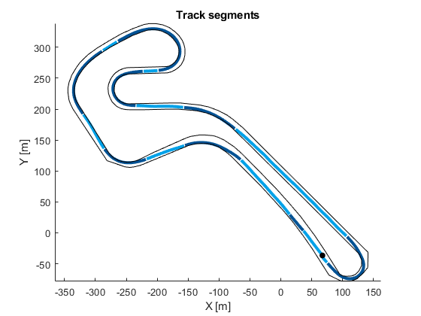
Figure 9. Counter output to represent the track segments
This signal is then used as input for 2 look-up tables to generate the previously mentioned flags. The first look-up table generates the flag that multiplies the altitude variation coefficient of the cost function, so the look-up table consists of a vector of 1 and 0, associated to the segment of the track in which the term is necessary. The other look-up table generates the flag activating k_{dir} and k_{dist}, and so it is null for any input apart from 0 and a value corresponding to the length of the vector for the other look-up table minus 1.
Abandoned solutions
Some solutions tried and dismissed will be briefly discussed explaining what their goal was and how they have been deemed unnecessary.
A term in the cost function assigned larger costs to the steering angles differing more from the previous one in order to avoid wide oscillations and sudden variations of angles: the filter with the current cost function has proven effective. Another term consisted in a coefficient multiplying the steering angle in absolute value, in order to limit high angles: this is what now is performed more accurately by the average speed term.
In the early stages of the design, the counter output was used to generate another flag, which made known to the controller if the turn was on the left or on the right so that it could minimise the distance to the corresponding track limit: this was not leaving enough freedom to the controller and did not reduce the mileage in straights, now the path length minimisation is achieved with the progression term.
Tuning and results evaluation
The parameters present in the function have been tuned: k₁ and k₂ for the micro-simulations timing, t_{hor} for the track limits portioning, δ_{range} and δ_{step} for steering angle and most importantly the 5 cost function coefficients (the track limits signal is high enough for any coefficient).
The different solutions have been compared on a run of 3 laps with standing start, considering as criteria the time to complete it and the energy in input of the motor; energy is theoretically identical if the segments with the motor on have the same trajectory, but maybe in other parts of the track some trajectories perform better and the consumed amount energy may miss to highlight this. On the other hand, the fastest time may not be the most efficient, because it may be caused by a longer path when the motor is on, which leads to a larger energy required. In conclusion, the evaluation has been performed normalizing both time and energy with respect to the average result of all simulations, as in Equation 23:
$$\begin{aligned}{result}_{traj}= \frac{t_{f}{-\overline{t}}_{f}}{{\overline{t}}_{f}}+\frac{E_{mot,in,f}-{\overline{E}}_{mot,in,f}}{{\overline{E}}_{mot,in,f}} \#\left(23\right)\end{aligned}$$
The parameters that will lead to a minimum result_{traj}, negative per definition, will be considered as the most performant.
Model validation
The model has been tested comparing its output using data from the 2024 Shell Eco-Marathon, applying the same powertrain inputs: the results are shown over a lap in the Nogaro circuit, in particular the 5th lap of morning run of the last day of competition. First, the voltage of the energy buffer is considered, as in Figure 10, to understand if the powertrain model is realistic.
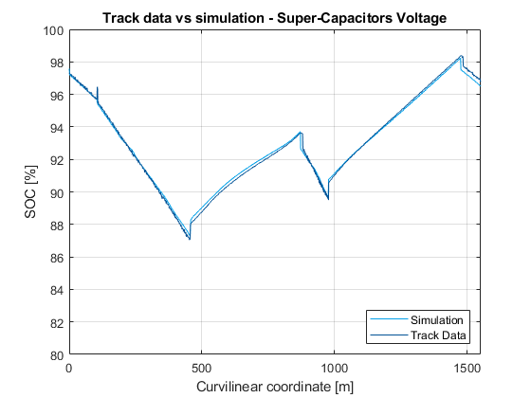
Figure 10. SOC comparison: powertrain modelling validation
Secondly, the speed error (difference of simulation and real speed, again function of curvilinear coordinate) is presented in Figure 11, as a measure of how much the vehicle dynamics approximations are correct:
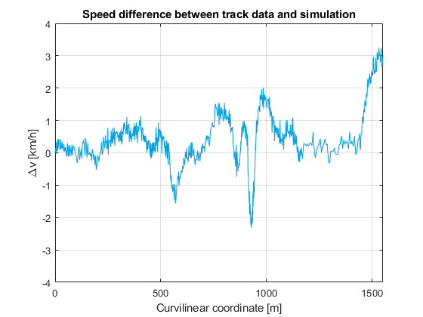
Figure 11. speed comparison: vehicle dynamics modelling validation
The difference is overall below 1 km/h, which is a tight enough margin, apart from 2 turns where the trajectory taken by the algorithm differs to those on track: unfortunately, no data of real steering angles are available, so the inputs cannot be the same. Specifically, the divergency around 900 m is due to a trajectory that climbs more at first and then starts to descend: this explains the minimum of -2 km/h and the maximum of +2 km/h; the last turn is then taken with a higher radius by the controller, and this is why it carries more speed there; furthermore, many uncertainties may have altered the track data: sensors errors, sudden wind, other vehicle slipstream and similar. Excluding these differences, the model gives small errors in different parts of the track (uphill and downhill, slow and fast turns, traction and coast-down) and therefore it can be considered reliable. The difference on the last turn can be seen as an indicator that the controller works properly, since it follows a different path resulting in higher speed.
Control algorithm effectiveness
The control algorithm has proven to be stable, keeping the vehicle on track with different parameters. At the same time, the fundamental goal has been reached, because the best combination of parameters leads to a result_{traj} equal to -0.0129, mostly due to the time component, while the variation in energy between the different runs has been subdued.
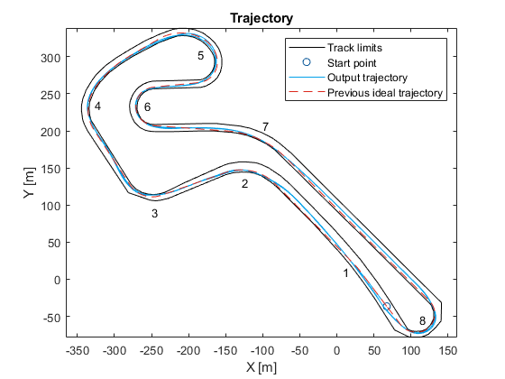
Figure 12. Trajectory on track with numbered turns
A 2D representation of the vehicle’s simulated and real trajectories is given by Figure 12. The simulated vehicle trajectory represented is first of all reasonable: the controller tries to minimize the length of the path apart from the turns in which the lateral acceleration is high, there is relevant banking or a maximum/minimum in altitude, where longer paths can be more efficient; there are no wide oscillations, nor the controller turns right in proximity of a left turn or vice versa. In fact, the previous trajectory determined by the Strategy division is followed in the parts of the track (mostly in the first turns) where the inside line was the right choice without any doubt: this is a signal that the controller is reliable in the first place. The second part of the track shows more evident differences: turn 5 is generally completed with a trajectory having shorter radius (the line varies between the laps unlike most of the other turns), the opposite happens with turn 8, which is run close to the internal track limit, but it starts and finishes closer to the center of the track.
The steering input, represented in the Figure 13, looks as expected in the turns, with a monotonous increase (in modulus) of steering angle and the following decrease. In the straights, there are visible oscillations, but the angle is minimum (well below 5%) and the frequency is coherent with human behavior. Furthermore, the vehicle trajectory is not affected as clear from Figure 12. The spikes are caused by the track limits indicator being active for each steering angle: it usually gets activated at corner entry, but it is effective, and the controller can actually come back to normal operation within a single time step, which is a desirable behavior.
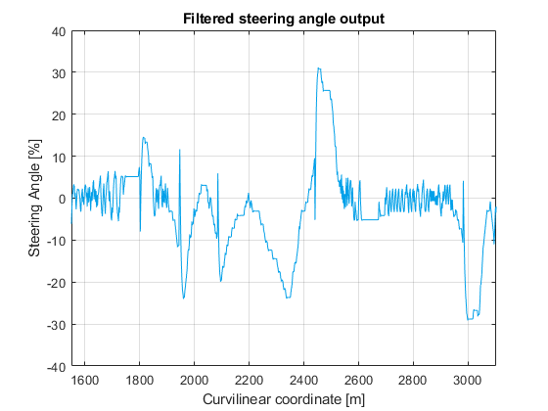
Figure 13. Steering angle, filtered output of the algorithm
Conclusion
Before anything else, the model has proven realistic; it is close to the state of the art, but the comparison between simulation and reality has shown that the approximations considered are correct.
With a proper model, the control algorithm can be considered effective: it can first and foremost keep the vehicle on track, acting with promptness when it is going off. At the same time, it can fulfill the original goal for which it was designed, minimizing the energy consumption basing its output on other data. The result gives credit to the Team’s Strategy division that predicted a trajectory very similar to the final one and is helpful in pointing out where a different route should be taken.
This work can help the Strategy team during the race preparation by generating a different trajectory for different acceleration strategies.
The controller can be improved in future with more data: at the moment, this is the only track at which IDRAzephyrus has raced offering a 3D scan; at the same time, data relatively to the steering angles during the run can help to validate the lateral dynamics and the behavior of the controller, which has the goal to be the closest possible to a human one. Nevertheless, the initial development was performed with a different circuit, Cerrina Race Track in Bruino (Italy), where IDRAzephyrus had several tests, so it can be affirmed that the control algorithm works in different tracks.
Further developments may include the presence of moving obstacles: the Shell Eco Marathon does not organize a wheel-to-wheel competition for Prototypes category, but the runs are completed while the track is open for every prototype. This means that traffic can be encountered during the race (or even a vehicle stopped in the middle of the track), and in particular with Internal Combustion Engine Prototypes it may result in multiple overtakes, as in Figure 14, and counterforces each lap.
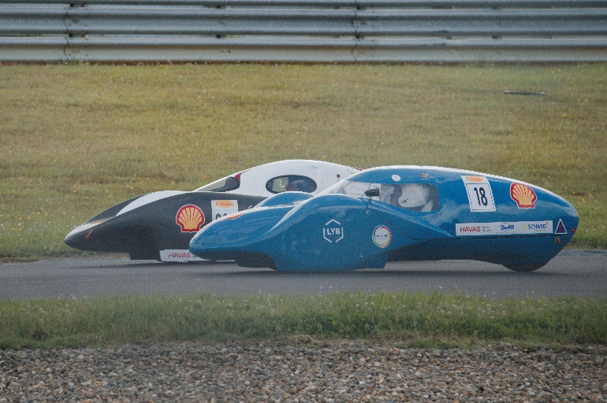
Figure 14. IDRAzephyrus overtaking an ICE prototype

References
- De Carlo, M., Dragone, P., Tempone, G. and Carello, M., “3DOF Vehicle Dynamics Model for Fuel Consumption Estimation”, SAE Technical Paper 2024-01-2757, 2024, doi: 10.4271/2024-01-2757.
- Hoffmann, G. M. , Tomlin, C. J., Montemerlo, M. and Thrun, S., “Autonomous Automobile Trajectory Tracking for Off-Road Driving: Controller Design, Experimental Validation and Racing”, 2007 American Control Conference: 2296-2301, Jul. 2007, doi: 10.1109/ACC.2007.4282788.
- Mashadi, B., Mahmoudi-Kaleybar, M., Ahmadizadeh, P. and Oveisi, A., “A path-following driver/vehicle model with optimized lateral dynamic controller”. Latin American Journal of Solids and Structures 11: 613-630, 2014, doi: 10.1590/S1679-78252014000400004.
- Mayne, D. Q. and Michalska, H., “Receding horizon control of nonlinear systems”, 27th IEEE Conference on Decision and Control 1: 464-465, 1988, doi: 10.1109/CDC.1988.194354.
- Micheli, F., Bersani, M., Arrigoni, S., Braghin, F. and Cheli, F., “NMPC trajectory planner for urban autonomous driving” Vehicle System Dynamics 61(5): 1387–1409, 2022, doi: 10.1080/00423114.2022.2081220.
- Shell Eco Marathon Rules 2024, Available:
https://www.shellecomarathon.com/2024-programme/regional-europe-and-africa.html, accessed Sep. 2024.
- Ercole, C., “Electronic Control Unit for Fuel cell - Supercapacitors system: from design to implementation in low-consumption vehicles”, M.Sc. thesis, DIMEAS, Politecnico di Torino, Torino, 2024.
- Bellman, R., Glicksberg, I. and Gross, O., “On the “Bang-Bang’ control problem”, Quarterly of Applied Mathematics 14: 11-18, 1956, doi: 10.1090/qam/78516.
- Kiencke, U. and Nielsen, L., “Automotive Control Systems For Engine, Driveline, and Vehicle”, (Berlin, Springer, 2005), 322-325, doi: 10.1007/b137654.
- Shampine, L. F. and Hosea, M. E., “Analysis and Implementation of TR-BDF2”, Applied Numerical Mathematics 20 (1-2): 21-37, 1996, doi: 10.1016/0168-9274(95)00115-8.

Contact Information
Massimiliana Carello - massimiliana.carello@polito.it
Henrique de Carvalho Pinheiro - henrique.decarvalho@polito.it
Matteo De Carlo - matteo.decarlo@polito.it
Simone Manzone - simone.manzoneh2@gmail.com
Politecnico di Torino – Mechanical and Aerospace Engineering
Department
Corso Duca degli Abruzzi, 24 10129 Torino – Italy
Acknowledgments
TBD
Definitions
Δz | Altitude variation [m]
$$α$$ | Tire side slip angle [rad]
$$β$$ | Vehicle side slip angle [rad]
$$δ$$ | Wheel steering angle [rad]
η | Efficiency [-]
$$ϑ$$ | Road inclination [rad]
$$μ$$ | Friction coefficient [-]
$$ρ$$ | Density [kg/m³]
τ | Time constant [s]
$$ψ$$ | Yaw [rad]
$$ω$$ | Rotational speed [rad/s]
C | Counter
D | Diameter [m]
E | Energy [J]
F | Force [N]
G | Low Pass Filter Transfer Function [-]
I | Current [A]
L | Inductance [H]
LHV | Lower Heating Value [MJ/kg]
Mm | Molecular Mass [kg/mol]
N | Number [-]
P | Power [W]
R | Resistance [Ω]
T | Torque [Nm]
TL | Track Limits Indicator [-]
V | Voltage [V]
X,Y,Z | Coordinates [m]
a | Acceleration [m/s²]
c | Cornering Stiffness [N/rad]
cc | Curvilinear Coordinate [m]
cost | Cost Function Result [-]
d | Distance Covered [m]
dir | Direction error [rad]
dist | Distance error [m]
e⁻ | Elementary charge [C]
g | Gravitational Acceleration [m/s²]
h | Height [m]
k | Coefficient/Constant [-]
l | Semi-Wheelbase [m]
m | Mass [kg]
$$\dot{m}$$ | Mass Flow Rate [kg]
progr | Progression [m]
u | Input [-]
s | Frequency [rad/s]
$$v$$ | Speed [m/s]
$$\overline{v}$$ | Average Speed [m/s]
wb | Wheelbase [m]
Subscripts
0 | Initial
1,2,3,…,i | Generic
μsim | Micro-Simulation
A | Avogadro
a | DC Motor Armature
b | Brake
act | Actuation
aux | Auxiliaries
eq | equivalent
FC | Fuel Cell
f | Front
fr | Friction
G | Center of Gravity
H₂ | Hydrogen
hor | Horizon
I1,I2,I3 | Current to the 1st,2nd,3rd
in | Input
l | Left
mot | DC Motor
OCV | Open Circuit Voltage
out | Output
prev | Previous
RL | Difference in number between track limit points
r | Right
s | Side
stab | Stabilized
TF | Turn Flag
tr | Transmission
traction | Rear Wheel
w | Wheel
x | Longitudinal
y | Lateral
z | Vertical

