The Future of E-Mobility: an innovative course to approach Big Global Challenges
Henrique de Carvalho Pinheiro[0000-0001-8116-336X] and Massimiliana Carello [0000-0003-2322-0340]
Mechanical and Aerospace Engineering Department, Politecnico di Torino, Turin, Italy
henrique.decarvalho@polito.it
Abstract. Education in engineering and STEM follows traditional methods and is usually focused on hard skills and science. Although essential, these disciplines are not sufficient to fully equip students for dealing with multidisciplinary and inherently socially complex problems. In this context, the article describes one of the courses offered in the “Big Global Challenges” initiative by Politecnico di Torino. “The Future of E-Mobility” applies innovative strategies for teaching, tutoring, and evaluating students, with the goal of preparing the next generations of engineers for the always more complex challenges in modern society.
Keywords: Mobility, Big Global Challenges, Education in engineering, Electric vehicles.
- Introduction
The mobility field, along with others in the industry, is going through significant changes. Engineers, technicians, and other STEM graduates need to keep up with new skills. STEM programs, especially engineering, need to swiftly embrace new teaching methods to stay current and produce skilled professionals and scientists. However, universities might not be keeping pace with these changes as quickly as needed.
Strategies as active learning [1] and gamification [2] are known in bibliography, alongside with remarkable results achieved by student projects [3,4] and competitions [5,6], however this tendency hardly transports to “standard” teaching hours [7,8]. Apart from the main innovation in the mobility sector, as Electrification [9,10], Autonomous Driving [11,12], Lightweight Design [13,14], Active Control [15–17], a series of challenging and pressing social issues characterize the future challenges of the sector.
For several years, Politecnico di Torino has been actively encouraging its student community to tackle vital contemporary challenges pertaining to climate and sustainable development. This article describes one of the courses, part of the Big Global Challenges initiative. These modules aim to expose students to innovative teaching methods and a mixed approach that includes the participation of professors with socio-humanistic backgrounds. The projects are intended to teach research skills, communication [18], and teamwork abilities, not so much exercised during their academic paths.
- The Big Global Challenges
Beginning in the academic year of 2021/22, PoliTo has introduced a new course category entitled "BIG GLOBAL CHALLENGES," consisting of six major contemporary issues: Climate, Mobility, Digital World, Health, Energy, and Humans and Technology. This initiative is offering an interdisciplinary perspective on each challenge.
These six critical global challenges are divided into four different dimensions, comprising a total of 24 courses, each accommodating up to 150 students. Each course is co-taught by two lecturers representing technical and human-social science backgrounds guaranteeing a well-rounded theoretical foundation for students. The courses are displayed in Table 1.
Table 1. Courses offered by Politecnico di Torino in its Big Global Challenges initiative.
Thematic area | Course title* | Language
Climate | Evidence, models, and perceptions on climate change | Italian
Climate | Climate crisis and cognitive biases | Italian
Climate | Cities, infrastructure, and climate change | Italian
Climate | The society of sustainability | Italian
Mobility | Sustainable urban mobility | Italian
Mobility | Intelligent infrastructures | Italian
Mobility | The future of E-mobility | English
Mobility | Migration and settlements | English
Digital World | Algorithms and democracy | Italian
Digital World | Cybersecurity and National Defense | English
Digital World | Politics and technology | Italian
Digital World | Internet and social media:  technologies and communication trends on the web | Italian
Health | Virtual reality and fragility | Italian
Health | Bio and nano technologies in medicine | Italian
Health | Neuroengineering and active aging | English
Health | Healthcare and artificial intelligence | Italian
Energy | Sustainability and responsibility | Italian
Energy | Future history of energy | Italian
Energy | Energy transition and society | English
Energy | The sea and the green transition | Italian
Humans and  Technology | Smart cities and inclusion | Italian
Humans and  Technology | Gender and technology | Italian
Humans and  Technology | Future of Work | English
Humans and  Technology | Digital well-being | Italian
* The titles of the courses in Italian were freely translated to English by the author
Currently, Politecnico is among the leading Italian sustainable universities network, and has been actively pursuing the achievement of the Sustainable Development Goals.
Students benefit from lectures delivered by philosophers of science, focusing on the significance of knowledge dialogue. This is aimed to prepare students for the three-hour general introduction to the six Big Global Challenges, which covers the technical and non-technical aspects of these challenges, thus providing students with a much broader perspective of these issues.
Upon completion of the general introductory phase, students undertake one of the 24 available courses, four being dedicated to each of the six challenges.
The interdisciplinary approach provides the students with a more comprehensive theoretical foundation for how to deal with each challenge. Subsequently, students are divided into groups for the development of projects based on what they have learned, employing an interdisciplinary approach to these projects. This approach will enable the application of theory in practical situations, fostering the development of well-rounded solutions to tackle these contemporary global challenges.
- The Future of E-Mobility course
The course “The Future of E-Mobility” is part of the Mobility thematic area, and follows the general framework proposed by the course. The goal of the course is to give the students the tools to deal with the main challenges in the mobility sector.
  - Lessons
The lessons are divided into three main blocks: general introduction, technical/engineering, and socio humanistic.
The first block is common to all big global challenges, where students are initially presented with a shared "zero" lecture that provides an understanding of the Sustainable Development Goals proposed by the United Nations' 2030 Agenda.
The two other blocks are taught in parallel. The technical syllabus includes electric propulsion systems and vehicle architectures, batteries, fuel cells, lightweight design, new mobility scenario, smart cities, car sharing, autonomous driving, and examples in railway, aviation, and maritime. The humanistic syllabus tackles topics as wicked problems, future studies, car dependency, public policies, and barriers to change.
  - Projects
The students are divided into groups of three to develop the projects, with the final goal of creating a presentation summing up the main insights and conclusions of their research. This presentation must be delivered not only to the professors, but to their fellows, creating an environment of mutual learning and sharing. The structure of the course is shown in Fig. 1.
The topics proposed are all focused on pressing problems in the mobility sector that do not have a clear answer yet (if it will ever be the case). To allow maximum creativity and avoid biases and constraints coming from the faculty members, the topics are presented in an “soft” form, based on thought provoking questions and open-ended directions for the research.

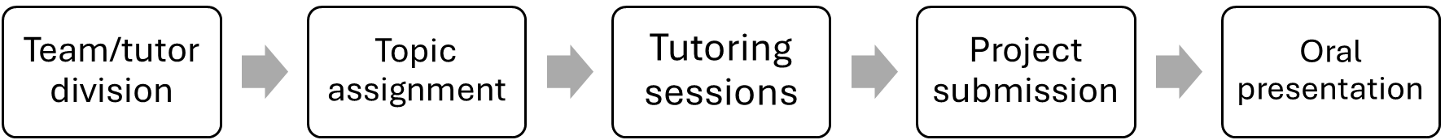
Fig. 1. Workflow of student’s projects
The 14 topics proposed in the 2021/22 class were the following:
- Cybersecurity for connected vehicles: What are the main risks associated with cybersecurity in the future of e-mobility? Who are the stakeholders, and how do they relate to addressing these risks? How can manufacturers, governments, and users approach and mitigate these risks?
- Privacy and data sharing: Are users justified in being concerned about their privacy when using modern vehicles? Should companies and governments have access to personal data, and under what conditions? How can one ensure the security of their personal data and implement mechanisms to limit potential issues?
- Recycle and reuse of E-components: What is the real impact of electrification on the mobility sector? How can this impact be reduced through strategies such as reuse and recycling of e-components? What new technologies can be employed to minimize environmental impact?
- Materials for EV - environment & politics: How environmentally impactful is the production of e-components? Which materials are critical in terms of availability and geographical distribution? What alternatives can be explored to address these challenges and ensure the long-term feasibility of electrification for mobility?
- EV impact on grid and renewable energy: Is the current infrastructure equipped to handle the increased demand for e-mobility? What steps can be taken to improve energy production and distribution? What are the potential risks and advantages of integrating vehicles with the grid?
- Biofuels and hydrogen: How do alternative fuels like hydrogen and biofuels compare with fossil fuels and pure electric options in terms of efficiency and environmental impact? What are the challenges associated with these types of vehicles?
- AD safety verification: How can we ensure the safety of autonomous vehicles amidst their increasing complexity? What regulatory and testing strategies can adapt to this evolving technology?
- Ethics for autonomous driving: Can machines be trusted to make ethical decisions in critical situations? Who should be held accountable in the event of accidents caused by autonomous vehicles? How can stakeholders address ethical dilemmas without impeding technological progress?
- Mobility-as-a-service: What are the main impacts of mobility services on urban mobility, and people's lives? How should people, governments, companies, and other parties navigate the opportunities and challenges presented by these services?
- Vehicle ownership and passion for cars: How is public perception and enthusiasm for car ownership evolving? Is personal vehicle ownership a lasting tradition, or is it becoming a niche luxury for future generations?
- Less vehicles - impacts on the city: What are the trends in vehicle ownership rates, and how might they affect urban spaces? How can the freed-up space be repurposed in future cities, and what are the benefits for urban life?
- COVID, home-office and impact on mobility: How has the shift to remote work during the COVID-19 affected mobility patterns? Will people continue to commute less in the future, and how will this impact city centre and public transportation?
- Diffusion of e-mobility in underdeveloped markets: How far behind are underdeveloped countries in e-mobility adoption? What scenarios are possible for the future of e-mobility in these regions, and how can stakeholders act to accelerate progress?
- E-bikes, scooters, and drones: What are the newest and most disruptive technologies in personal mobility? How are individuals, businesses, and cities adapting to these innovations, and what benefits and challenges do they present?
  - Tutoring
One key aspect related to the course is the tutoring sessions. Being the course present at the second year of university, it is natural that students won’t be yet equipped with the required tools to perform relevant research, thus a team of young researchers provides support to their progress through six two-hours tutoring sessions in which a basic framework for the project is presented (Fig. 2) and an active participation of the groups takes place. The tutors have the chance to check student’s progress and guide their efforts towards a comprehensive and robust result.
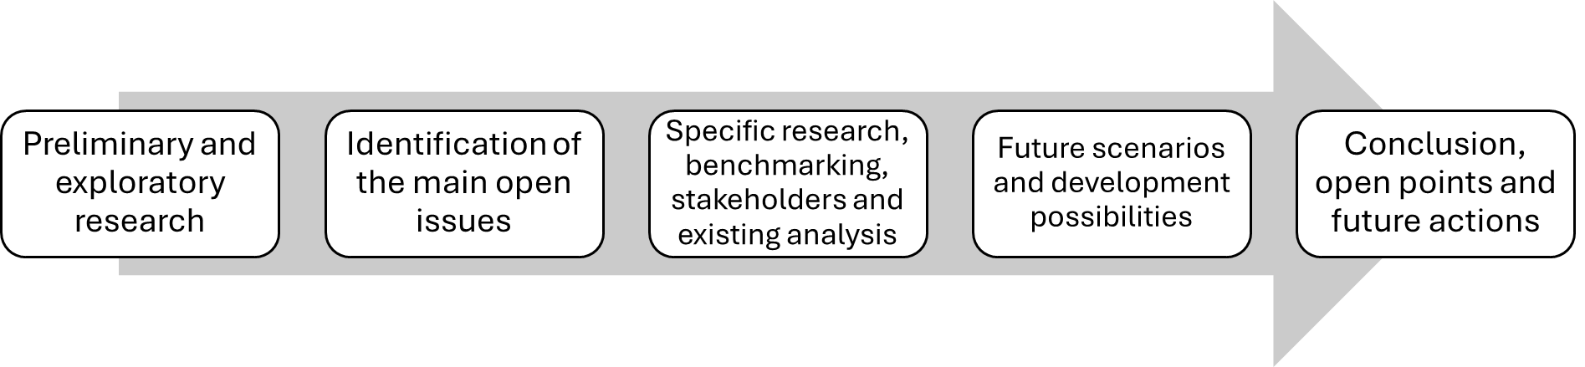
Fig. 2. A framework for scientific research applied to Big Global Challenges
The proposed framework, of course, is not rigid. The groups are free (and encouraged) to start from scratch if the initial path does not lead to satisfactory results, and to loop on the various phases to refine their ideas.
  - Evaluation
The final score method of the students during the course was changed between the two academic years of offering. In the first year the score was solely based on the performance of the students on the project and its presentation, while in the second year a multiple-choice written exam was added as 50% of the final grade. This change was motivated by the lack of attendance in the theoretical lessons, especially by the end of the semester once the students would get busier with the projects (and potentially further workload in other courses).
Being the written exam straightforward, focus is placed on the project’s score. The following criteria were used to assess presentation quality:
- Quality of the research and references.
- Style and organization of the slides and visual material used during the presentation.
- Coherence and cohesion of the presented arguments and relevance to the topic.
- Oral speech: fluence, clearness, energy, and overall quality.
- Creativity and resourcefulness in the exposition and exploration of the topic.
As described in Fig. 3, each faculty member of the presentation session would independently score each criterium from 0 to 30 points (as the Italian scale is 30-based) and the assigned “professors’ evaluation” of the student would then be the average of the single evaluations rounded up to an integer.
Apart from the assessment coming from the professors, also the students had the opportunity to rate their colleagues through a “peer-grading” system [19,20]. By using a Moodle functionality [21], each student would be randomly assigned to evaluate a total of 5 presentations performed by their colleagues (not their own presentation). The same five criteria were proposed to the students, and the average of the scores given by a random selection of peers counts for the 90% of the peer-grading. The other 10% are related to an evaluation of the quality of the peer-grading, in which the system identifies the lack of consistency/variability on one student scoring and penalizes it [22].

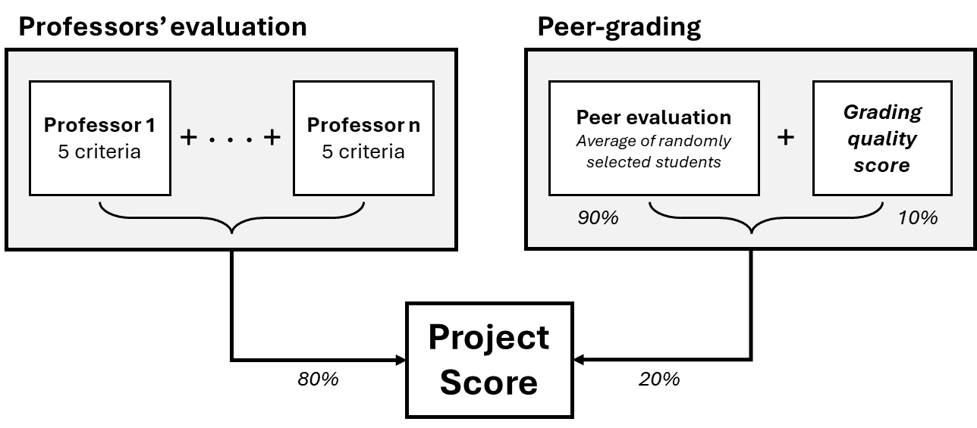
Fig. 3. Evaluation structure of the course
- Results and conclusions
The results of the first two years of the course are overall encouraging and promising. In both years of offering, “The Future of E-Mobility” was fully booked with 150 students, showing a great interest for the theme.
The tutoring method was appreciated by the students. Even though presence in the tutoring sessions was not mandatory (groups could autonomously assess when to attend based on their needs and progress) the overall rate of attendance was very high, almost always above 60-70% of the class.
Regarding the students’ path in the project development, it can be said that the average group starts being “lost”, not knowing where to begin to tackle the problem; it follows a stage in which the students are “overwhelmed” by the broad results of the first research efforts; then, with the help of the tutors, a more focused approach is identified, and the students start to refine their presentations. This process resembles what researchers face on an everyday basis when tackling new problems, which indicates that the course might serve as a valuable learning experience.
The multidisciplinary approach was transferred from the lessons and course imprinting to the presentations. It is evident that the students are impacted by the project approach, presenting significant improvements in the quality and clarity of presentation, as well as relevance of the researched contents. It was particularly notable the performance of groups composed of students with different experiences (both in terms of their BSc. Course and their cultural background) once again highlighting the importance of diverse and well-integrated teams when dealing with challenging issues.

References
1. Adrian, J.A.L., Zeszotarski, P., and Ma, C., “Developing Pharmacy Student Communication Skills through Role-Playing and Active Learning,” AJPE 79(3), 2015, doi:10.5688/ajpe79344.
2. Fustik, V., Rogleva, N.K., and Petrova, N., “Gamification for Practical Engineering Education in Project and Risk Management,” IEEE EUROCON 2019 -18th International Conference on Smart Technologies, 1–4, 2019, doi:10.1109/EUROCON.2019.8861900.
3. Carello, M., “Innovative and Multidisciplinary Teaching to Design a Low Consumption Vehicle,” in: Quaglia, G., Gasparetto, A., Petuya, V., and Carbone, G., eds., Proceedings of I4SDG Workshop 2021, Springer International Publishing, Cham, ISBN 978-3-030-87383-7: 641–650, 2022, doi:10.1007/978-3-030-87383-7_69.
4. De Carvalho Pinheiro, H. and Carello, M., “Engineering Education: Exploring Group Projects to Teach Innovative Automotive Topics,” in: Niola, V., Gasparetto, A., Quaglia, G., and Carbone, G., eds., Advances in Italian Mechanism Science, Springer International Publishing, Cham, ISBN 978-3-031-10776-4: 405–413, 2022, doi:10.1007/978-3-031-10776-4_47.
5. Ferraris, A., Messana, A., Airale, A.G., Sisca, L., De Carvalho Pinheiro, H., Zevola, F., and Carello, M., “Nafion® Tubing Humidification System for Polymer Electrolyte Membrane Fuel Cells,” Energies 12(9):1773, 2019, doi:10.3390/en12091773.
6. Tempone, G.P., De Carlo, M., and Carello, M., “1D control model of a hydrogen-powered vehicle for race strategy optimization,” 2023 IEEE International Conference on Environment and Electrical Engineering and 2023 IEEE Industrial and Commercial Power Systems Europe (EEEIC / I&CPS Europe), 1–6, 2023, doi:10.1109/EEEIC/ICPSEurope57605.2023.10194634.
7. Maraghy, W.H.E., “Future Trends in Engineering Education and Research,” in: Seliger, G., Khraisheh, M. M. K., and Jawahir, I. S., eds., Advances in Sustainable Manufacturing, Springer Berlin Heidelberg, Berlin, Heidelberg, ISBN 978-3-642-20182-0: 11–16, 2011, doi:10.1007/978-3-642-20183-7_2.
8. Rosen, M.A., “Engineering Education: Future Trends and Advances,” Proc. of 13th WSEAS Conference on Engineering Education, 22–24, 2009.
9. De Carvalho Pinheiro, H., Castro dos Santos, P.G., Sisca, L., Scavuzzo, S., Ferraris, A., Airale, A.G., and Carello, M., “Dynamic Performance Comparison Between In-Wheel and On-Board Motor Battery Electric Vehicles,” American Society of Mechanical Engineers Digital Collection, 2020, doi:10.1115/DETC2020-22306.
10. Grano, E., Bianco, E., De Carvalho Pinheiro, H., and Carello, M., “MTPA and flux weakening control of electric motors: a numerical approach,” 2023 IEEE International Conference on Environment and Electrical Engineering and 2023 IEEE Industrial and Commercial Power Systems Europe (EEEIC / I&CPS Europe), 1–7, 2023, doi:10.1109/EEEIC/ICPSEurope57605.2023.10194684.
11. De Carvalho Pinheiro, H., Cruz Stanke, D., Ferraris, A., Carello, M., Gabiati, G., Camuffo, I., and Grillo, M., “Autonomous Driving Scenario Generation in Overtake Manoeuvres Through Data Fusion,” in: Niola, V. and Gasparetto, A., eds., Advances in Italian Mechanism Science, Springer, ISBN 978-3-030-55807-9: 786–794, 2021, doi:10.1007/978-3-030-55807-9_87.
12. Carello, M., Ferraris, A., De Carvalho Pinheiro, H., Cruz Stanke, D., Gabiati, G., Camuffo, I., and Grillo, M., “Human-Driving Highway Overtake and Its Perceived Comfort: Correlational Study Using Data Fusion,” WCX SAE World Congress Experience, SAE Technical Paper 2020-01-1036, 2020, doi:10.4271/2020-01-1036.
13. De Carvalho Pinheiro, H., Messana, A., Sisca, L., Ferraris, A., Airale, A.G., and Carello, M., “Computational Analysis of Body Stiffness Influence on the Dynamics of Light Commercial Vehicles,” in: Uhl, T., ed., Advances in Mechanism and Machine Science, Springer International Publishing, ISBN 978-3-030-20131-9: 3117–3126, 2019, doi:10.1007/978-3-030-20131-9_307.
14. Carello, M., De Carvalho Pinheiro, H., Messana, A., Freedman, A., Ferraris, A., and Airale, A.G., “Composite Control Arm Design: A Comprehensive Workflow,” SAE Int. J. Adv. & Curr. Prac. in Mobility 3(5):2355–2369, 2021, doi:10.4271/2021-01-0364.
15. Ferraris, A., De Cupis, D., De Carvalho Pinheiro, H., Messana, A., Sisca, L., Airale, A.G., and Carello, M., “Integrated Design and Control of Active Aerodynamic Features for High Performance Electric Vehicles,” SAE Technical Paper 2020-36-0079, 2021, doi:10.4271/2020-36-0079.
16. De Carvalho Pinheiro, H., Punta, E., Carello, M., Ferraris, A., and Airale, A.G., “Torque Vectoring in Hybrid Vehicles with In-Wheel Electric Motors: Comparing SMC and PID control,” 2021 IEEE International Conference on Environment and Electrical Engineering and 2021 IEEE Industrial and Commercial Power Systems Europe (EEEIC / I CPS Europe), 1–6, 2021, doi:10.1109/EEEIC/ICPSEurope51590.2021.9584732.
17. De Carvalho Pinheiro, H., Russo, F., Sisca, L., Messana, A., De Cupis, D., Ferraris, A., Airale, A.G., and Carello, M., “Active Aerodynamics through Active Body Control: Modelling and Static Simulator Validation,” Virtual, Online, 2020, doi:10.1115/DETC2020-22298.
18. Pradhananga, P., ElZomor, M., and Santi Kasabdji, G., “Advancing Minority STEM Students’ Communication and Presentation Skills through Cocurricular Training Activities,” Journal of Civil Engineering Education 148(2):04022001, 2022, doi:10.1061/(ASCE)EI.2643-9115.0000060.
19. Tai, J., Ajjawi, R., Boud, D., Dawson, P., and Panadero, E., “Developing evaluative judgement: enabling students to make decisions about the quality of work,” High Educ 76(3):467–481, 2018, doi:10.1007/s10734-017-0220-3.
20. Li, H., Xiong, Y., Hunter, C.V., Guo, X., and Tywoniw, R., “Does peer assessment promote student learning? A meta-analysis,” Assessment & Evaluation in Higher Education 45(2):193–211, 2020, doi:10.1080/02602938.2019.1620679.
21. Workshop grading - MoodleDocs, https://docs.moodle.org/19/en/Workshop_grading, Feb. 2024.
22. Fulton, C., Peer assessment in Moodle, Centre for Teaching and Learning Enhancement | University of Macau, Feb. 2024.

