Modelling and Control of a Fuel Cell + Battery Electric Vehicle for Energy Optimization
Giovanni Imberti [0000-0003-4611-6802], Henrique de Carvalho Pinheiro ^{[0000-0001-8116-336X]}, Massimiliana Carello [0000-0003-2322-0340]
Politecnico di Torino
giovanni.imbertiolito.it
henrique.decarvalho@polito.it
massimiliana.carello@polito.it
Abstract. The paper describes the development of an energetic model to define a hybrid fuel cell + battery electric vehicle for performance analysis and the powertrain optimization. In fact, it is fundamental to balance battery powertrain, also considering the higher mass needed for such type of energy storage systems. The purpose of the paper is to develop a model capable of evaluating the consumption of a vehicle with an electric motor, finding the optimal ratio between the number of cells of the battery and the hydrogen mass to be sent in a fuel cell, to ensure a given range of 800 km.
The model also describes the repartition strategy between the Fuel-cell and the battery powertrain, to maximize the efficiency of both the systems, minimizing the energy scraps due to low-efficiency operative points.
Keywords: Longitudinal Dynamics, Mass Optimization, Energy Efficiency, Electric Powertrain, Hydrogen Fuel cell.
- Introduction
Mobility is a sector that is moving through significant changes, and it is challenging consistently with the reduction of vehicle emissions. Multiple different technical solutions have been presented through the years for finding a suitable zero-emission powertrain solution, aiming to replace the traditional internal combustion engine. Right now, the electric powertrain with a Li-Ion battery as energy storage system seems to be one of the most promising, but some issues have been noticed. In fact, as reported by [1]one of the significant limitations in terms of efficiency for battery driven cars regards the increased mass that the vehicle has having a huge Li-Ion battery to be comparable for range to a traditional ICE car.
It is possible to reduce the mass of a vehicle: proposing innovative material combining composite materials, capable of keeping the same stiffness properties [2] [3] or managing the aerodynamic behavior reducing the drag [4]. But other researches underline how using a hybrid solution of a battery and a fuel cell used as a range extender, could be potentially promising in reducing the total mass of the vehicle [5] [6].
The aim of this paper is to develop a model of a hybrid fuel-cell and Li-Ion battery electric vehicle, with the goal of optimizing its mass to reach the maximum range with the minimum mass. The targeted range should be over 800 km.
The model, developed with MATLAB Simulink, is a representation of the 1-D behavior of a vehicle, considering a standard driving cycle used for homologation tests WLTP.
The importance of finding an efficient driveline, not only in terms of efficiency of each component, but also in terms of mass reduction of the whole vehicle is fundamental. Considering this as one of the primary goals of this paper, it has been decided to consider a hybrid Fuel-Cell (FC) and battery powertrain depicted in Fig. 1. The main reason regards the fact that, traditionally, the FC tend to have significant efficiency drops [7], once the operative working point is changed from the optimal one. At the same time the battery needs to be composed by a significant number of cells, for ensuring enough energy storage to reach a working range compatible to the one of traditional ICEs vehicles, bringing a higher mass to the whole car.
The idea is to use the battery for absorbing the spikes requested by the electric motor requests, while the FC is used as a range extender, to optimize the maximum distance driven. In this way, the FC could work in a specific working point chosen by design as the most efficient one, sending constant power to the battery for recharging it. It is also important to consider that, because of the efficiency drops during transitory operations for the FC, it has been decided to turn it on and off at a specific SoC of the battery, to optimize the recharging of the battery itself.
The Voltage for connecting the motor inverter, the battery, and the output DC voltage of the FC DC/DC converter is the same.

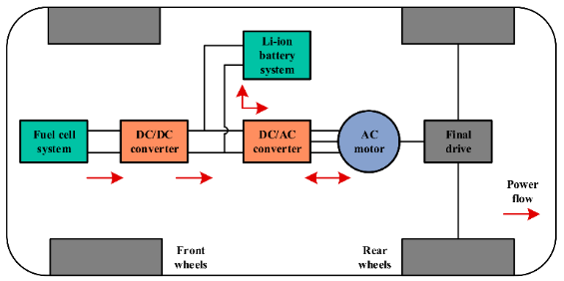
Fig. 1 Scheme of FC and Battery system
- Model Description
The model is composed of three main blocks capable of defining the longitudinal vehicle behavior considering a given speed reference, the energy storage of the vehicle and the fuel cell basic control logic. The three blocks are interconnected, to visualize and consider the effect of limited energy storage power on the vehicle performance and power needs on the electric motor.
In this paragraph those models are presented. For what concerns the longitudinal dynamics of the vehicle, given a speed reference curve, the model describes the performance needed by the motor to reach the given target, considering the longitudinal resistances of the vehicle, the slipping condition at the contact patch and limitations coming from the electric powertrain [9].
The vehicle dynamic model also considers the opposite longitudinal forces acting on the vehicle. In this case they are evaluated as shown in equation 1:

$F_{resistive}=\frac{1}{2}ρSC_{x}v^{2}+mg\left(f_{0}+Kv^{2}\right)cos⁡(α)+mg\sin\left(α\right)$ (1)

Where resistive forces F_{resistive} considered are the aerodynamic force, the rolling resistance and the vehicle mass m considering the road slope α. The aerodynamic effect is coming from the product between the frontal surface of the vehicle S, the air density ρ, the aerodynamic coefficient Cx and vehicle speed v. For what concerns the rolling resistance, a linear model, function of the speed v and friction coefficient tire-ground f₀ and K.
Once the energy evaluations are completed by the vehicle dynamics model the power is used for starting the evaluations on the energy storage system. For doing so, the power computed allow to calculate the battery voltage and current. As defined in the Vehicle Energy Storage Setup the battery and the inverter are at the same voltage, so once the power is transformed into voltage and current, it is directly possible to evaluate each cell’s behavior. For simulating the battery behavior, a RC model has been used. The block is connected directly to the FC modelling as the amount of current entering the block is the difference between the one requested by the power block and the one generated by the fuel cell that, after the DC/DC converter can be directly connected to the same buses as the battery and the inverter are.
The FC is modeled as a switch controlled by the battery SoC, in fact, only one operating point, chosen because it is the one with the higher punctual efficiency, is implemented with its specific generated power, specific fuel consumption and operative voltage.
The FC is turned on after the SoC decreases under a given threshold called in the model as low_SoC and it works for a SoC range equal to a value defined in the model as Delta_SoC limit its operative range. The concept used is to ensure the battery works in an operative range between two SOC limits, where the energy management system is ensuring its higher working efficiency.
The output is composed of three constant signals depending on the operative point of the chosen FC: Power, Voltage and the hydrogen mass flow rate.
- Simulation Results
  - Longitudinal Dynamic and Electric Behavior
The model can evaluate the longitudinal behavior of the vehicle, analyzing the powertrain needs and capabilities according to the power available at the electric motor and at the battery, following the speed input, descripted as an iterative WLTP cycle up to the full discharge of the battery.
In Fig. 2 is possible to underline the output of the electric and FC model, evaluating the discharge process of the Li-Ion Battery and the Hydrogen Tank.
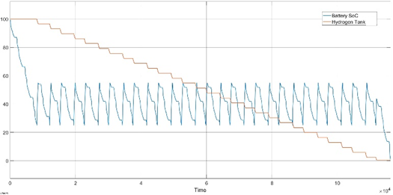
Fig. 2 State of Charge of the battery and hydrogen fuel tank state through the WLTP iterative cycles
It is possible to underline how the first step of the discharging process brings the battery SoC to the so called Low_soc level equal to 25% of the total SoC, then the FC starts working, consuming the hydrogen by steps. The FC recharges the battery to a SoC equal to 55%, following the optimal Delta_SoC. In this way the FC works iteratively, and it discharges following a step-down path. The two values have been chosen after a preliminary tuning of the FC operative points has been performed, with the goal of maximizing the range available. For doing so a fixed battery and FC setup has been chosen, varying the low_SoC and Delta_SoC values. This solution allows to have the higher range available, but it is also important to underline how, working between 25% to 55% of the SoC could partially reduce the battery efficiency, according to [9] - [10].
While the hydrogen in the tank is reaching zero (orange curve in Fig. 2) and the FC doesn’t work more, the battery starts to discharge and, because of the incapability of the FC to work anymore, the battery SoC goes lower than 25% for the first time in the whole cycle. The battery then discharges completely, and the driving cycle is interrupted.
It is important to observe that this approach allows to a significant increasing of the maximum range of the single battery and multiplying it multiple times. But it is important to analyze two different counter effects:
- Battery Aging mechanism for recharging and discharging cycles.
- Battery optimal working point.
In fact, multiple reports highlight the importance of the recharging sequences of a battery, as higher is the number of sequences in each operative time, the shorter the operative life of the battery could be. In particular, [8] underlines how one of the most critical parameters to be looked at for securing a longer working life for the battery is the charging rate. high charging rate accelerates the battery aging at low temperatures. The aging rate of the battery charging at 0.6 C is higher than that of the battery charging at 0.8 C after dozens of cycles. The influence of charging rate on battery aging changed with cycling. The model developed does not limit the C rate for ensuring a longer operative life of the Li-Ion battery, but it would be part of future development.
  - Energy Storage System Optimization
The aim of this section is finding the minimum mass for the energy storage system to reach a target range of at least 800 km. The optimization analyses three main parameters:
- Mass of Hydrogen in the tank (mH₂),
- Number of Cells in Series inside the battery (n° series),
- Number of Cells in Parallel inside the battery (n° par),
In order to make the results easier to be used, it has been decided to represent the variation of the number of cells in series as the Voltage variation. The model has been run for completely discharging the battery and emptying the Fuel tank, with every of the following different layouts:
- ṁH₂: 2, 3, 5, 6 kg.
- n° par: 20, 30, 35, 40.
- Battery Voltage: 230 V, 400 V, 525 V, 630 V.
As it is possible to conclude that, the higher is the amount of stored energy, so higher is the number of cells and mass of hydrogen stored, the higher will be the reached range. The results have also been visualized in Fig. 3, where the 4 surfaces represent the different trends varying the n° of cells in parallel. In Fig. 3 is also shown a blue surface, representing the target range of 800 km. It is easy to see how, with the layouts simulated, the targeted range is overcome in most of the configurations. It is possible to see how the increase of the n° cells in series gives a nonlinear growth of the range, while hydrogen gives a linear growth. This depends on the nonlinear energetic behavior of the Li-ion cells and by the linear range-extending logic applied to the FC.
It is possible to underline how the H₂ mass is more effective in range extension rather than the battery cells as it has a higher energy density. The range is not the only parameter to be taken into consideration for the optimization process developed, but it is critical to analyze the different energy storage masses coming as an output from the abovementioned setup.
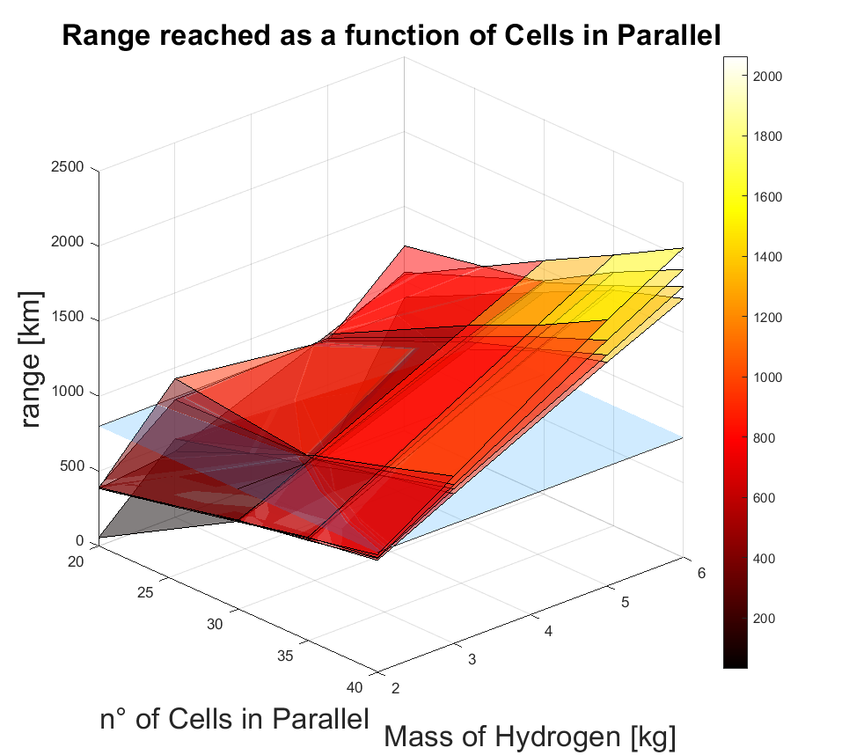
Fig. 3 Range vs. battery voltage vs. Cells in Parallel vs. hydrogen mass
The results, reported in Fig. 4, underline the energy storage system mass variations as a function of the cells in parallel, series and the stored mass of hydrogen into the tank. It is possible to note how the effect of increasing the mass of hydrogen does not affect too much the increase of the vehicle mass. This underlines the effectiveness of the FC and of the whole range extending hydrogen-based system on significantly increasing the range without reducing the efficiency of the whole vehicle.

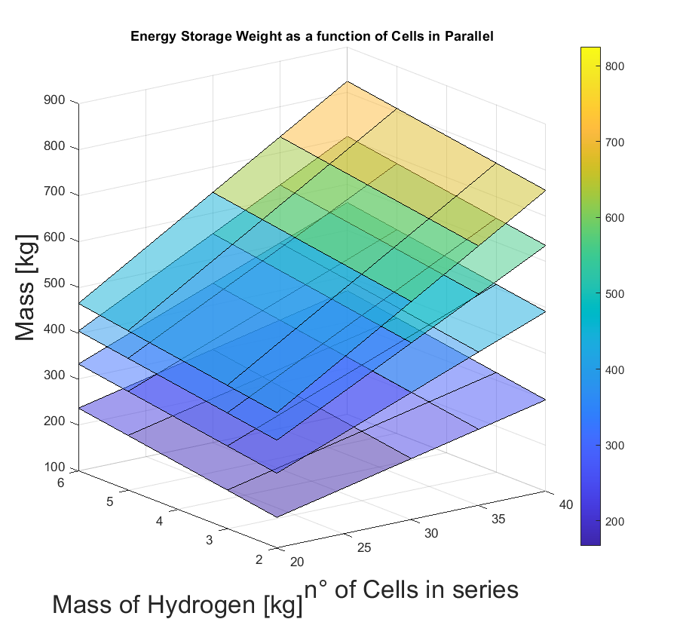
Fig. 4 Mass vs. Cells in series vs. hydrogen mass
A different approach should be taken into consideration by adding battery cells. Unfortunately, the mass to energy ratio is lower than the one of the hydrogens, not allowing to keep the mass low increasing the range.
As underlined in Fig. 3, the majority of the simulated vehicles reached more than 800 km, but the one reaching 834,2 km and with an Energy Storage System mass of 250,5 kg is considered the optimal one. The optimal setup proposes 3 kg of H₂, 55 cells in series and 30 cells in parallel. Having 250 kg of energy storage systems with the hybrid layout allows to significantly reduction of mass respect a traditional electric vehicle, taking into account, for example, an equivalent electric car as Tesla Model 3, where the battery mass is equal to 450 kg [11], the declared range on WLTP cycle is 629 km.
The proposed layout is 40% lighter and ensures 200 km higher range. It is important to underline how the disadvantages of this layout regard its need for a bigger volume because of the big tanks to be used for the H₂ and to be stored inside the same vehicle geometry.
- Conclusions
A Longitudinal Driving model for an electric vehicle has been deployed and the vehicle has been set up for introducing a hybrid fuel-cell + Li-Ion battery energy storage system. The system has been modeled and optimized, to reach a target range of 800 km with the lowest mass possible.
The result allows to individuate an optimal layout that is able to reach the target range, using the WLTP cycle as the reference speed target.
The model and the hybrid set-up, although, have some limitations regarding the use of the battery and a limitation in the optimal efficiency working point for the battery itself. Some next steps will analyze a more detailed model of the FC and the battery to increase the whole vehicle efficiency and battery operative life.
Another important consideration to be taken into account is the volumetric optimization, changing the parameters to be optimized and evaluating the need of a reduced hydrogen mass, as the tank volume will be significant. In fact, although the energetic mass ratio of the hydrogen is significantly higher than the battery, the volume needed for the tanks has to be considered a strong limitation for the technology.
The next step of the research will be advancing the complexity of the FC model inserting the chemical reaction in the cells and introducing volumetric parameters for the hydrogen tanks, to obtain a complete layout ready for the vehicle assembly.

References

[1] | R. Galvin, «Are electric vehicles getting too big and heavy? Modelling future vehicle journeying demand on a decarbonized US electricity grid,» Energy Policy, vol. 161, n. DOI:10.1016/j.enpol.2021.112746, 2021.
[2] | H. d. Carvalho Pinheiro, A. Messana, L. Sisca, A. Ferraris, A. Airale e M. Carello, «Computational Analysis of Body Stiffness Influence on the Dynamics of Light Commercial Vehicles,» Advances in Mechanism and Machine Science, n. doi:10.1007/978-3-030-20131-9_307, 2019.
[3] | M. Carello, C. Pinheiro, M. H. de, F. A. A., A. Ferraris e A. and Airale, «Composite Control Arm Design: A Comprehensive Workflow,» SAE Int. J. Adv. & Curr. Prac. in Mobility , n. doi:10.4271/2021-01-0364, 2021.
[4] | A. Ferraris, H. d. Carvalho Pinheiro, A. Airale, M. Carello e D. Polato, «City Car Drag Reduction by means of Flow Control Devices,» SAE Technical Paper 2020-36-0080, n. doi:10.4271/2020-36-0080, 2021.
[5] | E. Bianco, L. d. Napoli, E. Grano e M. Carello, «E-scooter Modelling: Battery and Fuel Cell System Integration,» Mechanisms and Machine Science, pp. DOI:10.1007/978-3-031-10776-4_104, 2022.
[6] | M. Carello, H. d. Carvalho Pinheiro, L. Longega e L. Di Napoli, «Design and Modelling of the Powertrain of a Hybrid Fuel Cell Electric Vehicle,,» SAE Int. J. Adv. & Curr. Prac. in Mobility , n. doi:10.4271/2021-01-0734, 2021.
[7] | H. Das, C. Tan e A. Yatim, «Fuel cell hybrid electric vehicles: A review on power conditioning units and topologies,» Renew. Sustain. Energy Rev., p. 268–291, 2017.
[8] | J. Liu, L. Zhou, Y. Zhang, J. Wang e Z. Wang, «Aging behavior and mechanisms of lithium-ion battery under multi-aging path,» Journal of Cleaner Production, p. doi: 10.1016/j.jclepro.2023.138678, 2023.
[9] | G. Caramia, N. Cavina, M. Caggiano e D. Moro, «Battery state of charge management strategies for a real-time controller of a Plug-in Hybrid Electric Vehicle,» Energy Procedia, p. DOI: 10.1016/j.egypro.2018.08.076, 2018.
[10] | R. Shankar, J. Marco e F. Assadian, «Design of an optimized charge-blended energy management strategy for a plugin hybrid vehicle,» Control, p. DOI: 10.1109/CONTROL.2012.6334701, 2012.
[11] | S. J. Harris, «Unlocking a Secret Stash of Energy,» Joule, p. doi:10.1016/j.joule.2020.05.019, 2020.
[12] | P. Yu, M. Li, Y. Wang e Z. Chen, «Fuel Cell Hybrid Electric Vehicles: A Review of Topologies and Energy Management Strategies,» World Electr. Veh. J. , p. doi.org/10.3390/wevj13090172, 2022.
[13] | H. d. Carvalho Pinheiro, A. Ferraris, E. Galanzino, L. Sisca, M. Carello, A. Airale e A. Messana, «All-wheel drive electric vehicle modeling and performance optimization,» SAE Technical Paper 2019-36-0197, n. doi:https://doi.org/10.4271/2019-36-0197, 2019.
[14] | Q. Cheng, R. Zhang, Z. Shi e J. Lin, «Review of Common Hydrogen Storage Tanks and Current Manufacturing Methods for Aluminium Alloy Tank Liners,» International Journal of Lightweight Materials and Manufacture, p. doi.org/10.1016/j.ijlmm.2023.08.002, 2023.

