In Situ Dynamic Nanostructuring of the Cu–Ti Catalyst-Support System Promotes Hydrogen Evolution under Alkaline Conditions
Dipak V. Shinde,*,† Zhiya Dang,† Urko Petralanda,† Milan Palei,† Mengjiao Wang,† Mirko Prato,‡ Andrea Cavalli,§ Luca De Trizio,*,† and Liberato Manna†
†Nanochemistry Department, ‡Materials Characterization Facility, and §CompuNet, Istituto Italiano di Tecnologia, via Morego 30, 16163 Genova, Italy
ABSTRACT: We report an interesting case of in situ dynamic nanostructuring of
catalyst and support under hydrogen evolution conditions in basic media. When
solution-grown CuO nanoplates on titanium substrates are subjected to hydrogen
evolution reaction, besides the reduction of CuO to metallic Cu nanoplates, both
catalyst and support simultaneously undergo a nanostructuring process. The process is
driven by the dissolution-redeposition of Cu and the alkaline etching of the titanium
support. The morphology of the resulting nanocomposite material consists of a porous
matrix made of ultrasmall Cu nanocrystals and amorphous TiOx nanoparticles.
Interestingly, the nanostructuring of the catalyst can be finely controlled by varying the
applied potential. Such a process leads to a 5.4-fold improvement in the catalyst
activity, which is attributed not only to its large active surface area (formed upon
nanostructuring), but also to an improved water dissociation activity, provided by the
in situ formation of TiO
x nanoparticles. The final catalyst exhibits -10 mA/cm2 of
current density at a small overpotential of -108 mV and a long-term operational
stability up to 50 h. Density functional theory calculations show that the co-presence of Cu and TiO2 nanoparticles optimizes
the free energy of hydrogen adsorption in the final catalyst. Our work highlights the importance of studying the dynamic
evolution of catalysts under operational conditions and choice of proper support that enhances the catalyst activity.
KEYWORDS: dynamic nanostructuring, hydrogen evolution, dissolution-redeposition, alkaline conditions, impedance spectroscopy,
density functional theory
■ INTRODUCTION
Hydrogen is considered a promising fuel for a future sustainable “green” economy.1-4 Currently, the majority of
hydrogen is produced from an energy-intensive process of
steam methane reforming, which, unfortunately, is not
sustainable and produces CO2 as a byproduct.5,6 Water electrolysis, performed by exploiting the energy obtained
from solar and wind sources, is probably the best sustainable and clean process to obtain hydrogen.1,6 In turn, hydrogen can
be used either as a fuel or for the conversion of CO2 into valueadded chemicals. To achieve this, a large-scale development of
efficient and stable electrocatalysts for both hydrogen and
oxygen evolution reactions is required. In particular, water splitting in basic media is very attractive, thanks to the
possibility of using low-cost earth-abundant oxygen evolution
catalysts that are otherwise unstable in acidic media.3,7 The
best catalyst for hydrogen evolution reaction (HER) is
platinum, which drives the hydrogen evolution with low
overpotentials in both acidic and alkaline media, but,
unfortunately, it is both scarce and very expensive for largescale development.5,6,8-14
The HER mechanism in basic media involves two steps:
water adsorption and dissociation to form adsorbed hydrogen
(i.e., the Volmer step) and the subsequent combination of
adsorbed hydrogen to form molecular hydrogen (i.e., the
Heyrovsky or Tafel step).15 Platinum exhibits a high HER activity because of its low energy barrier in the Volmer step (ΔGH2O = 0.44 eV).16-18 Earth-abundant metals like Ti,19
Co,20 Fe,21 Ni,22 W,23 and Cu24 have been explored as alternative low-cost catalysts for HER, but, unfortunately, they
have a much lower activity than Pt. To improve their catalytic
activity, three different approaches have been tested so far:
alloying such metals with other metals;6,25-27 synthesizing
their corresponding compounds, such as chalcogenides,2,8
nitrides,28 carbides,29,30 and phosphides;7,13,31 and coupling them with carbon supports and metal oxides.12,32,33 Although
these strategies increased the HER activity of the starting
materials, such modifications usually require energy-intensive
synthetic processes, making the final catalysts costly and
unsuitable for large-scale deployment.
Herein, we report a copper- and titanium-based catalyst with
excellent HER activity in basic media, which can be easily
prepared using a low-cost solution-based approach. In the first step, CuO nanoplates (NPLs) are grown in solution on a Ti
substrate. Then, under HER conditions, the CuO NPLs are
electrochemically reduced to Cu NPLs in situ and
subsequently transformed into a network of Cu NPLs interconnected with Cu fiberlike structures as a result of a dissolution-redeposition process. Simultaneously, the surface of Ti substrate undergoes morphological and chemical modifications, forming amorphous TiO2 nanoparticles that
decorate the Cu layer (Scheme 1). We further show that such a
nanostructuring process can be finely controlled by systematically varying the applied potential. Electrochemical impedance
spectroscopy analysis shows that the best-performing catalyst has a 100 times larger electrochemically active surface area (ECSA) and a lower charge transfer resistance than the starting
Cu NPLs, formed by the reduction of CuO. The density
functional theory (DFT) calculations show that the HER on
Cu is limited by too weak and on TiO2 by too strong H
adsorption, whereas in the case of Cu-TiO2 composite, this adsorption energy is optimized to promote H2 evolution. The
catalyst exhibits a -10 mA/cm2 HER current density at a small overpotential of -108 mV, which is one of the best
performances among the reported Cu-based electrodes. The improved catalytic activity was attributed to two factors: (i) a very large ECSA is created upon the nanostructuring process, which makes a large number of active sites available for HER,
and (ii) a synergic effect arising from the co-presence of
nanostructured Cu and amorphous TiO2 nanoparticles. Our
work highlights the importance of studying the dynamic
evolution of the whole electrode (catalyst + substrate) under
operational HER conditions to modulate its catalytic performance.
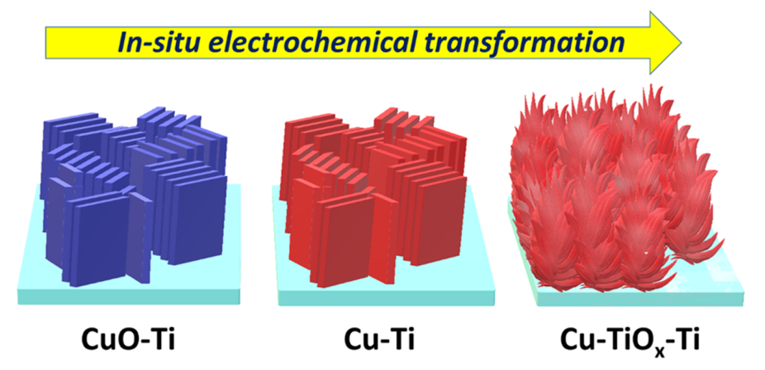
Scheme 1. Sketch of in Situ Electrochemical Fabrication Process of Cu-TiOx-Ti Electrodes Starting from Solution-Grown CuO Nanoplates on a Ti Substrate.
■ RESULTS AND DISCUSSION
CuO NPLs were synthesized by a low-temperature (∼80 °C)
solution deposition process directly on Ti substrates (see the
Experimental Section for details). This procedure is based on the reaction of copper chloride with ammonia to form copper-ammine complexes, which then decompose, leading
to the heterogeneous nucleation of vertically oriented CuO
NPLs on top of the Ti foils, as was revealed by our scanning
electron microscopy (SEM) analysis (see Figure 1a). The Xray diffraction (XRD) pattern of CuO NPLs, shown in Figure
1d, well matched with the monoclinic CuO phase (ICSD
number 43179). The formation of CuO NPLs was assumed to
proceed through the initial nucleation of metastable Cu(OH)2- layered nanostructures, which were immediately converted into more stable CuO NPLs (the gain in the Gibbs free energy
of the Cu(OH)2 → CuO transformation is ΔG = -1.62 kcal/
mol).34 The CuO-coated Ti substrates were then used as
working electrodes for HER in a three-electrode electrochemical cell using a 1 M NaOH solution in water as the
electrolyte. The electrode showed a large cathodic wave, which
was attributed to the reduction of CuO to Cu0 (see Figure
1e),35 followed by an increase in the cathodic current, which
was due to the hydrogen evolution. This was also evidenced
from bubbles that were generated at the electrode. The XRD
pattern of the electrode, measured after this cyclic voltammogram (CV) cycle, confirmed that the initial CuO material was
completely reduced to metallic Cu (ICSD number 64699) (see Figure 1d, red pattern). The SEM image of the same sample
revealed that the resulting Cu nanostructures inherited the
morphology of the parent CuO NPLs, but they had a rough
and porous surface (see Figure 1b). This was tentatively
attributed to the loss of oxygen from the CuO lattice, which
might cause the final structure to shrink. It was observed that
the HER activity of the CuO-Ti electrode increased upon
cycling: the HER current continued to rise until the 55th CV
cycle, after which no further improvements were observed (see Figure 1f). From the SEM analysis of the sample obtained after
55 CV cycles, we found that the catalyst underwent additional
restructuring: nodule and fiberlike structures emerged from the
starting NPLs (see Figure 1c). Furthermore, the XRD pattern
of the same sample revealed the presence of the starting Cu
material together with new peaks, which we ascribed to TiHx
phases, namely to tetragonal TiH (ICSD number 56181) and
cubic TiH2 (ICSD number 166235) (see Figure 1d, olive pattern). The presence of TiHx is not surprising considering that its formation is favored under hydrogen evolution
conditions.36
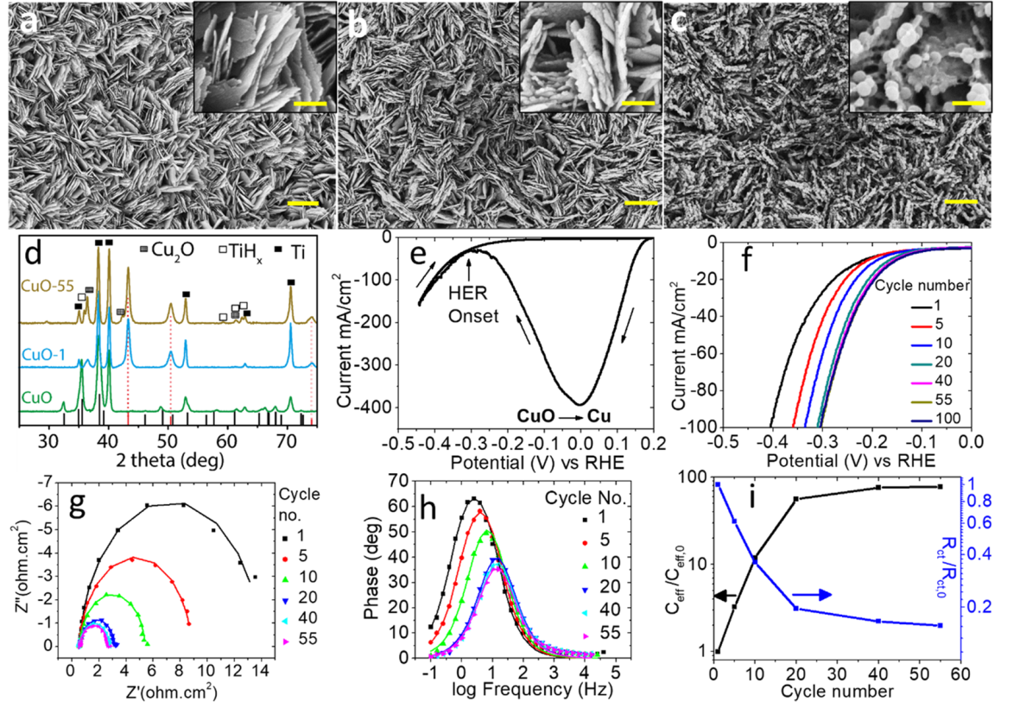
Figure 1. Representative SEM images of (a) pristine CuO NPLs grown on Ti substrates and their evolution after (b) 1 CV and (c) 55 CV cycles.
Scale bars in (a)-(c) panels are 1 μm and those in insets are 200 nm. (d) XRD patterns of the electrodes obtained before and after different CV
cycles. The bulk reflections of the cubic Cu (ICSD number 64699) and monoclinic tenorite CuO (ICSD number 43179) are also represented by
means of red and black bars, respectively. The reflections of the Ti substrate, TiHx, and Cu2O are marked with filled black squares, open squares,
and filled gray squares, respectively. First CV cycle (e), consecutive CV scans (f), Nyquist plots (g), Bode-phase plots (h) (the dots represent
experimental values, whereas lines represent corresponding fits), and a plot of effective capacitance and charge transfer resistance vs number of CV cycles (i) of CuO-Ti electrodes after various CV cycles.
It is known that metallic Cu is a poor catalyst for HER because of its very small hydrogen bonding energy.6 The improved activity of our Cu-based catalyst, therefore, was initially thought to be related to the nanostructuring process of
the catalyst itself. To test this hypothesis, we performed an
impedance spectroscopy analysis on the CuO-Ti samples after
different numbers of CV cycles. The corresponding Nyquist
plots are reported in Figure 1g, and the different parameters
that were extracted from the impedance plots are summarized
in Table S1 of the Supporting Information (SI). All of the
samples exhibited a single semicircle related to the charge
transfer resistance (Rct) of the electrode-electrolyte interface.37 The absence of any Warburg features in the plots
indicated that the measurements were not affected by mass
transfer, so the HER was kinetically controlled.38 Freshly
formed Cu NPLs (after 1 CV cycle) exhibited a very high Rct
of 13.4 ohm cm2, which clearly indicated their poor catalytic
activity. On the other hand, upon further cycling, a marked
decrease in the R
ct (2.10 ohm cm2) and a large increase in the
effective capacitance of the electrode (17.7 mF/cm2) was
observed, indicating a rise in the HER rate as a consequence of
the increased ECSA (see Figure 1i). The same conclusions
were drawn by analyzing the Bode-phase plots: the measured
peaks shifted toward higher frequencies and decreased in size
upon cycling, indicating a shorter reaction time constant (see
Figure 1h). Having been motivated by these findings, we
decided to investigate the origin of such a restructuring of the
CuO-Ti system and whether or not it could be controlled to
maximize the resulting HER performance. To do this, we
treated the CuO-Ti electrodes at various applied potentials
and monitored the corresponding HER currents over a period
of 24 h. The resulting chronoamperometry (CA) plots are
reported in Figure 2a. We would like to underline here that I0
denotes the minimum HER current observed immediately after
the reduction of CuO to Cu during the CA. Apart from the
sample that was biased at -0.4 V, the HER currents of the
electrodes increased with time: Those treated at -0.1 and -0.3
V showed a ∼2- and ∼3-fold increase, respectively, whereas the
one biased at -0.2 V exhibited the best HER current
enhancement (∼5.4 times). To understand the reason behind
this, SEM and XRD analyses were performed on these
electrodes (see Figure 2b,c). The XRD patterns confirmed,
as expected, the presence of metallic Cu in all of the samples,
and the presence of titanium hydride phases only in the
electrodes that had been treated at higher negative potentials
(-0.3 and -0.4 V) (see Figure 2b). As described above,
titanium hydrides can easily form under vigorous hydrogen
evolution. In samples that had been treated at -0.1 to -0.3 V,
minor peaks ascribable to Cu2O were also detected, which
might have formed because of the air oxidation of the samples.
More insight was provided by our SEM analysis: the initial Cu0
NPLs were transformed into a spongelike structure composed
of interconnected wires in the sample biased at -0.1 V; no
morphological changes were observed in the sample biased at
-0.4 V; the electrodes biased at -0.2 and -0.3 V had
morphological features in between those observed for the
samples obtained at -0.4 and -0.1 V (see Figure 2c).
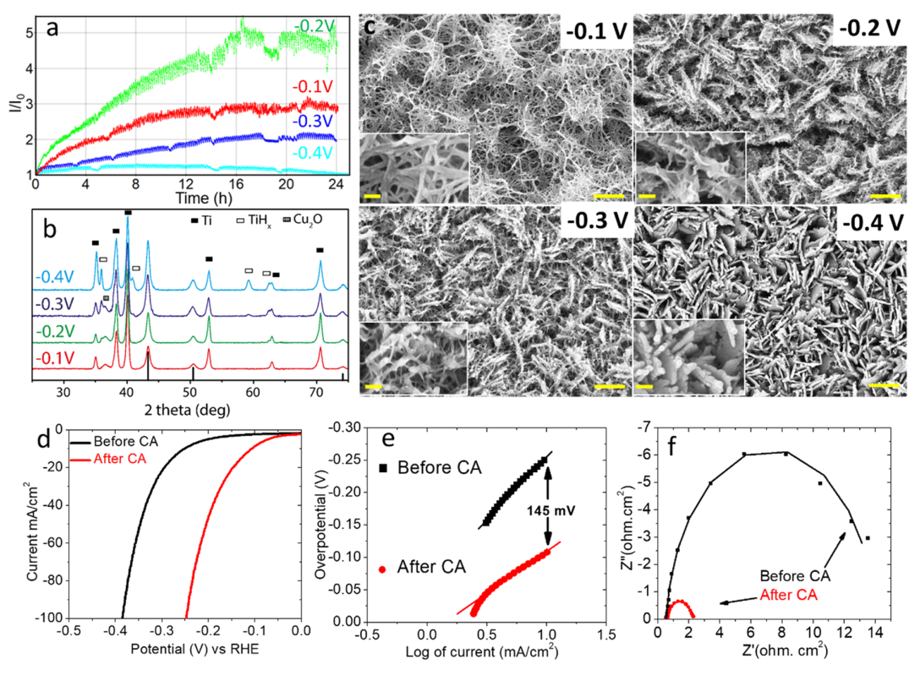
Figure 2. CA plots of CuO-Ti electrodes obtained at various applied potentials (no iR correction) (a) together with the corresponding XRD patterns. The bulk reflections of cubic Cu (ICSD number 64699) are also represented by means of black bars (b). Representative SEM images of
samples biased at different potentials (marked in the figure) for 24 h (c). The scale bars are 500 nm and those in insets are 200 nm. CV plots (d),
Tafel plots (e), and Nyquist plots (f) of CuO-Ti electrodes obtained before and after CA for 24 h at -0.2 V vs reversible hydrogen electrode (RHE).
These results, which indicate a dynamic evolution of the
electrodes’ morphology, were explained by considering a dissolution-redeposition mechanism.35 Shiddiky et al. observed that copper adatoms (Cu*) undergo premonolayer oxidation to form soluble copper hydroxides even under
negative applied potentials. Our initial Cu0 NPLs, which have a
rough and porous surface, are characterized by having a high
amount of undercoordinated Cu* adatoms, which are locally
converted into CuOHads during the HER. The Cu*/CuOHads electron transfer process is fast and fully reversible, which is the
reason why we could not observe it with simple DC
voltammetry (see Figure 1f). The formation of CuOH species can be considered as the result of two competing kinetic
processes, namely, the oxidation of Cu under alkaline
conditions and the reduction of copper species driven by the
negative potential. Indeed, Doblhofer and co-workers, while
working with Cu electrodes in 0.5 M NaOH, observed, with
the help of in situ Raman spectroscopy, the presence of CuOH
species up to -1.3 V vs SCE (ca. -0.3 V vs RHE), whereas no
formation of oxidized copper was registered at -1.4 V.39 These
results, which are in line with the results of our experiments,
suggest that at low negative voltage, up to -0.3 V, Cu0 NPLs
are locally oxidized to CuOH. The copper hydroxide species
are then dissolved in the electrolyte and redeposited upon
reduction as Cu0 on the electrode, leading to a restructuring of the electrode (see Figure 2c). However, at higher negative
potential of -0.4 V, the formation of CuOH species is
hindered and the morphology of the electrode remains
unaltered.
The best electrode that was formed upon dynamic
reconstruction, namely, the one biased at -0.2 V for 24 h,
was further electrochemically characterized. The CVs of the
sample measured before and after the CA at -0.2 V for 24 h
are shown in Figure 2d. As previously mentioned, a remarkable
improvement in the HER performance was clearly observed:
the overpotential of the catalyst before and after the CA was
reduced from -252 mV to only -108 mV (to achieve a current density of -10 mA/cm2). To elucidate the mechanisms behind the HER, Tafel analysis was performed.
The slopes of the lines were calculated by fitting the linear
parts of the graph (see Figure 2e) using the Tafel equation (η = b log j + a). The hydrogen evolution in basic media proceeds
via three steps. The first is a water dissociation step to form
adsorbed hydrogen (H*) (Volmer step) having a Tafel slope of -120 mV/dec. This step is followed by the evolution of
molecular hydrogen, which might take place via an electrochemical desorption step called the Heyrovsky reaction (Tafel slope of -40 mV/dec) or via the recombination of H* on the catalyst surface, with a Tafel slope of -30 mV/dec (see
Scheme S1 in SI). The theoretical Tafel slopes of -30 and -40
mV/dec refer to the low surface coverage of the electrode
surface by adsorbed hydrogen (H*), that is, to a low current
density range. The Tafel slope of the electrode changed from
-189 to -122 mV/dec after the CA, indicating a marked improvement in the HER kinetics. The values of the slopes also indicate that the Volmer step is the rate-determining step
for hydrogen evolution under alkaline conditions.17 The
impedance spectra recorded before and after the CA indicated
a decrease in the Rct and an increase in the effective
capacitance (see Figure 2f). This further highlights the fact
that Cu-Ti electrodes have better HER kinetics when they are
obtained after the CA treatment. It is also worth noting that
the HER performances of the electrode obtained after the CA
at -0.2 V for 24 h were better than those of the electrode
produced after CV cycling. This was rationalized considering
that a better control over the nanostructuring process should
be achieved by working at a constant potential rather than
under variable potentials. The performance of our best
electrode (the one treated at -0.2 V for 24 h) is among the best reported so far for metallic Cu-based electrodes (see Table S3 of the SI for a detailed comparison). Considering that Cu itself exhibits low activity for HER, as mentioned earlier,6 the high catalytic activity of our best electrode could not be
explained as deriving only from the nanostructuring of the Cu
electrode after the CA. To elucidate this point, we performed
X-ray photoelectron spectroscopy (XPS) and SEM-energy
dispersive X-ray spectroscopy (EDS) analyses of the catalyst
obtained after CA at -0.2 V for 24 h. The XPS depth profile, in which the atomic concentrations of Ti and Cu are reported
vs the etching time, revealed the presence of Ti species along
the whole thickness of the Cu layer of the electrode (see Figure 3a).
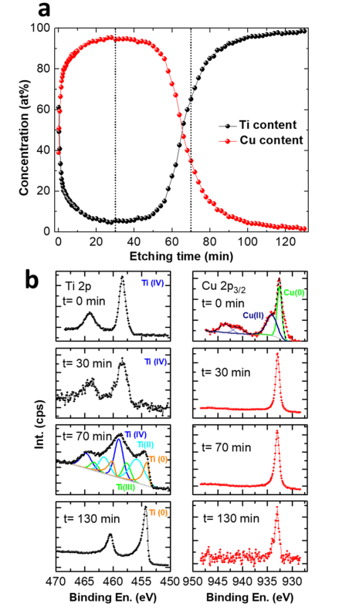
Figure 3. XPS characterization of a Ti-CuO electrode obtained after
24 h of CA at an applied potential of -0.2 V vs RHE (no iR correction). (a) Atomic concentrations of Ti and Cu recorded at
various time intervals during depth profiling and (b) high-resolution
scans of the Ti 2p and Cu 2p regions obtained at specified time
intervals.
Additionally, high-resolution XPS scans of the Ti and Cu 2p
regions were recorded at various time intervals (i.e., at different
depths) (see Figure 3b). At t = 0 (the surface of the electrode),
Ti is present in the +4 oxidation state, whereas Cu is oxidized
and present in a mixture of +1 and +2 oxidation states. This was attributed to the surface oxidation of Cu, which also resulted in the formation of Cu2O, as measured by XRD (see
Figure 2). At t = 30 min (in the bulk of the electrode), Ti was
detected as Ti4+ and copper as Cu0, as expected.40,41 At a
longer etching time, t = 70 min, whereas copper was still Cu0,
Ti was found in mixed oxidation states of 0, +2, +3, and +4. Moreover, at this specific etching time, the Cu amount starts to drastically drop with the concomitant rise in the Ti content
(see Figure 3a). These results suggest that the layer under the
analysis at t = 70 min is the interface between the catalyst and
the Ti substrate. Thus, the different Ti oxidation states
observed here were attributed to the surface oxidation of the
starting Ti substrate. Finally, at t = 130 min, the composition
of the substrate was revealed: Ti is in a 0 oxidation state along with the presence of traces of Cu0. The presence of Ti across
the whole thickness of the Cu film was also confirmed by SEM-EDS mapping across the cross section of the electrode
(see Figures 4a and S1 of the SI). Overall, our analyses clearly
indicated that the CA treatment not only led to the
nanostructuring of the Cu layer, but also to the diffusion of
Ti, as Ti(IV), from the substrate to the whole Cu catalyst. Indeed, it has been previously observed that Ti metal treated in
a NaOH solution forms a passivating layer of hydrated Ti oxides.42 As a control experiment, we treated pristine Ti foils
(without deposited CuO NPLs) under various applied
potentials for 24 h, and we observed the formation of porous
platelike structures, as shown in Figure S2 of the SI. The XRD
analysis of these samples reveals that the formed structures are
amorphous in nature (see Figure S3 of the SI). Moreover, the
XPS analysis of these electrodes, presented in Figure S4,
confirmed the formation of Ti(IV) oxides in each case. Finally, to have a complete understanding of the nanostructuring process and to elucidate where such Ti(IV) species are deposited inside the Cu catalyst, we performed a highresolution transmission electron microscopy (HRTEM)
analysis of the final electrode (on the powder that was
scratched off the sample treated at -0.2 V for 24 h). As shown
in Figure 4b, the final electrode was composed of ultrasmall Cu
nanocrystals with a size of 2-5 nm along with amorphous TiOx and rutile TiO2 nanoparticles. Such TiO2 particles are
believed to be the final result of the nanostructuring process,
which affects not only the Cu NPLs, but also the substrate, as
previously described. It is worth mentioning here that although XPS depth profile and TEM images show the co-presence of
Cu and Ti-oxide species, it is hard to state that a perfect Cu-
TiO2 interface is formed throughout the whole thickness of the
film. It is possible, in fact, that the electrode might be composed of isolated Cu and Ti-oxide particles. Interestingly,
TiO2 is known to promote the chemisorption and dissociation
of water at room temperature, especially in the case of highly
irregular surfaces (coordinately unsaturated sites).43 The formation of TiO2 nanoparticles after the CA on our Cu catalyst is therefore believed to strongly promote the Volmer step (water dissociation and Hads formation).32 To prove our
hypothesis, we performed a density functional theory (DFT) study (see more details in the Experimental Section), following the method reported by Nørskov et al.44,45 In this approach,
the hydrogen adsorption free energy (ΔGH*) on active sites is
taken as the descriptor of the HER activity. In such model, the
electrode first absorbs a proton, then it reduces it by donating
an electron, and, eventually, releases hydrogen in the form of
H2. Hence, ΔGH* values close to zero indicate an optimal balance between the hydrogen adsorption and release. In our study, we have modeled three clusters based on face-centered cubic (fcc) Cu (see Figure S5), rutile TiO2 (see Figure S6), and a Cu-TiO2 interface (see Figure S7) to model the mixed system.46 In Figure 4c, we show the values of ΔGH* obtained for the three systems under analysis. On the one hand, Cu
(ΔGH* = 0.21 eV), is known to have a very weak H adsorption
energy that limits its HER activity, whereas TiO2 has a too strong affinity toward H (ΔGH* = -0.78 eV). Of particular
importance, we find that the Cu-TiO2 interface exhibits an
optimal ΔGH* of -0.17 eV when H is considered to be adsorbed/released near a Cu-Ti bond, as indicated in Figure
S7. A schematic representation of the synergy between Cu and
TiO2 nanoparticles in the hydrogen evolution process in basic
media is shown in Figure 4d. We propose a concerted
interaction of O atoms with TiO2 and H atoms with Cu at the
boundary between TiO2 and Cu nanoparticles. In this scenario,
TiO2 helps in the water adsorption and dissociation by forming
H* species that are adsorbed on adjacent Cu sites. Two H* on Cu sites then combine to evolve H2, similar to what has been
previously shown in the case of Co-TiO2 and Pt-Ni(OH)2 catalysts.17,32 Our findings, thus, indicate that the high HER
performance of our catalyst could be attributed to two factors:
(i) a large number of Cu-TiO2 active sites (increased ECSA) that are formed by nanostructuring of Cu NPLs and Ti
substrate and (2) a boost of the Volmer step along with an
optimum hydrogen binding energy due to the decoration of
the Cu catalyst with TiO2 nanoparticles.
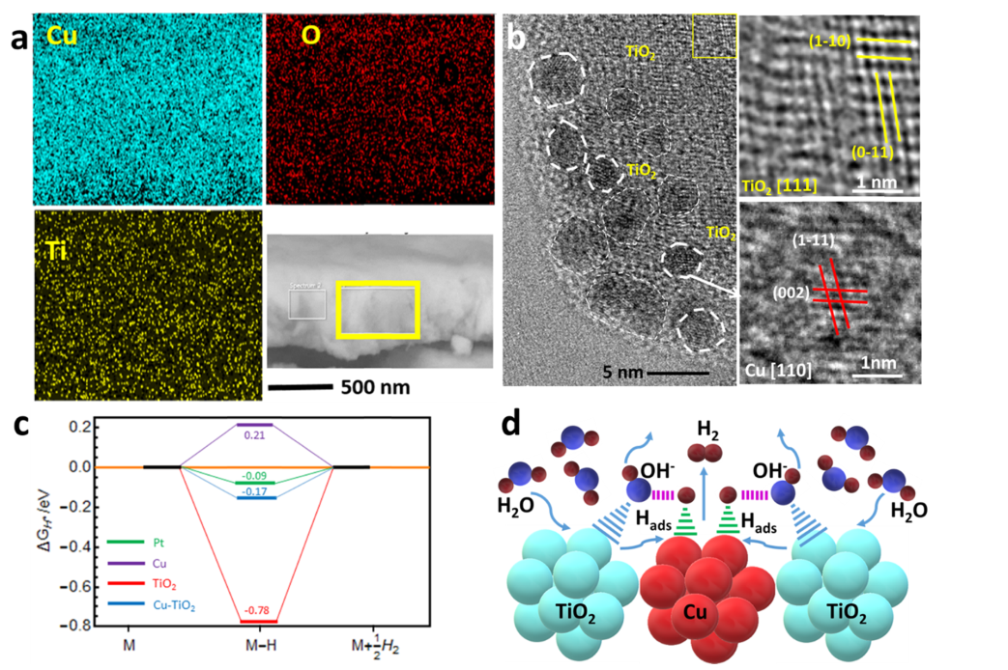
Figure 4. Characterization of a Ti-CuO electrode obtained after 24 h of CA at an applied potential of -0.2 V vs RHE: (a) SEM-EDS elemental
mapping of cross section in the selected area (yellow square in bottom right) and (b) HRTEM image of the powder scratched off from the electrode: It is possible to appreciate the presence of both small (<5 nm) Cu nanocrystals, with the corresponding lattice fringes reported in the bottom-right panel (right bars) and TiO2 nanoparticles. Some of the TiO2 nanoparticles show crystallinity (which might have been induced by the e-beam irradiation) with lattice fringes ascribable to the rutile TiO2 phase (shown in the upper-right panel by means of yellow bars). (c) Free
energy diagram for hydrogen evolution calculated by DFT in the three studied clusters, Cu, TiO2, and Cu-TiO2 interface and Pt and (d) schematic
representation of water adsorption, dissociation, and formation of Hads on Cu surface and the evolution of molecular H2, as well as the desorption of OH- from the TiO2 surface.
To prove the fundamental role of the in situ formed TiO2 nanoparticles, we also performed a control experiment in which CuO NPLs were directly grown on fluorine-doped tin oxide (FTO) substrates that did not contain any Ti species. The SEM images of the resulting electrodes revealed that, in
this case, the CuO nucleated on top of the FTO in the form of
islands of nanosheets (see Figure S8a,b of the SI). The CVs performed on the CuO-FTO electrodes at a scan rate of 10 mV/S showed no improvement in the HER performance after
cycling (see Figure S9 of the SI). We also conducted CA on
these electrodes for 60 h at -0.2 V and observed an initial slight improvement in HER currents, which eventually decreased to the initial values (see Figure S10 of the SI).
The initial slight improvement was attributed to the restructuring of Cu in the electrode, as was observed by our
SEM analysis (see Figure S8c,d of the SI). Additionally, we
also deposited CuO on graphite electrodes and subjected these
electrodes to CA tests. As shown in Figure S11 of the SI, the
restructuring of the electrode occurs during CA, but with no
improvement in the HER current (see Figure S12 of the SI). In
both these control experiments, in which CuO-FTO and
CuO-graphite electrodes were used, the morphology of the CuO material after the restructuring was different from that observed in the CuO-Ti system discussed above. These results suggested that the Ti support played an important role not only in providing Ti species for the formation of TiO2
nanoparticles but also in the restructuring of the Cu catalyst. Furthermore, it has been previously reported that Pt, when used as a counter electrode, dissolves in the electrolyte and
deposits on cathodically biased catalysts during HER measurements.47 To exclude the presence of Pt in our best-performing
sample, we also performed an XPS analysis, which revealed no
peaks in the Pt 4d and 4f regions (see Figure S13 of the SI).
Finally, we tested the long-term stability of the catalyst,
which was treated at -0.2 V for 24 h, by cyclic voltammetry
and chronopotentiometry at an applied current density of -50
mA/cm2 for 50 h. The CV plots shown in Figure S14a of the
SI indicated that the HER performance remained stable after 1000 cycles, and SEM images recorded of the sample after 1000 CV cycles confirmed that the electrode maintained its
porous structure. From the chronopotentiometry plot,
presented in Figure 5a, it is possible to appreciate that no
degradation of the HER performance occurred during the
stability test, confirming the robustness of our Cu-Ti
electrode. Furthermore, our SEM analysis, performed after
the chronopotentiometry tests confirmed that the electrode
maintained its nanostructured nature (see Figure 5b,c). The
XPS analysis after the stability tests confirmed the co-presence of surface-oxidized Cu (due to air oxidation) and Ti(IV),
confirming that the catalyst composition remained unaltered (see Figure 5d,e). Overall, our experiments demonstrated the
critical role of the Ti substrate in improving the HER
performance of the final Cu-Ti electrode, highlighting the importance of the choice of a proper substrate depending on
its interaction with the deposited catalyst.
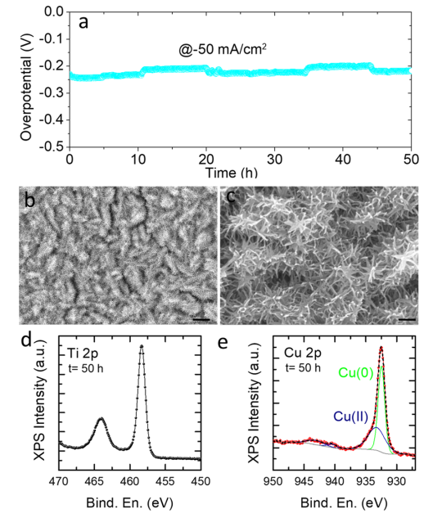
Figure 5. Long-term stability test: (a) Chronopotentiometry plot performed at a constant cathodic current of -50 mA/cm2 (the electrode was treated at -0.2 V for 24 h before the chronopotentiometry tests), (b, c) low- and high-resolution SEM images of the electrode obtained after 50 h stability test, and XPS spectra of the sample after 50 h stability test in Ti 2p (d) and Cu 2p (e) regions. The scale bar is 1 μm in (b) and 200 nm in (c).
■ CONCLUSIONS
In summary, we have developed a Cu- and Ti-based nanostructured catalyst with an excellent activity for the HER. The catalyst was produced by employing a simple and
low-cost approach: in the first step, CuO NPLs were grown
using a low-temperature (80 °C) solution-based method on
titanium substrates; second, the NPLs were electrochemically
reduced in situ under HER conditions to form porous Cu0
nanostructures decorated with TiO2 nanoparticles. The
formation of such nanostructured catalyst stemmed from two
different dissolution and redeposition processes, which affected
both the Cu layer and the Ti substrate. Of particular interest is
that such processes could be finely controlled by varying the
applied potential. As a result, the final catalyst exhibited a -10
mA/cm2 current density at a small overpotential of only -108
mV. The high HER performance of our catalyst was attributed
to a large number of active Cu sites that formed upon
restructuring, and a boost of the Volmer step and optimization
of hydrogen binding energy due to the presence of TiO2
nanoparticles decorating the Cu catalyst. The present work
highlights that the proper substrate selection could improve the performance of the otherwise poorly active HER catalysts.
This strategy could be logically extended to other catalyst-
substrate pairs to maximize their HER activity.
■ EXPERIMENTAL SECTION
Chemicals. The following chemicals were purchased from SigmaAldrich and used without further purifications: Copper(II) chloride
dihydrate (99.999%), sodium hydroxide (98%), ammonia solution
(25%), titanium foil (0.25 mm thickness, 99.7%), and F-doped SnO2
glass substrates (FTO, surface resistivity ∼7 Ω/sq). The FTO
substrates and Ti foils were cleaned with detergent mixed in water and then washed carefully with distilled water. Next, the substrates were
washed by ultrasonication in a solution of 2-propanol and acetone
(1:1 by volume), dried in a stream of air, and stored for further use.
Synthesis of CuO NPLs. CuO NPLs were grown on different
substrates (FTO or Ti) by the chemical solution deposition technique
reported by Pawar et al. with modifications.48 Briefly, 1.5 mmol of
copper chloride dihydrate was dissolved in 30 mL of deionized water
in a 40 mL glass vial to form a faint blue solution. After the addition of
1.5 mL of ammonia, the solution became deep blue, indicating the
formation of a copper-ammine complex. A precleaned Ti plate was then vertically inserted in the vial, and the whole system was heated
up to 80 °C for 2 h on a hotplate. After completing the reaction, the
black CuO-coated Ti substrate was removed, washed with deionized
water, and dried with a stream of air.
Structural Characterization and Elemental Analyses. SEM.
SEM analyses were performed on electrodes coated with a 10 nm gold
layer using a FEI NanoLab 600 dual-beam system.
HRTEM. HRTEM micrographs were acquired using a JEOL JEM-
2200FS, operating at 200 KV. The samples were prepared by
scratching off the materials from the electrodes and dispersing them in
ethanol. The catalyst dispersions were dropped onto 400 mesh copper grids (coated with ultrathin carbon/holey carbon) for imaging. The
microscope was equipped with a Ω-type in-column image filter and a
CEOS spherical aberration corrector for the objective lens. This
enabled a spatial resolution of 0.9 Å.
XRD. XRD patterns of the electrodes were acquired at room
temperature in ambient atmosphere using a PANalytical Empyrean
diffractometer, operating at 45 kV and 40 mA. The diffractometer was
equipped with a 1.8 kW Cu Kα ceramic X-ray tube and PIXcel3D 2 ×
2 area detector.
XPS. XPS analyses were performed on a Kratos Axis Ultra DLD
spectrometer, using a monochromatic Al Kα source, operated at 20
mA and 15 kV. Low-resolution survey scans were acquired at an
analyzer pass energy of 160 eV, whereas high-resolution scans were acquired in 0.1 eV steps at a constant pass energy of 20 eV, over the
energy regions typical of the main XPS peaks for Cu and Ti. A takeoff
angle (Φ) of 0° with respect to the surface normal was used to detect
photoelectrons. The pressure in the analysis chamber was always kept
below 6 × 10-9 Torr during the analysis. The data were processed
using Casa XPS version 2.3.17. The C 1s peak at 284.8 eV was used as
an internal reference for binding energy scale. To obtain information
on the chemical composition in the “bulk” of the electrode (XPS
depth profiling), we combined a sequence of ion gun etch cycles, using Ar+ ions at 4 keV of energy and etching cycle duration of 2 min,
interleaved with XPS measurements. The XPS data have been
collected on Ti 2p and Cu 2p energy regions; their relative content
has been calculated by evaluating the area under each peak, after
normalization to the so-called relative sensitivity factors, that is,
parameters that take into account the electron photoemission cross
section for each element.
Electrochemical Measurements. The setup for electrochemical measurements consisted of an electrochemical cell containing Pt wire
(counter electrode), CuO nanoplates grown on Ti of 0.25 cm2 area (working electrode), and a double-junction Ag/AgCl (3.8 M KCl)
(reference electrode). All of the measurements were performed on a
IVIUM Compactstat potentiostat. Cyclic voltammograms were
measured in 1 M NaOH solution as an electrolyte at a sweep rate
of 10 mV/S, in the potential range of -0.8 to -1.5 V. The
chronoamperometry (CA) measurements were performed by
applying various constant applied potentials. The long-term stability
of the electrode was measured by chronopotentiometry at a constant
applied current density of -50 mA/cm2. Impedance analysis was
performed at a constant potential of -0.2 V vs RHE. The spectra were
recorded with a potential amplitude of 5 mV in a frequency range of
0.1 MHz to 0.1 Hz. The iR correction was applied to all of the CV
data, unless otherwise noted, using IVIUM software. For this purpose,
series resistance was obtained from the Nyquist plots. All of the
potentials are reported versus the reversible hydrogen electrode
(RHE) scale, unless otherwise noted. The potentials were converted
using the following formula: ERHE = Eobs + EAg/AgCl + (0.0591 × pH),
where EAg/AgCl has a value of 0.199 V vs SHE.
DFT Analysis. We have calculated the HER free-energy diagram
following the procedure of Nørskov et al., as mentioned in the text. We computed ΔGH* as described previously by Zheng et al.49 For DFT calculations, the exchange correlation functional was approximated by the BLYP functional as implemented in Gaussian 09.50,51
LanL2DZ basis was selected, and the CPCM (water) was used as
solvent calculation model. The total energy convergence was set to be
lower than 10-8 Ha, and the force convergence was set to be smaller
than 5 × 10-4 Ha/Bohr. Unrestricted open-shell calculations were
performed in all cases.
To build the atom clusters, we have considered fcc Cu cut in the
(111) plane and rutile TiO2 cut in the (110) plane. Although the
exact values of the energy barriers obtained may depend on the approximation to the exchange correlation functional employed in
calculations and the size of the cluster modeled, a strengthening of
about 0.3-0.4 eV of the H adsorption on the Cu-TiO2 interface with
respect to the pure Cu cluster, which facilitates the HER, is confirmed
in all structural settings and DFT pseudopotentials tested.
■ ASSOCIATED CONTENT
*S Supporting Information
The Supporting Information is available free of charge on the
ACS Publications website at DOI: 10.1021/acsami.8b09493. XRD, SEM, XPS, and CVs; steps involved in the formation of molecular hydrogen in two different HER
mechanisms (Scheme S1); various parameters extracted
from impedance plots using the following equivalent
circuit (Table S1); roughness factor and specific activity
of the catalyst before and after CA (Table S2) (PDF)
■ AUTHOR INFORMATION
Corresponding Authors
*E-mail: dipak.shinde@iit.it (D.V.S.).
*E-mail: luca.detrizio@iit.it (L.D.T.).
ORCID
Dipak V. Shinde: 0000-0002-1197-8472
Mirko Prato: 0000-0002-2188-8059
Luca De Trizio: 0000-0002-1514-6358
Liberato Manna: 0000-0003-4386-7985
Notes
The authors declare no competing financial interest.
■ ACKNOWLEDGMENTS
We acknowledge funding from the European Union under grant agreement no. 614897 (ERC Grant TRANS-NANO).
■ REFERENCES
(1) Bard, A. J.; Fox, M. A. Artificial Photosynthesis: Solar Splitting of
Water to Hydrogen and Oxygen. Acc. Chem. Res. 1995, 28, 141-145.
(2) Tan, C.; Luo, Z.; Chaturvedi, A.; Cai, Y.; Du, Y.; Gong, Y.;
Huang, Y.; Lai, Z.; Zhang, X.; Zheng, L.; Qi, X.; Goh, M. H.; Wang, J.; Han, S.; Wu, X. J.; Gu, L.; Kloc, C.; Zhang, H. Preparation of HighPercentage 1T-Phase Transition Metal Dichalcogenide Nanodots for
Electrochemical Hydrogen Evolution. Adv. Mater. 2018, 30,
No. 1705509.
(3) Chen, G.; Wang, T.; Zhang, J.; Liu, P.; Sun, H.; Zhuang, X.;
Chen, M.; Feng, X. Accelerated Hydrogen Evolution Kinetics on
NiFe-Layered Double Hydroxide Electrocatalysts by Tailoring Water
Dissociation Active Sites. Adv. Mater. 2018, 30, No. 1706279.
(4) Shinde, D. V.; Trizio, L. D.; Dang, Z.; Prato, M.; Gaspari, R.;
Manna, L. Hollow and Porous Nickel Cobalt Perselenide Nanostructured Microparticles for Enhanced Electrocatalytic Oxygen
Evolution. Chem. Mater. 2017, 29, 7032-7041.
(5) Turner, J. A. Sustainable Hydrogen Production. Science 2004,
305, 972-974.
(6) Lu, Q.; Hutchings, G. S.; Yu, W.; Zhou, Y.; Forest, R. V.; Tao,
R.; Rosen, J.; Yonemoto, B. T.; Cao, Z.; Zheng, H.; et al. Highly
Porous Non-Precious Bimetallic Electrocatalysts for Efficient Hydrogen Evolution. Nat. Commun. 2015, 6, No. 6567.
(7) Xu, K.; Ding, H.; Zhang, M.; Chen, M.; Hao, Z.; Zhang, L.; Wu,
C.; Xie, Y. Regulating Water-Reduction Kinetics in Cobalt Phosphide
for Enhancing HER Catalytic Activity in Alkaline Solution. Adv.
Mater. 2017, 29, No. 1606980.
(8) Shinde, D. V.; Patil, S. A.; Cho, K.; Ahn, D. Y.; Shrestha, N. K.;
Mane, R. S.; Lee, J. K.; Han, S. H. Revisiting Metal Sulfide
Semiconductors: A Solution-Based General Protocol for Thin Film
Formation, Hall Effect Measurement, and Application Prospects. Adv.
Funct. Mater. 2015, 25, 5739-5747.
(9) Popczun, E. J.; Read, C. G.; Roske, C. W.; Lewis, N. S.; Schaak,
R. E. Highly Active Electrocatalysis of the Hydrogen Evolution
Reaction by Cobalt Phosphide Nanoparticles. Angew. Chem. 2014,
126, 5531-5534.
(10) Chen, W. F.; Sasaki, K.; Ma, C.; Frenkel, A. I.; Marinkovic, N.;
Muckerman, J. T.; Zhu, Y.; Adzic, R. R. Hydrogen-Evolution Catalysts Based on Non-Noble Metal Nickel-Molybdenum Nitride Nanosheets. Angew. Chem., Int. Ed. 2012, 51, 6131-6135.
(11) Greeley, J.; Jaramillo, T. F.; Bonde, J.; Chorkendorff, I.;
Nørskov, J. K. Computational High-Throughput Screening of
Electrocatalytic Materials for Hydrogen Evolution. Nat. Mater.
2006, 5, 909-913.
(12) Li, Y.; Wang, H.; Xie, L.; Liang, Y.; Hong, G.; Dai, H. MoS2
Nanoparticles Grown on Graphene: an Advanced Catalyst for the
Hydrogen Evolution Reaction. J. Am. Chem. Soc. 2011, 133, 7296-
7299.
(13) Liu, T.; Ma, X.; Liu, D.; Hao, S.; Du, G.; Ma, Y.; Asiri, A. M.;
Sun, X.; Chen, L. Mn Doping of CoP Nanosheets Array: An Efficient Electrocatalyst for Hydrogen Evolution Reaction with Enhanced
Activity at All pH Values. ACS Catal. 2017, 7, 98-102.
(14) Barber, J. H.; Conway, B. E. Structural Specificity of the
Kinetics of the Hydrogen Evolution Reaction on the Low-Index
Surfaces of Pt Single-Crystal Electrodes in 0.5 M dm-3 NaOH. J.
Electroanal. Chem. 1999, 461, 80-89.
(15) Zhang, T.; Anderson, A. B. Hydrogen Oxidation and Evolution
on Platinum Electrodes in Base: Theoretical Study. J. Phys. Chem. C
2007, 111, 8644-8648.
(16) Zhang, J.; Wang, T.; Liu, P.; Liao, Z.; Liu, S.; Zhuang, X.; Chen,
M.; Zschech, E.; Feng, X. Efficient Hydrogen Production on MoNi4
Electrocatalysts with Fast Water Dissociation Kinetics. Nat. Commun.
2017, 8, No. 15437.
(17) Subbaraman, R.; Tripkovic, D.; Strmcnik, D.; Chang, K.-C.;
Uchimura, M.; Paulikas, A. P.; Stamenkovic, V.; Markovic, N. M.
Enhancing Hydrogen Evolution Activity in Water Splitting by
Tailoring Li+-Ni(OH)2-Pt Interfaces. Science 2011, 334, 1256-1260.
(18) Fajín, J. L. C.; DS Cordeiro, M. N.; Gomes, J. R. B. Density
Functional Theory Study of the Water Dissociation on Platinum
Surfaces: General Trends. J. Phys. Chem. A 2014, 118, 5832-5840.
(19) Thomas, N.; Nobe, K. Kinetics of the Hydrogen Evolution
Reaction on Titanium. J. Electrochem. Soc. 1970, 117, 622-626.
(20) Bicelli, L. P.; Romagnani, C.; Rosania, M. Hydrogen Evolution Reaction on Cobalt. J. Electroanal. Chem. Interfacial Electrochem. 1975,
63, 238-244.
(21) de Chialvo, M. R. G.; Chialvo, A. C. Hydrogen Evolution
Reaction on a Smooth Iron Electrode in Alkaline Solution at Different
Temperatures. Phys. Chem. Chem. Phys. 2001, 3, 3180-3184.
(22) Hu, C.; Ma, Q.; Hung, S.-F.; Chen, Z.-N.; Ou, D.; Ren, B.;
Chen, H. M.; Fu, G.; Zheng, N. In Situ Electrochemical Production of
Ultrathin Nickel Nanosheets for Hydrogen Evolution Electrocatalysis.
Chem 2017, 3, 122-133.
(23) Tanaka, A. A.; Gonzalez, E. R.; Avaca, L. A. Mechanistic Studies
of the Hydrogen Evolution Reaction on Tungsten under Water
Electrolysis Conditions. Int. J. Hydrogen Energy 1986, 11, 455-458.
(24) Liu, X.; Cui, S.; Sun, Z.; Du, P. Robust and Highly Active Copper-Based Electrocatalyst for Hydrogen Production at Low
Overpotential in Neutral Water. Chem. Commun. 2015, 51, 12954-
12957.
(25) McKone, J. R.; Sadtler, B. F.; Werlang, C. A.; Lewis, N. S.;
Gray, H. B. Ni-Mo Nanopowders for Efficient Electrochemical
Hydrogen Evolution. ACS Catal. 2013, 3, 166-169.
(26) Wang, X.; Su, R.; Aslan, H.; Kibsgaard, J.; Wendt, S.; Meng, L.;
Dong, M.; Huang, Y.; Besenbacher, F. Tweaking the Composition of
NiMoZn Alloy Electrocatalyst for Enhanced Hydrogen Evolution
Reaction Performance. Nano Energy 2015, 12, 9-18.
(27) Sun, J.-S.; Wen, Z.; Han, L.-P.; Chen, Z.-W.; Lang, X.-Y.; Jiang,
Q. Nonprecious Intermetallic Al7Cu4Ni Nanocrystals Seamlessly Integrated in Freestanding Bimodal Nanoporous Copper for Efficient
Hydrogen Evolution Catalysis. Adv. Funct. Mater. 2018, 28,
No. 1706127.
(28) Cao, B.; Veith, G. M.; Neuefeind, J. C.; Adzic, R. R.; Khalifah,
P. G. Mixed Close-Packed Cobalt Molybdenum Nitrides as Nonnoble Metal Electrocatalysts for the Hydrogen Evolution Reaction. J.
Am. Chem. Soc. 2013, 135, 19186-19192.
(29) Vrubel, H.; Hu, X. Molybdenum Boride and Carbide Catalyze
Hydrogen Evolution in both Acidic and Basic Solutions. Angew. Chem.
2012, 124, 12875-12878.
(30) Seh, Z. W.; Fredrickson, K. D.; Anasori, B.; Kibsgaard, J.;
Strickler, A. L.; Lukatskaya, M. R.; Gogotsi, Y.; Jaramillo, T. F.;
Vojvodic, A. Two-Dimensional Molybdenum Carbide (MXene) as an
Efficient Electrocatalyst for Hydrogen Evolution. ACS Energy Lett.
2016, 1, 589-594.
(31) Wang, R.; Dong, X.-Y.; Du, J.; Zhao, J.-Y.; Zang, S.-Q. MOFDerived Bifunctional Cu3P Nanoparticles Coated by a N,P-Codoped
Carbon Shell for Hydrogen Evolution and Oxygen Reduction. Adv.
Mater. 2018, 30, No. 1703711.
(32) Feng, J.-X.; Xu, H.; Dong, Y. T.; Lu, X. F.; Tong, Y. X.; Li, G. R.
Efficient Hydrogen Evolution Electrocatalysis Using Cobalt Nanotubes Decorated with Titanium Dioxide Nanodots. Angew. Chem.
2017, 129, 3006-3010.
(33) Zhang, Y.; Ma, Y. L.; Chen, Y. Y.; Zhao, L.; Huang, L. B.; Luo,
H.; Jiang, W. J.; Zhang, X.; Niu, S.; Gao, D. J.; Bi, J. A.; Fan, G. Y.;
Hu, J. S. Encased Copper Boosts the Electrocatalytic Activity of NDoped Carbon Nanotubes for Hydrogen Evolution. ACS Appl. Mater.
Interfaces 2017, 9, 36857-36864.
(34) Feitknecht, W. Über die Löslichkeitsprodukte der Oxyde und
des Hydroxyds von Kupfer und über die Löslichkeit von
Kupferhydroxyd in Natronlauge. Helv. Chim. Acta 1944, 27, 771-775.
(35) Shiddiky, M. J. A.; O’Mullane, A. P.; Zhang, J.; Burke, L. D.;
Bond, A. M. Large Amplitude Fourier Transformed AC Voltammetric
Investigation of the Active State Electrochemistry of a Copper/
Aqueous Base Interface and Implications for Electrocatalysis.
Langmuir 2011, 27, 10302-10311.
(36) Millenbach, P.; Givon, M. The Electrochemical Formation of
Titanium Hydride. J. Less-Common Met. 1982, 87, 179-184.
(37) Liu, Y.; Wu, J.; Hackenberg, K. P.; Zhang, J.; Wang, Y. M.;
Yang, Y.; Keyshar, K.; Gu, J.; Ogitsu, T.; Vajtai, R.; et al. SelfOptimizing, Highly Surface-Active Layered Metal Dichalcogenide
Catalysts for Hydrogen Evolution. Nat. Energy 2017, 2, No. 17127.
(38) Downes, C. A.; Marinescu, S. C. Understanding Variability in
the Hydrogen Evolution Activity of a Cobalt Anthracenetetrathiolate
Coordination Polymer. ACS Catal. 2017, 7, 8605-8612.
(39) Hartinger, S.; Pettinger, B.; Doblhofer, K. Cathodic Formation ̈
of a Hydroxide Adsorbate on Copper(111) Electrodes in Alkaline
Electrolyte. J. Electroanal. Chem. 1995, 397, 335-338.
(40) Biesinger, M. C.; Payne, B. P.; Grosvenor, A. P.; Lau, L. W. M.;
Gerson, A. R.; Smart, R. S. Resolving Surface Chemical States in XPS
Analysis of First Row Transition Metals, Oxides and Hydroxides: Cr,
Mn, Fe, Co and Ni. Appl. Surf. Sci. 2011, 257, 2717-2730.
(41) Biesinger, M. C. Advanced Analysis of Copper X-ray
Photoelectron Spectra. Surf. Interface Anal. 2017, 49, 1325-1334.
(42) Prusi, A.; Arsov, L. Influence of the Cathodic Polarization on
the Stability of Ti Surface in Concentrated KOH Solutions. J. Solid
State Electrochem. 2006, 11, 355-360.
(43) Thiel, P. A.; Madey, T. E. The Interaction of Water with Solid
Surfaces: Fundamental Aspects. Surf. Sci. Rep. 1987, 7, 211-385.
(44) Nørskov, J. K.; Rossmeisl, J.; Logadottir, A.; Lindqvist, L.;
Kitchin, J. R.; Bligaard, T.; Jonsson, H. Origin of the Overpotential for ́
Oxygen Reduction at a Fuel-Cell Cathode. J. Phys. Chem. B 2004, 108,
17886-17892.
(45) Nørskov, J. K.; Bligaard, T.; Logadottir, A.; Kitchin, J. R.; Chen,
J. G.; Pandelov, S.; Stimming, U. Trends in the Exchange Current for
Hydrogen Evolution. J. Electrochem. Soc. 2005, 152, J23-J26.
(46) Yang, Y.; Zhou, J.; Nakayama, M.; Nie, L.; Liu, P.; White, M. G.
Surface Dipoles and Electron Transfer at the Metal Oxide-Metal
Interface: A 2PPE Study of Size-Selected Metal Oxide Clusters
Supported on Cu(111). J. Phys. Chem. C 2014, 118, 13697-13706.
(47) Wei, R.; Fang, M.; Dong, G.; Ho, J. C. Is Platinum a Suitable
Counter Electrode Material for Electrochemical Hydrogen Evolution
Reaction? Sci. Bull. 2017, 62, 971-973.
(48) Pawar, S. M.; Pawar, B. S.; Hou, B.; Kim, J.; Ahmed, A. T. A.;
Chavan, H. S.; Jo, Y.; Cho, S.; Inamdar, A. I.; Gunjakar, J. L.; Kim, H.;
Cha, S.; Im, H. Self-Assembled Two-Dimensional Copper Oxide
Nanosheet Bundles as an Efficient Oxygen Evolution Reaction (OER)
Electrocatalyst for Water Splitting Applications. J. Mater. Chem. A
2017, 5, 12747-12751.
(49) Zheng, Y.; Jiao, Y.; Zhu, Y.; Li, L. H.; Han, Y.; Chen, Y.; Du, A.;
Jaroniec, M.; Qiao, S. Z. Hydrogen Evolution by a Metal-Free
Electrocatalyst. Nat. Commun. 2014, 5, No. 3783.
(50) Lee, C.; Yang, W.; Parr, R. G. Development of The ColleSalvetti Correlation-Energy Formula into a Functional of the Electron
Density. Phys. Rev. B 1988, 37, 785-789.
(51) Frisch, M. J.; Trucks, G. W.; Schlegel, H. B.; Scuseria, G. E.;
Robb, M. A.; Cheeseman, J. R.; Montgomery, J. A., Jr.; Vreven, T.;
Kudin, K. N.; Burant, J. C.; Millam, J. M.; Iyengar, S. S.; Tomasi, J.;
Barone, V.; Mennucci, B.; Cossi, M.; Scalmani, G.; Rega, N.;
Petersson, G. A.; Nakatsuji, H.; Hada, M.; Ehara, M.; Toyota, K.; Fukuda, R.; Hasegawa, J.; Ishida, M.; Nakajima, T.; Honda, Y.; Kitao,
O.; Nakai, H.; Klene, M.; Li, X.; Knox, J. E.; Hratchian, H. P.; Cross, J.
B.; Adamo, C.; Jaramillo, J.; Gomperts, R.; Stratmann, R. E.; Yazyev,
O.; Austin, A. J.; Cammi, R.; Pomelli, C.; Ochterski, J. W.; Ayala, P.
Y.; Morokuma, K.; Voth, G. A.; Salvador, P.; Dannenberg, J. J.;
Zakrzewski, V. G.; Dapprich, S.; Daniels, A. D.; Strain, M. C.; Farkas,
O.; Malick, D. K.; Rabuck, A. D.; Raghavachari, K.; Foresman, J. B.;
Ortiz, J. V.; Cui, Q.; Baboul, A. G.; Clifford, S.; Cioslowski, J.;
Stefanov, B. B.; Liu, G.; Liashenko, A.; Piskorz, P.; Komaromi, I.;
Martin, R. L.; Fox, D. J.; Keith, T.; Al-Laham, M. A.; Peng, C. Y.;
Nanayakkara, A.; Challacombe, M.; Gill, P. M. W.; Johnson, B.; Chen,
W.; Wong, M. W.; Gonzalez, C.; Pople, J. A.;et al. Gaussian 09,
version A.02; Gaussian, Inc.: Pittsburgh, PA, 2009.

