Mechanism Study of Photocatalytic Degradation of Gaseous
Toluene on TiO2 with Weak-Bond Adsorption Analysis Using
In Situ Far Infrared Spectroscopy
Fan Zhang • Xiaodi Zhu • Jianjun Ding •
Zeming Qi • Mengjiao Wang • Song Sun •
Jun Bao • Chen Gao
Abstract
The development of far infrared spectroscopy offers a powerful method for comprehensive study in adsorption structure and photocatalytic degradation mechanism of photocatalysis. This study presented an improved in situ diffuse reflectance infrared Fourier transform spectroscopy technique in far infrared region for investigation of weak-bond adsorption and photocatalytic degradation of gaseous toluene on the surface of TiO₂. It was found that toluene tends to be adsorbed on the hydroxyl group via three possible sites, the ortho-, meta-, and para-adsorption site, instead of ipso-structure. The methyl group of toluene is consumed first during the process of toluene photocatalytic degradation. Based on these, a reaction route for the photocatalytic degradation of gaseous toluene on TiO₂ surface was proposed.
1 Introduction
Heterogeneous photocatalytic oxidation (PCO) shows much promise for degradation of gaseous toluene, one of the typical volatile organic compounds (VOCs) in the indoor environment under mild conditions of operation [1–6]. The adsorption and photocatalytic mechanism of toluene using TiO₂ have been extensively studied over the last decades. Generally, surface hydroxyls formed by water vapor interacting with TiO₂ surface can easily affect the adsorption and reaction processes [7]. It was speculated that the weak-bonding between the surface hydroxyl group and the aromatic ring of toluene adsorbed on TiO₂ was suggested to be the OH···π-electron-type interaction [8–10]. Therefore, the surface hydroxyl groups acting as active sites for toluene adsorption were introduced to enhance toluene adsorption on TiO₂ surface [11–13]. Ibusuki et al. [14] found that CO₂ and benzaldehyde were the major products of the photocatalytic degradation of toluene on TiO₂ and the water vapor was beneficial to complete oxidation of toluene. Similarly, the promotion of water vapor on the toluene degradation was also reported by Obee and Brown [15]. However, too high humidity level can slow the oxidation rate because of the competitive adsorption between toluene and water molecule [15]. Maira’s and Soria’s groups [16, 17] found that there are two types of hydroxyl groups: isolated type and H-bonded hydroxyls on the surface of TiO₂. The interaction of toluene with the hydroxyl groups of isolated types mainly leads to the formation of a stable intermediate benzaldehyde, while the interaction with H-bonded hydroxyls leads to nearly complete degradation. Many groups have also devoted to the identification of the intermediates, such as benzyl alcohol, benzaldehyde, and benzoic acid and attributing the photocatalyst deactivation to the strong adsorption of benzaldehyde and/or benzoic acid which occupies the active sites on the photocatalyst surface [9, 18–20]. Among these reports, in situ FTIR technique is one of the most powerful methods for identifying and characterizing the adsorption structure and intermediates on photocatalyst surface under realistic conditions and has been extensively employed in this field [3, 21].
In our previous work, the adsorption and photocatalytic degradation of VOCs over TiO₂ were investigated using in situ diffuse reflectance infrared Fourier transform spectroscopy (DRIFTS). We demonstrated that the carbonyl compounds are hydrogen bonded with hydroxyl groups on the TiO₂ surface, and explained that the hydroxyl radical (OH•) is an effective radical which improves the mineralization rate significantly [22]. Moreover, the deactivation mechanism and regeneration of TiO₂-based photocatalyst for the degradation of toluene were also investigated [23]. For the degradation of toluene on TiO₂ photocatalyst, the characterization of adsorption structure of toluene weak-bonded on the TiO₂ surface is very important to determine the prior offensive position by active radicals as well as the degradation mechanism and route. As we known, the frequencies of bending, twisting and stretching mode of the above mentioned weak-bond are in the far infrared region [24, 25]. In order to better understand the weak-bond adsorption of toluene on TiO₂ surface, an improved in situ far infrared DRIFTS method coupled with a reaction gas-dosing system was reported in this paper and used for the investigation of gaseous toluene adsorption and photocatalytic degradation on TiO₂. A comprehensive picture of the weak-bond adsorption and degradation route of toluene was proposed.
2 Experimental
The experimental set-up used for toluene adsorption and photocatalytic degradation was established based on our previous apparatus [22, 23]. As shown in Fig. 1a, the set-up consists of a detection system, a reaction system and a coupling reaction gas-dosing system. The main component of the detection system is Bruker IFS 66v/s FTIR spectrometer. The far infrared spectra in the region of 600–200 cm⁻¹ were recorded with a DTGS detector and an organic K film beam splitter. The reaction system consists of a praying mantis DRIFTS accessory (Harrick Scientific) and an in situ far infrared reaction cell. The reaction cell is equipped with a heater and a sample cup covered by a dome fitted with three windows. Two of the far infrared transparent windows are made of polyethylene, while the third of quartz which allows for UV irradiation of the photocatalyst (Fig. 1b). A gold-plated film used as the far infrared reflective layer is mounted on the bottom of the sample cup to improve the reflectance. The light resource employed for the photocatalytic reaction was a Xe-arc lamp (electric power: 300 W, optical power: 215 mW at 365 nm) equipped with an IR-cutoff filter for eliminating the thermal effect. The coupling reaction gas-dosing system is composed of reaction gas line and purging gas line. The 20 vol% O₂/N₂ compressed air was used as reaction gas to simulate real reaction conditions, and the Ar was used as purging gas. The gas flow rate was controlled by mass flow controllers (Beijing Sevenstar Electronics Co. Ltd.) in the range from 0 to 30 sccm. The toluene vapor feed was obtained by bubbling the 20 vol% O₂/N₂ compressed air through a saturator containing toluene at 298 K. In the experiments, the reaction gas flow rate was controlled at 10 sccm and the accurate concentration of toluene was analyzed by gas chromatograph. The experiments were performed under the relative humidity (R.H.) level at R.H. 37 %. The whole reaction gas-dosing system operation interface (Fig. 1c) has been renovated based on the previous study for convenience and user friendly.
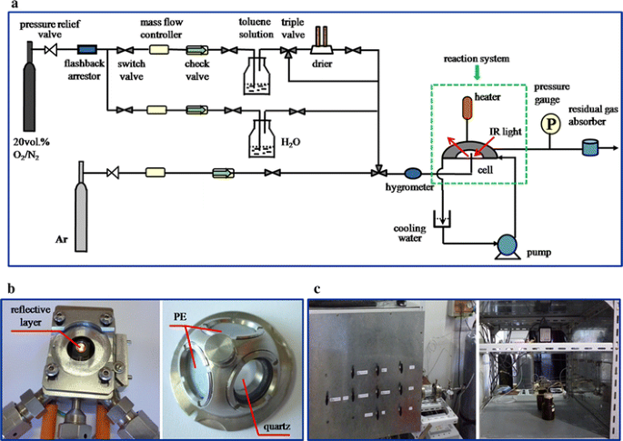
Fig. 1 a Schematic diagram of the experimental set-up, b digital images of reaction cell and c operation interface for reaction gas-doing system
The fresh TiO₂ photocatalyst prepared in advance by a sol–gel method [23] was filled in the sample cup and then pre-treated by purging Ar into the cell for a few minutes in order to remove the adsorbed impurities. The far infrared spectra of PE window were collected for background removal. The spectra were recorded in the range of 600–200 cm⁻¹ by averaging 32 scans with 4 cm⁻¹ resolution at a scanner velocity of 20 kHz. All the spectra were recorded in reflectance mode and then transformed to absorbance mode. For comparison, the far infrared spectra of p-xylene and formaldehyde adsorbed on TiO₂ were also obtained. In addition, the preliminary theoretical simulation on the far infrared spectra of toluene adsorbed on TiO₂ was performed based on the basic spectral theory and CASTEP/DMol3 modules using the Materials Studio.
3 Results and Discussion
3.1 Adsorption
Figure 2 shows the far infrared spectra of toluene adsorbed on TiO₂ in the flow of the reactant mixture (20 vol% O₂/N₂ compressed air and toluene) at room temperature. For the pure TiO₂, a broad band in the range of 350–200 cm⁻¹ was observed, which should be attributed to the characteristic vibration of anatase titanium [26]. After the toluene was introduced, the new bands at 464, 419, 398 and 375 cm⁻¹ appeared. Several small bands at 327, 303, 279, 267, 247 and 214 cm⁻¹ were also observed. The intensity of these bands increased with time and gradually reached a stable level, which indicated that the adsorbed toluene on the TiO₂ surface increased with time until the adsorption equilibrium was reached. As we known, the band position of the intrinsic IR feature is influenced mainly by stretching and bending force of adjacent chemical bonds. In order to assign these bands, a comparison between the far infrared spectra of toluene and that of p-xylene and formaldehyde adsorption on TiO₂ were carried out (Figure S1). The band at 464 cm⁻¹ may be assigned to the rocking vibration of methyl group caused by the symmetric skeletal vibrations of aromatic ring. The bands at 419, 398 and 375 cm⁻¹ may be assigned to the bending mode or twisting vibration of the aromatic ring skeleton. The small bands in the 350–200 cm⁻¹ range may be assigned to the symmetric and asymmetric twisting mode of the bond connecting the hydrogen atom with the aromatic ring skeleton. These assignments are consistent with the results of theoretical calculations (Figure S3).
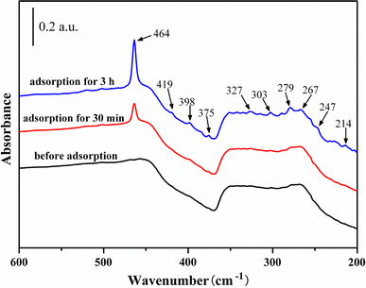
Fig. 2 In-situ far infrared spectra of toluene adsorption on TiO₂
According to the previous investigation of other groups [6, 27], the surface of TiO₂ was abundant in hydroxyl groups as a result of dissociative chemisorption of water molecules to satisfy the coordination of the surface Ti⁴⁺ sites when TiO₂ crystal was exposed to air. The toluene was adsorbed on the hydroxyl groups through the OH···π-electron-type weak interaction on the surface of TiO₂ before the photocatalytic degradation process [8–10]. Theoretically, there are four possible adsorption structures, ipso-adsorption, ortho-adsorption, meta-adsorption and para-adsorption, as shown in Fig. 3. In the case of the ipso-adsorption (Fig. 3a), the vibration of methyl group will be suppressed. However, from the Fig. 2, it is clearly shown that the band at 464 cm⁻¹ corresponding to the rocking vibration of methyl group became stronger with adsorption time. It suggests that the adsorption of toluene on TiO₂ surface is not on the ipso-adsorption site, but maybe the ortho-, or meta-, or para-adsorption site. Furthermore, the aromatic ring is easier to connect with the hydroxyl groups due to its electron-deficiency relative to the methyl group. The results also agree well with the preliminary theoretical simulation on the far infrared spectra of toluene adsorbed on TiO₂ (Figure S4). It should be mentioned that the exact adsorption site among the three possible sites is difficult to be identified in this study due to the poor signal-to-noise ratio caused by the low brightness of the globar light source.
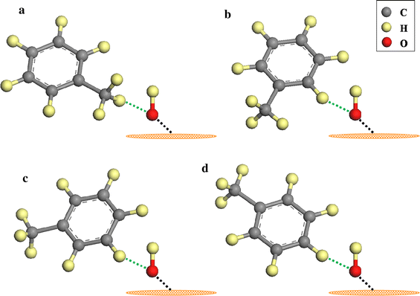
Fig. 3 Schematic diagram of four possible adsorption structure of toluene on hydroxyl groups over TiO₂ via weak hydrogen bonding. a Ipso-adsorption structure, bortho-adsorption structure, cmeta-adsorption structure, dpara-adsorption structure
3.2 Photocatalytic Degradation
After the toluene adsorption, the sample was irradiated with UV light and the far infrared spectra are shown in Fig. 4. It can be seen that the band of methyl group (464 cm⁻¹) decreased and the bands at 419, 398 and 375 cm⁻¹ were shifted slightly to 420, 399 and 376 cm⁻¹. Meanwhile, the irradiation also led to the formation of new small bands at 255 and 227 cm⁻¹. It was obviously found that only the intensity of the band at 464 cm⁻¹ decreased, indicating that the methyl group was first consumed during the toluene photocatalytic degradation process. The bands at 255 and 227 cm⁻¹ may be due to the new formed intermediate species such as benzaldehyde and benzoic acid, which were documented in some literature [9, 20, 28]. In a typical photocatalytic process for gaseous degradation, the photogenerated electrons and holes can migrate across the photocatalyst particle and then recombine on the surface or are trapped by extrinsic traps with the adsorbed electron donors and acceptors respectively and ultimately initiate redox reactions that oxidize the adsorbed organic molecules. It is apparent that toluene can be attacked directly by the holes [29]. In fact, the holes are most likely to react with surface hydroxyl groups first to form the OH• radicals because hydroxyl groups formed by dissociative chemisorption of molecular water to satisfy the co-ordination of the surface Ti⁴⁺ on TiO₂ are the most abundant electron donors [30]. On the other hand, toluene molecules adsorbed on the hydroxyl groups tend to be attacked by OH• radicals because of a relatively short attack path. Therefore, in most cases, the OH• radicals with a thermodynamically possible potential are the primary radicals to attack toluene [10, 31].
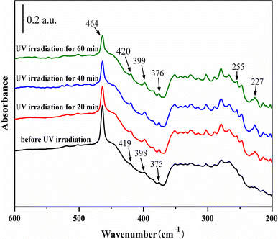
Fig. 4 In-situ far infrared spectra of toluene degradation on TiO₂ with UV irradiation
Based on the above discussions and experimental results, a reaction route for the photocatalytic degradation of toluene on TiO₂ is proposed and shown in Fig. 5. Firstly, the toluene molecule is adsorbed on the surface hydroxyl group via the three possible sites (ortho-, meta-, or para-) and then the aromatic ring is attacked by hydroxyl radicals, leading to the formation of methylphenol isomers (route 1). Subsequently, one hydrogen atom is abstracted from the aromatic ring of toluene by the hydroxyl radical to form water. Meantime, the conjugated aromatic radical cation is formed through the effect of delocalized charge around the aromatic ring [32]. The positive charge in the conjugated aromatic radical cation intermediates transfers to the methyl group. Then the H-abstraction from the methyl group forms the benzyl radical. As a result, the band intensity of methyl group at 464 cm⁻¹ decreased as shown in Fig. 4. Possibly, the OH• radical can also attack the methyl group of toluene to form the benzyl radical (route 2). It is emphasized the conclusion that the presence of hydroxyl groups is essential for the photocatalytic degradation of toluene [13, 15]. It should be pointed out that toluene can be attacked directly by the photogenerated holes and the possible routes are shown in route 3 and 4. Likewise, it can also generate the active benzyl radical.
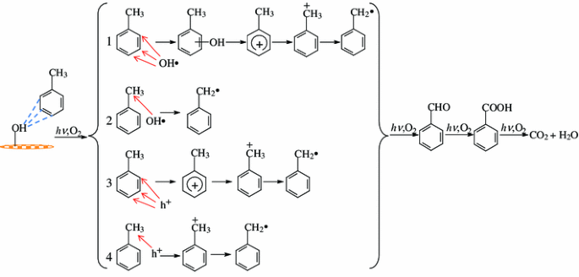
Fig. 5 Proposed reaction route for the photocatalytic degradation of toluene on TiO₂

Worth mentioning that, once the holes are trapped, the photogenerated electrons are free to participate in the adsorption of oxygen to produce a reactive superoxide radical (O₂ ⁻•) and hence prevent the recombination of hole-electron pairs [33, 34]. O₂ ⁻• or adsorbed oxygen reacts with the benzyl radicals and rearranges to give benzaldehyde and benzoic acid, which is consistent with the appearance of the new bands at 255 and 227 cm⁻¹ under UV light irradiation. It should be mentioned that with the formation of benzaldehyde and benzoic acid, the bands at 419, 398 and 375 cm⁻¹ assigned to the bending mode or twisting vibration of the aromatic ring skeleton were shifted slightly to 420, 399 and 376 cm⁻¹, due to the change of the adjacent groups of the aromatic ring. Lastly, the final products, CO₂ and H₂O of the complete photocatalytic oxidation of toluene are given, which has been documented by some groups [35–37]. Here, the improved in situ far infrared spectroscopy method offers a comprehensive understanding of the relationship between the weak-bond adsorption and degradation. The exact adsorption site and full explanation will be conducted with synchrotron radiation or free-electron laser to achieve higher signal-to-noise ratio.
4 Conclusions
In order to elucidate the role of adsorption structure, prior attacked sites and decomposition process of the photocatalytic degradation of gaseous toluene on TiO₂, the photocatalytic degradation of gaseous toluene on TiO₂ with weak-bond adsorption analysis using in situ far infrared spectroscopy was investigated in this study. In conclusion, toluene was adsorbed on the hydroxyl groups through the OH···π-electron-type weak interaction on the surface of TiO₂ with three possible adsorption structures, ortho-, meta- and para-, instead of ipso-adsorption structure. It demonstrated that the methyl group of the toluene is consumed first during the process of toluene photocatalytic degradation due to the conjugation of the aromatic ring and the function of the charge transfer. The result of this study is consistent with the conclusion that the presence of hydroxyl groups is essential for the photocatalytic degradation of toluene. Further study will be conducted using synchrotron radiation or free-electron laser apparatus to investigate the mechanism in detail with better signal-to-noise ratio.
Acknowledgments
This work was supported by National Basic Research Program of China (973 Program, 2012CB922004), National
Nature Science Foundation of China (11205159, 11179034), Anhui
Provincial Natural Science Foundation (1308085MB27) and Fundamental Research Funds for the Central Universities (WK2310000013, WK2310000020). The authors thank Dr. Yuyin Wang and Tao Shao for assistance on the far infrared spectroscopy measurements.
References
1. Mills A, Hunte SL (1997) J Photochem Photobiol A 108:1
2. Maira AJ, Yeung KL, Soria J, Coronado JM, Belver C, Lee CY,
Augugliaro V (2001) Appl Catal B 29:327
3. Herna´ndez-Alonso MD, Tejedor-Tejedor I, Coronado JM,
Anderson MA (2011) Appl Catal B 101:283
4. Chen HH, Nanayakkara CE, Grassian VH (2012) Chem Rev
112:5919
5. Yang MQ, Zhang YH, Zhang N, Tang ZR, Xu YJ (2013) Sci Rep
3:3314
6. Lewandowski M, Ollis DF (2003) Appl Catal B 45:223
7. Turchi CS, Ollis DF (1990) J Catal 122:178
8. Nagao M, Suda Y (1989) Langmuir 5:42
9. Augugliaro V, Coluccia S, Loddo V, Marchese L, Martra G,
Palmisano L, Schiavello M (1999) Appl Catal B 20:15
10. Lin HX, Long JL, Gu Q, Zhang WX, Ruan RS, Li ZH, Wang XX
(2012) Phys Chem Chem Phys 14:9468
11. Augugliaro V, Palmisano L, Scalfani A, Minero C, Pelizzetti E
(1988) Toxicol Environ Chem 16:89
12. Okamoto K, Yamamoto Y, Tanaka H, Tanaka M, Itaya A (1985)
Bull Chem Soc Jpn 58:2015
13. Luo Y, Tai WS, Seo HO, Kim KD, Kim MJ, Dey NK, Kim YD
(2010) Catal Lett 138:76
14. Ibusuki T, Takeuchi K (1986) Atmos Environ 20:1711
15. Obee TN, Brown RT (1995) Environ Sci Technol 29:1223
16. Maira AJ, Coronado JM, Augugliaro V, Yeung KL, Conesa JC,
Soria J (2001) J Catal 202:413
17. Fresno F, Herna´ndez-Alonso MD, Tudela D, Coronado JM, Soria
J (2008) Appl Catal B 84:598
18. Zhao J, Yang XD (2003) Build Environ 38:645
19. Cao LX, Gao Z, Suib SL (2000) J Catal 196:253
20. Me´ndez-Roma´n R, Cardona-Martı ´nez N (1998) Catal Today
40:353
21. Ryczkowski J (2001) Catal Today 68:263
22. Sun S, Ding JJ, Bao J, Gao C, Qi ZM, Li CX (2010) Catal Lett
137:239
23. Sun S, Ding JJ, Bao J, Gao C, Qi ZM, Yang XY, He B, Li CX
(2012) Appl Surf Sci 258:5031
24. Solimannejad M, Scheiner S (2006) Chem Phys Lett 424:1
25. Shipman ST, Douglass PC, Yoo HS, Hinkle CE, Mierzejewski
EL, Pate BH (2007) Phys Chem Chem Phys 9:4572
26. Busca G, Ramis G, Amores JMG, Escribano VS, Piaggio P
(1994) J Chem Soc Faraday Trans 90:3181
27. Davit P, Martra G, Coluccia S (2004) J Jpn Petrol Inst 47:359
28. Blount MC, Falconer JL (2001) J Catal 200:21
29. d’Hennezel O, Pichat P, Ollis DF (1998) J Photochem Photobiol
A 118:197
30. Henderson MA (2011) Surf Sci Rep 66:185
31. Suh I, Zhang RY, Molina LT, Molina MJ (2003) J Am Chem Soc
125:12655
32. Einaga H, Futamura S, Ibusuki T (2002) Appl Catal B: Environ
38:215
33. Lee SL, Scott J, Chiang K, Amal R (2009) J Nanopart Res 11:209
34. Quici N, Vera ML, Choi H, Puma GL, Dionysiou DD, Litter MI,
Destaillats H (2010) Appl Catal B: Environ 95:312
35. Luo Y, Ollis DF (1996) J Catal 163:1
36. Yu KP, Lee GWM (2007) Appl Catal B 75:29
37. Feng YC, Li L, Ge M, Guo CS, Wang JF, Liu L (2010) ACS Appl
Mater Interfaces 2:3134

