2023-36-0068

Path planning development for human-like virtual driver
Henrique de Carvalho Pinheiro, Salvatore Lubertino and Massimiliana Carello

Abstract
Virtual simulation is a fundamental tool for the development of new vehicles, both for individual components and for complete subsystems and full vehicles. Many software tools exist in the automotive sector to assess full-vehicle behavior and performance, including multibody software and algorithms based on 14 (or more) degrees-of-freedom vehicle dynamics models. In order to reproduce the testing maneuvers and typical vehicle mission, a key part of such simulation tools is the virtual driver algorithm. It is essential to implement a control logic that reproduces the handling response of the driver, so that the closed-loop maneuvers can be evaluated. However, the response of typical virtual drivers is not always similar to the human driving characteristics. Virtual driver algorithms can perform very fast, precise, and smooth steering and pedal actions, while humans display a more variable, delayed and often not optimal actions.
The aim of this article is to describe the concept and implementation of a novel human-like path planning model. The algorithm is developed in MATLAB environment, creating a function that obtains a human-like path and vision logic by setting some key-parameters. They are: Distance Factor, Widening Factor, Cutting Factor, Inner Smoothing Factor and Outer Smoothing Factor.
The parameters - essential to alter the shape of the trajectory described in a track - have their values attributed by fitting experimental data gathered during test sessions in a driving simulator. The vehicle model used to implement the path planning system is based on the VI-Grade CarRealTime environment, in co-simulation with MATLAB/Simulink, and the results indicate that the novel algorithm has a closer correlation with the DiL tests than the original virtual driver. The stronger correlation is confirmed also in the comparison between different human drivers, showing that the proposed strategy is robust to driving styles.
Among the potential applications of this new “human-like virtual driver” approach is the ability to better predict human driver response during tuning and optimization of vehicles and control systems, apart from a further understanding of human driving behavior useful for tasks like ADAS and autonomous driving.
Introduction
The strong impact of the virtual simulations has greatly lowered the costs related to the development of prototypes and a growth in the quality of products. Clearly, to achieve all these benefits, these simulations need to be as reliable as possible on the individual vehicle subsystems – structural [1,2], multibody [3,4], tire [5], powertrain [4,6], braking [7], control systems [8,9], etc. - and contemporarily capable of describing in an efficient way the driver behavior. So, the design of this product can be performed on a system able to simulate how a human being acts on it, and so the simulations are more realistic, and the quality of the final product can be improved [10,11].
Having as its goal the creation of a model capable of achieving results true and real as much as possible, this article was developed trying to create a Driver Model that represents human behavior [12]. Human behavior is one of the most complicated and fascinating aspects in design. The proposed method can be a way to extrapolate some factors that may describe human driving. The implementation of an algorithm that works as a human.
This work is carried out in collaboration with VI-Grade, and the reference driver model is precisely the one implemented in VI-CarRealTime. Human-like driving refers to a type of driving that can describe how a human would drive considering that driving variability depends on many factors, such as driver experience, emotional state, fatigue, age, gender etc., factors that can also influence the driving of the same driver.
Taking experimental data, collected in the preparatory phase using a Driver-in-the-loop (DiL) Desktop Simulator, as a reference for the model implementation, some analyses are performed in order to achieve the best configuration for each driver [13,14]. So, at the end is possible to extrapolate a set of parameters able to describe the path of the different driver. And so, to arrive closely at humanized behavior.
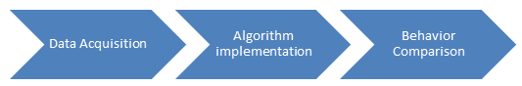
Figure 1. Logical Workflow
The aim of this paper is to describe how to implement a human-like model and, how construct a logic capable of more realistically describing how, a human, plans a trajectory acquiring information from the external world. This has been implemented in MATLAB, creating a function that obtains a human-like path and vision logic by entering various parameters. These parameters are five:
- Distance Factor
- Widening Factor
- Cutting Factor
- Inner Smoothing Factor
- Outer Smoothing Factor
All these parameters influence the shape of path, that comes out from the implemented algorithm, and can describe the driving style of the driver. In their software, VI-CarRealTime, the driver model (VI-Driver) is a Cognitive Architecture that gives a starting point to the implementation of the algorithm. Comparing the results of the VI-Driver with the experimental ones, and the results coming from the algorithm is possible to make some comments on the results. And it’s really interesting the fact that the parametrization described previously gives the possibility to achieve results nearer to a human driver.
Background
A human-like model is understood as a virtual model capable of describing and reproducing, as accurately as possible, human driving behavior in different driving conditions. Clearly, human behavior cannot be reproduced through an algorithm or model precisely because the behavior of the same individual can vary even having the same conditions. Some useful questions that focus the attention on “What characterizes the human driving style?” are:
- How does the driver approach the curves?
- Are the mistakes and errors in driving due to prediction or to distraction?
- How does he/she compensate these errors?
- Are there physiological limits, like reaction time or the tiredness of the driver?
- What is the experience in driving and in track knowledge?
- What’s the driver’s mental state?
- How does the driver acquire information?
- What’s the mental process done to plan the maneuver and perform it?
The previous questions are not immediately answered, and many of them are characterized by factors that cannot be measured. So, the approach used in this article is based on parameterizing factors that can be measured and extracted from a path. During the driving phase, the driver is subject to multiple interactions, from which he/she perceives information and through a process of elaboration leads to the planning of a strategy and ultimately the implementation of that strategy. Clearly, human limits must be respected, such as reaction time, then the implementation of the input command itself. Which varies with age, mental state, fatigue, etc.
The current studies cannot supply an architecture for learning-based methods that can reflect driver’s characteristics comprehensively and have solid foundations. So, a lot of different strategies are performed. Some studies that work on the Human-like driving methods based on various learning algorithms while the architectures are not related to human cognition characteristics closely. Like the studies done on how human drivers assess environments and drive in signalized intersections [15]. Or the one referred to the designed Human-Like driving methods with semantic maps and attention networks [16]. Other strategies adopted to achieve the human-like behavior clearly are performed but due to their limited scenarios of validity are not considered.
VI-Driver
According to the VI-Grade definition, a Human Driver can be schematized like a cognitive model [17]. This cognitive architecture is developed in order to establish a continuous exchange of information between Driver, Environment and Vehicle (Figure 2).
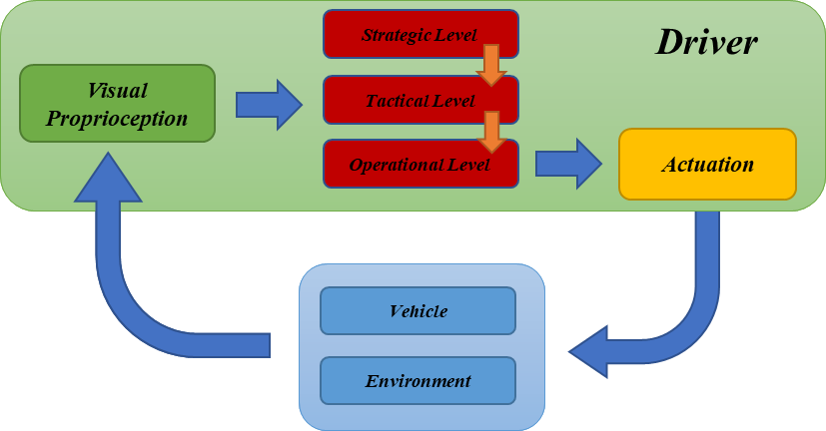
Figure 2. VI-Grade Cognitive Architecture of the Driver
The green box, that represents the Driver’s decisional process, is divided into three different layers: Perception Layer; Logical Layer; and Actuation Layer.
The first one, the Perception Layer, handles the information that comes from the external world (Environment and Vehicle itself). The human perception flow, according the VI-Grade Documentation [17], is shown in Figure 3.
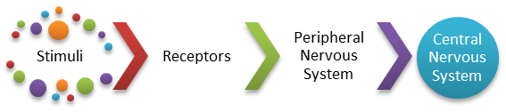
Figure 3. Human perception
Stimuli are the input signals, Receptors are the ones that convert the stimulus into an electric signal, Peripheral Nervous System conveys the electric signals to the Central Nervous System and Central Nervous System is the “Brain”.
This first layer, as shown in Figure 2 is composed of two different subsystems: the Vision subsystem and the Proprioception subsystem. Vision collects all the special information from the environment, like obstacles, limits of the road, speed limits, estimation of the vehicle velocity, sideslip of the vehicle etc. The Proprioception subsystem collects all the information that comes from the receptors along the body, like noise, vibration. The ones that derive from vehicle dynamics. The acquisition of these stimulus leads to processing it, then deciding a strategy and finally to an actuation that modifies the state of the vehicle in the environment.
The Logical layer, that describes in a schematic way the flow that the brain made to elaborate the information and manage the actuation, can be subdivided in levels.
- The Strategic level, that is one in charge to take the High-Level Decision.
- The Tactical level that defines the maneuver.
- The Operational level, the last one, that defines how are the commands to performs the wanted maneuver.
The last layer is the Actuation ones and manages the interface between the logical layer and the action in the real world. Reaction time, age, gender impact strongly on this part of the driving flow.
VI-CarRealTime, doesn’t implement the Tactical and the Strategic levels. Also, from the acquisition source point of view the information acquired comes only from the vehicle, the environment is partially not considered.
To develop a Human-Like Driver some steps must be followed, this chapter clarifies some aspects of these steps. The Human-Like Driver is an entity that can be divided into different stage:
- Path Planning;
- Motion Planning;
- Actuation Design;
Each of these stages treated different aspects, in fact, the Path Planning stage is based on the study of the vehicle’s trajectory, so is mainly focused on the driver’s path. The Motion Planning manages how the Driver must handle the velocity and the acceleration of the vehicle. Factors like emotional state, physical state, age of the driver influence the driving style of the driver and so also the dynamics of the vehicle are different. Another important stage that characterizes the driving style of the vehicle is the how the actuation on commands of the driver. Actuation Design is related to the human body limits, in fact, is strictly correlated to the age, that influences the reaction time. Building a human driver model these last two stages can be combined because they both affect vehicle dynamics, but on a logical level it is fair to distinguish them.
Driver Information and Data Acquisition
To develop a Human Driver Virtual model, is necessary to describe the humans that are used as reference. Ideally having a lot of drivers can improve the robustness of the model. Table 1, are reported the summarized data of the driver.
Table 1 Drivers’ data and results overall comparison.
Driver | 1 | 2
Age [y/o] | 24 | 30
Experience [-] | NOVICE | NOVICE
Num. Laps [-] | 5 | 5
Mean Velocity[km/h] | 93.1 | 92.9
Mean Path Distance [m] | 0.37 | 0.43

From the table can be detected that the two drivers have some similar characteristics. They perform the same number of laps on the track (5 laps) and another common characteristic is the mean velocity, that for the Driver 1 is slightly higher than the other. The last parameter is the Mean Path Distance, that represents a sort of variability associated with each driver. The following figure, Figure 4, represent the Path Distance of the Driver 2. So is possible to appreciate how can be different the path performed by the Driver 2.
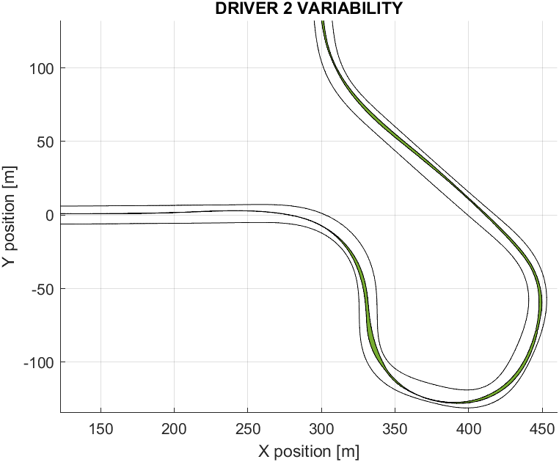
Figure 4 Sample of Driver Variability
Data Acquisition and description of the Simulator
To compare the VI-Driver and the Virtual Human Driver implemented some reference data must be collected. To do that, thanks to VI-Grade and their DIL Desktop Simulator it was possible to acquire all the data. The data come from the acquisition system, are stored with a frequency rate of 1000 Hz. The data is exported to a file .csv that holds all the 62 channels (including all relevant vehicle and driver parameters). Figure 5 shows the acquisition system.
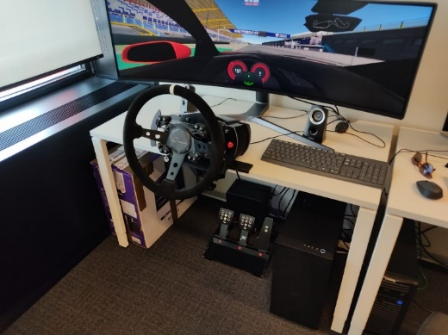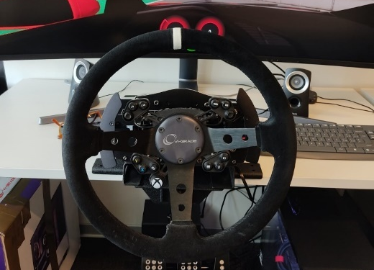
Figure 5 Desktop Simulator – Complete setup (top) and detail on the steering system (bottom)
From the graphical point of view of the driver knows the velocity of the vehicle, no optimal trajectory is shown, and the total lap time is reported on the top of the display.
Path Planning
To create a model capable of driving like a human the first step, as described previously, is the implementation of a Path Planning algorithm capable of determining a trajectory in the track. The output path is computed interpolating four points, where the first two determine the initial position and direction instead the other ones describe the final position and direction of the vehicle. The final position and direction define the goal of the driver so describe the position to which the driver tries to move the vehicle. The wanted goal clearly depends on the drivers’ logic. In the developed algorithm, there are two main logics:
- First Curve Vision Logic;
- Maximum Vision Logic;
Track selection and analysis of the racetrack
The track is characterized by different shapes of the curves, which leads to fully analyze the behavior of the driver and the algorithm developed. This track was chosen as a model, because, having a very variable shape, all the characteristics, that can characterize the driver, can been extrapolated. In fact, there are wide and strict turns. All these characteristics can be seen in the Figure 6
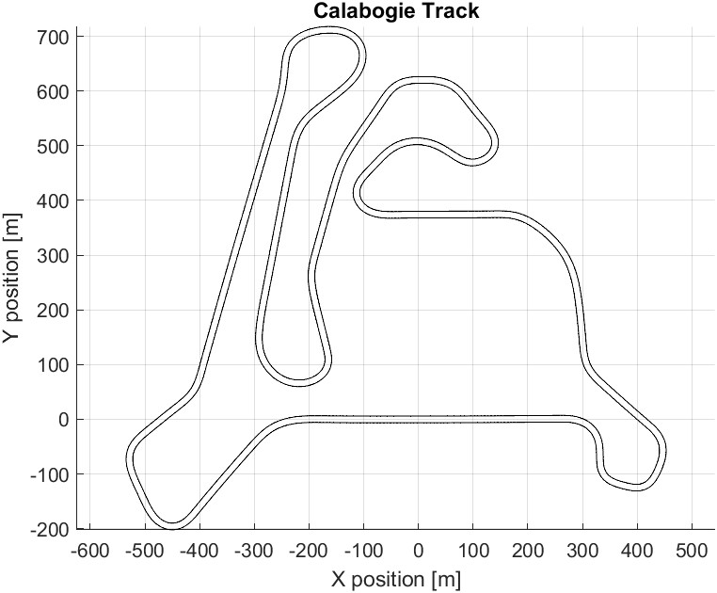
Figure 6. Calabogie Track in MATLAB
The algorithm is based on a 2D environment, and in order to obtain results that can ensure a high level of validity the racetrack selected has a low elevation difference and a low bank angle. A high difference in elevation impact the field of view of the driver, just thinking about the vision of the driver when he/she runs on a hill. So, at the end, to reduce the effort in calculation, this effect is not considered.
This algorithm compute the track limits, just importing the centerline and the mean width of the track. Going deeply into this aspect, it’s possible to define the Road Limit as the position defined by a set of coordinates [X, Y], taking into account that X and Y are vectors. Like the definition of Road Limit, the Centerline is also defined as a matrix of two dimensions [Centerline, Centerline] describing the x and y coordinates respectively in the track reference system. The track width instead is defined as a column vector that determines the boundary distance.
The factor that describes angle between two consecutive points on the centerline is indicated with the symbol θ. This parameter indicates the 'complementary' angle that will determine the position of the two Road Limits, and thanks to this is possible to able to describe the limits by imposing a perpendicular behavior between the two consecutive points and the coordinates of the point that will define the limits. The i^{th} value of theta is computed as:
The coordinates of each road limits come out applying:
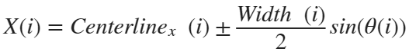
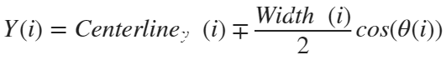
Cone of vision
In particular considering the human’s vision field reported described by Steve Metzer, the human vision can be described like a cone [18]. In which the field of view is schematize in Figure 7. Clearly the field of vision for a human is not fixed, have a sort of variability.
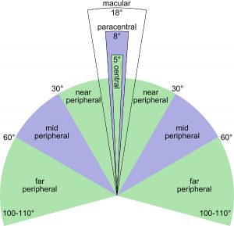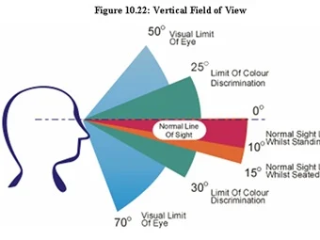

Figure 7 Human Vision Field - top view (left) and lateral view (right)
Working in a 2D environment, the field of view can be characterized using only 2 parameters, the Angle of Vision that describes how wide is the FoV, and the Max Distance, that describes how big is the driver field of view. The dimensions shown in Table 2 result from the trade-off between different sources.
Table 2 Cone of Vision dimensions
Cone of Vision
Cone of Vision
Cone of Vision
Angle of Vision | 120 | [deg]
Max Distance | 100 | [m]

According to [17], the angle of vision of a human is around the 150 degrees. While according to the study performed by Candida Castro in her work, she states that the human field of vision during driving is reduced from 150 degrees to 90 degrees [19]. The reduction is strongly influenced by the velocity of the vehicle. And another important aspect is related to the study on the Visual Requirement for Vehicular Guidance, in which is reported also the Performance of the Driver for different visual range. The trend is reported in the follow graph [20].
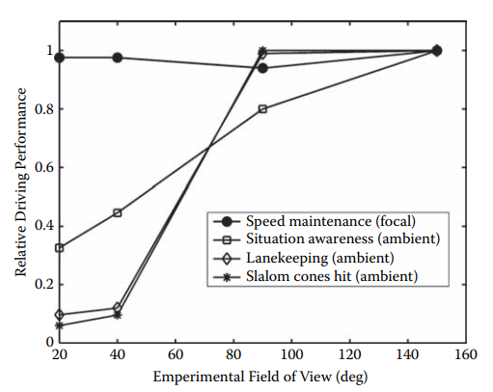
Figure 8 Relative Performance of the driver against the Field of View
Driver Vision Logics implementation
To obtain as output a path like a human one, the steps that must be followed to implement an algorithm are the following:
- Generation or importing the track, in the implemented algorithm, the known data are only the centerline coordinates and the width of the track, so the limits of the track must be computed.
- Creating the Cone of Vision, that schematizes the field of view of the driver.
- Implementation of the different Vision Logics.
- Implementation of a function able to obtain the path using the vision logic output (Goal position and direction).
The dimension of the field of view of the driver are reported Table 2. The next step is the selection of the Driver Vision Logic that defines how the driver plan the trajectory. The logics are two: First Curve Vision Logic and Max Distance Vision Logic.
To facilitate the implementation of the Vision Logic functionality, some limitations must be considered:
- 2-D Environment, so the field of view of the driver can be schematized like a triangle.
- The driver's point of view is always on the centerline of the track.
- The direction of the vision cone is defined by the centerline.
- The size of the vision cone is fixed, it does not vary with speed.
The Maximum Vision Logic has the aim to acquire all the information in the field of view of the driver. The Goal point of the driver is the farthest point in his cone of vision (if the driver is on a straight line, the driver will not look at the end of the straight but at the furthest point in his field of vision).
The First Curve Vision Logic is based on the fact that a driver, while looking at the track, can decide as his next move to 'point' his gaze to the next curve, not considering what lies beyond. Clearly this logic must consider that the driver 'sees' the curve only if it is within the cone of vision.
Both have characteristics in common, in fact, both exploit a logic that leads the driver to spread out before entering a curve, then tighten inwards, and finally to spread out to exit the curve more quickly. Having in mind that Different drivers have different driving style and so, to parametrize the vision logic and generalize the algorithm these factors are introduced:
- Distance Factor, α;
- In-Out Factor or Widening factor, β1;
- Cutting Factor, β2;
- Inner Smoothing Factor, s1;
- Outer Smoothing Factor, s2;
It’s possible also incorporate these factors in three different groups:
- Distance Factor, α, where also the “α” parameter is considered.
- Shape Factor, β = [β1 ; β2], where the In-Out/Widening Factor and the Cutting Factor are merged;
- Smoothing Factor, s = [s1 ; s2], where The Inner and the Outer Smoothing Factors are merged;
Distance Factor “α”
The following formula describes how works the algorithm varying the Distance Factor.
Point of View = α Vision_{Max} + (1 – α) Vision_{Min}
It is possible to use parameterize the final distance and thus to work in both First Curve Vision Logic (α = 0) and Maximum Distance Vision Logic (α = 1).
Shape Factor “β”
This factor is set by two parameters and describes the shape of the curve that the driver intends to perform. The first one is the In-Out or Widening parameter, that describe “how enter in the curve” and “how exit to the curve”. The parameter is settled in this way:
Shape of the Curve = β₁ RoadLimit _{int} + (1 - β₁) RoadLimit _{ext}
The Cutting parameter refers to the middle part of a curve, and in particular “how the curve must be tight”. As the In-Out parameter, the following formula describe the shape of the curve performed.
Shape of the Curve = β₂ RoadLimit _{int} + (1 – β₂) RoadLimit _{ext}
Smoothing Factor “s”
As the name suggests, this factor is the one referred to the smoothing of the curve, so the shape of the planned curve is affected. A higher smoothing factor determinates a more gradual manoeuvre. This parameter is composed by set of two factors, the Inner Smoothing factor (s₁) and the Outer Smoothing Factor (s₂). The first one characterizes the first part of the curves while the second characterizes the path in the final part of the curve.
Output of the Vision Logic Algorithm and Path extrapolation
As output, a matrix, in which there is all the information related to the position where the driver seen. A graphical representation of the driver’s vision on the track is showed in Figure 9 and in Figure 10. The first one plots the First Curve Vision Logic instead, the second one shown the output path of the Maximum Vision Logic.
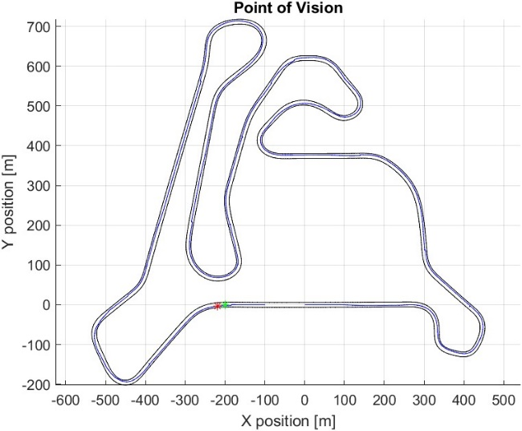
Figure 9 First Curve Vision Logic
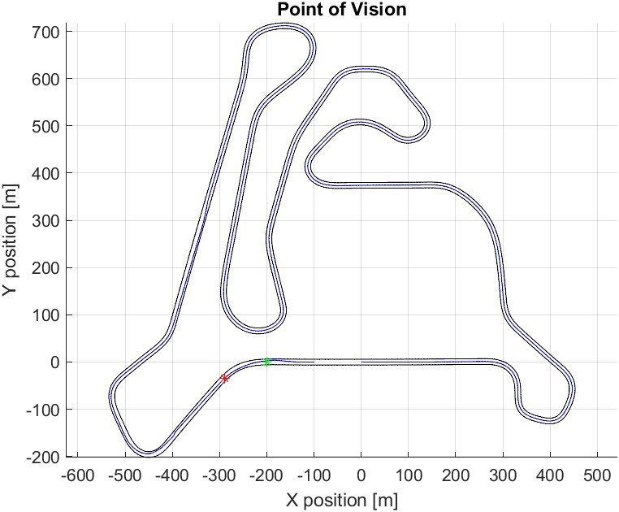
Figure 10 Maximum Vision Logic
In both, are present a green star and a red star. The green one represents the position of the driver, while the red one represents the goal position. These stars give an idea of how much is important the vision logic used. In fact, the difference between the two red stars is high. In the first case, the red star is at the beginning of the turn, instead in the red ones is after the turn.
Path extrapolation
To extrapolate the path initially the utilization of a path planning algorithm called “HybridAStar” was tried [21], but due to computational effort, the usage of this algorithm is not performed.
According to the ACT-R model, the one that use Salvucci [22] in his work, a cognitive driver model in which the path planning is simply obtained through a spline, between a “near point” and a “far point” of the track. The path is evaluated in this way due to the lower computational effort. Interpolation occurs through four points where the first two points define the direction and the position of the vehicle while the others the direction and the position of the Goal, and so how perform the maneuver.
Another important aspect is the selection of an appropriate update frequency, that determines how often the driver will have to program the next maneuver. According to the work performed by Reiner [23], an update frequency of 1 Hz is settled. An example of the output is reported in Figure 11 and in Figure 12
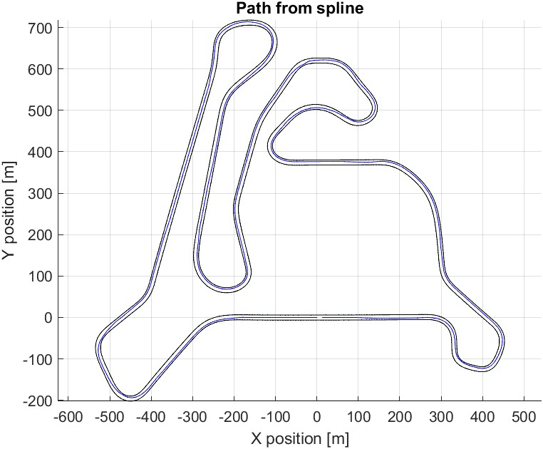
Figure 11 Path Extrapolation
To clarify how the sensitivity analysis is performed, must be introduced the variable “Path_s” capable to of describing uniquely each point of the path.
The idea is to compare two different paths and associate a value that describes the variability of them. The “Path_s” is a vector and each value inside this vector is the punctual distance. Assuming two trajectories that are divided with a resolution of 10 cm, the absolute distance between the two i-th points represents the i-th value of the vector “Path_s”. Then, by associating a distance with each point on the track, it is possible to extrapolate an average value that describes the distance between two trajectories on average. Clearly, a smaller average distance value describes greater similarity between trajectories. For example, looking the Table 1 is present the value that describe the mean path distance associated at each driver comparing the five laps.
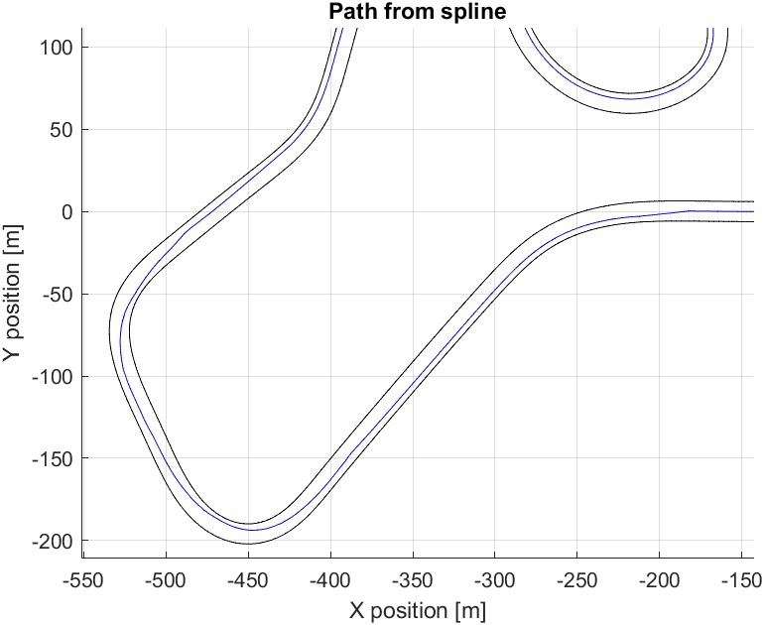
Figure 12 Zoom of the Pah Extrapolation
Sensitivity analysis of the five factors
Sensitivity analysis on the Distance Factor
Designated by the symbol α, the Distance Factor, represents a parametrizable value that influences the human’s vision. By setting a value between the range [0,1], not only the visions relating to the logics already described as First Curve Vision Logic and Maximum Vision Logic comes out, but also all those in between. Table 3 contains the parameters used in this analysis:
Input parameters for distance factor sensitivity analysis
 | Case 1 | Case 2 | Case 3 | Case 4 | Case 5
α | 0 | 0,25 | 0,5 | 0,75 | 1
β1 | 0,2 | 0,2 | 0,2 | 0,2 | 0,2
β2 | 0,7 | 0,7 | 0,7 | 0,7 | 0,7
S1 | 40 | 40 | 40 | 40 | 40
S2 | 40 | 40 | 40 | 40 | 40
Table 3 Input parameters Distance Factor sensitivity analysis
In the Table 3 are descripted the parameters taken as input to perform the analysis. Clearly to evidence the effect of the Distance Factor, the other 4 parameters are fixed. The next images reported the paths obtained using these inputs.
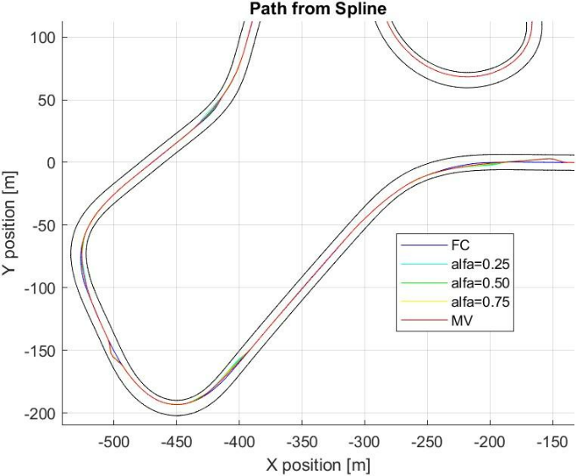
Figure 13 First Zoom Distance Factor - Sensitivity Analysis
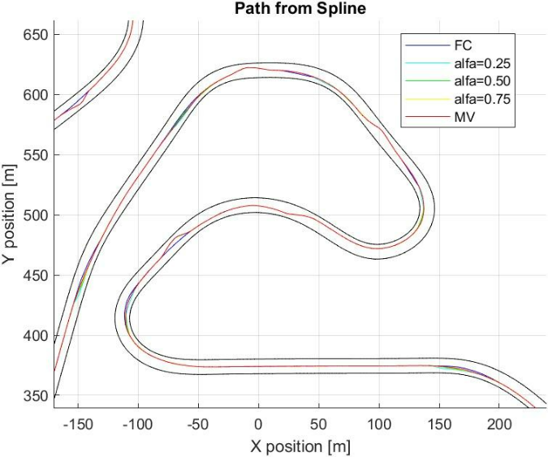
Figure 14 Second Zoom Distance Factor - Sensitivity Analysis
At this point, the following graphs show the “Path_s” along the track comparing Drivers and the Sensitivity Analysis done.
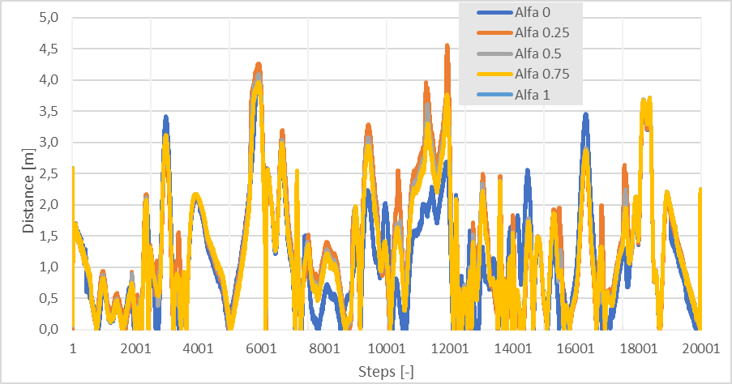
Figure 15 Path Difference Driver 1 and Alfa Sensitivity Analysis
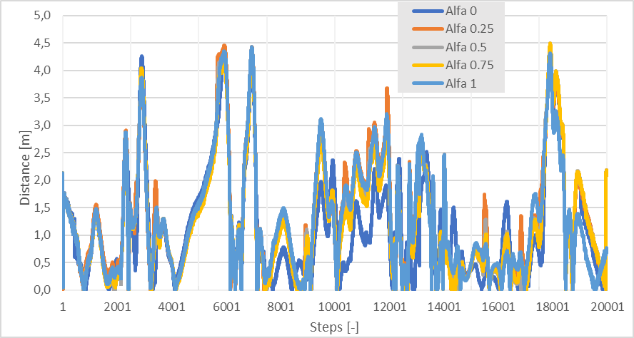
Figure 16 Path Difference Driver 2 vs Alfa Sensitivity Analysis
In these graphs is reported the value of “Path_s” punctually along the track and is interesting also comparing the two curves. Both describe a similar trend, focusing on the peaks present, like the step 3000, the step 6000 or the step 18000, can be noticed that the two drivers describe peaks in the same parts of the track. The following table reports the mean value of the vector “Path_s” and the graph shows the trend of the mean Path_s value against α. The Figure 17 gives an idea of the impact of α on the output path.
Table 4 Mean Path_s Distance Factor - Sensitivity Analysis
Mean difference in path
α | Driver 1 |  | Driver 2
0.00 | 1.13 | [m] | 1.12 | [m]
0.25 | 1.33 | [m] | 1.34 | [m]
0.50 | 1.27 | [m] | 1.26 | [m]
0.75 | 1.24 | [m] | 1.22 | [m]
1.00 | 1.25 | [m] | 1.28 | [m]

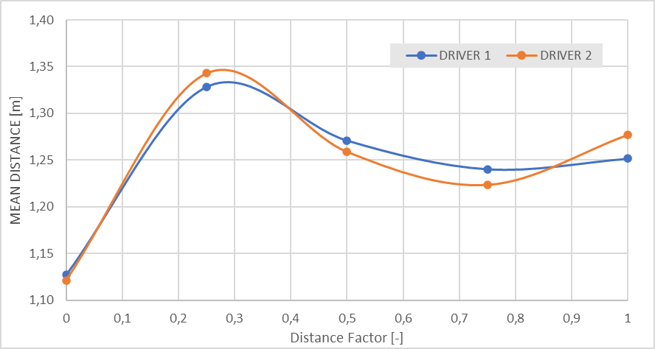
Figure 17 Distance Factor vs Mean Path_s
Referring to the Figure 17, the two drivers show a similar trend varying the Distance factor. Also, from the value point of view the mean Path_s is similar.
Sensitivity analysis on the Widening Factor
For what concerns the Widening Factor, the range of variability of this factor is (0,1). In this case the round parentheses are necessarily imposed since the β₁ assumes as value 0 or 1, the driver moves along the road limits. The inputs data are reported in Table 5.
Table 5 Inputs parameters for Widening Factor Sensitivity Analysis
Input parameters for distance factor sensitivity analysis
 | Case 1 | Case 2 | Case 3 | Case 4 | Case 5
Distance Factor | 0 | 0,25 | 0,5 | 0,75 | 1
Widening Factor | 0,2 | 0,2 | 0,2 | 0,2 | 0,2
Cutting Factor | 0,7 | 0,7 | 0,7 | 0,7 | 0,7
Inner Smoothing Factor | 40 | 40 | 40 | 40 | 40
Outer Smoothing Factor | 40 | 40 | 40 | 40 | 40

As output, the path, and in particular the shape of the curve changes a lot according to this factor, just looking the Figure 18 and Figure 19.
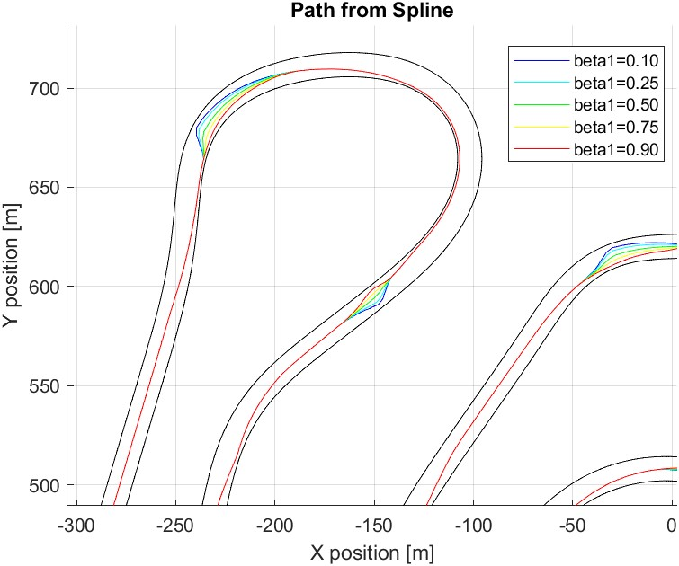
Figure 18 First Zoom Widening Factor – Sensitivity Analysis
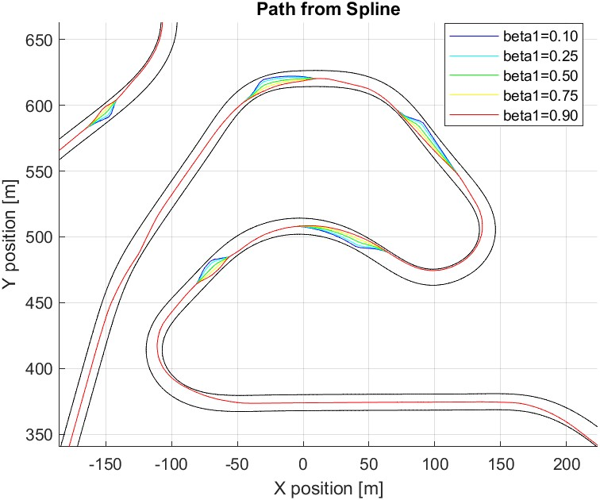
Figure 19 Second Zoom Widening Factor – Sensitivity Analysis
Comparing the Path_s along the track of the Drivers vs the different outputs, the results are the following:
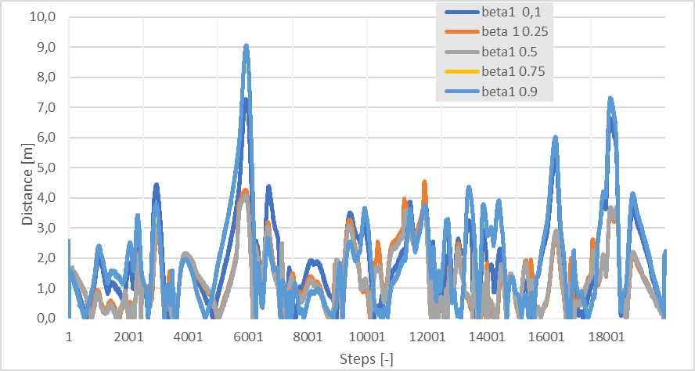
Figure 20 Path Differences - Driver 1 vs Algorithm - Widening Factor
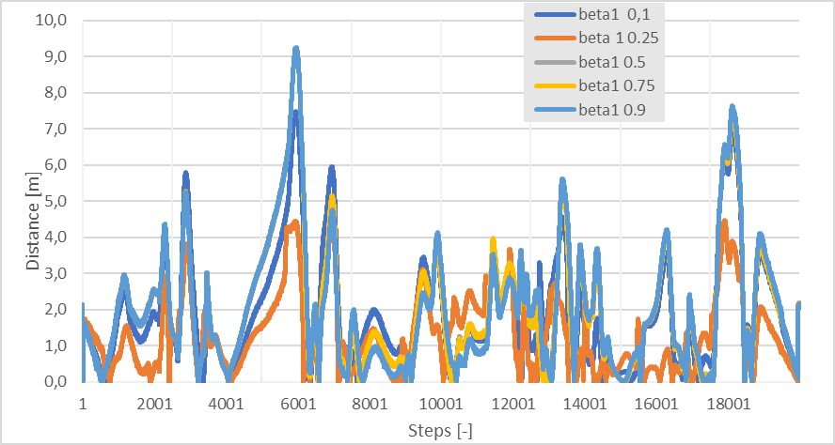
Figure 21 Path Differences - Driver 2 vs Algorithm - Widening Factor
Comparing the peaks, also here, there are some similarities between the two drivers. The following table reports the mean standard deviation, and the graph in Figure 22 shows the comparison of the driver in terms of Mean Path_s. An interesting trend can be pointed out, because the two drivers varying the Widening Factor have the same Mean Path_s trend.
Table 6 Mean Path_s Widening Factor - Sensitivity Analysis
Mean standard deviation
β1 | Driver 1 |  | Driver 2
0.10 | 1.82 | [m] | 1.89 | [m]
0.25 | 1.90 | [m] | 2.03 | [m]
0.50 | 1.92 | [m] | 2.06 | [m]
0.75 | 1.91 | [m] | 2.05 | [m]
0.90 | 1.86 | [m] | 1.96 | [m]

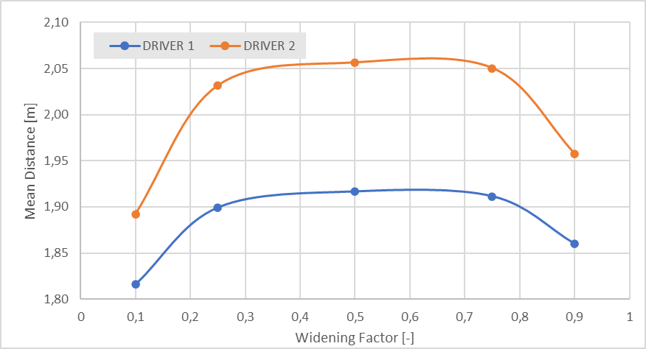
Figure 22 Widening Factor vs Mean Path_s
Another important aspect that can been pointed out is the difference between the two curves. The Driver 1 shows a lover mean Path_s distance respect the other driver.
Sensitivity Analysis – Cutting Factor
The Cutting Factor describes how much the driver wants to cut the curve, this means that impact on the maneuver on the vision and on the path. The analysis is performed with the following set of parameters, as in Table 7.
Table 7 Inputs parameters for Cutting Factor Sensitivity Analysis
Input parameters for cutting factor sensitivity analysis
 | Case 1 | Case 2 | Case 3 | Case 4 | Case 5
Distance Factor | 0 | 0 | 0 | 0 | 0
Widening Factor | 0,2 | 0,2 | 0,2 | 0,2 | 0,2
Cutting Factor | 0,1 | 0,25 | 0,50 | 0,75 | 1
Inner Smoothing Factor | 40 | 40 | 40 | 40 | 40
Outer Smoothing Factor | 40 | 40 | 40 | 40 | 40

As output paths, the Cutting Factor sweep generates the following trajectories. This factor influences a lot the shape of the curve, just by looking at how the trajectories are different. In Figure 23 and in Figure 24 the output paths are very different in curve but considering the straight part of the track, the 5 paths describe the same part.
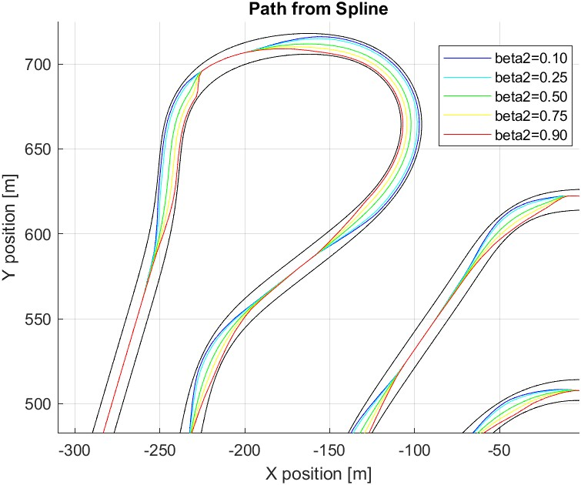
Figure 23 First Zoom Cutting Factor – Sensitivity Analysis
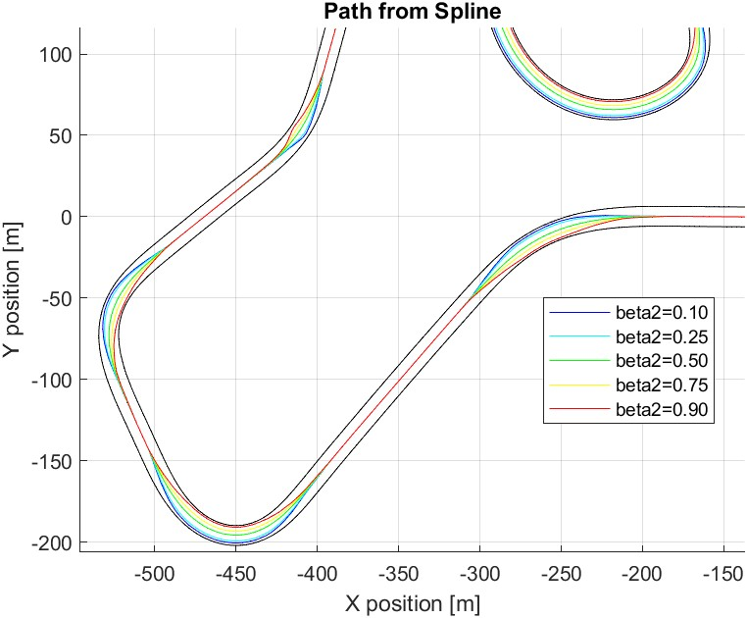
Figure 24 Second Zoom Cutting Factor – Sensitivity Analysis
For what concerns the trend of the Mean Path distance varying the Cutting Factor, both drivers show a similar behavior, with a global minimum around β₂ = 0.3.
Table 8 Mean Path_s Cutting Factor - Sensitivity Analysis
Mean distance between paths
β2 | Driver 1 |  | Driver 2
0.10 | 3.10 | [m] | 2.78 | [m]
0.25 | 1.09 | [m] | 0.79 | [m]
0.50 | 1.10 | [m] | 1.07 | [m]
0.75 | 1.85 | [m] | 1.94 | [m]
0.90 | 2.51 | [m] | 2.19 | [m]
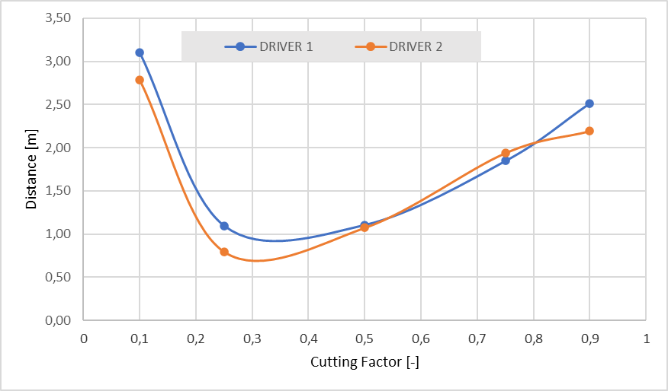Figure 25 Cutting Factor vs Mean Path_s
Sensitivity Analysis - Inner Smoothing Factor
As before, the inputs to perform the sensitivity analysis regarding the Inner Smoothing Factor are reported in the next table.
Table 9 Inner Smoothing Inputs – Sensitivity analysis
Input parameters for inner smoothing factor sensitivity analysis
 | Case 1 | Case 2 | Case 3 | Case 4 | Case 5
Distance Factor | 0 | 0 | 0 | 0 | 0
Widening Factor | 0,2 | 0,2 | 0,2 | 0,2 | 0,2
Cutting Factor | 0,8 | 0,8 | 0,8 | 0,8 | 0,8
Inner Smoothing Factor | 10 | 20 | 40 | 60 | 80
Outer Smoothing Factor | 40 | 40 | 40 | 40 | 40

The output paths are show in the next figures, Figure 26 and Figure 27, where is appreciable the effect of the Inner Smoothing Factor on the trajectories.
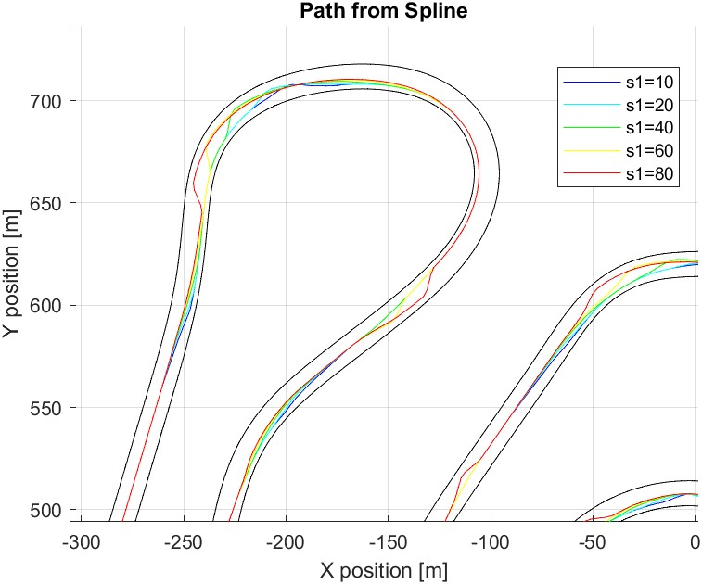
Figure 26 First Zoom Inner Smoothing Factor – Sensitivity Analysis
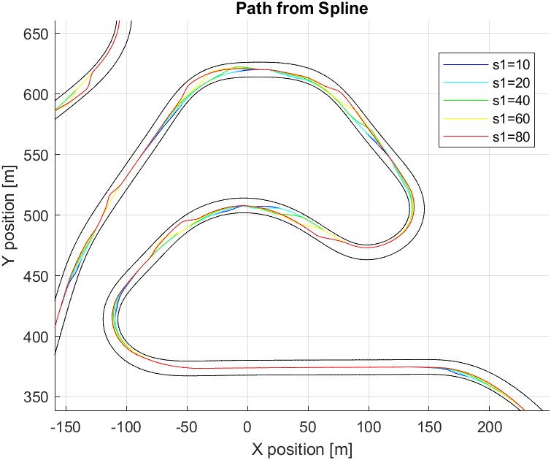
Figure 27 Second Zoom Inner Smoothing Factor – Sensitivity Analysis
The Table 10 reports the mean path distance for both drivers, and the graph in Figure 28 show the trend of the mean Path_s varying the Inner Smoothing Factor. From the graph can be appreciated the similar trend of the two drivers.
Table 10 Mean Path_s Inner Smoothing Factor - Sensitivity Analysis
Mean path distance
s1 | Driver 1 |  | Driver 2
10 | 1.63 | [m] | 1.74 | [m]
20 | 1.44 | [m] | 1.48 | [m]
40 | 1.31 | [m] | 1.32 | [m]
60 | 1.26 | [m] | 1.28 | [m]
80 | 1.59 | [m] | 1.69 | [m]
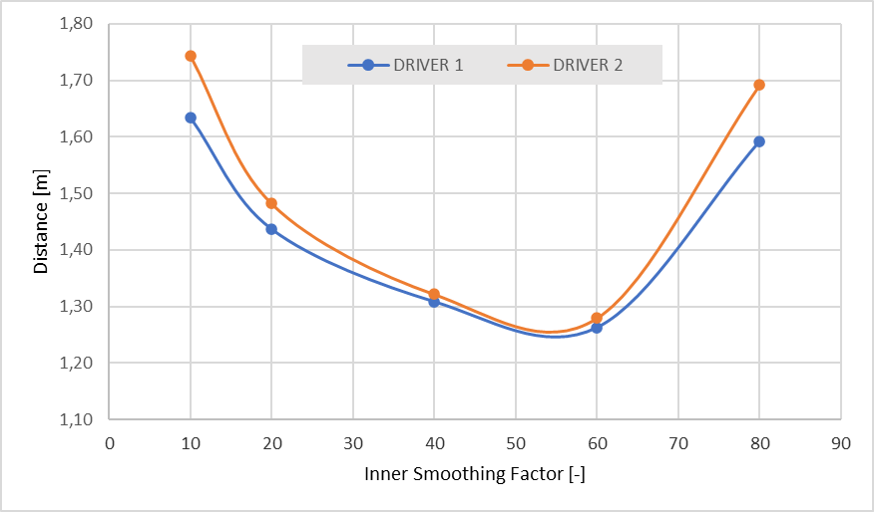
Figure 28 Inner Smoothing Factor vs Mean Path_s
Sensitivity Analysis - Outer Smoothing Factor
The last factor is the Outer Smoothing Factor, that characterizes the exit phase of the curve maneuver. The Table 11 reports the input data used to perform the sensitivity analysis.
Table 11 Outer Smoothing Factor – Sensitivity Analysis
Input parameters for outer smoothing factor sensitivity analysis
 | Case 1 | Case 2 | Case 3 | Case 4 | Case 5
Distance Factor | 0 | 0 | 0 | 0 | 0
Widening Factor | 0,2 | 0,2 | 0,2 | 0,2 | 0,2
Cutting Factor | 0,8 | 0,8 | 0,8 | 0,8 | 0,8
Inner Smoothing Factor | 40 | 40 | 40 | 40 | 40
Outer Smoothing Factor | 10 | 20 | 40 | 60 | 80

The figures below instead report the output paths in different zones of the track.
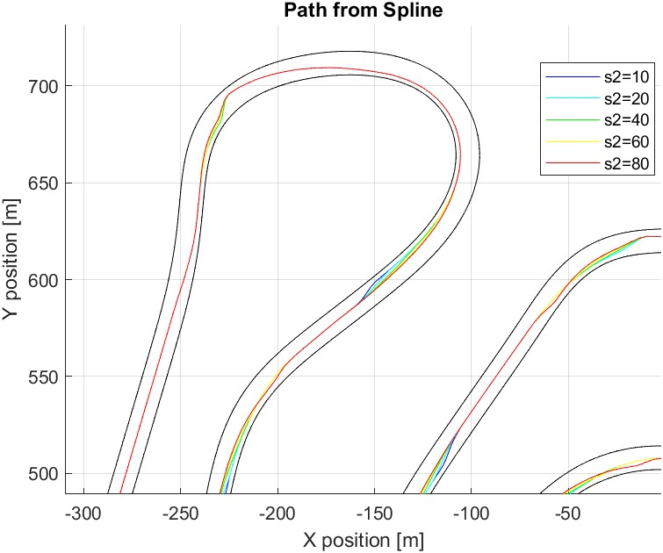
Figure 29 First Zoom Outer Smoothing Factor – Sensitivity Analysis

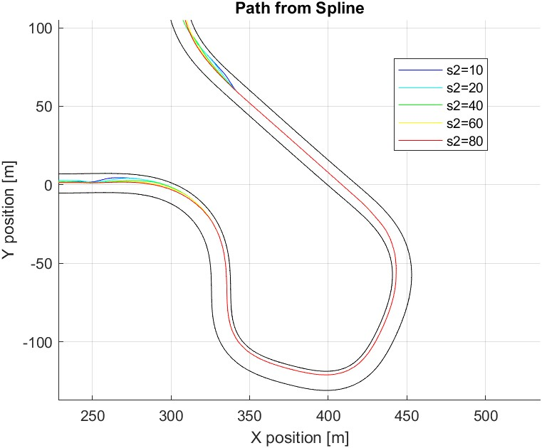
Figure 30 Second Zoom Inner Smoothing Factor – Sensitivity Analysis
The following table instead represents the mean path distance along the track comparing the Outer Smoothing Factor and the two drivers.
Table 12 Mean Path_s Outer Smoothing Factor - Sensitivity Analysis
Mean standard deviation
s2 | Driver 1 |  | Driver 2
10 | 1.48 | [m] | 1.53 | [m]
20 | 1.44 | [m] | 1.48 | [m]
40 | 1.44 | [m] | 1.47 | [m]
60 | 1.51 | [m] | 1.57 | [m]
80 | 1.46 | [m] | 1.51 | [m]

The graph in Figure 31 reports the trend of the mean distance against the Outer Smoothing Factor. Both Drivers shows a similar trend varying the s₂ factor.
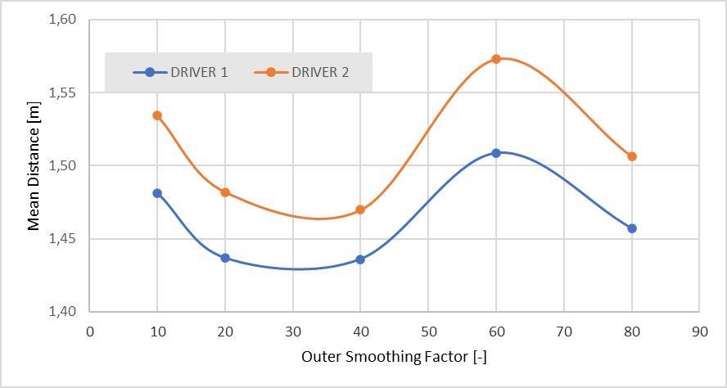
Figure 31 Outer Smoothing Factor vs Mean Path_s
Results and conclusion
Drivers Comparison
To understand the concept of variability due to the “Human Factor” a comparison between the two driver is done. The two drivers perform 5 laps and the following table resumes the mean path difference per laps. After there are the mean paths performed by the drivers.
Table 13 Mean Path distance per Lap
Mean path distance
Lap | Driver 1 |  | Driver 2
1 | 0.42 | [m] | 0.51 | [m]
2 | 0.35 | [m] | 0.39 | [m]
3 | 0.34 | [m] | 0.51 | [m]
4 | 0.34 | [m] | 0.31 | [m]
5 | 0.40 | [m] | 0.43 | [m]
Mean | 0.37 | [m] | 0.43 | [m]

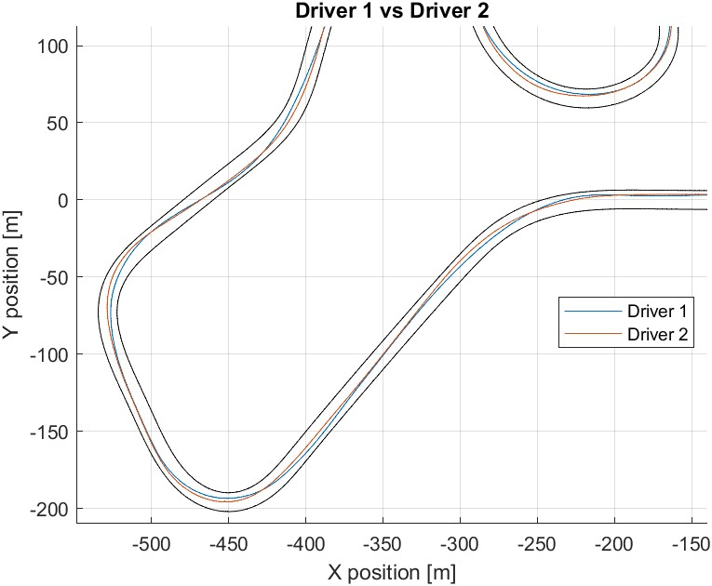
Figure 32 First Zoom Driver 1 vs Driver 2
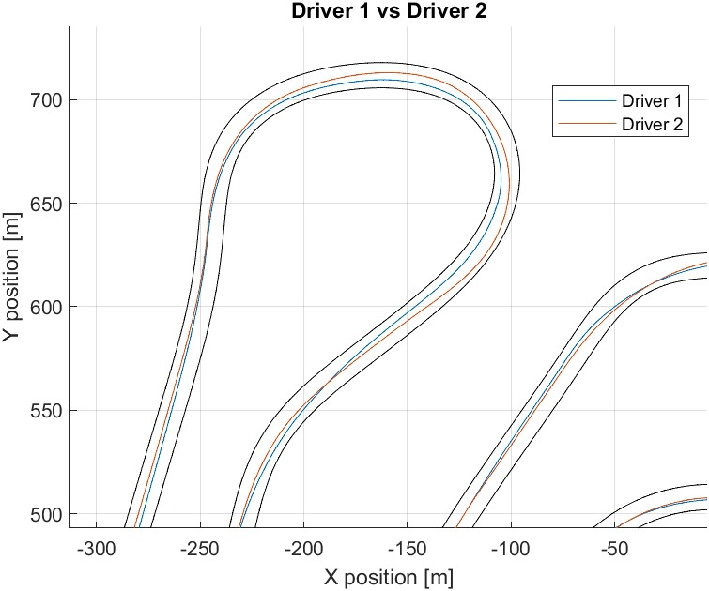
Figure 33 Second Zoom Driver 1 vs Driver 2
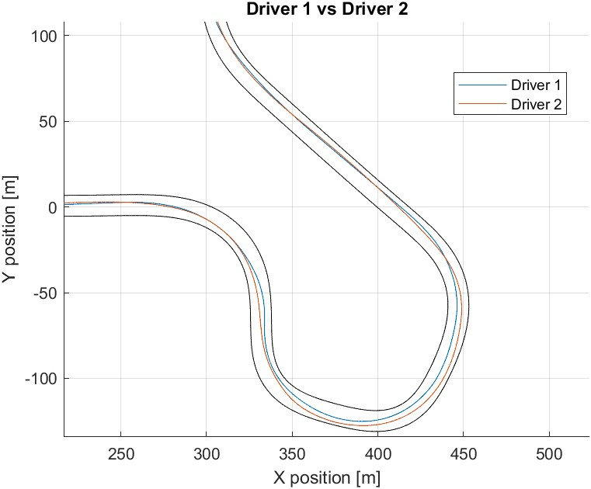
Figure 34 Third Zoom Driver 1 vs Driver 2
Human Drivers vs VI – Driver
To catch the effectiveness of this algorithm, a reference value is needed in order to evaluate the improvement on the Humanization of the path. The reference model is the VI-Driver, the Human-Like model implemented by VI-Grade. Using the Path_s concept, described in the Sensitivity Analysis part, an evaluation is done comparing the two drivers against the VI-Driver.
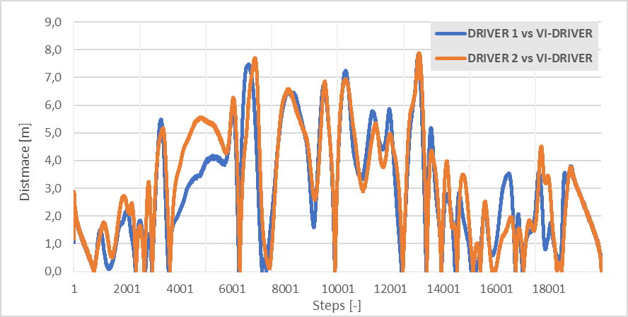
Figure 35 Path Distance - Drivers vs VI-Driver
The mean path distance is reported in Table 14.
Table 14 Mean Standard Deviation - Drivers vs VI-Driver
Mean path distance - drivers vs VI-driver
Driver 1 vs VI-driver | 2.90 | [m]
Driver 2 vs VI-driver | 3.17 | [m]
The output values are in the range of the 3 meters of difference, that means that the trajectories are different.
Drivers vs Algorithm
The comparison is performed as before but is necessary extrapolate a set of parameters able to describe in the more efficient way the driver driving style. In order to achieve the best results and so minimize the distance in path between the implemented algorithm and the experimental ones, a brutal optimization is performed with the following input data.
Table 15 Optimization Inputs
 | Tested values
α | 0 | 0.25 | 0.5 | 0.75 | 1
β1 | 0.1 | 0.25 | 0.5 | 0.75 | 0.9
β2 | 0.1 | 0.25 | 0.5 | 0.75 | 0.9
s1 | 10 | 20 | 40 | 60 | 80
s2 | 10 | 20 | 40 | 60 | 80

Through an optimization logic, the two-driving style can be represented with the sets of factors in Table 16.
Table 16 Optimization Outputs
 | α | β1 | β2 | s1 | s2
Driver 1 | 0.25 | 0.1 | 0.5 | 10 | 10
Driver 2 | 0.75 | 0.1 | 0.5 | 20 | 20
The mean Path_s analysis on the track for the two driver gives the following results:
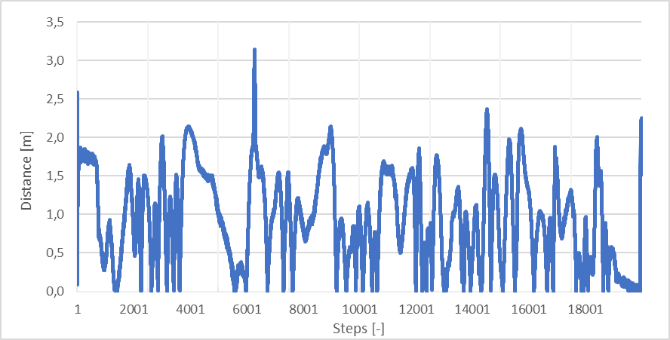
Figure 36 Path Distance Driver 1 vs Best Configuration
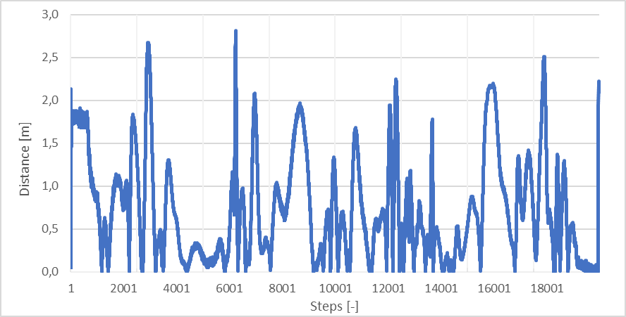
Figure 37 Path Distance Driver 2 vs Best Configuration
Comparing the path distance graphs of the drivers against the best configuration, also here, can be notice the presence of similar peaks along the track. This means that the error in distance between the human path and the humanized path show errors in the same points, maybe near curves or other section of the track.
Table 17 Mean Path Distance – Drivers vs Best Conf.
Driver 1 vs best configuration | 0.95 | [m]
Driver 2 vs best configuration | 0.73 | [m]

Conclusion
To conclude this work, some comments and comparisons on the results are made. The goal is the creation of an algorithm capable of generating a path that represents in a more efficient way, respect the VI-Driver implemented in VI-CarRealTime software, a human path.
As explained previously, each driver corresponds to a sort of variability due to the “Human Factor”. So, factors like fatigue, experience on the track, mental state, vehicle, age of the driver etc. impact the human driving style.
Another important comment is on the trends during the sensitivity analysis section. In fact, can be stated that both drivers describe similar trends for all the five factors. This maybe, due to the fact that there are common characteristics between the two drivers.
Furthermore, other comments on the results can be done, because looking the results reported in the Table 18, can be seen a clear improvement in the mean standard deviation. For Driver 1 the mean path distance goes from 2.90 m, comparing the VI-Driver and the mean trajectory, to 0.95 m compared to the Optimized Configuration. For the Driver 2, the mean path distance goes from 3.17 m to 0.73. This means that the implemented algorithm can improve the results and so reduce the differences. For Driver 1 the improvement is around 67%, while for Driver 2 the improvement is around 77%.
Table 18 VI-Driver vs Best Config. – Final Comparison
Mean path distance [m]
 | Vi-driver | Algorithm
Driver 1 | 2.90 | 0.95
Driver 2 | 3.17 | 0.73

Acknowledgements
The authors would like to thank VI-Grade for their support with software and facilities, as well as the technical collaboration throughout the work.
References
1. Carello, M., Carvalho Pinheiro, H. de, Messana, A., Freedman, A., Ferraris, A., and Airale, A.G., “Composite Control Arm Design: A Comprehensive Workflow,” SAE Int. J. Adv. Curr. Pract. Mobil. 3(5):2355–2369, 2021, doi:10.4271/2021-01-0364.
2. Carvalho Pinheiro, H. de, Messana, A., Sisca, L., Ferraris, A., Airale, A.G., and Carello, M., “Computational Analysis of Body Stiffness Influence on the Dynamics of Light Commercial Vehicles,” in: Uhl, T., ed., Advances in Mechanism and Machine Science, Springer International Publishing, ISBN 978-3-030-20131-9: 3117–3126, 2019, doi:10.1007/978-3-030-20131-9_307.
3. Carvalho Pinheiro, H. de, Messana, A., Carello, M., and Rosso, N., “Multibody parameter estimation: a comprehensive case-study for an innovative rear suspension,” 2022-36–0059, 2023, doi:10.4271/2022-36-0059.
4. Carvalho Pinheiro, H. de, Messana, A., and Carello, M., “In-wheel and on-board motors in BEV: lateral and vertical performance comparison,” 2022 IEEE International Conference on Environment and Electrical Engineering and 2022 IEEE Industrial and Commercial Power Systems Europe (EEEIC / I&CPS Europe), 1–6, 2022, doi:10.1109/EEEIC/ICPSEurope54979.2022.9854774.
5. Savant, S., De Carvalho Pinheiro, H., Sacchi, M.E., Conti, C., and Carello, M., “Tires and Vehicle Lateral Dynamic Performance: A Corrective Algorithm for the Influence of Temperature,” Machines 11(6):654, 2023, doi:10.3390/machines11060654.
6. Carvalho Pinheiro, H. de, Punta, E., Carello, M., Ferraris, A., and Airale, A.G., “Torque Vectoring in Hybrid Vehicles with In-Wheel Electric Motors: Comparing SMC and PID control,” 2021 IEEE International Conference on Environment and Electrical Engineering and 2021 IEEE Industrial and Commercial Power Systems Europe (EEEIC / I CPS Europe), 1–6, 2021, doi:10.1109/EEEIC/ICPSEurope51590.2021.9584732.
7. Imberti, G., De Carvalho Pinheiro, H., and Carello, M., “Regenerative Braking Effects on Non-combustion Pollutant Release,” in: Niola, V., Gasparetto, A., Quaglia, G., and Carbone, G., eds., Advances in Italian Mechanism Science, Springer International Publishing, Cham, ISBN 978-3-031-10776-4: 831–839, 2022, doi:10.1007/978-3-031-10776-4_95.
8. Carvalho Pinheiro, H. de and Carello, M., “Design and Validation of a High-Level Controller for Automotive Active Systems,” SAE Int. J. Veh. Dyn. Stab. NVH 7(1):10-07-01–0006, 2023, doi:10.4271/10-07-01-0006.
9. Carvalho Pinheiro, H. de, Carello, M., and Punta, E., “Torque Vectoring Control Strategies Comparison for Hybrid Vehicles with Two Rear Electric Motors,” Appl. Sci. 13(14):8109, 2023, doi:10.3390/app13148109.
10. Carvalho Pinheiro, H. de, Cruz Stanke, D., Ferraris, A., Carello, M., Gabiati, G., Camuffo, I., and Grillo, M., “Autonomous Driving Scenario Generation in Overtake Manoeuvres Through Data Fusion,” in: Niola, V. and Gasparetto, A., eds., Advances in Italian Mechanism Science, Springer, ISBN 978-3-030-55807-9: 786–794, 2021, doi:10.1007/978-3-030-55807-9_87.
11. Carello, M., Ferraris, A., Carvalho Pinheiro, H. de, Cruz Stanke, D., Gabiati, G., Camuffo, I., and Grillo, M., “Human-Driving Highway Overtake and Its Perceived Comfort: Correlational Study Using Data Fusion,” WCX SAE World Congress Experience, SAE Technical Paper 2020-01-1036, 2020, doi:10.4271/2020-01-1036.
12. Mars, F. and Chevrel, P., “Modelling human control of steering for the design of advanced driver assistance systems,” Annu. Rev. Control 44:292–302, 2017, doi:10.1016/j.arcontrol.2017.09.011.
13. Carvalho Pinheiro, H. de, Russo, F., Sisca, L., Messana, A., De Cupis, D., Ferraris, A., Airale, A.G., and Carello, M., “Advanced Vehicle Dynamics Through Active Aerodynamics and Active Body Control,” American Society of Mechanical Engineers Digital Collection, 2020, doi:10.1115/DETC2020-22290.
14. Ferraris, A., De Cupis, D., De Carvalho Pinheiro, H., Messana, A., Sisca, L., Airale, A.G., and Carello, M., “Integrated Design and Control of Active Aerodynamic Features for High Performance Electric Vehicles,” SAE Technical Paper 2020-36-0079, 2021, doi:10.4271/2020-36-0079.
15. Gu, Y., Hashimoto, Y., Hsu, L.-T., Iryo-Asano, M., and Kamijo, S., “Human-like motion planning model for driving in signalized intersections,” IATSS Res. 41(3):129–139, 2017, doi:10.1016/j.iatssr.2016.11.002.
16. Hecker, S., Dai, D., Liniger, A., and Van Gool, L., Learning Accurate and Human-Like Driving using Semantic Maps and Attention, 2020, doi:10.48550/arXiv.2007.07218.
17. VI-grade GmbH, VI-CarRealTime 20.0 Documentation, 2020.
18. Mentzer, S., “How Effective Scanning Helps Bus Operators See Potential Driving Hazards,” https://www.metro-magazine.com/10003025/how-effective-scanning-helps-bus-operators-see-potential-driving-hazards, 2015.
19. Candida, C., “Human Factors of Visual and Cognitive Performance in Driving,” CRC Press, 2009.
20. Schlorholtz, B., Schieber, F., and McCall, R., “Visual Requirements of Vehicular Guidance,” ISBN 978-1-4200-5530-6: 31–50, 2008, doi:10.1201/9781420055337.ch2.
21. Sedighi, S., Nguyen, D.-V., and Kuhnert, K.-D., “Guided Hybrid A-star Path Planning Algorithm for Valet Parking Applications,” 2019 5th International Conference on Control, Automation and Robotics (ICCAR), 570–575, 2019, doi:10.1109/ICCAR.2019.8813752.
22. Dario D. Salvucci, “Modeling Driver Behavior in a Cognitive Architecture,” Hum. Factors 48(2):362–380, 2006, doi:https://doi.org/10.1518/001872006777724417.
23. Riener, A., “Assessment of Simulator Fidelity and Validity in Simulator and On-the-road Studies,” Int. J. Adv. Syst. Meas. 3(4), 2010.

