Preliminary design of eddy current brake to improve sustainable mobility
Daniel Pacheco Quinones ˜ Department of Mechanical and Aerospace Engineering Politecnico di Torino Torino, Italy ORCID: 0000-0002-8274-0234
Ettore Bianco Department of Mechanical and Aerospace Engineering Politecnico di Torino Torino, Italy ORCID: 0000-0003-3653-1893
Massimiliana Carello Department of Mechanical and Aerospace Engineering Politecnico di Torino Torino, Italy ORCID: 0000-0002-5831-8156
Daniela Maffiodo Department of Mechanical and Aerospace Engineering Politecnico di Torino Torino, Italy ORCID: 0000-0003-2322-0340
Abstract
In recent years, the need to reduce CO2 emissions has developed a change in the transport sector. E-mobility is emerging as a zero-emissions way of travel, but not only the combustion engine produces emission. In fact, a significant part of the vehicle’s total pollution is produced by tires and conventional brakes. The eddy current brake is a possible alternative to the well-known mechanical brake to obtain zero-emissions braking with low maintenance. This type of brake converts the vehicle’s kinetic energy into thermal energy through the magnetic generation of the eddy currents, which generate Lorentz braking forces. This paper proposes a preliminary design of a zero-emission eddy current brake with a first geometry variation to increase the brake performance, that has been evaluated with an analytical approach and EMS by EMWorks, a 3D finite element method magnetic software able to calculate brake torque and electromagnetic effects.
Eddy current brake, Zero emission, Finite element method, Magnetic transient analysis, Multi-physics co-simulation, Mobility.

Introduction
In recent years the automotive field has experienced a rapid transition due to the need for change in the transport sector, which is now characterized by a more significant presence of Electric Vehicles (EVs) . In this context, car manufacturers have heavily invested in reducing vehicle pollution, as electric motors.
Even if EVs are considered zero-emissions vehicles , engine emission is only a part of the entire emissions produced by a traditional vehicle, as a significant part for the Euro 6 ICE (Internal Combustion Engine) vehicle is due to the brak-ing process . An emerging trend is to reach actual zero-emissions vehicles , as seen in the Euro 7 target for new cars, imposing a limit on brake pollutants .
A possible solution to reduce brake emission is to adopt, for example, Eddy Current Brakes (ECBs). This device produces braking torque due to electromagnetic interactions between the stator and the rotor, more specifically, the rotor develops eddy currents to oppose the stator’s magnetic field . The main drawback of ECBs is the rotor’s speed torque proportional dependency . This connection makes ECB-led stand-alone applications not perfect adequate for automotive applications considering the effective vehicle motion, as it can only decrease vehicle’s speed, while a mechanical brake is required for parking .
This paper aims to design and simulate a preliminary zero emissions eddy current brake to validate its geometry and maximize the braking torque. Simulations are performed first with an analytical approach and then through EMS, a 3D Finite Element Method (FEM) Magnetic add-on of the SolidWorks environment. The simulations are useful to evaluate ECB feasibility in EVs and assessing the low-speed torque, a critical factor for this type of brake . Six different geometric designs have been proposed and evaluated by computing the electromagnetic quantities and the braking torque. Two different approaches, analytical and with co-simulation, have been used and the results compared, to evaluate the capability of ECB to replace a mechanical brake.

Analytical Approach

General overview
ECBs are often composed of a rotor disk made of a conductive material, rotating inside a non-uniform magnetic field generated by the stator. An induced electromotive force is thus produced inside the rotor to counterbalance the magnetic flux variation due to relative motion between the two parts. Lorentz interaction forces thus build up the overall braking torque through the kinetic-to-thermic power conversion of eddy current Joule losses.
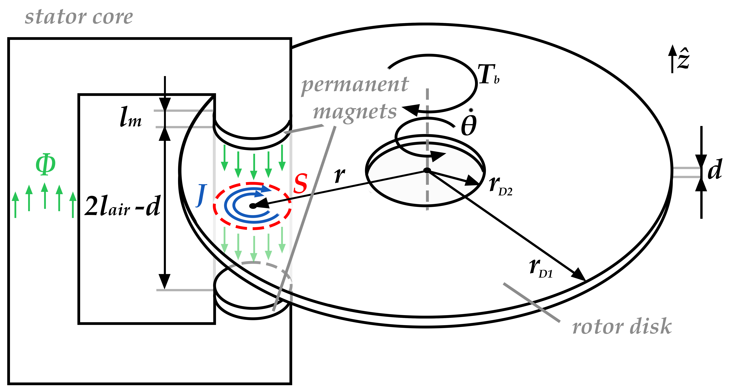
Scheme of an eddy current brake with a single couple of permanent magnets ($n=1)$.
The rotor disk’s material must be highly conductive to maximize eddy currents and light-weight to minimize the disk’s moment of inertia.
As this paper focuses on zero-emissions brakes, it only considers Permanent Magnets (PMs) couple setups, as exemplified in Fig. 1. The brake is thereby switched ON or OFF by respectively bringing the stator close to or afar from the rotating disk, thus acting on the air gap dimension $2l_{air}$.

Analytical assumptions and model
The analytical approach, starting from , is based on the following assumptions:
- The magnetic flux $Φ$ produced by the PM couple flows through a uniform cross-section $S$ without any leakages. Thus, the magnetic flux density $B=Φ/S$ remains uniform inside the magnetic path (ideal flux tube), and there are no interactions among adjacent PM couples.
- $Φ$ entering the disk stays parallel to the disk angular rotation $\dot{θ}=\dot{θ}\hat{z}$.
- $Φ$ closes inside the stator through a zero-reluctance path.
- The disk’s and the air’s magnetic permeabilities are approximated to vacuum $μ_{D}≈μ_{air}≈μ_{0}$.
- The PMs’ magnetic hysteresis $B\left(H\right)$ loop is approximated linear between points $\left[H_{c},0\right]$ and $\left[0,B_{r}\right]$, being $H_{c}$ and $B_{r}$ respectively the coercivity and the saturation remanence of the magnets.
- Other power losses inside the brake are considered null.
Thus, for each PM couple:
$$B=\frac{Φ}{S}=\frac{F_{mm}}{SR}=\left(\frac{μ_{0}}{2l_{air}+d}\right)F_{mm}$$
$$J=σ_{D}\left(r\dot{θ}\hat{τ}×B\right)$$
in which: $R$ magnetic reluctance of the path; $σ_{D}$ and $d$ electric conductivity and thickness of the disk; $F_{mm}$ PM couple’s magnetomotive force; $J$ eddy current density; $r$ distance between the disk and pole centers; $\hat{τ}$ tangential speed direction.
The PM couple’s $F_{mm}$ can be deduced through assumption (e) by the equations:
$$\left|B_{m}\right|=B_{r}\left(1-\frac{H_{m}}{H_{c}}\right)$$
$$\left|F_{mm}\right|=2l_{m}H_{m}=2l_{m}B_{r}{\left(\frac{B_{r}}{H_{c}}-μ_{0}\frac{2l_{m}}{2l_{air}+d}\right)}^{-1}$$
in which: $B_{m}$ and $H_{m}$ are the PM’s operating magnetic field density and intensity; $2l_{m}$ is the PM couple’s length.
The total braking torque $T_{b}$ can thus be obtained through [eq1], [eq2], [eq4], and energetic considerations related to the overall Joule losses inside the disk:
$$P_{d,tot}=nP_{d,1m}=n\frac{V}{σ_{D}}J^{2}=nSdσ_{D}{\left(r\dot{θ}B\right)}^{2}$$
$$\left|T_{b}\right|=\frac{P_{d,tot}}{\dot{θ}}=nSdσ_{D}{\left(\frac{μ_{0}r\left|F_{mm}\right|}{2l_{air}+d}\right)}^{2}\dot{θ}:=β\dot{θ}$$
in which: $P_{d,1m}$ and $P_{d,tot}$ are the Joule power losses related, respectively, to a single PM couple and the overall configuration containing $n$ couples; $V=Sd$ cross-volume; $β$ overall ECB damping factor.

Model specifications and calculus
Due to the considerations made in 2.1, this paper focuses on a uniform aluminum disk. The analyzed PMs are cylinders made of a NdFeB alloy N21. Tab. 1 resumes all relevant model specifications of the ECB used in the analytical approach.
ECB model specifications for the analytical approach. Symbols refer to Fig. 1.
 | Name | Symbol | Value | Unit
 | Density | $$ρ$$ | 2700 | $$kg/m^{3}$$
 | Thickness | $$d$$ | 0.01 | $$m$$
 | Radii | $$r_{D1};r_{D2}$$ | 0.11; 0.05 | $$m$$
 | Moment of inertia$​^{a}$ | $$I_{z}$$ | $$5.95⋅{10}^{-3}$$ | $$kg⋅m^{2}$$
 | Electric conductivity | $$σ_{D}$$ | $$5.98⋅{10}^{7}$$ | $$S/m$$
 | Number of couples | $$n$$ | 8 | /
 | Thickness | $$l_{m}$$ | 0.01 | $$m$$
 | Diameter | $$d_{m}$$ | 0.03 | $$m$$
 | Cross-section$​^{b}$ | $$S$$ | $$7.07⋅{10}^{-4}$$ | $$m^{2}$$
 | Coercivity | $$H_{c}$$ | $$-9.55⋅{10}^{5}$$ | $$A/m$$
 | Saturation remanence | $$B_{r}$$ | 1.2 | $$T$$
$​^{a}$ Obtained through the formula $I_{z}=1/2πρd\left(r_{D1}^{4}-r_{D2}^{4}\right)$ on $\hat{z}∥\dot{θ}$.
$​^{b}$ Obtained through the formula $S=πd_{m}^{2}/4$.

Fig. 2 shows ECB damping factor $β$ values by varying $l_{air}=0.001÷0.1 m$ and $r=0.05÷0.1 m$, obtained from [eq6], in MATLAB environment.
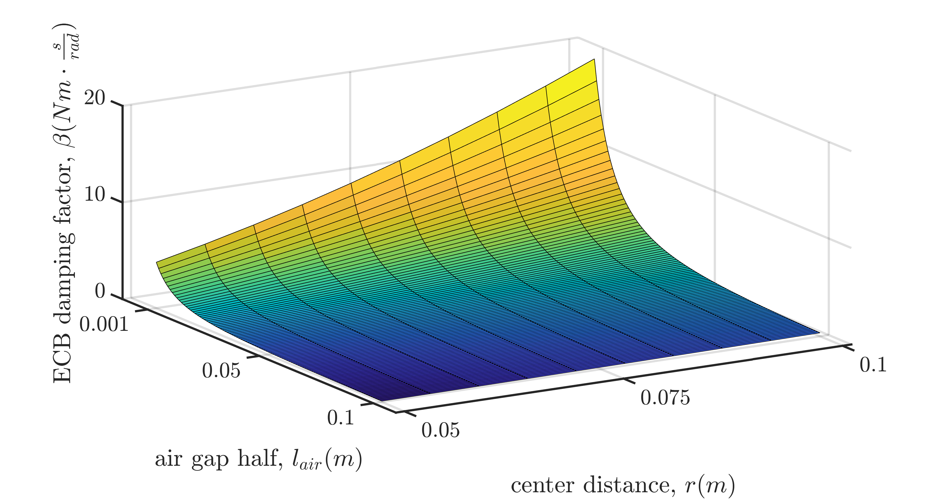
ECB damping factor $β\left(l_{air},r\right)$, logarithmic color map.

Limits of the analytical approach
The analytical approach is a good starting point for basic ECB design, as it delivers a basic idea of $T_{b}$ dimensions. Nevertheless, this approach provides a major simplification of the phenomena involved, as:
- $Φ$ does not tend to have a uniform parallel cross-section $S$, as field lines tend to enlarge, and some could close before reaching the disk. This behavior is more evident the greater is $l_{air}$.
- The poles’ fields can interact with each other, providing different closing paths for $Φ$ inside the disk and the stator.
- The approach does not take into account the material’s magnetic saturation, and thus any geometric differences of the cross-section $S$, nor any geometric or amount limitations of the PM couples $n$.
- The approach does not consider any magnetic dynamics when $l_{air}=l_{air}\left(t\right)$ , nor thermic dynamics. For instance, $R$ increases in function of the disk temperature, lowering the brake’s overall performance.
It is thus of critical importance to adopt a Finite Element Method (FEM) approach for more in-depth considerations.

FEM Magnetic Analysis

Designs selection
This study uses an iterative approach to maximize the ECB braking effect. Designs involve one or two stators, with PMs mounted on a cylindrical back iron so that adjacent PMs or, in two-stator designs, PM couples have opposite coercivity directions.
The magnets’ number and shape have been iteratively changed to evaluate the subsequent effects on the produced torque. All geometries take advantage of the PM couples’ interactions to close the produced magnetic fluxes, deviating from assumption (a) in Section 2.2. This characteristic reduces the overall design bulkiness by decreasing the back iron’s reluctance path and allows for variable $l_{air}\left(t\right)$ engineering.
Fig. 9 and Tab. 2 label and specify all the six designs proposed for this study, named "Design X" in the following parts with this reference. All relevant specifications are assumed the same of Section 2, as in Tab. 1, posing $r=0.08 m$ for Designs 1 and 3.
ECB designs selected for the FEM magnetic analysis simulation.
Design | Stator | Permanent Magnets Couples |  | Ref.$​^{a}$
3-4 | Number | Shape | Number
1 | 1 | Cylindrical | 8 | a
1-1 2 | 1 | Sector Prism | 8 | b
3 | 2 | Cylindrical | 8 | c
1-1 4 | 2 | Sector prism | 8 | d
1-1 5 | 2 | Sector prism | 16 | e
1-1 6 | 2 | Sector prism | 32 | f
$​^{a}$ Reference to Fig. 9 labels.

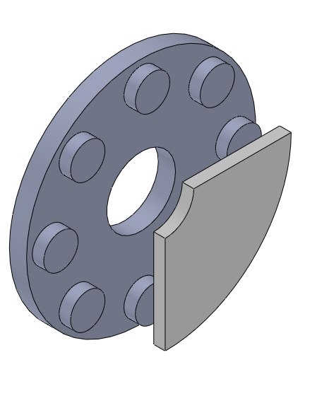  Design 1 | 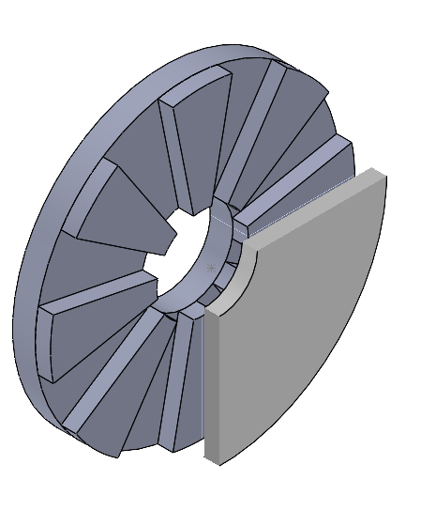  Design 2 | 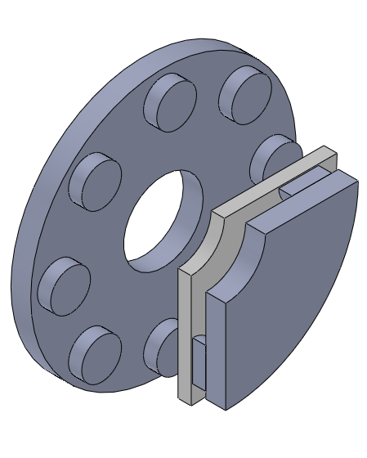  Design 3 | 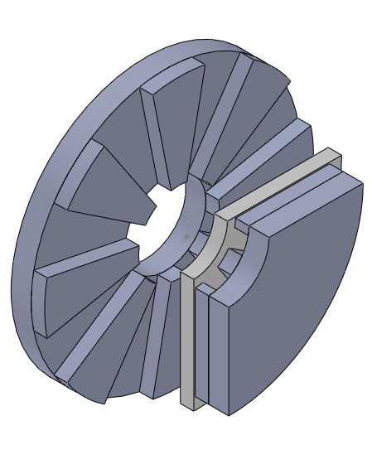  Design 4 | 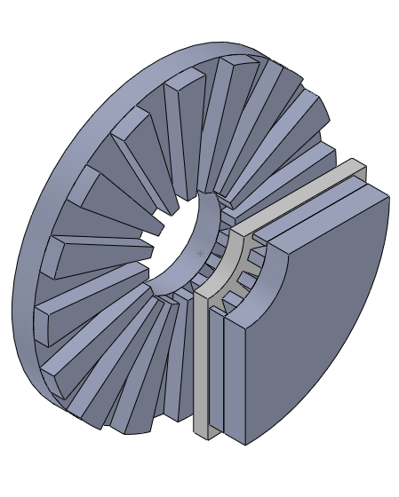  Design 5 | 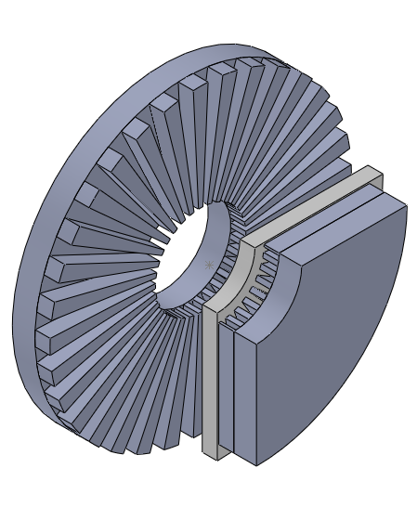  Design 6
Possible ECB design with disk (light brown) and front stator (grey, in a 90° section for sake of visualization), labels refer to Tab. 2.
Designs 1 and 2, being the simplest and cheapest to implement since they involve only one stator, have not been computed analytically because of the significant deviation from assumptions (a) and (b) cited in Section 2.2. As highlighted in a preliminary magnetostatic simulation for Design 1 is shown in Fig. 10, the flux entering the disk is indeed not parallel to the disk’s angular rotation, making the cross-section nonuniform and the magnetic circuit impossible to solve analytically.
Subsequent geometries focus on a two-stator brake. This setup is more compliant with the analytical approach than the first geometry, as assumption (b) is approximately met for low $l_{air}$, as shown in Fig. 11 for Design 3.
Nevertheless, magnetic fluxes tend not to comply with assumption (a), as magnetic pole fields can interact with each other.
The following comparisons have been made:
- The analytical system and Design 3 are compared in terms of maximum braking torque, to highlight the theoretical and simulated behavior. In fact, Design 3 is the system setup that most resembles the one considered in the analytical approach presented in Section 2.1.
- Designs 1 and 3, 2 and 4 are compared to highlight how the stator setup change affects overall performance.
- Designs 1 and 2, 3 and 4 focus on PM shape $S$ modification, i.e., from a cylindrical shape to a circular sector prism geometry.
- Designs 4, 5 and 6 differ on PM couples number $n$, with magnets per stator ranging from 8 to 32.
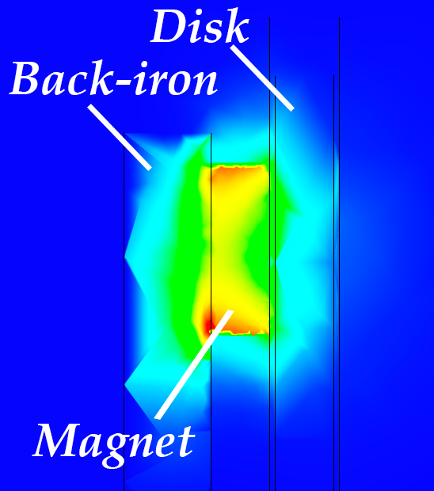  Design 1 | 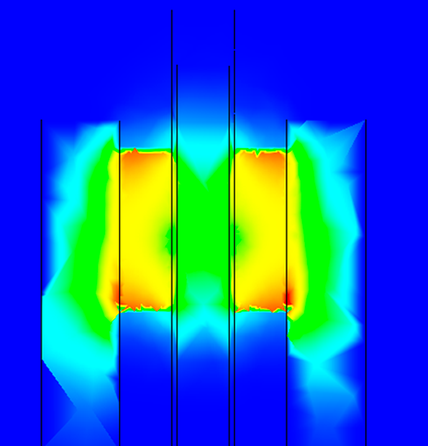  Design 3
Magnetic flux density $B$ comparison between Designs 1 and 3, lateral section view. Flux density is null in blue region, while up to $≈1 T$ in red regions.

Software and co-simulation
EMS Tool for SolidWorks allows field distribution analysis for electromagnetic devices and component performance with reasonable accuracy. The magnetic field calculation problem can determine the value of one or more unknown functions, like magnetic field intensity, magnetic flux density, scalar magnetic potential, and magnetic vector potential.
More specifically, the EMS software allows for solving complex differential equations problems involving entities such as loading conditions, boundary conditions, geometric construction, and material heterogeneity. Added realism is often preferred over simpler and deterministic yet inaccurate analytical methods. Using FEM, the software discretizes the domain into an adaptive mesh, as the tool thickens it near the geometrical or material changes and where a peak of an electromagnetic quantity is present, as seen in Fig. 13. The mesh is thicker near material changes (from ferromagnetic material to air and from air to aluminum disk). This area also contains the maximum magnetic field concentration due to the PMs’ proximity. The software then proceeds to solve the magnetic equations in each subdomain and impose boundary conditions on its limits to allow physical continuity.
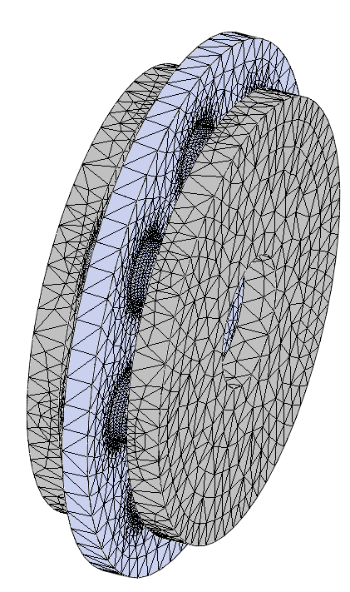
3D mesh for the FEM magnetic analysis of Design 2 (air gap band in light blue).
A co-simulation environment is necessary to obtain the braking torque, as the phenomenon involves mechanical and electromagnetic parameters. The FEM magnetic simulation must indeed be coupled with the rotating motion of the rotor to translate the magnetic flux density into Lorenz forces’ distribution for the total braking torque. Physical quantities are thus computed at each simulation time step in co-simulation with SolidWorks Motion Tool, which updates the mechanical quantities and, in particular, the angular speed for the next time step.
Due to EMS tool model restraints and for sake of brevity, the following co-simulations investigate on ECB ON configuration only, in which the air gap is imposed $2l_{air}=const=0.002 m$. The design comparison was performed by commonly imposing:
- Sampling frequency $f_{s}=1 kHz$.
- Initial rotor speed $ω_{0}=1000 rpm$.
- An equivalent load inertia of a 500 kg vehicle.
- Null external forces.

Co-Simulation Results

Maximum Braking Torque
This section compares the designs’ output maximum braking torques $T_{b,max}$. As $T_{b}∝\dot{θ}$ from [eq6], the maximum torque is found at maximum rotor speed $ω_{max}=ω_{0}$, as the rotor decelerates due to the ECB effect. On the other hand, the EMS tool cannot guarantee a correct measure of $T_{b}$ at the first time steps. By default, every simulation indeed starts with null magnetic fields, and thus, as shown in Fig. 14, a null torque. In the second iteration, the actual flux is imposed, causing a non-physical transient and, possibly, overshoots.
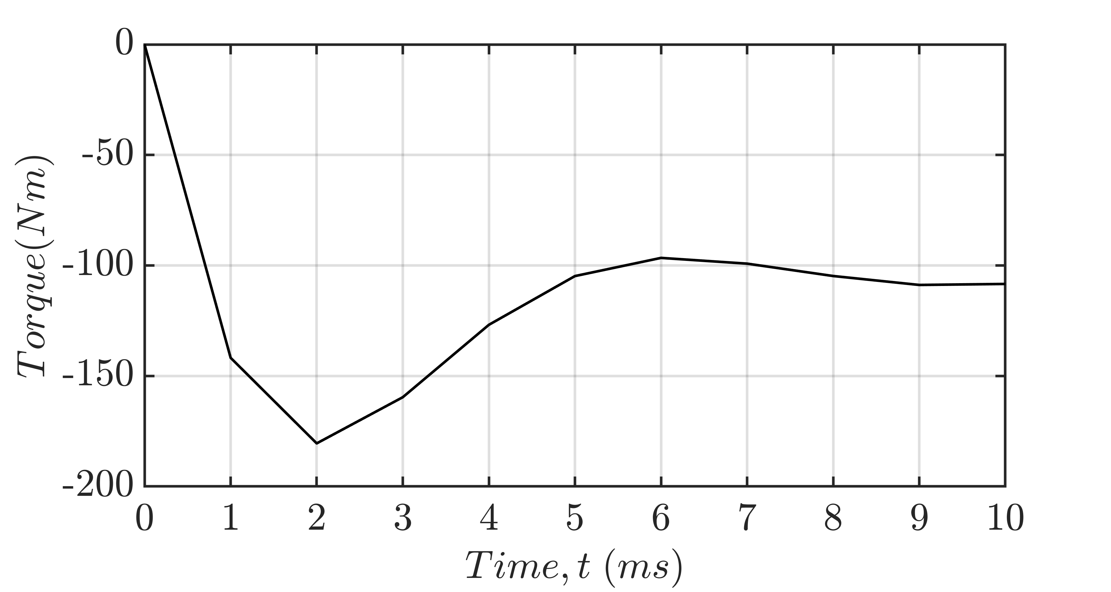
Braking torque $T_{b}$ vs. time for Design 5.
The maximum braking torque $\left|T_{b,max}\right|$ was thus selected in every simulation as a trade-off between transient behavior and analytical correctness. A resuming graph of the output $T_{b,max}$ for each Design is shown in Fig. 15.
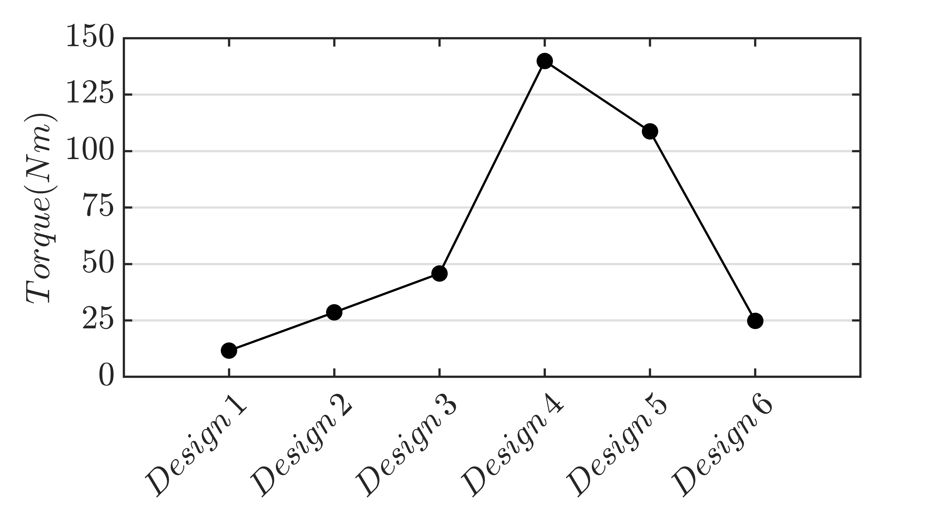
Maximum braking torque comparison using a common rotor’s initial speed $ω_{0}=1000 rpm$ for each Design solution.
The output analysis highlights that the two single-stator designs (Designs 1 and 2) show the lowest performance in terms of braking torque (explained in Section 3.1).
Furthermore, using: $r=0.08 m$, $l_{air}=0.001m$, and $ω_{0}=1000 rpm$, as in Design 3, the analytical braking torque is $T_{b}=1247 Nm$. Analytical approach thus outputs torques that are orders of magnitude higher than the co-simulated configurations. This result highlights the non-real hypotheses on which the analytical approach is based (highlighted in Section 2.2 and discussed in Section 2.4).
Magnets’ sector prism geometry (Designs 2, 4, 5, and 6) show far better performance than cylindrical geometry (Designs 1 and 3), due to the magnet’s cross-section $S$ increment and more efficient geometry.
As opposed to the analytical approach, increasing the number of magnets $n$ initially decreases the overall braking torque, as the maximum $T_{b}≈140 Nm$ is reached for Design 4, with only 8 magnet couples. This performance drop is due to pole fields’ interaction, as discussed in Section 2.4. The PMs mounted on the same back iron are indeed too close to their adjacent reverse-polarity counterparts. As Fig. 18 shows, the proximity makes the reluctance path among them lower than the one of the PM couple across the rotor, translating into a lower performance as dispersion fluxes increase.
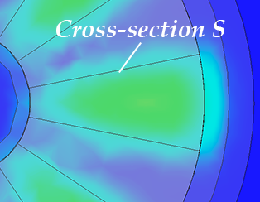  Design 4 | 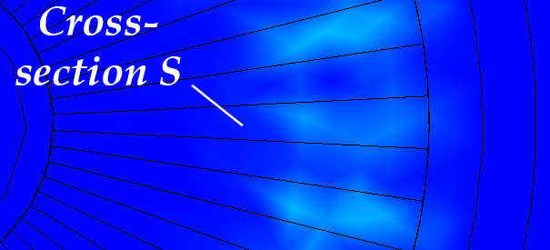  Design 6
Magnetic flux density $B$ comparison between Designs 4 and 6, rotor section view. Flux density is null in blue region, while up to $≈0.7 T$ in green regions.

Best performance design dynamic behavior
As stated in Section 4.1, Design 4 is the design showing the best braking performance. Fig. 19 shows the system’s overall behavior in $20 ms$, displaying the braking torque $T_{b}\left(t\right)$, the angular acceleration $\dot{ω}\left(t\right)$ and the angular speed $ω\left(t\right)$. Mechanical transients are computed considering, as stated in Section 3.2, a 500 kg vehicle inertia. As previously stated, the first time steps are biased by a non-physical transient due to the EMS tool default calculations.
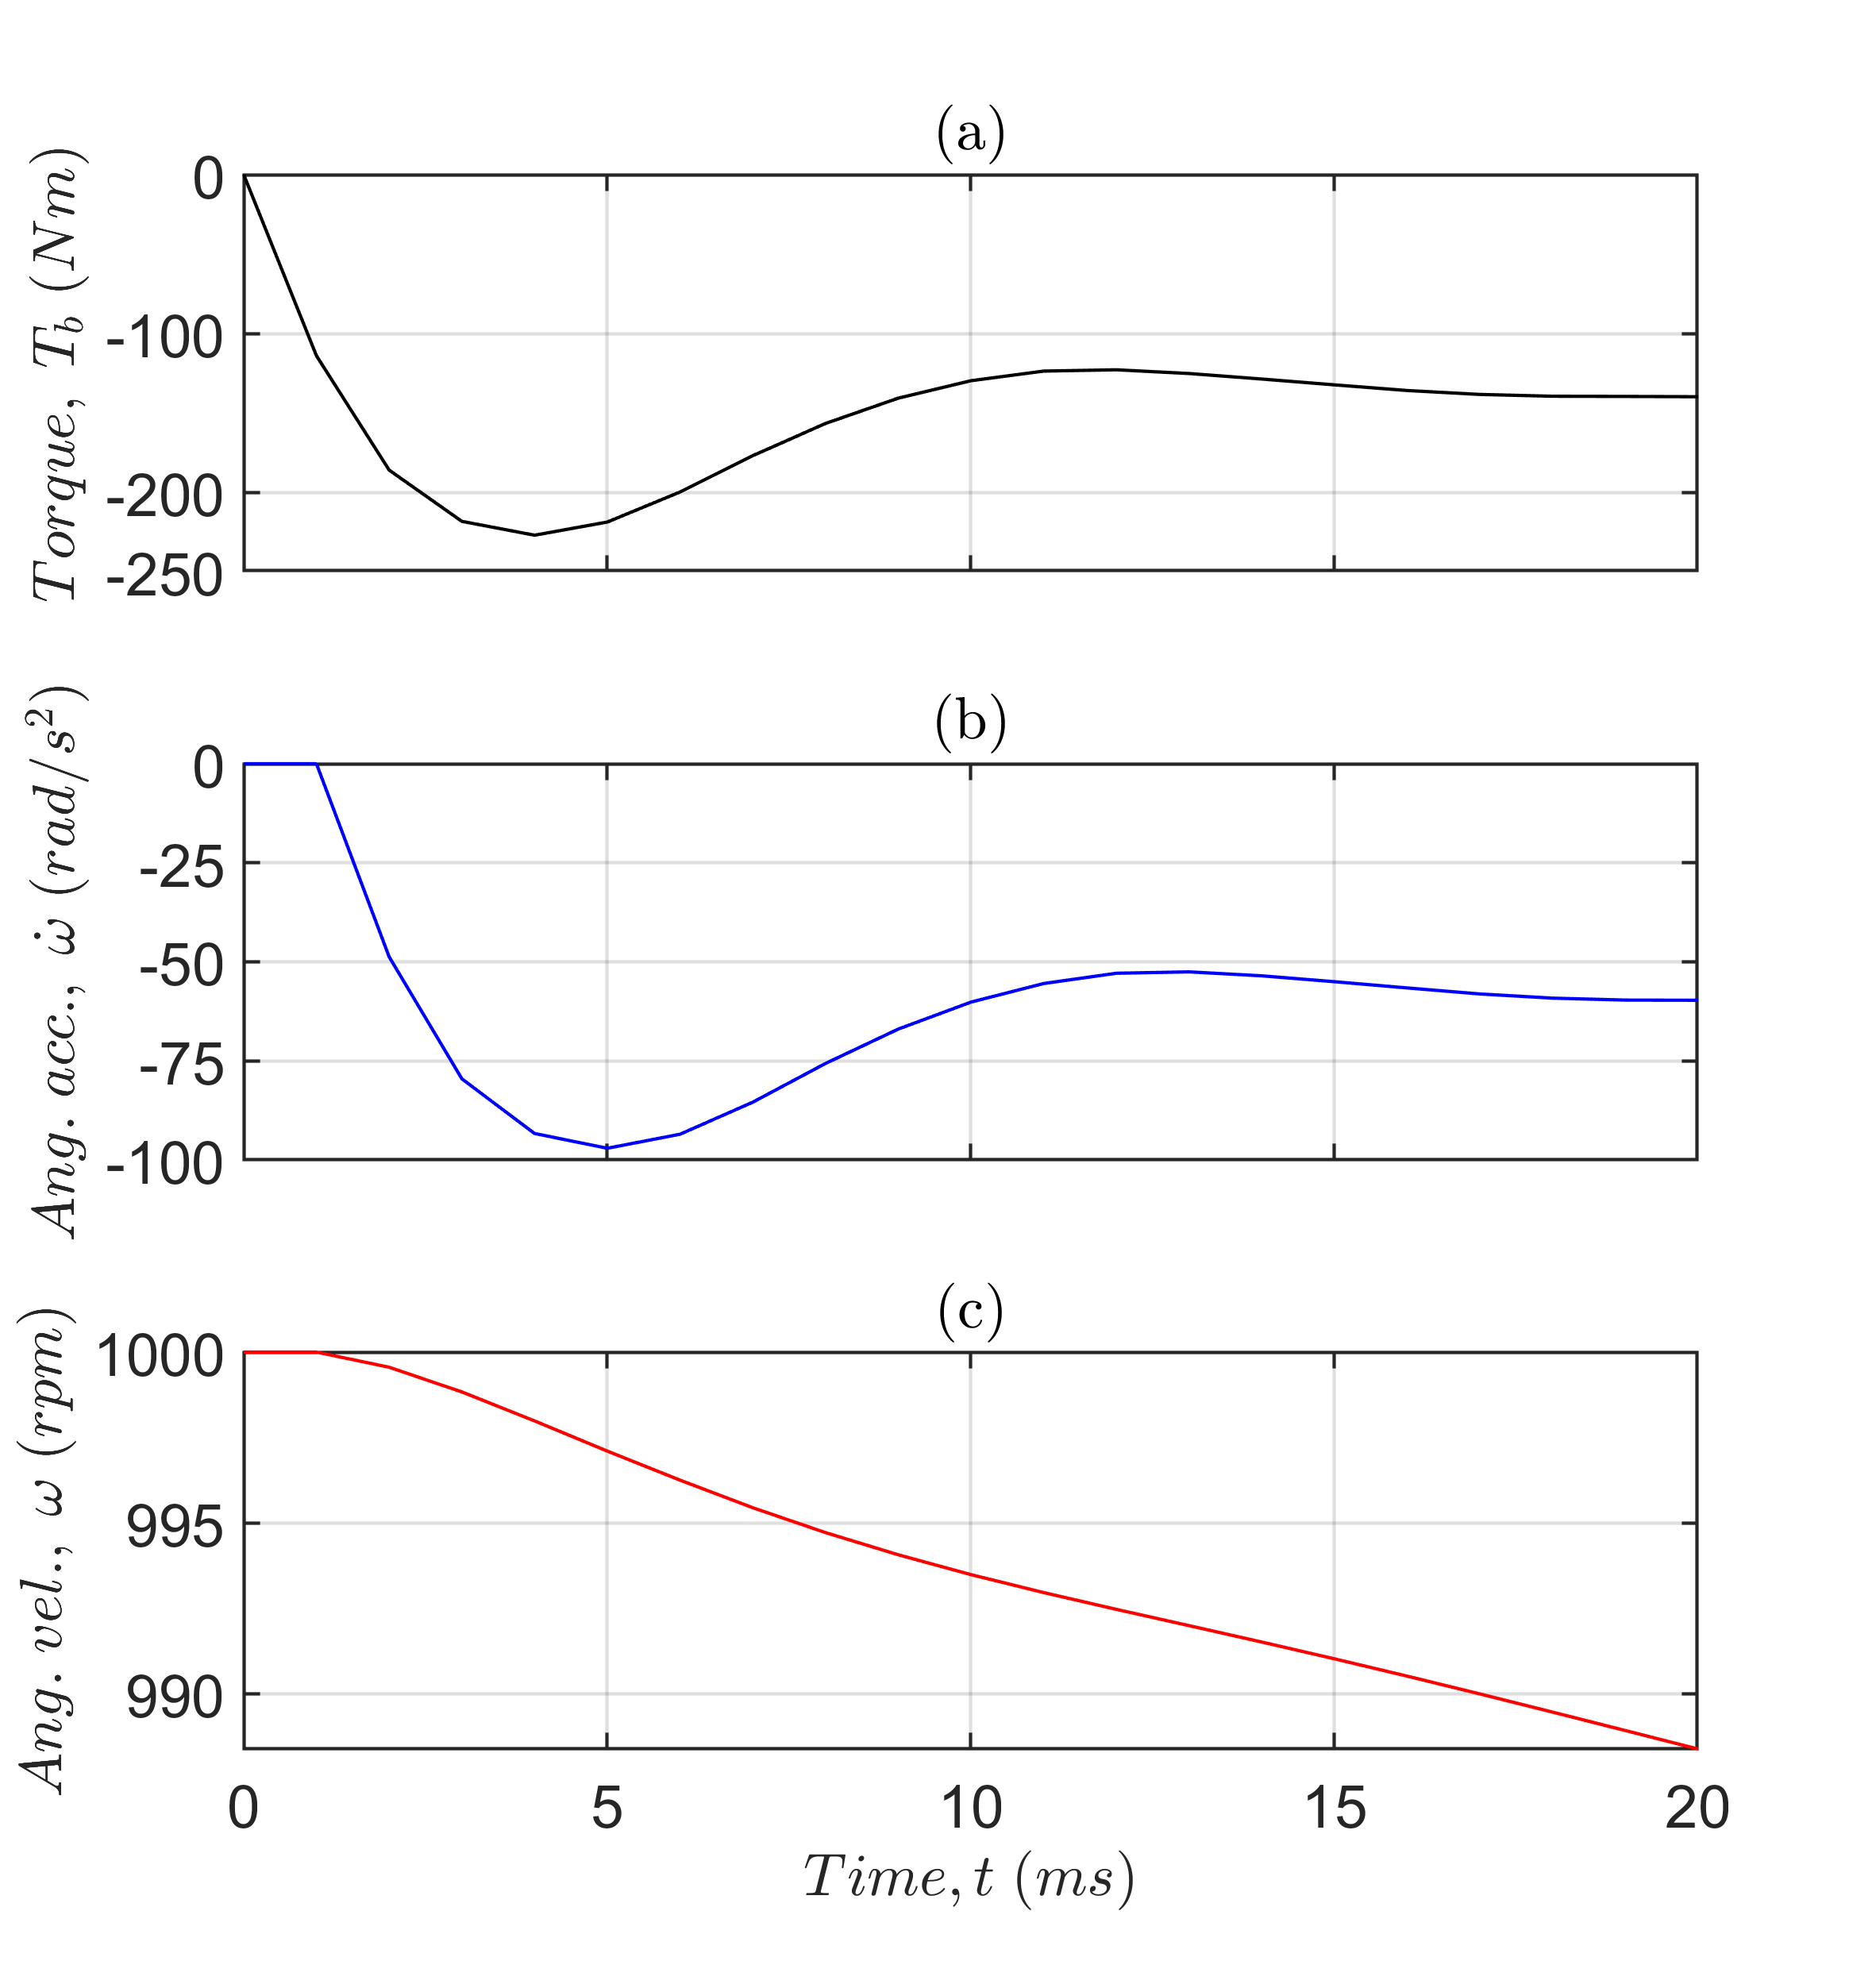
Design 5 rotor’s characteristics: braking torque $T_{b}\left(t\right)$ (a), angular acceleration $\dot{ω}\left(t\right)$, and angular speed $ω\left(t\right)$.
As Fig. 19c shows, the output speed decreases by about $10 rpm$ in $0.02 s$, with nearly constant deceleration of about $-60 rad/s^{2}$, as shown in Fig. 19b. This behavior is deemed not enough for autonomous nor emergency braking systems in automotive applications, as minimum requirements involve the necessity to stop the vehicle in emergency conditions within a specific longitudinal distance proportional to the vehicle speed, following the standard . This requirement could be satisfied with a deceleration of almost $0.8 g$ , so a force of about $3924 N$ would be needed to stop a vehicle of $500 kg$. The amount of continuous torque needed would be about $1177 Nm$, so, for instance, about $294 Nm$ per wheel in a 4-wheel vehicle. This amount is more than two times higher com-pared to $T_{b,max}$ of Design 4, shown in Fig. 19a. Furthermore, the ECB torque is proportional to the angular speed, so the torque produced is not constant.
With this braking torque at the wheel, a correct torque vectoring strategy is needed to guarantee stability to the vehicle, as in . In the 4-wheel configuration, considered in the calculations, the stator brake has to be fixed to the wheel’s hub, and the flywheel has to be attached to the wheel to transmit the produced braking torque to the ground.
Fig. 20 shows the rotor’s Joule-related losses $P_{d}$ deriving from the eddy currents computed in Design 4 co-simulation. Design 4 maximum instantaneous power loss, not considering non-physical transients, is $P_{d,max}≈15.5 kW$, in general one order of magnitude lower than minimum requirements . Joule losses are essential in evaluating the ECB, as they are directly proportional to the system’s braking capability. Furthermore, power loss general insight is crucial for the brake’s implementation, as a ventilation system is needed to cool down the rotor and guarantee standard performance.
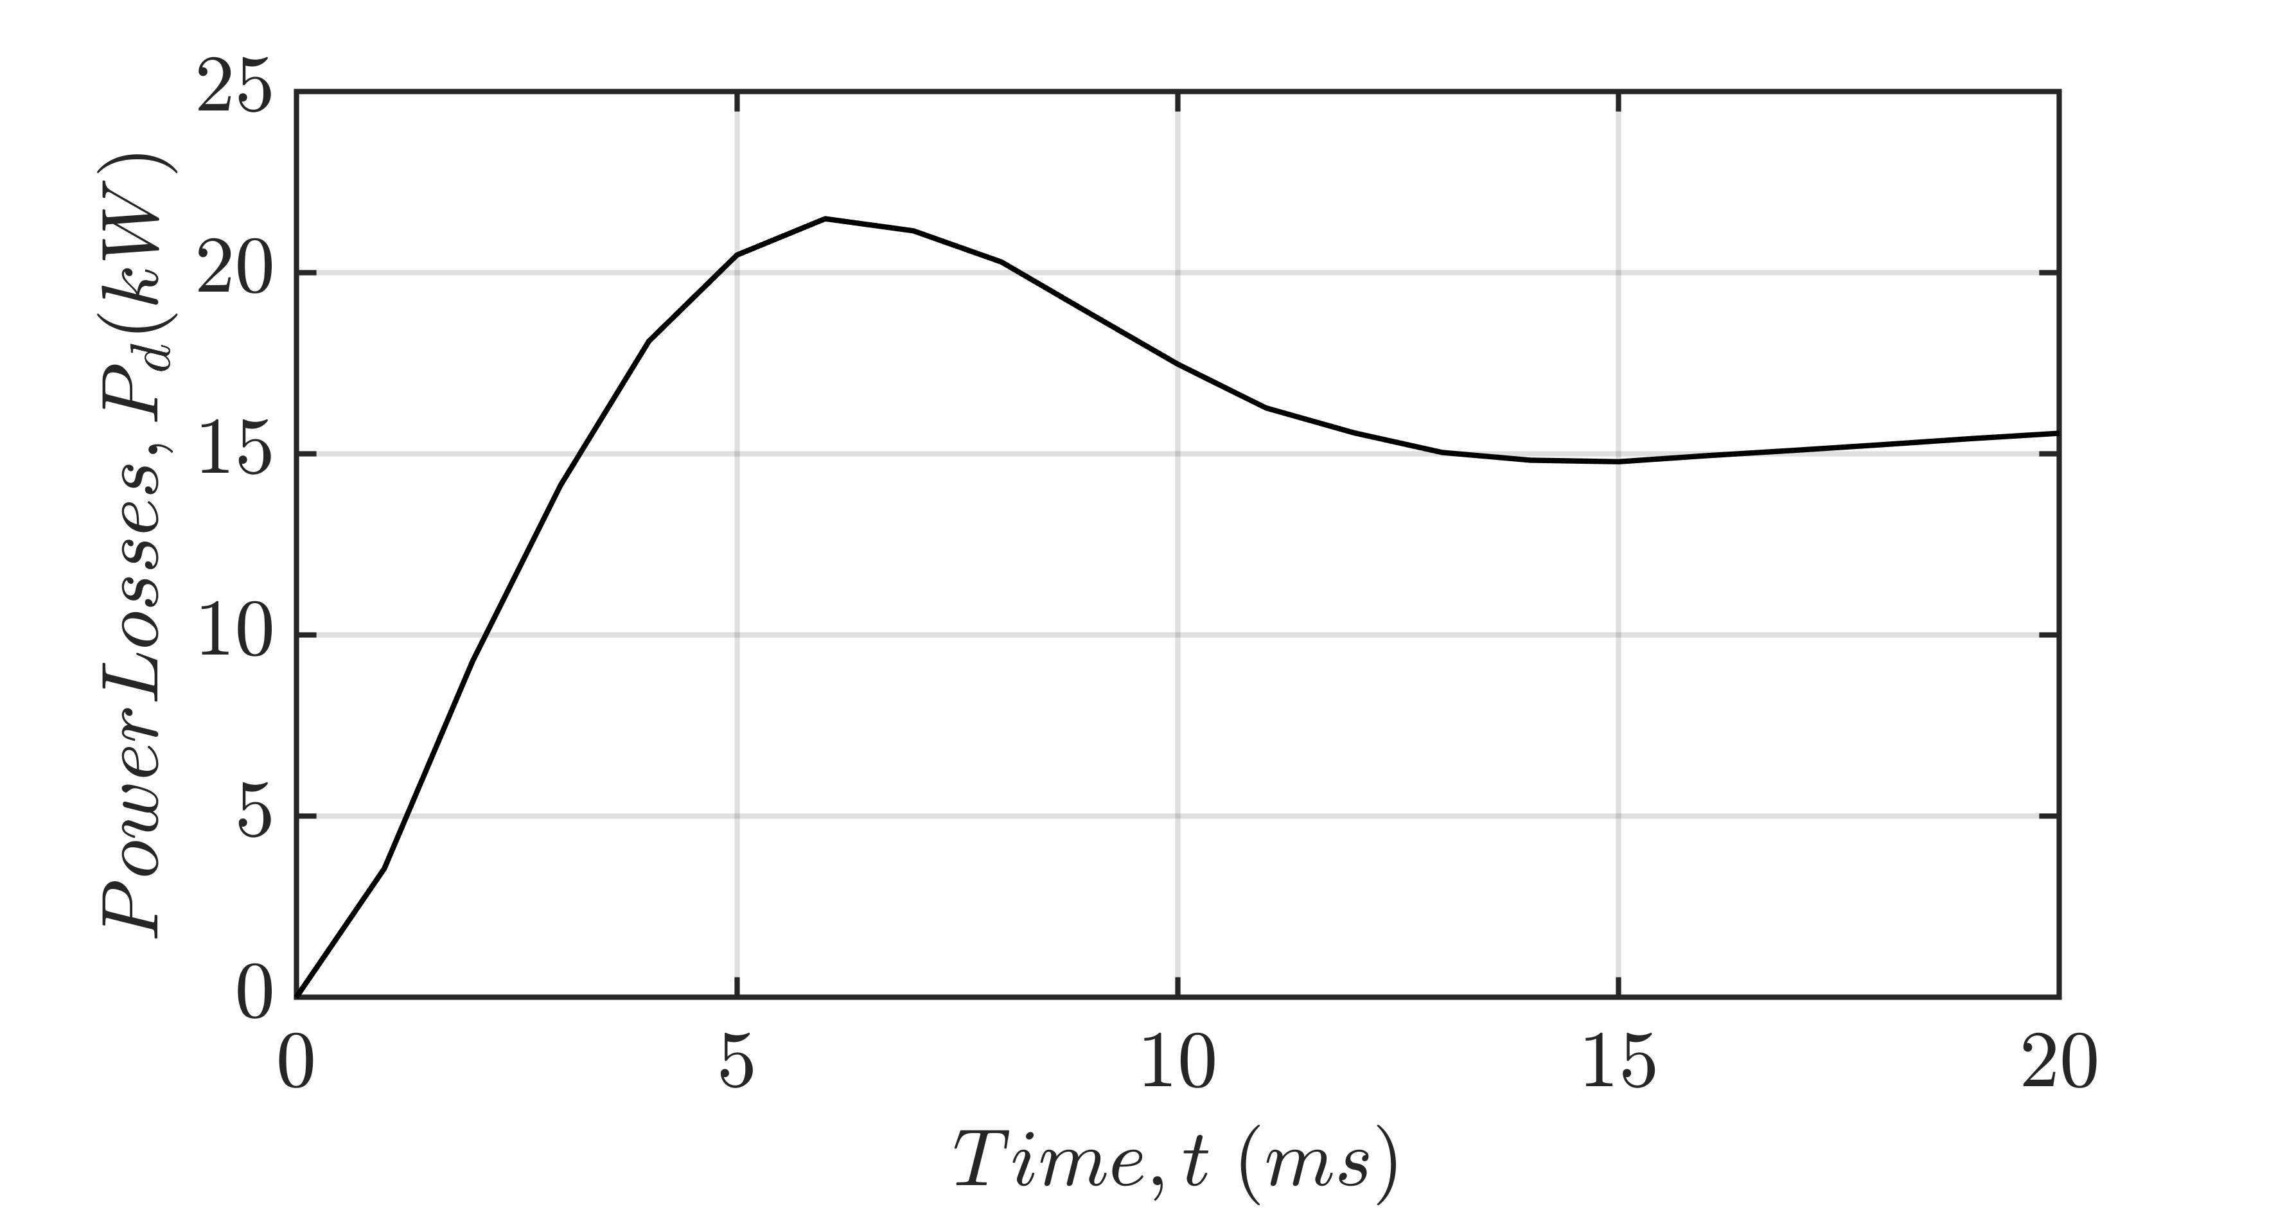
Rotor Joule-related losses for Design 5.

Conclusions
This paper presents a preliminary study of an eddy current that could be implemented in a traditional brake system to reduce the pollution and that could be a possible solution for mobility, from electric bicycle to vehicle. The study focused on analyzing and simulating different eddy current brakes designs using permanent magnets. After presenting a general phenomenon overview in Section 2.1, a schematic system for the analytical approach was analyzed in Sections 2.2 and 2.3, reviewing all the possible differences between the theoretical and the actual systems in Section 2.4. Designs for EMS tool’s FEM co-simulation were presented in Section 3.1 and detailed in Section 3.2.
Results, shown in Section 4, highlight the significant difference between analytical and simulation results. This gap is due to strong assumptions on the magnetic flux field behavior adopted in the analytical approach. In fact, the magnetic field tends not to stay in uniform cross-sections and permanent magnetic couples to interact with each other as, in the actual application, dispersion fluxes are a dominant part of the phenomenon. Due to this phenomenon, simulation procedures demonstrate how performance lowers by increasing the number of permanent magnet couples inside the stator. This drop is due to field interactions among adjacent permanent magnets mounted on the same back iron, as the related reluctance path is more preferable to the one crossing the rotor disk.
Based on the obtained results (4.1 and 4.2), eddy current brakes are deemed unsuitable for stand-alone or emergency automotive applications. This incompatibility is not only highlighted by poor performance results but also, as [eq6] shows, by the fact that the braking torque directly depends on the rotor’s angular speed through a proportional factor $β$. This is a severe restraint for many ECB applications, such as automotive, as the brake cannot effectively stop the disk in a limited amount of time, as opposed to standard brakes. Nevertheless, the brake could be efficiently used in parallel to more efficient braking friction-based systems to effectively reduce the overall system’s wear.
Further developments will focus on a more throughout FEM and thermic co-simulation by implementing different boundary conditions, optimizing all the relevant parameters involved, and evaluating the performance losses by increasing the operative temperature. A OFF to ON co-simulation is indeed necessary to evaluate the brake’s actual dynamic performance, as opposed to the presented conditions, which do not consider a physically continuous phenomenon. Finally, the research will focus on the ECB position and bulkiness inside the vehicle, considering both wheel-side and motor-side placements.

[1] H. Moon, S. Y. Park, C. Jeong, and J. Lee, “Forecasting electricity demand of electric vehicles by analyzing consumers’ charging patterns," in Transp. Res. Part D: Trans. and Env., vol 62, pp. 64–79, 2018. doi: 10.1016/j.trd.2018.02.009
[2] G. Imberti, H. De Carvalho Pinheiro, and M. Carello, “Design of an innovative zero-emissions braking system for vehicles," in ICECCME-2022 Maldives, pp. 1–6, 2022. doi: 10.1109/ICECCME55909.2022.9988291
[3] J. Kukutschová, et al.: “On airborne nano/micro-sized wear particles released from low- metallic automotive brakes," in Environ. Pollut., vol. 159(4), pp. 998 –1006, 2011. doi: 10.1016/j.envpol.2010.11.036
[4] H. J. Weiss, H. Weiss, A. N. Lopatkin and N. N. Lopatkin, “True zero-emission vehicle energy generation and measurement in students’ educational project," in APEIE-2010 Russia, pp. 86–92, 2010. doi: 10.1109/APEIE.2010.5677346.
[5] G. Imberti, H. De Carvalho Pinheiro, and M. Carello, “Regenerative Braking Effects on Non-combustion Pollutant Release,” in: Niola, V., Gasparetto, A., Quaglia, G., and Carbone, G., eds., Advances in Italian Mechanism Science, Springer Int. Publishing, Cham, pp. 831–839, 2022. ISBN 978-3-031-10776-4 doi: 10.1007/978-3-031-10776-4_95.
[6] H. de Carvalho Pinheiro, G. Imberti, and M. Carello, “Pre-Design and Feasibility Analysis of a Magneto-Rheological Braking System for Electric Vehicles,” SAE International Congress WCX Detroit MI, USA, 2023. SAE Technical Paper 2023-01-0888, 2023. doi: 10.4271/2023-01-0888
[7] “Commission proposes new Euro 7 standards to reduce pollutant emissions from vehicles and improve air quality," in European Commission website. February 2023 [Online]. Available: https://ec.europa.eu/commission/presscorner/detail/en/ip_22_6495
[8] M. Gulec, M. Aydin and P. Sergeant, “Eddy current brakes: a review on working principles and technology evolution," ICEM-2022 Spain, pp. 441–447, 2022. doi: 10.1109/ICEM51905.2022.9910747
[9] K. Lee and K. Park, “Optimal robust control of a contactless brake system using an eddy current," in Mechatronics, vol. 9(6), pp. 615–631, 1999. doi:10.1016/S0957-4158(99)00008-2
[10] C. Holtmann, “Eddy current- and friction brake fusion by a disc-spring to a hybrid- brake," in ICMT-2021 Singapore, pp. 1–6, 2021. doi: 10.1109/ICMT53429.2021.9687288
[11] ISO/TR 13487:1997 - Braking of road vehicles - Considerations on the definition of mean fully developed deceleration.
[12] L. Pugi, T. Favilli, L. Berzi, E. Locorotondo, M. Pierini, “Brake blending and torque vectoring of road electric vehicles: A flexible approach based on smart torque allocation," in International Journal of Electric and Hybrid Vehicles, vol. 12(2), pp. 87–115, 2020. doi: 10.1504/IJEHV.2020.106339

