Pre-Design and Feasibility Analysis of a Magneto-Rheological Braking System for Electric Vehicles
Abstract: Magneto-Rheological (MR) Fluid started to be used for industrial applications in the lasts 20 years, and, from that moment on, innovative uses have been evaluated for different applications to exploit its characteristic of changing yield stress as a function of the magnetic field applied. Because of the complexity of the behaviour of the MR fluid it is necessary to perform lots of simulations, combining multi-physical software capable of evaluating all the material’s characteristics.
This article proposes a strategy capable of quickly verifying the feasibility of an innovative MR system, considering a sufficient accuracy of approximation, able to easily verify the principal criticalities of the innovative applications respect the MR fluid main electromagnetic and fluid-dynamic capabilities. The procedure follows four main steps: designing the solution functionally related with the Magneto-Rheological principles, followed by two steady-state analysis (performed respectively with Altair Flux and Altair Acusolve) needed for defining the electromagnetic and fluid-dynamic behaviour of the fluid in the application; once the basic feasibility was defined, material and geometrical optimization were be performed for maximising the MR capabilities into the innovative system designed.
The strategy proposed has been used for validating the feasibility analysis of a Magneto-Rheological Brake for the automotive applications, in particular for electric vehicles. Once the design phase defines a preliminary functional geometry for the application taken into consideration, it is needed to validate through software the effectiveness of the innovative layout and its capabilities to reach the expected results, before developing a prototype that requires an important economical effort.

Introduction

State of Art for Pre-Design Magneto-Rheological Simulations
Magneto-Rheological (MR) Fluid is an innovative and multi-purpose fluid, whose most important characteristic is to change its yield stress as a function of the magnetic field applied on it. In bibliography lots of examples of innovative applications have been presented [1] [2] [3], but no strategy descriptions for developing from a concept through a pre-feasibility stage have been shown. It is important to apply a good strategy to define the pivotal points of the application, in order to limit the costs in term of computational power and time.
In this paperwork it is descripted a strategy that perfectly fits with the preliminary design phase. In fact, after the definition of a preliminary geometry and the application expected results, it has been proposed to follow these steps: Electro-magnetic analysis and feasibility, fluido-dynamic analysis and geometric and material proto-optimization. Each of this phase only takes into consideration the steady-state behaviour, as it is not needed yet to have an exhaustive analysis of the transitory behaviour of the innovative tools, in this validation phase.

Introduction to Magneto-Rheological Brakes Case Study
Nowadays, one of the most important research fields in the automotive industry is the development of vehicles capable of reducing the pollutant emitted, trying to reach a carbon neutrality during their whole driving life cycles. For doing so, it is fundamental to develop not only Electric Vehicles (EV), but also resetting the indirect pollutant emitted by other components and, most importantly, by the braking system [4]. For this reason, an innovative zero-emission driving system has been developed [5].
Considering the needs that a vehicle has in terms of braking performances the braking system chosen uses the MR fluid as the pivotal component able to create a sufficient resistive torque to stop the vehicle without emitting particulates and other pollutants [6].The geometry layout chosen is represented in Fig. 1 and it is composed combining an in-wheel motor with an external braking stator, while in between the MR fluid is put, for creating in that area the resistive forces needed to create the braking torque. The idea is to use the free spaces around the external part of the in-wheel motor to maximise the arm of the resistive forces generated by the changes in yield stress of the MR fluid, and, in this way optimising the decelerating torque.

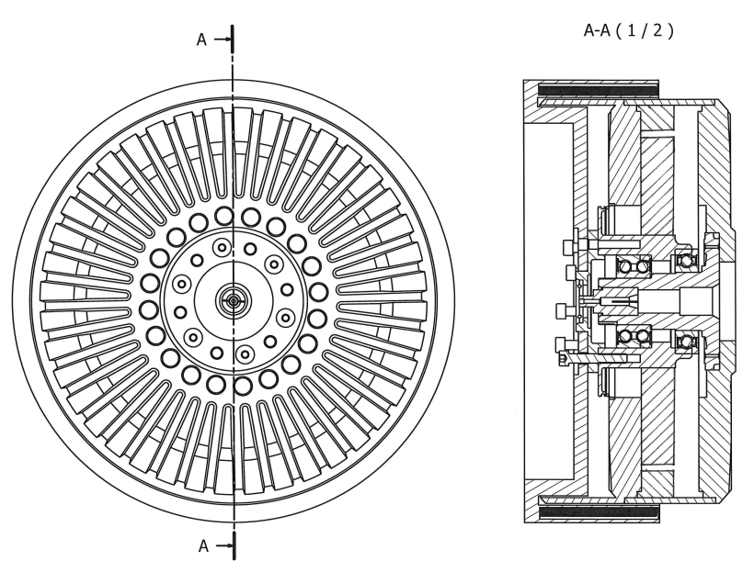
Fig. 1 Layout of the Innovative Braking Solution
The In-Wheel EM should be adapted to maintain a thinner and concentrated structure on the external part of the rim. In particular, the rotor should be designed with a protuberance that goes over the stator volume, to use the free space as the interference surface with the MR brake stator.
The MR stator has been developed with the goal of obtaining a sort of clamp able to surround the rotor protuberance and have part of the interference surface both on the inner and the outer part of the rotor. It has been also thought as a concave component to obtain an acceptable volume for the connection to the rest of the vehicle and to the suspensions. On the external part of the clamp the coil must be fixed. It has been considered as a double component of a bobbin where the coil is wrapped up and its dimensioning has been performed during the electro-magnetic validation, as one of the most effective parameters on the development of a sufficient magnetic field on the MR fluid.
Two are the important parameters to be taken into consideration for changing the physical characteristics of the braking system:
- The current and the coil disposal
- The gap between the MR stator and the rotor
Considering bibliographical data coming from Nguyen et al [7] and Sohn et al [8], they have been defined for the first feasibility evaluation.
The main objective to be taken into consideration is related to the braking torque needed. The following simulations have been performed at the higher legal speed in Italy (130km/h) and the needed braking torque for each wheel has been computed following the equations proposed by Nguyen et al. [7]. A minimum torque to be reached has been defined using the energy conservation of equation (1):
$\frac{M_{C}V_{C}^{2}}{2}=\frac{T_{tb}V_{C}^{2}}{R_{w}2a_{c}}$ (1)
Where $M_{C}$ is the vehicle mass, $V_{C}^{2}$ is the vehicle speed, $T_{tb}$ is the torque to be computed, $R_{w}$ the wheel radius and $a_{c}$ the deceleration to be performed. Considering average values for standard cars, where the mass is equal to 1600kg, the deceleration of an average limit braking is 0.8g and the wheel radius can be considered equal to 0.326m, considering the simplification of eq. 11 it is possible to affirm that:
$T_{tb}=M_{c}R_{w}a_{c}=1025 Nm$ (2)
The number computed is pivotal in the further analysis for considering a technology feasible more than another, as it will be considered the minimum threshold to be obtained. For evaluating a realistic value of the torque through the pre-feasibility stage it is fundamental to evaluate two types of simulations:
- Electro-Magnetic, for evaluating if the maximum yield stress of the MR fluid is reachable through the new layout defined and through the distance between the coil and the MR fluid itself.
- Fluid-Dynamic, for the evaluation of the torque available at the wheel in the maximum yield condition.
Every step needs to be positively overcome, with a result compliant to the expectations, before starting the following one, because the result of each stair is the input for the following one.

Electro-Magnetic Validation
The main goal of this simulation is to understand how much the MR fluid is got through the magnetic density generated by the coil and, if not, to perform a first raw optimization for what concern the magnetic properties of the parts, starting with the number of windings for the coil, to the current to slide in the coil itself and the materials chosen for the optimal magnetic fit for the rotor protuberance, the stator and the bobbin. Another interesting aspect is to understand the correlation between the current and the magnetic field, expected to be linear, in order to start understanding the way the system can be controlled. In fact, it is important to remember that the MR fluid has the capability to respond immediately to the magnetic field changes, so it would be possible to control the braking system building a control transfer function that, with the current as input, can vary the final braking torque applicable to the wheel and the whole vehicle.
The first step has been to define the geometry of the part, that has been sketched as a section of the CAD drawing presented in Fig. 1, with a focus on the interface area. It has been preferred to not reproduce the bearing and the stator, as, for the first feasibility analysis are not the focus of the results expected. It is important to underline that the MR stator has been divided into 3 subparts: the main stator, the coil, and the bobbin, as those three parts have a different impact for what concern the electro-magnetic capabilities.
The materials chosen for the parts are shown in Tab. 1.
Tab. 1 Material Electro-Magnetic Characteristic [9]
COMPONENT | RELATIVE PERMEABILITY (H) | SATURATION (T) | SHAPE COEFFICIENT
Rotor | 2500 | 2.01 | 0.75
Stator | 2500 | 2.01 | 0.75
MR Fluid | 3.9789 | 2 | 0.05
Bobbin | 2500 | 2.01 | 0.75
As it is possible to see, the material chosen for the metallic parts is the same and it is FISI Steel, chosen as a common magnetic steel with non-linear magnetic properties. It is important to choose an adaptable value for the permeability of the steel in order to allow reasonable transmission of the magnetic field to the MR fluid. The MR fluid chosen is LORD MRF-132DG [10], as its characteristics have been considered as better from different points of view. In fact, only two MRF are suitable for this application, MRF-132DG and MRF-140DG, but, although the second has a higher peak for the shear stress at the same magnetic field applied, it has a higher viscosity, meaning in a higher rolling resistance and higher temperature at zero magnetic field. Another factor not to be forgotten is the thermal conductivity of the two, lower for MRF-140, meaning in higher temperatures and also, combined with higher heat dissipated due to the higher viscosity. The most suitable is definitely MRF-132DG whose electro-magnetic characteristics have been reported in Fig. 2.
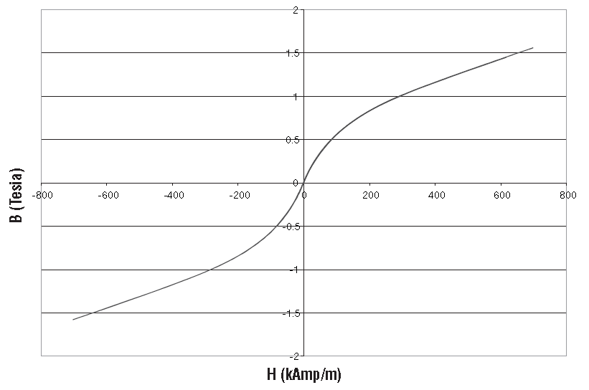
Fig. 2 MRF-132DG Magnetic Properties [10]
The application is magneto-static, as the magnetic field has a constant value as a function of the current coil. The coil is the pivotal component in analysing the magnetic field. In fact, the more windings are present, the higher the magnetic field will be, considering the same current flowing in it.
The results obtained must be fit with the magnetic density vs yield stress graph presented as a characteristic for the MRF-132-DG shown in Tab. 1, so that the maximum magnetic field value corresponding to the maximum yield stress point is reached in the majority of the MR fluid area. Considering possible limits in computing the magnetic field of the software the value of 300 kA/m has been chosen as the threshold.
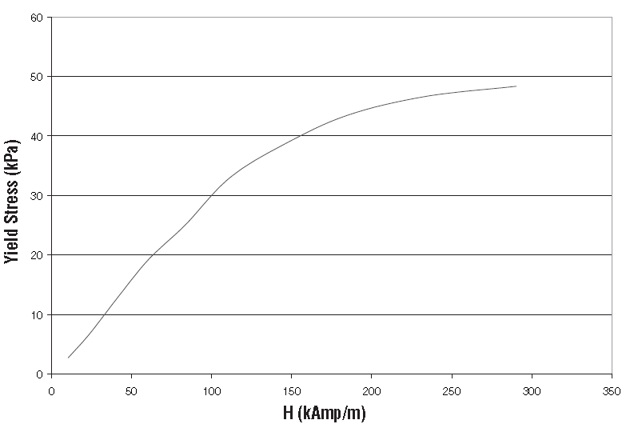
Fig. 3 Yield Stress vs. Magnetic Field Strength MRF-132DG [10]
The results obtained are shown in Fig. 4 and Fig. 5, presented at a constant value of 25 A:
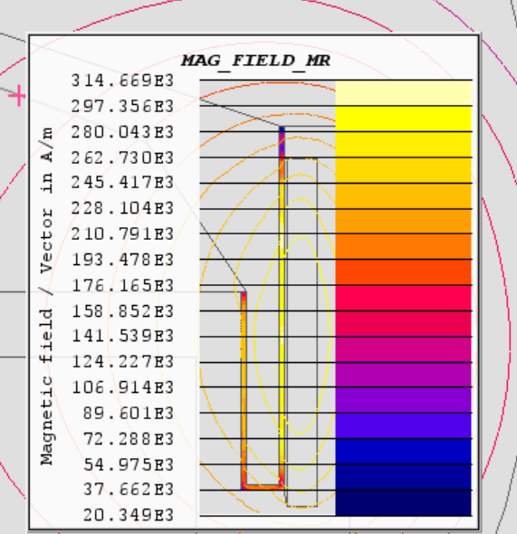
Fig. 4 Magnetic Field in Magneto-Rheological Fluid
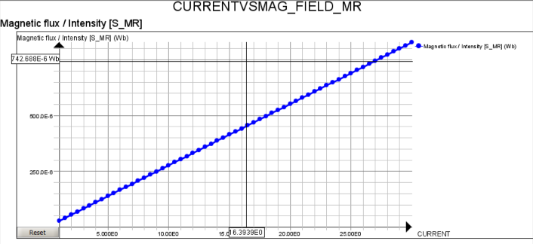
Fig. 5 Current vs Magnetic Field in Magneto-Rheological Fluid
As it is possible to see from Fig. 4, the expected result of 300 kA/m is reached in the greater amount of the area of the MR fluid. It is possible to underline that the effects on the upper border are not strongly effective because of the absence of the coil over that area, so, a first optimization possible is to enlarge the coil area reaching the end of the MR stator, for obtaining a homogeneous magnetization. The current is an aspect important to be defined and, as it is possible to underline from Fig. 5, it has a linear behaviour respect the magnetic flux generated, so, it is safe to say that higher the current, higher will be the magnetization of the MR fluid. It is important to underline that from a feasibility point of view, considering the geometrical sizes descripted before and a current of 25 A is enough to consider the application valid and working from an electro-magnetic point of view.
Because for a pre-feasibility step this simulation gives sufficient results, it is possible to proceed with the fluid-dynamic computations in the following paragraph.

Fluid-Dynamic Validation
After the validation of the electro-magnetic behaviour of the braking system, it is needed to proceed computing the maximum torque available to evaluate if it is enough to reach the expected value of 1025 N·m. For doing that, two different simulations have been performed, with the goal of evaluating the steady-state behaviour at the maximum yield stress possible for the fluid, but also the behaviour and rolling resistance at zero-magnetic field, so that would be possible to compute the rolling resistance of the new layout. In Fig. 6 it is possible to focus on the two points (blue dots) of the yield-vs-magnetic field curve points analysed.
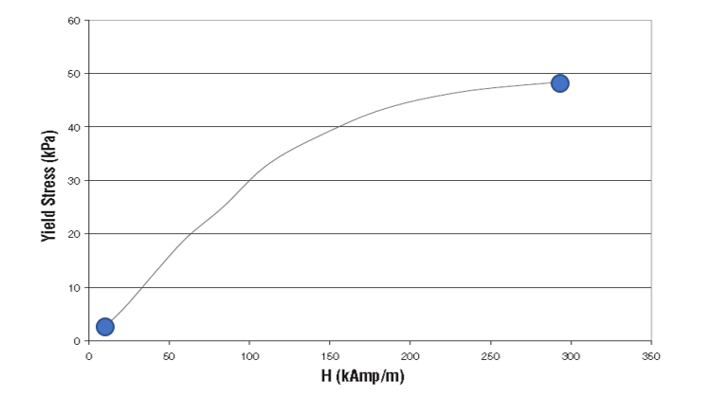
Fig. 6 Yield Stress vs. Magnetic Field Strength CFD Points Analysed MRF-132DG [51]
The CFD simulations have been performed using the software Altair Acusolve, while the model has been developed with Acuconsole. Using the software main rules only the fluid and its boundaries must be simulated, for this reason a specific CAD model presented in Fig. 7, where only the MR fluid is present, has been created. The thickness chosen has been maintained equal to 1.5 mm and all the other dimensions has been maintained unchanged, but only a section of 30° has been studied, to maintain smaller the number of nodes studied. The results of force and momentum computed would be right without any type of further multiplications because they are needed only in case of study of masses of solid parts.
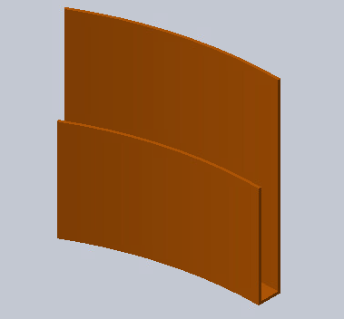
Fig. 7 MR Fluid CFD Simulated
The basic of CFD software is to put the fluid in motion and for this reason the simulation has been performed at a rotational speed of 120 rad/s, representative of a vehicle speed of 130 km/h. It is important to remember that a viscous rolling resistance is function of the vehicle speed and for this reason the minimum. It is for this reason fundamental to know the resistance at the hypothetical maximum allowable speed and, also the braking torque capable at the speed for which the minimum needed torque of 1025 N·m have been computed.
Materials simulated have to introduce the main characteristic of the MR fluid: non-Newtonian behaviour. The Bingham model has been implemented. This decision has been taken for simplicity as the software is able to simulate the specific behaviour of a fluid with Bingham, so the results obtained, will be slightly overachieving and this will be taken into consideration in the conclusion phase. Two materials model have been introduced with the characteristics presented in Tab. 2. For the baseline values the left-lower point in Fig. 6 is considered while max takes into consideration the right-upper blue point.
Tab. 2 MRF Characteristic for CFD simulation Bingham Model [9]
VALUE | MRF BASELINE | MRF MAX
DENSITY (g/cm³) | 3 | 3
SPECIFIC HEAT (J/kg) | 800 | 800
REFERENCE VISCOSITY (Pa-s) | 0.112 | 0.112
YIELD STRESS (kPa) | 0.8 | 50
INFINITE SHEAR VISCOSITY (Pa-s) | 0.112 | 0.112
PRANDTL NUMBER | 0.91 | 0.91
The obtained results of momentum and force must be considered on the stator surface because of the concordance of the fluid with the rotor. The force is the one coming from the Z axis, considering it the one concordant to the rotor speed. The expected speed result is to find a boundary layer representative of the laminar flow simulated, where the speed of the fluid would be decreasing reaching the zero-value near the stator wall.
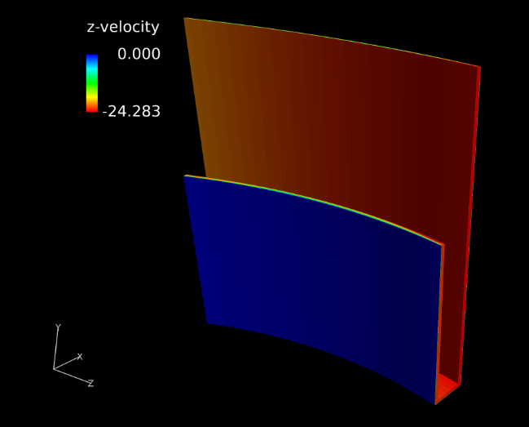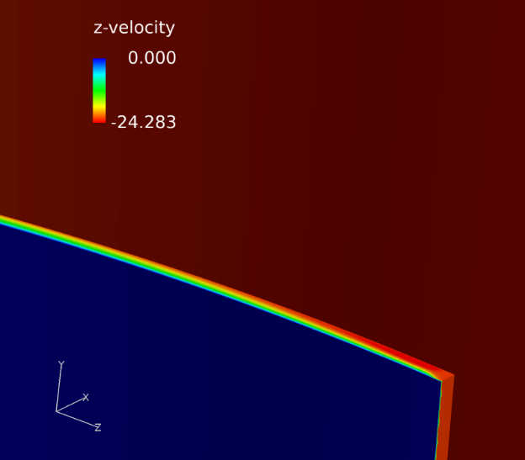
Fig. 8 Z-Velocity - Zero-Magnetic Field Simulation
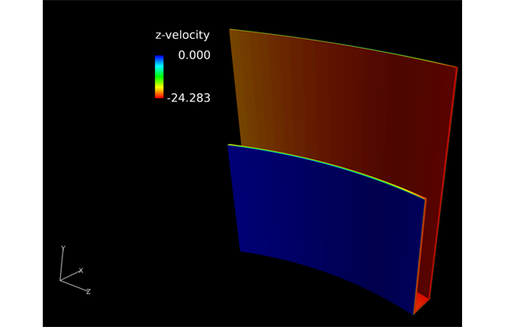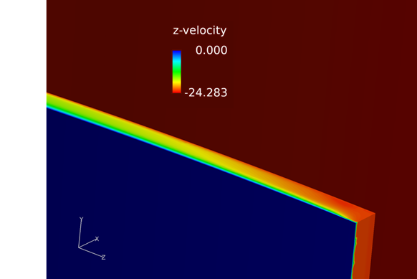
Fig. 9 Z-Velocity - Maximum Magnetic Field
As it is possible to see in both Fig. 8 and Fig. 9, the laminar behaviour on the boundary layer is confirmed and it is possible to affirm that the simulation from a speed point of view has an acceptable result. The maximum speed underlined by a red colour is 24 m/s as expected for the rotational speed of the fluid implemented as 120 rad/s for obtaining 130 km/h on the wheel. The boundary layer is reasonably thick to rapidly reduce the speed from the rotor to the stator surface. The difference in boundary layers is also acceptable and depends on the different yield behaviour of the fluid. In fact, for the maximum magnetic field case the boundary layer area at the beginning of the interface between the stator and the rotor has a shorter cue, meaning the deceleration of the fluid is more rapid and impactful, as to be expected by a theoretical point of view, considering the same input velocity and boundary conditions.
Tab. 3 Torque Computed with CFD Simulation
 | ZERO-MAGNETIC FIELD | MAXIMUM-MAGNETIC FIELD
TORQUE (N·m) | 64 | 1113
Torques obtained for the two simulations are shown in Tab. 3. It is possible to affirm that the maximum magnetic field torque overcome the threshold defined at 1025 Nm, meaning that for a pre-feasibility analysis the result is satisfactory and good enough to affirm that optimizations could be done for improving and enlarging it. The zero-magnetic field torque is small enough to not affect the acceleration performances of the vehicle and for these reasons it is possible to proceed in computations and analysis for improving the whole system performances.

Optimization
The first optimization needed during a pre-feasibility phase are related to pivotal geometrical data and, most importantly, on the material choice. For doing so, another iteration of both simulations are needed, as for a general MR tool the material choice depends on the electro-magnetic behaviour of the materials themselves, while for the geometry it depends on the fluid-dynamic behaviour.
In this case, the MR brake, needs three pivotal cases to be analysed and optimised:
- Material Optimization and choice.
- Coil disposal, number and radius.
- Stator to Rotor gap optimal height, where the MR fluid is put.

Electro-Magnetic Optimization
Materials used in the pre-feasibility analysis and reported in Tab. 1 represent a raw definition of the choices in term of materials to be used in the application. It is important to remember that the substances can be divided into three categories according to their magnetic compatibility. For the metals, the behaviour could be divided into ferromagnetic materials (as iron or steel for example) and paramagnetic (like aluminium). In an optimization for the application of MR fluid is fundamental to manage different combinations of materials between the two categories and the components, to maximise the magnetic field inside the MR fluid surface, limiting useless dispersion.
In this case, after managing different simulations combining the materials, the best fit used is the one chosen and reported in Tab. 4.
Tab. 4 Material Electro-Magnetic Characteristic after Optimization
COMPONENT | RELATIVE PERMEABILITY (H) | SATURATION (T) | SHAPE COEFFICIENT
Rotor | 2500 | 2.01 | 0.75
Stator | 1 | 1.95 | 0.4
MR Fluid | 3.9789 | 2 | 0.05
Bobbin | 2500 | 2.01 | 0.75
As it is possible to see, the material chosen for the external part of the Stator is aluminium and not steel anymore, because it allows to increase the magnetic field around the MR fluid, as it works as a wall, limiting dispersion of the field in the area over the component and focusing it on its internal part, as it is visible in Fig. 10, respect the ones shown in Fig.4. Rotor and bobbin are maintained in steel as it is a good compromise between the peak magnetization and avoiding insulation. No further analysis should be done on the coil material as copper is generally and globally considered the better solution.
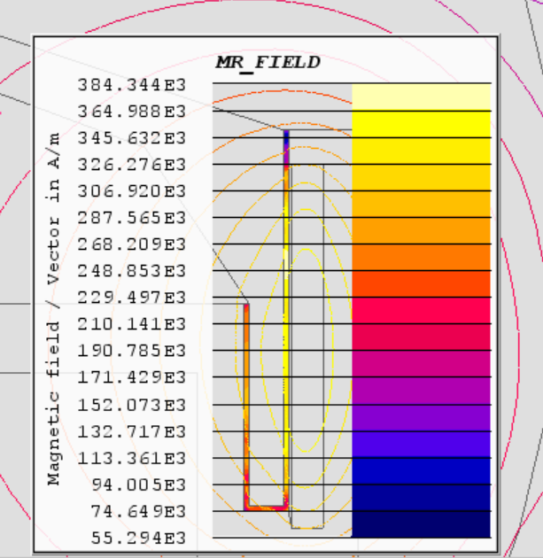
Fig. 10 MR Fluid Magnetic FIeld after Material Optimization
Another possible optimization is related to the number of coils combined with the current needed for obtaining the threshold magnetic field needed. The simulation has been performed evaluating the variable magnetization factor respect the current and the coils obtaining, as a result, a map representative of the different magnetization situations. It is easy to see from Fig. 11 a growing factor related to the current growth, but the interesting part is related to finding the optimal point for obtaining the maximum magnetization with the minimum n° of coil and a lower current, found on the peak of the graph.
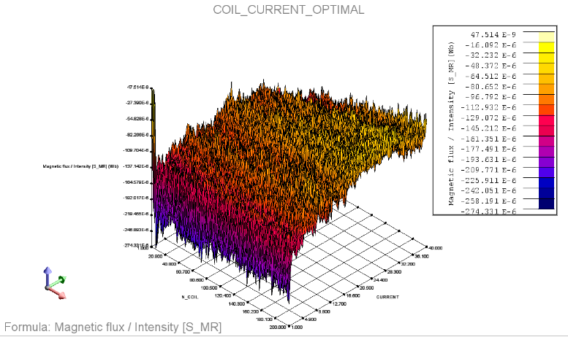
Fig. 11 N° Coils optimization graph

Fluid-Dynamic Optimization
The second most important parameter for a MR brake is the gap between the stator and the rotor, where the MR fluid is put. Optimizing it is important for maximising the braking torque without having an exaggerate rolling resistance at zero magnetic field. Nguyen et al. affirm that a critical behaviour is shown when the gap overcome 2mm, so for this reason the analysis has been done using a parametric CAD file of the MR fluid CAD drawing shown in Fig. 7. The parametric value of the gap has been imposed between 1mm to 2mm, starting with the 1,5mm simulation done for the pre-feasibility phase.
The results obtained and shown Fig. 12 represents respectively the curves of the maximum braking torque and the rolling resistance at zero-magnetic field varying the gap between the two parts.
Fig. 12 Torque Coefficients as a Variable of the Gap Width – Max Magnetization left, Zero-Magnetic Field right
After performing different CFD simulations with a gap-width varying geometrical model, computing the torque coefficient as the ratio between the baseline torque computed at 1,5mm of width with the other CFD simulation results and then fitting it with a third-degree equation, the graphs have been produced. As it is possible to see, the different behaviour shown allows to confirm the conduct descripted by Choi et al. [11], considering 2mm as an important threshold for having an acceptable torque for the maximum magnetization status. Comparing the results obtained for the maximum magnetic field torque and the results at zero-magnetic field, it is possible to affirm that reducing too much the gap width has more drawbacks in term of rolling resistance respect how much improve the maximum braking torque available. For these reasons, it is possible to affirm that, for sake of geometrical simplicity 1,5mm is a good approximation between advantages and issues.

Conclusions
In conclusion it is possible to synthetize the strategy used for simulating the pre-feasibility phase for a magneto rheological fluid component:
- Definition of the application and the geometry, with a threshold value to be reached and overcome for considering the technology feasible. For the MR Brake application, it has been chosen as the braking torque higher than 1025Nm.
- Electro-Magnetic Analysis. As the pre-feasibility should analyse a steady-state behaviour, it is sufficient to evaluate if the MR fluid reach the minimum magnetization considered for the application. In the case of MR Brakes, the maximum magnetization possible for the MR fluid is requested and reached.
- Fluid-Dynamic Analysis. This tool allows to evaluate the forces acting on the walls around the fluid, giving the forces and torques reacting to the fluid itself. In the case of the MR Brakes, torque around the stator walls has been considered and evaluated, overcoming the threshold torque imposed.
- First Material, electro-magnetic and geometrical optimization. The three main parameters of the MR fluid application should be analysed for maximising the effects requested. In this case a material change has been decided after the optimization and the number of coils and the gap distance have been changed for having a more suitable and operative design.
In the end of the first simulations try-out, it is possible to affirm if the innovative solution is working and if it would be considered feasible, while, if one or more simulations do not satisfy the considered goal, the geometrical layout should be modified and adapted for reaching the expected objective. In the case of the MR brakes, it is possible to affirm that the simulations give a consistent result and proceeding with a prototype could be possible for validating the results obtained.

References

[1] | M. K. Kwak and al, “Hardware-in-the-loop simulation experiment for semi-active vibration control of lateral vibrations of railway vehicle by magneto-rheological fluid damper,” Vehicle System Dynamics, vol. 52:7, no. DOI: 10.1080/00423114.2014.906631, pp. 891-908, 2014.
[2] | S. Suzuki and al, “Dynamic Response Analysis of Shear-Type Compact MR Brake Using Finite Element Method,” IEEE Transactions on Magnetics, vol. 3, no. doi: 10.1109/TMAG.2009.2012798., pp. 1728-1731, 2009.
[3] | C. Wu and al, “Simulations on the rheology of dry magneto-rheological fluid under various working modes,” Smart Materials and Structures\, vol. 31, no. DOI:1361-665X/22/015031, pp. 15-31, 2022.
[4] | J. Kukutschová and al., “Wear mechanism in automotive brake materials, wear debris and its potential environmental impact,” Materials Science - Wear, no. doi:10.1016/J.WEAR.2009.01.034, 2009.
[5] | G. Imberti and al, “Regenerative Braking Effects on Non-Combustion Pollutant Release,” Unpublished, 2022.
[6] | G. Imberti and al, “Design of an Innovative Zero-Emissions Braking Solution for Vehicles,” IEE, no. unpublished, 2022.
[7] | Q. H. Nguyen and al, “Optimal design of disc-type magnetorheological brake for mid-sized motorcycle: experimental evaluation,” Smart Mater. Struct, no. DOI: 10.1088/0964-1726/24/8/085009, 2015.
[8] | J. W. Sohn, J. Jeon and Q. H. Nguyen, “Optimal Design of disc type magnetorheological brake for mid-sized motorcycle: experimental evaluation,” Smart Mater. Struct, 2015.
[9] | M. R. Jolly and al, “Properties and Applications of Commercial Magnetorheological Fluids,” Lord Corporation, Cary, NC 27511, 1999.
[10] | L. ltd, MRF-132DG Magneto-Rheological Fluid, 111 Lord Drive, Cary, NC, USA, 2019.
[11] | J. Sohn, H. G. Gang and S.-B. Choi, “An experimental study on torque characteristics of magnetorheological brake with modified magnetic core shape,” Advances in Mechanical Engineering, no. DOI: 10.1177/1687814017752222, 2018.
[12] | Nguyen and Choi, “Optimal design of an automotive magnetorheological brake considering geometric dimensions and zero-field friction heat,” IOP PUBLISHING, no. doi:10.1088/0964-1726/19/11/115024, 2010.

