Biomethane potential of wine lees from mesophilic anaerobic digestion
Marco Chiapperoª, Franco Berruti^{b}, Silvia Fioreª *

ª DIATI (Department of Engineering for Environment, Land and Infrastructures), Politecnico di Torino, Corso Duca degli Abruzzi 24, 10129, Torino, Italy
^{b} Institute for Chemicals and Fuels from Alternative Resources (ICFAR), Department of Chemical and Biochemical Engineering, Faculty of Engineering, Western University, London, Ontario, N6A 5B9, Canada

*corresponding author: Prof. Silvia Fiore (silvia.fiore@polito.it)

Highlights
- Wine lees (WL) were suggested as a potential substrate for biomethane production
- The wide range of WL characteristics led to varying biomethane potentials
- Overloads of COD in WL mostly in soluble forms led to inhibition of methanogenesis
- In this study, biochar supplementation didn’t mitigate the process’ instabilities
- High sCOD and wide variability of WL characteristics were critical issues

Graphical abstract
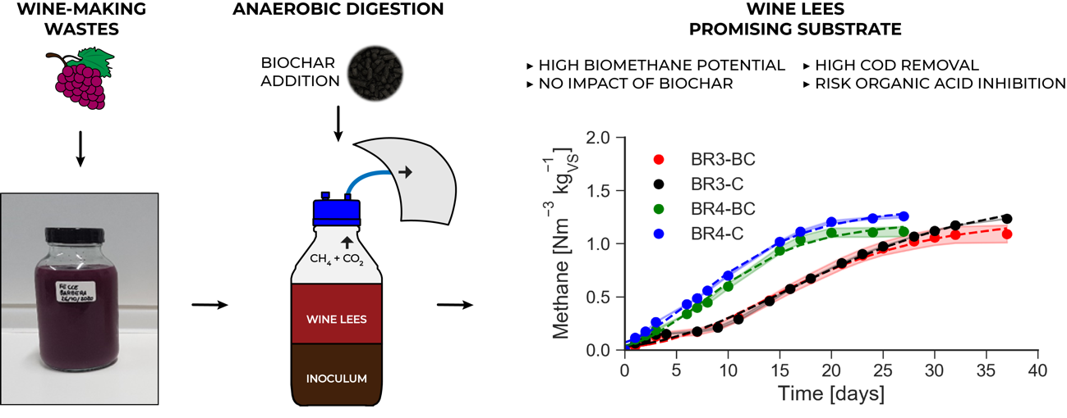

Abstract
Wine lees (WL) are undervalued residues from the wine-making process. Anaerobic digestion (AD) of WL is highly challenging due to the acidic pH and high content of readily biodegradable compounds. This study investigated the biomethane potential (BMP) of 3 WL samples through mesophilic batch tests fed with 2-3 % total solids. The influence of wood-based biochar (BC), considering 2 different BCs and doses (3 and 10 g L⁻¹), was also assessed. BMP values up to 1.257 Nm³ kg_{VS}⁻¹ and 92-96 % soluble COD removal were recorded. However, the inhibition of methanogenesis was observed due to organic acids accumulation exceeding 21-24 g L⁻¹. BC addition didn’t improve biomethane production in the considered experimental conditions. This study proved that WL is a highly attractive AD substrate, considering its high biodegradability and availability throughout the year, although the process must be carefully operated.

Keywords: anaerobic digestion; biochar; biogas; organic acids; winery waste.
Abbreviations:
AD: anaerobic digestion
BC: biochar
BR: Barbera
BS: Barbaresco
COD: chemical oxygen demand
GAE: gallic acid equivalent
S/I: substrate to inoculum ratio
SBP: specific biogas production
SWP550: soft wood pellets biochar, produced at 550 °C
ThBMP: theoretical biomethane potential
TS: total solids
VS: volatile solids
WL: wine lees

1. Introduction
The wine-making industry has considerable importance around the world, with global grape production reaching 78 Mt in 2020 [1]. Italy, France and Spain are the top three world producers, with 12.3 million m³ of wine in 2019 [2]. Environmental concern related to wine-making can regard water and energy consumption, greenhouse gases emissions, use of pesticides and fertilizers, production of solid and liquid waste flows [3]. In details, 1000 kg of processed grapes produce 0.75 m³ of wine and 130 kg of marcs (or pomace) from pressing, 60 kg of lees from settling, 30 kg of stalks from destemming and 1.65 m³ of wastewater [4]. The reduction and the proper management of these wastes can improve the overall environmental performances of the wine production [5]. These wastes can be suitable feedstocks for biological or thermo-chemical treatments to produce bioenergy, to extract valuable chemicals as phenols, antioxidants, and tartaric acid, and for agricultural and environmental applications as composting or animal feed [6–8]. In Europe, pomace and lees were compulsorily used in distilleries according to EC 1493/1999 Council Regulation [9]. However, Council Regulations 479/2008/EC and 555/2008/EC permitted many of the abovementioned applications. Unfortunately, in some countries as Italy the adoption of these solutions remains unexploited, due to economic, bureaucratic, and technical barriers [10].
Anaerobic digestion (AD) is a well-established biological technology able to convert complex organic substrates into biogas, a renewable energy source, and digestate, a potential soil improver [11]. AD has been already adopted to treat winery wastewater [12], and pomace, stalks, seeds, and wine lees (WL), with methane productions in the range 0.1-0.5 Nm³ kg_{VS}⁻¹ [13]. Compared to other wine residues, fewer studies considered the AD of WL alone. A yield of 0.370 Nm³ CH₄ kgVS⁻¹ was observed during batch thermophilic AD of WL [14], and 0.876 m³ Kg_{VS}⁻¹ during mesophilic AD of WL [15]. Biogas yields ranging 0.254-0.856 Nm³ kg_{VS}⁻¹ with 55-60 % methane were obtained from the mesophilic AD of WL [16].
Wine lees are the by-products remaining at the bottom of wine production tanks after fermentation, storage, or additional processing, including waste generated from filtering and centrifugation [17]. WL are composed by yeast cells, tartrates, proteins, and polysaccharides [18]. They present high COD (> 30,000 mg L⁻¹) and are produced throughout the year (in contrast to other wine-making residues), hence WL could be a promising substrate for AD. On the other hand, WL also have acidic properties (pH values from 3 to 6), contain phenolic compounds (up to 1,000 mg L⁻¹) [19], and during their AD organic acids are formed [15], all inhibitors of methanogenesis. To overcome these limitations, different strategies have been proposed to apply AD to WL: co-digestion with waste activated sludge [20,21], co-digestion with other winery wastes [21,22]; and pre-treatment via electro-oxidation [13].
Biochar (BC) is the solid residue produced during the thermo-chemical treatment of biomass in absence or with limited air. As carbonaceous porous material, BC can be used as adsorbent and catalyst in many environmental applications[24,25]. BC addition can improve the AD of readily biodegradable substrates [26-28] also in presence of inhibitory substrates [29,30]. BC has been reported to increase the buffer capacity of AD system, act as biomass support, and accelerate the syntrophic degradation of organic acids [31]. BC also enhances digestate quality as soil improver [32]. To our knowledge, the supplementation of BC to the AD of WL without any pre-treatment has been poorly explored, with only one study available [13]. However, the existing literature related to the analysis of BC role in the AD of other substrates [33] suggests that BC addition to WL may relieve organic acids’ stress and mitigate inhibition phenomena. The overall novelty of this study consists in the investigation of the AD of WL as single substrate in mesophilic conditions (37 °C) focusing on the control of methanogenesis and on the limitation of inhibition phenomena. Specifically, this study had two main novelties and objectives: 1. Investigating if AD constitutes a valid technology to treat WL: three WL samples, collected in different phases of red wine-making fermentation (1, 5 and 10 months after the harvesting), have been considered as substrate to account for its qualitative variability along the year. AD tests were performed adopting a substrate-to-inoculum ratio equal to 1:2, feeding 2-3 % total solids in batch and fed-batch modes, and applying (or not) pH adjustment. 2. Exploring the application of BC to control AD inhibition phenomena: two different BC samples deriving from woody biomass have been supplemented to the digesters, and the effect of different doses (3 and 10 g L⁻¹) was researched.

2. Materials and methods

2.1. Materials
The substrates consisted of wine lees (WL) derived from Barbaresco (BS) and Barbera (BR) red wines’ production in Piedmont (Italy). This study was based on four experiments of AD tests (Table 1): WL from Barbaresco in experiments 1 (BS1) and 2 (BS2), sampled respectively in July 2019 and February 2020; WL from Barbera (BR) in experiments 3 and 4, sampled in October 2020. Multiple WL samples were considered, to account for the variability in the composition of the substrates, depending on the phases of the wine fermentation process. BR were collected at the beginning of the fermentation, one month after the harvesting of the grapes; while BS were collected 5-10 months after the harvesting, when the fermentation process was forward. BS1 was characterized and stored in a freezer until the AD tests.
The inoculum employed in the AD tests consisted of anaerobic digestate from a mesophilic digester serving a large-scale wastewater treatment plant in Piedmont. The inoculum was sampled before each set of AD tests and stored at 37 °C in a water bath for 5-7 days [33].
Two biochar (BC) samples, both deriving from woody biomass, were supplemented to the AD tests. The first BC sample (SWP550) is a standard material supplied by the UK Biochar Research Centre (UKBRC, Edinburgh, United Kingdom, www.biochar.ac.uk). SWP550 was produced through slow pyrolysis of soft wood pellets in a pilot-scale rotary kiln pyrolysis unit at 550°C for 30 min [34] . The second BC sample was produced the pyrolysis of wood pallets (B-BC) at 1000 °C in an industrial scale pyrolysis unit; the B-BC was provided by the Institute for Chemical and Fuels from Alternative Resources (ICFAR, www.icfar.ca) at the Western University of Ontario, Canada. Before their addition to the digesters, the BC samples were manually powdered in an agate mortar.

2.2. Anaerobic digestion tests
The AD tests were carried out in mesophilic conditions at 37 °C (Table 1). Each reactor consisted of a 0.5 L Duran glass bottle, connected to a gas sampling apparatus (see Section 2.4). Substrate and inoculum were added to each reactor implementing a substrate to inoculum ratio (S/I) equal to 1:2 expressed as volatile solids (VS), that was adjusted respect to a previous study (S/I equal to 1:1) to minimize acidification [13]. The total solids (TS) content of WL in the digesters was tuned to 2-3 % by adding distilled water. The pH of the substrate was adjusted to 7.5 by adding NaHCO₃. The reactors were not supplied with any solution of macro- and micro-nutrients.

Table 1. Experimental conditions applied in the anaerobic digestion of wine lees
 | experiment 1 |  | experiment 2 |  | experiment 3 |  | experiment 4
Starting date | January, 2020 |  | February, 2020 |  | November, 2020 |  | November, 2020
Duration (days) | 20 |  | 15 |  | 37 |  | 27
Temperature (°C) | 37 |  | 37 |  | 37 |  | 37
Type of WL  Sampling date | Barbaresco (BS1)  July, 2019 |  | Barbaresco (BS2)  February, 2020 |  | Barbera (BR)  October, 2020 |  | Barbera (BR)  October, 2020
Working volume (L) | 0.4 |  | 0.25 |  | 0.4 |  | 0.4
S/I | 1:2 |  | 1:2 |  | 1:2 |  | 1:2
TS content (% bw) | 2 |  | 2 |  | 3 |  | 3
pH adjustment | no |  | yes |  | yes |  | yes
Methane measurement | gas analyser |  | washing solution |  | washing solution |  | washing solution
Feeding mode | batch | fed-batch | batch |  | batch |  | batch
Biochar | - | - | SWP550 | - | B-BC | - | B-BC | -
Biochar dose (g L⁻¹) | 0 | 0 | 10 | 0 | 3 | 0 | 10 | 0
ID | BS1 | BS1-FB | BS2-BC | BS2-C | BR3-BC | BR3- C | BR4-BC | BR4-C
No. reactors biogas | 3 | 3 | 2 | 2 | 3 | 3 | 3 | 3
No. reactors methane | 3 | 3 | 1 | 1 | 3 | 3 | 3 | 3

The headspace of each digester was purged with nitrogen for 3 minutes to eliminate air. The digesters were closed with a polypropylene GL45 screw cap and connected to the gas sampling apparatus (see Section 2.4). In total, this study was based on the results obtained from 42 reactors (Table 1). For each WL sample, 6 reactors were operated (3 for biogas measurement and 3 for methane). A “control” group of 6 reactors filled with substrate and inoculum (and no BC) was also operated, as well as a “blank” group (6 reactors containing only inoculum). The only except to this experimental design concerned experiment 2 of the tests, where 2 digesters have been operated for biogas measurement and 1 for methane. The digesters were placed in a temperature-controlled water bath set at 37 ± 1 °C. The mixing was provided manually twice a day. The tests were concluded when the marginal biogas or methane production was below 1 % of cumulative production for 2-3 consecutive days. At the beginning and at the end of each experiment, samples of digestate were collected and characterized (see Section 2.4).
Different experimental conditions (additional to the ones just described) have been adopted in the AD of sample BS1 (experiment 1) to investigate the stress of the AD system due to the high COD of the WL. In details, two feeding modes were investigated, batch mode (BS1) and fed batch mode (BS1-FB). In batch mode, 2 % TS substrate was added to the inoculum at the beginning of the tests with S/I equal to 1:2. Fed batch mode provided a final 2 % TS substrate content by means of four 0.5 % TS supplements, supplied every 2 days [22], so that the final S/I reached 1:2. Unlike other experiments, pH adjustment to 7.5 by NaHCO₃ was not provided to test the system in the worst conditions.
The net effect of BC on the AD process was explored in experiment 2 with sample BS2 (BS2-BC) by supplementing 10 g L⁻¹ of SWP550 BC, in agreement with literature [28,29], and considering a control group (BS2-C). In experiments 3 and 4, the effect of BC dose on methane production from sample BR was investigated by supplementing 3 g L⁻¹ (BR3-BC) and 10 g L⁻¹ (BR4-BC) of B-BC, considering control groups without BC (BR3-C and BR4-C).

2.3. Kinetic analysis
To assess the performance and kinetic of AD, the cumulative biogas and methane production curves were fitted by the modified Gompertz equation (eq. 1):
$B\left(t\right)=P\exp\left\{-\exp\left[\frac{R_{max} e}{P} \left(λ-t\right)+1\right]\right\}$ (1)
Where B(t) is the cumulative biogas/biomethane production (Nm³ kg_{VS}⁻¹) at time t (d); P is the biogas/biomethane potential of the substrate (Nm³ kg_{VS}⁻¹); R_{max} is the maximum production rate (Nm³ kg_{VS}⁻¹ d⁻¹); λ is the lag phase (day); e is the Euler’s number. The kinetic parameters were estimated using non-linear regression analysis by the least squares method in Microsoft Excel 2016 [35]. The goodness of fit of the functions was estimated by the coefficient of determination (R²).

2.4. Analytical methods
The samples of substrates, inoculum, and digestate collected at the beginning and at the end of the AD tests were stored at 4 °C until the analyses. The physic-chemical features of inoculum and WL samples were achieved from 4 replicates each. Total solids (TS) and volatile solids (VS) were obtained according to Standard Methods [36]. The pH was recorded with a benchtop pH meter (pH80+DHS, XS Instruments). Total and soluble chemical oxygen demand (tCOD and sCOD, respectively), and the total organic acids were measured with colorimetric tube tests (Nanocolor, Macherey-Nagel, Germany) via photometric determination (photometer PF-12^{Plus}, Macherey-Nagel). The total phenolic content at 280 nm was determined according to the method described by Ribéreau-Gayon [37] by an Onda UV-30 Scan spectrophotometer, and expressed as mg L⁻¹ of gallic acid equivalent (GAE). The samples were centrifuged at 6000 rpm for 10 min (Z206A, Hermle Labortechnik, Germany) and the supernatant was filtered through a 0.45 µm syringe filters before the analyses of sCOD, organic acids and total phenolic content.
The BC samples SWP550 and B-BC were characterized respectively at the UKBRC and at the ICFAR as described in a previous study [38].
Biogas and methane productions were monitored periodically through a volumetric method fully described elsewhere [39], except in experiment 1. In experiment 1, biogas production was monitored by the volumetric method exposed above, while methane content was analyzed by a portable gas analyzer (Optima 7 Biogas, MRU, Germany). Biogas and methane productions of the inoculum (blank group) were subtracted from each tested condition. Biogas and methane productions were normalized to standard temperature and pressure (0 °C, 1 atm) and expressed as Nm³ kg_{VS}⁻¹.

2.5. Sensitivity analysis
The theoretical biomethane potential (ThBMP) was estimated from the COD of the substrate, since 1 kg of COD is equivalent to 0.35 m³ of methane at standard temperature and pressure [40]. The ThBMP (Nm³ kg_{VS}⁻¹) was calculated according to eq. 2:
${ThBMP}_{S}=\frac{{0.35 COD}_{S} }{{VS}_{S}}$ (2)
Where COD_{S} is the chemical oxygen demand of the substrate (kg L⁻¹), VS_{S} is the volatile solids of the substrate (kg L⁻¹), 0.35 as Nm³ methane kgCOD⁻¹.
All analyses were conducted in triplicates. Mean values and standard errors were determined; error propagation was used in case of derived variables.
The final biogas and methane yields were analysed using unpaired Student’s t-test or one-way analysis of variance (ANOVA) at α = 0.05. Significant differences were detected using Fisher’s Least Significant Difference (LSD) post-hoc test (α = 0.05). The statistical analysis was carried out by means of the Data analysis extension of Microsoft Excel 2016.

3. Results and Discussion

3.1. Characterization of materials
The physic-chemical features of the inoculum and the substrates are shown in Table 2. The mesophilic digestate used as inoculum had 2.3 % TS (56 % VS), and pH around neutrality. Considering the 3 WL samples, two from Barbaresco red wine (BS1 and BS2) and one from Barbera red wine (BR), they have been sampled at different times of the wine-production fermentation. While BS1 and BR samples presented TS around 13.6 %, TS of BS2 was lower (2.1 %), with 67-70 % VS in all cases. The pH values were acidic, ranging 3.4-3.9. In all WL samples, high concentrations of tCOD were detected (173-362 g L⁻¹), where for BR around the 79 % was sCOD. Therefore, most of the COD was present in readily biodegradable forms, in good agreement with other studies [14,21] reporting high tCOD values in WL composed by readily biodegradable compounds as organic acids, sugars, and alcohols. In our study, significant concentrations of organic acids were also present in the soluble fraction of WL samples (6.3-7.2 g L⁻¹). However, due to their variable level of fermentation related to the date of sampling (Table 1) and to their different contents of solids, the organic acids of BS2 (expressed as g g_{TS}⁻¹) were 5.5 and 5.4 times higher than those of BS1 and BR, respectively, and the tCOD of BS2 was 3.8 and 2.9 times larger. In detail, the type of grape, its origin, and winemaking technologies are reported to be the key factors that influence the variability of the substrate [14]. The solid fraction of WL is made by microorganisms (yeast and bacteria), insoluble carbohydrates, phenols, lignin, proteins, organic salts; the liquid fraction is composed by ethanol and organic acids [41]. The total phenolic content in BR was equal to 483 mg_{GAE} L⁻¹ in agreement with literature [42].

Table 2. Characterization of inoculum and substrates of anaerobic digestion tests, consisting of wine lees from Barbaresco (BS) and Barbera (BR) wines. Wine less samples were collected at different times of the wine fermentation: October, February, and July. Results are reported as mean with standard error between brackets. ND: not detected.
Parameter (unit) | Inoculum | Wine lees
sampling date |  | BS1  July, 2019 | BS2  February, 2020 | BR (3-4)  October, 2020
TS (% bw) | 2.3 (0.15) | 13.59 (0.01) | 2.21 (0.003) | 13.56 (0.03)
VS (% bw) | 1.29 (0.07) | 9.5 (0.3) | 1.53 (0.02) | 9.1 (0.1)
VS (% TS) | 56.4 (1.4) | 70.0 (1.8) | 69.1 (0.7) | 67 (1)
pH (-) | 7.0 (0.1) | 3.88 (0.02) | 3.35 (0.02) | 3.52 (0.01)
tCOD (g_{O2} L⁻¹) | 29.0 (5.6) | 279 (4) | 173 (0) | 362 (4)
tCOD (g_{O2} g_{TS}⁻¹) | 1.3 (0.3) | 2.05 (0.03) | 7.82 (0.01) | 2.67 (0.03)
sCOD (g_{O2} L⁻¹) | 0.39 (0.01) | ND | ND | 285.2 (0.7)
sCOD/tCOD (%) | 1.67 (0.02) | ND | ND | 78.7 (0.9)
Organic acids (mg _{CH₃COOH} L⁻¹) | 159 (79) | 7080 (220) | 6310 (70) | 7150 (270)
Organic acids (mg _{CH₃COOH} g_{TS}⁻¹) | 7 (4) | 52 (2) | 285 (3) | 53 (2)
Total phenolic content (mg_{GAE} L⁻¹) | ND | ND | ND | 483 (9)

Considering BC samples, both exhibited favourable properties for their use as additive in AD process [31]. The complete characterization of SWP550 can be found in a previous study [39]. Wood consists mainly of cellulose, hemicellulose, lignin, and some inorganic compounds [43]. Therefore, woody BCs present a large porous structure, high contents of fixed and total C, and low ash content [43,44]. SWP550 and B-BC had quite large surface area (25.9 and 88.4 m² g⁻¹, respectively) and total pore volume (0.027 cm³ g⁻¹ for SWP550). High surface area and porous structure can favour microbial immobilization on BC, leading to a major resistance to inhibitory compounds as organic acids, and improve the direct removal of toxic compounds through sorption mechanisms [31]. The pH of SWP550 was slightly alkaline, due to the low ash content (1.25 % wt). Both SWP550 and B-BC had high carbon contents (85.5 % wt SWP550, 90.4 % wt B-BC). B-BC had relatively low contents of H, N, and S, respectively equal to 0.99 %, 0.7 %, and 0.01 %. In case of SWP550, H (2.77 % wt) and O (10.36 % wt) contents were significant, suggesting the presence of superficial acidic and oxygen functional groups, important for the redox-active properties of BCs [45], as confirmed by the H/C and O/C molar ratios. Due to its redox properties BC may act as a temporary electron acceptor and donor during AD, supporting the faster syntrophic degradation of intermediates as organic acids by microbes [31]. The larger C content and lower H content of B-BC may be due to a higher temperature of production [46].

3.2. Biogas and methane production
In order to assess the BMP of the WL samples (BS1, BS2 and BR), the AD tests were managed according to different experimental conditions: with BS1 in batch (BS1) and fed batch (BS1-FB) mode (experiment 1); with BS2 in batch mode with and without addition of SWP550 (experiment 2); and with BR in batch mode with and without addition of two doses of B-BC, 3 g L⁻¹ and 10 g L⁻¹ (experiments 3 and 4, respectively). The results of the AD tests are shown in Figure 1, reporting the cumulative specific biogas (SBP) and methane production (SMP) curves for the given substrates, and the fitting with the modified Gompertz model. In overall, WL presented high BMP values, up to 0.744 Nm³ kg_{VS}⁻¹ for BR lees and 1.257 Nm³ kg_{VS}⁻¹ for BS sample, proving that they may be a promising substrate for AD, despite the significant risks of instabilities. Inhibition of methanogenesis was also observed (in BS2), probably due to the accumulation of organic acids. The addition of BCs, both SWP550 and B-BC, did not improve biomethane production from WL under the adopted experimental conditions. The details of the results of the AD tests are discussed as follows.

Figure 1. Cumulative specific biogas production (SBP) and cumulative specific methane production (SMP) with Modified Gompertz fitting (dashed line): (a) SBP for Barbaresco wine lees 1 in batch mode (BS1) and fed-batch mode (BS1-FB); (b) SMP for BS1 and BS1-FB; (c) SBP for Barbaresco wine lees 2 with SWP550 (BS2-BC) and without biochar (BS2-C); (d) SMP for BS2-BC and BS2-C; (e) SBP for Barbera wine lees with and without 3 g L⁻¹ of B-BC (BR3-BC and BR3-C, respectively), with and without 10 g L⁻¹ of B-BC (BR4-BC and BR4-C, respectively); (f) SMP for BR3-BC, BR3-C, BR4-BC and BR4-C.

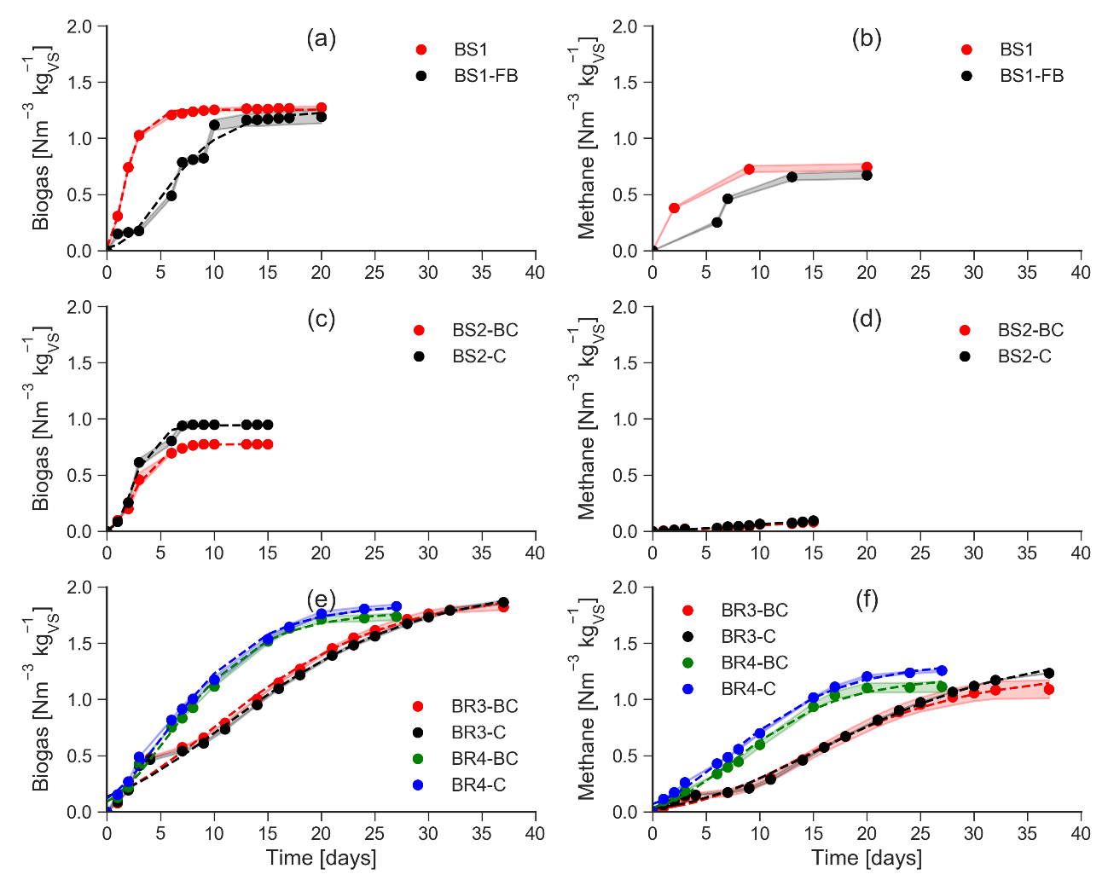

In experiment 1, the trends of SBP differed based on the feeding mode (Figure 1.a), between batch (BS1) and fed-batch (BS1-FB). The latter exhibited a “stair-like” profile due to the adaptation of the system to the consequent additions of substrate. In details, while BS1 showed one sharp peak at day 2 (0.434 Nm³ kg_{VS}⁻¹d⁻¹), BS1-FB had 4 lower peaks up to 0.298 Nm³ kg_{VS}⁻¹d⁻¹, delayed by 1 day after the corresponding feeding events, which occurred on days 0, 3, 6, and 9. Despite the different kinetics, after 20 days the SBP values were not significantly different (p > 0.05) (Table 3), equal to 1.273 ± 0.013 for BS1 and 1.193 ± 0.060 Nm³ kg_{VS} ⁻¹ for BS1-FB. The high COD of BS1 didn’t produce any overload of organic acids intermediates. The final BMP values of BS1 and BS1-FB were 0.744 Nm³ kg_{VS}⁻¹ and 0.705 Nm³ kg_{VS}⁻¹, respectively (Figure 1.b). These values accounted for 73 % and 64 % of the respective theoretical BMPs calculated from the COD of BS1 (1.03 ± 0.03 Nm³ kg_{VS}⁻¹) (Figure 2.a). This means that in both feeding modes at least two thirds of the organic matter was converted to biomethane. The average methane content (Figure 2.b) was 58 ± 2 % and 55 ± 4 %, respectively, confirming the good performance of AD in both feeding modes. In fed-batch mode, the overall organic load is distributed over time, thus preventing potential overload problems. In this experimental condition, the S/I ratio of 1:2 was sufficient to prevent overloads even in batch mode.
In experiment 2, the SBPs values obtained from BS2-BC and BS2-C (Figure 1.c) after 15 days were lower than those of experiment 1, respectively equal to 0.775 Nm³ kg_{VS} ⁻¹ and 0.948 Nm³ kg_{VS} ⁻¹. A significant impact of 10 g L⁻¹ of SWP550 BC on biogas production from BS2 was not observed (p >0.05) (Table 3).

Table 3. Results of the sensitivity analysis: one-way ANOVA at α = 0.05 with Fisher’s Least Significant Difference (LSD) post-hoc test and unpaired t-test at α = 0.05. A significant difference (p < 0.05) is identified by different letters.

Parameter | test | F or t | p value | experimental condition | average value | Std Error | Post-Hoc test
SBP  [Nm³ kg_{VS}⁻¹] | 2 | 1.315 | 0.259 | BS1 | 1.273 | 0.013
 |  |  |  | BS1-FB | 1.193 | 0.060
SBP  [Nm³ kg_{VS}⁻¹] | 3 | -3.380 | 0.183 | BS2-BC | 0.775
 |  |  |  | BS2-C | 0.948 | 0.030
SBP  [Nm³ kg_{VS}⁻¹] | 4 - 5 | 5.545 | 0.024 | BR3-BC | 1.823 | 0.028 | a
 |  |  |  | BR3-C | 1.866 | 0.016 | a
 |  |  |  | BR4-BC | 1.736 | 0.030 | b
 |  |  |  | BR4-C | 1.829 | 0.018 | a
SMP  [Nm³ kg_{VS}⁻¹] | 4 - 5 | 1.825 | 0.260 | BR3-BC | 1.091 | 0.081
 |  |  |  | BR3-C | 1.234 | 0.002
 |  |  |  | BR4-BC | 1.113 | 0.046
 |  |  |  | BR4-C | 1.257 | 0.011

Despite the addition of SWP550, methanogenesis was inhibited during the AD of BS2, possibly due to a sudden accumulation of readily biodegradable compounds, as suggested by the high theoretical BMP (Figure 2.a). Lower SMP values, compared to experiment 1, were observed (Figure 1.d) with 0.094 Nm³ kg_{VS}⁻¹ for BS2-C and 0.081 Nm³ kg_{VS}⁻¹ for BS2-BC, corresponding to nearly 2 % of their theoretical BMP (3.96 ± 0.04 Nm³ kg_{VS}⁻¹). In both cases the average methane content was around 10 % (Figure 2.b).

Figure 2. Results of anaerobic digestion tests for experiments 1 to 4: (a) Theoretical and experimental biomethane potentials (BMP), where the ratios between experimental and theoretical BMP (%) are reported as numerical values; (b) Average methane contents during anaerobic digestion tests. Results are reported as mean with standard errors.
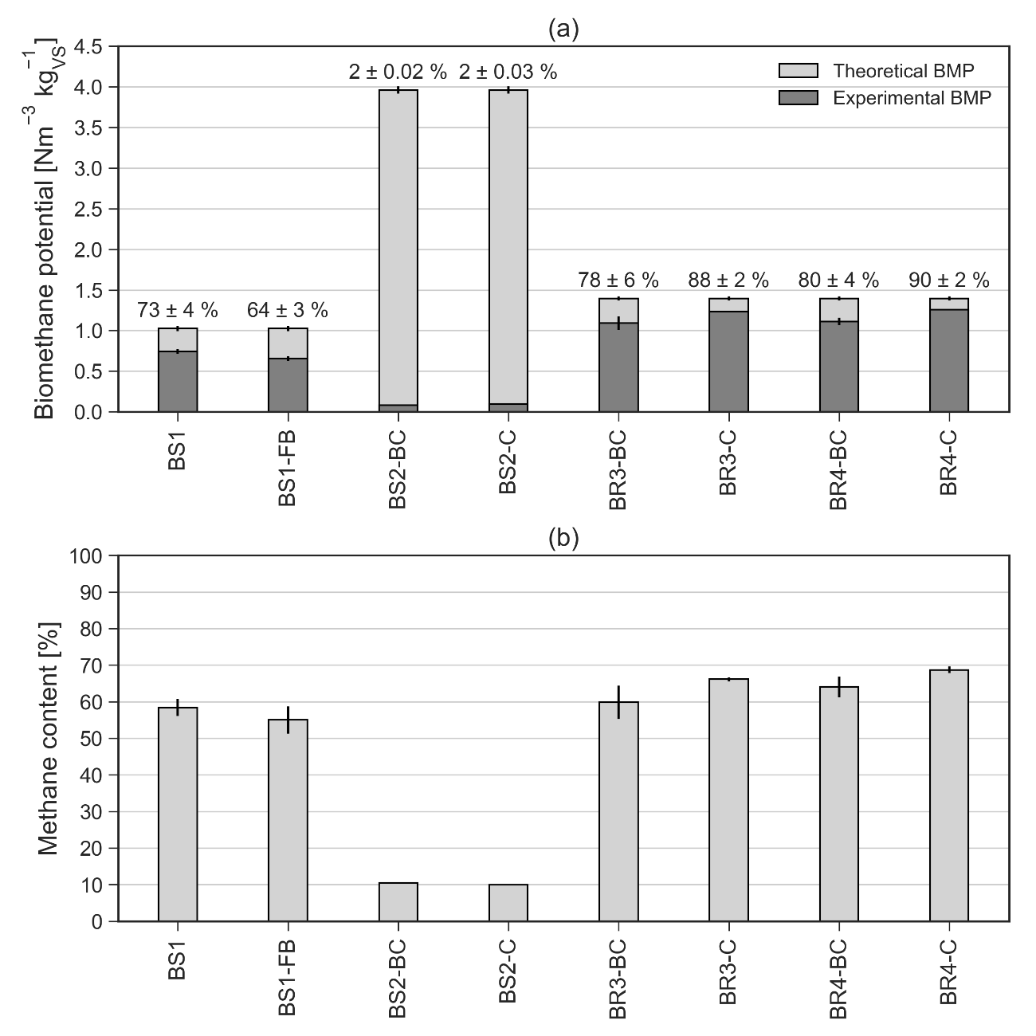

In experiments 3 and 4, high SBPs (Figure 1.e) were observed for BR3-C and BR4-C, equal to 1.866 ± 0.016 Nm³ kg_{VS}⁻¹ after 37 days and 1.829 ± 0.018 Nm³ kg_{VS}⁻¹ after 27 days, respectively. The SBP curves overlapped until days 3-4, when the growth of BR3-C suddenly slowed down until day 9, reaching a comparable biogas yield after a longer time at the end of AD. The different behavior may be ascribable to the different inocula employed in experiments 3 and 4, and to their adaptation to the system. In experiment 4, the sharp release of intermediate compounds during acidogenesis probably required some sort of adaption for the inoculum. As observed for SWP550, the SBP value of BR4-BC was slightly lower than BR4-C, while BR3-BC was not significantly different from BR3-C (Table 3). None of the two doses had beneficial effects on biogas production from BR sample. The SMP values obtained from BR (Figure 1.f) were promising and remarkably higher than BS, ranging 1.234-1.257 Nm³ kg_{VS}⁻¹ for the control groups. These SMP values accounted respectively for 88-90 % of the theoretical BMP (Figure 2.a), clearly indicating an almost complete degradation of the organic compounds in the WL. Their average methane content was around 66-69 % (Figure 2.b). Despite the similar nature of BS1 and BR lees (see Section 3.1), their SMP values were different, maybe due to the higher tCOD in BR and the initial pH adjustment to 7.5 provided just for BR in experiments 3 and 4 (see Table 1). Consistently with the SBPs, neither dose of B-BC (BR3-BC and BR4-BC) significantly affect (p > 0.05) the SMP respect to the control groups (Figure 1.f and Table 3). Consistently, conversions of theoretical BMPs around 78-80 % (Figure 2.a) and methane contents of 60-64 % (Figure 2.b) were observed when B-BC was supplemented. In overall, WL presented high BMP values during mesophilic AD, up to 0.744 Nm³ kg_{VS}⁻¹ for BR lees and 1.257 Nm³ kg_{VS}⁻¹ for BS sample, proving that WL may be a promising substrate for biomethane production, despite the significant risks of instabilities. Inhibition of methanogenesis was also observed (in BS2), probably due to the accumulation of AD intermediates as organic acids. The addition of BCs, both SWP550 and B-BC, did not improve biomethane production from WL under the adopted experimental conditions. Similarly, literature provides a wide range of methane productions during the AD of WL, resulting from a high variability of WL characteristics depending on the wine making process. As in experiments 3 and 4 of the present study, a BMP of 0.876 m³ Kg_{VS}⁻¹ was recorded during the mesophilic AD of WL [15]. A BMP of 0.370 Nm³ kg_{VS}⁻¹, corresponding to the 80 % of its thBMP, was observed during thermophilic batch tests of WL [14]. However, low biogas productions were also detected during the mesophilic AD of WL from red wine with electro-oxidation pre-treatments, ranging 0.181-0.25 m³ kg_{VS}⁻¹ with 58 % average methane content [13].

3.3. Kinetic analysis
The results of the fitting of experimental SBP and SMPs are in Figure 1, and the kinetic parameters calculated for experiments 1 to 4 are in Table 4. In overall, the modified Gompertz equation exhibited a good fit against the experimental SBP and SMP curves, with R² values higher than 0.980 and 0.957, respectively (Table 4). In general, in case of biogas, the lag phase λ values were relatively low (0.1-1.5 days), probably because of the availability of soluble readily degradable compounds in all WL samples. Despite few studies assessed the kinetics of AD of winery wastes [13,47], they shown an absence or a short lag-phase confirming that hydrolysis was not the rate-limiting step in AD of wine lees. In case of methane, in experiment 2, λ was larger in presence of SWP550 during AD of BS2. In experiment 3, as observed in Section 3.2, the AD of BR required a longer adaption period of inoculum than in experiment 4, with λ ranging 3.9 d and 0.6-1.4 d, respectively. The maximum production rate (R_{max}) is related to the growth rate of bacteria. Considering biogas production, R_{max} ranged between 0.07 and 0.46 Nm³ kg_{VS}⁻¹d⁻¹. Despite BS1 exhibited the highest R_{max}, this did not correspond to the largest SBP, which occurred for BR. The AD of BR lees in experiments 3 and 4 was longer, requiring 27-37 days compared to 20 days observed for BS1, but it reached the largest conversion of organic matter to biogas.

Table 4. Kinetic parameters derived from the fitting of experimental biogas and methane production curves with the modified Gompertz model: biogas/methane potential (P); maximum biogas/methane production rate (R_{max}), lag-phase (λ), coefficient of determination (R²). ND: not detected.
 | Biogas |  |  | Methane
Experimental conditions | P  (Nm³ kg_{VS}⁻¹) | R_{max}  (Nm³ kg_{VS}⁻¹d⁻¹) | λ  (days) | R²  (-) | P  (Nm³ kg_{VS}⁻¹) | R_{max}  (Nm³ kg_{VS}⁻¹d⁻¹) | λ  (days) | R²  (-)
BS1 | 1.253 | 0.457 | 0.35 | 0.998 | ND | ND | ND | ND
BS1-FB | 1.241 | 0.132 | 1.49 | 0.980 | ND | ND | ND | ND
BS2-BC | 0.774 | 0.195 | 0.78 | 0.996 | 0.197 | 0.007 | 3.30 | 0.957
BS2-C | 0.942 | 0.277 | 0.93 | 0.990 | 0.126 | 0.007 | 1.64 | 0.988
BR3-BC | 1.972 | 0.075 | 0 | 0.988 | 1.242 | 0.048 | 3.89 | 0.994
BR3-C | 2.049 | 0.070 | 0 | 0.989 | 1.467 | 0.048 | 3.96 | 0.995
BR4-BC | 1.781 | 0.129 | 0.51 | 0.995 | 1.199 | 0.075 | 1.44 | 0.993
BR4-C | 1.844 | 0.130 | 0.06 | 0.994 | 1.333 | 0.078 | 0.57 | 0.996

In case of methane production, R_{max} ranged between 0.007 and 0.078 Nm³ kg_{VS}⁻¹d⁻¹. The lowest values were obtained for BS2, where inhibition occurred. Conversely, the largest values were recorded for BR in experiment 4 where inhibition phenomena did not occurred (0.078 Nm³ kg_{VS}⁻¹d⁻¹), significantly higher than those reported by other authors [22,47].The experimental SMP values of BS1 were not fitted since the number of experimental data was not sufficient due to the methane sampling method (Section 2.4). Finally, the addition of BC did not exhibit beneficial impacts on the kinetic parameters.

3.4. Digestate characteristics
Samples of substrate, inoculum and digestate were analyzed in all tested conditions (Figure 3). The removal of organic matter was promising when methanogenesis was not inhibited. The removal of tCOD (Figure 3.a) was in the order BR4 (49-57 %) > BR3 (49 %) > BS1 (39-40 %) > BS2 (17 %), in good agreement with biogas and methane productions. In experiments 3 and 4, the high removal of sCOD (92-96 %) suggested that the conversion of soluble organic matter was almost complete. In contrast, in experiment 2, the removal of sCOD was marginal (12-20 %), due to the inhibition of methanogenesis happened with BS2. Unfortunately, in experiment 1, the removal of sCOD was not assessed due to some problems happened during the tests. The initial pH values (Figure 3.b) of the inocula were between 7.4 and 7.7 in all cases, due to the pH adjustment to 7.5 (except in experiment d 1). At the end of AD tests, the pH values of the digestate ranged from acidic (when inhibition of AD occurred) to slightly alkaline when methanogenesis was complete. In experiment 1, the final pH values of BS 1 and BS1-FB decreased but remained in the optimal range for methanogens, respectively equal to 7.28 and 7.24. In contrast, in experiment 2, the final pH dropped to 5.5 at the end of AD of BS2 despite the presence of SWP550, indicating inhibitory conditions for methanogens. Apparently, the addition of 10 g L⁻¹ of SWP550 was not effective in mitigating the pH drop caused by the rapid accumulation of organic acids.

Figure 3. Characteristics of digestate before and after the anaerobic digestion of wine lees: (a) Removal of total COD (tCOD) and soluble COD (sCOD); (b) pH and total phenolic content; (b) Organic acids.

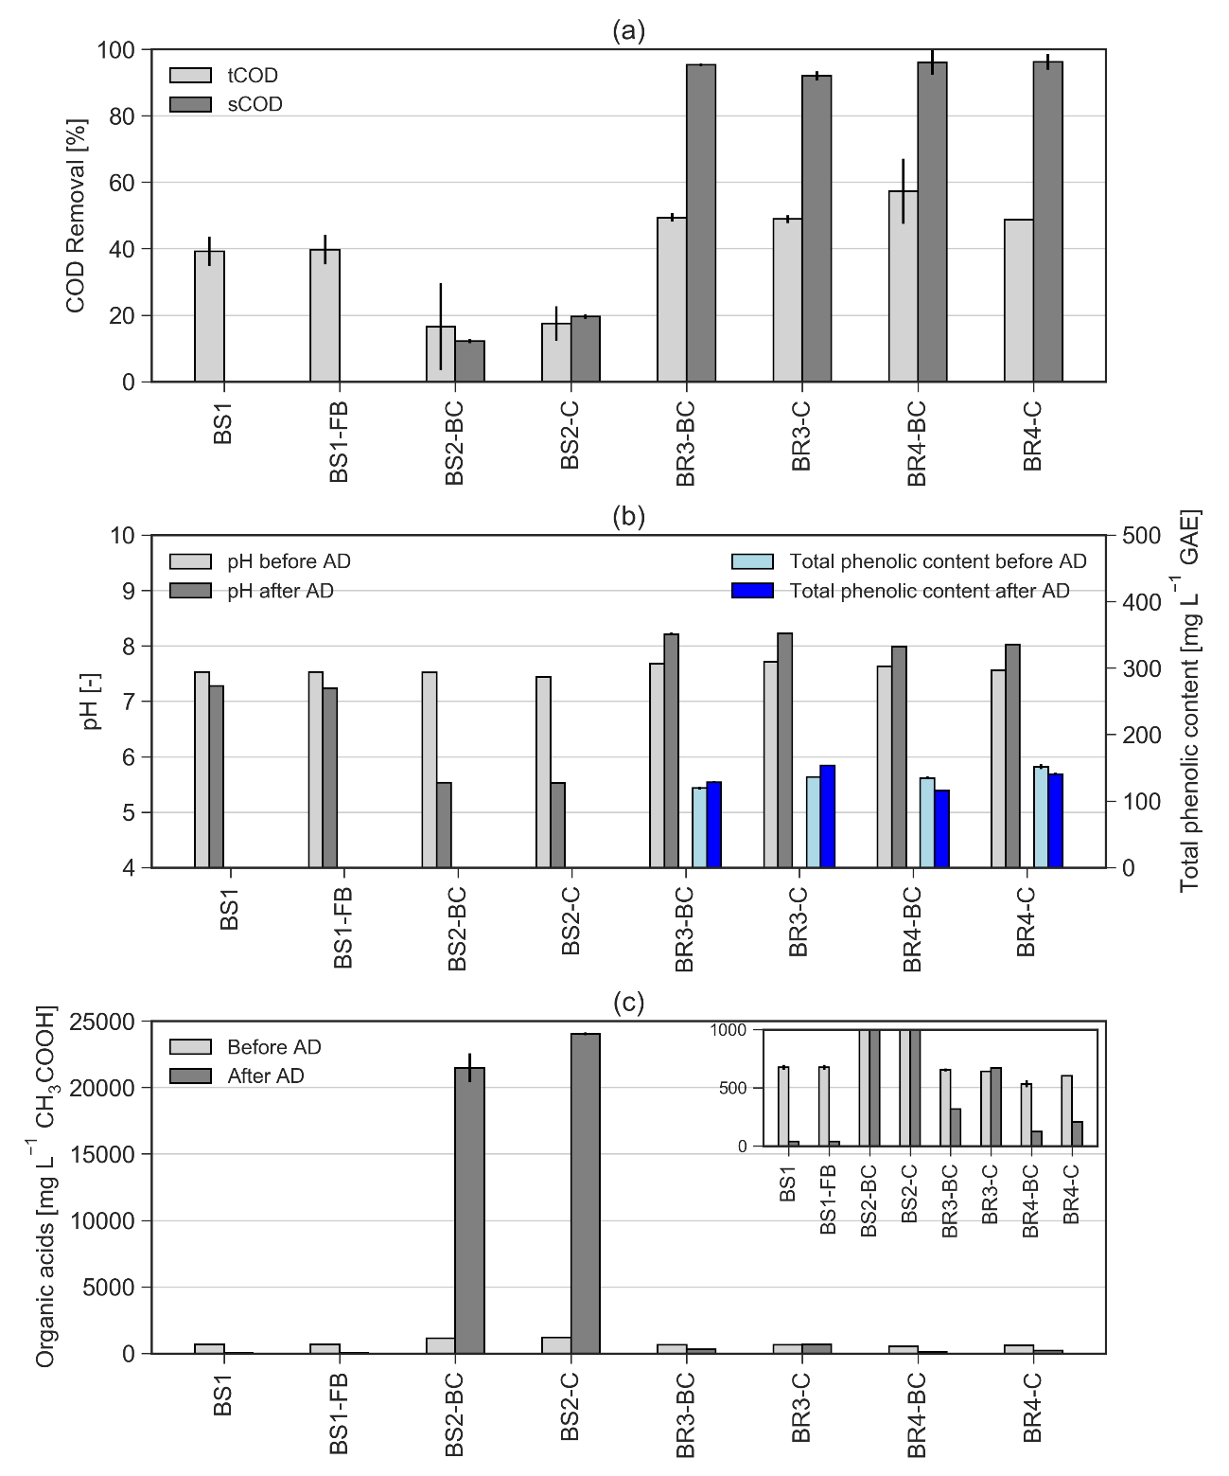
The AD of BR resulted in final pH values in the alkaline range, equal to 8.2 in experiment 3 and 8.0 in experiment 4, without significant differences between B-BC and control groups. Further, in experiments 3 and 4, the total phenolic content of the digestate was analysed to investigate the effect of AD process on polyphenols. Excessive concentrations of these compounds, commonly present in WL, can be inhibitory for the AD process [19]. In overall, the total phenolic content ranged from 116 to 154 mg L⁻¹ GAE, slightly lower in the BC amended groups (119-135 mg L⁻¹) than in control groups (136-152 mg L⁻¹), maybe suggesting a certain adsorption capacity of BC. However, in experiment 3, polyphenols tended to accumulate during the AD, increasing by 8 % for BR3–BC and 13 % for BR3–BC. In experiment 4, the total phenolic content was slightly reduced during AD by 14 % for BR4-BC and by 7 % for BR4–C.
Figure 3.c shows the concentration of organic acids before and after AD. In experiment 1, the initial organic acids concentration (676 g L⁻¹) of BS1 and BS1-FB was reduced by more than 90% in both cases. In experiment 2, the organic acids accumulated during AD. The initial concentration of organic acids of BS2-BC and BS2-C was higher than in experiment 1, respectively equal to 1125 g L⁻¹ and 1198 g L⁻¹, accounting for around 3 % of the initial sCOD concentration. At the end of AD, organic acids raised by 19 and 20 times for BS2-BC and BS2-BC, up to 21 and 24 g L⁻¹, representing respectively 58 % and 68 % of the residual sCOD concentration. The degradation of organic acids by acetogens and methanogens was likely too slow to contrast their rapid production by acidogenic bacteria during the first days of AD, resulting in the pH drop and the failure of methanogenesis. The supplementation of BC did not mitigate the accumulation of organic acids. In experiments 3 and 4, the initial organic acids concentrations were reduced in presence of B-BC respect the control group by 53 % in experiment 3 and by 40 % in experiment 4. At the end of AD, organic acids were removed by 52 %, 77 %, and 66 % for BR3-BC, BR4-BC, and BR4-C, respectively. Just in case of BR3-C, organic acids increased by 4 % at the end of the AD process.
In overall, the high removal of tCOD and sCOD were consistent with the significant methane productions from BS1 (experiment 1) and BR (experiments 3 and 4). However, in case of BS2, overload occurred with accumulation of organic acids (Figure 3.c) and the inhibition of methanogenesis (Figure 1.d).

4. Conclusions
This study investigated the BMP of WL through AD batch tests at 37 °C, obtaining BMP values up to 1.257 Nm³ kg_{VS}⁻¹ and 92-96 % sCOD removal. Inhibition of methanogenesis was detected when the concentration of organic acids reached 21-24 g L⁻¹. The addition of BC didn’t improve the BMP in the considered experimental conditions, as it was not able to contrast the effect of the accumulation of organic acids. In conclusion, WL may be a promising substrate for AD process, but the high sCOD and wide variability of WL characteristics are critical issues. The proper management of the organic loading rate and the provision of adequate alkalinity are crucial for a stable AD system. Due to the availability of WL throughout the year, the AD of WL may provide a reliable and stable source of biomethane. Further, AD could stabilize a putrescible waste and avoid uncontrolled emissions of greenhouse gases into the atmosphere, thus increasing the sustainability of the wine making industry. The results of this study can provide valuable insights into the optimization of the AD process of WL. However, further research is needed to find more stable conditions for the AD of WL especially during continuous AD experiments.

Acknowledgements
This research was funded with internal resources. The authors declare no conflict of interest. The authors would like to thank CORDAR Biella Servizi SpA for supplying the inoculum employed in this research, and the wine companies Barolo San Biagio (www.barolosanbiagio.com/) and Terre Astesane (www.terreastesane.it/) for supplying the wine lees. The authors gratefully acknowledge the support of Eng. Sara Cassini to the experimental activities. Authors’ contributions: Marco Chiappero: investigation, data curation, validation, visualization, writing-original draft; Silvia Fiore: conceptualization, methodology, supervision, writing-review&editing; Franco Berruti: supervision, writing-review&editing.

References
[1] FAO (Food and Agriculture Organization of the United Nations), FAOSTAT, crops and livestock products, (2022). https://www.fao.org/faostat/en/#data/QCL/visualize (accessed January 17, 2022).
[2] OIV (International Organisation of Vine and Wine), State of the world vitivinicultural sector in 2019, 2020. http://www.oiv.org/public/medias/7298/oiv-state-of-the-vitivinicultural-sector-in-2019.pdf.
[3] K.L. Christ, R.L. Burritt, Critical environmental concerns in wine production: An integrative review, J. Clean. Prod. 53 (2013) 232–242. doi:10.1016/j.jclepro.2013.04.007.
[4] M. Oliveira, E. Duarte, Integrated approach to winery waste: waste generation and data consolidation, Front. Environ. Sci. Eng. 10 (2016) 168–176. doi:10.1007/s11783-014-0693-6.
[5] N. Zhang, A. Hoadley, J. Patel, S. Lim, C. Li, Sustainable options for the utilization of solid residues from wine production, Waste Manag. 60 (2017) 173–183. doi:10.1016/j.wasman.2017.01.006.
[6] R.A. Muhlack, R. Potumarthi, D.W. Jeffery, Sustainable wineries through waste valorisation: A review of grape marc utilisation for value-added products, Waste Manag. 72 (2018) 99–118. doi:10.1016/j.wasman.2017.11.011.
[7] I.S. Arvanitoyannis, D. Ladas, A. Mavromatis, Wine waste treatment methodology, Int. J. Food Sci. Technol. 41 (2006) 1117–1151. doi:10.1111/j.1365-2621.2005.01112.x.
[8] M.-P. Zacharof, Grape winery waste as feedstock for bioconversions: Applying the biorefinery concept, Waste Biomass Valori. 8 (2017) 1011–1025. doi:10.1007/s12649-016-9674-2.
[9] European Council, Council Regulation (EC) No 1493/1999, (1999). https://eur-lex.europa.eu/legal-content/EN/TXT/?uri=CELEX:31999R1493 (accessed January 16, 2020).
[10] C. Creo, G. Ansanelli, P. Buttol, C. Chiavetta, S. Cortesi, L. Cutaia, P. Nobili, P. Sposato, Uso efficiente delle risorse nelle imprese vitivinicole, 2018. https://www.enea.it/it/seguici/pubblicazioni/edizioni-enea/2018/uso-efficiente-delle-risorse-nelle-imprese-vitivinicole.
[11] C. Da Ros, G. Libralato, A.V. Ghirardini, M. Radaelli, C. Cavinato, Assessing the potential phytotoxicity of digestate from winery wastes, Ecotoxicol. Environ. Saf. 150 (2018) 26–33. doi:10.1016/j.ecoenv.2017.12.029.
[12] L.A. Ioannou, G.L. Puma, D. Fatta-Kassinos, Treatment of winery wastewater by physicochemical, biological and advanced processes: A review, J. Hazard. Mater. 286 (2015) 343–368. doi:10.1016/j.jhazmat.2014.12.043.
[13] C.B. Arenas Sevillano, M. Chiappero, X. Gomez, S. Fiore, E.J. Martínez, Improving the anaerobic digestion of wine-industry liquid wastes: Treatment by electro-oxidation and use of biochar as an additive, Energies. 13 (2020) 5971. doi:10.3390/en13225971.
[14] C. Da Ros, C. Cavinato, D. Bolzonella, P. Pavan, Renewable energy from thermophilic anaerobic digestion of winery residue: Preliminary evidence from batch and continuous lab-scale trials, Biomass and Bioenergy. 91 (2016) 150–159. doi:10.1016/j.biombioe.2016.05.017.
[15] S. Montalvo, J. Martinez, A. Castillo, C. Huiliñir, R. Borja, V. García, R. Salazar, Sustainable energy for a winery through biogas production and its utilization: A Chilean case study, Sustain. Energy Technol. Assessments. 37 (2020) 100640. doi:10.1016/j.seta.2020.100640.
[16] J. Jasko, E. Skripsts, V. Dubrovskis, Biogas production of winemaking waste in anaerobic fermentation process, Eng. Rural Dev. 11 (2012) 576–579.
[17] S. Maicas, J.J. Mateo, Sustainability of wine production, Sustain. 12 (2020). doi:10.3390/su12020559.
[18] M.E. Gómez, J.M. Igartuburu, E. Pando, F.R. Luis, G. Mourente, Lipid composition of lees from sherry wine, J. Agric. Food Chem. 52 (2004) 4791–4794. doi:10.1021/jf030499r.
[19] Y. Chen, J.J. Cheng, K.S. Creamer, Inhibition of anaerobic digestion process: A review, Bioresour. Technol. 99 (2008) 4044–4064. doi:10.1016/j.biortech.2007.01.057.
[20] C. Da Ros, C. Cavinato, P. Pavan, D. Bolzonella, Winery waste recycling through anaerobic co-digestion with waste activated sludge, Waste Manag. 34 (2014) 2028–2035. doi:10.1016/j.wasman.2014.07.017.
[21] C. Da Ros, C. Cavinato, P. Pavan, D. Bolzonella, Mesophilic and thermophilic anaerobic co-digestion of winery wastewater sludge and wine lees: An integrated approach for sustainable wine production, J. Environ. Manage. 203 (2017) 745–752. doi:10.1016/j.jenvman.2016.03.029.
[22] S. Fiore, B. Ruffino, G. Campo, C. Roati, M.C. Zanetti, Scale-up evaluation of the anaerobic digestion of food-processing industrial wastes, Renew. Energy. 96 (2016) 949–959. doi:10.1016/j.renene.2016.05.049.
[23] J. Hungría, J.A. Siles, A.F. Chica, A. Gil, M.A. Martín, Anaerobic co-digestion of winery waste: comparative assessment of grape marc waste and lees derived from organic crops, Environ. Technol. (United Kingdom). 0 (2020) 1–9. doi:10.1080/09593330.2020.1737735.
[24] D. Monga, N.P. Shetti, S. Basu, K. Raghava Reddy, M. Badawi, A. Bonilla-Petriciolet, T.M. Aminabhavi, Engineered biochar: A way forward to environmental remediation, Fuel. 311 (2022). doi:10.1016/j.fuel.2021.122510.
[25] S. Nanda, A.K. Dalai, F. Berruti, J.A. Kozinski, Biochar as an exceptional bioresource for energy, agronomy, carbon sequestration, activated carbon and specialty materials, Waste Biomass Valori. 7 (2016) 201–235. doi:10.1007/s12649-015-9459-z.
[26] J.L. Linville, Y. Shen, P.A. Ignacio-de Leon, R.P. Schoene, M. Urgun-Demirtas, In-situ biogas upgrading during anaerobic digestion of food waste amended with walnut shell biochar at bench scale, Waste Manag. Res. 35 (2017) 669–679. doi:10.1177/0734242X17704716.
[27] D. Wang, J. Ai, F. Shen, G. Yang, Y. Zhang, S. Deng, J. Zhang, Y. Zeng, C. Song, Improving anaerobic digestion of easy-acidification substrates by promoting buffering capacity using biochar derived from vermicompost, Bioresour. Technol. 227 (2017) 286–296. doi:10.1016/j.biortech.2016.12.060.
[28] Q. Li, M. Xu, G. Wang, R. Chen, W. Qiao, X. Wang, Biochar assisted thermophilic co-digestion of food waste and waste activated sludge under high feedstock to seed sludge ratio in batch experiment, Bioresour. Technol. 249 (2018) 1009–1016. doi:10.1016/j.biortech.2017.11.002.
[29] E.J. Martínez, J.G. Rosas, A. Sotres, A. Moran, J. Cara, M.E. Sánchez, X. Gómez, Codigestion of sludge and citrus peel wastes: Evaluating the effect of biochar addition on microbial communities, Biochem. Eng. J. 137 (2018) 314–325. doi:10.1016/j.bej.2018.06.010.
[30] M.O. Fagbohungbe, B.M.J. Herbert, L. Hurst, H. Li, S.Q. Usmani, K.T. Semple, Impact of biochar on the anaerobic digestion of citrus peel waste, Bioresour. Technol. 216 (2016) 142–149. doi:10.1016/j.biortech.2016.04.106.
[31] M. Chiappero, O. Norouzi, M. Hu, F. Demichelis, F. Berruti, F. Di Maria, O. Mašek, S. Fiore, Review of biochar role as additive in anaerobic digestion processes, Renew. Sustain. Energy Rev. 131 (2020) 110037. doi:10.1016/j.rser.2020.110037.
[32] M.O. Fagbohungbe, B.M.J. Herbert, L. Hurst, C.N. Ibeto, H. Li, S.Q. Usmani, K.T. Semple, The challenges of anaerobic digestion and the role of biochar in optimizing anaerobic digestion, Waste Manag. 61 (2017) 236–249. doi:10.1016/j.wasman.2016.11.028.
[33] C. Holliger, M. Alves, D. Andrade, I. Angelidaki, S. Astals, U. Baier, C. Bougrier, P. Buffière, M. Carballa, V. de Wilde, F. Ebertseder, B. Fernández, E. Ficara, I. Fotidis, J.-C. Frigon, H.F. de Laclos, D.S.M. Ghasimi, G. Hack, M. Hartel, J. Heerenklage, I.S. Horvath, P. Jenicek, K. Koch, J. Krautwald, J. Lizasoain, J. Liu, L. Mosberger, M. Nistor, H. Oechsner, J.V. Oliveira, M. Paterson, A. Pauss, S. Pommier, I. Porqueddu, F. Raposo, T. Ribeiro, F. Rüsch Pfund, S. Strömberg, M. Torrijos, M. van Eekert, J. van Lier, H. Wedwitschka, I. Wierinck, Towards a standardization of biomethane potential tests, Water Sci. Technol. 74 (2016) 2515–2522. doi:10.2166/wst.2016.336.
[34] O. Mašek, W. Buss, A. Roy-Poirier, W. Lowe, C. Peters, P. Brownsort, D. Mignard, C. Pritchard, S. Sohi, Consistency of biochar properties over time and production scales: A characterisation of standard materials, J. Anal. Appl. Pyrolysis. 132 (2018) 200–210. doi:10.1016/j.jaap.2018.02.020.
[35] A.M. Brown, A step-by-step guide to non-linear regression analysis of experimental data using a Microsoft Excel spreadsheet, Comput. Methods Programs Biomed. 65 (2001) 191–200. doi:10.1016/S0169-2607(00)00124-3.
[36] APHA-AWWA-WEF, Standard methods for the examination of water and wastewater, 22nd ed., Washington, DC, US, 2012.
[37] P. Ribéreau-Gayon, Le dosage des composés phénoliques totaux dans les vins rouges, Chim. Anal. 52 (1970) 627–631.
[38] M. Chiappero, F. Berruti, O. Mašek, S. Fiore, Analysis of the influence of activated biochar properties on methane production from anaerobic digestion of waste activated sludge, Biomass and Bioenergy. 150 (2021) 106129. doi:10.1016/j.biombioe.2021.106129.
[39] M. Chiappero, F. Cillerai, F. Berruti, O. Mašek, S. Fiore, Addition of different biochars as catalysts during the mesophilic anaerobic digestion of mixed wastewater sludge, Catalysts. 11 (2021) 1094. doi:10.3390/CATAL11091094.
[40] R.M. Jingura, R. Kamusoko, Methods for determination of biomethane potential of feedstocks: a review, Biofuel Res. J. 4 (2017) 573–586. doi:10.18331/BRJ2017.4.2.3.
[41] M.J. Jara-Palacios, Wine lees as a source of antioxidant compounds, Antioxid. 8 (2019) 1–10. doi:10.3390/antiox8020045.
[42] I. de Bustamante, J. Temiño, Vinasses purification model in carbonated materials by low-cost technologies: An example in the Llanura Manchega (Spain), Environ. Geol. 24 (1994) 188–193. doi:10.1007/BF00766888.
[43] N.A. Qambrani, M.M. Rahman, S. Won, S. Shim, C. Ra, Biochar properties and eco-friendly applications for climate change mitigation, waste management, and wastewater treatment: A review, Renew. Sustain. Energy Rev. 79 (2017) 255–273. doi:10.1016/j.rser.2017.05.057.
[44] J.A. Ippolito, L. Cui, C. Kammann, N. Wrage-Mönnig, J.M. Estavillo, T. Fuertes-Mendizabal, M.L. Cayuela, G. Sigua, J. Novak, K. Spokas, N. Borchard, Feedstock choice, pyrolysis temperature and type influence biochar characteristics: a comprehensive meta-data analysis review, Biochar 2020 24. 2 (2020) 421–438. doi:10.1007/s42773-020-00067-x.
[45] L. Klüpfel, M. Keiluweit, M. Kleber, M. Sander, Redox properties of plant biomass-derived black carbon (biochar), Environ. Sci. Technol. 48 (2014) 5601–5611. doi:10.1021/ES500906D/SUPPL_FILE/ES500906D_SI_001.PDF.
[46] S. Li, S. Harris, A. Anandhi, G. Chen, Predicting biochar properties and functions based on feedstock and pyrolysis temperature: A review and data syntheses, J. Clean. Prod. 215 (2019) 890–902. doi:10.1016/j.jclepro.2019.01.106.
[47] A. Fabbri, G. Bonifazi, S. Serranti, Micro-scale energy valorization of grape marcs in winery production plants, Waste Manag. 36 (2015) 156–165. doi:10.1016/j.wasman.2014.11.022.

