Design and validation of a high-level controller for automotive active systems

Abstract
Active systems, from active safety to energy management, play a crucial role in the development of new road vehicles. However, the increasing number of controllers creates an important issue regarding complexity and system integration. This paper proposes a high-level controller managing the individual active systems - namely Torque Vectoring, Active Aerodynamics, Active Suspension, and Active Safety (Anti-lock Braking System, Traction Control, and Electronic Stability Programme) - through a dynamic state variation. The high-level controller is implemented and validated in a simulation environment, with a series of tests evaluate the performance of the original design and the proposed high-level control. Then, a comparison of the virtual driver response and the Driver-in-the-loop behavior is performed to assess the limits between virtual simulation and real-driver response in a lap time condition. The main advantages of the proposed design methodology are its simplicity and overall cooperation of different active systems, where the proposed model was able to improve the vehicle behavior both in terms of safety and performance, giving more confidence to the driver when cornering and under braking. Some differences were discovered between the behavior of the virtual driver and the Driver-in-the-loop, especially regarding the sensitivity to external disturbances.
Key-words: Vehicle Dynamics; Control Systems; Driving Simulator; Automotive Control; Electric Vehicles

Introduction
Modern vehicles are undoubtedly growing in complexity at an unprecedented rate [1]. The uprising of sensors’ availability [2,3] and the always more stringent safety and emission homologation rules [4] create a strong and consistent trend towards intricate and multifaceted control systems. Even more demanding are the requisites related to autonomous driving [5,6] and other technologies related to Connectivity, Autonomous Driving, Shared Vehicles and Electrification.
The ECUs are the hardware elements in charge of the physical implementation of the control strategies. The traditional approach used to implement active systems in a vehicle happens through parallel logic and interconnection [7]. Each vehicle system has its own ECU with dedicated sensors, and there is limited communication between different systems. Even if this strategy has worked well for many years, with great efforts in tuning and validation, it cannot hold forever: there is a pressing issue to come up with a high-level intelligence system in vehicles.
This paper presents a case study that verifies the performance of a switching-logic high-level control system, able to operate simultaneously a series of active systems applied to an AWD electric hyper car. The objective is to propose and evaluate a simple – yet efficient – Vehicle Control Unit (VCU) logic that can harmonize the active systems with few input parameters, in such a way that this logic could be easily transferred to other vehicles.
This flexible strategy with high-level logic represents a current gap in the state-of-the-art and an important need of the industry, and although this paper is not intended as a definitive solution to the issue, the proposed methodology can represent a step towards more comprehensive and less specific strategies.
The case study is based on a series of models previously published in which the single active systems were analyzed.
More specifically, the articles [8,9] present the implementation of a Torque Vectoring (TV) strategy applied to an All-Wheel Drive (AWD) electric vehicle with four in-wheel motors. This strategy combines feedback and feedforward control systems and proposed both a lateral dynamics enhancement and an energy efficiency improvement.
Instead, the papers [10–12] are related to the development and simulation of an active aerodynamics logic combined with an active suspension control system. The papers study the relation between vehicle attitude and its effect on aero loads, combining them with the effects caused by active aerodynamic surfaces. In this case, the studied vehicle is also an electric hyper car with four independent in-wheel motors.
This article proposes a final validation of the controller through the testing in a driving simulator, for a Driver-in-the-Loop (DiL) condition. This strategy was previously implemented and presented in the works [9,11] so the obtained results can be compared in terms of human response, as well as in a pure simulation environment.
The dynamic simulations were performed on MATLAB – Simulink and on VI-CarRealTime using a co-simulation environment. VI-CarRealTime operates with a simplified four-wheeled vehicle model. The vehicle is a reduced DOF model, including 5 rigid bodies (vehicle sprung mass and four wheels) and 14 DOF [13]. This kind of modelling is well established in the vehicle dynamic’s theory and, not representing a key contribution of the article, then will not be fully described here. The vehicle parameters used, as described in the previous works, is an adaptation of the “Racecar” template provided by VI-CarRealTime with the inclusion of a full-electric AWD powertrain composed of four in-wheel high performance motors [14,15]. More details regarding the vehicle model can be found in the Appendix.
Following the same reasoning, for the sake of brevity, the details, and specific characteristics of the baseline control systems are not going to be included in this paper, thus it is highly recommendable to the readers to familiarize themselves with the background work [8–12] to fully appreciate the considerations of this article.
Apart from the mentioned active systems (TV, active suspension and active aerodynamics), other controllers are considered in this paper: The Active Safety systems – composed by the ABS, ESP, and traction control logics. The Active Safety systems implemented are integrated in the VI-CarRealTime co-simulation environment [13]. This block is an essential part of road-legal vehicles’ safety, and due to its core logic of altering the individual wheel torques during instability conditions, it can easily disturb the working logic of the other active systems (specially for the torque vectoring that directly actuates the same variables).
As a matter of fact, the initial issues identified by the authors during the integration of the active systems were exactly related to the conflict between the TV and ESP control. Figure 1 displays the rear wheel rotational speed during a fishhook maneuver. It is clear from the plot that the TV alone (blue curve) impacts the dynamic response and render it more stable throughout the simulation, but when the ESP system is turned on (yellow curve) the signal is disrupted and a noisy behavior - and the presence of a backward rotation - is present.
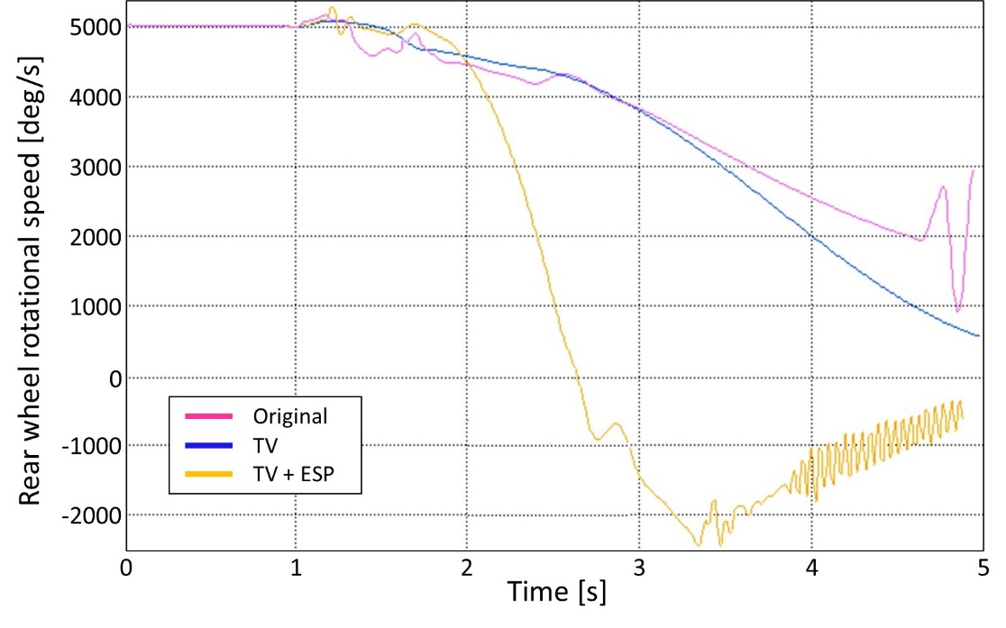
Figure 1. Rear wheel speed vs. time – Original, TV and TV+ESP conditions during a fishhook maneuver
From this result and other conflicts found in a preliminary analysis, the high-level control system – key contribution of this article - was motivated.

Literature review
A brief review of the state-of-the-art is necessary to contextualize the paper content. The works are organized in three main parts relative to
- single control systems;
- system integration;
- system enhancing strategies;
- higher-level controllers proposing broader strategies.
Single control systems: The literature presents a lot of articles and studies where control strategies and active systems are presented and discussed. Some of the most relevant and recent topics covered in literature fall in two categories: energy management [16–19] and stability control [20–25], both closely related to the electrification trend in the automotive sector that has already populated the academia for years [26,27]. The presence of electric and hybrid powertrains, indeed, opens up a huge range of possible control systems for vehicle dynamics – of particular interest to this paper are the Torque Vectoring implementations [28–31].
Controller enhancement: Of course, the scientific state-of-the-art does not stop at a single active system modelling and validation, several studies aim to integrate different active systems [32], improve sensor capabilities [33] and verify hardware application (both in virtual [7] and physical [34,35] conditions). However, the presence of more encompassing studies where the interaction between active systems is discussed, simulated/tested and improved is still timid.
High-level controllers: Some examples of Vehicle Control Units, that include hybrid powertrain management [36], BMS integration [37] and power electronics [38] can be found, as well as more broad efforts to improve the system communication [39], position integration [40], functional safety [41] and control failure [42]. Nonetheless, there are few examples truly propose high-level methodologies and frameworks [43,44].
From the presented review, the research gap this paper aims to cover is the absence of comprehensive high-level control systems able to integrate signals coming from advanced control systems in modern electric vehicles, more specifically when dealing with high-performance EVs.

High-level controller
The high-level controller included in the VCU logic has the objective of sending control signals to the previously listed active systems to improve the vehicle’s safety and performance as well as to avoid collisions in the controller logics. This was done by designing a controller that reads the inputs from the vehicle and driver and decides the behavior of each active system. Figure 2 presents a scheme with the main concept of the controller. The first diagram (top) represents a traditional non-integrated approach, in which each active control system receives the state information and decides the best control action based on its on internal parameters - this approach requires high efforts in tuning and can produce numerous integration problems (as seen in Figure 1). The second diagram (bottom) represents the VCU proposed by the authors, encompassing the single active systems and the high-level controller that coordinate them based on the overall vehicle states and driving requests, as described in this section.
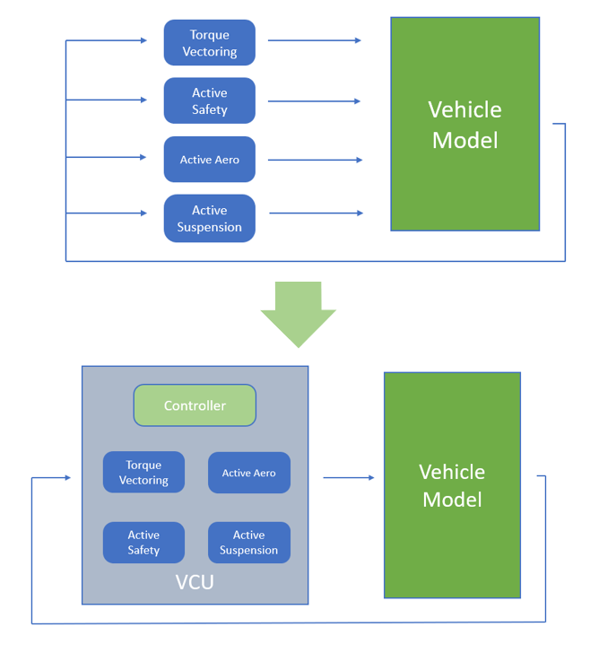
Figure 2. Traditional (top) vs. proposed VCU architecture (bottom)
It was decided to use the vehicle instability condition as the deciding factor to base the switching logic between control states for the active systems.
The first step in the design of the high-level controller was to decide how to act on the most critical stability parameters. The core idea was to create two driving modes, representing different driving conditions that require more or less intervention. The modes are:
- Normal: Uses TV and all active safety systems (ABS, ESP, TCS) + active aerodynamics and active suspension in the neutral trim keeping (NTK) setting. This mode is intended for road use, where safety and comfort are more important than pure performance. In this configuration, the ESP operates as in a normal vehicle. This means that the Feedforward control for TV is deactivated whenever ESP corrects the vehicle trajectory, and the ESP has the priority over the control of the throttle signals.
- Performance: This mode is focused on performance, so the active safety systems can be deactivated completely or made less invasive. Active aerodynamics are more focused on increasing downforce. Contrary to the Normal mode, ESP is not the primary system in the control chain. In fact, its activation is decided by the high-level controller, which prefers TV instead, allowing the Feedforward (FF) control to remain active.
As an additional safety level for performance mode, the ESP controller was tuned to grant vehicle’s stability on spinouts, but without interfering with the quick direction changes (where the FF is more effective). The basic idea was that the high-level controller monitors the sideslip angle of the vehicle and allows the ESP intervention only when its value goes over a certain threshold.
Measuring the actual sideslip angle of a vehicle in real life conditions is still a very complicated task. In the current state-of-the-art, there are mainly two solutions to solve this problem, in particular:
- Direct measure using a sideslip angle sensor – as in [45,46] – but this solution is usually very expensive and cumbersome to be installed in a road-vehicle (usually used for research and testing purposes).
- Sideslip estimator – as in [33,47,48] – that profits from other measures already present in the vehicle network to continuously calculate the best approximation to the sideslip.
For the purposes of this paper, it is considered that this value is readily available from an estimator (not modelled) as an input. Future works can study the effects of errors and delays related to the estimator.
Figure 3 depicts, schematically, the high-level controller state logic. The driver can select one of the two driving modes: normal and performance; once the driving mode is selected, the system operates following the blocks in the top part of Figure 3 when in normal mode and following the bottom blocks in case of performance mode. The other parameter that dictates the high-level controller behavior is the vehicle’s state in terms of stability and instability. If the vehicle is stable, it shall follow the blocks on the left part of Figure 3, while during instability periods the controller follows the right-hand side commands.
The driving mode (normal vs. performance) is static throughout a maneuver/lap, in the other hand the state (stability vs. instability) is dynamic and changes based on the vehicle instantaneous response.
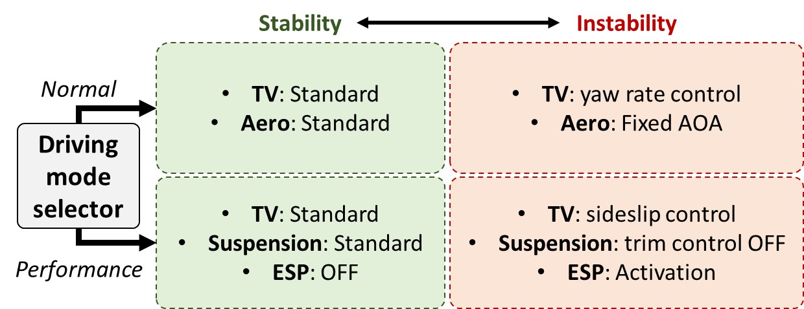
Figure 3. Mode selection scheme: driving mode (top and bottom) and vehicle’s state (left and right)
The primary objective of the controller is to detect when the vehicle enters an instability state, which requires the intervention of active safety systems. To do this the controller was split into three different parts:
- Normal mode detector: Active when normal mode is selected, it monitors the same parameters of the ESP and TV (ideal yaw rate and actual yaw rate). So, TV will be controlled by the ESP signal.
- Performance mode detector: Its objective is always to detect vehicle instability, but the monitored parameter, now is the vehicle’s sideslip angle. TV controller is preferred over ESP.
- Reference signal: It provides the reference signal used to make the corrections. For both driving modes, when the instability state is reached, the corrections are made based on the yaw rate signals.
When the monitored parameters - both for normal and performance mode – exceed their thresholds, the controller activates a flag signal called instability. This signal is binary (0 = no instability and 1 = instability). Due to its nature, this flag signal can switch between its two states several times every second (acting essentially as the ESP controller). This may cause oscillating behaviors in the controllers as they are constantly activated and deactivated, preventing them from correcting the vehicle’s trajectory. To prevent this problem, the controller was designed so that, after entering the instability state, it will return to its default mode only after the flag signal has been OFF for a certain time interval.
An example of the effect on the controller outputs can be seen in Figure 4. On the top plot there is the output of the instability monitor, the flag signal switches rapidly between its two states (0 and 1) due to the yaw rate error passing the instability threshold. On the bottom plot it is shown the logic state signal (the real output of the controller) which will be sent to the active systems, after that the oscillations have been eliminated.
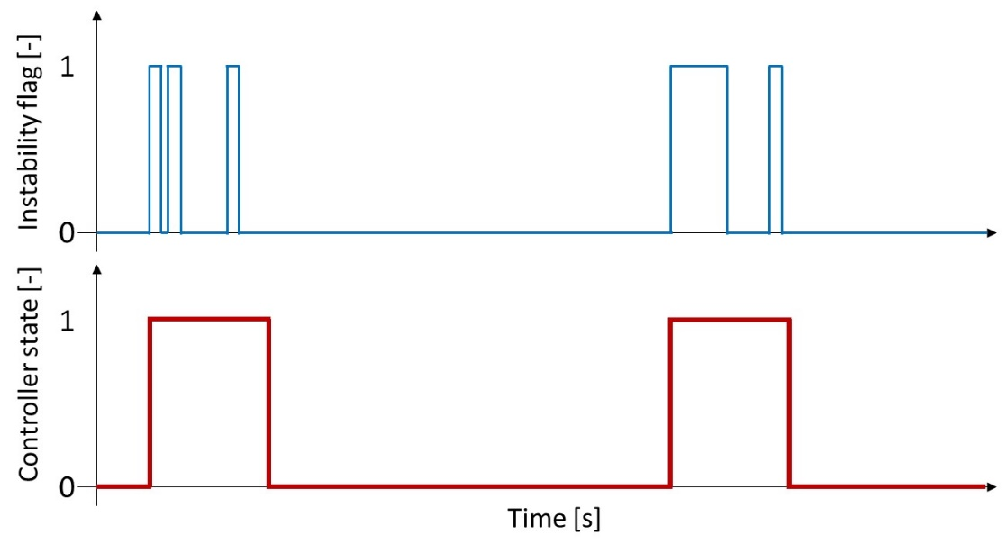
Figure 4. Flag signal (top) vs. logic state (bottom)

Interface between high-level control and active systems
The high-level controller detects when the vehicle enters in instability and its output signals are routed to each active system and a specific control architecture must be implemented in each one as follows.

Torque vectoring interface
When the ESP is not active, TV is able to increase cornering performance of the vehicle, while with ESP activated, the best results in testing were obtained when TV was operating based on the ESP signal. Two modes were created for the TV algorithm, one for stable operation and one for whenever instability was detected, in particular:
- Stable mode: TV is always ON correcting the yaw error of the vehicle. Its output signals go directly to the motors.
- Instability mode: The ESP activates and takes priority in the control chain. Now TV signals will be passed to a switching block, which will pass them to the motors only when the ESP is making a correction (acting on the brakes) and will put them to 0 whenever the ESP releases the brakes.
This logic improves the vehicle’s safety and performance since TV can apply positive torques to the wheels, while ESP alone was able to only apply braking torques. This results in a quicker and more precise correction, with lower vibrations and increased comfort.
To obtain this result, an if - elseif logic was used along with the signals coming from the controller. Figure 5 shows the block with the three possible modes in the Simulink environment: ESP OFF mode (No Instability); ESP Normal mode (Instability); ESP Performance mode (Instability).
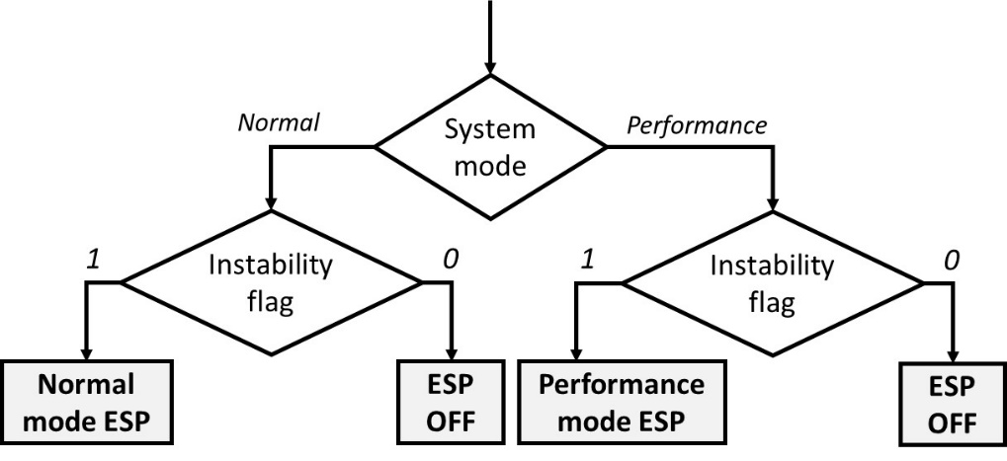
Figure 5. High level controller – TV controller interface
The reason why the instability blocks were split into two blocks is due to their activation being carried out by different signals coming from the high-level controller. The instability criteria used in the two driving modes (Normal and Performance) are different, so they produce two different flag signals.

ESP interface
Also, the ESP has two different modes, which in this case depend directly on the driving mode selected by the driver:
- Normal mode: ESP operates normally, activating when the yaw rate error goes above a certain threshold.
- Performance mode: ESP outputs are deactivated until the high-level controller enters instability mode, which now depends on the vehicle’s sideslip angle, and not on the yaw rate.
When performance mode is selected, ESP will not intervene to help the driver in case of quick direction changes (that could be wrongfully detected as a loss of control). Instead, now the ESP will be able to correct the vehicle trajectory only to avoid spinouts leaving the quick direction changes to the FF control in the TV. To obtain these results, while still assuring the required robustness for a safety system, an additional control loop was added to the original ESP controller (Figure 6).
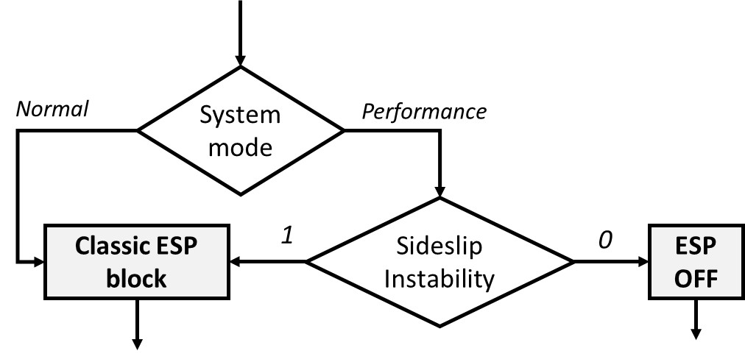
Figure 6. Modified ESP controller
The controller was modified by adding two logic switches in the Simulink model. When the vehicle is in normal mode (so with the traditional ESP logic), this additional part is bypassed by the ESP signals. When performance mode is selected, the high-level controller starts to monitor the sideslip angle and the ESP signals are deactivated (setting pressure gain = 0 and throttle gain = 1). This means that the ESP will not intervene unless the sideslip angle threshold is met, activating the instability state for performance mode.

Active aerodynamics interface
To control the state of the active aerodynamics, a simpler approach was used. As can be observed in Figure 7, two simple logical switches were inserted, where the two output signals are the front spoiler and rear wing Angle of Attack (AOA).
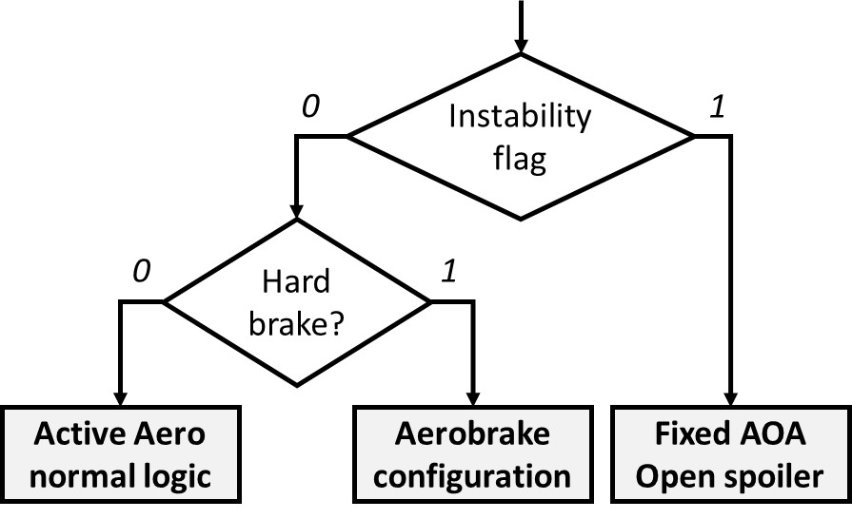
Figure 7. Active aerodynamics controller
When the high-level controller enters its instability state, the same flag signal sent to the TV and to these switches. As a result, whenever the instability state is triggered, the active aero surfaces positions can be forced to a pre-defined value. This control is beneficial because it completely removes the oscillations caused by the active aerodynamic, which is a critical situation, had been noticed to be detrimental to the overall vehicle stability. Like all other controls, as soon as the instability state ends, the active aerodynamic surface controller returns to its normal operation. It should be mentioned that this control has been enabled only for the normal driving mode, the reason behind this decision is that having a fixed aerodynamic balance is especially helpful when the ESP is trying to recover the car.

Active suspension interface
Like active aerodynamics, the active suspension controller was modified to be interfaced with the high-level controller by adding logical switches in the active aerodynamic state machine, responsible for the vehicle trim control. In this case, however, the switches can be activated only if the vehicle is in performance driving mode. This decision was taken because, during the previous testing, it was noticed that NTK was beneficial during emergency situations, so these switches act only on the trim controller of the vehicle which is active only in performance mode.

VCU testing with virtual driver
The control strategy and active systems’ interface were implemented in the co-simulation environment and tuned to determine the most suitable thresholds and parameters to the specific vehicle. To test the final system the first step was the simulation of full-vehicle maneuvers in the different modes.
Therefore, three events were simulated:
- Overall lateral dynamics response: to investigate the vehicle response in lateral dynamics, and also consider the influence of the active aerodynamics, the parabolica event was chosen as proposed in [10,11]. The maneuver consists of a long high-speed turn with variable radius, perfect for the evaluation of longitudinal and lateral behaviors working together.
- Safety response: to evaluate the system response in a condition of danger, a classic fishhook maneuver was implemented. This maneuver consists in a steering and counter steering sequence, known for its capacity to induce instability.
- Track performance: since the target system is an electric hyper car it is necessary to consider the overall performance in terms of lap time. To achieve this result a MaxPerformance [13] event was set up.
Regarding the vehicle modes, the configurations tested (and presented in the subsequent figures) are:
- Original: model with no high-level controller, all active systems working concurrently.
- Normal: active high-level controller, in normal driving mode, used for safety maneuvers and road driving.
- Performance: active high-level controller, for performance driving mode, used for lap-time simulation as well as safety evaluation in limit conditions.
The sideslip angle plot is the most useful to spot differences in vehicle behaviors. Figure 8 shows the sideslip angles of the models around the parabolica turn [10,11]. The normal and performance driving modes induced a similar behavior on the vehicle, whereas the original mode is significantly different. In particular, the last one shows an understeering behavior that cannot be corrected by the original controller, resulting in a vehicle loss of control.
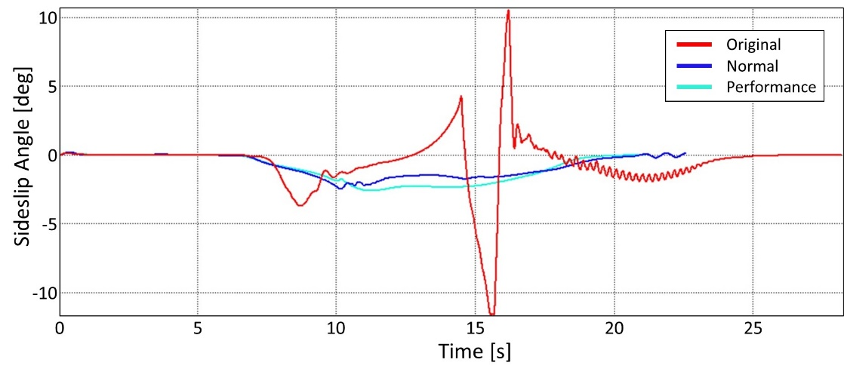
Figure 8. Sideslip angle comparison during a parabolica turn
Regarding the safety maneuvers, the vehicle using normal mode far outperformed both the other configurations. The proposed high-level controller can improve vehicle stability in case of a sudden loss of control very effectively.
About the lap time simulations, the best overall performances were obtained by the vehicle in performance mode (Table 1). The original vehicle was faster than the normal mode, and the analysis indicates that this difference is related to the difference in aerobrake deployment. In fact, this mode is intended for road use, where the stability of the vehicle is more important than a higher top speed.
Table 1. Virtual driver lap times in the three control modes
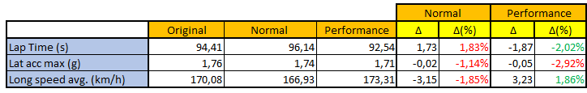
The system logic, despite its clear simplicity, can effectively resolve interference issues and avoid instability and undesired behavior in various situations.
Static Simulator Validation
As in [9,11], the final judgment to indicate the system ability to improve vehicle safety and performance cannot come from simple virtual driver simulations. It is necessary to assert that the benefits can be fully exploited by a human driver.
It is well recognized the capacity of virtual drivers to respond in a precise, smooth, and immediate manner to every kind of driving condition. Even with efforts to create faithful human-driving simulations [49], the best way to feel and confirm the final results still is the DiL approach.
Figure 9 shows the desktop simulator used in the activity. It is composed of: active steering and active pedals, widescreen curved monitor, and CPU with real-time computing power both for running the models and generating the graphic interface.
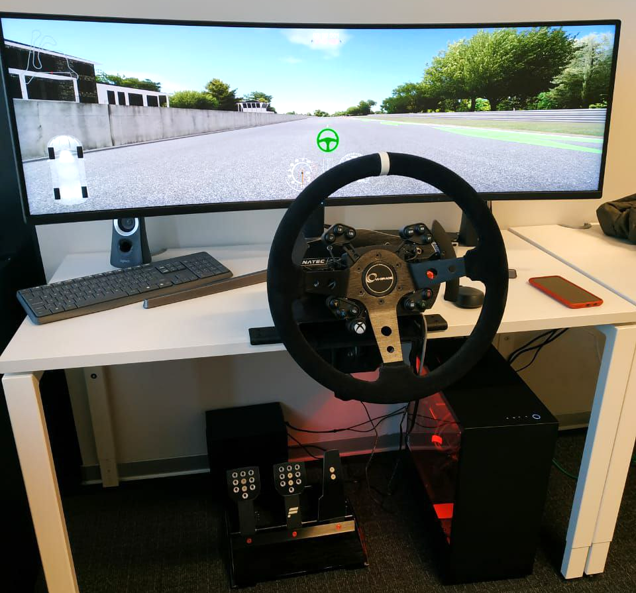
Figure 9. Desktop Simulator overview
Some visual aids are included in the driving interface to support the drivers. Figure 10 shows: the ideal racing line (1); lap time counter, and best lap time tracker (2); speed, rpm, throttle, brake and steering wheel angle inputs (3); Tire slip monitor - particularly useful to see if the TV is working correctly (4); racetrack map (5).
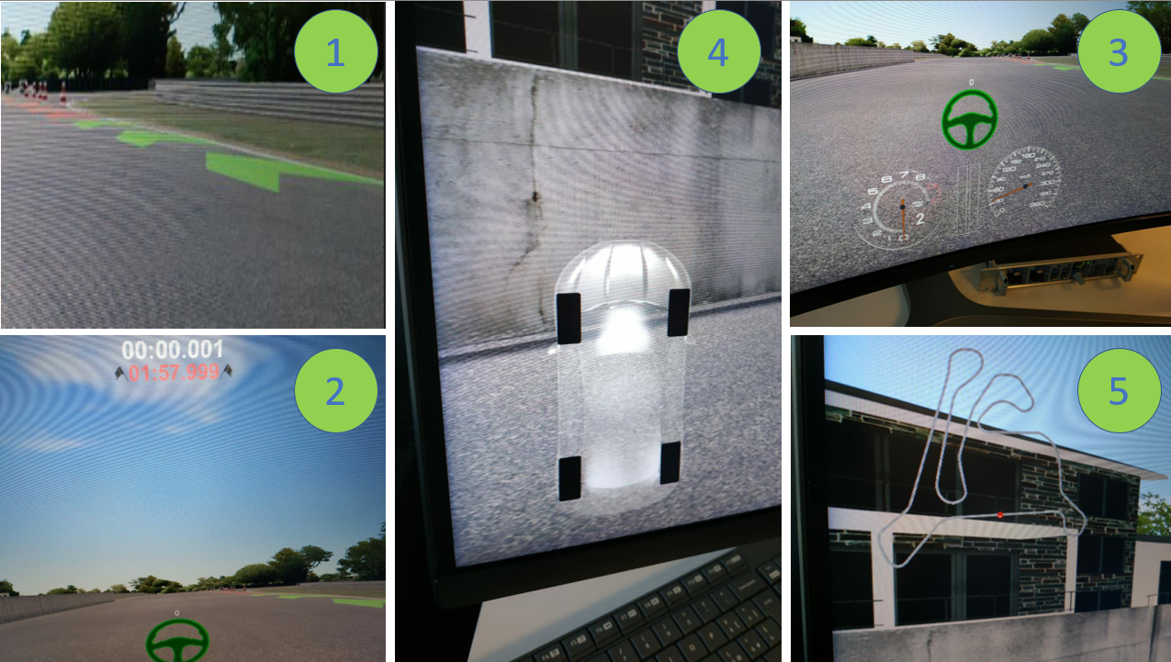
Figure 10. Graphic elements in the driving simulator
In the test session, a series of lap time events were performed by two different drivers, with different levels of experience, in the Calabogie track. The results obtained from the DiL simulations are displayed in Table 2.
Table 2. DIL Lap time comparison
The best way to analyze the results obtained from virtual testing is to consider both the telemetry data and the drivers’ comments.

Drivers’ subjective evaluation
The following statements were extracted from the direct opinion of the two drivers present in the driving simulator.
Original model: The original model was the starting point of this research. The active systems struggled to work together since there wasn’t any kind of superior controller. The vehicle behaves very badly under braking. There isn’t enough engine braking to slow the vehicle down effectively. At low speeds, it is very easy to spin both under braking and under acceleration. When exiting from the corners, the TV interferes heavily with the traction and causes the vehicle to be unpredictable. The safety systems are unable to recover the vehicle from a loss of control. Additionally, they cause unexpected braking/accelerations for some wheels, making recovery impossible for the driver. For the reasons discussed above, the lap times obtained have big variability. Both drivers agreed that this was the worst model due to the lack of predictability and the very aggressive active systems.
Normal mode: This mode was thought to be used mainly on the road, prioritizing the safety of the occupants over the pure performance of the vehicle. The vehicle is much more controllable during cornering, giving more confidence to the drivers. Thanks to the high-level controller, it is much easier to recover a spin and the vehicle can negotiate curves with higher speed. The throttle can be used much more aggressively since the active control systems will cut its signal automatically, making the driving experience much easier. Thanks to the proposed TV system, the vehicle brakes a lot better. However, on the straights the TV seemed to cause vibrations in the steering line. This effect, if not properly dampened by the driver, amplifies until the vehicle loses control. This small problem caused a very big discrepancy between the two drivers’ results since it caused a lack of confidence under acceleration. Both drivers agreed that the high-level controller is clearly helping the vehicle during braking and cornering, while under acceleration, an investigation should be carried out to remove the oscillatory behavior.
Performance mode: This mode was created to obtain the best performance of the vehicle when driven on a track. So, the safety systems intervene less, leaving the driver more freedom in controlling the vehicle. The vehicle is much more reactive to throttle and steering inputs, aided by the proposed TV system. The braking is very similar to the Normal mode, but some adjusting is needed when switching modes. This is because the performance mode accelerates quicker than the normal mode, so the braking points are different. The oscillatory behavior of the steering is not present anymore. The active safety systems leave more freedom to the driver while still ensuring vehicle recovery in case of a loss of control. The result of this less invasive system is that the car can negotiate corners much faster. In case the car starts to drift (oversteering slide), it helps the driver in keeping the slide under control without slowing it down too much. An important fact to notice is that both drivers were the fastest while using this mode, with lower variability in the lap times. Additionally, this was the only mode where the drivers were able to consistently complete laps without having to reset the vehicle (after losing control).

Telemetry analysis
To validate the drivers’ sensation about the three models tested, some considerations on the telemetry data are reported.
Longitudinal velocity: The model with the fastest lap was the performance mode. As can be seen in Figure 11 the vehicle reaches a higher top speed in performance mode, while the slowest is the normal mode, due to the different active aerodynamics control. Normal mode is better in the slower corners, and it allows the driver to slow down later, gaining distance over the other two faster models. Around s = 4000 m the benefits of normal mode can be fully appreciated, seeing that it allows the driver to carry the highest speed through that corner.
Aerodynamic balance: Figure 12 compares the aerodynamic balances of the three vehicle’s conditions, it can be clearly seen where in normal mode, the vertical load is shifted to the rear axle. This is an effect of the aerobrake actuation to give more traction to the rear wheels. When the vehicle goes on a straight, the aerobrake turns off and the aerodynamic balance returns close to the normal behavior.

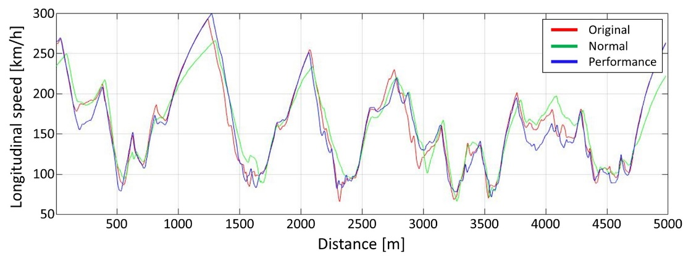
Figure 11. Longitudinal speed vs. distance – comparison between Original, Normal and Performance modes
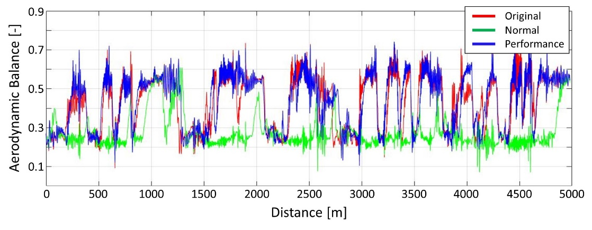
Figure 12. Aerodynamic balance vs. distance – comparison between Original, Normal and Performance modes

Sideslip: Figure 13 shows a comparison of the sideslip angles obtained with the three different models tested. Normal mode is more invasive with its controls and allows recovery of the vehicle in more situations than the performance mode. For this reason, the spikes are higher since with any other mode they would have resulted in a spinout.
Comparison between DIL and Virtual driver
As was expected, the virtual driver was able to achieve a considerably faster lap time than the real driver in all three models. Specific analysis for each mode follows.
Original model: This model shows important differences between the speed obtained by the two drivers (DIL and Virtual driver). Figure 14 shows how the VD was able to accelerate faster, reaching a higher top speed throughout the entire lap. This is most likely due to the slower and less precise human response in applying the throttle and less than optimal assistance from the active systems.
Further confirmation of the driver’s sensations about the vehicle behavior can be seen in Figure 15, where the sideslip angle comparison shows that the driver experiences sudden losses of control due to the active system, whereas the virtual driver does not.
Normal mode: Like the previous model, the virtual driver was able to keep a higher speed throughout the entire lap. This time, the driver’s braking and cornering speeds were significantly closer to the simulated ones, proving that the active systems were able to help it drive faster (Figure 16). In fact, this mode was the one where the gap between the real driver’s time and the virtual driver’s time was the smallest.
The drivers’ sensations highlighted heavy oscillations on the steering line during acceleration. Figure 17 clearly shows the unwanted behavior. When the steering angle is close to neutral, the DiL (blue line) experiences oscillations, which are of increasing intensity. Looking at the steering signal from the VD, there is no sign of such oscillations. This could mean that the system is not calibrated properly, or some other error is happening in the driver to model interface, causing this unwanted behavior.

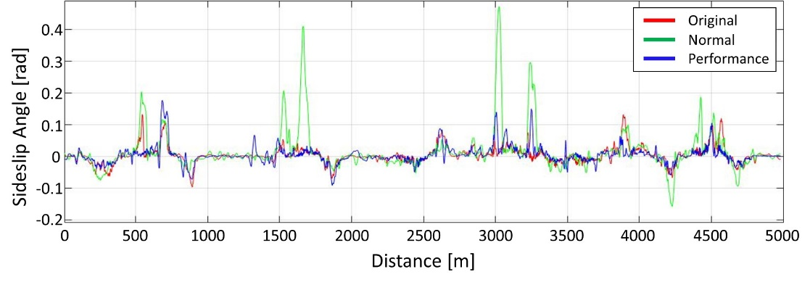
Figure 13. Side slip angle vs. distance – comparison between Original, Normal and Performance modes
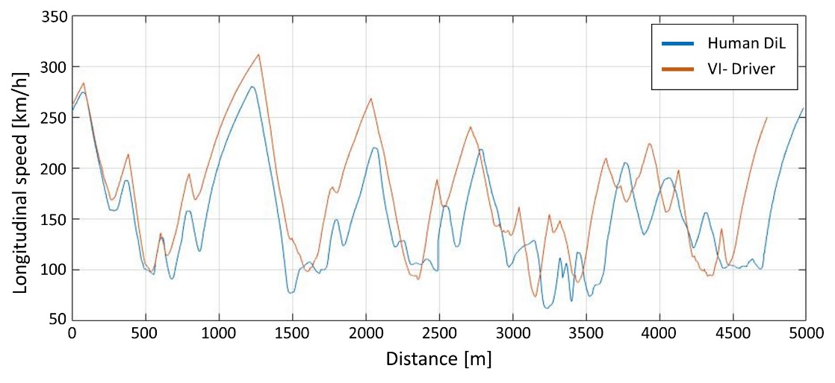
Figure 14. Longitudinal speed vs. distance – comparison between DiL and VD
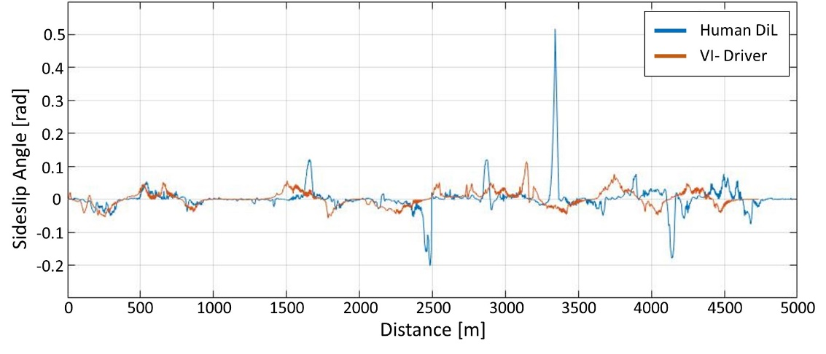
Figure 15. Side slip angle vs. distance – comparison between DiL and VD
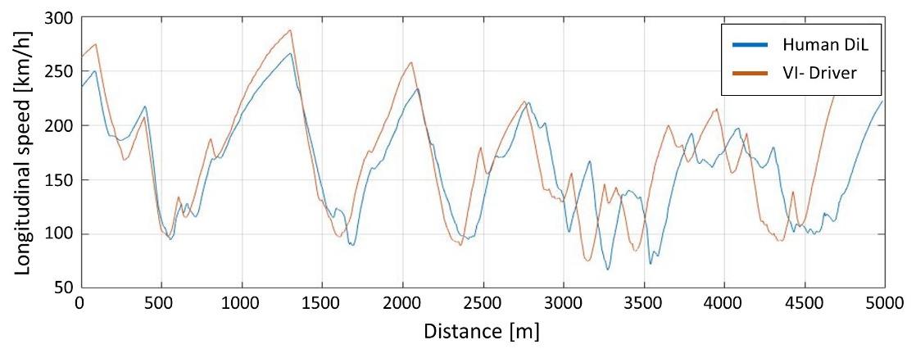
Figure 16. Longitudinal speed vs. distance – comparison between DiL and VD in Normal mode
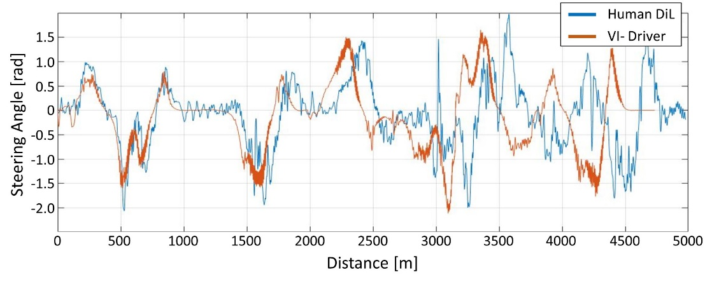
Figure 17. Steering angle vs. distance – comparison between DiL and VD in Normal mode
Performance mode: Like the real driver, the VD was able to perform its best lap using performance mode. Although the differences in lap times were much smaller than the ones obtained on the desktop simulator. It should also be noted that this mode guaranteed both drivers the highest constancy in lap times, meaning that it was easier to obtain similar times lap after lap. Looking Figure 18, it can be seen how the performance mode enabled the real driver to follow more closely the speed profile of the VD.
The active systems help the driver in recovering from spins resulting in a spike in the sideslip angle of the vehicle (Figure 19). Every time the sideslip angle goes above the system’s threshold, instability mode activates, helping the driver in recovering the vehicle.
It is clear that the VD doesn’t benefit as much as the real driver from the system, since its signal has lower spikes, meaning that the vehicle doesn’t enter in instability mode. However, towards the end of the lap, instability mode was triggered and the VD recovered from a spinout thanks to the active controller (two red spikes in Figure 19).

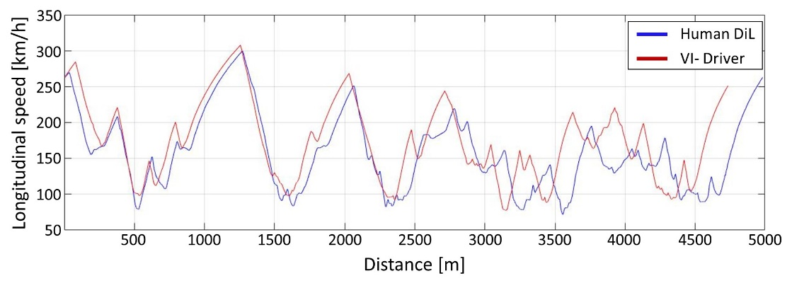
Figure 18. Longitudinal speed vs. distance – comparison between DiL and VD in Performance mode

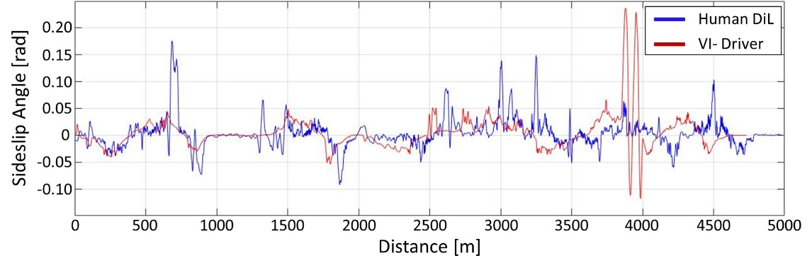
Figure 19. Side slip angle vs. distance – comparison between DiL and VD in Performance mode

Conclusions
This paper identifies an important issue in vehicle development related to the increasing complexity of active systems and their integration. Therefore, a novel high-level control strategy is proposed based on a simple dynamic state control logic. The proposed system was able to interface and correctly harmonize the control signals coming from TV, Active Aerodynamics, Active Suspension and Active Safety systems, which initially produced several conflicts and overall vehicle stability.
Preliminary validation of the system was performed in a purely virtual simulation environment, showing an important net improvement with the proposed design. The DiL tests performed on the desktop simulator showed many similarities with the preliminary validation.
However, some differences were highlighted in the steering response and overall dynamic behavior of the vehicle. The VD is less sensitive to changes made to the active systems of the vehicle; it can get very close lap times in all three models tested. This is because it can ignore external disturbances such as vibration while a real driver cannot. For this reason, the real driver benefitted much more from the proposed active systems than the VD.
Normal mode can recover the vehicle in a wider range of situations, with fewer inputs from the driver while Performance mode leaves more to the ability of the driver while still helping in stabilizing the vehicle. Real driver’s lap times indicate the high-level controller increased performance by assisting in braking, acceleration, and mid-corner. Drivers felt more comfortable in high-speed corners due to increased stability.
The results are considered satisfactory and represent an important step in the development of high-level controllers with flexible design and low complexity – a topic not fully covered by existing research.
Future developments can include: a physical implementation to validate the logic in an experimental setting; inclusion of new/more detailed active systems and vehicle subsystems; development and comparison of different control strategies.

Bibliography
1. Schmitt, M.C. and Pischinger, S., “Trends and Challenges in Mobility and Transportation,” in: Grote, K.-H. and Hefazi, H., eds., Springer Handbook of Mechanical Engineering, Springer International Publishing, Cham, ISBN 978-3-030-47035-7: 995–1014, 2021, doi:10.1007/978-3-030-47035-7_21.
2. Armstrong, K., Das, S., and Cresko, J., “The energy footprint of automotive electronic sensors,” Sustain. Mater. Technol. 25:e00195, 2020, doi:10.1016/j.susmat.2020.e00195.
3. Wang, S., Al Atat, H., Ghaffari, M., Lee, J., and Xi, L.-F., “Prognostics of automotive sensors: Tools and case study,” 2008.
4. Bielaczyc, P. and Woodburn, J., “Trends in Automotive Emission Legislation: Impact on LD Engine Development, Fuels, Lubricants and Test Methods: a Global View, with a Focus on WLTP and RDE Regulations,” Emiss. Control Sci. Technol. 5(1):86–98, 2019, doi:10.1007/s40825-019-0112-3.
5. Carvalho Pinheiro, H. de, Cruz Stanke, D., Ferraris, A., Carello, M., Gabiati, G., Camuffo, I., and Grillo, M., “Autonomous Driving Scenario Generation in Overtake Manoeuvres Through Data Fusion,” in: Niola, V. and Gasparetto, A., eds., Advances in Italian Mechanism Science, Springer, ISBN 978-3-030-55807-9: 786–794, 2021, doi:10.1007/978-3-030-55807-9_87.
6. Carello, M., Ferraris, A., Carvalho Pinheiro, H. de, Cruz Stanke, D., Gabiati, G., Camuffo, I., and Grillo, M., “Human-Driving Highway Overtake and Its Perceived Comfort: Correlational Study Using Data Fusion,” WCX SAE World Congress Experience, SAE Technical Paper 2020-01-1036, 2020, doi:10.4271/2020-01-1036.
7. Plöger, M., Sauer, J., Büdenbender, M., Held, J., Costanzo, F., De Manes, M., Di Mare, G., Ferrara, F., and Montieri, A., “Testing Networked ECUs in a Virtual Car Environment,” 2004-01–1724, 2004, doi:10.4271/2004-01-1724.
8. Carvalho Pinheiro, H. de, Ferraris, A., Galanzino, E., Sisca, L., Carello, M., Airale, A., and Messana, A., “All-wheel drive electric vehicle modeling and performance optimization,” SAE Technical Paper 2019-36-0197, 2019, doi:https://doi.org/10.4271/2019-36-0197.
9. Ferraris, A., Carvalho Pinheiro, H. de, Galanzino, E., Airale, A.G., and Carello, M., “All-Wheel Drive Electric Vehicle Performance Optimization: From Modelling to Subjective Evaluation on a Static Simulator,” 2019 Electric Vehicles International Conference, EV 2019, 2019, doi:10.1109/EV.2019.8893027.
10. Carvalho Pinheiro, H. de, Russo, F., Sisca, L., Messana, A., De Cupis, D., Ferraris, A., Airale, A.G., and Carello, M., “Advanced Vehicle Dynamics Through Active Aerodynamics and Active Body Control,” American Society of Mechanical Engineers Digital Collection, 2020, doi:10.1115/DETC2020-22290.
11. Carvalho Pinheiro, H. de, Russo, F., Sisca, L., Messana, A., De Cupis, D., Ferraris, A., Airale, A.G., and Carello, M., “Active Aerodynamics Through Active Body Control: Modelling and Static Simulator Validation,” American Society of Mechanical Engineers Digital Collection, 2020, doi:10.1115/DETC2020-22298.
12. Ferraris, A., De Cupis, D., De Carvalho Pinheiro, H., Messana, A., Sisca, L., Airale, A.G., and Carello, M., “Integrated Design and Control of Active Aerodynamic Features for High Performance Electric Vehicles,” SAE Technical Paper 2020-36-0079, 2021, doi:10.4271/2020-36-0079.
13. VI-grade GmbH, VI-CarRealTime 20.0 Documentation, 2020.
14. Carvalho Pinheiro, H. de, Castro dos Santos, P.G., Sisca, L., Scavuzzo, S., Ferraris, A., Airale, A.G., and Carello, M., “Dynamic Performance Comparison Between In-Wheel and On-Board Motor Battery Electric Vehicles,” American Society of Mechanical Engineers Digital Collection, 2020, doi:10.1115/DETC2020-22306.
15. Carvalho Pinheiro, H. de, Messana, A., and Carello, M., “In-wheel and on-board motors in BEV: lateral and vertical performance comparison,” 2022 IEEE International Conference on Environment and Electrical Engineering and 2022 IEEE Industrial and Commercial Power Systems Europe (EEEIC / I&CPS Europe), 1–6, 2022, doi:10.1109/EEEIC/ICPSEurope54979.2022.9854774.
16. Ullah, I., Liu, K., Yamamoto, T., Al Mamlook, R.E., and Jamal, A., “A comparative performance of machine learning algorithm to predict electric vehicles energy consumption: A path towards sustainability,” Energy Environ. 0958305X211044998, 2021, doi:10.1177/0958305X211044998.
17. Carello, M., Carvalho Pinheiro, H. de, Longega, L., and Di Napoli, L., “Design and Modelling of the Powertrain of a Hybrid Fuel Cell Electric Vehicle,” SAE Int. J. Adv. Curr. Pract. Mobil. 3(6):2878–2892, 2021, doi:10.4271/2021-01-0734.
18. Carello, M., Bonansea, P., and D’Auria, M., “Driveline Optimization for a Hybrid Electric City Vehicle to Minimize Fuel Consumption,” SAE 2014 World Congress & Exhibition, 2014-01–1090, 2014, doi:10.4271/2014-01-1090.
19. Ferraris, A., Messana, A., Airale, A.G., Sisca, L., Carvalho Pinheiro, H. de, Zevola, F., and Carello, M., “Nafion® Tubing Humidification System for Polymer Electrolyte Membrane Fuel Cells,” Energies 12(9):1773, 2019, doi:10.3390/en12091773.
20. Davoudi, M., Menhaj, M.B., and Davoudi, M., “A Fuzzy Based Vehicle Dynamic Stability Control (FDSC),” 2006-01–3483, 2006, doi:10.4271/2006-01-3483.
21. Sidhu, A., Guenther, D.A., and Heydinger, G.J., “Development of a Method to Assess Vehicle Stability and Controllability in Open and Closed-Loop Maneuvers,” 2010-01–0111, 2010, doi:10.4271/2010-01-0111.
22. Nitta, C., Koto, H., and Takahashi, K., “Online Estimation of Vehicle Stability Factor for Electronic Stability Control,” 2013-01–0690, 2013, doi:10.4271/2013-01-0690.
23. Ahmed, A.A. and Saleh Alshandoli, A.F., “Using Of Neural Network Controller And Fuzzy PID Control To Improve Electric Vehicle Stability Based On A14-DOF Model,” 2020 International Conference on Electrical Engineering (ICEE), 1–6, 2020, doi:10.1109/ICEE49691.2020.9249784.
24. Peng, H. and Chen, X., “Active Safety Control of X-by-Wire Electric Vehicles: A Survey,” SAE Int. J. Veh. Dyn. Stab. NVH 6(2):10-06-02–0008, 2022, doi:10.4271/10-06-02-0008.
25. Tianjun, Z., Wan, H., Wang, Z., Wei, M., Xu, X., Zhiliang, Z., and Sanmiao, D., “Model Reference Adaptive Control of Semi-active Suspension Model Based on AdaBoost Algorithm for Rollover Prediction,” SAE Int. J. Veh. Dyn. Stab. NVH 6(1):71–86, 2021, doi:10.4271/10-06-01-0005.
26. Masding, P.W. and Bumby, J.R., “Identification and performance simulation of a hybrid i.c.-engine/battery electric automotive power train. Part 1: The i.c. engine,” Trans. Inst. Meas. Control 12(1):27–39, 1990, doi:10.1177/014233129001200104.
27. Masding, P.W. and Bumby, J.R., “Identification and performance simulation of a hybrid i.c.-engine/battery electric automotive power train. Part 2: The electric traction system,” Trans. Inst. Meas. Control 12(2):97–112, 1990, doi:10.1177/014233129001200205.
28. Wong, A., Kasinathan, D., Khajepour, A., Chen, S.-K., and Litkouhi, B., “Integrated torque vectoring and power management framework for electric vehicles,” Control Eng. Pract. 48:22–36, 2016, doi:10.1016/j.conengprac.2015.12.012.
29. De Novellis, L., Sorniotti, A., Gruber, P., Shead, L., Ivanov, V., and Hoepping, K., “Torque Vectoring for Electric Vehicles with Individually Controlled Motors: State-of-the-Art and Future Developments,” World Electr. Veh. J. 5(2):617–628, 2012, doi:10.3390/wevj5020617.
30. Carvalho Pinheiro, H. de, Messana, A., Sisca, L., Ferraris, A., Airale, A.G., and Carello, M., “Torque Vectoring in Electric Vehicles with In-wheel Motors,” in: Uhl, T., ed., Advances in Mechanism and Machine Science, Springer International Publishing, ISBN 978-3-030-20131-9: 3127–3136, 2019, doi:10.1007/978-3-030-20131-9_308.
31. Carvalho Pinheiro, H. de, Punta, E., Carello, M., Ferraris, A., and Airale, A.G., “Torque Vectoring in Hybrid Vehicles with In-Wheel Electric Motors: Comparing SMC and PID control,” 2021 IEEE International Conference on Environment and Electrical Engineering and 2021 IEEE Industrial and Commercial Power Systems Europe (EEEIC / I CPS Europe), 1–6, 2021, doi:10.1109/EEEIC/ICPSEurope51590.2021.9584732.
32. Cooper, N., Crolla, D., Levesley, M., and Manning, W., “Integration of Active Suspension and Active Driveline to Ensure Stability While Improving Vehicle Dynamics,” 2005-01–0414, 2005, doi:10.4271/2005-01-0414.
33. Bonfitto, A., Feraco, S., Amati, N., and Tonoli, A., “Virtual Sensing in High-Performance Vehicles With Artificial Intelligence,” American Society of Mechanical Engineers Digital Collection, 2019, doi:10.1115/DETC2019-97906.
34. Gehring, J. and Schütte, H., “A Hardware-in-the-Loop Test Bench for the Validation of Complex ECU Networks,” 2002-01–0801, 2002, doi:10.4271/2002-01-0801.
35. Esfandyari, M.J., Yazdi, M.R.H., Esfahanian, V., and Nehzati, H., “A Low-Cost Single PC Based HiL Simulation Platform for Verification of The Hybrid Electric Vehicle Control Unit,” Iranian Conference on Electrical Engineering (ICEE), 760–765, 2018, doi:10.1109/ICEE.2018.8472636.
36. Borman, S., Kennedy, G., Cains, T., Hall, J., and Bassett, M., “The Development of a Flexible Hybrid Vehicle Control Unit,” 2014-01–1907, 2014, doi:10.4271/2014-01-1907.
37. Yunzheng, Z., Shaofei, Q., Huang, A.C., and Jianhong, X., “Smart Vehicle Control Unit - an integrated BMS and VCU System,” IFAC-Pap. 51(31):676–679, 2018, doi:10.1016/j.ifacol.2018.10.156.
38. Sültrop, C., “Vehicle control unit for drivetrains exclusively from power electronics technology demonstrators,” 2015 IEEE Transportation Electrification Conference and Expo (ITEC), 1–6, 2015, doi:10.1109/ITEC.2015.7165825.
39. Slivka, D., Palacky, P., Vaculik, P., and Havel, A., “Electric Vehicle Control Units Communication,” Adv. Electr. Electron. Eng. 10(1):17–21, 2012, doi:10.15598/aeee.v10i1.557.
40. Liu, Y. and Cheng, Y., “Vehicle Control Unit Integrated with GPRS/GPS Development for Electric Vehicle,” Adv. Mater. Res. 694–697:2680–2684, 2013, doi:10.4028/www.scientific.net/AMR.694-697.2680.
41. Liu, B. and Li, Y., “Research on Vehicle Control Unit based on functional safety,” 2017 2nd Asia-Pacific Conference on Intelligent Robot Systems (ACIRS), 160–164, 2017, doi:10.1109/ACIRS.2017.7986085.
42. Li, J., Li, D., and Xu, Y., “Design of Dual MCU Vehicle Control Unit Based on Electric Vehicles to Respond to Control Failure,” IOP Conf. Ser. Earth Environ. Sci. 512(1):012132, 2020, doi:10.1088/1755-1315/512/1/012132.
43. Jeutter, R. and Heppner, B., “Model-Based System Development - Is it the Solution to Control the Expanding System Complexity In The Vehicle?,” 2004-01–0300, 2004, doi:10.4271/2004-01-0300.
44. Aouadj, N., Hartani, K., and Fatiha, M., “New Integrated Vehicle Dynamics Control System Based on the Coordination of Active Front Steering, Direct Yaw Control, and Electric Differential for Improvements in Vehicle Handling and Stability,” SAE Int. J. Veh. Dyn. Stab. NVH 4(2):119–133, 2020, doi:10.4271/10-04-02-0009.
45. PUELLEN, L., Kaul, D., and Doerr, M., “Method and apparatus for contactless determination of a lateral offset relative to a straight-ahead direction,” US20090303459A1, 2009.
46. De Martino, M., Farroni, F., Pasquino, N., Sakhnevych, A., and Timpone, F., “Real-time estimation of the vehicle sideslip angle through regression based on principal component analysis and neural networks,” 2017 IEEE International Systems Engineering Symposium (ISSE), 1–6, 2017, doi:10.1109/SysEng.2017.8088274.
47. Nishio, A., Tozu, K., Yamaguchi, H., Asano, K., and Amano, Y., “Development of Vehicle Stability Control System Based on Vehicle Sideslip Angle Estimation,” SAE Technical Paper 2001-01–0137, SAE International, Warrendale, PA, 2001, doi:10.4271/2001-01-0137.
48. Chindamo, D., Gadola, M., Bonera, E., and Magri, P., “Experimental Comparison of The Two Most Used Vehicle Sideslip Angle Estimation Methods for Model-Based Design Approach,” J. Phys. Conf. Ser. 1888(1):012006, 2021, doi:10.1088/1742-6596/1888/1/012006.
49. Moon, K.S., Osborne, M.D., Kuykendall, D.J., and Poirier, W.H., “Modeling of Human Response From Vehicle Performance Characteristics Using Artificial Neural Networks,” SAE Technical Paper 2002-01–1570, SAE International, Warrendale, PA, 2002, doi:10.4271/2002-01-1570.
50. Genta, G. and Morello, L., “The Automotive Chassis: Volume 1-2,” Springer Science & Business Media, ISBN 978-1-4020-8676-2, 2008.
51. Setiawan, J.D., Safarudin, M., and Singh, A., “Modeling, simulation and validation of 14 DOF full vehicle model,” International Conference on Instrumentation, Communication, Information Technology, and Biomedical Engineering 2009, 1–6, 2009, doi:10.1109/ICICI-BME.2009.5417285.
52. EMRAX, “User’s Manual for Advanced Axial Flux Synchronous Motors and Generators,” https://emrax.com/products/emrax-208/, 2016.

Acknowledgements
The authors would like to acknowledge Kevin Pistono, for the collaboration, and VI-grade Italy team, for the support, during the research.

Abbreviations
ABS | Antilock Braking System
AWD | All-Wheel Drive
BMS | Battery Management System
DiL | Driver in the loop
DOF | Degrees of Freedom
ECU | Electronic Control Unit
ESP | Electronic Stability Programme
FF | Feed Forward
NTK | Neutral Trim Keeping
TCS | Traction Control System
TV | Torque vectoring
VCU | Vehicle Control Unit
VD | Virtual Driver

Appendix – Details on the vehicle model
As mentioned in the main part of the article, the details of the vehicle dynamics model are not a core part of the contribution of the authors. Nonetheless, to render the article more self-contained, some more details regarding the modelling strategy and the specific vehicle parameters are included in this appendix. In any case familiarity with basic vehicle dynamics modelling [50], specific features of the software used [13] and previous work related to the paper [8–12] are essential to fully grasp the proposed concepts.
The vehicle model was performed using the commercial software VI-CarRealTime. As presented by the VI-Grade documentation [13]:
“VI-CarRealTime is a virtual modelling and simulation environment targeted to a simplified 4 wheels vehicle model. Its functionalities include the ability to assemble the vehicle system by collecting its fundamental subsystems, specifying dynamic maneuver schedules, launching standalone or Matlab-Simulink embedded simulations, post-processing the obtained results.”
The environment is based on symbolic derived parametrized equations of motion, combined with non-linear tire models with the Pacejka formulation. The simplified model of four-wheeled vehicles is much simpler than the multibody approach, where the vehicle is represented by a reduced lumped model with 14 degrees of freedom distributed in 5 rigid parts: vehicle chassis (sprung mass) and four wheels (unsprung masses) – as in Figure 20. The vehicle chassis has 6 DOFs (free-body translations and rotations) while wheels have 2 DOFs each (one for the motion with relation to the vehicle body and the other for the longitudinal slip).
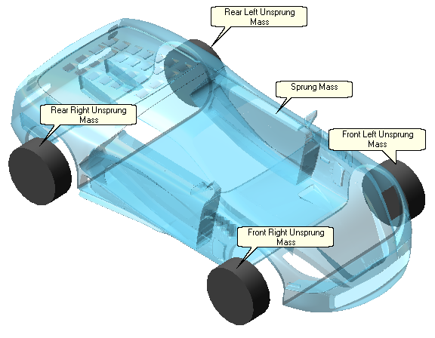
Figure 20. VI-CarRealTime model – rigid bodies
To achieve such reduced model, it is necessary to represent some of the subsystems of the vehicle in a simplified manner, as is the case for the suspension and steering systems. The suspension and steering models – differently from the classic multibody approach - do not contain the mechanical parts, such as linkages and bushings, but represent their mechanical behaviour through look-up tables, using a conceptual approach. It is necessary to supply the software with kinematic, compliance and component data for the specific suspension and steering configuration. Other vehicle subsystems (brakes and powertrain) are described using differential and algebraic equations, so no extra part is present in the model.
This approach allows a good compromise between complexity and accuracy, allowing the user to create a sufficiently detailed description of the vehicle dynamics – of course without some of the details of a complete multibody model – with reasonable computational time, apt to run in real-time and be used in optimization and co-simulation environments easily.
At a more theoretical level, some authors derive the explicit linearized equations of motion for an equivalent 10 or 14 DOFs model [50]. The general model with the considered degrees of freedom is depicted in Figure 21. From this framework it is possible to derive the equations of motion of each DOF by the trivial application of linear or rotational versions of Newton’s second law of motion, considering the corresponding forces in the ride and handling movements.

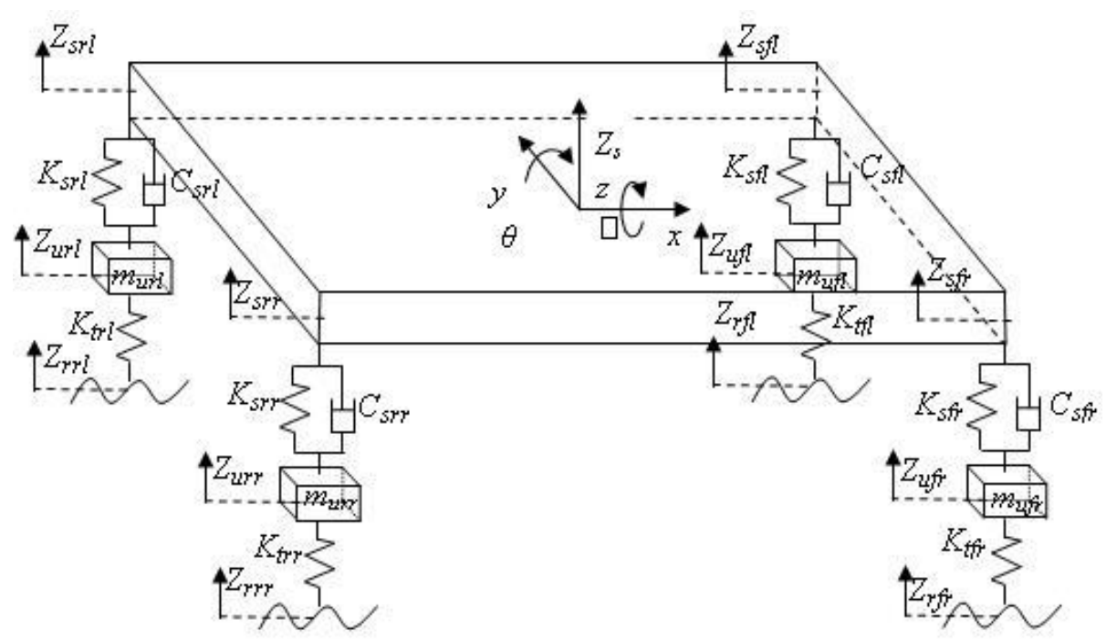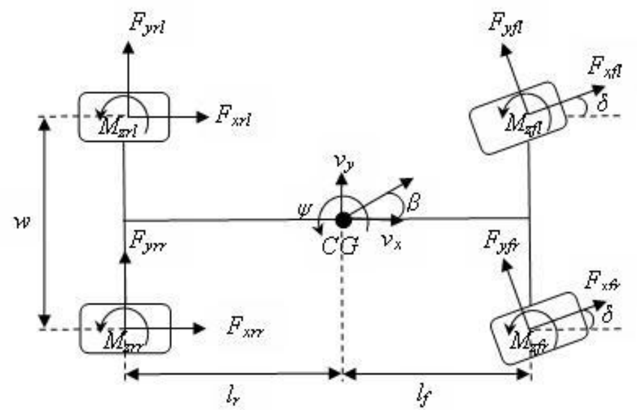
Figure 21. Vehicle dynamics 14 DOF model - ride model (left) and handling model (right) [51]
In the vertical direction the external input comes from the road profile represented by z_{rrr,} z_{rrl,} z_{rfl,} and z_{rfr}, while the handling model sees the steering angle δ as the main control input, as well as the longitudinal tire forces induced by the powertrain or braking subsystems. The two models are, of course, coupled, since the accelerations generated by the handling model impact the attitude and load transfer of the vehicle, while the road profile and vertical model define the wheel road-holding capabilities and suspension position, for instance.
The forces generated by the tires can be defined by the Pacejka Magic Formula (in the lateral direction):
$$F_{y}=D·sin[C·arctan\{B·α-E·(B·α-arctan(B·α)\}]$$
Where α is the sideslip angle of the wheel and B, C, D and E are the experimentally determined coefficients. An equivalent formulation can be observed in the longitudinal direction.
With the general concept of the 14 DOF modelling strategy adopted by VI-CarRealTime, some specific characteristics of the case-study proposed by the article are discussed.
The baseline vehicle used in the analysis is the “Racecar” template in VI-CarRealTime, which are described the main features of a sports vehicle. This template has been modified to match the technical specifications of latest high end full electric vehicles (such as Rimac Nevera, Pininfarina Battista or Lotus Evija) as shown in Table 3. The main change in the original software template, apart from mass and CoG positioning, regards the electric powertrain. The used powertrain layout is an adapted version of the In-wheel motors supplied by EMRAX [52], more specifically the model EMRAX 348 High voltage, simulated based on the torque, power and efficiency curves scaled to achieve the desired output power.
Table 3. Vehicle reference model technical specification
Vehicle sprung mass | 2050 | kg
Vehicle un-sprung mass | 190 | kg
Total maximum power | 1257 | kW
Wheelbase | 2691 | mm
CoG longitudinal coordinate | 1369 | mm
CoG height | 378 | mm
Front track width | 1700 | mm
Rear track width | 1620 | mm
Frontal area | 2.1 | m²

From the aerodynamic perspective, the reference vehicle body shape used in the previous work was the Aston Martin Vantage 2019 to fit vehicle dimensions with a reference Computer Aided Design (CAD) model used for aerodynamic simulations.
Details regarding the aerodynamic modelling, electric powertrain and other subsystem modifications, and overall system performance with the singular control systems can be found in [8–12].

