Impact of biochar on anaerobic digestion: meta-analysis and economic evaluation
Marco Chiapperoª, Silvia Fiore^{a,*} , Franco Berruti^{b}

ª DIATI (Department of Engineering for Environment, Land and Infrastructure), Politecnico di Torino, Corso Duca degli Abruzzi 24, 10129, Torino, Italy
^{b} ICFAR (Institute for Chemicals and Fuels from Alternative Resources), Department of Chemical and Biochemical Engineering, Faculty of Engineering, Western University, London, Ontario, N6A 5B9, Canada

*corresponding author: Prof. Silvia Fiore, DIATI, Politecnico di Torino, Corso Duca degli Abruzzi, 24; 10129, Torino, Italy; E-mail: silvia.fiore@polito.it; Phone: +39 011 090 7613

Abstract
The growing global energy demand encourages the request for renewable sources, as biomethane from the anaerobic digestion (AD) of waste biomass. Biochar (BC) can effectively increase methane production when supplemented to AD, depending on BC physico-chemical properties. This study was developed in two phases. Firstly, a systematic meta-analysis of current literature was performed to correlate AD performance with BC properties, aiming to define their optimal range. The obtained results prove that BC enhances and accelerates biomethane production. Considering 408 experimental conditions of 76 studies in batch mode, biomethane yield and maximum production rate were significantly increased by BC addition. From the results of the subgroups meta-analysis, an optimal range of BC physico-chemical properties may be suggested as follows: high ash (≥ 20%) and low C contents (< 50%), high O/C molar ratios (≥ 0.3), high contents of O (≥ 20%) and N (≥ 0.6%), acidic pH (< 7.0), low surface area (< 10 m² g⁻¹). Secondly, an economic analysis aimed at assessing the economic profitability of BC addition to an existing AD plant suggest avoiding a dose above 0.45-0.76 g_{BC} g_{VS}⁻¹, independently of the specific AD operating conditions. In conclusion, BC application in full-scale digesters is able to maximize biomethane production and economically feasible.

Highlights
- Biochar addition enhances and accelerates biomethane production from waste biomass
- An inventory of literature on biochar addition to anaerobic digestion is provided
- Meta-analysis defined the optimal range of biochar properties for this application
- An economic analysis suggested to use biochar doses below 0.45-0.76 g_{BC} g_{VS}⁻¹

Keywords
anaerobic digestion; biochar; economic analysis; methane; meta-analysis.

Abbreviations
AD: anaerobic digestion; ANOVA: analysis of variance; BC: biochar; BET: Brunauer–Emmett–Teller; C: total carbon; CEC: cationic exchange capacity; CI: confidence intervals; CHP: combined heat and power; COD: chemical oxygen demand; DF: degrees of freedom; EAC: electron accepting capacity; EC: electrical conductivity; EDC: electron donating capacity; FC: fixed carbon; GHG: green-house gas; H: herbaceous; HRT: hydraulic retention time; HSD: honestly significant difference; λ: lag-phase; LR: lignocellulosic residue/crops; M: Manure or animal-based residue; NLR: Non-lignocellulosic residue; OFMSW: organic fraction of municipal solid waste; OLR: organic loading rate; P: biomethane potential; PI: prediction interval; R_{max}: methane production rate; S: sludge; SA: specific surface area; SD: standard deviation; SE: standard error; SMD: standardized mean difference; SRT: sludge retention time; SS: suspended solids; TKN: total Kjeldahl nitrogen; TP: total phosphorous; TS: total solids; UM: unit of measure; VFA: volatile fatty acids; W: wood; VM: volatile matter; VS: volatile solids.

1. Introduction
Biochar (BC) is the solid carbonaceous material derived from the thermo-chemical treatment of biomass in absence or with limited air [1]. BC can be produced using a wide array of feedstocks, including wood, herbaceous crops, agro-industrial residues, animal manure, and biosolids [2,3], through different technologies (pyrolysis, hydro-thermal carbonization, torrefaction, gasification, or partial combustion) [4,5]. By controlling biomass feedstock, thermo-chemical operating conditions, and further activation, BC can be produced with a wide-range of physico-chemical features [5,6] and tailor-made for specific applications. Initially, a strong interest about BC was focused on its agronomical application, due to its potential benefits on soil quality coupled with the significant effects on the reduction of greenhouse gases (GHG) emissions through carbon sequestration. Recently, other BC applications have been proposed [7–9], as adsorbent for contaminants in soil, water, and gaseous streams, precursor for BC-based materials or for energy storage applications, and additive for anaerobic digestion (AD) or composting.
In recent years, the production of renewable energy, including bioenergy from waste biomass, has increased considerably to reduce GHG emissions from fossil fuels. AD could reduce the global GHG emissions by 3.29 to 4.36 Gt CO₂ eq. [10], representing the 7-9% of the world’s current GHG emissions (equal to about 50 Gt CO₂ eq) [11]. AD is a biological process used to convert organic wastes and wastewater in absence of oxygen to biogas and digestate. Biogas, mainly formed by CH₄ and CO₂, can be burnt in cogeneration units to produce heat and electricity or upgraded to renewable natural gas. Digestate can be recycled into value-added products as bio-fertilizer, solid biofuel, or carbon-based materials [12]. Despite AD is a mature technology some critical issues persist; process instabilities due to volatile fatty acids (VFAs) accumulation may occur in case of high organic loads of easily degradable biomass [13]. Other issues include low biogas yield due to a slow hydrolysis of recalcitrant substrates [14,15], as well as the presence of AD inhibitors [16,17].
The application of BC as additive in AD process has shown the potential of enhancing and accelerating methane production from different substrates [18]. Several review studies analysed the complex mechanisms of BC intervention in AD [18–27]: mitigation of potential inhibitions and process instabilities through the adsorption of inhibitors, increased AD buffering capacity, immobilization of microbial cells on BC, acceleration of metabolic activities by BC, and transfer of electrons and/or other metabolites among the microorganisms involved in hydrolysis, acidogenesis, acetogenesis, and methanogenesis. Further, BC can remove CO₂ and impurities from biogas. BC doesn’t need to be separated from the digestate due to the enhanced agronomic quality in terms of carbon sequestration, nutrients and water retention in soils, reduction of nutrients and contaminants run-off, and reduction of GHG emissions from soils [18,19,28]. However, despite a good agreement in literature regarding the benefits of BC intervention, a proper understanding of the role of the BC physico-chemical properties in these mechanisms and their correlation with AD performance still needs to be reached. As a result, the addition of BCs with a wide variation of physico-chemical properties had proven effects on AD, often positive, but, sometimes, also detrimental. Therefore, it is necessary to define the optimal range of BC physico-chemical properties specifically targeting AD. Despite the wide range of experimental data, few attempts have been performed to correlate BC properties with AD performances [27,29,30]. In a previous study [29] we explored the correlation of each BC feature with AD performances through Principal Component Analysis on experimental data achieved from our batch tests, suggesting some key BC properties and underlying the need of more experimental data to draw additional conclusions. In this direction, Khashaba et al. [30] identified strong correlations between the physico-chemical BC features and AD performances through an artificial neural network based on literature data focusing just on sewage sludge substrate.
Meta-analysis is a statistical approach allowing to analyse the results of multiple complex studies, and to critically compare the results of different studies to identify patterns and relationships, leading to robust conclusions. Meta-analysis has been carried out to investigate the effects of BC on GHG emissions from soil [31–33], on plants growth and productivity [34,35], and on soil properties [36–38]. Recently, Xiao et al. (2021) [27] conducted a meta-analysis on 27 publications and 156 datasets to assess the impact of BC properties (dose, pH, size, specific surface area, feedstock, pyrolysis temperature) on AD performance, concluding that BC enhances methane production, and suggesting that BC features able to control methane production were feedstock type, pyrolysis temperature and BC dose, without defining their optimal range values. Compared to Xiao et al. (2021) [27], submitted in March 2021, this work presents the results of a meta-analysis that has elements of novelty as follows. In details, just 6 months later (in September 2021) over 50 additional studies exploring BC influence on AD have been published. Therefore, compared to the ones considered in Xiao et al. (2021) [27], more datasets can be accounted in a meta-analysis, considering a wider number of BC physico-chemical features (conductivity, pH, specific surface area, particle size, dose), BC production characteristics (feedstocks and pyrolysis temperature), and also AD operating conditions and substrates. To our knowledge, a key knowledge gap of the available literature is that it only suggests what are BC desirable properties, without defining the optimal range values of the single BC physico-chemical properties, their correlation with AD performance, nor the AD substrates and operating conditions that are more likely improved by BC supplementation. It is reasonable to expect different effects of BC on AD performance depending on the specific combinations of AD temperature and feeding conditions (substrate, organic load); for instance, BC was acknowledged as a stabilizing agent [21] in case of high organic loads of a highly degradable substrate as the organic fraction of municipal solid waste (OFMSW), and also as an accelerating agent of metabolic activities [24,26], in case of a relatively refractory substrate as sewage sludge. Another knowledge gap of current literature on the topic is the uncertainty related to the full-scale application of BC to AD is the comparison between BC input cost and output revenues deriving from the energy production, since few studies have investigated the economic feasibility of BC supplementation in AD [39–41] Therefore, compared to existing literature, the present work has two key elements of novelty, as follows. Firstly, it compiled a systematic inventory (in the form of a database) of the literature selected according to specific strict requirements, which was further used to conduct a meta-analysis on the effects of BC and its properties on AD performance, considering not only BC features but also the ones of AD process. Secondly, it evaluated the economic feasibility of BC addition to existing full-scale AD installations.
This study was focused on the application of BC as additive in AD, with a specific interest for the optimization of BC physico-chemical properties and their correlation with AD performance. In details, this study had the following aims: (1) assessment of the overall effect of BC on AD performance derived from batch and semi-continuous studies; (2) analysis of the impact of BC physico-chemical properties, BC production conditions, and AD operating conditions on the global effects of BC on AD products yields and quality; and (3) assessment of the economic feasibility of BC addition on AD at full-scale, based on data from published semi-continuous AD studies.

2. Material and methods

2.1. Data collection and selection
A systematic bibliographic search was conducted using Scopus and Google Scholar, and compared with the list of references of a previous review paper [18]. The collection of references was completed in September 2021. The size of the selected datasets was significant (613 paired experimental conditions of BC amended “treatment” and “control”), and the following phases of data extraction and database compilation applied to such a huge amount of information required several months before starting data analysis. The compiled systematic database was made available as Appendix A to other researchers with the specific aim of providing a common dataset that can be updated and expanded with new studies for future analyses. The literature survey was based on the following combination of keywords: (methane or CH₄ or biogas or anaerobic digestion) and (biochar or bio-char). Around 450 references were collected and imported to Mendeley.
A first filtering phase (data extraction) was conducted checking abstract and title, and based on the following criteria: (1) use of English language; (2) access provided to the full text; (3) only primary sources (no review studies); (4) studies with “treatment” group (reactors with biochar supplementation) and “control” group (reactors without biochar), where other experimental conditions were identical; (5) studies reporting methane and/or biogas production; (6) no combined use of biochar and other additives. As a result, 112 studies with 613 paired measurements of “treatment” vs “control” met the inclusion criteria.
A second screening phase (data selection) was conducted to select the studies eligible for a meta-analysis, according to the following additional criteria: (7) provided number of experimental replicates > 1; (8) provided mean and uncertainty of methane production, as standard deviation (SD) or standard error (SE). Therefore, 76 studies with 408 experimental conditions in batch mode and 18 studies with 83 conditions in semi-continuous mode were included in the meta-analysis performed in this work.

2.2. Categorization of the selected literature data
The full text and the supplementary materials of the studies passing the first screening phase were subjected to data extraction, and an inventory of the selected literature (613 paired measurements of “treatment” vs “control”) was compiled as a database in Excel (Appendix A). The data were grouped based on variables affecting methane production, considering the most frequent to include enough results within each category. These include BC production conditions (feedstock, pyrolysis temperature), physico-chemical properties of BC (surface area, ash, pH, contents of C, H, N, and O, H/C and O/C molar ratios), substrates for AD, operating conditions of AD (temperature, batch vs semi-continuous, dose of BC). Data included in the database were obtained directly from tables and text, or extracted using Web Plot Digitizer (Pacifica, US) [42] if only presented in figures. Primary data about methane production were extracted: in case of batch AD tests, CH₄ yield and kinetic parameters (CH₄ production rate R_{max} and lag-phase λ) when the modified Gompertz model was applied; in case of semi-continuous AD tests, CH₄ production rate and CH₄ content. For all parameters, mean, SD, number of replicates (n), and unit of measures (UM) were extracted. When only SE was provided, SD was estimated as $SD=\sqrt{n} SE$. Further relevant data and information were extracted: (1) article information, (2) operating conditions of BC production, (3) physico-chemical properties of BC, (4) operating conditions of AD tests, (5) physico-chemical features of substrate and inoculum for AD. UMs were converted to standardized units for comparison; for instance, the dose of biochar provided in different UMs (g g_{TS}⁻¹, g g_{VS}⁻¹, g L⁻¹, % bw) was standardized to g L⁻¹ or derived from the available data. When it was not possible, it was recorded in the database, but excluded from the statistical analysis. Further, when the oxygen content of the BC was not available, it was determined by difference as O = 100 – Ash (%) – C (%) – H (%) – N (%) – S (%), according to standard method ASTM D3176. H/C and O/C molar ratios were derived from H, C, and O element contents (%), and their corresponding atomic weights (H: 1.008; C: 12.011; O: 15.999). Table B1 in Appendix B summarises the data presented in the inventory (Appendix A): data category, data type, unit of measure, notes, and assumptions for data extraction. Table B2 in Appendix B contains the selected research studies included in the inventory, published from 2012 to September 3rd, 2021.

2.3. General overview of the selected literature data
The systematic bibliographic research firstly selected around 450 studies, reduced to 112 after the first screening. 613 paired experimental conditions of BC amended “treatment” and “control” were included in the inventory from the 112 selected studies. The detailed inventory (Appendix A) represents a systematic overview of current state of the research, while summarized data are in Tables B1 and B2 of Appendix B. These include article information, conditions of BC synthesis, BC physico-chemical properties, operating conditions of AD tests, and physico-chemical features of substrate and inoculum for AD. More data than the information used for the meta-analysis was collected in the inventory (Appendix A) to provide a common basis for further research exploring BC role in AD.
The 613 paired case-studies were grouped based on parameters possibly affecting methane production (Table 1). Most AD tests were conducted in batch (82%) than in semi-continuous mode (17%). A clear imbalance was observed between tests in AD mesophilic (77%) and thermophilic (22%) conditions. Regarding the substrates for AD, in case of mono-digestion (81%) the most frequent substrates were sewage sludge (20%), food waste or OFMSW (18%), and manure (10%), along with agro-industrial wastes, wastewater and simple substrates. In case of co-digestion (19%), food waste (with manure or sewage sludge) was the most abundant substrate (11%). BC was obtained from several feedstocks, as wood (49%), herbaceous materials (19%), sludge (13%), crops and lignocellulosic residues (9%), manure (6%), and non-lignocellulosic residues (5%). Different temperatures were employed during the thermo-chemical production of BCs, from less than 400 °C (11%), to typical pyrolysis temperatures ranging between 400 and 700 °C in most cases (64%), up to more than 700 °C in the gasification range (25%). Because of the varying feedstocks and temperature of pyrolysis, a large spectrum of physico-chemical properties of BCs was observed, as discussed in section 3.1. Despite a wide range of BC doses reported (0.2-100 g L⁻¹), in most cases it was below 20 g L⁻¹ (75%), and 10 g L⁻¹ was the most adopted.

Table 1. Classification of case studies in the inventory: variables and corresponding levels, relative and absolute (between brackets) frequency of studies in each level.
Variable [unit of measure] | Levels/subgroups | Definition | Relative frequency (number of occurrence)
Feedstocks for biochar production (classification adapted from [31,37]) | Wood (W) | Oak, pine, willow, unidentified wood mixtures, spruce, pine trimmings, coppiced woodlands, orchard pruning, pristine wood, bamboo, sawdust, vineyard pruning, holm oak, Ash juniper, white oak, shrub, cotton wood, douglas fir | 48.5% (289)
 | Herbaceous (H) | Green waste, straws, and corn stover, maize stover, wheat straws, miscanthus straw, rice straw, water hyacinth, fucus serratus, corn straw, switchgrass, reed straw | 18.5% (110)
 | Manure or animal-based residue (M) | Manure or manure-based materials (bone, meat, blood, etc.)  sheep manure, dairy manure, cattle bone, poultry waste, cow dung, cow manure, chicken manure | 6.2% (37)
 | Sludge (S) | Any sludge, usually obtained from wastewater treatment but also including brewery sludge  biosolids | 12.8% (76)
 | Crops/Lignocellulosic residue (LR) | Walnut shells, peanut shells, maize cobs, furfural from corn cobs, rice husk, nuts shells, paper mill waste, coconut endocarp or shell, coffee grounds, almond shells | 9.2% (55)
 | Non-lignocellulosic residue (NLR) | Fruit peels, seeds, beet-root chips, spent brewer's grains or draff, wheat bran, citrus peel, oil seed rape, canola meal, corn stalk, whiskey draff | 4.9% (29)
Pyrolysis temperature [°C] | < 400 | t < 400 °C | 10.5% (58)
Pyrolysis temperature [°C] | 400 - 550 | 400 °C ≤ t < 550 °C | 32.9% (182)
Pyrolysis temperature [°C] | 550-700 | 550 °C ≤ t < 700 °C | 31.3% (173)
Pyrolysis temperature [°C] | ≥ 700 | t ≥ 700 °C | 25.3% (140)
Biochar dose [g L⁻¹] | < 5 | Dose < 5 g L⁻¹ | 18.7% (108)
Biochar dose [g L⁻¹] | 5-10 | 5 g L⁻¹ ≤ dose < 10 g L⁻¹ | 16.1% (93)
Biochar dose [g L⁻¹] | 10-15 | 10 g L⁻¹ ≤ dose < 15 g L⁻¹ | 26.5% (153)
Biochar dose [g L⁻¹] | 15-20 | 15 g L⁻¹ ≤ dose < 20 g L⁻¹ | 13.5% (78)
Biochar dose [g L⁻¹] | ≥ 20 | Dose ≥ 20 g L⁻¹ | 25.3% (146)
Feeding mode of anaerobic digestion | Batch |  | 82.1% (503)
Feeding mode of anaerobic digestion | Fed-batch |  | 1.0% (6)
Feeding mode of anaerobic digestion | Semi-continuous |  | 17.0% (104)
Substrate for anaerobic digestion | Agro-industrial | Draff, brewer’s spent grain, citrus peel, cardboard, dried sorghum, orange peel, corn-straw, wheat straw, sugar beet pulp, water hyacinth, corn stalk, beer lees, whiskey draff, broadleaf cattails | 15.4% (93)
Substrate for anaerobic digestion | Other co-digestion | Other co-digestion (no food waste with manure/sewage sludge): orange peel + sewage sludge, cassava wastewater + poultry litter, straw + cow manure, wheat husk + mixed sludge, swine manure + sewage sludge, corn stover + chicken manure, cow dung + sewage sludge pyrolysis liquid, algal biomass + food waste, corn straw + cow dung, wheat straw + cow dung, rice straw + cow dung | 7.9% (48)
Substrate for anaerobic digestion | Co-digestion of food waste + manure/sludge | Co-digestion of food waste with manure or sewage sludge | 10.8% (65)
Substrate for anaerobic digestion | Manure | Swine manure, poultry litter, chicken litter, dairy manure, chicken manure, swine waste, pig manure | 9.8% (59)
Substrate for anaerobic digestion | OFMSW/food waste | Fruit waste, food waste, organic fraction of the municipal solid waste (OFMSW), rice, chicken, vegetables, kitchen waste, cooked rice/egg white/lard | 17.9% (108)
Substrate for anaerobic digestion | Sewage sludge | Mixed sludge, sewage sludge, wastewater sludge, waste activated sludge, primary sludge | 19.7% (119)
Substrate for anaerobic digestion | Simple substrate | Phenol solution, glucose solution, oil, mixed volatile fatty acids, ethanol, glucose, cellulose, acetate, propionate, butyrate, valerate, oily sludge + starch + naphthalene | 10.4% (63)
Substrate for anaerobic digestion | Wastewater | Wastewater, synthetic wastewater, piggery wastewater, food waste fermentate, cassava wastewater, soured anaerobic digestate, Aqueous phase of bio-oil generated via Hydrothermal Liquefaction of Algae, synthetic blackwater, cread fermentate, synthetic dairy wastewater | 8.1% (49)
Temperature for anaerobic digestion [°C] | Low temperature | t < 25 °C | 0.8% (5)
Temperature for anaerobic digestion [°C] | Mesophilic | 25 °C ≤ t < 40 °C | 77.3% (469)
 | Thermophilic | t ≥ 40 °C | 21.9% (133)
Ash [% wt] | < 5.0 | Ash < 5% | 15.5% (51)
Ash [% wt] | 5-10 | 5% ≤ ash < 10% | 29.0% (95)
Ash [% wt] | 10-20 | 10% ≤ ash < 20% | 20.4% (67)
Ash [% wt] | 20-50 | 20% ≤ ash < 50% | 25.6% (84)
Ash [% wt] | ≥ 50 | Ash ≥ 50% | 9.5% (31)
Surface area  [m² g⁻¹] | < 10 | surface area < 10 m² g⁻¹ | 12.8% (56)
Surface area  [m² g⁻¹] | 10-20 | 10 m² g⁻¹ ≤ surface area < 20 m² g⁻¹ | 16.7% (73)
Surface area  [m² g⁻¹] | 20-100 | 20 m² g⁻¹ ≤ surface area < 100 m² g⁻¹ | 21.2% (93)
Surface area  [m² g⁻¹] | ≥ 100 | surface area ≥ 100 m² g⁻¹ | 49.3% (216)
pH [-] | < 7 | pH < 7 | 12.9% (48)
 | 7-8 | 7 ≤ pH < 8 | 11.8% (44)
 | 8-9 | 8 ≤ pH < 9 | 23.9% (89)
 | 9-10 | 9 ≤ pH < 10 | 34.3% (128)
 | ≥ 10 | pH ≥ 10 | 17.2% (64)
Total C [% wt] | < 50 | Total C < 50% | 17.7% (76)
 | 50-70 | 50% ≤ total C < 70% | 29.1% (125)
 | 70-80 | 70% ≤ total C < 80% | 26.3% (113)
 | ≥ 80 | Total C ≥ 80% | 26.8% (215)
H [% wt] | < 1 | H content < 1 % | 23.5% (81)
 | 1-2 | 1% ≤ H content < 2% | 21.2% (73)
 | 2-3 | 2% ≤ H content < 3% | 20.3% (70)
 | 3-4 | 3% ≤ H content < 4% | 13.9% (48)
 | ≥ 4 | H content ≥ 4% | 21.2% (73)
O [% wt] | < 5 | O content < 5% | 12.0% (42)
 | 5-10 | 5% ≤ O content < 10% | 17.7% (62)
 | 10-15 | 10% ≤ O content < 15% | 25.7% (90)
 | 15-20 | 15% ≤ O content < 20% | 16.6% (58)
 | ≥ 20 | O content ≥ 20% | 28.0% (98)
N [% wt] | < 0.3 | N content < 0.3% | 15.1% (54)
 | 0.3-0.6 | 0.3% ≤ N content < 0.6% | 37.5% (134)
 | 0.6-1.2 | 0.6% ≤ N content < 1.2% | 16.5% (59)
 | ≥ 1.2 | N content ≥ 1.2% | 30.8% (110)
H/C molar ratio [-] | < 0.1 | H/C molar ratio < 0.3% | 16.7% (56)
 | 0.1-0.3 | 0.1% ≤ H/C molar ratio < 0.3% | 22.4% (75)
 | 0.3-0.5 | 0.3% ≤ H/C molar ratio < 0.5% | 24.5% (82)
 | 0.5-1.0 | 0.5% ≤ H/C molar ratio < 1.0% | 22.4% (75)
 | ≥ 1.0 | H/C molar ratio ≥ 1.0% | 14.0% (47)
O/C molar ratio [-] | < 0.075 | O/C molar ratio < 0.075% | 26.0% (92)
 | 0.075-0.15 | 0.075% ≤ O/C molar ratio < 0.15% | 29.1 (103)
 | 0.15-0.3 | 0.15% ≤ O/C molar ratio < 0.3% | 23.4 (83)
 | ≥ 0.3 | O/C molar ratio ≥ 0.3% | 21.5 (76)

3. Theory and calculations

3.1. Analysis of variance (ANOVA)
The influence of feedstocks for BC production and pyrolysis temperature on the physico-chemical properties of BCs was assessed. All BCs included in the inventory were considered. Feedstocks and pyrolysis temperatures were grouped according to the criteria described in Table 1. One-way analysis of variance (ANOVA) at α = 0.05 was used to compare different feedstocks and temperatures. Then, significant differences between individual subgroups were identified through Tukey’s honestly significant difference (HSD) post-hoc test (α = 0.05). Boxplot was used to identify the distribution of each BC property. All statistical analyses were conducted using R language [43].

3.2. Meta-analysis
Meta-analysis was carried out using the Metafor package v. 3.0-2 [44] in R. Firstly, data were divided into two subsets (batch and semi-continuous AD tests). Then, three separate meta-analysis were carried out to investigate the effect of BC supplementation on CH₄ yield, CH₄ production rate (R_{max}) and lag-phase (λ) from the modified Gompertz model fitting. In case of the semi-continuous subset, an additional meta-analysis was conducted to assess the effect of BC on CH₄ production rate. In each case, the paired results of the “treatment” and “control” groups were computed to obtain the effect size (ES), being the extent of the treatment effect (BC addition), or, in other words, the magnitude of the difference between the “treatment” and the “control” means [45]. The Hedges’s standardized mean difference (g) [46] was adopted as ES index, suitable for small sample sizes (2 or 3 replicates in most studies) and for comparing means with different units of measure across studies (see Table B1, Appendix B). Thus, for each variable the Hedges’s g was calculated according to eq. 1:
$g=J\frac{\overline{X_{1}}-\overline{X_{2}}}{S_{p}}$ (1)
where
$S_{p}=\sqrt{\frac{\left(n_{1}-1\right){S_{1}}^{2}+ \left(n_{2}-1\right){S_{2}}^{2}}{n_{1}+n_{1}- 2}}$ (2)
$J=1-\frac{3}{4df-1}$ (3)
$\overline{X_{i}}$, n_{i}, and S_{i} are the variable mean, the standard deviation, and the number of samples of the treatment (1) and the control groups (2), respectively; S_{p} is the pooled standard deviation across groups (eq.2); J is a correction factor accounting for small sample sizes (eq.3); df is the degrees of freedom (n₁ + n₂ – 2 for two independent groups). The second term of eq.1 is the standardized mean difference (SMD). Thus, considering for example the CH₄ yield, a positive value of g means that BC addition enhances CH₄ yield compared to the control group. The variance V_{g} of g was determined according to eq. 4:
$V_{g}=J^{2}\frac{n_{1}+n_{2}}{n_{1}n_{2}}\frac{g^{2}}{2\left(n_{1}+n_{2}\right)}$ (4)
Once determined the ESs and associated variances for the individual measures, the summary effects of BC addition on CH₄ yield, R_{max}, λ, and CH₄ production rate were determined. The summary effect was estimated using a random-effects model instead of a fixed-effects model, which assumes a common or fixed effect for all the tests, since the true effects likely varied across studies due to the different experimental conditions [47]. DerSimonian and Laird method was used to estimate the between-studies variance (T²) [48]. The confidence intervals (CIs) for the summary effect were determined by using the Knapp-Hartung adjustment [49]. Therefore, the summary ES was considered significantly different from zero whether the 95% CIs did not overlap zero, i.e., supplementation of BC had a significant impact. Significance of heterogeneity in true effects was tested by Q-value, degrees of freedom (df) and corresponding p-value. I² statistic (%) was also reported to express the fraction of observed variance due to heterogeneity rather than random error [46].
Subgroup analyses were carried out to investigate how different variables could influence the effects of BC supplementation on CH₄ yield, R_{max}, and λ. Each moderator variable was classified in two or more subgroups. Then, a mixed-effects model was used to estimate the effect of each variable, assuming that variation across tests within each subgroup was due to random error, while variation between subgroups was fixed [47]. The summary effect within each subgroup was computed using a random-effect model with a separate estimate of T², whereas the summary effect across subgroups was calculated with a fixed-effects model. An omnibus test (Q_{M}) was used for testing the significance of each moderator variable: if a Q_{M} was significant, this meant that on average the ES differed between subgroups (p-value < 0.05); consequently, each pair of effects of moderator subgroups was considered significantly different if their 95% CIs did not overlap [47].
All results of meta-analysis were condensed on a forest plot. The vertical axis (g equal to zero) is known as line of no effect [45]: a positive ES on the right constitutes an increase of CH₄ yield, R_{max}, λ, or CH₄ production rate due to BC supplementation, whereas a negative value on the left indicates a decrease. A square represented the mean ES of a given subgroup together with its 95% CIs, being significantly different from zero when CIs did not intercept the vertical axis. The summary effect was represented by a diamond, where its location identified the mean, and its vertices depicted the lower and upper 95% CIs. Further, the 95% prediction intervals (PIs) were shown by a dashed line in case of a random-effects model.

3.3. Economic analysis
To assess the economic feasibility of BC supplementation to AD at full-scale, an economic analysis was carried out using input data of semi-continuous AD tests at lab or pilot scale (Table B3 in Appendix B). Input data ($Δ{CH}_{4}$, VS, d_{BC}) were directly extracted or derived from the available information. Some studies were excluded due to lack of useful data, and 14 studies with 57 experimental conditions in semi-continuous mode were included in the economic analysis. Since the specific objective of the analysis was to assess the economic feasibility of biochar addition to AD, the main assumption was to consider BC addition to an operating full-scale digester, compared to AD without BC as baseline, similarly to another recent techno-economic analysis [50] related to the addition of various BCs to the AD of food waste. Therefore, capital costs and operation and maintenance costs of the digester were not considered, as in the mentioned study [50].
The economic analysis estimated the maximum sustainable unit cost of BC (C_{BC,max}) [41], which equals the higher (compared to AD without BC) revenues from the enhanced AD. The C_{BC,max} was compared with the current BC market price. The revenues consisted of the extra thermal energy and electricity from the combustion of biogas in a combined heat and power (CHP) unit due to the enhanced CH₄ production respect to the baseline scenario without BC supplementation. The revenues from thermal (R_{TH}) and electrical (R_{EL}) energy were derived as in eq. 5:
$R_{i}= Δ{CH}_{4} ∙VS ∙ {LHV}_{CH4}∙ η_{CHP,i}∙ C_{EN,i}$ (5)
where $Δ{CH}_{4}$ is the difference between CH₄ production rates (m³ kg_{VS}⁻¹) of BC and CTRL conditions of each study, and VS (kg_{VS} m⁻³) is the concentration of VS of the substrate fed to digester of each study (Table B3, Appendix B); LHV_{CH4} is the lower heating value of CH₄, $η_{CHP,i}$ is the thermal or electrical energy efficiency of CHP unit, C_{EN,i} is the average EU-27 thermal or electrical energy price for non-household consumers (Table B4, Appendix B). The operational cost of BC supply depends on the dose and unit cost of BC. Other capital costs related to the equipment for BC storage, handling, and dosing in the AD substrate can be reasonably neglected [50]. Therefore, by equalling the revenues and the cost of BC supply for each experimental condition, the maximum BC unit cost ($ ton_{BC}⁻¹) was estimated as in eq. 6:
$C_{BC,max}= \frac{R_{TH}+R_{EL}}{d_{BC}} ∙ER ∙1000$ (6)
where R_{TH} and R_{EL} are the revenues from thermal and electrical energy determined according to eq. 5; d_{BC} is the dose of BC (kg m⁻³) supplemented to digester of each study (Table B3 in Appendix B), ER is the average exchange ratio USD-euro (Table B4 in Appendix B).

4. Results and discussion

4.1. Effects of feedstocks and pyrolysis temperature on biochar properties
The distinctive properties of BC parent biomass and the operating conditions of its production (temperature, heating rate, duration) determine the physico-chemical properties of BC. Figure 1 shows the influence of the different feedstock categories on BC physico-chemical properties. The chemical composition of BC parent biomass vary significantly: wood or lignocellulosic residues are mainly composed by cellulose, hemicellulose, and lignin and have a low ash content [5]; herbaceous precursors have a similar composition, but they are richer in ashes [51]; bio-solids (manure or sewage sludge) are a mixture of moisture, micro-organisms, organics, and abundant ashes rich in nutrients and metals [52,53]. Regarding BC physical features, lignocellulosic residue BCs (LR) and wood BCs (W) exhibited a larger specific surface area (SA) (Figure 1A), while W and non-lignocellulosic residue BCs (NLR) a lower average pore diameter compared to other feedstock-based BCs (Figure 1C). Feedstocks with high contents of volatile matter and lignin (W and LR) tend to develop a dense porous structure through the release of volatile compounds during pyrolysis, which is preserved by the thermal stability of lignin [54], resulting in a larger porosity and SA. Conversely, BCs from sludge (S) and manure (M) showed a relatively low SA, probably due to the large ash content (Figure 1E) inducing structural cracking or micropore blockage during pyrolysis [55]. Further, BCs from sludge (S) and manure (M) presented scarce contents of fixed carbon (FC) and total carbon (C) (Figure 1G-H). W clearly differed from other feedstock-based BCs for a lower ash content and higher FC and C. Concerning the contents of nutrients and alkali metals, a larger content of N and P was observed for BCs from S, M, and NLR (Figure 1M-O), while M exhibited a high content of Ca (Figure 1Q). Finally, the O/C molar ratio (Figure 1T) was higher for S and M BCs, suggesting a higher polarity and presence of O-containing functionalities than for herbaceous (H) and W BCs. The cation exchange capacity (CEC) is the amount of exchangeable cations that BC is able of holding [6]. Manure- and sludge-derived BCs have greater CEC compared to other BCs due to an increased ash content [55]. Unfortunately, differences between feedstocks relative to the other BC properties were not significant.
The variation of pyrolysis temperature also affects BC physico-chemical properties, as clearly shown in Figure 2. The specific surface area increased with pyrolysis temperature (Figure 2A). At low temperatures (up to 200 °C) the evaporation of moisture and light volatiles occurs with breakage of bonds; from 200 to 500 °C hemicellulose and cellulose devolatilize and decompose at faster rate; over 500 °C lignin and other organic matter with stronger chemical bonds tend to degrade [56]. The progressive release of gas, water, micro-organic compounds during pyrolysis can create more voids within the BC matrix [56].
A rising processing temperature increased the pH (Figure 2D), likely due to the release of acidic functional groups as carboxyl, hydroxyl, or formyl groups [6] and the formation of Ca-, Mg-, Na-, and K-bearing oxide, hydroxide, and carbonate phases [55], and decreased the volatile matter (VM) (Figure 2F). Since elements as H, O, N tend to volatilize with increasing temperatures (Figure 2I-L-M), the contents of FC and C concentrated significantly within the BCs (Figure 2G-H). Both H/C and O/C molar ratios were reduced significantly by an increased pyrolysis temperature (Figure 2S-T). BCs produced at low temperatures are mostly polar and hydrophilic due to the abundance of oxygen-containing functional groups; BCs produced at high temperatures contain less functional groups and more aromatic structures, with hydrophobic functional groups and a higher stability [5,57]. CEC of BCs tends to decrease with rising temperatures due to the removal of surface functional groups providing negative charges [56].

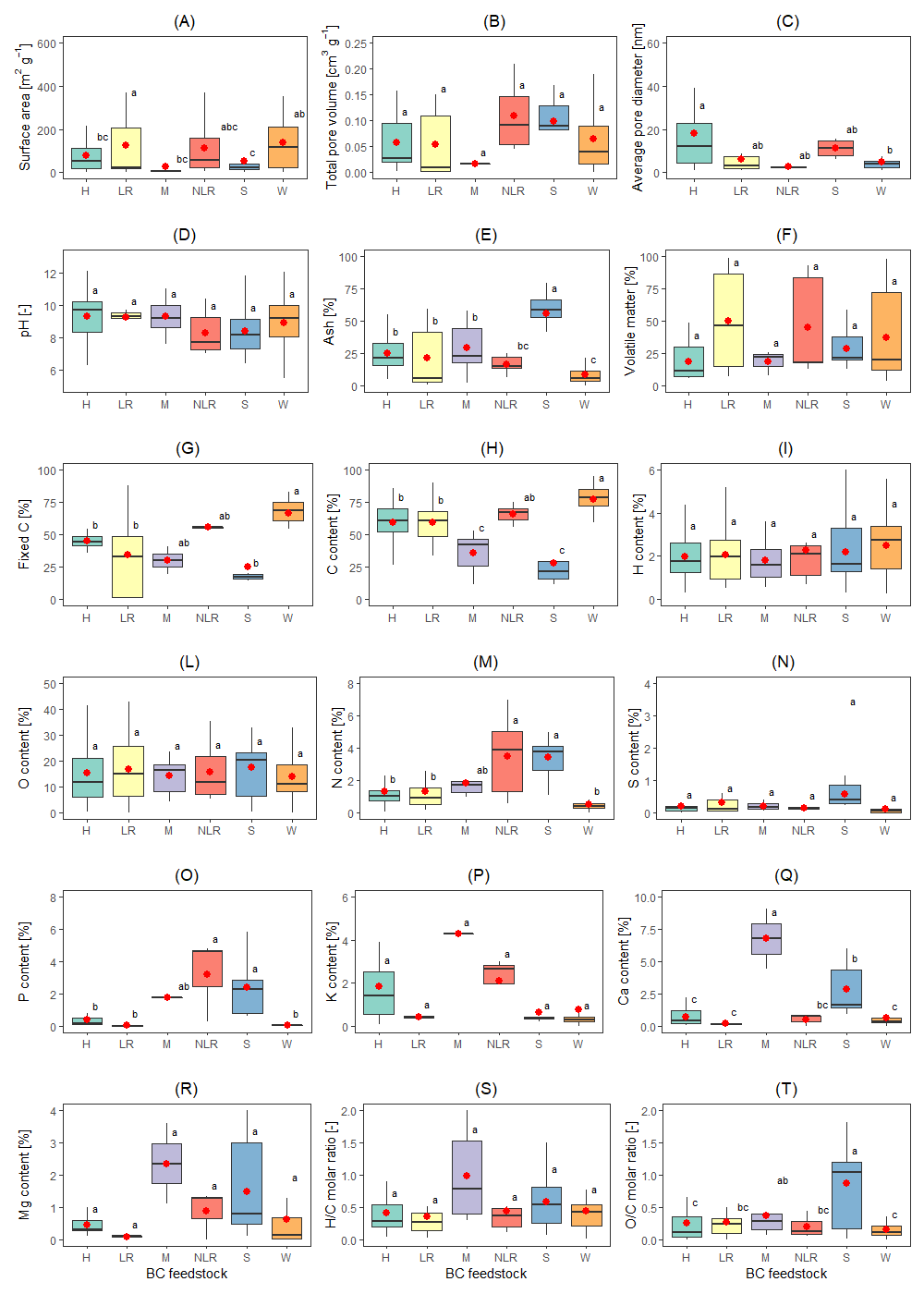
Figure 1. Effect of the different parent biomass on the physico-chemical properties of biochar: (A) Surface area; (B) Total pore volume; (C) Average pore diameter; (D) pH; (E) Ash; (F) Volatile matter; (G) Fixed C; (H) C content; (I) H content; (L) O content; (M) N content; (N) S content; (O) P content; (P) K content; (Q) Ca content; (R) Mg content; (S) H/C molar ratio; (T) O/C molar ratio. Parent biomass: H: herbaceous; LR: lignocellulosic residue; M: manure; NLR: non-lignocellulosic residue; S: sludge; W: wood. A significant difference (p < 0.05) within a boxplot is identified by different letters. Red dots: average values; lines: median values.
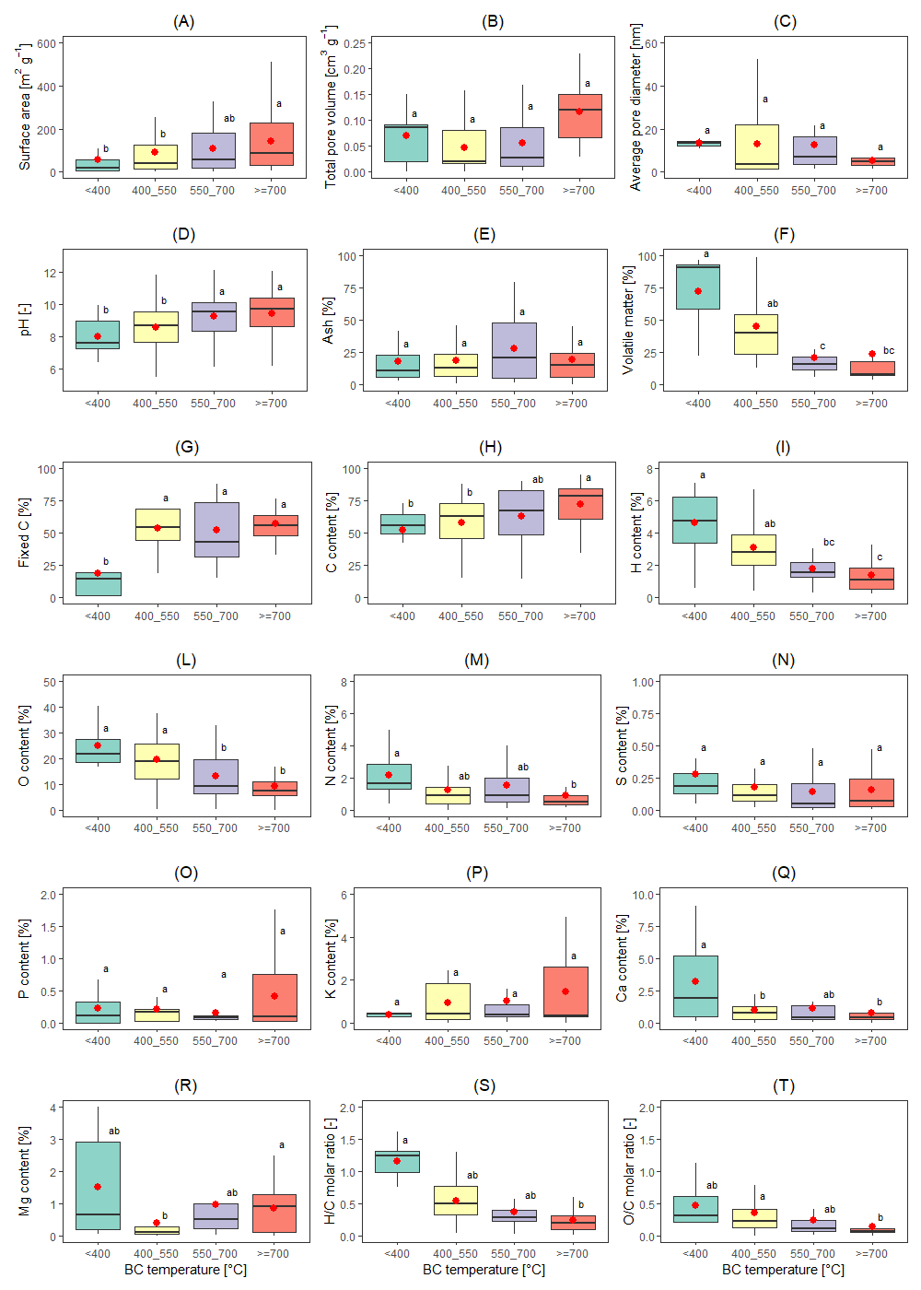

Figure 2. Influence of pyrolysis temperature of the physico-chemical properties of biochar: (A) Surface area; (B) Total pore volume; (C) Average pore diameter; (D) pH; (E) Ash; (F) Volatile matter; (G) Fixed C; (H) C content; (I) H content; (L) O content; (M) N content; (N) S content; (O) P content; (P) K content; (Q) Ca content; (R) Mg content; (S) H/C molar ratio; (T) O/C molar ratio. A significant difference (p < 0.05) within a boxplot is identified by different letters. Red dots: average values; lines: median values.

4.2. Meta-analysis

4.2.1. Overall effects of biochar addition on anaerobic digestion performance
A meta-analysis was used to assess the overall (“summary”) effect of BC addition on AD performance using 408 experimental conditions of 76 studies in batch mode and 83 conditions of 18 studies in semi-continuous mode (Figure 3). Considering the subset of batch tests, the effect of BC addition was investigated on three variables: CH₄ yield, maximum CH₄ production rate (R_{max}) and lag-phase (λ) from the modified Gompertz model fitting of experimental data. On the one hand, the overall effect of BC on CH₄ yield was significant (g = 2.43, 95% CIs = 2.02-2.84), clearly indicating that BC enhances bio-methane production, consistently with the previous meta-analysis by Xiao et al. (2021) [27]. The PIs overlap the line of null effect, indicating also adverse impacts of BC in a reduced number of studies, likely due to inhibitory effects on the methanogenic active toity related excessive doses of BC [58,59]. Not surprisingly, there was a significant heterogeneity among different studies (Q = 2359, p < 0.01, I² = 82.7%), given the high variability of the physico-chemical properties of BCs (section 3.1), AD substrates and AD operating conditions tested (Table 1). Therefore, the role of different moderator variables was further investigated by subgroups analysis. On the other hand, the supplementation of BC accelerated methane production, as indicated by the significant enhancement of R_{max} (g = 2.54, 95% CIs = 1.86-3.22). Besides, the duration of lag-phase was shortened by the presence of BC (g = -1.74, 95% CIs = -2.60/-0.88) able to reduce biomass adaption period to new AD conditions. Therefore, both the start-up phase of a digester or the adaption to substrate changes may be accelerated through BC supplementation. For both R_{max} and λ, there was a significant heterogeneity among studies (Q = 740, p < 0.01, I² = 81.1% and Q = 807, p < 0.01, I² = 84.2%, respectively). Overall, BC supplementation can significantly enhance and accelerate methane production during AD in batch mode.
In case of semi-continuous AD studies, an additional meta-analysis was conducted to assess the effect of BC on CH₄ production rate. Consistently with previous results, BC supplementation significantly improved CH₄ production rate (g = 2.21, 95% CIs = 1.42-3.01). Therefore, the overall positive impact of BC addition on AD performance was confirmed in feeding conditions closer to the full-scale than batch tests.

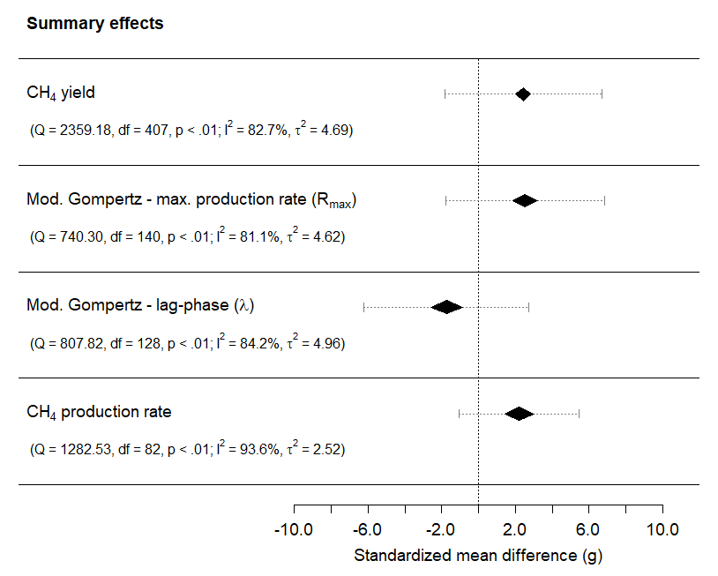
Figure 3. Forest plot of the summary effects (g - Hedges’ standardized mean difference): influence of biochar addition on CH₄ yield, maximum CH₄ production rate (R_{max}) and lag-phase (λ) from modified Gompertz fitting during batch AD tests; influence of biochar addition on CH₄ production rate during semi-continuous AD tests. The position of a diamond stays for the average effect size and its vertices for the lower and upper 95% confidence intervals; the dashed line identifies the 95% prediction intervals.

4.2.2. Effect of moderator variables on CH₄ yield, maximum CH₄ production rate and lag-phase
As just described, in the meta-analysis with 408 paired conditions in batch mode and 83 conditions in semi-continuous mode, BC supplementation to AD significantly enhanced CH₄ yield, R_{max}, and CH₄ production rate, while reduced λ. Therefore, globally, BC addition to AD can enhance and accelerate methane production. However, the summary effects exhibited a significant heterogeneity (Figure 3) due to the high variability of the employed BCs and AD conditions. In this section, the influence of different moderator variables was assessed and discussed through subgroups analysis. The variables considered were as follows: AD temperature and substrates, BC dose, temperature and feedstocks for BC production, and BC physico-chemical properties (ash, pH, surface area, O/C and H/C molar ratios, C, H, O, N contents). The impact of the moderator variables on CH₄ yield is discussed as follows, while their effect on R_{max} and λ is exposed in Appendix B (Figure B1 and B2).

4.2.3. Impact on methane yield
In Figure 4, the results of the subgroups analysis on CH₄ yield are presented, focusing on the influence of different moderator variables. Considering AD temperature (Figure 4A), both mesophilic and thermophilic conditions showed positive effects of BC on CH₄ yield, slightly larger at mesophilic temperatures. Further, a positive effect of BC addition was observed for most AD substrates except in the case of wastewater, which did not exhibit a statistically significant difference from the null effect. The lowest effect was for simple substrates, the largest for co-digestion. The relatively large CIs of co-digestion and wastewater may be attributed to the limited sample size, but also to the highly heterogeneous nature of these substrates. The effect for sewage sludge was slightly lower than for other substrates, as for OFMSW, manure, food waste with manure or sludge.
Overall, the BC dose resulted in significantly positive effects on CH₄ yield, except for the range 15-20 g L⁻¹. The largest effect was observed for the lowest doses (<5 g L⁻¹), followed by the range 5-10 g L⁻¹. Conversely, a previous meta-analysis by Xiao et al. (2021) [27] found a larger impact on methane production for BC doses exceeding 10 g L⁻¹. Excessive BC doses can inhibit methane production, possibly due to the non-selective adsorption of gases or intermediate AD products, or to the presence of excessive concentrations of metals in the BC [40,60–62]. The optimization of BC dose is a crucial step to apply BC to AD at full-scale.
The impact of BC production temperature on CH₄ yield was positive but remarkably diversified. BCs produced at temperatures below 400 °C displayed the highest improvements, followed by BCs produced at 550 - 700 °C. BCs synthetized at temperatures above 700 °C had the lowest impact. The diverse response can be linked to the variation of BC physico-chemical properties controlled by changes in pyrolysis temperature (section 3.1).
Overall, all feedstocks for BC production exhibited positive impacts on CH₄ yield. The largest effects were slightly different from each other: sludge>manure>lignocellulosic residues>herbaceous. Instead, BCs from wood feedstocks presented the lowest g, significantly lower than the others. Again, the diverse influence of feedstocks can be related to the different physico-chemical properties of BCs (section 3.1).
Considering the BC physico-chemical properties, larger ash contents resulted in the highest g, equal to 4.10 for ash contents in the range 20-50% and 5.12 for ash contents beyond 50%. Significantly lower g, around 0.82-1.94, were found for ash contents below 20%. These findings are consistent with previous observations: wood-based BCs with the lowest ash contents (Figure 1C) had the lowest impact compared to other BC feedstocks; instead, BCs from sludge and manure characterized by large ash contents showed the largest g values. BCs having large O/C molar ratios, over 0.3, exhibited the largest g of 3.71 (Figure 4B), significantly different from BCs having O/C below 0.15. Therefore, BCs with more polar O-containing functional groups and hydrophilicity may be more favourable for methane production. Again, consistently with previous findings, sludge-based BCs showed the largest impacts on CH₄ yield having larger O/C molar ratios than wood-based BCs (Figure 1T). Furthermore, pyrolysis temperatures below 400 °C resulted in the highest g values, having large O/C which tends to decrease with rising temperatures (Figure 2T). Except for the BCs having H/C molar ratios ranging 0.5-1, other BCs led to significant positive effects on CH₄ yield without net differences between categories.
Regarding the C content, the largest impact on CH₄ was found for BCs having C <50%, consistently with ash content (as sludge-based BCs, Figure 1H). The lowest effect was for C >80% (as wood-based BCs, Figure 1H). BCs with higher content of O (≥20%) and N (≥0.6%) exhibited larger improvements of CH₄ yield. An increasing content of H resulted in improvements up to a range of 2-3%, though higher H contents exhibited insignificant (H 3-4%) or low g (H ≥ 4%). Regarding the role of pH on CH₄ yield, the largest g value was observed for BCs with an acidic pH, while BCs having pH 8.0 - 9.0 resulted in the lowest g, which became slightly larger for BCs having a pH ≥9. Therefore, there is no evidence that BCs with basic pH can determine better enhancements of CH₄ yield when compared to acidic BCs.
All specific surface area categories resulted into positive effects of BC. The largest effect was for BCs with SA <10 m² g⁻¹, the lowest for BCs with SA >100 m² g⁻¹, consistently with previous observations about feedstocks and pyrolysis temperature. Wood-based BCs having large SA resulted in the lowest effects among different feedstocks. BCs from low pyrolysis temperature exhibited the highest impacts as for BCs having low SA, likely because an increasing temperature tends to enhance SA of BCs (Figure 2A). Despite large SA was reported to enhance the BC absorption capacity and favour microbial attachment on BC [18], there is no evidence of an enhancement of BC effect on CH₄ yield due to high SA.
Overall, based on the subgroups meta-analysis, the optimal range of BC physico-chemical properties to enhance CH₄ yields may be as follows: high ash contents (≥20%) and low C contents (<50%), high O/C molar ratios (≥0.3), high contents of O (≥20%) and N (≥0.6%), acidic pH (<7.0), and modest values of SA (<10 m² g⁻¹). To synthetize BCs having these range of properties, the selection of feedstocks as manure or sludge may be recommended, as well as the use of moderate pyrolysis temperatures (see section 3.1). The results of the subgroups meta-analysis of BC feedstocks and pyrolysis temperature support these observations. Our findings are in partial agreements with the literature. Masebinu et al. (2019) [21] suggested that BCs with diverse functional groups, increased SA and porosity, abundance of micropores over other pore sizes, high electrical conductivity, and large alkalinity can favour the AD stability and enhance CH₄ content. A meta-analysis by Xiao et al. (2021) [27] declared more favourable for AD the BCs having low electrical conductivity (<450 μS/cm), synthetized at temperatures <700 °C. Conversely, they did not find any statistically significant impact on the global effect of BC of properties as pH, SA, and particle size; this may be attributed to the restricted sample size compared to the present study.

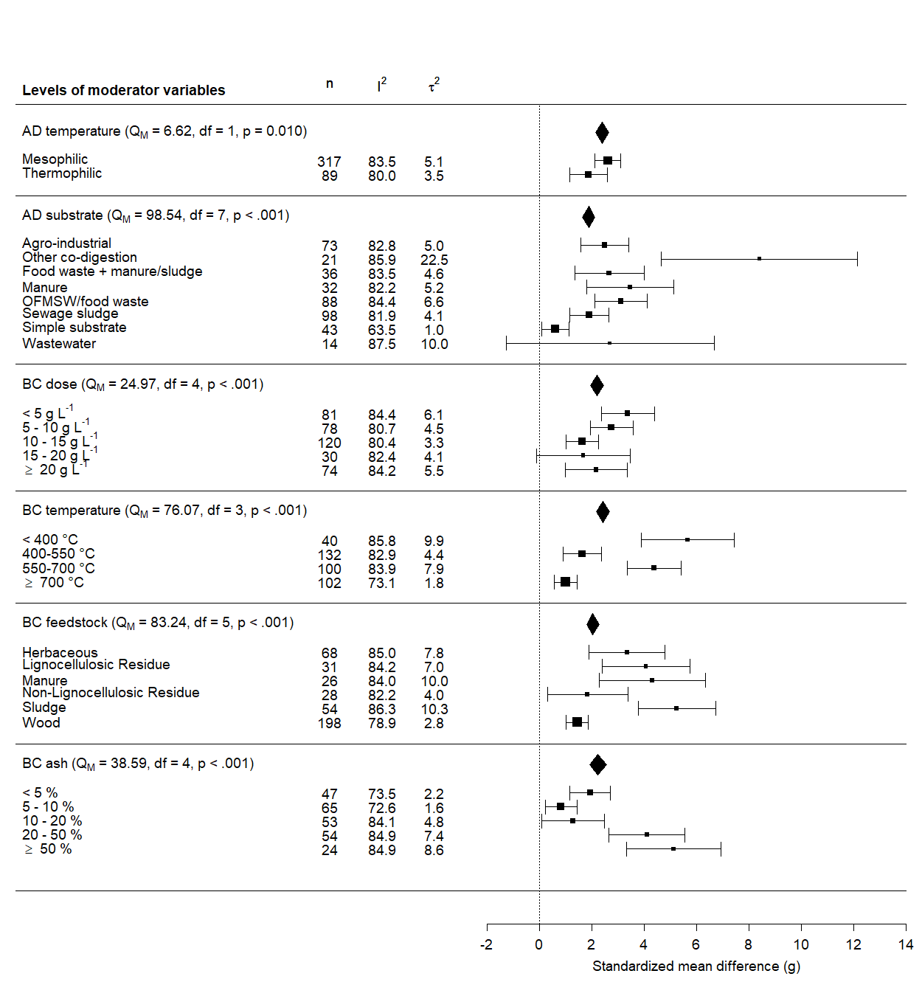
(A)

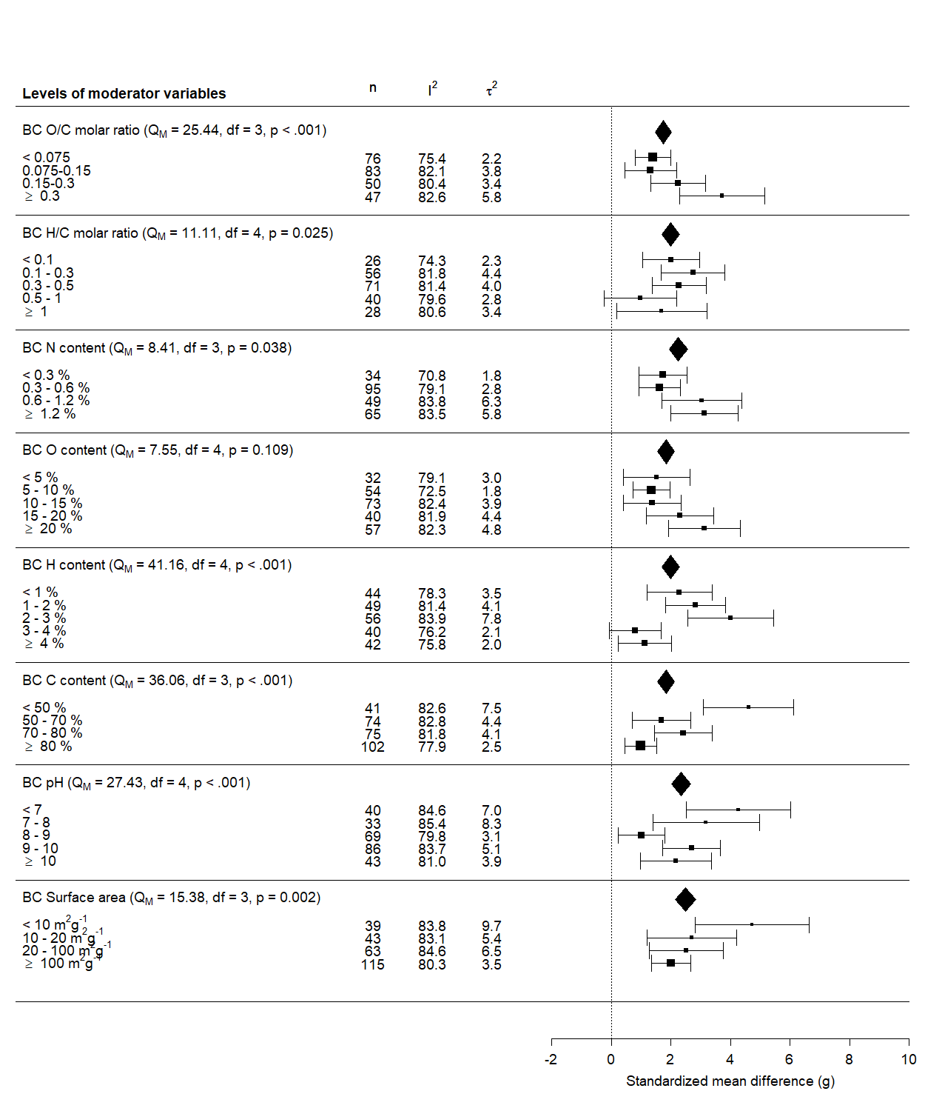
(B)

Figure 4. Forest plot with results of subgroups analysis on CH₄ yield, influence of different moderator variables: (A) AD temperature and substrates, BC dose and production temperature, BC feedstocks and ash content; (B) BC characteristics: O/C and H/C molar ratios, C, H, O, N contents, pH, surface area. For each subgroup the mean effect size and 95% confidence intervals are reported. The summary effect for each moderator variable is indicated by a diamond. The results of testing the significance of each moderator variable are reported between brackets: Q_{M}, degrees of freedom and p-value (significant when <0.05).

4.3. Economic analysis
An economic analysis was carried out using input data of semi-continuous AD tests at lab or pilot scale from recent studies (Table B3 in Appendix B) to compare the estimated maximum sustainable BC unit cost (C_{BC,max}) with BC market price. Assuming to add BC to an operating digester, the higher revenues due to the extra thermal and electrical energy from the enhanced methane production respect to the scenario without BC supplementation were accounted. As a result, a wide range of C_{BC,max} (0 – 7,500 USD ton_{BC}⁻¹) was found. Compared with a typical range cost for BC of 50-500 USD ton_{BC}⁻¹ [18,41], 49% of C_{BC,max} was below the lower limit, 30% between 50 and 500 USD ton_{BC}⁻¹, and 21% above the upper limit. Therefore, under certain conditions BC addition to AD may be economically feasible. On the one hand, the choice of the proper BC is also crucial from the cost-effectiveness perspective, since BC market price may vary significantly based on feedstock, production process, and location. For instance, lower pyrolysis temperature could reduce BC market price due to a larger BC yield [63,64]. According to our meta-analysis, the largest improvements of CH₄ yield and CH₄ production rate was found for the addition of BCs produced at temperatures <400 °C (Figure 4 and Figure B1 in Appendix B). The feedstock, and specifically its availability and BC yield, and the availability of waste biomass with tipping fees [24,63], may also affect the BC market price. For instance, sludge-based BC was found to have the lowest cost compared to wood- and crop-based |BCs due to the higher BC yield [63]. Indeed, in the next few years it is expected that a rapid rise of BC supply will likely decline its market price. The market volume of BC was around 1.6 billion USD in 2020 and is expected to reach 4.0-6.3 billion USD by 2026-2031 [65,66].
Going further, the role of the main influencing variables on C_{BC,max} was investigated (e.g., the organic load (VS) of AD substrate and the dose of BC) to identify the conditions of cost-effectiveness. A single linear regression was used to predict C_{BC,max} based on BC dose as g_{BC} g_{VS}⁻¹ (Figure 5). A significant regression equation was found (F(1,47) = 197.3, p-value: < 2.2 e-16) with R² 0.8076. The prediction equation was log(y) = 1.545 – 1.313 log(x), where y is the maximum BC cost as USD ton_{BC}⁻¹, x is the dose of BC as g_{BC} g_{VS}⁻¹. A reduction of BC dose can significantly favour the economic effectiveness of BC addition, where an upper threshold of 0.45-0.76 g_{BC} g_{VS}⁻¹ may be suggested based on the regression equation (corresponding to 100-50 USD ton_{BC}⁻¹). In any case, BC doses above these limits should be avoided despite the choices of BC and AD conditions. Therefore, the optimization of BC dose is a crucial step to maximize methane production (section 3.2.2) and to reach the economic feasibility, towards a practical application of BC to full-scale digesters.

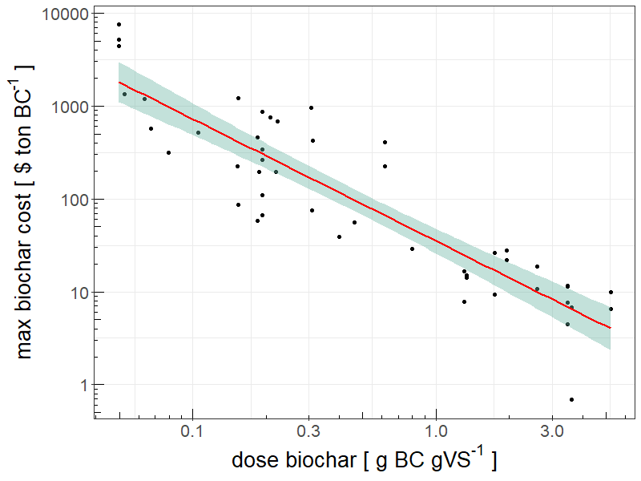
Figure 5. Influence of the dose of biochar on the maximum sustainable cost of biochar (both variables were log-transformed). The red line is the regression equation (F(1,47) = 197.3, p-value: < 2.2 e-16), with R² equal to 0.8076, with 95% confidence intervals. The prediction equation is log(y) = 1.545 – 1.313 log(x), where y is the maximum BC cost in USD ton_{BC}⁻¹, x is BC dose in g BC g_{VS}⁻¹.

5. Conclusions
This study presents a systematic analysis (organized in an inventory) of the current literature on BC addition to AD processes. The selected and categorized literature underwent a meta-analysis, aimed at correlating AD performance with BC physico-chemical properties, to define their optimal range. Overall, the findings of the meta-analysis proved that BC enhances and accelerates biomethane production. Considering 408 experimental conditions from 76 studies in batch mode, methane yield and maximum production rate were significantly enhanced by BC supplementation. Besides, the duration of the lag-phase was shortened by the presence of BC. Further, 83 experimental conditions from 18 studies in semi-continuous mode proved that BC supplementation significantly improved CH₄ production rate. Based on the subgroups meta-analysis, an optimal range of BC physico-chemical properties favouring AD performance may be suggested as follows: high ash contents (≥20%) and low C contents (<50%), high O/C molar ratios (≥0.3), high contents of O (≥20%) and N (≥0.6%), acidic pH (<7.0), and modest values of SA (<10 m² g⁻¹). Consequently, the choice of feedstocks as manure or sludge for BC production, and the use of moderate pyrolysis temperatures can be recommended. The economic analysis, aimed at evaluating the economic viability of adding BC to an existing full-scale AD plant, identified a wide range of maximum unit cost of BC (0 - 7,500 USD ton_{BC}⁻¹) that equals the revenues from energy production. The minimization of BC dose is crucial to reach the economic feasibility of BC application to AD. A dose of BC above 0.45-0.76 g_{BC} g_{VS}⁻¹ should be avoided despite the features of BC properties and AD conditions. In conclusion, the overall findings of this work can provide guidance to further studies exploring the underlying mechanisms of BC addition to AD processes, and support BC practical application in full-scale digesters.

Acknowledgments
This research was funded with internal resources. The authors declare no conflict of interest. Authors’ contributions: methodology, data elaboration, original draft writing: M. Chiappero; conceptualization, methodology, supervision, manuscript revision: S. Fiore; conceptualization and manuscript revision: F. Berruti.

References
[1] J. Lehmann, S. Joseph, Biochar for environmental management: science, technology and implementation, 2nd ed., Routledge, 2015. https://books.google.it/books?hl=it&lr=&id=gWDABgAAQBAJ&oi=fnd&pg=PP1&dq=Biochar+for+Environmental+Management,+Science,+Technology+and+Implementation&ots=tYXmCTLWp1&sig=YOocBmeXmKfPw4VcuN4bmuJAAIY (accessed March 4, 2019).
[2] S. Li, S. Harris, A. Anandhi, G. Chen, Predicting biochar properties and functions based on feedstock and pyrolysis temperature: A review and data syntheses, J. Clean. Prod. 215 (2019) 890–902. doi:10.1016/j.jclepro.2019.01.106.
[3] G.S. Ghodake, S.K. Shinde, A.A. Kadam, R.G. Saratale, G.D. Saratale, M. Kumar, R.R. Palem, H.A. AL-Shwaiman, A.M. Elgorban, A. Syed, D.Y. Kim, Review on biomass feedstocks, pyrolysis mechanism and physicochemical properties of biochar: State-of-the-art framework to speed up vision of circular bioeconomy, J. Clean. Prod. 297 (2021) 126645. doi:10.1016/j.jclepro.2021.126645.
[4] D. Wang, P. Jiang, H. Zhang, W. Yuan, Biochar production and applications in agro and forestry systems: A review, Sci. Total Environ. 723 (2020) 137775. doi:10.1016/j.scitotenv.2020.137775.
[5] N.A. Qambrani, M.M. Rahman, S. Won, S. Shim, C. Ra, Biochar properties and eco-friendly applications for climate change mitigation, waste management, and wastewater treatment: A review, Renew. Sustain. Energy Rev. 79 (2017) 255–273. doi:10.1016/j.rser.2017.05.057.
[6] K. Weber, P. Quicker, Properties of biochar, Fuel. 217 (2018) 240–261. doi:10.1016/j.fuel.2017.12.054.
[7] S. Nanda, A.K. Dalai, F. Berruti, J.A. Kozinski, Biochar as an exceptional bioresource for energy, agronomy, carbon sequestration, activated carbon and specialty materials, Waste Biomass Valori. 7 (2016) 201–235. doi:10.1007/s12649-015-9459-z.
[8] Z. Zhang, Z. Zhu, B. Shen, L. Liu, Insights into biochar and hydrochar production and applications: A review, Energy. 171 (2019) 581–598. doi:10.1016/j.energy.2019.01.035.
[9] M. Bartoli, M. Giorcelli, P. Jagdale, M. Rovere, A. Tagliaferro, A review of non-soil biochar applications, Materials (Basel). 13 (2020) 261. doi:10.3390/ma13020261.
[10] World Biogas Association, Global potential of biogas, (2019). https://www.worldbiogasassociation.org/global-potential-of-biogas/ (accessed November 10, 2021).
[11] H. Ritchie, M. Roser, CO₂ and Greenhouse Gas Emissions. Published online at OurWorldInData.org., (2020). https://ourworldindata.org/greenhouse-gas-emissions#annual-greenhouse-gas-emissions-how-much-do-we-emit-each-year (accessed January 10, 2022).
[12] S. Dutta, M. He, X. Xiong, D.C.W. Tsang, Sustainable management and recycling of food waste anaerobic digestate: A review, Bioresour. Technol. 341 (2021) 125915. doi:10.1016/j.biortech.2021.125915.
[13] F. Xu, Y.Y. Li, X. Ge, L. Yang, Y.Y. Li, Anaerobic digestion of food waste – Challenges and opportunities, Bioresour. Technol. 247 (2018) 1047–1058. doi:10.1016/j.biortech.2017.09.020.
[14] V. Khanh Nguyen, D. Kumar Chaudhary, R. Hari Dahal, N. Hoang Trinh, J. Kim, S.W. Chang, Y. Hong, D. Duc La, X.C. Nguyen, H. Hao Ngo, W.J. Chung, D.D. Nguyen, Review on pretreatment techniques to improve anaerobic digestion of sewage sludge, Fuel. 285 (2021) 119105. doi:10.1016/j.fuel.2020.119105.
[15] S. Paul, A. Dutta, Challenges and opportunities of lignocellulosic biomass for anaerobic digestion, Resour. Conserv. Recycl. 130 (2018) 164–174. doi:10.1016/j.resconrec.2017.12.005.
[16] Y. Chen, J.J. Cheng, K.S. Creamer, Inhibition of anaerobic digestion process: A review, Bioresour. Technol. 99 (2008) 4044–4064. doi:10.1016/j.biortech.2007.01.057.
[17] J.L. Chen, R. Ortiz, T.W.J. Steele, D.C. Stuckey, Toxicants inhibiting anaerobic digestion: A review, Biotechnol. Adv. 32 (2014) 1523–1534. doi:10.1016/j.biotechadv.2014.10.005.
[18] M. Chiappero, O. Norouzi, M. Hu, F. Demichelis, F. Berruti, F. Di Maria, O. Mašek, S. Fiore, Review of biochar role as additive in anaerobic digestion processes, Renew. Sustain. Energy Rev. 131 (2020) 110037. doi:10.1016/j.rser.2020.110037.
[19] M.O. Fagbohungbe, B.M.J. Herbert, L. Hurst, C.N. Ibeto, H. Li, S.Q. Usmani, K.T. Semple, The challenges of anaerobic digestion and the role of biochar in optimizing anaerobic digestion, Waste Manag. 61 (2017) 236–249. doi:10.1016/j.wasman.2016.11.028.
[20] F. Codignole Luz, S. Cordiner, A. Manni, V. Mulone, V. Rocco, Biochar characteristics and early applications in anaerobic digestion-a review, J. Environ. Chem. Eng. 6 (2018) 2892–2909. doi:10.1016/j.jece.2018.04.015.
[21] S.O. Masebinu, E.T. Akinlabi, E. Muzenda, A.O. Aboyade, A review of biochar properties and their roles in mitigating challenges with anaerobic digestion, Renew. Sustain. Energy Rev. 103 (2019) 291–307. doi:10.1016/j.rser.2018.12.048.
[22] L. Qiu, Y.F. Deng, F. Wang, M. Davaritouchaee, Y.Q. Yao, A review on biochar-mediated anaerobic digestion with enhanced methane recovery, Renew. Sustain. Energy Rev. 115 (2019) 109373. doi:10.1016/j.rser.2019.109373.
[23] J. Pan, J. Ma, L. Zhai, T. Luo, Z. Mei, H. Liu, Achievements of biochar application for enhanced anaerobic digestion: A review, Bioresour. Technol. 292 (2019) 122058. doi:10.1016/j.biortech.2019.122058.
[24] W. Zhao, H. Yang, S. He, Q. Zhao, L. Wei, A review of biochar in anaerobic digestion to improve biogas production: Performances, mechanisms and economic assessments, Bioresour. Technol. 341 (2021) 125797. doi:10.1016/j.biortech.2021.125797.
[25] J. Song, Y. Wang, S. Zhang, Y. Song, S. Xue, L. Liu, X. Lvy, X. Wang, G. Yang, Coupling biochar with anaerobic digestion in a circular economy perspective: A promising way to promote sustainable energy, environment and agriculture development in China, Renew. Sustain. Energy Rev. 144 (2021) 110973. doi:10.1016/j.rser.2021.110973.
[26] Z. Bin Khalid, M.N.I. Siddique, A. Nayeem, T.M. Adyel, S. Bin Ismail, M.Z. Ibrahim, Biochar application as sustainable precursors for enhanced anaerobic digestion: A systematic review, J. Environ. Chem. Eng. 9 (2021) 105489. doi:10.1016/j.jece.2021.105489.
[27] L. Xiao, E. Lichtfouse, P.S. Kumar, Q. Wang, F. Liu, Biochar promotes methane production during anaerobic digestion of organic waste, Environ. Chem. Lett. 19 (2021) 3557–3564. doi:10.1007/s10311-021-01251-6.
[28] S. Tayibi, F. Monlau, A. Bargaz, R. Jimenez, A. Barakat, Synergy of anaerobic digestion and pyrolysis processes for sustainable waste management: A critical review and future perspectives, Renew. Sustain. Energy Rev. 152 (2021) 111603. doi:10.1016/j.rser.2021.111603.
[29] M. Chiappero, F. Cillerai, F. Berruti, O. Mašek, S. Fiore, Addition of different biochars as catalysts during the mesophilic anaerobic digestion of mixed wastewater sludge, Catalysts. 11 (2021) 1094. doi:10.3390/CATAL11091094.
[30] N.H. Khashaba, R.S. Ettouney, M.M. Abdelaal, F.H. Ashour, M.A. El-Rifai, Artificial neural network modeling of biochar enhanced anaerobic sewage sludge digestion, J. Environ. Chem. Eng. 10 (2022) 107988. doi:10.1016/J.JECE.2022.107988.
[31] S. Jeffery, F.G.A. Verheijen, C. Kammann, D. Abalos, Biochar effects on methane emissions from soils: A meta-analysis, Soil Biol. Biochem. 101 (2016) 251–258. doi:10.1016/j.soilbio.2016.07.021.
[32] Y. He, X. Zhou, L. Jiang, M. Li, Z. Du, G. Zhou, J. Shao, X. Wang, Z. Xu, S. Hosseini Bai, H. Wallace, C. Xu, S.H. Bai, H. Wallace, C. Xu, Effects of biochar application on soil greenhouse gas fluxes: a meta-analysis, GCB Bioenergy. 9 (2017) 743–755. doi:10.1111/gcbb.12376.
[33] X. Liu, P. Mao, L. Li, J. Ma, Impact of biochar application on yield-scaled greenhouse gas intensity: A meta-analysis, Sci. Total Environ. 656 (2019) 969–976. doi:10.1016/j.scitotenv.2018.11.396.
[34] L.A. Biederman, W.S. Harpole, Biochar and its effects on plant productivity and nutrient cycling: a meta-analysis, GCB Bioenergy. 5 (2013) 202–214. doi:10.1111/gcbb.12037.
[35] Y. Wang, M.B. Villamil, P.C. Davidson, N. Akdeniz, A quantitative understanding of the role of co-composted biochar in plant growth using meta-analysis, Sci. Total Environ. 685 (2019) 741–752. doi:10.1016/j.scitotenv.2019.06.244.
[36] M.O. Omondi, X. Xia, A. Nahayo, X. Liu, P.K. Korai, G. Pan, Quantification of biochar effects on soil hydrological properties using meta-analysis of literature data, Geoderma. 274 (2016) 28–34. doi:10.1016/j.geoderma.2016.03.029.
[37] T.T.N. Nguyen, C.Y. Xu, I. Tahmasbian, R. Che, Z. Xu, X. Zhou, H.M. Wallace, S.H. Bai, Effects of biochar on soil available inorganic nitrogen: A review and meta-analysis, Geoderma. 288 (2017) 79–96. doi:10.1016/j.geoderma.2016.11.004.
[38] F. Razzaghi, P.B. Obour, E. Arthur, Does biochar improve soil water retention? A systematic review and meta-analysis, Geoderma. 361 (2020) 114055. doi:10.1016/j.geoderma.2019.114055.
[39] M. Mainardis, S. Flaibani, F. Mazzolini, A. Peressotti, D. Goi, Techno-economic analysis of anaerobic digestion implementation in small Italian breweries and evaluation of biochar and granular activated carbon addition effect on methane yield, J. Environ. Chem. Eng. 7 (2019) 103184. doi:10.1016/j.jece.2019.103184.
[40] L. Zhang, E.Y. Lim, K.-C. Loh, Y.S. Ok, J.T.E. Lee, Y. Shen, C.-H. Wang, Y. Dai, Y.W. Tong, Biochar enhanced thermophilic anaerobic digestion of food waste: Focusing on biochar particle size, microbial community analysis and pilot-scale application, Energy Convers. Manag. 209 (2020) 112654. doi:10.1016/j.enconman.2020.112654.
[41] M. Chiappero, F. Berruti, O. Mašek, S. Fiore, Semi-continuous anaerobic digestion of mixed wastewater sludge with biochar addition, Bioresour. Technol. 340 (2021) 125664. doi:10.1016/j.biortech.2021.125664.
[42] A. Rohatgi, WebPlotDigitizer, (2021). https://automeris.io/WebPlotDigitizer/citation.html (accessed September 21, 2021).
[43] R Core Team, R: A Language and Environment for Statistical Computing, (2021). https://www.r-project.org/.
[44] W. Viechtbauer, Conducting Meta-Analyses in R with the metafor Package, J. Stat. Softw. 36 (2010) 1–48. doi:10.18637/jss.v036.i03.
[45] S.N. Ugwu, R.K. Biscoff, C.C. Enweremadu, A meta-analysis of iron-based additives on enhancements of biogas yields during anaerobic digestion of organic wastes, J. Clean. Prod. 269 (2020) 122449. doi:10.1016/j.jclepro.2020.122449.
[46] M. Borenstein, L. V. Hedges, J.P.T. Higgins, H.R. Rothstein, Introduction to Meta-Analysis, 2nd ed., Wiley & Sons, 2021. https://www.wiley.com/en-us/Introduction+to+Meta+Analysis%2C+2nd+Edition-p-9781119558354 (accessed October 4, 2021).
[47] Z. Xiao, S. Rasmann, L. Yue, F. Lian, H. Zou, Z. Wang, The effect of biochar amendment on N-cycling genes in soils: A meta-analysis, Sci. Total Environ. 696 (2019) 133984. doi:10.1016/j.scitotenv.2019.133984.
[48] R. DerSimonian, R. Kacker, Random-effects model for meta-analysis of clinical trials: An update, Contemp. Clin. Trials. 28 (2007) 105–114. doi:10.1016/j.cct.2006.04.004.
[49] G. Knapp, J. Hartung, Improved tests for a random effects meta-regression with a single covariate, Stat. Med. 22 (2003) 2693–2710. doi:10.1002/sim.1482.
[50] C.B.F. Flores, T.A. Trabold, Food waste , manure and digestate derived biochar to enhance biomethane potential in mesophilic anaerobic digestion of food waste, in: 8th Int. Conf. Sustain. Solid Waste Manag. 23-26 June 2021, Thessaloniki, Greece, 2021. https://thessaloniki2021.uest.gr/proceedings.html.
[51] A. Hlavsová, A. Corsaro, H. Raclavská, S. Vallová, D. Juchelková, The effect of feedstock composition and taxonomy on the products distribution from pyrolysis of nine herbaceous plants, Fuel Process. Technol. 144 (2016) 27–36. doi:10.1016/j.fuproc.2015.11.022.
[52] K.B. Cantrell, P.G. Hunt, M. Uchimiya, J.M. Novak, K.S. Ro, Impact of pyrolysis temperature and manure source on physicochemical characteristics of biochar, Bioresour. Technol. 107 (2012) 419–428. doi:10.1016/j.biortech.2011.11.084.
[53] I. Fonts, G. Gea, M. Azuara, J. Ábrego, J. Arauzo, Sewage sludge pyrolysis for liquid production: A review, Renew. Sustain. Energy Rev. 16 (2012) 2781–2805. doi:10.1016/j.rser.2012.02.070.
[54] L. Leng, Q. Xiong, L. Yang, H. Li, Y. Zhou, W. Zhang, S. Jiang, H. Li, H. Huang, An overview on engineering the surface area and porosity of biochar, Sci. Total Environ. 763 (2021) 144204. doi:10.1016/j.scitotenv.2020.144204.
[55] J.A. Ippolito, L. Cui, C. Kammann, N. Wrage-Mönnig, J.M. Estavillo, T. Fuertes-Mendizabal, M.L. Cayuela, G. Sigua, J. Novak, K. Spokas, N. Borchard, Feedstock choice, pyrolysis temperature and type influence biochar characteristics: a comprehensive meta-data analysis review, Biochar 2020 24. 2 (2020) 421–438. doi:10.1007/s42773-020-00067-x.
[56] A. Tomczyk, Z. Sokołowska, P. Boguta, Biochar physicochemical properties: pyrolysis temperature and feedstock kind effects, Rev. Environ. Sci. Biotechnol. 19 (2020) 191–215. doi:10.1007/s11157-020-09523-3.
[57] M. Hassan, Y. Liu, R. Naidu, S.J. Parikh, J. Du, F. Qi, I.R. Willett, Influences of feedstock sources and pyrolysis temperature on the properties of biochar and functionality as adsorbents: A meta-analysis, Sci. Total Environ. 744 (2020) 140714. doi:10.1016/j.scitotenv.2020.140714.
[58] Y. Shen, J.L.J.L. Linville, P.A.A.P.A.A. Ignacio-de Leon, R.P.R.P. Schoene, M. Urgun-Demirtas, Towards a sustainable paradigm of waste-to-energy process: Enhanced anaerobic digestion of sludge with woody biochar, J. Clean. Prod. 135 (2016) 1054–1064. doi:10.1016/j.jclepro.2016.06.144.
[59] M. Zhang, Y. Wang, Effects of Fe-Mn-modified biochar addition on anaerobic digestion of sewage sludge: Biomethane production, heavy metal speciation and performance stability, Bioresour. Technol. 313 (2020) 123695. doi:10.1016/j.biortech.2020.123695.
[60] R. Shen, Y. Jing, J. Feng, J. Luo, J. Yu, L. Zhao, Performance of enhanced anaerobic digestion with different pyrolysis biochars and microbial communities, Bioresour. Technol. 296 (2020) 122354. doi:10.1016/j.biortech.2019.122354.
[61] J. Ma, F. Chen, S. Xue, J. Pan, B. Khoshnevisan, Y. Yang, H. Liu, L. Qiu, Improving anaerobic digestion of chicken manure under optimized biochar supplementation strategies, Bioresour. Technol. 325 (2021) 124697. doi:10.1016/j.biortech.2021.124697.
[62] J.L. Linville, Y. Shen, P.A. Ignacio-de Leon, R.P. Schoene, M. Urgun-Demirtas, In-situ biogas upgrading during anaerobic digestion of food waste amended with walnut shell biochar at bench scale, Waste Manag. Res. 35 (2017) 669–679. doi:10.1177/0734242X17704716.
[63] F. Cheng, H. Luo, L.M. Colosi, Slow pyrolysis as a platform for negative emissions technology: An integration of machine learning models, life cycle assessment, and economic analysis, Energy Convers. Manag. 223 (2020) 113258. doi:10.1016/j.enconman.2020.113258.
[64] S. Shabangu, D. Woolf, E.M. Fisher, L.T. Angenent, J. Lehmann, Techno-economic assessment of biomass slow pyrolysis into different biochar and methanol concepts, Fuel. 117 (2014) 742–748. doi:10.1016/j.fuel.2013.08.053.
[65] Transparency Market Research, Biochar Market (Feedstock: Woody Biomass, Agricultural Waste, Animal Manure, and Others; Technology: Pyrolysis, Gasification, and Others; and Application: Electricity Generation, Agriculture, Forestry, and Others) - Global Industry Analysis, Size, Share, , (2021). https://www.transparencymarketresearch.com/biochar-market.html (accessed November 12, 2021).
[66] Research and Markets, Biochar Market Research Report by Row Material, Feedstock, Technology, Application, and Region - Global Forecast to 2026 - Cumulative Impact of COVID-19, (2021). https://www.researchandmarkets.com/reports/4857865/biochar-market-research-report-by-row-material?utm_source=GNOM&utm_medium=PressRelease&utm_code=9x793b&utm_campaign=1514448+-+Global+Biochar+Market+Research+Report+(2020+to+2025)+-+by+Row+Material%2C+Feed (accessed November 12, 2021).

