Experimental evaluation of the effect of controlled damages on the dynamic response of PC bridge beams
D. Sabia, A. Quattrone, F. Tondolo, P. Savino
Department of Structural, Geotechnical and Building Engineering, Politecnico di Torino, 10129 Torino, Italy
ABSTRACT: The present paper describes the dynamic test campaign on the prestressed concrete bridge beams taken from a dismantled viaduct in Turin, Italy after a service life of 50 years in the framework of BRIDGE|50 research project. Dynamic measurements were previously performed on the decks from which the 29 beams were taken to characterize the behaviour of the viaduct in service condition. Successively the single beams are tested to evaluate the effects of the different damage levels on the dynamic properties. The vibration data have been collected before the application of static load, after the first cracking condition and after the maximum load capacity of the beam and analysed to extract the principal modal components. The results highlight the correlation among the evolution of the damage and the dynamic response of the beam and then the effectiveness of vibration tests to identify the occurrence of damages and follow their evolution. The experimental findings will be used in future works to explore the effects of damages of the single beams on the global response of this bridge typology. This work presents the results of the experimental tests on the first three beams.

InTroduction
A large part of the road infrastructures in Italy was built over 50 years ago, adopting the technologies available after the second world war. The management of their obsolescence, in particular road bridges built in reinforced concrete, requires facing challenging issues such as the assessment of their reliability and the reparation costs (ASCE 2021, European Commission 2019). Causes and effects of structural deterioration and the damage models in life-cycle reliability analysis have been widely investigated (Fernando et al. 2015, Biondini 2016), whereas the efforts of the testing have limited the experimental investigations on the residual capacity of real aged bridges or their components (Quattrone et al. 2012, Guiglia et al. 2014).
In this context, the BRIDGE|50 research campaign will represent an invaluable opportunity to deeply investigate the behaviour of aged structural elements approaching the end of their service lives (Biondini et al. 2021). The research activities will be devoted to deeply test a representative portion of a viaduct dismantled after 50 years of service life, namely 25 prestressed concrete beams, 4 box girders and 2 pier caps. Each element will be investigated in its current state and then progressively damaged up to collapse. The results will be used to evaluate the impact of defects, damages and material deterioration on the residual load capacity of the bridge. The research outcomes are expected to help in moving forward the currently adopted in the reliability assessment procedures.
Dynamic tests are one of the most widespread methods to provide a more thorough knowledge of the global structural behaviour (Aoki et al. 2007). Moreover, periodic or continuous monitoring can track the structural changes and help to characterize the eventual state of damage and its evolution (Lancellotta et al. 2015). The beams of Bridge|50 project will be tested both in their current conditions and after the induction of defined damage steps. The goal of the tests is to estimate the contribution of the single beams on the global response of the decks, previously tested before the dismantling, and to investigate the influence of damages of the single beams on the global behaviour.
In this paper the results of the dynamic test campaign on the first three beams are reported. The beams belonged to the same deck and had the same nominal geometrical and material characteristics.
The dynamic data have been collected before the execution of the static tests adopting the simply supported configuration in order to simulate the original structural behaviour. In the case of one of the beams, namely the B08, the tests have repeated at two levels, unloading after reaching the 63% ant the 100% of the ultimate load condition

THE CORSO GROSSETO VIADUCT
The Corso Grosseto viaduct was built in 1970. It was originally constituted by 90 concrete decks having variable spans, from 16 m to 24 m, and a total length of 1400 m (Figure 1). The structural elements which will be investigated in the BRIDGE|50 research project belong to the first four decks of the southern part of the viaduct highlighted in Figure 1 by the red box within the plan view.
(a) (b)
Figure 2. (a) Drawings of the Corso Grosseto viaduct decks (in green the dismounted beams, in red the beams already tested). (b) I-shaped beam cross section (measures in cm).
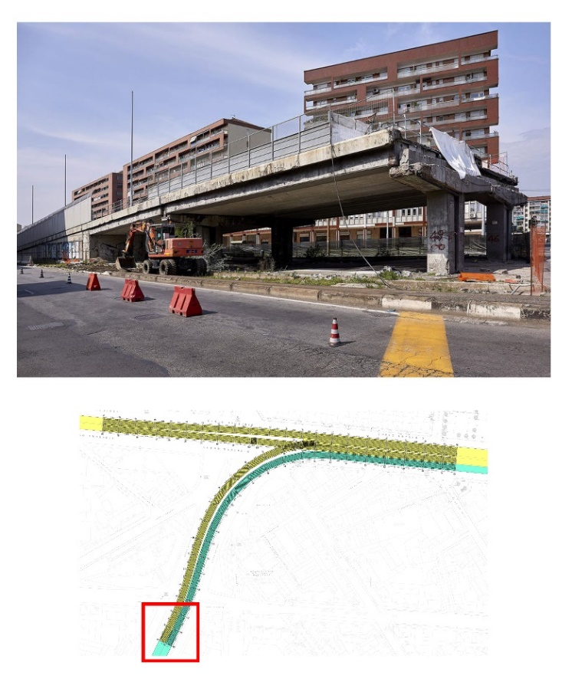
Figure 2. Top: a view of the investigated decks (top). Bottom: plan view of corso Grosseto viaduct. The red box indicates the investigated decks.
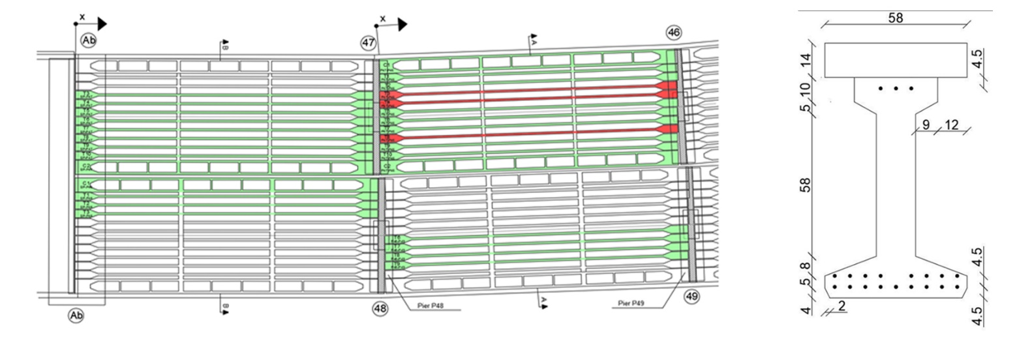
Each girder was composed of 10 inner precast prestressed concrete I-beams and 2 external precast prestressed concrete U-beams, simply supported at piers, and connected transversely by 3 equally spaced diaphragms. In Figure 2a the beams selected for the experimental campaign are highlighted in green, whereas the beams analysed in the present study, respectively named B3, B4 and B8, all belonging to the P47/46 deck, are depicted in red. Two transverse beams at the thirds of the span and the 0.14 m thick upper slab were both casted on site. The dimensions of the I-beams cross section and the on-site casted slab are shown in Figure 2b. A set of 25 prestressed concrete beams constituting the decks have been dismounted and collected in a testing area, where a bench test has been realized to perform both static and dynamic tests (Figure 3).

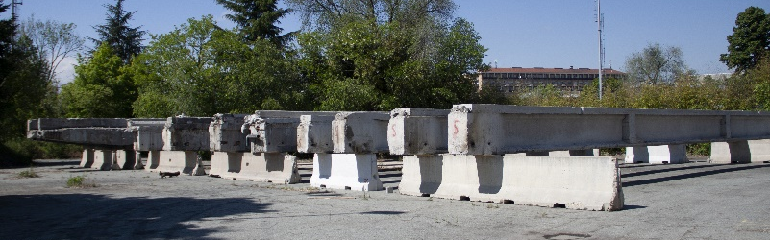
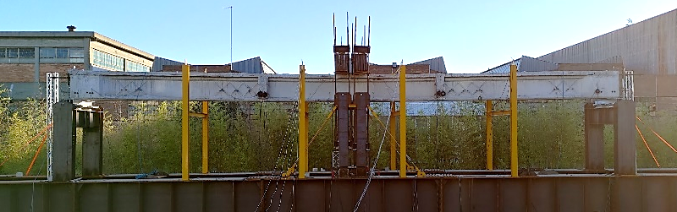
Figure 3. View of the test bench and of the collected beams.

the experimental tests of the decks

The in-situ activities have been devoted to testing a representative portion of the whole viaduct before its dismantling. The tests were made on each deck adopting a setup mainly designed to obtain a dense spatial resolution to optimize the discrimination between modes in vertical plane.

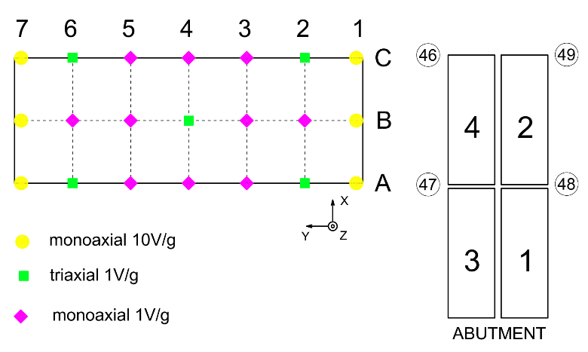
Figure 4. Dynamic test setup. Position of the sensors and the assigned labeling of the decks (right).

A comprehensive description of the dynamic tests and the modal dynamic identification results are reported in (Quattrone et al. 2021, Sabia et al. 2021).
Table 1 and Figure 5 report the mean values of the modal frequencies, shapes and damping identified for deck 4, from which the beams objects of this study were dismounted.

Table 1. Deck 4. Experimental modal frequencies and damping.

Mode | f (Hz) | ξ (%)
1 | 6.17 | 3.8
2 | 7.18 | 3.9
3 | 12.95 | 1.0
4 | 19.05 | 3.5
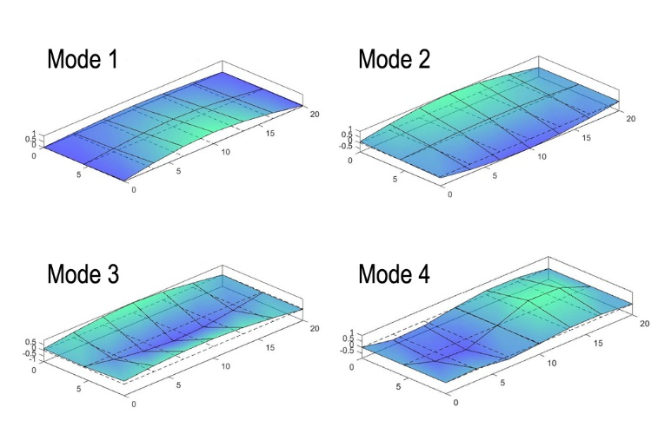
Figure 5. Deck 4. Experimental modal shapes of the deck.

STATIC TEst CAMPAIGN
According to the preliminary visual inspection carried out to map the presence of corrosion, cracks, and spalling, the three beams above mentioned are classified in good structural condition.
A three-point bending test scheme was chosen to apply the incremental static loads up to the reaching the ultimate load capacity by means of four hydraulic jacks. Each specimen was loaded with a constant loading rate of 1.6 KN/min in both service and ultimate phase. The B3-P47/46 and B8-P47/46 have been unloaded and reloaded after the opening of cracks to estimate the residual prestress.
All the beams reached the ultimate condition highlighting a brittle flexural mode corresponding to the crushing of the upper slab. The principal results are summarized in Table 2.

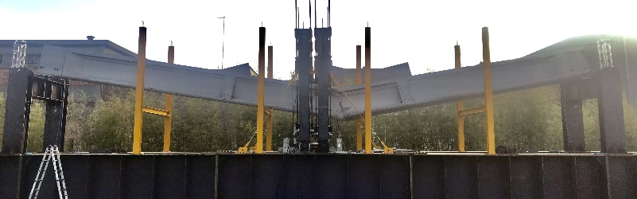
Figure 6. View of the beam B3 after the collapse.

Table 2. Summary of load tests.
Beam | B3 | B8 | B4
Cracking load [kN] | 96 | 100 | 60
Failure load [kN] | 312 | 332 | 288
Max midspan def. [mm] | 167 | 151 | 135

DYNAMIC TEst CAMPAIGN
The setup adopted for the dynamic test of the beams is constituted by a set of 11 uniaxial capacitive accelerometers having a sensitivity of 1V/g. The test setup is showed in Figure 7.

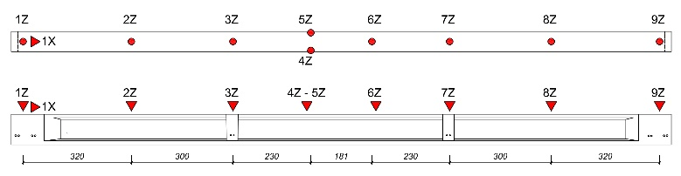
Figure 7. Dynamic test setup.

The accelerometers have been placed on the upper slab along the longitudinal axis of the beam, spaced to get an adequate spatial resolution of the vertical flexural modes. The sensors 1X on the rolling support and the couple of accelerometers 4Z and 5Z placed near the midspan on the edges are used to discriminate the longitudinal and torsional dynamic components.
The acceleration signals were acquired at a 512 Hz sampling frequency for both ambient noise and impact hammer excitations. The impact tests were carried out by hitting the beams with an instrumented hammer in vertical direction in the halfway of two consecutive accelerometers.
To replicate as close as possible the onsite supporting conditions of the deck, the bench components lying on the upper slab during the static tests are each time removed.
The dynamic test campaigns have been performed before the static test. The beam B8 have been also tested after the intermediate unloading cycle and after the application of the ultimate load.

Experimental modal analysis
The experimental modal analysis was performed through the transfer function from the excitation to the measured responses. The transfer function is a mathematical model deﬁning the input–output relationship of a physical system and is deﬁned as the Laplace transform of the output divided by the Laplace transform of the input (Ljung 1999).
When dealing with experimental or operational modal analysis, a more useful tool is the frequency response function (FRF), deﬁned for a linear system by the relationship between q forcing functions $\left\{F(ω)\right\}$ and p structural responses $\left\{Y(ω)\right\}$ is fully described in frequency domain by the frequency response function matrix (Eq. ):

$\underset{(p x 1)}{\left\{Y\left(ω\right)\right\}}=\underset{(p x q)}{\left[H(ω)\right]}\underset{(q x 1)}{\left\{F\left(ω\right)\right\}}$ (1)

The element of FRF matrix $H_{k,j}(ω)$ maps the input F_{k}(ω), applied at the k-th degree of freedom (DOF), and the output Y_{j} measured at the j-th DOF. If the responses are accelerations, as usually measured during in-situ testing, the FRF matrix can be expressed in the accelerance form. The generic element of the accelerance matrix, expressed in terms of modal properties, is given by:
$H_{j,k}\left(ω\right)=\frac{{\ddot{Y}}_{j}\left(ω\right)}{F_{k}\left(ω\right)}=-ω^{2}\sum_{r=1}^{N}{\frac{1}{m_{r}}\frac{{{}_{}^{r}ψ}_{j}{{}_{}^{r}ψ}_{k}}{ω_{r}^{2}-ω^{2}+2iωω_{r}}}$ (2)
The FRF can be estimated by classical H₁ or H₂ estimators, given by the ratio between the cross-spectrum S_{fy}(ω) of the output $Y(ω)$ and the input $F_{k}\left(ω\right)$ and the auto-spectrum of the input S_{ff} (ω) or of the output S_{yy}(ω) that can be chosen according to whether the major source of noise is in the input or output signals. The FRF is a complex function which amplitude has a maximum at the resonant frequency. The magnitude of the modal coefﬁcient is simply taken as the value of the imaginary part at resonance. The sign is either positive or negative, considering the direction of the peak along imaginary axis. This implies that the phase angle is either 0° or 180°. Figure 8 shows an example of FRF, imaginary part, from the excitation and the time history measured at the position from 1Z to 9Z on the beam.
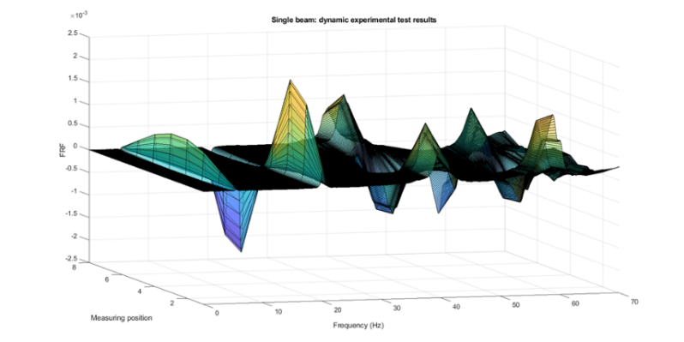
Figure 8. Beam test: FRF, mode shapes

After a preliminary analysis of the spectral content, the signals were pre-treated by filtering out of the bandwidth [0 - 100 Hz], removing the trends. The FRFs have been estimated basing on singular impulse acceleration data and the modal parameters extracted. The remaining modes have been grouped basing on natural frequencies, damping values and the relative resemblance of their modal shapes evaluated through the Modal Assurance Criterion (MAC).

Initial condition results
The following table reports the mean values of the frequencies and damping obtained analysing each impulse response recorded in the initial condition test campaigns. A similar modal shape sequence is found for all the beams, corresponding to the first three flexural modes (Figure 9).

Table 3. Experimental modal frequencies and damping.

Beam N. | Mode 1 |  | Mode 2 |  | Mode 3
Beam N. | f (Hz) | ξ (%) | f (Hz) | ξ (%) | f (Hz) | ξ (%)
B3 | 5.56 | 0.38 | 20.12 | 1.37 | 40.06 | 0.86
B8 | 5.50 | 0.39 | 19.44 | 0.83 | 36.42 | 1.18
B4 | 5.50 | 0.43 | 19.37 | 0.70 | 36.37 | 1.04

Figure 9. B03 Experimental mode shapes

B8 test results
The dynamic test on beam B8 were repeated after the first unloading cycle (Phase 1) and after the end of the static test (Phase 2).
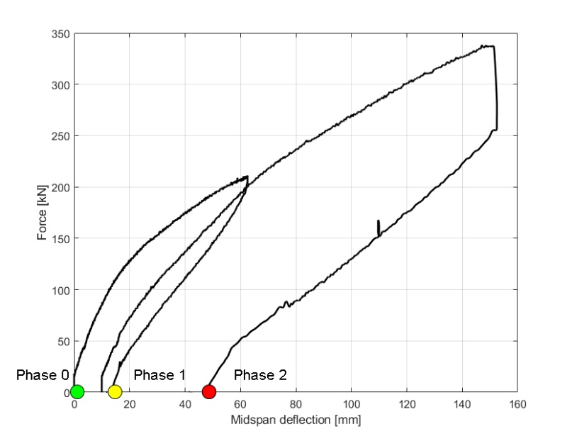
Figure 10. B8 Force – midspan deflection. The dots indicate the phase test.

The phase 1 corresponds to the unloading condition subsequent the application of 63% F_{max}, corresponding to a wide opening of flexural cracks.
Finally, the tests have been repeated at the end of the static test, after the reaching of the maximum load capacity of 332 kN (phase 2), when the loading has been quickly stopped at the crushing of the upper slab, avoiding the collapse.
The Table 4 summarizes the mean mode parameters identified in the three phases.

Table 4. B08. Experimental modal frequencies and damping.
Beam B8 | Mode 1 |  | Mode 2 |  | Mode 3
Beam B8 | f (Hz) | ξ (%) | F (Hz) | ξ (%) | f (Hz) | ξ (%)
Phase 0 | 5.50 | 0.39 | 19.44 | 0.83 | 36.42 | 1.18
Phase 1 | 5.21 | 0.48 | 18.88 | 0.78 | 35.27 | 1.21
Phase 2 | 4.75 | 0.59 | 18.34 | 0.7 | 34.02 | 1.09

The reductions of the frequencies vary from 3% to 14%, as depicted in Figure 11. The entities of these reductions are comparable to the findings reported in similar experimental campaign present in literature (Quattrone et al. 2012).
The corresponding modal shapes are illustrated in Figure 12. The comparison between the modal coordinates at different damage levels shows small but clearly appreciable variations. The higher difference is observable for the third mode in the position corresponding to the sensor 6Z, as circled in Figure 12, mode 3. It worth noticing the sensor was located near the crushing area, as reported in Figure 13.

Figure 11. B8. Reduction of the mode frequencies in percentage: phase 1 (blue) and phase 2 (red)

Figure 12. B8. Mode shapes for phase 0 (blue), Phase 1 (red) and Phase 2 (yellow).

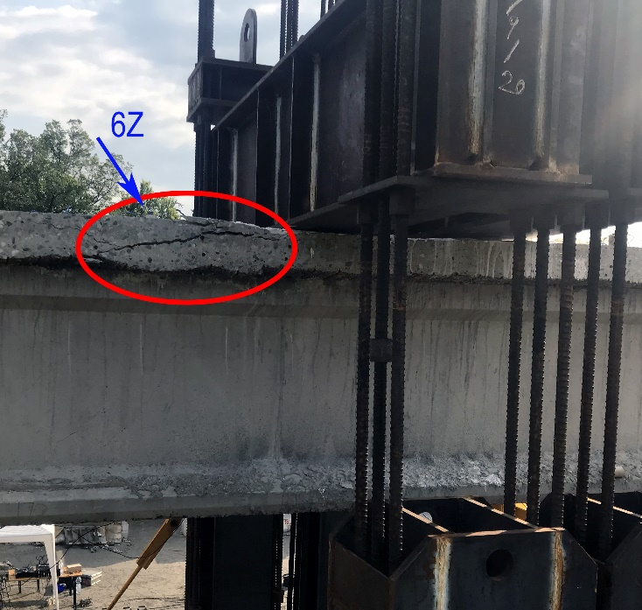
Figure 13. B8. Ultimate load capacity. Position of the crush (bottom view)

CONCLUSIONS
This work presents the results of the experimental dynamic campaign performed on the first three beams of BRIDGE|50 project.
The results obtained from the dynamic experimentation on the single beams are consistent with those obtained by testing on the decks before dismounting. It will allow to represent the global response combining the dynamic responses of the single elements.
The dynamic experimentation on the single beam B8 has been repeated in the presence of imposed damages induced by static actions. The results show the capability of dynamic identification to detect the presence of damage, to localize the position and to give an estimation of the magnitude.
The results of the experimental campaigns, integrated by the static test findings, will be used to simulate realistic damage scenarios on the complete structure depending on their positions and magnitudes.
The dynamic parameters showed to be sensitive features of the damage occurrence. This capability makes them suitable symptoms to be monitored in order to estimate the evolution of the structure behaviour.

Acknowledgements
BRIDGE|50 is a research project based on a research agreement among universities, public authorities, and private companies. Members of the Management Committee: S.C.R. Piemonte (President); Politecnico di Milano (Scientific Coordinator); Politecnico di Torino (Scientific Responsible of the Experimental Activities); Lombardi Engineering (Secretary); Piedmont Region; City of Turin; Metropolitan City of Turin; TNE Torino Nuova Economia; ATI Itinera & C.M.B.; ATI Despe & Perino Piero; Quaranta Group. BRIDGE|50 website: http://www.bridge50.org

REFERENCE
Aoki, T., Sabia, D., Rivella, D., Komiyama, T.: Structural characterization of a stone arch bridge by experimental tests and numerical model updating. International Journal of Architectural Heritage 1, 227–250 (2007).
ASCE. 2021. Infrastructure report card. American Society of Civil Engineers.
Biondini, F., Frangopol, D.M. 2016. Life-cycle performance of deteriorating structural systems under uncertainty: Review. Journal of Structural Engineering, ASCE, 142(9), F4016001, 2016, 1-17.
Biondini, F., Manto, S., Beltrami, C., Tondolo, F., Chiara, M., Salza, B., et al. BRIDGE|50 research project: Residual structural performance of a 50-year-old bridge. Bridge Maintenance, Safety, Management, Life-Cycle Sustainability and Innovations – Proceedings of the 10th International Conference on Bridge Maintenaince, Safety and Management (IABMAS 2020).
European Commission. 2019. Discussion Paper: State of infrastructure maintenance.
Fernando, D., Adey, B., & Lethanh, N. 2015. A model for the evaluation of intervention strategies for bridges affected by manifest and latent deterioration processes, Structure and Infrastructure Engineering, 11(11), 1466-1483
Guiglia, M., Taliano, M.: Experimental analysis of the effective pre-stress in large-span bridge box girders after 40 years of service life. Engineering Structures 66 (1), 146-158 (2014).
Lancellotta, R., Sabia, D.: Identification technique for soil-structure analysis of the Ghirlandina tower, International Journal of Architectural Heritage: Conservation, Analysis, and Restoration 9 (4), 391–407, (2015).
Ljung, L.: System identification. Theory for users, Englewood Cliffs, NJ, Prentice Hall, (1999).
Quattrone, A., Matta, E., Zanotti Fragonara, L., & Ceravolo, R., 2012. Vibration tests on dismounted bridge beams and effects of deterioration, Journal of Physics: Conference Series, 382(1).
Quattrone, A., Sabia, D., Tondolo, F., Capacci, L., Lencioni, A., Legramandi, C.: Dynamic tests and modal identification of Corso Grosseto viaduct decks before the dismounting. Bridge Maintenance, Safety, Management, Life-Cycle Sustainability and Innovations. CRC Press (2021).
Sabia, D., Quattrone, A., Tondolo, F., Savino, P. Dynamic identification of damaged PC bridge beams. First Conference of the European Association on Quality Control of Bridges and Structures (EUROSTRUCT 2021), August 29 – September 1, 2021, Padua, Italy (2021).

