Regenerative Braking Effects on Non-Combustion Pollutant Release
Giovanni Imberti, Henrique De Carvalho Pinheiro, Massimiliana Carello
Mechanical and Aerospace Engineering Department -Politecnico di Torino, Italy
giovanni.imberti@polito.it
Abstract. Electric Vehicles (EV) have been introduced in the market as a zero-emission solution for the automotive industries, but they are not globally zero-emissions. In fact, there are components, like brakes and tires, emitting dangerous pollutants also in electric cars. This paper focuses on the analysis of a possible ways to reduce the pollutants emitted by the braking system on electric vehicles, in order to reach possible real zero-emissions drive, more specifically during regenerative braking. The aim is to develop a driving model able to simulate the braking behaviour of a vehicle, understanding how impactful regenerative braking is on the dust emissions of the car, comparing the global parameter to a model where regenerative braking is not present. The validation of the model has been performed comparing the computed data to the ones obtained during on-track tests. Finally, it has been possible to implement the optimal driving layout to maximise the regenerative braking and obtaining the maximum reduction of the dust emitted by the braking system.
Keywords: Regenerative Braking, Electric Vehicles, Pollutant, Zero-Emissions.
Introduction
The future of automotive industry is focused on breaking down CO2, NOx, and particulate emissions, then the development of new generation electric vehicles has the final scope to minimise the pollutant emitted by a vehicle, totally removing the combustion emissions coming from the traditional internal combustion engine [1]. However, not all the pollutants are coming from the engine, there are a great number of emissions coming from non-combustion component, like the brakes for example. As it has been reported by Kukutschová et al. [2] [3], Hagino et al. [4] or Perricone [5].
This article investigates how already implemented features on EVs, like regenerative braking, whose the studied capabilities are generally focused on the effects of enlarging the possible range of the vehicle and improving efficiency of the driveline recovering, impact on reducing non-combustion emissions [6]. The goal is defining a driving model connected to a brake abrasive model that can evaluate the amount of dust saved using the regenerative braking system. The results can be compared to real case scenarios recorded during on-track tests on two different cars. Defining a global dust parameter for each vehicle, comparing it to a hypothetical car with the same characteristics but without regenerative braking applied, allows to understand better how impactful this technology is on secondary pollutant emitted. This type of analysis would be new and could add know-how to the carmakers to develop the optimal regenerative braking layout to be implemented to optimize the range of the vehicle and at the same time minimizing the pollutant emitted.
Model Configuration
The model developed, using MATLAB Simulink software, allows to simulate the mono-dimensional behaviour of a car with an electric powertrain, computing: the pressure at the brake piston, the current regenerated by the Electric Motor (EM) and the dust generated by the disc-brake pads interface from each disc brake caliper. Considering as input the dimensional characteristics of the car and its speed and acceleration during the on-track test. The model should be able to calculate the amount of dust created by a car with the same geometrical characteristics without Regenerative Braking (RB), so that, as a result, a comparison on the effects of RB on brake-pads consumption can be performed. The following models were taken into consideration:
• Braking and Electric Motor (EM) Model.
• Abrasion Model.
• On-Track Test Description.
Two cars were tested, allowing to validate the model in different working condition. CAR1 has four disc-brakes and two EM, one for each axis, while CAR2 has drum-brakes on rear wheels and disc-brakes on front wheel and only one EM on rear axle.
Braking and EM Model
The braking model has been developed starting with speed and acceleration as input signal, computing the maximum braking force (Fbr,max) needed to stop the vehicle as the product between the vehicle mass (mv) and the acceleration (a). For quantifying the needed braking force (Fbr), it is needed to subtract all effects of resistance acting on the vehicle, implemented in Fig. 1 in “Traditional Braking Model Block and shown by equation (1) [7], [8]:
$F_{br}=m_{v}a-[$ $C_{0}+$ $C_{1}v+C_{2}v^{2}]-\frac{1}{2}ρC_{d}Av^{2}-R_{r}$ (1)
Where: C0, C1, C2 are the coast-down coefficients, ρ is the air density, Cd is the aerodynamic drag coefficient, A is the frontal surface of the vehicle and Rr is the rolling resistance. Then the total amount should be divided between front and rear axle following the braking valve distribution design, to recreate the real situation. Starting from Chen [9] design of the EBD it has been possible to define the equation (2) and (3) respectively for the first and second part of the typical EBD curve.
$F_{r}=\frac{1}{2}F_{f}$ (2)
$F_{r}=\frac{1}{6}F_{f}+576$ (3)
To validate the data obtained with the model through the available signals obtained with the on-track tests, the forces should be transformed into pressures, using (4) as descripted by Meng [7], where the force on the axle Faxle is divided by the friction coefficient between the brake pad and the disk µ and for the piston surface Apiston:
$p=\frac{F_{axle}}{4μA_{piston}}$ (4)
The model can compare the behaviour of a vehicle with and without the regenerative braking system. For this reason, the braking model analysed up to this point considers a non-regenerative vehicle; subtracting in equation (1) a regenerative braking force coefficient, defined considering the dimensioning of EMs on the vehicle itself.
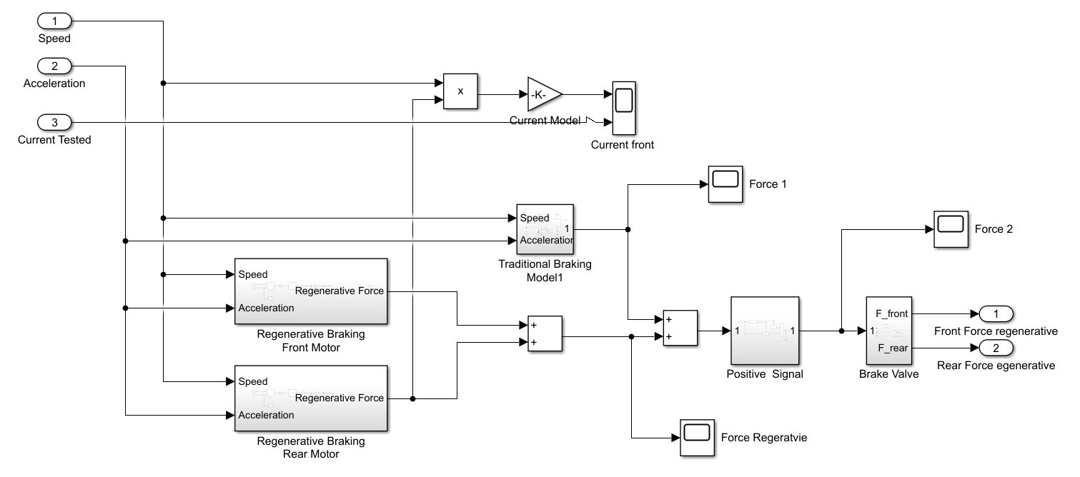
Fig. 1 Regenerative Braking Simulink Model
One of the main capabilities for an EM is to perform equally in both traction and deceleration manoeuvres in term of torque and power [10] [11]. This allows to use RB for recovering energy and enlarging the maximum allowable vehicle range. This capability is limited because of the battery, in order to limit the overheating effects [12]and most importantly for the inverter, whose role is fundamental in order to manage vehicle performance in traction and for this reason it is mounted to have the better performance in acceleration, limiting the deceleration and, as a consequence, the RB capability of the whole vehicle.
The best way to simulate this behaviour is rescaling the total power and torque available at the EM in regeneration on a lower percentage. For this reason, an empirically computed regenerative level coefficient kRB has been implemented and introduced in regenerative model to simulate the real behaviour of the car.
The RB logic considered different strategies and idea descripted in different sources [13] [14] and is based on the idea to model the RB as a sort of inertia that reduces the total amount of braking force to be re-distributed on the two axes. To compute the value of the RB force on each axle (FRB,axle) the following equations were applied:

$F_{RB, axle}=k_{RB}\frac{T_{ist}i_{0}i_{x}}{r_{w}}$ (5)
$T_{ist}=f\left(v_{v},a_{v}\right)$ (6)
Where: Tist is the instantaneous torque computed starting from the EM specific curve, i0 is the final ratio, ix is the gear ratio and rw is the wheel radius.
The regenerative force coming from the different axles has been cumulated and subtracted to the braking force already computed and represented in Fig. 1
Abrasion Model
An already developed and tested model by Akihiroi Ijima et al [15] was identified. The model defines a rug diagram from where it is possible to obtain the dust emitted in the contact between the brake-disk and the brake-pad.
Mathematically the abrasion model is not consistent respect the one defined before as it computes a total dust emitted per braking, while the braking model developed computes the instantaneous braking manoeuvre performed, for this reason an offset has been computed and evaluated starting from different standard braking manoeuvres comparing the result obtained considering them as instantaneous and continuous. After that the offset (equal to 0.222 mg/axle) has been introduced inside the whole model.
On-Track Test Description
Experimental tests have been performed on two different vehicles, which have been sensorized to acquire speed, acceleration, current and braking pressure.
The testing plan defined has been defined as follows, to evaluate different effects of RB among the driving life of the vehicle. All the manoeuvres described in Table 1 have been performed on a straight line, reaching a peak velocity, then, after a constant speed period, the deceleration occurred.
Table 1 Testing Plan Manoeuvres
Throttle Release | Low Pressure Brake | Mid Pressure Brake | Limit Brake
Initial velocity 40 km/h and 60 km/h | Initial velocity 40 km/h and 60 km/h | Initial velocity 40 km/h and 60 km/h | Velocity 120 km/h
No pressure applied to the brake pedal | Low pressure applied to the brake pedal (0.4g) | Medium pressure applied to the brake pedal (0.6g) | Maximum pressure to the brake pedal
Throttle release when target speed is stable | Throttle release just before braking | Throttle release just before braking | Straight line trajectory until vehicle stop
Straight line trajectory until track ends | Straight line trajectory until vehicle-stop | Straight line trajectory until vehicle-stop | Avoiding the ABS & no pressure control
Regenerative Braking: Analysis of the Performance
The two analyses presented in this section are the validation of the model and implementation of the regenerative level coefficient and the evaluation of different impacts of RB in different driving cycles with different brake intensity.
Model Validation
Using the speed and deceleration data coming from the mid-pressure braking manoeuvre is possible to compare them to the real data to estimate precise values for both CAR 1 and CAR 2 of kRB. The result obtained for CAR1 is equal to 0.4, while CAR2 has a coefficient equal to 0.25 respect the maximum available EM performance.
Two main data have been compared for evaluating those results: the current coming into the EM and the pressure on the braking callipers. The results shown in Fig. 2 represent the best fitting on the curve after having defined the better kRB available.
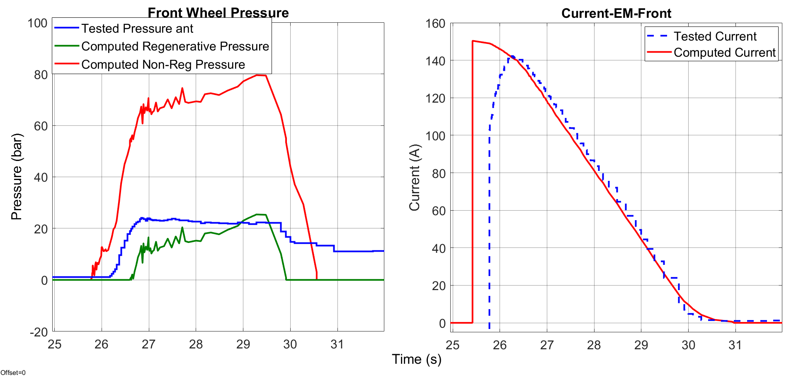
Fig. 2 Front-Wheel Pressure (left) and Rear EM Current (right) - CAR1
It is possible to notice that the behaviour obtained is satisfactory, considering the difference after the braking impulse (since during the test the driver maintains the vehicle stopped) and for a small delay at the beginning due to a small difference between the real case and the simulations done for the regenerative forces.
RB Impact on Particulate Production in different Driving Condition
After the validation it is possible to use the model for simulating braking manoeuvres able to evaluate de effectivity of RB in reducing the dust emitted by the braking system. The two manoeuvres considered are the limit braking and a WLTP Cycle. For sake of brevity, the results are shown only for CAR 1 as it is considered representative enough.
3.2.1 Limit Braking
Limit braking is the most critical condition in deceleration testing, the one in which the braking system is stressed the most and during which RB is not that effective. Structurally, RB can always reach the same power peak, no matter what the vehicle speed is, limited by the EM performance curve and by the regenerative level coefficient. Considering a braking event with specific acceleration higher than the maximum achievable with RB, the percentage of the manoeuvre covered by RB itself is always the same. As it is possible to see in the left part of Fig. 3 for the pressure signals, the intensity and the reduced duration of the braking manoeuvre need a great impact and usage of the traditional braking.

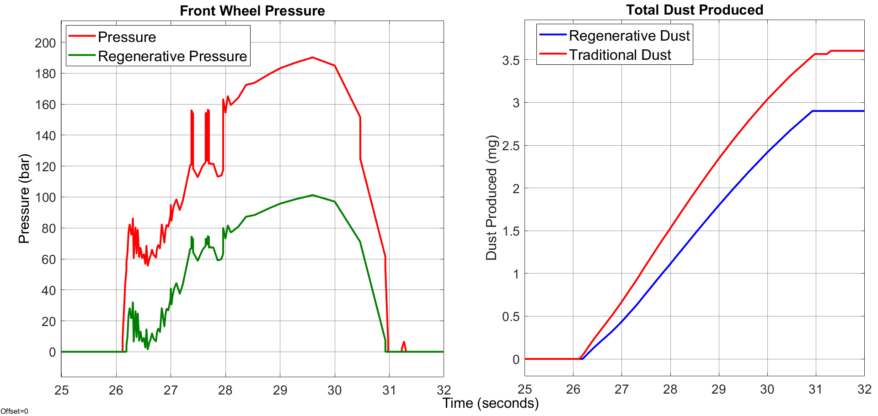
Fig. 3 Front Wheel Pressure (left) and Total Dust Produced (right) - Limit Braking Case
The great request for hydraulic braking force in this manoeuvre represent a small reduction in term of dust generated. In fact, as shown in the right part of Fig. 3 the dust generated in regenerative case is 14% reduced, as opposed to a 40% reduction in pressure needed. The difference in dust emitted reduction from the mid-pressure braking scenario depends on the faster overcome of the total regenerative power available.
3.2.2 WLTP Cycle
Impacts of RB on vehicle behaviour during a driving cycle are pivotal in enlarging the car range, making it more efficient, but looking at the data already analysed, is safe to say that is way more effective in reducing the particulate generated by the brake-pads and disk-brakes during a homologation driving cycle like WLTP. In fact, most of the braking performed during the cycle is lower than the maximum one the vehicle can perform in release, without activating the braking system. In Fig. 4 it is possible to understand the results observing that the savings are close to 100%. The results obtained point out limits for the computation of a global footprint for a vehicle using the standards homologation cycles. NEDC or CACD cycles have been tested, but the same result has been pointed out. The purpose of these tests is to evaluate the traction performance of the vehicle instead of strong braking manoeuvres.
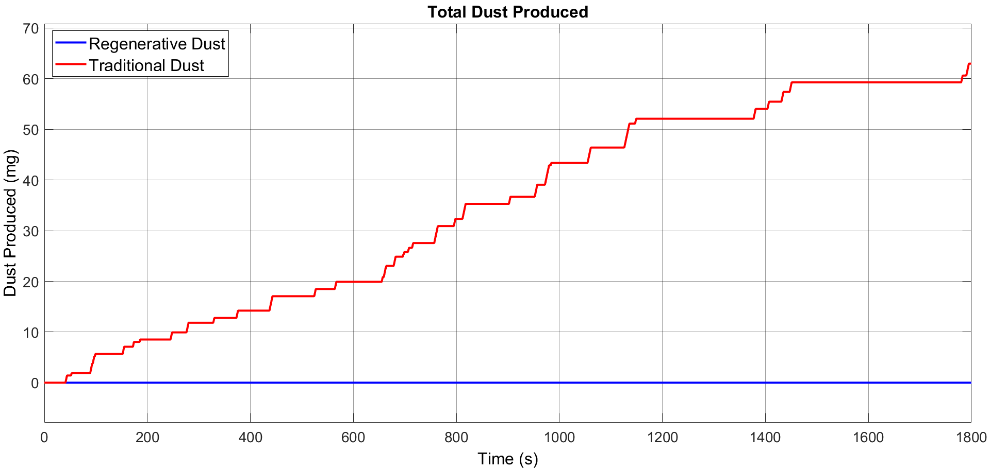

Fig. 4 Dust Produced - CAR1 -WLTP Cycle
In conclusion, it is possible to say that two main parameters can be considered in designing a vehicle with the possibility to reduce dramatically the non-combustion pollutant emissions: Regenerative Braking and dimensioning of the braking system. The two parameters are strictly connected, in fact, RB allows to create smaller braking system, because they are less stressed and less used.
Conclusions
In conclusion, it is important to make considerations on the data analysed for developing the better layout for an electric car to maximise the effects of RB and obtaining the most energy recovered, but at the same time avoiding the use of friction brakes as much as possible. The strategies to be used are related to the idea of having the maximum regenerative power to be distributed on the vehicle to reduce the transmission ratio between the wheels and the EM, not only for a traction point of view. The solution that best satisfies all the condition described before is the one using a four EM. In this solution the vehicle has 4 electric motors independent one to each other, so that are better manageable by the ECU for obtaining good performance from a vehicle dynamics point of view maximising the use of RB.
In fact, having a transmission ratio between the wheel and the EM allows that the torques applied to the wheel are equal to the one exiting by the EM itself, increasing the regenerative braking torque. At the same time, the energy regenerated is at least the same amount of the case with a single axle electric motor, considering the same motor specifications divided by two on each wheel. Because of the reduced cumulative efficiency of the single EM, it is possible to obtain a limited peak performance for each in-wheel motor [16], so this solution remains comparable to the one with a single EM for each wheel axle. Four traction wheels are still needed to obtain the maximum regenerative capability. Having 4-wheel regenerative motors with a higher efficiency means that the maximum regenerative deceleration obtainable is higher with regenerative braking on only one axle, as well as other control benefits from this layout [17-20].
Implementing the new descripted layout inside the model, it is possible to understand what its performance are. The RB optimal design is able to perform a 0.6g deceleration without applying any mechanical force, enlarging the RB braking range demonstrated for CAR1, equal to 0.4g.
In conclusion it is possible to affirm that disk-brakes, developing more and more cars with RB strongly implemented, could become rarer on traditional mass production vehicles, going to be substituted by other tools, because the braking system should be lower stressed and used principally into two conditions: Limit and safety braking manoeuvres and high SoC vehicle driving. In those two conditions RB is not effective enough to be safe for the passengers and for this reason a redundant braking system would be always introduced.
References
M. Carello et al. “Design and Modelling of the Powertrain of a Hybrid Fuel Cell Electric Vehicle”, SAE Int. J. Adv. & Curr. Prac. in Mobility, 3(6), pp. 2878–2892, 2021, doi: 10.4271/2021-01-0734.
J. Kukutschová et al. “On airborne nano/micro-sized wear particles released from low-metallic automotive brakes”. Environmental Pollution, Volume 159, Issue 4, April 2011, Pages 998-1006. doi.org/10.1016/j.envpol.2010.11.036
J. Kukutschová, et al. “Wear mechanism in automotive brake materials, wear debris and its potential environmental impact”. Materials Science - Wear, 15 June 2009, doi:10.1016/J.WEAR.2009.01.034.
H. Hagino et al. “Laboratory testing of airborne brake wear particle emissions using a dynamometer system under urban city driving cycles”. Atmospheric Environment, Volume 131, April 2016, Pages 269-278. doi.org/10.1016/j.atmosenv.2016.02.014
G. Perricone, “Laboratory measurements of airborne emissions from car brakes for clean air”. Doctoral thesis in Machine Design Stockholm, 2020. ISBN: 978-91-7873-530-3
A. Ferraris et al. “The regenerative braking for a L7e Range Extender Hybrid Vehicle”, in 2018 IEEE International Conference on Environment and Electrical Engineering, University of Palermo, Italy, May 2019, p. 7. doi: 10.1109/EEEIC.2018.8494000.
H. Meng and K. Ludema, “Wear models and predictive equations: their form and content”. Elsevier Wear, Hannover, 2017.
M. Meywerk., Vehicle Dynamics, First Edition., John Wiley & Sons, Ltd, 2015.
S. Song and Z. Chen, “Analysis of EBD Based on Active Safety Technology of Automobile”. IOP Publishing, 667(5), 2019. DOI: 10.1088/1757-899x/677/5/052014
J. Chen et al. “Control of regenerative braking systems for four-wheel-independently-actuated electric vehicles”, June 2017, DOI: 10.1016/j.mechatronics.2017.06.005
Guido Wager, “Performance evaluation of regenerative braking systems,” PhD Western Australia, 2017.
R. Bojoi, “Lesson 2 – eDrives for Architectures of Hybrid and Electrical Vehicles”. Politecnico di Torino, Dipartimento Energia “G. Ferraris”, 2020.
D. Kim et al. “Energy-Optimal Regenerative Braking Strategy for Connected and Autonomous Electrified Vehicles: A Practical Design and Implementation for Real-World Commercial PHEVs”.
F. Naseri et al. "An Efficient Regenerative Braking System Based on Battery/Supercapacitor for Electric, Hybrid, and Plug-In Hybrid Electric Vehicles With BLDC Motor," IEEE Trans. on Vehic. Tech., 66(5), 3724-3738, 2017, doi: 10.1109/TVT.2016.2611655.
A. Ijima et al. “Emission Factor for Antimony in Brake Abrasion Dusts as One of the Major Atmospheric Antimony Sources”. Environmental Science & Technology, 42(8), 2008. DOI: 10.1021/es702137g.
H. de Carvalho Pinheiro et al. “Dynamic Performance Comparison Between In-Wheel and On-Board Motor Battery Electric Vehicles”. ASME 2020 International Design Engineering Technical Conferences, 2020. doi: 10.1115/DETC2020-22306.
A. Ferraris et al. “All-Wheel Drive Electric Vehicle Performance Optimization: From Modelling to Subjective Evaluation on a Static Simulator”, 2019 Electric Vehicles International Conference, EV 2019. doi: 10.1109/EV.2019.8893027.
H. de Carvalho Pinheiro et al., “All-wheel drive electric vehicle modeling and performance optimization”, SAE Technical Paper 2019-36-0197, 2019. doi: 10.4271/2019-36-0197.
H. de Carvalho Pinheiro et al. “Advanced Vehicle Dynamics Through Active Aerodynamics and Active Body Control”, ASME 2020 International Design Engineering Technical Conferences, 2020. doi: 10.1115/DETC2020-22290.
H. de Carvalho Pinheiro et al., “Active Aerodynamics Through Active Body Control: Modelling and Static Simulator Validation”, ASME 2020 International Design Engineering Technical Conferences, 2020. doi: 10.1115/DETC2020-22298.

