In-wheel and on-board motors in BEV: lateral and vertical performance comparison

Henrique de Carvalho Pinheiro
Politecnico di Torino
Torino, Italy henrique.decarvalho@polito.it
ORCID: 0000-0001-8116-336X

Alessandro Messana
Politecnico di Torino
Torino, Italy
alessandro.messana@polito.it
ORCID: 0000-0002-2350-6149

Massimiliana Carello
Politecnico di Torino
Torino, Italy massimiliana.carello@polito.it
ORCID: 0000-0003-2322-0340

Abstract—Following the electrification trends in the automotive sector, many powertrain architectures are being studied, and among them a very interesting possibility – not yet fully developed – regards the use of in-wheel motors. This kind of electric machine positioned inside the wheel rims grants the vehicles great design freedom and opens numerous possibilities in terms of vehicle control, however some issues regarding handling and comfort are raised with the increase of the unsprung mass. This paper proposes a comprehensive study, combining the electric modelling of the motors, inverter, and battery using Simulink and its co-simulation with multibody simulation in Adams/CAR, in such a way that a full electro-mechanical coupling is achieved, and a full range of dynamic phenomena can be inquired both for an in-wheel and an on-board EV setup. The paper focuses on lateral and vertical performance, since they represent the main controversies in the adoption of in-wheel motors, and promising results are obtained.
Keywords—Vehicle dynamics; Electric motors; Electric vehicles; Multibody analysis; Handling; Comfort.
Introduction
The goal of reducing emissions and increasing efficiency is present throughout the recent scientific and industrial research, and to achieve this goal, electrification is a consolidated trend. The implementation of electric machines (EM) as main power source for vehicles opens a wide range of possibilities in terms of powertrain architectures. Differently from internal combustion engines (ICE), whose efficiency is highly dependent on size and for which assemblies are quite cumbersome, EMs allow for a flexible and modular application of multiple power sources [1].
The use of in-wheel EMs is an idea that is present in the literature for a long time [2,3], but its industrial implementation is far from reaching mass market. In-wheel EMs have several potential advantages respect to traditional central motors, being the packaging and modularity one of the most prominent, as well as the flexibility of the control systems related to independent torque sources [4–13].
Certainly, side-by-side with these positive features, a series of issues and technical disadvantages can be identified: lower efficiency due to the unfavorable aspect ratio, difficult to implement cooling and related thermal limitations, vibrations, and the required robustness to withstand direct road load, as well as the increase of the unsprung mass [14].
The latter issue is closely related to the main scope of this paper: understanding the real implications of the usage of in-wheel motors in terms of dynamic response of the vehicle, more specifically regarding lateral and vertical dynamics.
This paper proposes a study of lateral, roll and vertical dynamics by means of, respectively, a Constant-radius cornering, a Fish-hook maneuver, and the Cruising on sine-wave road profile. These maneuvers are performed by two different models, the first displaying a conventional on-board (OB) electric powertrain with a single EM, while the second is composed of four in-wheel (IW) motors.
For both models a co-simulation environment is proposed, where the electric powertrain components (battery, inverter and EM) are simulated in MATLAB/Simulink and the mechanical behavior of the vehicle is simulated in the ADAMS/Car software. Apart from the electric and mechanical features of the different powertrains, all other parameters are maintained fixed, to highlight the sole effect of the EM change. The choice of a co-simulation permits a complete coupled analysis between mechanical and electrical behavior of the system [15], and represents an important contribution to the state-of-the-art, where the mechanical response of the system is heavily simplified in drivability analysis, and vice-versa the electric behavior is greatly simplified for handling studies [16,17].
The full-vehicle models are characterized according to the vehicle 2020 Tesla Model 3 Standard Range Plus RWD [18].
Previous work has shown the results related to the longitudinal dynamics [19], and these considerations won’t be replicated in this paper.
The goal of the study is to gather evidence based on the coupled electro-mechanical model, about the advantages and issues related to the use of In-wheel motors, more specifically evaluating if with their presence dynamic lateral and vertical phenomena could arise jeopardizing handling and comfort. Thus, after performing the mentioned maneuvers, the main dynamic parameters, such as acceleration, steering angle and tire behavior are analyzed and compared.
Electrical and mechanical modelling
The following section describe the main subsystems modelled during the study, namely battery, power control unit, electric machine, transmission, and the full-vehicle model encompassing the remaining subsystems.
Battery
The energy storage is one of the main components of the electric powertrain, and its dynamics can play a decisive role in the vehicle behavior. Several kinds of battery model can be implemented, ranging from complete chemistry-based models to purely data-driven system descriptions. For the purposes of this paper, an equivalent circuit model was chosen, more specifically the single cells are represented as a double-polarization model, with three resistances and two capacitances, arranged as in Fig. 1 - left. The battery pack is simulated as a assemble of single-cell models, to meet the capacity and output voltage by means of parallel and series connections (Fig. 1 – right).

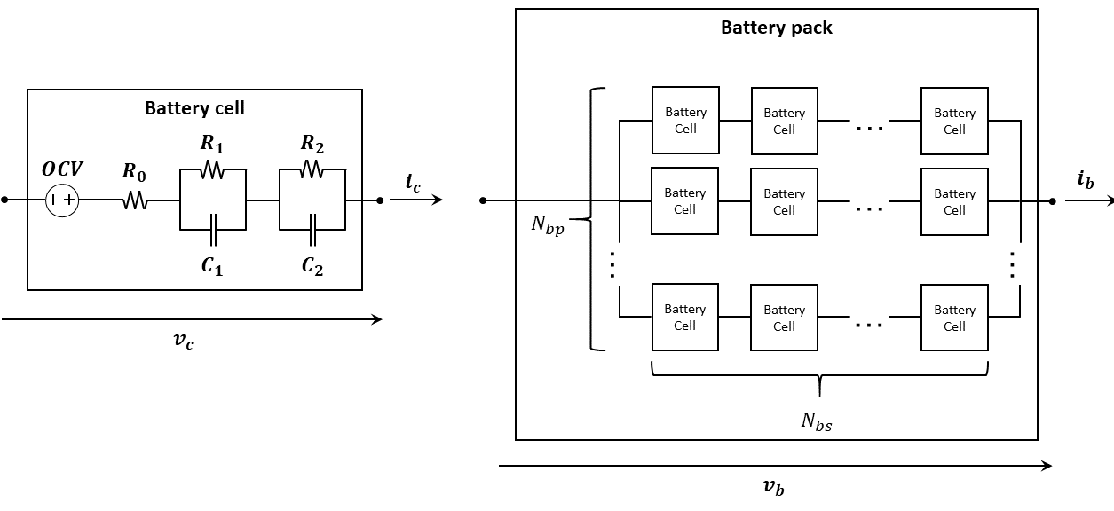
Battery cell double-polarization model (left) and battery pack configuration composed of multiple single-cell models (right).
The battery cell parameters are modelled as defined in [20].
The overall battery pack features, as in [19], represent the approximated features of the reference vehicle. Some parameters are: Capacity of 150 Ah, rated voltage of 360 V, total mass of 361 kg and dimensions 1850 x 1170 x 89 mm.
Inverter, Motors and overall Powertrain
To convert the DC power supplied by the battery into the needed AC power to drive the EMs, a power electronics system composed of DC/DC converter and three-phase inverter is modelled.
The application of the modulation schemes supposes either a voltage source or a current source at the inverter input link. In the first case, the power converter is known as voltage source inverter and it can control the AC voltage output. In the second case, the device is known as current source inverter and it can control the AC current output. In automotive powertrains, given that the battery pack is designed to keep a constant voltage supply within its range of operation, the three-phase inverter is designed as a voltage source inverter [21].
The power control unit might include several power controllers and power converters. A simplified model is considered: an assembly of a DC/DC power converter and a three-phase inverter connected in series between the battery pack and the electric machine. Neither accessory stages nor any additional components (i.e. LC filters) are included. In addition, it is supposed that the stator phase windings of the electric machine are connected according to the wye configuration.
Regarding the EM, an IPM machine is used for modelling the motor in the two studied configurations.
On the electrical side, the Powertrain Blockset library on MATLAB/Simulink is used: the Interior PMSM block is employed. It implements an IPM machine with sinusoidal back electromotive force and three-phase input voltages to control the individual wye-connected phase currents, thus, allowing the application of torque control techniques. The motor torque $T_{m}$ is defined according to (1)-(4).
 | $$ω_{e}=Pω_{r}$$ |  | (1)
 | $$\frac{d}{dt}i_{d}=\frac{1}{L_{d}}v_{d}-\frac{R}{L_{d}}i_{d}+\frac{L_{mq}}{L_{md}}ω_{e}i_{q}$$ |  | (2)
 | $$\frac{d}{dt}i_{q}=\frac{1}{L_{q}}v_{q}-\frac{R}{L_{q}}i_{q}-\frac{L_{md}}{L_{mq}}ω_{e}i_{d}-\frac{λ_{pk}ω_{e}}{L_{mq}}$$ |  | (3)
 | $$T_{m}=\frac{3}{2}P\left[λ_{pk}i_{q}+\left(L_{md}-L_{mq}\right)i_{d}i_{q}\right]$$ |  | (4)
In which, 𝜔𝑒 is the rotor electrical motor speed; 𝑃 is the number of pole pairs in the rotor magnetic; 𝜔𝑚 is the rotor mechanical speed; 𝑖𝑑, 𝑣𝑑 and 𝐿𝑑 are the d-axis armature current, voltage and inductance; 𝑖𝑞, 𝑣𝑞 and 𝐿𝑞 are the q-axis armature current, voltage and inductance; λpk is the flux linkage of the permanent magnetic rotor; and 𝑇𝑚 is the motor torque.
The basis models adopted in the on-board and in-wheel full-vehicle models are EMRAX 348 CC Low Voltage and EMRAX 228 CC Medium Voltage, respectively. Among the available options in the company catalogue, the two chosen basis motors closer represent the rated power of the basis vehicle. Table I shows the main parameters of the motors.
Main parameters of the OB and IW motors [22]
Parameter | OB | IW
Rated power $P_{max}$ | $$186 kW$$ | $$55 kW$$
Rated torque $T_{max}$ | $$500 Nm$$ | $$120 Nm$$
Maximum speed $ω_{max}$ | $$4,000 RPM$$ | $$5,000 RPM$$
Mass $m_{s}+m_{r}$ | $$40.0 kg$$ | $$12.3 kg$$
Diameter/length $D_{m}/l_{m}$ | $$348/107 mm$$ | $$228/86 mm$$
Rotor rotational inertia $J_{r}$ | $$0.365 kg∙m^{2}$$ | $$0.038 kg∙m^{2}$$
Maximum current $i_{max}$ | $$550 Arms$$ | $$160 Arms$$
Maximum voltage $v_{max}$ | $$400 Vdc$$ | $$470 Vdc$$
Magnetizing inductance $L_{md}/L_{mq}$ | $$24.3/26.3 μH$$ | $$76.0/79.0 μH$$
Pole pairs P | $$10$$ | $$10$$
Magnetic flux $λ_{pk}$ | $$0.051 Wb$$ | $$0.036 Wb$$
Per-phase stator resistance $R_{s}$ | $$5.0 mΩ$$ | $$8.0 mΩ$$

Applying the mentioned parameters to the overall powertrain model it is possible to obtain the efficiency map of each configuration. Fig. 2 depicts the map for both configurations.

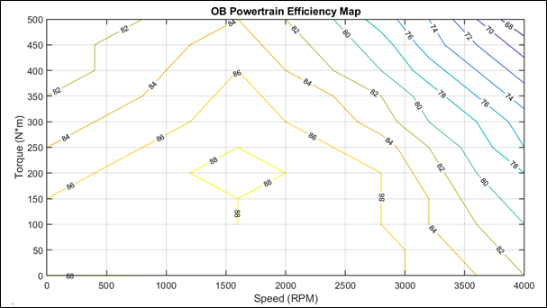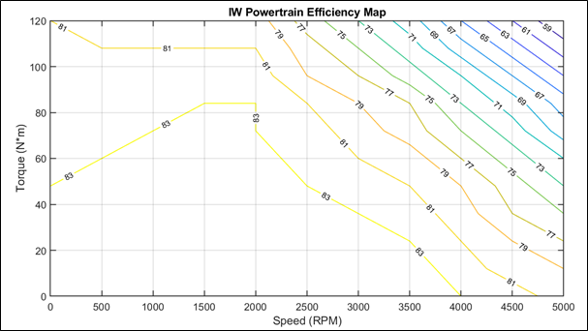
Overall efficiency of the electric powertrain in the On-board and In-wheel confirgurations
Transmission
The final link before the power transmission to the vehicle wheels is the transmission. Different models must be applied to the OB and IW configurations. The IW are directly connected to the wheel hubs, and the torque and speed of the EMs are independent, while the OB consists of a single EM in central RWD position, therefore a differential is needed to distribute torque equally to right and left sides.
The respective ratios are chosen in a way that the main longitudinal features of the vehicles – acceleration and maximum speed - are comparable, as described in [19].
Full-vehicle
The other vehicle’s subsystems are modelled in the ADAMS/Car environment and use as main reference the default C-segment model available in the acar_concept.cdb library. Therefore, the brakes, front and rear suspension, body, steering, wheels and tires are only adapted to follow the overall mass and dimensions of the basis vehicle [23] but the modelling characteristics follow the same behavior as proposed by the templates.
This way the results are easily replicable, and the focus of the study (the electric powertrain) can be scrutinized without concerns related to the mechanical parts.
Maneuvers and analysed parameters
As previously mentioned, this paper concentrates in the representative maneuvers describing lateral, roll and vertical dynamics, as shown in Table II.
Maneuvers and their correspondent dynamics
Maneuver | Main vehicle motion | Dynamic analysis
Constant-radius cornering | Lateral | Handling
Fish-hook maneuver | Roll | Roll stability
Sine-wave road profile | Vertical | Vertical

A detailed description of the simulation conditions follows.
Constant-radius cornering
The constant-radius cornering maneuver is a closed-loop simulation, which includes four mini-maneuvers:
Straight static-setup: an initial setup phase is performed so to have the vehicle reach a longitudinal static-setup and to guarantee that any start-up transients are mitigated.
Turning transient: once the vehicle reaches a longitudinal steady-state condition, the steering angle is increased so to have the vehicle corner at the user-defined radius.
Cornering static-setup: a subsequent setup phase is performed so to have the vehicle reach a lateral static-setup and guarantee that any transients are mitigated.
Accelerating transient: once the vehicle reaches a steady-state condition, the throttle pedal is controlled to have the vehicle reach a target user-defined longitudinal acceleration. The steering angle is controlled to maintain the constant-radius cornering. The maneuver ends at the final vehicle speed. Table III resumes the parameters of the mini-maneuvers created with the Event Builder tool.
Parameters of the constant-radius cornering maneuver
Parameter | Value
Initial vehicle speed $V_{0}$ | $$10 {km}/h$$
Straight static-setup time duration $Δt_{ss}$ | $$1 s$$
Turn radius $R_{t}$ | $$50 m$$
Cornering static-setup time duration $Δt_{cs}$ | $$1 s$$
Longitudinal acceleration $a_{long}$ | $$7 {{km}/h}/s$$
Final vehicle speed $V_{f}$ | $$80 {km}/h$$
Fish-hook maneuver
The fish-hook maneuver is a closed-loop simulation, whose standards are defined by the National Highway Traffic Safety Administration (NHTSA) [24]. The maneuver is based on the sequence of steering and counter-steering the vehicle to obtain the maximum roll angle rate $\dot{ϕ}$.
The fish-hook maneuver is a closed-loop simulation, which includes five mini-maneuvers:
Straight static-setup: an initial setup phase is performed so to have the vehicle reach a longitudinal static-setup and to guarantee that any start-up transients are mitigated.
Steering transient: once the vehicle reaches a steady-state condition, the steering angle is increased by a ramp function until the final value +A. The throttle is set to 0% (null electromechanical torque Tem) until the end of the maneuver.
Holding I: the steering angle is held constant until the roll angle rate decreases to the threshold B.
Counter-steering transient: the steering angle is decreased by a ramp function until the final value.
Holding II: the steering angle is held constant for three seconds.
Returning: the steering angle is released for two seconds.
Table IV resumes the parameters of the mini-maneuvers created with the Event Builder tool.
Parameters of the fish-hook maneuver
Parameter | Value
Initial vehicle speed $V_{0}$ | $$50 mph \left(80.5 {km}/h\right)$$
Static-setup time duration $Δt_{s}$ | $$1 s$$
Steering rate $r_{steer}$ | $$720 {deg}/s$$
Steering scalar $SS$ | $$6.5$$
Steering angle amplitude $A$ | $$δ_{0.3 g}∙SS$$
Roll angle rate amplitude $B$ | $$1.5 {deg}/s$$
Holding II time duration ${∆t}_{2}$ | $$3 s$$
Returning time duration ${∆t}_{3}$ | $$2 s$$
Cruising on sine-wave road profile
In contrast to the previous maneuvers, the cruising on sine-wave road profile maneuver is not run on the built-in standard flat road. The profile is created with the Roadbuilder and consists of two segments:
Initial flat segment: an initial flat segment which has the same properties as the built-in standard flat road.
Sine-wave segment: a sinusoidal segment which has the same properties as the built-in standard flat road.
The new profile enables the vehicle to run for about $1 s$ on the initial flat segment at a constant vehicle speed $V_{v}=10 {km}/h$ then in a sine-wave profile with amplitude A = 0.1 m and wavelength λ = 0.8 m.
The cruising on sine-wave road profile maneuver is a closed-loop simulation, which includes three mini-maneuvers:
Static-setup on flat segment: an initial setup phase is performed so to have the vehicle reach a longitudinal static-setup on the flat segment and to guarantee that any start-up transients are mitigated.
Static-setup on sine-wave segment: an initial setup phase is performed so to have the vehicle reach a longitudinal static-setup on the sine-wave segment and to guarantee that any start-up transients are mitigated.
Accelerating transient: once the vehicle reaches a steady-state condition, the throttle pedal is controlled to have the vehicle reach a target user-defined longitudinal acceleration. The steering angle is controlled to maintain the constant-radius cornering. The maneuver ends at the final vehicle speed. Table V resumes the parameters of the mini-maneuvers created with the Event Builder tool.
Parameters of the cruising on sine-wave road profile maneuver
Parameter | Value
Initial vehicle speed $V_{0}$ | $$10 {km}/h$$
Static-setup on flat segment time duration $Δt_{ss1}$ | $$1 s$$
Static-setup on sine-wave segment time duration $Δt_{ss2}$ | $$1 s$$
Longitudinal acceleration $a_{long}$ | $$7 {{km}/h}/s$$
Final vehicle speed $V_{f}$ | $$80 {km}/h$$
Results
Constant-radius cornering
In Fig. 3 the longitudinal slip of all four tires is plotted
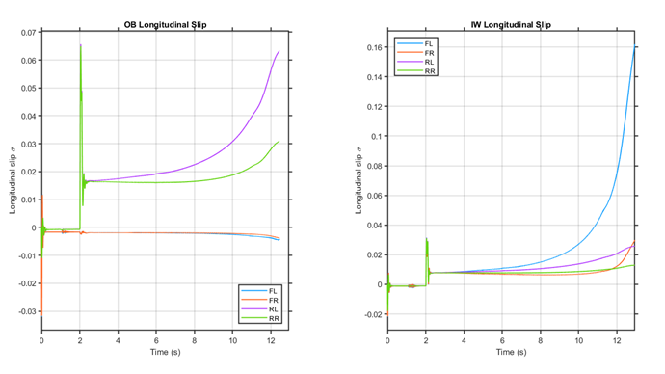
Longitudinal slip in constant-radius cornering maneuver
As expected, for the OB configuration only two wheels present positive slip (traction) while the front ones follow a decreasing pattern. Since the vehicle is constantly accelerating, there is an inherent coupling between lateral and longitudinal behavior. The all-wheel drive condition of the IW layout present lower slips for the rear wheels, since a more uniformly distributed torque is achieved, which grants the tires more usable force in the lateral direction.
In slow speeds, the tire sideslip angles $α$ are mostly affected by the static toe and camber angles. As shown in the Fig. 4, there is not considerable changes in the values between the straight and the cornering setup stages (up to 2s).
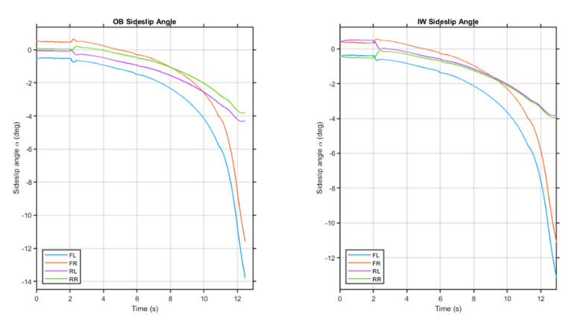
Sideslip angle in constant-radius cornering maneuver
A similar pattern is observed between the two configurations regarding the sideslip, being the OB just slightly higher throughout the maneuver. The values are significantly higher than longitudinal slip since the maneuver is mainly designed to highlight lateral response. Both configurations present higher sideslips at the front axle, characteristic of an understeering vehicle. Fig. 5 shows the steering angle (left) and the vehicle speed (right).
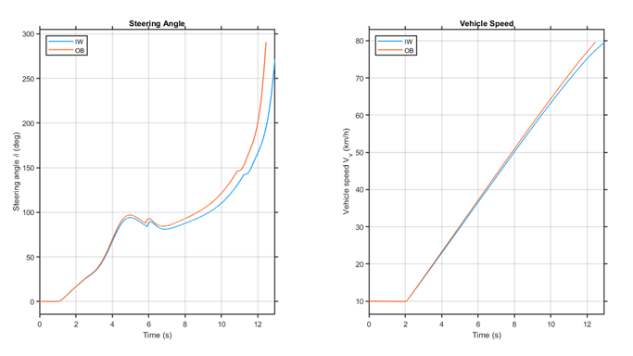
Steering angle and vehicle speed in constant-radius cornering maneuver
Looking at the steering result it is clear that the required driver input to complete the maneuver is higher in the OB configuration, which means that the OB vehicle is more undesteering. With a more equilibrated behavior the IW vehicle can hold the trajectory and negotiate the curve longer. This indicate that in terms of lateral response not only the IW didn’t raise any issues due to the additional unsprung mass, but on the contrary the AWD feature improved the overall contant radius curve response.
Fish-hook maneuver
Fig. 6 displays the steering angle and roll angle rate in fish-hook maneuver. Been a closed-loop maneuver the input values of the steering are slightly different between the tests, it is noticeable that the first peak steering is higher for the IW vehicle and the holding time is longer for the OB vehicle. That’s mainly due to the sprung mass difference: since the unsprung mass plays negligible role in the roll dynamics, the higher mass on-boar in the OB version makes the vehicle more prone to rolling, so the peak value A is more quickly achieved, and It takes longer to the roll rate to fade to the B threshold.
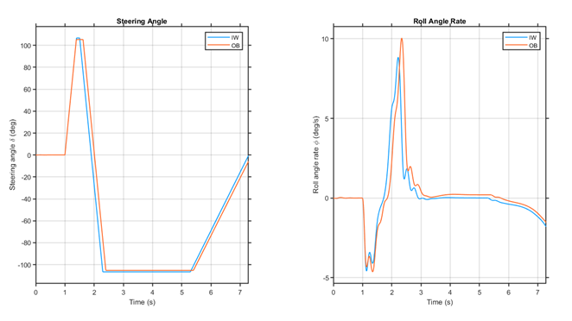
Steering angle and vehicle speed in fish-hook maneuver
Fig. 7 shows the plots of lateral acceleration and roll angle in both vehicles. As expected, due to the previous considerations, the OB vehicle has a higher roll inertia and displays overall worse behavior when it comes to roll stability. The vehicle is less responsive and get closer to limit lateral acceleration during the maneuver, as the lateral acceleration peak is higher both in steering and counter-steering phases.
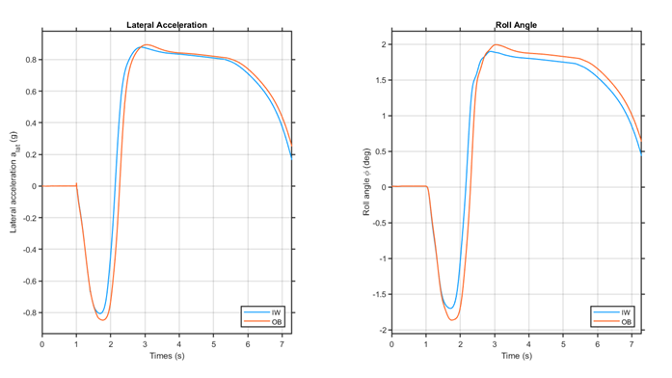
Lateral acceleration and roll angle in fish-hook maneuver
Once more, the IW presents a similar pattern, but with slight advantage when compared to the OB layout. In this case, since the maneuver is not strongly marked by longitudinal intervention, the benefits do not come from a better torque distribution, but to a lighter body. Both tests performed regarding handling suggest that IW configuration can improve vehicle dynamics even in absence of advanced control methods.
Cruising on sine-wave road profile
The last test regards vertical dynamics, and it is the one in which the main issues of the unsprung mass might come up. Fig. 8 shows the longitudinal and vertical acceleration of the body during the IW and OB vehicle’s maneuvers.
Both cases present an important coupling between drive and vertical vibrations, and it is possible to see that the longitudinal acceleration oscillate around the target value with increasing frequency and amplitude. It is only at around 10 s that a difference is noticeable between the vehicles, when the IW version starts to present higher amplitude.
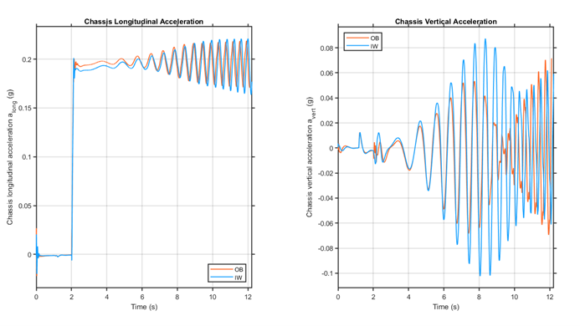
Chassis longitudinal and lateral accelerations in cruising on sine-wave road profile
Both cases present an important coupling between drive and vertical vibrations, and it is possible to see that the longitudinal acceleration oscillate around the target value with increasing frequency and amplitude. It is only at around 10 s that a difference is noticeable between the vehicles, when the IW version starts to present higher amplitude.
The vertical acceleration instead presents a much clearer contrast, the IW vehicle goes through higher body vertical vibrations. To improve the understanding of this phenomenon, after using a simple moving-average filter, the chassis RMS vertical acceleration is shown in Fig. 9.

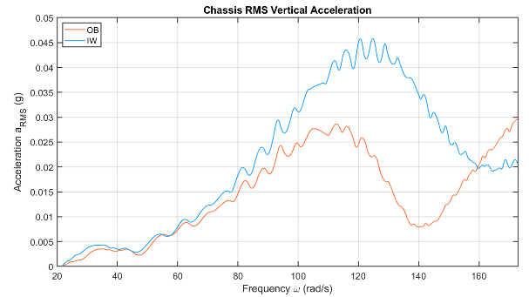
Chassis RMS vertical acceleration in cruising on sine-wave road profile
It is evident that both configurations present a resonance point within the studied range of frequency, which represents the natural frequency of the sprung mass. Given that the on-board architecture has the motor attached to the chassis, the incremental mass lowers the sprung mass resonance frequency $ω_{ns}$. the IW performs rather poorly and presents peak values up to 56 % higher than the response of the OB configuration.
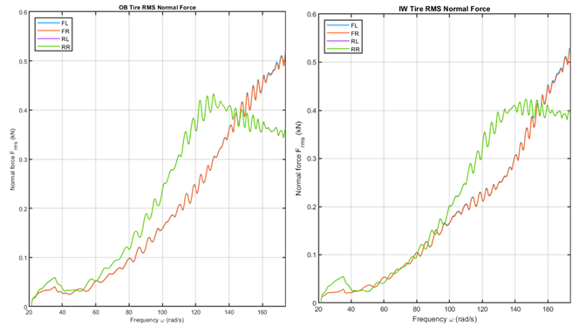
Tire RMS normal force in cruising on sine-wave road profile
A similar analysis can be performed for the tire normal forces Fz. Fig. 10 shows the results. It is possible to see that, despite the variations in the unsprung mass, both configurations behave in similar manner when the road-holding capabilities are concerned. Their curves of front and rear wheels are comparable.
Conclusion
In-wheel motors are a promising technology for the future of electric vehicles, but some concerns exist regarding their application. This paper studies the lateral and vertical dynamics of two vehicles, one consisting of an electric vehicle with a central RWD on-board electric machine and the other with four in-wheel motors.
Results of the co-simulation in MATLAB/Simulink and ADAMS/Car suggest that the vehicles have similar dynamic capabilities, with a slight advantage for the IW vehicle when it comes to lateral and roll behavior. Nevertheless, the higher mass of the unsprung mass indeed makes a difference when it comes to vertical vibrations: an important increase of 56% in the experienced accelerations during the sine-profile road test. These vertical oscillations didn’t, however, caused issues in the road holding capabilities or in the longitudinal-vertical coupling of the drivelines.
The proposed methodology allowed a deep look at the dynamics of the vehicles and supplied much more detailed information then typical simplified models. The combination of multibody analysis and detailed modelling of the electric components created a powerful model. Future developments are three-fold: validation of the simulations through experimental tests, looking at the main electrical and mechanical parameters of the system; improvement of the multibody dynamics and inclusion of flexible components [25] and non-linear bushings and dampers to a full NVH account; and continue the development of the modelling methodology to account for more detail electric phenomena and employ the tool during early design and optimization phase to get a better grasp of handling and drivability before prototyping.
References
Yildirim, M., Polat, M., and Kürüm, H., “A survey on comparison of electric motor types and drives used for electric vehicles,” 2014 16th International Power Electronics and Motion Control Conference and Exposition, 218–223, 2014, doi:10.1109/EPEPEMC.2014.6980715.
Brusaglino, G., “Electric vehicle development in fiat,” SAE Tech. Pap., 1991, doi:10.4271/910244.
Glover, M., “Clean concepts,” Automot. Eng. Lond. 28(10):16–18, 2003.
Carvalho Pinheiro, H. de, Messana, A., Sisca, L., Ferraris, A., Airale, A.G., and Carello, M., “Torque Vectoring in Electric Vehicles with In-wheel Motors,” in: Uhl, T., ed., Advances in Mechanism and Machine Science, Springer International Publishing, ISBN 978-3-030-20131-9: 3127–3136, 2019, doi:10.1007/978-3-030-20131-9_308.
Favilli, T., Pugi, L., Berzi, L., and Pierini, M., “Coordinated Steering and Torque Vectoring Lateral Stability Sliding Mode Control Applied to an Electric In-Wheel Motors Vehicle,” 2021 IEEE International Conference on Environment and Electrical Engineering and 2021 IEEE Industrial and Commercial Power Systems Europe (EEEIC / I CPS Europe), 1–6, 2021, doi:10.1109/EEEIC/ICPSEurope51590.2021.9584717.
Carvalho Pinheiro, H. de, Punta, E., Carello, M., Ferraris, A., and Airale, A.G., “Torque Vectoring in Hybrid Vehicles with In-Wheel Electric Motors: Comparing SMC and PID control,” 2021 IEEE International Conference on Environment and Electrical Engineering and 2021 IEEE Industrial and Commercial Power Systems Europe (EEEIC / I CPS Europe), 1–6, 2021, doi:10.1109/EEEIC/ICPSEurope51590.2021.9584732.
Montani, M., Favilli, T., Berzi, L., Capitani, R., Pierini, M., Pugi, L., and Annicchiarico, C., “ESC on In-Wheel Motors Driven Electric Vehicle: Handling and Stability Performances Assessment,” 2020 IEEE International Conference on Environment and Electrical Engineering and 2020 IEEE Industrial and Commercial Power Systems Europe (EEEIC / I CPS Europe), 1–6, 2020, doi:10.1109/EEEIC/ICPSEurope49358.2020.9160768.
Carvalho Pinheiro, H. de, Russo, F., Sisca, L., Messana, A., De Cupis, D., Ferraris, A., Airale, A.G., and Carello, M., “Active Aerodynamics Through Active Body Control: Modelling and Static Simulator Validation,” American Society of Mechanical Engineers Digital Collection, 2020, doi:10.1115/DETC2020-22298.
Kanchwala, H., Rodriguez, P.L., Mantaras, D.A., Wideberg, J., and Bendre, S., “Obtaining Desired Vehicle Dynamics Characteristics with Independently Controlled In-Wheel Motors: State of Art Review,” SAE Int. J. Passeng. Cars - Mech. Syst. 10(2):413–425, 2017, doi:10.4271/2017-01-9680.
Carvalho Pinheiro, H. de, Russo, F., Sisca, L., Messana, A., De Cupis, D., Ferraris, A., Airale, A.G., and Carello, M., “Advanced Vehicle Dynamics Through Active Aerodynamics and Active Body Control,” American Society of Mechanical Engineers Digital Collection, 2020, doi:10.1115/DETC2020-22290.
Carvalho Pinheiro, H. de, Ferraris, A., Galanzino, E., Sisca, L., Carello, M., Airale, A., and Messana, A., “All-wheel drive electric vehicle modeling and performance optimization,” SAE Technical Paper 2019-36-0197, 2019, doi:https://doi.org/10.4271/2019-36-0197.
Ferraris, A., Carvalho Pinheiro, H. de, Galanzino, E., Airale, A.G., and Carello, M., “All-Wheel Drive Electric Vehicle Performance Optimization: From Modelling to Subjective Evaluation on a Static Simulator,” 2019 Electric Vehicles International Conference, EV 2019, 2019, doi:10.1109/EV.2019.8893027.
Jeon, J., Na, S., and Heo, H., “Cascade Sliding Mode — New Robust PID control for BLDC motor of In-wheel system,” 2011 10th International Conference on Environment and Electrical Engineering, 1–4, 2011, doi:10.1109/EEEIC.2011.5874632.
Carello, M., Carvalho Pinheiro, H. de, Messana, A., Freedman, A., Ferraris, A., and Airale, A.G., “Composite Control Arm Design: A Comprehensive Workflow,” SAE Int. J. Adv. Curr. Pract. Mobil. 3(5):2355–2369, 2021, doi:10.4271/2021-01-0364.
Luca, P., Argeo, B., and Francesco, G., “Design and simulation of a multirole electric vehicle,” 2017 IEEE International Conference on Environment and Electrical Engineering, 1–6, 2017, doi:10.1109/EEEIC.2017.7977432.
Ciceo, S., Mollet, Y., Sarrazin, M., Gyselinck, J., Van der Auweraer, H., and Martiş, C., “Model-based design and testing for electric vehicle driveability analysis,” 2016 IEEE 16th International Conference on Environment and Electrical Engineering (EEEIC), 1–4, 2016, doi:10.1109/EEEIC.2016.7555884.
Pellegrino, G., Vagati, A., Guglielmi, P., and Boazzo, B., “Performance Comparison Between Surface-Mounted and Interior PM Motor Drives for Electric Vehicle Application,” IEEE Trans. Ind. Electron. 59(2):803–811, 2012, doi:10.1109/TIE.2011.2151825.
Worldwide electric vehicle sales by model 2020, https://www.statista.com/statistics/960121/sales-of-all-electric-vehicles-worldwide-by-model/, Feb. 2022.
Carvalho Pinheiro, H. de, Castro dos Santos, P.G., Sisca, L., Scavuzzo, S., Ferraris, A., Airale, A.G., and Carello, M., “Dynamic Performance Comparision between In-Wheel and On-Board Motor Battery Electric Vehicles,” Virtual, Online, 2020.
Cittanti, D., Ferraris, A., Airale, A., Fiorot, S., Scavuzzo, S., and Carello, M., “Modeling Li-ion batteries for automotive application: A trade-off between accuracy and complexity,” IEEE, ISBN 978-88-87237-26-9: 1–8, 2017, doi:10.23919/EETA.2017.7993213.
Ye, H., Yang, Y., and Emadi, A., “Traction inverters in hybrid electric vehicles,” 2012 IEEE Transportation Electrification Conference and Expo (ITEC), 1–6, 2012, doi:10.1109/ITEC.2012.6243442.
EMRAX, “Technical Data and Manual for EMRAX Motors / Generators,” https://emrax.com/wp-content/uploads/2017/10/user_manual_for_emrax_motors.pdf, 2018.
2020 Tesla Model 3 Standard Range Plus RWD - Specifications and price, https://www.evspecifications.com/en/model/cc48e0, Feb. 2022.
U.S. Department of Transportation and National Highway Traffic Safety Administration, “Laboratory Test Procedure for Dynamic Rollover - The Fishhook Maneuver Test Procedure,” 2013.
Carvalho Pinheiro, H. de, Messana, A., Sisca, L., Ferraris, A., Airale, A.G., and Carello, M., “Computational Analysis of Body Stiffness Influence on the Dynamics of Light Commercial Vehicles,” in: Uhl, T., ed., Advances in Mechanism and Machine Science, Springer International Publishing, ISBN 978-3-030-20131-9: 3117–3126, 2019, doi:10.1007/978-3-030-20131-9_307.

