20XX-01-XXXX

Methodology and application on load monitoring using strain-gauged bolts in brake calipers
Author, co-author (Do NOT enter this information. It will be pulled from participant tab in MyTechZone)
Affiliation (Do NOT enter this information. It will be pulled from participant tab in MyTechZone)

Abstract
As technology evolves, the number of sensors and available data on vehicles grow exponentially. In this context, it is essential to use sensors for monitoring key components, increasing safety and reliability, and gathering data useful for mechanical dimensioning and control systems. This paper presents an application of strain-gauged bolts on brake calipers fixation of two electric vehicles. With this approach it was possible to evaluate the loads applied to the brake pads fixation zone and correlate them with braking behavior, therefore gaining insights on braking conditions and system state for an improved braking function control. The goal of the study is analyzing the strengths and limitations of the method and proposing developments to deploy it in real applications. This is particularly important and novel for electric vehicles, where powertrains can create positive/negative torques and generate complex interactions with braking system. Strain-gauges are a long-known technology applied in many fields, and its usage in bolts and screws is well established. However, within automotive field, it could represent cutting edge technology for load sensing and monitoring. The application shows promising results and proves a valid option for monitoring safety components due to its low cost, small dimensions, and reliability. The presented case study takes place in a straight-line test track, where three braking maneuvers were performed: low-pressure braking, mid-pressure braking, and emergence braking. The effects of ABS intervention and wet disk conditions were investigated from an experimental point of view. The paper describes the method used for the strain-gauge application in the bolts, calibration in a dynamometer traction and compression test, installation in the vehicle, and data analysis and post-processing. Results present consistent readings in the higher-pressure conditions, while for the low-pressure cases, the challenges related to load sensing sensitivity are more evident, with a clear tradeoff between system stiffness and measure sensitivity. Finally, evolutions of the system and further investigations on this promising technology applied to the automotive field are presented.
Introduction
The automotive field is witnessing several changes and new research and development trends in the recent years. Coming from years of research in lightweight design [1,2] and energy efficiency [3,4] the main pillars of the current sector evolution are commonly expressed through the widely used acronym CASE (standing for Connected, Autonomous, Shared and Electric).
One of the keystones to permit the development path towards each letter the CASE car is the incorporation of sensors, processors, and communication devices in the new vehicles to come. Indeed, the number of sensors installed in passenger vehicles is constantly growing, arriving at an average of 60-100 in 2015 and expected to achieve over twice as much by 2030 [5]
Essential sensors can be organized in many categories, ranging from thermal, mechanical, chemical, and electric quantities. When considering mechanical sensors, typically vehicles present accelerometers and gyroscopes to determine linear and angular movement. Potentiometers are applied to evaluate relative displacements and recently the presence of RADAR, LIDAR and ultrasound sensors help determining the relative position of the vehicle relative to its environment [6-9]. Still in the mechanical domain, a particular set of sensors is applied to evaluate mechanical stresses and strains present in vehicle’s parts, such as piezoelectric transducers [10] and – as this paper’s focus – strain-gauges.
Strain-gauges and other strain sensors can be used for a variety of applications in the automotive field, such as the estimation of deformation of components, and a wide range of safety applications, as the commonly referred Structural Health Monitoring (SHM) or Fault Analysis [10]. Having an accurate and real-time measurement of the structural status of key safety parts of vehicles can have deep impacts on reliability, allow for a more efficient use of materials and lower costs of maintenance.
Among the main safety related subsystems of vehicles, brakes certainly play a distinct role, being one of the most critical systems of the chassis. Preventing faulty components on the brake subsystem and creating mechanisms to avoid function loss is a standard in the design and development of current automobiles, as well as Worst Case Scenario analysis, use of large safety factors and the creation of backup and redundant schemes. Certainly, these measures come with a burden in terms of cost, mass, and system complexity.
With the growing presence of Electric Vehicles (EV) in the market, it is expected a large set of changes in the layout and mechanical design of cars. Apart from the most evident evolutions happening in the powertrain, driveline, and energy storage, also braking function shall expect layout changes. Packaging of the unsprung mass will see modifications (especially if in-wheel electric machines would become an industry common practice [11-14]) and the possibility to perform regenerative braking with electric motors will impact the brake system mission and typical loads [15].
Starting from current scenario, considering the electric powertrain progressive introduction, and considering decrease in cost for sensing and processing power, the opportunity to rethink the brake system partitioning can also trigger possibility to explore advanced monitoring techniques applied to braking components, with the goal to create leaner, modular, scalable and more reliable outcomes.
This paper is the results of a collaboration between Politecnico di Torino, SKF Italia and Beond and shows a case-study with two EVs where strain-gauges were applied inside the fixation bolts of the brake calipers and the vehicles were tested in a dynamic track environment. The study demonstrates the feasibility of the methodology, to assert the effect of some testing conditions to the overall sensor outputs. Figure 1 shows a schematic view of the system, where the red elements are the bolts in which the sensors were applied.
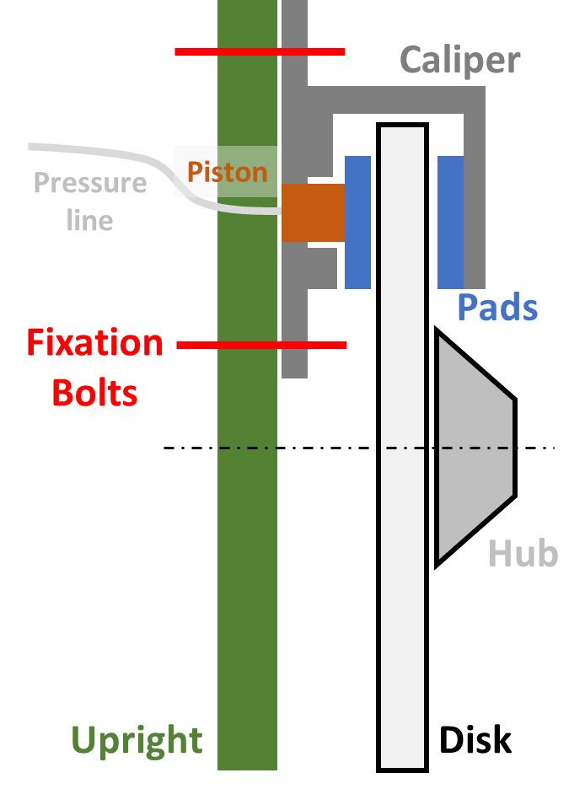
Figure 1. Scheme of the braking system and the fixation bolts of the caliper
The studied vehicles, Tesla Model 3 and Volkswagen ID3, recognized as market reference in their respective segment, are considered representative examples of the existing EV’s passenger cars, displaying different powertrain and braking layouts and represent an interesting case-study.
The strain-gauged bolts can be seen as an alternative to other load estimation techniques present in literature. When considering direct load measurement, some commercial solutions are available in the market [16] where direct measurements are obtained, for example, through the application of load-cells. However, these sensors are usually bulkier and more expensive than expected for industrial applications in the automotive industry, being implemented mainly for research and development purposes.
Several works propose leaner systems for load estimation in different areas of vehicles, such as aerodynamic loads [17], suspension loads [18] or engine torque [19]. Certainly, one of the most useful and hardest measurements to obtain is the wheel loads. Strategies to estimate the contact forces range from hall sensors and pressure sensors applied to the tires [20,21] to sensorizing hub bearings [22,23]. More specifically regarding braking forces, measurement proposals are present in the literature for a long time [24]. Nonetheless, the presence of such sensors in mass market vehicles (where they could have a real impact for safety and reliability) is yet to be seen.
The choice of applying the strain-gauges inside the fixation bolts is granting a flexible methodological approach, because of geometry and load distribution affected by lower spread when compared to the various shapes and outlines adopted by the brake components themselves, in fact the validation of the working principle in bolts permit a faster diffusion and higher standardization for future applications. The detailed definition of the system and its application method, as well as the calibration methodology and experimental tests validation represent the main contributions of this paper, as a first step towards reliable and flexible load sensors.
Strain Gauges
Sensor technology and application
Strain gauges are bonded electrical resistances (wires, foil or semiconductor) that permit to assess the following requirements for strain measurement on a structure [25]:
- Ability to measure strains precisely under static and dynamic conditions.
- Small size and weight to ensure precise mounting and negligible inertia effects in dynamic conditions.
- Possibility of remote observation and recording.
- Independence of temperature influence with proper circuit configuration.
- Easy installation and high reliability.
- Stability of calibration in the operating conditions.
- Linear response to strain.
- Low cost of sensors and data acquisition hardware.
- Possibility to measure different mechanical strain (tension, compression, bending, torsional) as a function of the arrangement of circuit.
The strain sensitivity of metallic wires and foils is related to the change of the electrical resistance of the conductor when a stress is applied on the structure (Figure 2).
The strain sensitivity factor is dimensionless, and it is defined as:
$S=\frac{∆R/R}{∆L/L}=\frac{∆R/R}{ε}$ (Eq.1)
Where:
- S is the strain sensitivity factor of the conductor
- R, ΔR are the resistance and resistance change
- L, ΔL are the length and length change
- ε is the strain along the conductor
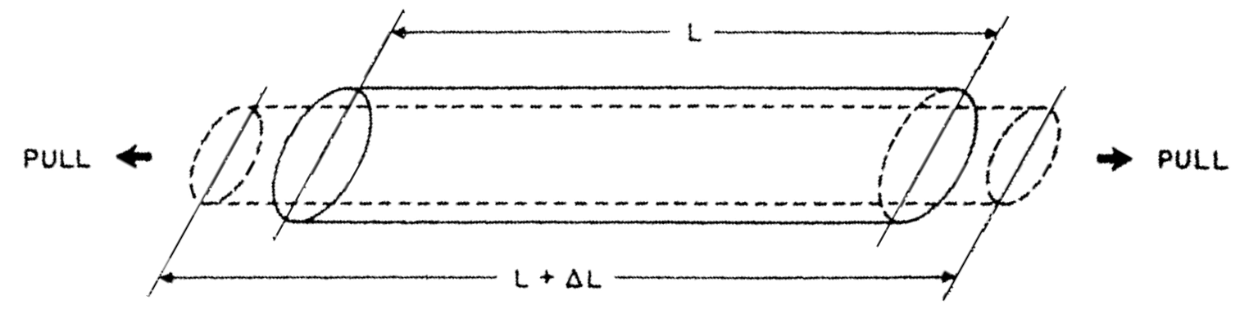
Figure 2. Basic principle of strain gauges: tensile effect on electrical conductor. Unstressed in solid line and stressed in dotted line [25].
There is a huge quantity of commercially available strain gauges, in function of the desired application (Figure 3). The variables to keep into account for the selection of the proper strain gauge are: application space on structure, temperature limits, electrical resistance, bridge factor or circuit configuration, gage factor, soldering or connection mode. Other parameters that follow the selection of the strain gauge type are: pre-treatment of the surface, adhesive type and curing process, soldering or connection process, protection of strain gauge.
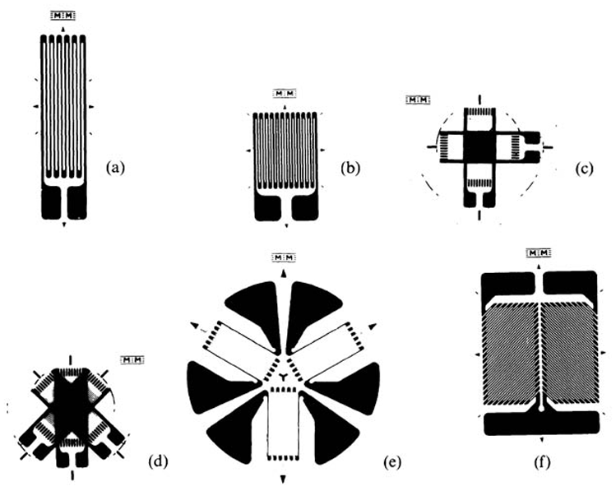
Figure 3. Examples of strain gauge shapes for various applications [25].
The strain can be evaluated from the resistance change thanks to the wheatstone circuit, measuring a variation of voltage. The configuration of circuit can be chosen in dependence of the mechanical strain to measure: quarter bridge, half bridge or full bridge. In this paper the quarter bridge configuration has been used (Figure 4), using specifically one strain gauge as active sensor and one strain gauge as dummy or inactive sensor for temperature compensation.
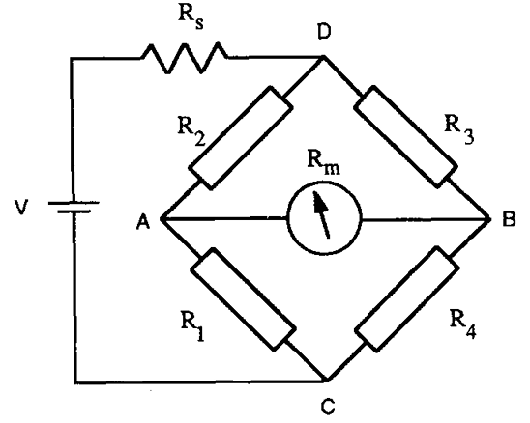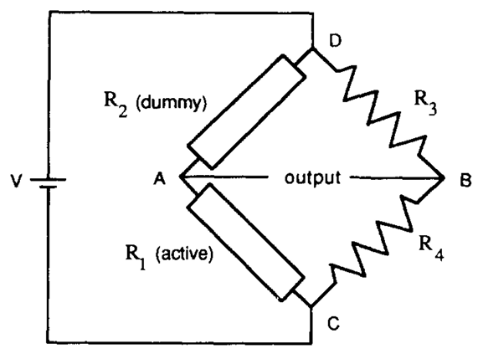
Figure 4. Wheatstone bridge generalized (left) and temperature-compensated circuit using a dummy strain gauge (right) [25].
The strain gauges are widely used on structures for strain monitoring. In the civil structures they are bonded directly or englobed in blocks with glass fiber rods [26], on carbon fiber composite prototypes the strain is measured in order to prevent the structure collapse since there is not a large plasticity region as for the metals [27] and for numerical-experimental correlation purposes [28]; wireless systems are continuously under development to communicate the strain measures from non-accessible structures with the higher reliability and lower power consumption [29]; the electrical property of the carbon fiber in the CFRP can be used for strain evaluation [30,31]; there are some initial trials of layered sensors application in the automotive sector combined with MEMS accelerometers, but for now they remains yet a research aim [32].
Application to the bolt
In the case of strain gauged bolts, studied in this paper, there is a wide use in the traditional civil structures for damage evaluation and corrosion monitoring of the bolts [33]. The experimental calibration procedure and numerical correlation with FEA are fundamental in order to validate the sensorized bolts from the mechanical design point of view [34]. The schematic principle of strain gauged bolts is reported in Figure 5, it consists in the bonding of a single linear strain gauge in the drilled hole of a screw.
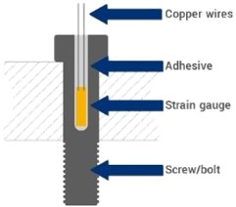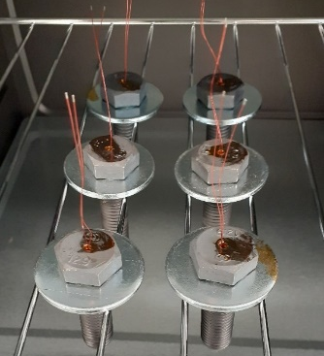
Figure 5. Schematic section of the strain gauged bolt (left) [35] and bolts after the curing in oven (right).
In the presented research, four M12 hexagonal head screws to replace the front and rear caliper screws of Tesla Model 3 and two M14 cylindrical head screws to replace the front caliper screws of Volkswagen ID3 were prepared. All the replacing screws are chosen of class 12.9, higher than the series ones for safety reasons. They have been drilled with a central axial hole diameter 2 mm and depth 15 mm excluding the screw head thickness. The strain gauge is inserted at room temperature, then the liquid adhesive is injected with a syringe and the curing is carried on in oven at 190°C for 1 hour.
Laboratory calibration
The experimental methodology to calibrate the strain gauged bolts have been assessed in the BALF (BeonD Advanced Laboratory Facility) of Beond s.r.l. It consists in the evaluation of strain measurements as a function of the force application through an electromechanical dynamometer equipped with a 300 kN. The same hardware (NI cRIO) used on vehicle has been set for the strain logging and acquisition. The experimental setup and the six screws tested are shown in Figure 6.
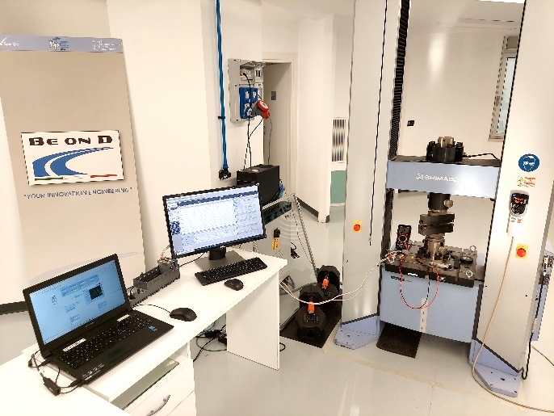
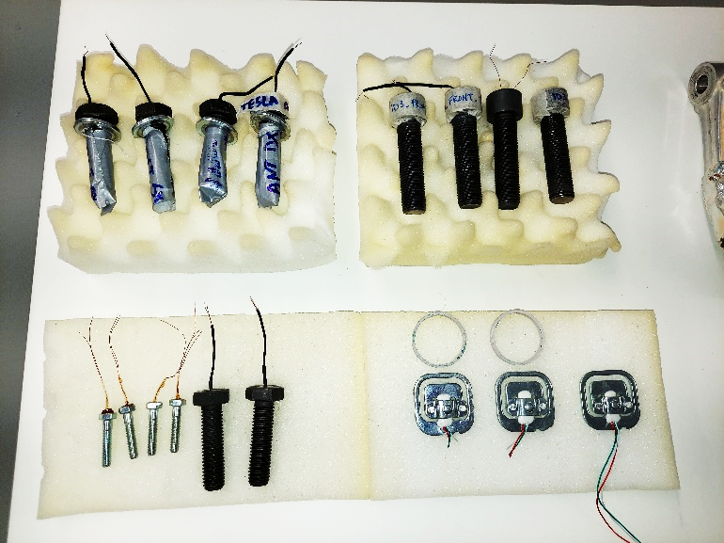
Figure 6. Bolts for the test campaign (left) and experimental setup for calibration of strain gauged bolts (right)
Each screw has been tested with a procedure of 3 load cycles in the range 0/+20kN (tension) and 0/-20kN (compression) with the customized jigs reported in Figure 7.
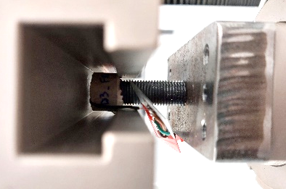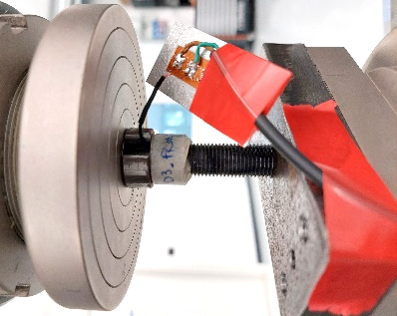
Figure 7. Configuration for bolts calibration: tensile (left) and compression (right).
Load vs. strain curves are useful to convert the strain measured on vehicle tests into a load value. An example of calibration result is reported in Figure 8, with the calculated equation of linear regression lines for the tensile and compression configurations. Repeatability for all the screws has been evaluated and max deviation of slope load vs. strain was found under 5%.
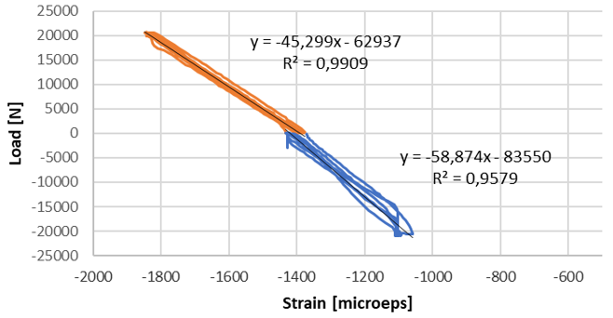
Figure 8. Example of calibration results and linear regression of a strain gauged bolt after 3 cycles of tension (orange) and 3 cycles of compression (blue).
Installation to vehicle
The replacement of strain gauged bolts on the calipers of the vehicles has been assessed on a two-post car lift using a proper torque wrench. For the M12 hexagonal head screws used on Tesla Model 3 the strain gauge wires have been protected with a specific putty to avoid cut from the edge of the drilled hole. For the M14 cylindrical head screws used on Volkswagen ID3, the wires have been rolled up into the shaped screw head before the closing (Figure 9). In any case, a heat shrink tubing has been used to protect the soldering zones from heat and the thin wires from possible damages during vehicle tests. The final installation of strain gauged on the Tesla Model 3 and Volkswagen ID3 is reported respectively in Figure 10 and Figure 11.
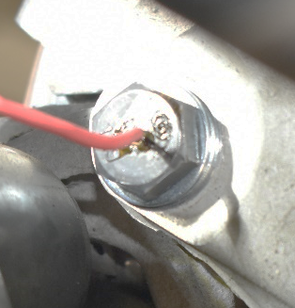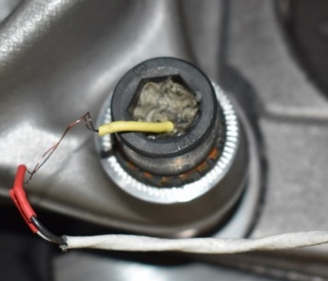
Figure 9. Detail of strain gauged bolts mounted on Tesla Model 3 (left) and Volkswagen ID3 (right).
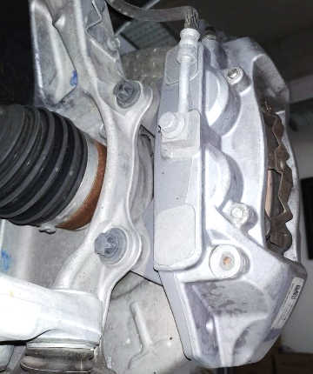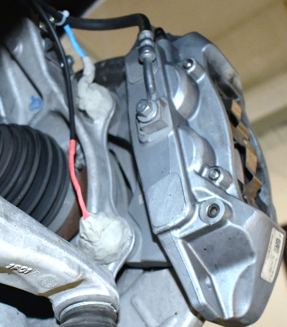
Figure 10. Detail of strain gauged bolts mounted on Tesla Model 3.
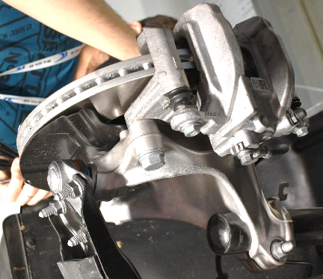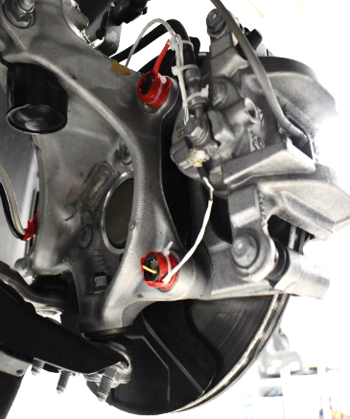
Figure 11. Detail of strain gauged bolts mounted on Volkswagen ID3.
Testing Plan
This paragraph describes the methodology and objectives of the track test campaign, with particular attention to vehicles, measurement chain, track and maneuvers and the variable condition will be explored.
The experiments were designed with the purpose of creating a repeatable and robust results set, altering singularly each one of the test variables to highlight their impacts and replicating measures to avoid systematic errors.
Vehicles
The first important step to describe the experimental setup is to explore the features of the selected vehicles (Figure 12) namely:
- Tesla Model 3 Dual Motor 2021
- Volkswagen ID3 PRO 150 kW

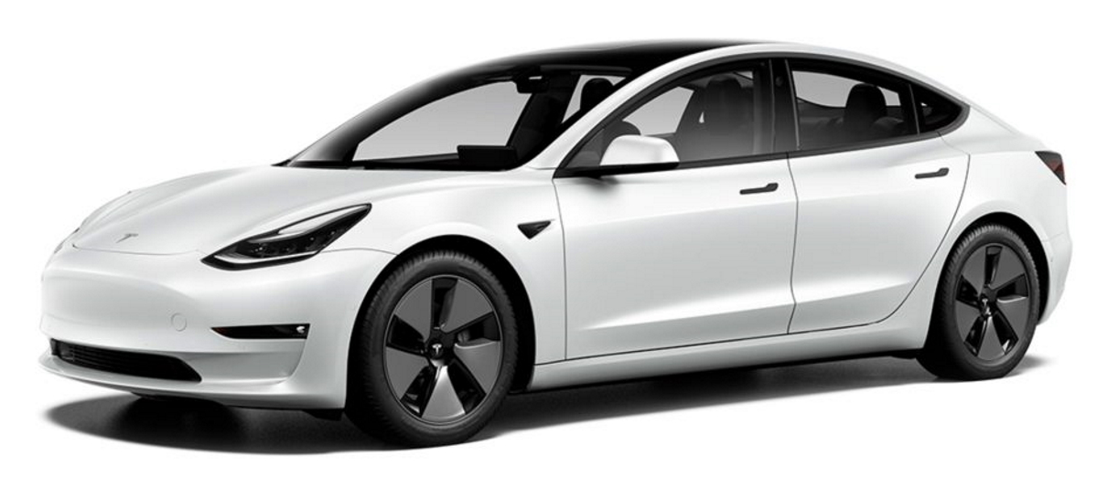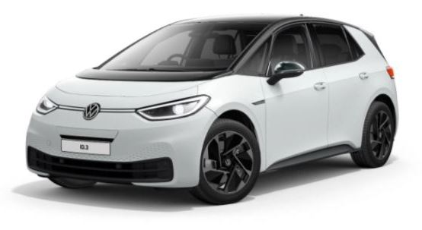
Figure 12. Vehicles used in the test campaign: Tesla Model 3 (left) and Volkswagen ID3 (right)
The vehicles are from normal production version, with no modifications to their construction other than the ones required to the installation of the described experimental setup. Table 1 describes the main datasheet features of the vehicles.
It is important to highlight the difference between the braking layouts: the proposed methodology is applied to the caliper fixation bolts with Model 3 equipped with two sets of strain-gauges mounted on (front right and rear left) while the ID3 has been equipped with just one set in the front right corner since it presents drums in the rear axle.
Table 1. Vehicles' main parameters
Feature | Tesla Model 3 | Volkswagen ID3
Declared curb mass | 1847 kg | 1812 kg
Battery energy | 82 kWh | 58 kWh
Battery typology | NCR 21700A | LGX E78
Powertrain layout | AWD | RWD
Motor typology | IPM synchronous (rear) Induction motor (front) | PM brushless motor
Front suspension | High double wishbone | MacPherson
Rear suspension | Multilink | Multilink
Brake front | Ventilated disks | Disk and caliper
Brake rear | Ventilated disks | Drums
Wheels | 235/40R19 | 215/55R18
Wheelbase | 2875 mm | 2770 mm
Track (front:rear) | 1580:1580 mm | 1536:1513 mm
Apart from the datasheet characteristic presented, during the execution of the experimental campaign the actual conditions of the vehicles were assessed in the test configuration, to have an accurate status of the vehicles’ setup. Table 2 shows the values mesured.
Table 2. Vehicle conditions in the final experimental setup
Feature | Tesla Model 3 | Volkswagen ID3
Total mass* | 2070.0 kg | 1991.5 kg
Mass distribution (front:rear) | 49.4:50.6% | 49.3:50.7%
Tire pressure FL | 2.82 bar | 2.52 bar
Tire pressure FR | 2.90 bar | 2.51 bar
Tire pressure RL | 2.89 bar | 2.52 bar
Tire pressure RR | 2.90 bar | 2.52 bar
*Including datalogging, sensors and the presence of driver and passenger
Sensors and datalogging
Other than the strain-gauges applied to the calipers’ fixation bolts, some other sensors were implemented in the tested vehicles to allow deeper understanding of its operation.
The first sensor applied to the experimental setup is the Kistler S-Motion. It combines a complete inertial platform (with 3-axis accelerometers and gyroscopes) with a lamp module that can obtain a direct measure of the longitudinal and lateral velocities by processing a sequence of road images using the correvit principle [36,37]. To do so, the lamp module must be positioned at a 350±50 mm height facing the road, condition achieved in this case by a suction fixture in the rear door of the vehicles (Figure 13). The alignment procedure suggested by the manufacturer is performed once the sensor is fixed, to avoid systematic errors in the heading direction of the sensor. This sensor provides important measures such as longitudinal and lateral acceleration, yaw rate, pitch angle and vehicle’s slip angle, providing important data regarding the dynamic conditions of the cars during the maneuvers.
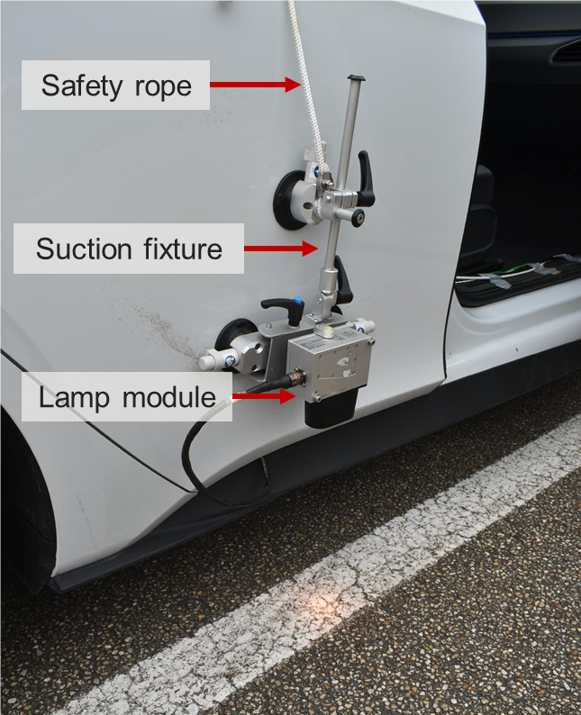
Figure 13. Kistler S-Motion sensor installed with a suction fixture to the right rear door of the vehicle
A pressure sensor to monitor the brake fluid pressure in the vicinities of the wheels has been inserted. The goal is to obtain an instantaneous pressure condition of the single vehicle corner, so that this measure can be better correlated to the signals coming from the strain-gauges.
It is known that the brake subsystem – even with all the engineering efforts to reduce it – present a delay between the pedal force application and the actual transmission of the pressure signal through the braking line, therefore it is essential to install the sensor close to the wheels. The chosen setup, presented in Figure 14, is composed of a T-valve (installed just after the rigid section of the brake line) that will divide the pressure signal in two directions, one going normally to the brake pistons and the other connected to the pressure sensor. Since the length of the flexible section of the brake line is increased to allow the proper setup of the T-valve and the bleed valve of the line, it was decided to substitute the original elastomeric tubes with braided steel tubes to avoid excessive deformation of the line.
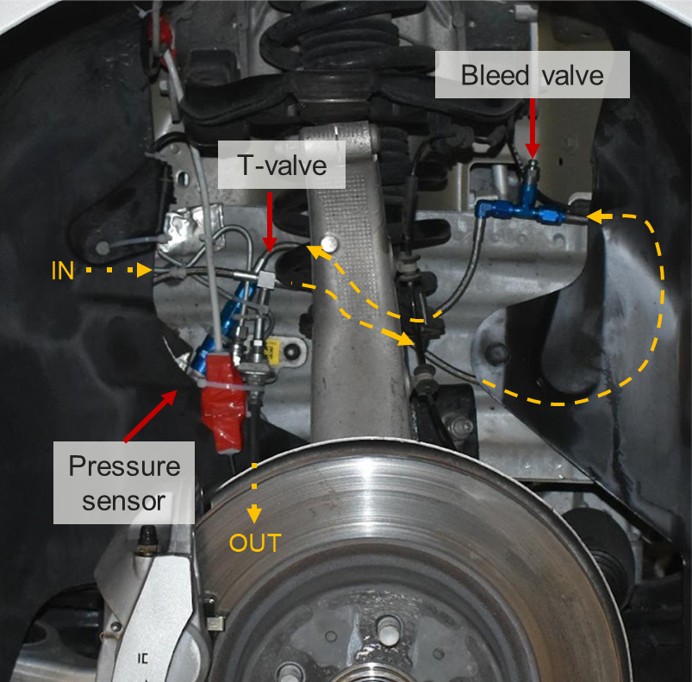
Figure 14. Pressure sensor installed in the right front brake of Tesla Model 3
Another sensor was added to the line, namely a load sensor placed in the pedal, ad depicted in Figure 15. With the presence of this sensor correlated to the pressure behavior of the brake line it is possible to analyze the delays and effects caused by the valves and control systems influencing the brake system. This sensor was only used during the tests with the Tesla Model 3.
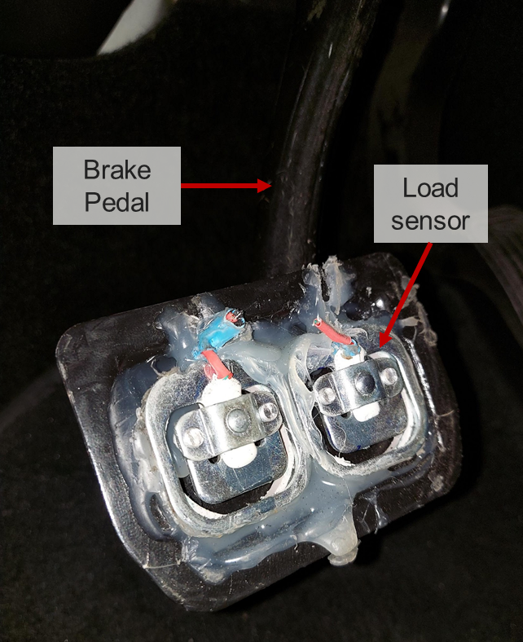
Figure 15. Load sensors applied to the Tesla Model 3 brake pedal
To complete the analysis of the longitudinal behavior of the vehicles, it is necessary to observe the action of the other subsystem that can influence the braking response of an EV: the powertrain. The presence of regenerative braking can significantly modify the longitudinal behavior of the vehicle and dealing with full-electric cars in which the power available is quite elevated this impact can be even more decisive.
One way to measure the effect of the electric motor could be the application of torque sensors, to directly read the mechanical output of the powertrain. However, this kind of sensor has elevated costs, and a non-straightforward management is required to install and operate them, in such a way that the authors opted for an estimation method using the current passing through the motors. By installing current sensors to the battery output cable (Figure 16), knowing the nominal voltage of the battery, it is possible to retrieve the power flow in and out the energy storage system – and therefore also the mechanical torque apart from the system intermediate efficiencies.
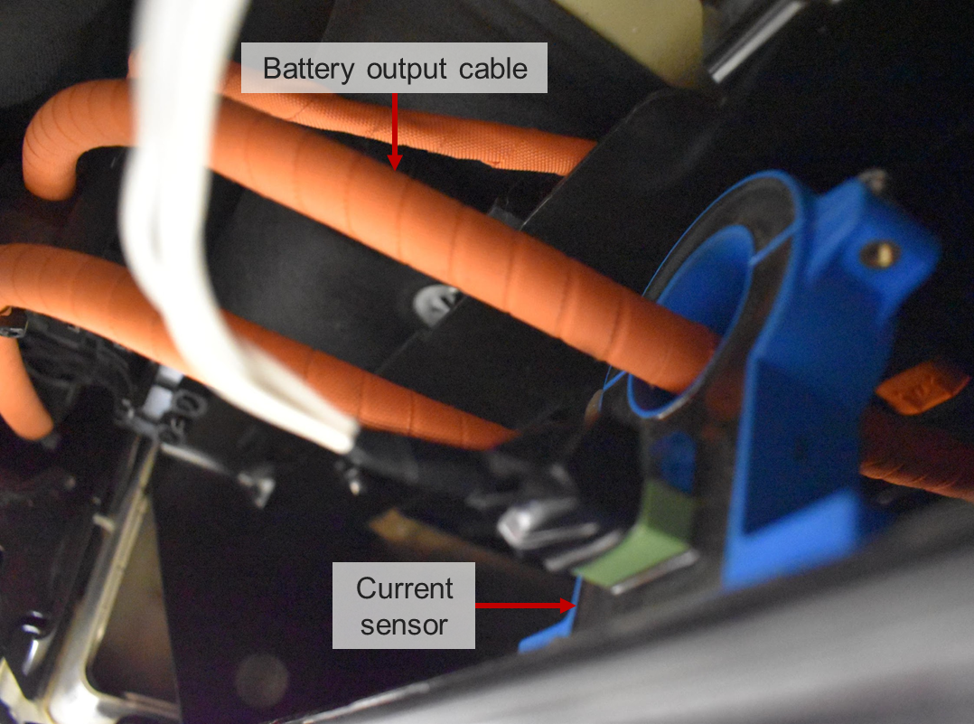
Figure 16. Current sensor installed in the battery output cable of the Tesla Model 3
The experimental setup count on the connection of the datalogging with the CAN Bus of the vehicles. Through this connection, it was possible to obtain directly from the vehicle’s internal sensors some key-measurements, such as position of the throttle pedal, steering angle, ABS status and many others. These values were not at the core of the studied behavior but help obtaining a more complete picture of the vehicle status.
Figure 17 shows the data acquisition modules and power supply used in the experimental tests.
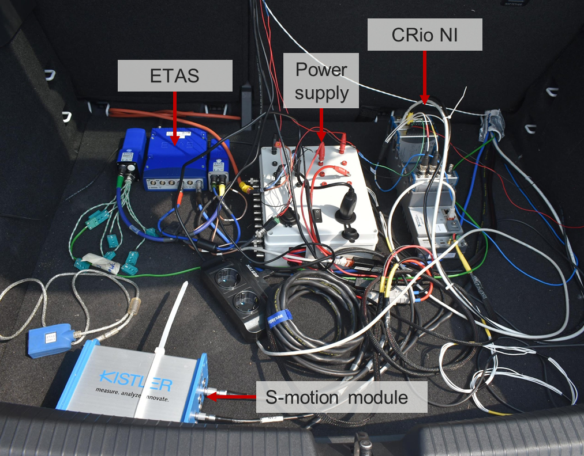
Figure 17. Data acquisition modules connected to the vehicle during the tests
The main data acquisition modules used are ETAS and Compact Rio (cRIO) that encompasses several acquisition modules for different applications. Figure 18 shows a scheme of the sensors and their connection to the acquisition modules. Both vehicles used the same topology, apart from the pedal load sensor, installed only in the Tesla Model 3.
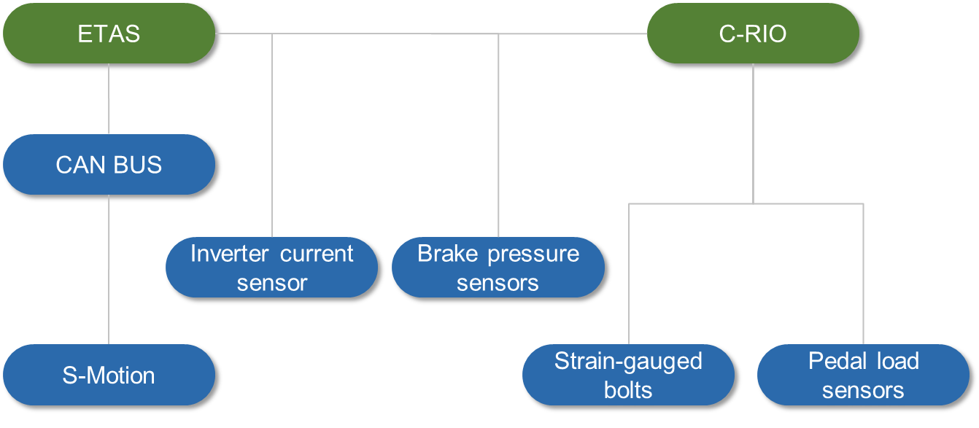
Figure 18. Scheme of the sensors and their connection to the acquisition modules
Finally, to complete the experimental setup, an overall view of the sensors and their position in the vehicles, with the datalogging devices, is provided in Figure 19. The position and quantity of all sensors in the Tesla Model 3 (top) and Volkswagen ID3 (bottom) is provided.
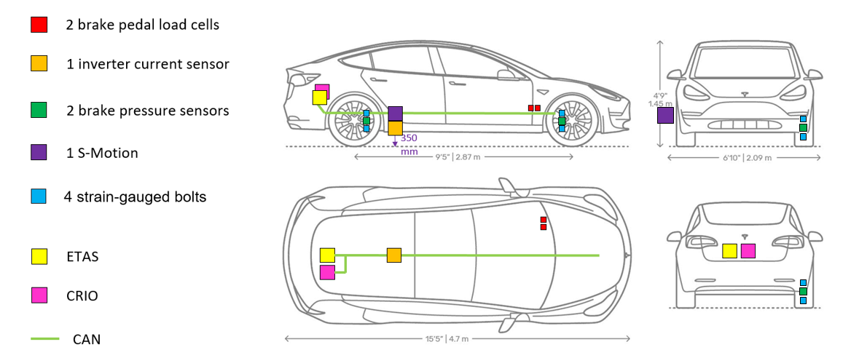
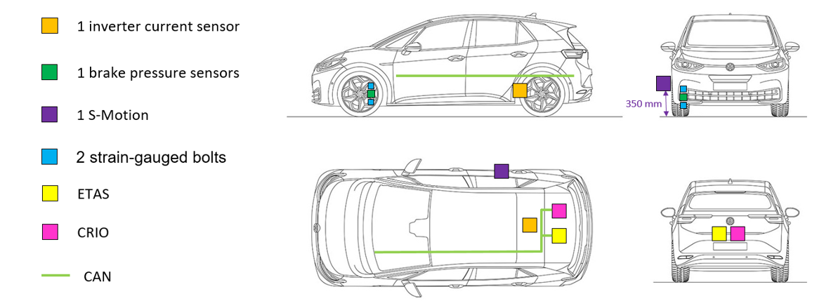
Figure 19. Sensors positioning in the Tesla Model 3 (top) and Volkswagen ID3 (bottom)
Track and environment
The facilities selected for the test were the MotorOasi test track (Figure 20) in the region of Susa (Turin – Italy).
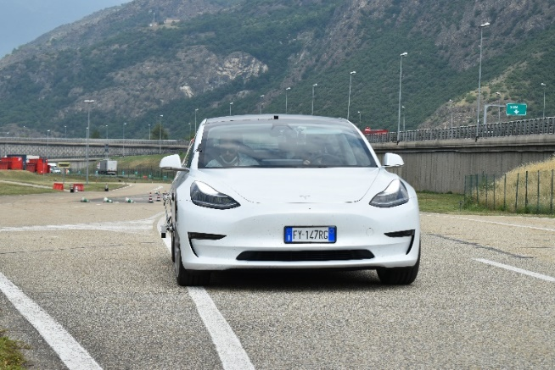
Figure 20. Tesla Model 3 in the test track
The track is usually used for vehicle testing and for safety driving lessons and counts with a series of specific driving conditions including handling circuit (A), constant radius curves (B), straight line tracks (C-D) and the possibility to experiment with variable friction conditions (E) as shown in Figure 21.
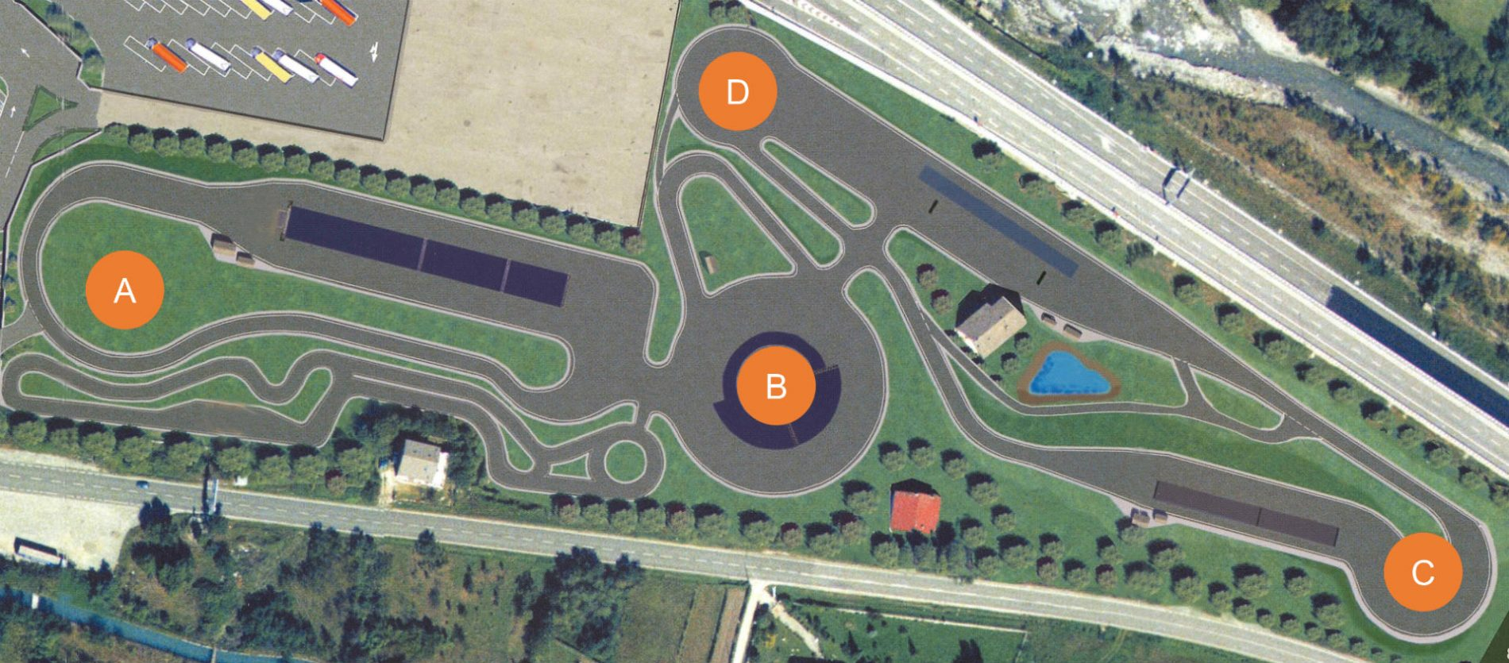
E
E
Figure 21. Top view of the MotorOasi test facilities in Susa – Italy
To the specific tests reported in this paper, the straight-line section of the track was used (Figure 22) with a total dimension of 300 m from the exit of the curve (C) and the beginning of the roundabout section (D). 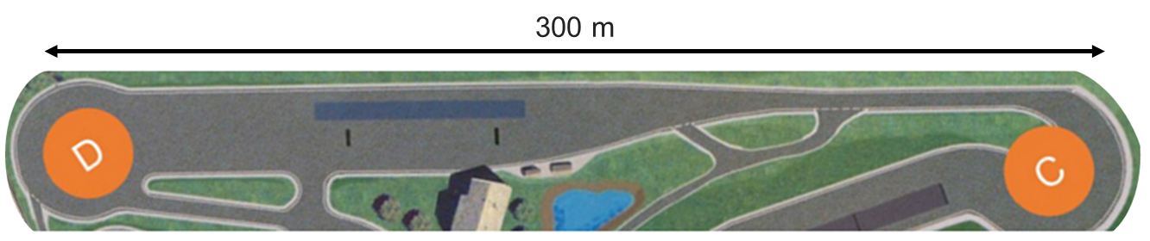
Figure 22. Straight-line section of the track, used during the tests
To prevent any sort of systematic error, the maneuvers described in the paper were executed in both directions and the result compared to guarantee robustness to the conclusions. No significant changes were observed when performing the comparison.
The weather conditions were closely monitored during the days of experiment. Each vehicle has been tested during an entire day for all the maneuvers, conditions and data analysis discussed in the paper. The Volkswagen ID3 was tested first in the henceforth called Day 1 and the Tesla Model 3 has been tested in Day 2.
Table 3 reports the humidity, temperature and wind speed and direction for the morning and afternoon of Days 1 and 2.
Table 3. Weather conditions during the test days
 | Day 1 |  | Day 2
 | Morning | Afternoon | Morning | Afternoon
Temperature | 24°C | 26°C | 26°C | 27°C
Air humidity | 76% | 63% | 65% | 50%
Wind speed | 6 km/h | 10 km/h | 6 km/h | 11 km/h
Wind direction | West | West | West | Southwest

It is possible to notice that the weather conditions are quite constant during the day and no significant differences were observed during the two days, thus it is possible to assume that for the executed tests the environmental conditions shall play a negligible role.
Tested conditions and maneuvers
The experimental test was designed to fully explore the response of the vehicles during the brake maneuvers and determine the main factors influencing the longitudinal dynamics and its correlation to the strain-gauge output signal.
Three different longitudinal maneuvers were performed:
- Low-pressure braking: from a stable velocity of 60 km/h the driver releases the throttle and apply a low pressure to the brake pedal aiming for a deceleration of 0.4 g. The trajectory is kept straight until vehicle stop.
- Mid-pressure braking: from a stable velocity of 60 km/h the driver releases the throttle and apply a medium pressure to the brake pedal aiming for a deceleration of 0.6 g. The trajectory is kept straight until vehicle stop.
- Limit braking: from a stable velocity of 120 km/h the driver releases the throttle and apply a high pressure to the brake pedal aiming for the maximum deceleration. The trajectory is kept straight until vehicle stop.
Combined with the different maneuvers, two parameters were controlled during the tests:
Disk friction: before the beginning of the maneuvers indicated as “low friction” a spray of Vaseline was applied to the external face of the braking disk of each wheel. This way the friction coefficient between disk and braking pads is expected to be reduced.
ABS Intervention: during the tests of limit braking the vehicle ABS system tends to activate, thus two different approaches were tested:
- ABS action: where the pilot continues to maintain pedal pressure even with the activation of the system.
- ABS avoidance: where the pilot modulates the applied pedal pressure to prevent ABS intervention.
The tests were organized to cover all permutations between the variable parameters, and to execute the maneuvers in every combined condition. Each test was repeated in the opposite direction of the track, as previously noted.
This experimental design generates a quite extensive and rich dataset to study and draw conclusions regarding the braking behavior and its correlation with the strain-gauges.
Data Analysis and Results
After the data acquisition, one key step of the research regards the post-processing and analysis of the signals acquired. The processing, done in the MATLAB environment, followed the steps:
- Validation – check the individual signals to verify the coherence and its order of magnitude respect to the physical value expected.
- Data cleanse – to eliminate missing data points, zero values and other eventual outliers or faulty signals.
- Integration - combine data coming from the different acquisition systems, guaranteeing the synchronization of the signals.
- Determination of the periods of interest – the acquisition starts before the actual start of the maneuver, so it was decided to fix the time reference as zero for the start of the braking action.
- Filtering – for particularly noisy signals, as the accelerometers for example, a low pass filter is applied to smooth the curve and help the data analysis and comparison.
Once the treated datasets are prepared, each maneuver is analyzed in a series of plots containing all the relevant variables (accelerations, velocities, brake pressures, battery current, throttle action, brake pedal load, strain-gauge deformations, steering angle).
Figure 23 shows an example of a low-pressure braking maneuver executed with the Tesla Model 3 with dry disks. It is possible to see a typical order of events, where the driver reaches the target initial velocity (60 km/h) and once stabilized the throttle is released and the brake action starts after a delay due to the pedal change. Brake pedal signal is a binary value represented as value 50 to allow reading, while the acceleration pedal is a percentage of the Wide-Open Throttle (WOT) condition.
Figure 23. Longitudinal acceleration, speed and pedal position of Tesla Model 3 in a low-pressure braking with dry disks
It is possible to notice a precise tracking of the target deceleration of 0.4 g during the most part of the braking event, and a good correlation between the pedal load and the pressure in the line. The first 0.5 s of the maneuver displays the behavior of the vehicle under regenerative braking action only, and a significant 0.2 g total deceleration is obtained in this condition, confirm the initial expectations that the powertrain can have a relevant role in the braking events.
During the same maneuver, it is possible to observe in Figure 24 the trends in terms of brake line pressure and the signals read in the front axle strain-gauges. The pressure signal follows the trend of pedal load and deceleration seen in the previous plot.
Figure 24. Brake pressure and strain-gauge deformations of Tesla Model 3 in a low-pressure braking with dry disks
The deformation sensed by the strain-gauges instead do not present a clear trend in correlation to the braking action. As a matter of fact, the net variation of the deformations before and after the beginning of the pressure signal cannot be distinguished from its noise. The main hypothesis to explain this behavior is that with low braking torque the internal friction of the parts is enough to counterpose the load created during the maneuver, in such a way that the bolts do not experience significant stress.
The outcomes are quite similar between maneuvers of low and mid-pressure, but the situation changes drastically when considering the limit braking. As Figure 25 depicts, for a limit braking executed by Tesla Model 3 with dry disks and ABS action the trend of the strain-gauges is much clearer.
Figure 25. Brake pressure and strain-gauge deformations of Tesla Model 3 in a limit braking maneuver with dry disks
While the baseline noise of the signal remains around 5 µm/m amplitude the net variation in the beginning of the braking action arrives at almost 20 µm/m with a very well delineated outline. The delay between the pressure rises and the response of the strain-gauges is almost negligible, showing that the technology could be used in applications requiring a quick reply. It is also interesting to observe that after the first peak, the trend of the strain curves follows the intensity of the pressure, as it decreases in the interval between 3,5 and 5 s the strain-gauges follow the variation and reduce their gap. By the end of the maneuver with the full stop of the vehicle, the brake pedal remains pressed, and the line pressure is maintained, as well as part of the bolts’ deformation.
Figure 26 shows the results of the two brake maneuvers tests, both with the Tesla Model 3 in a mid-pressure brake condition: the “Test 30” with the wet disks and the “Test 42” with dry disks. It is very interesting to observe that both tests achieve a similar level of deceleration matching the 0.6 g target, however they do so by creating significantly different levels of pressure in the brake line – while test 30 maintains the pressure at more than 40 bar for a good part of the maneuver, test 42 peaks at 40 bar for a moment and then plummets to levels lower than 30 bar right after.
The regenerative braking action, represented by the battery current at the rear motors, plays a very similar role in both tests, while the load pressure applied to the brake pedal follows a similar trend, with slightly higher load applied in test 30 between 2,5 and 4 s of the maneuver time. Proportionally the pedal load is not as higher as the line pressure observed, suggesting that the effect is created by the active systems of the vehicle.
Figure 26. Comparison between dry and wet disks on Tesla Model 3 during a mid-pressure maneuver
When looking at the tests executed with the Volkswagen ID3, the conclusions are aligned. As in Figure 27, the strain-gauge deformation follows the pressure rises with a clear trend during the limit braking with dry disks and ABS action.
Figure 27. Brake pressure and strain-gauge deformations of Volkswagen ID3 in a limit braking maneuver with dry disks
In the tests performed with both vehicles in the ABS avoidance condition the results were similar, the strain-gauge deformation responded quickly to the first pressure peak and followed the general pressure trend.
Finally, in Figure 28 it is possible to observe the results of a mid-pressure maneuver with the ID3, in which the strain-gauges maintain their general behavior and do not respond to the low stress level caused, creating no variation distinguishable from the overall signal noise.
Figure 28. Brake pressure and strain-gauge deformations of Volkswagen ID3 in a low-pressure braking with dry disks
Conclusion
The braking system of vehicles is evolving with new technologies, especially electrification, and this fact correlated to the continuous increase of sensors in the automotive field opens up a vast range of opportunities. One critical aspect to be developed by the industry is related to monitoring of key-elements in safety systems.
This paper explores the possibility to use strain-gauged bolts in the Automotive sector. In the case of sensorizing the brake caliper, a safety monitoring system could be assessed to measure over the time the values of axial force verifying the preload and the possible bolt loosening. This new approach must be validated to understand the real utilization on the vehicles, because it could also bring to: system complexity increase, cost of sensors, data logging and post-processing, weakening of modified bolts, system fragility in operative condition.
Counting on a series of sensors – such as an inertial platform, battery current sensor, brake line pressure sensor and pedal load cell – and a complete experiment analyzing three brake maneuvers (low and mid-pressure brake and limit braking) within two variable parameters (dry/wet disks, ABS action) a full picture of the vehicles’ behavior is drawn.
As shown in the most representative plots reported in the Results section, the strain-gauge technology proves to be suitable to the automotive application displaying a robust and clear response to limit braking maneuvers with low delay. However, the presence of the strain-gauges in the bolts has displayed a limited dynamic in response to low and mid pressure events, underlying the tradeoff between load sensing sensitivity and overall bolt stiffness to optimize signal to noise ratio.
Disk friction condition made an important effect when considering the pressure line level, forcing the brake system to exert higher pressures to obtain the same deceleration profile. However, this condition change has not altered the conclusions when it comes to the strain-gauge outcomes.
The ABS action had limited influence on the response of the strain-gauges, that continued to follow the same overall trends during the limit braking maneuvers independently from the modulation strategy chosen (ABS action or driver’s modulation to achieve ABS avoidance).
In summary, the application of strain-gauges to bolts on automotive safety components is a promising technology and this paper hopefully will help to demonstrate a practical application to fixation bolts on brake calipers and pave the way to new studies and industrial development.
Future developments of the research can include:
- analysis of other safety components and positions for the fixation elements;
- investigate the influence of new parameters (such as temperature or vibration levels);
- evaluate new system layouts to estimate the effective braking torque;
- improve the sensibility of the method to low and mid-pressure braking conditions.

References
1. Carvalho Pinheiro, H. de, Messana, A., Sisca, L., Ferraris, A., Airale, A.G., and Carello, M., “Computational Analysis of Body Stiffness Influence on the Dynamics of Light Commercial Vehicles,” in: Uhl, T., ed., Advances in Mechanism and Machine Science, Springer International Publishing, ISBN 978-3-030-20131-9: 3117–3126, 2019, doi:10.1007/978-3-030-20131-9_307.
2. Carello, M., Carvalho Pinheiro, H. de, Messana, A., Freedman, A., Ferraris, A., and Airale, A.G., “Composite Control Arm Design: A Comprehensive Workflow,” SAE Int. J. Adv. & Curr. Prac. in Mobility 3(5):2355–2369, 2021, doi:10.4271/2021-01-0364.
3. Carello, M., Carvalho Pinheiro, H. de, Longega, L., and Di Napoli, L., “Design and Modelling of the Powertrain of a Hybrid Fuel Cell Electric Vehicle,” SAE Int. J. Adv. & Curr. Prac. in Mobility 3(6):2878–2892, 2021, doi:10.4271/2021-01-0734.
4. Ferraris, A., Messana, A., Airale, A.G., Sisca, L., Carvalho Pinheiro, H. de, Zevola, F., and Carello, M., “Nafion® Tubing Humidification System for Polymer Electrolyte Membrane Fuel Cells,” Energies 12(9):1773, 2019, doi:10.3390/en12091773.
5. Armstrong, K., Das, S. and Cresko, J., “The energy footprint of automotive electronic sensors,” Sustainable Materials and Technologies, Volume 25, 2020, ISSN 2214-9937, doi:10.1016/j.susmat.2020.e00195
6. de Carvalho Pinheiro, H. et al., “Autonomous Driving Scenario Generation in Overtake Manoeuvres Through Data Fusion,” in Advances in Italian Mechanism Science, 2021, pp. 786–794. doi: 10.1007/978-3-030-55807-9_87.
7. Carello, M., Ferraris, A., Bucciarelli, L., Data, S. and Gabiati, G., “Customer Oriented Vehicle Dynamics Assessment for Autonomous Driving in Highway,” SAE Technical Paper 2019-01-1020, 2019. doi: 10.4271/2019-01-1020.
8. Carello, M. et al., “Human-Driving Highway Overtake and Its Perceived Comfort: Correlational Study Using Data Fusion”, in WCX SAE World Congress Experience, SAE Technical Paper 2020-01-1036, 2020. doi: 10.4271/2020-01-1036.
9. Kim, J. G., et al. "Study on an Autonomous Driving Based on a Curb Extraction Algorithm of a LiDAR Sensor and Mapping of DGPS." Journal of Institute of Control, Robotics and Systems, vol. 25, no. 2, 2019, pp. 132-139. doi:10.5302/J.ICROS.2019.18.0137.
10. Carello, M. et al., “Experimental Characterization of Piezoelectric Transducers for Automotive Composite Structural Health Monitoring,” SAE Int. J. Adv. & Curr. Prac. in Mobility, vol. 2, n. 5, Art. n. 2020-01–0609, 2020, doi: 10.4271/2020-01-0609.
11. de Carvalho Pinheiro, H. et al., “Dynamic Performance Comparison Between In-Wheel and On-Board Motor Battery Electric Vehicles,” presented at ASME 2020 International Design Engineering Technical Conferences and Computers and Information in Engineering Conference, nov. 2020. doi: 10.1115/DETC2020-22306.
12. A. Ferraris, H. de Carvalho Pinheiro, E. Galanzino, A. G. Airale, e M. Carello, “All-Wheel Drive Electric Vehicle Performance Optimization: From Modelling to Subjective Evaluation on a Static Simulator,” EV 2019, Electric Vehicles International Conference, 2019. doi: 10.1109/EV.2019.8893027.
13. Carvalho Pinheiro, H. de, Punta, E., Carello, M., Ferraris, A., and Airale, A.G., “Torque Vectoring in Hybrid Vehicles with In-Wheel Electric Motors: Comparing SMC and PID control,” 2021 IEEE International Conference on Environment and Electrical Engineering (EEEIC / I CPS Europe), Bari, Italy, September 7-10, 2021. doi:10.1109/EEEIC/ICPSEurope51590.2021.9584732
14. Kanchwala, H., et al. "Obtaining Desired Vehicle Dynamics Characteristics with Independently Controlled in-Wheel Motors: State of Art Review." SAE International Journal of Passenger Cars - Mechanical Systems, vol. 10, no. 2, 2017. doi:10.4271/2017-01-9680.
15. A. Ferraris, S. Xu, M. Carello, A. Messana, and A. Airale, “The regenerative braking for a L7e Range Extender Hybrid Vehicle,” in 2018 IEEE International Conference on Environment and Electrical Engineering and 2018 IEEE Industrial and Commercial Power Systems Europe, Campus of the University of Palermo, Italy, mag. 2019, pag. 7. doi: 10.1109/EEEIC.2018.8494000.
16. K. Nishikawa, “Hub Bearing with Integrated Multi-axis Load Sensor,” NTN Technical Review, 79, pp. 58-63. 2011.
17. Gertz, L.C., Cervieri, A., Rodrigues, A.F.A., Da Silveira, M.A., Ferreto, C.J., and Pelzer, T.D.C., “Project and construction of a measuring system to determine the forces applied to automotive airfoils,” SAE Technical Papers 2011-36-0275, 2011, doi:10.4271/2011-36-0275.
18. Napolitano, F., Pederiva, R., and Brito, J.N., “Load cell project to be applied to suspension vehicles,” SAE Technical Papers 2000-01-3277, 2000, doi:10.4271/2000-01-3277.
19. Kraus, M. and Bäuml, M., “Continuous wheel force measurement for passenger vehicles and commercial vehicles,” in: Pfeffer, P., ed., 6th International Munich Chassis Symposium 2015, Springer Fachmedien, Wiesbaden, ISBN 978-3-658-09711-0: 717–717, 2015, doi:10.1007/978-3-658-09711-0_45.
20. Suzuki, M., Nakano, K., Miyoshi, A., Katagiri, A., and Kunii, M., “Method for Sensing Tire Force in Three Directional Components and Vehicle Control Using This Method,” SAE Technical Papers 2007-01–0830, 2007, doi:10.4271/2007-01-0830.
21. Belforte, C. Ferraresi, D. Maffiodo, V. Viktorov, C. Visconte, M. Carello, “Numerical and experimental development of a hub+bearing system for tire pressure control”, Mechanisms and Machine Science - Advances in Italian Mechanism Science, Springer Netherlands, 27th International Conference on Robotics in Alpe-Adria-Danube Region - RAAD, Patrasso 6-8 June 2018, pp. 9, Vol. 67, 2019,ISBN: 978-3-030-00231-2, DOI: 10.1007/978-3-030-00232-9_35.
22. Kerst, S., Shyrokau, B., and Holweg, E., “Reconstruction of Wheel Forces Using an Intelligent Bearing,” SAE Int. J. Passeng. Cars – Electron. Electr. Syst. 9(1):196–203, 2016, doi:10.4271/2016-01-0092.
23. Kerst, S., Shyrokau, B., and Holweg, E., “A Model-Based Approach for the Estimation of Bearing Forces and Moments Using Outer Ring Deformation,” IEEE Transactions on Industrial Electronics 67(1):461–470, 2020, doi:10.1109/TIE.2019.2897510.
24. Ohkubo, N., Horiuchi, T., Yamamoto, O., and Inagaki, H., “Brake Torque Sensing for Enhancement of Vehicle Dynamics Control Systems,” SAE Technical Papers 2007-01–0867, 2007, doi:10.4271/2007-01-0867.
25. Murray, William M, and William R Miller. “The Bonded Electrical Resistance Strain Gage,” Cary: Oxford UP, Incorporated, 1992. Web.
26. Yu, Jung-Doung, Jong-Sub Lee, Bibek Tamang, Sungyong Park, Sukhyun Chang, Jungmyeon Kim, and Yongseong Kim. "Performance Evaluation of GFRP Rock Bolt Sensor for Rock Slope Monitoring by Double Shear Test." Advances in Civil Engineering 2020 (2020): 1-14. Web.
27. Carello, M., Airale, A.G., Ferraris, A. et al. “Static Design and Finite Element Analysis of Innovative CFRP Transverse Leaf Spring.” Appl Compos Mater 24, 1493–1508, 2017. Doi: 10.1007/s10443-017-9596-6
28. N. Amirth Jayasree, A.G. Airale, A. Ferraris, A. Messana, L. Sisca, M. Carello, “Process analysis for structural optimisation of thermoplastic composite component using the building block approach,” Composites Part B: Engineering, Volume 126, 2017, Pages 119-132, ISSN 1359-8368, doi: 10.1016/j.compositesb.2017.06.007
29. Gasco, Federico, Paolo Feraboli, Jeff Braun, Joshua Smith, Patrick Stickler, and Luciano DeOto. "Wireless Strain Measurement for Structural Testing and Health Monitoring of Carbon Fiber Composites." Composites. Part A, Applied Science and Manufacturing 42.9 (2011): 1263-274. Web.
30. Wang, Daojun, and D.D.L Chung. "Through-thickness Piezoresistivity in a Carbon Fiber Polymer-matrix Structural Composite for Electrical-resistance-based Through-thickness Strain Sensing." Carbon (New York) 60 (2013): 129-38. Web.
31. Saifeldeen MA, Fouad N, Huang H, Wu Z. “Advancement of long-gauge carbon fiber line sensors for strain measurements in structures.” Journal of Intelligent Material Systems and Structures. 2017;28(7):878-887.
32. Klein, L. “Sensor Systems for FRP Lightweight Structures: Automotive Features Based on Serial Sensor Products.” Sensors 2019, 19, 3088.
33. Ahn, Jin-Hee, Jun Min You, Jungwon Huh, In-Tae Kim, and Young-Soo Jeong. "Residual Clamping Force of Bolt Connections Caused by Sectional Damage of Nuts." Journal of Constructional Steel Research 136 (2017): 204-14. Web.
34. Fric, Nenad, Marko Pavlovic, Dragan Budjevac, Zoran Miskovic, Zlatko Markovic, and Nina Gluhovic. "Calibration of the Bolt Pretension by Strain Gauges vs. FEA." Gradjevinski Materijali I Konstrukcije 59.4 (2016): 3-15. Web.
35. HBM Website, “How to Bond a Strain Gauge into a Bolt,” https://www.hbm.com/en/7901/bond-strain-gauges-to-bolts/, accessed Oct. 2021.
36. Puellen L., Kaul D. and Doerr M., “Method and apparatus for contactless determination of a lateral offset relative to a straight-ahead direction,” U.S. Patent 2009303459A1, December 10, 2009.
37. De Martino, M., et al. “Real-Time Estimation of the Vehicle Sideslip Angle through Regression Based on Principal Component Analysis and Neural Networks”, 2017 IEEE International Symposium on Systems Engineering, ISSE 2017. doi:10.1109/SysEng.2017.8088274.
Contact Information
Politecnico di Torino:
Henrique de Carvalho Pinheiro - henrique.decarvalho@polito.it
Lorenzo Sisca - lorenzo.sisca@polito.it
Massimiliana Carello - massimiliana.carello@polito.it
Beond Srl:
Alessandro Ferraris - alessandro.ferraris@beond.net
Andrea G. Airale - andrea.airale@beond.net
SKF Industrie SPA:
Marco Falossi - marco.falossi@skf.com
Alberto Carlevaris - alberto.carlevaris@skf.com
Acknowledgments
The authors would like to acknowledge the contribution of:
- Kistler Italia for the assistance with the sensors;
- MeC for the availability of the vehicles;
- The track test team in Beond for their work;
- Piero Rissone for the support in the test’s execution.
Thank you for the support.

Definitions/Abbreviations
ABS | Antilock Braking System
AWD | All-Wheel Drive
CASE | Connected, Autonomous, Shared and Electric
CFRP | Carbon Fiber Reinforced Plastic
EV | Electric Vehicle
FEA | Finite Elements Analysis
LIDAR | Light Detection and Ranging
MEMS | Micro Electro-Mechanical Systems
RADAR | Radio Detection and Ranging
RWD | Rear Wheel Drive
SHM | Structural Health Monitoring
WOT | Wide-Open Throttle

