Deep learning segmentation of transverse musculoskeletal ultrasound images for neuromuscular disease assessment
Francesco Marzola¹, Nens van Alfen², Jonne Doorduin², and Kristen M. Meiburger¹
¹Biolab, Polito^{BIO}MedLab, Department of Electronics and Telecommunications, Politecnico di Torino, Turin, Italy.
²Department of Neurology, Donders Institute for Brain, Cognition and Behavior, Radboud University Medical Center, Nijmegen, The Netherlands

Corresponding author:
Kristen M. Meiburger
c/o Politecnico di Torino
Corso Duca degli Abruzzi, 24
10129 Torino ITALY
Tel: +39 011 090 4207
Fax: +39 011 090 4217
E-mail: kristen.meiburger@polito.it
Abstract
Ultrasound imaging is a patient-friendly and robust technique for studying physiological and pathological muscles. An automatic deep learning (DL) system for the analysis of ultrasound images could be useful to support an expert operator, allowing the study of large datasets requiring less human interaction. The purpose of this study is to present a deep learning algorithm for the cross-sectional area (CSA) segmentation in transverse musculoskeletal ultrasound images, providing a quantitative grayscale analysis which is useful for studying muscles, and to validate the results in a large dataset. The dataset included 3917 images of biceps brachii, tibialis anterior and gastrocnemius medialis acquired on 1283 subjects (mean age 50 years ± 21, 729 male). The algorithm was based on multiple deep-learning architectures, and its performance was compared to a manual expert segmentation. We compared the mean grayscale value inside the automatic and manual CSA using Bland-Altman plots and a correlation analysis. Classification in healthy and abnormal muscles between automatic and manual segmentation were compared using the grayscale value z-scores. In the test set, a Precision of 0.88 ± 0.12 and a Recall of 0.92 ± 0.09 was achieved. The network segmentation performance was slightly less in abnormal muscles, without a loss of discrimination between healthy and abnormal muscle images. Bland-Altman plots showed no clear trend in the error distribution and the two readings have a 0.99 Pearson’s correlation coefficient (p<0.001, test set). The ICC(A,1) calculated between the z-score readings was 0.99. The algorithm achieves robust CSA segmentation performance and gives mean grayscale level information comparable to a manual operator. This could provide a helpful tool for clinicians in neuromuscular disease diagnosis and follow-up. The entire dataset and code are made available for the research community.

Keywords: computer aided analysis, convolutional neural network, image segmentation, neurology, open source software, ultrasonography.

1. Introduction
Neuromuscular diseases consist of several hundred disorders that affect the muscles, neuromuscular junction and nerves, and include disorders such as Duchenne muscular dystrophy and amyotrophic lateral sclerosis, among many others [1]. Although neuromuscular disorders are rare as individual disease entities, as a group they are not [1].
MRI and ultrasound are two imaging modalities that are able to show tissue composition, architecture and movement abnormalities which can indicate neuromuscular pathology [2]. Ultrasound (US) is less expensive and more patient friendly than MRI imaging, and it has been extensively used to detect suspected neuromuscular disorders and also to track changes over time with a high sensitivity and specificity [3]. Diseased muscles show a progressive increase in echogenicity, as intramuscular fat and fibrosis replace the normal tissue architecture [3]. One of the most robust measures that has been validated in clinical use is the mean grayscale value, which is often computed on the cross-sectional area (CSA) of muscle in a transverse ultrasound image, giving a quantitative parameter of the muscle echogenicity [4], [5]. The CSA is typically manually segmented, i.e. a Region-of-Interest (ROI) within the muscle is manually placed, which is time consuming and can be error prone, especially when analyzing larger datasets. It can be experimentally determined that the least measurement variation in echogenicity will arise from a maximum ROI size within a given muscle, so obtaining maximum ROIs is desirable. To facilitate the use of quantitative muscle ultrasound in clinical practice, new approaches are needed that will reduce the clinicians time and effort in processing the image information. One of these approaches is the use of artificial intelligence. Recent studies have for example focused on automating muscular segmentation within the ultrasound image, showing good results on normal echogenicity images from various muscles [6]–[8]. When muscle echogenicity increases, techniques that are based on traditional image processing methods, such as rule-based approaches [6], [7], can fail as there is a reduced contrast between the tissue within the CSA and the aponeuroses. In fact, it is a common procedure in traditional image-processing rule-based methods to extract the location of the superficial and deep aponeuroses to determine the muscle boundaries based on the fact that it is a bright mostly linear stripe across the image with a large contrast when compared with the muscle tissue within the CSA. When the muscle echogenicity increases, which is common in abnormal muscle ultrasound images where muscle tissue is replaced by fat and fibrous tissue, this contrast is reduced and the tissue within the CSA appears whiter (Fig. 1, second row), making the assumptions made when applying rule-based methods fall short and fail.
Deep learning methods for medical ultrasound image analysis have grown exponentially over the last few years [9]. In the specific field of musculoskeletal ultrasound image analysis, a recent review [10] goes into depth how artificial intelligence has been used for the automatic diagnosis and detection of pathologies such as hip dysplasia by acetabular segmentation [11], for the assessment of synovitis using the segmentation of Dopper US images [12], and for spine level analysis using vertebrae segmentation of sagittal US images [13]. Other main studies found in literature are based on the segmentation of junctions, nerves, or cartilage [10]. Regarding the segmentation of junctions from US images, Zhou et al. [14] developed a region-adaptive network to adaptively locate the myotendinous junction and segment it. Using images acquired on 10 healthy adults, the authors showed that their developed method reached a Dice coefficient (DSC) of 80%. More work has been done on the task of segmenting nerves in musculoskeletal ultrasound images, where Huang et al. [15] developed a deep learning method using a U-Net architecture for segmenting the nerve block region and on 562 images, the performances reached an Intersection over Union (IoU) of 63.8%. Smistad et al. [16] confronted the task of segmenting four different nerves (median, ulnar, musculocutaneous, and radial) using the U-Net architecture and on 123 sequences of B-mode images acquired on 49 subjects, the obtained F-score ranged from 39% to 73%. Weng et al. [17] employed an architecture called a NAS-UNet (NAS = Neural Architecture Search) for brachial plexus nerve segmentation showing a Dice coefficient equal to 88.1% on 5508 test images, showing an improvement over the U-Net (DSC = 74%) but showing a training time 150% longer (NAS-UNet = 27 h, U-Net = 18 h). Regarding cartilage segmentation from musculoskeletal ultrasound images, Antico et al. [18] confronted the task of segmenting femoral cartilage for guidance in robotic knee arthroscopy. In their study, a U-Net architecture was employed and using 18278 images acquired on only 6 volunteers, the final obtained Dice coefficient was equal to 87%. Kompella et al. [19] employed a Mask R-CNN architecture for the segmentation of knee cartilage, using a total of 256 images acquired on two sequences of the right knee at different angles of only one volunteer. The final DSC was equal to 80% on 55 test images. Regarding the specific task of muscle segmentation from ultrasound images, recent studies have shown good results on both healthy subjects using longitudinal images acquired on multiple muscle sites [8] and on pathological subjects considering transverse images only of the gastrocnemius medialis muscle [20], but only moderate results for diagnostic discrimination of different inflammatory muscle pathologies [21], [22].
The aim of this study is to present a deep learning method for the assessment of neuromuscular diseases and, specifically, for the computation of the mean grayscale value through the automatic segmentation of the CSA in muscle ultrasound images acquired at different anatomical sites, in both healthy subjects and patients with a neuromuscular disease. The database used in this study, including the images used, code, manual segmentations, automatic segmentations, and z-scores, has been made publicly available at the following link: (http://dx.doi.org/10.17632/3jykz7wz8d.1).
2. Material and Methods
2.1 Dataset
The images for this study were acquired during routine clinical practice, at the Radboud University Medical center. Since 2003 this center performs around 500 clinical muscle ultrasound studies each year. Images were acquired by experienced neurodiagnostic technicians (5-10+ years of experience), using an Esaote® MyLab Twice (Esaote SpA, Genoa, Italy) device, with a 3-13 MHz linear broadband transducer and a fixed preset (gain 50%, general mid frequency setting, fixed depth of 40 or 60 mm depending on the muscle protocol, focus at 40 mm depth, image enhancers off). A fixed measurement protocol [23] was used to ensure reproducibility of the images. As this was a retrospective study using deidentified data, no further ethical approval was deemed necessary by our local regulatory board.
A total of 3917 images of 3 different muscles from 1283 subjects were analyzed: the tibialis anterior (TA, 1397 images), gastrocnemius medialis (GM, 1140 images), and biceps brachii (BB, 1380 images) (Fig. 1). This is a convenience sample of 2.5 years of clinical imaging results for these 3 muscles. While imaging data from more muscles was available, we chose these three to test our approach, as these muscles are commonly studied clinically on the one hand, but quite different in architecture, which would make any successful result from this study more generalizable. 591 images of only the GM muscle have been analyzed in previous studies [20].
For each subject, 3 to 4 images were acquired as dictated by clinical protocol Radboud University Medical Center [24]. Muscles were categorized as either normal or abnormal based on their individual z-scores with a z-score > 2 labeled as abnormal. The z-scores were calculated as [[grayscale value measured – grayscale value predicted] / standard deviation grayscale value]. The predicted grayscale value was calculated using a linear regression equation including age, sex, weight, length and BMI. This linear regression equation is obtained from muscle ultrasound images from healthy subjects (0 – 90 years) with an even distribution of males and females.
Demographic characteristics for each muscle are available in Table 1.
2.2 Deep learning models for segmentation and output processing
To demonstrate the feasibility of using a deep-learning based system for the robust segmentation of the muscle cross-sectional area (CSA) in different muscles and at different echogenicity levels, we compared four of the most recent segmentation algorithms: Unet [25], Feature Pyramyd Networks (FPN) [26], Unet++ [27], and Attention Unet [28], and an Ensemble model that combines the predictions of the four deep networks.
Unet
Unet [25] is the most important segmentation algorithm in recent years, having been applied successfully in several different fields for segmentation tasks. This model performs a down-sampling of the image in the Encoder, which has been pre-trained on the ImageNet dataset [29], to extract low-level features from the image. Then, the Decoder section of the model learns to project those features to a higher level to perform segmentation of the object. For the Encoder section we chose ResNet50 [30] that uses residual connection to achieve a deep representation of the features while being robust to the vanishing gradient problem [30]. Unet is represented in Figure 2.A.
Feature Pyramyd Networks (FPN)
FPN is composed of two main components: a bottom-up encoder using a ResNet50 that uses strided convolutions to halve the spatial dimensions of the input image [26]. The feature maps after each downsampling are used in the top-down section after a 1x1 convolution to reduce channels depth and added element wise to the upsampled feature maps resulting from the next downsampling. Two 3x3 convolutions are applied to the obtained feature maps, then these are stacked to obtain a 512 channels module. On this module, 512 3x3 convolution filters, batch normalization, ReLU activation and 1x1 convolution are applied to obtain the desired output. Representation of this model from the original paper is displayed in Figure 2.B.
Unet++
Unet++ has the same Encoder-Decoder structure of the standard Unet but the skip-connection that merge the feature maps in the encoder section and the respective segmentation maps in the decoder section have been redesigned [27]. Each block of feature maps undergoes a dense convolution block with a number of convolutions that depends on the sampling level as can be seen in Figure 2.C. This dense convolution block is expected to bridge the semantic gap between the feature maps in the encoder section before concatenating them to the ones in the decoder.
Attention Unet
Attention Unet does not introduce any structural difference in comparison with the standard Unet but uses a self-attention gating module in the decoder section to weight the feature maps from the encoder. This module is useful to suppress feature activation from background regions while preserving the activations specific to the segmentation task. In the Unet decoder, the attention module is applied before feature maps concatenation. Schematics of this structure are available in Figure 2.D.
Ensemble model
Finally, we implemented an Ensemble model that combined the predictions of the previously described 4 deep networks (Unet, Unet++, FPN and Attention Unet). Specifically, the outputs of the 4 networks were averaged to obtain the Ensemble model output, with the purpose of obtaining a better segmentation compared to the single individual models.
All the mentioned models have been implemented using Pytorch 1.8.1 with Cuda 11.2 in a workstation with an RTX 3090. The code used in this study is based on the Github repository “Segmentation_Models” by Pavel Yakubovskiy[31], for Attention Unet we used the implementation available in the repository Image_Segmentation by Junhyun Lee [32]. All the code and data to reproduce our work will be available at (http://dx.doi.org/10.17632/3jykz7wz8d.1).
2.2.1 Implementation details and training strategy
For the training and performance evaluation steps, we divided the images in our dataset into Training, Validation and Test sets with percentages of 65%, 17% and 18% of the total dataset, respectively. The subjects were sampled randomly to assign the images of the same subject to each set. Specifically, for the BB muscle, the percentages are the 66%, 18%, and 15% of the total in each set, for the GM muscle the 59%, 19%, and 21%, and for the TA the 67%, 14%, and 18%. This dataset division was chosen to have an acceptable training time and to have large validation and test sets to have a robust estimate of network performances.
The ratio between the number of Normal and Abnormal echogenicity images is 1.97 in the overall dataset. This imbalance is present also for each muscle, with ratios of 1.81 for the BB muscle, 2.46 for the GM and 1.8 for the TA.
We trained all the models for a total of 50 epochs. We used the Dice score loss function given its robustness over unbalanced segmentation tasks. As optimization strategy we employed Adam [33] with an initial learning rate of 2×10^{^-4}, and then decreased the learning rate at epochs 10, 20, 30, and 40 to 1×10^{^-4}, 5×10^{^-5}, 1×10^{^-5}, 1×10^{^-6}, respectively. We adopted as the best model the one having the best Intersection/Union score [34] in the validation set. The batch size was set to 8 for all the models. We used the images at the original size of 512 by 480 pixels normalizing the pixel values between 0 and 1. Augmentation was performed for all the images during training with the following operations: horizontal flip, shifting along both axis, scaling, rotation, sharpening, Gaussian noise addition, image sharpening, and blurring of the image. These operations have been implemented using Albumentation library [35] and details about the probability of each operation can be found in the shared code.
2.2.2 Models comparison
We compared the previously described models in the Test set using Precision, Recall, Dice, and IOU metrics [34]. As can be seen in Table 2, all individual models have similar performances in terms of the metrics we investigated. The Ensemble model obtained the best score in all the metrics with the sole exception of Recall. To further investigate the differences in performance between the different approaches we performed a paired Wilcoxon test between each model, individual or ensemble. The difference between each individual model and the Ensemble model was significant(p<0.05) for all the metrics apart from Recall. With this analysis taken into consideration we chose the Ensemble model for the consequent analysis. A flowchart with the illustration of the complete pipeline is available in Fig.3.
2.2.3 Post-processing
We performed a light post-processing of the output to avoid the presence of holes or hard discontinuities in the detected CSA. The following strategy has been tuned using the validation set to avoid any bias in the processing of the images in the test set.
The first step is erosion with a disk-shaped structuring element of radius 3 pixels to detach “drip-like” structures when present (Fig. 4); afterward, a morphological opening is applied with a disk-shaped structuring element of radius 10 pixels to smoothen the boundaries of the detected area.
Finally, if more than one structure was located and the second-largest structure was smaller than 75% of the largest structure, the final CSA was selected as the structure having the largest area. If the difference between the two largest connected areas was less than the previous case, the selected CSA is the one that is the most superficial (i.e., towards the top of the image).
These operations favor Recall metric penalizing Precision. This choice is supported by our interest of having a larger area in which to compute the mean gray level.

2.3 Validation and Statistics
For both the training phase and the CNN algorithm validation, the ground truth was the manual segmentation of each image CSA by a neurodiagnostic technician, with 5-10+ years of experience in the field of quantitative muscle US imaging. The manual segmentation was performed using a custom software package developed in the Radboudumc Clinical Neurophysiology laboratory, that combines grayscale image histogram analysis similar to what can be found in the open-source ImageJ software [29] with a healthy reference value set and graphic z-score outcome report. Per local protocol, a ROI shape was drawn manually with a freeform tool, to capture the maximum transverse muscle area in the image but excluding both lateral 1 cm edges because of lower image quality in this area. ROI size will thus vary per muscle and between patients. To ensure that different neurodiagnostic technicians manually segmented the muscles in a way to guarantee inter-observer consistency, segmentation was first of all strictly protocolized, and secondly, every study was reviewed by an expert clinical neurophysiologist (N.v.A, with 20+ years’ experience in performing and evaluating muscle ultrasound) and if any aberrant segmentation was found it was corrected before the final report was sent to the clinic. Semantic segmentation performance was assessed using the pixel-based parameters Precision and Recall (ranges 0-1, where 1 is the optimum). As an additional check, the ROIs from muscles in the automatic segmentation test set (n = 713) were visually compared to the manual segmentations by an expert observer (N.v.A), and coded as “equal” (i.e. both methods roughly the same ROI region), “worse” (the CNN model drew an incorrect or smaller ROI than the technician), or “better” (the CNN model drew a larger ROI within the muscle of interest than the technician). Mean grayscale values for each image were calculated within both the manual and automatic segmented ROIs and were compared using a Bland-Altman analysis for the evaluation of possible bias in the automatic grayscale measurement, conditioned by the grayscale value of the muscle. For assessing abnormality, both in the manual analysis and in the automatic analysis, the average histogram gray value of 3 measurements were averaged for each muscle to obtain the mean grayscale value. We further tested the normality of the distributions of the Precision and Recall metrics in each set with a chi-squared test.
Finally, the z-scores were computed for both the automatic and manually segmented ROIs within the muscles. Since the database included images both with normal and abnormal muscle, the results were also reported dividing the database into two subsets: normal (z-score < 2) /abnormal (z-score > 2).
We evaluated the possibility of comparing the segmentation performances of the heuristic-based TRAMA algorithm [7] with those of the Ensemble model, but TRAMA was developed using a different dataset which did not include images of the biceps brachii so it could not perform successfully in this dataset. Moreover, we performed a similar comparison in [20] that already showed better results using a deep-learning approach.
In order to provide a comparison study of the developed deep learning method with other techniques available in literature, we compared the segmentation performances of the deep Ensemble model with the rule-based TRAMA algorithm [7] to compare success rate, precision and recall. We performed a similar comparison on a smaller dataset with only GM images in a previous study [20]. TRAMA was based on the detection of the aponeuroses to define the CSA of the muscle, so a reduced performance in the abnormal muscle image group is expected, as the muscle echogenicity is higher and contrast between aponeuroses and muscle is lower.
3. Results
Considering the entire dataset, the Precision and Recall were equal, respectively, to 0.91 ± 0.08 and 0.95 ± 0.05 for the training set, 0.89 ± 0.10 and 0.93 ± 0.09 for the validation set, and 0.88 ± 0.12 and 0.92 ± 0.09 for the test set. The same decrease in performance in the validation and test sets can be seen in Table 3 when considering each single muscle (i.e., GM, BB and TA). The results for the separate subsets normal/abnormal for each muscle show lower performances in the abnormal group, as also reported in Table 3.
Regarding the normality of the distributions of the Precision and Recall metrics in each set, all distributions failed to match a normal distribution with exception of Recall for the normal echogenicity group in all subsets. With this background, we tested for the distribution, of the two metrics in each set from the two groups, to come from the same distribution with Kruskal-Wallis test. In all the tested cases, with the exception of the one for Recall in the Validation set, the difference in performance between normal and abnormal resulted significant(p<0.05). This confirms our prediction of slight lower performances on the abnormal echogenicity group. Graphical results of this analysis in the form of box plots can be seen in Fig. 7.
Fig. 5 shows the Bland-Altman plot of the calculated mean grayscale level from the two methods (i.e., automatic and manual), and the two methods show a Pearson’s correlation coefficient of 0.99 (p<0.001) for the training set, 0.99 (p<0.001) for the validation set and 0.99 (p<0.001) for the test set.
The visual comparison of the ROIs for the test-set muscles showed that both methods performed equal in 26.4% of the muscles, whereas the CNN model did worse than the manual ROI in 19.8%. Most automated ROI errors were seen in abnormal muscles with increased echogenicity and blurring of textural features where the DL algorithm overestimated the muscle area (Fig. 5). The DL algorithm performed better than the technician in optimizing the ROI size in 53.6% of the images.
Confusion metrics for z-score based classifications of subjects were computed, to evaluate if the automatic algorithm can extract the same information as a manual operator in terms of the grayscale level of the image. The absolute error in z-score calculation (mean ± std) is 0.14 ± 0.21 for BB images, 0.07 ± 0.15 for GM images and 0.10 ± 0.18 for TA images. Results from the z-score confusion matrices show an overall accuracy of 99.1% in the BB, 97.6% in the GM, and 97.4% in the TA (Fig. 8A) and did not show an important difference in performance when dividing the dataset into the training/validation/test subsets (Fig. 8B). There was a total of 25 (1.9%) misclassified muscles (4 in BB, 9 in GM and 12 in TA). In 13 of these 25 cases (3 in BB, 5 in GM and 5 in TA), the absolute error between the automatic and the manual z-score, for these subjects, was lower than the mean absolute error of the specific muscle. Therefore, the automatic reading was at least accurate as the average reading for that muscle, but the z-score crossed the threshold of < or ≥ 2 in a very small subset of muscles. This shows how even when the algorithm overestimated the ROI in an affected muscle, it did not greatly influence the overall accuracy of the z-score. To further evaluate the reliability of the two z-score readings (i.e., automatic and manual) we computed the ICC(A,1) [30] score between the two z-score readings in each muscle. Results show an excellent agreement with scores of 0.99 for all the muscles, over the entire dataset.
Considering the z-score based classification, we performed the same analysis we executed muscle-wise to evaluate if the dataset division has an impact on the classification performances. In the training set we have an accuracy of 98.1%, in the validation set of 99.1% and in the test set of 97.0%. Moreover, the ICC(A,1) score is higher than 0.99 for all the three sets (i.e., training, validation and test). Therefore, we can state that the performance of our algorithm to calculate the normality or abnormality of the echogenicity is maintained across all the subsets in our dataset.
The TRAMA algorithm [7] showed a success rate ranging from 40% to 82% with a clear reduction in the abnormal group (Table 4), while the Ensemble deep learning model was able to process 100% of the images. Moreover, precision and recall were lower for TRAMA for each combination of muscle, subset, and group. The results of this comparison are shown in Tables 3 and 4, where in Table 4 bold indicates a statistically significant difference between the Ensemble deep learning model using only the images TRAMA successfully processed (Wilcoxon signed rank test, p<0.05).
4. Discussion
In this study, we compared four state-of-the-art segmentation deep learning networks and propose an Ensemble model that successfully automated the calculation of the mean muscle ultrasound gray scale value through the automatic segmentation of the CSA, in muscle ultrasound images acquired at different anatomical sites. Importantly, the images that were analyzed were acquired both from healthy subjects, that present US images with a normal echogenicity and high contrast between muscle structure and the aponeuroses, and from patients with a neuromuscular disorder, who have increased echogenicity and loss of muscle architecture that lower contrast. Hence, the results using this inclusion of abnormal muscle images shows great promise for the proposed technique, as it is generalizable and provides good results not only for images with a strong object boundary, but also for those that present weak boundaries and inhomogeneous object regions. The deep learning model not only accurately segmented the US muscle images from three different muscles, but was also able to provide good results for images of both healthy and diseased muscles. The comparison of the individual deep-learning models with different architectures showed similar performances across different models. This stresses the importance of having good quality images with the associated labels created by human experts, but also ensures that a deep-learning model can achieve human-level performance in the segmentation task upon correct training.
As Table 3 shows, there was a slight performance drop in the validation and test sets with respect to the training set. This was foreseeable given the difficulty of the task and the division of our dataset, and overfitting was prevented by using early stopping in the training phase. This slight performance drop is detectable in the overall dataset and is similar between the muscles. We expected lower segmentation performances in the abnormal muscles. This was confirmed by our analyses, but still the segmentation results were adequate, and no relevant difference was seen in the z-score calculations between the automatic and manual ROI methods. This means that even with a slightly lower segmentation performance, the DL algorithm will still be able to provide a correct echogenicity measurement in affected muscles. This finding was corroborated by the manual check of the automatic DL algorithm accuracy in a subset of the muscles, that showed that even when the algorithm overestimated the ROI in an affected muscle, this only involved areas with a similar (abnormal) echogenicity than the muscle of interest, which would not influence overall accuracy of the z-score. Moreover, for 13 out of 25 misclassified muscles the z-score was accurate in absolute terms, but the error was just enough to cross the threshold for abnormality detection (e.g., manual z-score = 2.1 and automatic z-score = 1.9). The possibility to have an accurate mean gray value measurement, while having a suboptimal segmentation performance, is due to the fact that the manual ground truth segmentation may sometimes leave out parts of the muscle, especially close to the superficial and deep aponeuroses or in lateral parts of the muscle as in Fig. 6. The deep learning model, on the other hand, may segment the muscle closer to the aponeuroses or considering a larger area having the same texture, giving forth a lower pixel-based performance (i.e., precision and recall) but a very similar performance in terms of mean gray scale value. Still, as the Bland-Altman plots show in Fig. 5, the difference between the automatically determined mean gray value measurement and the manually determined one is very close to zero, proving that the automatic method led to a similar clinical accuracy compared to the manual operator.
We performed the posterior manual check to evaluate if the muscle area was segmented better by the human operator or by the automatic algorithm. In this comparison, very promising results were demonstrated, but it has to be noted the presence of a possible bias in this evaluation, given that it was performed by one of the authors of this work (N.v.A.). Nonetheless, in our opinion an expert evaluation of the output of a deep learning model, like the one we performed, provides an added value to the assessment of the usability of a deep learning-based system.
The comparison with the TRAMA algorithm has clearly shown the advantages of deep learning-based systems in the muscle segmentation task, especially for abnormal muscle images. The main reason for this advantage of deep learning is the lower sensitivity to noise. While the sensitivity of the aponeuroses detection step of TRAMA is heavily affected when the aponeuroses are not clearly separated from the background, the deep learning system looks at the whole texture of the image, and more complex parameters are computed from the image during convolutions, hence achieving a very accurate result in more challenging images as well.
We hypothesize that provided a sufficient number of training examples and the correct preprocessing of the images, the same approach could be tested also using other imaging modalities, such as MRI images both for binary and for multiclass segmentation tasks as has been described in recent studies [38, 39].
There are some limitations to this study. First, while we studied three architecturally very different muscles, we cannot be fully confident yet that our results will be generalizable to all 200+ skeletal muscles. Moreover, the images analyzed were all acquired on the same ultrasound device, which could produce some bias if other devices are used. We also did not assess how the automated analysis could help in discerning between different neuromuscular disorders. Still, our work provides encouraging results that can motivate further studies in assessing other pathologies (e.g., muscle area computation for sarcopenia assessment) and that can be easily extended to images acquired with different ultrasound devices.
5. Conclusion
In this study, we showed how a deep learning algorithm based on multiple deep-learning architectures can accurately segment the cross-sectional area of muscles in transverse ultrasound images. The automatic segmentation was used to extract important quantitative parameters from the image, such as the mean grayscale value, which is important for neuromuscular disease assessment. The developed algorithm was tested on a large dataset and showed good segmentation performance compared to a manual segmentation and very high correlation with manually obtained values considering both the actual grayscale value and the obtained z-score. This work could provide a helpful and robust tool for clinicians in neuromuscular disease diagnosis and follow-up. Our future work will include developing models to not only segment the CSA of the muscle but also provide an automatic classification of the neuromuscular disease type.
The full dataset involved in this study (images, code, manual segmentations, automatic segmentations, z-scores) has been made publicly available for the community at this link: http://dx.doi.org/10.17632/3jykz7wz8d.1. It is the authors’ intention to facilitate future studies by different groups by providing a large annotated dataset.

References
[1] J. C. W. Deenen, C. G. C. Horlings, J. J. G. M. Verschuuren, A. L. M. Verbeek, and B. G. M. Van Engelen, “The epidemiology of neuromuscular disorders: A comprehensive overview of the literature,” J. Neuromuscul. Dis., vol. 2, no. 1, pp. 73–85, 2015.
[2] J. Wijntjes and N. van Alfen, “Muscle ultrasound: Present state and future opportunities,” Muscle and Nerve, no. September, pp. 1–12, 2020.
[3] N. van Alfen, K. Gijsbertse, and C. L. de Korte, “How useful is muscle ultrasound in the diagnostic workup of neuromuscular diseases?,” Curr. Opin. Neurol., vol. 31, no. 5, pp. 568–574, 2018.
[4] S. Pillen, I. M. P. Arts, and M. J. Zwarts, “Muscle ultrasound in neuromuscular disorders,” Muscle Nerve, vol. 37, no. 6, pp. 679–693, Jun. 2008.
[5] C. M. Zaidman, M. R. Holland, and M. S. Hughes, “Quantitative Ultrasound of Skeletal Muscle: Reliable Measurements of Calibrated Muscle Backscatter from Different Ultrasound Systems,” Ultrasound Med. Biol., vol. 38, no. 9, pp. 1618–1625, 2012.
[6] C. Caresio, M. Salvi, F. Molinari, K. M. Meiburger, and M. A. Minetto, “Fully Automated Muscle Ultrasound Analysis (MUSA): Robust and Accurate Muscle Thickness Measurement,” Ultrasound Med. Biol., vol. 43, no. 1, pp. 195–205, Jan. 2017.
[7] M. Salvi, C. Caresio, K. M. Meiburger, B. De Santi, F. Molinari, and M. A. Minetto, “Transverse Muscle Ultrasound Analysis (TRAMA): Robust and Accurate Segmentation of Muscle Cross-Sectional Area,” Ultrasound Med. Biol., vol. 45, no. 3, pp. 672–683, 2019.
[8] N. J. Cronin, T. Finni, and O. Seynnes, “Fully automated analysis of muscle architecture from B-mode ultrasound images with deep learning,” arXiv Prepr. arXiv2009.04790, pp. 1–12, 2020.
[9] S. Liu et al., “Deep Learning in Medical Ultrasound Analysis: A Review,” Engineering, vol. 5, no. 2, pp. 261–275, 2019.
[10] Y. Shin, J. Yang, Y. H. Lee, and S. Kim, “Artificial intelligence in musculoskeletal ultrasound imaging,” Ultrasonography, vol. 40, no. 1, pp. 30–44, 2021.
[11] A. R. Hareendranathan, D. Zonoobi, M. Mabee, D. Cobzas, M. Noga, and J. L. Jaremko, “Toward Automatic Diagnosis of Hip Dysplasia from 2D Ultrasound,” in 2017 IEEE 14th International Symposium on Biomedical Imaging (ISBI 2017), 2017, pp. 982–985.
[12] J. K. H. Andersen et al., “Neural networks for automatic scoring of arthritis disease activity on ultrasound images,” RMD Open, vol. 5, no. 1, Mar. 2019.
[13] N. Baka, S. Leenstra, and T. Van Walsum, “Ultrasound Aided Vertebral Level Localization for Lumbar Surgery,” IEEE Trans. Med. Imaging, vol. 36, no. 10, pp. 2138–2147, 2017.
[14] G. Q. Zhou et al., “A Single-Shot Region-Adaptive Network for Myotendinous Junction Segmentation in Muscular Ultrasound Images,” IEEE Trans. Ultrason. Ferroelectr. Freq. Control, vol. 67, no. 12, pp. 2531–2542, 2020.
[15] C. Huang et al., “Applying deep learning in recognizing the femoral nerve block region on ultrasound images,” Ann. Transl. Med., vol. 7, no. 18, pp. 453–453, 2019.
[16] E. Smistad, K. F. Johansen, D. H. Iversen, and I. Reinertsen, “Highlighting nerves and blood vessels for ultrasound-guided axillary nerve block procedures using neural networks,” J. Med. Imaging, vol. 5, no. 04, p. 1, 2018.
[17] Y. Weng, T. Zhou, Y. Li, and X. Qiu, “NAS-Unet: Neural architecture search for medical image segmentation,” IEEE Access, vol. 7, pp. 44247–44257, 2019.
[18] M. Antico et al., “Deep Learning-Based Femoral Cartilage Automatic Segmentation in Ultrasound Imaging for Guidance in Robotic Knee Arthroscopy,” Ultrasound Med. Biol., vol. 46, no. 2, pp. 422–435, 2020.
[19] G. Kompella et al., “Segmentation of Femoral Cartilage from Knee Ultrasound Images Using Mask R-CNN,” Proc. Annu. Int. Conf. IEEE Eng. Med. Biol. Soc. EMBS, pp. 966–969, 2019.
[20] F. Marzola, N. Van Alfen, M. Salvi, B. De Santi, J. Doorduin, and K. M. Meiburger, “Automatic segmentation of ultrasound images of gastrocnemius medialis with different echogenicity levels using convolutional neural networks,” in Proceedings of the Annual International Conference of the IEEE Engineering in Medicine and Biology Society, EMBS, 2020, vol. 2020-July, pp. 2113–2116.
[21] P. Burlina, S. Billings, N. Joshi, and J. Albayda, “Automated diagnosis of myositis from muscle ultrasound: Exploring the use of machine learning and deep learning methods,” PLoS One, vol. 12, no. 8, pp. 1–15, 2017.
[22] P. Burlina, N. Joshi, S. Billings, I. J. Wang, and J. Albayda, “Deep embeddings for novelty detection in myopathy,” Comput. Biol. Med., vol. 105, no. November 2018, pp. 46–53, 2019.
[23] S. Pillen, R. R. Scholten, M. J. Zwarts, and A. Verrips, “Quantitative skeletal muscle ultrasonography in children with suspected neuromuscular disease,” Muscle and Nerve, vol. 27, no. 6, pp. 699–705, 2003.
[24] N. Van Alfen and J. K. Mah, “Neuromuscular Ultrasound: A New Tool in Your Toolbox,” Can. J. Neurol. Sci., vol. 45, no. 5, pp. 504–515, 2018.
[25] O. Ronneberger, P. Fischer, and T. Brox, “U-net: Convolutional networks for biomedical image segmentation,” Lect. Notes Comput. Sci. (including Subser. Lect. Notes Artif. Intell. Lect. Notes Bioinformatics), vol. 9351, pp. 234–241, 2015.
[26] Seferbekov, S. S., Buslaev, A. V., Iglovikov, V. I., & Shvets, A. A. (2018). Feature pyramid network for multi-class land segmentation. ArXiv, 4321–4324.
[27] Zhou, Z., Rahman Siddiquee, M. M., Tajbakhsh, N., & Liang, J. (2018). Unet++: A nested u-net architecture for medical image segmentation. Lecture Notes in Computer Science, 11045 LNCS, 3–11. https://doi.org/10.1007/978-3-030-00889-5_1
[28] Oktay, O., Schlemper, J., Le Folgoc, L., Lee, M., Heinrich, M., Misawa, K., Mori, K., McDonagh, S., Hammerla, N. Y., Kainz, B., Glocker, B., & Rueckert, D. (2018). Attention U-Net: Learning where to look for the pancreas. ArXiv, Midl.
[29] A. Krizhevsky, I. Sutskever, and G. E. Hinton, “ImageNet classification with deep convolutional neural networks,” in Advances in neural information processing systems, 2012, pp. 1097–1105.
[30] He, K., Zhang, X., Ren, S., & Sun, J. (2016). Deep residual learning for image recognition. Proceedings of the IEEE Computer Society Conference on Computer Vision and Pattern Recognition, 2016-December, 770–778. https://doi.org/10.1109/CVPR.2016.90
[31] Pavel Yakubovskiy, Segmentation Models Pytorch, https ://github.com/qubvel/segmentation_models.pytorch, 2020.
[32] Lee Jun Hyun, Image Segmentation, https://github.com/LeeJunHyun/Image_Segmentation, 2020
[33] D. P. Kingma and J. L. Ba, “Adam: A method for stochastic optimization,” 3rd Int. Conf. Learn. Represent. ICLR 2015 - Conf. Track Proc., pp. 1–15, 2015.
[34] Bertels, J., Eelbode, T., Berman, M., Vandermeulen, D., Maes, F., Bisschops, R., & Blaschko, M. B. (2019). Optimizing the Dice Score and Jaccard Index for Medical Image Segmentation: Theory and Practice. Lecture Notes in Computer Science (Including Subseries Lecture Notes in Artificial Intelligence and Lecture Notes in Bioinformatics), 11765 LNCS, 92–100. https://doi.org/10.1007/978-3-030-32245-8_11
[35] Alexander Buslaev et al. “Albumentations: Fastand Flexible Image Augmentations”. In:Information11.2 (2020).ISSN: 2078-2489. DOI:10 . 3390 /info11020125. URL:https://www.mdpi.com/2078-2489/11/2/125.
[36] M. D. Abràmoff, P. J. Magalhães, and S. J. Ram, “Image processing with imageJ,” Biophotonics Int., vol. 11, no. 7, pp. 36–41, 2004.
[37] K. O. McGraw and S. P. Wong, “Forming Inferences about Some Intraclass Correlation Coefficients,” Psychol. Methods, vol. 1, no. 1, pp. 30–46, 1996.

[38] Reyngoudt, Harmen, Benjamin Marty, Jean-Marc Boisserie, Julien Le Louër, Cedi Koumako, Pierre-Yves Baudin, Brenda Wong et al. "Global versus individual muscle segmentation to assess quantitative MRI-based fat fraction changes in neuromuscular diseases." European Radiology (2020): 1-13

[39] Kemnitz, J., Baumgartner, C. F., Eckstein, F., Chaudhari, A., Ruhdorfer, A., Wirth, W., Eder, S. K., & Konukoglu, E. (2020). Clinical evaluation of fully automated thigh muscle and adipose tissue segmentation using a U-Net deep learning architecture in context of osteoarthritic knee pain. Magnetic Resonance Materials in Physics, Biology and Medicine, 33(4), 483–493. https://doi.org/10.1007/s10334-019-00816-5

Figures
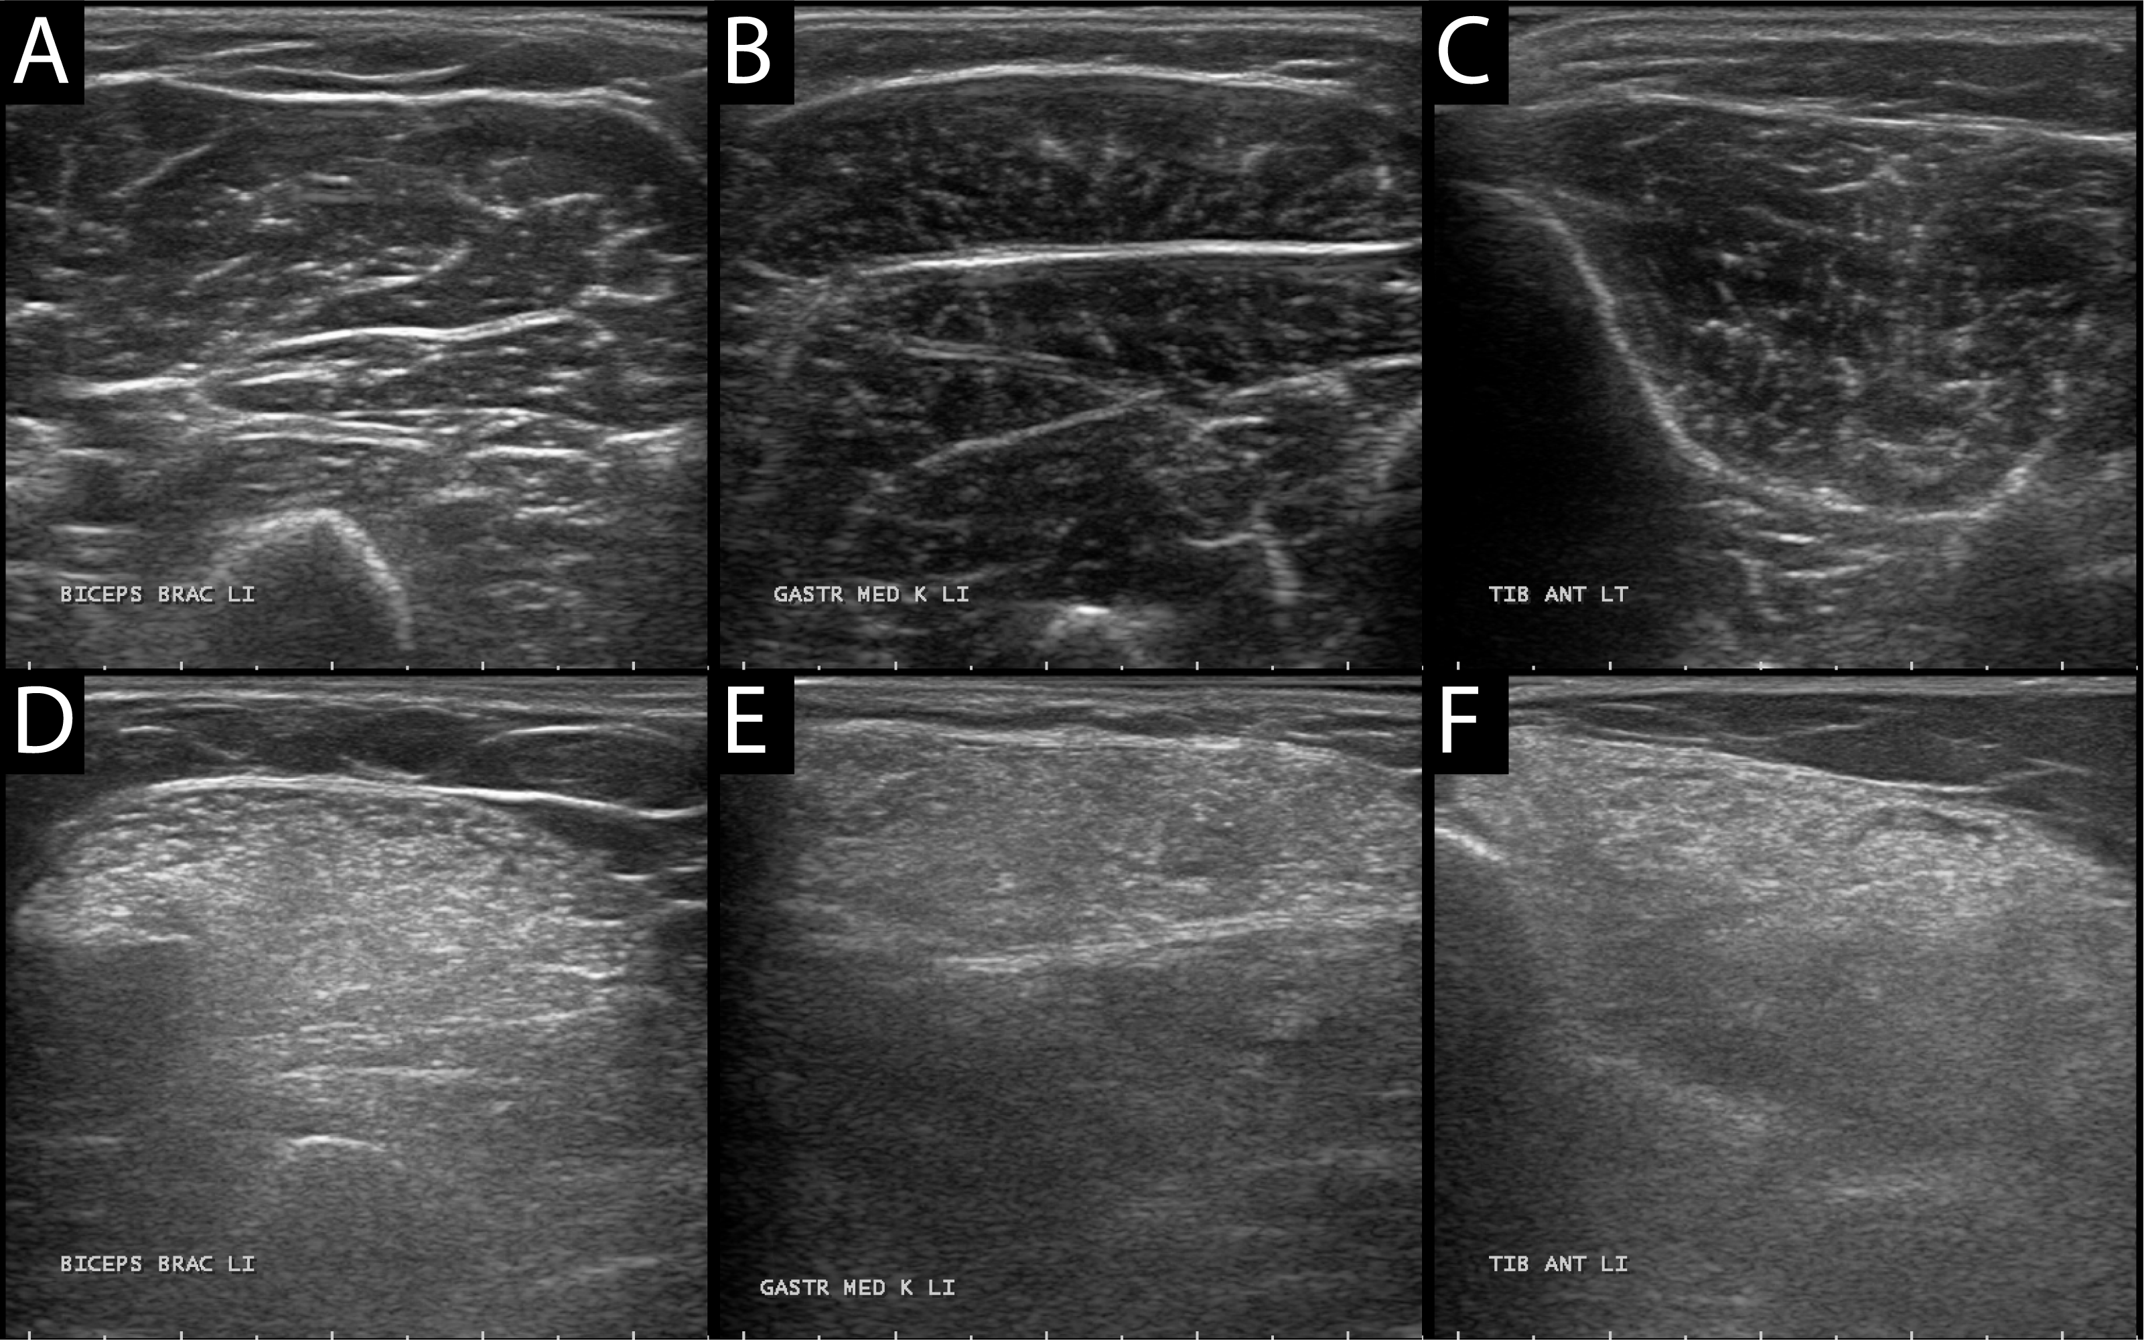
Fig. 1. Example muscle ultrasound images. (A-D) Tibialis anterior; (B-E) Gastrocnemius medialis; (C-F) Biceps brachii. First row: normal echogenicity, second row: abnormal (increased) echogenicity.

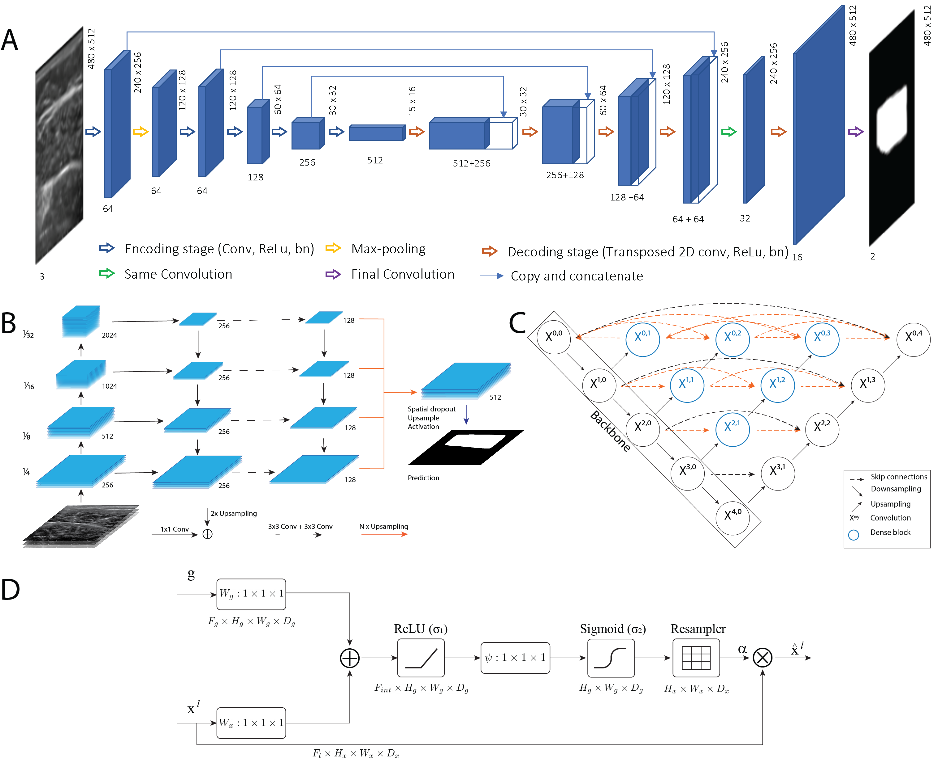
Fig. 2. Deep neural network architectures. (A) Structure of the U-Net[25]. (B) Feature Pyramyd Network[26], the image is downsampled in the bottom-up path using convolutions, then the feature maps are passed through other operations and concatenated to obtain the final tensor which is used to obtain the prediction. (C) Structure of Unet++ [27], in black the original Unet connections, dense blocks are presented in blue. (D) Attention gate in the decoder path of the Unet[28], applied at layer l, the gating signal g comes from the deeper scale of the decoder, while feature maps x^{l} are downscaled to match size of g.
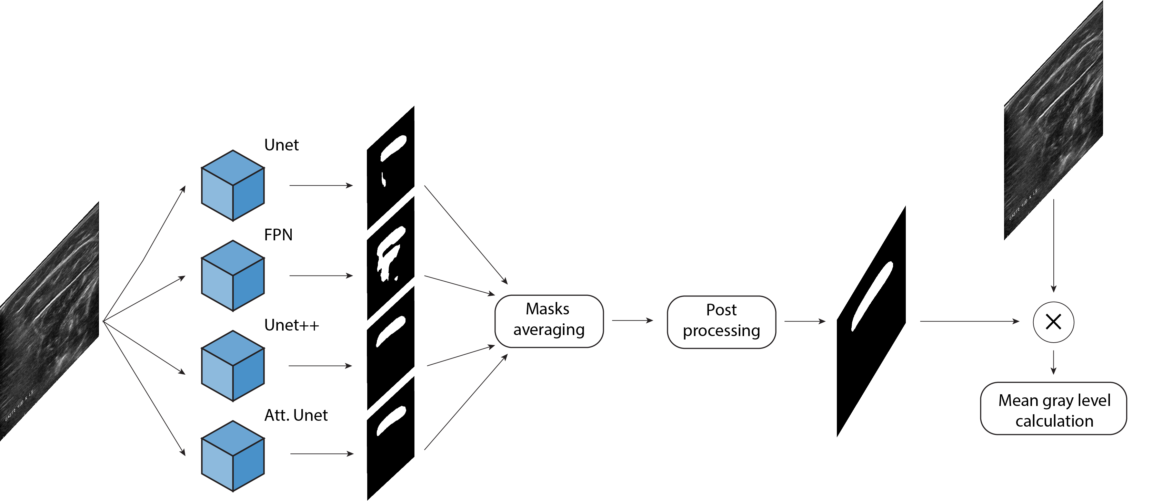
Fig. 3. Full pipeline from the original image to mean gray level calculation.

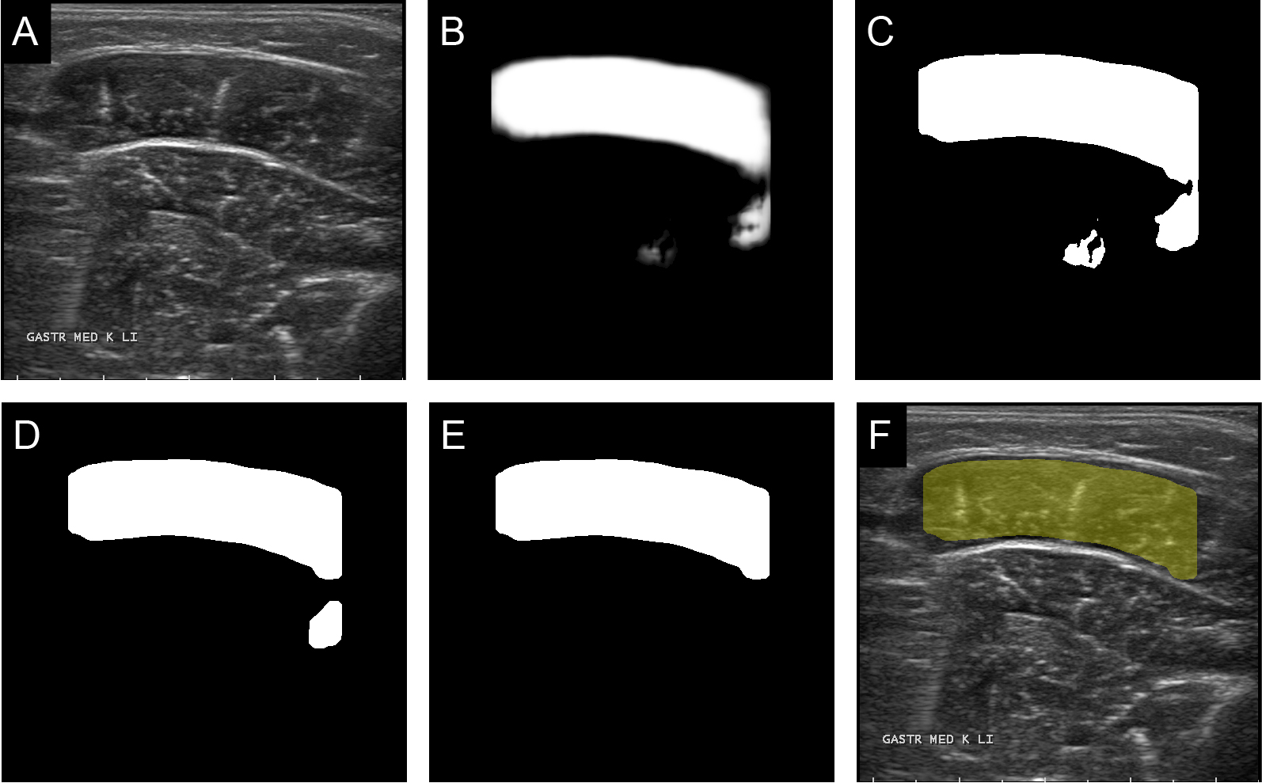
Fig. 4. Illustration of the workflow of the segmentation process. (A) Original Image. (B) Softmax output of the network. (C) Binarization of softmax with presence of drip artifact. (D) Morphological operators are applied to detach the drip artifact. (E) Best candidate for CSA is chosen. (F) Overlay of the automatic segmentation with the original image.

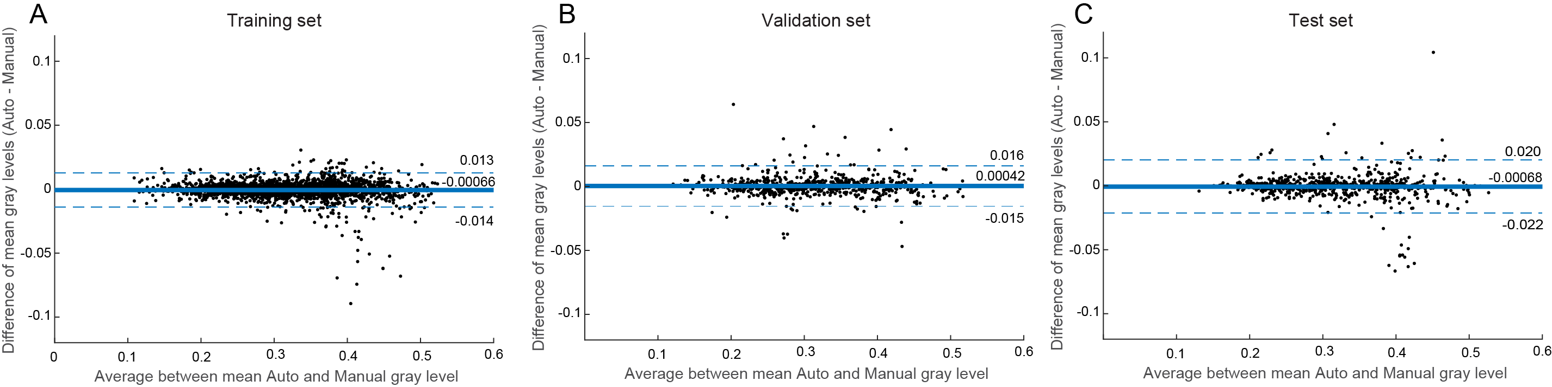
Fig. 5. Bland-Altman plots for the evaluation of the accordance between the manual and automatic readings of the mean gray value inside the CSA. Here the analysis has been performed for the (A) training set, (B) validation set, and (C) test set. No clear trend in the error distribution can be detected.

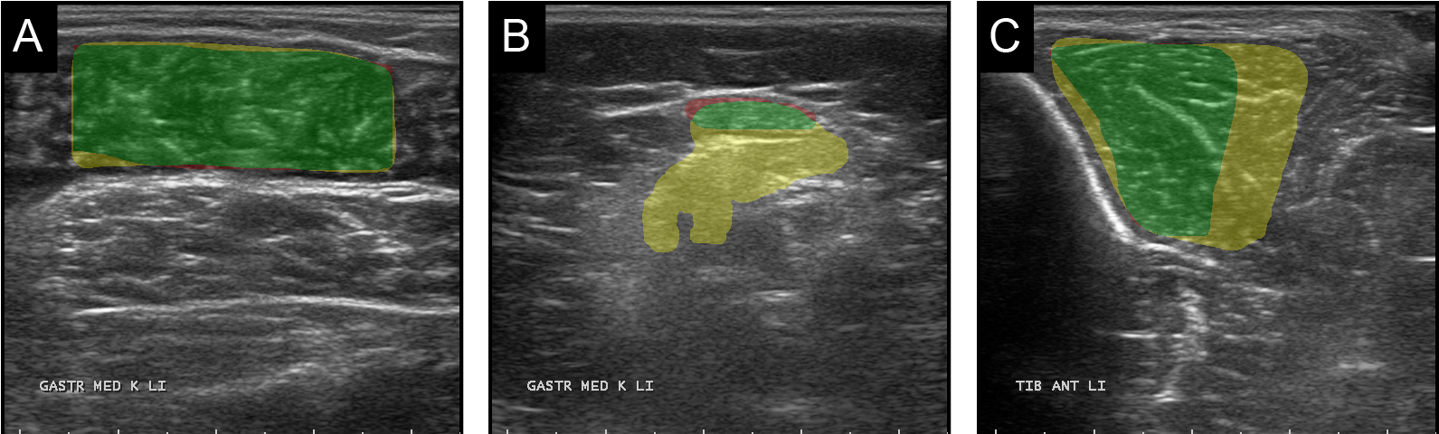
Fig. 6. Examples of automatic segmentations which were labelled by an expert as equal, worse or better with respect to the manual segmentation. (A) Example image of equal performance, (B) example of worse performance by the automatic algorithm, and (C) example of better performance by the automatic algorithm. The color code is as follows: green for intersection between manual and automatic segmentations, yellow where only the automatic method detected the muscle, and red where it failed to detect the muscle unlike the manual operator.

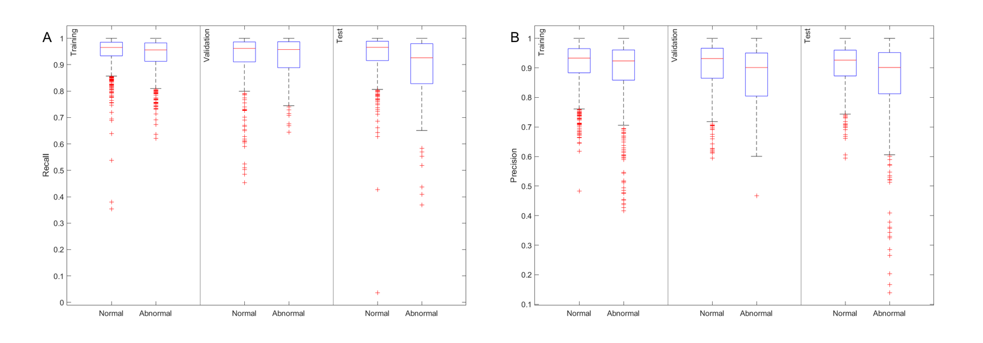
Fig. 7. Boxplots for the comparison of automatic method performances, in terms of precision and recall metrics, dividing the dataset between muscles with normal or abnormal echogenicity.

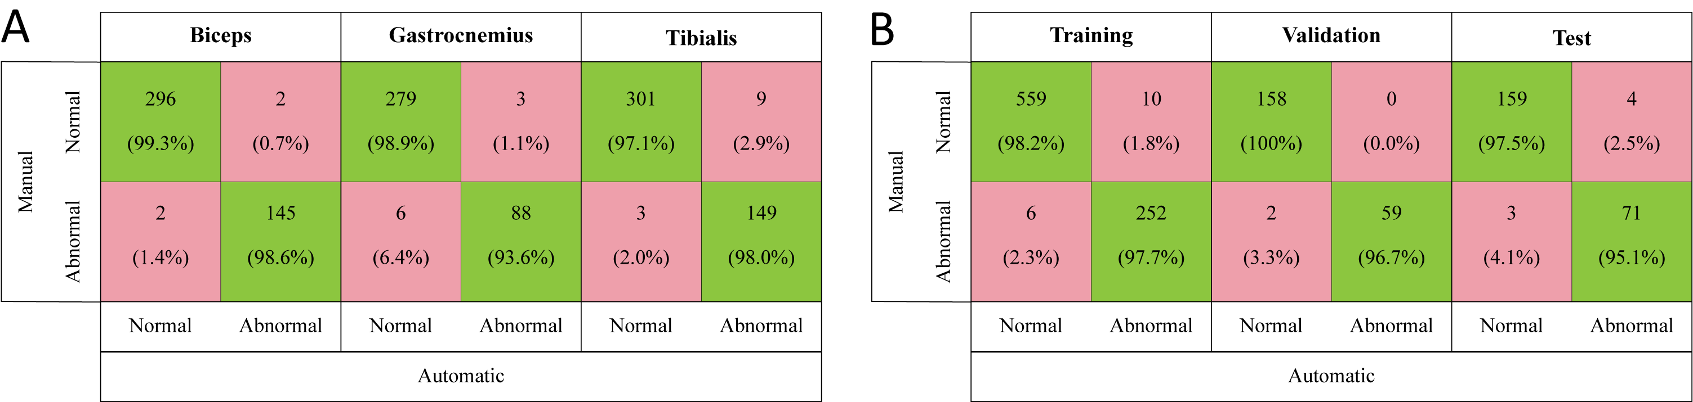
Fig. 8. Confusion matrices from (A) z-score based classification by muscle type and (B) z-score based classification by subset.

Tables
Table 1. Summary of Subjects’ Characteristics
Muscle type | Characteristic | Normal | Abnormal
Tibialis Anterior (TA) | N° images | 296 | 166
Tibialis Anterior (TA) | Age (years) | 46.7 ± 22.0 | 44.5 ± 21.9
Tibialis Anterior (TA) | Sex (M/F) | 170/126 | 94/72
Tibialis Anterior (TA) | Weight (kg) | 72.5 ± 24.3 | 70.4 ± 22.5
Tibialis Anterior (TA) | Height (cm) | 167.6 ± 23.7 | 167.5 ± 23.2
Gastrocnemius Medialis (GM) | N° images | 266 | 110
Gastrocnemius Medialis (GM) | Age (years) | 53.8 ± 18.3 | 57.1 ± 18.8
Gastrocnemius Medialis (GM) | Sex (M/F) | 153/113 | 71/39
Gastrocnemius Medialis (GM) | Weight (kg) | 77.9 ± 19.0 | 77.1 ± 20.9
Gastrocnemius Medialis (GM) | Height (cm) | 173.3 ± 13.2 | 171.7 ± 20.3
Biceps Brachii (BB) | N° images | 287 | 158
Biceps Brachii (BB) | Age (years) | 47.1 ± 23.6 | 54.2 ± 18.7
Biceps Brachii (BB) | Sex (M/F) | 167/120 | 74/84
Biceps Brachii (BB) | Weight (kg) | 69.3 ± 25.0 | 75.7 ± 17.6
Biceps Brachii (BB) | Height (cm) | 165.7 ± 25.1 | 170.5 ± 13.6
Table 2. Summary of network performances in the test set
 |  | Precision | Recall | Dice | IoU
 | Unet [25] | 0.88 ± 0.12 | 0.92 ± 0.10 | 0.89 ± 0.09 | 0.81 ± 0.13
Test set | Unet++ [27] | 0.89 ± 0.13 | 0.91 ± 0.10 | 0.89 ± 0.10 | 0.81 ± 0.13
Test set | FPN [26] | 0.89 ± 0.13 | 0.92 ± 0.08 | 0.90 ± 0.09 | 0.82 ± 0.12
Test set | Attention-Unet [28] | 0.88 ± 0.13 | 0.91 ± 0.10 | 0.88 ± 0.10 | 0.80 ± 0.13
 | Ensemble model | 0.90 ± 0.12 | 0.91 ± 0.10 | 0.90 ± 0.09 | 0.82 ± 0.12

Table 3. Summary of the developed algorithm performances divided by subset, muscle type and echogenicity level
 |  | Training |  | Validation |  |  | Test
 |  | Normal | Abnormal | Normal | Abnormal |  | Normal | Abnormal
Tibialis Anterior | N° images | 640 | 304 | 130 |  | 66 | 129 | 128
Tibialis Anterior | Precision | 0.91 ± 0.07 | 0.89 ± 0.11 | 0.88 ± 0.10 |  | 0.83 ± 0.11 | 0.90 ± 0.08 | 0.84 ± 0.16
Tibialis Anterior | Recall | 0.94 ± 0 05 | 0.92 ± 0.06 | 0.92 ± 0.09 |  | 0.94 ± 0.06 | 0.90 ± 0.08 | 0.89 ± 0.09
Gastrocnemius Medialis | N° images | 447 | 231 | 167 |  | 51 | 197 | 47
Gastrocnemius Medialis | Precision | 0.92 ± 0.06 | 0.89 ± 0.10 | 0.92 ± 0.07 |  | 0.88 ± 0.08 | 0.91 ± 0.07 | 0.78 ± 0.24
Gastrocnemius Medialis | Recall | 0.98 ± 0.03 | 0.97 ± 0.04 | 0.95 ± 0.09 |  | 0.96 ± 0.03 | 0.97 ± 0.04 | 0.92 ± 0.12
Biceps Brachii | N° images | 577 | 339 | 164 |  | 88 | 148 | 64
Biceps Brachii | Precision | 0.92 ± 0.06 | 0.90 ± 0.09 | 0.90 ± 0.11 |  | 0.90 ± 0.09 | 0.90 ± 0.07 | 0.90 ± 0.08
Biceps Brachii | Recall | 0.95 ± 0.06 | 0.93 ± 0.07 | 0.91 ± 0.11 |  | 0.89 ± 0.10 | 0.93 ± 0.11 | 0.88 ± 0.14
Table 4. Summary of TRAMA performances divided by subset, muscle type and echogenicity level. Results in bold: p<0.05 Wilcoxon Signed Rank Test.
 |  | Training |  | Validation |  |  | Test
 |  | Normal | Abnormal | Normal | Abnormal |  | Normal | Abnormal
Tibialis Anterior | Success Rate | 45% | 41% | 55% |  | 47% | 48% | 38%
Tibialis Anterior | Precision | 0.45 ± 0.15 | 0.37 ± 0.18 | 0.39 ± 0.18 |  | 0.37 ± 0.15 | 0.44 ± 0.16 | 0.33 ± 0.19
Tibialis Anterior | Recall | 0.81 ± 0.24 | 0.70 ± 0.32 | 0.74 ± 0.34 |  | 0.72 ± 0.28 | 0.81 ± 0.27 | 0.62 ± 0.35
Gastrocnemius Medialis | N° images | 81% | 64% | 82% |  | 63% | 82% | 40%
Gastrocnemius Medialis | Precision | 0.53 ± 0.25 | 0.38 ± 0.32 | 0.54 ± 0.24 |  | 0.32 ± 0.30 | 0.53 ± 0.24 | 0.36 ± 0.28
Gastrocnemius Medialis | Recall | 0.81 ± 0.37 | 0.59 ± 0.44 | 0.81 ± 0.36 |  | 0.57 ± 0.47 | 0.82 ± 0.36 | 0.64 ± 0.44
Biceps Brachii | N° images | 65% | 46% | 59% |  | 41% | 63% | 42%
Biceps Brachii | Precision | 0.54 ± 0.15 | 0.45 ± 0.25 | 0.55 ± 0.15 |  | 0.51 ± 0.24 | 0.58 ± 0.14 | 0.55 ± 0.17
Biceps Brachii | Recall | 0.93 ± 0.18 | 0.75 ± 0.37 | 0.95 ± 0.14 |  | 0.75 ± 0.34 | 0.91 ± 0.19 | 0.83 ± 0.25

