Sustainability assessment of waste electric and electronic equipment management systems: development and validation of the SUSTWEEE methodology
Daniela Gavrilescu ¹, Anișoara Enache ¹, Dumitrița Ibănescu¹, Carmen Teodosiu^{1,}*, Silvia Fiore²*
¹ Department of Environmental Engineering and Management, ”Gheorghe Asachi” Technical University of Iasi, 73 Prof. D. Mangeron Street, 700050, Iasi, Romania
² Department of Engineering for Environment, Land and Infrastructures (DIATI), Politecnico di Torino, 24 Corso Duca degli Abruzzi, 10129 Torino, Italy

* Corresponding authors: Carmen Teodosiu (cteo@tuiasi.ro); Silvia Fiore (silvia.fiore@polito.it)
Abstract
Waste electric and electronic equipment (WEEE) became an important waste stream due to its recycling potential and negative effects on the social, economic and environmental aspects. Currently, the evaluation of WEEE management systems focus on specific parts of their lifecycle (mostly on recycling options), providing information on environmental impacts and/or economic benefits. Therefore, a methodology that would address the entire WEEE lifecycle and the 3 pillars of sustainable development (environmental, economic, social) is necessary. The proposed SUSTWEEE methodology dedicated exclusively to the WEEE stream comprises a 4 level methodology, with indicators to be addressed on background information, WEEE generation, WEEE technical performance and sustainability. The technical performance and sustainability aspects are evaluated on 7 main categories of indicators, both quantitative and qualitative, assessed according to 44 criteria. All the indicators went through a score allocation and a normalization step where a percentage, qualitative score and color coding were assigned, resulting in a WEEE evaluation matrix. In the validation step, the methodology was tested successfully at national level to evaluate the sustainability of WEEE management system in Romania in reference year 2014. The results obtained in this case show a rather mixed performance, with indicators in extreme situations. The main hot spots were the very low collection rates and the non-existent reuse rate, at least in official data, while the other indicators indicated at least medium performances. The best performances are in the area of WEEE collected that undergoes suitable treatment, the existence of WEEE facilities in Romania capable to perform the treatment, high recycling rate and the overall environmental performance indicator.
Keywords: e-waste; management; methodology; sustainability; waste electric and electronic equipment

1. Introduction
Waste electric and electronic equipment (WEEE) (e.g. all items and parts of electric and electronic equipment, EEE, discarded by the owner without considering re-use) (Step Initiative, 2014), also defined e-waste, is globally a priority waste flow because of its rapid growth in the last decades. Worldwide 45 Mt of WEEE were discarded in 2016 (only 20%-wt formally recycled), and 52.2 Mt are expected by 2021 (Balde et al., 2017). This expectation was unfortunately met 2 years earlier, in 2019, when 53.6 Mt of WEEE were generated (out of which 17,4%-wt formally recycled). Newer adjusted expectations are that by 2030, WEEE generation will reach 74 Mt (https://weee-forum.org/). There are large discrepancies among different countries depending on national socio-economic development status, consumers’ behavior and level of education, availability of formal management systems, etc. Specific WEEE regulations are in force in 66% of the countries worldwide (Balde et al., 2017) and aimed at improving the recovery of recyclable materials, however most WEEE management system are inefficient and inappropriate processing leads to hazardous effects on human health and the environment. There are many specific additional aspects related to the organization of WEEE management, when compared to municipal solid waste (MSW) management systems: the focus on repair, reuse and recycling, the existence of informal collectors, the need to adopt efficient protection measures for the workers, just to name a few. A sustainable WEEE management system should be able to intercept 100 % e-waste, recovery recyclable materials, separate hazardous components, support economic development and create workplaces. It was estimated that the efficient recovery of secondary and critical raw materials associated to e-waste could correspond to about 55 billion €/y (Balde et al., 2017).
The characterization of WEEE management systems, as a whole or per stage, was already addressed at continental, national and regional scales. The European and Chinese WEEE models (as a whole) have been discussed and compared (Salhofer at el. 2016), while the assessment of WEEE management practices in Australia, Japan and Switzerland allowed to identification of 5 key issues: stakeholders roles and responsibilities, legislation on recovery and recycling, public involvement and access to services, set targets on recovery and recycling, material flows check and compliance (Morris and Metternicht, 2016, Baher and Kim, 2018). These studies showed that, at regional level, possible dysfunctions of the WEEE management system were mainly due to the lack of involvement of authorities and consumers and to the existence of informal collectors/recyclers, which acted as dispersion channels, contributing to unsafe and/or illegal WEEE practices (Ardi and Leisten, 2016). There is also the problem of rapidly increasing WEEE quantities and varieties which require different collection points and various treatment lines to be established, this being a complex problem for local authorities as underlined by Özkır et al. (2015) who suggested as possible solution a three-stage methodology to establish an efficient collection system in Istanbul, Turkey.
Several authors specifically analyzed WEEE collection and recycling through indicators (Arduin et al., 2020; Dias et al. 2018; Nelen et al., 2014), obtaining results sometimes partial about the overall sustainability performances of e-waste management systems. The analysis of WEEE management in Denmark (Parajuly and Wenzel, 2017) demonstrated that it was focused primarily on material recycle and did not sufficiently exploit fully-functional (W)EEE. A recent study (Boldoczki et al., 2019) revealed that reuse compared to recycling achieved positive environmental implications in Germany for small devices but not for white goods with C/D efficiency rating. The environmental implications of e-waste reuse were analyzed in Denmark (Zacho et al., 2018), leading to the definition of pre-requisites related to incentives and logistics aspects. The concepts of “reverse logistics” and “closed-loop supply chain” could contribute to improve the sustainability of WEEE management systems (Islam and Huda, 2018).
Currently, most WEEE management systems interfere to some extent with the Sustainable Development Goals (SDGs) and Targets, and specifically with: Goal 3. Good health and well-being referring to the number of illnesses/deaths caused by exposure to hazardous substances and environmental pollution; Goal 6. Clean water and sanitation- access to safe and affordable drinking water for all and pollution reduction, landfill restrictions and emissions reductions; Goal 14. Life below water- marine pollution reduction and the protection of aquatic ecosystems. Furthermore, the impact of WEEE management can be followed also through Goal 11. Sustainable Cities and communities- with the cities being the main core of WEEE generation, so adequate collection and increased recycling in urban areas is important; Goal 12. Responsible Consumption Production- safe management of materials and chemicals throughout their lifecycle and reduction of waste generation by prevention, reduction, repair, reuse and recycling, plus the need to raise awareness among producers and consumers, and finally Goal 8. Decent work and economic growth, keeping in mind that the informal sector in WEEE processing involved many jobs that are neither safe nor protected (Ardi and Leisten, 2016; Leung, et al. 2008).
Life Cycle Assessment (LCA) approach was commonly adopted to assess the sustainability of WEEE management systems, with at least 61 LCA studies analyzing WEEE management strategies (parts or entire systems), or their hazardous potential (Ismail and Hanafiah, 2019). Most studies started the analysis with a material flow analysis (Boldoczki 2019; De Meester, 2019; Fiore et al. 2019). It is important to mention that these studies usually discussed only the environmental impacts of WEEE management systems and are limited to practitioners and experts in the field of LCA, while the stakeholders still need the interpretation of these results for the decision-making process. The economic aspects of WEEE were discussed (Sousa et al., 2018), also together with the environmental impacts (Messmann et al. 2019; Nowakowski and Mrowczynska 2018; Ibanescu et al., 2018).
Based on all the above considerations, to the best of our knowledge, there is no methodology that captures the WEEE management system sustainability as a whole, involving at the same time background information, technical details and assessment in relationship with the components of sustainable development: social, economic and environmental. The main purpose of this study is to fill this knowledge gap by proposing a comprehensive methodology dedicated to the WEEE stream, with clearly defined indicator categories, involving quantitative (where possible) or qualitative indicators, established considering official statistics and evaluated against objective criteria. The main objective is accomplished by the development of the methodology step, accompanied by the validation step to check the fit for purpose.
By contrast with other existent methodologies that evaluate only certain components, the presented methodology, named SUSTWEEE is developed considering all the elements of sustainability, resulting in an extensive evaluation matrix, distributed on 4 levels of information: (1) background information, (2) WEEE generation profile, (3) technical performance and (4) social, economic and environmental performances. Level 1 and 2 incorporate relevant social, economic and WEEE generation and composition information for a better comprehension of results presented in the next 2 levels. Levels 3 and 4 especially give results after the evaluation of 7 main categories of indicators based on a mechanism of score allocation and on a results normalization stage, to obtain a unitary and coherent image of the WEEE management system under analysis. Furthermore, the proposed methodology was validated on the Romanian national WEEE management system data of 2014. The country was selected to reflect the situation in an EU member state with a Gross Net Income that would classify the state in the Upper Middle Income group aggregate, with an overall fragile waste management system. The WEEE collection rates in Romania validated in the Eurostat database has expanded ten times in 2014 (from 32159 tones) as compared to 2007 (3413 tones), so the intention is to track how this expansion has caused the corresponding developments and challenges in the WEEE management system and its sustainability. Besides the main geographical focus, the suggested timeline (reference year 2014) is chosen to reflect the situation at the transition between two Waste Management Strategies for 7 years cycles, 2007-2013 and respectively 2014-2020.

2. SUSTWEEE Methodology development
This methodology aims to give a framework of the WEEE management system, starting from the point when EEE turns into WEEE and ending with the final treatment stage. The system boundary included public and private activities, along with reuse and recycling of valuable resources from WEEE. All pillars of sustainable development (environmental, economic, and social) and their respective interactions were addressed. SUSTWEEE is flexible and adaptive because it can be used at any level: local, regional, national etc., allowing the comparison between same level systems and being able to incorporate different aspects (as many as considered appropriate) for a specific analysis. It may be used to follow the dynamics of the system for various periods of time (if consistent data are available) and it was based on official reported data rather than on primary survey work. SUSTWEEE can be seen as a diagnose tool able to reveal the status of any aspect considered in the analysis.
SUSTWEEE was developed starting from the report of the UN-Habitat on solid waste management in the world’s cities (Scheinberger et al. 2010) and the Wasteaware benchmark indicators for integrated sustainable waste management in cities (Wilson et al., 2015) and it was designed to fit the description of WEEE management system (Figure 1).
In the evaluation of Level 1, the authors bring new indicators compared to other similar methodologies. The need to include more indicators in the general information background is dictated by the special features of the object of analysis: WEEE stream in this case and the social and economic context in which EEE are placed on the market, and the level of analysis: country level. Level 2 is discussing the WEEE generation and collection situation per capita and per WEEE categories, the selection of the indicators is again underlined by the specificity of the WEEE stream.
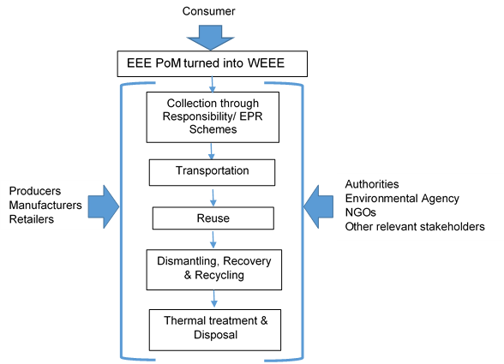
Figure 1. WEEE management system boundary and relevant pressures impacting the system
In the assessment of Levels 3 and 4 of the evaluation matrix, SUSTWEEE was based on 7 main categories of indicators, 3 “hard” physical components (assessing collection, treatment, disposal methods and resource management options), and 4 “soft” components (social and legal aspects, financial sustainability and environmental performance). Each main category of indicators consists of a set of sub-indicators responding to the most important and relevant question their respective field (Table 1): 1. WEEE collection (3 indicators, with 2 quantitative and 1 qualitative assessed against 7 criteria); 2. Environmental control– WEEE treatment and disposal (3 indicators, with 2 quantitative and 1 qualitative assessed against 7 criteria); 3. Resource management– reduce, reuse and recycle (3 indicators, with 2 quantitative and 1 qualitative assessed against 9 criteria); 4. Inclusivity– user and provider (provided after the evaluation of 5 criteria); 5. Financial sustainability (obtained after judging 6 criteria); 6. Sound institutions, proactive policies (resulted after the assessment of 5 criteria) and 7. Environmental performance (obtained after evaluating 5 criteria). The main features of SUSTWEEE (Table 1), compared to the UN-Habitat and Wasteaware methodologies, can be summarized as follows:
- SUSTWEEE uses the physical components as main core of the approach, with interactions with social development, economic issues and with certain environmental impacts (the other methodologies considering a “2 triangle” approach with a link between physical and soft components represented by social governance, the latter including legislation, financial aspects and user-providers relationships, but not discussing the environmental impacts of the system).
- As another important original feature, by incorporating an easy-to-use and accessible instrument for the rapid assessment of the WEEE environmental performance, the methodology giving thus the full picture of the system sustainability status.
- The criteria suggested have been selected carefully to allow the analysis of the system and have been extensively revised, for all the considered indicators.
- The physical components considered in SUSTWEEE relied on the balance between EEE placed on market (PoM) and WEEE generation rate, or better said the WEEE collection rate, because actually the real WEEE generation rates are very difficult to quantify. The background information and WEEE generation profile considered to be useful in the assessment is extended by comparison with the Wasteaware methodology, the new information included referring to: a) material composition: WEEE was classified by the equipment type, according to the legislation, but also the composition per material was available, both being used in the further assessment and data validation stage; b) energy consumption and level of education: both seen as indicators of EEE existence/use and likelihood of becoming WEEE.
Table 1. Comparison of SUSTWEEE methodology with UN-Habitat and Wasteaware ones
Aspects | UN-Habitat | Wasteaware | SUSTWEEE
Waste management system investigated | MSW | MSW | WEEE
Validation level | City | City | Country
Main concept | 2 triangles grouping 3 physical components with 3 governance aspects | 2 triangles grouping 3 physical components with 3 governance aspects | physical components at the core of sustainability (economic-social-environmental) interactions
Measurement | Hard physical components and soft governance aspects | Hard physical components and soft governance aspects | Hard physical components and soft aspects related to sustainable development
Background information requirements | Extended information required | Reduced information required | Extended and adapted information required
Physical  Components (hard) | 3 categories with 4 quantitative indicators (1 not validated).  The results are not refined, based on qualitative criteria | 3 categories with 4 quantitative indicators (all tested). The results of the indicators are based on 18 qualitative criteria | 3 categories and 6 quantitative indicators (all tested). The results of the qualitative indicators are based on 23 qualitative criteria
Soft components
Governance aspects
Degree of user and provider inclusivity | 1 composite qualitative indicator | 1 composite qualitative indicator analyzed against 11qualitative criteria.  Extensively revised  compared to UN-Habitat. | 1 composite qualitative indicator analyzed against 5 (new) qualitative criteria. Extensively revised as compared to Wasteaware. The indicator is included in the social sustainability
Degree of financial sustainability | Quantitative indicator | 1 composite qualitative indicator analyzed against 6 qualitative criteria.  Extensively revised compared to UN-Habitat. | 1 composite qualitative indicator analyzed against 6 (new) qualitative criteria. Extensively, revised compared to Wasteaware. The indicator is included in the economic sustainability
Sound institutions and pro-active policies | 1 composite qualitative indicator, obtained based on results at different scales national/local /regional. | 2 composite qualitative indicators, 1 at national level and 1 at city level against 6 qualitative criteria. | 1 composite qualitative indicator, at national level, against 5 qualitative criteria. The indicator is included in the social sustainability
Environmental performance | Not available | Not available | New composite indicator against 5 qualitative criteria. The indicator is included in the environmental performance
Score allocation | Not available | 0-25 scale | 1-5 scale
Qualitative assessment  (Results normalization) | Not available | Available.  5 categories with color coding. | Available (same as Wasteaware).  5 categories with color coding

2.1 General background information and WEEE generation profile
General background information included: i) country level income: income category (World Bank, 2014) and national Gross Domestic Product (GDP) per capita (Eurostat, 2014); ii) population: the total population and the population distribution in rural and urban areas (Eurostat, 2014); iii) level of education: individuals' level of internet skills, individuals' level of computer skills and Employment rate % (15-64 years) (INS, 2014); iv) material consumption expressed as Domestic Material Consumption per Capita (tonnes) (INS, 2014); v) resource productivity expressed in euros per kilogram (Eurostat, 2014); vi) energy consumption- Energy consumption per inhabitant expressed as tonnes of equivalent petrol per capita (Eurostat, 2014; ANPM, 2014); vii) EEE PoM - total amount of EEE placed on national market on a year, and EEE placed on national market per capita (Eurostat, 2014; ANPM, 2014); viii) WEEE generated and collected expressed in tons per year (Eurostat, 2014; ANPM, 2014).
It is important to mention that no official data regarding how much WEEE was generated at national level in a specific year were available, and in the absence of this information, data related to WEEE collected from official sites like ANPM (Romanian National Agency for Environmental Protection) and Eurostat were used. WEEE production profile comprised the total EEE placed on market and the total WEEE collected at country level and per capita. The 10 WEEE categories derived from WEEE Directive 2012/19/EU. For each category, the total quantity placed on market, the total waste generated and collected for that category and the waste per capita per category were considered (Eurostat, 2014). The material composition of a “generic” WEEE (http://ewasteguide.info/) included 10 fractions as metals (ferrous and non-ferrous), plastics, glass, wood, printed circuits, refrigerants, oil, capacitors and others.
2.2. Indicators overview
The appraisal of hard and soft components happened through the assessment of technical performance and sustainability aspects. The overall methodology indicators and their scores are presented in detail in the Supplementary Material.
Quantitative indicators were used to describe the physical components of the system: 2 for WEEE collection (1.1 WEEE collection coverage, 1.2 WEEE collected; 2 for Environmental control (2.1 Controlled treatment and disposal, 2.2 Domestic/foreign WEEE treatment; 2 for Resource management – 3RS (Recycling rate, Reuse Rate); 5 for the Environmental Performance category (7.1 Water, 7.2 Air, 7.3 Resources, 7.4 Energy and 7.5 Zero WEEE index). Other indicators, related to physical components or sustainability aspects, were qualitative and based on the assessment of at least 5 criteria each. For the evaluation of quality indicators, a scoring scale from 0 to 5 was proposed. One quality indicator evaluation score represented the average number obtained from scores given in the criteria suggested for that indicator. After the score allocation, values were transformed in percentages to achieve consistency (Table 2), and further classified on a 5 stage scale (from LOW to HIGH). Additionally, color coding of the scores provided a quick visual assessment of the data and highlighted areas that were under performing and in need for immediate attention. The same qualitative assessment and color-coding system has been used to analyze the quantitative indicators. A guidance of the relative performance classification was the comparison with best practices in each indicator field. For example, 50% WEEE controlled treatment and disposal was considered relatively low, while 50% collection rate was classified medium and 50% reuse rate was classified high.
Table 2. SUSTWEEE: Correlation between qualitative stage, relative performances and color coding
Qualitative stage | Percentage | Color code
LOW | 0–20% | red
LOW/MEDIUM | 21-40% | amber
MEDIUM | 41-60% | orange
MEDIUM/HIGH | 61-80% | yellow
HIGH | 81-100% | green

3. Results of SUSTWEEE methodology validation
SUSTWEEE methodology was validated assessing the performance of the Romanian WEEE management system in 2014 (Table 3 a and b). That specific year was chosen since it was the most recent for which complete data for EEE put on market and the overall WEEE management systems were available.
Table 3a. Results of SUSTWEEE methodology applied to Romania in 2014-national background and WEEE generation profile
No. | Category | Indicator | Results
Country: Romania, year: 2014
National background (socio-economic profile)
B1 | Country level income | World Bank category | Upper middle income
B1 | Country level income | GDP per capita | 7600 €/cap
B2 | Population | Total population of the country | 19.643 million
B2 | Population | Rural/urban (%) | 46.3% |  | 53.87%
B3 | Education | Level of competence | low | middle |  |  | high
B3 | Education | Individuals' level of internet skills (%) | 29 | 23 |  |  | 5
B3 | Education | Individuals' level of computer skills (%) | 18 | 13 |  |  | 7
B3 | Education | Employment rate % (15-64 years) | 61 %
B4 | Material consumption | Domestic Material Consumption per Capita (tonnes/year) | 16.79
B5 | Resource | Resource productivity (EUR/kg) | 0.3735
B6 | Energy consumption | Energy consumption per inhabitant (tep/capita) | 1.584
B7 | EEE PoM | EEE put on market (tonnes/year) | 139587
B8 | WEEE generated and collected | WEEE generation (tonnes/year) | 32159
WEEE generation profile
W1 | EEE PoM/ WEEE collected |  | EEE (t/y) | WEEE (t/y) |  | WEEE (kg/cap/y)
 |  |  | 139587 | 32159 |  | 1.62
W2 | WEEE waste categories:
W2.1 | C1-large household appliances (tons/year) |  | 84995 | 20465 |  | 1.03
W2.2 | C2-small household appliances (tons/year) |  | 10466 | 1021 |  | 0.05
W2.3 | C3-IT and telecommunications equipment (tons/year) |  | 13400 | 4803 |  | 0.24
W2.4 | C4-consumer equipment and photovoltaic panels (tons/year) |  | 14833 | 3513 |  | 0.18
W2.5 | C5-lighting equipment (tons/year) |  | 5351 | 1140 |  | 0.06
W2.6 | C6-electrical and electronic tools (with the exception of large-scale stationary industrial tools) (tons/year) |  | 7727 | 815 |  | 0.04
W2.7 | C7-toys, leisure and sports equipment (tons/year) |  | 999 | 66 |  | 0
W2.8 | C8-medical devices (with the exception of all implanted and infected products) (tons/year) |  | 395 | 34 |  | 0
W2.9 | C9-monitoring and control instruments (tons/year) |  | 938 | 236 |  | 0.01
W2.10 | C10-automatic dispensers (tons/year) |  | 483 | 65 |  | 0
W3 | WEEE material composition:
W3.1 | Metals | Ferrous metals (%) | 43.63
W3.1 | Metals | Non-ferrous metals (%) | 4.6
W3.2 | Glass | Glass (%) | 10.01
W3.3 | Plastics | Plastics (%) | 14.61
W3.4 | Wood | Wood (%) | 2
W3.5 | Capacitors | Capacitors (%) | 0.1
W3.6 | Printed circuit boards | Printed circuit boards (%) | 2.2
W3.7 | Non-recyclable | Non-recyclable (%) | 4
W3.8 | Refrigerants | Refrigerants (%) | 0.02
W3.9 | Oil | Oil (%) | 0.1
W3.10 | Other components | Other components (%) | 18.71

Table 3b. Results of SUSTWEEE methodology applied to Romania in 2014-management system technical performance and system sustainability
No. | Category | Indicator | Results
Country: Romania, year: 2014
WEEE management system technical performance (physical components)
1.1 | WEEE collection | WEEE collection coverage | 76% | M/H
1.2 | WEEE collection | WEEE collected | 24.37% | L/M
1C | WEEE collection | Quality of WEEE collection | 60 % | M
2.1 | Environmental control– WEEE treatment and disposal | Controlled treatment and disposal | 100% | H
2.2 | Environmental control– WEEE treatment and disposal | Domestic/foreign WEEE treatment | 96.26% | H
2TD | Environmental control– WEEE treatment and disposal | Degree of environmental protection in WEEE treatment and disposal | 80% | M/H
3.1 | Resource management – reduce, reuse and recycle | Recycling rate | 87.3% | H
3.2 | Resource management – reduce, reuse and recycle | Reuse rate | 0% | L
3R | Resource management – reduce, reuse and recycle | Quality of 3Rs – Reduce, reuse, recycle – provision | 57.8% | M
WEEE management system sustainability
4I | Degree of user and provider Inclusivity | User and Provider inclusivity | 56% | M
5F | Degree of Financial sustainability | Degree of Financial Sustainability | 76.66% | M/H
6N | Sound institutions, proactive policies | Adequacy of national WEEE framework | 52% | M
7E | Environmental performance indicator | Water, air, resources, energy savings and zero WEEE index | 92% | H

The main findings resulted in the Romanian WEEE matrix for 2014 can be discussed over the four main sections. As general background, Romania is an upper income country, with one of the lowest Gross Domestic Product per capita in Europe, the largest proportion of rural living population having lower incomes. This means that in general, the urban population has access to EEE products, both in terms of purchase and accessibility, and those being also the predominant WEEE generators. The economic status of Romanians affects the way the purchases are performed, in the sense that a long usage status is desired. This explains also the results in the generation profile, with very low figures of WEEE collected per capita as compared to the EU countries.
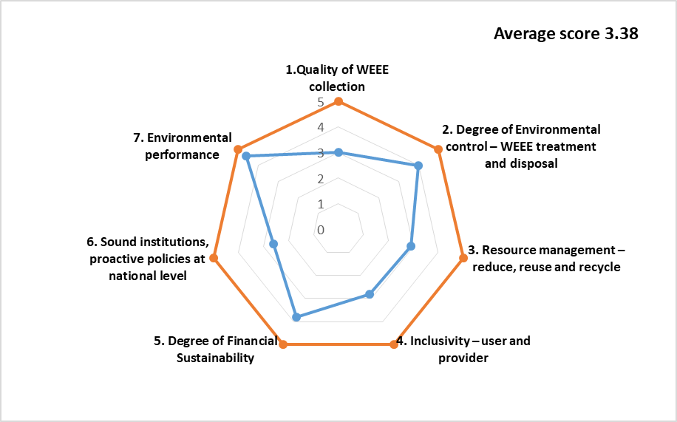
Figure 2. Overall performance of the WEEE management system, in Romania, reference year 2014, based on SUSTWEEE methodology

In terms of WEEE management, the hot spots are WEEE collection (Quantity of WEEE collected per inhabitant), that is the lowest in EU and the Reuse rate, although here there are no information officially recorded, so a rate cannot be calculated. According to independent RTO reports, Romanians have the habit to reuse EEE (by handing it to relatives/friends), mainly due to low income. The high performance areas are in the case of indicators Controlled Treatment and Disposal (100% controlled WEEE treatment, 96,26% of WEEE collected treated in country) and Recycling rate (87,3%), due mainly to the fact that Romania has the treatment capacity to manage all the WEEE that is collected, the issue being to get them to the treatment facility. What can be noticed here is that the highest and the lowest performing indicators are quantitative ones. The qualitative indicators have generally an overall average performance, being situated in the MEDIUM zone most of the time – Quality of WEEE collection, Quality of 3Rs.
Regarding the sustainability, it can be observed that the social and legal components of the system are facing more difficulties, than the financial situation related to WEEE management, with User and Provider Inclusivity, Adequacy of National Framework scoring MEDIUM, while the Degree of Financial Sustainability is in MEDIUM/HIGH zone. For the particular case of Environmental Performance Indicator the score is HIGH due to an increase in its rate comparatively with the 2 previous years, this being linked with the high recycling rate and the medium quality of recycling services.
In a single score, the country performance is 3.38, this being classified in the Medium/High performance category according to the SUSTWEEE methodology.

3.1 Quantitative indicators for the physical components of the WEEE Management System
The main figures describing the Romanian WEEE management system in 2014 were (ANPM, 2014): 808 collectors and 75 authorized WEEE treatment facilities; approximately 2000 collection points (administered by RTOs) were registered (Păceșilă, et al., 2016). A national study developed in 2015 by Ecotic (one of the most important RTO in Romania) (Ecotic, 2015 a, b), estimated 76% WEEE collection coverage with 30.6% respondents saying that they handled over their WEEE to authorized entities, 26% to stores where they purchased new equipment, 13% to specialized companies and 6% to informal collectors. As for the qualitative assessment for indicator 1.1, the score was 76 (MEDIUM/HIGH performance).
1.2- WEEE collected by the system referred to the collection rate imposed by WEEE Directive 2012/19/EU until 2016 (4 kg/cap/y). It can be observed that Romania’s performance (1.62 kg/cap) was LOW/MEDIUM.
About 2.1- Controlled treatment or disposal, in Romania the entire amount of WEEE collected (32,159 t) was reported as treated, which means an equivalent score of 100% (MEDIUM-HIGH performance). It is important to mention that WEEE fractions escaped the official collection routes, being managed by the informal collectors and improperly treated, or gathering dust in households or just being dumped.
For 2.2- Domestic/foreign WEEE treatment, collected data indicated that a small fraction (1,200 t) of WEEE was treated outside Romania but still in an EU country, and in consequence the score was 96.26% (HIGH performance).
About 3.1- Recycling rate and 3.2- Reuse rate, the overall recycling rate in Romania was 87.3% (Eurostat, 2014), higher than the one imposed by legislation and comparable to other EU member states, indicating the capacity of the country to adequately treat e-waste, once it has been collected. For the reuse rate, few efforts have been made in this direction, mainly by the NGOs and RTOs that are organizing centers for repairing and refurbishing old EEEs, especially ITC equipment, and are handling them to schools and libraries in socially vulnerable areas (Ateliere fara frontiere, 2014). According to Ecotic national study (Ecotic, 2015b), 22% respondents declared that they handled old or unwanted EEE to friends and relatives, an action that could count toward reuse or preparation for reuse, but it was unaccounted in official records.
3.2. Quality indicators for Physical Components and Sustainability Aspects
3.2.1. Indicator set 1C – Quality of WEEE collection
The average score for score for set 1C was 3 (MEDIUM performance) (Figure 3).
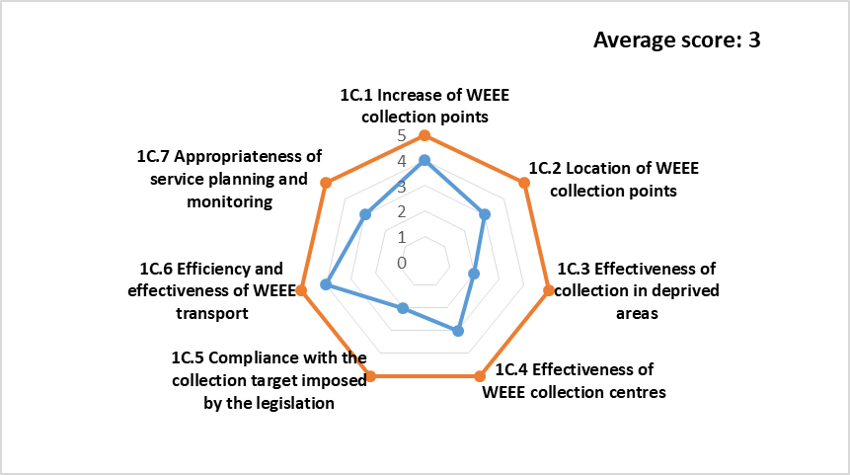
Figure 3. Scores for indicator 1C: Quality of the WEEE collection
Indicator 1C.1 scored 4, based on the 10% increase of WEEE collection centers (with environmental permits) in 2014 compared to previous year (ANPM, 2014). The location of WEEE collection points (1C.2) scored 3, because collection centers were available but two thirds of the population was unaware of their existence (Ecotic, 2015b). In the case of WEEE collection efficiency in isolated or low income areas (1C.3.), there were no collection points and in the best case scenario WEEE collection was done by an authorized operator in a defined day agreed with local authorities (Popescu et al., 2014). However, the informal collectors contributed to the collection and/or dismantling of WEEE in these areas, and in some cases to improper disposal, so the score was 2 (e.g. evidences of random collection/improper disposal). The efficiency of collection centers (1C.4) scored 3. Based on EU legislation, the minimum requirements of WEEE collection centers are: ability to sort/reuse equipment; waterproof locations, weather resistant, with wastewater collection facilities; proper vehicles for WEEE transport and personal protective equipment for workers. There were no official records in Romania for reuse operation facilities. Considering existence of the minimum technical requirements regarding transportation from authorized collection centers, criterion 1C.6 scored 4. Compliance with the collection target imposed by the legislation (1C.5) scored 2, based on the WEEE reports (Eurostat, 2014). Acceptability of service planning and monitoring activities (1C.7) was controversial. A legislative framework applicable for both public and private sector existed, but the aggregated results (scope adequacy) obtained for the stakeholders (collection centers, treatment plants, RTOs, distributors, producers and municipalities) were hard to quantify and even harder to evaluate in order to make continuous improvement. Based on these aspects, the given score was 2.
3.2.2 Indicator set 2TD – Degree of environmental protection in WEEE treatment and disposal
The average score of 2TD indicator set was 4 (MEDIUM-HIGH performance) (Figure 4).
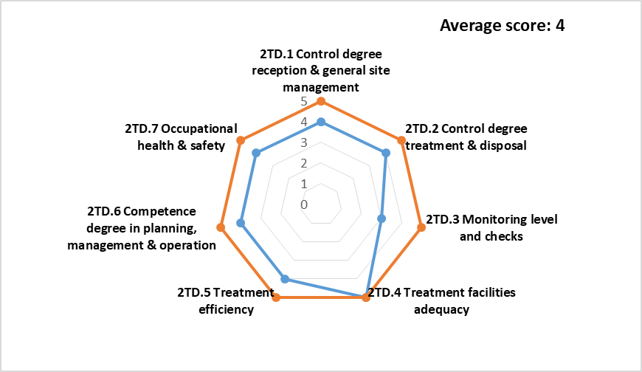
Figure 4. Scores for indicator 2TD: Degree of environmental protection in WEEE treatment and disposal
The degree of control over WEEE reception and general site management (2TD.1) considered the access to the treatment facility, queuing, reception, security and unloading. The top WEEE treatment facilities (by capacity) from Romania (e.g. GreenWeee International, Rematholding, Remat Müller-Guttenbrunn) (Table 4) were evaluated analyzing the technical documents available on their internet sites and 2TD.1 scored 4, since all operators had good management practice. Based on these considerations, also criterion 2TD.2 (control degree for treatment and disposal) scored 4. 2TD.1 and 2TD.2 did not reach the highest score because although the largest treatment facilities were performing very well, smaller treatment plants with lower performance existed and the informal sector was present.
Table 4. Overview of the main WEEE treatment facilities in Romania in 2014
No | Company | Capacity | WEEE categories | Implemented standards
1 | SC Green WEEE INTERNATIONAL SA http://greenweee.ro/ | 50,000 t | all 10 categories | ISO 9001:2008; ISO: 14001:2004  OHSAS: 18001:2008; (currently WEELABEX)
2 | SC Rematholding SRL http://rematholding.ro/ | 20,000 t | all 10 categories | ISO 9001:2008; ISO: 14001:2004  OHSAS: 18001:2008; SA 8000:2014  Quality Management certification acc. EU 333/2011 (currently WEELABEX)
3 | SC Remat Müller Guttenbrunn SRL http://remat-mg.ro | n.a. | 4 categories | ISO 9001:2008; ISO: 14001:2004  OHSAS: 18001:2008

Indicator 2TD.3- Monitoring level and checks scored 3. On one hand the activity of treatment facilities was monitored by various governmental/independent organizations, plus there was the obligation to report the WEEE quantities in all its life cycle stages. On the other hand, there were 2 main disadvantages: the application for an integrated environmental authorization (IEA) is long and the existence of scrap dealers and informal recyclers. The adequacy of treatment facilities (2TD.4) scored 5 because Romania had a capacity to treat WEEE exceeding 70,000 t/y (Table 4).
2TD.5-Treatment efficiency scored 4 because of 90.9% national recovery rate (Table 3a). The most important treatment facilities in Romania implemented voluntary instruments (management system standards) in their day-to day operations with in-place procedures to protect the human resources exceeding the requirements imposed by the legislation. Thus, 2TD.6 and 2TD.7 scored 4, but not 5 because of the existence of the WEEE informal collection and improper disposal treatment practices.
3.2.3 Indicator set 3R – Quality of 3Rs- Reduce, reuse, recycle
Indicator set 3R achieved an average score of 2.9 (MEDIUM performance) (Figure 5).
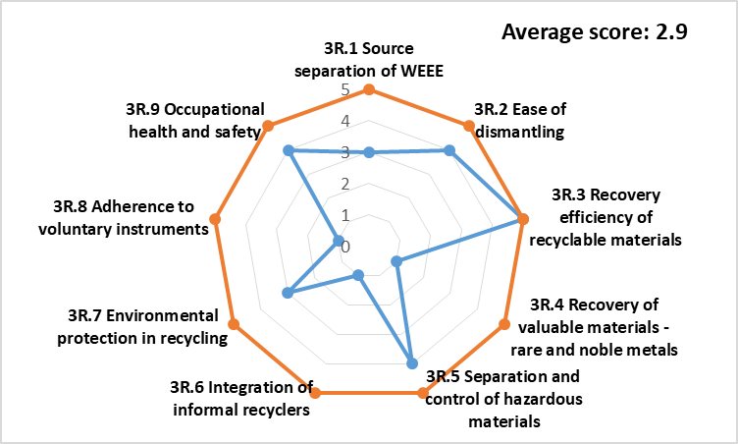
Figure 5. Scores for indicator 3R-Quality of 3Rs- Reduce, reuse, recycle

3R.1- Source separation of WEEE scored 3, because proper and improper source separation coexisted. The consequences of the informal WEEE management are: low collection rates, improper dismantling and recycling (with release of hazardous substances) and cross-contamination with the metals recycling system (Ciocoiu and Târțiu, 2012; Popescu et al., 2014). Based on the consequences of informal WEEE management impacting also the dismantling operations, 3R.2 scored 4.
In terms of recovery efficiency of recyclable materials, Romania had 87.3% recycling rate (Table 3b), (EU average was 81.5%) and therefore 3R.3 scored 5. By contrast, Romania didn’t have in 2014 the capacity of recovering precious and special valuable metals (Chancerel et al., 2009), therefore 3R.4 scored 1.
In spite of valuable fractions recovery potential, there are also materials or compounds within WEEE that pose serious risks to human health and have significant environmental impacts (GWMO, 2015). Considering on one hand that the main recycling facilities according to their IEA have the means to properly separate and contain the hazardous substances, and on the other hand the fact that some WEEE are improperly dismantled by the informal collectors and only some metals are recovered, 3R.5 scored 4.
Integration of community and/or informal recycling sector with the formal WEEE management system (3R.6) scored 1, because there were no official evidences made by the authorities to integrate the informal collectors into the formal WEEE management system.
Environmental protection in recycling (3R.7) scored 3. A lower environmental impact would be ascribed to plants that only perform physical operations and a higher one for chemical and thermal recovery processes. It considers also the impact of transport to the facility (distance, number of transports received and means of transports). In Romania the existent WEEE recycling facilities perform mechanical operations, but the informal sector and the status of the transport infrastructure (no high speed roads, slow train speeds) increased the environmental impacts.
In 2014 the adherence to voluntary management instruments as WEEELABEX or PAS 141:2011 was non-existent in Romania, so 3R.8 scored 1. Currently the key players in WEEE recycling in Romania (GreenWeee International and Rematholding) implemented WEEELABEX standards. The reference requirements for Occupational health and safety (3R.9), which scored 4, are similar to 2TD.7.

3.2.4. Indicator set 4I – Degree of user and provider inclusivity
Indicator set 4I achieved an average score of 2.8 (MEDIUM performance) (Figure 6).

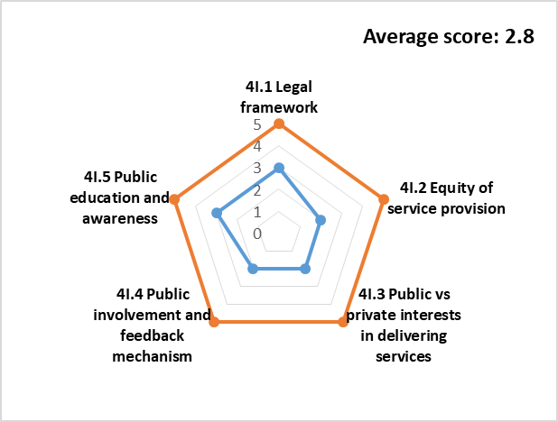

Figure 6. Scores for indicator 4I – Degree of user and provider inclusivity

4I.1- Legal framework scored 3. The participation of public and private sectors was clearly expressed in Romanian national laws (Law 211/2011 and Governmental Decision no. 1037/2010). Additional regulations and policies assisted the enforcement of legislation, however there were no clear regulations and guidance for service contracts (NWMP, 2017).

The accessibility of WEEE system services (4I.2) scored 2. One third of Romanians mentioned the lack of collection points as the biggest barrier to WEEE collection, however about one fourth did not have any information on the location of proper collection points (Ecotic, 2016). In Romania there were major differences between urban and rural areas (NWMP, 2017) and people perception on WEEE (Păceșilă et al., 2016; Ecotic, 2015). In the rural areas the population was not aware of the existence of a WEEE collection system and turned to the informal sector (Ciocoiu et al., 2011a).

The balance of public versus private sector interests in delivering services (4I.3) scored 2. Although the role of the public sector in Romanian regulations is explicit, the involvement of public authorities in WEEE management is low, the collection of domestic e-waste not being part of MSW collection service provided by the municipality. Only 2.3% WEEE is collected through municipal centers, most through the retail sector (65.5%), collection campaigns (13%) and private collectors (19.2%) (Ecotic, 2015b). In Romania NGOs and RTOs manage collection, treatment and recycling facilities are operated by the private sector, while the landfills are owned by municipalities.

4I.4- Level of public involvement and feedback mechanisms scored 2. In Romania, central/local authorities organize public consultations/debates before issuing new legislation (Ecotic, 2015b) or deciding matters of public interest, but public feedback mechanisms are virtually nonexistent.

Public education and awareness (4I.5) scored 2. In Romania few public education programs (6) existed, mainly in urban areas at university level. The raising awareness and collection campaigns are organized by RTOs and NGOSs, with low interest in rural areas (Colesca et al., 2013; Ciocoiu et al., 2011b). Examples of national campaigns were: “Let’s Do it, Romania”, “The Big Get Rid of Waste”,” Your house is not a museum – Recycle!”, “Throw it in the street! “, having as follow-up 16 % increase in WEEE collected by authorized entities in 2014 compared to 2011.
3.2.5 Indicator set 5F – Degree of financial sustainability
Indicator set 5F achieved an average score of 3.8 (MEDIUM-HIGH performance) (Figure 7).
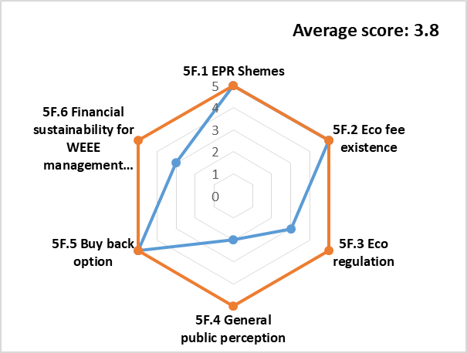

Figure 7. Scores for indicator 5F – Degree of Financial Sustainability
5F.1-EPR schemes scored 5. WEEE management system is a positive example of the implementation of Extended Producer Responsibility (EPR) (OECD, 2001). In Romania, the most important steps towards EPR were: 2006- launching of the Register of Manufacturers and Importers of EEE; 2007- national legislation on waste and WEEE, with EPR; 2014- 99% collective organizations took responsibility for WEEE (NWMP, 2017).
5F.2- Eco fee existence scored 5. The Advanced Recycling Fee (ARF) (an extra-fee associated with costs related to collection, transportation, sorting, dismantling and recycling) was positively perceived compared to Pre Disposal Fee (PDF). In Romania ARF is paid in advance by the consumer/customer and periodically collected by EPR organizations, based on sales reports from producers or importers. ARF is visible for customers, but it may be named in various ways such as “Green Stamp” (an Ecotic trademark), “Green fee”, “Eco fee” and it is applied through a legislative instrument (Ordinance 1037/2010).
5F.3-Eco regulation scored 3. The eco fee level for WEEE management in Romania (Ordinance 1441/ 2011) established that the eco fee applied by EPR organizations equals the financial guarantee and that it is different in each organization and the same for any product of the same category. Usually the producers (individually/through EPR organization) put in a financial guarantee to the Environmental Fund Administration that is given back at the end of the guarantying period, if they can prove the adequate WEEE management. Even though these mechanisms existed, there was still a lack of transparency on information availability.
5F.4 General perception of eco fee scored 2. The public perception on ARF in Romania was: 42.2%-respondents did not know it, 20.5% thought that it was an environmental tax, 12.5% that the product was “more recyclable”, 8.4% that it was a recycling fee, 6.4% that it was an additional price for a new product (Ecotic, 2016).
5F.5- Buy Back option scored 5. The system may work producer-to-customer or producer-to-RTOs (Ibanescu et al., 2018). 65.5% WEEE in Romania in 2014 were collected by the Buy Back options through regular campaigns of large EEE retailers (Ecotic, 2015b). Around 40% Romanians said that it was the main motivation for giving away the WEEE (Ecotic, 2016).
5F.6- Financial Sustainability of WEEE management system scored 3. EU introduced instruments to ensure both environmental protection and financial sustainability: WEEE collection and recycling targets, materials replacements, recycled materials market increase. However, in Romania the collection targets were not met, there was a strong informal recycling system cross-contaminating the scrap metal market, there were no incentives for recycled materials market and no official market for WEEE reuse. The key players Romanian recyclers had however the compliant technologies for WEEE recycling.
3.2.6 Indicator set 6N – Sound institutions and pro-active policies at national level
Indicator set 6N achieved an average score of 2.6 (MEDIUM performance) (Figure 8).
6N.1- Legislation and regulation scored 3. In 2014 Romania transposed Directive 2012/19/EU into the national legislation (Government Ordinance 5/2015). However, according to the National Waste Management Plan (2016), there is scarce consistency between EU and national regulations on who takes responsibilities on WEEE collection.
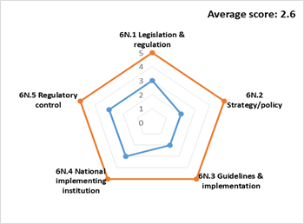

Figure 8. Scores for indicator 6N – Sound institutions and pro-active policies at national level
6N.2- Strategy/policy scored 2. In 2014, Romania issued a new National Waste Management Strategy, valid until 2020. The accompanying document, the National Waste Management Plan was adopted very late, in 2017. Both documents discuss the situation on WEEE, provide future measures and are required to work simultaneously, if for example Romania would like to access European Funds in this field of action (http://www.ecoteca.ro).
6N.3- Guidelines and implementation scored 2. Because of the mentioned delay, guidelines and implementation procedures were not available in 2014. Ecotic, together with the Romanian Environmental Protection Agency applied for a program aimed at the exchange of good practices in the field of WEEE management (http://www.caravanaecotic.ro). Although this initiative was welcomed, it didn’t substitute a set of clear guidelines.
6N.4- National implementing institution scored 3. The main national institution involved in designing and implementation WEEE management policies is ANPM (Romanian National Agency for Environmental Protection), with credits regarding EEE producers (registration, licensing), WEEE management (collection, treatment, disposal, transfer) and reporting. The Ministry of Economy, Commerce and Tourism has the role of promoting cooperation between producers and recyclers, identifying measures to foster the design and production of EEE so as to facilitate reuse, dismantling and recovery of components and materials when they become WEEE.
6N.5- Regulatory control scored 3. The regulatory control concerned: the National Environmental Guard, covering the whole WEEE management (producers, importers, retailers, collectors, treatment and recycling facilities, municipalities, RTOs); the National Environmental Fund controlling RTOs; the National Authority for Consumer Protection, keeping consumers informed on the importance of separate WEEE collection, hazardous substances in WEEE, their role in WEEE management, existence and role of the eco fee; and the Competition Council, ensuring that any anticompetitive practices across the market occurred. Although there are several institutions for control and enforcement, the unfair competition from informal/unlawful operators is an issue for lawful players (Magalini, 2018) translated in an uneven playing field.
3.2.7 Indicator set 7E – Environmental performance
The Environmental performance of the WEEE management system was evaluated by using the zero WEEE index that can be calculated through equation:
Zero WEEE index = (Q_{WEEE} _{m,i} x SF_{m,i}) /Q_{WEEE}
where: Q_{WEEE} _{m,i} = potential amount of WEEE material managed by the country and treated with i treatment (t/y); SF_{m,i}= substitution factor, based on the efficiency in replacing virgin material; Q_{WEEE} = total amount of WEEE collected in the country (t/y).
The zero WEEE index was based on the amount of material that can potentially replace the raw material inputs and on the substitution of energy, water and greenhouse gas emissions (GHG) (Zaman and Lehmann, 2013), extracted from the life cycle database of different LCA tools and database sources. The amount of materials and resources substituted was directly proportional to the level of technology of the recovery process, also depending on specific materials and WEEE management system. Four major recoverable waste streams were considered: glass, plastic, metal and other mixed recyclable components, due to data availability, to the fact that they encompass WEEE composition and the fractions that are incinerated and landfilled, to close the mass balance of inputs/outputs. The environmental performances (indicator set 7E) of Romanian WEEE management system in years 2012-2014 (Table 5) were obtained considering WEEE collected and treated within the EU borders, through recycling, incineration and landfilling.

Table 5. Environmental benefits (per capita) related to the WEEE management system in Romania in 2012-2104
 | Environmental benefits | Min. |  |  | Max.
 | Environmental benefits | 2012 | 2013 | 2014 | 2012 | 2013 | 2014
7E.1 | Water savings (L/inhab) | 1.93 | 2.86 | 2.44 | 98.22 | 140.48 | 136.62
7E.2 | GHG emissions reduction (kg CO₂eq/ inhab) | 1.06 | 1.60 | 1.56 | 10.04 | 14.44 | 14.60
7E.3 | Raw material substitution (t/ inhab) | 0.71 | 1.03 | 1.00 | 0.79 | 1.12 | 1.09
7E.4 | Energy substitution (MJ/ inhab) | 27.34 | 38.34 | 37.52 | 117.57 | 167.83 | 162.63
7E.5 | Zero WEEE index | 0.636 | 0.645 | 0.647 | 0.705 | 0.705 | 0.705

Score allocation criteria for set 7E were: score was 1 for 10% decrease of environmental benefits (in 2014 compared to 2012); 2 for 0-10% decrease; 3 for no changes; 4 for 0-10% increase; 5 for increase exceeding 10%. Indicator set 7E achieved an average score of 4.6 (HIGH performance) (Figure 9).

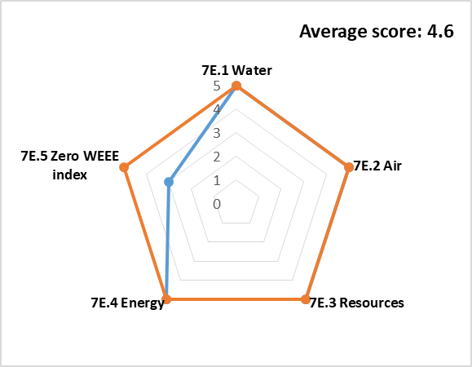

Figure 9. Scores for indicator 7E – Environmental performance

4. Conclusions

SUSTWEEE methodology for assessing the sustainability of WEEE management filled a gap in the scientific literature by using clearly defined quantitative and qualitative indicators based on official statistics and evaluated against objective criteria. It considers 4 levels: background information, WEEE generation profile (per category, according to EU legislation, and per material), WEEE technical components and sustainability assessment organized on social, economic and environmental aspects. In total 7 main categories of indicators were: 3 for the physical components– collection, treatment and disposal, resource management – reduce, reuse and recycle and 4 for the sustainability– inclusivity (user and provider), financial sustainability, sound institutions, proactive policies and environmental performance (a completely new indicator set). In all main categories of indicators, quantitative and/or qualitative types of indicators were defined. The quantitative indicators were calculated then assessed qualitatively on a LOW to HIGH grade, while the qualitative indicators were allocated scores from 1 to 5 based on criteria and transformed into LOW to HIGH grades. Colour codification was also used for rapid visualization of data.

The established level to validate SUSTWEEE was the country level, considering Romania official data for 2014. Primary data collection requires information from multiple files (legislation status, policy making, environmental reports, statistics on consumer habits, economic statistics), however, the final SUSTWEEE matrix allows a rapid overview of the situation with immediate identification of hot-spots. It can be said that WEEE management in Romania is rather complex, with heterogeneous performances in all areas.

In Romania’s case, the hot spots were represented by the very low collection rates and by the non-existent reuse rate, at least in official data. The HIGH performance areas were in: Controlled Treatment and Disposal (100% controlled WEEE treatment, 96.26% of WEEE collected treated in the country); Resource management (87.3%) due mainly to the fact that Romania has the treatment capacity to manage all the WEEE that are generated, the main issue being to get them to the treatment facility; and Environmental Performance (92%) due to an increase in its rate in 2014 compared to 2012 and 2013. The qualitative indicators generally scored average performance, being situated in the MEDIUM zone most of the time (Quality of WEEE collection, Quality of 3Rs, User and Provider Inclusivity, Sound institutions, proactive policies) and MEDIUM/HIGH areas (Degree of Environmental Protection in WEEE Treatment and Disposal, Degree of Financial Sustainability).

This work may be considered as the reference scenario in the case of national WEEE management system in a European Union country. Future work should consider the application of the SUSTWEEE methodology for a wider period, or with other WEEE management systems. The follow-up studies could also investigate how the actual, but also foreseen changes in the European or national waste management strategies on WEEE may impact the obtained results and how social, economic and technology development in terms of collection and treatment have an effect on the overall WEEE system performance. This would enable scenarios development and the results could act as basis for the decision-making process of relevant stakeholders.

Another direction for future studies should concentrate on the enhancements of the SUSTWEEE methodology itself. Depending on the studied systems, some indicators could be refined to better suit the evaluation of specific cases and also improvements in criteria formulation and score allocation may be conducted.

Acknowledgments:
This study was supported by the Romanian Ministry of Research and Innovation, CCCDI-UEFISCDI, project number 26PCCDI/01.03.2018, “Integrated and sustainable processes for environmental clean-up, wastewater reuse and waste valorization” (SUSTENVPRO), within PNCDI III.
Authors’ Contributions: Conceptualization: D. Gavrilescu, C. Teodosiu, S. Fiore; Methodology: D. Gavrilescu, A. Enache, D. Ibanescu; Data processing, analysis and validation: A. Enache, D. Ibanescu; Writing-original draft preparation: D. Gavrilescu, A. Enache; Writing—review and editing: C. Teodosiu, S. Fiore. All authors have read and agreed to the published version of the manuscript.
The authors declare no conflict of interest.

References
Ardi, R., and Leisten, R., 2016. Assessing the role of informal sector in WEEE management systems: A System Dynamics approach, Waste Manag. 57, 3–16, http://dx.doi.org/10.1016 /j.wasman.2015.11.038.
Arduin, R.H., Mathieux, F., Huisman, J., Blengini, G.A., Charbuillet, C., Wagner, M., Baldé, C.P., Perry, N. 2020. Novel indicators to better monitor the collection and recovery of (critical) raw materials in WEEE: Focus on screens, Resour., Conserv. & Recycl.157, 104772, https://doi.org/10.1016/j.resconrec.2020.104772.
Bahers J.B., and Kim, J., 2018. Regional approach of waste electrical and electronic equipment (WEEE) management in France. Resour., Conserv. & Recycl. 129, 45–55, http://dx.doi.org/10.1016/ j.resconrec.2017.10.016
Baldé, C.P., Forti, V., Gray, V., Kuehr, R., Stegmann, P., 2017.The Global E-waste monitor, Quantities, Flows and Resources.
Boldoczki, S., Thorenz, A., Tuma, A., 2019. The environmental impacts of preparation for reuse: A case study of WEEE reuse in Germany. J. Clean. Prod. 252, 119736, https://doi.org/10.1016/j.jclepro. 2019.119736
Chancerel, P. M., Meskers, C.E.M., Hagelüken, C., Rotter, V.S., 2009. Assessment of Precious Metal Flows during Preprocessing of Waste Electrical and Electronic Equipment. J. Ind. Ecol. 13, 791 - 810. https://doi.org/10.1111/j.1530-9290.2009.00171.x.
Ciocoiu, C.N., Hȋncu, D.L., Dobrea, R.C., Colesca, S.E., 2011a. Performance of WEEE management system in Romania. Recent Researches in Urban Sustainability and Green Development. 178-182. Available online at: http://www.wseas.us/elibrary/conferences/2011/Prague/USCUDAR/ USCUDAR -28.pdf
Ciocoiu, C.N., Dobrea, C., Tȃrțiu, V., 2011b. The role of consumer behavior in e-waste management system in Romania, Review Int. Comp. Manag. 1, 208-214.
Ciocoiu, C.N., and Tȃrțiu V., 2012. The role of informal sector within WEEE management systems: a Romania perspective, Theor. Empir. Res. Urban Manag. 7(1), 27-38.
Colesca, S.E., and Popescu, M.L. (2013), Managing waste electrical and electronic equipment in Romania: comparative analysis with other countries in Europe. Proceedings of the 7th International Management Conference “New Management for the New Economy”, November 7th-8th, 2013, Bucharest, Romania, 704-712. http://conferinta.management.ase.ro archives/2013 /pdf/80.pdf.
Dias, P., Bernardes, A.M., Huda, N., 2018 b. Waste electrical and electronic equipment (WEEE) management: An analysis on the australian e-waste recycling scheme. J. Clean. Prod. 197, 750-764. https://doi.org/10.1016/j.jclepro.2018.06.161.
Ecotic Retrospective Report, 2015a. Available online at: https://www.ecotic.ro/rapoarte-anuale/
Ecotic, and UN University, 2015b. Cuantificarea deseurilor de echipamente electrice si electronice generate in Romania (in English: Quantification of Waste of Electric and Electronic Equipment in Romania). Available online at: http://www.ecotic.ro/wp-content/uploads/2015/11/Studiu-DEEE-Generate-2015.pdf
Ecotic, and GBD Research 2016. Evolutie pozitiva a gradului de constientizare fata de deseurile electrice (in English: Awareness increase trend towards waste electrical and electronic equipment (WEEE) recycling. Available online at: http://www.ecotic.ro/wp-content/uploads/2015 /07/Comunicat-Studiu.pdf
EU Report 2010. Critical raw materials for the EU. Report of the Ad-hoc Working Group on defining critical raw materials.
Fiore, S., Ibanescu, D., Teodosiu, C., Ronco, A., 2019. Improving waste electric and electronic equipment management at full-scale by using material flow analysis and life cycle assessment. Sc. Total Environ. 659, 928–939, https://doi.org/10.1016/j.scitotenv. 2018.12.417
GWMO, 2015. Global Waste Management Outlook, United Nations Environment Programme.
Ibanescu, D., Cailean (Gavrilescu), D., Teodosiu, C., Fiore, S., 2018. Assessment of the waste electrical and electronic equipment management systems profile and sustainability in developed and developing European Union countries. Waste Manag. 73, 39–53, https://doi.org/10.1016/ j.wasman.2017.12.022.
Islam, M.T., and Huda, N., 2018. Reverse logistics and closed-loop supply chain of Waste Electrical and Electronic Equipment (WEEE)/E-waste: A comprehensive literature review. Resour., Conserv. & Recycl. 137, 48-75. https://doi.org/10.1016/j.resconrec.2018.05.026
Ismail, H., and Hanafiah M.H., 2019. An overview of LCA application in WEEE management: Current practices, progress and challenges. Clean. Prod. 232, 79-93, https://doi.org/10.1016/j.jclepro.2019.05.329
Leung, A.O.W, Duzgoren-Aydin, N.S, Cheung, K.C., Wong, M.H., 2008. Heavy Metals Concentrations of Surface Dust from e-Waste Recycling and Its Human Health Implications in Southeast China. Environ. Sci. Technol. 42 (7) 2674-2680.
Magalini, F., and Huisman, J, 2018. WEEE Recycling Economics- The shortcomings of the current business model, Technical Report, 12 pages.
De Meester, S., Nachtergaele, P., Debaveye, S., Vos., P., Dewulf, J., 2019. Using material flow analysis and life cycle assessment in decision support: A case study on WEEE valorization in Belgium. Resour., Conserv. & Recycl. 142, 1-9, https://doi.org/10.1016/j.resconrec.2018.10.015
Messmann L, Helbig, C., Thorenz, A., Tuma, A. 2019. Economic and environmental benefits of recovery networks for WEEE in Europe. J. Clean. Prod. 222, 655-668. https://doi.org /10.1016/j.jclepro. 2019.02.244
Morris, A., and Metternicht G., 2016. Assessing effectiveness of WEEE management policy in Australia. J. Environ. Manag. 181, 218-230,http://dx.doi.org/10.1016/j.jenvman. 2016. 06.013
NWMP, 2017. Romanian National Waste Management Plan
Nelen, D., Manshoven, S., Peeters, J.R., Vanegas, P., D'Haese, N., Vrancken,K., 2014. A multidimensional indicator set to assess the benefits of WEEE material recycling. J. Clean. Prod. 83, 305-316, http://dx.doi.org/10.1016/j.jclepro.2014.06.094
Nowakowski, P., and Mrowczynska, B., 2018. Towards sustainable WEEE collection and transportation methods in circular economy-Comparative study for rural and urban settlements. Resour., Conserv. & Recycl.135, 93-107. https://doi.org/10.1016/j.resconrec.2017.12.016
OECD, 2001. Extended Producer Responsibility: A Guidance Manual for Governments, OECD, Paris, https://doi.org/10.1787/9789264189867-en.
Özkır V.C., Efendigil T., Demirel T., Demirel N.C., Deveci M., Topcu B., (2015), A three-stage methodology for initiating an effective management system for electronic waste in Turkey, Resour., Conserv.& Recycl. 96, 61–70.
Parajuly, K, and Wenzel, H., 2017. Potential for circular economy in household WEEE management, J. Clean. Prod. 151, 272-285. http://dx.doi.org/10.1016/ j.jclepro.2017.03. 045
Păceșilă, M., Ciocoiu, C. N., Colesca, S. E., Burcea, Ș. G., 2016. Current trends in WEEE management in Romania. Theor. Empir. Res. Urban Manag. 11 (4), 46-59.
Popescu, M.L, Colesca, S. Ciocoiu, C. N., 2014. Waste Electrical and Electronic Equipment Management in Two Eu Developing Countries: Romania and Bulgaria. In: Loster, T., Pavelka, T. (eds) Proceedings of the 8th international days of statistics and economics conference, 11–13 September, 1218–1229. Prague, CZ: Melandrium.
Salhofer, S., Steuer, B., Ramusch, R., Beigl, P., 2016. WEEE management in Europe and China – A comparison. Waste Manag. 57, 27-35, http://dx.doi.org/10.1016/j.wasman. 2015.11.014
Scheinberg, A., Wilson, D.C., Rodic, L., 2010. Solid Waste Management in the World’s Cities: Water and Sanitation in the World’s Cities 2010, Earthscan on behalf of UN-HABITAT, London.
Sousa, R., Agante, E., Cerejeira J., Portela, M., 2018. EEE fees and the WEEE system – A model of efficiency and income in European countries, Waste Manag. 79, 770-780. https://doi.org/10.1016/ j.wasman.2018.08.008
Step Initiative, 2014. One Global Definition of E-waste. Solving the E-waste Problem (Step) White Paper, 13 pages, available online at: step-initiative.org/files_documents/whitepapers/ StEP_WP_ One%20Global%20Definition%20of%20E-waste_20140603_ amended.pdf
Zacho, K.O., Bundgaard, A.M., Mosgaard, M.A., 2018. Constraints and opportunities for integrating preparation for reuse in the Danish WEEE management system. Resour., Conserv. & Recycl. 138, 13-23, https://doi.org/10.1016/j.resconrec.2018.06.006.
Zaman, A.U., and Lehmann, S., 2013. The zero waste index: a performance measurement tool for waste management systems in a ‘zero waste city’. J. Clean. Prod. 50, 123-132, http://dx.doi.org/10.1016/ j.jclepro.2012.11.041.
Wilson, D. C., Rodic, L., Cowing, M. J., Velis, C. A., Whiteman, A. D., Scheinberg, A., Vilches, R., Masterson, D., Stretz, J., Oelz, B. 2015. ‘Wasteaware’ benchmark indicators for integrated sustainable waste management in cities, Waste Manag., 35, 329-342, http://dx.doi. org/10.1016/j.wasman.2014.10.006
http://www.anpm.ro/
http://www.atelierefarafrontiere.ro/
http://www.caravanaecotic.ro
http://www.ecoteca.ro
https://ec.europa.eu/eurostat/
http://ewasteguide.info/
http://www.insse.ro
https://data.worldbank.org/country/romania
https://weee-forum.org/iewd-about/

