Measurement of Dynamic Voltage Variation Effect on Instrument Transformers for Power Grid Applications

G. Crotti, D. Giordano
Istituto Nazionale di Ricerca Metrologica (INRIM),
Torino, Italy
g.crotti@inrim.it,
d.giordano@inrim.it

G.D’Avanzo, A. Delle Femine, D. Gallo, C. Landi, M. Luiso
Dept. of Engineering, University of Campania “Luigi Vanvitelli”,
Aversa (CE), Italy
mario.luiso@unicampania.it

P.S. Letizia
Politecnico di Torino,
Istituto Nazionale di Ricerca Metrologica (INRIM),
Torino, Italy
p.letizia@inrim.it

L. Barbieri, P. Mazza,
D. Palladini
Ricerca sul Sistema Energetico
(RSE)
Milano, Italy
paolo.mazza@rse-web.it

Abstract—Within the framework of distribution and transmission grids, the knowledge of Instrument Transformers (ITs) behavior in distorted conditions is a topic of great interest. Its relevance stems from the ITs wide use in metering, protection, monitoring and control applications, where their role is to reduce voltage and current to levels compatible with measuring instrument inputs. In force standards require that the performance of measuring instruments is assessed under realistic conditions. On the contrary, performance tests of ITs are generally carried out only at rated conditions, so that their behavior under actual waveforms is not fully known. To cover this gap, a suitable setup for the traceable test of Voltage Instrument Transformers (VTs) under a quite large set of static and time-varying test waveforms is developed. The paper, after a short description of the setup, shows the performance of two commercial VTs under some power quality events, that are amplitude and phase modulations and voltage dips.
Keywords—Instrument transformers, power grid, power quality, phasor measurement unit, uncertainty

Introduction
Power Quality (PQ) measurement instruments, Phasor Measurement Units (PMUs) and all metering and protection instruments installed in the distribution and transmission grids require the measurement of grid voltage and current [1]. Since in transmission and distribution grid amplitude these quantities span from hundreds of volt and tens of ampere up to hundreds of kilovolt and tens of kiloampere, transducers have to be introduced in the measurement chain, in order to reduce the signals to be acquired to the input levels of the installed measurement instruments.
By examining the standards relating the most common measuring instruments present on the power network, it can be observed that verification of their performance is required under different operating conditions and several measurement test points. For instance, as regards the PQ instruments, the IEC 62586-2 standard [2] requires tests performed in a wide amplitude range, from 5% to 150% of the nominal voltage and additional frequency test points, besides the power frequency, are indicated. Furthermore, these instruments must be tested with several distorted waveforms, for example multi-tone signals (both harmonic and interharmonic are required), typical time-varying PQ disturbance signals (f.i. dips and swells) and also signals combining several disturbances.
The IEEE C37.118.1 standard [3] and its amendment [4], focused on synchrophasor measurement methods and performance verification of PMUs, deal, among the others, with amplitude and phase modulation, frequency ramp, harmonic distortion and prescribe some tests to verify the performance of PMUs in their presence. Even if in the power grids these measuring instruments are always coupled to Instrument Transformers (ITs), currently there is a gap in the standards about IT testing, since the accuracy verification is prescribed just at power frequency or at higher frequency but with reduced amplitudes. Nowadays, several new kinds of voltage and current instrument transformers (active or passive, generally referred to as Low Power Instrument Transformers, LPIT) are available [5], but inductive voltage and current transformers (VTs and CTs) are still widely employed. The metrological performances of these sensors in presence of distorted signals significantly depend on their operating principles [6]-[11]. It has been highlighted that inductive ITs have, in particular, an intrinsic non-linear behaviour, involving uncertainty increasing up to some percent when they are used to measure harmonic disturbances [12][13]. However, the behavior of the inductive ITs in presence of non-sinusoidal and/or time-varying disturbances is still not fully addressed and methods for the performance verification of ITs have to be identified. To this end, a set up has been developed at INRIM, which is designed for the traceable characterization of VTs under a realistic set of test waveforms at rated voltage level. In particular, this setup can generate the waveforms prescribed by the IEEE C37.118.1 standard [3] for PMUs dynamic compliance verification as well as reproduce time-varying PQ disturbance.
However, it is worth to highlight that the scope of the paper is not the calibration of a PMU with input transducers: in fact, in this case it would be necessary to define accurate reference signals [17] with amplitudes in the range of tens of kilovolt.
In the paper, after a short description of the setup, examples of its applications to the different test voltage waveforms are given, with focus on the amplitude and phase modulation tests, as those suggested for Phasor Measurement Units in IEEE Std. C37.118.1.
The paper is organized as follows. Section II deals with the definition of test signals and procedures implemented by the set-up. Section III briefly recalls the measurement setup. Some experimental results of the characterization of commercial VTs are shown in Section IV. Finally, Section V draws the conclusions.

Waveform definitions and testing procedure

Signal Definition
The developed generation system is able to produce several test waveforms, compliant with standards for PMUs and PQs performance verification (mult itone, frequency ramp, dips and swells, etc.). It also allows the generation of waveforms extracted from databases or synthesized by the user.
As a first example of application, the reproduction of a voltage dip disturbance in a MV grid is addressed. To this end, a fault has been simulated to reproduce those included in the QuEEN (Quality of Electric Energy) web portal, where PQ data measured by a widespread monitoring system including 400 measurement unit installed in High Voltage(HV)/MV substations [13] distributed all over the Italian territory are reported. To this end, a detailed model of the distribution network used (Fig. 1). The model includes a Primary Substation (PS), modelled through sinusoidal three phases 132 kV, 50 Hz generator and a 40 MVA HV/MV power transformer with 2300 MVA short circuit impedance. From the PS MV bus-bar, six feeders start. The feeders include four underground cables and two overhead lines with 5 km to 25 km length. At the top of each line, a three-phase Circuit Breaker (CB) is installed and passive loads are places connected to some lines. A fault is simulated by the closure of a CB on a suitable resistor.
- Model of the considered HV/MV system.
- Amplitude modulated signal (k_{x}=0.1, f_{m}=5 Hz)
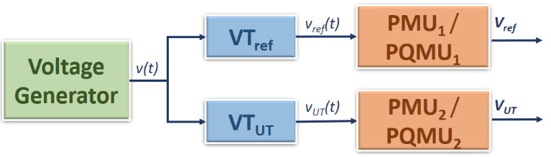
- Functional block diagram of the measurements
As regards the identification of test signals under dynamic conditions, modulated signals based on [3] are considered. They consist of a fundamental tone at power frequency (i.e. the carrier), amplitude or phase modulated, according to the following expressions:
$$v\left(t\right)=\sqrt{2}X_{m}(1+k_{x}cos⁡(2πf_{m}t))∙cos⁡(2πft)$$ | (1)
$$v\left(t\right)=\sqrt{2}X_{m}∙\cos\left(2πft+k_{a}∙cos⁡(2πf_{m}t-\right))$$ | (2)
where $X_{m}$ and $f$ are, respectively, the root mean square (rms) amplitude and the frequency of the fundamental tone, $k_{x}$and $k_{a}$ are the amplitude and phase modulation factors and $f_{m}$ is the modulation frequency.
An example of an amplitude modulated signal is shown in Fig. 2.
VT accuracy is assessed according to [14], both ratio error (ɛ) and phase error (φ) are evaluated as:
$$ε=\frac{k_{r}V_{s}-V_{p}}{V_{p}} φ=φ_{s}-φ_{p}$$ | (3)
where:
- $k_{r}={V_{p,r}}/{V_{s,r}}$ is the rated transformation ratio ($V_{p,r}$ and $V_{s,r}$ are the rated primary and secondary voltages);
- $V_{p}$ and $V_{s}$ are the rms values of the primary and secondary voltage;
- $φ_{p}$ and $φ_{s}$ are phase angles of the primary and secondary voltage.

VT Measurement Scenario
With the aim of investigating the possible errors introduced by the VT when it is used at the input of a PMU or a PQ Measurement Unit (PQMU), the measurement system configuration shown in Fig. 3 is assumed.
The reference VT (${VT}_{REF}$) and the VT under test (${VT}_{UT}$) are used to sense and reduce the same distorted voltage signal $v\left(t\right)$. Their outputs, $v_{REF}\left(t\right)$ and $v_{UT}\left(t\right)$, are acquired and processed by two identical and synchronized devices, which can be PQMUs or PMUs.
In case of PQMUs, the output quantities V_{REF} and V_{UT} are the rms values, refreshed each half-cycle (U_{rms} _{(1/2cycle)}), of $v_{REF}\left(t\right)$ and $v_{UT}\left(t\right)$; from them, the quantities of interest, that are dip duration and residual voltage, are evaluated.
For the PMU tests, the outputs are the synchrophasors of the fundamental tone, $V_{REF}$ and $V_{UT}$, from which primary and secondary voltage are obtained, as in equation (4).
$$V_{p}=k_{REF}V_{REF }V_{s}=V_{UT}$$ | (4)
In (4), $k_{REF}$ is the ratio of ${VT}_{REF}$. In turns, ratio and phase errors of ${VT}_{UT}$ are obtained from primary and secondary voltage.
In addition, the Total Vector Error (TVE) is considered for the VT performance analysis, as defined in [3][4]:
TVE=$\sqrt{\frac{{\left(Re\left({k_{r}V}_{s}\right)-Re\left(V_{p}\right)\right)}^{2}+{\left(Im\left({k_{r}V}_{s}\right)-Im\left(V_{p}\right)\right)}^{2}}{Re{\left(V_{p}\right)}^{2}+Im{\left(V_{p}\right)}^{2}}}$ | (5)
If the two measuring devices are assumed identical, linear and accurately synchronised, and are used to measure the same distorted voltage signal, the evaluated quantities (3), (4) and (5) can represent the errors introduced by the VT under test when it is used for synchrophasor measurement. Same consideration can be done if the PQ event measurement is considered.

Meaurement Setup
Starting from the hardware used for the MV VT frequency characterization, a suitable measurement setup is developed. The block diagram and the setup used for VT characterization at INRIM are shown in Fig. 4a and Fig. 4b. The system is based on a National Instruments (NI) PCI eXtension for Instrumentation (PXI) chassis. The test waveform is generated by an Arbitrary Waveform Generator (AWG, NI PXI 5422, 16 bit, ± 12 V, 200 MHz maximum sampling rate).
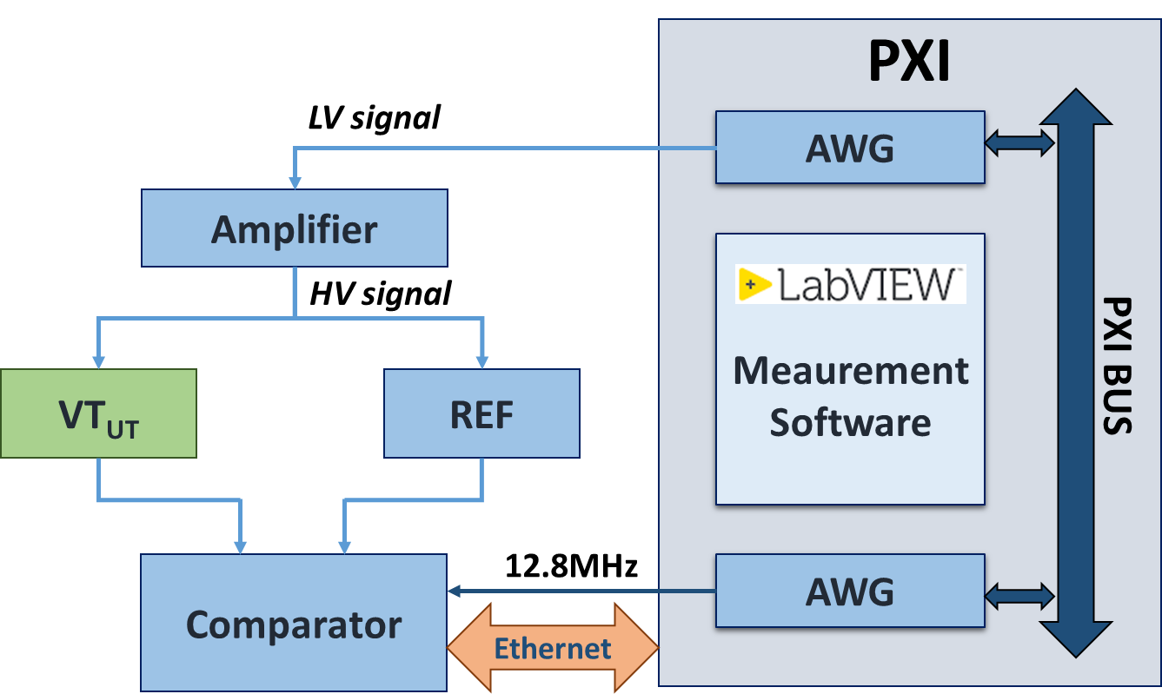a)
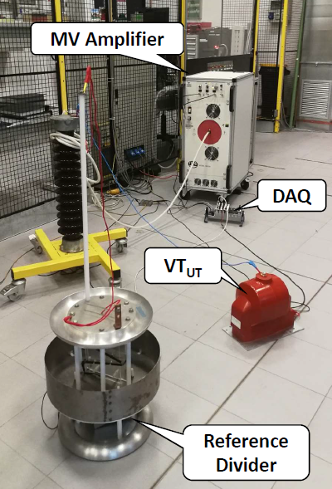b)
- Setup for the VT characterization: a) block diagram, b) experimental test bench at INRIM.
The 10 MHz PXI clock is used as reference clock for its Phase Locked Loop (PLL) circuitry. The generation frequency of the AWG is therefore chosen to be an integer multiple of the generated fundamental frequency. A second AWG is used to generate a 12.8 MHz clock, which is used as a time base clock for the signal comparator. As described in [12], the low voltage waveform from the AWG is amplified by a Trek high-voltage power amplifier (30 kV_{peak}, 20 mA_{peak}) with wide bandwidth (from DC to 2.5 kHz at full voltage and 30 kHz at reduced voltages), high slew rate (<550 V/µs) and low noise. The reference values of the applied voltage are obtained by means of a 30 kV wideband reference divider (${VT}_{REF}$ in Fig. 3) designed, built and characterized at INRIM.
The acquisition system is a NI compact Data AcQuisition System (cDAQ) chassis with four acquisition modules: NI 9225 (300 V, 24 bit, 50 kHz), NI 9227 (5 A, 24 bit, 50 kHz), NI 9239 (± 10 V, 24 bit, 50 kHz), NI 9238 (± 500 mV, 24 bit, 50 kHz). Expanded uncertainty (level of confidence of 95%) is 0.007% for the ratio error and 0.07 mrad for the phase up to 1 kHz 0. The sampling clock of the digital comparator is derived from the 12.8 MHz time base clock so that generation and acquisition are synchronized. The software for data processing and instrument control is developed in LabVIEW. A large variety of signals can be generated, such as sinusoidal, fundamental plus a harmonic tone, fundamental with N harmonics, fundamental with an inter-harmonic, modulated signal, frequency ramp, transient, typical PQ events etc. The VT primary and secondary voltage are acquired with f_{s}=50 kHz sampling frequency and 20 s acquisition time. As to the PQ event test, a different type of comparator device (Fig. 4a) has been used. The outputs of both the reference and sensor under test are acquired by an acquisition unit that is designed by RSE, to serve also as a part of a Stand-Alone Merging Unit provided with additional functions as well. This acquisition unit is equipped with a 24 bit Delta Sigma (∆Σ) Analog to Digital Converter (ADC), it has two voltage channels (100 V or 3 V), one current channel (5 A) and variable sampling frequency. The clock can be provided both internally or externally. The communication is made through a Serial Peripheral Interface (SPI) / Universal Serial Bus (USB) 2.0 Bridge interface and the control and measurement software is realized in C++ language. The prototype was characterized at RSE and INRIM and it is possible to attribute to the prototype a 110 dB Spurious-Free Dynamic Range (SFDR) [16].
Table I - VT rated characteristics
VT | V_{pr} (kV) | V_{sr} (V) | Burden (VA) | Accuracy class
A | 20/√3 | 100/√3 | 50 | 0.5
B | 11/√3 | 110/√3 | 50 | 0.5
Both PMUs and PQ algorithms are implemented through a MATLAB script. In the case of the PMU tests, because of the synchronization between generation and acquisition, the Discrete Fourier Transform (DFT) of the acquired samples is used to evaluate the voltage fundamental phasors; the observation interval is chosen equal to four cycles of the fundamental frequency and a reporting rate of 50 Hz is assumed.

Experimental Results

Devices under test
The behaviours of two different resin insulated MV VTs, whose rated characteristics are summarised in Table I are tested. All the tests described in the following were carried out with zero burden.
- VT A: Ratio error for four amplitude modulation frequencies (fm) versus time.
- VT A: Phase error for for four amplitude modulation frequencies (fm) versus time.
- VT A: Total vector errors for four amplitude modulation frequencies (fm) versus time.

Modulated signal test
The VTs have been tested using an amplitude (phase) modulated voltage signal with fundamental component at 50 Hz and rated amplitude, assuming an amplitude modulation factor of 0.1 (phase modulation factor of 0.1 rad), with modulation frequencies of 0.1 Hz, 0.2 Hz, 0.5 Hz, 1 Hz, 2 Hz, 5 Hz, in accordance with [3], [4].
Figures from 5 to 7 show the measured ratio and phase errors, expressed in percent and milliradians, respectively, and the TVEs, in percent, as a function of the analyzed frames, corresponding to a time window of 20 s, when an amplitude modulation is applied. Fig. 8 and Fig. 9 show the ratio error in percent and the phase error in milliradians when a phase modulation test is performed. The obtained behaviours show the presence of oscillations in the evaluated quantities, whose amplitude is quite constant with respect to the modulating being about 0.02% for the ratio error and 0.2 mrad for the phase for amplitude modulated test. On the other hand, the number proportionally increases with the value of f_{m}. Same behaviours, but with lower oscillation amplitudes can be observed for VT B in case of phase modulated test. These phenomena can be explained considering that: 1) the VT introduces a 50 Hz phase delay with respect to the reference device, which can be determined by carrying out a calibration under sinusoidal conditions, 2) the DFT over four 50 Hz cycles (i.e. 200 ms) is used to compute the phasors, whereas 3) the period of the oscillations varies from 200 ms to 10 s. Under the assumption of negligible phase error of the reference sensor, no deviation will be found if the VT does not introduce any phase displacement. Moreover, the results highlight that the peak to peak value of the oscillations is quite constant increasing the modulating frequency.
Looking at the mean value, in all test conditions, the analyzed indexes have almost equal value and the investigated VT remains in its accuracy class.
- VT B Ratio error for 2 Hz phase modulation frequency
- VT B Phase error for 2 Hz phase modulation frequency
- VT A vs Reference Divider Urms (1/2cycle) p.u.

Voltage dip test
The voltage dips measured by the reference sensor and by the VT A, under application of a simulated realistic voltage dip, are shown in Fig 10, where the voltage values are normalised to the MV grid rated primary value (20 kV/√3). The evaluated quantities are the residual voltage (U_{res}), and the voltage dip duration t_{dip}; according to the IEC 50160, the selected dip threshold is set to 90% of the MV line rated primary voltage U_{r}, while the hysteresis is set to 2%·U_{r}.
As regards the voltage dip duration, since the voltage time variation of the reproduced dip is very fast, no difference is measured between the duration measured by the reference divider and the VT under test (170 ms). As to the measurement of the residual voltage U_{res}, the deviation between the value obtained with the VT and the reference one reaches a maximum difference of 0.15%. This deviation is significantly lower than the quantity to be measured, but cannot be considered negligible, since it is of the same order of magnitude of the uncertainty required by the standards for the measuring instrument associated to the VT, when measuring the dip residual voltage [2].

Conclusion
A measurement approach for the quantification of the error contribution of VTs when they are involved in PQ measurement or synchrophasor measurement performed by a PMU has been presented. The developed measurement setup is modular, so it is easily extensible to the characterization of different types of sensors including current transformers LPITs with analog and digital output.
First tests performed on commercial VTs for MV applications have proved the feasibility of the proposed approach. By the developed system, investigations about the VT performance will be possible, by varying other parameters, such as fundamental amplitude, frequency and phase. VTs with different rated characteristics and of different types will be also investigated.
Thanks to the large set of implemented test waveforms, the same generation and measurement system will be used to test the sensors in presence of several phenomena including typical PQ disturbances.

Acknowledgement
The work presented in this paper was funded by EMPIR, 17IND06 Future Grid II project, which is jointly funded by the EMPIR participating countries within EURAMET and the European Union.

References
- E. Mohns, G. Roeissle, S. Fricke and F. Pauling, "An AC Current Transformer Standard Measuring System for Power Frequencies," in IEEE Transactions on Instrumentation and Measurement, vol. 66, no. 6, pp. 1433-1440, June 2017.
- IEC Standard Power quality measurement in power supply systems- Functional tests and uncertainty requirements. IEC 62586-2, 2015.
- IEEE standard for synchrophasor measurements for power systems. IEEE Std C37.118.1-2011, pages 1– 61, Dec 2011.
- IEEE standard for synchrophasor measurements for power systems – amendment 1: Modification of selected performance requirements. IEEE Std C37.118.1a-2014, pages 1–25, April 2014.
- B. Kerr, L. Peretto, N. Uzelac, and E. Scala “Integration challenges of high-accuracy LPIT into MV recloser”, CIRED - Open Access Proceedings Journal, 2017(1):260–263, 2017.
- A. Cataliotti, D. Di Cara, A. E. Emanuel, S. Nuccio, "Improvement of Hall Effect Current Transducer Metrological Performances in the Presence of Harmonic Distortion", IEEE Trans. on Instrumentation and Measurement, vol. 59, no. 5, May 2010, pp. 1091-97.
- R. Stiegler, J. Meyer, J. Kilter and S. Konzelmann, "Assessment of voltage instrument transformers accuracy for harmonic measurements in transmission systems", 2016 17th International Conference on Harmonics and Quality of Power (ICHQP), Belo Horizonte, 2016, pp. 152-157.
- M. Faifer, R. Ottoboni, M. Prioli, and S. Toscani, "Simplified Modeling and Identification of Nonlinear Systems Under Quasi-Sinusoidal Conditions, IEEE Trans. on Instrument. and Measur., vol. 65, no. 6, June 2016.
- A. Cataliotti, V. Cosentino, D. Di Cara, S. Nuccio, G. Tinè, "Rogowski coil current transducer compensation method for harmonic active power error", Measurement, vol. 63, Mar. 2015, pp. 240-251.
- G. Crotti, A. D. Femine, D. Gallo, D. Giordano, C. Landi and M. Luiso, "Measurement of the Absolute Phase Error of Digitizers," in IEEE Transactions on Instrumentation and Measurement. doi: 10.1109/TIM.2018.2888919.
- A. J. Collin, A. Delle Femine, D. Gallo, R. Langella and M. Luiso, "Compensation of Current Transformers' Non-Linearities by Means of Frequency Coupling Matrices," 2018 IEEE 9th International Workshop on Applied Measurements for Power Systems (AMPS), Bologna, 2018, pp. 1-6. doi: 10.1109/AMPS.2018.8494893.
- G. Crotti, D. Gallo, D. Giordano, C. Landi, M. Luiso and M. Modarres, "Frequency Response of MV Voltage Transformer Under Actual Waveforms," in IEEE Transactions on Instrumentation and Measurement, vol. 66, no. 6, pp. 1146-1154, June 2017.
- R. Chiumeo, A. Porrino, L. Garbero, L. Tenti, M. de Nigris “The Italian Power Quality monitoring system of the MV network results of the measurements of voltage dips after 3 years campaign” CIRED - 20th International Conference on Electricity Distribution, Prague, 8-11 June 2009.
- Instrument transformers - Part 2: Additional requirements for voltage transformers. IEC 61869-3 (2013).
- .G Crotti; D. Gallo; D. Giordano; C. Landi; M. Luiso; "Industrial Comparator for Smart Grid Sensor Calibration," IEEE Sensors Journal, vol. 17, no. 23, pp. 7784-7793, Dec.1, 1 2017.
- P. Mazza, L. Barbieri, M. Gondola, M. Faifer, C. Laurano, R. Ottoboni, S. Toscani, M. Zanoni, “Metodologie e strumenti per la verifica e il miglioramento delle misure di tensione, corrente ed energia in Alta Tensione”, (http://www.rse-web.it), March 2018.
- G. Frigo, D. Colangelo, A. Derviškadić, M. Pignati, C. Narduzzi and M. Paolone, "Definition of Accurate Reference Synchrophasors for Static and Dynamic Characterization of PMUs," in IEEE Transactions on Instrumentation and Measurement, vol. 66, no. 9, pp. 2233-2246, Sept. 2017.

