Waste heat to power by means of a thermomagnetic colloidal energy harvester
Erik Garofalo^{1,2}*, Fabio Mattiussi^{1,2}, Giuseppe Fortunato^{1,2}, Michele Iovieno², Luca Cecchini^{1,2}, Matteo Bevione^{1,2}, Alessandro Chiolerio¹
¹ Istituto Italiano di Tecnologia, Center for Sustainable Future Technologies, Corso Trento 21, 10129 Torino, Italy
² Politecnico di Torino, Corso Duca degli Abruzzi 24, 10129 Torino, Italy
email: erik.garofalo@iit.it
Abstract

Energy utilization, sustainability and care for the environment are now under the spotlight; dealing with energy must take into account the non-unitary efficiency of any thermodynamic process and the consequent production of waste heat, playing a crucial role in global warming. A valuable approach to tackle this problem is to capture and reuse the waste heat, providing an attractive opportunity for an emission-free and cost-effective energy resource. Waste heat to power is the process of converting the heat discarded in electricity, via thermodynamic cycles, thermoelectric materials, pyroelectric materials. Here, a new ThermOmagnetic hydRODYNAmic energy harvester (TORODYNA) exploiting a commercial ferrofluid, is presented. The lab-scale prototype has a toroidal geometry adopted from the well-known tokamak reactor. Peltier modules are used to generate the thermal gradient between the two sides of the reactor, that combined with the effect of permanent magnets trigger the advection. To extract and ensure the output electrical energy, the structure is wrapped-up with coils and connected to an impedance and pico-amperometer. Two coil configurations (purely poloidal and mixed poloidal/toroidal windings) are tested, in a heterogeneous water-ferrofluid two-phase flow, reaching a maximum extracted electrical power of 10.4 μW/K from a thermal gradient of 10 K, which is approximately 20% of the ideal Carnot efficiency of a thermal machine working in the same temperature drop. Furthermore, numerical analysis of the system has been performed developing a Fortran™ code in an Eulerian framework, using Galerkin approximation and harmonic functions.

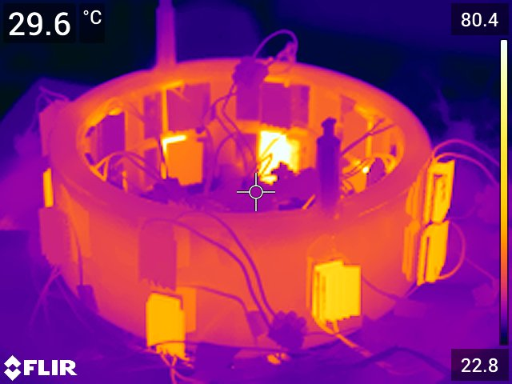

Figure 1. Side view of the operational TORODYNA with a thermal camera.
References

[1] Garofalo, Erik and Cecchini, Luca and Bevione, Matteo and Mattiussi, Fabio and Chiolerio, Alessandro, “Waste Heat to Power: Technologies, Current Applications and Future Potentials.” Submitted to Progress in Energy and Combustion Science.
[2] Chiolerio, Alessandro and Quadrelli, Marco B., “Colloidal Energetic Systems”, Energy Technology 1800580, 2019.
[3] N. S. Mousavi and S. Kumar, “Effective heat capacity of ferrofluids e Analytical approach,” International Journal of Thermal Sciences, vol. 84, pp. 267-274, 2014.
[4] Suslov, Sergey A., “Thermomagnetic convection in a vertical layer of ferromagnetic fluid”, Physics of Fluid, vol. 20, pp. 084101-1-084101-17, 2008.

Acknowledgements

The Authors wish to thank Politronica Inkjet Printing S.r.l. for providing the 3d printed prototype of the TORODYNA vessel for free.

