A High Gain S-band Slot Antenna with MSS for CubeSat
Faisel EM Tubbal, Raad Raad, Kwan-Wu Chin, Ladislau Matekovits, Brenden Butters, and Gianluca Dassano
Abstract— Cube satellites, aka CubeSats, are a class of tiny satellites that have become popular for space programs. This is because they can be built using commercial off-the-shelf components. Moreover, CubeSats can communicate with each other, and assemble into swarms to carry out different functions; e.g., wide area measurements and sensing. Swarms of CubeSats also have the effect of increasing the contact period with ground stations. These capabilities require CubeSats to be equipped with an efficient, high gain, small antenna to facilitate cross-link or inter-satellite communications. Henceforth, this paper presents a high gain coplanar waveguide (CPW)-fed slot antenna for CubeSats. A key feature is the use of a Metasurface Superstrate Structure (MSS) to significantly improve gain and reduce back-lobe level. This also has the advantage of minimizing interference to components inside a CubeSat. We have evaluated the antenna comprehensively using the High Frequency Simulator Structure (HFSS) as well as a 3U (10 x 10 x 30 cm³) CubeSat platform. We have studied the effect of MSS element sets and their position and the effect of a 3U CubeSat body on the performance of the proposed antenna. The experimental results confirm that our antenna achieves a return loss of 21.5 dB and a fractional impedance bandwidth (BW) of 55.91% with S₁₁ ≤ -10 dB and has a simulated and measured superior gains of 9.71 and 8.8 dBi respectively at the desired frequency of 2.45 GHz. In contrast, amongst all previous S-band planar antennas that are suitable for CubeSats, the best gain is only 5.96 dB at 2.45 GHz.

Index Terms— CubeSat, metasurface superstrate structure, S-band, gain improvement, satellite, slot antenna.

INTRODUCTION
Cube satellites have opened the door to cost-effective missions that allow universities, small companies or small countries to gain experience in space technology, and to be involved in space exploration and research [1]. CubeSats are small satellites weighing no more than 1 kg and operate in low Earth orbits, e.g., sun-synchronous, at altitudes of 200 to 600 km [2]. All cube satellites have a fixed face size of 10 cm×10 cm with the following depth configurations: 10 cm (1U), 20 cm (2U), and 30 cm (3U). Advantageously, they can be constructed using Commercial Off-The-Shelf (COTS) electronic components [3]. A key feature of CubeSats is their potential to form a collaborative swarm that covers a large geographical area. The resulting swarm allows CubeSats to have a longer contact time with ground stations and enables them to collectively take multiple measurements; consequently, they allow users to conduct comprehensive assessments of a given geographical region that otherwise would be impossible with a single conventional satellite [4, 5].
CubeSats operating in a swarm require reliable cross-link communications. A key challenge is to be able to establish cross-links without a priori position knowledge. An obvious solution is to use omnidirectional antennas but they are inefficient because they incur high power consumption and emit radiation that permeates all directions. Also, they have low gains, and hence, they can only afford low data rates and short communication distance. Ideally, CubeSats should employ an antenna with wide coverage while at the same time have high gains in the desired direction. The design challenges are the limited size and low mass of CubeSats. Another challenge is that CubeSats are difficult to reorient and reposition due to the aforementioned limitations (they will require a more complex propulsion system and control mechanisms such as torque wheels which add to the weight), hence an antenna with wide coverage is suitable.
To address the aforementioned challenges, planar antennas are ideal. They are low-cost, have a low profile, light weight, are easily integrated with electronic devices and can achieve high gains. Henceforth, in this paper, we propose a high gain coplanar waveguide (CPW)-fed slot antenna that operates at 2.45 GHz (S-band) and in particular we will demonstrate its performance when mounted on a 3U CubeSat. A key feature is the use of a Metasurface Superstrate Structure (MSS) [6] {R. W. Ziolkowski, Jul. 2003 #78}as a resonant cavity model. This allows our antenna to have high gains because the MSS redirects the back radiation pattern forward [7]. Advantageously, its use allows our antenna to occupy less space than using a reflector as in [8].
Table I compares the proposed CPW-fed slot antenna against competing designs. Observe that the designs of [3] and [9] achieve beam steering using phase shifters and beam forming algorithms. However, this adds extra cost and complexity. The design in [10] is a simple monopole antenna that provides wide directivity without the need for beam steering techniques. It, however, has a low total gain. Another drawback of [10] is its deployment mechanism that incurs extra cost and complexity. Also, there is a risk it might not deploy, which contributes to the likelihood of mission failure. In terms of size, the antenna in [11] has the smallest area of 75 mm×75 mm but its main limitation, as pointed out by the authors, is the resulting low gain, i.e., 1.53 dBi, because of its bi-directional radiation [12]. To solve this problem, one common approach is to redirect the back radiation pattern forward by placing a backing metallic reflector that is λ/4 away from the antenna [8]. Its main drawback, however, is its large profile structure due to the λ/4 spacing between the reflector and the antenna. Moreover, the authors of [13] propose to place two S-band patch antennas on two faces of the CanX-4 and CanX-5 CubeSats to achieve omni-directional coverage and a data rate of 10 kbps. In another example, the authors of [3] propose to use a square patch antenna array. The antenna array is fed at 0⁰, 90⁰, 180⁰, and 270⁰ to achieve beam steerability using a phase shifter. In contrast, our antenna design achieves a superior simulated and measured gains of 9.71 and 8.8 dBi at 2.45 GHz respectively. This is important as it enables long distance communications. Consequently, fewer CubeSats will be required to operate in a swarm. Moreover, it further reduces the cost related to manufacturing and placing a satellite into orbit. Moreover, as our design uses a MSS to suppress back radiation, there is less interference with components inside a CubeSat. Note that we do not consider other types of antennas because they have a large profile, require deployment mechanisms and occupy a large area [14].
The rest of the paper is organized as follows. Section II describes the geometry of the proposed CPW-fed slot antenna and its MSS. Section III generalizes the design procedure and studies the influence of lengths and widths of feed section, tuning stub and the position of MSS. Section IV compares the simulated and measured results of return loss, and radiation patterns. The paper concludes with Section V.

Antenna Configuration
In this work, we redesign the antenna presented in [15] for the purposes of our CubeSat mission. Namely we modify the two square panels in either corner of the patch and readjust most dimensions and eventually add a focusing metasurface and then test on an Aluminum CubeSat body. This all results in much higher gain than what was reported in [15] and is suitable for the application for inter-CubeSat communication at our required operating frequency of 2.45 GHz.

Table I. Comparisons Between Antennas for Inter CubeSat Communications and Proposed Antenna
Reference | Type of Antenna | CubeSat Type | Frequency  [GHz] / band | Gain [dBi] | Volume  [mm³] | Beam Steering
Proposed antenna | CPW-fed slot antenna | 3U | 2.45 | 9.71 | 90×90 ×10.5 | Not required
[11] | A square slot antenna | 1U | 2.45 | 1.53 | 75×75 ×1.6 | Not required
[3] | Phased patch antenna array with 90⁰ hybrid | 1U | 5.8 | 5.1 | 90×90×5 | Electronic pointing  (using phase shifter)
[13] | Patch antenna | 1U | S-band | N/A | N/A | Not required  (Omnidirectional)
[9] | Six individual patch antennas. Each is placed on a different face of a CubeSat | 3U | 2.45 | 4.8 | N/A | Beam-forming algorithm
[10] | Four monopole antennas | 2U and 3U | 0.437 | N/A | N/A | Not required  (Omnidirectional)

Fig.1 shows the geometry of the proposed CPW-fed slot antenna. The slot and the feed line are etched on a square FR4 substrate with a dielectric constant of 4.4 and a substrate thickness of 1.6 mm. This FR4 substrate is commonly used in antennas designed for CubeSats [3]. Small thickness FR4 substrate provides good performance for antennas that operate in the frequency range of 2-10 GHz [16, 17] . The antenna is fed by a 50-Ω CPW with a strip line width of W_{f} = 3.4 mm and is separated from the ground plane by two gaps with width g = 0.45 mm and T = 1.65 mm. In addition, by using the lightening shape of feedline, a Circularly Polarization (CP) radiation characteristics is achieved. This lightening-shaped feedline is formed by extending the signal strip of the CPW in the -y direction to the lower left corner of the horizontal feed section. This lightening-shaped feed-line has horizontal and slanted (S) feed sections with the same width of W_{s} = 3.75 mm and the slant angle is 45º. The main idea of connecting the slant and horizontal sections at 45º is generating a displacement shift of quarter cycle between the feeding signal fields to obtain an excitation of two orthogonal modes (which are 90º phase difference). This is important as it provides a CP and enhances the Axial Ratio (AR) bandwidth. The horizontal feed section is separated from the lower and left edges of the slot by two gaps of width T and g, respectively. Moreover, tuning stubs are embedded in the feed-line structure to widen the impedance bandwidth by shifting and combining the second operating frequency with the first operating frequency. As shown in Fig. 1 (a), the vertical tuning stub is formed by extending L_{n} along the CPW’s signal line, whereas the horizontal tuning stub is formed by extending the horizontal feed section to the right by L_{t}=7.5 mm as measured from the right edge of the center signal line of the CPW.
Fig. 1 (b), (c) and (d) show a MSS that is comprised of a 7 × 6 Closed-Square Resonator (CSR) array. It is printed on an inexpensive 0.8 mm thick (h₂) FR-4 material. This MSS has dimension 90 mm × 78 mm and is placed above the slot antenna. The physical parameters of DCSR are as follows: P = 10 and b = 9 mm. More details about the physical parameters of MSS can be found in reference [7]. We have selected the square-shaped metasurface elements because it provides better performance and results. CSR achieves in-phase reflection of the incident waves and provide a uniform current distribution over unit cells that flows in one direction. This is important as it leads to an increase in the antenna gain and directivity. Moreover, as compared to 3-D metamaterial structure, the proposed 2-D square-shaped metasurface are easy to construct, cheaper and occupy less space [18]. Moreover, used MSS structure has no effect on the proposed antenna polarization.

Results and Discussion
This section outlines a parametric study that aims to identify factors that affect antenna performance; i.e., return loss, impedance bandwidth, gain and radiation pattern. Moreover, in Section III.B we compare simulated and experimental results.

Parametric Study
We now present various parametric analyses conducted using HFSS [19]. We focus on the best return loss, impedance matching, and gain at the operating frequency of 2.45 GHz, In order to optimize for the best parametric, the Quasi Newton method in HFSS was used. The Quasi Newton method is computer-aided finite element method-based optimization tool. It works on the basis of finding the minimum or maximum of a cost function by varying the variables to meet the constraints. In our case, the decision variable is the antenna dimensions with different ranges (minimum to maximum. The aim is to achieve the best antenna performance, i.e., maximum return loss and gain (design parameter) at operating frequency of 2.45 GHz (constraint). Therefore, the Quasi-Newton method maximizes the value of return loss (RL) by varying the antenna dimensions, i.e., lengths, width or height, 100 times (iterations) for a given range by minimum and maximum step sizes.
Table II lists the optimal parameters of the proposed antenna.
Table II. Optimal Parameters of the Proposed Antenna
Parameters | Values (mm)
G | 90
L | 60
W | 60.3
W_{n} | 2.15
W_{s} | 3.75
L_{n} | 12.8
L_{t} | 7.5
h_{a} | 8.1
T | 1.65
g | 0.45
W_{f} | 3.4
S | 55.8

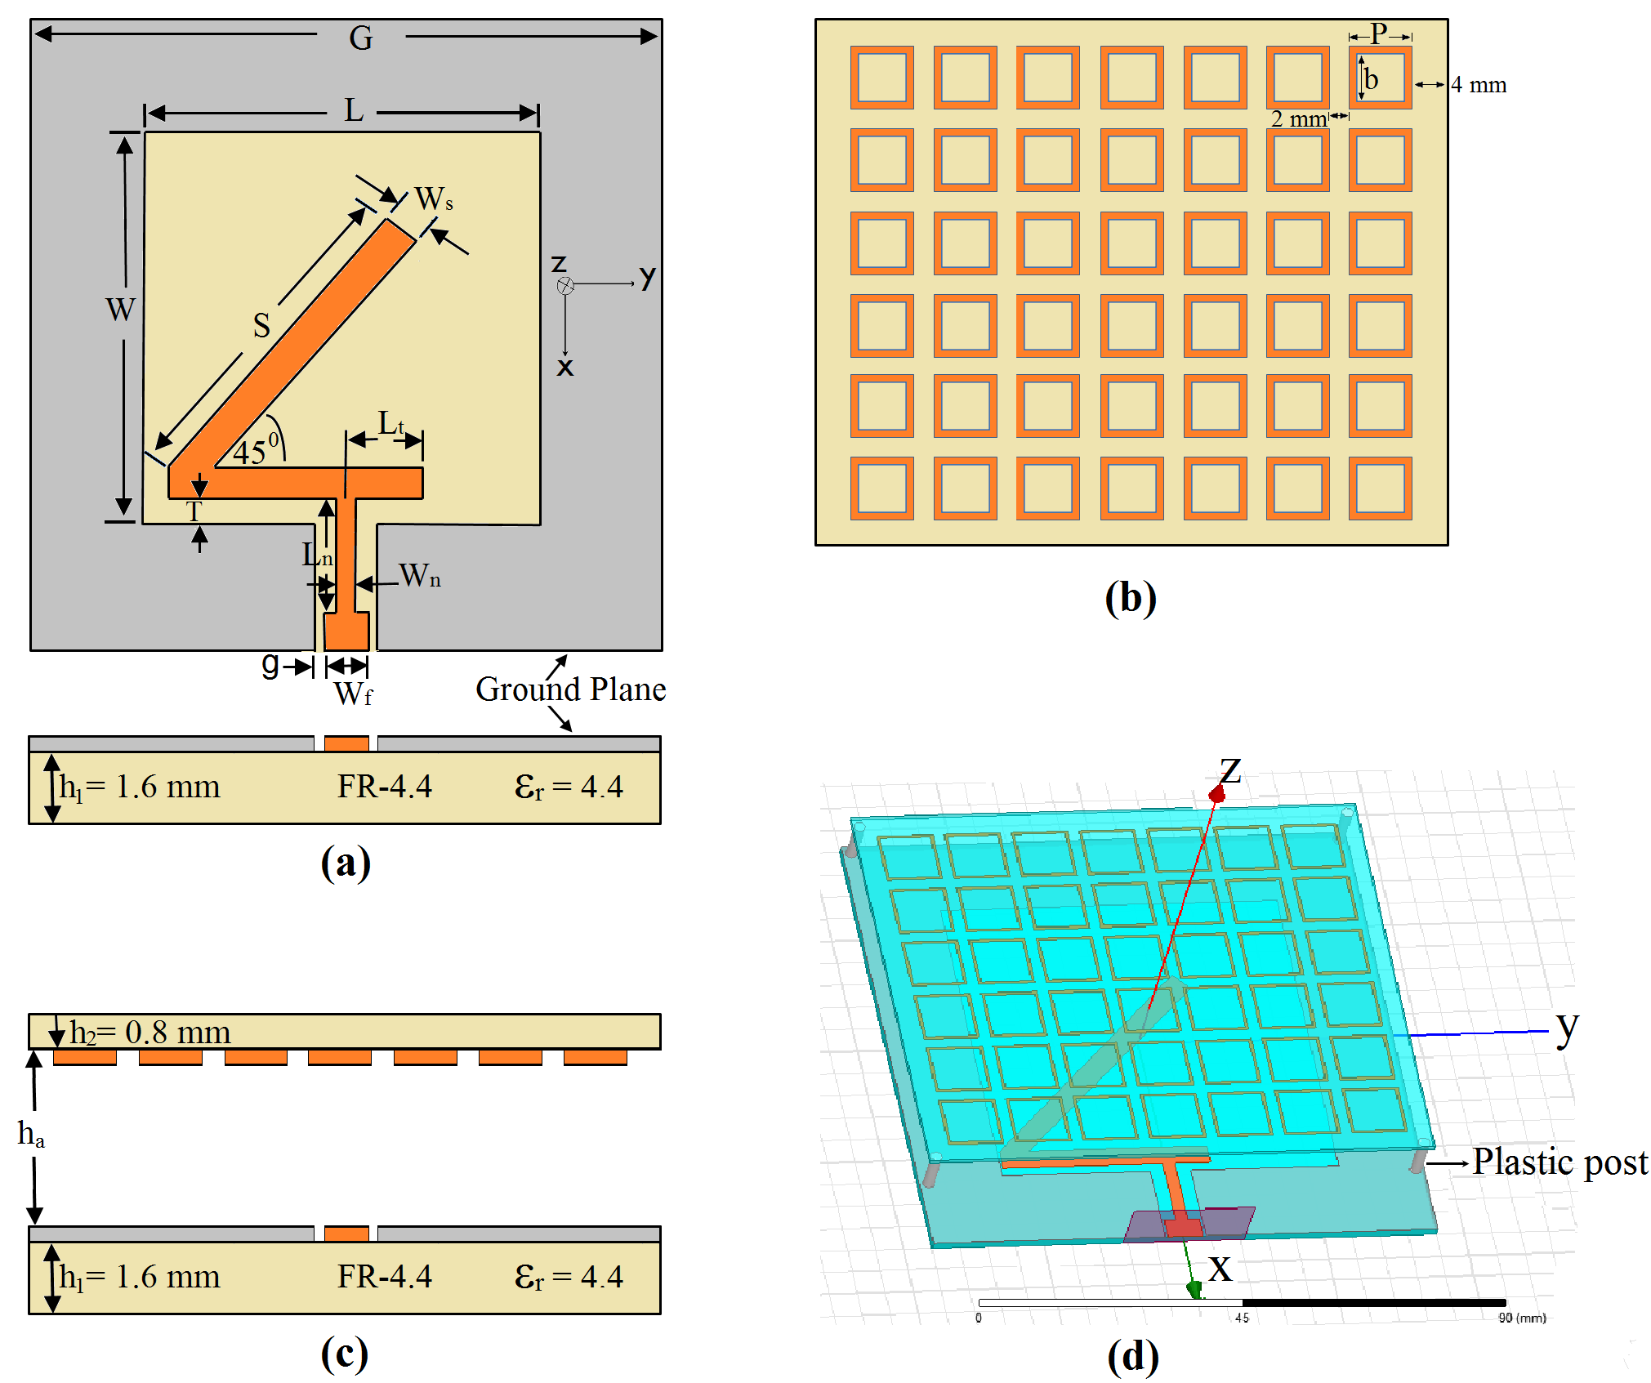
Fig. 1. Configuration of CPW-fed slot antenna with MSS (a) the proposed CPW-fed slot antenna, (b) MSS, (c) a cross section view, and (d) the model in HFSS

Design Frequency and Initial Parameters
The target operating frequency is f_{t}=2.45 GHz which is commonly used by the CubeSats community due to its high bit-rate and is within the 2.4-2.5 GHz unlicensed Industrial, Scientific and Medical (ISM) band [20]. The antenna operating frequency is varied by controlling its size as per F=f₀/f_{t}, where f₀ = 3.675 GHz is the obtained resonant frequency of the initial obtained design over the specified dimensions, i.e., 60 mm × 60 mm. As the obtained frequency of the initial design is 3.65 GHz, the antenna size needs to be increased by F to ensure it operates at the desired resonant frequency of f_{t} with maximum return loss (R_{L}). In order to determine the best value of F, we used the Quasi Network method [21], which is part of HFSS package. The Quasi Newton method works on the basis of finding the minimum or maximum of a cost function by varying the variables to meet the constraints. In our case, the decision variable is the length of the antenna’s dimensions with range 0.653 (minimum) to 1.959 mm (maximum). The aim is to achieve a maximum return loss (design parameter) at operating frequency of 2.45 GHz (constraint). Therefore, the Quasi-Newton method minimizes the value of reflection coefficient (S₁₁) and hence maximize R_{L} by varying the antenna lengths 100 times (iterations) from 0.653 to1.959 mm by minimum and maximum step sizes of 0.013 and 0.13 mm respectively. The results show that the antenna size must be increased by a factor of 1.5 mm to achieve a maximum return loss of 21.5 dB at an operating frequency of 2.45 GHz.

Effect of W_{n} and L_{t}
Fig. 2 (a) illustrates the return loss (R_{L}) with the following widths (W_{n}): 1.8, 2.15 and 3.15 mm. Other parameters are fixed. We see that the width W_{n} of the tuning stub has an effect on impedance matching, operating frequency and impedance bandwidth. When the width W_{n} increases, e.g., exceeds 2.15 mm, the return loss decreases and the impedance bandwidth (BW) improves; we observe that BW increases proportionally with W_{n}. Also, the operating frequency is slightly increased when W_{n} increases and vice-versa; The best value of W_{n} is 2.15 mm, which gives good impedance matching with input impedance of about 49 ohms and hence low reflected power at the target resonant frequency of 2.45 GHz. This is because of the excitation of the magnetic currents at operation frequency of 2.45 GHz with W_{n} = 2.15.
Fig. 2 (b) shows the simulated return loss of the proposed CPW-fed slot antenna for the following L_{t} lengths: 6.5, 7.5 and 8.5 mm. We see that L_{t} also has a significant effect on the operating frequency and return loss. As the length of the horizontal feed section increases, the return loss and the operating frequency decrease. The highest return loss is achieved at L_{t}=6.5 mm. However, the operating frequency shifts to 2.55 GHz. The most suitable L_{t} value is 7.5 mm. This value shifts the operating frequency from 2.55 to 2.45 GHz with a return loss of 27.5 dB and bandwidth of 730 MHz (1.9 – 2.63 GHz).

Effect of L_{n}
With the width of the tuning stub fixed at W_{n} = 2.15 mm and the length of the horizontal feed section set to L_{t} = 7.50 mm, we then study the following L_{n} values: 11.80, 12.80 and 13.80 mm. Referring to Fig. 3, the length L_{n} has a significant effect on the return loss and the impedance bandwidth. As the value of L_{n} increases, the return loss decreases. This means more power is reflected instead of being radiated into space. Moreover, the BW decreases proportionally with L_{n}. The highest return loss is achieved at L_{n}=11.8 mm. However, the operating frequency is not at the required operating frequency of 2.45 GHz. The most suitable length is L_{n}= 12.80 mm as it provides high return loss (R_{L} = 27 dB), and wide bandwidth of 750 MHz at the required operating frequency of 2.45 GHz.
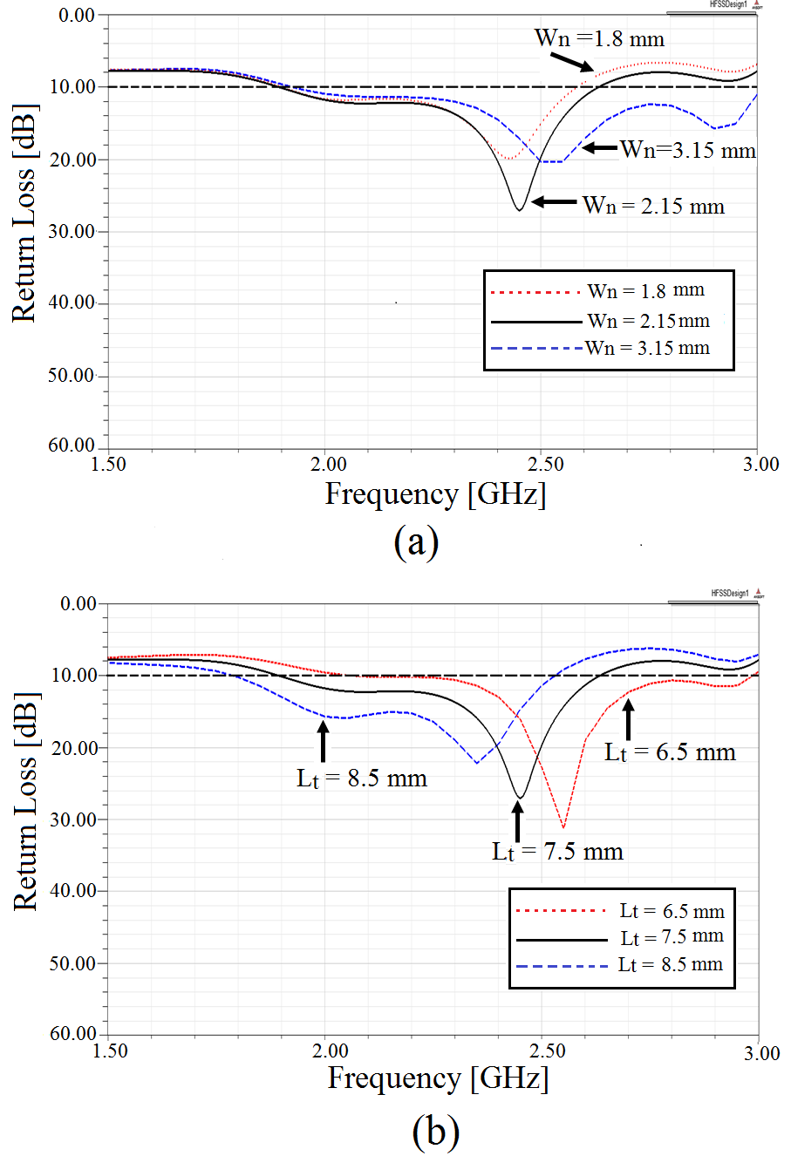
Fig. 2. Simulated return loss against frequency for various (a) W_{n}, and (b) L_{t} values.

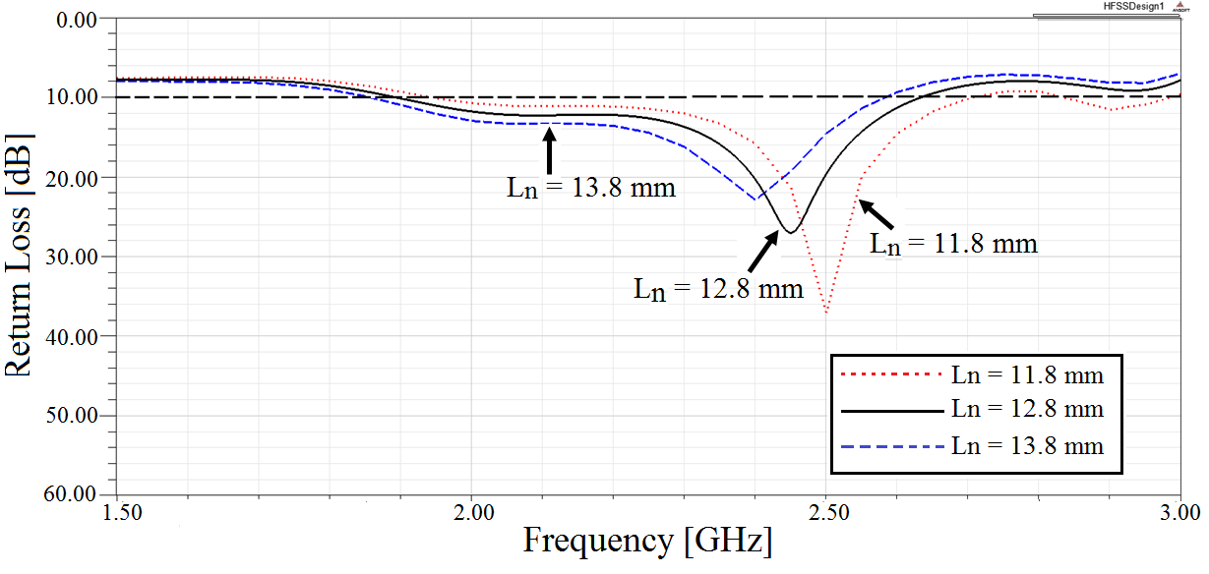
Fig. 3. Simulated return loss against frequency for various values of L_{n}.

Effect of metasurface starting positions
Fig. 4 shows (a) the simulated return loss (R_{L}) and (b) the simulated 2D gain for the following MSS positions: 0, 6, and 12 mm from the bottom CPW feed at MSS height of 8.1 mm. 12 mm from the feed line. Other parameters are fixed. MSS positions have a significant effect on the return loss. We can see that the return loss (R_{L}) decreases and the gain decreases when the MSS starting position is close to the feed line, e.g., 0 and 6 mm. There is almost no change to the resonant frequency of 2.45 GHz. Therefore, the starting position of 12 mm from the CPW feed in the -x direction yields the best result. This is because it gives the highest return loss (good impedance matching), e.g., 36.5 dB, and highest gain, e.g., 5.20 dBi, at the required operating frequency of 2.45 GHz.
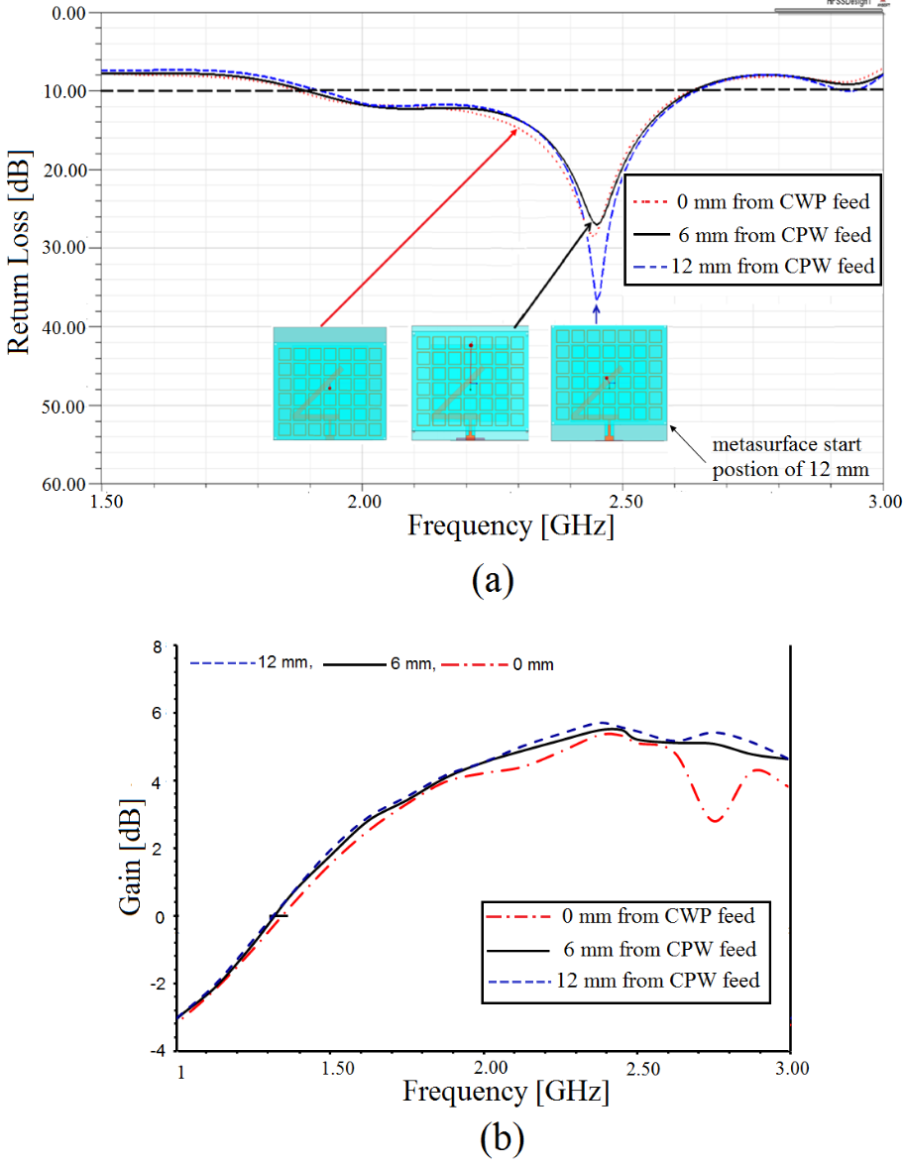
Figure 4. The effect of the starting edge of the MSS position on (a) the Return Loss RL, and (b) antenna gain.

Effect of metasurface array element sets
As shown in Fig. 5 the array element sets of the MSS have a significant effect on the return loss and hence, impedance matching. As the number of elements increases, the operating frequency approaches the operating frequency of 2.45 GHz and return loss increases. We have tested different array element sets. We found that the most important sets that have a significant effect on return loss are 7x2, 7x4 and 7x6. Thus, we only focus on these sets from here onwards. Fig. 5 shows that a 7 × 6 array element set is ideal because it achieves the highest return loss; i.e., 36.5 dB at an operating frequency of 2.45 GHz.
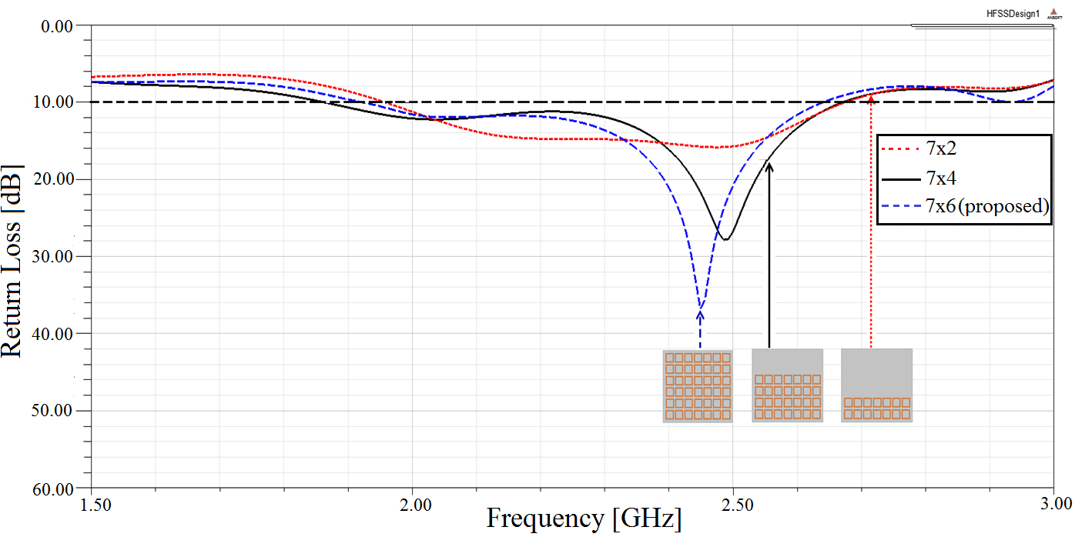
Fig. 5. The influence of MSS element sets over the return loss of the proposed antenna

Effect of metasurface height
We now study the effect of MSS height on the impedance matching by varying the MSS height from 4.1 to 10.1 mm; see Fig 6. Heights of h_{a}= 4.1 and 6.1 mm result in smaller return loss as compared to h_{a} = 8.1 and 10.1 mm. In the case of h_{a} = 8.1 mm, the obtained impedance bandwidth (VSWR ≤ 2) is wide, i.e., 130 MHz (2383 – 2513 MHz), and the return loss is very high, i.e., 36.8 dB. This means large bandwidth, low reflected power and good impedance matching. This is because at h_{a} = 8.1 mm, a good coupling between the MSS and the slot antenna is achieved with only a single resonant mode excited at the operating frequency of 2.45 GHz.
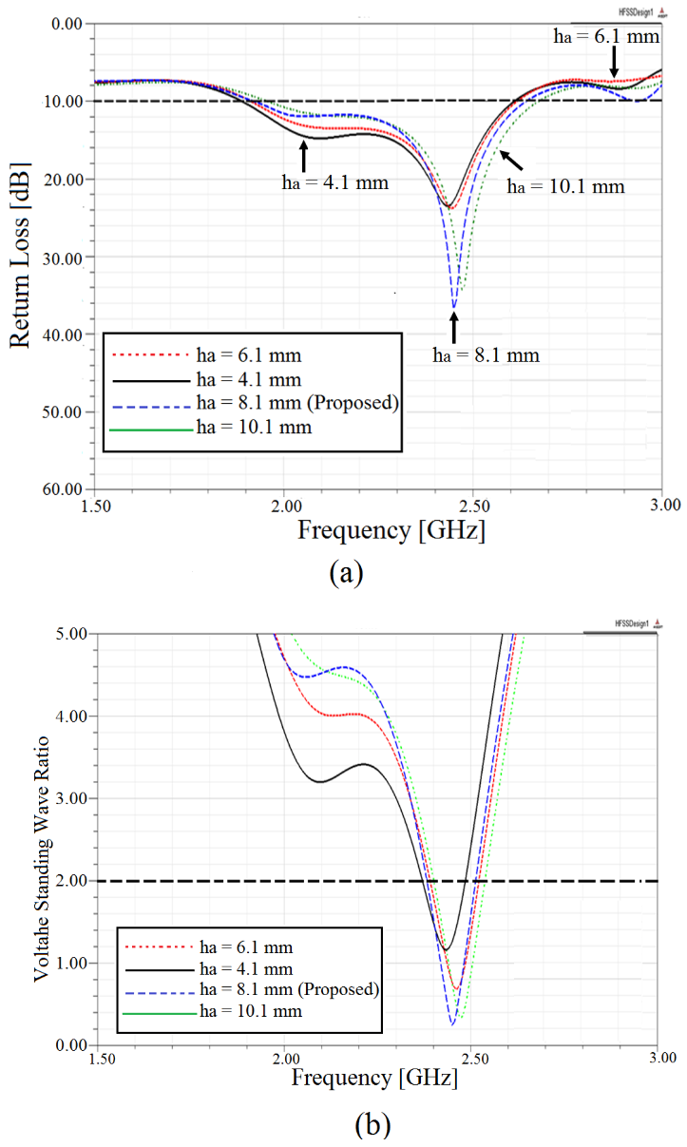
Fig. 6. The MSS height, i.e., h_{a}, as a function of (a) the return loss and (b) VSWR of the proposed antenna.

Effect of MSS
We now study the effect of MSS on antenna gain. We fix the width of the tuning stub at W_{n} = 2.15 mm, the length of the horizontal feed section at L_{t} = 7.50 mm, the length of the tuning stub at L_{n} = 12.8 mm, the MSS array set has 7 × 6 elements and we set the MMS height, i.e., h_{a}, to 8.1 mm. Fig. 7 shows the total gain of the CPW-fed slot antenna with and without the use of MSS. We can see that the use of the MSS dramatically increases the antenna’s gain from 2.52 to 5.67 dBi. Moreover, the amount of back lobe radiation has been further reduced from -9.9 to -8.7 dBi. This is important as it increases the total antenna gain. We conclude that MSS has a significant effect on the antenna gain; we observe decreases in the back-lobe pattern. In turn, this dramatically increases (improves) the proposed antenna total gain. The main idea is that when the antenna is tuned to the resonant frequency of the MSS, the radiated electrical field spread over a larger radiating aperture enhancing its gain. The use of MSS provides more radiating slots as compared to only one radiating slot for antenna without MSS. This is important as it results in a wide effective area. Moreover, the metasurface picks up the radiated power, confines it over a larger area on top of the antenna and then re-radiates. This improves the boresight radiation and reduces the back radiation.
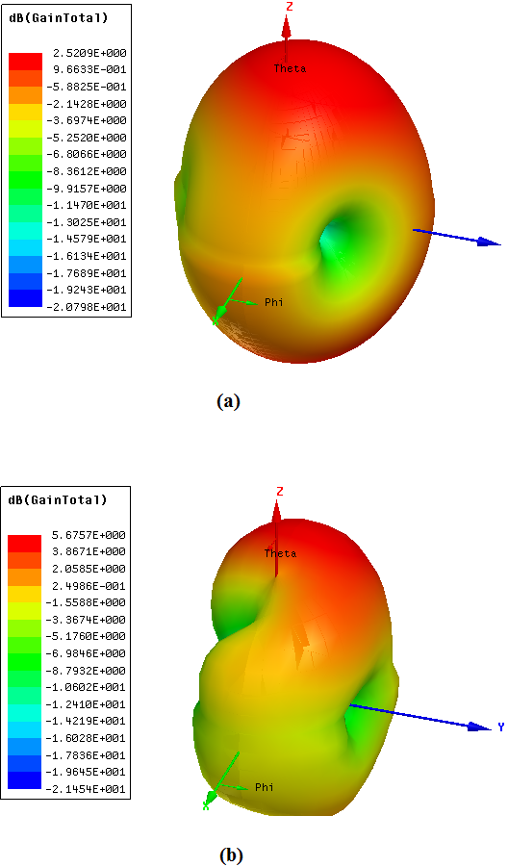
Fig. 7. The total gain of our CPW-fed slot antenna (a) without MSS, and (b) with the MSS.

Effect of CubeSat body
We place the proposed antenna on a 3U CubeSat as shown in Fig. 8 and Fig. 13 (b). Note, the antenna can have different placement configurations on a 3U CubeSat. Specifically, for satellite to ground station communications, placing it on only one CubeSat face is sufficient [14]; magnetic torqueing can be used to ensure it is always pointed at a ground station. For inter-satellite (cross-link) communications, placing an individual antenna on each face of a 3U CubeSat will be required [22].
To avoid direct contact between the backside (dielectric) of the antenna and the satellite body, we kept a distance (air gap) of 8.5 mm between the antenna and the satellite body. Consequently, the satellite body will act as a reflector that leads to higher gains. This air gap distance between the CubeSat and the proposed antenna is obtained using the Quasi-Newton method. Quasi-Newton method maximize the value of the antenna gain by varying the air gap 100 times (iterations) from 0.5 to 20 mm by minimum and maximum step sizes of 0.013 and 0.13 mm respectively. The result shows that the air gap distance of 8.5 achieves the highest gain of 9.7 dBi at a resonant frequency of 2.45 GHz.
We see that the 3U CubeSat body has no effect on the operating frequency. However, the return loss decreased from 36.8 to 21.5 dB; see Fig. 9(a). Moreover, the total antenna gain increased from 5.67 to 9.71 dBi; see Fig.9 (b). This is because the Aluminium surface of the CubeSat acts as a reflector and reflects some of the back-lobe radiation forward. Fig. 10 shows the simulated radiation pattern on the yz-plane. We see that our antenna achieves a maximum gain with a 20º elevation tilt and Half Power Beamwidth (HPBW) of 33⁰ at 2.45 GHz. We can see that the radiation is in the direction almost normal to the substrate (z-axis).
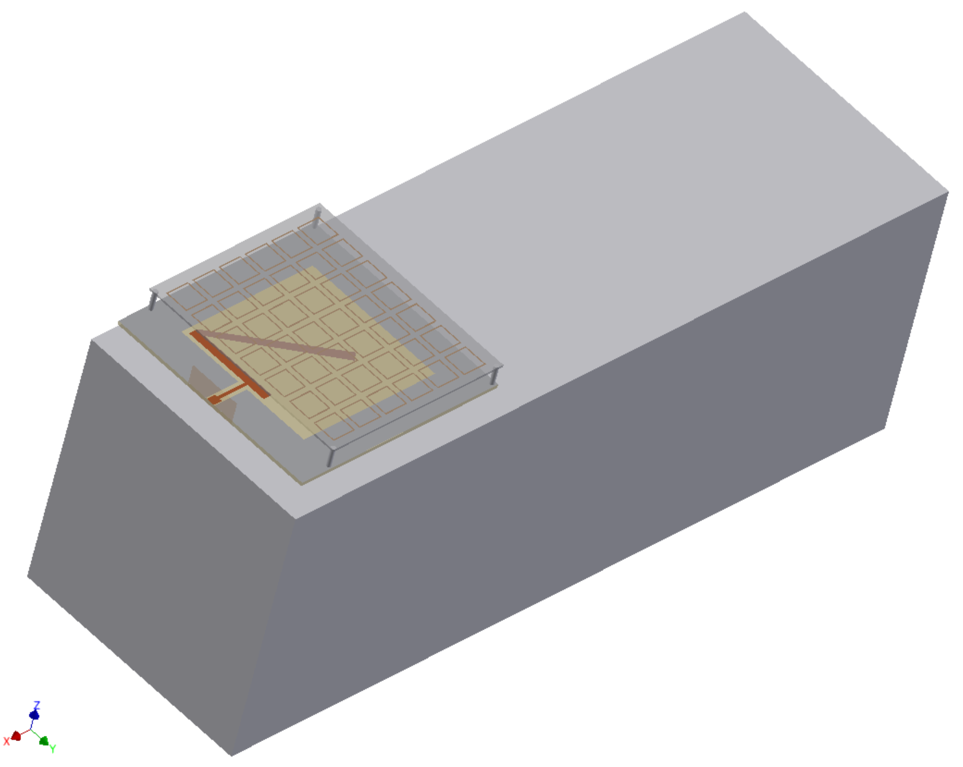
Fig. 8. A CPW-fed slot antenna on a 3U CubeSat.

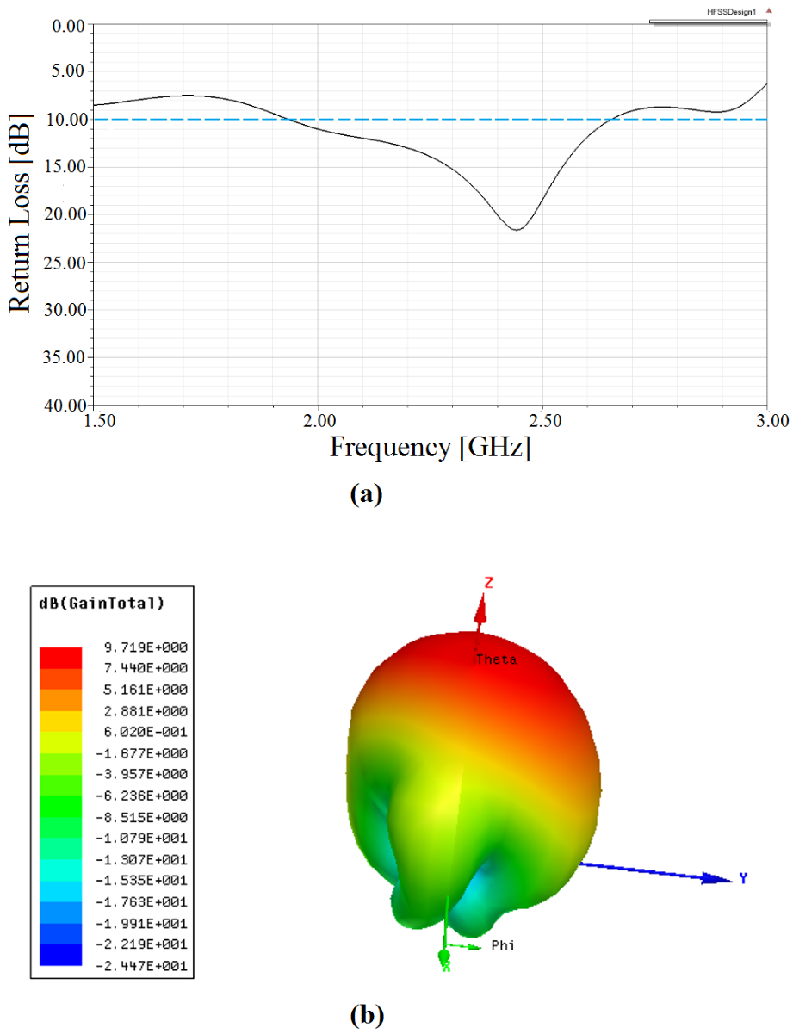
Fig. 9. Simulated results of proposed antenna on the CubeSat's body (a) return loss and (b) total gain at 2.45 GHz.

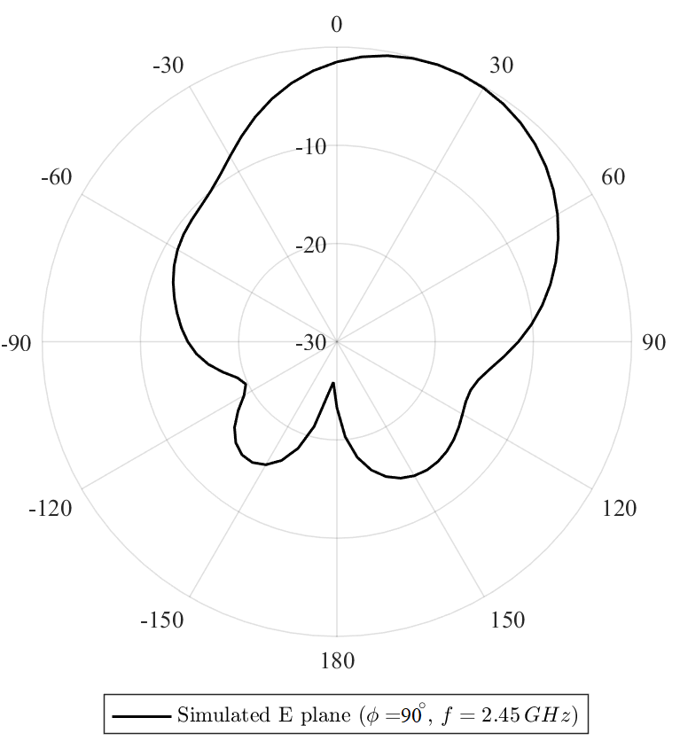
Figure 10. Simulated radiation pattern of the proposed antenna on a CubeSat's body at 2.45 GHz.

As shown in Fig. 11 (a) and (b), the proposed antenna is placed in two different positions, e.g., positions 1 (the left corner) and position 2 (middle) to study the effect of the antenna position on 3U CubeSat. Fig. 12 shows the return loss of the antenna at two different positions on CubeSat’s surface, i.e., middle and corner positions. In the middle position, the proposed antenna operates at three bands, i.e., 1.76, 2 and 2.38 GHz; see Fig. 13. However, in our proposed antenna we are targeting a single operating frequency for communication with ground station and hence positioning the antenna at the corner is more appropriate.
Fig. 13 shows the 3D total gain of the proposed antenna at (a) corner position and (b) middle position. We note that the total gain has not been significantly affected by changing the location of the antenna on the surface. This is because when using lumped terminal for excitation modal, the field distribution modal is stabilized and is not significantly affected by changing the antenna position using same surface size. The total gain of the proposed antenna at the corner position is higher than the middle position by about 1.23 dB.
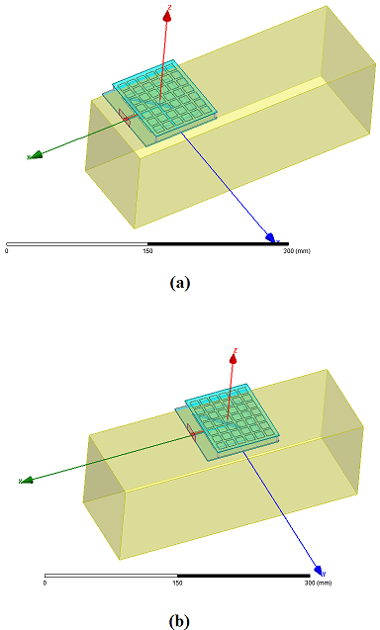
Fig. 11. Proposed antenna at two positions (a) corner and (b) middle.

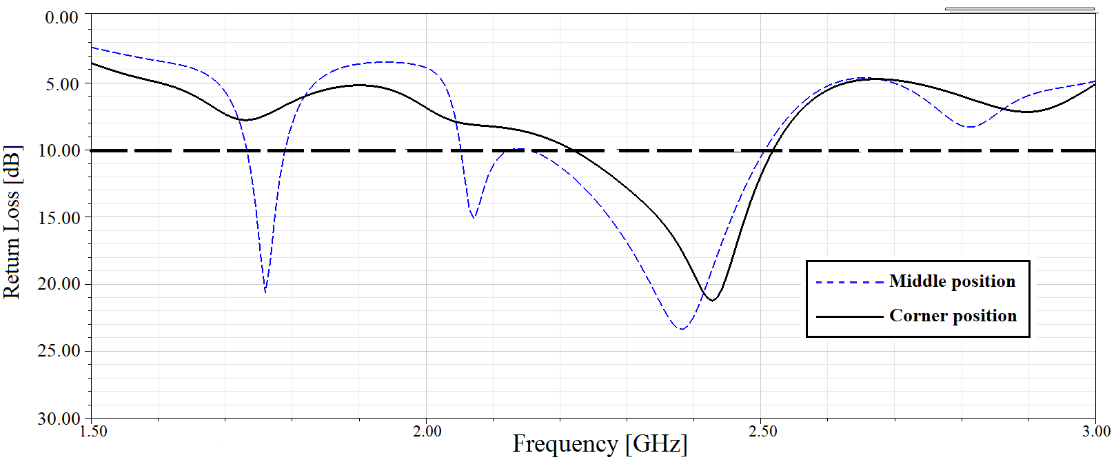
Fig. 12. the effect of antenna position on return loss.

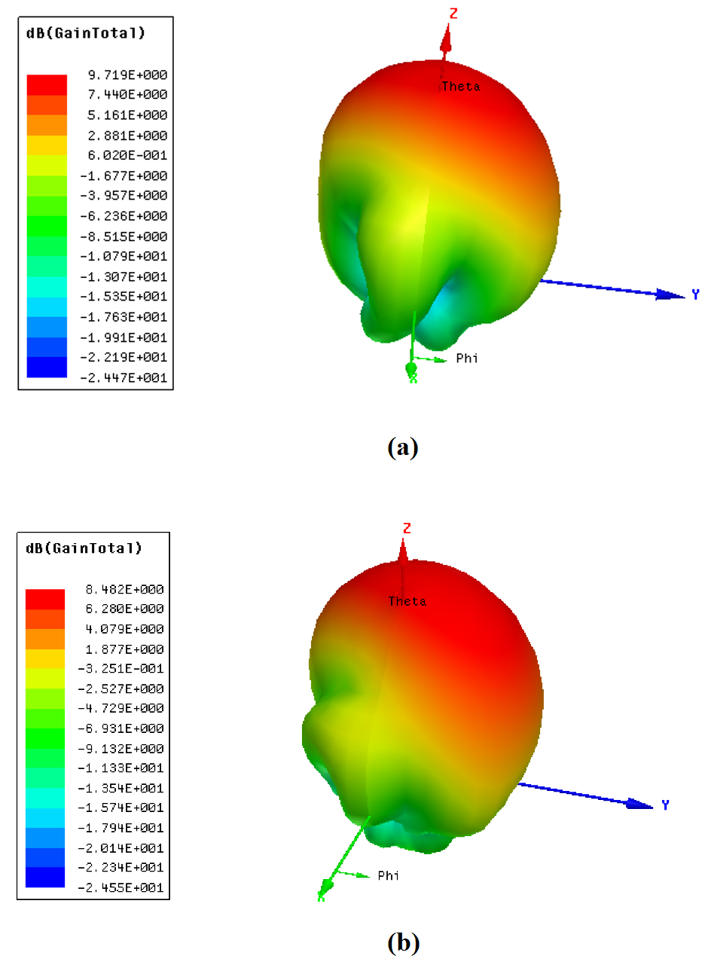
Fig. 13. The simulated total gain of proposed antenna at surface's positions (a) corner and (b) middle.

Fig. 14 depicts the simulated axial ratio of the proposed antenna located on the 3U CubeSat. We see that the antenna achieved a circular polarization with 3 dB axial ratio bandwidth of 130 MHz, ranging from 2.34 to 2.47 GHz. This corresponds to a 5.4% relative bandwidth with respect to the center frequency of f=2.41 GHz. The obtained axial ratio of the antenna is 0.44 at 2.41 GHz. CP is important for establishing cross-link communications. Moreover, to perceive the CP that generated by the designed antenna, we examined the distribution of the magnetic current.
Fig 15 illustrates the variation of the electric fields at 2.45 GHz for different time instant, i.e., ωt = 0º, 90º, 180º and 270º. For 0º and 180º. The predominant magnetic current is parallel to the x axis while for 90º and 270º it is parallel to y axis and horizontal feed section. The electric field distribution at 0º, 90º is opposite to that at 180º and 270º respectively. This electrical field distribution implies a quadrature phase between the x and y directions. We note that the antenna generates Right-Hand Circular Polarization (RHCP) in +Z direction and Left-Hand Circular Polarization (LHCP) in the -Z direction. When the magnetic current rotates. Moreover, Fig. 16 shows the normalized RHCP and LHCP patterns of the proposed antenna at the operating frequency of 2.45 GHz.
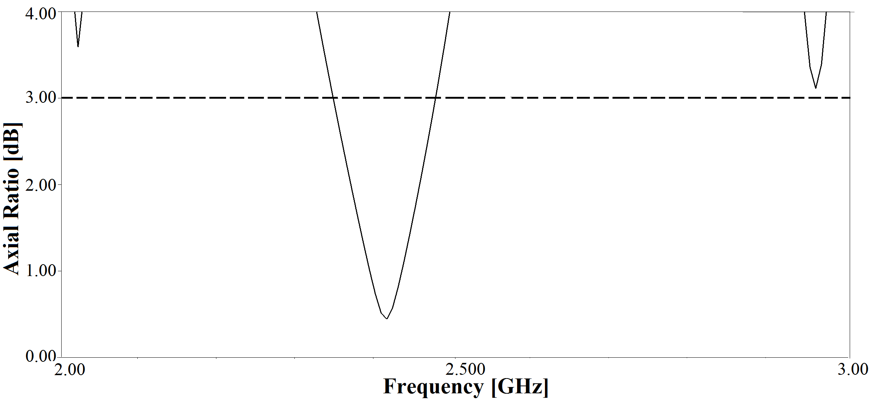
Fig. 14. Simulated axial ratio of proposed antenna.
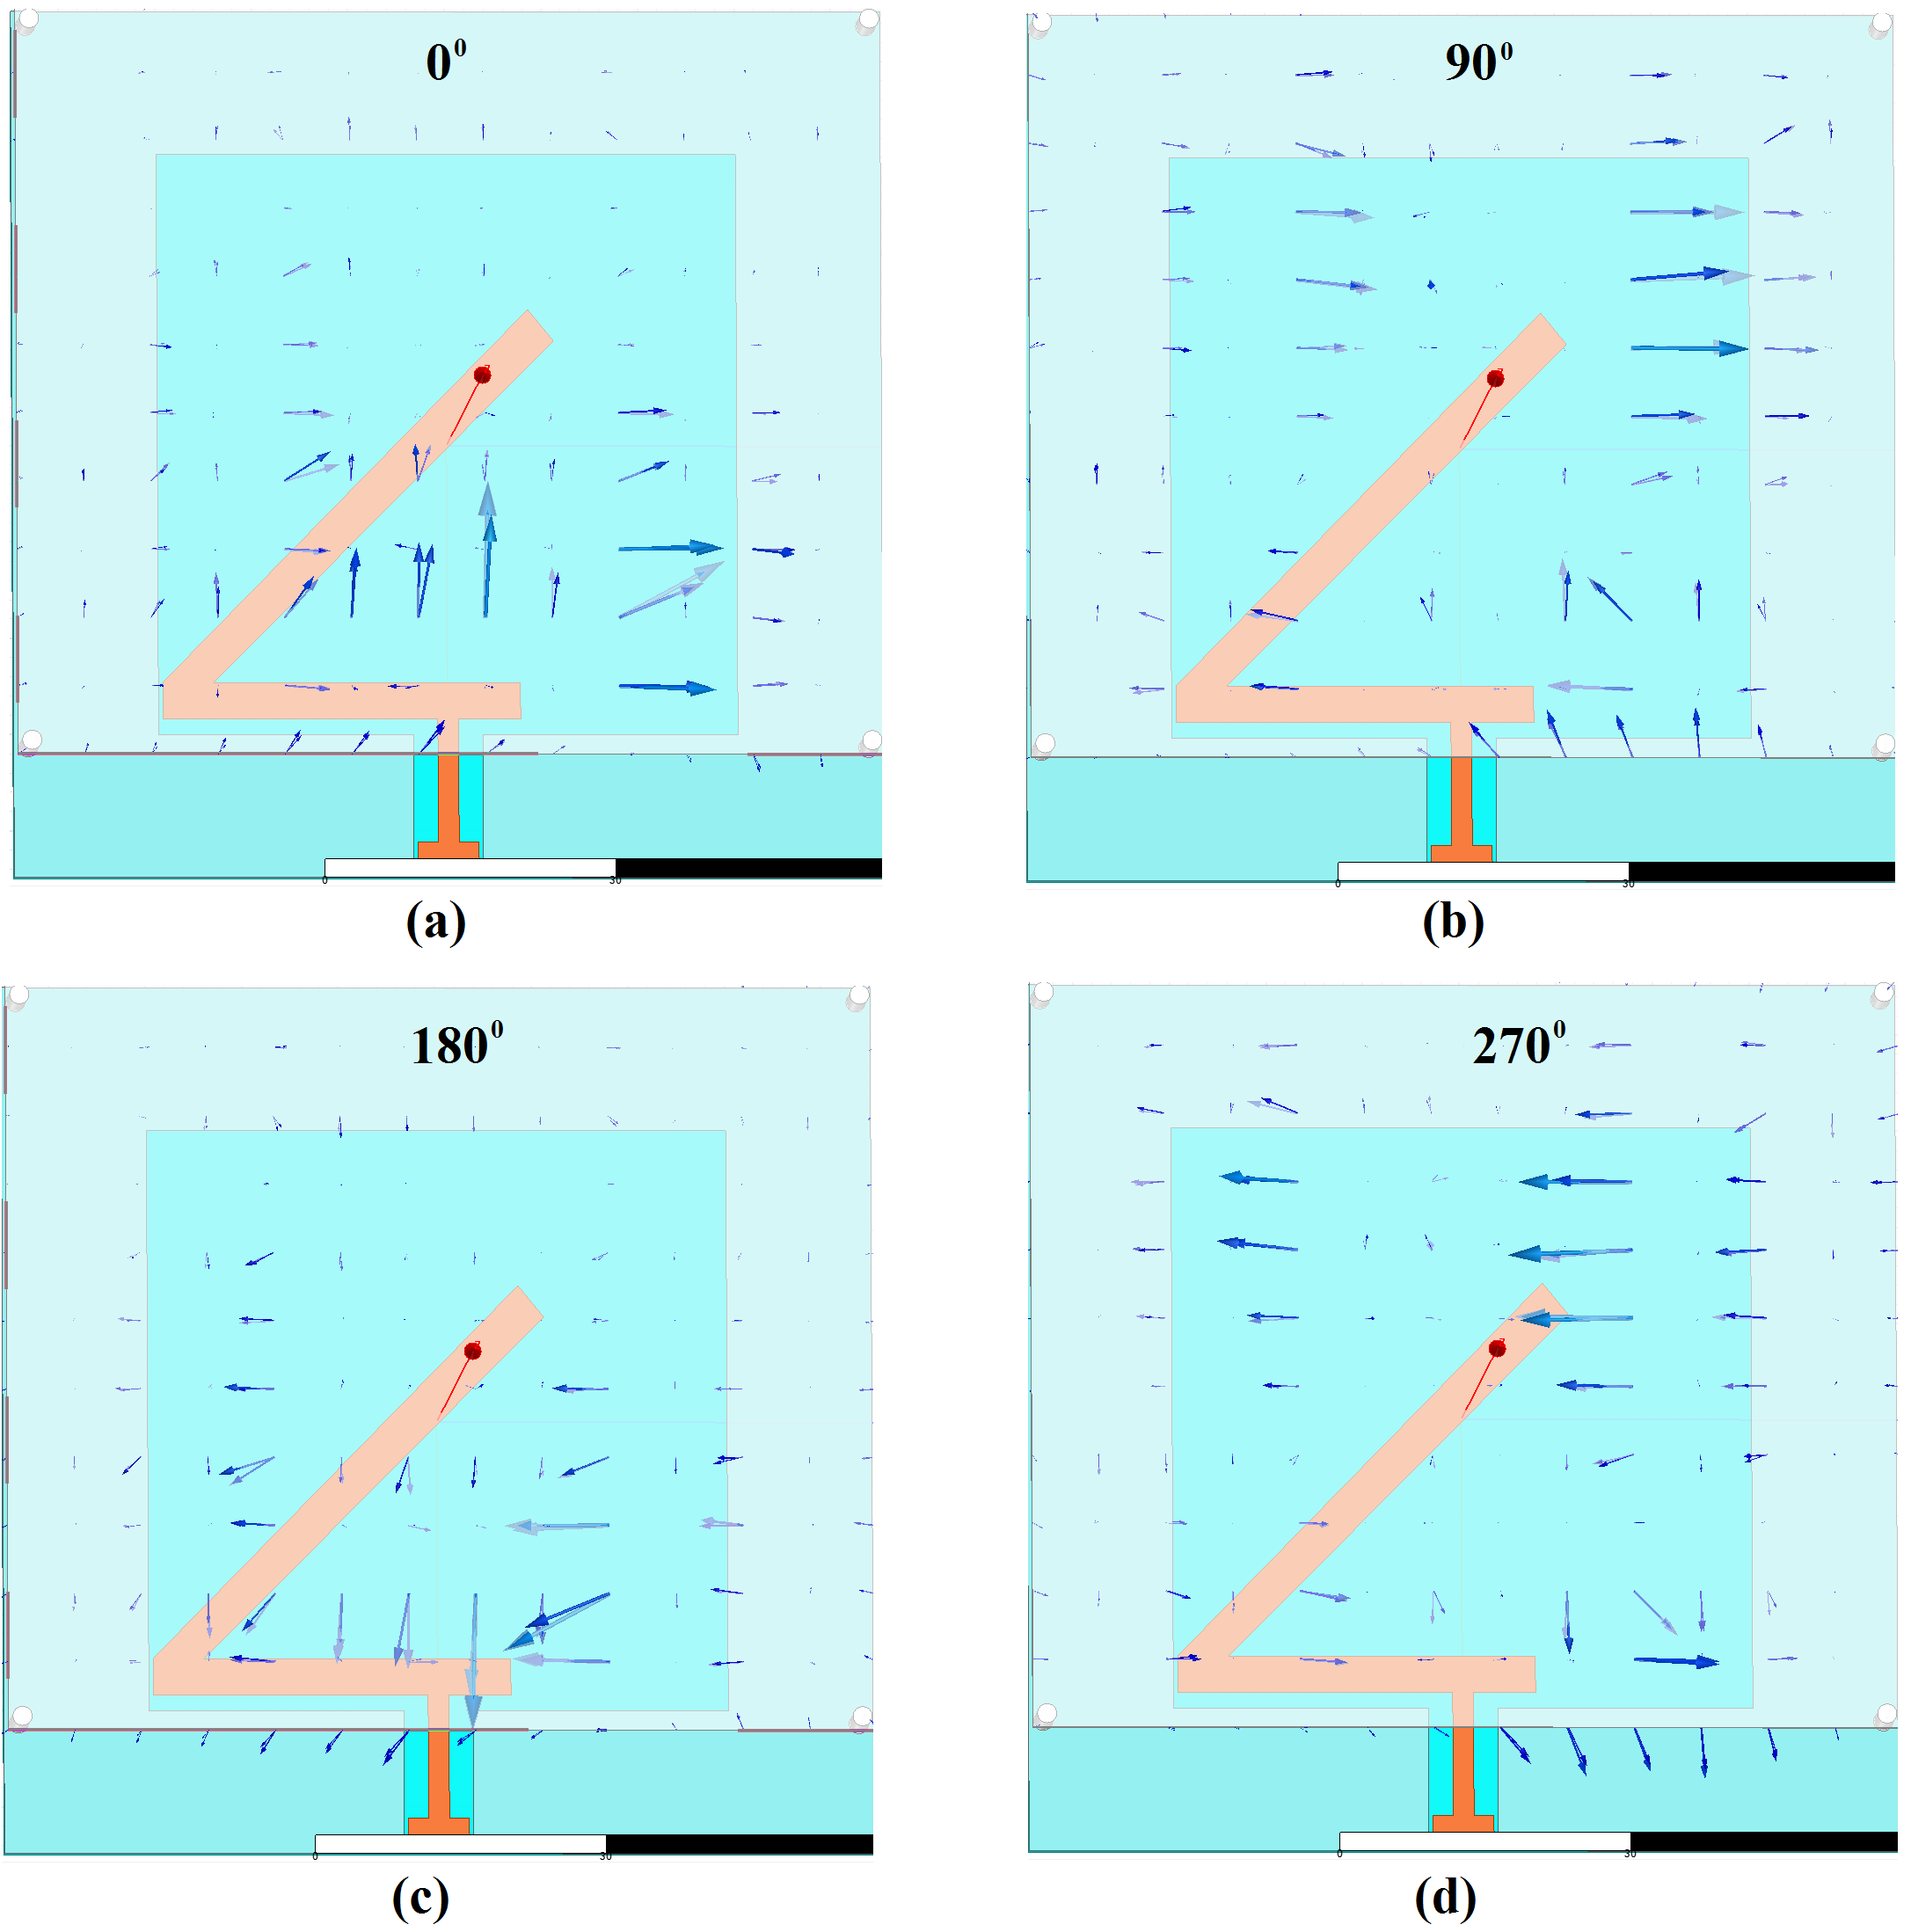
Fig. 15. Electric field distributions of the proposed antenna at different phase instants (a) ωt=0º, (b) 90º, (c) 180º and (d) 270º.
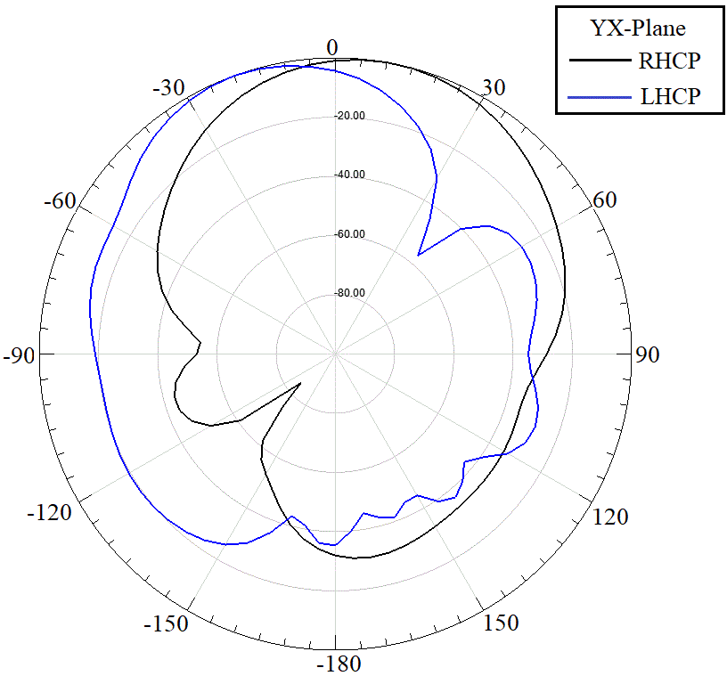
Fig. 16. Simulated radiation patterns of proposed antenna at 2.45 GHz.

Experimental Verification
In order to verify the simulated results, we have fabricated the CPW-fed slot antenna with a MSS array set of 7 × 6 elements; see Fig. 16 (a) and (b) for a photograph. Our experiments consider the case with and without a 3U CubeSat model. We measure the antenna’s characteristics using Keysight’s M9370A vector network analyzer (VNA). We attach the antenna to port one of the VNA using a ridged interconnect featuring male SMA connectors on both ends. The test setup was calibrated with a Rohde & Schwarz ZV-Z270 50Ω calibration kit and a characterized female SMA to male N-connector adapter. The system is de-embedded to the reference plane of the SMA connector on the antenna. We set the VNA to sweep from 1.5 to 3.5 GHz using a resolution bandwidth of 100 kHz and an output power of -5 dBm.
The simulated and measured return losses (R_{L}) with and without the 3U CubeSat model are depicted in Fig. 17; all are in agreement with the simulation results from HFSS as they have the same shape and same resonance frequency at their highest R_{L}. Compared to the simulated return loss of the proposed antenna on the CubeSat’s body, the measured and simulated (individual) return losses of the proposed antenna without the CubeSat’s body have higher R_{L}. Moreover, both simulation (solid line and long dashed line) and measured (dashed line) results of R_{L} indicate that the CPW-fed slot antenna is well matched at the desired operating frequency; e.g., 2.45 GHz with R_{L} > 10 dB. The simulated and measured fractional impedance bandwidths of the CPW-fed slot antennas with CubeSat are 740 MHz (1900 – 2640 MHz) and 1370MHz (1600 – 2970 MHz) respectively. These discrepancies between the measured and simulated results are caused by the limited accuracy of the etching process used and the antenna testing set up. Fig. 18 shows the simulated and measured input impedances of the proposed antenna in the frequency bands 1.900 – 2.630 and 1.819 – 2.787 GHz respectively. The simulated and measured input impedance at 2.45 GHz is 43.97Ω and 48.59Ω, respectively.
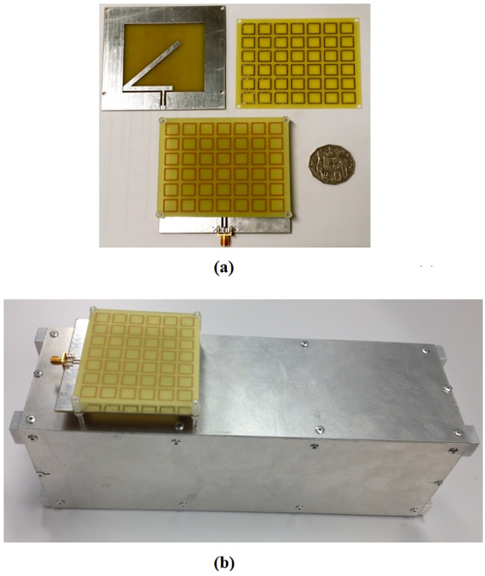
Fig. 17. A photograph of the fabricated prototype CPW-fed slot antenna: (a) geometry, and (b) its installation on a 3U CubeSat model face.
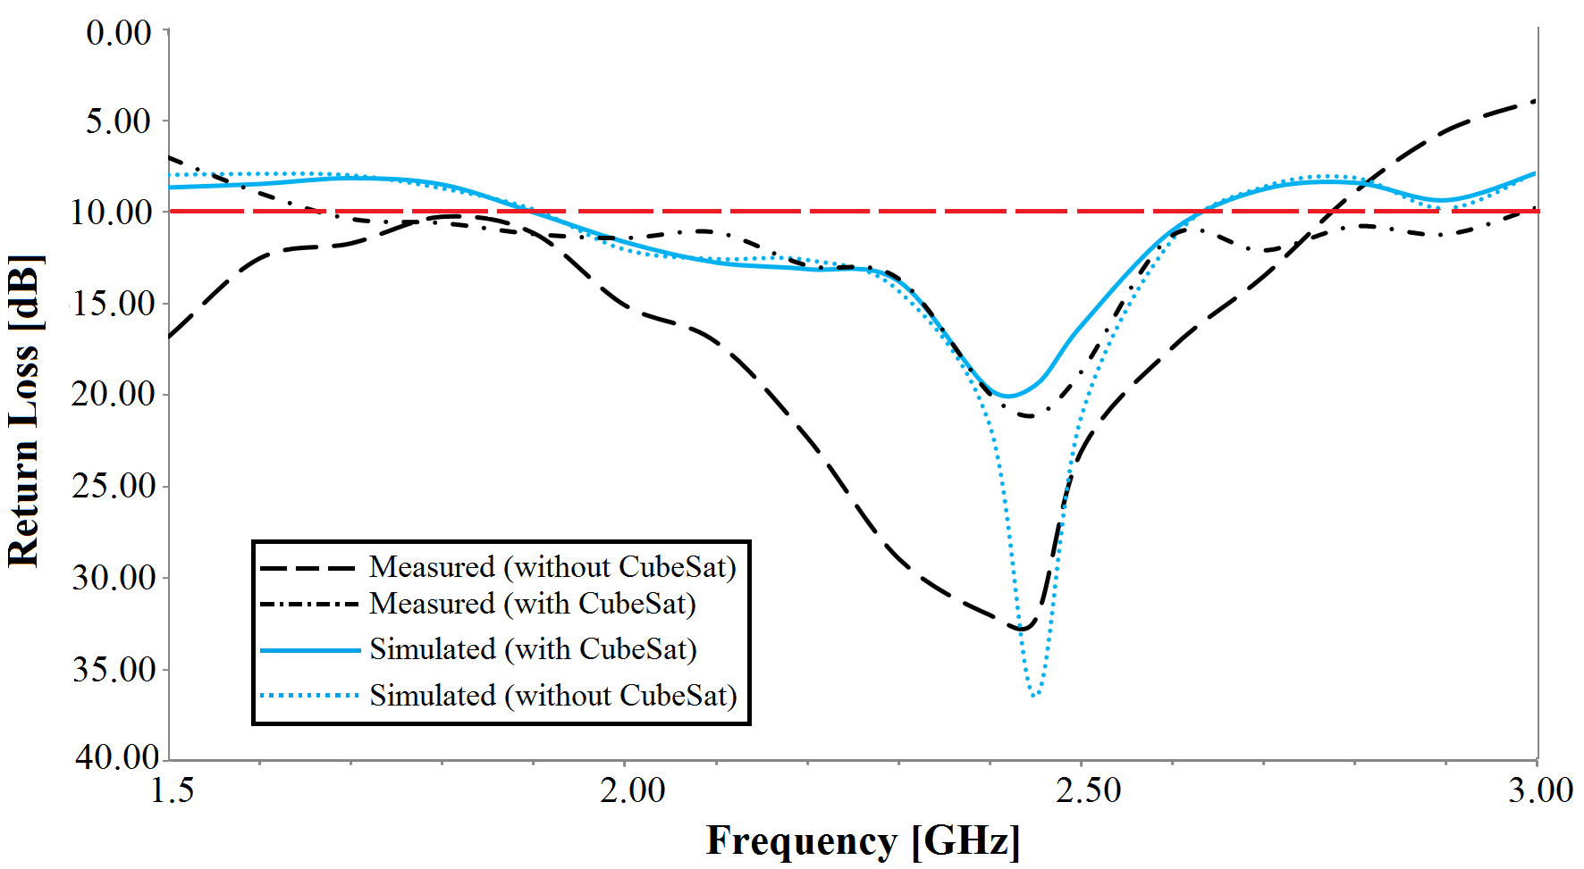
Fig. 18. Simulated and measured return losses (RL) of the proposed antenna.

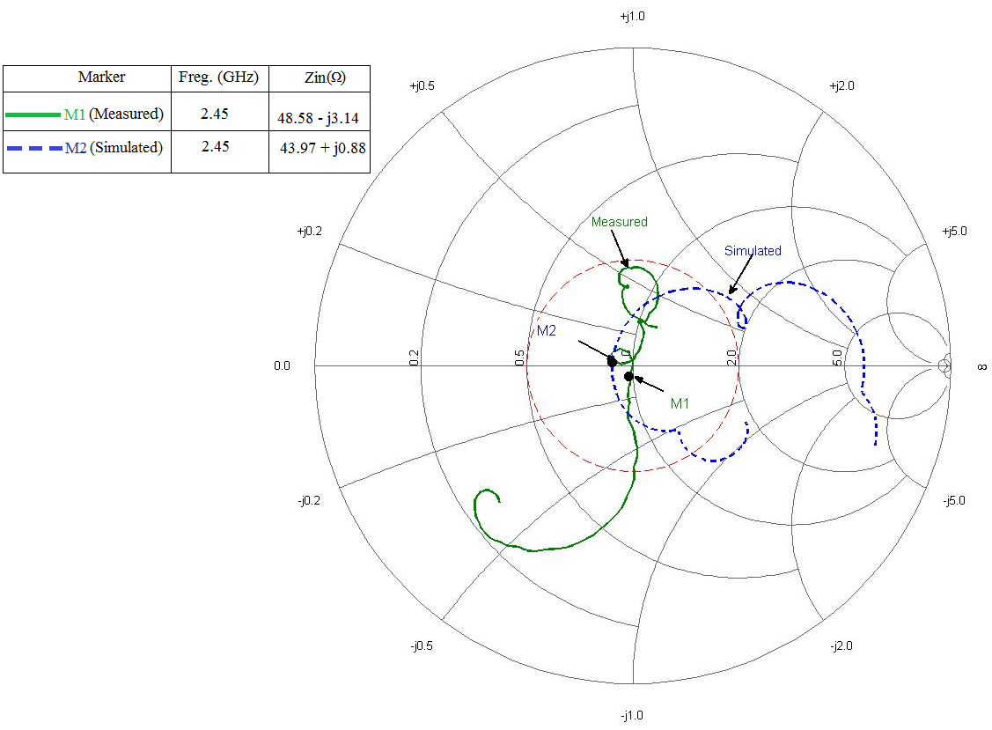
Fig.19. Simulated and measured input impedance of the proposed antenna.
Fig. 19 compares the simulated and measured patterns on the plane parallel to the satellite axis and contain the antenna itself. The plane includes the direction of the maximum radiation, as discussed earlier in section A. The radiation pattern is quite similar with a small rotation in the pointing angle. This can be due to the mounting of the antenna during measurement, see the inset of Fig. 19, as the center of the rotation is different with respect to the phase center of the antenna.
Fig. 20 shows the measured and simulated gains versus varying frequencies of the proposed antenna with CubeSat. We see that there is a reasonable agreement through the entire band. The peak gains of simulated and measured gains are 9.71 and 8.8 dBi at 2.45 GHz respectively. The minor discrepancy can be mostly attributed to the fabrication error and measurement uncertainties.
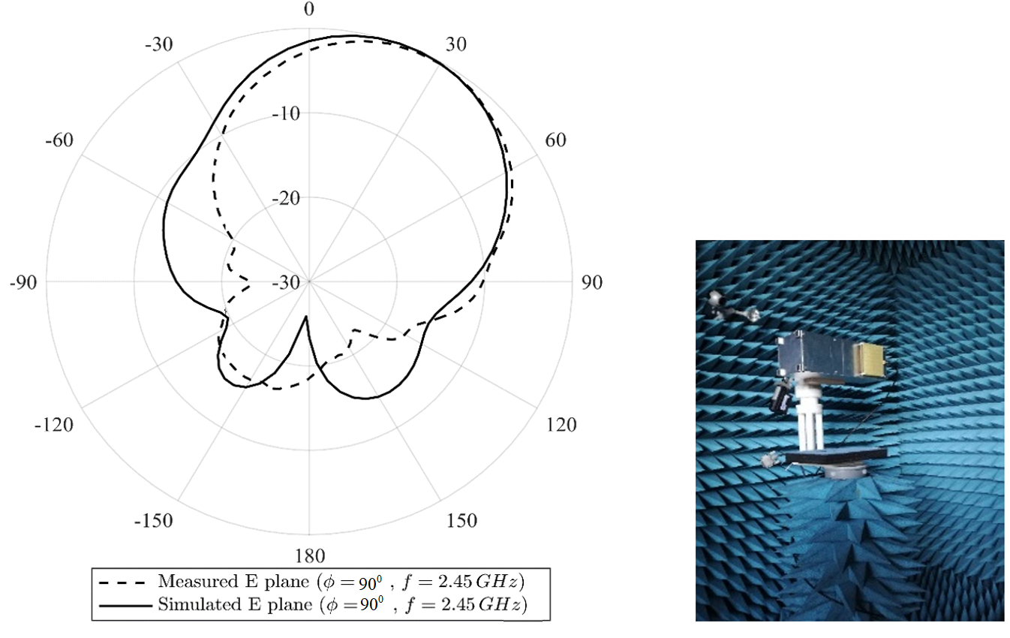
Fig. 20. Simulated and measured radiation pattern of the proposed antenna on a CubeSat's body at 2.45 GHz (inset: Antenna under measurement).

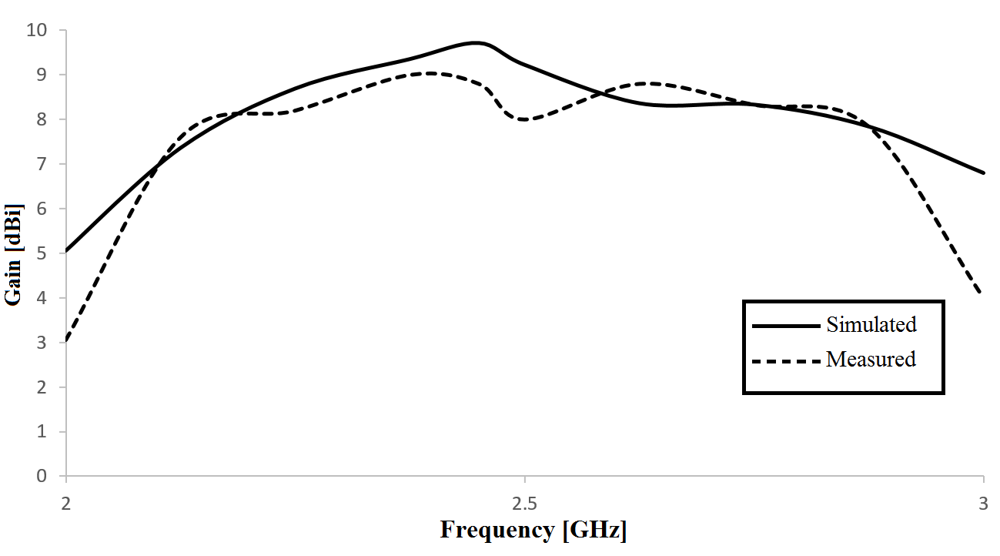
Fig.21. Simulated (continuous line) and measured (dashed line) gain of the proposed antenna with CubeSat.

Conclusion
We have presented the design and the realization of a high gain CPW-fed slot antenna for CubeSat communications. We also obtained the optimal parameters of the proposed antenna and the optimal element sets of MSS using parametric analysis. We have designed and used a MSS to significantly increase the gain from 2.52 to 5.67 dBi. This gain further improved to 9.71 (simulated) and 8.8 dBi (measured) when the CPW-fed slot antenna is placed on the Aluminium cube satellite’s surface. Simulation and measured results show that the proposed antenna has a return loss that is well below 10 dB at the operational frequency of 2.45 GHz, and achieves an impedance bandwidth of 1370 MHz.

Acknowledgements
The authors would like to thank Mr. Frank Mikk for helping fabricate the antenna and Mr. Jacob Donley for his help in processing some of the results.

References
[1] M. Swartwout, "The first one hundred cubesats: A statistical look," Journal of Small Satellites, vol. 2, pp. 213-233, Dec. 2013.
[2] C. Underwood, V. Lappas, A. D. S. Curiel, M. Unwin, A. Baker, and M. Sweeting, "Science Mission Scenarios Using “PALMSAT” Pico-Satellite Technology," 18th Annual AIAA/USU Conference on Small Satellites, Logan, Utah, 2004.
[3] R. M. Rodriguez-Osorio and E. F. Ramirez, "A Hands-On Education Project: Antenna Design for Inter-CubeSat Communications," IEEE Antennas and Propagation Magazine, vol. 54, pp. 211-224, October 2012.
[4] C. Pinciroli, M. Birattari, TE. uci, M. Dorigo, M. d.R. Zapatero, T. Vinko, and D. Izzo, "Self-Organizing and Scalable Shape Formation for a Swarm of Pico Satellites," pp. 57-61.
[5] C. A. Rouff, M. G. Hinchey, J. Pena, and A. Ruiz-Cortes, "Using Formal Methods and Agent-Oriented Software Engineering for Modeling NASA Swarm-Based Systems," Swarm Intelligence Symposium, 2007. SIS 2007. IEEE, 2007, pp. 348-355.
[6] R. W. Ziolkowski, "Design, fabrication, and testing of double negative metamaterials," IEEE Transactions on Antennas and Propagation, vol. 51, pp. 1516-1529, July 2003.
[7] S. Chaimool, K. L. Chung, and P. Akkaraekthalin, "Bandwidth and gain enhancement of microstrip patch antennas using reflective metasurface," IEICE transactions on communications, vol. 93, pp. 2496-2503, October 2010.
[8] Y. Yoshimura, "A Microstripline Slot Antenna (Short Papers)," IEEE Transactions on Microwave Theory and Techniques, vol. 20, pp. 760-762, 1972.
[9] A. Budianu, T. J. W. Castro, A. Meijerink, and M. J. Bentum, "Inter-satellite links for cubesats," IEEE Conference on Aerospace, Big Sky, United States, pp. 1-10, March 2013.
[10] An international network of 50 CubeSats Project [online] available: https://www.qb50.eu/.
[11] F. Em . Tubbal, R. Raad, K.-W. Chin, and B. Butters, "S-band shorted patch antenna for inter pico satellite communications," in Proc. 8th Int. Conf. Telecommu. Syst. Services and Appl. (TSSA 2014), Kuta, Bali, Indonesia Oct. 2014, pp. 1-4.
[12] C. Rakluea, S. Chaimool, P. Rakluea, and P. Akkaraekthalin, "Unidirectional CPW-fed slot antenna using metasurface," 8th International Conference on Electrical Engineering/Electronics, Computer, Telecommunications and Information Technology (ECTI-CON) Khon Kaen, Thailand, May 2011, pp. 184-187.
[13] N. Orr, J. Eyer, B. Larouche, and R. Zee, "Precision formation flight: the CanX-4 and CanX-5 dual nanosatellite mission," in Proc. 21st Annu. AIAA/USU Conf. Small Satellites, Logan, UT, USA, Aug. 2007, pp. 1-10.
[14] F. EM. Tubbal, R. Raad, and K-W. Chin, "A survey and study of planar antennas for pico-satellites," IEEE Access, vol. 3, pp. 2590-2612, Dec. 2015.
[15] J. Y. Sze, C. I. G. Hsu, Z. W. Chen, and C. C. Chang, "Broadband CPW-Fed Circularly Polarized Square Slot Antenna With Lightening-Shaped Feedline and Inverted-L Grounded Strips," IEEE Transactions on Antennas and Propagation, vol. 58, pp. 973-977, 2010.
[16] E. L. Holzman, "Wideband measurement of the dielectric constant of an FR4 substrate using a parallel-coupled microstrip resonator," IEEE transactions on microwave theory and techniques, vol. 54, pp. 3127-3130, 2006.
[17] A. A. Qureshi, M. U. Afzal, T. Tauqeer, and M. Tarar, "Performance analysis of FR-4 substrate for high frequency microstrip antennas," Microwave Conference Proceedings (CJMW), 2011 China-Japan Joint, 2011, pp. 1-4.
[18] T-K. Wu. Frequency Selective Surfaces: Wiley online library, 1995.
[19] High Frequency Structure Simulator (HFSS) [online] available: http://www.ansys.com/.
[20] F. EM. Tubbal, R. Raad, and K-W. Chin, "A Wideband F-shaped Patch Antenna for S-band CubeSats Communications " 10th International Conference on Signal Processing and Communication Systems (ICSPCS), Surfers Paradise, Gold Coast, Australia Dec. 2016.
[21] R. Fletcher, Practical methods of optimization (2nd ed.). New York: John Wiley & Sons. ISBN 978-0-471-91547-8.
[22] F. Em . Tubbal, ER. Raad, K-W. Chin, and M. Madni, "Low profile aperture coupled microstrip antenna for inter cubesat communications," in Proc. 4th Int. CubeSat Workshop, London, United kingdom, May 2015, pp. 1-2.

