Supplementary information for:
Synergic Effect of catalyst/binder in passivation side-products of Li-Oxygen cells
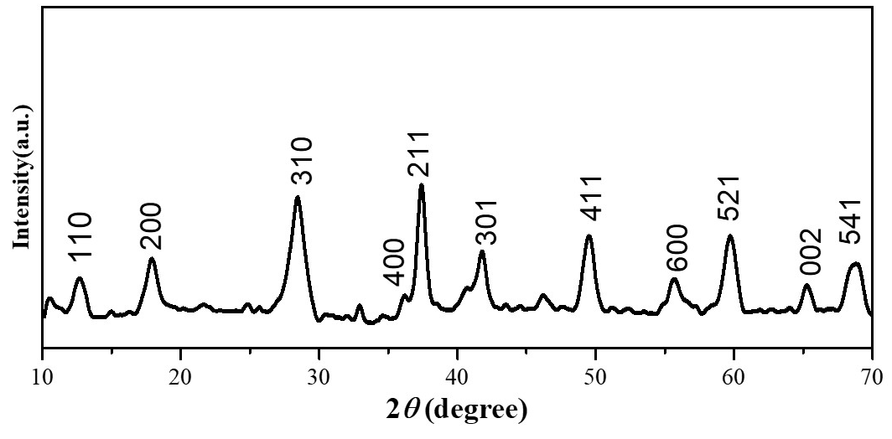
Fig. S1. XRD pattern of the synthesized α-MnO₂
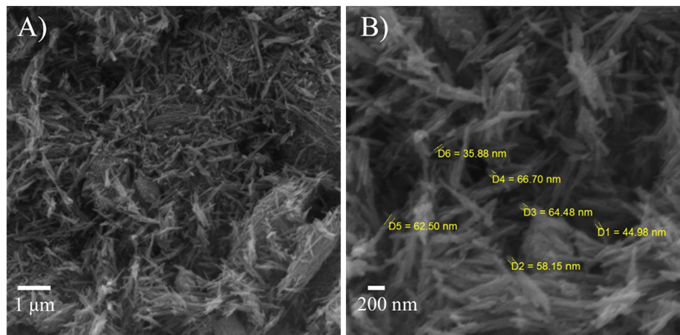
Fig. S2. SEM micrographs of α-MnO₂ powder at 20000 magnification (A) and 50000 magnification (B) and including diameters of nanowire.

Fig. S3. TGA plot of MnO₂ nanostructure. Thermogravimetric analyses (TGA) were performed using a Mettler Toledo Gas Controller GC20 Stare System TGA/DCS (Schwerzenbach, Switzerland). Sample (ca. 7.7 mg) was heated from 20 to 600 °C at 10 °C min⁻¹.
The pristine α-MnO₂ water content was measured by thermogravimetric methods. The measurements were performed at a heating rate of 10 °C / min, from room temperature to 600 °C. In the temperature range below 400 °C there is a significant mass loss, corresponding to the evaporation of the surface hydration water molecules (Zone I) and to the molecules trapped inside the 2x2 tunnels of the α-MnO₂ nanostructures (Zone II) [Zahoor, A.; Jeon, J. S.; Jang, H. S.; Christy, M.; Hwang, Y.; Nahm, K. S., Mechanistic Study on Phase and Morphology Conversion of MnO2 Nanostructures Grown by Controlled Hydrothermal Synthesis. Science of Advanced Materials 2014, 6 (12), 2712-2723]. Most of the water content corresponding to Zone 1 was eliminated during the vacuum drying before using the catalyst. On the contrary, the binding energy of the chemisorbed water molecules within the surface of the tunnel being generally high [Li, L. P.; Pan, Y. Z.; Chen, L. J.; Li, G. S., One-dimensional alpha-MnO2: Trapping chemistry of tunnel structures, structural stability, and magnetic transitions. Journal of Solid State Chemistry 2007, 180 (10), 2896-2904.], this implies a significant increase in mass loss in dehydration temperature above 300 °C, as shown in Fig. 1, denoted as zone II (300 °C - 380 °C). Meaning that the corresponding water content may still be inside the material after vacuum drying, indeed influencing catalyst behavior. At temperatures above 400 °C, the transformation of α-MnO₂ into Mn₂O₃ occurs. (Fig. 1, Zone III). This further confirms the Authors hypothesis regarding LiOH formation.

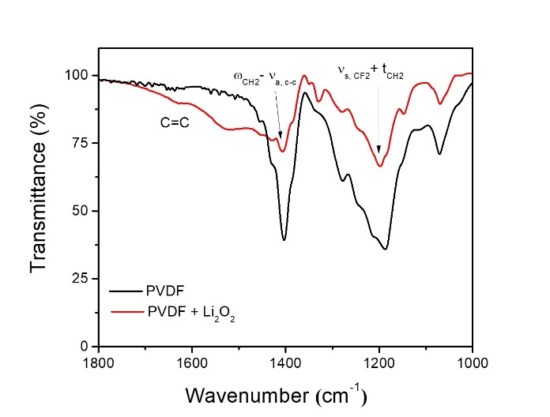
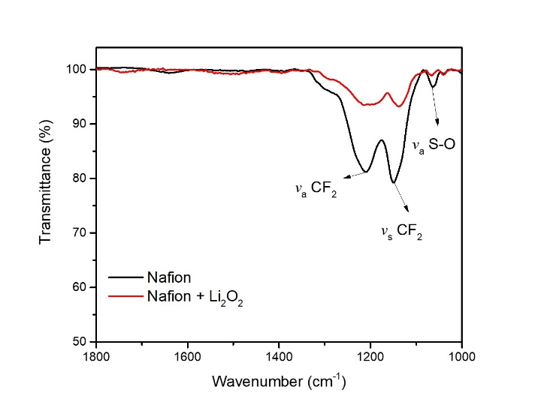
Fig. S4. FTIR analysis of A) PVDF and B) Li-Nafion binders; black line refers to pristine polymer, red line refers to the polymer in contact to Li₂O₂.
A
B
A | B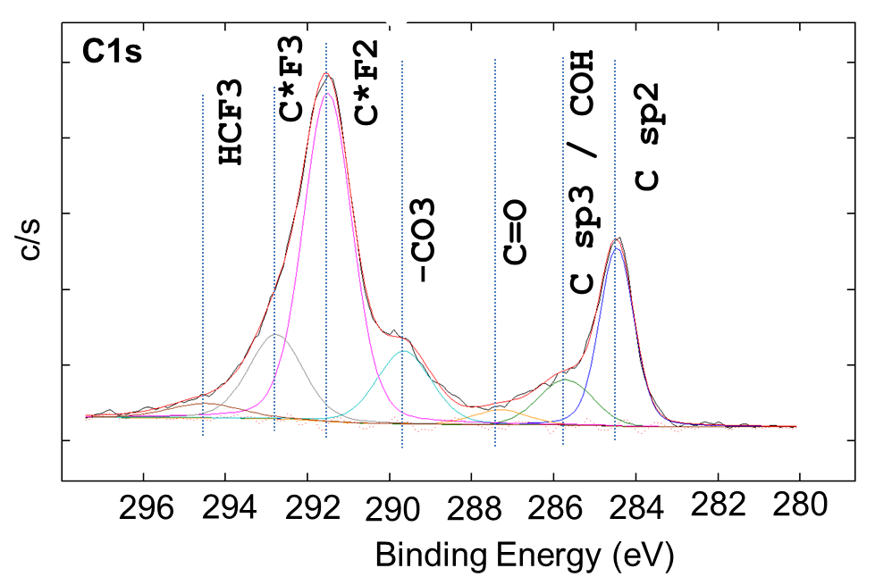
Fig. S5. XPS analysis of a cycled carbon cathode with PVDF binder, A) survey spectra, B) C1s high resolution spectra.

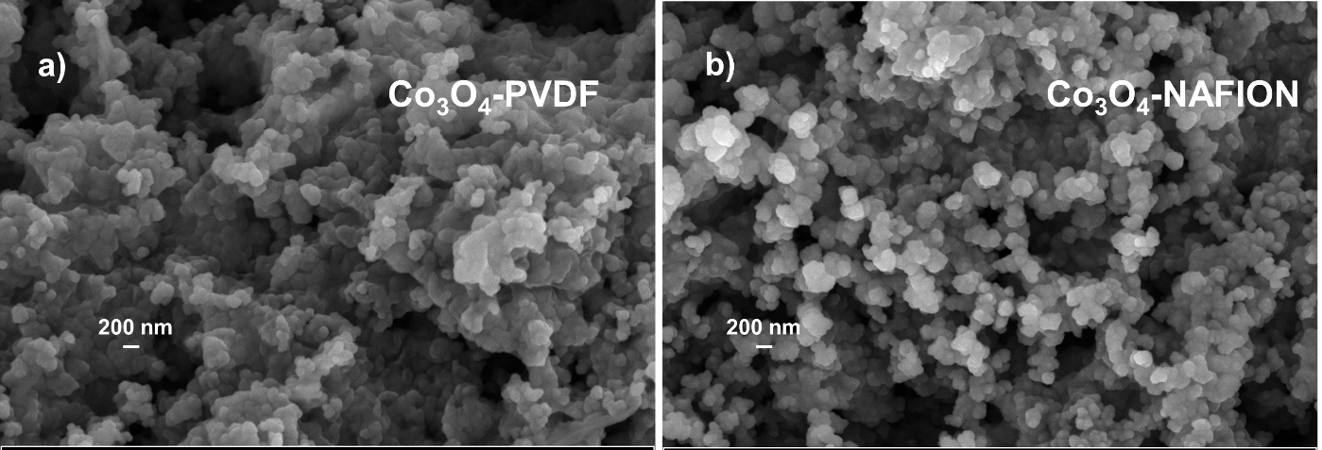
B
A
Fig. S6. FESEM images of: A) Co₃O₄-PVDF cathode after charge; B) Co₃O₄-NAFION cathode after charge

