Stiffness, energy dissipation and hyperelasticity in hierarchical multilayer composite nanocoated open cell polyurethane foams

Francesca CURA’, Raffaella SESANA*
*DIMEAS, Politecnico di Torino, corso duca degli Abruzzi 24, 10129 Torino, ITALY
Xiao-Chong ZHANG, Fabrizio SCARPA
Bristol Composites Institute (ACCIS), University of Bristol, BS8 1TR Bristol, UK
Wen Jiang LU, Hua-Xin PENG
Institute for Composites Science Innovation (InCSI), School of Materials Science and Engineering, Zhejiang University, Hangzhou, 310027, PRC

Abstract
The paper describes the manufacturing, testing and modelling of a class of open cell polyurethane foams doped with multi-walled carbon nanotubes and nano polyurethane dispersions and subjected to quasi-static cycling compressive loading at large deformations. The doped nano-ink foams are produced using a multiple steps dip coating technique that makes possible the development of nano-based porous materials by post-processing existing off-the-shelf open cell foams. Tests are carried out up to 18.5% of compressive strain to identify loading/unloading moduli and energy absorbed after 5 cycles of stabilization. Hyperelastic Ogden models also considering the Mullins effect for cyclic loading are used to identify the constitutive parameters for these foams. The results show that the use of the multi-walled carbon nanotube layers provide an effective increase of the stiffness and energy absorbed compared to pristine and nano polyurethane dispersions-treated foams. The volume average energy absorbed after the stabilization cycles is increased by 200% compared to the pristine foam when the multi-walled carbon nanotube layers are used. The parameters of the constitutive models extracted from the tests show that these nano-ink foams can be modelled following state-of-the-art hyperelastic representations

Keywords: multilayer nanocomposites, nanoinks, foams, mullin effect, hyperelasticity

Introduction
Polymer nanocomposite foams represent a multifunctional multi-materials platform that combines the energy absorption and lightweight properties of foams used in packaging, with the added multifunctionalities of nanomaterials dispersed within their structure. Polymer nanocomposite foams show in general enhanced strength [1][2][3] and dielectric properties [2][4][5]. A particular mechanical property that polymer nanocomposite foams tend to exhibit in a significant manner is the sound and vibration damping [6][7][8][9], which is enhanced compared to baseline foams and tends to approach the energy dissipation of high-performance auxetic foams under compressive loading [10]. The reason behind the increased damping capacity of the nanocomposites foams is the energy dissipation mechanisms involved in the polymer/carbon nanotube (CNT) interface, nanotube/nanotube interfacial sliding and – in the case of multi-walled carbon nanotubes (MWCNTs) – the coaxial sliding of the tube walls [11]. These deformation mechanisms have been particularly evident in the nanofoams produced by Verdejo et al [6], in which 0.1wt% of MWCNTs were added into flexible polyurethane (PU) foams that showed a 30% higher sound absorption coefficient peak within the 1 kHz-2kHz frequency range compared with pristine polyurethane (PU) foams. Other sources of mechanical damping are however the formations of internal voids in the nanocomposite foam struts because of clustering and inhomogeneity, and this has been witnessed in the PU/CNT-COOH and PU/CNTOH foams produced by Bandarian and co-workers [9].
The examples of polymer nanocomposite open cell foams cited above are made from the dispersion of nanoparticles within the chemical compounds used in the foaming process. An alternative approach to produce these particular nanocomposite foams is by dip coating the porous materials in nanoinks. This procedure is described in [12][13][14]. In all the papers the coatings appear to be well adherent to the foam substrate. These procedures allow to obtain, a multilayer structured composite foam instead of the more investigated nanostructured composite foams.
Polyurethane foams with embedded carbon nanotubes or graphene dispersions have been developed to increase the sound absorption at low frequencies, to increase the viscoelastic loss factor for vibration damping applications and dielectric properties to obtain multifunctional conductive porous materials, also for microbial fuel cells [6] [9] [15]. Those multifunctional nano-based foams have been produced by dispersing the nanoparticles within the foaming process. While this approach is able to produce foam samples at laboratory level, the broader use of dispersions of nanoparticles in large scale industrial reactors involves a careful and cost-critical modification of the whole chemistry at industrial plant level. The foams with nano coatings tested in this work offer the advantage of creating nano-based foams by using available off-the-shelf produced open cell thermoplastic PU porous materials and post-processing those by dip-coating techniques, which do not require any modification of industrial reactors used to produce commercial open cell PU foams.
In [12] the preparation of porous composites by means of a simple dip-coating method is presented. A commercial melamine sponge was coated with silver nanoparticles and then dip-coated with graphene (GP) based inks to obtain Ag/carbon nanomaterial hybrid composites. EMI measurements were then performed in the frequency range of 0.45–1.5 GHz, finding significant differences introduced by dip coated composites. In particular due to the porous structure, the EMI SE measurements showed that reflection phenomena dominate the EMI SE for all the sponge composites. In [13] a procedure to obtain, by means of alternate dip coating and electroplating, patterned laminated carbon nanotube (CNT)/copper composites produced by dip‐coating is presented. Then microtensile testing is performed and it results that samples fail by pullout but the CNTs are completely covered by matrix, thus revealing the efficacy of the procedure.
The procedure described in [14] was followed for the present research.
In technical literature, the hyperelastic and viscoelastic behaviour of foams is modelled following different approaches. In [16] large uniaxial quasi-static compressive loading and unloading tests run on flexible polyurethane foam undergoing are reported. Three cycles are applied to specimens with deformation values up to 65%. The materials show a noticeable nonlinear and viscoelastic behaviour and the response changes strongly from first cycle to subsequent ones. Stresses in the loading paths are higher than those in unloading paths, accordingly to literature. In the paper the quasi-static response is modelled as a sum of a nonlinear elastic and a linear viscoelastic contributions. The cyclic behaviour is modelled then by means of a multi-element fractional derivative model, separating the contributions of the viscoelastic elements and the nonlinear elastic component. In particular, the nonlinear elastic behaviour is modelled as a polynomial function of compressive strain, while the viscoelastic behaviour is modelled as a parallel combination of five-parameter fractional derivative model. The combination of a nonlinear elastic component and a two-element fractional derivative model well predicts the experimental response. This procedure allows to describe the two contributions, elastic and viscoelastic, and to predict the behaviour with cyclic loading frequency. On the other hand, it increases the number of parameters used in the model.
In [17] an analogous research is presented, aiming at modelling the non linear quasistatic response of foams under uniaxial and biaxial compressive, tensile and shear loading of elastomeric foams. In particular a procedure for calibrating a neural network based constitutive model is presented. Experimental data (from ABAQUS manual) are then simulated both by means of neural network model and hyperfoam model by means of ABAQUS simulations and the results are compared. This model well adapts for an accurate definition of hyperfoam strain energy function. According to Authors, results obtained by means of neural network model provide a better simulation of the test data than those obtained by means of Hyperfoam model, especially in the case of tension or simple shear deformations, but no quantitative information about the difference with experimental data is given. Cyclic response was not investigated.
In [18] an open cell foam (commercial mattresses polymer) behaviour is modelled taking into account of both the hyperelastic and the viscous time dependent behaviour using finite-strain formulation. In particular the hyperfoam ABAQUS model is used to model the Ogden-Hill’s compressible hyperelastic behaviour and the time-dependent material response is modelled by means of the finite-strain viscoelastic formalism of ABAQUS. A two parameter hyperelasticity model is implemented and the experimental data fitting performance is compared between a closed form method and the separated method.
In [19] uniaxial compression tests run on a melt-extruded closed-cell low-density polyethylene foam are described. The stress–strain response shows that the mechanical behaviour of the foam is predominantly transversely isotropic viscoelastic and compressible.
When the deformation is lower than 5%, the compression response of the polymer foam is modelled by a linear compressible transversely isotropic elastic model; while for large strains, a method is proposed to estimate the uniaxial compression response of the foam at any arbitrary orientation by processing experimental data obtained from simple testing. An isotropic compressible Ogden hyperfoam model is used to model compressive behavior for large deformations in ABAQUS solver. This model is indicated for describing both large deformations and long term behaviour of foams. The combination of the two models allow to follow the transition and regime response in case of cyclic loading simulation. According to the Authors a good agreement with experimenatal data is obtained but no quantitative information about the difference with experimental data is given.
In [20] twelve foam materials were subjected to three testing procedures: uni-axial compression, simple shear and volumetric compression. Then the calibration parameters for a compressible hyperelastic material model were obtained from experimental data for each material and for each testing conditions and used in ABAQUS finite element simulation, obtaining material parameters for the best fits with their associated errors. The material model was able to reproduce deformation modes for which data was provided during parameter calibration but it was not possible to predict behaviour in other deformation modes. Parameters were determined for simple loading cases and no quantitative information about the difference with experimental data is given. Cyclic response was not investigated.
It has to be noted that the Hyperelastic model, implementing the Ogden model, has three main advantages: a simple calibration procedure, the possibility to increment the level of complexity of the model and, above all, the possibility to correlate damage phenomena with model parameters.
The microscopic investigation of damage phenomena related to cyclic loading of polymeric foams at the author’s knowledge is poor. In [21] an accurate microscopic analysis on the effect of cyclic compression on a metallic open cell foam with coating is reported, but it is applied to a metallic foam. In particular the coating damage phenomena were described from a microscopic point of view in [9] [11] [14] where it was observed energy dissipation is related to nanotube-nanotube interfacial sliding of the tube walls within multiwall carbon nanotubes. However, to the author’s knowledge, very few studies were performed on damage phenomena of multilayer composite nanocoated open cell polyurethane foams.
The present paper describes an experimental campaign carried out on seven types of samples of PU open cell foam. Five quasistatic compression cycles have been applied to each type of specimen, and stress and strain data were processed.
The experimental data were used for two different aims.
The first objective was about the observation of the effects of a cyclic quasistatic compression on different samples to compare from a qualitative and quantitative perspective the influence of the presence of different layers of nanocomposites on the damping behaviour of the nanocomposite foams via the cyclic loading.
The second objective of the paper consisted in using the stress strain data to calibrate the material constitutive hyperelasticity models of the different samples for further finite element simulations related to the quasistatic uniaxial compressive behaviour of the hierarchical multilayer composite nanocoated open cell polyurethane foams.

Materials
The nanocoated foams have been prepared following the procedure outlined in[14]. The nanoinks were made using Carboxylic functionalised Elicarb® MWNTs with over 70% purity, an average diameter of 2 nm and tend of microns in length (Thomas Swan Ltd). The as received MWNTs were first dried in a vacuum oven to remove moisture, and then dispersed in an isopropanol alcohol (IPA) solvent at room temperature. The multi-walled nanotubes were added directly into the IPA, and the solution was then subjected to ultrasonication performed with a probe sonicator for 30 mins with polyvinylpyrrolidone (PVP) as dispersant. An initial master batch of 0.3wt% solution was produced, and then diluted to the desired 0.1 wt% with isopropanol alcohol.
The foams used in this work are open cell polyurethane foams with density close to 27 kg/m³ and linear pore density up 2244 pores/m (SM Upholstery Ltd, Cardiff). The PU foams are thermoplastic (hardness 60). Elemental analysis (C/H/N), TGA and DSc of the PU foams without coatings are described in [22]. The pristine foam has an average of 66.2% carbon composition, 8% hydrogen and 7.1% nitrogen. No significant mass loss is observed below 200 C. Two T_{g} points are observed at -50.7 C and 109 C.
The foams have been dip-coated with the following procedure. The foam samples were first treated with IPA-diluted silane (3-Aminopropyl)triethoxysilane as a coupling agent to bond the CNTs onto the foam struts. The first step of coating involves a silane treatment consisting in (3-Aminopropyl) triethoxysilane used as coupling agent for bonding the CNTs onto the foam struts. The pristine PU foam samples were O₂-plasma treated for 1 minute and then immediately immersed and agitated in the silane solution. The foams were manually squeezed to expel the liquid, and then placed on a chemical sorbent sheet for 30 minutes to eliminate the liquid excess. The samples were then dried in an oven at 80 °C for four hours, and then immersed into the MWCNT ink. The dip-coated foams were then removed from the ink after 20 mins, hand pressed and placed on an absorbent sheet to the remove excessive ink. The same samples were again dried in an oven at 80 °C for 12 hours. To mechanically fix the MWCNT ink, another top coating layer consisting in a water-based aliphatic polyurethane dispersion (PUD). The PUD chosen was U4101 (Alberdingk Boley), with solids content of 39-41 and nominal elongation at break of 1400%. The PUD solution was used to sandwich the MWNT coating to the single polyurethane foam struts [14].
The overall coating process including the PUD layers could be repeated to produce hierarchically architected foam structures with nanocoating at microscale levels. To this end, seven different types of samples (five specimens for each type) have been produced for the mechanical testing and evaluation. Two types of foams were coated with one layer (1PU) and 4 layers (4PU) of PUD; four types of samples, after being coated with 1 layer PU, were also coated with one (1MW), two (2MW), three (3MW) and four layers (4MW) of CNTs. Each specimen was measured along the three main dimensions by means of a precision caliper; the results are shown in Appendix (Table A1). The specimens were also weighted by means of an Orma ESB 100S balance (100g full scale, 0,0001g sensitivity). The measured weights and average densities are reported in Appendix (Table A1). Figure 1 shows all specimens; the dimensions along the different directions (a, b and s) are indicated in the same figure.

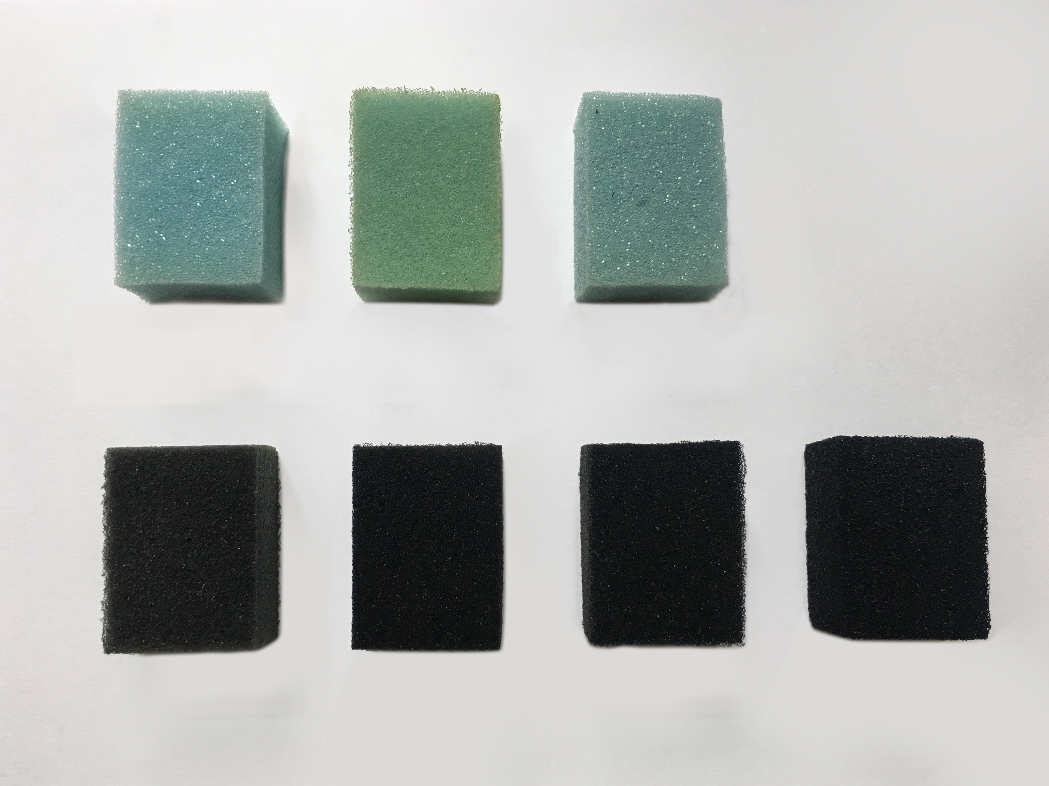 | b  s  h
PU 1PU 4PU

1MW 2MW 3MW 4MW
Figure 1: The seven types of foams evaluated in this work and the designation of the dimensions for each specimen.

Experimental tests and processing techniques.
Each specimen was subjected to five loading and unloading quasistatic compression cycles (triangular waveform) which were run by means of a MTS QTest/10 testing machine, equipped with a 50 N load cell, in displacement control, with a 5 N preload and a maximum of 20% strain [10]. The nominal strain ε was calculated as follows:
$$ε=\frac{Δl}{l_{0}}$$
Eq 1

Where l₀ [mm] is the initial specimen thickness (h) and Δl [mm] is the testing machine crosshead displacement. The nominal stress σ was calculated as follows:
$$σ=\frac{L}{A}$$
Eq 2

Where L is the load from the unit cell (in N) and A [mm²] is the initial specimen cross section perpendicular to load direction.
In the experimental load-displacement curve of a loading-unloading cycle for open cell foams, three trends can be detected (Figure 2): during loading, one can observe a linear elastic initial slope (see zone (a) in Figure 2), and a second linear elastic one with a lower slope (see zone (b) in the same Figure). These two parts are separated by a smooth knee zone (indicated as (c)). A third part with a steeper nonlinear slope, corresponding to the material densification [24], is however not emphasised in this Figure. Densification has not been reached during the tests carried out in this work because of the low deformation levels applied. In the unloading curve similar trends can be found (i.e., the linear elastic initial trend is indicated as zone (d)).
The area subtended by loading and unloading σ−ε curves is a measure of the unit volume dissipated energy U [25].
Different values of the elastic modulus can be defined during both the loading and unloading phases. In particular, the first elastic modulus for foams in the loading and unloading phases (zones (a) and (d) respectively) can be related to the bending modulus of ribs which, in case of foams, can be assumed as beams of base polymer material [24]. The two moduli referenced above have been calculated as secant moduli, according to the E1823 ASTM Standard [26] for the loading (zone (a)) and unloading (zone (d)) first elastic trends. For the current experimental testing, the first linear trend occurred on average within a strain range of 4%. This means that during the loading phase, the elastic modulus E_{L} has been defined as:

$$E_{L}=\frac{σ_{0\%}-σ_{4\%}}{0-0,04}$$
Eq 3
where σ_{x%} is the stress at x% deformation.
During unloading the first linear elastic trend occurred within strain values between 2 % and 1.8 %. The unloading elastic modulus E_{U} has been therefore defined as:

$$E_{U}=\frac{σ_{2\%}-σ_{1.8\%}}{0,02-0,018}$$

Nominal stress at 10% deformation during loading was also measured [27].
The corresponding average stiffness loss at 10% strain for each cycle ${SL}_{i}$ [23] is defined as the ratio between the stress at a set strain (10%) in the i-th cycle σ_{i} and the corresponding stress for the same strain in the first cycle σ₁.
$${SL}_{i}=\frac{σ_{i}}{σ_{1}}$$

The area of the hysteresis cycles U [J] was calculated by means of a linearization method. The values of U vs number of cycles were tabulated and plotted.

Material model and numerical simulation
Aim of the numerical simulation is to calibrate the constitutive models for cyclic viscoelastic behaviour by means of fitting experimental data and to investigate the trend of calibration parameters with cycle evolution in static compression testing. These trends were then compared for the different hierarchical multilayer composite nanocoatings.
Non linear structural simulations of compression cyclic tests were performed by means of ABAQUS finite element structural solver. Specimens were simulated as uniform isotropic continuous prisms, modelled using 8-nodes linear brick elements with reduced integration (C3D8R), characterized by 2mm size. A displacement corresponding to 4% of strain was applied on the upper surface of the model, while the base nodes were constrained in all translations.
Foam constitutive models have to take into account both non-linearity and cyclic related phenomena (i.e. stress softening), occurring during the loading-unloading compression test. To describe the mechanical behaviour of foams, two different analytical models can be used: one for the compression phase (hyperfoam model [28]) and a second model related to the unloading-reloaded phases (Mullins effect [29]).

Hyperelastic foam model
Simulations of the compressive phase of foams, related to the cyclic loading-unloading tests, were run by means of the modified Hill strain energy potential by Ogden [28] and implemented in ABAQUS for highly compressive elastomeric foams [32]. The modified Hill strain energy potential is expressed by the following equation:
$U(λ_{i})=\sum_{i=1}^{N}{\frac{2μ_{i}}{α_{i}^{2}}\left[λ_{1}^{α_{i}}+λ_{2}^{α_{i}}+λ_{3}^{α_{i}}-3+\frac{1}{β_{i}}({J^{el})}^{-α_{i}β_{i}}-1\right]}$ Eq 4
where N is the fitting order;$α$ and $β$ are dimensionless temperature-dependent material parameters, while $μ$ is a material parameter (in MPa). The deformation modes are then characterized in terms of principal stretches $λ_{i}$ (defined in [28]) and the elastic volume ratio $J^{el}$, linked with the following expression:

$$J^{el}=λ_{1}λ_{2}λ_{3}$$
Eq 5
The degree of compressibility is expressed by the coefficient$β$, which is dependent by the Poisson’s ratio$ν$ by means of the following equation:

$$β_{i}=\frac{ν_{i}}{1-2ν_{i}}$$
Eq 6
If${ β}_{i}$ is the same for all terms, a single effective Poisson’s ratio, $ν$, is considered. For${ β}_{i}=ν_{i}=0$, there is no Poisson effect. The foam initial shear modulus $μ_{0}$ is related to $μ_{i}$ as:
$$μ_{0}=\sum_{i=1}^{N}{μ_{i}}$$
Eq 7

Mullins effect
The stress softening phenomenon occurring during the cyclic loading-unloading tests can be modelled using an augmented energy function. The stress softening behaviour, identified as Mullins effect [31], is directly related to the damage occurring during the loading phase [29] [30]. The modified strain energy density function is based on Ogden and Roxburgh expressions [29] for filled rubber elastomers. In ABAQUS [32] an augmented strain energy function revised for the foams is available and expressed in the following form:

$$U\left(λ_{i}, η\right)=ηU\left(λ_{i}\right)+ϕ(η)$$
Eq 8
This formulation considers the progressive damage by adding the damage function $ϕ(η)$ to the strain energy potential for the primary behaviour $U\left(λ_{i}\right)$. In particular, the term $ϕ(η)$ is expressed as a continuous function of the damage variable $η$ (monotonically variable between 1.0 and its minimum value $η_{m}$). $η$ is a continuous function related to material parameters (generally obtained by fitting experimental data) and the value of the strain energy $U\left(λ_{i}\right)$ during its deformation history [29]:

$$η=1-\frac{1}{r}erf\left(\frac{U^{m}-U}{m+βU^{m}}\right)$$
Eq 9
where $r$, $β$ and$m$ are material parameters (generally obtained by fitting experimental data), $erf$is the error function and $U^{m}$ is the maximum value of the strain energy $U$ during its deformation history.
The material coefficients $r$ and $β$ are dimensionless, while $m$ has the dimension of an energy; all material parameters do not have direct physical interpretation [29]. The parameter $m$ is related to the amount of damage at low strain levels: a value of $m=0$ indicates the presence of a significant amount of damage, on the contrary a non-zero value of $m$ suggests either absence or little amount of damage at low strain levels. Moreover, the dissipated energy is inversely proportional to the $r$ and $β$ values: increasing its values leads to a lower amount of damage and vice versa.
The case of $η$=1 corresponds to a point on the primary curve when $U\left(λ_{i}\right)$ is maximum and then $U\left(λ_{i}\right)$ reaches the minimum value upon deformation removal.
In the subsequent loading cycles, the term $U\left(λ_{i}\right)$ results to be lower due to previous damage phenomena.
This means that the damage variable decreases with cycles. This model takes into account that the unloading-reloading response approaches the asymptotic response. This experimentally occurs for PU foams within 5-10 cycles, according to author’s experience. In [33] only two cycles for a PU foam were investigated and simulated by means of FEM analysis. In [16] only three cycles were investigated for a maximum strain value of 65%.
A different result was found in [31] where a 65kg/m³ density PU foam in cyclically compressed at an elevated strain rate and stability is reached after 100 cycles. The relation of mechanical properties on strain rate [23] [34]can be the cause of this discrepancy.
The material coefficients $r$ and $β$ are dimensionless, while $m$ has the dimension of an energy; all material parameters do not have direct physical interpretation [29]. The parameter $m$ is related to the amount of damage at low strain levels: a value of $m=0$ indicates the presence of a significant amount of damage, on the contrary a non-zero value of $m$ suggests either absence or little amount of damage at low strain levels. Moreover, the dissipated energy is inversely proportional to the $r$ and $β$ values: increasing its values leads to a lower amount of damage and vice versa. An alternative to hyperelasticity to model the stress softening in rubbers is proposed in [35] with the aim of overcoming discrepancies between experimental and predicted results in monotonous loading.

Identification of the material parameters
Material parameters related to constitutive models implemented in FE model have been calibrated using a fitting procedure available in ABAQUS. The software, starting from experimental data, determines the material parameters using a least-squares-fit procedure and minimizing the relative error in stress. The list of experimental data has been given in terms of nominal stress and nominal strain. Provided uniaxial compression test data are related only to the 5th cycle, in order to calculate the parameters of the stabilized cycle at fixed strain levels [10].

Results and discussion

Experimental cyclic loading-unloading tests

Figure 2 shows the quasi-static cyclic compression average (on five specimens) curves of the different materials. During cycling, a stress decrement at the maximum strain has been observed from the first to the fifth cycle, typical of hyperelastic foams as stated in [16].
Figures 3 and 4 show the corresponding maximum stresses σ_{max} at 20% strain, averaged on five specimens per material for each cycle and each sample. In particular Figure 4(a) shows the averaged decrement Δσ_{max} of the maximum stress σ_{max} on five specimens per material from the first to the fifth cycle; the same value, normalized with respect to the maximum stress in the first cycle and in % value, %Δσ norm is also reported (Figure 4 (b)).
From the analysis of these experimental results, it can be observed that this decrement of maximum stress (stress softening) corresponds to the hyperelastic behavior described by Mullin effect.
This means that damage phenomena are taking place during uniaxial static compression. The contribution to damage may be split in two parts, the first part can be accounted to pure foam (PU) and it is constant for all specimens; the second one can be attributed to coating layers damage.
This second contribution is quantitatively different for different specimens as demonstrated from the analysis of Figure 3 and Figure 4.

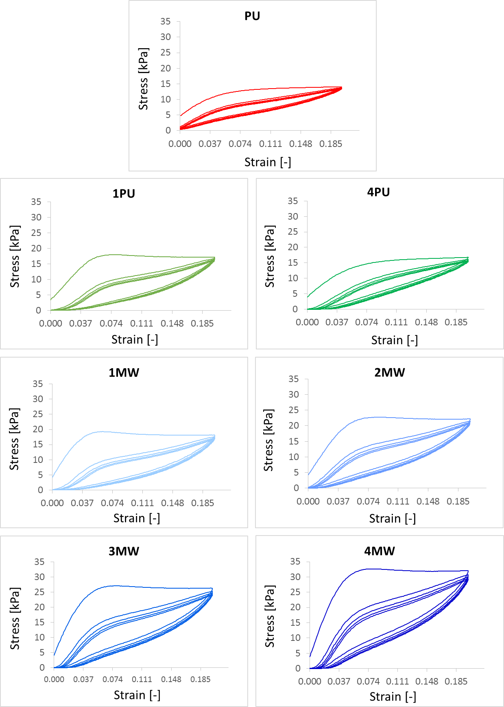
(c)
(a)
(b)
(d)

Figure 2: quasi-static compression cyclic average curves for the different materials

Figure 3: average maximum stress σmax vs cycle

(a) | (b)

Figure 4: average decrement in maximum stress in absolute value (a) and % normalized (b)

Observing Figure 3 it appears that specimens with increasing numbers of coating layers have higher values of maximum averaged stress σ_{max} in all cycles at the same strain value, both for the PU and MWCNT coatings. Between the 1PU and 1MW the average maximum stress increases by 4.4%. A direct comparison between the 4PU and 4MW shows however a remarkable 57% increase by adding the multi-walled carbon nanotubes coatings.
The stronger sensitivity of the presence of the MWCNT in stiffening the foam rather than the use of the PUD coatings has also been observed in similar nanocoated foams subjected to lower applied compressive strains [14].
Also the averaged decrement normalized with respect to the maximum stress in the first cycle% Δσ_{norm} (see Figure 4(a)) increases by increasing the number of PU layers, from 5.2 to 8.9%; on the contrary, the number of MW layers produces a different behavior.
This group of specimens shows a % decrement of normalized maximum stress between 7.0 and 9.6%. This range is narrower than the variation observed between the simple PU specimens, and all the observed values are higher than 1PU specimen which is 6.6%. This means that the presence of CNT layers stiffens the global mechanical response of the specimens, but their damage rate is globally higher than in the case of the simple PU layered specimens.
In Figure 5 the average values for the loading E_{L} and unloading E_{U} elastic moduli for each cycle and each material are reported.

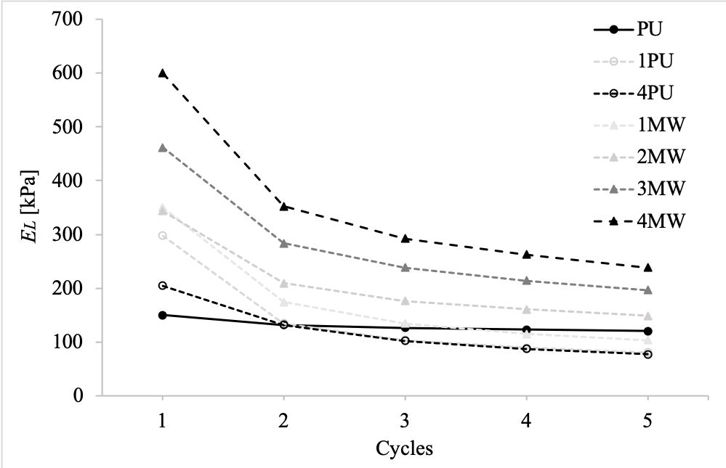 | 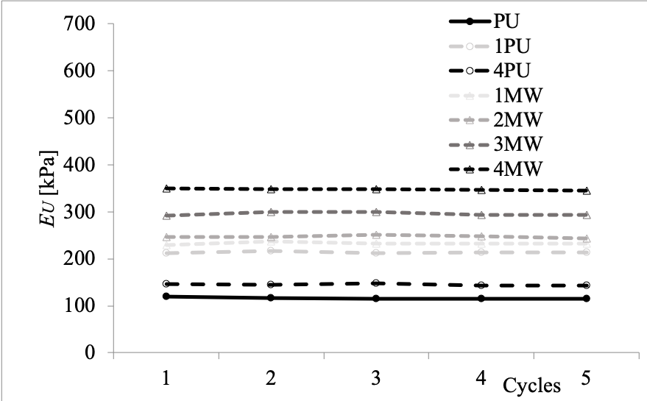
(a) | (b)

Figure 5: Average loading (a) and unloading (b) elastic modulus vs cycles

The value of the Young’s modulus of the pristine PU is 120 kPa, and it is consistent with previous measurements carried out on open cell PU foams with similar stiffness [36]. The elastic modulus E_{L} measured during the loading phase decreases during the first cycles for all the materials here considered but tends to stabilize after the third cycle. This phenomenon becomes more evident in the case of MW coatings, which also provide higher stiffness to foams; the corresponding E_{L} values are higher for both the initial and the stabilized conditions. On the contrary, the unloading E_{U} elastic moduli are quite constant during cycles (see Figure 5 (b)), even if the presence of coating layers makes the foam stiffer, in particular for the case of MWCNT layers. In Table 1 the average stiffness loss at 10% strain ${SL}_{i}$ is reported per cycle and per each material.
The average stress σ_{10%} shows a behavior similar to the one of the elastic modulus E_{L}, emphasizing a decrement in the first cycles, and then a stabilization.

Table 1: Stiffness loss SL_{i} calculated at 10% strain
 | PU | 1PU | 4PU | 1MW | 2MW | 3MW | 4MW
Cycle 2 | 0.74 | 0.62 | 0.71 | 0.62 | 0.67 | 0.68 | 0.69
Cycle 3 | 0.71 | 0.57 | 0.65 | 0.57 | 0.62 | 0.62 | 0.64
Cycle 4 | 0.68 | 0.54 | 0.62 | 0.54 | 0.59 | 0.59 | 0.61
Cycle 5 | 0.67 | 0.52 | 0.60 | 0.52 | 0.57 | 0.58 | 0.59

Coatings provide an increase of the foams stiffness, more evident for MW layers. After 5 cycles, the pristine PU has a 33% stiffness loss compared to the first cycle, and the adding of PUD layers worsens the performance with a 48% drop of stiffness in the case of one PUD layer (Table 1). The presence of MWCNTs also tends to provide a knock-down effect on the stiffness after repeated cycles, with stiffness losses varying between 41% and 43% compared to the first cycles and depending upon the number of nanocoatings applied. Repeated cycles tend to eliminate the influence of defected ribs and non-homogeneous coatings over the foam skeleton, with the resulting stiffness loss of these foams.
In Appendix (Table A2), the average dissipated energy U per cycle per material is reported. The average specific dissipated energy is reported in Appendix (Table A3).
From the energy balance point of view, the phenomenon represented in Figure 7 shows a stabilization after a dissipation decreasing during the first cycles for all materials. The presence of layers emphasizes this behavior and the average dissipated energy U increases for increasing the number of layers, in respect to the PU foam. It is worth noticing that adding more PUD layers does not necessarily lead to an increase in dissipated energy: one PUD layer provides a 66% increase in U, but the repeated dip coating with four layers generates only 31% more dissipation. On the opposite, the effect of the slip-stick behavior of carbon nanotubes within the coatings is evident in the mechanism leading to energy dissipation, with increases of U compared to the pristine foam between 94% and 232% proportional to the number of MWCNT layers applied.

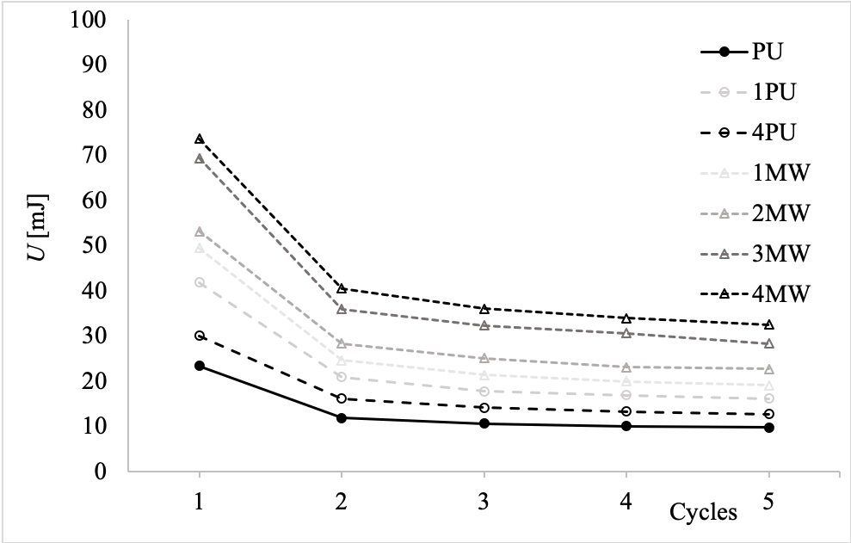
Figure 6: average dissipated energy U per cycle

If one considers the same mechanical parameters, but specific to volume and weight the results are shown in Figure 7.

(a) (b)
Figure 7: average dissipated energy U per cycle specific to weight (a) and to volume (b)

Numerical results
Table 2 shows the results of the fitting procedure carried out to define all material parameters for the hyperfoam model.
For all simulations, the assumption of a Poisson’s ratio $ν_{i}=0$ was made, which corresponds to the default value used in the software. The use of $ν_{i}=0$ in case of polyurethane foam is not new in literature, as also demonstrated in different works ( [37] [16]). Moreover, a series of numerical simulations using different values of $ν_{i}$ ($ν_{i}=0.22$ and $ν_{i}=0.15$) were carried out, confirming that the best fit of the experimental data is obtained using a value of $ν_{i}=0$.
The fitting order N varies between 3 for PU and 4PU and 4 for the other materials.
The least-squares-fit procedures error (%err) is low for the pristine PU foam (2.39%), but it generally increases with the complexity of the architecture of the foam microstructure. In particular, this effect is predominant for 2MW, 3MW and 4MW foams, passing from 6.54% to 11.01%. On the contrary, for materials without MCNT (1PU and 4PU), the %err rises slowly to the maximum one 4.73%. If comparing the obtained parameters values with literature ones (for example [33][17][31][38]), it can be observed that a wide variability is present. This can be related to the intrinsic variability of polymers properties, which are related to ambient conditions, ageing, processing and storage conditions, and loading history.
The results reported in Table 2 can be compared to the ones related to [17] for PU elastomeric foam; in particular the N=3 simulations results show a good correspondence, thus indicating a correct numerical and experimental approach. Corresponding values for the N=2 model described in [17] show a lower correspondence.
In [19] simulations are run with N=2 and analogously show relative root mean square errors values with experimental results ranging from about 4.5 to 12.8%, while for simulations with N=5 or 6 the % error decreases to a range of about 1.6 to 9.3%.

Table 2: Material parameters for the hyperfoam model
Material | μ1 | α1 | μ2 | α2 | μ3 | α3 | μ4 | α4 | %err
PU | 0.258894 | 7.36787 | -0.275664 | 2.34666 | 0.09488813 | -1.3900 | - | - | 2.39
1PU | 0.733339 | 12.995 | -0.572921 | 25 | -0.256284 | -0.663415 | 0.07780372 | -6.296 | 4.73
4PU | -0.440809 | 25 | 0.190778 | 18.2729 | 0.245809 | 0.245809 | - | - | 3.79
1MW | 0.732665 | 13.168 | -0.568587 | 25 | 0.07247065 | -7.29249 | -0.243609 | -1.25059 | 3.59
2MW | 1.05210 | 14.706 | -0.746239 | 25 | -0.374634 | 0.823312 | 0.107828 | -5.33024 | 6.54
3MW | -1.05827 | 25 | 0.651904 | 16.8779 | 0.652842 | 16.8781 | -0.250148 | 8.92335 | 8.37
4MW | 1.08774 | 17.049 | -1.55223 | 25 | 0.851808 | 17.0372 | -0.402857 | 8.62292 | 11.01

In order to calculate the Mullins effect parameters, a different fitting procedure has been utilized: starting from the first results of the fitting procedure performed by ABAQUS, the material parameters have been progressively modified in order to obtain the best fitting of the experimental data. Table 3 shows the final material parameters. Values of $r$ and $m$ are constant and equal for each material. The only varying parameter is $β$; in particular, starting from a value of 2 for PU foam, it achieves the lowest value of 1.1 for the 1MW one. A lower value of $β$ indicates a major amount of dissipated energy in the foam: this confirms the experimental results in which the dissipated energy is small for PU, while it achieves the biggest amounts for MW foams.

Table 3: Material parameters for the Mullins effect
Material | R | m | β
PU | 1.001 | 0 | 2
1PU | 1.001 | 0 | 1.9
4PU | 1.001 | 0 | 1.8
1MW | 1.001 | 0 | 1.1
2MW | 1.001 | 0 | 1.3
3MW | 1.001 | 0 | 1.2
4MW | 1.001 | 0 | 1.2

Figure 8 shows a comparison between experimental results and numerical results in terms of nominal stress-nominal strain behaviour for the 5thcycle. The two models employed to develop the numerical simulations generally fit well the experimental results. In particular, the best results are related to the polyurethane foam PU. Also for 1PU, 4PU and 1MW foams the results are good. The gap between experimental results and numerical results rises progressively passing for 2MW and 3MW to 4MW. This phenomenon is due to the different behavior of this material during the compression phase, especially for 3MW and 4MW, that are characterized on a steeper curve respect to materials without MWNT. The main causes of the discrepancy between the experimental and numerical results can be attributed to the fact that the nanoink cannot be modelled as a simple hyperelastic material, and a composite multilayer model is the one most likely apt to obtain a better description of the stress-strain behavior during the quasi-static compression of this type of foams.
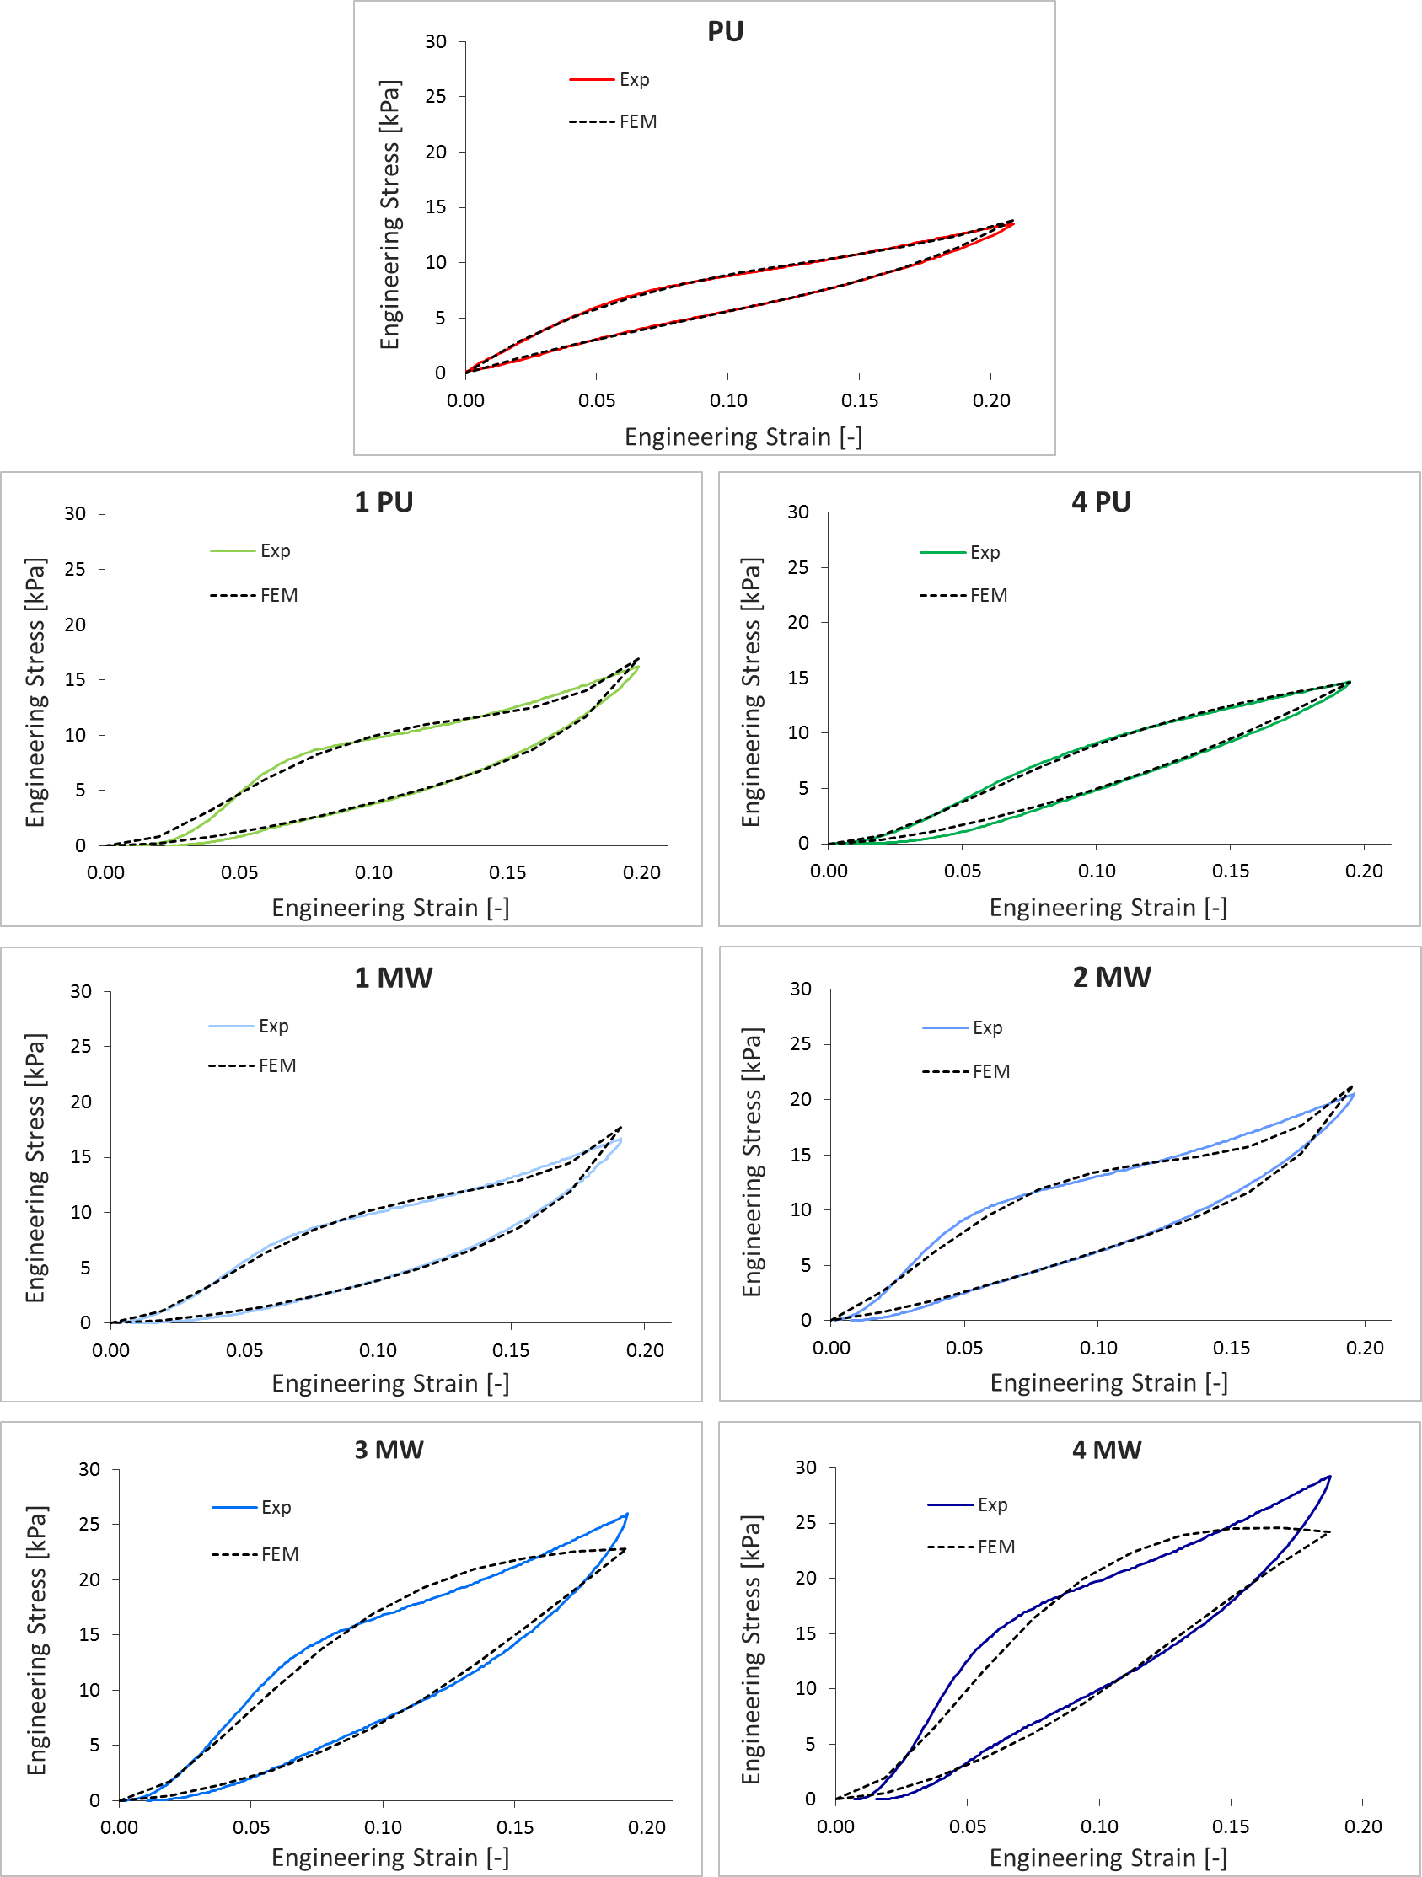
Figure 8: comparison between experimental and numerical results.

Conclusions
The paper has presented the mechanical compressive quasi-static and cyclic properties of a novel class of nano-ink coated polyurethane open cell foams. Hyperelastic models based on Ogden formulations and considering Mullins effects have been also developed to identify constitutive materials representations for these classes of nano-ink doped foams. The porous materials are coated with multi-walled carbon nanotubes, and the bonding between the nanoparticles and the cell struts is provided by a layer of nano PUD polymer. As a further reference benchmark, foams with equal numbers of PUD layers but without the nanotubes dispersions have been produced and tested. The foams evaluated in this work show – in absolute terms – an increase of the maximum compressive stresses after five cycles of stabilization. The loading moduli show a decay after the first cycle, while the unloading one is constant during the cycle history. In both cases the use of the multi-walled carbon nanotubes layers does provide an effective increase of the stiffness of the foams; the foam porous materials with the nano PUD layers do not reach the same performance in terms of increased stiffness. In terms of specific (weight average) properties, the performance of the nano-coated foams in terms of absorbed energy is not significantly enhanced compared to the baseline PU. This is expected because of the added mass contribution provided by both the PUD and MWCNT layers, albeit with the latter a slight increase of the energy absorption performances can be observed for one MWCNT layer only. The volume average energy absorbed however is significantly enhanced by the use of nano-ink doped foams, with a remarkable 232% increase of absorbed energy compared to the pristine PU foam case. The parameters of the hyperelastic models fitted from the experimental data show that these foams can be adequately simulated using existing constitutive models applied to poroelastic materials under large quasi-static compressive deformation.
The foams used in this work possess other multiphysics properties, like electrical conductivity [19]. These mechanical data related to large compressive and cyclic deformation and the model parameters obtained could be useful to design multifunctional energy absorbing packaging porous materials, to increase the sound absorption at low frequencies, to increase the viscous damping factor for vibration damping applications and dielectric properties to obtain multifunctional conductive porous materials, also for microbial fuel cells, with tailored nano-ink solution.

Acknowledgements

XCZ, FS and HXP thank Thomas Swann Ltd for the support of the work related to the development of the nano-inks for the porous materials.

References
- V. Dolomanova, J.C.M. Rauhe, L.R. Jensen, R. Pyrz, A.B. Timmons, J Cell Plast 2011, 47(1), 81.
- M.T. Chen, L. Zhang, S.S. Duan, S.L. Jing, H. Jiang, M.F. Luo, C.Z. Li, Nanoscale 2014, 6(7), 3796.
- L.M. Chen, L.S. Schadler, R. Ozisik, Polymer 2011, 52(13), 2899.
- N. Athanasopoulos, A. Baltopoulos, M. Matzakou, A. Vavouliotis, V. Kostopoulos, Polym Composite 2012, 33(8), 1302.
- K. Dai, X. Ji, Z.D. Xiang, W.Q. Zhang, J.H. Tang, Z.M. Li, Polym-Plast Technol 2012, 51(3), 304.
- R. Verdejo, R. Stämpfli, M. Alvarez-Lainez, S. Mourad, M.A. Rodriguez-Perez, P.A. Brühwiler, M. Shaffer, Compos Sci Technol 2009, 69(10), 1564.
- J. Lee, G.H. Kim, C.S. Ha, J Appl Polym Sci 2012, 123(4), 2384.
- C.H. Sung, K.S. Lee, K.S. Lee, S.M. Oh, J.H. Kim, M.S. Kim, R.M. Jeong, Macromol Res 2007, 15(5), 443.
- M. Bandarian, A. Shojaei, A.M. Rashidi, Polym Int 2011, 60(3), 475.
- A. Bezazi, F. Scarpa, International Journal of fatigue 2007, 29, 922.
- X.C. Zhang, H.X. Peng, A.P. Limmack, F. Scarpa, Compos Sci Technol 2014, 105, 66.
- T. Kang, J. Yoon, D. Kim, S. Kum, Y. Huh, J. Hahn, S. Moon, H. Lee, Y. Kim, Adv. Mater. 2007, 19, 427.
- Y.J. Chen, Y. Li, B.T.T. Chu, I.T. Kuo, M. Yip, N. Tai, Composites: Part B 2015, 70, 231.
- X.C. Zhang, F. Scarpa, R. McHale, A.P. Limmack, H.X. Peng, RSC Advances 2016, 6(83), 80334.
- L. Yang, S. Wang, S. Peng, H. Jiang, Y. Zhang, W. Deng, Y. Tan, M. Ma, Q. Xie, Chem. Eur. J. 2015, 21, 10634-10638.
- R. Deng, P. Davies, A.K. Bajaj, Signal Processing 2006, 86, 2728.
- G. Liang, K. Chandrashekhara, Engineering Structures 2008, 30, 2002.
- A. Kosa, S. Berezvai, Materials Today: Proceedings 2016, 3, 1003.
- Q. Hatem Jebur, P. Harrison, Z. Guo, G. Schubert, X. Ju, V. Navez, Proc IMechE Part C: J Mechanical Engineering Science 2011, 226(9), 2168.
- M.T. Petre, A. Erdemir, P.R. Cavanagh, Computer Methods in Biomechanics and Biomedical Engineering, 2006, 9(4), 231.
- Z.L. Hu, Q. Pang, G.Q. Ji, G.H. Wu, Rare Met. 2018, 37(8), 650.
- K. Boba, M. Bianchi, G. McCombe, R. Gatt, A.C. Griffin, R.M. Richardson, F. Scarpa, I. Hamerton, J.N. Grima, ACS Appl. Mater. Interfaces. 2016, 831, 20319-20328.
- M.F. Alzoubi, E.Y. Tanbour, R. Al-Waked, Proceedings of the ASME 2011 International Mechanical 2011 ASME International Mechanical Engineering Congress
- L. Gibson M.F. Ashby, Cellular Solids – structure and properties. 2nd Edition, Cambridge Press, Cambridge 1997.
- T. J. Lazan, B. J. Horger, O. J. Dolan. Fatigue. American Society for Metals 1954.
- ASTM E1823-13. Standard terminologies relating to fatigue and fracture tests.
- D. Zhang, F. Scarpa, Y. Ma, K. Boba, J. Hong, H. Lu. Material Science & Engineering A 2013, 580, 305.
- R. Ogden, Rubber Chemistry and Thecnology, 1986, 59, 361.
- R. W. Ogden, D. G. Roxburgh, Proceedings of the Royal Society of London 1999, 455, 2861.
- S. Govindjee, J. Simo, J. Mech. Phys. Solids 1991, 39(I), 87.
- Y. Shen, F. Golnaraghi, A. Plumtree, International Journal of Fatigue 2001, 23, 491.
- ABAQUS 6.14 Analysis User's Guide, Dassault Systèmes Simulia Corp., Providence, RI, USA.
- N.J. Mills, Cellular Polymers 2006, 25(5), 293.
- D.V.W.M. de Vries, Characterization of polymeric foams, MD Thesis, Eindhoven University of Technology Department of Mechanical Engineering, July 2009.
- R. Kazakevicˇiûte_-Makovska, International Journal of Solids and Structures 2007, 44, 4145.
- M. Bianchi, F. Scarpa, C.W. Smith, Journal of Materials Science 2008, 43(17), 5851.
- N.J. Mills, A. Gilchrist, Cellular polymers 2000, 19(6), 389.
- C. Briody, B. Duignan, S. Jerrams, J. Tiernan, Computational Materials Science 2012, 64, 47.

Appendix: tabular data
In the following Tables, results are presented in tabular form.

Table A1: specimen average dimensions, weights and densities
 | PU |  | 1PU |  | 4PU |  | 1MW |  | 2MW |  | 3MW |  | 4MW
h [mm] | 28,75 | ±0,40 | 29,11 | ±0,30 | 29,14 | ±0,66 | 29,19 | ±0,38 | 28,79 | ±0,40 | 29,17 | ±0,46 | 29,50 | ±,19
b [mm] | 38,65 | ±0,40 | 39,17 | ±0,55 | 39,39 | ±0,25 | 39,089 | ±0,53 | 39,15 | ±0,35 | 39,29 | ±0,63 | 39,44 | ±0,41
s [mm] | 19,67 | ±0,47 | 19,90 | ±0,42 | 19,68 | ±0,58 | 20,17 | ±0,78 | 20,67 | ±0,66 | 20,66 | ±0,98 | 20,66 | ±0,34
weight [g] | 0,5734 | ±0,0231 | 0,9360 | ±0,0378 | 1,6924 | ±0,0850 | 0,9687 | ±0,47 | 1,2938 | ±0,0662 | 1,6921 | ±0,0411 | 2,0243 | ±0,0993
density [kg/m³] | 26,2 |  | 41,3 |  | 74,9 |  | 42,1 |  | 55,6 |  | 71,5 |  | 84,2

Table A2: average dissipated energy U per cycle [mJ]
 | PU | 1PU | 4PU | 1MW | 2MW | 3MW | 4MW
Cycle 1 | 23,47±3,52 | 41,96±5,18 | 30,11±11,47 | 49,50±9,65 | 53,20±4,93 | 69,48±4,71 | 73,70±5,26
Cycle 2 | 11,93±2,96 | 20,93±3,76 | 16,22±6,82 | 24,66±2,61 | 28,37±2,07 | 36,01±1,28 | 40,59±2,00
Cycle 3 | 10,71±1,97 | 17,79±2,19 | 14,23±6,48 | 21,48±1,39 | 25,20±1,72 | 32,39±1,63 | 36,14±2,14
Cycle 4 | 10,14±1,61 | 17,01±0,99 | 13,32±8,11 | 20,03±2,30 | 23,16±1,28 | 30,70±2,44 | 33,98±1,37
Cycle 5 | 9,78±2,16 | 16,25±1,76 | 12,77±2,32 | 19,13±2,17 | 22,73±1,09 | 28,39±2,61 | 32,59±0,99

Table A3: average dissipated energy U per cycle, specific to volume and to weight
Specific energy (mJ/g)
 | PU | 1PU | 4PU | 1MW | 2MW | 3MW | 4MW
Cycle 1 | 40,9±4,09 | 44,8±6,12 | 17,8±13,16 | 51,1±10,62 | 41,1±6,22 | 41,1±6,40 | 36,4±7,28
Cycle 2 | 20,8±3,53 | 22,4±4,70 | 9,6±8,51 | 25,5±3,58 | 21,9±3,36 | 21,3±2,97 | 20,1±4,02
Cycle 3 | 18,7±2,54 | 19±3,13 | 8,4±8,17 | 22,2±2,36 | 19,5±3,01 | 19,2±3,32 | 17,9±4,16
Cycle 4 | 17,7±2,18 | 18,2±1,93 | 7,9±9,80 | 20,7±3,27 | 17,9±2,57 | 18,2±4,13 | 16,8±3,39
Cycle 5 | 17,1±2,73 | 17,4±1,70 | 7,5±4,01 | 19,7±3,14 | 17,6±2,38 | 16,8±4,30 | 16,1±3,01

Specific energy (mJ/mm³)
 | PU | 1PU | 4PU | 1MW | 2MW | 3MW | 4MW
Cycle 1 | 1,074±0,353 | 1,850±0,154 | 1,333±0,213 | 2,152±0,191 | 2,285±0,142 | 2,938±0,140 | 3,066±0,147
Cycle 2 | 0,546±0,305 | 0,923±0,136 | 0,718±0,107 | 1,072±0,121 | 1,218±0,113 | 1,523±0,106 | 1,689±0,114
Cycle 3 | 0,490±0,206 | 0,784±0,120 | 0,630±0,093 | 0,934±0,108 | 1,082±0,110 | 1,37±0,110 | 1,504±0,115
Cycle 4 | 0,464±0,170 | 0,750±0,108 | 0,590±0,087 | 0,871±0,118 | 0,994±0,105 | 1,298±0,117 | 1,414±0,108
Cycle 5 | 0,448±0,225 | 0,716±0,106 | 0,565±0,083 | 0,831±0,116 | 0,976±0,103 | 1,2±0,119 | 1,356±0,104

* Corresponding author: raffaella.sesana@polito.it DIMEAS, Politecnico di Torino, corso duca degli Abruzzi 24, 10129 Torino, ITALY

